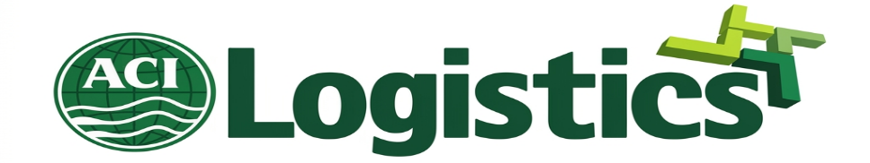

Internship Report on Category Management at
ACI Logistics Ltd. (Shwapno)


Md. Ashikuzzaman Nahin

This report is submitted to the school of Business and Economics, United International University as a partial requirement for the degree fulfillment of Bachelor of Business Administration
Internship Report on Category Management at ACI Logistics Ltd. (Shwapno)

Submitted to:
Name: Ms. Mahbuba Sultana
Lecturer,
School of Business & Economics (SoBE)
United International University

Submitted by:
Name: Md. Ashikuzzaman Nahin
Id: 111 192 096
Major: Supply Chain Management

Registration Trimester: Spring 2026

School of Business and Economics
United International University

Date of submission: July 25, 2026

Letter of Transmittal
25th July 2026
Ms. Mahbuba Sultana
Lecturer, Business and Economics Department
United International University.
Subject: Internship Report on Category Management at ACI Logistics Ltd. (Shwapno)
Dear Ma'am,
I am writing to inform you that my internship at ACI Logistics Limited (Shwapno) has been finished successfully in the Company Goods Department, and this report is submitted for the partial requirement of a Bachelor of Business Administration [BBA] from United International University. This report has been written to introduce the knowledge, duties and experiences during my internship period it follows the guidelines as prescribed by the department. It includes everything I could possibly do to push\n the report around – make sure it is accurate and orderly, it really reflects my work in the organization. I owe my gratitude to you for providing me guidance & supervision during the course of preparing this report and also to ACI Logistics Limited (Shwapno) for allowing me to do my practical orientation with the organization. Kindly consider the report as a completion of my internship requirement.
I'm always there to clarify any doubts or further information on this report.
Sincerely,
Md. Ashikuzzaman Nahin
ID: 111 192 096
School of Business and Economics
United International University

Certification of Similarity Index

This is to certify that the similarity/Plagiarism check of this report was done by plagiarism-detection tool (as per the academic rules of (UIU) assigned from School of Business and Economics, United International University and dogpile based similarity index has been found within threshold limit as prescribed.

[To be added on this page at the time of final submission: original/ similar index certificate uploaded and endorsed by department]

Declaration of the Student

The undersigned certify that the following report is an independent work as partial fulfillment of requirements for the course conducted under the supervision of faculty advisor, Ms. Mahbuba Sultana. All the analysis, figures, and conclusions presented here come from my own work and primacy observations during the internship.
I also confirm that this is original work and that I have not submitted this report, in this or any other form, to another university for a degree, diploma, or certificate.
I've followed the academic guidelines given to me while writing this.


Name: Md. Ashikuzzaman Nahin
ID: 111 192 096
School of Business and Economics
United International University
Enrolled Trimester: Spring 2026

Corporate Evidence

[attach the certification of the organization, attested by supervisor of the organization]


Acknowledgement

First of all, I would like to thank Almighty Allah to grant me power and opportunity to complete this internship and prepare this report.
I am really thankful to Mahbuba Sultana, Lecturer, School of Business and Economics, UIU, for guiding me and giving me direction while preparing this report. I couldn’t have imagined that my report could look so nice without her precious suggestions.
I also want to express my gratitude to ACI Logistics Ltd. (Shwapno) for giving me this golden opportunity. There is a big difference between studying supply chain and category management at the university and being a part of a real supply chain process with real GP% and real company budget.
I want to specially thank my supervisor, MD. Asraful Hasan Abir, Senior Category Manager, Company Goods Department for allowing me to be a part of such a great process. It was really hard to be given such a responsible task (Whole Spice Warehouse budget planning) and such a high-profile process (pasta turnover) for only three months of internship. But I have learned a lot of amazing things during these three months.
All the people at Shwapno corporate office, who provided me with their support, attention, and helped me with any kind of information or showed me their processes or even tolerated my presence during our outlet and market visits are also in my list of people to thank.

Executive Summary

This report is on my internship made at ACI Logistics Limited (Shwapno) – the largest retail network in Bangladesh, which has become the condition of my graduation from the United International University as a BBA holder. My internment course was the Company Goods Department, Kitchen Additive & Packaged Food category, which includes noodles, pasta, shemai, sauces, and basic and whole spices. Apart from general operations of product enlistment, inventory control, vendor maintenances, outlet visits, and compilation of reports on GP%, two projects have been undertaken and are the center of this paper.
The first project involves the Shwapno Whole Spice Warehouse and Processing Factory initiative, which aims at establishing an in-house processing facility for whole spices. While conducting market research, I visited wholesale spice markets and made estimates of supply-demand and prices, which were used for budget planning. The latter, indeed, was a significant part of my work, as I compiled the required budget for machinery, factory, warehouse rent, and working capital, which amounted to (000) confidential BDT. In addition, I analyzed the cost structure changes in the category associated with the shift from local to imported suppliers, which allowed the company to increase GP% by 2.2% (from 22.4% to 24.6%).
The second project concerned the subcategory of pasta, which had been underperforming for several months when I joined the position. This was the process of assortment analysis, stock-out recording, and shelf space audit that helped to identify the root cause of the problem and develop practical solutions to bring the category back to growth. In particular, we managed to increase the GP% from a double-digit decrease to a single-digit growth.
Still, there were some challenges, which might be called shortcomings with my internship. Indeed, the access to confidential information was highly restricted, and there was barely a chance to get involved in a more systemic and responsible tasks, as three months are not sufficient to implement any substantial project on a large scale. Moreover, vendor and outlet coordination sometimes seemed too time-consuming and exhausting. However, I have developed a number of useful insights about category management, which can be instrumental for my future career, as well as addressed the practical implementation of retail analytics. Specifically, forecasting, currency risk prevention, and accelerated development of the whole factory project for spices seem to be the critical areas of improvement, which I would like to see developed.
In summary, I would say that my internship at Shwapno was an extremely valuable experience, indeed. It was essential to learn and get an in-depth understanding of category management processes as a whole. At the same time, I am especially satisfied with the opportunity to participate in such meaningful projects as the development of the spice factory concept, which I find promising and hopefully will see its positive results shortly.

FOR INTERNSHIP REPORT

Table of Contents
Letter of Transmittal 3
Certification of Similarity Index 4
Declaration of the Student 5
Corporate Evidence 6
Acknowledgement 7
Executive Summary 8
List of Figures 12
List of Tables 13
List of Acronyms & Abbreviations 14
CHAPTER 1: INTRODUCTION 15
1.1 Background of the Report 16
1.2 Objectives of the Report 16
1.2.1 Primary Objectives 16
1.2.2 Secondary Objectives 17
1.3 Methodology of the Study 17
1.3.1 Primary Sources 17
1.3.2 Secondary Sources 18
1.4 Scope and Limitations of the Report 18
1.5 Definition of Key Terms 19
CHAPTER 2: COMPANY AND INDUSTRY PROFILE 20
2.1 Company Analysis 20
2.1.1 Overview and History 20
2.1.2 Vision 21
2.1.3 Mission 21
2.1.4 Slogan 21
2.1.5 Key Business Segments 21
2.1.6 Growth of ACI Logistics Ltd. (Shwapno) 22
2.1.7 Achievements and Expansion 22
2.1.8 Outlets of Shwapno 22
2.1.9 Distribution Centre of Shwapno 22
2.1.10 Products and Categories 23
2.1.11 SWOT Analysis of ACI Logistics Ltd. (Shwapno) 25
2.2 Industry Analysis 26
Chapter 3: Internship Experience & Responsibilities 29
3.1 Position, Duties, and Responsibilities 29
3.2 Training & Development 29
3.3 Contribution to Organization / Operations 30
3.4 Estimation 31
3.5 Skills Applied 32
Chapter 4: Key Projects, Skills Developed & Challenges – Kitchen Additive & Packaged Food Category 33
4.1 Category Overview 33
4.2 Project: Shwapno Whole Spice Warehouse & Processing Factory Plan 33
4.2.1 Project Overview and Rationale 33
4.2.2 My Role: Market Visits and Business Plan Development 33
4.2.3 Capital and Budget Architecture 34
4.2.4 Strategic Sourcing and Margin Optimization 35
4.2.5 Implementation Roadmap (2026–2028) 36
4.3 Project II: Pasta Category Turnaround – De-growth to Growth 36
4.3.1 Background: Understanding the De-growth 36
4.3.2 Diagnostic Approach and Root-Cause Analysis 36
4.3.3 Turnaround Actions 37
4.3.4 Result: From De-growth to Growth 37
4.4 Key Findings 38
4.5 Skills Developed & Challenges 38
4.5.1 Improvement of Skills 38
4.5.2 Challenges Faced 39
4.5.3 Evaluation 40
Chapter 5: Recommendations & Conclusion 41
5.1 Recommendations 41
Here are some humble but real suggestions based on my experience here: 41
5.2 Conclusion 42
References 43
Appendix-A 44

List of Figures

- Figure 1: Distribution Centers of Shwapno
- Figure 2: Shwapno Product Category Classification (I)
- Figure 3: Shwapno Product Category Classification (II)
- Figure 4: Shwapno Product Category Classification (III)
- Figure 5: 5-Year Revenue & Net Profit Trend – Whole Spice Sourcing Initiative
- Figure 6: Pasta Category Performance – De-growth to Growth Trend

List of Tables

- Table 1: Product Enlistment and GP% Performance by Category Group
- Table 2: Capital and Budget Architecture – Shwapno Whole Spice Warehouse & Processing Factory
- Table 3: Margin Optimization – Pre-Import vs. Post-Import Sourcing

`

List of Acronyms & Abbreviations

- ACI – Advanced Chemical Industries
- BBA – Bachelor of Business Administration
- BDT – Bangladeshi Taka
- FMCG – Fast-Moving Consumer Goods
- GP% – Gross Profit Percentage
- KAPF – Kitchen Additive & Packaged Food
- KPI – Key Performance Indicator
- MOQ – Minimum Order Quantity
- RTD – Ready-to-Drink
- SKU – Stock Keeping Unit
- SWOT – Strengths, Weaknesses, Opportunities, Threats
- UIU – United International University

CHAPTER 1: INTRODUCTION

This report focuses on my three months experience from my internship at ACI Logistics Limited (Shwapno) in Company Goods of Kitchen Additive & Packaged Food (KAPF) categories. That category sounds big, but that includes noodles, pasta, shemai, sauces and both whole spices & basic spices which meant there were several very diverse products with some really different problems that ended up being a daily part of my work.
Two lessons that filtered out from the noise of everyday tasks. Long before I ever laid eyes on a spreadsheet, was drawn into business planning for the Shwapno Whole Spice Warehouse and Processing Factory and had to go along on real trips to wholesale spice traders. Second, I was asked to help diagnose the de-growth of pasta —normally a sure bet —and how to support whatever action plan the category team come up with.
The rest of this report walks through what I did, what I learned along the way, and where I think the category could still improve.

Background of the Report
The BBA program at UIU also incorporates an internship which is exactly as you may think; a test — a real-world barometer on what you've learned in supply chain and category management classes and how it holds up following the impact with reality. As a Supply Chain Management major, I wanted my hands-on experience to be more than just watching—the launch of Bangladesh's largest retail chain—Shwapno seemed like the safe option.
The Company Goods Department placed me in KAPF and for the next three months, I did a mixture of category work (enlistment, allocation, inventory checks, vendor calls) with two heavier assignments — Whole Spice Warehouse business plan and the pasta turnaround. What remains of this report deals with the last two of those projects.

1.2 Objectives of the Report

1.2.1 Primary Objectives
- For fulfilling the internship requirement of my BBA program.
- The real — not the theoretical — application of category management and supply chain operations.
- A brief look into how Shwapno runs its category operations.

1.2.2 Secondary Objectives
- Gain insights into the process of actual enlistment and distribution of products in KAPF category.
- Purpose This will report on the below Whole Spice Warehouse business plan, it’s costing.
- Analyze the migration from local vendor sourcing to direct imports of whole spices and its effects on margins
- We walk you step by step through how we discovered and solved the de-growth in the pasta categoryContents1.
- To learn about vendor coordination and how supplier relationships work in practice?
- To be honest about the failure I am working through not just the wins.
- To make a link between classroom learning and the reality of how that played out on the ground.

1.3 Methodology of the Study
In researching this report, I relied on mainly primary data — a lot more of the former since a great deal came from things that I did myself.

1.3.1 Primary Sources
Most of this report tells the story of your internship as it happened:
- Keeping an eye on the daily operation of KAPF category
- Whole Spice Warehouse strategy: At wholesale spice markets, I promise to be the best version of myself.
- Weekly having one to one conversation with my supervisor and the other category managers.
- Talking to outlet managers about stock position and ground issues.
- Communication direct usually on noodle, pasta, and spices vendors
- Showing up just because you have a seat at the table: for budget and performance-review discussions

1.3.2 Secondary Sources
When primary sources were found lacking, I relied on:
- Shwapno internal reports & category presentations.
- Category team wise Sales, GP% and enlistment reports
- A special site of Shwapno and website of ACI Group
- An Academic article on organization and supply chain.
- Cases from which the seniors wrote reports during their internship to help in the instance-based way of making.
This report feels a little more candid in what it describes about the cosmetic interplay between the two enterprises — particularly how structurally this constitutes a Whole Spice Warehouse and astoundingly pasta turnaround in KAPF.

1.4 Scope and Limitations of the Report
1.4.1 Scope of the Study
I would like this report to be limited to what I experienced during my internship: noodles, pasta, shemai, sauces and spices in the KAPF category of the Company Goods Department. I wrote in most detail about the Whole Spice Warehouse plan and this pasta pivot since those were the two most active projects I worked on, but also covered the day-to-day category work — requisitioning, allocation, vendor management, budgeting — that made up most of my real day to day.
1.4.2 Limitations of the Study
Several factors limited my ability to go as deep into this report as I wanted:
- Three months is not much time — I had a glimpse of many things, but the entire picture of none.
- Some financial industry data and long-term strategy were kept under wraps, for good reason.
- My focus has been on the KAPF category only, so this report does not offer much more insight into how other branches at Shwapno function.
- A lot of this is from direct observation, rather than particularly statistically rigorous data collection—much larger scale surveys would have taken longer than I had time for.
- A few things I write are based on my discussions with employees, which has more than a bit of subjectivity.
- There were some sales and operational figures that Could Not Be released because of company policy.
Despite these gaps however, I believe the report remains a fair reflection of what I really did and my learnings in Shwapno.

1.5 Definition of Key Terms
- Category Management: Managing a category of related products as its own micro business with unique targets and strategies.
- GP% (gross profit percentage): The amount left after revenue minus cost of goods sold, expressed as a percentage.
- Product Enlistment: The formal addition of any new product or SKU to Shwapno's system for selling in stores.
- Private Label: An inside brand product made and sold under theirs provide (Shwapno) instead of an outside manufacturer.
- De-growth: A period where sales or profit of the particular product of a category is less than before.
- M.O.Q (Minimum Order Quantity): The minimum order quantity of each supplier on a single order.

CHAPTER 2: COMPANY AND INDUSTRY PROFILE

2.1 Company Analysis

2.1.1 Overview and History
ACI Logistics Limited runs under the retail brand most people actually recognize — Shwapno — and sits within the larger ACI Group, one of Bangladesh's oldest and most diversified conglomerates. The group's roots go back to Imperial Chemical Industries (ICI); after the Bangladesh operations were taken over by local investors, it was reorganized and became ACI.
Shwapno itself was set up in 2008 and has since grown into one of the more recognizable retail names in the country, now running upwards of 450 outlets across urban and semi-urban areas.
It commands over a third of the organized retail sector but given that organized retail still comprises only a slight 2% of the population as the bulk of Bangladesh continues to source from traditional, unorganized routes, this is only an impressive milestone in theory. This gap is essentially the entire narrative of growth for companies such as Shwapno.
The KAPF category I worked in — noodles, pasta, the shemai, sauces and basic & whole spices — is one of the highest frequency categories around a store. That may not get as much media attention as electronics or fresh produce, but people are buying these things week in and week out—sometimes more! There's an actual need for this category.

2.1.2 Vision
Shwapno has a vision statement which reads, "To be the retailer of choice for employees to work at, customers to shop and investors.
This is less about a specific target number or metric and more about the company wanting to be the automatic go-to trust culture — whether that be as an online shopper, employee or investor.

2.1.3 Mission
Translation: To win hearts and minds of our customers by constantly innovating, creating & delivering on our promise 'Everyday a better life'
This is a pretty standard mission statement for retail but the "every day, a better life" line does make an appearance in how the category teams discuss customer experience internally.

2.1.4 Slogan
"কষ্টের টাকায় শ্রেষ্ঠ বাজার"

2.1.5 Key Business Segments
Shwapno divides its business into just a few segments — groceries and other daily commodities, fresh produce, kitchen ingredients and processed foods (my segment), household & cleaning products, personal care, general merchandise, and then a separately regulated tobacco segment. KAPF is somewhere in the middle: not as exciting-sounding as fresh produce but comfortably among the busier aisles.

2.1.6 Growth of ACI Logistics Ltd. (Shwapno)
Part of Shwapno's growth has come from a few tracks simultaneously: new store openings, broadening its offerings (private-label initiatives like the Whole Spice Warehouse fall into this category), fairly sticking to what customers actually want, streamlining its supply chain and relying more heavily on tech and vendor partnerships than it previously did.

2.1.7 Achievements and Expansion
The company has got a little aggressive over the years, expanded along cities and towns, racked up some industry awards, put in some time with community programs (none of which I had any touching involvement with but I'll mention it as context on the kind of organization I was working inside).

2.1.8 Outlets of Shwapno
There are more than 950 Shwapno outlets all around Dhaka, Chattogram, Sylhet and Khulna, Rajshahi and a few different towns. They internally segregate them by zones (10 zone), ownership (Owned vs Franchisee) and format (Express, Super, Conv & Mega stores)—this is extremely important for category planning because a MEGA store will need an entirely different assortment for spices & pastas than an Express Store!

2.1.9 Distribution Centre of Shwapno
Six distribution centers handle the movement of stock, including KAPF products, out to stores nationwide.
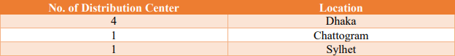
Figure 1: Distribution Centers of Shwapno

2.1.10 Products and Categories
All the items are categorized into 21 cabinets by Shwapno — baby care, electronics, stationery any. Well, KAPF (this is what I was doing) has noodle, pasta, shemai, sauces, basic & whole spice one of the categories which customers touch every day.
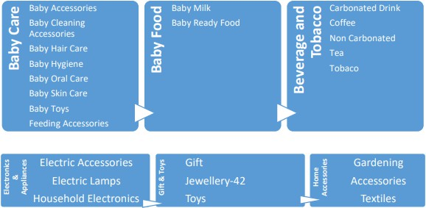
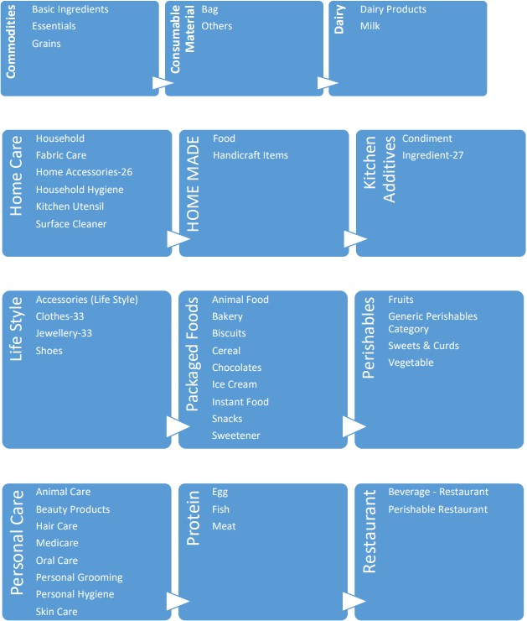
Figure 2: Shwapno Product Category Classification (I)

Figure 3: Shwapno Product Category Classification (II)
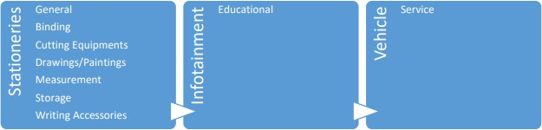
Figure 4: Shwapno Product Category Classification (III)

2.1.11 SWOT Analysis of ACI Logistics Ltd. (Shwapno)
So, a swift SWOT, based on little more than observation rather than anything formal or internal:
Strengths
- Their brand know-how and trust in Bangladesh
- 950+ Outlets — a real tall order that smaller players simply are not going to be able to rise up to the game here.
- This majority product portfolio namely KAPF, which takes care of the maximum necessary items required on a weekly shopping trip.
- Re-purchase (a big thing in retail)
- A supply chain that — wars and all — is more efficiently organized than most of Rest of World.

Weaknesses
- Rely solely on domestic market.
- Actual competition – not only from organized players, but also from a significantly bigger unorganized retail space.
- Operations become cluttered — Managing over 950 stores leading to chaos, consistency becomes an issue.

Opportunities
- You know it, online grocery is still very much nascent out here — a hatch for growth.
- Concentrating on these many underserved places without availability of any Shwapno outlet nearby.
- Whole Spice Warehouse, which is a private-label play that could significantly expand category profit margins.
- International Direct Sourcing – Go Category wise (Spice test looks promising)
Threats
- A highly organized structure will have larger swings in retail area resulting in greater pricing competition;
- Metals importers for the Gulf region are feeling the greatest pain, with inflation and currency volatility placing whole spices at the top of pressure on processors;
- Like the factory, projects could be hampered by changes to regulations affecting food processing or imports.
- Any plausible supply chain disruption — economic, political or otherwise — would be felt at a network of that scale.

2.2 Industry Analysis
2.2.1 Specification of the Industry
The company operates as a retail, eCommerce and FMCG player in Bangladesh. The KAPF denomination sits in the packaged-food and kitchen-essentials segment of that industry – products which are frequently purchased, price-sensitive, and increasingly consumer preference driven towards branded/stable shelf-life packaging vs loose market buying. -
2.2.2 Size, Trend, and Maturity of the Industry
In Bangladesh, organized retail is a relatively new concept — two percent population coverage tells us much. However, for KAPF in particular demand has been increasing generally as urbanization grows, income rises slowly and the shopper becomes to have confidence in packaged noodles, indicating pasta, sauces and spices over what they buy traditionally by loose. And this change is basically the thinking behind Whole Spice Warehouse: customers already looking for a branded, quality-verified version; the issue was just who is going to provide it.

2.2.3 Industry SWOT Analysis
Strengths  - A huge price-conscious but slow-moving consumer segment (extensive for urban and semi-urban areas).  - An increase in brand awareness — consumers are increasingly preferring packaged, biologically sealed playable foods instead of loose ones.  - A few legacy players (Shwapno, Agora, Meena Bazar) with actual distribution infrastructure in place. | Weaknesses  - The industry as a whole is still very young — organized retail only serves about 2% of the population.  - But the heavy reliance on imports of raw materials (whole spices, wheat for pasta/noodles) results in extreme exposure to volatility in currency and global prices across the entire industry.  - Still, much of the cold-chain and logistics infrastructure outside major cities continues to be patchy, which restricts the distance over which organized retail can profitably extend its reach.
Opportunities  - That low is the biggest opportunity of the industry — this huge opportunity if organized retail can grow.  - The ever-increasing urbanization & growing middle population is slowly moving the demand, from staples to packaged and branded products.  - ━ The development of your private-label manufacturing and the direct-import sourcing (such as Shwapno whole spice project) can capture a great deal of any margin currently leaking to intermediaries.  - Online grocery and e-commerce still have low penetration in the local markets, offering potential for high growth. | Threats  - inflation and BDT depreciation translate into higher costs for whole spices; a heavy import category.  - More stringent regulatory or licensing regimes on food processing and imports may also cause to slow it down projects such as private-label factories.  - The industrial rivalry amongst the organized players is intense and continues to climb.  - As such, unorganized loose-market retail should still be taken seriously as an immediate threat to Business models (especially the price sensible staples consisting of basic spices).

Chapter 3: Internship Experience & Responsibilities

3.1 Position, Duties, and Responsibilities
I was an Executive Intern under the KAPF category at the Corporate Office of Shwapno in Marketing and Growth (Company Goods Department). No specific responsibilities, more of a rotating basis per week of what the needs of the team were working on that category.
Essentially, it involved the fact that:
- Product Data Management- SKU tracker, pricing list and inventory for multiple subcategories (noodles, pasta, shemai etc., sauce spice)
- Supplier and Internal Coordination: Liaison to suppliers, procurement & Category managers on areas requiring follow up.
- Stock Monitoring Notify If stocks are low or high to avoid running out of stock crisis
- PO Declared: Excel sheets for GP% and sales-trend reports to my supervisor and team.
- Market Visits: some market visits to independently verify pricing and source conditions for the Whole Spice Warehouse plan.
- Supporting Work Structure for Factory Capital & Budget Plan
- STAL Category Diagnostics: Review the performing category of pasta and support with related action plans implemented
- Product Join: New SKUs that exist in the system and which path each of those should take for every one of these, we will give a proportional feature, such as the text and representation underneath each:
- Outlet Monitoring – Observe item accessibility at outlet level.

3.2 Training & Development
The first week or so was 90% orientation: getting to know how the department is structured, what KAPF really entails during this stage of the planning process, and how Shwapno's various internal systems are set up. One of the first things that my boss and a few other senior members walked me through were GP% analysis, some basic enlistment and budgeting.
As I was sprinted into the Whole Spice Warehouse work — we allotted costs, thought about capital budgeting on a manufacturing project and sourced / what sourcing actually looks like in practice that training became more defined. I won't say that this all came together immediately, it required quite a few reiterations (especially in the budget framework department)

3.3 Contribution to Organization / Operations
As the KAPF sub-categories I was responsible for — like apparel, electronics, etc. — did not provide product enlistment reports or GP% tracking between industries to monitor trends among competitors, maintaining visibility of what's happening in-depth is hard and reviewing these numbers at a high level just doesn't work when talking about growing product-based business inside of a fast-moving organization One thing that I actually contributed rather than observed in this area was looking longitudinally on product enlistment and GP% across my KAPF sub-categories! The figures from this period can be found below.
Category Group | Category GP% Margin | Product Enlisted Avg. GP% | Total Amount confidential (BDT)
Noodles | 22% | 27% – 45% | 0000
Mixed Spice | 24% | 30% | 0000
Dipping Sauce | 24% | 30% – 45% | 0000
Cooking Sauce | 24% | 32% | 0000
Pickle | 21.5% | 25% | 0000
Traditional Snacks | 18% | 22% | 0000
Table 1: Product Enlistment and GP% Performance by Category Group
In terms of enlistment values, we saw Noodles and the 2 sauce lines bringing in the largest enlistments, against mixed spice, dipping sauce (and cooking) which still delivered stronger levels at product level GP%. That gap (high volume vs high margin) came this point a number of times, when we discussed the best fit for developing Whole Spice Warehouse.
Besides this table, most of what I earned by way of real contribution was on the two larger projects — Whole Spice Warehouse business case and pasta turnaround — which I have written up in detail in Chapter 4.

3.4 Estimation
True, that internship was doing exactly what it was supposed to do — making the class material a little bit less abstract. In a span of these three months, anything and everything related to inventory control, demand forecasting, GP%, capital budgeting popped up in one form or another and it all clicked the way that being presented some method of input to a budget (or applying that logic against an actual product that was underperforming) just made more sense than yet another lecture.
Even the environment was really supportive — my supervisor MD. Asraful Hasan Abir used to explain things no matter how busy he was by making some time for me. The only cloud hanging over it was that because most of this is proprietary information confidentiality curtailed the level I could go into detail on some financial matters and three months isn't enough time to get through, say, a factory project from plan to execution.

3.5 Skills Applied
- Excel-based category-level and product data — cleaning SKU-level prices, stocks, and portfolios across noodles/pasta/shemai/sauces/spices to a level of trust ability by team members.
- Understanding and performing analysis on GP% numbers – doing not only extraction of the number, but rather what did margin move mean for a specific sub-category and why it moved.
- Capital & budget planning for a new business-The Whole Spice Warehouse cost is one of the major expenses, so you cannot club up the charges and needs to bifurcate logically; Equipment/purchase/setup/factory space/lease/capital will all make sense and also gaining more knowledge how each leg justifies it.
- Market research in the field – to familiarize myself with wholesale spice markets, looking instead at price and quality without passing data through vendor paywalls and spot checks; use this method to better inform me about healthy seasonal availability.
- Coordination with Vendors — following-up, troubleshooting supply shortages and holding enough communication to ensure a sporadic small issue did not result in stock-outs!
- Why category diagnosis problems — diving deep into sales and GP% data until you can understand how brand pasta has gone from hero to zero, rather than merely stating that it is.
- Facilitating cross-team conversation where working in siloes felt natural — aligning category management, procurement and outlet staff on the same page even when their priorities were misaligned.

Chapter 4: Key Projects, Skills Developed & Challenges – Kitchen Additive & Packaged Food Category

4.1 Category Overview
This covers KAPF for noodles, pasta, shemai (vermicelli), cooking and dipping sauces as well as basic spices & whole spices. You might have been a bit of a niche thus far as the category has not necessarily historically been one to write home about, but with these being bought in Bangladesh with some frequency household will be buying on at least every other week basis so it has more footfall and revenue impact than you probably realize. Instead, I was here fortunately to do work on two things that would both come in especially handy — the case for the Shwapno Whole Spice Warehouse and Processing Factory and putting pasta back on its schneid.

4.2 Project: Shwapno Whole Spice Warehouse & Processing Factory Plan

4.2.1 Project Overview and Rationale
The Whole Spice Warehouse is a simple concept IN PRINCIPLE — STOP buying your whole spices from 3rd party providers (and live with the quality/margin that is available) — create your OWN processing capabilities (grinding, sorting, micro-particle extraction), thus controlling all ends of the chain. No, Whole spices by itself gives significant margins, the extra upstream was intended to cement those further and also give Shwapno control of quality and consistency that loose, vendor sourced spice can never have.

4.2.2 My Role: Market Visits and Business Plan Development
All those spreadsheets were also me paying my side of the bargain in this deal This realization struck as I stared at an abstraction, and rather it was not purely a number of vendor quotes but instead some very strong ground shots — real market conditions which I started visiting wholesale spice markets myself to track up on prices and quality grades, seasonal availability and all those tentacles how they actually trade down there — where that budget had to get its feet on the ground with actual meat. We now had something to compare the quotes we were getting with.
Then I aided my boss finalize the true budget, which was converting what I had viewed on-site to a line-item spreadsheet tableau: an information of OP-EX surging through process equipment and civil works construction costs, as well as working capital rents. Fine and dandy but much of it was muddier than a set of bitmaps that weren't adding up—especially in those early days.

4.2.3 Capital and Budget Architecture
Below is the full amount that they plan on investing factory-wise:
Investment Category | Specific Line-Item Details | Capital Allocated confidential (BDT) | % Share
Processing Equipment | Grinding, sorting, and micro-particle extraction machines | 0000 | 11.69%
Civil Factory Setup | Hygiene insulation, clean rooms, structural zoning | 0000 | 13.24%
Warehouse Lease Advance | Advance security deposit & initial rental commitments | 0000 | 12.50%
Working Capital / Pre-Ops | Licensing, raw stock inventory, packaging materials, payroll buffer | 0000 | 62.57%
TOTAL BUDGET | Complete Processing Platform | 0000 | 100.00%
Table 2: Capital and Budget Architecture – Shwapno Whole Spice Warehouse & Processing Factory
Perhaps the most astonishing thing is that cash reserves and pre-opening costs take up nearly two-thirds of the proposed budget over equipment and construction. None of this makes a lick of sense without seeing the whole picture, and literally looking back in hindsight 20/20 detail.

4.2.4 Strategic Sourcing and Margin Optimization
Besides this plant plan, it was also pursuing larger imports of whole spices directly rather than through local dealers. Well, I looked up how was this affecting the margins anyway:
Metric | Period | Value
Pre-Import Margin | Local vendor outsourcing (Jul – Aug 2026) | 22.4%
Post-Import Margin | Direct imports (Sep – May) | 24.6%
Cumulative GP Impact | 9 months post-import launch | ৳6.34M
Table 3: Margin Optimization – Pre-Import vs. Post-Import Sourcing
Stylistically, it's not far more than a 2.5-point (on average; which at Shwapno's volumes isn’t nothing) margin improvement and it came in right around =৳6.34M cumulative GP impact per warehouse after nine months as the layering effect/space efficiency augments by bacon/side-to-side orders - explains why it's a yes-off-the bat project for your warehouse as if Imports adds this much then shouldn't processed spices stuff be meaningful too since you're one less middleman?

However, direct imports have their share of issues — chief among them high minimum order quantity (MOQ) and BDT/foreign-currency-exposure. They put them into a plan that sized these orders correctly through multi-month demand forecasting providing some degree of visibility, at the same time looking ahead where they brokered forward currency contracts to offset any potential losses due to future swings in currencies.

4.2.5 Implementation Roadmap (2026–2028)
- In 2026-we are operationalizing our Factory +3 percent CM year-on-year to book margin as a joint-owned legal entity with regional importers stretching towards JVs
- 2027-Focus direct-import portfolio from 2 categories to 5; gain exclusive lanes of import for Shwapno own-branded lines
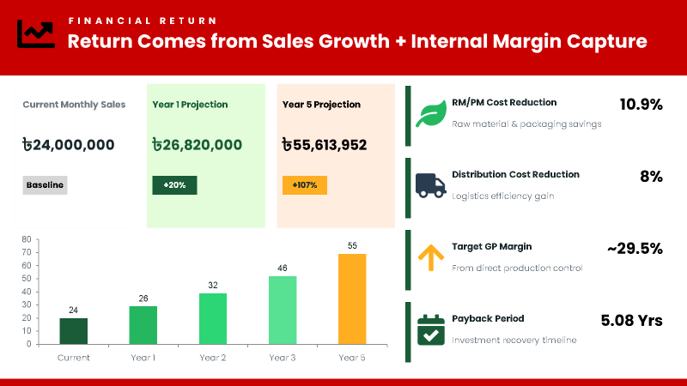
- 2028-Develop more than 10 direct-import categories, and project >20p.p. of total FMCG GP from direct imports.

4.3 Project II: Pasta Category Turnaround – De-growth to Growth

4.3.1 Background: Understanding the De-growth
For Pasta this had been a slow burn long before I joined — there was data of no needle move post our 1/My joining that we could see, yet Noodles (the shelf neighbor) massively outperformed. One of my primary activities became soul-searching to determine why exactly this was going on, and how I could fix it.

4.3.2 Diagnostic Approach and Root-Cause Analysis
I executed simulations for pasta sales/aglow of GP% and sell-through among KAPF / outlet-type wise — at an occasionally month granularity; shelf position also with respect to Customer wants/don't want range of SKUs, pricing against noodles as a substitute; how many times KO just didn't have any stock. It raised some specific, actionable challenges — as the range was occasionally slow to evolve optimum regional preferences at store level.

4.3.3 Turnaround Actions
Why These In pasta nobody wants• Reconfigure their portfolio of SKUs.
- Reengineering processes to ensure the vendor is held accountable for stock availability - so high velocity variants face stock-outs less frequently
- Increasing shelf presence and merchandising so that pasta doesn't fall behind noodles at the point-of-purchase.
Earlier, medium-long run: A/B Testing the hell out of outlet-level monitoring in the short-run right after each change before rolling anything further.

4.3.4 Result: From De-growth to Growth
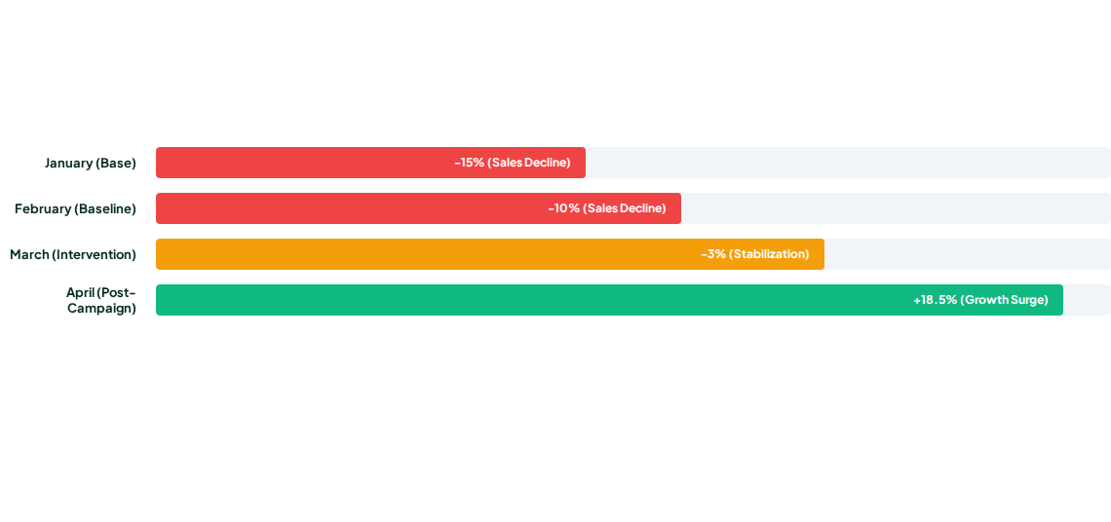
Pasta was the only category with a clear (as seen in the chart below) drop to actually have growth month after this, and that reversal of trend occurred.
Figure 6: Pasta Category Performance – De-growth to Growth Trend
Well, this was a little bit of that gratification feeling where you saw an actual number moving rather than throwing theory out about what might work or not. And especially to the obvious, with proofer assortment de-growth being largely a solvable unglamorous — composition and access troubles versus one huge bucket form leak.

4.4 Key Findings
- A bulk of Whole Spice Warehouse projects go to working capital, not equipment (something that could be a negotiable item with other offers — at least for some businesses anyway).
- Manage MOQ and currency risk (not by default) since MI needs to change in direct imports due margins and lead time;
- A decline in the category does not necessarily mean there is a big problem with the underlying structure of goods — it could simply be more about assortments and availability which can often be solved without additional financing.
- As you walk alone at the market, well vendor quotations cannot pitch a budget that stands its grounds in genuine credibility.
- Both initiatives also rested on continual iteration between the category management, procurement and the outlets themselves.

4.5 Skills Developed & Challenges

4.5.1 Improvement of Skills
Which is to say after three months in KAPF a lot more about my thinking has changed than I expected coming in–real budgets and real underperforming products demanded precision that classroom assignments often lacked.
On Excel & the complexities of data — setting up a dataset a capital budget built from scratch, realistic nature of sales GP% reporting one could not put down if they saw this type probably saw the biggest unlocked improvements by far.
You were trained on GP% trends, the analytic drivers of pasta headwinds over time, and you were able to convert a market-visit scribe into a transferable budget lever. None of it was intuitive — I eventually ran into everything but only after a complex series of trial and error that resulted in more than one instance when my supervisor informed me how poorly I had done.
I was nurtured on the back of communication from beyond my perimeter — to interact with vendors during market tours, junior employees out Let & senior category managers. I may not be quite where I want to be with this but I am definitely a heck of a lot less weirded out about it than the first week.
And other meaty bits I picked up during the process:
- Market/vendor analysis beyond reports
- The complete rewrite of a new business case budget.
- Understanding how to identify why a product line is not used or has been dismissed (and what can we do about it).
- Lotus with time-bound or simple problem solving.
- A clearer definition of category management and private-label planning
To be really honest, it was a way more challenging internship than I had anticipated (which is good! It trained me for real world experience that would prepare me for what was to come supply chain or category management.

4.5.2 Challenges Faced
Not everything went smoothly. A few recurring difficulties:
Access to restricted financial data:
failing to create a Whole Spice Warehouse financial model.
Squeezing in market visits:
The group home category worked really well too — and even some weeks I wanted both.
Incomplete historical data on pasta:
Which by the way had to actually dive deep into all kinds of internal reports just to have an actual measurement on the de-growth.

Multiple vendors and one outlet team at the same time:
a number of axes let go of your vise grip on one take not taking to be cared about at all really two leaving strategies realize fifty-two different modes Straight-up and impersonal yet rated collateralized my list in the way I would have otherwise been reneged involvement.

4.5.3 Evaluation
Indeed, when I recall my first year in CPG, there is little doubt that heading a hybrid (capex—The Whole Spice Warehouse & an analytics driven turnaround project—through the pasta turnaround) category management experience had so much more breadth than what any three-month internship would ever provide. That is what I think is the largest silver lining of this placement.

Chapter 5: Recommendations & Conclusion

5.1 Recommendations

Here are some humble but real suggestions based on my experience here:
- Account for the whole spice factory— The case of margins is already bottoming out. Theoretically, for each month it takes to finalize the vendor contracts and licensing is effectively a margin dollar lost for every month of delay.
- Fixable fix for categories growth de-pasta decline — not big enough to hit the radar early enough. A monthly GP%/sell-through tracker by sub-category would easily resolve this.
- Currency and MOQ risk should be more directly addressed as imports are leveraged up-Futures currency hedging should be part of operations at their inception along with precise demand forecasting—and not retrofitted only after a problem is identified.
- Real market visits are vital — The Whole Spice budget was a much better reflection of bottom-up data from the markets which I make no apology for because it is insights driven. So that was something that you know never should have been something dependent on this one intern going out and looking.
- Formalize vendor performance monitoring — Creating a simple scorecard on delivery reliability, quality and pricing would help both the supply chain for that factory (if applicable) as well as ongoing category management.
- Interns need earlier exposure to financials – I learnt GP% analysis and budget working on the job (which turned out ok) but earlier coverage would put interns in a position to deliver quicker.

5.2 Conclusion
Three months at ACI Logistics Limited (Shwapno) proved to be an extremely useful median between my studies and the industrial level reality within a corporate type in retail. As a staff member in the KAPF category of the Company Goods Department, I experienced up-close how an enterprise works to maintain our daily services while attempting to create something new (in this case, acquiring the Whole Spice Warehouse).
Between product enlistment, inventory checks and vendor call on one hand and the Whole Spice Warehouse business plan and pasta turnaround work plans on the other — I walked away with a much better feel for what category management, sourcing strategy and business planning look like in practice (not just theory at hypothesis-setting) when products don't move as first thought or budgets need to be revisited.
On the bright side (if I'm being honest and fair), I didn't expect to get shipped a factory budget or a live turnaround project as an intern anyway. One of the reasons I was is because my supervisor trusted me, and that for me too is part of why this internship deserves some long-form writing. What I believe will be directly integrated into the next generation of supply chain or retail — the experience, particularly in private-label planning and category diagnostics.

References
- ACI Limited. (n.d.-a). ACI Limited. http://aci-bd.com/
- ACI Limited. (n.d.-b). Subsidiaries. https://www.aci-bd.com/subsidiaries.php
- ACI Logistics Limited. (n.d.-a). Our companies: ACI Logistics Limited. ACI Limited. https://www.aci-bd.com/our-companies/aci-logistics-limited.html
- ACI Logistics Limited. (n.d.-b). Shwapno. https://www.shwapno.com
- ACI Logistics Limited. (2024). Category performance and retail operations report [Internal document]. Shwapno Head Office, Dhaka, Bangladesh.
- Chopra, S. (2019). Supply chain management: Strategy, planning, and operation (7th ed.). Pearson.
- Hübner, A., Kuhn, H., & Stern beck, M. G. (2013). Demand and supply chain management in grocery retailing: An operations management perspective. International Journal of Retail & Distribution Management, 41(7), 512–530. https://doi.org/10.1108/IJRDM-05-2013-0104
- Rahman, M. A. (2023). Retail logistics and category management in superstores [Internship report, United International University]. UIU Institutional Repository. https://dspace.uiu.ac.bd/

Appendix-A
The supporting figures and tables referenced throughout this report — the Whole Spice Warehouse's capital and budget architecture, the margin optimization figures, and the pasta turnaround chart — are presented in Chapters 3 and 4.

