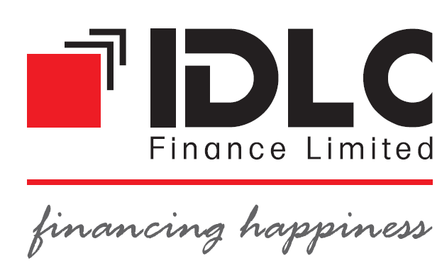
United International University
Internship Report
on
An In-Depth Analysis of the Small Enterprise Financing Division & Performance Evaluation of IDLC Finance Limited.
Internship Course Code: INT 4399

Submitted To:
Faculty Name: Prof. Dr. Salma Karim
Designation: Professor
School of Business and Economics
United International University
 | Submitted By:
 | Student Name | ID. No.
 | Abdullah Al Numan | 111 141 386

Date of Submission: 27-12-2018
Table of Contents

Letter of Transmittal 4
Acknowledgement 5
Executive summary 6
Important Acronyms 7
Introduction 8
Objectives of the study 8
Literature Review 9
Methodology 10
Limitation of this Report 10
Company Profile 11
Findings and Analysis 12-15
Ratio Analysis 15-21
Recommendations 23
Conclusion 24
References 25

Letter of Transmittal
Date: 27/12/2018
Subject: Submission of Internship Report on “An In-Depth Analysis of the Small Enterprise Financing Division & Performance Evaluation of IDLC Finance Limited.”
Dear Madam,
With all respect, I would like to say that it was a great privilege for me to submit my internship report titled “An In-depth Analysis of the small enterprise financing division & Performance Evaluation of IDLC Finance Limited” which has been prepared as a part of my BBA program requirement.
During the preparation of the report, I have tried my level best to make to cover all concerning matters.
Thank you for encouraging me to work on this topic. Please accept my report and oblige thereby.

Regards
Abdullah Al Numan

Acknowledgement
First of all, I would like to be grateful to the Almighty Allah for giving me good health during this work.
In the process of doing the report, I want to pay my gratitude and respect to some special persons for their kind cooperation. At first, I would like to thank my parents for their support and love. I would also like to express my gratitude to my coordinator, Prof. Dr. Salma Karim, School of Business & Economics who has given me the opportunity to do this report. Without her kind suggestions and constant guidance, it would have not been possible to complete the report. At last but not least, I want to thank the officials of IDLC Finance Limited, because they helped me a lot to make this report by providing accurate information.

Executive Summary
This report is prepared with a view of an in-depth analysis of the small enterprise financing division & performance evaluation. This report has been prepared with a view to widen the idea of the operation of small enterprise financing (SEF) and its responsibility. The purpose of preparing this report was to identify the credit risks a Non-banking financial institution (NBFI) faces and how the credit risks can affect their performance. This report used a quantitative approach so that the findings could be generalized to a larger population. The study is based on the performance of IDLC finance limited. The secondary data were collected from annual reports, journals published by IDLC finance limited. The study revealed that the credit risk management has influence on financial performance of IDLC finance limited as measured by Return on Asset (ROA) and Return on Equity (ROE) and the credit risk management indicators mentioned in the report have significant influence on Return on Asset (ROA) and Return on Equity (ROE). Based on findings, the report suggests that the company is already doing great in its industry but there is still room for improvement. Modifying credit risk management policies, maintaining effective credit administration that requires monitoring, monitoring and controlling the credit risk could be few options for the company to manage credit risk as well as to improve its financial performance.

Important Acronyms
IDLC= Industrial Development Leasing Company
CRM= Credit Risk Management
SEF= Small Enterprise Financing
SME= Small and Medium Enterprise
CD= Credit Division
RSTL= Revolving Short-Term Loan
RAROC= Risk Adjustment Returns on Capital
IPO= Intellectual Property Owners
NPL= Non-Performing Loan
KYC= Know Your Customer

Introduction

Risk management is recognized in today’s business world as an integral part of good management practice (Haneef et al., 2012). It entails the systematic application of management policies, procedures, processes and practices to the tasks of identifying, analyzing, assessing, monitoring and managing risks.
The development of the financial market has been receiving heightened attention from the policymakers in recent years due to the increasing spate of small enterprise business, emphasized on Small Enterprise Financing (SEF). Through the effective management of credit risk exposure, banks not only support the viability and profitability of their own business, but they also contribute to systemic stability and to an efficient allocation of capital in the economy.

Objectives of the study
This report has two broad objectives. They are:

Primary Objective
The main objective of this report is to examine the effect of credit risk management on financial performance of IDLC finance limited.

Secondary Objectives
- To explore the overall activities of the Small Enterprise Financing (SEF) department of IDLC Finance Limited.
- To state the decision-making process of the SEF of IDLC Finance Limited.
- To measure the performance of IDLC Finance limited.

Literature Review
Kargi (2011) evaluated the impact of the credit risk of the SEF on the profitability of IDLC finance. Financial ratios as measures of bank performance and credit risk were collected from the annual reports and accounts of sample banks from 2013-2017. The findings revealed that credit risk management has a significant impact on the profitability of IDLC finance limited.
The main goal of CRM is to minimize the risk of giving loan by maintaining credit exposure within acceptable perimeters. Banks need to manage the credit risk to maintain a smooth operation and a strong portfolio. NBFI should also think about the difference and the similarity between credit risk and other risks. The active and effective management for credit risk is very important and essential for a management to sustain in the long-term success of any banking organization.
Majority of income of financial and non-banking financial organizations are generated from the loan and the deposit they actually deliver and gain and all those are highly related with risk. For this CRM is the most important and mandatory part for financial institution. Because if the particular financial institution failed to manage their loan repayment and failed to keep lower the loan defaulter, they face a huge image issue and this will hamper the smooth workflow of that institution and it also kill the portfolio. (Fredrick, 2012).
Proper strategy, guiding, policy and controlling are highly required to maintain a successful CRM team. (Muninarayanappa and Nirmala, 2004).

Methodology
Both Primary and secondary data source were used to compete this report.
A majority portion of information in the report is taken from the primary sources. Three months internship of mine was with IDLC finance limited so the information was from the primary source because all are provided form the IDLC finance limited officials. The secondary data source was the website of IDLC finance limited and the annual report of IDLC finance limited other sources was newspapers and related website of finance of Bangladesh.

Limitation of this Report
Several obstacles were faced to prepare this report. There was a little chance to work at main loan giving section as an intern student. The main limitation of this study is the time constraint because three-month period is not enough to understand the whole Credit Risk Management (CRM) activities of IDLC finance limited. Unavailability of sufficient data and secrecy of the management was also major limitations for this report.

Company Profile
Beginning: IDLC finance limited stared their journey in 1985 with 5 staff members. At that time, it served the purpose of giving loan to the industries. And it was one of the first non-banking finance company of that time.
Vision of IDLC Finance Limited: “We will be the best financial brand in the country.”
Mission of IDLC Finance Limited: “We will focus on quality growth, superior customer experience and sustainable business practices.”

Values:

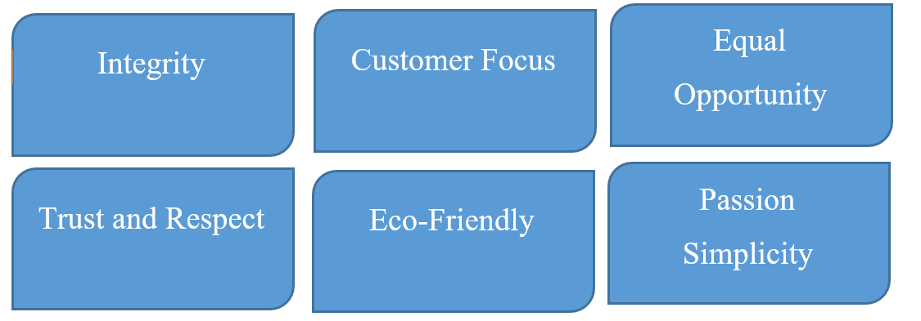
Branches of IDLC Finance Limited: IDLC finance limited has 39 branches all around the country recently they have opened the Bagura Branch as their 39th branch.
Corporate Profile of IDLC Finance Limited
Company Name: IDLC Finance Limited
Company Type: Public Limited Company
CEO: Arif Khan
Director: Mahia Juned
Head Office: 57 Gulshan Avenue. Dhaka DA 1212. Bangladesh
Employees: 1,318
Sales or Revenue: 11.16 Billion taka 2017.
Company Website: www.idlc.com

Findings and Analysis
To explore the overall activities of the Small Enterprise Financing (SEF) division.
IDLC Finance limited has three dedicated department which works together to complete the whole loan giving process of the company these are:

Sales & Marketing Department:
This division decides the sales budget and the marketing cost of the organization. They implement new strategy to avail customers (loan holder). This department actually works on the field and convinces the customers to take the loan. This department takes the whole responsibility of the loan on behalf of their client. The products of the SEF are.
- SME Term Loan:
- Purnota (Women Entrepreneur Loan)
- Supplier Finance
- Revolving Short Term Loan (RSTL)
- Partially Secured Loan
- Seasonal Loan
- Abashan (Commercial Housing Loan)
- Commercial Vehicle Financing
- IDLC Startup Loan
- IDLC Udbhabon
SME Term Loan:
This Loan is up to two corers for an on-loan holder. The time limit for this loan may vary form 13 month to 60 months as per the loan holder demand and the amount of the loan. This loan given to the loan holder without any collateral up to twenty-five lacks taka. If the loan amount exceeds the amount of 25 lakhs then the loan holder needs to mortgage something against the loan for the security purpose. This mortgage can be a car, home, and lands as well.

Purnota (Women Entrepreneur Loan):
IDLC finance especially offers this loan for the women entrepreneurs because they believe the development of the country is impossible without including the women in the mainstream. They offer this loan to women to encourage them to invest in the various business. This loan is lower in interest rate than the other loans in IDLC finance limited. The minimum loan amount of this loan is three lakhs and the maximum amount of the loan is twenty-five lakhs without any security. The loan tenure is formed thirteen months to sixty months. This loan installment also flexible repayment systems are available. Under Bangladesh Bank refinancing scheme loans up to taka fifty lacks at 9 percent interest rate.
Revolving Short Term Loan (RSTL):
The loan limit for this loan is up to one corer. Without security customer take up to twenty-five lakhs taka at a time. Loan tenure up to twelve months. Flexible repayment structure based on the cash flow of business. Flexible disbursement method based on your specific needs. Unlimited drawdowns throughout the contract period.
Partially Secured Loan:
This loan Limit up BDT 1 crore at a time for a single loan holder. Loan Tenure thirteen to sixty months. Flexible repayment based on customers’ business cash flow.
Seasonal Loan:
IDLC finance limited offer some special loans for their customers seasonal loan is one of them. Loan amount up to BDT seventy-five lacks. Loan time up to twelve months. Loan repay system is available both equal monthly installment and seasonal payment based on the customer's business situation.
Abashan (Commercial Housing Loan):
IDLC finance’s one of the best products which gives this organization the fast mover advantages. Loan amount of this product is up to 2 crores and clients can repay this loan by taking up to 180 months. And all the repayment system is equal installment through months.
IDLC Finance Startup Loan:
IDLC finance limited also help the new entrepreneur to start new business with new ideas on that vision they offer IDLC startup loans. Loan Limit: Up to twenty-five lacks. Loan tenure: Up to 60 months. Grace period is for three to six months. Repayment method: Equal monthly installment or structured payment.
IDLC Finance Udbhabon:
This loan is the latest products of IDLC Finance this loan also for the new entrepreneur. The lowest loan amount is taka five lacks. Without security up to taka twenty-five lacks. Partially secured loan up to taka one crore. Loan repay time is minimum 13 months and maximum 60 months. Clients can repay the loan through equal installment. Special facilities for members of BASIS.

Credit Risk Management Department:

This department works after the loan application submitted by the customers. Especially this department works on the risk factors of the particular loan. These specialized people assume the loan risk. This department also goes for the audit to the customer to assess whether this customer is able to repay the loan or not. This department makes the decision that this loan will be given or not. After the approval of the loan papers by CRM department, the loan statement goes for the Credit Administration Department (CAD).

Credit Administration Department:
This Department actually verifies the papers of the loan and makes sure that all are genuine and they also do a background check for the loan holder. If all the papers are correct and genuine then this department issues the loan check for the customer.
There are main three departments which directly works on a loan of Small enterprise financing division.
To state the decision-making process of the SEF
The decision-making process starts with the application of the loan. The business department actually takes the applications of loan. Then they come to the CRM department for the further sanction of the loan for their client. After this step is done CRM department’s work starts.
Initial Checkup
The first task of the CRM officials is to check the loan file, whether it is fully filled up correctly or not. After that, they go for the initial checkup of the documents which includes NID verification, other documents verifications. If all the documents are up to the mark, they go for the next step.
Physical Checkup
After all the documents are good to go further than the officials make a call to the loan holder to know more about them and what is the purpose of the loan ,how many guarantors are actually secured for this loan who are the guarantors. Then one or two officials actually go to the loan holder place to visit the property and other belongings to verify if they are real or not which was provided by the loan holder in the loan application. If everything is good then this loan application will go for the approval.
To measure the performance of IDLC Finance limited.

Ratio Analysis

Return on Assets (ROA)
Return on Assets indicates that the particular organization will get by investing their assets. The percentage can be calculated by the Credit Risk Management department. The higher the ROA, the higher efficiency of that department because all the returns of IDLC finance limited come from interest, commissions, service etc. which is completely in the hand of CRM department.
Table 2: Return on Assets (Annual Report, 2017-2013)
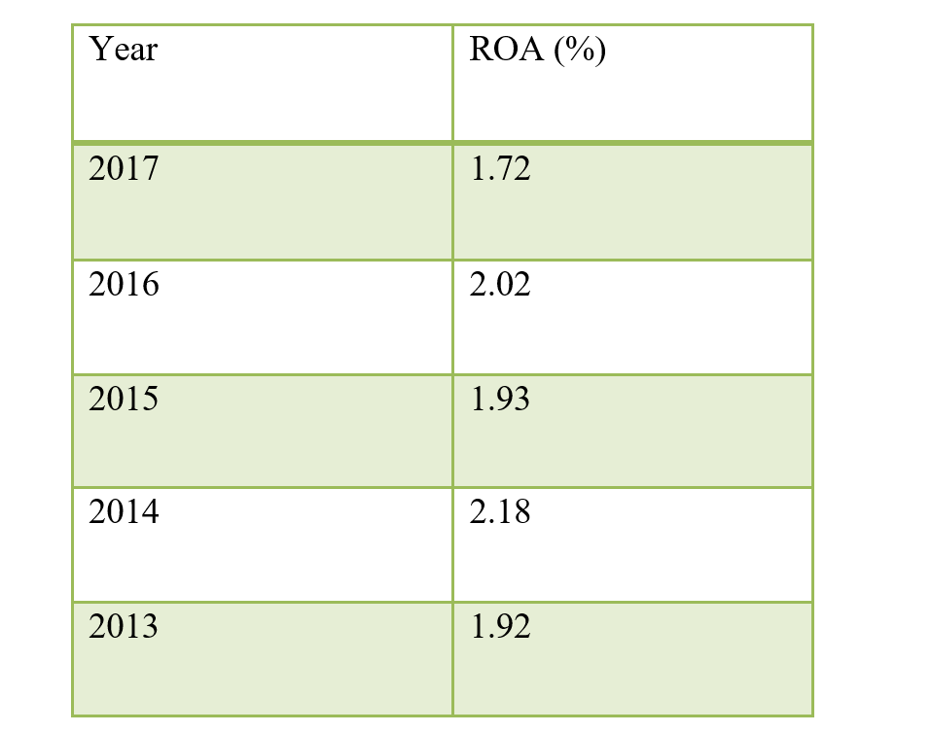

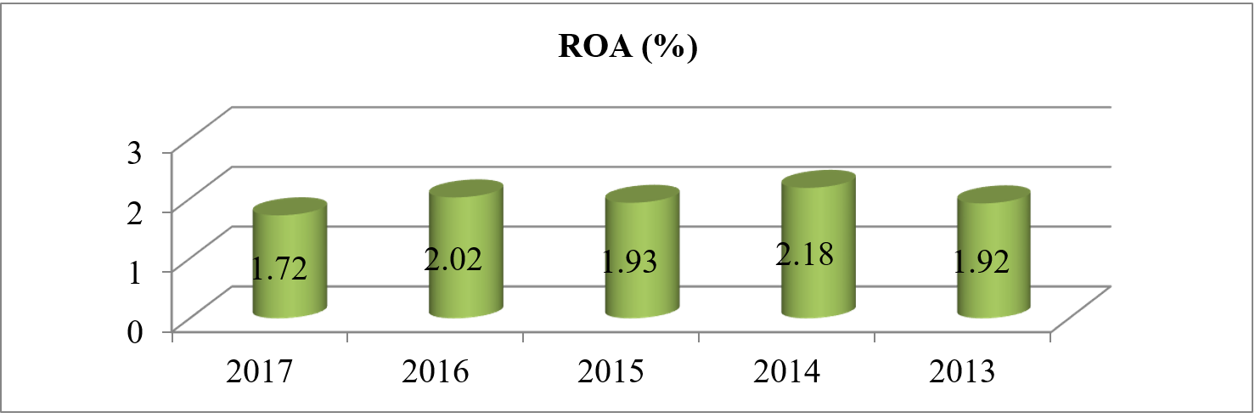

Interpretation
ROA in 2017 is 1.72% which shows that if IDLC finance limited invest BDT 1 they can earn BDT 0.0172 as profit. But it seems to be lesser than 2016, it can be the reason of opening new branch Barishal and this branch is not fully operational yet so the expense has already occurred but the return is not in the hand. So the percentage decrease compared to 2016. 2015 is also lesser than 2014 because IDLC finance limited invest a huge amount to purchase land for their new office and the political issues are the main two reason to reduce this percentage compare to last year.
Return on Equity (ROE)
ROE means how much a company can generate profit by using the capital of shareholders. ROE measures the ability of a company and efficiency of officials. The larger the ratio, the more efficient will be the CRM.
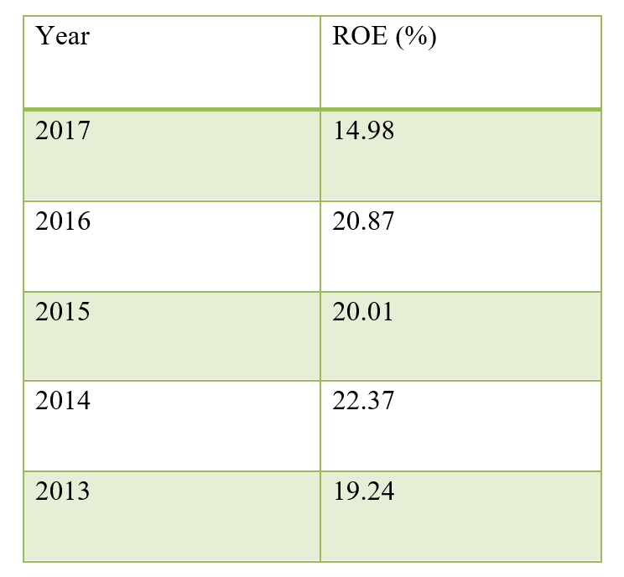
Table 3: Return on Equity (Annual Report, 2017-2013)

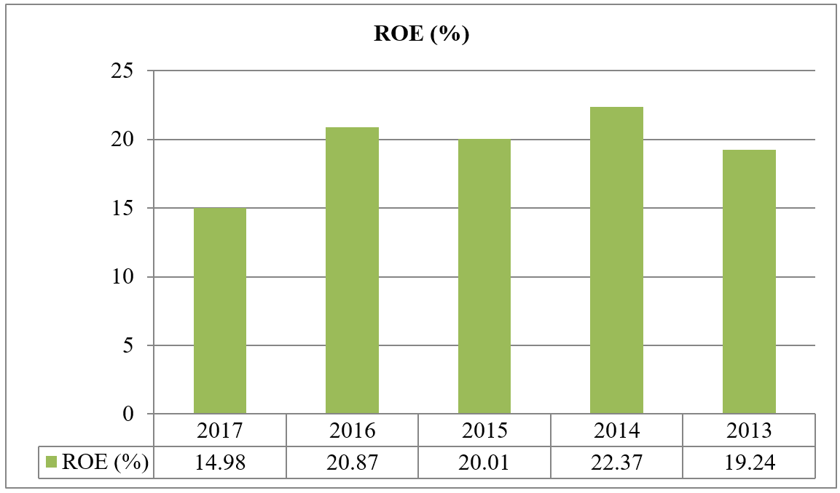

Interpretation
ROE in 2017 was 14.98% which shows that IDLC finance limited use their shareholder money by BDT 1 and get the returns of BDT 0.1498 as profit. But this year IDLC finance Limited’s ROE is little bit lower compared to other years because this year IDLC finance limited invest a huge amount on their infrastructure.
Return on Capital Employed (ROCE)
This ratio indicates that how much money a company get by investing its total capital amounts. The organization's efficiency will high if this ratio is going upward.

It can be measured by this formula: Net Operating Income/ (Total Assets - Total Liabilities).
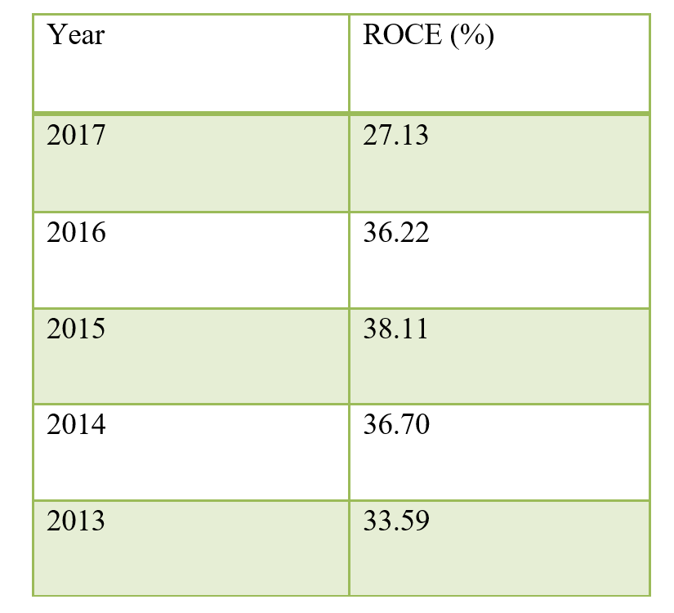
Table 4: Return on capital employed (Annual Report, 2017-2013)
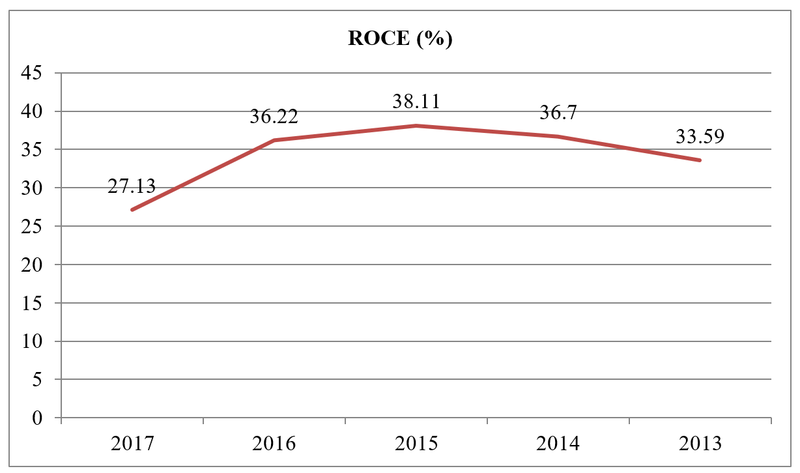
Interpretation
The ROCE of IDLC finance limited is 27.13% which shows that IDLC finance limited use BDT 1 and that 1 BDT 1 will give IDLC finance limited in return BDT 0.2713. In 2017 IDLC finance get the lowest percentage among the years which means IDLC finance limited become little bit in efficient this year. Due to their huge investment of asset.
Growth of Loans of IDLC Finance Limited
IDLC finance limited is born to be the lender and wants to be the number one lander of Bangladesh. Although they have started their operations by giving to some particular sector but now a days, they increase their products from the industry they now provide personal loans as well. So, their Growth of loans increased over the year. IDLC finance limited major income source is providing loan to the customer.

Table 5: Loans of IDLC Finance Limited (Annual Report, 2017-2013
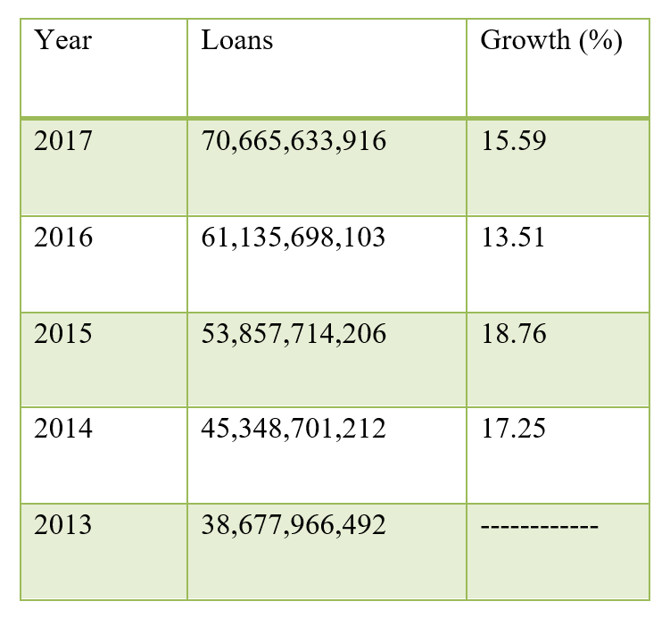

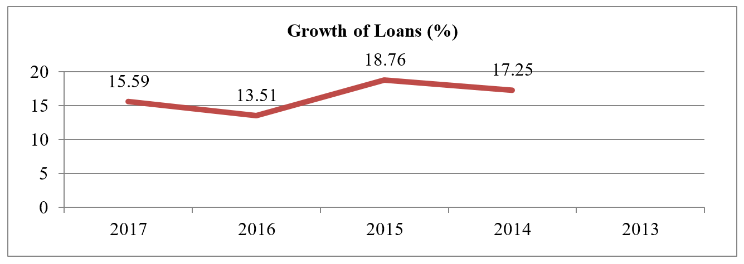
Interpretation
IDLC loan growth rate is moderate. Issuing loan with proper risk management is the main success of CRM officials. The growth rate of 2016 is less compared to 2015 and 2014. Due to huge competition in 2016 IDLC lost some core and prime customers, results to less loan growth. The result also influences the growth of 2017.

Loan Portfolio of SME

IDLC Finance is focusing on SME division to create more entrepreneurs. The main reason is to ensure equal development to all parts of Bangladesh. It offers SME loan to its clients at low rate compared to others and provides regular instructions and counselling to clients so that they can use their funds in a right way.

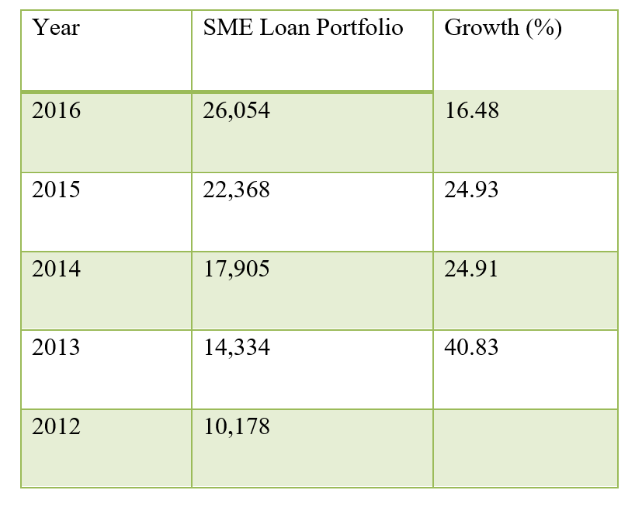
Table 6: Loan portfolio of SME (Annual Report, 2017-2013)

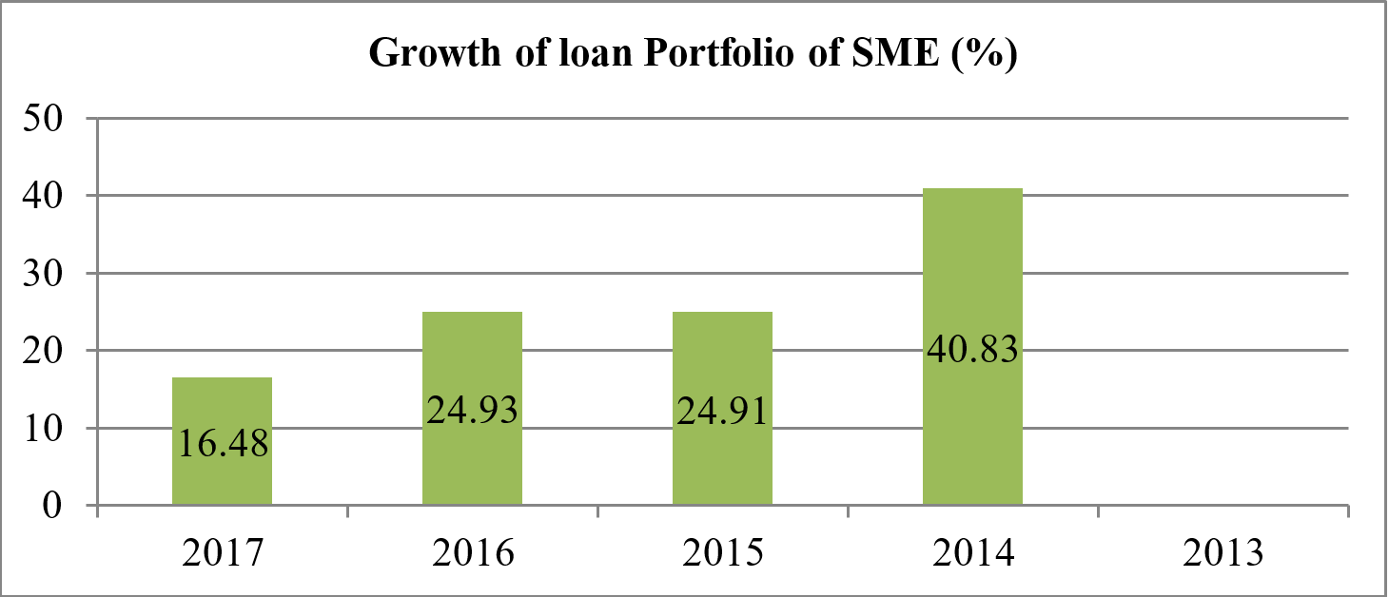
Figure 7: Growth of loan portfolio of SME.

Interpretation
As the information of 2017 is not available, the analysis is done based on the information of 2012 to 2016. Growth of SME was incredible in 2013 and the growth rate was 40.83% because at that time some new and developing sectors flourished their business such as leather, steels, exporters etc. Later on, it started to reduce gradually but IDLC always considers new ideas and business by issuing loan at low pricing.

Recommendations
It is quite difficult to give any recommendation on the lacking of IDLC because IDLC finance limited is a well-structured financial institution. But based on findings from this study the possible recommendations are as follows:
- IDLC can reduce their interest rate on different loans by which the amount they hold that will be on loan and that liquid will produce more return. On the other hand they will able to get more clients as they have a good reputation in this sector.
- IDLC in order to design an effective credit risk management system they need to work with the other organization in the market for a sustainable credit risk management environment.
- Officials should be more attentive when sectioning loans to new customers because 3,178 customer uses false information at Know Your Customer (KYC) form. They also can lessen the duration of loan sanction.

Conclusion

Credit risk management department is the most crucial and sound department of IDLC finance limited, the top lending NBFI in Bangladesh. As per the overall study, I can conclude that Interest rate has a negative effect on the company’s financial performance. So, IDLC finance limited should keep their interest rate intolerable level. It should also increase their capital adequacy ratio so that it can absorb the credit risk thus increasing the financial performance of the company. The CRM department needs more manpower for faster service. And last but not the least IDLC finance limited should improve and automation the technology by which they can avail loan holder information by a click of a mouse.

References

- Al-Tamimi, H. and Al-Mazrooei, F. (2007). Banks’ risk management: a comparison study of UAE national and foreign banks. Journal of Risk Finance, 8(4), pp.395-407.
- Annual Report of IDLC Finance Limited (2013-2017)
- Bangladesh Bank (2016). Integrated Risk Management Guidelines for Financial
Institutions. pp.1-50.
- Basel Committee on Banking Supervision (2000). Principles for the Management of Credit Risk. [online] pp.1-4. Available at: https://www.bis.org/publ/bcbs75.pdf • Bb.org.bd. (2018). Financial System of Bangladesh.
- Cao, Y. and Gruca, T. (2005). Reducing Adverse Selection through Customer Relationship Management. Journal of Marketing, 69, pp.219-229.
- Danjuma, I. (2015). Relationship between Credit Risk Management and Customer Satisfaction in Deposits Money Banks: A Conceptualisation. pp.1-9.
- Danjuma, I., Kola, I., Magaji, B. and Kumshe, H. (2016). Credit Risk Management and
Customer Satisfaction in Tier-one Deposits Money Banks: Evidence from
Nigeria. International Journal of Economics and Financial Issues, pp.225-228.
- Dedu, V. and Nechif, R. (2010). Banking Risk Management in the Light of Basel II. Theoretical and Applied Economics, [online] XVII(543), pp.111-116. Available at:
http://www.store.ectap.ro/articole/445.pdf
- En.wikipedia.org. (2018). IDLC Finance Limited. [online] Available at: https://en.wikipedia.org/wiki/IDLC_Finance_Limited
- Fredrick, O. (2012). The Impact of Credit Risk Management on Financial Performance of Commercials Banks in Kenya. DBA Africa Management Review, 3(1), pp.22-24.
- Giziw, M., Kebede, M. and Selvaraj, S. (2015). The Impact of Credit Risk on Profitability Performance of Commercial Banks in Ethiopia. African Journal of Business Management, 9(2), pp.59-66.
- Idlc.com.(2018). http://idlc.com/public/documents/reports/Annual%20Report%202016.p df. [online] Available at: http://idlc.com/investor-relations-reports.php
- Idlc.com. (2018). IDLC Finance Limited - Loans, Deposits, SME and Corporate Finance. [online] Available at: http://idlc.com/
- Kolapo (2012). Credit Risk And Commercial Banks’ Performance In Nigeria: A Panel Mode
- Approach. Australian Journal of Business and Management Research, 2(2), pp.2-8.
- Mugambi, M. and W. Kagiri, D. (2015). Effects of Customer Retention Strategy on Performance of Commercial Banks in Kenya. International Journal of Science and Research (IJSR), 4(6), pp.44-48.
- Muninarayanappa and Nirmala (2004). Credit Risk Management in Banks-Key
Issues. Journal of Accounting and Finance, 18(1), pp.94-96.
- Mwangi, G. N. (2012). The Effect of Credit Risk Management on the
FinancialPerformance of Banks in Kenya. 1-16.
- NYASAKA, F. (2017). The Relationship between Credit Risk Management Practices And Non-Performing Loans In Kenyan Commercial Banks: A Case Study Of Kcb Group.
[online] pp.40-55.
- NYONG’O, J. (2014). The Relationship between Credit Risk Management And NonPerforming Loans In Commercial Banks In Kenya. pp.1-20.
- Rosman, R. (2009). Risk Management Practices and Risk ManagementProcesses of Islamic Banks: A Proposed Framework. International Review of Business Research Papers, [online] 5(1), pp.242-54.
- Tedder, K. (2009). One-to-One Customer Risk Management. First Data, [online] pp.1-21.
- Tetteh, F. (2012). Evaluation of Credit Risk Management Practices in Ghana Commercial Bank Limited. pp.1-15.
- Thisika, L. and Muturi, W. (2017). Effects of Credit Risk Management on Loan Performance In Kenyan Commercial Banks. International Journal of Economics, Commerce and Management, 9(9), pp.1-15.
- Uwuigbe, U., Ranti, O. and Babajide (2015). Credit Management and Bank Performance of Listed Banks in Nigeria. Journal of Economics and Sustainable Development, 6(2), pp.1-7.

