Role of Trade Promotions in Enhancing Sales at PRAN Foods Ltd.: An Analysis

Md.Farhad bin Nahid

The Report is submitted to the School of Business and Economics, United International University as a partial requirement for the degree fulfillment of Bachelor of Business Administration

Role of Trade Promotions in Enhancing Sales at PRAN Foods Ltd.: An Analysis

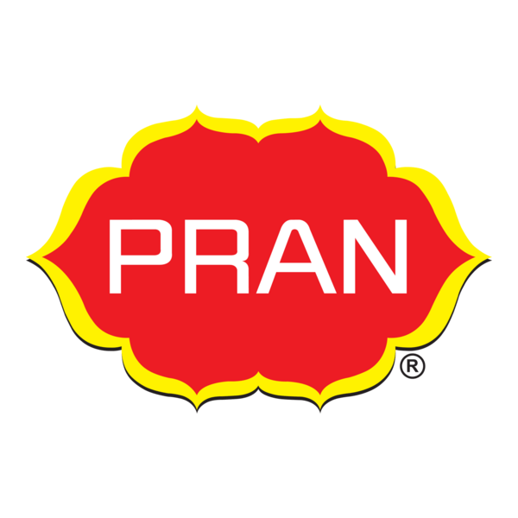

Submitted By
Md.Farhad bin Nahid
Id: 111201201

Supervised by
Dr. Kawsar Ahmmed
Professor, SoBE & Director

Date of Submission: 9 July 2025

Letter Of Transmittal
9 July 2025
Dr. kawsar Ahmed
Professor,
Department of Business Administration
United International University
Subject: Acceptance of internship report on “Role of Trade Promotions in Enhancing Sales at PRAN Foods Ltd.: An Analysis”
Respected sir,
With great pleasure I am submitting my internship report on “Role of Trade Promotions in Enhancing Sales at PRAN Foods Ltd.: An Analysis” that you have assigned to us for my academic degree complete purpose. While preparing this report, I have to followed your instructions and guidelines with attention and diligence. This report has been completed primarily with the help and information from different internet sites and also through online research and customer market. I express my special gratitude to you for dedicating your time, expert guidance and support. I have tried my best to complete the report appropriately as much as possible. I will be pleased to answer any sort of query you may have regarding this term paper.
We hope with great anticipation that you would like and accept our report, looking forward to your cooperation.

Sincerely Yours,
Md.Farhad bin nahid
111201201
Letter of Authorization:

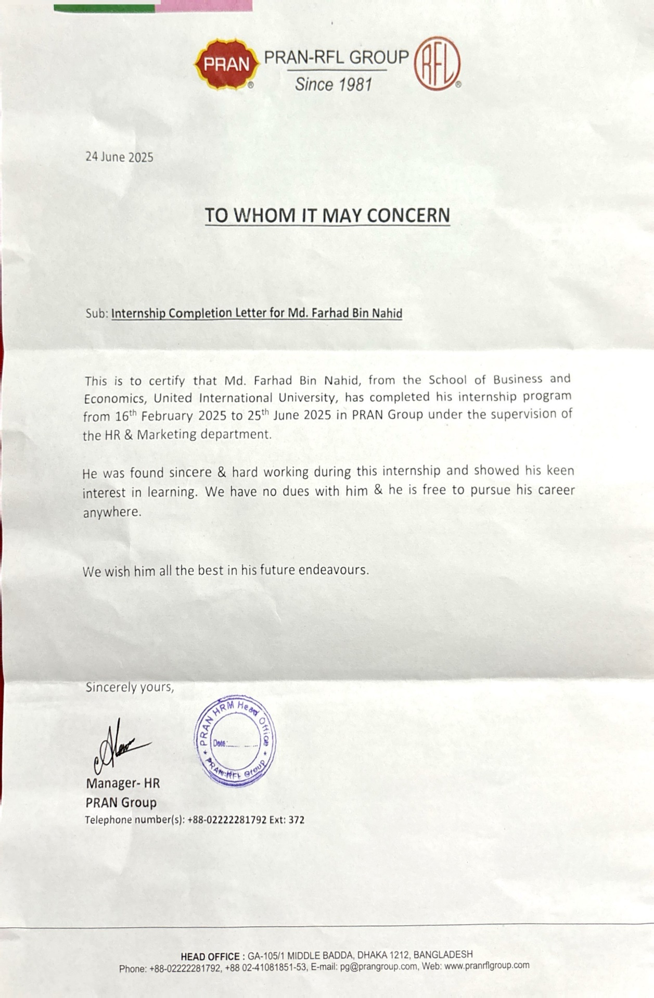

Acknowledgement

I would like to express my heartfelt gratitude and sincere appreciation to all those whose support and guidance have contributed to the successful completion of this report.
First and foremost, I would like to extend my profound thanks to Prof. Dr. Kawsar Ahmed for granting me the opportunity to prepare this report on “Role of Trade Promotions in Enhancing Sales at PRAN Foods Ltd.: An Analysis”. His encouragement and academic guidance have been instrumental in shaping the direction of this report.
I am also deeply grateful to the entire PRAN Marketing Team for providing me with valuable information, insights, and continuous support throughout the preparation of this report.
My sincere appreciation goes to my organizational supervisor, Mr. Ashraful Alam, Assistant Manager, Marketing Department, PRAN Foods Ltd., for his kind cooperation, constructive feedback, and constant guidance during my internship. His mentorship played a vital role in my learning experience.
Lastly, I would like to extend my thanks to all the officers and team members of the Marketing Department who supported me generously—even with the smallest of instructions—whenever I needed assistance with my work.Their collective contributions have made this report possible, and I am truly thankful to each one of them.

Student Declaration
I, Md. Farhad bin nahid hereby solemnly declare that the work presented in this internship report has been carried out by me under the supervision, Prof. Dr. Kawsar Ahmed, United International University. I hereby assure that the work I have presented does not breach any existing copyright laws. It contains no materials previously published or written by any other person which has been accepted for the degree UIU or any other educational institution, except the quotation and references which have been duly acknowledged. It has not been prepared for any other purpose, reward, or presentation.

………………………………………..
Md. Farhad bin nahid
ID: 111201201
Program: BBA
United international university

Supervisor Declaration

This is to certify that Md.Farhad bin nahid a student in the BBA program of the United International University with ID: 111201201, has successfully finished the internship report titled “The Role of Trade Promotion in Enhancing Sales” of PRAN Foods Ltd. He conducted the research under my guidelines and supervision at PRAN Foods Ltd., located at 105 Pragati Sarani, Middle Badda, Dhaka-1212.

He is allowed to submit this report on the date.

……………………………………..
Dr. Kawsar Ahmmed
Professor, SoBE & Director

Executive Summery

PRAN RFL Group stands as one of the largest FMCG companies in Bangladesh. Since its establishment in 1981, the company has served the country in the agriculture and domestic usage sectors. It is widely known for its production of foods and plastic products, along with agricultural equipment. The mother company is Agricultural Marketing Company Ltd. PRAN and RFL are two main subsidiaries of the company. This research explores the impact of trade promotion strategies on enhancing sales at PRAN Foods Ltd., one of Bangladesh’s leading FMCG companies. Despite the company’s strong distribution network and brand presence, recent sales declines prompted an investigation into the effectiveness of its trade promotional tools. The study specifically focuses on five trade promotion variables: free goods, display allowance, sales contests, trade allowance, and buying allowance.

The research follows a quantitative methodology, using survey data from 20 Dhaka-based retailers, distributors, and wholesalers. Statistical analysis—including descriptive statistics, correlation, hypothesis testing, and regression—was used to assess the relationship between each trade promotion tool and sales performance. The findings revealed that all five trade promotion strategies have a positive correlation with sales enhancement, with trade allowance, buying allowance, and free goods showing the most significant impact. Regression analysis confirmed that these three variables are the most effective contributors to increasing sales.
Based on the insights, several recommendations were proposed, such as optimizing incentive structures, improving coordination with retailers, and focusing on promotional tools that deliver the highest return. The study concludes that a well-structured trade promotion program, especially emphasizing free goods, buying allowances, and trade allowances, can significantly boost PRAN’s sales and competitive position in the FMCG market.

Key words: Trade Promotion, Sales Enhancement, Buying Allowance, Sales Contes, Display Allowance, Trade Allowance, PRAN Foods Ltd, Bangladesh

..
Table of Contents
Chapter One 11
Introduction 11
1.1. Primer 12
1.2Purpose/Objective of the Study 13
1.3 Motivation of the Study 13
1.4 Limitation of the Study 14
1.5 Organization of the Remaining Chapters 15
Chapter Two 16
Organizational overview 16
2.1. Background Information 17
2.2. Mission & Vision 18
2.3 Corporate Governance 19
2.4. Top Management 21
2.5. Organizational Structure 22
2.6. Products 22
2.7 Financial Information 28
2.8. Macro Environment (External Analysis) 29
2.9. Micro Environment Analysis 30
Chapter Three 33
Literature Review 33
3.1 Study Background 34
3.2. Problem Statement 34
3.3 Study Variables 35
3.4 Conceptual Framework 39
Figure: 1 39
Explanation of the Conceptual Framework 39
Chapter Four 41
Methodology, Analysis 41
and Discussion 41
4.1 Research Methodology 42
4.2. Budget 44
4.3. Hypothesis Development 45
4.4. Data Presentation & Analysis 46
Interpretation: 48
4.5. Descriptive Statistics 57
4.6 Hypothesis Test 58
4.7. Bivariate Correlation 63
Chapter Five 70
Internship experience, Recommendations and Conclusion 70
5.1 Assigned Department & Target 71
5.2 Structure & Manpower 72
5.3 Departmental Activities: 73
5.4 Departmental Achievement 73
5.5 Tasks and Duties Performed during the three months of my internship at PRAN Foods Ltd. 73
5.6 Working Environment: 74
5.7 Facilities and Constraints Faced: 74
5.8 Lessons Learned from the Practicum: 75
5.10 Recommendations 76
5.11 Conclusion 77
References 78
Appendix 80
Questionnaire 81
Result timeline: 84

Chapter One

Introduction

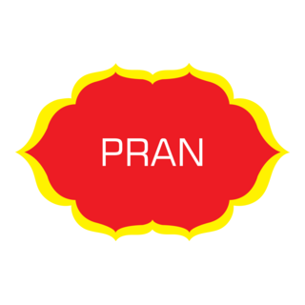

1.1. Primer
PRAN Foods Ltd. is one of the largest FMGC companies in Bangladesh. Since its founding in 1981, it has maintained its position as the country’s leading food products provider. Currently, it has 168+ product variations and has one of the largest marketing teams in the country. Every day, they send out the taste of PRAN products to 145 countries with their numerous agro-food products of 10 different categories, including snacks, confectionery, dairy, juices, carbonated beverages, mineral water, baked items, culinary, drinks, and biscuits. The marketing department of PRAN is the soul department responsible for all of its operations and maintaining the company’s competitive hold in the market.
However, like all other companies, PRAN also faces periods of ups and downs as a regular cycle. The company is always careful about what is causing its business to struggle and how to overcome that problem to continue its sales increase. Increasing sales among buyers is vital for a company's financial success, market position, and overall growth. It enables businesses to reinvest, innovate, and remain relevant in a dynamic marketplace. Moreover, higher sales can positively impact various stakeholders, including employees, investors, customers, and the broader community.
The importance of sales for the success of a business is self-explanatory and is emphasized by the fact that many companies implement whole sales and marketing departments to achieve the highest possible sales performance. But when the performance does not show the desired results, companies are trying to find a way to counteract this development.

1.2Purpose/Objective of the Study
The main goal of this study is to examine the role of trade promotions in improving the sales performance of PRAN Foods Ltd. The research aims to meet academic requirements and give useful insights for the company. Specifically, it looks into how different trade promotion tools, such as buying allowance, free goods, trade allowances, sales contests, and display allowances, influence sales outcomes. The study seeks to identify effective strategies and suggest improvements based on data analysis.

Broad Objective: The broad objective of the research is to analyze the role of trade promotion in enhancing the sales of Pran Foods Ltd.
Specific Objective:
To examine the effect of buying allowance on the sales performance of Pran Foods Ltd.
• To analyze the impact of sales contests on enhancing the sales of Pran Foods Ltd.
• To assess the influence of free goods promotions on the sales volume of Pran Foods Ltd.
• To investigate the role of display allowance in increasing product visibility and boosting sales of Pran Foods Ltd.
• To evaluate the contribution of trade allowance to the sales growth of Pran Foods Ltd.
• To determine the overall effectiveness of trade promotion strategies in enhancing the sales of Pran Foods Ltd.
• To provide recommendations to Pran Foods Ltd.

1.3 Motivation of the Study
The primary motivation for this research is to investigate how specific independent variables related to trade promotions, including buying allowance, sales contests, free goods, display allowance, and trade allowance, affect the dependent variable, which is the increase in sales at PRAN Foods Ltd.

In recent years, PRAN Foods Ltd. has faced inconsistent sales growth, especially in competitive product categories like snacks and beverages, despite making significant investments in promotions. This situation raises an important question: Are the current trade promotion tools effective in boosting sales performance?

The research is driven by the need to analyze the strength and nature of the relationship between these trade promotion tools and sales outcomes. By taking a quantitative approach, this study aims to provide statistical evidence on which promotional strategies are most effective in increasing sales volume.

From an academic perspective, the study enhances marketing knowledge by testing established theories, such as those proposed by Kotler & Keller (2016) and Kumar & Leone (1988), within a real-world fast-moving consumer goods company in Bangladesh. From a practical viewpoint, the findings will assist PRAN Foods Ltd. in reassessing its promotional priorities, optimizing resource use, and maximizing return on investment in trade marketing.

Ultimately, the motivation comes from closing the gap between theoretical marketing models and their real-world applications to improve both academic understanding and company performance.

1.4 Limitation of the Study
Despite efforts to conduct thorough research, a few limitations should be noted:
• The study was geographically confined to Dhaka city, which may not reflect the effectiveness of trade promotions across the whole country.
• The sample size included only 20 respondents out of a 200-person population, which was limited due to time and access issues.
• Only quantitative data was gathered, so in-depth qualitative insights from participants were not examined.
• The internship lasted three months, which limited the ability to observe long-term impacts.
These limitations might affect how broadly the findings can be applied, but they do not lessen the overall relevance of the study.

1.5 Organization of the Remaining Chapters
This report is structured into several chapters for clarity and coherence:
• Chapter Two – Organization Profile: This chapter outlines the background, mission, vision, and structure of PRAN Foods Ltd., including an analysis of its internal and external environment.
• Chapter Three – Departmental Analysis: This section discusses the intern's assigned department, key tasks, learning outcomes, and the challenges encountered during the internship.
• Chapter Four – Research Part: This chapter presents the problem background, research methods, hypothesis testing, data analysis, and findings related to trade promotions and sales performance.
• Chapter Five – Recommendation and Conclusion: This final chapter summarizes the key outcomes of the study, offers practical recommendations, and provides concluding thoughts on how to optimize trade promotions.

Chapter Two

Organizational overview

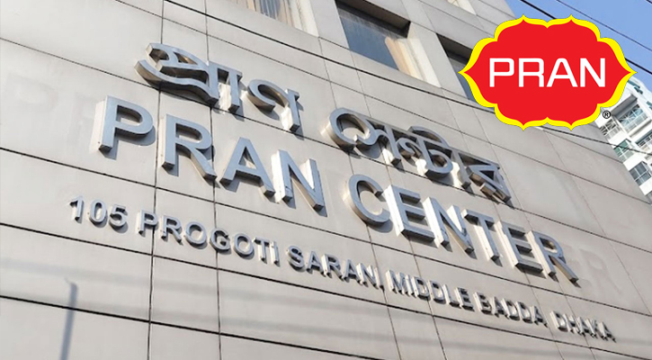

2.1. Background Information
PRAN Foods Ltd. is the largest food and beverage producer group in Bangladesh. PRAN stands for “Program for Rural Advancement Nationally”. In Bangla, "Pragati Rupayone Agrani Noboddom" PRAN GROUP was intuitive in 1980. Keeping in see the business errand of the group, they have throughout the long term expanded their exercises. Today, they are the largest processors of natural products and vegetables in Bangladesh. They empower contract ranchers and assist them with developing quality harvests with expanded yields and to achieve reasonable costs. The Group involves 10 organizations. The administrative centers are situated in Dhaka with creation offices around the nation. Their administration is currently customized to our atmosphere& culture. Their biggest resource is their skillful group of involved throughs &committed workers. Farming Marketing Co Ltd-PRAN-RFL is the primary food regulation organization in Bangladesh to accomplish the great disparity ISO 9001:2000 certification for its quality management system. This extreme confirmation guarantees that PRAN-RFL Products arrive at the buyer's table, keeping up the most elevated level of value. I expansion to ISO, PRAN-RFL has overall affirmations like HALAL and HACCP. They have defined their objective as "Be Number One". It implies that they are continually attempting to give their clients the best product, which will be in the main position in the end. For this objective, they give their best possible work in each stage.
After successfully serving millions of consumers domestically, PRAN-RFL has zeroed in on fares to serve the billions. At present, PRAN-RFL is the biggest exporter of agro-prepared food products of Bangladesh. In acknowledgment of the exceptional exhibition in the send-out, PRAN-RFL has won the best prepared agro-food trade prize for the last three consecutive years. Right now, PRAN-RFL items are consistently being sent out to 142 nations of the 6 mainland’s everywhere on the globe. Significant fare markets are Asia, the Middle East, and Africa.

2.2. Mission & Vision
Vision: Improving livelihood
Mission: Poverty & Hunger are curses
Aim: To generate employment and earn dignity & Self Respect for our compatriots through profitable enterprises.
PRAN Food's Mission is to never bargain with quality, towards holding the position of the market leader and continuing it, and ultimately arrive at the worldwide market. Today, PRAN's regular Bangladeshi taste has been acknowledged all over the world business and has acquired pride and dignity for their countrymen through their profitable ventures. Today, Bangladesh is a developing business sector and is facing competition from everywhere the world. We accept rivalry as an open door to substantiate ourselves. It likewise causes us to improve our quality ceaselessly. This empowers us to serve you better through Continuous Quality Improvement. PRAN Food commits its ceaseless life to serve humanity by giving them the most ideal food, as it is an essential need of humankind. What's more, it is for the caring acknowledgment of individuals that Ahmed has made significant progress.

2.3 Corporate Governance

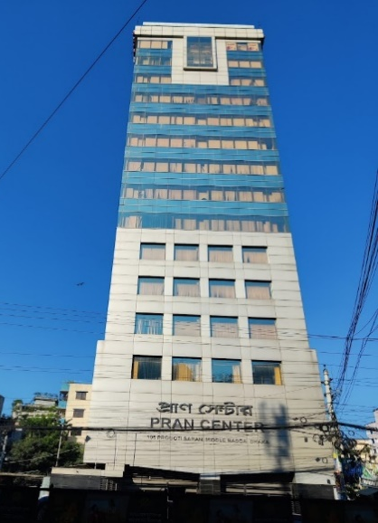
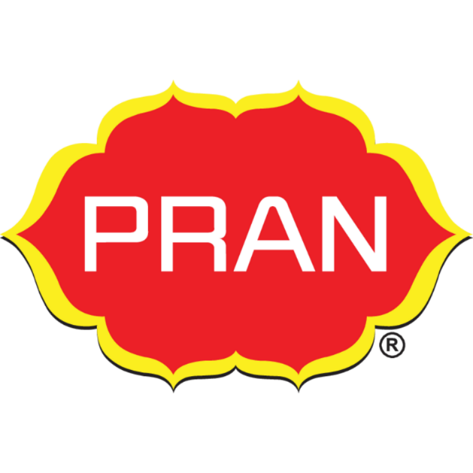
Chairman & CEO: Ahsan Khan Chowdhury
Type of Company: Multinational Conglomerate
Date of Incorporation: 1st January, 1981
Corporate Head Office: 105 Pragati Sarani, Middle Badda, Dhaka-1212
Contact No: 09613737777
Email: emailcrd@prangroup.com
Board Members
Chairman | Mr. Ahsan Khan Chowdhury
Managing Director | Mr. Md. Eleash Mridha
Director | Mrs. Uzma Chowdhury
Director | Mrs. Sabiha Amjad
Independent Director | Md. Abdus Salam, FCA

Senior Management
Chief Financial Officer | Mr. Mohammad Yeamin
Director Marketing | Mr. Chowdhury Kamruzzaman
Company Secretary | Advocate Kazi Abdur Rahman

Registered Head Office | Factories
PRAN CENTRE  Ga-105/1, Middle Badda, Dhaka-1212 Ph:88-02-222281792, Fax: 88-02-8837464 Web: www.amclpran.com | Ghorashal, Palash, Narshingdi,Habigonj,  Natore,Rajshahi.

Auditors | Legal Advisers
S. F. Ahmed & Co  Chartered Accountants  House- 51 (2nd Floor)  Road-9, Block-F, Banani  Dhaka-1213 | Mirza S. Alraza & Associates  Mahtab Center (15th Floor)  177, Syed Nazrul Islam Sarani  Bijoynagar, Dhaka-1000

2.4. Top Management

Ahsan Khan Chowdhury
Chairman & CEO

Product & Engineering
Salahuddin
Graphic Designer
Finance
Halim Khan
Chief Executive Officer

HR
MK Mclhrd (Chief Human Resource Officer)
Legal
Suzan Molla
Legal Officer

Health
R N Paul
Managing Director
Marketing
Ali Hasan
Head of Marketing

Operation
Parashwar Roy
Assistant Manager EXPORT
Sales
Arunangshu Ghosh
General Manager, Marketing

2.5. Organizational Structure

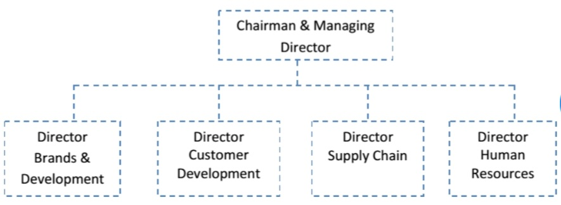

2.6. Products
Businesses of PRAN
PRAN agribusiness marketing organization has restricted and controlled the nine individual Business Units under its umbrella.
- Agricultural Marketing Company Limited (AMCL)
- PRAN Foods Limited (PFL), PRAN Argo Limited. (PAL)
- PRAN Argo Business Limited (PABL)
- Bango Argo Processing Limited (BAPL)
- PRAN Dairy Limited (PDL)
- PRAN Beverage Limited (PBL)
- PRAN Confectionery Limited (PCL)
- PRAN Exports Limited (PEL)

Products
Singara and Samosa(asorted) 12pcs  Chicken pop corn(150gm)  Forzade plus 250ml  Green Chili Sauce  Nazirshail Rice  Salty Biscuit  Tikka Chanachur  Krako Chips  Cup Pudding  Ping Pong  Pran Mango Juice (Glass Bottle) 250ml  Pran Joy(Mango, Orange, Fruit Cocktail)200ml Pran Mango Juice Pack (mango) 125ml  Pran Mango Juice Pack (mango) 200ml  Pran Mango Juice Pack(mango) 250ml  Pran Mango Juice Pack(mango)1 Liter  Pran premium Mango Juice 250ml  Pran Premium Mango juice 1 liter  Pran Juice(premium) (Mango, Orange, Fruit Cocktail)1 liter  Pran Apple Nectar 200ml  Pran Apple Nectar 1 liter  Pran Junior Juice (Orange, Mango, Fruit Cocktail, Litchi)125ml  Pran Frooto(Mango) 125ml  Pran Frooto/mango)200ml  Frooto Mango Juice(Mango)250ml  Frooto Mango Juice(Mango)500ml  Frooto Mango Juice (Mango)1 liter Sundrop(Mango) 250ml Sundrop(Mango)500ml Sundrop(Mango)1000ml Apple Nectar 250ml Pran Juice(guava, Mango, Orange, Apple)250ml  Fazlee(mango)250ml Fazlee(mango0500ml Fazlee(mango)1000ml Pran Juice Tin Can (Fruit Cocktail, Mango, Tarmarind, Orange, Banana, Guava, Pineapple)250ml IN HDPE Shape Drink(mobile shape, fruit shape, ice lolly, ice panda)40ml In HDPE Bottle (Mango, Orange, Pineapple, Fruit cocktail, Litchi) 170ml IN HDPE Bottle(Orange, Pinrapple, Fruit Cocktail,  Litchi 400ml Pet Bottle, Litchi 1 liter Pet Bottle, Litchi 250ml Pran  VITA Plus Jar  Pran Pure Drinking Water 500ml  Pran Pure Drinking Water 1000ml  Pran Pure Drinking Water 1500ml  Pran Pure Drinking Water 2000ml  Chilli Powder 200gm Turmeric Powder 200gm  Coriander Powder 200 gm  Camin Seed Powder  In Pouch  Chilli Powder 200 gm  Turmeric Powder 200 gm  Coriander Powder 200 gm  In Paper Pack  Chilli Powder 200 gm  Turmeric Powder 200 gm  Coriander Powder 200 gm  Mix Spice  Curry powder 200 gm  Fish Mix Masala 200 gm.  Haleem Mix 200 gm  Chatpati Mix 200 gm  Meat Masala200gm  Chicken Masala 200 gm  Garam Masala 200 gm  Kabak Masala 200 gm | Papa cake(cup, layer cake)18gm  Pran Tiffin Cake (strawberry, banana, chocolate, vanilla, 50:50)22gm  Wander (fruit slice cake)350gm  Wonder (pie cake) 50gm  Fun Bite(custered, Layer)250gm  All time Bread 150gm  All time Bread 250gm  All time Bread 350gm  All time Bread 500gm  All time Bread 700gm  All time bun 90gm  Pran Up 250ml  Pran up 500ml  Pran Up 1000ml  Pran Up 2000ml  Pran Maxx Cola 1 liter  Pran Lemon 250ml  Pran Lemon 500ml  Pran Lemon 1000ml  Tango 250ml  Tango 500ml  Tango 1000ml  Fire Fly 250ml  Fire Fly 500ml  Fire Fly 1000ml  Power 250ml.  Chanachur 350 gm  Hot Chanachur 350 gm  Dal (fried) 30 gm  Badam Bhaja 30 gm  Fried pees 30gm Mr.Nut 20gm  Potato Cracker 25 gm  Tom Cracker 25 gm  Chicken Bite 25 gm  Chira Laddu 30 gm  Muri Mua 20 gm  Chira Bhaja 150 gm  Jhal Muri 150 gm  Tetul Chatni 20 gm  Boroi Chutney 20 gm  Mango Chutney 20 gm  Mixed fruit Chutney 20 gm  In Jar Pran Super Chutney 20 gm  In Jar  Curry Powder 200 gm  Chicken Masala 200 gm  Meat masala 200 gm  Pickle Boroi  Pickle 350gm  Garlic Pickle 300 gm  Mango Pickle 300 gm  Mixed Pickle 300ml  Chili Pickle 300 gm  Olive Pickle 300 gm  Satkora Pickle 300 gm  Naga Pickle 300gm Sauce,  Ketchup and Paste Hot tomato Sauce 340 gm Tamarind Sauce 340 gm  Thai Chili Sauce 340 gm  Tomato Ketchup 340 gm  Premium Tomato Sauce 340 gm  Sauce Minipack 10 gm Apple  Jelly 200gm  Orange Jelly 200 gm  Mango Jam 350gm  Pineapple jam 350 gm  Mixed Fruit Jam 350 gm  Pran Mustered Oil 500ml Mustered Oil 80ml

Here are some demo pictures of PRAN Foods products:

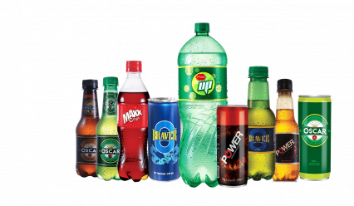

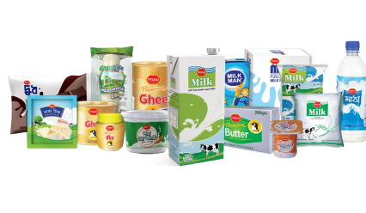

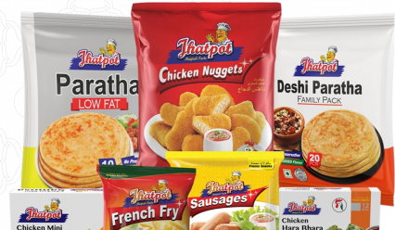

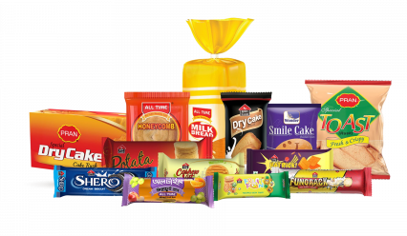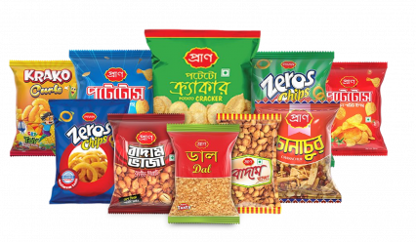

Super shop & Fast-Food Chains: PRAN has a Sweet and dessert chain named Mithai, a Fast-food chain named Sarah’s Pizza & Fry Bucket, and a super shop chain named Daily Shopping.

Location of Markets
PRAN Agriculture Marketing Company has spread its products all over the country and launched 177 products in the consumer market. Locations of the markets are: Narsingdi, PRANRFL Dairy, PRL, AMCL, PBL, PC, PEL
Ghorashal, Rangpur, RFL, BAPL (Rice)
Natore, PAL, PABL, Chittagong, PRAN-RFL Tea
Al-Mostafa Bread & Biscuit (Pvt.) Ltd (Sub-contract- Biscuit)
Fulkoli Food Products (Sub-contract- Biscuit)
Bramhon Baria, Ratan Foods Ltd. (Sub-contract- Biscuit).

2.7 Financial Information
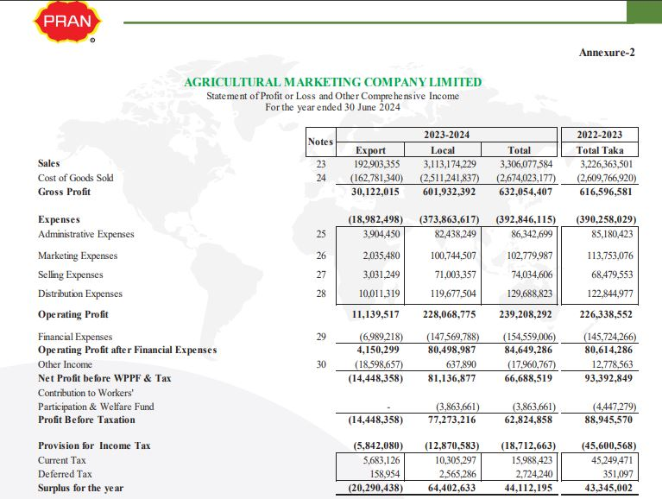

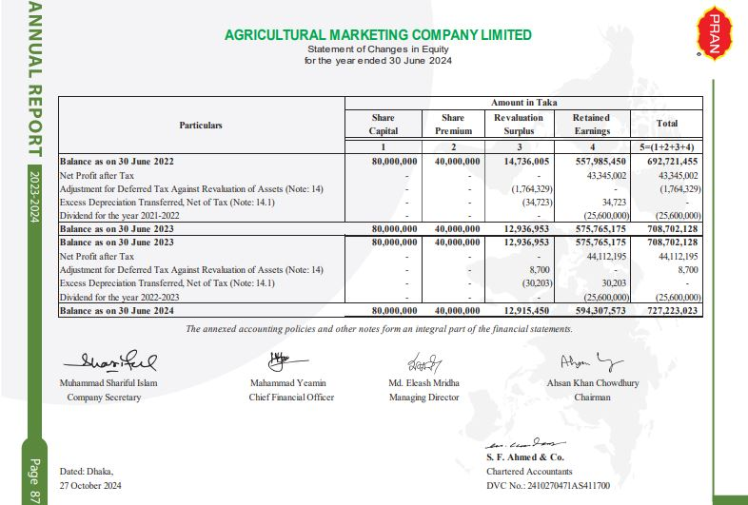

2.8. Macro Environment (External Analysis)

To appreciate an organization’s ability to perform in the market, we need to know what external challenges are posing problems to the organization and how the company is dealing with these challenges. To understand the external environment of the organization, we will carry out a PESTEL analysis. The PESTEL analysis concerns the examination of Political, Economic, Social, Technological & Legal factors surrounding an organization.

PESTEL Analysis of PRAN:
- Political Factor: PRAN has been doing Cross-border business, and they are maintaining pretty good consistency in their business. They are operating in 42 countries now. It would not be possible for them to conduct this level of business if they were facing any political obstacles. So right now, they are not facing any political issue.
- Economic Factor: Agriculture shares a major portion of Bangladesh’s economy. For more than decades, PRAN has been investing in improving the quality of agriculture-based products of Bangladesh.PRAN Dairy and other agricultural food products of PRAN are getting a high level of global response. This phenomenon is increasing PRAN’s economic stability as well as the country’s economic gain. The financial situation of the organization is currently staying in stable.

- Social Factor: PRAN has a very good reputation in society. They are conducting a lot of CSR activities. They have a promise to their customer to deliver the best product. They established good communication with their customers.

- Technological Factor: Use of modern technologies has become a crucial part of modern businesses. Especially the operation and marketing departments are heavily dependent on the use of technology. The marketing department of PRAN is working on developing and maintaining constant communication with its customers.

- Environmental Factor: This factor has been a major factor for the last two decades. The reason behind this is the increasing use of raw materials and chemicals in factories to keep up with the increasing demand of consumers, as the number of consumers is also increasing. To save the environment from pollution, the government has set a Carbon Footprint Target that companies must follow. PRAN has its textile company named CHORKA. They are building a green factory for CHORKA and also following other rules.

- Legal Factor: Legal factors include health and safety, equal opportunities, advertising standards, consumer rights, and laws, and following other laws provided by the government. PRAN is maintaining a clear image in this sector, and they are not facing any complaints for violating laws.

2.9. Micro Environment Analysis
- Suppliers
PRAN has a large variety of sources for generating its raw materials for food items. Specifically, talking about the Food Sector, PRAN has huge suppliers from rural areas. They have 100000 contractual farmers. So, any disruption in supply from any area can not have much effect on the overall supply chain, which is a positive factor for the company.
- Intermediaries
Distributors: PRAN has a strong network of distributors at both the domestic and international levels. This network helps PRAN to keep its product delivery on track.
Retailers: The company has the largest retail network throughout the whole country. From local grocery shops to supermarket chains, it has given the company a broader reach compared to its other competitors. However, managing strong relationships with retailers and distributors is critical to staying strong in the market.
Online Platform: E-commerce has been the largest advertising medium in Bangladesh for the past several years. PRAN has its strong tie with the large e-commerce platforms of the country.
- Customer
Customer Segments: PRAN serves a broad demographic sector, which includes both urban and rural populations. The affordable price of its product helps it to satisfy the needs of various economic groups.
Changing Preferences: The taste and preferences of customers are changing rapidly with the change of their economic situation. People are now becoming more conscious of quality products and the variation in the products. So, PRAN should work on it to make its product stay on the customer’s bucket list.
Loyal Customers: PRAN has developed a loyal customer group of large members who have trust in the product of PRAN. However, it requires to take a lot of pressure to maintain the trust.
- Competitors
Local Competitors: In the food segment, PRAN competes with companies like Square Food & Beverage, ACI, Akij, and other local brands. These companies are giving tough competition to PRAN in the market. PRAN should give more focus on product variation and affordability to stay competitive in the market.
International Competitors: The company is also in competition with international brands, especially in the food and beverage sector, where multinational giants like Nestlé, Unilever, and Coca-Cola operate. International competitors can often have advantages in technology, R&D, and economies of scale.
Competitive Strategy: PRAN targets the mass market by keeping its products affordable and accessible, making it a go-to brand for daily essentials. This pricing strategy allows PRAN to attract a broad customer base and secure a strong presence, especially in developing regions where value for money is crucial.
- Public Relations
Media: PRAN has a positive reputation with the media. It is often praised for its contribution to the economy, reducing unemployment, increasing exports, etc.
Government Relations: PRAN operates in highly regulated industries (food safety, plastics). Changes in government policies on plastic waste, food safety regulations, or import-export tariffs could have a direct impact on its business.
CSR Activities: Pran is involved in many Corporate Social Responsibility (CSR) activities, like rural development and environmental activities.

Chapter Three

Literature Review

3.1 Study Background
Trade promotion has emerged as a vital component of marketing strategies, especially within the fast-moving consumer goods (FMCG) sector. The marketing department of PRAN Foods Ltd. is the soul department of the company and is responsible for generating business for the company. In the vast market of FMGC goods, the highest possible performance of the marketing department is crucial to stay competitive and ensure a sustainable market hold. PRAN Foods. Ltd. has one of the biggest marketing groups among all other FMCG companies in Bangladesh. However, in the past few years, the company has noticed a period of sales decline compared to previous sales. This decline in sales is causing the company to face financial losses. The higher officials are predicting that the performance of the marketing department is not reaching its level best for a while.
One of the main reasons for this situation is that PRAN Foods Ltd. has a gap in its trade promotion efforts, as it places less focus on engaging wholesalers and retailers.
This research, therefore, aims to explore how trade promotions influence the sales performance of Pran Foods Ltd. It will look at what promotional tools are most effective, the challenges faced, and how these promotional strategies can be improved for better results.
.

3.2. Problem Statement
PRAN Foods Ltd., one of the leading FMCG companies in Bangladesh, continues to invest heavily in trade promotion to boost product visibility and sales. However, as of early 2025, inconsistencies in sales growth, particularly in competitive categories like snacks, beverages, and dairy, suggest that trade promotion strategies may not be gaining optimal results. This raises concerns about the effectiveness, execution, and alignment of trade promotions with retail and consumer dynamics. Therefore, it is essential to analyze how trade promotion contributes to sales performance and identify areas for strategic improvement.
Evidence of the Problem:
Internal sales data from PRAN Foods Ltd. revealed that in Q1 of 2025, several product lines, especially within the beverage and snacks categories, are experiencing declining sales despite active trade promotional campaigns. Retailer feedback collected during quarterly distribution reviews highlighted issues such as insufficient promotional materials, delayed incentive disbursement, and a lack of coordination between sales teams and retailers. These challenges suggest a gap between trade promotion efforts and actual market impact.

3.3 Study Variables
Buying Allowance
Buying allowance is a discount for the purchase of a promoted product during a specific period of time based on the purchase of certain minimum quantity of products/brands by resellers (D&B, 2010). Quantity discounts have a high capacity to influence the coordination mechanism to increase market share through price reduction that would motivate major distributor to exceed target with volume purchase (Jeuland and Shugan 1983, and Moorthy, 1987).This trade incentive is often used to gain more distribution or to maintain the existing, and create new distributors and wholesalers. The quantity of crates of beer brand of Guinness purchase by distributors and wholesaler could be a function of the incentive of buying allowance. Buying allowance could be a dominant practice of trade promotion owing to the quantity purchase effect. The consumption of beer products may have increased in Cross River State, particularly in Calabar Metropolis. The evidence may not be to clear, but the number of beer joint has increased exponentially over the years. Buying allowance could be one of the trade promotional tools required to build and cement distributors, wholesalers and retailer relationships for quantum purchase. For example Guinness may offer to give its middlemen who purchase up to 200 crates of its brands discounts of N100.00 per crate. Some retailers may buy more than what is required during such promotion to be sold latter at regular prices (Kalaiselvan, 2011).
Sales Contest
Futrell (1981) defined sales contest as a special sales program offering sales people incentives to achieve short-term goals. The incentives may include items that indicate recognition of achievement (e.g. certificates, cash merchandise, or travel) and are given in addition to regular compensation. Contests normally require the participant to perform some type of activity, like being the best company customer with the highest stock buyer within a said period. Trade contest rewards are given to brokers, retail sales people, wholesalers, agents or other channel members for achieving a specific goal. The goal could be achieving the highest sales within a specific time period, or it could be for all channel members to reach a minimum target level (Kotler and Keller, 2009). For example, Guinness manufacturer can run a contest among its distributors and offer a grand prize to distributor with the highest sales, with second and third place prizes for runners up. Money or prizes awarded in trade contests are known as spiff money, the rewards may be cash or items or a trip to an exotic place. Contest can be held at any level of distribution channel. Positive impact of sales contest include increasing motivation and morals of sales people, leading to great effort and resultant performance improvements on targeted goals, revenue generation and contributions to sales profit (Urbanski, 1986; Wild et al, 1980; Wotruba and Schoel, 1983).According to Murphy and Dacin (1998), ‘trade contest (sales contest) is an important tool to motivate sales people to achieve goals that surpass those associated with normal compensation. Bettramini and Kenneth (1998) argued that contest enhances overall job satisfaction, it also increase corporate profit and could be very successful (Eisenberger and Cameron, 1999). There may include cash merchandise and travels. Cash represents 70% of award type being given to sales people. This is due to the belief that cash better motivate people (Colletti et al 1988; Urbanski 1986 and Ford et al, 1985). Tour canbe advantageous to African especially Nigerians, that have flare to tour other countries but may not be able due to poor economic circumstance (Hastings, Kiely and Watkins 1988). Kalaiselvan (2013) reports that Cepacol mouthwash offered supermarket managers cash prizes matched to the percentages by which they exceeded the sales quota, plus a vacation to Bermuda for the manager who achieved the highest percentage. This target and accomplishment on the part of the organization will ever remain a source of motivation on the part of the supermarket managers.

Free Goods
A manufacturer offers extra cases of free goods to the retailer with a purchase at the regular price (Blattberg and Briesch 2012).Free goods are considered one of the most powerful tools in trade promotions, especially within the fast-moving consumer goods (FMCG) industry. This strategy involves giving extra items at no added cost, encouraging retailers to place larger orders and aligning with push strategies. According to( Blattberg and Neslin -1990), free goods appeal to retailers because they appear more profitable, while consumers appreciate the added value. (Chandon et al. 2000) also pointed out that consumers often react more strongly to free goods than to price cuts, as they feel they’re getting a better deal. This perception can drive trial purchases and repeated buying, eventually boosting sales. In emerging markets, where people tend to be more cautious about spending, free goods are particularly effective. (Ahmed and Ahmed 2015), in their research on Bangladesh’s FMCG market, found that brands offering free goods saw better engagement from retailers and faster shelf turnover. Ultimately, free goods help brands connect with both sellers and buyers, solidifying their role as a key element in trade promotion strategies.

Display Allowance
A manufacturer pays a retailer for a short period of time when the manufacturer wants to sell their inventory to customers(Achrol 2012; Blattberg and Briesch 2012).
Display allowances are payments or incentives that manufacturers offer to retailers in return for better shelf positioning, dedicated displays, or promotional signage that enhances a product’s visibility. Studies have consistently shown that these allowances can positively affect sales. Chevalier (1975) was one of the earliest researchers to show that in-store displays directly shape consumer purchase decisions, particularly in areas with high shopper traffic. Building on this, Drèze, Hoch, and Purk (1994) discovered that prime spots like end-of-aisle displays significantly improve how visible products are, which in turn drives more impulse buying. Inman, Winer, and Ferraro (2009) further confirmed that visibility and ease of access play a major role in how shoppers make decisions in stores—both of which are boosted by display allowances. For FMCG brands, especially in cluttered retail markets, these tactics are essential. In the case of Bangladesh, where Pran Foods Ltd. competes, display allowances are used to win over limited shelf space in a highly competitive environment. Hassan et al. (2014) noted that retailers are more likely to back brands that offer display incentives, which leads to better product placement and stronger brand recognition. As a result, display allowances serve as an effective way to sway consumer choices while also building stronger ties with retail partners.

Trade Allowance
Trade allowance encompasses price reductions given to distributors, such as wholesalers and retailers by manufacturers to encourage them to stock and sell more quantities of their products (Michael & Ogwo, 2013). Trade discounts and allowances are price reductions given to middlemen (such as wholesalers, industrial distributors, retailers) to encourage them to stock and give preferential treatment to an organization’s products. Through such offers, distributors are able to realize more value for their investments, which encourages them to purchase in large quantities from retailers (McNeill, 2013). Trade allowances also enable wholesalers and retailers to offer some incentives to consumers in form of consumer promotions such as price-offs, discounts, premium and bonus packs in order to entice consumers to make large-scale or frequent purchases. The foregoing premise suggests that trade allowance significantly contribute to improvements in the marketing performance of distributors. This premise is corroborated by the study of Ezekiel et al. (2020), which revealed that trade allowance (special allowance and buying allowance) had a significant positive impact on the sales volume of Guinness products in Calabar. The premise is also substantiated by the study of Michael & Ogwo (2013), which revealed that trade allowances had a significant positive effect on marketing performance in the soft drink industry in Abia State, Nigeria (Yulianti & Kintani, 2020; Sipayung et al., 2021).

Enhancing Sales
The ultimate aim of trade promotion strategies is to drive sales, which can be tracked through higher sales volume, increased revenue, or a growing market share. Researchers have studied how these promotions affect sales outcomes. Kotler and Keller (2016) pointed out that well-executed promotions don’t just lead to quick sales spikes—they also enhance a product’s visibility and help build lasting brand preference. Kumar and Leone (1988) developed a model showing that trade promotions can boost both individual brand sales and overall category sales by encouraging short-term demand while also fostering long-term customer loyalty. In many developing countries, where traditional advertising might not reach as effectively, trade promotions often play a central role in generating sales. For instance, Ahmed and Ahmed (2015) found that in Bangladesh’s FMCG industry, trade promotions had a stronger effect on sales than media ads. Peppers and Rogers (2011) added that although short-term gains are important, real growth comes from using promotions to consistently create trust and value. For brands like Pran Foods Ltd., combining strategies like free goods and display incentives with clear sales goals helps improve retailer support, attract consumers, and achieve steady revenue growth over time.

3.4 Conceptual Framework

Figure: 1
Independent Variables | Dependent Variable

Buying Allowance
Sales Contest
Free Goods
Display Allowance
Trade Allowance
Enhancement of Sales Volume

Explanation of the Conceptual Framework
The above conceptual framework illustrates the relationship between selected sales promotion strategies and the enhancement of sales volume within PRAN Foods Ltd. In this model, five independent variables—Buying Allowance, Sales Contest, Free Goods, Display Allowance, and Trade Allowance—have been identified as key promotional tools used by the company to influence market performance.
These promotional techniques are aimed at motivating both intermediaries and end customers to increase purchase quantities, improve product visibility, and enhance brand engagement. For example, buying allowances and trade allowances serve as financial incentives to encourage bulk purchases and product stocking. Sales contests are designed to boost the motivation of the sales force, while the distribution of free goods and display allowances supports retailers in promoting products more effectively.
All these independent variables are hypothesized to contribute positively to the dependent variable, which is the enhancement of sales volume. The directional arrows in the framework indicate the assumed cause-and-effect relationship, where the implementation of these promotional activities is expected to lead to a measurable increase in sales performance.
This framework serves as the foundation for analyzing the effectiveness of trade promotion strategies undertaken by PRAN Foods Ltd. and provides a structured approach to examine their impact on overall sales growth.

Chapter Four

Methodology, Analysis

and Discussion

4.1 Research Methodology
To conduct the research successfully, we adopted a quantitative method. By using this method, researchers will investigate the relationship between the dependent and independent variables. The main goal here is to identify the main factors and link them with their outcomes. The researcher has used a deductive methodology where an existing theory has been evaluated with the aim of linking the premise with the conclusion.

- Research Approach
To solve the research problem, the researcher has used a Quantitative Research Approach. Firstly, the problems were determined, and then the researcher concluded by using the statistical tool. The study has been conducted based on respondents' opinions and a questionnaire survey. The opinions of respondents were collected through a questionnaire by using the Likert Scale method.
Likert Scale Table:
Opinions | weight
Strongly Disagree | 1
Agree | 2
Neutral | 3
Agree | 4
Strongly Agree | 5

- Methodological Choice
The research is conducted with a quantitative method, as the research shows and deals with numerical data.

- Research Instrument
  - Survey Questionnaire
  - Google Spreadsheet
  - SPSS Software
- Time Horizon
The research is a cross-sectional study since it was conducted only once with a limited time frame.

- Sampling Frame
  - For this research, the sampling frame was collected from different traders who lived in Dhaka.
- Sampling Unit
  - For this research, the sampling unit was chosen as individuals involved as a retailer, distributor, or wholesaler.

- Population Size
  - The population size is 200 traders who work inside Dhaka city.

- Sample Size
The sample size should be 10% of the Population (Bullen, 2022) . So, for 200 people, the sample size here consists of 20 people.

- Sampling Method
The sampling procedure which has been used in this research is Convenience Sampling. Convenience sampling is a non-probability sampling technique where participants are selected based on their availability, ease of access, or proximity to the researcher. This method does not rely on random selection, making it quick and cost-effective, but it can introduce bias, as the sample may not represent the broader population.
- Source of Data
Primary Source: In this research, the Primary data was collected through an online survey. A structured survey questionnaire was prepared to conduct an online survey.
Secondary: The secondary source was the website of the company and other online articles.

4.2. Budget
Cost Items | Amount
Transportation | 2500 Tk
Internet Bill | 500 Tk
Foods and Others | 500 Tk
Printing & Binding | 300
Total | 3800 Tk

4.3. Hypothesis Development

Hypothesis 01 | H₀ | Buying Allowance has a positive relationship with enhance the sales of Pran Foods Ltd product.
Hypothesis 01 | H_{A} | Buying Allowance has no positive relationship with enhancing the sales of Pran Foods Ltd product.
Hypothesis 02 | H₀ | Sales Contest has a positive relationship with enhancing the sales of Pran Foods Ltd Product
Hypothesis 02 | H_{A} | Sales Contest has no positive relationship with enhancing the sales of Pran Foods Ltd Product
Hypothesis 03 | H₀ | Free Goods has a positive relationship with enhancing the sales of Pran Foods Ltd products
Hypothesis 03 | H_{A} | Free Goods has no positive relationship with enhancing the sales of Pran Foods Ltd Product
Hypothesis 04 | H₀ | Display Allowance has a positive relationship with enhancing the sales of Pran Foods Ltd Product.
Hypothesis 04 | H_{A} | Display Allowance has no positive relationship with enhancing the sales of Pran Foods Ltd Product.
Hypothesis 05 | H₀ | Trade allowance has a positive relationship with enhancing the sales of Pran Foods Ltd product.
Hypothesis 05 | H_{A} | Trade allowance has no positive relationship with enhancing the sales of Pran Foods Ltd product

4.4. Data Presentation & Analysis

4.10.1 Frequency & Graphical Representation

- Buying Allowance has a positive relationship with enhancing the sales of Pran Foods Ltd product.

Buying Allowance has a positive relationship with enhance the sales of Pran Foods Ltd product.
 |  | Frequency | Percent | Valid Percent | Cumulative Percent
Valid | Strongly Disagree | 1 | 5.0 | 5.0 | 5.0
Valid | Neutral | 2 | 10.0 | 10.0 | 15.0
Valid | Agree | 9 | 45.0 | 45.0 | 60.0
Valid | Strongly Agree | 8 | 40.0 | 40.0 | 100.0
Valid | Total | 20 | 100.0 | 100.0

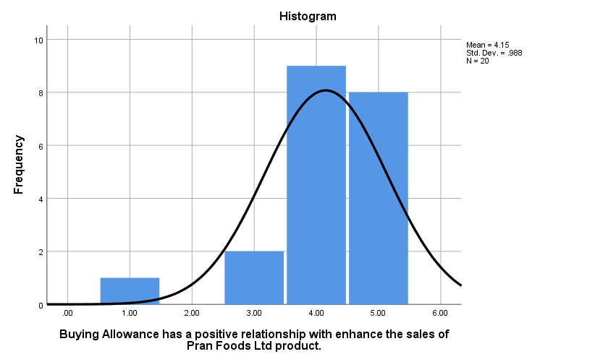

Figure 4.1 Histogram shows the frequencies of the responses to the H1 statement, with 1 on the X axis corresponding to the response "Strongly Disagree," 2 for "Disagree," 3 for "Neutral," 4 for "Agree," and 5 for "Strongly Agree."

Interpretation:
The following graph shows the responses of those who have been surveyed for the H1 statement that Buying Allowance has a positive relationship with enhancing the sales of Pran Foods Ltd product. Here, 5.00% have strongly Disagreed to the statement, 10% were Neutral, 45% Agreed & 40% Strongly Agreed to the statement.

- Sales Contest has a positive relationship with enhancing the sales of Pran Foods Ltd Product.

Sales Contest has a positive relationship with enhancing the sales of Pran Foods Ltd Product.
 |  | Frequency | Percent | Valid Percent | Cumulative Percent
Valid | Agree | 10 | 50.0 | 50.0 | 50.0
Valid | Strongly Agree | 10 | 50.0 | 50.0 | 100.0
Valid | Total | 20 | 100.0 | 100.0

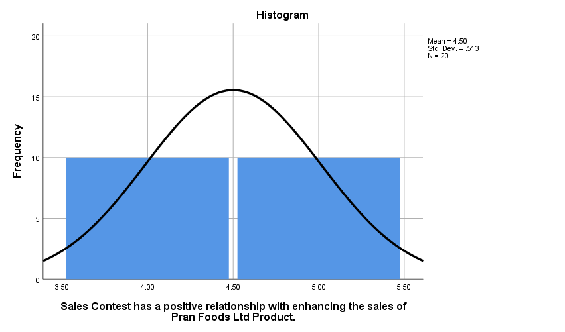

Figure 4.2 Histogram shows the frequencies of the responses to the H1 statement, with 1 on the X axis corresponding to the response "Strongly Disagree," 2 for "Disagree," 3 for "Neutral," 4 for "Agree," and 5 for "Strongly Agree.
"

Interpretation:
The following graph shows the responses of those who have been surveyed for the Hypothesis 02 statement that Sales Contest has a positive relationship with enhancing the sales of Pran Foods Ltd Product. Here, 50% have strongly Agreed to the statement, and 50% have Agreed to the statement.

- Free Goods has a positive relationship with enhancing the sales of Pran Foods Ltd Product.

Free Goods has a positive relationship with enhancing the sales of Pran Foods Ltd Product.
 |  | Frequency | Percent | Valid Percent | Cumulative Percent
Valid | Agree | 11 | 55.0 | 55.0 | 55.0
Valid | Strongly Agree | 9 | 45.0 | 45.0 | 100.0
Valid | Total | 20 | 100.0 | 100.0

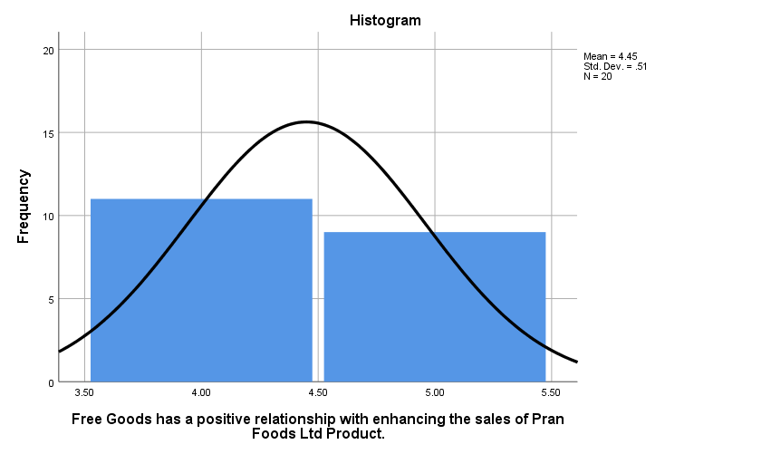
Figure 4.3 Histogram shows the frequencies of the responses to the H1 statement, with 1 on the X axis corresponding to the response "Strongly Disagree," 2 for "Disagree," 3 for "Neutral," 4 for "Agree," and 5 for "Strongly Agree."
Interpretation:
The following graph shows the responses of those who have been surveyed for the Hypothesis 03 statement that Free Goods has a positive relationship with enhancing the sales of Pran Foods Ltd Product. Here, 55% Agreed & 45% Strongly Agreed to the statement.

- Display Allowance has a positive relationship with enhancing the sales of Pran Foods Ltd Product.

Display Allowance has a positive relationship with enhancing the sales of Pran Foods Ltd Product.
 |  | Frequency | Percent | Valid Percent | Cumulative Percent
Valid | Neutral | 2 | 10.0 | 10.0 | 10.0
Valid | Agree | 11 | 55.0 | 55.0 | 65.0
Valid | Strongly Agree | 7 | 35.0 | 35.0 | 100.0
Valid | Total | 20 | 100.0 | 100.0

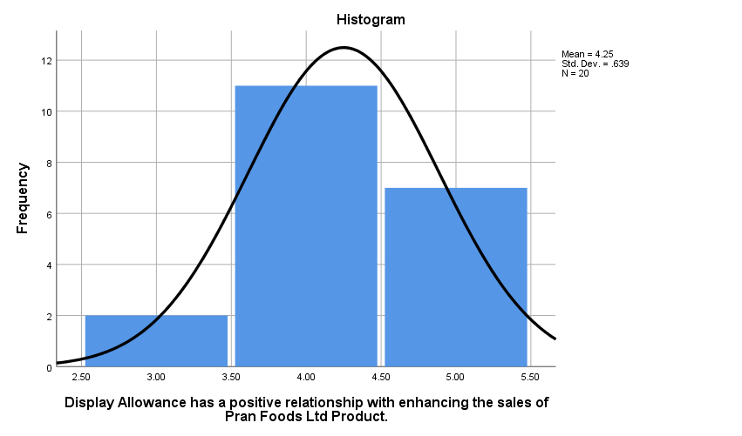

Figure 4.4 Histogram shows the frequencies of the responses to the H1 statement, with 1 on the X axis corresponding to the response "Strongly Disagree," 2 for "Disagree," 3 for "Neutral," 4 for "Agree," and 5 for "Strongly Agree.".
Interpretation:
The following graph shows the responses of those who have been surveyed for the Hypothesis 04 statement that Display Allowance has a positive relationship with enhancing the sales of Pran Foods Ltd Product. Here, 10.0% were Neutral, 55.0% Agreed & 35.0% Strongly Agreed to the statement.

5. Trade allowance has a positive relationship with enhancing the sales of Pran Foods Ltd product.

Trade allowance has a positive relationship with enhancing the sales of Pran Foods Ltd product.
 |  | Frequency | Percent | Valid Percent | Cumulative Percent
Valid | Disagree | 1 | 5.0 | 5.0 | 5.0
Valid | Neutral | 1 | 5.0 | 5.0 | 10.0
Valid | Agree | 6 | 30.0 | 30.0 | 40.0
Valid | Strongly Agree | 12 | 60.0 | 60.0 | 100.0
Valid | Total | 20 | 100.0 | 100.0

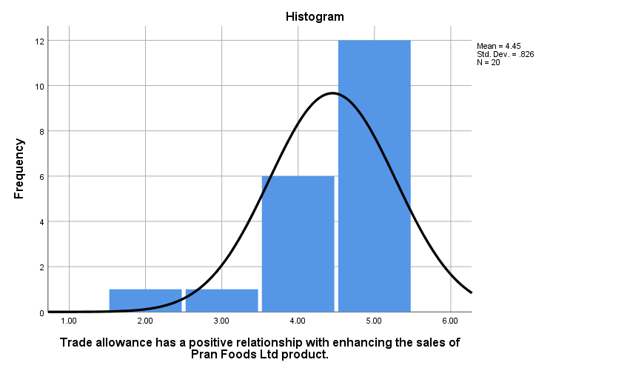

Figure 4.4 Histogram shows the frequencies of the responses to the H1 statement, with 1 on the X axis corresponding to the response "Strongly Disagree," 2 for "Disagree," 3 for "Neutral," 4 for "Agree," and 5 for "Strongly Agree.".

Interpretation:
The following graph shows the responses of those who have been surveyed for the Hypothesis 05 statement that Trade allowance has a positive relationship with enhancing the sales of Pran Foods Ltd product. Here, 60% have strongly Agreed to the statement, 5.00% have Disagreed to the statement, 5.00% were Neutral, and 30% Agreed.

Scatter Plot

1.
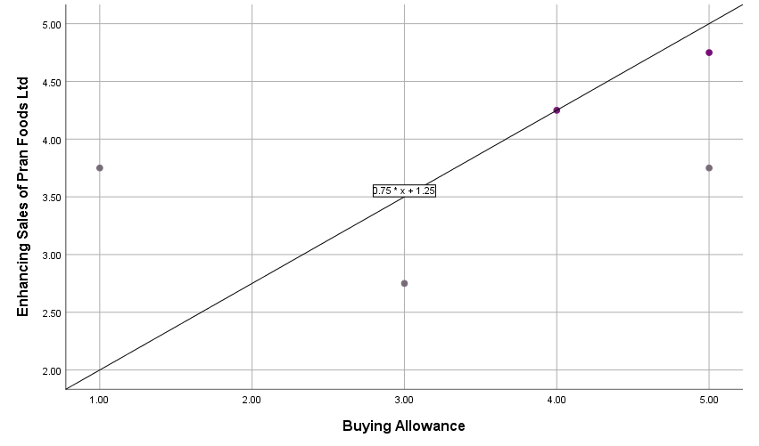

Interpretation: Here in the above figure, it’s a Scatter Plot where the Y axis (Vertical) represents the Dependent Variable “Enhancing Sales of Pran Food Ltd” and the X axis (Horizontal) represents the independent variable “Buying Allowance”. The Scatter Plot shows that the values of X & Y are increasing in a simultaneous manner, which indicates a positive relationship between the Buying allowance and Enhancing sales of Pran Foods Ltd.

2.
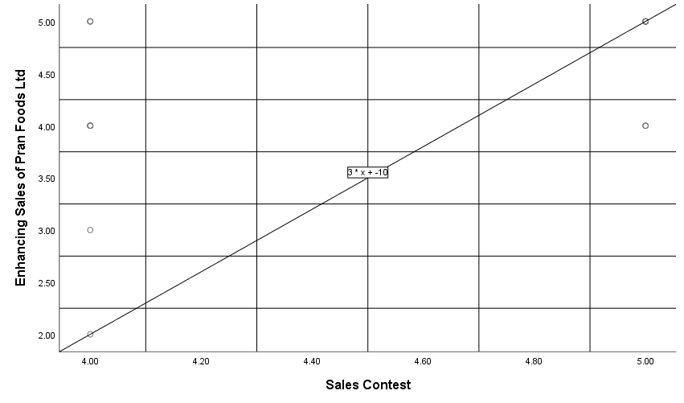

Interpretation: Here in the above figure, it’s a Scatter Plot where the Y axis (Vertical) represents the Dependent Variable “Enhancing Sales of Pran Food Ltd” and the X axis (Horizontal) represents the independent variable “Sales Contest”. The Scatter Plot shows that the values of X & Y are increasing in a simultaneous manner, which indicates a positive relationship between Sales Contest and Enhancing Sales of Pran Food Ltd.

3.
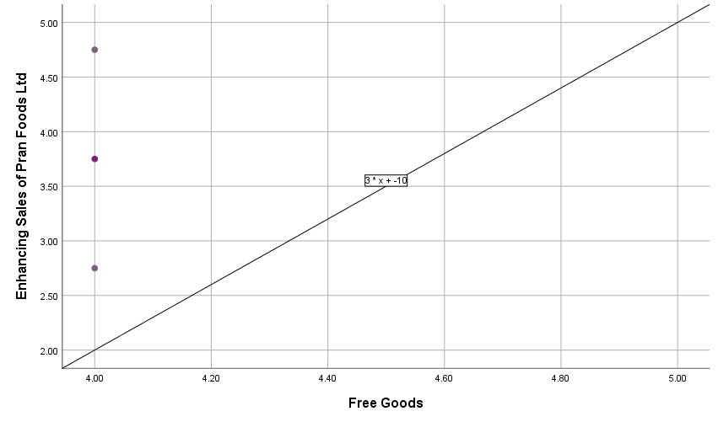
Interpretation: Here in the above figure, it’s a Scatter Plot where the Y axis (Vertical) represents the Dependent Variable “Enhancing Sales of Pran Food Ltd” and the X axis (Horizontal) represents the independent variable “Free Goods”. The Scatter Plot shows that the values of X & Y are increasing in a simultaneous manner, which indicates a positive relationship between Free Goods and Enhancing Sales of Pran Food Ltd.

4.
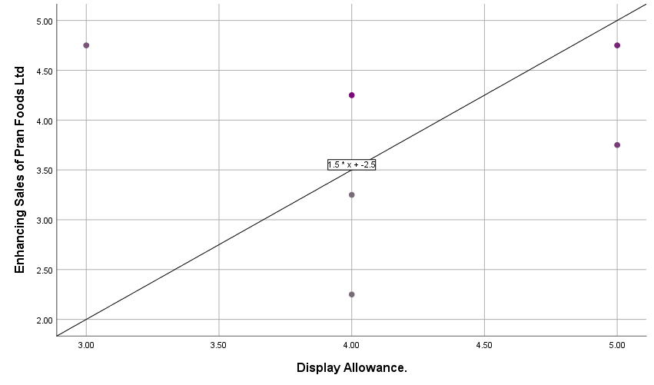

Interpretation: Here in the above figure, it’s a Scatter Plot where the Y axis (Vertical) represents the Dependent Variable “Enhancing Sales of Pran Food Ltd” and the X axis (Horizontal) represents the independent variable “Display Allowance”. The Scatter Plot shows that the values of X & Y are increasing in a simultaneous manner, which indicates a positive relationship between Display Allowance and Enhancing Sales of Pran Food Ltd.

5.
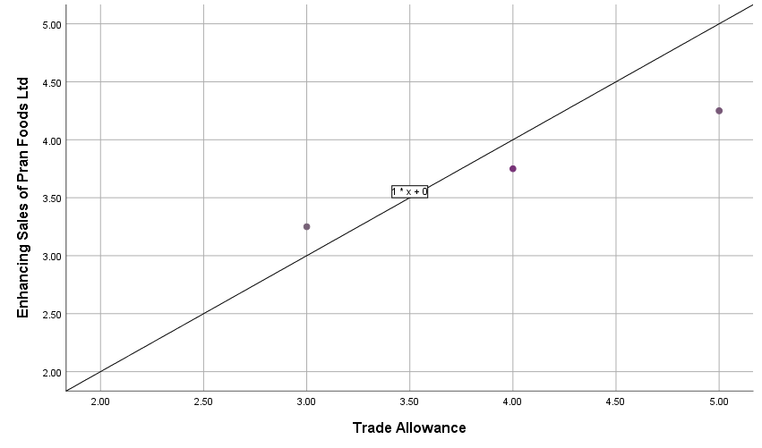
Interpretation: Here in the above figure, it’s a Scatter Plot where the Y axis (Vertical) represents the Dependent Variable “Enhancing Sales of Pran Food Ltd” and the X axis (Horizontal) represents the independent variable “Trade Allowance”. The Scatter Plot shows that the values of X & Y are increasing in a simultaneous manner, which indicates a positive relationship between Trade Allowance and Enhancing Sales of Pran Food Ltd.

4.5. Descriptive Statistics

Descriptive Statistics
 | N | Minimum | Maximum | Mean | Std. Deviation
Buying Allowance | 20 | 1.00 | 5.00 | 4.1500 | .98809
Sales Contest | 20 | 4.00 | 5.00 | 4.5000 | .51299
Free Goods | 20 | 4.00 | 5.00 | 4.4500 | .51042
Display Allowance. | 20 | 3.00 | 5.00 | 4.2500 | .63867
Trade Allowance | 20 | 2.00 | 5.00 | 4.4500 | .82558
Enhancing Sales of Pran Foods Ltd | 20 | 2.00 | 5.00 | 4.3500 | .81273
Valid N (listwise) | 20

Interpretation
From the above table, the Sample Size is 20 (denoted by N)
- For H01, the independent variable of Buying Allowance, the mean value is 4.1500 with a standard deviation of 0.98809.
- For H02, the independent variable of Sales Contest, the mean value is 4.5000 with a standard deviation of .51299.
- For H03, the independent variable of Free Goods, the mean value is 4.4500 with a standard deviation of .51042.
- For H04, the independent variable of Display Allowance, the mean value is 4.2500 with a standard deviation of .63867.
- For H05, the independent variable of Trade Allowance, the mean value is 4.4500 with a standard deviation of .82558.
- For the dependent variable of Enhancing Sales of Pran Foods Ltd, the mean value is 4.3500 with a standard deviation of .81273.

4.6 Hypothesis Test

Hypothesis 01 | H₀ | Buying Allowance has no positive relationship with enhance the sales of Pran Foods Ltd product.
Hypothesis 01 | H_{A} | Buying Allowance has a positive relationship with enhancing the sales of Pran Foods Ltd product.
One-Sample Statistics
 | N | Mean | Std. Deviation | Std. Error Mean
Buying Allowance has a positive relationship with enhance the sales of Pran Foods Ltd product. | 20 | 4.1500 | .98809 | .22094

One-Sample Test
 | Test Value = 0
 | t | df | Sig. (2-tailed) | Mean Difference | 95% Confidence Interval of the Difference
 |  |  |  |  | Lower | Upper
Buying Allowance has a positive relationship with enhance the sales of Pran Foods Ltd product. | 18.783 | 19 | .000 | 4.15000 | 3.6876 | 4.6124

Interpretation
From the above tables, it can be seen that the respondents of this survey agreed with the null hypothesis “Buying Allowance has a positive relationship with enhancing the sales of Pran Foods Ltd product.”. Here t (19) = 18.783 and p = .000. As here p<0.5, the test is significant and the null hypothesis will be rejected.
Hypothesis 02 | H₀ | Sales Contest has no positive relationship with enhancing the sales of Pran Foods Ltd Product
Hypothesis 02 | H_{A} | Sales Contest has a positive relationship with enhancing the sales of Pran Foods Ltd Product
One-Sample Statistics
 | N | Mean | Std. Deviation | Std. Error Mean
Sales Contest has a positive relationship with enhancing the sales of Pran Foods Ltd Product. | 20 | 4.5000 | .51299 | .11471

One-Sample Test
 | Test Value = 0
 | t | df | Sig. (2-tailed) | Mean Difference | 95% Confidence Interval of the Difference
 |  |  |  |  | Lower | Upper
Sales Contest has a positive relationship with enhancing the sales of Pran Foods Ltd Product. | 39.230 | 19 | .000 | 4.50000 | 4.2599 | 4.7401

Interpretation
From the above tables, it can be seen that the respondents of this survey agreed with the null hypothesis “Sales Contest has a positive relationship with enhancing the sales of Pran Foods Ltd Product”. Here t (19) = 39.230 and p = .000. As here p<0.5, the test is significant and the null hypothesis will be rejected.

Hypothesis 03 | H₀ | Free Goods has no positive relationship with enhancing the sales of Pran Foods Ltd Product.
Hypothesis 03 | H_{A} | Free Goods has a positive relationship with enhancing the sales of Pran Foods Ltd Product.

One-Sample Statistics
 | N | Mean | Std. Deviation | Std. Error Mean
Free Goods has a positive relationship with enhancing the sales of Pran Foods Ltd Product. | 20 | 4.4500 | .51042 | .11413

One-Sample Test
 | Test Value = 0
 | t | df | Sig. (2-tailed) | Mean Difference | 95% Confidence Interval of the Difference
 |  |  |  |  | Lower | Upper
Free Goods has a positive relationship with enhancing the sales of Pran Foods Ltd Product. | 38.990 | 19 | .000 | 4.45000 | 4.2111 | 4.6889

Interpretation
From the above tables, it can be seen that the respondents of this survey agreed with the null hypothesis “Free Goods has a positive relationship with enhancing the sales of Pran Foods Ltd Product” . Here t (19) = 38.990 and p = .000. As here p<0.5, the test is significant and the null hypothesis will be rejected.

Hypothesis 04 | H₀ | Display Allowance has no positive relationship with enhancing the sales of Pran Foods Ltd Product.
Hypothesis 04 | H_{A} | Display Allowance has a positive relationship with enhancing the sales of Pran Foods Ltd Product.

One-Sample Statistics
 | N | Mean | Std. Deviation | Std. Error Mean
Display Allowance has a positive relationship with enhancing the sales of Pran Foods Ltd Product. | 20 | 4.2500 | .63867 | .14281

One-Sample Test
 | Test Value = 0
 | t | df | Sig. (2-tailed) | Mean Difference | 95% Confidence Interval of the Difference
 |  |  |  |  | Lower | Upper
Display Allowance has a positive relationship with enhancing the sales of Pran Foods Ltd Product. | 29.760 | 19 | .000 | 4.25000 | 3.9511 | 4.5489

Interpretation
From the above tables, it can be seen that the respondents of this survey agreed with the null hypothesis “Display Allowance has a positive relationship with enhancing the sales of Pran Foods Ltd Product.”. Here t (19) = 29.760 and p = .000. As here p<0.5, the test is significant and the null hypothesis will be rejected.

Hypothesis 05 | H₀ | Trade allowance has no positive relationship with enhancing the sales of Pran Foods Ltd product.
Hypothesis 05 | H_{A} | Trade allowance has a positive relationship with enhancing the sales of Pran Foods Ltd product

One-Sample Statistics
 | N | Mean | Std. Deviation | Std. Error Mean
Trade allowance has a positive relationship with enhancing the sales of Pran Foods Ltd product. | 20 | 4.4500 | .82558 | .18460

One-Sample Test
 | Test Value = 0
 | t | df | Sig. (2-tailed) | Mean Difference | 95% Confidence Interval of the Difference
 |  |  |  |  | Lower | Upper
Trade allowance has a positive relationship with enhancing the sales of Pran Foods Ltd product. | 24.106 | 19 | .000 | 4.45000 | 4.0636 | 4.8364
Interpretation
From the above tables, it can be seen that the respondents of this survey agreed with the null hypothesis “Trade allowance has a positive relationship with enhancing the sales of Pran Foods Ltd product”. Here t (19) = 24.106 and p = .000. As here p<0.5, the test is significant and the null hypothesis will be rejected.

4.7. Bivariate Correlation
Correlations
 |  | Buying Allowance | Sales Contest | Free Goods | Display Allowance. | Trade Allowance | Enhancing Sales of Pran Foods Ltd
Buying Allowance | Pearson Correlation | 1 | .363 | .590** | .188 | .558* | .587**
Buying Allowance | Sig. (2-tailed) |  | .115 | .006 | .428 | .011 | .007
Buying Allowance | N | 20 | 20 | 20 | 20 | 20 | 20
Sales Contest | Pearson Correlation | .363 | 1 | .302 | .562** | .559* | .442
Sales Contest | Sig. (2-tailed) | .115 |  | .196 | .010 | .010 | .051
Sales Contest | N | 20 | 20 | 20 | 20 | 20 | 20
Free Goods | Pearson Correlation | .590** | .302 | 1 | -.040 | .618** | .742**
Free Goods | Sig. (2-tailed) | .006 | .196 |  | .866 | .004 | .000
Free Goods | N | 20 | 20 | 20 | 20 | 20 | 20
Display Allowance. | Pearson Correlation | .188 | .562** | -.040 | 1 | .175 | .025
Display Allowance. | Sig. (2-tailed) | .428 | .010 | .866 |  | .461 | .916
Display Allowance. | N | 20 | 20 | 20 | 20 | 20 | 20
Trade Allowance | Pearson Correlation | .558* | .559* | .618** | .175 | 1 | .930**
Trade Allowance | Sig. (2-tailed) | .011 | .010 | .004 | .461 |  | .000
Trade Allowance | N | 20 | 20 | 20 | 20 | 20 | 20
Enhancing Sales of Pran Foods Ltd | Pearson Correlation | .587** | .442 | .742** | .025 | .930** | 1
Enhancing Sales of Pran Foods Ltd | Sig. (2-tailed) | .007 | .051 | .000 | .916 | .000
Enhancing Sales of Pran Foods Ltd | N | 20 | 20 | 20 | 20 | 20 | 20
**. Correlation is significant at the 0.01 level (2-tailed).
*. Correlation is significant at the 0.05 level (2-tailed).

Interpretation
H01 & H02: From the correlation analysis, the relationship between “Buying Allowance has a positive relationship with enhancing the sales of Pran Foods Ltd product” and “Sales Contest has a positive relationship with enhancing the sales of Pran Foods Ltd Product” can be declared as highly statistically significant. ( r = 0.363 , p = 0.115 & p > 0.05)
H01 & H03: From the correlation analysis, the relationship between “Buying Allowance has a positive relationship with enhancing the sales of Pran Foods Ltd product” and “Free Goods has a positive relationship with enhancing the sales of Pran Foods Ltd Product” can be declared as highly statistically significant. ( r = 0.590 , p = 0.006 & p > 0.05)
H01 & H04: From the correlation analysis, the relationship between “Buying Allowance has a positive relationship with enhancing the sales of Pran Foods Ltd product” and “Display Allowance has a positive relationship with enhancing the sales of Pran Foods Ltd Product” can be declared as highly statistically significant. ( r = 0.118 , p = 0.428 & p > 0.05)
H01 & H05: From the correlation analysis, the relationship between “Buying Allowance has a positive relationship with enhancing the sales of Pran Foods Ltd product” and “Trade allowance has a positive relationship with enhancing the sales of Pran Foods Ltd product” can be declared as highly statistically significant. ( r = 0.558 , p = 0.011 & p > 0.05)

H02 & H03: From the correlation analysis, the relationship between “Sales Contest has a positive relationship with enhancing the sales of Pran Foods Ltd Product” and “Free Goods has a positive relationship with enhancing the sales of Pran Foods Ltd Product” can be declared as highly statistically significant. ( r = 0.302 , p = 0.196 & p > 0.05)

H02 & H04: From the correlation analysis, the relationship between “Sales Contest has a positive relationship with enhancing the sales of Pran Foods Ltd Product” and “Display Allowance has a positive relationship with enhancing the sales of Pran Foods Ltd Product” can be declared as highly statistically significant. ( r = 0.562 , p = 0.010 & p > 0.05)

H02 & H05: From the correlation analysis, the relationship between “Sales Contest has a positive relationship with enhancing the sales of Pran Foods Ltd Product” and “Trade allowance has a positive relationship with enhancing the sales of Pran Foods Ltd product” can be declared as highly statistically significant. (r = 0.559, p = 0.010 & p > 0.05)

H03 & H04: From the correlation analysis, the relationship between “Free Goods has a positive relationship with enhancing the sales of Pran Foods Ltd Product” and “Display Allowance has a positive relationship with enhancing the sales of Pran Foods Ltd Product” can be declared as highly statistically significant. ( r = 0.-040 , p = 0.866 & p > 0.05)
H03 & H05: From the correlation analysis, the relationship between “Free Goods has a positive relationship with enhancing the sales of Pran Foods Ltd Product” and “Trade allowance has a positive relationship with enhancing the sales of Pran Foods Ltd Product” can be declared as highly statistically significant. ( r = 0.618 , p = 0.461 & p > 0.004)
H04 & H05: From the correlation analysis, the relationship between “Display Allowance has a positive relationship with enhancing the sales of Pran Foods Ltd Product” and “Trade allowance has a positive relationship with enhancing the sales of Pran Foods Ltd Product” can be declared as highly statistically significant. ( r = 0.175 , p = 0.461 & p > 0.05)

H01 & DV: From the correlation analysis, the relationship between “Buying Allowance has a positive relationship with enhancing the sales of Pran Foods Ltd product” and “Enhancing Sales of Pran Foods Ltd” can be declared as highly statistically significant. (r = 0.587, p = 0.007 & p > 0.05)
H02 & DV: From the correlation analysis, the relationship between “Sales Contest has a positive relationship with enhancing the sales of Pran Foods Ltd Product” and “Enhancing Sales of Pran Foods Ltd” can be declared as highly statistically significant. (r = 0.442, p = 0.051 & p > 0.05)
H03 & DV: From the correlation analysis, the relationship between “Free Goods has a positive relationship with enhancing the sales of Pran Foods Ltd Product” and Enhancing Sales of Pran Foods Ltd” can be declared as highly statistically significant. (r = 0.742, p = 0.00 & p > 0.05)

H04 & DV: From the correlation analysis, the relationship between “Display Allowance has a positive relationship with enhancing the sales of Pran Foods Ltd Product” and “Enhancing Sales of Pran Foods Ltd” can be declared as highly statistically significant. (r = 0.250, p = 0.333 & p > 0.05)
H05 & DV: From the correlation analysis, the relationship between “Trade allowance has a positive relationship with enhancing the sales of Pran Foods Ltd Product” and Enhancing Sales of Pran Foods Ltd” can be declared as highly statistically significant. (r = 0.930, p = 0.000 & p > 0.05)

4.10.5 Multiple Regression
Model Summary
Model | R | R Square | Adjusted R Square | Std. Error of the Estimate
1 | .960ª | .921 | .892 | .26653
a. Predictors: (Constant), Trade Allowance, Display Allowance, Buying Allowance, Free Goods, Sales Contest

Interpretation
From the Model Summary above, the value of R Square (R²) is 0.921, and the Adjusted R² is 0.892. The value of R² is less than the actual value of R, which is 0.960.

ANOVAª
Model |  | Sum of Squares | df | Mean Square | F | Sig.
1 | Regression | 11.555 | 5 | 2.311 | 32.533 | .000^{b}
1 | Residual | .995 | 14 | .071
1 | Total | 12.550 | 19
a. Dependent Variable: Enhancing Sales of Pran Foods Ltd
b. Predictors: (Constant), Trade Allowance, Display Allowance, Buying Allowance, Free Goods, Sales Contest

Interpretation
From the above result we have got, we can state that the overall model is significant to the research. The result of the F value is 32.533, which is larger than the Critical F-table value of 0.00. So, the result is statistically significant to the statement, and the overall model is good and relevant. In the following ANOVA table, the significant value at 0.000ª level of significance, which is p<0.005 it indicates that Trade Allowance, Display Allowance, Buying Allowance, Free Goods, and Sales Contest have a positive relationship with enhancing sales of Pran Foods Ltd.

Coefficientsª
Model |  | Unstandardized Coefficients |  |  | Standardized Coefficients | t | Sig.
 |  | B |  | Std. Error | Beta | t
1 | (Constant) | -.179 |  | .756 |  | -.237 | .816
1 | Buying Allowance | .024 |  | .082 | .030 | .296 | .772
1 | Sales Contest | -.064 |  | .175 | -.041 | -.368 | .719
1 | Free Goods | .375 |  | .170 | .235 | 2.202 | .045
1 | Display Allowance. | -.113 |  | .122 | -.089 | -.923 | .372
1 | Trade Allowance | .793 |  | .112 | .806 | 7.086 | .000
a. Dependent Variable: Enhancing Sales of Pran Foods Ltd

Interpretation
From the following table, it can be stated that Free Goods, Trade Allowance, and Display Allowance have a more significant impact on enhancing the Sales of Pran Foods Ltd. They can be more effective and provide us with better outcomes, according to the respondents. On the other hand, Buying Allowance & Sales contests have less impact on enhancing the Sales of Pran Foods Ltd. These factors can provide us with less effective results than those in the first place.

Findings
H01: The respondents were requested to provide their opinion on the determined hypothesis, “Buying Allowance has a positive relationship with enhancing the sales of Pran Foods Ltd product”. Here, it is found that the one-sample t-test Value of t =18.773 and Sig. (2-tailed) p =0.000. As p < 0.05, the test is significant and it is indicating that there is strong evidence that can reject the null hypothesis. From the Correlation analysis, it is found that the independent variable “Buying Allowance” has a statistically significant relation with the dependent variable “enhancing the sales of Pran Foods Ltd ” (r = 0.517, p = 0.007 & p > 0.05). Also, the R-squared value (R²) of 0.921 supports the truthfulness of the assumption. So, the null hypothesis will be rejected. So, the alternate hypothesis can be accepted.

H02: The respondents were requested to provide their opinion on the determined hypothesis, “Sales Contest has a positive relationship with enhancing the sales of Pran Foods Ltd Product.” It is found that the one-sample t-test Value of t = 39.230 and Sig. (2-tailed) p = 0.000. As p < 0.05, the test is significant and it is indicating that there is strong evidence that can reject the null hypothesis. From the Correlation analysis, it is found that the independent variable “Sales Contest” has no statistically significant relation with the dependent variable “enhancing the sales of Pran Foods Ltd” ( r = 0.442, p = 0.051 & p > 0.05). Also, the R-squared value (R²) of 0.921 supports the truthfulness of the assumption. So, the null hypothesis fails to be rejected. So, the alternate hypothesis can not be accepted.
H03: The respondents were requested to provide their opinion on the determined hypothesis “Free Goods have a positive relationship with enhancing the sales of Pran Foods Ltd Product”. Here, it is found that the one-sample t-test Value of t = 38.990 and Sig. (2-tailed) p = 0.000. As p < 0.05, the test is significant and it is indicating that there is strong evidence that can reject the null hypothesis. From the Correlation analysis, it is found that the independent variable “Free Goods” has a statistically significant relation with the dependent variable “enhancing the sales of Pran Foods Ltd” ( r = 0.772, p = 0.000& p > 0.05). Also, the R-squared value (R²) of 0.921 supports the truthfulness of the assumption. So, the null hypothesis will be rejected. So, the alternate hypothesis can be accepted.
H04: The respondents were requested to provide their opinion on the determined hypothesis, “Display Allowance has a positive relationship with enhancing the sales of Pran Foods Ltd Product”. Here, it is found that the one-sample t-test Value of t = 29.760 and Sig. (2-tailed) p = 0.000. As p < 0.05, the test is significant and it is indicating that there is strong evidence that can reject the null hypothesis. From the Correlation analysis, it is found that the independent variable “Display Allowance” has no statistically significant relation with the dependent variable “enhancing the sales of Pran Foods Ltd” ( r = 0.25, p = 0.916 & p > 0.05). Also, the R-squared value (R²) of 0.921 supports the truthfulness of the assumption. So, the null hypothesis fails rejected. So, the alternate hypothesis can not be accepted.

H05: The respondents were requested to provide their opinion on the determined hypothesis “Trade allowance has a positive relationship with enhancing the sales of Pran Foods Ltd product”. Here, it is found that the one-sample t-test Value of t = 24.106 and Sig. (2-tailed)p = 0.000. As p < 0.05, the test is significant and it is indicating that there is strong evidence that can reject the null hypothesis. From the Correlation analysis, it is found that the independent variable “Trade allowance” has a statistically significant relation with the dependent variable “enhancing the sales of Pran Foods Ltd” ( r = 0.930, p = 0.00 & p > 0.05). Also, the R-squared value (R²) of 0.921 supports the truthfulness of the assumption. So, the null hypothesis will be rejected. So, the alternate hypothesis can be accepted.

Chapter Five

Internship experience, Recommendations and Conclusion

5.1 Assigned Department & Target

To fulfill the requirements of my internship, I have done my internship in the Marketing department (Brand & Business Development) in PRAN Foods Ltd. I worked under the supervision of the Senior Executive of Brand and Marketing, and my main task was receiving various types of data information and creating a database. Most of the time, I have to manipulate various raw data, and this time I was also able to help in the documentation unit by providing various necessary data. My initial work is generating a sales boost for the up SR call, as much as possible, understanding the wholesaler & retailer requirements and what services we provide to them.
• Focused on enhancing operational efficiency and productivity to maximize sales performance.
• Consistently aimed to meet or exceed assigned sales targets.
• Maintained strong relationships with existing customers, dealer points, and wholesalers to ensure satisfaction.
• Implemented various sales strategies and techniques to drive increased revenue and market reach.

5.2 Structure & Manpower

CEO

Brand

Head of Marketing

Product
Creative
Social
Head of Product Marketing
Graphic Designer
Social Media Manager

Video Producer
Product Marketing Manager
Content Manager

Social Media Analyst

5.3 Departmental Activities:

  - Identifying potential customers
  - Preparing and delivering a sales campaign gift to the retailer & wholesalers
  - Relationship Management
  - Analyzing market trends, customer preferences, and competitor activities
  - Sales Reporting and Analysis
  - Participating in Branding events, marketing campaigns, and collaborations
  - Traders Feedback Collection

5.4 Departmental Achievement
The goal of my department was to ensure that the company’s brand image gives a good impression among traders and consumers, and we are moderately successful in achieving our goal.

5.5 Tasks and Duties Performed during the three months of my internship at PRAN Foods Ltd.

During this 3-month internship period, I was assigned to perform these responsibilities-

  - Survey data collection & entry into the database system
  - SR Follow-up call to boost sales
  - Sales Documentation
  - Data Entry
  - Market Research
  - Attending Sales Training Sessions
  - Assisting in Sales Events and marketing campaigns
  - Collaborating with Other Departments

5.6 Working Environment:
PRAN Foods Ltd. offered an exceptional and welcoming work environment throughout my internship. My supervisor and boss were understanding and supportive, never making me feel uncomfortable about my mistakes whenever I encountered technical errors.
The office environment is overall good. The office building uses a huge space, and each floor is dedicated to each department. There are daily Lunch and evening snacks facilities, and also provided unlimited coffee facilities are also available at all times.

5.7 Facilities and Constraints Faced:

Facilities:

  - The work atmosphere is amicable and welcoming.
  - Colleagues and supervisors are supportive and ready to assist.
  - The company provides remuneration, subsidized lunches, unlimited refreshment snacks, and holiday benefits.
  - Employees are given individual prayer time shifts and three short breaks throughout the day.

Constraints:

- Gained experience in communicating and collaborating with individuals holding diverse perspectives and viewpoints.
- Encountered and managed certain mental challenges, which helped build resilience and adaptability in a professional setting.

5.8 Lessons Learned from the Practicum:

During my internship at PRAN Foods Ltd., I learned the corporate culture and how to adjust myself to that culture. I engaged in conversations with the authorities, understanding their responsibilities in supervising the work. I’ve learned how things are done here. The most important thing I have learned is to work efficiently and to make myself adjust to an 8-9 hour office schedule and traveling to a far distance from home every day by using local transportation.

Other things I’ve learned are:

  - I learned various sales techniques, including prospecting, building rapport, and handling objections, which are essential for successful selling.
  - I improved my communication skills.
  - I learned the importance of teamwork and effective coordination.
  - I learned to adapt my approach to different customers and situations.
  - Setting clear and achievable sales goals helped me stay focused and motivated throughout the practicum.
  - Receiving feedback from supervisors and peers allowed me to identify areas for improvement and grow professionally.
  - I learned to prioritize ethical practices and maintain integrity in all sales interactions.

5.10 Recommendations
- Hypothesis 01: The results of this study indicate that the Buying Allowance has a meaningful and positive effect on increasing sales for Pran Foods Ltd. Based on these findings, the company should expand its investment in buying allowance initiatives. These programs should be thoughtfully planned to encourage retailers and distributors to place larger orders. Offering greater incentives during peak seasons or for targeted product categories can help drive better sales outcomes.

- Hypothesis 02: Free goods are a powerful way to boost sales, and Pran Foods Ltd. should continue using and even expanding this strategy. These promotions are especially effective during new product launches and highly effective in influencing both retailers and end consumers to increase purchase volumes.

- Hypothesis 03: Another key finding from this study is that trade allowances have a strong positive effect on boosting sales. Pran Foods Ltd. should look at expanding its use of trade allowances as a strategic lever to secure better shelf positioning, eye-level product placement, and more in-store promotional support. These efforts can lead to greater product visibility and improved customer reach.

- Hypothesis 04: On the other hand, the findings reveal that sales contests don’t have a statistically significant link to increased sales. The current format might not be delivering the desired results. I will suggest to the head of sales that he should take a fresh look at how often sales contests are run and how they’re set up. To make them more effective, the company could set easier-to-reach goals or mix them with other rewards and incentives. This could help boost motivation and get better results.

- Hypothesis 05: Display Allowance was found to have no significant effect on sales. This suggests a need to critically evaluate how these allowances are currently being utilized. Pran Foods Ltd. may consider revising its display strategies to include more modern and engaging formats, such as digital displays or branded shelves. Proper placement and retailer compliance should be ensured through regular monitoring and support from the sales team.

5.11 Conclusion
In conclusion, I would like to say that my internship experience has been an incredibly enriching and transformative journey that I had no experience ever and has provided me with invaluable insights, skills, and personal growth. My respected supervisor, other officials, and my other intern mates were very helpful to me. The senior interns have given me the guidelines on how to perform things. For this internship, I have had the privilege of working alongside talented professionals at PRAN Agricultural Marketing Products Ltd, and I am immensely grateful for the opportunity. The best thing I learned from them was how to do and manage things efficiently. I learned how the corporate world works, a life in which I had never been into. Things are a little bit different here; the way of doing things will represent how professional a person is. This is the skill of professionalism, which I have upgraded here through my day-to-day work. Each day, I developed myself more than the previous day.
This practicum report has shed light on various strategies and recommendations aimed at enhancing the sales of PRAN Foods Ltd. through a comprehensive analysis of the trader's perspectives, the company’s current performance, and future expectations. By implementing the strategies that were found from the results, the researcher expects that the problem that PRAN Foods Ltd. is facing will be solved.

References
Ailawadi, K., Farris, P., & Shames, E. (1999). Trade promotion: Essential to selling through resellers. MIT Sloan Management Review, 41(1), 83.
Kumar, N., Rajiv, S., & Jeuland, A. (2001). Effectiveness of trade promotions: Analyzing the determinants of retail pass through. Marketing science, 20(4), 382-404.
Michael, B. N., & Ogwo, E. (2013). Trade sales promotion strategies and marketing performance in the soft drink industries in Nigeria. International Journal of Marketing Studies, 5(4), 96.
Bondarenko, V., & Vyshnivska, B. (2023). Promotional marketing as a method of increasing sales. Three Seas Economic Journal, 4(2), 21-28.
Etuk, A., Anyadighibe, J. A., James, E. E., & Egemba, P. M. (2022). Trade sales promotion and distributors’ performance of fast-moving consumer goods (FMCGS). International Research Journal of Management, IT & Social Sciences, 9(2), 254-263.
Zerrillo, P., & Iacobucci, D. (1995). Trade promotions: a call for a more rational approach. Business Horizons, 38(4), 69-77.
Tat, P. K. (1992). Enhancing Trade Promotion Effectiveness. Journal of Promotion Management, 1(2), 15-26.
Seo, J. H. (2016). Effectiveness and Role of Trade Promotions in the CPG Industry. 유통연구, 21(2), 77-93.
Blattberg, R. C., & Briesch, R. (2012). Sales promotion: Concepts, methods, and strategies. Prentice Hall.
Blattberg, R. C., & Neslin, S. A. (1990). Sales promotion: Concepts, methods, and strategies. Prentice Hall.
Chandon, P., Wansink, B., & Laurent, G. (2000). A benefit congruency framework of sales promotion effectiveness. Journal of Marketing, 64(4), 65–81.
Chevalier, M. (1975). Increase in sales due to in-store display. Journal of Marketing Research, 12(4), 426–431.
Colletti, J. A., Fiss, S. S., & Ford, N. M. (1988). The use of cash and non-cash rewards in sales contests. Journal of Personal Selling & Sales Management, 8(3), 1–9.
Drèze, X., Hoch, S. J., & Purk, M. E. (1994). Shelf management and space elasticity. Journal of Retailing, 70(4), 301–326.
Dun & Bradstreet (D&B). (2010). Small business solutions: Sales and marketing guide. Dun & Bradstreet.
Eisenberger, R., & Cameron, J. (1999). Does reward undermine intrinsic motivation? American Psychologist, 54(6), 676–679.
Ezekiel, J. A., Uduak, A. S., & Otu, B. A. (2020). Influence of trade promotion on marketing performance of selected breweries in Nigeria. Journal of Marketing and Consumer Research, 61, 21–32.
Ford, N. M., Walker Jr., O. C., & Churchill Jr., G. A. (1985). How salespeople respond to performance-based incentives. Harvard Business Review, 63(2), 118–126.
Futrell, C. (1981). Sales management: Teamwork, leadership and technology. Cengage Learning.
Hassan, M. M., Islam, A., & Ferdous, J. (2014). The role of shelf space and display location on sales in Bangladesh: A retail perspective. Asian Business Review, 4(3), 21–26.
Hastings, G., Kiely, E., & Watkins, F. (1988). Sales promotion tours and their impact on African sales forces. Journal of International Marketing, 2(1), 45–56.
Inman, J. J., Winer, R. S., & Ferraro, R. (2009). The interplay among category characteristics, customer characteristics, and customer activities on in-store decision making. Journal of Marketing, 73(5), 19–29.
Jeuland, A. P., & Shugan, S. M. (1983). Managing channel profits. Marketing Science, 2(3), 239–272.
Kalaiselvan, R. (2011). Trade promotions and their effectiveness: A study on Guinness Nigeria Plc. International Journal of Management Research and Review, 1(3), 27–36.
Kalaiselvan, R. (2013). Influence of trade promotion tools on retailer’s buying behavior: A case study of Cepacol mouthwash. Journal of Retail Marketing, 3(1), 48–56.
Urbanski, J. (1986). The power of sales contests. Sales & Marketing Management, 136(10), 30–35.
Yulianti, S., & Kintani, T. (2020). Trade allowances and marketing performance: Evidence from soft drink firms. Asian Journal of Marketing, 14(1), 52–60.
Kotler, P., & Keller, K. L. (2016). Marketing management (15th ed.). Pearson Education.
Ahmed, S., & Ahmed, M. (2015). Impact of trade promotions on the sales performance of fast-moving consumer goods in Bangladesh. International Journal of Business and Social Research, 5(12), 19–32.

Appendix

Questionnaire
1. Types of Trader
- Wholesaler
- Retailer
- Distributor
2. Territory
- Dhaka North City
- Dhaka South City
3. Monthly Sales
- 1-10 lac
- 11-20 lac
- 21-40 lac
- 40-50 lac
- 50 lac+
- Don’t want to disclose
1. Buying Allowance helps to enhance the sales of Pran Foods Ltd product.
- Strongly Disagree
- Disagree
- Neutral
- Agree
- Strongly Agree
2. Sales Contest helps to enhance the sales of Pran Foods Ltd Product.
  - Strongly Disagree
  - Disagree
  - Neutral
  - Agree
  - Strongly Agree

3. Free Goods help to enhance the sales of Pran Foods Ltd Product.
  - Strongly Disagree
  - Disagree
  - Neutral
  - Agree
  - Strongly Agree

4. Display Allowance helps to enhance the sales of Pran Foods Ltd Product.
  - Strongly Disagree
  - Disagree
  - Neutral
  - Agree
  - Strongly Agree

5. Trade allowance helps to enhance the sales of Pran Foods Ltd product.
  - Strongly Disagree
  - Disagree
  - Neutral
  - Agree
  - Strongly Agree

6. Trade Promotion enhances the Sales more Pran Foods Ltd products to customers.
  - Strongly Disagree
  - Disagree
  - Neutral
  - Agree
  - Strongly Agree

SPSS Data
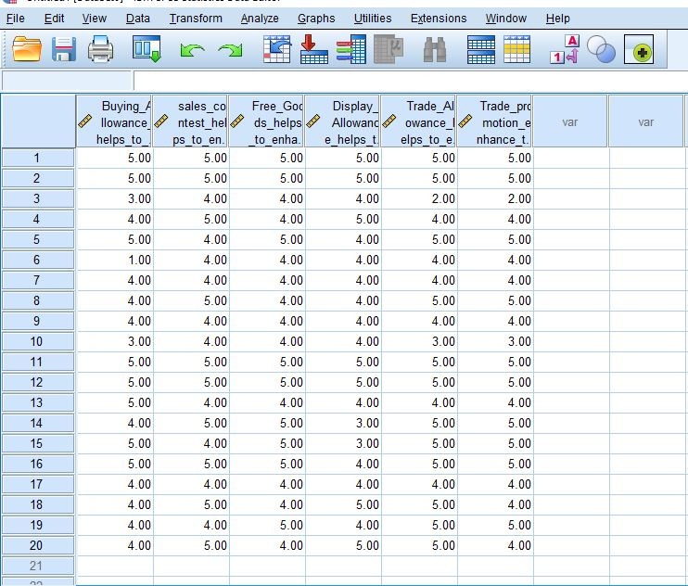
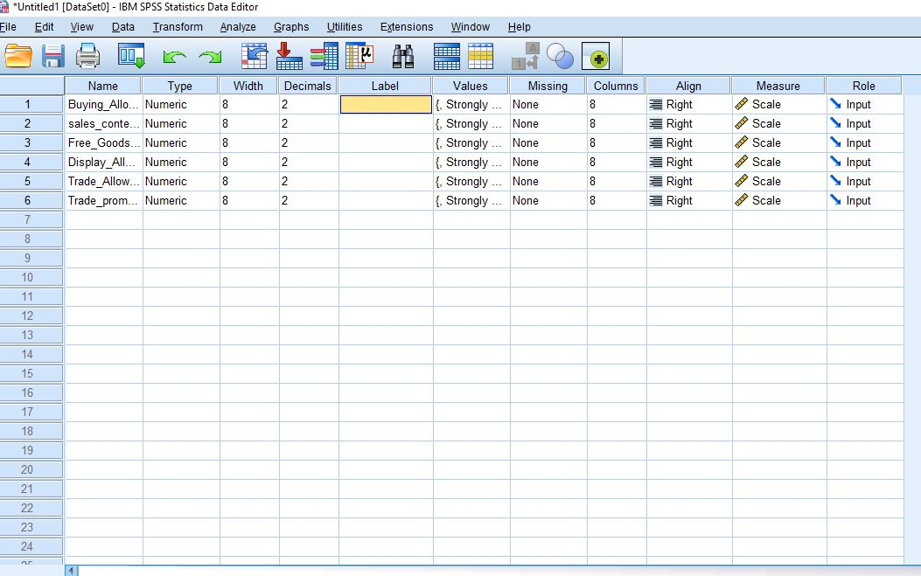

Result timeline:
TASK | Month |  | February |  |  |  | March |  |  |  | April |  |  |  |  | May
TASK | Week | W  1 | W  2 | W  3 | W  4 | W  5 | W  6 | W  7 | W  8 | W  9 | W 10 | W 11 | W 12 | W 13 |  | W 14 | W 15 | W 16
Observing
Activities
Topic
Selection
Gathering
Information
Data
Collection
Select research topic & develop IV, DV
Develop
Survey Questionnaire
Conducting
Survey
Calculating
Hypothesis
Report
Writing
Revision &
Correction

