Internship Report on Financial Analysis of Jamuna Spacetech Joint Venture Limited (Jamuna Gas)
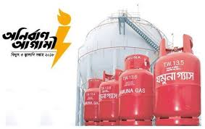
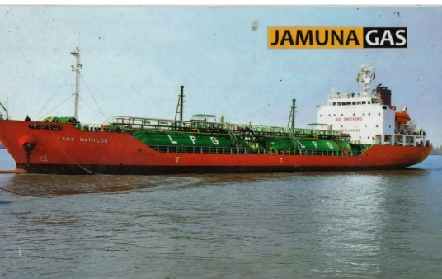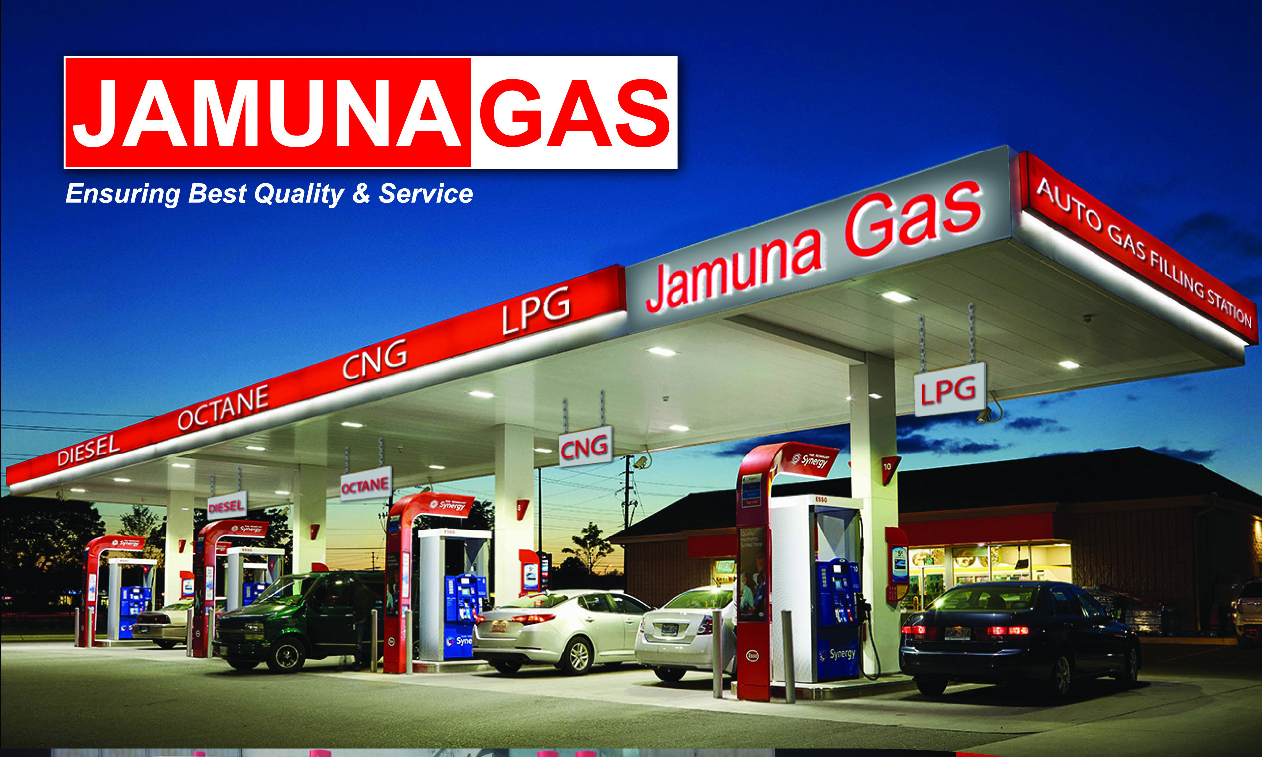



Internship Report
On
Financial Analysis of Jamuna Spacetech Joint Venture Limited

Submitted To:
Ishrat Jahan
Assistant Professor
School of Business & Economics
United International University

Submitted By:
Tasmima Ahmed Lubna
ID: 111 142 244
School of Business & Economics
United International University

Date of Submission: 16 June, 2019

Letter of Transmittal
Date: 16 June, 2019
Ishrat Jahan
Assistant Professor
School of Business & Economics

Subject: Submission of the Internship Report Titled “Financial Analysis on Jamuna Spacetech Joint Venture Limited”.
Dear Madam,
It is a pleasure for me to submit to you the internship report titled “Financial Analysis” on Jamuna Spacetech Joint Venture Limited”. My target was to prepare this internship report according to your guidelines and in your directions. I have tried my best to make the report as per your guidelines. I hope that I have done a satisfactory job considering my level of experience and capability. Moreover, I am also grateful for the opportunity that you gave me to express my ability and I hope that you will like the work that I have done.

Yours Sincerely,
Tasmima Ahmed Lubna
Id: 111142244
United International University
School of Business& Economics

Acknowledgement
This internship report is an open door for the understudy to work at a spot for restricted timeframe. I might want to pass on my genuine gratefulness to the all-powerful Allah. Allah helped me to set up my report inside the particular time.

I might want to express my earnest to my temporary position guide, Ishrat Jahan, Assistant Professor, School of Business &Economics, United International University. I am thankful to her entire hearted supervision during the temporary position time frame. Her compelling proposals help me to set up the report in an efficient way.

I might likewise want to thank the specialist of Jamuna Spacetech Joint Venture Limited (JSJVL) for allowing me the chance to do my entry level position in their outstanding association and providing me the vital data. I might want to thank to Md. Nurul Amin, General Manager of JSJVL for his assistance and direction during my entry level position, and furthermore prefer to express gratitude toward Raihanul Abedin, Executive Director for assistance me a great deal. I likewise thank to the next authority's part that encourages me setting up the report and give me legitimate data which was essential for making my report.

Executive Summery
This internship report relies on money analysis, secondary information, and educational data. In my place amount, I even have worked arduous on accounts department of Jamuna Spacetech venture restricted (JSJVL). It had been a good chance to expertise and gather data concerning completely different aspects of a company, especially the work associated with accounts. Supported the suggestion of my educational supervisor, I even have chosen the subject money Analysis on Jamuna Spacetech venture Limited”. Money analysis is that the method of evaluating businesses, projects, budgets and different finance-related entities to see their performance and suitableness. Within the starting, this report discusses concerning the JSJVL of Bangladesh and its money analysis as an entire. Jamuna Gas is that the pioneer in bulk phonograph record Gas Transportation in Bangladesh. Jamuna LPG is largest growing market in Bangladesh. It’s the quickest in growing network of reticulated business in phonograph record Gas sector. They still implement and explore for new technologies and application for the good thing about their product and additionally for the purchasers. They guarantee absolute safety long with the convenient usages of LPG. They develop and promote technologies, product and services that are environmentally friendly and property. JSJVL may be a productive company however each business faces some form of issues, they're attempting to keep up and recover all the issues.

Contents
Introduction 8
Origin of the report: 8
General Objective: 8
Specific Objective: 9
Scope of the Report: 9
Company Overview 10
Literature Review: 15
Ratio Analysis: 18
Liquidity Ratio: 18
Current Ratio: 18
Quick Ratio: 19
Inventory Turnover: 20
Net profit Margin: 21
Asset Turnover: 22
Return on Asset:. 23
Debt to asset Ratio: 24
Debt to equity ratio: 25
Equity Analysis: 27
Conclusion 31
Recommendation 32
References: 33
Appendix 35

Introduction
Jamuna Gas in one of the biggest LP Gas mass importation, stockpiling, packaging, showcasing and circulation, organization in Bangladesh. It is the quickest in developing system of interrelated business in LP Gas segment. They proceed to execute and look for new advances and application to assist our item and furthermore for the clients. They guarantee outright security long with the advantageous utilizations of LPG. Security is their main need.
Proportion examination is the best instrument of the presentation assessment of the organization. It establishes that how well the organization is effectiveness and how well the organization has had the option to use its benefits and benefit. Proportion Analysis is identified with estimation of the organization's advantage the executive’s condition, gainfulness, and liquidity condition. Its analysis the use of its assets and control of its assets. It measures the company’s overall efficiency and financial performance. It is also used to past financial position and to establish the future position of the company. Ratio analysis also determines the market value of the company. Ratio Analysis of Jamuna Gas is very important because by using this analysis to measures the company’s efficiency. And Equity analysis is determining the company’s investment

Origin of the report:

The report was originated to make an analysis on the financial conditions of JamunaSpacetech Joint Venture Limited(JamunaGas) for the fulfilment of the internship program required for the completion of the degree Bachelor of Business Administration (BBA) under United International University. The report was prepared under the academic supervision of Ishrat Jahan,Assistant Professor, and School of Business & Economics at United International University and under the organizational supervision of Md. Nurul Amin, General Manager, Accounts & Finance, Jamuna Spacetech Joint Venture Limited.

General Objective:

This report is prepared to fulfil the degree Bachelor of Business Administration (BBA) under United International University.

Specific Objective:

- To gain an idea on theJamunaSpacetech Joint Venture Limited(Jamuna Gas) in Bangladesh.
- To give a brief overview onJamuna Gas
- To conduct an industry analysis on Jamuna Gas
- To conduct a Financial Analysis on Jamuna Gas
- To give an overall recommendation to Jamuna Gas.

Scope of the Report:
This report gives a brief idea on Jamuna Spacetech Joint Venture Limited (Jamuna Gas) and its operation. The information provided in this report is based on about the company and on financial statement. This report mainly focuses on the financial performance of Jamuna Gas and the analysis is made through reviewing the financial statements of the company. It also gives an idea of the overall Jamuna LP Gas of Bangladesh.

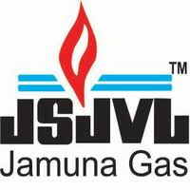
Company Overview
Jamuna Spacetech Joint Venture Limited (JSJVL) began its task in Bangladesh on LPG (Liquified Petrolium Gas) segment named as Jamuna Gas. Jamuna Spacetech adventure Limited was joined on August 11, 1998 under the Company Act 1994 and began its tasks in 2000.
Jamuna Gas Offers a wide scope of item and administrations to fulfill the requirements of a few gatherings of clients. LP Gas is provided in Cylinder compartment and furthermore in mass. Configuration, drawing &installation support for the mass LP Gas clients is likewise completed by them. JSJVL has different sister of concerns, those are: J.B Cylinder Ltd, J.B Refinery ltd, J.B Dredger ltd, Jamuna venture, J.B Agro Plantation Ltd, Teledata Marine arrangement ltd.
Jamuna Gas is the pioneer in mass LP Gas Transportation in Bangladesh. The most effective mass transportation through street tanker is completed by them. They have great group of specialized help to help LPG Auto Gas station as indicated by their needs. At present they have 57 Nos. of Road Tanker to help their important clients. They give advantageous plan and attracting to their clients along these lines filling total need for Auto Gas arrangement. The Common name for Liquefied Petroleum Gas (LPG) utilized as transport fuel. The second most generally utilized and acknowledged as an option car fuel on the planet today.
Jamuna Gas in one of the biggest LP Gas mass importation, stockpiling, packaging, marketing& circulation, organization in Bangladesh. It is the first Govt. Endorsed private LP Gas plant to be occupied with this area. It has grown enormously in both inside and remotely from the season of its initiation. It is the quickest in developing system of interrelated business in LP Gas part. They proceed to actualize and scan for new innovations and application to serve their item and furthermore for the clients.

Jamuna Gas has got two conveyance plants one is in Mongla and others are in Bogra therefore covering the real two areas topographically southern and eastern individually. It has' by and large 5,854 MT stockpiling limit in Bogra and Mongla. Jamuna Gas is Pioneer in bulk carry of LPG in Bangladesh and also the most efficient among all. This facility to enter into a new modern era in LP Gas sector.
Jamuna Gas is distributed and marketed throughout the country using network of authorized dealers and sub dealers. LPG filled cylinder of 5.5kg,12kg,45 kg are sold through the distribution network. It supplies gas for domestic, commercial and industrial users. It has got their own transport facilities to reach the cylinder to the dealer’s point.
Vision Statement: It is to be among the leading providers of Liquefied Petroleum Gas by delivering a personalized standard of service that pertains to a level of excellence.

Mission Statement: Committed to contribute the exemplary service and quality products, ensuring customer and employee satisfaction as well as providing the company with the best financial returns and corporate image.
Core Values:

- Commitment to Quality: JSJVL Industry best practises in all of its operations to ensure highest quality products. They ensure their high-quality products to their customer.
- Customer Satisfaction: JSJVL committed to their customer. They provide high quality products to their customer.
- People Focus: It gives high priority on building capabilities of its employees and empower them to realize their full potential.

- Accountability: They maintain their highest ethical standard. It is accountable for its own actions and responsible for sustaining corporate reputation.

- Corporate Social Responsibility: It actively takes part in initiatives that benefit the society and contribute to the welfare of its people. It takes great care in managing its operations with high concern for safety and environment.

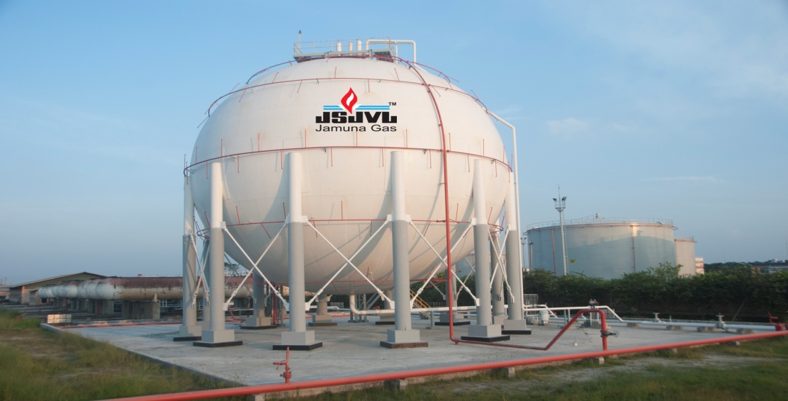

Product and Service of JSJVL: JSJVL offers complete solution of LPG Auto Gas Station equipment to the user. They ensure quality, superiority, safety including the complete range of equipment, consultancy, feasibility study and basic guidelines for the government approval of the project.
- Auto gas: Auto Gas is widely known as a Green fuel for lower emission. JSJVL offers complete solution of LPG Auto Gas Station equipment to the user. They ensure quality, superiority, safety including the complete range of equipment, consultancy, feasibility study and guidelines for the government approval of project.

- Storage Tank:

Tank type: Horizontal.
Origin of the country: Europe\ China\Turkey.
Tank capacity: 10000-40000 litre.
Design Temp: 40 Deg C to + 50 Deg C.
Design Pressure: 15 bar to 17.5 bar.

- Dispenser:
Country of Origin: European \Newszealand.
Maximum Flow Rate: 45 to 50 ltr/min.
Density present range: 0.5-.69
Gas Filling Present Range: 0.3-9000 Litre.

- Pump: This high performance of pump capacity is 90 litre-120 litres per min. Country of origin is European/ USA/ Germany.
What Is LPG:
LPG (Liquefied Petroleum Gas) is the need of the hour in Bangladesh. is flexible, ,reliable, portable, clean and affordable which makes it suitable for all types of domestic, commercial, industrial and auto gas application. It is important for use in industrial, commercial, agricultural, horticultural and manufacturing applications. It can provide with heating, hot water and power to cook food, as well as fuel for cars.LPG has a high warming or caloric worth which implies that as a vitality source, LPG gives an abnormal state of warmth in a short lifetime. LPG additionally has a virtual nonattendance of sulphur, prompting cleaner consuming. Normally sold in gas chambers, LPG is an advantageous, convenient vitality source that is anything but difficult to transport and store. LPG is a hydrocarbon fuel mix of propane and butane. It is clean, portable and emits carbon at a lower rate, when burned for energy. Use of LPG can significantly reduce the health impacts associated with burning of wood, kerosene etc. LPG operates in Bangladesh is contributing to attaining the SDGs by helping improve Good Health.
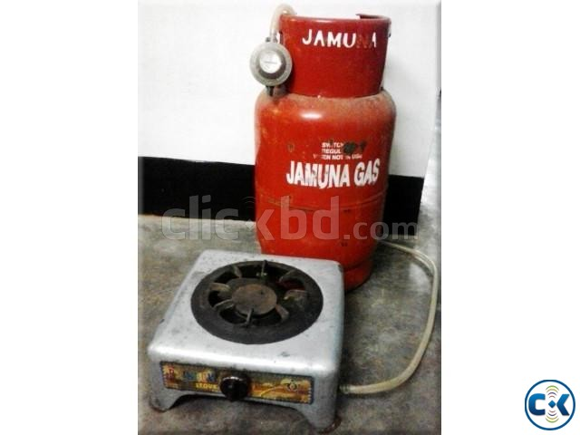
LPG GAS Business System:

JSJVL Manpower:
Jamuna Gas in one of the biggest LP Gas mass importation, storage, bottling, marketing & distribution, company in Bangladesh. JSJVL has very qualified and skilled manpower for storaging, bottling, marketing. For that reason, every day they touch the lives of millions of people through their product and services across the country. Escape Bangladesh Limited has provided skilled and technical manpower services to the various projects.


Promises of Jamuna Gas:
Every day they touch the lives of millions of people through their product and services across the country. They have the ability to make a difference and offer additional packages through their extensive research and development. They ensure absolute safety long with the convenient usages of LPG. Safety is their number one priority. They endeavour towards zero accident and incidents to create a safe and effective environment for their people, customers and the community in which they operate. They always ensure customer satisfaction and loyalty by consistently providing product and service that meet each customer’s expectation and quality. They develop and promote technologies, product and services that are environmentally friendly and sustainable.

Literature Review:

According to Dr. M. Ravichandran [ CITATION DrM16 \l 1033 ] the financial performance can be
measured by using various financial tools such as profitability ratio, solvency ratio, comparative
statement, etc. Based on the analysis, findings have been arrived that the company has got enough
funds to meet its debts & liabilities, the income statement of the company shows sales of the
company increased every year at good rate and profit also increased every year.
According to Dr. M. Ravichandran [ CITATION DrM16 \l 1033 ] the financial performance can be
measured by using various financial tools such as profitability ratio, solvency ratio, comparative
statement, etc. Based on the analysis, findings have been arrived that the company has got enough
funds to meet its debts & liabilities, the income statement of the company shows sales of the
company increased every year at good rate and profit also increased every year.
According to Dr. M. Ravichandran: The budgetary exhibition can be estimated by utilizing different monetary apparatuses, for example, productivity proportion, dissolvability proportion, near proclamation, and so forth. In light of the examination, discoveries have been arrived that the organization has got enough assets to meet its obligations and liabilities, the salary explanations of the organization demonstrates offers of the organization expanded each year at great rate and benefit likewise expanded each year.
An examination has been embraced by Ms. M. Ganga on the assessment of money related execution of Equities Micro Finance Private Limited in Chennai. As indicated by them monetary examinations are imperative to plan and control the company's budgetary assets. They embraced different exploration strategies to discover the assessment of money related execution of the association. They found that the chief must focus on hazy area which would be helpful for future development of the organization.
(Lin, Liu & Chu, 2005). Financial ratios are the simplest tools for evaluating the financial performance of the firm. Individual be able to utilize financial ratios to determine a firms liquidity, profitability, solvency and capital structure and asset turnover.
Jahur and Uddin(1995) used financial ratios to measure operational performance of limited company. They used profitability, liquidity, activity and capital structure to measure operational performance.
Uddin and Kabir (1996) examined the financial performance of Bangladesh. They found that conversion of long term debt to equity might improve the financial performance of Bangladesh to a greater extent.
Hannan and Miah (1998) utilized money related proportions to demonstrate the monetary position and execution investigation of Bangladesh. They demonstrated that strategies of money related investigation could be utilized in the assessment of monetary position and execution of budgetary foundations just as non – monetary organization.
firm
James Clausen (2009),express that the Profitability Ratio Analysis of Income Statement and Balance Sheet Ratio investigation of the pay articulation and accounting report are utilized to gauge organization benefit execution. The pay explanation and asset report are two significant reports that demonstrate the benefit and total assets of the organization. It examinations demonstrates how well the organization is getting along as far as benefits contrasted with deals. He likewise demonstrates how well the advantages are performing as far as creating income.
Maria Zain (2008), in articles he talks about the arrival on resources is a significant rate that demonstrates the organization's capacity to utilize its advantages for creates pay. He said that a high rate shows that organization's is completing a decent using the organization's resources for create pay. The net benefit assumes that ought to be utilized is the measure of salary after all costs, including charges. He denounces that the low rate could imply that the organization may experience issues meeting its obligation commitments. He articulates that the overall revenue proportion is communicated as a rate that demonstrates the connection among deals and benefits. It is once in a while called the working execution proportion since it's a decent sign of working efficiencies.
James Clausen (2009), in article he expresses about the liquidity proportion. He Pronounce that it is investigation of the fiscal reports is utilized to quantify organization's exhibition. Speculators and loaning establishments will frequently utilize proportion investigations of the budget summaries to decide an organization's gainfulness. On the off chance that the proportions demonstrate terrible showing, financial specialists might be hesitant to contribute. He likewise said that the present proportion estimates the organization's capacity to pay back its transient obligation commitments with its present resources. He supposes a higher proportion demonstrates the organization is better prepared to satisfy transient obligation with current resource and liquidity.
Jo Nelgadde (2009), He said that figure out how to perform stock examination and stock turnover investigation to all the more likely comprehend a business just as to recognize powerful stock administration. He dissecting an organization's money related execution certainly incorporates performing stock investigation.

Gopinathan Thachappilly (2009), in this articles his express about obligation the board. He notice that the Ratio of Debt to Equity has Implications for profit for value obligation proportions check the budgetary structure of the business by looking at obligation against complete capital, against all out resources and against proprietors' assets. The proportions help check how "utilized" an organization is.

James Hutchinson (2010), He understands that about the long haul obligation to value proportion of a Business. The proportion of these numbers educates a great deal regarding the business. It is determined by taking the obligation owed by the organization and partitioned by the proprietor's value, otherwise called capital. The obligation number may incorporate all liabilities, or simply long haul obligation.

Munya Mtetwa (2010), in this article he short recommend that about the fixed resource. He characterize that fixed resources are resources that are utilized underway or supply of products or administrations and they are to be utilized inside the business for more than one budgetary year. Subsequently, fixed resources speak to the organization's long haul salary creating resources and they can either be substantial or non unmistakable.Dr. M. Ravichandran, M. V. (2016). A Study on Financial Performance Analysis of Force
Motors Limited. International Journal for Innovative Research in Science &
Technology, 662-666.
Jo Nelgadde (2009), He said that figure out how to perform stock examination and stock turnover investigation to all the more likely comprehend a business just as to recognize powerful stock administration. He dissecting an organization's money related execution certainly incorporates performing stock investigation.
Gopinathan Thachappilly (2009), in this articles his express about obligation the board. He notices that the Ratio of Debt to Equity has Implications for profit for value obligation proportions check the budgetary structure of the business by looking at obligation against complete capital, against all out resources and against proprietors' assets. The proportions help check how "utilized" an organization is.
James Hutchinson (2010), He understands that about the long-haul obligation to value proportion of a Business. The proportion of these numbers educates a great deal regarding the business. It is determined by taking the obligation owed by the organization and partitioned by the proprietor's value, otherwise called capital. The obligation number may incorporate all liabilities, or simply long-haul obligation.
Munya Mtetwa (2010), in this article he short recommends that about the fixed resource. He characterizes that fixed resources are resources that are utilized underway or supply of products or administrations and they are to be utilized inside the business for more than one budgetary year. Subsequently, fixed resources speak to the organization's long-haul salary creating resources and they can either be substantial or non-unmistakable.

Financial Analysis

Ratio Analysis: Ratio analysis is a quantitative method of gaining insight into a company's liquidity, operational efficiency, and profitability by comparing information contained in its financial statements. Ratio analysis is the best tool of the performance evaluation of the company. It is defined as the systematic use of the ratio to interpret the financial statements. It determines that how well the company is efficiency and how well the company has been able to utilize its assets and profit. The ratios are various types such as
- short term solvency ratio,
- debt management ratios,
- Profitability ratios.
Analysis:
Liquidity Ratio: Liquidity ratios measure the short term ability of the company to pay its maturing obligations and meet to unexpected needs for cash. Short term creditors such as bankers and suppliers are particularly interested in assessing liquidity. And also determine the company short term debt paying ability is the current ratio, the quick ratio and inventory turnover. Those are:
Current Ratio: The present proportion is a generally utilized measure for assessing an organization's liquidity and momentary obligation paying capacity. The present proportion is just one proportion of liquidity. The present proportion is now and again alluded to as the working capital proportion. Working capital proportion is present resource less present liabilities. Current resource incorporates stock, exchange account holders, advances, stores and reimbursement, interest in attractive protections in transient credit, money and money counterparts. Financial specialists and investigators estimated how an organization can expand the present resources on its monetary record to legitimize its present obligation and different payables. Least Current Ratio is 2:1.
Current Ratio Formula: Current Asset\ Current Liability

Analysis: In this chart we can see that Jamuna gas is in a very strong position. Higher the current ratio, the company is more capable of paying its obligation. Here this company’s current ratio is above ‘1’, so its indicates that company is in a very strong position. In this company ratio is above ‘1’, so their current assets is higher than the current liabilities. In 2017 their ratio is 7.83%, excess higher ratio. But excess higher ratio is not good always because it indicates excessive amount of current assets or inefficient asset utilization by management. Low current ratio may be an indication of a firm’s inability and indication of high current liabilities. The current ratio are measured is the standard of 2 to 1 (2:1). This means that for every tk1 current liabilities there must be a minimum of tk2 current assets to cover it.
Quick Ratio: Quick ratio is measure of a company’s immediate short-term liquidity. It demonstrates the organization's capacity to utilize its close money resources that is, resources that can be changed over rapidly to money to square away its present liabilities; it is additionally called as the basic analysis proportion. Standard speedy proportion is 1:1
Quick Ratio formula: Current Asset- Inventory \Current Liability

Analysis: In Jamuna Gas, 2014 to 2016 ratios are highly increasing, and in 2017 and 2018 ratios are low. In this company the ratio is above ‘1’so their current assets are higher than current liabilities. So Jamuna Gas is in a very strong position. In 2016 quick ratio is so high, and higher ratio means a more liquid current position. But in 2017 and 2018 ratio is less than ‘1’ so its indicates that their current liabilities is increasing than current assets.
Inventory Turnover: Normal stock is a computation that gauges the worth or number of a specific decent or set of products during at least two determined time spans. Normal stock is the mean estimation of a stock inside a specific timeframe, which may differ from the middle estimation of similar informational index, and is figured by averaging the beginning and consummation stock qualities over a predefined period
Inventory Turnover Formula: Cost of goods sold\ Average Inventory

Analysis: In This Chart we can see that Jamuna Gas maintains a high ratio in 2014 and 2015. And other year ratio is also high. So Jamuna Gas is in a healthy market position. Their inventory level is low and ratio is high because of their increasing sales. That’s why their market position is so good. If sales are decreasing, the inventory ratio will be low.
Profitability ratios: Profitability ratios measure the income or operating success of a company for a given period of time. It affects the company’s ability to obtain debt and equity financing. It also affects the company’s liquidity position and the company’s ability to grow. Analysts frequently use profitability as the test of management operating effectiveness. Profitability ratios are Net Profit Margin, Asset turnover, Return on equity. Those are:
Net profit Margin: Net profit margin is the ratio of net profits to revenues for a company or business segment. It measures how much net income or profit is generated as a percentage of revenue Net profit margins is typically expressed as a percentage but can also be represented in decimal form.
Net profit Margin Formula: Net Income\Net sales

Analysis: In this Chart we can see that in 2014 to 2017 ratio is high, it is a good sign for the Jamuna gas. In this company their net profit margin is high because their cost is low. But in 2018 ratio is reducing because cost is high. So Jamuna Gas is in a very strong position, in every year their cost is low. Higher the profit margins better the condition of the firm. For higher the net profit ratio, the company is very effective. It indicates the firm’s ability.
Asset Turnover: The value of a company's sales or revenues relative to the value of its assets is measured called the asset turnover ratio. The asset turnover ratio can be used as an indicator of the efficiency. The higher the asset turnover ratio, the more efficient a company. The asset turnover ratio is calculated on an annual basis. Asset turnover ratio helps the company to measure how productive the business and how much revenue is generated from investments in the assets. The company needs to analyse and improve their asset turnover ratio.
Asset Turnover Formula: Net sales\ average asset

Analysis:
In this Chart we see that 2014 to 2018 all ratios are high, and it is strong position for Jamuna Gas It is a good sign for the company. Their Asset turnover ratio is high because they utilize their proper fixed asset. This company generated more sales with proper an asset that’s why their asset turnover ratio is high. The higher the asset turnover ratio, the more efficient a company. The asset turnover ratio can be used as an indicator of the efficiency. Other hand, the lower ratio indicates the company’s inefficiency, poor utilization of fixed assets, and bad inventory management. It measures the efficiency of a company uses assets to produce sales.
Return on Asset: Profit for resources (ROA) is a marker of how productive an organization is with respect to its complete resources. ROA gives an administrator, financial specialist, or investigator a thought regarding how proficient an organization's administration is at utilizing its resources for produce profit. Profit for resources is shown as a rate. The ROA figure gives investors an idea of how effective the company is in converting the money it invests into net income.
Return On Asset Formula: Net Income\ Average total asset

Analysis: In Jamuna Gas Return on Asset is increasing from 2014 to 2017, It is very good position for the company. Their ratio is increased because the company earn more money on less investment. But in 2018 ratio is fluctuating because of decreasing net Asset. The return on asset useful for the company. Higher the ROA, higher the management. Higher return on ratio is very efficient for the Jamuna Gas. So, for earning more money, Jamuna Gas is in a strong position of the market.
Solvency Ratio: Its measure the capacity of the organization to get by over an extensive stretch of time. Long haul loan boss and investors are especially keen on an organization's capacity to pay enthusiasm as it comes due and to reimburse the presumptive worth of obligation at development. Obligation to resources gives data about obligation paying capacity.
Debt to asset Ratio: The debt ratio is a financial ratio that measures the extent of a company’s leverage. The debt ratio is defined as the ratio of total debt to total assets, expressed as a decimal or percentage. The higher the debt ratio, the more leveraged a company is, implying greater financial risk. At the same time, leverage is an important tool that companies use to grow, and many businesses find sustainable uses for debt.
Debt to asset Ratio Formula: Total Debt / Total Asset

Analysis: In this chart we can see that at Jamuna Gas 2014 to 2018 debt ratio is less than’1’. If debt ratio is less than ‘1’ it means that a company has more assets than debt. So Jamuna Gas is more efficient and has better financial position. If the debt ratio is greater than ‘1’ it indicates that the company has more debt than assets. The higher the debt ratio, greater the company’s financial risk. But higher ratio is sometimes not bad because of interest payments which are made on time, if it is not maintain by the company then it will be great risk
Debt to equity ratio: The obligation to value proportion is a monetary, liquidity proportion that thinks about an organization's absolute obligation to add up to value. The obligation to value proportion demonstrates the level of organization financing that originates from banks and speculators The D/E proportion is a significant measurement utilized in corporate money. It is a proportion of how much an organization is financing its activities through obligation versus completely possessed assets. All the more explicitly, it mirrors the capacity of investor value to cover every single extraordinary obligation in case of a business downturn.
Debt to equity ratio Formula: Total Liabilities\ Total Equity

Analysis: In this chart we can see that ratio is very high in 2014 to 2016.It’s a very bad position for Jamuna Gas becausethis company cannot generate enough cash, and their bank loan is high. In 2014 to 2016 Jamuna Gas is not a financially stable. But in 2017 and 2018 ratio is fluctuate so it is good sign for the Jamuna Gas because lower debt to equity ratio implies more financially stable business.

Equity Analysis
Equity analysis is the investigation of values or stocks with the end goal of speculations. The reason for existing is to organizations, break down financials and take a gander at quantitative and subjective angles, helping speculators of differing degrees to settle on an educated choice. In more straightforward terms, value investigation is the demonstration of social affair the accompanying data:
- Information helps to investor to put their money and helps to decision making.
- Information that traders require to understand whether to enter or exit a market position.
- Financiers (bankers and firms) need to evaluate companies by information

Steps of Equity Analysis:

For this analysis, I have collected the annual report of Jamuna Spacetech Joint Venture Ltd. I have collected the Balance sheet and Statement of Comprehensive income of the organization. I have analysis their financial statements for its 5 years 2014 to 2018.
To justify the equity analysis, it is very important to disclose all necessary items and calculations of each step.
Step 1.Calculating operating cash flow (OCF): To calculate the OCF of JSJVL there are three elements are important. Those are:

Formula of EBIT: To calculate the EBIT JSJVL followed a specific structure in their statement of Comprehensive Income, which is given below:
Terms | Value
Net Sales Revenue | ***
(-) Cost of Goods Sold | ***
Gross Profit | ***
(-) Operating Expenses | ***
Profit from Operation | ***
(+) Other Income | ***
(-) Financial Cost | ***
Profit Before Contribution to WPPF & Welfare Funds | ***
(-) Contribution to WPPF & Welfare Funds | ***
EBIT | ***

Calculation of Operating Cash Flow (OCF):
Items | 2014 | 2015 | 2016 | 2017 | 2018
EBIT | 574116100 | 373372947 | 869032387 | 664825561 | 431381907
( +)Depreciation | 8136450 | 7749000 | 73,80,000.00 | 73,80,000.00 | 12,979,353.08
(-) Taxes | 200940635 | 130680531 | 340161335 | 22688946 | 150983667
=Operating Cash Flow | 381311915 | 250441416 | 536251052 | 649516615 | 94822407

Step 2: Calculating Project Cash Flow: To calculate the project cash flow of JSJV, must needed three elements from financial statements. Those are given below:

Formula: Operating Cash Flow already calculated under table.
Formula: Net working capital: Current Asset – Current Liabilities
Formula: Change in Net Working Capital: Net working capital (Current Year)-Net working capital (previous Year)
Formula: Capital Spending: Non- Current Asset (Current Year) - Non- Current Asset (previous Year)
Calculation of Project Cash Flow: After computing three elements, must calculated the project cash flow for the five years (2014-2018)
Items | 2014 | 2015 | 2016 | 2017 | 2018
Operating Cash Flow |  |  | 536251052 | 649516615 | 94822407
  381311915 | 250441416 | 536251052 | 649516615 | 94822407
  250441416 | 250441416 | 536251052 | 649516615 | 94822407
(-) Change in net working capital | 3094257 | 12347755 | 27957167 | 131900175 | 19386569
(-)Capital Spending | 140292654 | 44581904 | 240857976 | 24728904 | 24611928
=Project Cash Flow | 237925004 | 193511757 | 265435909 | 492887536 | 50823910

Step 3: Calculating Net Present Value (NPV):
Formula: Cash Flow = Project Cash Flow\ (1+i) 𝑛
Calculation of Net Present Value:
Items | 2014 | 2015 | 2016 | 2017 | 2018
Project cash flow | 237925004 | 193511757 | 265435909 | 492887536 | 50823910
(÷) (1+i) n | (1+0.08)1=1.08 | (1+0.08)2=1.17 | (1+0.08)3=1.26 | (1+0.08)4=1.36 | (1+0.08)5=1.47
=Cash Flows | 2203009210 | 165394664 | 210663410 | 362417306 | 34574088
Net Present Value (NPV) | =2976058678

Conclusion

Jamuna Gas is the pioneer in mass LP Gas Transportation in Bangladesh. The most efficient bulk transportation through road tanker is carried out by them. Presently the deemed for LPG is growing very fast in Bangladesh. The growth of local LPG based industries is also very significant. The players who are heaving LPG business are also facing a healthy competition among themselves. All LPG operations are now investing a big amount of funds in plant installation, LPG import and also import and manufacture of LPG cylinders. Presently the total LPG by the private players in Bangladesh is around 700,000 tonnes per year. Presently the JSJVL imports 120,000 tonnes per through its own terminal at the Mongla Port. The volume of LPG imported by the LPG operators has increased quite significantly. All operators are also increasing their LPG storage capacity to cope up with the present demand in the market. Their sister concern J.B Cylinder Ltd produces more than 2000 cylinder per day. Besides JSJVL also regularly imports LPG cylinders from Thailand to meet the present demand. JSJVL has already started vigorously its LPG operations throughout the country so that it can remain within the top two operators in Bangladesh. Presently the government of Bangladesh is encouraging setting up of LPG filling stations by the side of all main highways and also in the cities and towns which will include automobile conversion workshops. The JSJVL has received permission from the government to set up 200 LPG filling stations and fifty workshops.
Financial Analysis is a statement which is performance of companies past and present situation is measured. It gives the ideas of company’s performance of future. Industry analysis is the statistical relationship between data which is very important of financial analysis. Equity Analysis is another part of financial analysis of the company. To analyse this company, I have seen that is performing well. This company is financially solvent but they have some problematic issues which need to manage properly to survive and have more successful position in Bangladesh. Overall JSJVL is really so good LPG company.

Recommendation

After making this report, I can see that Jamuna Gas is the growing very fast in Bangladesh. It is very good position in market. LPG business is also facing a healthy competition among them. They have the ability to make a difference and offer additional packages through their extensive research and development. They ensure absolute safety long with the convenient usages of LPG. Safety is their number one priority. As a intern, I have been working here for three month, I found out some certain aspects which goes in favour of them and some which goes against them.
Positive side:
- High Quality Product
- Customer Satisfaction
- Innovative market strategies
- Loyalty of Customer
- Growing Demand
Jamuna Gas has some weaknesses whose are threats for LPG business. But I think if this company minimize their weaknesses, they will be more successful and efficient business in Bangladesh. They minimize those problems in some ways. Those are given below;
- Jamuna Gas always should maintain a high quality product to reduce effect of high competition and also regain the market share that it is lost.
- Jamuna Gas should always use its efficient quality control system.
- They should capitalized their low production facility in Bangladesh in order to reduce its per order cost.
- They should use the technological advancement to promote its products more efficiently.

References:

Annual Report 2014, Jamuna Spacetech Joint Venture Limited
Annual Report 2015 Jamuna Spacetech Joint Venture Limited
Annual Report 2016 Jamuna Spacetech Joint Venture Limited
Annual Report 2017 Jamuna Spacetech Joint Venture Limited
Annual Report 2018 Jamuna Spacetech Joint Venture Limited
Weygandt, Kimmel, KaisoAccountingPrincipal , (11 edition) Ratio Analysisaccounting.

Dr. M. Ravichandran, M. V. (2016). A Study on Financial Performance Analysis of Force
Motors Limited. International Journal for Innovative Research in Science &
Technology, 662-666
Dr. M. Ravichandran, M. V. (2016). A Study on Financial Performance Analysis of Force
Motors Limited. International Journal for Innovative Research in Science &
Technology, 662-666
Dr. M. Ravichandran, M. V.(2016). A study on Financial Performance Analysis of Force Motors Limited. International Journal for Innovative Researchin Science & Technology, pp: 662-666.
Ms.M. Ganga, M.(2015, April), Evaluation of Financial Performance. International Journal of Scientific and Research publications, pp.1-6.
Lin, W. C., Liu, C. F., & Chu, C.W. (2005). Performance Efficiency Evaluation of the
Taiwan’s shipping Industry: An application of DEA. Proceeding of the
Transportation Studies, 5, 467 – 476.
Lin, W. C., Liu, C. F., & Chu, C.W. (2005). Performance Efficiency Evaluation of the
Taiwan’s shipping Industry: An application of DEA. Proceeding of the
Transportation Studies, 5, 467 – 476.
Lin, W. C., Liu, C. F. & Chu, C. W. (2005), performance efficiency evaluation of the Taiwan’s shipping industry: an application of DEA. Proceeding of the transportation studies, 5, 467-676.
Jahur & Uddin, S.M. & Uddin, M.M. (1995): measurement of operational performance through Ratio Analysis – The Chittagong University Journal of Commerce, 11, 245-255
Uddin,S.M.&Kabir, M.A.(1996), Financial performance of Bangladesh of Shipping Corporation- A case study. Journal of Chittagong University, 12, 25-36
Hannan, A. & Miah, M.A.(1998), Financial position and performance analysis of Bangladesh Shilpa Bank. Islamic University Studies, 1(2), 207-255
James Clausen (2009) a, ‘Accounting 101 – Financial Statement Analysis in Accounting: Liquidity Ratio Analysis Balance Sheet Assets and Liabilities’, Journal of financial statement, vol. 3, pp. 25-34.

James Clausen, (2009) b, “Accounting 101 – Income Statement: Financial Reporting and Analysis of Profit and Loss ‟‟, Journal of income statement.vol. 4, no. 3, pp. 36-47

Maria Zain 2008, ‘How to Use Profitability Ratios: Different Types of Calculations that Determine a Firm's Profits’, Journal of profitability ratio analysis, vol. 3, no. 2, pp. 34-43

Nelgadde, Jo. (2009). “Inventory Analysis: A Guide to Analyzing Inventory for Small Business Owners ‟‟, Journal of inventory analysis.

GopinathanThachappilly (2009) a, ‘Debt Ratios Look at Financial Viability/Leverage: The Ratio of Debt to Equity Has Implications for Return on Equity’, Journal of debt ratios analysis, 2009.

Hutchinson, James (2010), “Long Term Debt to Equity Ratio of a Business: Understand a Company's Value to its Investors and Owners‟‟, Journal of long term debt to equity ratio.Working paper no: 05.

Mtetwa, Munya. (2010). “Fixed Assets: Capital Expenditure ‟‟, Journal of fixed assets in accounting.

.

Appendix
Current Ratio of JSJVL
Items | 2014 | 2015 | 2016 | 2017 | 2018
 |  |  |  | 159,848,542.97 | 197,031,425.41
  Current Asset:
  Stock
  Trade Debtors
  Loans & Advances
  Cash In Hand
  Bank Balance
  596995321
  131226154
  45163150
  227366902
  7343472
  185895643
  1077903294
  656694853.1
  144348769.4
  49679465
  250103592.2
  8077819.2
  204485207.3
  1185693623
  20,96,57,021.90
  11,52,98,645.69
  5,98,66,330.53
  9,08,411.00
  3,35,83,634.68
 |  |  | 26,74,549.32 | 141,335,697.30 | 84,766,245.35
  Current liabilities:
  Liabilities for Goods
  Liabilities for Expenses
  Liabilities for other Finance
  430317770
  374680460
  20890530
  34746780
  477669547
  412148506
  22979583
  38221458
  031,425.41
Current Ratio | 1.38 | 1.37 | 7.83% | 1.13% | 2.32%

Quick Ratio of JSJVL
Items | 2014 | 2015 | 2016 | 2017 | 2018
Current Asset: | 596995321 |  | 20,96,57,021.90 | 159,848,542.97 | 197,031,425.41
  656694853.1
(-) Inventory | 131226154 | 144348769.4 | 11,52,98,645.69 | 97,903,739.68 | 150,417,453.29
Current Liability | 430317770 | 477669547 | 26,74,549.32 | 141,335,697.30 | 84,766,245.35
Quick Ratio | 1.08% | 1.07% | 35.28% | 0.43% | 0.50%

Inventory Turnover of JSJVL

Items | 2014 | 2015 | 2016 | 2017 | 2018
Cost Of Goods Sold | 1799057577 | 1979058936 | 406313119.5 | 545240859.2 | 603,495,030.77
Beginning Inventory | 59816776 | 65798454 | 14,57,73,759.84 | 11,52,98,645.69 | 88,109,673.16
Ending Inventory | 131226154 | 144248769 | 11,52,98,645.69 | 9,23,89,082.93 | 142,945,514.51
Average Inventory | 18.83% | 18.84% | 3.11% | 5.25% | 5.22%

Net Profit Margin of JSJVL
Items | 2014 | 2015 | 2016 | 2017 | 2018
Net Income | 288218502 | 317040352 | 8,69,76,792.96 | 7,01,47,975.27 | 5,219,077.19
Net Sales | 2365832476 | 2602415724 | 55,73,15,228.01 | 70,41,97,566.18 | 510,251,900.00
Net Profit Margin | 0.12% | 0.12% | 0.16% | 0.99% | 0.03%

Asset Turnover of JSJVL
Items | 2014 | 2015 | 2016 | 2017 | 2018
Net Sales | 2365832476 | 2602415724 | 55,73,15,228.01 | 70,41,97,566.18 | 510,251,900.00
Beginning Total Asset | 1077903294 | 1185693623 | 45,91,99,997.65 | 434,120,422.74 | 197,031,425.41
Ending Total Asset | 1053007206 | 1077903294 | 1185693623 | 45,91,99,997.65 | 434,120,422.74
Average Asset | 1065455250 | 1131798459 | 615806810.3 | 446660210.2 | 315575924.1
Asset Turnover | 2.22% | 2.29% | 0.90% | 1.57% | 1.61%

Return on Asset of JSJVL
Items | 2014 | 2015 | 2016 | 2017 | 2018
Net Income | 288218502 | 317040352 | 8,69,76,792.96 | 7,01,47,975.27 | 5,219,077.19
Average Asset | 1065455250 | 1131798459 | 615806810.3 | 446660210.2 | 315575924.1
Return On Asset | 0.27% | 0.28% | 0.14% | 0.15% | 0.01%

Net profit Ratio of JSJVL
Items | 2014 | 2015 | 2016 | 2017 | 2018
Net Income | 288218502 | 317040352 | 8,69,76,792.96 | 7,01,47,975.27 | 5,219,077.19
Net Sales | 2365832476 | 2602415724 | 55,73,15,228.01 | 70,41,97,566.18 | 510,251,900.00
Net Profit Ratio | 0.12% | 0.12% | 0.15% | 0.09% | 0.01%

Debt Ratio of JSJVL
Items | 2014 | 2015 | 2016 | 2017 | 2018
Total Debt | 985396486 | 1088256135 | 459999998 | 84766245 | 141335697
Total Asset | 1077903294 | 1185693623 | 45,91,99,998 | 434,120,423 | 495,915,234
Debt Ratio | 0.91% | 0.92% | 0.10% | 0.19% | 0.28%

Debt to Equity Ratio of JSJVL
Items | 2014 | 2015 | 2016 | 2017 | 2018
Total Liability | 1077903294 | 1185693623 | 45,91,99,997.65 | 434,120,422.74 | 495,915,233.88
Total Equity | 92506808 | 97437488.8 | 12,00,000.00 | 349,354,177.39 | 354,579,536.58
Debt to Equity Ratio | 11.65% | 12.16% | 3.82% | 1.24% | 1.39%

