INTERNSHIP REPORT ON

AN ANALYSIS OF THE RELATEDNESS BETWEEN BUDGETS AND PERFORMANCE OF A MICROFINANCE ENTITY:
A CASE STUDY OF “BRAC INTERNATIONAL”





An analysis of the relatedness between budget and performance of a microfinance entity: A case study of “BRAC International”

Submitted to
Mosabbir Uddin Ahmad
Assistant Professor
School of Business and Economics
United International University

In Partial fulfilment
Of the Requirements for the Degree of
Bachelor of Business Administration (BBA)

By
Narsuda Bhuiyan
ID: 111 172 019

24th July, 2021

STUDENT DECLARATION

I, Narsuda Bhuiyan, do hereby solemnly declare that the work presented in this internship report has been carried by solely by me and has not been previously submitted to any other university, college or organization for any academic purposes.
I hereby warrant that the work I have completed in this report does not breach any current copyright laws. All materials covered have been appropriately cited through full referencing where needed. I also acknowledge all main sources of help.

Student’s Full name and Signature:


Narsuda Bhuiyan
111 172 019
School of Business and Economics
United International University

LETTER OF TRANSMITTAL
July 24, 2021

Mosabbir Uddin Ahmad
Assistant Professor
School of Business and Economics
United International University

Subject: Submission of internship report on “An analysis of the relatedness between budget and performance of a microfinance entity: A case study of BRAC International”

Dear Sir,

With due respect, I am pleased to notify you that I have prepared this report as a fulfilment of the internship which is a final requirement of our programme.

I have completed the report based on my experience and knowledge gathered while working as an intern at BRAC International in the Finance and Accounts Department and have given my utmost effort to collect all the necessary information. Though I am still on the learning curve, this report has enabled to gain insight into the core facts of real life budgeting processes and how they relate to financial performance of an organization.
Thank you for your supportive consideration for letting me formulate this report. I have tried my best to avoid any deficiencies and hope that the analysis that I have completed will meet your expectations.

Sincerely,
Narsuda Bhuiyan (Student, BBA)
111 172 019
School of Business and Economics
United International University

ACKNOWLEDGEMENT

It is not possible to prepare a project report without the assistance and encouragement of other people. This one is certainly no exception. On the very outset of this report, I would like to extend my sincere and heartfelt gratitude towards all the individuals who have helped me in this endeavor. Without their active guidance, help, and encouragement I would not have made headway in this project.
I deem it a pleasure to acknowledge my supervisor, Mr. Mosabbir Uddin Ahmad Sir for his conscientious direction and support in the accomplishment of this assignment as well as his valuable teachings in the courses I have completed with him.
I am also extremely grateful to all my seniors and supervisors at BRAC International, especially Mr. Zohirul Islam Jewel, Ms. Sharmin Sultana and Ms. Rokaiya Iftekhar for giving me this amazing opportunity and constantly guiding me and enlightening me with the real world business theories and practices in an international setting.
I also extend my gratitude to United International University to provide with such a strong academic atmosphere and positive environment to work towards success in life.
Finally, I must say that no height is achieved without some sacrifices made at some end and it is here where I owe a special debt to my family and friends who have always showed their love and care the entire time.
Thank you,
Narsuda Bhuiyan

EXECUTIVE SUMMARY
This report is a result of a 5-months long internship that I completed in the finance and accounts department of BRAC International, an NGO who has operations in 9 different countries across Africa and Asia. BRAC International has been formed as a separate part from BRAC Bangladesh and it is in its 12th year of operation.
This report consists of three important chapters:
- The Company overview – This chapter covers BRAC’s basic profiles, timelines, products and services, the two parts of BRAC International that is Stichting BRAC International and BI Holdings B.V., about its Microfinance programme and my overall internship experience at BI.
- Budgeting processes of Microfinance programme – The process of initiating a budget till its successful implementation and review is very carefully developed at BI, especially for its Microfinance programme, which is what we tried to explain in this section. The budgeting process consists of 5 stages: development and approval, implementation, monitoring, revision and annual review.
- Research to find a link between budget variance and performance of the entity – This is the most fundamental part of the report as it mostly addresses the main report topic. The research performed consists of a questionnaire answered by the staff of BI and an econometric model to prove the link between budgets and performance. Finally, a conclusion and some recommendations were given.
From the findings of the research it can be said that through an employee perspective at BI, data collected through the questionnaire supported the fact that budget surely contributes to improvement of performance of the company. However, if the statistical data is considered, the fact that there is a link between budget and performance could not be proven from the tests that were performed.
From these findings we can suggest that though not statistically proven, we can ignore the fact that budgets are a very important step in financial operations especially in such big entities as BRAC. From my internship, I could also observe that there are responsibilities of handling budgets were collective and everybody worked together to achieve the best results.
Table of Contents
STUDENT DECLARATION i
LETTER OF TRANSMITTAL ii
ACKNOWLEDGEMENT iii
EXECUTIVE SUMMARY iv
CHAPTER 1: INTRODUCTION 1
1.1 Introduction 2
1.2 Background of the study 2
1.3 Origins of the report 3
1.4 Rationale of the study 3
1.5 Methodology of Study 3
1.5.1 Primary Data Collection 3
1.5.2 Secondary Data Collection 4
1.6 Limitations 4
CHAPTER 2: COMPANY OVERVIEW 5
2.1 BRAC Company Profile 6
2.1.1 BRAC 6
2.1.2 Vision, Mission and Values 6
2.1.3 BRAC Timeline 7
2.2 BRAC Social Enterprises at a Glance 8
2.3 BRAC International 8
2.3.1 Stichting BRAC International 8
2.3.2 BRAC International Holdings B.V 8
2.3.3 Countries operating in 9
2.4 Microfinance Programme at BRAC International 10
2.5 Internship Experience 12
CHAPTER 3: LITERATURE REVIEW 13
3.1 The Budget 14
3.2 Budgetary controls 14
3.3 Budget variance 14
3.4 Performance 14
3.5 Budget and Performance improvement 15
CHAPTER 4: BUDGETING PROCESS OF MICROFINANCE PROGRAMME 16
4.1 Financial Planning and Budgeting 17
4.2 Overview of MF Budgeting Process 17
4.3 Steps in the Budgeting Process 18
4.3.1 Budget Development and Approval 18
4.3.2 Budget Implementation 19
4.3.3 Budget Monitoring 19
4.3.4 Budget Revision 20
4.3.5 Annual Review 20
CHAPTER 5: RESEARCH AND ANALYSIS 21
5.1 Introduction 22
5.1.1 Research Structure 22
5.1.2 Data Collection for Questionnaire (Practical approach) 22
5.1.3 Sample Size for Regression analysis (Statistical approach) 22
5.2 Questionnaire results and analysis 23
5.2.1 Question #1 23
5.2.2 Question #2 23
5.3 The Econometric Model 24
5.3.1 Developing the econometric model 25
5.3.2 Linear regression analysis calculation 26
5.4 Findings 27
5.4.2 Findings Summary 30
5.5 Conclusions 31
5.6 Recommendations 31
References 33

Figures
Figure 1: Some products and services of BI Microfinance programme 10
Figure 2: Budget processes 17
Figure 3: Do budgets contribute to improvement of performance? 23
Figure 4: How do budgets lead to performance improvement? 24
Figure 5: Performance measurement methods 25
Figure 6: Linear Function Graph 27

Tables
Table 1: Countries BI operates in and associated programmes 9
Table 2: Quantifying Budget variance 25
Table 3: Quantifying Performance level 26
Table 4: Analysis of Linear function 27
Table 5: Dispersion of error 28
Table 6: Estimator variance 28
Table 7: Confidence intervals 28
Table 8: T-test statistics data 29
Table 9: Coefficient of determination and correlation 29
Table 10: Summary of Findings from questionnaire and econometric model 30

- Background of the study
- Origins of the report
- Rationale of the study
- Methodology of study
- Limitations

CHAPTER 1: INTRODUCTION

Introduction
NGOs perform severable activities to develop territory and engage in the extensive socio-economic uplift of the poor in rural and urban areas. Their main task is to organize people, create awareness and make them development oriented. BRAC is largest non-governmental development organization in the world. They started their journey in 1972 and has introduced as “a pioneer in recognizing and tackling the many different realities of poverty”. Other successful NGOs in Bangladesh include Caritas Bangladesh, Wikimedia Foundation, CARE International and Oxfam among others. Finance is a great tool in circulating monetary prospects and fighting poverty. Access to finance allows the poor to use their rich talents or open avenues for greater chances. Providing continued credit services is one of the means to increase income and productivity of poor. Microfinance represent a method of lending that is to be customized specifically to the world’s poorest population. Microfinance has been a form of intended help to most disadvantaged population. However, today it represents a market solution to vindication of poverty and acts as a development and economic tool in bringing about financial inclusion. Most of the NGOs usually provide microfinance services. Therefore it is in their capacity to ensure a poverty-free world and encourage economic development. So, the financial performance of these NGOs are very crucial as their failure could lead to the deprivation of financial services for the underprivileged ones. Budgets should be carefully developed and monitored as it is considered an essential instrument for the performance of organizations.

1.2 Background of the study
Basically, organizations operate using several resources such as financial, human, capital and others. Financial resource is one of the crucial elements in achieving organizational objectives. So as to achieve these goals, budgets have to be prepared effectively and adhered to. Budget is one of the most extensively used tools for planning and controlling business objectives and policies. An appropriately managed budget can promote sustainable incomes in many business organizations. The rapid changes in the business world nowadays render a firm approach to budgetary control outdated. It is no longer helpful to compare actual results to that forecasted anything up to 15 months previously. Thus, there is a need to integrate strategic management and budgeting. To be effective, it has been thought that budgets must be aligned with the organization’s strategies, suitable strategic planning, and performance management processes. Hence, the reason for this report is to evaluate the effectiveness of budgeting process and relate it with performance at BRAC International.

1.3 Origins of the report
As it is a basic requirement of the BBA programme at United International University, I worked at an organization as an intern and related my educational knowledge with the practical experience that I harnessed during the five months of work to prepare this report. As I wanted to learn more extensively about budgeting processes of BRAC International, I chose this topic and improvised it to relate with the performance of the entity. It was my senior at the office who suggested some of these types of contents to me for preparing the report.

1.4 Rationale of the study
Performance is an essential goal for any economic entity. Following this, any instrument that contributes to the growth of performance should be analyzed. Budgets are tools that may have the ability to contribute to performance improvement in an organization. Therefore this report’s objective is to confirm the link between budget and performance by developing a questionnaire and a simple econometric model. Some minor but important goals are also to provide an overview about the company’s history, its operations and services and an extensive understanding about its budgeting processes.

1.5 Methodology of Study
Two types of data were collected, both primary and secondary.

1.5.1 Primary Data Collection
Most of the information collected and included in this report has been an outcome of the observational approach while working as in an intern at BRAC head office. All my seniors and supervisors helped me during my queries to understand about the budgeting processes and methods of performance evaluation at BRAC International. A questionnaire survey was also designed using Google form which the staffs of BI was requested to fill up so as to obtain their opinions.

1.5.2 Secondary Data Collection
Secondary Information without a doubt, formed an integral part of this report. Data was collected from the Internet, from previous research papers as a guide, from the company’s website, the annual reports of previous years and also from the company’s own finance manuals.

1.6 Limitations
During the preparation of this report as well as my tenure as an intern, I faced several restrictions:
- Firstly, it was very difficult to obtain accurate information as the staffs were always occupied with their work and due to privacy constraints.
- Due to the Covid-19 pandemic, there was lockdown restrictions and I had to work from home for almost 2 months which greatly impacted communications with the staff.
- It was not possible to survey many people from other department and other NGOs because of time constraint and also because of insufficient acquaintances.

- BRAC Company Profile
- Social Enterprises
- BRAC International
- Microfinance Programme
- Internship Experience

CHAPTER 2: COMPANY OVERVIEW

2.1 BRAC Company Profile

2.1.1 BRAC
Based in Bangladesh, BRAC is known to be the largest non-governmental developmental in the world as per its number of people employed as of September 2016. Sir Fazle Hasan Abed, the founder of BRAC left behind a legacy of exemplary leadership, strong morals and a frontline workforce to fight any hardship and suffering.
Since its inception in 1972 in the district of Sunamganj, BRAC has greatly evolved from being just a small relief and rehabilitation project for helping refugees of the Bangladesh Liberation War in 1971 to being one of the most diverse organizations in the world. BRAC is now proudly present in all 64 districts of Bangladesh as well as other countries in Asia, Africa, America and Europe. BRAC USA is the North American affiliate based in New York. BRAC UK is the UK-based affiliate in London and they are both used as an independent charity to raise profile and funds and maintain an effective partnership for BRAC globally with several institutional donors, foundations, NGOs, research organizations and the media.
Over these 49 years, BRAC has been focusing on serious issues such as poverty alleviation, economic development, gender equality, public healthcare and sanitation, illiteracy, and food security. BRAC is divided into two parts: BRAC Bangladesh and BRAC International

2.1.2 Vision, Mission and Values
Vision:
A world free from all forms of exploitation and discrimination where everyone has the opportunity to realize their potential.

Mission:
Our mission is to empower people and communities in situations of poverty, illiteracy, disease and social injustice. Our interventions aim to achieve large scale, positive changes through economic and social programmes that enable women and men to realize their potential.

Values:
Integrity. Innovation. Inclusiveness. Effectiveness.

2.1.3 BRAC Timeline
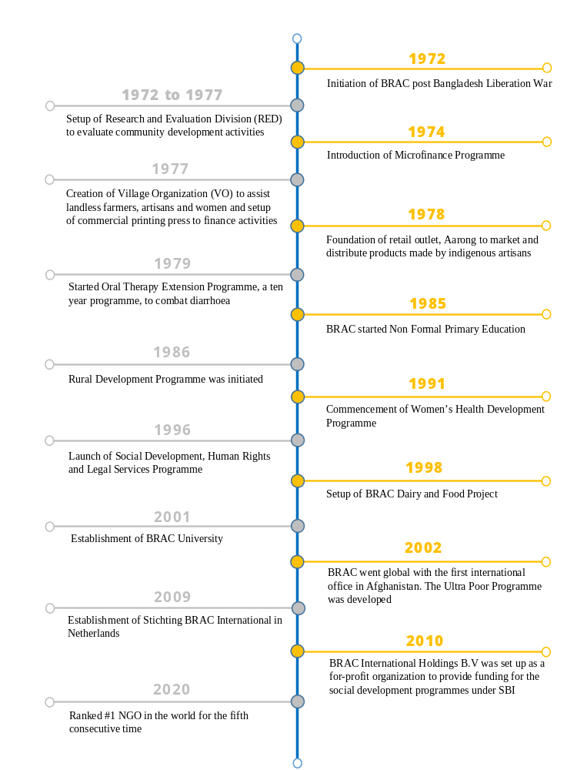

2.2 BRAC Social Enterprises at a Glance

 |  | 
 |  | 
 |  | 
 |  | 

2.3 BRAC International
BRAC International is a part of Global BRAC and it mainly manages all the international operations of the organization. It has two wings: Stichting BRAC International and BRAC International Holdings B.V.

2.3.1 Stichting BRAC International
Stichting BRAC International (SBI) is a Dutch legal entity set up in 2009 as a non-profit foundation in the Netherlands to manage and administer all BRAC entities on a global scale. Development programmes include health, education, agriculture, livelihoods, targeting the ultra-poor, human rights and legal services programmes.

2.3.2 BRAC International Holdings B.V
BRAC International Holdings B.V (BIHBV) is a wholly owned subsidiary of SBI incorporated in 2010. BRAC International’s microfinance programmes, investment companies and regulated finance companies, and social enterprises are consolidated under this wing. It provides financial services to people who are financially constrained and are not in position to avail formal banking facilities. The income generated is mainly used as a source of funding for the social development programmes under SBI. Social enterprise program includes seed production and distribution in Uganda.

2.3.3 Countries operating in
Region | Countries | Initiated in | Programmes
Asia | Afghanistan  Philippines  Myanmar  Nepal | 2002  2012  2013  2015 | Health, Education, CDP, CCAP  Health, UPG  EPRP, AFSL, MF  YE, SDP, Health, AFSL
Africa | Uganda  Tanzania  Sierra Leone  Liberia  Rwanda  South Sudan | 2006  2006  2008  2008  2018  2007 | AFSL, Education, ECD, YE, EPRP, Health, UPG-DI, MF  ECD, YE, WESOLVE, MF  AFSL, YE, Health, EPRP, MF  AFSL, Education, YE, UPG, Health, MF  MF  AFSL
Table 1: Countries BI operates in and associated programmes
AFSL: Agriculture, Food Security and Livelihood
CCAP: Citizens’ Charters Afghanistan Project
CDP: Community Development Programme
ECD: Early Child Development
EPRP: Emergency Preparedness and Response Programme
MF: Microfinance
SDP: Skills Development Programme
UPG: Ultra-Poor Graduation
UPG-DI: Ultra-Poor Graduation-Disability Inclusive
WESOLVE: Women Empowerment through Solar Value chain for Economic Development
YE: Youth Empowerment

2.4 Microfinance Programme at BRAC International
Over the last 40 years, BRAC Microfinance has grown to become one of the world’s largest providers of financial services, operating in seven countries across Asia and Africa.
Research has shown that microfinance helps making financial services accessible to the poor, who are not able to avail formal banking services, thereby reducing vulnerability to health shocks or natural disasters as the poor can borrow or withdraw savings to resume economic activity. This is why the microfinance programme particularly addresses the needs of target populations such as rural women, youth and adolescents, landless poor marginal farmers, migrant workers, urban poor and small entrepreneurs.

Figure 1: Some products and services of BI Microfinance programme

How does BRAC select its microfinance clients?
The clients mostly approach BRAC requesting for membership of a local group called “village organization”. The VO, made up of 15 to 25 women will choose to admit her after they ensure she can be trustworthy. Loan requests are then verified by BRAC staff who meets with the client and visits their household or business to understand their credit needs.
The microfinance programme does not lend to women who are too poor and weak to support debt. That is why there is the Ultra Poor programme which offers them a combination of asset transfer, financial services, basic healthcare and social integration.

What does BRAC do if clients are unable to repay?
- There are options for rescheduling and refinancing which offers the flexibility to defaulters who intend to repay loans but are not able to due to some circumstances.
- BRAC has a cumulative realization rate of 96%. When borrowers are totally unable to repay the loan, BRAC writes off their loans. For that, there are roughly 4% loan provisions of the loan portfolio for bad debts.
- In some exceptional cases, defaulters who are known to be able to pay and also create conflicts among other clients are sued.

How is the microfinance programme funded?
Microfinance operations do not rely on donor funding. One third of the programme is funded by savings, one third by retained earnings and the rest by borrowings from a commercial bank. BRAC is charged higher rates of interest on its loan compared to other banking institutions. This partly explains why microfinance providers such as BRAC charge higher interest rates than commercial banks to cover greater operating costs and higher costs of lending.

What does BRAC do with the revenues?
All revenues generated from the microfinance operations are reinvested into the programme. This is legally required of all NGO microfinance providers under Microfinance Regulatory Authority (MRA).

Highlights: (For the year 2019)
- Total number of borrowers: 646442
- Total loan disbursement for the year: $298.68 million
- Percentage of female borrowers: 96.23%

2.5 Internship Experience
My internship at BRAC International was a whole new experience. Being selected for doing an internship at BRAC is very competitive and after applying on their website, I got called for an interview just after some days.
I joined BRAC International at the 7th floor of BRAC Centre at Mohakhali on the 7th of February 2021 for a 3-month long internship as an intern of finance and accounts. The tenure was later extended for 2 more months.
Working as an intern at BI was worthwhile. I got heads on experience which maybe I would not have got the opportunity in any other organization. The office environment was very safe, well organized, sanitized and friendly. However due to Covid-19 pandemic, only around 50 people were allowed on the floor and therefore, we had to come to the office on a roster basis.
My work responsibilities were very diverse and I got to learn about several operations, if not all and work techniques of an international organization. I also got to practice very advanced level functions of Microsoft Excel and my overall computer skills greatly improved. Online communication was through Skype. My work responsibilities basically included:
- Worked with all country accounts and consolidation files of BRAC International Holdings B.V.
- Updated data collection reports, trend reports and management reports.
- Worked on reconciliation of transactions.
- Prepared budget consolidation files and budget variances.
- Reviewed financial statements to be sent to auditors.
- Prepared balance confirmation letters for auditor after reconciliation of accounts.
- Worked on ERP to prepare Chart of Accounts.
- Worked on project regarding policy change with Director Finance.
- Prepared KYC file for investors in debt programme of BI.
- Attended training session on internal controls, risk management and internal audit processes of BI.

- The Budget
- Budgetary controls
- Budget variance
- Performance

CHAPTER 3: LITERATURE REVIEW

3.1 The Budget
Budget acts as a financial plan for a specific period to estimate revenues and expenses. It is a sum of finances allocated for a particular purposes and the summary of intended expenditures along with proposals on how to meet them. Economic entities prepare their budgets in order to effectively manage their business and resources through a detailed planning of their activity. Budgets help economic entities achieve their objectives, coordinate the activity, empower and motivate managers and employees, offering the possibility to control the activity in an effective manner, to make best decisions, to identify the aberration of actual figures from the budgeted ones and to approve and implement corrective measures.

3.2 Budgetary controls
Budgetary control is the process by which budgets are prepared for the future period and are compared with the actual performance for finding out variances if any. The comparison of budgeted figures with actual figures will help the management to find out variances and take corrective actions without delay.

3.3 Budget variance
A budget variance is a measure to compare budgets with actual figures for a particular accounting category. A favorable variance means positive variance or gain. An unfavorable variance indicates negative variance or budget shortfalls. If variances are considered to be material, they will be investigated to find out the reason and get a solution. If this variance persists over a long period of time, management should consider evaluating the budget process. Variances between budgeted and actual costs lead to modification of business goals, objectives and strategies.

3.4 Performance
Performance represents a certain level of the expected significant results obtained and involves achieving organization’s objectives in the long run. It can be considered a quantification and evaluation of all efforts made by the entity and performing the activity in terms of competitiveness, competitive advantage, efficiency, effectiveness, quality and progress. There are many ways to measure performance based on indicators such as turnover, market share, rates of return, comprehensive income, earnings per share, investment or equity, or qualitative indicators such as the level of customer satisfaction, product quality, welfare and employee satisfaction, innovation rate and employee training.

3.5 Budget and Performance improvement
It is believed that budgets support performance improvement. The efficacy of decisions made and the enhancement of performance can also be accomplished through budget planning and analyzing budget variances. There are many ways in which budgets can influence the entities’ performance. It predicts the company’s performance by estimating the takings and outgoings expected to be realized. It also provides a reason to monitor the execution and realization of budgets. This allows the staff to follow the plan and get an understanding of what to do to reach stated objectives. Therefore, the individual performance of employees serves as a way to improve performance of the company. Efficient management of resources also reduces the risk of losses. Thus, theoretically, an effective planning through budget leads to an increase in performance. However, there may be some differences between theory and practice which is why this research aims to see whether the hypothesis about the association of budget with performance is supported in real life.

- Financial Planning at BI
- MF Budgeting Process
- Development & Approval
- Implementation
- Monitoring
- Revision
- Annual Review

CHAPTER 4: BUDGETING PROCESS OF MICROFINANCE PROGRAMME

4.1 Financial Planning and Budgeting
Financial planning is a major operation so as to attain goals set for the Microfinance Programme. It involves the development of long term funding strategies for the organization which is broken down to individual entity business plans that include operational forecasts and financial budgets. At the beginning of this financial planning stage, Microfinance objectives must be clearly defined so that budgets and forecasts can be made to ensure a successful implementation of the programme.
Budgeting is an essential financial planning tool. BI normally prepares a five year operational plan along with financial forecasts. These are reviewed, updated and presented before the end of the year as operational budgets.

4.2 Overview of MF Budgeting Process
Budgeting process is an ongoing process which requires a rational and informed process in allocating resources which is why it involves a variety of stakeholders including the Board of directors, management and employees.
Budgets for Microfinance programme is normally established on a yearly basis but occurs with continuous monitoring throughout the year. New budgets are developed with the most recently approved budget as a beginning point and reformed accordingly from year to year in response to changes in economic, organization or programme related matters. At least past five years operational and financial information are included in the budget to see the trend and analyze it critically.

Figure 2: Budget processes

4.3 Steps in the Budgeting Process

4.3.1 Budget Development and Approval
Budget development process typically starts with a meeting between country microfinance team and BI HO. The team must clearly define the operational goals and business strategies to the BI HO and set the target plan for the MF programme.
The process flow for MF budget development and approval process is:
At Country Level:
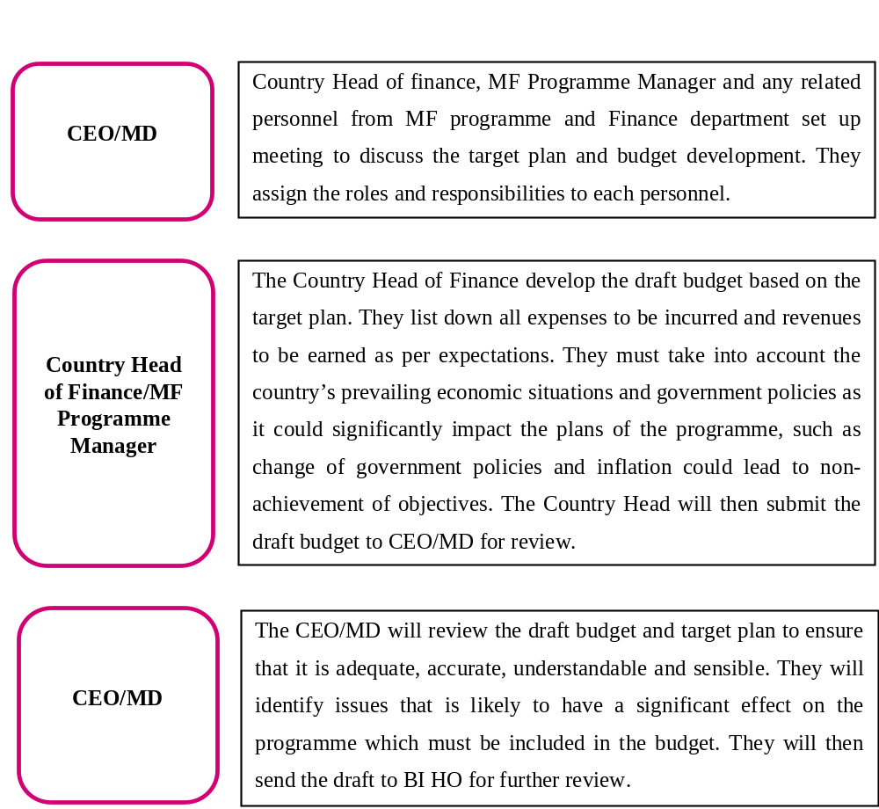

At BI HO Level:
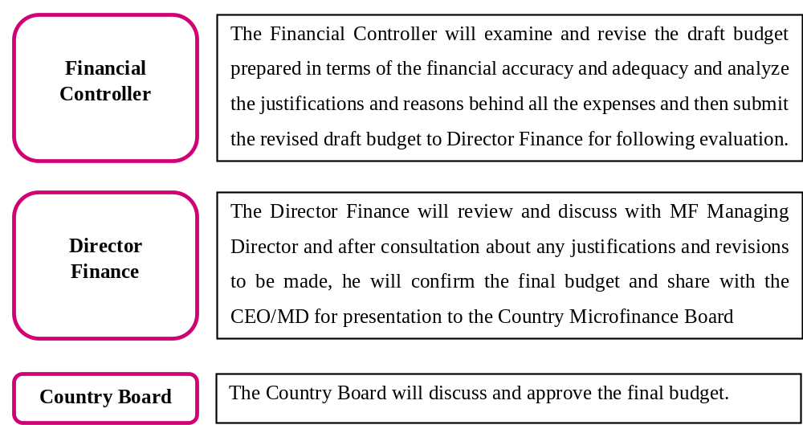

4.3.2 Budget Implementation
After approval of the draft budget and target plan, implementation of the plan will initiate. Firstly, the approved budget will be transferred to the MFI programme and finance staff so they can work on it. It will be communicated and understood by all levels to make sure that there is an effective and qualitative implementation of the budget.

4.3.3 Budget Monitoring
Budget monitoring involves comparing the actual financial outcomes against the approved budget to assess the progress of the MF programme. This could highlight income deficits, expense overrun or difficulties in attaining operational goals. The early detection of potential issues through monitoring would enable the management to take necessary corrective actions as required.
Below are the steps taken during budget monitoring:
- The Country Head of Finance will prepare monthly MF Programme budget variance report that compares approved budget with actual data that is extracted from accounting system. Huge variances are then discussed with the Manager.
- The Country Programme Head or Manager will justify and document the reason for these differences and submit a progress report to the CEO for review and approval.
- The CEO will monitor on a semi-annual basis with Country Head of Finance to evaluate the overall performance. If there is detection of any financial problem, corrective actions will be taken. Immediate action should be taken when there are high variances from budgeted income and expenses. Delays in resolving these issues can result in deficits, operational problems and potential difficulties with funding sources. The CEO will decide about the documentation of any follow ups.
- The CEO will present the achievements against budgets to Board of Directors. They will discuss and agree on the action plan in case of any deviance and follow up of the plan will be made to ascertain that the action is completed as per schedule.
- The Director Finance and BI management will review progress report and monitor overall operational position of the programme and consolidate the actual performance against approved budgets and present to the Board.

4.3.4 Budget Revision
Adjustments to approved budget due to shortage or excess of funding may be done as a result of:
- Unanticipated change in staffs causing additional expenditures.
- Price increase of materials required for the programme.
- Changes in local law and regulatory systems.
A solution for inadequate budget for specific line item is to transfer funds between budget line items. Such transfer, if within the same expense category can be allowed in situations where a specific line item is short of budget and another with excess budget allocated.

4.3.5 Annual Review
Each year in September or October actual results are reviewed and compared against the budget for the period. It reflects the budgeting and implementation performance effectiveness and shortfalls to be addressed during the development of next year budget.

- Introduction of research
- Questionnaire analysis
- The Econometric Model
- Findings
- Conclusion
- Recommendations

CHAPTER 5: RESEARCH AND ANALYSIS

5.1 Introduction
This chapter covers the main topic of the report and the study and conclusions based on the research made. We try to answer the question: Do budgets help an economic entity to improve performance?

5.1.1 Research Structure
There will be two approaches to conduct our research: A practical approach and a statistical approach.
To verify in a practical manner how budget variances relate to performance, a questionnaire was conceived to get an overall image about the budgeting processes of the company and about the perceptions of the staffs. However, the questionnaire’s result is independent of the regression analysis that we will perform (statistical manner) as the variables will consist of only financial indicators collected from the annual reports. Nevertheless, some answers from the questionnaire will be considered while analyzing the results and drawing conclusions.

5.1.2 Data Collection for Questionnaire (Practical approach)
The questionnaire was prepared using the common Google Forms platform and the link was sent to the staffs of BRAC International via email and Skype. The study was conducted between April 2021 and June 2021 and registered a response rate of about 53%, which is about 15 people only due to expressed limitations. Responses came from employees operating in different levels of activities. Those who completed the survey were mainly financial analysts, interns, financial controllers, general managers in finance and risk management, head of finance and head of audit. Most of them had a very long work experience working at BI ranging from 3 months to 11 years. 75% of the respondents are actively involved in budgeting processes, 12.5% know about the budgeting activity but do not work with this tool, and 12.5% never involved in budgeting.

5.1.3 Sample Size for Regression analysis (Statistical approach)
The sample size of the regression analysis was taken as data from annual reports and financial statements for 5 latest consecutive years. We could not and did not collect more than 5 years data as they were not available and also factors such as interests, inflation, political aspects and management changes could influence the data in the older years.
Note: Multiple choice questions were used which allowed respondents to choose one or more answer. Therefore for some answers may have total percentage exceed 100%.

5.2 Questionnaire results and analysis

5.2.1 Question #1
Firstly we wanted to know if the staffs believe that budgets contribute to the improvement of performance so that we can confirm whether the regression analysis is worth doing or not. 75% of the respondents consider budgeting activity very essential to improvement of performance, 12.5% think that it contributes only if properly done, 12.5% do not see budget as a tool to improve performance of the company. 0% were unsure.

Figure 3: Do budgets contribute to improvement of performance?

5.2.2 Question #2
Next, we want to know about the ways that they believe budget contributes to the increase of performance. 37.5% of respondents believe that effective resource management increase performance while 50% attributed this role to the ability of budgets for effective control of business, leading to performance. 25% considered important that budgets can detect deviations from actual values and therefore allows managers to take corrective measures on time. 12.5% determined that budgets do not help in performance improvement.

Figure 4: How do budgets lead to performance improvement?

5.3 The Econometric Model
To further analyze whether budgets and performance at BRAC International are related, we tried to create an econometric model to show the relationship between two variables: budget variance and performance of latest five consecutive fiscal years.
The dependent variable will be performance. We will start from the hypothesis that budgets do help increase the company’s performance. We assume that as budget variances are lower, performance level grows. We need to estimate how performance changes with escalating or decreasing budget variances. Therefore, the dependent variable, performance is a linear function of the budget variance. The econometric model can be presented as:
Y = c + (m * X) + e_{t}
f (budget variance) = α + (β * budget variance) + e_{t}

α - The intercept determines the magnitude of the dependent variable (performance level) when the independent variable (budget variance) is zero.
β - The change in performance when budget variance increases by one unit, also known as the gradient of the line (slope).
e_{t} - The error that arises from factors that were not included in the model or due to other limitations.

5.3.1 Developing the econometric model
We first have to quantify the two variables.
To quantify the budgets variances, we gave a value of 1 to 5 based on the range of variances for each year as shown in the table below.
Value | Variance Level
1 | >=41% or <0%
2 | 31% to 40%
3 | 21% to 30%
4 | 11% to 20%
5 | 0% to 10%
Table 2: Quantifying Budget variance
The last question from the survey that we will analyze takes into consideration how performance is measured. Usually, more than one way are used to quantify performance.
75% measure performance using net result of the year, 25% take into account turnover rate, 25% use rates of return and ROE and 50% of the respondents use other various methods of measuring performance such as PAR, OSS, Solvency ratio, real time burn rate, loan disbursement, etc. 12.5% use qualitative tools such as customer satisfaction.

Figure 5: Performance measurement methods

Following the responses, we can see that net result of the year is the most appropriate measure of performance. To have the same measuring scale (values 1 to 5) for both variables, we have to develop a scale of values to quantify performance as well:
Grade | Performance level based on net result of the year (in USD)
1 | <=11,000,000
2 | 11,000,000 to 12,000,000
3 | 12,000,000 to 13,000,000
4 | 13,000,000 to 14,000,000
5 | >= 14,000,000
Table 3: Quantifying Performance level

5.3.2 Linear regression analysis calculation
The next step is the calculation of the linear regression that were performed using Excel function: DATA ANALYSIS, REGRESSION.
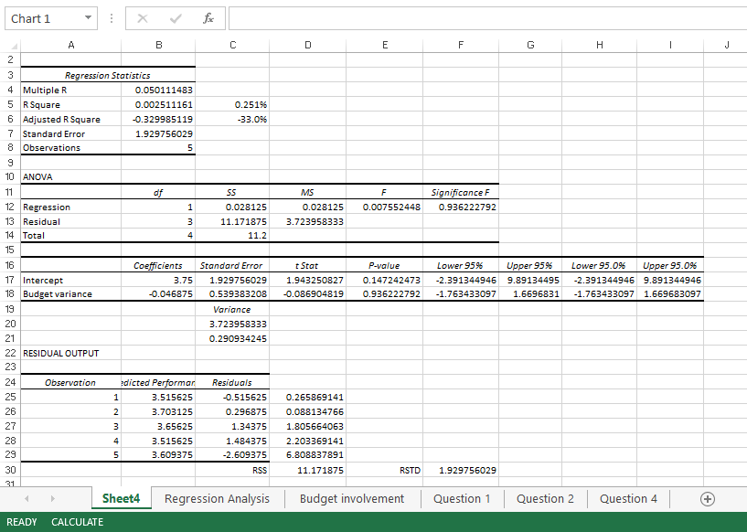

5.4 Findings
We will do the following interpretations from our regression analysis:
- Analysis of Linear Function

f (budget variance) = α + (β * budget variance) + e_{t}
Intercept, α | 3.75
Slope, β | -0.046875
Table 4: Analysis of Linear function
Y = 3.75 – 0.05X + e_{t}

Parameter α has value greater than zero whereas parameter β is negative. The intercept, α shows that when budget variance is zero, the average performance level of the entity should be 3.75 points. On the other hand, the slope, β is -0.05, so when budget variance increases by one unit, the net result or performance level should decrease by 0.05 points that is they are negatively correlated. This statement is true as we already know that negative budget variances indicate shortfalls and may be attributed to decrease in performance level.

Figure 6: Linear Function Graph

- Calculating dispersion of errors and estimator’s variance
We will now calculate dispersion of error from residual sum of squares, and estimator’s variance for the estimated intercept and slope.
 | Residual sum of squares | Dispersion of errors (√(RSS/n-2)
Residual (Error) | 11.171875 | 1.929756029
Table 5: Dispersion of error
For estimators, generally when the variation is smaller, the estimation is more reliable and there is less error.
Estimate | Standard error | Variance (Standard error squared)
Intercept, a | 1.929756029 | 3.723958333
Slope, b | 0.539383208 | 0.290934245
Table 6: Estimator variance
If we analyze the values obtained, we see that the variance of the estimator b, which is attached to budget variance, is fairly small having a value of 0.29, so we can say that the estimated value of b is near to the true value of the parameter β.
The standard error is used to determine confidence interval.

- Analyzing confidence intervals for estimators
When developing the econometric model, significance level was α = 5% as permitted level of error.
 | Lower 95% | Upper 95%
Intercept, a | -2.391344946 | 9.891344946
Slope, b | -1.763433097 | 1.669683097
Table 7: Confidence intervals
We find that with a probability of 95%, intercept estimate, a lies in the interval {-2.39, 9.89} and slope estimate, b lies in the interval {-1.76, 1.67}.

- T-test statistics and P-value
To validate the model and to formulate conclusions based on the sample that we analyzed, we must test the significance of the model’s parameters. This will allow us to determine whether budget variances have any impact on the net results of the year of the economic entity.
We will start from the hypothesis that slope, β = 0, that is, the assumption that no matter how much budget variances increase or decrease, net result will not be impacted. Then we will calculate the statistics of the t-test shown in the output given by Excel after running the regression. We will also find critical value t using the t-table with df = 4 and confidence interval = 95%. From this, we get critical value t = 2.776
 | t-stat | p-value
Intercept, α | 1.943250827 | 0.147242473
Slope, β | -0.086904819 | 0.936222792
Table 8: T-test statistics data
If t lies in the interval {-critical t, critical t}, then the null hypothesis of the irrelevance of budget variances is not rejected. In this case, t = -0.087 so we should not reject the hypothesis. This means there is no statistically significant link between budget variances and net results of the year of the entity.
We should confirm this result by analyzing the probability associated with t-test which is denoted by p-value. Usually, if p-value is greater than our significance level, α = 0.05, the null hypothesis should not be rejected. As we see from the above table, p-value = 0.936 which is greater than 0.05. So we can confirm from the statistics that budget variance is statistically insignificant for performance level obtained at the end of each year.

- Coefficient of determination and Correlation
Multiple R | 0.050111483
R Square | 0.002511161
Table 9: Coefficient of determination and correlation
From the coefficient of determination R square, we find that only 0.25% of the performance variance is explained by the model. As it is almost 0%, the model does not explain any of the variation in the dependent variable around its mean.
The multiple R which is the correlation coefficient is 0.05. It measures a very small intensity of the relationship between budget variance and net results of the year which is almost negligible. The result matches with the t-test statistics that there is no relationship between the two variables.

5.4.2 Findings Summary
Practical Approach (Questionnaire) | Statistical Approach (Econometric model)
- Involved real life survey questions answered by staff of BI.  - The majority (75%) of the respondents view budgets as very important for the performance of the company.  - 50% of them attributed this importance to increased effectiveness in control of business and 37.5% agreed with effective resource management.  - The practical approach is more in favor of budget’s importance related to entity’s performance. | - Involved collecting financial data from annual reports rather than qualitative data based on staff perception.  - Slope of linear function is negative which shows budget variance and net results are negatively related. When one increases the other decreases.  - The t-test shows that budget variance does not impact net results of the year. This is confirmed by the probability p-value which is greater than 5% significance level.  - The correlation coefficient also could not find any relevant link between the two variables.  - The statistical approach does not support link of budget with performance.
Table 10: Summary of Findings from questionnaire and econometric model

5.5 Conclusions
From a theoretical perspective as well as from a practical side coming from responses of the staffs of BRAC International, it is easy to say that budgets are really management tools that contributes to performance improvement. From our questionnaire questions that we graphed, most replies came in favor of budgets. However statistically speaking our results show that the relationship between budget variances and performance is not validated through the model that we developed. Regardless of this result, generally any instrument, tool or method, such as budgets that contributes to performance improvement should be considered essential. As we have seen in Question #2 from the questionnaire questions, most of the respondents believe that budgets lead to effective resource management and effective control on the business, helping in performance improvement. This helps the management take important decisions as it is also a prediction of future gains or losses, thus relevant measures are pre-planned. To conclude, we can say that though not statistically proven due to limitations, budgets are surely useful tools that add to superior performance.

5.6 Recommendations
Based on the findings and conclusion made, some recommendations on how to improve budget processes for performance improvement are suggested below:
- Even though it is seen that the budget processes of BI is very well developed and implemented, there is still a 12.5% of the employees who believe that budgets do not contribute to performance improvement. So the management should deliver an open and clear communication with its employees to determine any discrepancy and address the importance of developing effective budgets through training programs.
- Also improve the communication system between the top managers and low level managers so their work can be properly coordinated and they work together to take measures in case of faulty budgets.
- From the questionnaire it was seen that the pandemic covid-19 was a reason for adverse budget variance. Therefore, the management should try to cut down any unnecessary cost as due to the pandemic, revenues of the loan takers are very limited. In this way, revenues and costs of the company could be balanced.
- While developing the budget, the management should not only consider previous budgets but also understand the dynamics of the market, the competitive environment, the behavioral changes of customers, etc.
- Instead of simplifying budget forecasting, the management could build econometric models that take into account key factors such as inflation, GDP and interest rates. Though the level of complexity would increase, the risk of budget deviation would significantly be more limited.
- Another observation made was that the finance department worked very limitedly with other departments while preparing their budgets. Collaboration with the other departments could very well translate into a better budget.
- Go for a proactive approach rather than a reactive approach. That is, prepare and try to find out discrepancies during budget development and get solutions rather than taking corrective actions after the monitoring and review of the budget.
Finally as a parting word, I could say that budgets in some way or the other could either go for improving the performance level of the entity if properly developed, and could also affect negatively the performance if recklessly processed. So it is all the job of an effective and hardworking management to cater for all the financial operations of the company so as to ensure the best interest of everyone.

References
Admin. (2020). How to effectively reduce budget deviations? PMR Market Experts. Retrieved from https://www.pmrmarketexperts.com/en/effectively-reduce-budget-deviations/
Bidita, M. (Ed.). (2020). Stichting BRAC International Annual Report 2019. Stichting BRAC International. Retrieved from http://www.brac.net/images/reports/2019/STICHTING-BRAC-INTERNATIONAL.pdf
Bidita, M. (Ed.). (2020, December). BRAC Life. Retrieved from http://brac.net/images/downloads/LIFE-BI_Magazine-December_2020.pdf?24122020
BRAC Communications. (2020). BRAC Microfinance Programme. Retrieved from https://brac.net/images/factsheet/MF_Briefing_Doc_English.pdf
BRAC International Holdings B.V. Annual Report 2019. (2020). Retrieved from http://www.brac.net/images/reports/2019/BV-audit-report.pdf
BRAC International Holdings B.V. Financial Statements 2015. (2016). Retrieved from http://www.brac.net/images/reports/bi/FS-BRAC-International-Holdings-BV-2015.pdf
BRAC International Holdings B.V. Financial Statements 2017. (2018). Retrieved from https://www.bracinternational.nl/nl/wp-content/uploads/2018/08/Consolidated-FS-2017-BRAC-International-BV-Final-14-June-2018-unsigned.pdf
Budgetary Control. Money and management related articles on finance, business management, office management, investment, marketing, planning, accounting, Auditing etc. (2021). Retrieved from https://accountlearning.com/budgetary-control-objectives-advantages-disadvantages/
Chen, J. (2021, May 19). Budget Variance. Investopedia. Retrieved from https://www.investopedia.com/terms/b/budget-variance.asp
ShineTheme. (n.d.). Our ventures. BRAC Enterprises. Retrieved from http://www.brac.net/enterprises
ShineTheme. (n.d.). Vision, Mission and Values. Retrieved form http://www.brac.net/vision-mission-values
Wikimedia Foundation. (2021, May 19). BRAC (organisation). Wikipedia. Retrieved from https://en.wikipedia.org/wiki/BRAC_(organisation)

