

Assessment of a Project of Local
Sourcing Milk

A CASE STUDYOF ARLA FOODS BANGLADESH LTD.

Assessment o


Internship Report
On
Assessment of a Project of Local Sourcing Milk:
A Case Study of ARLA Foods Bangladesh Ltd

Submitted To:
Muhammad Enamul Haque
Assistant Professor
Department of Business Administration,
United International University

Submitted By:
Afsara Tasnim Chowdhury
ID# 111 141 299
United International University

Submission Date: 23rd May, 2019
LETTER OF TRANSMITTAL

23rd May, 2019
Muhammad Enamul Haque
Asst. Professor,
Department of Business Administration,
United International University

Subject: Submission of Internship Report

Dear Sir,
I would like to submit my report titled “A Project of Arla Foods Bangladesh Limited to Utilize the Local Sourcing of Milk” which is a part of the BBA Program curriculum. It is great achievement to work under active supervision.
I have got the opportunity to work in Arla Foods Bangladesh in ‘Project Department’ under this project and also under the supervision of Mr. Kazi Reshad Islam, Head of Project.
While doing this project the academic and practical exposure that I got shall remain as an experience of a lifetime. Not only I had learned about the organizational culture of such a prominent dairy organization but also i had developed a network with the corporate environment.
I shall remain grateful if you are kind enough to receive this report and provide your valuable judgement. It will be my pleasure if you provide your valuable perspective on this report and find this report useful and informative.

Sincerely Yours,

________________________
Afsara Tasnim Chowdhury
ID: 111 141 299
United International University

ACKNOWLEDGEMENT

First of All, I would like to take this opportunity to express a deep sense of gratitude towards almighty ALLAH for giving me the ability to complete my internship as well as the report within the stipulated time.
I am really fortunate that I had the kind association as well as supervision of Mr. Muhammad Enamul Haque, Assistant Professor, United International University. I am deeply honored and indebted for his whole-hearted supervision during my organizational attachment period.
My gratitude goes to entire CCC-Career Counselling Center, of United International University for arranging Internship Program that facilitates of theoretical knowledge with real life situation.
Last but not the least, I am also grateful to have Mr. Kazi Reshad Islam, Head of Project- Arla foods Bangladesh, as my supervisor. And convey my gratitude for helping me in furnishing the report. Moreover, I would like express my gratitude to my Arla Foods Bangladesh fellows, seniors and colleagues who gave me good advice, suggestions, inspirations and support. I must mention the wonderful working environment and group commitment of this organization that has enabled me to deal with lots of things.

EXECUTIVE SUMMARY
This report is prepared on the basis of my 5 months working and practical experience at Arla Foods Bangladesh. This internship program helped me to learn about the practical scenario of dairy market in Bangladesh and Arla’s position in this market. The demand of milk products for the large domestic market of Bangladesh was met through importation of subsidized milk, powder milk and milk products from developed countries. During the period of 1989-90, the total worth of milk and milk products that Bangladesh imported was 400 million taka just to meet a short fall of 40 percent of domestic demand. The milk sector of Bangladesh has failed to provide sufficient supply for liquid milk. Government took some initiatives like importing powder milk and developing dairy farms to the to the private entrepreneurs’ levels just to fulfill the shortage of milk products. Local dairy farms alone were unable to provide sufficient supply of liquid milk and milk products according to demand of the consumers. Just to fulfill this scarcity of milk products, a large number of companies established themselves in Bangladesh to sell milk product. DANO is one of those companies which has become familiar in almost every household in rural and urban areas of Bangladesh. Mutual Group- A Toll Manufacturing & Distribution Company, established two global brands, known as “Horlicks and Dano”, in Bangladesh. DANO in 2011 separated from Mutual Group and created its own brand as a joint venture with Arla Foods AMBA in Denmark. On the basis of all information, this project was developed and this document will give a brief of their new project. This project will focuses on the needs and wants of the consumer and organization and will create an alignment among every party’s needs and wants related with this projects. Through this project Arla Bangladesh wants to grow their business by ensuring that the dairy products are consumable by every Bangladeshi and people easily can reach their desired high quality products within easy reach. Through quality assurance scheme, Arla Foods Bangladesh will be backing farmers to ensure high animal welfare standards. Farmers and Arla will work together to secure high quality standards throughout the production of raw milk. And for a new project it is important to check the project viability. By using some financial parameters (Like- NPV, Payback, ROI) it has been showed that the project has positive return on investments and good to be undertaken the project. So this project will benefit the Arla in near future and also the related factors of this project.
Job Description of Me:

As an intern I worked under sales department in Project department. In this department I worked as a helping hand of the project manager. This department provide value to organization by working cross functional task with other department to support different projects of Arla. My duty was maintain communication with all the department to prepare project documents and presentation, assist in forecasting and resource allocation, analyzing performance of new projects, maintain business to business communication and observe work flow of third party vendor.

Specific responsibility for the job:
- Preparing project documents and presentations.
- Responsible for forecasting, expense reporting, risk management, status reporting, execution, major deliverables, finances, resource allocations and status.
- Supporting to develop strategy and architecture for clients in alignment with business plans.
- Session coordination
- Taking meeting minutes

Table of Contents
Chapter 1 8
Introduction 8
INTRODUCTION: 9
Origin of the Report 10
Objective of the Report: 10
Methodology: 11
Data Sources of Report: 11
Limitations: 11
Chapter 2 12
Overview of the Company 12
Overview of Arla Foods Bangladesh Ltd 13
VISION, MISSION AND STRATEGIES 14
❖ Vision: 14
❖ Mission: 14
❖ Strategies: 14
Products of Arla Foods in Bangladesh: 14
CHPTER 3 16
Project Local Sourcing of Milk 16
Project Summary: 17
Overview: 17
Projected Products 19
Project Goals: 20
General assumptions: 20
Requirements of the Project: 21
Ownership Modules: 22
Bangladesh dairy capacity and Availability: 23
Arla’s targeted volumes: 24
Chapter 4 25
Findings and Analysis 25
Estimate and cost benefits: 26
Development costs (Fixed): 26
Operational costs (Variable): 27
Benefits of the projects: 29
Cost- Benefit Analysis: 31
Cost- Benefit ratio of this project: 32
Income statement Assumption: 32
Financial parameters: 33
❖ Net present value (NPV): 33
❖ Return on Investment (ROI): 34
❖ Payback period (PBP): 34
CHAPTER 5 35
Alternative Analysis, Constraints and Risk, Conclusion 35
Alternatives Analysis: 36
❖ Strengths 36
❖ Weakness 37
❖ Opportunity 38
❖ Threats 39
Constraints and Risks 39
Constraints and Risks 39
Constraints and Risks mitigation 40
Conclusion: 41
Reference: 42
Bibliography 42

Chapter 1

Introduction

INTRODUCTION:
Part of ARLA FOODS’s historical roots, their DNA, is their constant aim to progress and create something greater and better. Since the cooperative movement began 130 years ago, milk producers and colleagues have worked together to create a common future in the dairy industry. Their achievements over the years have laid the foundations for ARLA FOODS today, which is now one of the world's leading dairy companies.
Every day, we seek to improve and refine what we deliver and develop solutions for the future. These may take the form of new products and new inspiration for our consumers. New technologies and more effective ways of working. More value in the collaboration with our customers. Healthier and more natural foods. Greater social responsibility. A reduced impact on the environment and climate. Improved food safety.
We will not only follow others in the dairy industry - but also help to shape its future, and participate actively in developing the dairy structure of tomorrow and creating new trends in dairy consumption. Therefore, we will keep asking ourselves how we can set the standard for the dairy activities of the future. Are we first? Are we best? Can we research and develop our professional field even more than we do today? Can we challenge ourselves and each other more? They want to do our best and realize ARLA FOODS's full potential.
Arla Foods dates back to the 1880s, when dairy farmers in Denmark and Sweden joined forces with one common goal: to produce and provide the best dairy products, creating new opportunities for business growth. Today we have farmer owners is seven countries in Europe. The two companies behind Arla Foods, the Danish MD Foods and the Swedish Arla, are both rooted in the co-operative movement. . Globally we are 19,000 colleagues across 30 countries and 12,700 dairy farmer owners in Denmark, Sweden, United Kingdom, Germany, Belgium, Luxembourg, Netherlands and Bangladesh.

Origin of the Report
This document has helped to collect, analyze and define high-level needs and features of the project about “local sourcing of milk”. It focuses on the capabilities needed by the organization why these needs and wants exist. The details of how local sourcing of milk project fulfills these organizational needs are briefed in this report.
At the end of my BBA it was necessary to do internship in an organization to gain the practical knowledge besides the academicals knowledge. So I applied in some organization and from them Arla Foods Bangladesh offered me for their internship program. I started there my internship 3rd June, 2018 and completed it 31st October. According to the project need they offered me to extend my internship period to 30th September 2018. During my internship periods, I was reporting to the head of the project and I have visited many rural areas and Arla’s factory to understand the current dairy situation in Bangladesh and Arla’s position in dairy market. Then I have developed local sourcing of milk project modality with the help of my line manager, spreadsheet design for keeping track of rural distributor and many third parties, prepare communication material. A professor of Bangladesh Agriculture University helped me with his valuable information and database.

Objective of the Report:

The Objective of the report can be viewed in two forms:
- General Objective
- Specific Objective
General Objective:
The internship report is prepared to fulfill the Bachelor of Business Administration (BBA) degree requirement under the faculty of UIU- Business School, United International University.
Specific Objective:
More specifically, this study entails the following aspects:
To give an overview of Arla Foods Bangladesh.
- To focus on the new project that they are going to launch and viability of the project to their business.
- To learn the real picture of the dairy market and the position of Arla foods Bangladesh in this market.
- To find the financial viability of this project with Arla’s present situation and how it will influence their progress in the market.

Methodology:
This project was conducted in a systematic manner where the sequence of the steps consists of selection of the topic and the final step was to complete the report. The core part was to identification and and collection of the data; although the classification, analyzing , interpretation and presentation of the vital points was the most important part of this whole project. The complete process of the methodology followed in the study has been explained further.

Data Sources of Report:

Sources of Primary data:
All the necessary information are collected by using:
- Informal discussion with honorable officials.
- Direct observation and work practically.
- Taking interview of the consumer.
- Practical desk job.
Sources of Secondary data:
The secondary data collection source was official website, and the different files of Arla Foods Bangladesh Ltd.

Limitations:
The report has been conducted within a short time frame as I have to prepare this report along with my regular office work. There were some limitations of access to information, which are strictly confidential for the company.

Chapter 2

Overview of the Company

Overview of Arla Foods Bangladesh Ltd
Dano Milk powder is the leading milk powder product in Bangladesh. Dano was introduced in the market in1962 by MD Foods all over the world. MD Foods is a Danish company and operation business in European market Some of Bangladeshi (Former East Pakistan) businessmen were imported Dano milk powder from Denmark in 1962. Basically their market was whole sales point like Moulovi Bazar base. They distribute Dano milk powder all over East Pakistan. They continue their import Dano as scattered from Denmark till 1970. MD Foods was recognized one Bangladeshi person as intender in 1973. Bangladesh indenter was collected & identifies importer demand and authorized indent of importer letter of credit from Bangladesh to Denmark till 1994.
In 1989, MD Foods was setup liaison office in Bangladesh. MD foods basically monitor the market by various activities like sales promotion (Both for consumer & Traders) and advertisement in print and electronic media.
In 1995, Mutual Trading Ltd was got import license of Dano milk powder from Denmark as an exclusive importer in Bangladesh. Mutual Trading Ltd. is only one Bangladesh Company, who can import Dano milk powder from Denmark.
In 1995, Arla foods take over MD foods and merger new company name as Arla Foods Ingredient. Arla Foods Ingredients owned Dano milk powder all over the world.
In 1998, Mutual Trading ltd was setup new factory in Bangladesh for packing of Dano milk powder product as per Arla Foods recommendation and Mutual Trading Ltd changed company name as Mutual Milk Products Ltd.
In 2011, Arla Foods is detached from Mutual Trading Ltd and it would make solely joint venture with Arla Foods amba. This company is established as Arla Foods Bangladesh Ltd.

VISION, MISSION AND STRATEGIES

Vision:
“Vision is to be the leading dairy company in the world through considerable value creation and active market leadership to obtain the highest possible milk price.”
Arla’s aim is to maximize the price paid for our owners’ raw material – the milk. To achieve this objective, we are committed to creating added value and demonstrating proactive market leadership. Being market leader means a strong negotiating position. We wish to be the most attractive dairy company for owners and employees and for customers and suppliers.

Mission:
“The mission is to provide modern consumers with natural milk-based products that create inspiration, confidence and well-being. So the task is to meet your wishes and requirements. By doing so, we create the greatest possible value in the market and maximize the price paid to our owners for their milk.

Strategies:
Arla foods Bangladesh Ltd. has these strategically key Success Factors:
- Strong brands / relationships with consumers
- Research and development
- Innovation and renovation
- Product availability

Products of Arla Foods in Bangladesh:
Arla Foods’ milk powder products are marketed under the brand names of Dano. Dano milk powder provides a series of functional and nutritional properties, making it widely used both as an ingredient in food and dietetic products and in its own right as a consumer product, Company want to hold their existing market and increase sales through Company strategy. To achieve this goal product breadth should be increased through satisfied consumers need. In this connection company’s ranges of milk powder products and its functions are as follows:

- Full cream milk powder – the family’s choice
Give your family the essential energy and nutrition they need with Dano full cream milk powder. Available in Regular and Instant versions, this highly nutritious product has an identical composition to liquid cow’s milk – not to mention an authentic creamy taste. Dano full cream milk powder is also rich in vitamins A and D3 and contains a high level of calcium, essential for development, growth and the maintenance of bones and teeth.
- Filled milk powder – for a good start in life
Dano Daily Pushti is an affordable nutritious solution for your whole family. Produced from high quality milk ingredients, Dano Daily Pushti contains Calcium, Protein and important Vitamins and minerals that are necessary for your family’s everyday wellness. It is also suitable for tea & other milk based foods.
- Dano Mom
Dano Mom is a milk-based nutritional supplement with essential vitamins and minerals for those women who are planning to get pregnant, women who are pregnant and for women who breastfeed their babies to support the quality of breast milk. It meets the stringent international and government standards of hygiene and nutritional quality. Daily 2 glasses of Dano Mom fulfills the daily requirement of 100% Vitamin D, Folic Acid, Iron, 94% Calcium, 70% Zinc and other important nutrients.
- Dano Slim
Dano Slim contains only 0.1% fat, greater amount of Calcium, Vitamin A and Vitamin D. With Dano Slim, you are making an active commitment to health and vitality while getting all the goodness from milk.

- Sterilized canned cream
In addition to powder products. Company supply sterilized cream with all the natural, rich flavor of fresh cream, Contract manufacturing teams are dedicated to seeing each alignment through all phases of development to production, packaging and dispatch.

CHPTER 3

Project Local Sourcing of Milk

Project Summary:
For the fulfillment of academic requirements about getting partial knowledge.For my internship, I applied in some organizations and from them Arla foods Bangladesh offered me to do so. My Internship period has been started in 3rd June, 2018 to 31st August 2018 and they offered me to extend my internship period to 30th September 2018.I was reporting there to the project manager. During my internship period I have visited many rural areas and Arla’s factory to understand the current situation of Arla and dairy market in Bangladesh. Then I developed there this project charter with the help of my line manager and also made a new unique project planning by the help of many external source,
This document will give us a brief knowledge about the products and market of Arla. On the basis of all information, this project was developed. Arla will create a new dimension through this project. It will focuses on the needs and wants of the consumer and organization and will create an alignment among every party’s needs and wants related with this projects. Through this project Arla Bangladesh wants to grow their business by ensuring that the dairy products are consumable by every Bangladeshi and people easily can reach their desired high quality products within easy reach. Through quality assurance scheme, Arla Foods Bangladesh will be backing farmers to ensure high animal welfare standards. Farmers and Arla will work together to secure high quality standards throughout the production of raw milk. Because animal welfare and ownership over the whole value chain process will make it possible to provide milk with the implied benefits of better tasting, healthy and more natural dairy products.

Overview:
Focusing on the local people all around the country. Arla Bangladesh has decided to launch some container plant in many rural areas through they can easily reach the consumers of remoted areas, So their main focus is to ensure continuous distribution of dairy products and Arla products will available to every sphere people within easy reach. And they also wants to ensure the wellbeing of farmers so they can easily reach their milk buyers like Arla within minimum efforts and struggle and sell their products easily.
Why this project is needed:
Through discussing some benefits of this project, we can easily identify why this project is needed.
- It will preserve Small Local Farm Land and will cover aspects such as animal welfare, milk quality and the environment. They will help farmers by financing the local farmers so that the farmers can focuses on the welfare of their animals and the quality of the milk.

- It will reduce Food Miles - “Food miles- is a term that used to describe the total distance that the food was traveled from the food originated or produced to the distribution or sold the ultimate consumer. It was accumulated during transportation and the perishability of the products. Because it will reduce the food miles that the product traveled from the place it produce to the place it is sold. So it will reduce the fossil fuels that burn for the travel and also increase the longevity of the product which is important for perishable products. So In Bangladesh, it is very important the quality of the dairy products with different variety, liquid milks are available in many farms but it is very difficult for our farmers to provide those liquid milk to every areas and the consumers desired products with variation, Arla will try to provide variants of products by implementing containers plants in remoted areas. So that farmers can easily utilize their sourced milk by selling their milk to the distributor like Arla.
- It will promote Accountability, when the source of milk is local, • Now-a-days people are more concerned about the product origin and details. They want to pay little bit more about those products which are in good quality and the purchase of the product supports beyond economic consideration and takes into account environmental, ethical and social factors as well. This kind of awareness encourages local farmers to use good agriculture practice and helps to be more accountable for safe ecological practices which may include not using chemicals and other bad things which has impact on human being. So this project will support local families and bring the community together

Projected Products

The following table presents the major products of this project for those objectives to be achieved-
  Laban | 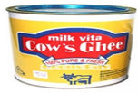  Ghee |   Cream | 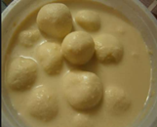  Rasmalai
  Chocolate milk | 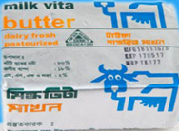  Butter | 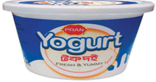  Yogurt | 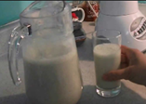  Borhani
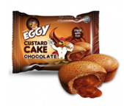  Custard cake | 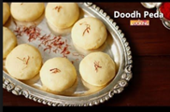  Pera |   Rice pudding |   Rossogolla
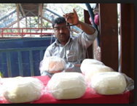  Cheese/paneer | 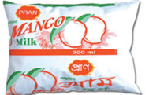  Fruit flavored milk | 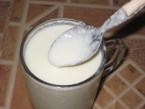  Butter milk | 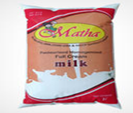  Matha
  Dhaka Cheese | 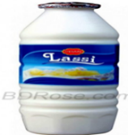  Lassi | 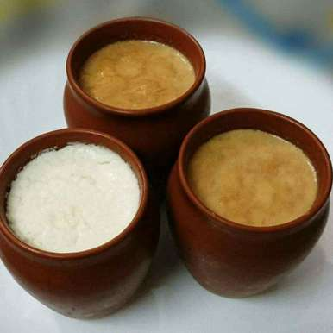Sweet Curd | Pudding

Project Goals:
- Impact on sustainable development goals- To create sustainable development in the business and dairy market
- Environmental and Responsible production and consumption- Sustainable farming Climate so that quality of milk will remain good and the responsible production and consumption
- Water and Affordable and clean energy- Use of proper water and energy and also utilize the remoted areas energy in a right way.
- Zero waste- One of the main focus is to make zero waste cause through this project it will produced to the areas where it will be sold to the consumer. Because it will reduce the food miles that the product traveled from the place it produce to the place it is sold. So it will reduce the fossil fuels that burn for the travel and also increase the longevity of the product which is important for perishable products.
- Animal welfare and Good health and well-being of the farmers are main concerns.

General assumptions:
- Arla Foods Bangladesh Limited is considering local sourcing option as part of its 2022 ambition on the working assumption that it reaches a sizeable business to do the necessary investments and develop facilities.
- It will be easier for Arla Bangladesh to grab the market demand by local sourcing of milk and producing dairy products in Bangladesh.
- Arla foods Bangladesh can directly linked with the local consumer and can contribute on nutrition, health of their consumers. It also can ensure the availability of their product for most vulnerable areas.

- It will be easier for Arla to build a trustworthy and strong relationship with vendors and suppliers of milk with whom are not possible to meet face to face.

Requirements of the Project:
The most important aspect of the project is finding suitable location for the local sourcing of milk. Various factors are depending on it because nearness to market will decrease the transportation cost and it will reduce the loss due to spoilage of highly perishable milk and production during storage and transportation.
Dairy farmers
Willing to participate/sell and situated locally

Land & Infrastructure
Minimum 5000 sft Plant shade, collection and admin buildings
Equipment
Container plant and additional equipment as required

Arla local Sourcing of milk project

Plant Owner
Preferably a local business owner

This project calls for minimal infrastructure requirement but within this requirements they wants to ensure the quality and availability of dairy products. Container plant is the concept to look after for the project.

Ownership Modules:

Depending on the business volume and strategic objective, Arla will take the call regarding the options. Other options may also be explored which will impact on the time line. However, land procurement in Bangladesh is a time-consuming process, which requires the active participation from other functions including external land law experts.

Option 1 | 24 months
Option 2 | 12 months
Option 3 (all 3P owned) | 6 months
Option 4 | 2 months

Bangladesh dairy capacity and Availability:

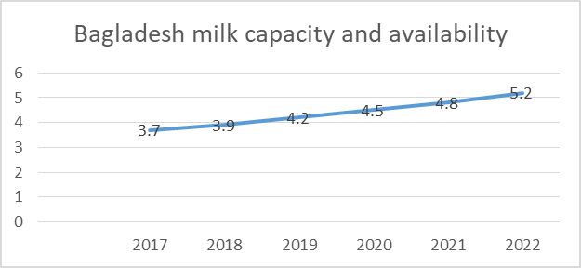

- Arla can increase business activities in Bangladesh because here we can see that the growth will be increased day by day, Arla has to keep in consider that the growth does not have any adverse impact in the local people and local market.
- Arla foods Bangladesh can directly linked with the local consumer and can contribute on nutrition, health of their consumers. It also can ensure the availability of their product for most vulnerable areas.

Arla’s targeted volumes:

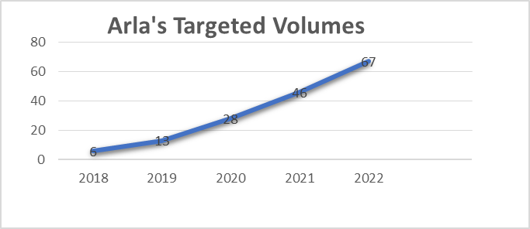

The targeted segment is growing fast so Arla needs to satisfy them with their variants of Milk. As Arla targeted that they will increase their production which will cover 75% target within 2022.As we see in the graph, If the production increased by 28000 ton every year so it will be not possible for any Arla Bangladesh to import in more than 20000 ton every year and manufactures will not permit it.

Chapter 4

Findings and Analysis

Estimate and cost benefits:
This section provides a summary of estimated spending to meet the objectives of local sourcing of milk. Here we have shown a preliminary spending that reflects on the costs for the whole project investment lifecycle. It is presenting the probable funding that is required for the project and budgeting all. So, it is presenting the costs for the project design, development cost, material cost, operational and consumable for the proposed project. It analyzed each and every year cost for the project life cycle and it can be offsets by the benefits that gained by this projects.
While estimating the cost and benefits we need to consider the below assumptions that will help to consider the estimated cost and benefits.
- Food mile for at least half of the production will be restricted within 10 km
- Plant capacity shall be 3000 to 5000 liter / day
- Local demand supply gap will not be more than 50%.
- Additional amount will be sold in bigger market

Development costs (Fixed):

Development costs considered as the direct costs accompany incurs during its research and development activities. It is absorbed into the products fixed expenses and distributed into the par unit cost. For each option described above cost has been estimated. When determining the overall cost, the calculation includes costs for fixed asset (land, infrastructure, and equipment) and variable cost (personnel, soft equipment, and training).
Assumption:
- Land lease- 4000sft (Rate-2.50€/sft)
- Infrastructure: 2000 sft (Rate: 20.00 €/sft)
- Equipment: One time (150000€)
 | Year 1 | Year 2 | Year 3 | Year 4 | Year 5 | Remarks
Land Lease | 10,000 | 10,500 | 11,025 | 11,576 | 12,155 | 5% rent increment yearly
Infrastructure | 40,000 | - | - | - | - | one off cost
Equipment | 150,000 | - | - | - | -
Total | 200,000 | 10,500 | 11,025 | 11,576 | 12,155
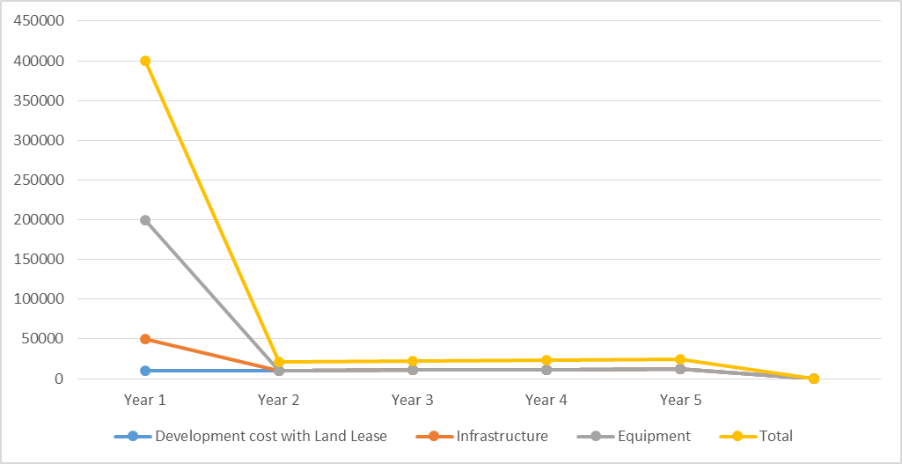

Operational costs (Variable):
Operating costs are directly related to the operations of business an associated with the maintenance and administration of a business on a day to day basis. Here For each option, described cost has been estimated for the installation, operation, and maintenance including costs for personnel, equipment, and other relevant expenses.
Assumption description | Quantity
Milk (From local source):  (0.50 € per liter) | 5,000liter per day
Salary and Wages:  150€ per person | 2 person needed monthly
Soft equipment:  (100€ per month) | One
Training:  (1,000 € per year) | Twice within 5 years
Maintenance:  (1,000 € per year) | Twice within 5 years
Utility:  (1,500 € per month) | Per month
Logistics:  (100€ per month) | Per Month
Solid Milk Distribution  (0.02€ per liter) | 5,000 per day

 | Y 1 | Y 2 | Y 3 | Y 4 | Y 5 | Remarks
Milk | 875,000 | 918,750 | 964,688 | 1,012,922 | 1,063,568 | 350 operation days/year, 5% quantity increment yearly
Salary and Wages | 3,600 | 3,780 | 3,969 | 4,167 | 4,376
Soft equipment | 1,200 | 1,260 | 1,323 | 1,389 | 1,459
Training | 1,000 | - | - | 1,000 | -
Maintenance | 2,000 | - | - | 2,000 | -
Utility | 18,000 | 18,900 | 19,845 | 20,837 | 21,879 | 8 hours/day operation of the equipment
Logistics | 1,200 | 1,260 | 1,323 | 1,389 | 1,459
Solid Milk Distribution Cost | 35,000 | 36,750 | 38,588 | 40,517 | 42,543 | 4% of the milk price
Total | 937,000 | 980,700 | 1,029,735 | 1,084,222 | 1,135,284

Benefits of the projects:

Forecasted benefits that will mitigate the cost in next four years and it will help to analysis the cost- benefits.
Assumptions | Quantity
Plain Milk  (0.70€/lt) | 1,000 liter per day
Other mik products  (4.00€/kg) | 571 kg per day
More effective Promotion Campaigns | 2000
Reduce the cost maintenance at 5% rate | 1900
 | Y 1 | Y 2 | Y 3 | Y 4 | Y 5 | Remarks
Plain Milk | 245,000 | 257,250 | 270,113 | 283,618 | 297,799 | 350 operation days/year, 5% quantity increment yearly
Other Milk Products | 800,000 | 840,000 | 882,000 | 926,100 | 972,405 | Liquid Milk Equivalent 7 liter considered on average
More effective Promotion Campaigns | 2000 |  |  | 2000
Reduce the cost maintenance at 5% rate | 1900 |  |  | 1900
Total | 1,048,000 | 1,097,250 | 1,152,113 | 1,213,618 | 1,270,204

Cost- Benefit Analysis:
Cost-benefits analysis is a simple technique for comparing the business value a project will produce with the cost of producing it. It is the project intimation phase to show the value of doing a project. So, project manager conduct the cost-benefit analysis by gathering data on the value of the benefits and the cost of the project.
 | Year 1 | Year 2 | Year 3 | Year 4 | Year 5 | Remarks
Total Benefits | 1,048,000 | 1,097,250 | 1,152,113 | 1,213,618 | 1,270,204 | 350 operation days/year,  5% quantity increment yearly
Development cost | 200,000 | 10,500 | 11,025 | 11,576 | 12,155
Operational cost | 937,000 | 980,700 | 1,029,735 | 1,084,222 | 1,135,284
Total cost | 1137000 | 991200 | 1040760 | 1095798 | 1147439
Cost-Benefits or Net Revenue | (89000) | 106050 | 111353 | 117820 | 122765
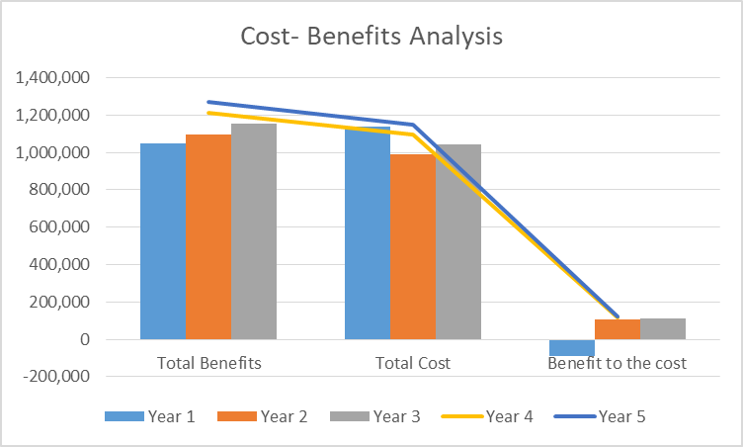

Cost- Benefit ratio of this project:
Formula Total Benefits/Total Cost
Year 1 1048000/1137000=0.921723835
Year 2 1,097,250/ 991200 =1.106991525

Income statement Assumption:
The project income is generated from the sales of goods or services, used of capital or assets and all of these are related with the main operations of an organizations before any costs and expenses deducted. In income statement revenue is shown usually in the top of all the items in income statements (profit and loss) and the cost and expenses are deducted to arrive in net income.Here we determining revenues by the quantities forecasts of milk provided and their prices. Taking the total benefit as a revenue the below forecasting are considered.
 | Year 1 | Year 2 | Year 3 | Year 4 | Year 5 | Remarks
Gross revenue | 1,048,000 | 1,097,250 | 1,152,113 | 1,213,618 | 1,270,204 | 350 operation days/year,  5% quantity increment yearly
Total cost | 1137000 | 991200 | 1040760 | 1095798 | 1147439
Net Revenue | (89000) | 106050 | 111353 | 117820 | 122765
Interest expense 20% | 17800 | 21210 | 22270.6 | 23564 | 24553 | Assumption
 | (71200) | 84840 | 89082.4 | 94256 | 98212
Tax 45% | 32040 | 38178 | 40087.08 | 42415.2 | 44195.4 | Corporate tax 45%
Net income after tax | (39160) | 46662 | 48995.32 | 51840.8 | 54016.6

Financial parameters:
We will consider some financial parameters here because it is important to check the viability of a project. All the investments are necessary to check the reason and viability of investments. To ensure the project viability we have used some financial parameters which are given below-
- Net present value (NPV)
- Return on Investment (ROI)
- Payback period (PBP)

Net present value (NPV):
Net present value depend on the difference between the value of cash now it has and the value of cash it will have in near future. Generally, it is used to determine that the anticipated financial gains of a project will offset the investment which are investing in present day. If it offsets then the project will be worthwhile to undertaking. So we can say, a positive NPV gives the green light on all the considerations and it would be profitable. On the other hand, a negative NPV resembles of financial loss it may not undertake. By taking an assessment of the economic viability of the project, it is determined the net present value (NPV) at a discount rate of 12%.Net present value has shown in the below:
Discount rate | 12%
Discount Factor | 0.892857 | 0.797194 | 0.71178 | 0.635518 | 0.567427
 | 1 | 2 | 3 | 4 | 5 | Total
Total cost | 1137000 | 991200 | 1040760 | 1095798 | 1147439
Discounted Costs | 1015179 | 790178.6 | 740792.4 | 696399.4 | 651087.7 | 3893637
Total Benefits | 1,048,000 | 1,097,250 | 1,152,113 | 1,213,618 | 1,270,204
Discounted Benefits | 935714.3 | 874721 | 820051.3 | 771276.2 | 720747.9 | 4122511
 |  |  |  |  | NPV | 228873.9

Here the NPV is positive and bigger so it can be determined that the project will be profitable and it will good to be undertaken the project.

Return on Investment (ROI):
It is used as an indicator that measures financial gain and losses of a new project in according to its cost. Actually it is determining the project that will return a positive payback and value for the business.

ROI = Total Discounted Benefits- Total Discounted Costs
Total Discounted Costs

= 4122511-3893637
4122511
= 0.05552
= 6%
It will give positive feedback with 6% gain.

Payback period (PBP):
The payback period refers to the amount of time it takes to recover the cost of an investment. Simply put, the payback period is the length of time an investment reaches a break-even point.
 | Year 1 | Year 2 | Year 3 | Year 4 | Year 5
Discounted Benefits-Discounted Costs | -79464.3 | 84542.41 | 79258.87 | 74876.74 | 69660.16 | 228873.9
Cumulative dis benefits-Discounted Costs | -79464.3 | 5078.125 | 84336.99 | 159213.7 | 228873.9

So we can see from the Year 2 this project will go in break even and it is become positive from 2nd year. So the Payback period is Year 2.

CHAPTER 5

Alternative Analysis, Constraints and Risk, Conclusion

Alternatives Analysis:

Arla is playing an important role in the global market through sourcing of local milk from the farmers or owner of dairy and ensuring that their dairy products are consumed by millions of people every day. This project contributes in strengthening milk marketing, collection, payment and improve other aspects of the dairy business. Demand is rising as people's purchasing capacity has gone up. The habit of drinking milk is developing among us so the local sourcing of milk would be more beneficial then another alternative.
We can analysis these alternatives with the SWOT analysis of our project-

SWOT ANALYSIS
STRENGTHS  - Demand profile  - Margins  - Product Mix Flexibility  - Availability of Raw materials  - Make proper utilization of perishable products. | WEAKNESS  - Lack of control over the yield.  - Importing Cost of machineries  - Grab the interest of consumer for variants of dairy products.
OPPORTUNITY  - Value addition  - New concept and first mover advantage  - Complete utilization of resources  - Utilizing the proper advantage of food mile concept. | THREATS  - The Un-Organized sector  - Lack of knowledge about the dairy products in rural areas and the quality of the products they are having.

Strengths
- Demand profile- It will create demand on the peoples. Because when they started to get their desired product in their nearest market, the demand will be driven by it.
- Margins- Margin refers to the difference between the seller's cost for acquiring products and the selling price. It will reduce sellers cost for acquiring the product so they can easily sell the product in reasonable price. Because through the container plant the product will be produced in different areas so the distribution cost and raw materials cost will be less. Arla can directly sell their variants of products to their desired customer.
- Product Mix Flexibility- A product mix is the group of everything a company sells. However, the product line is a subset of the product mix. A product line refers to a unique product a company offers. They will offer different products in different areas so that consumers will get the products with easy reach.

Laban | Chocolate milk
Ghee | Pera
Cream | Rice pudding
Butter | Rossogolla
Yogurt | Cheese/paneer
Borhani | Fruit flavored milk
Custard cake | Butter milk
Rasmalai | Lassi Sweet Curd Pudding
Mayonnaise | Matha

- Availability of Raw materials- It will be easier for this project the to get the raw materials cause the source of milk is local. Arla will collect the raw material from the nearest farmers and with the help of container they can easily produce variants of products. So that consumers do not have to go far for get the products.
- Make proper utilization of perishable products- Various factors are depending on it because nearness to market will decrease the transportation cost and it will reduce the loss due to spoilage of highly perishable milk and production during storage and transportation.

Weakness
- Lack of control over the yield- First year it will not possible to control the yield but from the second year it will show positive yields.
- Importing Cost of machineries- All the containers plants will be imported by foreign countries so import cost will be higher.
- Grab the interest of consumer for variants of dairy products- But at first it will be difficult to get the interest of products because the concept is very new. If we able believe that people about our product quality and product details so it will be easier for our business and variants of products will increase the people interest.

Opportunity
- Value addition- it will add value in dairy market.
- New concept and first mover advantage- Now-a-days people are more concerned about the product origin and details. They want to pay little bit more about those products which are in good quality and the purchase of the product supports beyond economic consideration and takes into account environmental, ethical and social factors as well so it will give full advantage of first mover because the concept of container is very new to our country and if we provide the products with all of these details so it will be easier for our business.
- Complete utilization of resources- - Various factors are depending on it because nearness to market will decrease the transportation cost and it will reduce the loss due to spoilage of highly perishable milk and production during storage and transportation.
- Utilizing the proper advantage of food mile concept- It will reduce Food Miles - “Food miles” is a term that used to describe the total distance that the food was traveled from the food originated or produced to the distribution or sold the ultimate consumer. It was accumulated during transportation and the perishability of the products. This project will reduce the food miles and will be good for such perishable items like Milk

Threats
- The Un-Organized sector- Dairy market is still unorganized in our country and people are not used packed milk or variants of dairy products which are made in machines. But it has huge growth and opportunity in near future.
- Lack of knowledge about the dairy products in rural areas and the quality of the products they are having so it will be difficult to grab their interest for variants of dairy product which are made in locally but with new technology.

Constraints and Risks
This section identifies limitation that must be taken into consideration prior to the initiation of the project.

Constraints and Risks
- Main material (milk) may not be available from primary vendors and inconsistent supply or collection of milk may become challenging. Cause local farmers sometimes are not willing to sell in the the different vendors where they most likely to sell it directly.
- Vendors for local milk doesn’t offer a broad range of milk cause the cost behind their livestock food and others are huge so the desired production does not happened.
- Increased competitions for providing local products cause the local people believes in the local products and competitors may take the advantage of it
- Distribution inefficiencies with local producers.
- The gap between demand and supply is more than 50% so initially it will not be easier the decrease the local demand through the supply.
- Customer satisfaction through the price and products will not be easier.

Constraints and Risks mitigation
- If we give the proper benefits to our primary vendors and ensured their wellbeing and livestock’s so they will be committed to sell the proper amount of materials to us. By giving incentives to local vendors or suppliers, it is possible to avoid competition. It will ensure continuous supply of local item (milk).

- Through financing the farmers and taking care of their livestock’s with proper food, it can be possible to increase the production. By encouraging and supporting farmers and other milk suppliers in their efforts to adopt the latest farming practices and concerning to animal welfare, to improve the quality of life and physical environment of their animals.

- Now-a-days people are more concerned about the product origin and details. They want to pay little bit more about those products which are in good quality and the purchase of the product supports beyond economic consideration and takes into account environmental, ethical and social factors as well. So if we able to build the trust so it will be easier to grab the attention of our ultimate consumers. By concerning to animal welfare, to improve the quality of life and physical environment of their animals. By installing high-tech container plant, Arla Bangladesh can ensure quality and it will be easier to build lasting, trustworthy relationship with customers, vendors and farmers.

- At first people will want to get those variants of products in reasonable price and after getting the product trust it will not be easier to meet their demand. But the proper distribution of product can it possible to mitigate the supply demand gap and to provide reasonable price by reducing cost. By installing high-tech container plant, Arla Bangladesh can ensure quality and it will be easier to build lasting, trustworthy relationship with customers, vendors and farmers

Conclusion:
Demand of local sourcing products are growing day by day. People are embracing more the new trend of local products. Now they are more concerned about the food and beverages which are sourced in locally and which are good for their health and environment. Nowadays people want those products which they can rely and also trustable they want to know the product origin and want to be more concerned about the quality of the product. People are willing to pay on those products which purchase are supporting the economic consideration and takes account environmental, ethical and social factors as well .This vision document applies to the local sourcing of milk, which will be developed by Arla foods Bangladesh. It will arrange local sourcing of milk to work on the Bangladesh platform. It will provide a way for Arla to make value added products for consumers and benefits from the successful development of these products will increase both on-farm and off-farm, spanning the dairy, arable and horticulture sectors. It will create a market where a consumer will get their desired product with easy reach and farmer will easily provide their product to their ultimate customer.so farmers and Arla will work together to secure the high quality standards throughout the dairy production process. Farmer’s welfare and animal welfare are the main concern of Arla foods Bangladesh. Through quality assurance it will be backing the farmers to ensure high animal welfare standards. So this project will be beneficial for –
- Secure the highest value for the farmers’ milk while creating opportunities for their growth
- Aim to provide various dairy products to the customers in a sustainable way with adequate and relevant information about the company and the products.
- Evaluate potential impact on local stakeholders and local production from the perspective of social business and CSR aspect.

So Arla Dano has been successfully performing its business operations maintaining its own quality and ethics. The company has provided its products not only to fill up the shortage of dairy products in Bangladesh but also has set the standard which will be followed by many other companies. Company’s vision and mission itself speaks for its customer’s health and wellbeing. Thus the company has become a role model and a pioneer of dairy product company in Bangladesh.

Reference:

- ttps://www.arlafoods.com.bd/brands/arla-dano/
- www.tradeway.usBrochure_Specifications.pdf
- https://www.thedailystar.net/supplements/dairy-ind
- http://www.fao.org/3/a-i3593e.pdf
- Milk%20sourcing_local_economics.docx%201.pdf
- http://www.thedairysite.com/articles/3633/the-bangladesh-dairy-market-times-of-change/
- ttps://tind-customer-agecon.s3.amazonaws.com
- http://www.fao.org/3/i0588e/I0588E03.htm
- https://thefinancialexpress.com.bd/views/dairy-sector-a-global-view

Bibliography

- Internship report of a concerned officer
- Research Paper of Dr. Mohammad Mohi Uddin,Team Leader
Dairy Nutrition, Economics, Marketing and Environment Research Group and Associate Professor Department of Animal Nutrition Bangladesh Agricultural University, Mymensingh.
- Financial Books of BBA program
- Employee book of Arla Foods Bangladesh.

_______________________

