
United International University

Project Report
On
Credit risk management of commercial Banks in Banglades

Submitted To
Mosabbir Uddin Ahmad
Assistant professor
School of Business and Economics
United International University

Submitted By
MD. Touhidul Islam
ID- 111 122 300
BBA Program
United International University.

Date of Submissin : 2nd July, 2019

Letter of transmittal
2nd July, 2019
Mosabbir Uddin Ahmad
Assistant professor
School of Business and Economics
United International University
Subject – Submission of report on “Credit risk management of commercial Banks in Bangladesh”
Dear Sir
With due respect I hereby submit to you my project paper entitled “Credit risk management of commercial banks in Bangladesh” as requirement to fulfill the degree “Bachelor of Business administration”. I have tried to give my best in this project paper. Disregarding some constraint, I attempt to set it up in thorough, logical and instructive way. On the off chance that there have any unexpected blunders or misstep due to my restricted information in this field and additionally absence of logical capacity, I trust that you would be thoughtful enough to ignore this mistakes and thinking about that I am still during the time spent learning.

Yours sincerely
MD. Touhidul Islam
ID- 111 122 300
BBA Program
United International University.

Acknowledgement
Toward the start of the report, I would like to show my gratitude to almighty Allah who has given me the capability to complete this report successfully, my parent & also my honorable supervisor “Mosabbir Uddin Ahmad, Assistant Professor, School of Business and Economics, United International University” to help in this report named “Credit risk management of commercial banks in Bangladesh”.

His appropriate direction, supervision helped me to set up this report. He likewise causes me a great deal of by giving data and additionally supports me and likewise prompts me for this report. And likewise my some companion encourages me to gather data. Undertaking work includes diligent work, which relates network to broad investigation, counseling mastery, leading meetings and examining voluminous information. I demonstrate my warm respectability to the general population who helped me and urge me to set up this task report. I wish every one of them good luck and long lives and glad life.

Abstract
Credit risk management needs to be robust process that enables banks to proactively manage loan portfolios in order to minimize losses and earn an acceptable level of return for shareholders. Credit risk can be seen as the presence of different potential results when a bank makes an advance or other augmentation of credit. The conceivable result extends from full and auspicious installment as indicated by the agreement, right to a total nonappearance of any reimbursement (an absolute misfortune on the credit). Bank keep eyes towards parity dispensing ought not to be concentrated to some restricted geological regions/areas. As test I have chosen 5 private banks. The goal of the report to distinguish credit risk position of chosen banks, their arrival, exceptional sum and so on and additionally look at among of those bank. Those data is gathered from optional sources like yearly report, articles and so forth. Credit is presentation in various zone and division. In some segment reimbursement is nonappearance or suspicious that is making credit risk. Loan identified with acknowledge risk as well as store and different speculations additionally related with it. Banks give advance from their store area. Such sorts of credit are given at some development period. On the off chance that reimbursement crosses the development time frame, at that point it will make misfortune or hazard. Less store additionally makes credit risk. On the off chance that administration division of bank structure credit risk the executive’s framework, at that point credit risk can be limit or misfortune might be diminish. Bank need to focus that where they contribute or give advance, client profile, probability of misfortune and so on the off chance that they alert about that, at that point credit risk might be overseen. Banks benefit is for the most part influenced by credit chance. Less intrigue give poor benefit. That is the reason banks give significant on CRM framework. Bangladesh bank additionally gives some rule or structure about it, and many banks pursue BB rule or at some point they change it and make their very own system.

Table of contents

Serial number | Contents | Page number
Chapter 1- Introductory Part
1.1 | Introduction | 1
1.2 | Rationality of the Study | 2
1.3 | Objective of project | 2
Chapter 2 – Methodology
2.1 | Research Methodology | 4
2.2 | Limitations | 4
Chapter 3 – Literature Review
 | Literature Review | 6-7
Chapter 4 – Overview Of Credit Risk Management
4.1 | Credit Risk | 8
4.2 | Credit Risk Management | 8
4.3 | Credit products | 9
4.4 | Policy Guidelines on Credit Risk Management | 10
4.5 | Credit Risk Management Framework | 11
4.6 | Major roles and responsibilities of CRMC | 13
4.7 | Credit Risk Grading | 14
Chapter 5 – Credit risk Management of Commercial Bank
5.1 | Dutch Bangla Bank | 16
5.2 | Eastern Bank limited | 21
5.3 | Islami Bank Bangladesh Limited | 23
5.4 | Trust Bank Limited | 27
5.5 | Prime Bank Limited | 31
Chapter 6 – Analysis , Findings & Recommendations

6.1 | Findings | 37
6.2 | Recommendations | 38
Chapter 7 – Conclusion , References & Abbreviations
7.1 | Conclusion | 39
7.2 | References | 40-41

Chapter 1 - Introductory part

1.1 Introduction
Credit department is one of the most important departments in every bank, because of having a high risk over there. Every one of the banks dependably attempts to make a proper harmony between its risk and return. Risk is the component of vulnerability or probability of misfortune that win in any business exchange in wherever, in any mode and whenever. Credit risk can be seen as the presence of different potential results when a bank makes an advance or other augmentation of credit. The potential results go from full and auspicious installments as indicated by the agreement, right to a total nonattendance of any reimbursement (an all out misfortune on the credit). To limit this risk bank center around some administration framework or procedure to deal with the risk is called credit chance administration process.
As a major aspect of this procedure, the idea of risk weighted resource was first presented in 2003 for the FIs in Bangladesh. Since then BB has issued five core risk management guidelines, namely Asset‐Liability Management (2005), Credit Risk Management (2005), Internal Control and Compliance Framework (2005), ICT Security (2010), and Prevention of Money Laundering and Terrorist financing (2013).The credit danger of a bank is likewise impact the book estimation of a bank. The more credit of a specific is in risk, the greater likelihood of a bank to be ruined. In this manner, the status of investor in the bank is in danger and likelihood of acquiring misfortune from their stored worth. That is the reason; I am intrigued to set up the report based on Credit Risk Management Practices of the private Commercial Banks in Bangladesh. I need to experience our examination using a credit card framework in some private bank restricted to investigation it appropriately. I talk about the credit chance, credit chance administration, and general credit vital, various sorts of credit items, credit arrangement structure Relationship between credit chance execution and bank gainfulness, and some suggestion on CRM framework. Without these elements it is beyond the realm of imagination to investigation the credit arrangement of Bank.

1.2 Rationality of the Study
Banking sector is one of the fastest growing sectors in our country. There are in excess of 60 banks are working which incorporates nearby and outside endeavor. Some new banks are coming in the market. In this way, the financial business is especially rewarding and in the meantime focused as well. All banks are putting forth more up to date items and offices to draw in the clients and hold them. Proper client determination and maintenance is indispensable for bank productivity. If there should arise an occurrence of endorsing credit choice of borrowers, credit examination is must. These as well as readiness of credit report credit endorsement process and organization following legitimate credit chance administration is significant for any bank. In such a case that there is any need in credit the board the advance may default this may run a bank in liquidation. In time of setting up this report I discovered it make them need in banking area in credit risk the executives. On the off chance that it will comprehend, at that point the financial framework will be improved.

1.3 Objective of project
Board objective:
- To satisfy the necessity for the consummation of BBA program.
- To watch and get familiar with the Credit procedure and Risk Management framework.

Specific Objective:
- To distinguish the Credit Risk Management Practices of business Banks in Bangladesh.
- To audit the current credit chance administration frameworks, devices and procedures use in banks.
- Comparing CRM among chose private business banks
- To distinguish the shortcoming and impediments of the current credit chance administration frameworks and devices.
- To distinguish and recommend extents of progress in credit risk the board

- Chapter 2 - Methodology
- 2.1 Research Methodology
Methods followed to perform a job or conducting activities to complete a task is called methodology. In leading this report the accompanying system was embraced in information and data, arrangement of reports and so forth. Both subjective and quantitative strategies were connected for setting up this report. The information were examined and displayed by shows rate, graphical introduction and various sorts of outlines.
- Here the sample (5 banks are selected) -
Selected Banks | Number of sample
Dutch Bangla Bank | 2
Islami Bank Bangladesh Limited | 2
Eastern Bank Limited | 2
Trust Bank Limited | 2
Prime Bank Limited | 2

My study mainly based on secondary data:
- Newspaper
- Article
- Annual Report, Research paper and Relevant book

2.2 Limitations
The investigation will be directed with a target to make a careful investigation of yearly report issued by various chose business banks. In the execution of the investigation likely constraints might be number of test, time or potentially cost.
1. Number of sample: For the trouble of gathering all the yearly reports of recorded banks in DSE, here 5 banks will be removed from an absolute number of 63 banks (open and private) working in Bangladesh.
2. Time: Time range won't adequate to cover all data.

3. Cost: cost will be required for the finish of the examination as to buy the distributed yearly report from the reason of DSE or download from web for getting the example yearly report which additionally constrains the quantity of test.

Chapter 3 - Literature Review
Literature Review
Credit risk is a standout amongst the most fundamental dangers for any business bank. Credit risk emerges from non-execution by a borrower. It might emerge from either a failure or a reluctance to perform in the pre-duty contracted way. Credit risk is a fundamental factor that should be overseen.

Credit risk is the likelihood that a borrower or counter gathering will neglect to meet concurred commitments. All around, over half of complete risk components in Banks and Financial Institution (FI) s are credit chance alone - ( Raad Mozib Lalon. Credit Risk Management (CRM) Practices in Commercial Banks of Bangladesh - 2016) .It is fundamental for banks having hearty credit chance administration.

Bagchi (2003) analyzed the credit risk the board in banks. He inspected risk distinguishing proof, chance estimation, chance observing, and risk control and risk review as essential contemplations for credit chance administration. The creator reasoned that appropriate credit chance design, approaches and structure of credit risk the board, FICO score framework, and checking and control contributes in achievement of credit chance administration framework.

Credit risk isn't just connected with direct bookkeeping misfortune yet in addition with financial exposures. This includes opportunity costs, exchange expenses and costs related with a non‐performing resource far beyond the bookkeeping misfortune. Credit chance not really happens in detachment. A similar source that imperils credit risk for the organization may likewise spread it to different dangers. For example, by and large mediocre arrangement of a FI may lead it to liquidity issue (Integrated Risk Management Guidelines for Financial Institutions, Department of Financial Intuitions and Market Bangladesh bank-2017).

RODEAN Maria-Daciana, GRIGOROI Lilia, MINCULETE Georgiana Daniela (2017) Inadequate credit chance administration is probably going to lead a credit organization' insolvency. There are numerous methods of this risk the executives some of which went for early cautioning models of deterioration advance portfolio (Credit Risk +, Credit Portfolio View, KMV and so on.), while, the other part is to screen the credit risk to the borrowers. The loaning rule ought to incorporate Industry and Business Segment Focus, Types of credit offices, Single Borrower and gathering limit, Lending tops. It ought to embrace a credit evaluating framework. All offices ought to be doled out a risk grade.

Chapter 4 – Overview of Credit Risk Management
4.1 Credit risk
Commitments as per concurred terms, bringing about a negative effect on the benefit and capital of the bank. - Generally credits are the biggest and most evident wellspring of credit chance. Be that as it may, credit risk could originate from both on-asset report and cockeyed sheet exercises, for example, ensures. It might emerge from either a powerlessness or a reluctance to perform in the pre-submitted contracted way. Credit risk originates from managing families, little or medium-sized Credit risk emerges from the potential that a borrower will neglect to meet its ventures (SMEs), corporate customers, different banks and budgetary foundations, or a sovereign. - In increasingly specialized terms, credit risk can be seen as the presence of numerous potential results when a bank makes an advance or other expansion of credit. The potential results go from full and auspicious installments as per the agreement, right to a total nonattendance of any reimbursement (a complete misfortune on the credit). Installments could be made in full yet not in an auspicious way, or installments could be made in a convenient way however not in full.

4.2 Credit Risk Management (CRM)
The compelling administration of credit risk is a basic segment of an extensive way to deal with risk the board. It is fundamental for long‐term achievement of any FI. The objective of credit risk the executives is to augment a FI's risk‐adjusted rate of return by keeping up credit chance introduction inside satisfactory parameters. FIs need to deal with the credit risk inalienable in the whole portfolio just as the risk in individual credits or exchanges. Credit chance administration is a constant exertion of distinguishing, estimating, checking and alleviating the credit chance in both pre‐sanction arrange just as post‐sanction organize. Before give credit a few insights concerning client need to know. Here demonstrate the component of Credit risk the executives.


4.3 Credit products
- Overdraft,
- Lease Financing,
- House Building,
- Small Medium Enterprise,
- Consumer Credit Scheme,
- Trade finance,
- Mortgage,
- Car loan,
- Term loan, etc.

4.4 Policy Guidelines on Credit Risk Management
Albeit explicit credit chance administration practices may contrast among FIs relying on the nature and intricacy of their credit activities, a thorough credit chance the executives program should address four stages referenced in Table‐1. These ought to be connected related to the appraisal of advantage quality, sufficiency of arrangements and stores, and exposure of credit chance. The credit chance administration structure will incorporate the followings:
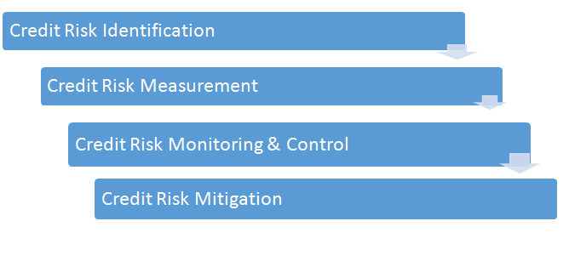
4.5 Credit Risk Management Framework
- Establishing an appropriate credit risk environment-
Principle 1: The top managerial staff ought to have obligation regarding supporting and occasionally (at any rate every year) looking into the credit risk system and noteworthy credit chance approaches of the bank. The procedure ought to mirror the bank's resistance for risk and the dimension of benefit the bank hopes to accomplish for bringing about different credit dangers.

Principle 2: Senior administration ought to have duty regarding executing the credit risk methodology endorsed by the top managerial staff and for creating strategies and techniques for distinguishing, estimating, observing and controlling credit chance. Such arrangements and methods should address credit risk in the majority of the bank's exercises and at both the individual credit and portfolio levels.

Principle 3: Banks ought to distinguish and oversee credit risk innate in all items and exercises. Banks ought to guarantee that the dangers of items and exercises new to them are liable to sufficient risk the board methods and controls before being presented or embraced, and endorsed ahead of time by the top managerial staff or its fitting panel.

- Operating under a sound credit granting process-
Principle 4: Banks must work inside sound, well-characterized credit-conceding criteria. These criteria ought to incorporate a reasonable sign of the bank's objective market and an intensive comprehension of the borrower or counterparty, just as the reason and structure of the credit, and its wellspring of reimbursement.

Principle 5: Banks ought to build up generally speaking credit limits at the dimension of individual borrowers and counterparties, and gatherings of associated counterparties that total in a tantamount and significant way various sorts of exposures, both in the banking and exchanging book and on and off the asset report.

Principle 6: Banks ought to have an obviously settled procedure set up for favoring new acknowledges just as the alteration, reestablishment and re-financing of existing credits.

Principle 7: All expansions of credit must be made on an arm's-length premise. Specifically, credits to relate organizations and people must be approved on an exemption premise, observed with specific consideration and other suitable advances taken to control or alleviate the dangers of non-a manageable distance loaning.
- Maintaining an appropriate credit administration, measurement and monitoring process-
Principle 8: Banks ought to have set up a framework for the continuous organization of their different credit chance bearing portfolios.

Principle 9: Banks must have set up a framework for observing the state of individual credits, including deciding the ampleness of arrangements and stores.

Principle 10: Banks are urged to create and use an inward risk rating framework in overseeing credit chance. The rating framework ought to be predictable with the nature, size and intricacy of a bank's exercises.

Principle 11: Banks must have data frameworks and logical strategies that empower the board to gauge the credit risk innate in all on-and cockeyed sheet exercises. Standard 12: Banks must have set up a framework for observing the general creation and nature of the credit portfolio.

Principle 13: Banks should mull over potential future changes in monetary conditions when evaluating individual credits and their credit portfolios, and ought to survey their credit chance exposures under unpleasant conditions

- Ensuring adequate controls over credit risk
Principle 14: Banks must build up an arrangement of autonomous, progressing appraisal of the bank's credit risk the board forms and the aftereffects of such surveys ought to be imparted legitimately to the top managerial staff and senior administration.
Principle 15: Banks must guarantee that the credit-allowing capacity is in effect appropriately overseen and that credit exposures are inside dimensions steady with prudential benchmarks and inner breaking points.
Principles 16: Banks must have a framework set up for early medicinal activity on decaying credits, overseeing issue credits and comparable exercise circumstances.

4.6 The major roles and responsibilities of CRMC are as follows:
- Review of Bank's credit chance craving, resilience and system considering present and forthcoming macroeconomic and business condition.
- Review of Bank's Credit Risk Management approaches and methodology.
- Review and screen adequacy and utilization of Credit Risk Management Policy related models and methodology and the control condition as for credit choices.
- Monitor credit chance on a bank wide premise and guarantee consistence of the cutoff points endorsed by the Board of Directors or any Board Committee.
- Review of prudential cutoff points on enormous credit introduction, measures for advance guarantee, credit focus, advance estimating, early ready framework, checking and assessment of relationship methods.
- Review and supervise the improvement in advance misfortune arrangement strategy and survey suitability and sufficiency of such approaches in accordance with the credit risk inserted in EBL advance portfolio; while consistence of least administrative prerequisite is to be guaranteed.
- Ensure administrative and legitimate consistence in all parts of credit tasks.
- Review Bank's concern credit the executive’s procedure and advancements in reprobate portfolio.
- To screen accumulation and recuperation activity for Stand Alone/Single Product Lending through quarterly survey of reports.
- To audit arrangements and discharges taken and potential arrangements and discharges

4.7 Credit risk grading
All banks ought to receive a credit risk evaluating framework. The framework ought to characterize the risk profile of borrower's to guarantee that record the board, structure and evaluating are similar with the risk included. Risk evaluating is a key estimation of a Bank's benefit quality and in that capacity, it is basic that reviewing is a hearty procedure. All offices ought to be allotted a risk grade. Where crumbling in risk is noticed, the Risk Grade relegated to a borrower and its offices ought to be promptly changed. Borrower Risk Grades ought to be unmistakably expressed on Credit proposition.

CGR Parameters
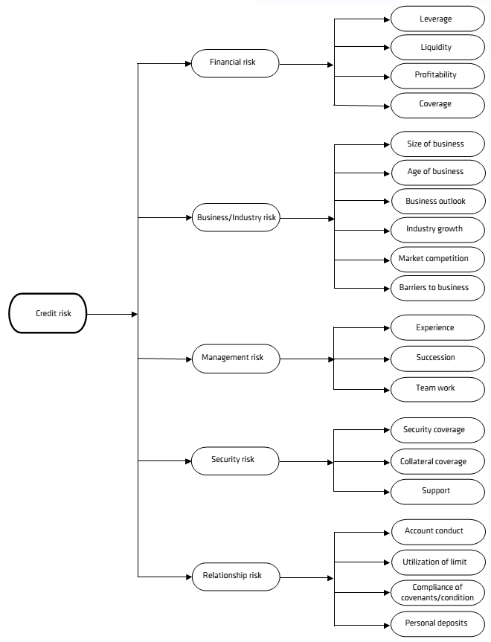

Chapter 5 - Credit Risk Management of Some Selected Private Commercial Banks
5.1 Dutch Bangla Bank Limited-
Credit Risk Management is at the heart of the overall risk management system of the Bank. It is planned and normally refreshed to recognize, measure, oversee and moderate credit risk to keep up and improve nature of advance portfolio and decrease genuine advance misfortunes and to guarantee that endorsed procedures are pursued and suitable due ingenuity are made in favoring new credit offices and reestablishments.
Credit risk management infrastructure of DBBL
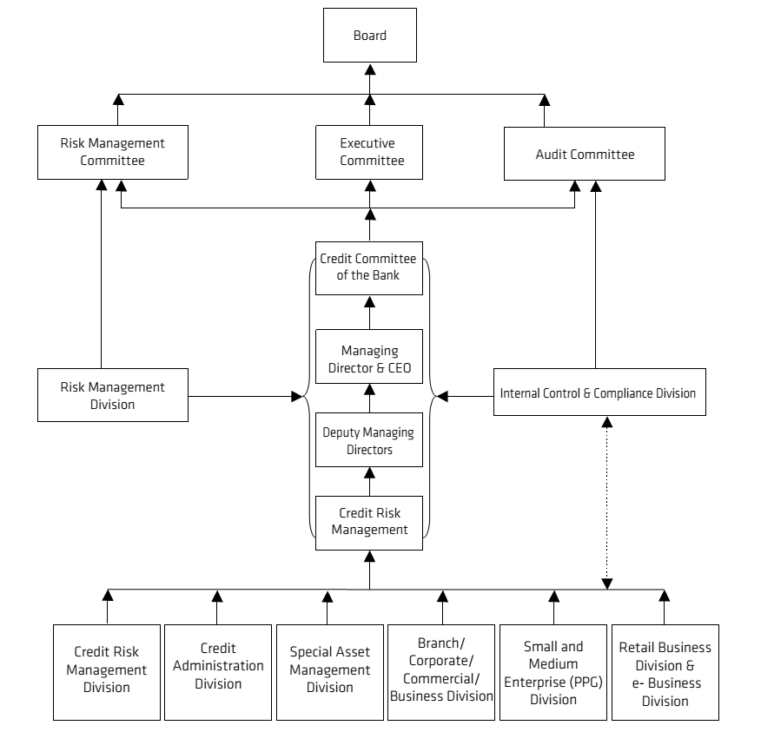
The Bank has taken the test decidedly. Therefore, out of absolute Taka 167,397.8 million of advance of the Bank qualified for FICO score (corporate and SME), Taka 126,922.1 million (75.8 % of qualified advance exposures) has been brought under the rating domain toward the finish of 2018.

Example 20%, half, and 100% starting at 31 December 2018 and 31 December 2017 is outfitted a near position of evaluated introduction of the Bank at various risk loads for beneath:
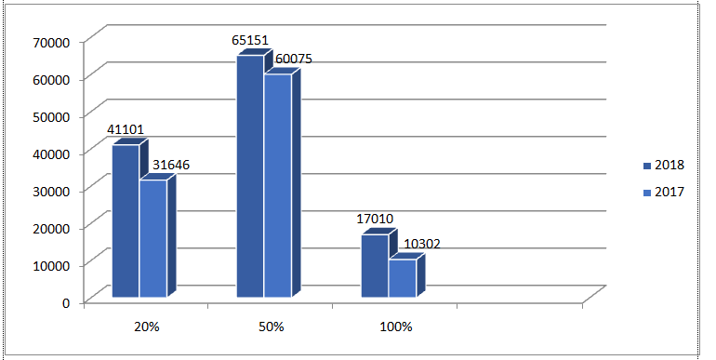
Geographical distribution of credit exposures as per the disclosures in the audited financial statements as of 31 December 2018 is as follows:
particulars | Outstanding  Amount | Mix (%)
Urban Area | 203,512.2 | 98.2%
Rural Area | 3,745.2 | 1.8%
Total | 207,257.4 | 100%
Industry or counterparty type dispersion of exposures, separated by real kinds of acknowledge exposures according to the revelations in the examined budget summaries starting at 31 December 2018 are as per the following:
Advances and Advances including bills obtained and limited based on noteworthy focus
Amount (million tk)
Particulars | 2018 | 2017
Commercial lending | 5,732.3 | 7,344.1
Agricultural loan | 3,547.5 | 2,578.6
Export financing | 11,550.8 | 9,253.4
Consumer credit scheme | 10,699.0 | 3,913.3
Small and medium enterprise financing | 26,268.3 | 23,720.5
Staff loan | 589.9 | 591.7
House building loan (other than the employees) | 1,082.6 | 1,243.5
Others | 147,787.0 | 124,752.7
Total | 207,257.4 | 173,397.8

To perform against risk bank required some Capital -
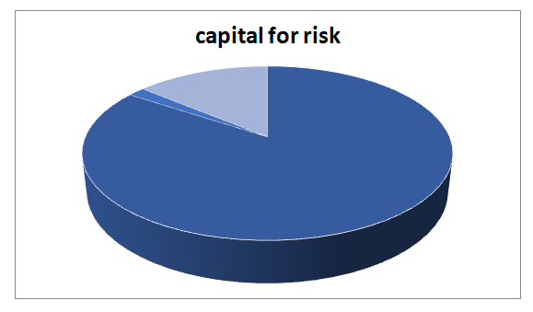
Source- Annual report DBBL 2018
Here we can see that, Bank required increasingly capital for credit risk then other part market chance and operational risk.

Remaining legally binding development breakdown of the entire portfolio breakdown by real sorts of credit introduction.
Million tk
Repayable | Outstanding  amount | Mix (%)
On demand | 12987 | 6.3%
Within one to three months | 59186 | 28.6%
Within three to twelve months | 69860.7 | 33.7%
Within one to five years | 42664 | 20.6%
More than five years | 22559.7 | 10.9%
Total | 207257.4 | 100%
Here three to twelve months is higher % of all.
Based on the past due we measure that a credit as standard, doubtful, bad/loss or not. If it is past due/ overdue for 3 months or beyond but less than 6 months, it is standard. On the off chance that it is past due/late for a half year or past yet under 9 months, it is doubtful. On the off chance that it is past due/late for 9 months or past, it is bad/loss.
Measure of hindered/arranged advance by major counterparty type as of December 31, 2018 as given below–
Major counter party type | Status wise amount of impaired / classified loan |  |  | Total ( million TK)
Major counter party type | Standard | Doubtful | Bad / loss | Total ( million TK)
Continuous loan | 85.9 | 122 | 1122.4 | 1330.3
Demand loan | 40.9 | 7.7 | 1201.4 | 1250.0
Term loan | 25.5 | 11.6 | 7027.1 | 7064.2
Other loan | - | - | - | -
Total | 152.3 | 141.3 | 9350.9 | 9644.5
Source – annual report DBBL 2018
Here we can see that terrible/misfortune is high of all arranged credit. Standard is normal and dicey is low. In any case, for ceaseless credit dubious is more than standard. More measure of awful/misfortune isn't useful for any association.

Most importantly, DBBL is proceeding with an interesting procedure of rechecking security documentation by a moment lawful counselor other than the legal counselor who checked it initially. The Risk Management Division is routinely helping the Credit Risk Management Division on expanding the security inclusion, item/area explicit broadening of credit exposures, single borrower exposures limit, enormous advance portfolio roof as stipulated by Bangladesh Bank, improving the advantage quality, directing FICO score of the borrowers to limit the capital charge against credit danger of the Bank. Satisfactory arrangement is kept up against grouped credits according to Bangladesh Bank Guidelines. Status of advances is consistently answered to the Board of Directors/Risk Management Committee of the Board.

5.2 Eastern Bank Limited
The nine-part Credit Risk Management Committee has been shaped under the prerequisites of Core Risk Guideline on Credit of Bangladesh Bank for generally speaking supervision of the credit risk of EBL including survey of guaranteeing measures, loaning rehearses, gathering procedure and issue advance administration. The individuals from the Committee are Chief Risk Officer, all Business Heads, Head of CRM and Head of Finance. Be that as it may, MD and CEO can choose some other official in the board.
Credit Management Process-
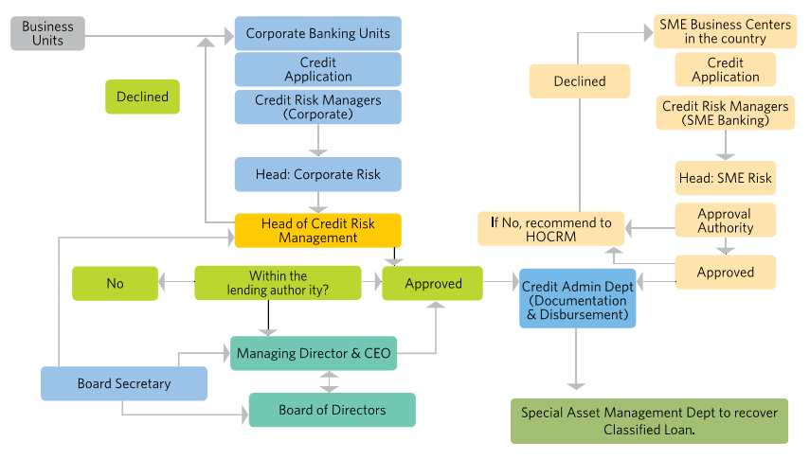

Source- Annual report EBL 2018

Total gross credit risk exposure of 31-12-17:-
Particulars | TK (million)  2018 | 2017
Continuous Loan | 16301 | 14627.74
Demand loan | 86587 | 72959.69
Term loan | 76093 | 62394.04
Short term Agro credit | 5046 | 2102.22
Total | 184027 | 152083.69
From this table I locate that firm total loan is184027 million at the end of 31Dec 2018 which was 152083.69 million final year. The increase percentage rate is 17.36%
Here draw a chart to show the capital that is required for credit risk
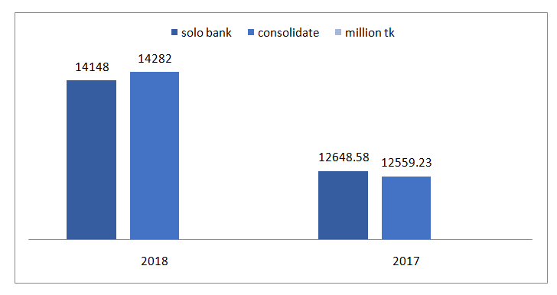Source- Annual report of EBL2018

Residual contractual maturity of credit exposure (31-12-18)
Particulars | Amount (million)
On demand | 4735
In not more than one month | 10211
In more one month but not more than three months | 30530
In more three months but not more than one year | 69411
In more than one year but not more than five years | 60773
In more than five years | 8366
Total | 184027
For development of credit presentation multi month to one year is high.

The fundamental target of credit risk the executives is to limit negative effect through receiving appropriate mitigates and to restrict credit chance exposures inside satisfactory cutoff. Risk Management Division builds up the credit chance administration structure and strategies that detail, in addition to other things, the credit risk rating frameworks and related parameter appraises; the appointment of power for conceding credit; the computation of the remittance for credit misfortunes; and the approval of discounts.

5.3 Islami Bank Bangladesh Limited
Money related Stability Department of Bangladesh Bank in its Financial Stability Report 2017, Issue 7, June 2018 uncovers that the offer of Risk Weighted Assets (RWA) ascribed to credit risk was 87.20 percent of the absolute RWA of the financial business of the nation as toward the finish of December 2017. In IBBL point of view, speculation risk presentation was 88.41% in 2017 and 88.62% in 2018. In this manner speculation risk is the key factor of IBBL's risk the board for assurance of capital prerequisite, productivity, liquidity and numerous other risk components included in that. IBBL handles this risk through a system that sets out approaches and strategies covering its estimation and the board.
Area wise distribution of exposure of credit risk-
Credit risk is not same in all area, it different on the basis of people income, life style.
particulars | TK (million) 2018 | 2017
In Rural area | 61913.62 | 53279.88
In Urban areas | 648815.31 | 563139.03
Total | 710728.93 | 616418.91

Here draw a pie chart to show that what % a bank required performing against risk. Because it effect on profit-
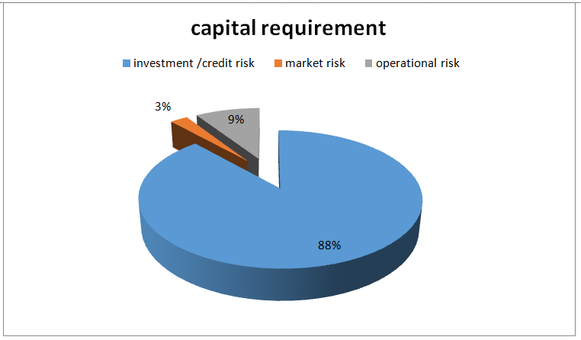

Source – annual report IBBL 2018
From this we find capital requirement for credit risk is more than other. That means bank concentrate more on credit / investment risk.

Capital requirement for credit risk
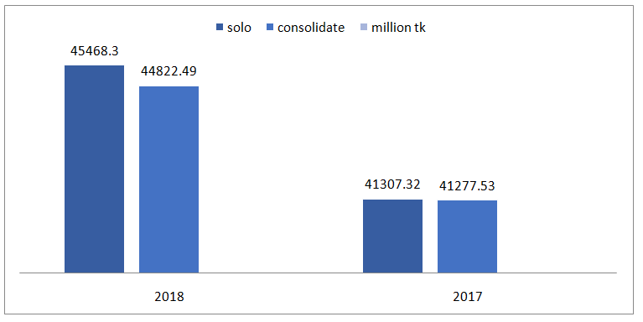
Source- annual report IBBL -2018
This chart show that capital for credit risk is increment in 2018, it is 82584.85 million of every 2017 and 90290.79 million out of 2018. Which 8.34% increase 2017 to 2018.

By major industry / counterparty type amount of impaired investment/loan & if available past due investment loan provided separately –
Particulars | BDT million tk
Special mention account (SMA) | 28152.26
Sub – standard | 2447.
Doubtful | 1990.93
Bad /loss | 21080.67
Total | 53670.86

Past due investment/ loan provided-

Source- Annual report IBBL -2018
Here find that SMA loan classification is more than standard, doubtful & also bad/loss.
Residual contractual maturity breakdown of the whole portfolio breakdown by major types of credit exposure
Particulars | Amount ( million TK)
Repayable on demand | -
Up to 1 month | 109462.84
Over 1 month but not more than 3 months | 113916.12
Over 3 months but not more than 1 year | 189463.03
Over 1 year but not more than 5 years | 131478.80
Over 5 years | 124411.15
Total | 668731.94

5.4 Trust bank
The credit chance administration builds up the obligation and approach through which the Board of Directors and Senior Management administer its business and the related credit risk the board issues. Through a viable Board endorsed chance administration system, the Bank looks to guarantee satisfactory risk oversight, checking and detailing of credit chance.

Credit Risk Management Framework-
Pre-credit sanctioning | Numerous levels of approval authority
Pre-credit sanctioning | complex risk rating and scoring system
Pre-credit sanctioning | Prudential limits for concentration risk
Pre-credit sanctioning | Organized and comprehensive credit evaluation and characterized credit criteria
Post-credit observing | Portfolio assessment with emphasis on early caution signals
Post-credit observing | Strong credit survey component
Post-credit observing | Stress testing and scenario analyses
Post-credit observing | Review of chosen exposures
Portfolio management | Regular observing of concentration risk and other prudential cut off point
Portfolio management | Organized credit review system
Portfolio management | Periodic answering to RMD, RMC and BRMC

Total gross credit risk exposure -
particulars | Million tk (2018) | 2017
Continuous loan | 27701.29 | 20027.26
Demand loan | 46778.19 | 34456.56
Term loan | 105072.74 | 86344.25
Short term agri- credit | 259.91 | 263
Stuff loan | 1045.55 | 896.17
Off shore banking | 4052.79 | -
Total | 184910.47 | 141987.44
Source- annual report of trust bank
From the chart find that term loan is higher than other loan. Short term agri – credit is most low.
Capital requirement for credit risk (Solo-16043.23 million TK, Consolidate-15957.18 million TK)


Credit risk performance

Source- annual report Trust bank 2018

Residual contractual maturity breakdown of the whole portfolio breakdown by major types of credit exposure
Particulars | Amount (million tk)
Repayable on demand | 12224
Not more than 3 months | 71363.89
More than 3 months but not more 1 year | 53811.33
More than 1 year but not more than 5 years | 34991.62
More than 5 years | 12519.63
Total | 184910.47
Source – annual report trust bank 2018
The Bank has an all-around organized designation and sub-appointment of credit endorsement specialist for guaranteeing better control in credit endorsement framework. The Board of Directors and its Executive Committee hold the incomparable expert for any acknowledge endorsement in line for the credit advisory group comprising of the senior administration of the Bank. Credit proposition handling, appraisal of dangers and mitigates there against, setting before credit board, looking for endorsement from the able specialist, aiding finish of documentation conventions or more all keeping up association with the branches and clients have so long been finished by Credit Risk Management.

5.5 Prime bank
To give an expansive rule towards productive administration of the credit arrangement of the Bank, a solid, unmistakably characterized, thorough and proper Credit Risk Management condition is a pre-imperative. Credit chance administration should be a comprehensive procedure that empowers a Bank to proactively deal with its advantages portfolio so as to limit misfortunes and win a satisfactory dimension of return for partners. Given the quick changing unique worldwide economy and the expanding weight of globalization, progression, solidification and disintermediation, since beginning Prime Bank has been proactive to build up a solid Credit Risk Management structure under the umbrella of CRM Division
Geographical distribution of credit exposure of the bank
(Million TK)
Particulars | 2018 | 2017
In rural area | 489.52 | 421.57
In urban area | 19342.75 | 16599.61
Total | 19832.27 | 17021.18

Bank provide capital to mitigate credit risk-
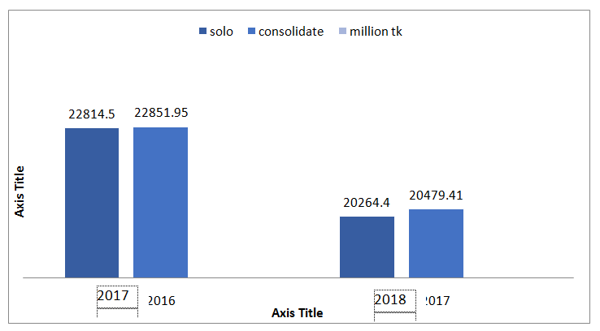

Source- annual report PBL 2018
2017
Capital requirement is decrease 2017 to 2018 is 10.78%, 2017 it was 45666.45 &2018 it is 40743.81 million.

Total gross credit risk exposure of bank
Particulars | 2017 | 2018
Commercial lending | 2204.72 | 3168.98
Export financing | 837.69 | 2749.16
House building loan | 271.73 | 237.78
Retail loan | 1498.94 | 1650.26
SME | 1819.05 | 1473.03
Special program loan | - | 2405.18
Stuff loan | .84 | .55
Other loan & advances | 2565.75 | 4089.31
Investment to managing director | 170.71 | 457
Industrial loan | 7651.75 | 4330.78
Bill purchase discounted inside & foreign | - | 1472.92
Total | 17021.18 | 19832.27

By major industry / counterparty type amount of impaired investment/loan & if available past due investment loan provided separately –
Particulars | BDT million TK
Standard | 18445.36
Special mention account (SMA) | 376.29
Sub – standard | 126.36
Doubtful | 44.14
Bad/loss | 840.12
Total | 19832.27

Here Standard is high amount but doubtful is low amount. Bad/loss is more than SMA & sub -standard.
The loan & advances that are classified as per Bangladesh guideline in 2018-

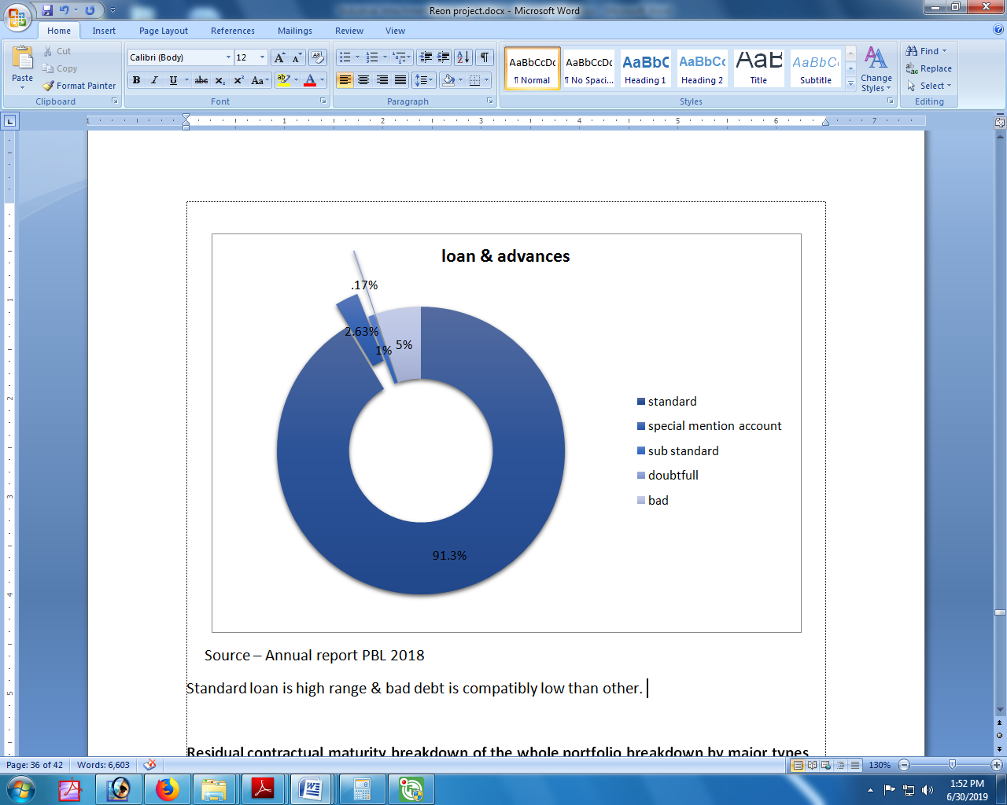

Source – Annual report PBL 2018
Standard loan is high range & bad debt is compatibly low than other.

Residual contractual maturity breakdown of the whole portfolio breakdown by major types of credit exposure
Particulars | Amount (million TK)
Repayable on demand | -
Up to 1 month | 2314.43
Over 1 but not over3 month | 3129.53
Over 3 but not more than 1 year | 8398.97
Over 1 year but not more than 5 years | 4561.42
Over 5 years | 1427.92
Total | 19832.27

At the time of maturity, most credit is mature at 3 months to 1 year.

The Company has no noteworthy convergence of credit risk. The Company has strategies set up to guarantee that exchanges are gone into just with counterparties that are of adequate credit quality. Likewise, receivable adjusts are checked on a progressing premise with the outcome that the Company's introduction to awful obligations isn't critical. The greatest presentation to credit risk is spoken to by the net conveying measure of budgetary resources recorded in the fiscal summaries. The Bank has isolated obligations of the officers/officials associated with credit related exercises. A different Corporate Division has been shaped at Head Office which is depended with the obligations of keeping up compelling association with the clients, showcasing of credit items, investigating new business openings, and so forth. Additionally, credit endorsement, organization, checking and recuperation capacities have been isolated.

Chapter 6 -Analysis & findings &Recommendations
6.1 Findings
- From breaking down 5 test chosen bank I bring up some point that
- Credit risk is significant piece of any bank productivity.
- Bank pursue BB rule/system, they likewise have their own strategy.
- In every one of the 5 banks, the capital measure of IBBL is high then other bank, and TBL bear low capital.
- Bank give larger part of their cash-flow to credit chance, as IBBL required their 86% center capital for credit risk.
- Outstanding measure of DBBL is high contrasting and speculation. Terrible/loss of advance and advances are bad for benefit.
- The higher the development time frame, the higher the risk.
- Profitability of bank fundamentally relies upon premium/return. The % of enthusiasm of PBL is low than other bank. And IBBL % is sufficient.
- Deposit additionally impact on advance and speculation.
- Most of the bank puts more in development period 3 months a year.

From examining I locate that all banks are insufficient accomplishment about their CRM framework. Since their extraordinary sum is sufficient high in respect to their credit and advances. And their loan fee isn't sufficient great. They don't appropriately keep up their approach. Be that as it may, it guarantees that they center around credit risk more than other risk.
Risk the board division is basically in charge of any disappointments. Like as Credit Risk Management Unit, Credit Administration Unit and Credit Monitoring and Recovery Unit – are affirm the credit proposition, characterize resource quality, evaluating risk
In loaning to a specific client, endorsing credit, detailing arrangement/procedure for loaning task, figure numerous polices, and so forth. In the event that their administration capacity is high, at that point bank can recuperate any issue.
6.2 Recommendations
The suggestions are made based on discoveries and investigation and these are:
- The bank ought to embrace a credit evaluating framework. All offices ought to be appointed a risk grade. Furthermore, the borrowers' hazard grades ought to be unmistakably expressed using a credit card application.
- The obligations of the key people of the above capacity should likewise be plainly indicated.
- Bank should make appropriate and comprehensive documentation before dispensing and to guarantee legitimate supervision, observing and follow up of each credit.
- The credit authorize methodology ought to be made faster since rivalry is hard in the present business world. Individuals would prefer not to hang tight for three to about a month on a normal to get a credit which is even ensured by security.
- Acting as the essential contact individual with borrowers.
- Building up the most abnormal amount of association with the customers conveying most ideal administrations.
- Maintaining careful information of borrowers' the same old thing and industry through ordinary contact, business site visit, manufacturing plant/distribution center visit, and so on.,
- Monitoring the monetary presentation and record direct of borrowers
- Gathering and investigating data of the customer from every single dependable source

Chapter 7 – Conclusion and Reference

7.1 Conclusions
A banker can't rest soundly with terrible obligations in his portfolio. The disappointment of business banks happens fundamentally because of awful credits, which happens because of wasteful administration of the advances and advances portfolio. Subsequently any banks must be incredibly wary about its loaning portfolio and credit strategy. Everything around us are changing at a quickening rate. Today isn't care for yesterday and tomorrow will be not quite the same as today. The Credit Management framework that may appear to be fit today yet may not work tomorrow. In this way, by taking thought the quick changing, powerful worldwide economy and the expanding weight of globalization, advancement, union and disintermediation. Bangladesh Bank has present a decent quantities of booklets, rules, devices and systems for dealing with the credit chance in a judicious way just as to limit the rate of default/non-performing advances at a standard dimension. Banks have additionally some inside approach, rules, instruments and systems for better risk the board. Regardless of a judicious credit endorsement process, advances may even now become beset. From the dialog in this report, it has turned out to be evident that credit risk the executives is a perplexing and continuous procedure and in this way budgetary foundations must adopt a genuine strategy in tending to these issues. They must be forward-thinking in consenting to all the required systems and must utilize able individuals who can manage these unpredictable issues. Most extreme significance ought to be given to the improvement of the systems administration framework which is fundamental for current financial condition and clearly for productive and powerful credit risk the executive’s procedure. The fundamental reason for this paper is to appear about the CRM routine with regards to banks. It depicts about the hypothetical structure, significance, procedure, favorable position and difficulties of CRM. It attempts to discover if there is a connection between CRM execution and banks benefit.

7.2 Reference
Annual report of bank 2017 &2018 (DBBL, IBBL, EBL, TRUST bank, Prime bank)
Annual report of Bangladesh bank
Article –
Alien L. and Jagliani J. (2000); “The Impact of New Bank Power (security and Insurance Activities) on Banking Holding Companies Risk”, Journal of Economics and Business
Bangladesh Bank (2013). “Risk Management Guidelines for Banks” Bangladesh Bank
Banking survey (2001) ; “ A comprehensive Analysis and Ranking of Banks”; market intelligence, The Business and Finance Journal, April
Credit assessment practices of commercial in Bangladesh – Rana al mosharraf, dated: jan 2014.
Credit Risk Grading Manual publish by Bangladesh bank
Credit risk grading model & loan performance of commercial bank in Bangladesh- Niaz Mohammad & Azimun nahar onni, dated: May 2016
Credit risk management of commercial bank in BD- prime bank, assignment point
Credit Risk Management vides FID Circular No.10, dated: September 18, 2005.
Credit Risk Measurement: New approaches to Value at Risk and other Paradigms by Anthony Saunders.
Formation of Risk Management Forum (RMF) & Risk Analysis Unit (RAU) in the Financial Institutions (FIs) vide DFIM Circular No.01, dated: 07 April, 2014.
Hanweck, G., and Ryu, L. (2004). The Sensitivity of Bank Net Interest Margins to Credit,
Interest Rate and Term Structure Shocks. [Online]. Available:
http://www.fdic.gov/bank/analytical/cfr/2004/sept/CFRSS_2004-02_Hanweck.pdf

Integrated Risk Management Guidelines for Financial Institutions, Department of Financial Intuitions & Market Bangladesh bank- 2017

Kiseľáková D., Kiseľák A., 2014, Analysis of banking business and its impact on financial stability of economies euro area, “Polish Journal of Management Studies”, 8.
Mosharrafa, R. Al. (2014) Credit Assessment Practice of a Commercial Bank in Bangladesh. International Journal of Economics, Finance and Management Sciences. Vol. 1, No. 6, pp. 382-387.
Proshenjit Ghosh, Md. Ariful Islam, Md. Moeid Hasan( Credit Risk Management: An Empirical Study on BRAC Bank Ltd.) Published: June 5, 2015 doi:10.5296/bms.v5i1.4618 URL: http://dx.doi.org/10.5296/bms.v5i1.4618
Raad Mozib Lalon. Credit Risk Management (CRM) Practices in Commercial Banks of Bangladesh: “A Study on Basic Bank Ltd.”.International Journal of Economics, Finance and Management Sciences. Vol. 3, No. 2, 2016, pp. 78-90. doi: 10.11648/j.ijefm.20160302.12
Rahman, S. M. (2012). Credit risk management practices in Banks: An appreciation, Journal of Islamic Economics, Banking and Finance, Vol. 7, No. 3, pp: 37-38

RODEAN Maria-Daciana & GRIGOROI Lilia & MINCULETE Georgiana Daniela, 2017.
"<B><A HREF="https://ideas.repec.org/a/blg/reveco/v68y2017i4p163-176.html">Study On Credit Risk Management In Commercial Banks</A></B>,"
<A HREF="https://ideas.repec.org/s/blg/reveco.html">Revista Economica</A>,
Lucian Blaga University of Sibiu, Faculty of Economic Sciences, vol. 68(4), pages 163-176, December.

Saunders, A., and Cornett, M. M.,(2006) “Financial Institutions Management: A Risk Management Approach”, 5th edition, McGraw-Hill 2006, pp. 304 – 309

S.K Bagchi “Credit risk management” , published August 20th 2004 by Jaico publishing house.

