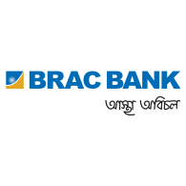
Internship Report
on
Retail Banking Products and Services
of
BRAC Bank Limited

Retail Banking product and Services
of
BRAC Bank Limited

Prepared For
Mohammad A. Ashraf, Ph.D.
B.Sc. Econ. (BAU)
M.A. Econ. (U.OTTAWA)
PhD (UUM)
Associate Professor & Former Head & Syndicate Member
Department of Economics (UIU)
School of Business & Economics
United International University

Prepared By
MD. JAHID HASAN
BBA in Finance
ID- 111 142 178

United International University
Date of Submission- 25 September, 2018

Letter of Transmittal

25 September, 2018
Mohammad A. Ashraf, Ph.D.
Associate Professor
School of Business & Economics
United International University

Subject- Submission Of report on “Retail Banking Product and Services” of BBL.

Dear Sir,
This is my pleasure to inform you that I have successfully completed my internship report on “Retail Banking Products and Services” of BRAC Bank Limited. I am happy to present this report on after a long realization and oppressive effort. I have tried to organize all the knowledge that I have gathered during my internship program to make the report reliable, relevant and informative as possible.

I would like to express my gratitude to you for your endless support, guidance and valuable suggestions to prepare this report. I would like you to grant my report and to recognize my devotion and efforts. I will be happy to answer any of your queries regarding the report.

Sincerely yours,
MD. JAHID HASAN
BBA in Finance
ID- 111 142 178

Acknowledgement

First, I would like to pay my gratitude to Almighty Allah for keeping me physically, mentally sound and giving me the strength to prepare this report on time. This report is nothing but many people’s contribution and help.
I would like to thank my Academic Supervisor Mohammad A. Ashraf, Ph.D, Associate Professor, for supporting me and giving me his valuable time, guidance and endless support during the course of preparing this report.
I am also thankful to my organizational Supervisor Clary Robin Baul, Associate Manager, Premium Banking & special thanks to Mohammad Almas Hossain, Associate Manager, Deposits & NFB & Liability Products Team, BRAC Bank Limited, for giving me a lucrative working environment and support. They directed me towards the right information and regularly monitored and reviewed my progress in developing my skills and knowledge and making this report as well.
Without their constant guidance, advice and helpful nature throughout the internship, it would have never been possible to finish the report so smoothly. I have tried hard and giving my best to prepare this report. I express my sincere gratitude to all of them.

Table of Contents
1. Introduction: 1
2. Objective of the Study: 1
2.1 Primary Objective: 1
2.2Secondary Objective: 1
3. Methodology of the study: 1
3.1 Type of Data: 1
3.1.1 Primary Data: 1
3.1.2 Secondary Data: 1
3.2 Data Collection Procedure: 1
4. Scope of the study: 2
4.1 Area: 2
4.2 Time: 2
5. Limitations of the Study: 2
2.1 Historical Background of BRAC Bank Ltd: 4
2.2 Corporate Vision: 5
2.3 Corporate Mission 5
2.4 Core Values 6
2.5 Function of different Division of BRAC Bank Ltd: 7
2.5.1 Corporate Banking Division: 7
2.5.2 SME Banking Division: 7
2.5.3 Financial Division: 7
2.5.4 Human Resources Division: 7
2.5.5 Retail Banking Credit Risk Management: 8
2.5.6 Treasury & Financial Institution Division: 8
2.5.7 Operations Divisions: 8
2.5.8 Information Technology: 8
2.6 BRAC Bank Subsidiaries: 8
3.1 Retail Banking: 10
3.2 Objective of Retail Banking: 10
3.3 Target Market of Retail Banking: 10
3.4 Retail Banking Products and Services: 10
3.4.1 Retail Banking Deposits: 10
Savings Classic Account: 10
3.4.2 Triple Benefits Savings Account: 11
3.4.3 Future Star Account: 12
3.4.4 Current Plus Account: 12
3.4.5 Salary Account: 13
3.4.6 Resident Foreign Currency Deposit (RFCD) Account: 13
3.4.7 Term Deposit: 14
Deposit Premium Scheme (DPS): 14
1.Flexi DPS: 14
2. Fixed Deposit General: 15
3. Fixed Deposit Plus: 15
4. Freedom Fixed Deposit (FFD): 16
5. Abiram Fixed Deposit: 16
6. Unit Fixed Deposit: 16
3.4.2 Retail Banking Loan Products: 17
1. Home Loan: 17
2. Personal Loan: 17
3. Auto Loan: 18
4. Holiday Loan: 19
3.5 BRAC Bank Cards: 19
3.5.1 Credit Cards: 19
3.5.2 Debit card: 20
3.5.3 Resident Foreign Currency deposit (RFCD): 20
3.5.4 Prepaid Card: 20
3.6 Premium Banking: 21
3.7 Internship Responsibilities: 22
4.1 Findings 24
4.2 Recommendations 25
4.3 Conclusion 26
4.4 Appendix 27
References: 30

Executive Summary
This report is prepared as a requirement for the successful completion of my BBA Program of United International University. As a part of the internship program, I got the opportunity to work for a period of three months in the Product department under Retail banking division of BRAC Bank Limited. Commercial banks play an important part in the economic development of a country. As a fully operated commercial bank- BRAC Bank Limited has emerged as a market leader in the private sector, reciprocal the pattern of SME financing by achieving unexplored market niches. This report has been divided into four broad segments: First chapter consists of a brief description about the report introduction, objective of the report, methodology and scope of the study. Second chapter consists of a brief description about organization, corporate mission, vision, values and CSR activities. . During this period, I have learned about this organization and operations that are conducted by the Retail Banking Division. There are several departments under Retail Banking Division: Retail Deposits, Loans, Customer Experiences, cards. Third chapter of this report comprises of all the departments under retail banking along with all the different products and services offered. Current accounts, Savings accounts, Term Deposits, Loans, Debit/Credit Cards services. This division also operates the priority banking segment which includes Premium Banking and TARA-women banking providing personalized banking services for specific market segments. Finally, the Fourth chapter consists of some findings of the BRAC Bank Limited provided with some recommendation in order to improve their financial situation, customer service quality.

CHAPTER- ONE
INTRODUCTION

1. Introduction:
Internship is the basic requirement of the entire business study program in all of business study institutes of universities. As it is the practical implication of the theoretical knowledge, it nurtures us with the necessary knowledge, skills and values of business culture which are the fundamentals of the business professional and which also can assist to professionals. The major focus is on learning professional skills and abilities. An internship assists with career development by delivering real work experiences which give me the opportunity to explore my interest and develop professional skills and competencies.

2. Purpose of the Study:
The objective of the study are included into two criteria:

2.1 Fundamental Objective:
Internship is the one of the vital prerequisite of completion of the BBA Program. So the primary objective of the study is to accomplish the partial requirement of the awarding of the BBA degree from the school of business & economics, United International University.

2.2Secondary Objective:
The objective of the study is to gain practical experience regarding banking system and its operation. Theoretical classes of BBA provide us theories regarding different subjects whereas practical orientation gives us the possibility to observe those systems and their operations. More precisely we can identify the objectives of this report as follows-
- Knowing about the general banking activities.
- Observing the working environment in commercial banks.
- Gathering knowledge how well a customer be managed
- Understanding the overall procedure of how well BBL executed and managed different branches.

3. Methodology of the study:

3.1 Type of Data:
- Primary Data vs Secondary Data

3.1.1 Primary Data:
For preparing this report, data and information were needed and collected from both primary and secondary sources. Primary data and information were collected through:

- I managed data by discussing with officials.
- I noted different information by working with Officials.
- I gained different knowledge by participating conversations with customers.
- I have got opportunity to gain information and data by personal surveillance & intelligence.

3.1.2 Secondary Data:

Secondary information was collected from the following Sources:

- I have collected different information through files, records, journals, manuals and publications obtained from the bank.
- I gathered some information from the library of United International University.
- Different updated rates and law are introduced and issued by the Head office and Bangladesh Bank. I have taken some information over there.
- I have gathered a large portion of data from Annual Reports of BRAC Bank.
- Gathered information from official website of the BRAC Bank Ltd.
- Many reports are existed in the library which had been done by several internship students.

3.2 Data Collection Procedure:
The necessary data and information were collected in the following ways:
- I have collected information by personal inquiry with official personnel.
- I have gathered information through discussion about how the bank achieve its predetermined goals.
- I have collected some information from different journals of banks which was published earlier in different magazines and journals.
- I have got opportunity to visit different branches with my supervisors to collect information and gained Personal experience.

4. Scope of the study:

4.1 Area:
I got the chances to work as a intern in product department at BRAC Bank Ltd, Head Office. So, I decided to make an internship report about the products and services of this bank. For conducting this study, I worked in a Premium Banking, Product Department, Retail Banking Division.

4.2 Time:
The report is made in terms of the three months of internship program. I begun my internship program on 10 June, 2018 and completed my program on 11 September, 2018. During that period I have tried my best to do my internship program successfully and in effective manner.

5. Limitations of the Study:
Many difficulties have arose in the way of conducting the study. All the given information is not fully accomplished. Some of the information is the secret, clandestine, undiscovered, confidential, and important in manner. However, I have tried my best to fix and pass the report before due date and expected that the report is going to be satisfied. The study considers following limitations:

- Only three months are not sufficient to prepare a standard report with sufficient information.
- Absence of depth knowledge and analytical ability about products and services.
- Deficiency of experience in processing data properly.
- BRAC Bank maintains strict confidentiality about their financial information
- Scarcity of sufficient books, papers and journals to do brainstorming while making this report

Chapter- TWO
Corporate Profile

2.1 Historical Background of BRAC Bank Ltd:
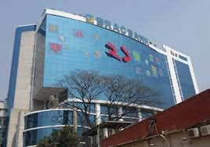
BRAC Bank Ltd is a private commercial bank in Bangladesh. Its main focus is on Small and Medium Enterprise (SME). It is formed under the industry of Financial Services Banking. Sir Fazle Hasan Abed, KCMG founded this bank on 4 July 2001 for reaching the large number of people who are deprived of modern banking facility. It has been providing different types of products and services to its customer since it started. BRAC Bank has 186 branch, 457 SME unit office, 1800 Remittance Delivery Point and 447 ATMs Booth across the country. The bank has achieved a dominant market position within a short period of time by its large branch network and commitment,.
Recently, BRAC Bank LTD have moved from being product centric to customer centric by differentiating their products, process and policies according to different customer segments. The primary objective of the bank is to carry on all kinds of banking activities with a key focus in facilitating Small and Medium Enterprise. There are 6000 employees are working with a efficiency to serve the about more than 15,00,000 individual customer.

2.2 Corporate Vision:
Building profitable and socially responsible financial institution focused on Market and Business with Growth potential, thereby assisting BRAC and stakeholders to build a just, enlightened, healthy democratic and poverty free Bangladesh.

2.3 Corporate Mission
BRAC Bank has several mission in serving their customer and for being leader in the banking industry.
- Continuous enhancement in Small & Medium Enterprise sector
- BRAC Bank have structured and continuous enhancement in low-cost deposit and retail assets.
- BRAC Bank financing Corporate Assets through self-liability solidarity and want to grow assets through huge investments in faster growing sectors.
- BRAC Bank commits constant effort to raise non-funded (NFB) income to its customers.
- BRAC Bank realizing efficient understanding between the branches, SME unit offices and BRAC field offices for delivery of remittances and other products and services.
- BRAC Bank conducting various lines of business with a diverse, fully dedicated team and well regulated environment with no compromise on service quality.
- BRAC Bank have a highly driven team entirely devoted to achieve the bank’s vision into reality.

2.4 Core Values
- Value the right that one is a member of the BRAC family.
- BRAC Bank always try to generate an honest, open, environment.
- Brac Bank have a strong customer focus and create relationships based on integrity, superior service and mutual benefits.
- Combatting for profit to ensure growth which is promised to shareholders.
- Working as a team member to reach the best interest of the owners
- Relentless in pursuit of business innovation and improvement
- Value and respect people and take decision based on merit
- BRAC Bank always ensures to be responsible, trustworthy and law-abiding.

2.5 Function of different Division of BRAC Bank Ltd:

2.5.1 Corporate Banking Division:
- The main functions of corporate banking division is wholesale banking services.
- Not only that BRAC Bank also providing banking services such as working capital finance, project finance, loan syndication and trade solutions etc.

2.5.2 SME Banking Division:
- Providing financial solutions to small and medium and emerging business.
Products and services of SME Division
- Anonno- This products is designed for those clients who is need for unsecured Term Loan.
- Apurba- Secured Term Loan, Overdraft and Demand Loan.
- TARA- This products was For women entrepreneur
- Shommriddhi- It is designed for facilitating the Trade Finance
- NIRMAN- It is a loan facility provided by the bank to customers who need this kind of loan facility-Loan for Constructions

2.5.3 Financial Division:
- Financial Planning, Preparing Budget and daily monitoring
- Salary Payment
- Monitoring and controlling all branch transaction
- Bill disbursement
- Maintain provident fund, Gratuity and pension Scheme.
- Preparing Financial reports

2.5.4 Human Resources Division:
- Employee recruitment
- Employee training and development
- Managing employee benefit, compensation, leave etc.
- Evaluating employee performance and reporting to Board of Director Committee
- Promotional camping and press release

2.5.5 Retail Banking Credit Risk Management:
- Loan administration
- Loan disbursement
- Project evaluation
- Processing and approving credit proposals of the branches
- Arranging and managing different credit facilities
- Providing related statement to Bangladesh Bank and other department at regular basis

2.5.6 Treasury & Financial Institution Division:
- Providing all kinds of treasury solutions to internal and external clients.
- Fund management, regulatory requirements handling, and daily liquidity management services.

2.5.7 Operations Divisions:
- Having Regional operating centers all over the country to make service delivery faster.

2.5.8 Information Technology:
- Procurement of hardware, software and its maintenance
- Data entry and processing
- Network management and expansion
- Software development

2.6 BRAC Bank Subsidiaries:
It has five more subsidiaries-
  - BRAC EPL Investments Ltd
  - BRAC EPL Stock Brokerage Ltd
  - Bkash (Mobile Banking Services)
  - BRAC Saajan Exchange Ltd
  - BRAC IT Services Ltd

Chapter- Three
Retail Banking Products & Services

3.1 Retail Banking:
Retail Banking is a customer oriented services that means conducting transactions with customers directly. Here, customers are getting different financial services such as savings and transactional accounts, corporate loans, personal loans, Debit/ Credit cards etc. As the Retail Banking is totally focused on consumers, that’s why their division always try to serve the customers by providing such services to satisfy and sustain its customer for improving its business condition and profitability.

3.2 Objective of Retail Banking:
- Rising penetration by providing increasing level of service, by offering value added services, by packing with them retail banking products and services.
- For taking place in the socio-economic development of the country
- Capturing large number of customers by assuring accessibility to credit.
- Try to minimize risk by Diversifying loan portfolio.
- Try to maximize bank profit to increase EPS to satisfy the shareholders of the bank.
- Try to minimize pressure on liquidity through quick recycling.

Target Market of Retail Banking:
The main target of the BRAC Bank is person who is Professionals, Business Executives and Self-Employed persons who have regular monthly income with repayment ability. Permanent officers of Government, Non-Government organizations/Institutions, Semi-Government, Autonomous bodies and Corporations.

3.4 Retail Banking Products and Services:

3.4.1 Retail Banking Deposits:

Savings Classic Account:
Savings Classic Account is used by individual to keep money for carrying out day to day financial transactions. This account don’t have maturity and customers have to maintain minimum daily average balance.
- Minimum Tk. 10000 balance is required to open such account for standalone. But, you need Tk. 50000 for opening Account in Dhaka.
- Minimum Tk. 50000 balance is required to earn interest.
- You get a cheque Books of 25 pages is free.

3.4.2 Triple Benefits Savings Account:
Triple Benefits Savings Account offers you to increase your savings at a higher savings rate with great opportunity for enjoying wide range of Alternate Channel Services.

Features:
- Minimum Tk. 10000 balance is required to open such account for standalone. But, you need Tk. 50000 for opening Account in Dhaka.
- You can earn higher interest rate on monthly basis on your principal amount.
- Ease of banking from branches and you can enjoy fast track services of internet banking, call center, SMS Banking and e- Statement.
- You can earn reward points and gift voucher by using our Visa/ Master Card
- Withdrawal limit maximum Tk. 100000 per day.

Benefits:
- No Account maintenance fee.
- No counter transaction fee.
- You get a cheque Books of 25 pages is free.
- You can enjoy Excellent Alternative Channel Services
- Monthly interest accrual.

Annual Rate of Interest:

Slab | Rate of Interest
5 Crore and above | 4%
50 Lac- <5 Crore | 3%
10 Lac-< 50 Lac | 2%
50000- < 10 Lac | 1%

3.4.3 Future Star Account:
Future Star Account provides us the opportunity to increase your savings from a low initial balance so that you can support your children to being a Superstar in the near future.

Features:
- Tk. 100 is minimum balance is required to open such account.
- You can earn higher interest rate on a monthly basis on average balance.
- You can earn reward points and gift voucher by using our Visa/ Master Card
- Withdrawal limit maximum Tk. 100000 per day.

3.4.4 Current Plus Account:
Current Plus Account offers you the freedom of unlimited transaction with the ease of Branch Banking and Alternate Channels.

Features:
- Minimum Tk. 5000 balance is required to open such account for standalone. But, you need Tk. 50000 for opening Account in Dhaka.
- There is no intercity online transaction fee.
- Ease of banking from branches and you can enjoy fast track services of internet banking, call center, SMS Bankingand e- Statement.
- You can earn reward points and gift voucher by using our Visa/ Master Card

Benefits:
- There is no account maintenance and Debit Card fee for maintaining the opening balance threshold.
- No counter transactions fee.
- Customer get the Cheque Book of 25 leaves.
- You can enjoy Excellent Alternative Channel Services
- Withdrawal limit maximum Tk. 100000 per day.

3.4.5 Salary Account:
Salary Accounts provides you the account with no minimum balance requirements and disburse your monthly salary giving the ease to earn interest Semi-Annually on daily balance.

Features:
- Employees who are working jn a MNC/LLC/MID CORP/NGO and has a partnership in a large proprietorship/Partnership firm and other foreign nationals are eligible to open such account.
- There is no minimum account opening balance required.
- You can earn interest on daily balance on any amount greater than zero.
- You can enjoy Excellent Alternative Channel Services
- Withdrawal limit maximum Tk. 100000 per day.

Benefits:
- There is no account maintenance fee.
- Get cheque book facility whose monthly balance is more than Tk. 20000
- You can enjoy Excellent Alternative Channel Services
- Withdrawal limit maximum Tk. 100000 per day.

3.4.6 Resident Foreign Currency Deposit (RFCD) Account:
RFCD Account offers our local customers to manage and access foreign currency from anywhere around the world and travel without worry.

Features:
- Currency can be USD, GBP or EURO.
- You can earn interest on day end balance of USD 1000 or GBP 500 or greater on a monthly basis.
- You can earn reward points on using the International Visa Debit Card (USD) at retail outlets abroad.
- Ease of banking from branches and you can enjoy fast track services of internet banking, call center, SMS Banking and e- Statement.

Benefits:
- There is no account maintenance fee.
- You can connect our call center from anywhere around the world.
- You can avail the facility of International Visa Debit Card (USD)
- You can remit your additional fund abroad from your RFCD Account with no minimum amount of instructions.

3.4.7 Term Deposit:
Tern deposit accounts are non-transactional deposit accounts with maturity. You can withdraw your money when the term has ended.

Deposit Premium Scheme (DPS):
BRAC Bank Ltd DPS account is special savings scheme that allows customer to save on a monthly basis.

1.Flexi DPS:

Features:
- Minimum monthly installment is Tk. 500 or any multiples of Tk. 1000, Tk. 2500, Tk. 5000 and so on.
- Here, customers get the facility of transferring monthly deposit installment automatically from their savings account to DPS account on due dates.
- Interest is accumulated on monthly basis after adjusting government tax.
- Customers get the options to choose the period of tenure starting from 1 year till 10 years. They can choose the installment date according to their will or convenience.

Years | Tk. 500 and Multiples
1 | 3%
2 | 4%
3 | 5%
4 | 5%
5 | 6%

2. Fixed Deposit General:
Fixed Deposit General is a non-transactional account that provides interest and principal at maturity. Here, minimum amount of Tk. 100000 is required to open the General Fixed Deposit Account. The tenor can be opened for 1, 3, 6, 12, 24, 36 months. Total interest and principal is paid on maturity, calculated on 360 days. This accounts continues on a roll over basis untill the customer confirms its closure. As per the Bangladesh Bank guidelines, Government Tax/Excise Duty will apply to the interest amount.

Tenor | 1 Lac- <10 Lac | 10 Lac- <50 Lac | 50 Lac-< 3 Crore | 3 Crore and above
91 days | 6% | 7% | 7.50% | 8%
182 days | 6.5% | 7.5% | 8% | 8.25%
364 days | 7.5% | 8% | 8.25% | 8.50%
36/24 Months | 8% | 8% | 8.5% | 8.50%

3. Fixed Deposit Plus:

Features:
- Tk. 10000 is the minimum amount is required to open such account.
- The interest is paid on maturity (calculated at 360 days) after adjusting Government tax.

Tenor | 1 Lac- < 10 Lac | 10 Lac- < 50 Lac | 50 Lac and above
89 days | 3% | 4.5% | 5%
150 days | 3% | 4.5% | 5%
360 days | 5% | 5% | 5%

4. Freedom Fixed Deposit (FFD):

Features:
- Tk. 10000 is minimum amount is required to open Freedom Fixed Deposit. The length of tenor can be 3/6/12/24/36 months. Interest is paid on a maturity basis after adjusting the Government Tax.

Tenor | 1 Lac-< 10 Lac | 10 Lac- < 50 Lac | 50 Lac and above
24/36 months | 7.25% | 7.25% | 7.25%
12 months | 7% | 7% | 7%
6 Months | 6% | 6% | 6%
3Months | 5% | 5% | 5%

5. Abiram Fixed Deposit:

Features:
- It is a non-transactional account that deposits interest monthly to your existing current or savings account.
- Minimum amount of Tk. 100000 is required to open such account.
- Abiram FD can be opened for 1/2/3 years.
- This account continues on a roll over basis untill the customer confirms its closure.
- The interest is paid on a monthly basis after adjusting tax as per the Bangladwsh Bank guidelines, as per the interest rate matrix.

6. Unit Fixed Deposit:
Here, the extra benefit the customer can avail the partial encashment. If customer want, then he/she allow to cash partially before it reaches maturity and the remaining amount of fixed Deposit will be continued to earn interest at tge initially agreed rate fir the rest of the tenure.

Features:
- Minimum amount of Tk. 50000 is required to open such account.
- Each Bangladeshi taka is considered as 1 Unit.
- There is no ceiling on maximum amount of fixed deposit
- 12 months tenure.
- Lucrative interest rate.
- Customer can get the loan facility against lien on fixed deposit.

3.4.2 Retail Banking Loan Products:

1. Home Loan:
There are three types and purpose available-
- Home Loan: Financing against purchase oy your under-construction, Semi-complete, Completed, Secondhand Apartment of house.
- Home Credit: Financing against renovation, extension, construction of your own home.
- Takeover: Financing against transfer to the current balance of your existing housing loan to BRAC Bank Ltd.

Eligibility:
For individual,
- Minimum 3 years of job experience needed and must be permanent in nature in current job.
- Minimum Tk. 25000 income must be needed.
For Businessmen, Self-employed, Landlords,
- The applicants must be owner, Director of Proprietorship, Partnership, Private Limited Company.
- Minimum 3 years of business experience needed.
- Income Tk. 30000 must be needed.

Product Features:
- The borrower must be the owner of the property.
- Applicants must be permanent in Bangladesh.
- The age of the applicants must be minimum 25 years and maximum age 65 years at the time of maturity.
- Competitive interest rate.
- Maximum loan tenure is 25 years.
- Property must be located in city corporation area.

2. Personal Loan:
An individual can take loan from BRAC Bank if any individual seems to do make the dream gadgets, wedding, medical attention or whatever the requirements true, an unsecured loan upto 20 lac exclusively designed to cater the person's needs.

Interest rate & Processing Fee:
- Starting from 10.75%

Special Features:
- A personal loan facility for any customer needs.
- Loan amount Tk. 1 lac to Tk. 20 lacs.
- No collateral or cash securities.
- Flexible repayment Equal Monthly Installments over a period of 12 months to 60 months.

Eligibility:
- Age: The age of the applicants must be minimum 25 years and maximum age 65 years at the time of maturity.
- Personal Experience: For salaried, Confirmed Employee having minimum total experience of 1 years. For Businessmen, minimum 3 years of Business Experience in same business.
- Minimum monthly income: Tk. 25000 per months.

3. Auto Loan:
If you want to buy brand new or reconditioned car, the BRAC Bank is always beside your side and BRAC Bank Auto loan is built for maximum speed and efficiency.

Eligibility:
- Auto loan is available for salaried individual, Business Persons, Self- Employed and Landlords.
- Age: The age of the applicants must be minimum 25 years and maximum age 65 years at the time of maturity.
- Monthly income must be Tk. 25000 (salaried) and Tk. 35000 (For others)
- Confirmed employment with total 1 year work experience
- Age of business: Minimum 3 years.

Features:
- The loan would be up to 50% of quoted value of the car.
- Maximum loan ceiling up to Tk. 40 lac.
- Flexible repayment Equal Monthly Installments over a period of 12 months to 60 months.
- Loan approved for the brand new and reconditioned cars.

4. Holiday Loan:
The main objective of this loan is to enjoy a gateway with your loved ones from escaping the hustle and bustle of everyday life. BRAC Bank Holiday loan will help you to make those dreams become a reality, if you have a mind for a trip but still haven’t saved up enough. You can take up to Tk. 10 lac as Holiday loan and have to make repayment within 36 months.

Interest Rate:
- Starting from 10.50%

Special Features:
- Loan amount 1 lac to 10 lac
- No collateral or cash securities.
- Flexible repayment Equal Monthly Installments over a period of 12 months to 60 months.

Eligibility:
- Age: The age of the applicants must be minimum 25 years and maximum age 65 years at the time of maturity.
- Monthly income: Tk. 25000 ( Per months)

3.5 BRAC Bank Cards:

3.5.1 Credit Cards:
- Signature Card
- Platinum Card
- Gold Card
- Classic Card

Eligibility:
Any Bangladeshi people whose monthly minimum income Tk. 25000 after deducting tax as per the Bangladesh Bank guidelines.
- Minimum 21 years- eligible for Primary Card
- Minimum 18 years- eligible for Supplementary Card
- Minimum 60 Years- eligible for Any Card

3.5.2 Debit card:
This card is for environment conservation. When someone is availing a planet card, they are supposed to donate for various projects such as waste management projects, Renewable energy projects, Tree plantation programs etc.

3.5.3 Resident Foreign Currency deposit (RFCD):
This card is used to access RFCD account from abroad, it can also be used worldwide at VISA ATMs for cash withdrawal.

3.5.4 Prepaid Card:
- Travel Card- a prepaid card is featured for accessing safely while travelling abroad. A travel cardholder can withdraw cash from any VISA ATMs to fulfill their need when required.
- Hajj Card: This card is especially designed for such personnel who are going to Hajj. It is totally interest free prepaid card for safe access for getting money while Hajj.

3.6 Premium Banking:

Premium banking is a BRAC Bank’s top Retail Segment designed exclusively to serve to the bank’s high segmented customers. As premium banking customer, the banking service will be conducted in a more personalized, prioritized and privileged manner. Here, all financial requirements of the customers are met with top priority.
Eligibility:
To become a member of the premium banking customer, you need total deposit balance of Tk. 75 Lac and above (CASA+TDA) or 40 Lac & above (only CASA)

Product Mix |  | Criterion
Retail Deposit | Tk. 40 Lac (CASA )or Tk. 75 Lac (CASA+TDA)
Retail Loan and Deposit | Tk. 1 Crore Loan Disbursement + TK. 10 Lac (CASA – average of last 6 months)

Benefits:
All premium banking customers are entitled to the following benefits:
- BRAC Bank has dedicated Relationship Manager to deliver premium services to its permium customers.
- Premium banking basically designed for delivering personalized banking service to its PB Customers.
- The PB customers are getting Platinum Debit Card and Premium Cheque Book to execute their financial transaction with banks.
- PB customers are getting personalized birthday wishes and gifts on their birthdays.
- PB customers are getting invitations to exclusive events, parties and seminars which is arranged by BRAC Bank Ltd.
- PB customers getting the festivals greetings gifts on several occasions.
- Not only that Special occasion based offer will always be remained to make the customer feel significant and remarkable to banks.

Privileges and Value Propositions:
As premium banking customer, you can enjoy unique privileges catering to your Healthcare, Hospitality, Travel, Entertainment and Lifestyles.
- Apollo Hospitals
- United Hospitals
- Balaka Lounges at Hazrat Shahjalal International Airport
- Complementary Pick & Drop and Meet & Greet Service
- Buy1 Get1 free buffet at The Westin Dhaka
- Buy1 Get1 free buffet at Four Points by Sheraton Hotel
- Buy1 Get1 free buffet at Amari Dhaka
- Buy1 Get1 free buffet at Le Meridien Dhaka
- Buy1 Get1 free buffet at Radisson BLU Water Garden Dhaka
- Buy1 Get1 free buffet at Radisson Chittagong

3.7 Internship Responsibilities:
Placement: Premium Banking, Product Department, Retail Banking Division.
- Preparing “Payment Approval Note” of different Hotel Partners with whom BRAC Bank Ltd has agreement to provide its Premium Customer B1G1 offer. Having prepared the Approval Note, sending it to the Finance Department to process.
- Preparing Health Voucher for Apollo & United Hospitals for giving the customer complementary health check-up. The request for voucher was coming from different Relationship Manager of different Branches as per customer’s request.
- Arranging Pick & Drop and Meet & Greet Service request. Here, premium customer usually contact with their Relationship Manager and request for such benefits. Then, Relationship Manager send to the BRAC Bank Ltd Premium Banking Department the arrival and departure information of customer for processing.
- Preparing excel Format for PB upgrading as per customer request. Here, the customers who are willing to get the benefits of PB, then they maintain OB threshold (CASA 40 LAC & CASA+TD= 75 LAC) and asked to their Relationship Manager to migrate their cost center. Here, I was assigned to make the excel format for upgrading and sent it to my supervisor to process.
- Preparing list of Birthday of Premium Banking customer. Here, Relationship Manager usually send to the head office of birthday list and then take the decision whether the birthday gift is sending to customer's address or particular Branch. Then sending the Birthday gift to premium Banking Customer's Premises.
- Working in a project named “CIF against Multiple SOL” and determining the preferred branch.

Chapter- Four
Findings & Recommendations

4.1 Findings
- BRAC Bank Limited always cares for its services to customer. They always try to provide premium service to its customer than any other bank in the banking sector. The management and the employees who are working in a BRAC Bank is extremely focused on their customer and its quality of services.
- BRAC Bank Limited always try to provide exclusive and unique product features to customer by keeping in mind the preference of customers. The products and services the BEAC Bank usually provide are the combination of exciting facilities and features to their customers.
- BRAC Bank Limited always think that the main power is their skilled employees for being market leader in the banking sector. They always care for their employees and many times they arrange different seminars, training session and workshop on regular basis to train and develop them.
- BRAC Bank Limited has excellent hierarchy. Through this hierarchy, whatever the decision are taken by the top management are implemented effectively and efficiently. Though the decision making power is so centralized but by a excellent hierarchy, they operates its business activities so smoothly. The working environment is so attractive to work and the culture BRAC Bank follows is so flexible and comfortable for its employees.
- In BRAC Bank, all the decisions are taken in head office. So, the Relationship Manager from different branches have to wait for long times for getting approval in different bill and other documents. BRAC Bank should improve such inconvenience.
- BRAC Bank offers an exclusive and unique product features named Premium Banking. The demand for Premium Banking is so high in the market. Many customers have the capability to be the customer of Premium Banking. But the lounges of Premium Banking are only available at Dhaka and Chittagong. BRAC Bank should open more premium banking lounges outside Dhaka and Chittagong.
- The employees of BRAC Bank is so much dedicated to their responsibilities. Though the working hour is about 8 hours. But sometimes, many of the employees are working about 10 to 11 hours in a day. But there is no extra benefit for employees such as overtimes and others. Though the employees are much dedicated but the remuneration package of BRAC Bank is so tight.

4.2 Recommendations
Some steps should be taken to improve its business conditions:
- BRAC Bank requires to develop an open and free working environment, where employees have been given more autonomy and given place for introducing their capabilities.
- HR practices should be improved by ensuring proper training, workshop, seminars.
- BRAC Bank should develop more strategic plan to sustain profitably in the market.
- The working environment of the branches should be well furnished, organized and should be placed perfectly.
- The work life balance of the employees of the bank is so weak. That is why management should make a balance work life of the employees.
- The request is coming from different Relationship Manager should be conducted fast to smooth customer services.
- BRAC Bank should add junior employees in taking decision. Because such employees may have better ideas.

4.3 Conclusion
There are many new financial institutions like banks are getting permission to start their business day by day. That’s why banks have to be more customer centric (products and services have to be designed according to the customer’s demand and preferences) to be leader in the banking industry. All of the banks in a banking sector are conducting their activities in a modern ways. The major focus for banks is to sustain in this competitive environment by managing its assets and liabilities efficiently and delivering superior products and services to customers which is really beneficial to fulfill customer’s need. BRAC Bank is the most promising bank in the banking industry of Bangladesh. In this report, findings are found by watching and conducting the different task in the Head office of BRAC Bank. The overall performance of the product of BRAC Bank is satisfactory but some improvement is also needed to create better service to its customers and its stakeholders. Some financial issues are also monitored to take more market share to be a market leader. After all, it can be said that the way the BRAC Bank operating its business is so transparent and ethical manner with the best industry practice. With the current performance of the BRAC Bank with little improvement in particular sector, then there will definitely make the BRAC Bank is one of the best Private Bank in the industry of banking in Bangladesh in near future.

4.4 Appendix
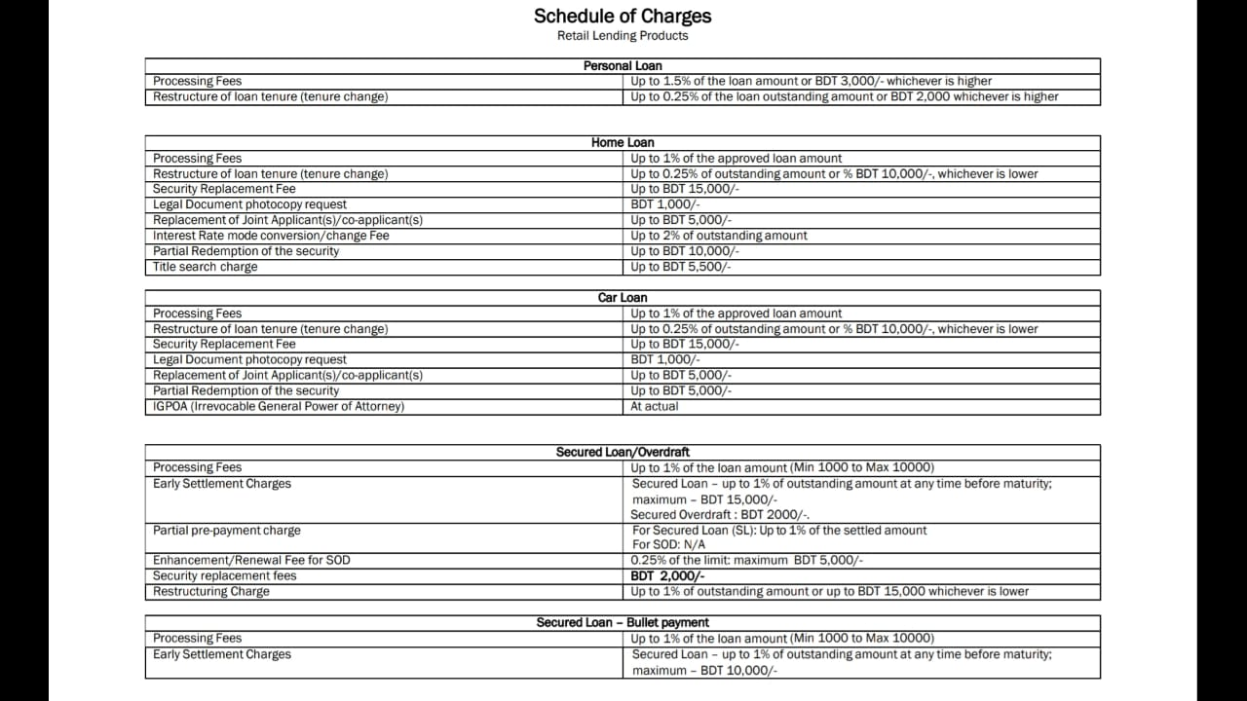
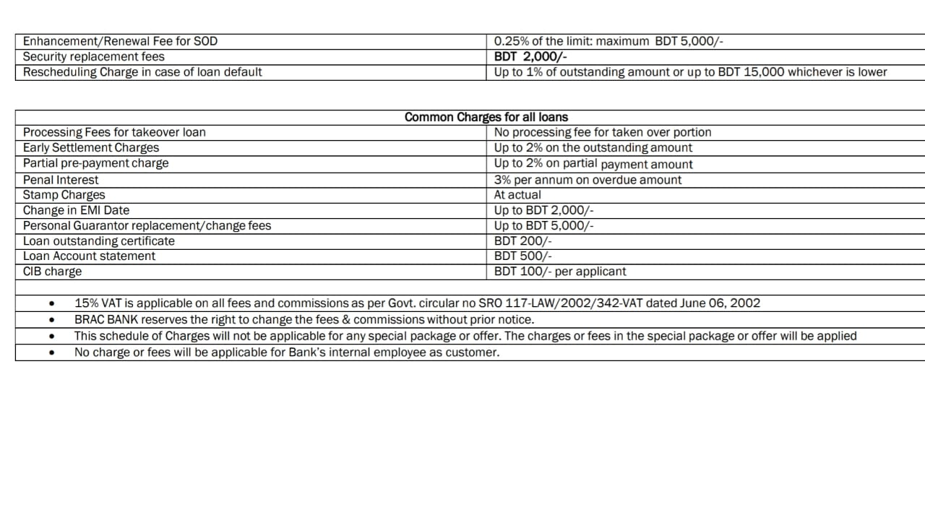

Rate of Interest of Deposits:
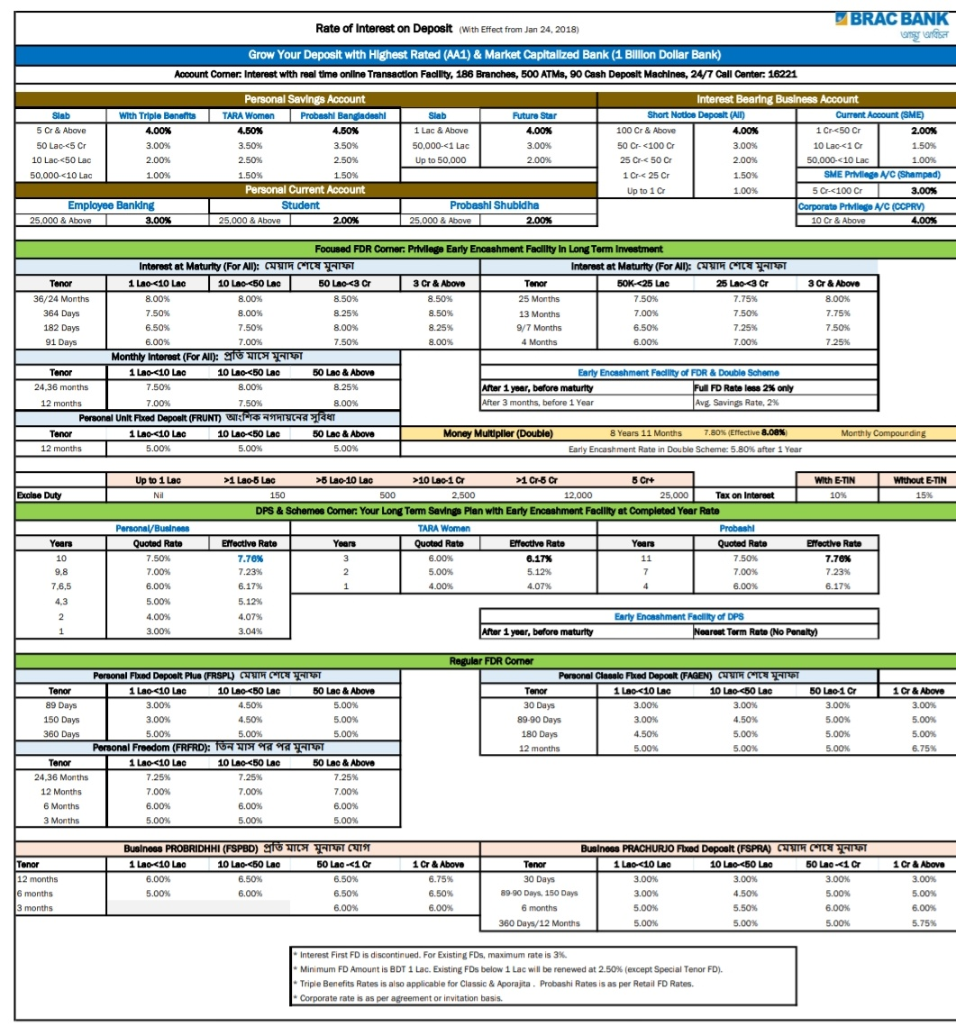

References:
- www.bracbank.com/Deposit-Account.php
- www.bracbank.com/Loan-Account.php
- www.bracbank.com/card.php
- ww.bb.org.bd
- en.wikipedia.org/wiki/BRAC_Bank_Limited
- Annual report of BRAC Bank LTD.
- Internship report available at UIU Library.

