


UNITED INTERNATIONAL UNIVERSITY

Prepared for
Dr.Badruddozza Mia
Associate Professor
School of business & Economics
United International University

Prepared by
Arefin Wisea Ablag
ID-111-151-189
United International University

Letter of transmittal
August 04, 2019
To,
Dr Mohammad Badruddozza Mia
Associate Professor
School of Business and Economics
United International University (UIU)
Subject: Submission of Internship Report on "HR Practice in Shahjalal Islami Bank “
Dear Sir,
Here is my Internship Report on HR Pravtice in Shahjalal Islami Bank Limited. I might want to review with appreciation the huge help and support, which I have gotten from you. The entire experience of this report composing has helped me to overcome any issues between homeroom learning and genuine circumstance to a lot more prominent degree.
It would be somewhat you, in the event that you please take the inconvenience of experiencing the report and assess my exhibition.
I am anticipating your benevolent examination on this Internship report.
Expressing gratitude toward you.
Yours dutifully,
Arefin Wisea Ablag
ID: 111 151 189
BBA Department
United International University

(Signature)- -

Acknowledgement
The report titled as "HR Management Practices in Shahajalal Islami BankLimited'' has been set up to satisfy the prerequisites of BBA entry level position program. While setting up this report I have gotten most extreme and true direction, supervision and co-task from various people and associations. As a matter of first importance I might want to express my most profound gratefulness to Dr Mohammad Badruddozza Mia, who motivated me to take this investigation and informed me ceaselessly during arrangement with respect to the report. His true direction, untiring collaboration, important counsel and unending motivation empowered me to survive every one of the issues that sprung up over the span of my temporary position program and keeping in mind that getting ready this report. I am likewise obligated to Mr. A.K.M Hasan Rahim(Senior Assistant Vice President),Mr Fajlul Karim Khan (Senior Assistant Vice President) Mr. Md. Mazharul Alam (Junior executive Officer), Mr. Yousuf Hasan (Assistant Executive Officer) ,Mr. Md Shamiul Islam (Junior Assistant Vice President) & Mr Md Ahteshamul Hoque ( Senior Executive Officer) who contributed a great deal by sharing their knowledge with me & enlighten me with HR Operations.I am particularly appreciative to Mr. Majumdar Ishteak Mahmud for supervising me in every step, guiding me through my journey & sharing his knowledge and experience with me

Executive Summary
About Bank we can say it is an association where the general population are consent to take monetary stores from the general population and cause a credit to offer advance to the general population to should be possible straight or optionally by the capital markets. Typically Bank administrative relies upon the financial aspects state of the nation. In Bangladesh, Banking Sector is confronting exceptional redesign as a result of the monetary guideline and progressing of the financial framework. We can see that as of now our Banking industry transforming into the huge finish locate due to enter a few new Banks alongside high improvement by expanding innovative progression, legitimate credit the executives, solid execution level with the consumer loyalty. This Report has been made dependent on "Human Resource Management Practices in Shahajalal Islamic Bank Limited" who assumes the indispensable job and the most fundamental part for the association and business. So hence significance of the board framework in human asset of banking part has been expanded quickly around the world. Human asset is the main powerful approach to build the estimation of capital, land, system for including legitimate estimation of business. Thus human asset the executives rehearses in the association thinking about real piece of the Bank. In the present focused world we are confronting vivacious challenge in each progression of our life including another time. As of now all the association enlisting, holding and keeping up the best representatives rather than considering accomplishment benefit. Effective human asset just by means of too rich the corporate vision

Table of Content

SL |  | Description | Page  no
Letter of Transmittal Acknowledgment Executive Summary Table of Content |  |  | i
 |  |  | ii
 |  |  | iii
 |  |  | iv
1 | Preparative |  | 01
2 | Introduction |  | 04
 | 2.1 | Introduction | 05
 | 2.2 | Origin of the Report | 05
 | 2.3 | Purpose of the Report | 05
 | 2.4 | Scope of the Report | 06
 | 2.5 | Limitation of the Report | 06
 | 2.6 Methodology |  | 06
3 | Company Profile |  | 08
 | 3.1 | Historical Background of Shahajalal Islami Bank | 09
 | 3.2 | Vision | 09
 | 3.3 | Mission | 09
 | 3.4 | CSR Activites | 10
 | 3.5 | Shahajalal Islami Bank’s Motto | 11
 | 3.6 | Objective Of Shahajalal Islami Bank | 11
 | 3.7 Strategies of Shahjalal Islami Bank |  | 11
 | 3.8 | Brand Promise | 11
 | 3.9 | Core Value of Shahajalal Islami Bank Limited | 12
 | 3.10 | Product & Services | 12
 | 3.11 | Investments product (Corporate) | 13
 | 3.12 | Investment ( Retail) | 13
 | 3.13 | Investment Product (SME) | 13
 | 3.14 | Compliance Status on BSEC Notification | 14
4 | Human Resource Practice in Shahajalal Islami Bank |  | 21
 | 4.1 | Human Resource Practice | 22
 | 4.2 | Distribution Of Man power | 22
 | 4.3 | Gender Positioning | 22
 | 4.4 | HR Strategy | 23
 | 4.5 | Work Environment & Culture | 23
 | 4.6 Recruitment & Placement |  | 25
 | 4.7 | Complacence & Disciplinary Action | 32
 | 4.8 | Training & Development | 33
 | 4.9 | Human Resource Operation | 36
 | 4.10 | Compensation | 41
5 | Suggestion & Learning |  | 44
 | 5.1 | Suggestion | 45
 | 5.2 | Learning | 47
6 Conclusion |  |  | 49
Appendix

Chapter -1
Preparative

Preaprative
Bangladesh is referred to be as vigorously populated nations in this world and greater part of individuals are till now numerous individuals excluded with the financial administration appropriately. Therefore Bangladesh is confronting deterrent in advancing with the budgetary status. In order to stay away from with this sort of troublesome situation, Bangladesh Bank which is the Shahajalal Islami Bankof Bangladesh, has been chosen to actualize and advance the financial administrations among the provincial individuals by advancing operator banking administration in the regions under focal financing. Presently the present circumstance is portable administrator can assume significant job and to persuade the country individuals to keep away from monetary hazard in their everyday life. Likewise, top financial administration can cooperate to construct bound together stage and to give powerful administration to the country individuals in Bangladesh. Being a piece of this modernization Bangladesh needs to be created in banking division by giving the thought regarding portable banking to the country individuals with this successful advance country individuals will be profited with the better, secure.
Banking segment is ruling since the introduction of Bangladesh. Strength intensity of the banking framework serves to monetary development of a nation. Then again with the colossal ups and downs the financial division of Bangladesh voyaged an adventure where the nation confronted a few injuries. For the improvement, various advances have been taken by the worry specialist to make this area increasingly gainful.
Capital sufficiency of bank, streamlining rules for rescheduling of different sorts of advance, fixing arrangement for non-performing advance, reinforcing divulgence and improving bookkeeping framework and so on goal can play to turn out to be progressively proficient. Throughout the years this area has improved amazingly. In spite of the fact that prior in this part has not accomplished its objective tastefully as like today. At this moment still its should be built by the Central Bank in certain zones to make it more beneficial more.
Bangladesh Bank expanded his perception in view of huge money related administrative on Sonali Bank Constrained, BASIC Bank restricted and likewise on fourteen bank and monetary establishment, state possessed and private to improve their administration and furthermore to relieve the budgetary injury
As of late some antagonism indicating has been seen that the state claimed bank gainfulness isn't sufficient. In private business bank it‟s positive yet low. For nonperforming advances (NPL) has comparative execution which has been watched however the rate is still high 21.82%. On the opposite side private business Bank and remote business bank has expanded. So for high NPL state possessed Bank needs to keep high arrangement thank benefit. Government needs to embed riches into these Banks to prop them up. So the capital sufficiency proportion to be raised to 12.5% of their hazard situated weighted resources by 2019 will change for the SCB trying for the SCBs. In 2015 capital sufficiency of SCB was just 6.2%.
Because of political impedance, awful resources and wastefulness are the explanations behind lower benefit in SCB. For open segment slow condition is the reason less benefit which reflected high volume of liquidity in the Bank. The development store proportion has been minimal over 70% in 2015 and furthermore Bank is permitted to loan up to 80%.
Notwithstanding frail execution of the part, administration still stays removed from the truth. The specialists delayed to make cash move. The trademark gathering has not restored their cash till presently. The Banking area notwithstanding reluctant to take this misuses cash which is making more issues in the area. This stun is making more difficulties and further changes the said segment. The Commission can perform by observing the rising need and so as to develop more straightforward and mindful financial framework.
Because of changes during the 1990s, 2000 and a short time later financial segment made extensive progress. However, this segment should get ready for the up and coming age of worldwide administrative system what's more, meet developing customers need. The up and coming days banking industry should accomplish the capacity of ingest stuns emerging from money related and financial pressure, improve hazard the board also, administration and fortify Bank straightforwardness and exposure. In this way, if the part needs to accomplish bigger job to contribute with steady and sound macroeconomics. Hence the banking segment needs to experience the excruciating way of stricter approach.

Chapter -2
Introduction
2.1 Introduction
Human asset the executives is the capacity of inside an association that centers enrollment, the board and giving guidance for the general population who work in the association .Human asset the board can likewise be performed by line administrator.
Representatives are the center asset of any association, without them one can't run their association and human asset is directed with the development of advancement of individuals toward more elevated amount of competency, innovativeness and satisfaction. it keep representatives become better more capable individual and afterward it attempts to make an atmosphere in which they add to the furthest reaches of their improved their capacities .it accept that extended abilities and open doors for individuals with legitimately improvement .
Shahajalal Islami Bank Limited constantly determinate what occupations should be done and what number of kinds of laborers will be required. So building up the structure of the bank, it help with deciding the aptitudes, learning and capacities of employment holders. To guarantee proper work force are accessible to meet the prerequisites set during the key arranging process .this bank accepts that the nature of work originates from quality specialists
2.2 Origin of the report
As an understudy of BBA it’s required to take part in an association as assistants to find out about the corporate world to expand more business information. A report is a portrayal of that realizing which I have learnt as an understudy. The assigned recommendation suggested by the guide educator the subject of my report is "HR the executives Practices in Shahajalal Islami Bank Limited and I have achieved my assignment with Shahajalal Islami Bank Limited . In this report I have composed the examination discoveries and accomplishments which is comprising with my exploration, discoveries, also, accomplishments. This record "HR the executives Practices in Shahajalal Islami Bank Limited is masterminded under the supervision and direction of
2.3 Purpose of the report
- Primary target in this examination is compose a report on "HRM rehearses in Shahajalal Islami Bank Limited''
- Expanding learning about the capacity of human asset.
- Getting clear thought regarding HR practice procedure of Shahajalal Islami Bank Limited Process
- To know inside and out about human asset the executives of Shahajalal Islami Bank Limited
- Discover the problem of human asset division in Shahajalal Islami Bank Limited
- Productivity of HR practices and impediment in the Shahajalal Islami Bank Limited constraints
2.4 Scope of the Report
The degree for this report fundamentally encompassed with Shahajalal Islami Bank Limited. In this report generally concentrated on down to earth perception. There was meeting and auxiliary information sources from NBL and likewise from other Bank. Report degree was not excessively much nice, just bank office and field tasks of the bank could use for this paper. As I was doing entry level position in Shahajalal Islami Bank constrained, Head Office, Human Resource Division, so therefore extent of the examination was as it were confined to the Human Resource Division of Shahajalal Islami Bank Limited. When I began doing report this zones I have concentrated on zone which are as per the following:
- Acquirement of representative or business
- Development of representative or business
- Facilities, advantages and pay
2.5 Limitations of the Report
- For getting the data of the bank exercises one must be an approved official of this bank. As I am an understudy I am not approved to think pretty much all actuates data of this bank. I am doing this report dependent on my own experience which I got from various course I have finished in my BBA life, from web, by perusing a wide range of diaries, sites, and articles about this bank.
- Timeframe (just 3 months) is an impediment for me as I am working in this bank and I need to report my exercises to my administrator, so it is hard to keep up time span to make my report with a constrained timeframe.
- insufficient records, distributions were accessible according to my prerequisite
- Maximum data that I need was confidential to the bank
2.6 Methodology
Nature of the examination: Exploratory
Source of data: For gathering information and data I have embraced assortment of information accumulation strategies. These are exact thinking; meetings, perception and experience. This investigation has been led fundamentally based on both essential and optional information. To a few expand essential information are utilized and these are gathered from pertinent diaries, magazines papers and so on and furthermore from production of expert establishments. Perception systems too have been utilized in the event of need. Anyway information utilized in this examination has been additionally broke down hat's more, handled with the end goal of the investigation. For optional information I explored some pdf archives, records. Then again, essential information has been gathered by the meeting with the a few meetings with different sorts of representatives of Shahajalal Islami Bank

- I have posed numerous inquiries to my Supervisors and some investor HR usage, which can be alluded to as interview.
- I have perused a few books, manuals, reports which have given me exact help. In this way, it is experimental thinking.
- I have likewise utilized my experience which I have accumulated over the span of my internship
Primary Data
- Getting information by face to face coversation.
- Direct perception

Chapter -3
Company Overview

3.1 Historical Background of Shahajalal Islami Bank Limited
Presently a-days banks become a basic piece of human life. For transection of cash individuals are significantly more subject to banks. Banks are giving their customer better administration to get by in focused market.
Shahjalal Islami Bank restricted pursues the islami shariah or standards. SJIBL is named after a holy person Hajrat Shahjalal (R) who dedicated himself in getting harmony the world and he likewise served for the mankind. On first April 2001 SJIBL first presented as open constrained bank under the organizations demonstration 1994. On tenth may SJIBL first began its financial exercises. Inside a brief timeframe due to its exercises it's accomplished a momentous position and furthermore become a treat for different banks.
SJIBL from the earliest starting point they are very worry for consumer loyalty and that is the reason bank is overseen by exceedingly expert group. They accept that fulfilled clients are their incredible minister. Under the principles of Shahajalal Islami BankSJIBL offers various administrations to individual and corporate clients which covers all portion individuals of the general public.
At present Shahjalal Islami bank is one of the biggest private business manage an account with 123 branches
3.2 Vision
To be the most desirable bank in Bangladesh based on Sariah while maintaining customer trust, value, wealth, service, rapid growth and embodied with human development based on moral ethics and values.
3.3 Mission
- To provide quality services to customers
- To set high standards of integrity
- To make quality investment
- To ensure sustainable growth in business
- To ensure maximization of shareholders wealth
- To expand the customer’s innovative service acquiring state-of the-art technology blended with Islamic principles.
- To ensure human resource development to meet the challenges of the time.

3.4 CSR Activies
So as to guarantee welfare of the more prominent network by using the C.S.R. and Zakah subsidize, Bank has built up an establishment called "Shahjalal Islami Bank Foundation". The principle targets of Shahjalal Islami Bank Foundation are:
- To give social insurance to poor and bothered individuals.
- To give instruction backing to praiseworthy however poor understudies through grant, grant.
- To give money related help to flood, twister or debacle influenced individuals.
- To help compassionate.
- To give money related help to advancement of culture, sports of the nation
- To take an interest in social and natural activities
Corporate Social Responsibility (C.S.R.) is a type of corporate self-guideline incorporated into a plan of action. C.S.R. arrangement works as an inherent, automatic system whereby business screens and guarantees its dynamic consistence with the actual intent of the law, moral measures, and universal standards. The objective of C.S.R. is to grasp duty regarding the organization's activities and support a positive effect through its exercises on nature, customers, workers, networks, partners and every other individual from the open circle.
Sector for Corporate Social Responsibility (C.S.R.) as per Regulatory Authority Instruction |  | Yearly C.S.R. to be allocated | C.S.R. Contribution of Shahjalal Islami Bank Ltd
Education and Job focused Vocational Training |  | 30% | Distribution of Scholarship to 500 Students of S.S.C.& H.S.C. level each year.
Preventive and Curative Healthcare |  | 20% | Donation to Hospitals running as non-profitable organizations.
Climate Risk Fund (CRF)/Environment Purpose |  | 10% | Tree Plantation(program arranged by banks 10 branches separately in 2013), House Repair in cyclone(was done last in Brahmonbaria natural disaster affected area), flood affected area etc.
Remaining Other Sectors |  | 40% | Blanket Distribution and Cash Contribution to Prime Ministers Fundto assist in national and international disasters as remarkably did during Tajrin Fashion Disaster, Rana Plaza Disaster, Nepals' massive Earth Quake, Rohingya Aid etc.
Corporate Social Responsibility (CSR) of the Shahjalal Islami Bank Ltd has been shaped out considering following perspectives
- Responsibility towards Shareholders
- Responsibility towards Suppliers
- Responsibility towards Customers
- Responsibility towards Community
- Responsibility towards Environment
3.5 Shajalal Islami Bank Limited’s Motto:
SJIBL is very much committed to cordial service.
3.6 Objectives of Shajalal Islami Bank Limited:
- Contributing in sustainable economic growth
- Maintain an interest free banking system based on Sariah.
- Helping in reducing poverty and unemployment rate.
- Ensuring maximum utilization of available resources
- In respects of assets and profit to be the best and number one position in Bangladesh
3.7 Strategies of Shahajalal Islami Bank Limited:
- Earning customer best satisfaction and their confidence
- Increasing capital
- Manage and Handle the bank in most effective manner
- Fulfill customer needs and continuously observe their perception toward meeting those requirements
- To provide better service to customers updates, policy, procedure and practice need to be probe.
- Focusing on employee development to identify customer need properly.
- Raise a compatible working environment
- To diversify portfolio both the retail and wholesale market.
- Facilities trade throughout the market
- Providing simplest solution of complex business situation
- Capturing those population which are not still aware about banking activities.

3.8 Brand promises of Shahajalal Islami Bank Limited:
- People- Believing in long lasting relationship which creates a greater value
- Process- the process or technique we conduct ourselves
- Prosperity- we focused about to create suitable value addition to all stakeholders

3.9 Core value of Shahajalal Islami Bank Limited:
- Unique bank: Setting a benchmark for other banks by operating the banking system in a modern and unique way which will automatically help in expanding business.
- Dynamic: Providing technically advanced products and services to customer
- Professional: Challenging situation will be handle by team of professionals and they believe in providing fasts response, service.
- Caring: Always concern about customer needs and satisfaction
- Trustworthy: we believes in both was communication and always think about stakeholders and share knowledge with all the stakeholders.

3.10 Product & Services
Shahjalal Islami Bank Limited accepts deposits on the basis of Mudaraba in the following types of accounts & pays profit ,like that of dividend in the account

- Modaraba monthly Scheme.
- Modaraba Double Money.
- Modaraba Monthly Deposit.
- Modaraba Millionaire
- Modaraba Haji Deposit
- Modaraba Housing Deposit,
- Modaraba Small Business.
- Modaraba Cash waqf Deposit.
- Modaraba Lakhopoti Deposit
- Modaraba Bibaho Deposit.
- Modaraba Mohor Deposit.
- Modaraba Shikka Deposit.
- Modaraba Special Term Deposit.
- SJIBL School Banking.
- Modaraba Money Spinning

3.11 Investment products, Corporate (Mode)
- Murabaha
- Bai-Muazzal
- Hire Purchase under ShirkatulMeelk
- Ijara
- Bai-Salam
- Quard-e-Hasana
- Investment against LC
- Investment against Scheme/Deposit

3.12 Investment ( Retail)
- Long-lasting scheme of the house
- Housing investment program
- Car investment plan
- Investment for self-employment
- Investment scheme for executives
- Investment scheme for doctors
- Investment scheme for marriage
- Investment for education
- Investment plan for employment in abroad

3.13 Investment Products (SME)
- Small Business Investment Program
- Small Entrepreneur Investment Program
- Medium Entrepreneur Investment Program
- Rural Investment Program
- Women Entrepreneur Investment Scheme

3.14 Compliance Status on BSEC Notification

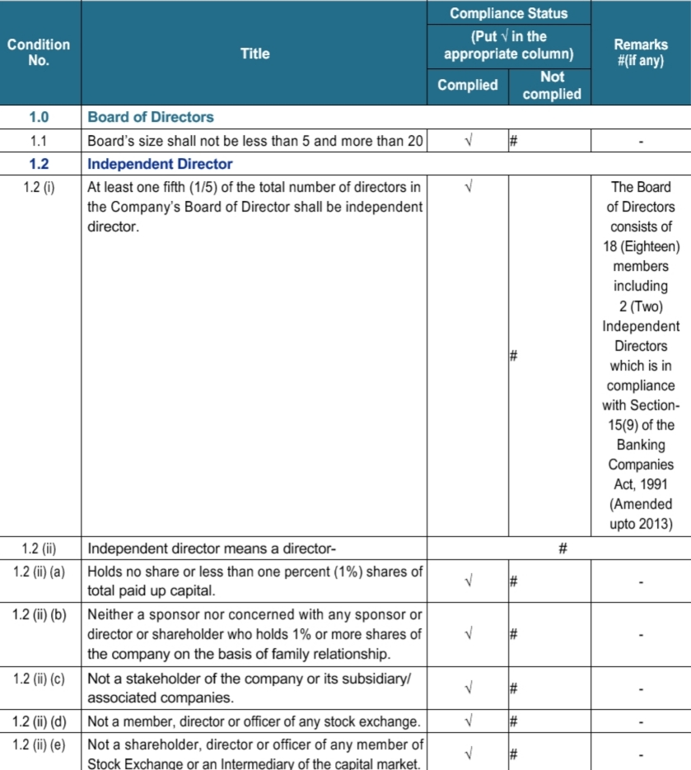

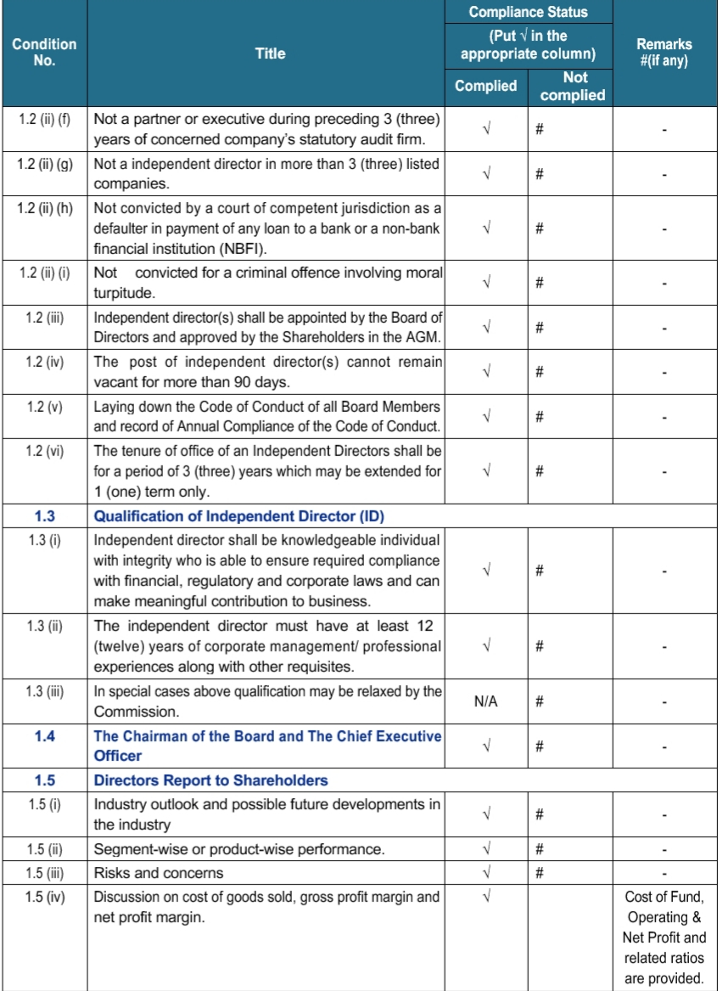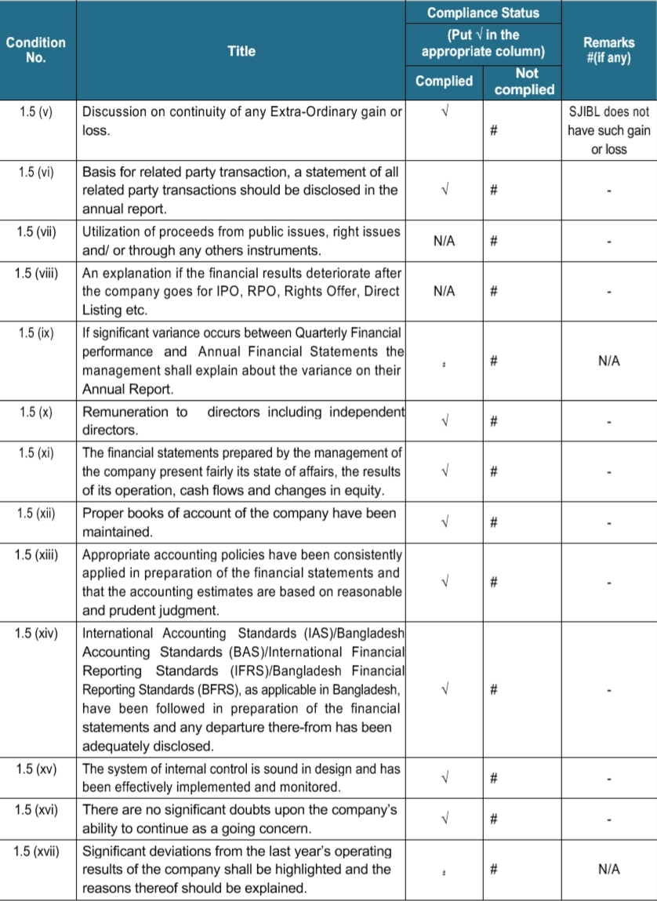
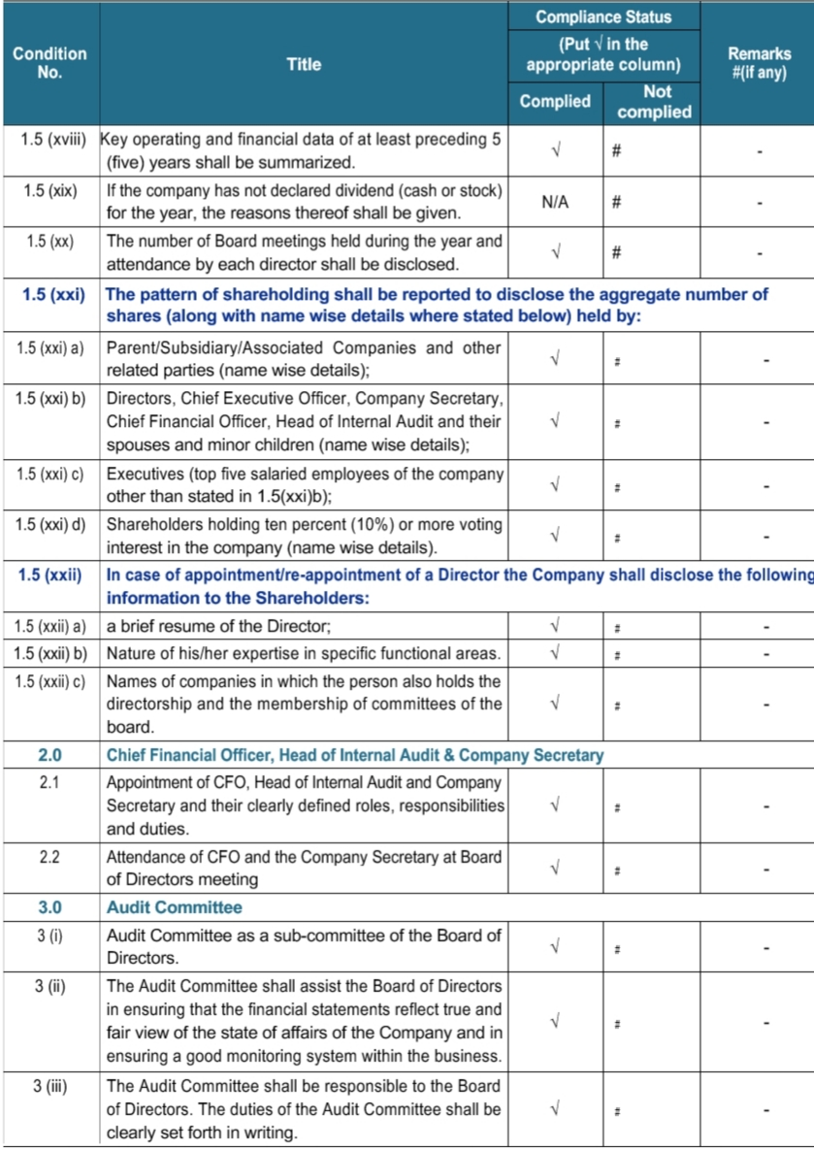
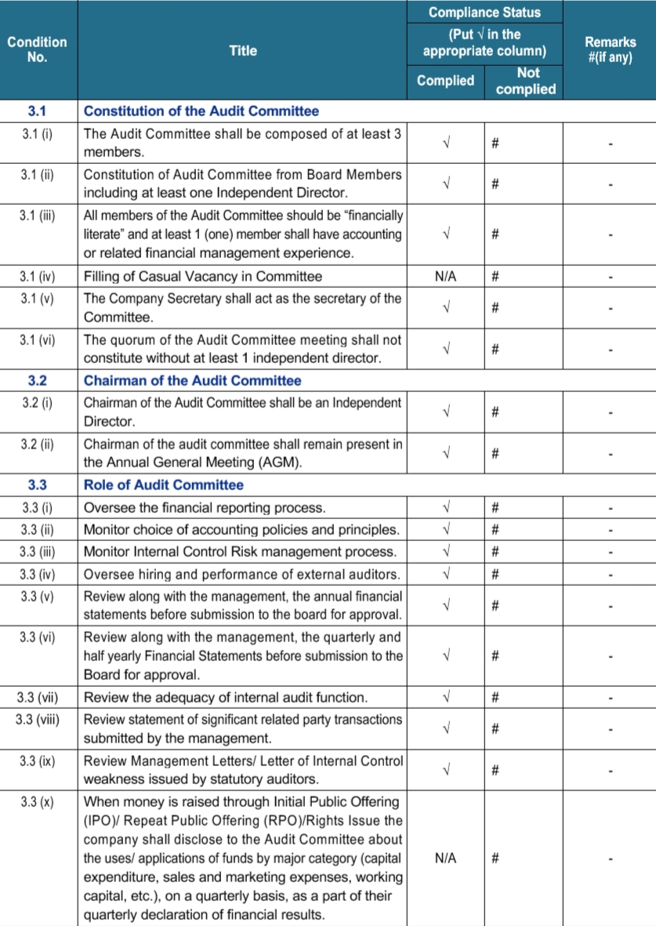
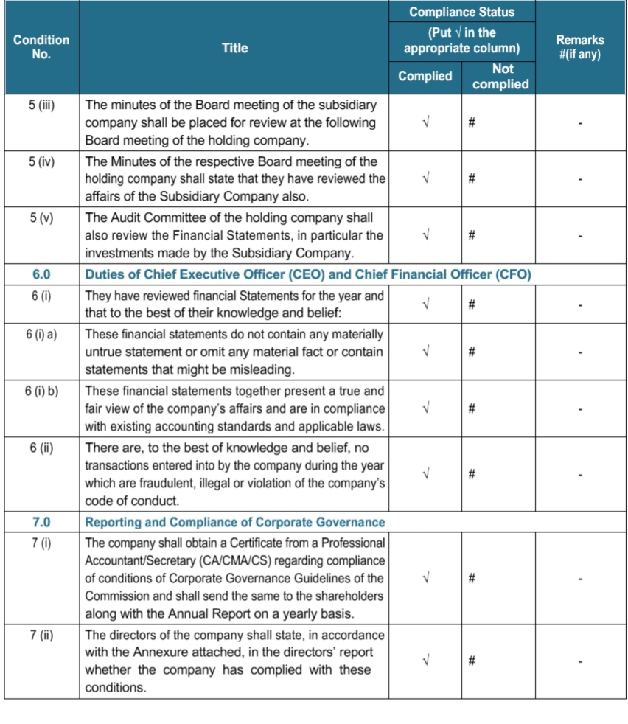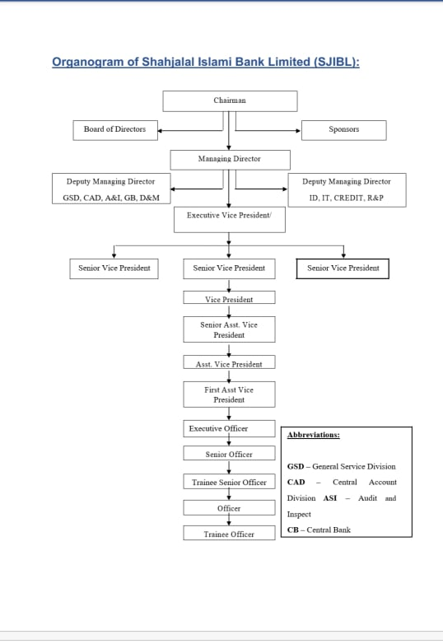

Chapter -4
Human Resource Practice in Shahajalal Islami Bank Limited

4.1 Human Resourc Practice
The bank constantly laid accentuation on human asset advancement. The Bank has faith in the factor that enables the bank's to endure is intently interlinked with the nature of administration and fulfillment of the prerequisites of the customer and that legitimately relies upon the capability and effectiveness of the representatives.

As our HR give the association a noteworthy focused edge, we proceed with our approach of enrolling the best experts and execute projects to create and hold superb representatives.

4.2Distribution Of Man power
During the time spent selecting, accepting and holding new gifts, we are proceeding with our endeavors to offer everybody an appropriate preparing that will enable them to turn out to be genuine experts, whose abilities will be fundamental for the advancement of their professions.
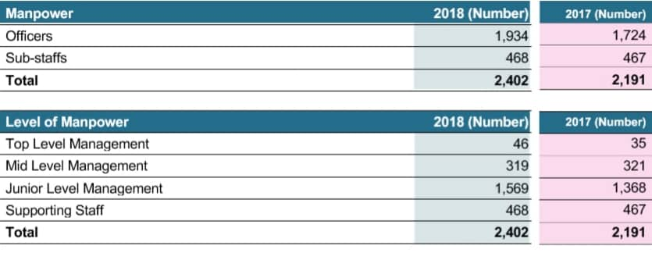

4.3Gender Positioning
Shahajalal Islami Bank Limited gives equivalent chances to business , learning & improvement and professional success for the two sexes. Out of the all out number of 2402 workers, 380 representatives are female and rest 2022 workers are male

4.4HR Stategy
1. As a business, their plans to pull in the most capable staff
2.We hold skillful representatives by remembering them appropriately with the goal that they can work effectively in a group
3.Furnish new workers with proper preparing.
4.Make a solid supervisory group.
5.Guarantee equivalent open doors concerning business, work offices , task, preparing, profession advancement & benefits
6.Guarantee suitable & open to workplace for all classes of representatives and to make chances to demonstrate their abilities for advancement of expert vocation
4.5Work Environment & Culture
The Bank is resolved to keep up an amiable and happy with workplace free from segregation of race, religion, sexual orientation and age. The Bank guarantees a positive, amicable and deferential condition where all representatives are getting chances to demonstrate their abilities and we trust in filling in as a major aspect of a group. The Bank attempts to prepare up its workers with most extreme expert standpoint. The workers are perceived and remunerated for steady employments done. Our compensation bundle, welfare arrangements, administration benefits, auspicious advancement, increase, motivators are worthwhile contrasted with friend banks which guarantee to hold the current work power just as to draw in the wannabe experts of the business to investigate openings in SJIBL.
Shahjalal Islami Bank Continues to keep up an attractive position as far as individuals profitability.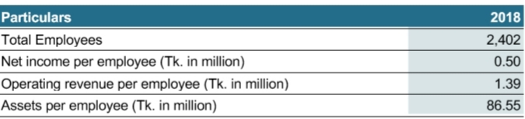

The Human Resource Division is divided in 5 parts those are

4.6Recruitment & Placement
No Organization can be successful without providing quality service to their customer, for a bank it is even more important in terms of service. In order to achieving their goal Shahajalal Bank must hire resourceful employees so that they can provide best service to their clients . The authority believes in paying sufficient salary to their employees so that they will provide their best to the customer. That why the authority has to become very careful for recruiting right person for right place.

Appointment & Recruitment with Prior Sanction of post
It is the duty of board of directors to analyze and approve the manpower requirements every year and fix up the number of officers every year. The numbers of executives, Officers & Sub-stuff will depend on opening number of new branches and increasing amount of customers. They always consider all the rules and regulation of Bangladesh Bank before sanctioning a recruitment note. If the bank demand for any temporary or contractual employees for the sake of business the board of directors full fill the demand
The Shahajalal Bank does not believe in paying for extra man power that’s why the board of directors recognizes the importance of estimation of man power and they hire according to the organogram . This must be reviewed and revised from time to time for expanding the business when it is required. Still, professionals will take the edge to fill up posts lying vacant within the approved chart or organogram. For the justification they can take initiative and can revise the chart for justification of the post. The organogram has to be revised time to time.

Recruitment through advertisement
For hiring the right person for a right place it is really important to attract the right persons for job and select the best one. Shahajalal Bank believes in being updated and try to reach every deserving candidate so they use all the method including print media and online media to launch the advertisement for a vacant position
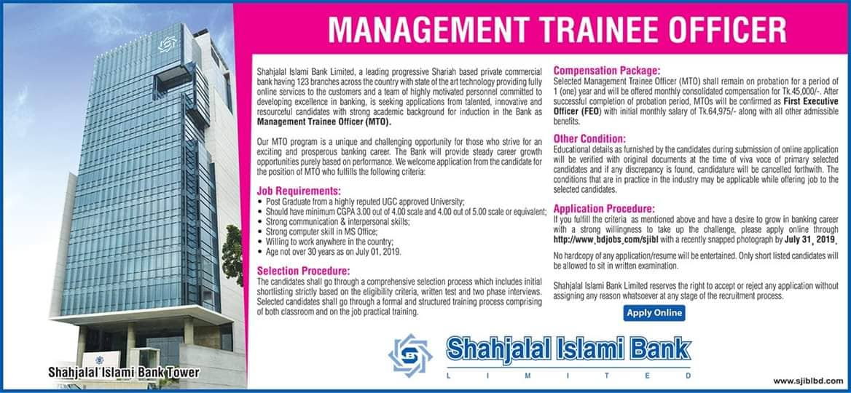

Flow Chat of Recruitment

The Criteria Of recruiting an employee is set under following rules
- He/ She must be a citizen of Bangladesh.
- Candidates must be Masters/BBA from a well reputed University
- Preference will be given to those having MBA/BBA in Accounting, Finance & Banking, Marketing, Management & other business oriented subjects and Masters with Honors in Economics, English, Statistics, Mathematics and other business oriented subjects.
- His/ Her age must be between 21 to 30. These conditions may be relax able in special cases to be recorded in writing
- He/ She must be physically fit.
- The new recruit be required to get full medical examination from the Doctor, appointed by the Bank. The fees of the Doctor be paid by the Candidate. However, any fees for Pathological/other services required by Doctor for full medical examination be paid by the prospective employee.
Experience and Educational grading can vary according to the required post.
Employee Life Cycle
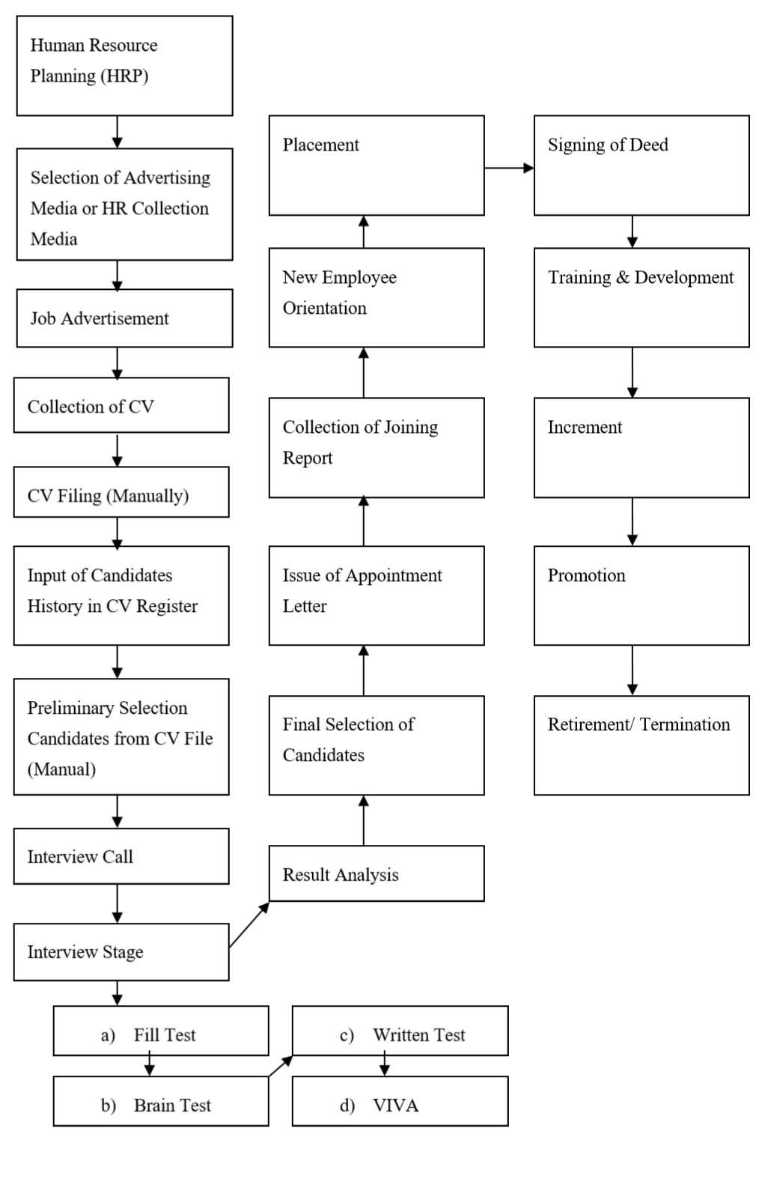

Grading Marking
The Grading System is same for all the post in the time of recruitment. The Selection Committee will follow a grading system as follows
- Education : 28
- Written Test : 47
- Interview Test : 25
Total 100
Written Test
It is mendetory of all the applicant to attend the written test containing 47marks. Questions are generally made on 4 context. They are
- Math
- English
- Analytical Ability
- Subject Specialization
Shahajalal Bank take the help of outside experts for setting the questions, supervising the examination work and marking the scripts. Passing with minimum marks of 60% will qualify the candidate. Code number should be used to protect secrecy and to avoid persuasion from any quarter to maintain high standard of quality. Board can make some relaxation on mark up to 50% depending on the situation and case to case basis.
Interview Test
Interview of an candidate by prior selecting penel. The candidate must full –fill all the aspects of job . The authority stays very careful because the responsibility of hiring right person is on their hand .As Shahajalal Bank is an Islamic shariah bank it is very much important for a candidate to have knowledge about Islamic shariah Banking. Grading system of interview test is
- Personality Outer (Personality/Outlook/Expression)-09
- Knowledge of Islamic Shariah, Specialized area & General Knowledge-09
- Analytical Thinking-07
Post & Required Experience
They hire both experience and inexperience employees . For the post that does not need experience are
- Trainee Officer (TO)
- Management Trainee Officer (MTO)
- Trainee Senior Officer( TSO)
For the experienced position they hire
- DMD
- Senior Executive Vice President
- Executive Vice President
- Senior Vice President
- Vice President
- Senior Assistant Vice President
- Assistant Vice President
- First Assistant Vice President
- Junior Assistant Vice President
- Senior Executive Officer
- Executive Officer
- First Executive Officer
- Junior Executive Officer
- Assistant Executive Officer
- Senior Officer
- Officer

Placement
Placement an employee is one of the toughest of human resource department. As shahajalal Bank always take decision according to their employees, placement can be hard to make every employee and comfortable. Placement can be 2 types , Permanent and Temporary placement. Temporary placement generally happens when employees take leave like maternity leave, Hazz leave or Sick leave. This kind be for 1/2 months
Permanent Placement can be happen on the ground of 2 context
- According to the branch requirement
- According to Bangladesh Bank 3 year placement rule
Mainly bank appointment an employees according to the manpower planning of new branches . There is an other rule in applied by Bangladesh Bank that only employee must to stay on a same branch for more than 3 years so the branch of an employee must be changed with in 3 year.
On the time of placement or transfer of an employee the authority of a bank try to keep some things on their mind
- Placing on the nearest branch
- Try to provide female employees their preferred place to work
There is an unusual of transfer employees can be mutual transfer where 2 employees can apply for interchange their branch, if there are practical bank try to accept their application.

Interview Performance
The members of the Selection Committee always consider the candidates appearance, personality, communication ability, presence of mind , manners, general and common sense an award marks individually which will totaled and averaged for determining interview performance score. The following criterion for interview may be followed:
- Personality / Outer Presentation/ Expression: 10
- Banking Knowledge: : 08
- Knowledge of Islamic Shariah, Specialized
Area and General Knowledge : 05
- Analytical Thinking Ability : 05
Total 100
In the case of experienced Bank Employee, the basis of evaluating experience would be
- Length of banking service.
- Knowledge in Computer & Banking Software.
- Expertise in different division of the bank.
- Professional Training.

Complacence & Disciplinary Action
In Shahajalal bank all the disciplinary action is handled by DMD & The head of Human Resource Division. It is very important to maintain the complacence and take every disciplinary action proper harmony in the organization and maintain a fair atmosphere in the organization. All the decision is taken according to the service book of the bank which is made in the light of Bangladesh labor Law & Bangladesh Bank Directives.
Ground Of Punishment
- Violates the provision of these rules or,
- Displays negligence or indolence in the discharge of his/her duties or,
- Does anything detrimental to the interest of the bank .
- Disregard and /or violates the principles of shariah in the conduct of business.
- Guilty of breach of discipline or of any other act of misconduct or insubordination.
- Convicted of any offence involving moral turpitude.
- Inefficient or has ceased to be efficient whether by reason of infirmity of mind or body.
- Corrupt or reasonably considered to be corrupt.
- Assumes Style of living beyond his ostensible means.
- He/She Has a persistent reputation of being corrupt.
- Involved or reasonable suspected to be involved in subversive activities or is associated with other involved in such activities.
- He/She is in possession of pecuniary resources or property disproportionate to his/her known source of income.
There can be 2 types of punishment . Those are
Minor Punishment
- Censure
- Withholding ,for a specific period ,of promotion, of increment otherwise than for unfitness for promotion or financial advancement
- Stoppage for a specified period, at an efficiency bar in the pay scale , otherwise than for unfitness to cross such bar and
- Recovery from salary and allowances or any other amount due to the employee of the whole or part of pecuniary loss caused to the bank by him/her
Major Punishment
- Reduction to a lower stage in a scale of pay
- Reduction to a lower post/grade
- Compulsory retirement
- Removal from service
- Dismissal from service
Appeal & Review
As Shahajalal bank believes in honesty and fairness every employee has the right appeal for reviewing the case by next higher authority empowered by board from time to time. When the board imposes the punishment to an employee either as an appellate authority or as an original authority (original Jurisdiction) the employee concerned may make an application for review to the board. In such an event the decision of board shall be finale.
It will always be the decision of authority if the case will be review or not. An appeal or application for review need to be made within one month of receipt of the order imposing the punishment and such appeal or application for review shall
- Contain all material statement and ground relied upon and shall be completed in itself but shall not contain any disrespectful or improper
- State the date on which the order imposing the penalty was received
- Specify the relief sought for
- Be submitted through the HRD
- Be addressed to the board
Review appeal shall be forwarded within 15 days of receipt at Human Resource Division to the concerned authority.
Training & Development
There is phase in western world that “ They invest billion to save trillion” . Here the full form of the phase is they invest billion on training to save trillion amount on extra man power. No organization can achieve their goal if they do not of talented employee.
Training is a process to enhance and increase employees talent and skill and make them loyal to the organization as it also help them to grow in future. Shahajala bank is a bank who always work on employee development and talent management cause the management team believes that if they can gain satisfaction from their employee and enhance their talent than their business will automatically grow and They will achieve their strategic goal.
Unlike maximum Bank Shahajalal bank has their own training academy in motijheel. That shows their concern regarding their employees . They also take employees training from reknowed organization like BIBM. Their training programs are given below
- Orientation Program: They orientation program is mainly for fresher. The training program concentrate for the new entrants in banking industry. Here they provide them the knowledge about banking industry, Rules and regulation and organization culture. As Shahajalal Bank is a Islamic Shariah maintaining bank their culture is different from other bank.
- Academic Training: As Shahjalal bank has their own academy so they arrange lot of training program for their employees to enhance their quality. These facility create image that the organization is their well-wisher
- Job Specific Training: They provide some specific training that are needed for specialized job such as risk management, cashmanagement etc
- Need based Local n/ Foreign training: This training can be both local or foreign .They training is arranged by analyzing the gap between skill & Knowledge and competency required for the current role
- Peer or supervisor coaching: They regularly arrange this type of training session. This training session can be both formal and informal. During my internship period several types of peer coaching which are not only useful for work life but also in employees personal life also
- E learning & Evaluation: Not only for maintaining the work balance in bank , for also employees convenience the bank also arrange e learning session and evaluation program

Some basic training that took place in shahajalal bank is
- Foundation training course
- General Banking operation
- International trade & operation
- Banking laws & practices
- Shariah compliance in Islamic Banking Operations
- Branch Management
- ICT security policy and cyber threats
- Marketing of bank product, Branding & Negotiation skill
- Accounting system on banking
- Ethics , Integrity, and Good governance
- Excellence in customer service
- Business letter , office note & e-mail writing skill

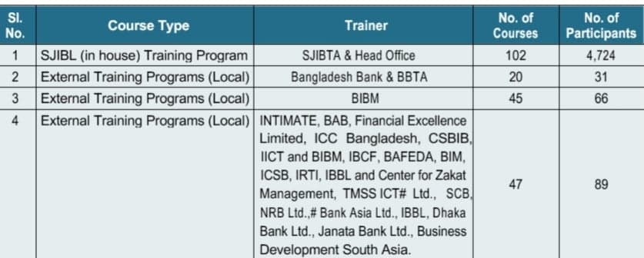

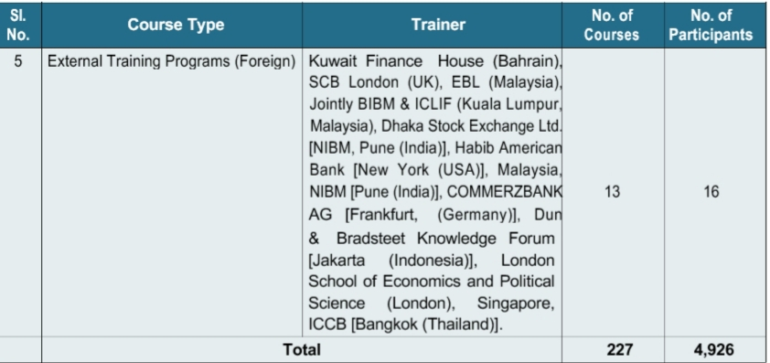

Human Resource Operation
Performance Appraisal
Shahajalal Bank believes in fairness in every step. Through the appraisal process they try to know to about the work force condition so that they can analyze the gap between expectation versus reality
Shahajalal bank 180 degree performance management service. The appraisal process is done by both supervisor & self. The steps of appraisal process is given below

Appraisal Form is given through electronic media to every employee . Every employee appraise them then the appraisal form is provided to the supervisor to make sure the appraisal system is properly done. Supervisor for each employee is selected by Human Resource Division and known to every employee. Then both analysis report is compared by HRD & find the gap. If gap found by HRD & the employee agreed with supervisor report then the report of supervisor is taken as final decision. But if any dispute got find the Human resource division solves the problem. decision. But if any dispute got find the Human resource division solves the problem.
Finally the Head of HR analyze the whole performance analysis report of a branch and find the deficiency if there is any.
The accountability of the performance appraisal is Job knowledge, Job Skill , Cost Management, Innovation, Business Contribution. The appraisal report is divided into 2 section
- Desk Performance
- Business Contribution
- Behavioral & Skill Competencies
No | Performance  Factor | Weight | Self  Assessment | Supervisor  Assessment | Review | Finale score  S=(A/  5*W*  100%) | Score
1 | Quality of Work | 30% |  |  |  |  | Self | Appraisal | Review
2 | Quantity of  Work | 40%
3 | Timeliness | 30%
Desk performance
Score

No | Performance  Factor  (Skill &  Competency  mix) | Weight | Self  Assessment | Supervisor  Assessment | Review | Finale score  S=(A/  5*W*  100%) | Score
1 | Job Knowledge | 40% |  |  |  |  | Self | Appraisal | Review
2 | Attitude | 15%
3 | Initiative | 15%
4 | Versatility | 10%
5 | Communication  Skill | 10%
6 | Relationship  Building | 10%
Behavioral & Skill Competencies Score
Promotion Policy
Promotion means getting on the next higher position which is very important because new position always comes with new challenges and responsibility which need to be handle carefully and efficiently. Choosing a right person for promotion is also important for management because on that person action the growth will depend.
Promotion can not be called as only employees right . It’s management duty to only promote an employee on the basis of merit and adequate amount of experience .Shahajala Bank believes that some quality that can be gained only by experience which is very much crucial for doing a job effectively & efficiently.
Some factors that plays role for promotion
- The first preference for promotion to the marks in performance appraisal . An employee must avail 60% mark in every marks . It reflects as employee’s merit
- An employee must spend 2 year in same position & gain experience
- They must avail some specific training & Certification such as Foundation Training, Shariah Training, Banking Diploma 01, Diploma -02
After being qualified for promotion employees must face an interview with management where management decide whether the employee is a deserving candidate for promotion or not
As Shahajala Bank always appreciate talent if an employee provide out standing performance he/she might get double promotion
Termination of Service
The bank can terminate a probationary or temporary employee without assaigning any reason after giving him/her one month notice on writing or one month’s substantive pay in lieu of such notice. In the case of confirmed employee the bank need to provide him or her 3 month’s notice in writing or on payment of three months substantive pay. In both case of termination no compensation shall be entitled.
Resignation
For resigning from any service an employee must submit 3 months prior notice to the managing director in writing by expressing his/her intention to do so unless he/she has to pay 3 month basic amount for three month. In case of probationary or temporary employee he /she has to provide 1 month written notice or one month basic to the bank.
Provided that when an employee having applied through proper channel , is selected for appointment in a higher rank post in any organization need not provide any notice or payment due to that notice.
If any employee the rule he/she be accounted as unauthorized absent. Even if he/she submit the notice fee they have wait until the bank accept the resignation & has to return every asset that belongs to bank provided to him/her because of his/her employment.
Retirement
Retirement is at term where employees who has 25 years of service or age more than 60 years old. Shajalal Bank categorized retirement in 3 types
- Normal Retirement
- Optional Retirement
- Compulsory Retirement
Normal Retirement
Employee who have completed 60 years of service shall have normal retirement. To avail that retirement he / she must provide . They can encash the 180 leave depend if it is available with full pay & allowances & other facilities. Gratuity & other allowance will be provided to him/her.
Optional Retirement
An employee can avail optional retirement if he/she complete 25 years of satisfactory service. In this case the will get benefits same as normal retirement but they has to provide notice of 3 month prior.
Compulsory Retirement
When an employee get retirement forcefully on the pressure of bank that’s call compulsory retirement. That benefits can vary depend on situation
Re-employment
A retired employee of the bank may be re employeed on a contract basis by the bank on such terms and conditions as may be decided by the component authority having regarded to the emoluments that he /she had been drawing before retirement.

Leave Policy
Shahajalal Islami Bank’s leave system is fully automated. For taking leave employee has to apply on line. But leave is earned by duty only . No one can claim it as their right .There are 7 types of leave . Those are
- Privilege Leave: Every employee shall earn privilege leave on full pay at the of one-eleventh of the period spent on duty, that is one day , for every eleven days of duty & the leave shall be credited to his leave account and the maximum that can be accumulated shall be 180 days
- Extraordinary Leave: Extraordinary leave may be granted without pay to an employee in special circumstances when no other leave is admissible under these rules. The duration of such leave shall be so regulated thet the amount of total leave including other leave taken in combination does not exceed the maximum of three years at any one time.
- Quarantine Leave: Quarantine leave is leave of absence from duty necessitated by orders not to attend office on consequence of the presence of infection disease in the family or household of an employee and such leave mey be granted by the competent authority on the certificate of a authorized Medical officer a period not more than 21 days
- Maternity Leave: The competent authority may grant to a female employee maternity leave which is not debited against the leave account on full pay at the rate she was drawing at time of talking leave for a period which may be extended up to the end of three months.
- Casual Leave:Casual leave means a leave of absence for short period granted to an employee who may be unable to attend duty during such period due to sudden illness or on urgent personal ground.
- Sick leave: An employee will be entitled to sick leave with full salary and other admissible benefits.
- Pilgrimage Leave: An employee who have completed 07 years of confirmed service in SJIBL will be entitled to 15 days pilgrimage leave to perform the Hajj.
Leave procedure
- The leave account of an employee shall be maintained in such form as competent authority may determine.
- Such Officer shall maintain the leave account of an employee as the competent authority may determine
- Every application for a leave or extension of leave shall be sent to the authority competent to sanction the leave through the immediate superior
- Before an employee is granted leave or extension of leave , on medical ground , he must obtain a certificate from the medical officer of the bank or any other medical authority specified by the bank

4.10 Compensation
Provident Fund
There is a fund called “ Shahajalal Islami Bank Limited Employees’ provident fund which will be governed by separate provident fund rules approved by the board, Every confirmed and full time employee shall be entitled to this fund at time of retirement / resignation/termination. The amount of provident fund is 20 % of employee’s basic which is carried by both organization and employee equally
Gratuity
A confirmed and full, time employee who has rendered continuous and satisfactory service in the bank may be granted gratuity to him /her on retirement /resignation termination or to his/her legal heirs in the event of his/her death
Serial Number | Duration in the service | Gratuity amount
1 | For completion of 5 years | 1 months basic
2 | For completion of 7.5 years | 1.5 months basic
3 | For completion of 10 years & Above | 2 months basic
The dismissed employee shall not be entitled to any gratuity
Special Remuneration
An employee may be specially remunerated for rendering arduous and meritorious service beyond normal call of duty which is casual and non- recurring in nature by the board or any other authority as may be empowered by board
In case an employee is required to work during holidays the board may remunerate him for such works or any other authority as may be empowered by the board
Award
An award in cash may be granted to an employee for outstanding academic and professional achievements by the board or any other authority empowered by board.
Leave fare assistance
Leave fare assistance is a amount of money that is provided to an employee to spent on 15 days extra holiday & it is paid yearly

Designation | LFA (Taka)
Additional Managing Director | 625000
Deputy Managing Director | 503750
Senior Executive Vice President | 355000
First Vice President | 300000
Senior Vice President | 270000
Vice president | 256500
Senior Assistant Vice President | 240000
Assistant Vice President | 216500
First Assistant Vice President | 150000
Junior Assistant Vice President | 130000
Senior Executive Officer | 106150
Executive Officer | 87500
First Executive Officer | 49000
Junior Executive Officer | 40300
Assistant Executive Officer | 33550
Senior Officer | 31500
Officer | 29560

Salary
A Salary is a type of installment from a business to a representative, which might be determined in a work contract.
The salary structure of Shahajalal Islami Bank is divided in different terms . An example of their salary sheet is given below


Chapter -5
Suggestions &Leanings

Suggestion
- First thing that I have noticed here is their working process is slow which is result of too much regulation from management. Every step need to get permission of management. This problem makes the work slow & employees also get irritated as they do not have any freedom of work. If the management start believes in their employees and let them work on their own to some extend that will not only make the work process fast but will make the employee feel relived
- Their performance appraisal form only have 180 degree dimension which is not accurate. If they can include peer on their performance system that will make the assessment system better , accurate and more transperant.
- Their performance appraisal system is not clear to the employee for example in appraisal a accountability is attitude but by attitude what does the meant , How the employee going to be judged , nothing is mentioned that need to be fixed otherwise the system can be misused
- Their HRIS system is not up to date, Still they have to depend on paper which not only time consuming but information can go missing which can cause hamper so they should up to date their system
- The employees are only informed about change or decision but why this change happened or why the management has taken the decision this is not communicated to the employee properly employee will understand management & try to achieve the target that’s why the management should communicate every change & decision. They should also elaborate how the decision is beneficial to them also so that they could feel motivated
- Shahajal Bank does not evaluate the job rotation system properly as a result maximum time job rotation does not happen properly . The management should provide their attention to this particular issue & make sure the process is properly done
- They have a rigid environment in their Bank. Especially between male & female employee awkwardness always take place. They should try to fix it.
- There is no entertainment mechanism in their bank which creates monotonousness in employees which make the employees dissatisfied to their wok and make the quality of work slow , that’s why management should try to fix the problem.
- They Should provide child care center so that their employees can work peacefully
- There is no work life balance for their employee, Though they claim they have a fixed working hour but they don’t really maintain that so I think they should try to make a balance working hour
- They don’t do job analysis properly. The method is not systematic that’s why they does not get proper result they should work on that
- They don’t make any plan or take any action to retain their employees. They still believes a attractive compensation package is the only thing that can retain an employee that is wrong and ancient perspective. They should chance it.

Learning
1.Corporate Behavior
Through our student life we always learn about how to behave with everyone. Even in my bachelor degree I have done several courses where our faculties groom us about how to behave with everyone. But through my internship I got to learn about those things.
As I have spent pretty much time with the joining procedure of employees and stuff, my supervisor Mr. Mahmud make me learn how to be polite and patient. In joining procedure mostly people make silly mistakes, people who are highly educated and have a lot experience. I have always seen him to tackle it politely and with patient. He make me do the same, I learned in this procedure to be patient , polite.
2.Personal Bookkeeping
Here I have how to organize an employee’s information both in papers & in computer. They make me learn which document holds what value and why they are taken. They also make me learn in which order we need to keep it.
3. Recruitment Procedure
They also let me work on their recruitment procedure which helps me to learn about the procedure and it’s steps
4.Training Program
They also make me work on their training department where I also learn about How they do their training need assessment, How they organize their training schedule for whole year & how they conduct training.
5.Disciplinary Action
They provide many of their disciplinary case so that I can understand that situation . While my internship I have also saw them handling case where I learnt how to be fair with humanity. I also learn that in which ground they take decision
6.Human Resource Term
They also make me learn different HR terms such as EOL, LFA ( Leave Fare Assistance) which was unknown to me

7.Performance Appraisal
I have also worked their appraisal department. Where I learned how they appraise their employees, In which ground they are jugged and what would the action.
8.Problem Solving Ability
During my internship my supervisor always share his experience what kind of problem that can arise in an HR executive’s life what can be the possible solution. He make me understand the advantage of being in work life . They learning was really great & is useful not only for work life but personal life also.

Chapter -6
Conclusion

Conclusion
Shahjalal Islami Bank is one of the most potential Sariah based bank in Bangladesh. This bank sets another benchmark for other bank. In this focused market they are holding a solid position. In the event that we assess its presentation, at that point we can say that their longing and potential is the explanation behind coming to in this position. They are offering verity sorts of item and ceaselessly attempting to make new item and administration to serve their customers. On account of the solid client connection and great administration SJIBL prevail to pull in more customers.
It is an extraordinary attractive for me to work in Shahjalal Islami Bank Limited (Corporate Head Office) In this multi month, at the season of running my temporary position I plainly see that, there is an enormous distinction between academic information and down to earth work. Down to earth work is genuine work. During my entry level position period I found that all offices are completely synchronized and the vivacious officials are working productively and that is the reason this bank is running gainfully. Step by step this bank is turned out to be so mainstream as a result of its Islamic based administration. SJIBL is emphatically contributing in the nation's economy. Then again Shahjalal Islami Bank is attempting to contributing in social welfare dependent on Quran and Sunnah. Their fundamental proverb is giving better administration to customer not gaining benefit.
The way SJIBL is building up its administration one day it might turn into the market head. Each bank has some positive and negative sides. In view of my experience SJIBL should give greater need to its client and for that representative preparing is required. The bank handle their client all the more carefully. In the event that SJIBL don't consistently refreshed, at that point it can't adapt up to their rivals since banking framework is continually changing and being similarly testing. SJIBL principle aim is consistently on quality administration not on amount and that is the reason they are all the more giving need on client not in their business.

Appendix
