Internship Report On
Employees’ Performance Appraisal System in Flora Telecom Limited

Submitted To:

Prof. Dr. F. A. Sobhani
Director, MBA and MIHRM Program
School of Business and Economics
United International University

Submitted By:

Taspia Nowshin
ID No: 111151498
BBA Program
School of Business and Economics



United International University

8th December, 2020

Letter of Transmittal
8th December, 2020
To
Prof. Dr. F. A. Sobhani
Director, MIHRM Program
School of Business and Economics
United International University
Subject: Submission of internship report.
Dear Sir,
With due respect, I would like to submit my internship report on the topic of employees’ performance appraisal system. I have done the internship for three months in Flora Telecom Ltd. It is a great opportunity for me to know the organization and its employees’ more closely and to obtain more practical knowledge, skills and experiences.
At the time of preparing report I have tried my best to provide all relevant and accurate information that are needed to complete the report. I have tried to obey the guidelines and suggestions given by you. I am very grateful to you for your nice support.
Therefore, I hope you will consider the mistakes that are occurred at the time of preparing report and hope that this report will qualify your approval.
Sincerely yours,

_______________________________
Taspia Nowshin
ID: 111 151 498
United International University
Letter of Authorization
The internship report is entitled as ‘Performance Appraisal of Flora Telecom Ltd.’ Which has been submitted for partial fulfillment of the requirements for the degree of Bachelor of Business Administration along with the core in Human resource management from United International University and this report is submitted by Taspia Nowshin, ID: 111 151 498.

__________________________________
Prof. Dr. F. A. Sobhani
Director, MBA and MIHRM Program
School of Business and Economics
United International University

Acknowledgments

Before moving forward, I would like to thank my Almighty Allah for giving me the strength and keeping patience to complete the report in due time. I would like to precise my special thanks and gratefulness to United International University (UIU) for giving me suchlike a course which widen my knowledge and increase my capability at the time of preparing the report that will be beneficial for me in near future.
It is the opportunity to express my bottommost appreciation to those persons who have helped me to finish the report perfectly. First, I want to give my heartiest gratitude to my academic supervisor Prof. Dr. F. A. Sobhani, Director, MIHRM Program, United International University (UIU) for giving me the scope of making this report & for his great supervision, valuable suggestions, and wishful encouragement in my study work.
Last, I also recognize the guidance and assistance of the department manager Mahbub Ul Alam management team and employees for providing their comprehensive support for preparing this report successful. I am very obliged to all of them because without their magnificent aids it was very hard for me to prepare the report

Executive Summary

In November 1997, Flora Telecom Limited was introduced as a private limited company. It is connecting people for 32 years as a leading organization in Technological sector. It actually focuses on providing enterprise solutions in the field of telecommunication sector, financial sectors, government sectors and large multinational and manufacturing enterprise. Customers are very much satisfied with them that helps them to create a strong customer base in the market. IT consultancy services, customized software solution, enterprise resource planning (ERP) solution to all multinationals, UN Agencies, Foreign Missions, entire leading local organizations dealing with sales, distribution, finance and manufacturing are being provided service by them. Thus, Flora Telecom Ltd. Is leading as a global provider of value-added logistics services to the wireless communications industry, with operations through the country.
Flora Telecom Ltd. is well structured. It has a HR department to maintain one of the most important resources of the organization human resources. Therefore, like any other organization Flora Telecom ltd. is aware of the employees’ performance appraisal. The HR department do the performance appraisal.
Different methods are followed for evaluating the performance of employees in many organizations. In this report, my motive is to find out how performance of the employees is evaluated in Flora Telecom Ltd. and to what extent I can relate it with my theoretical knowledge. To accomplish the task, I collect data from different sources, such as, from the employee handbook of the organization, website, relevant books etc. which helps me to enrich my knowledge, to gather some new ideas, to differentiate between my bookish knowledge and practical experience etc. Through this report I have presented the practice of performance appraisal, the lacking I find in the appraisal system and some recommendations which may become to an aid for them.

Table of Contents
CHAPTER: 1 2
Introduction 2
1.1 Origin of the study 3
1.2 Scope of the study 3
1.3 Objectives of the study 3
1.4 Methodology of the study 4
1.5 Limitations of the study 4
CHAPTER: 2 5
Company Overview 5
2.2 Company Profile 7
2.3 Vision, Mission and Core Values 8
2.4 Strategic Alliance 10
2.5 Company Organogram 11
2.6 Functional Department of Flora Telecom Ltd 12
2.7 Products and Services 14
2.8 Customers 16
2.10 Key Business Domain 18
CHAPTER: 3 19
Performance Appraisal System 19
3.1 Performance Appraisal System at Flora telecom 20
3.2 Objectives of Evaluation of employees’ Performance 20
3.3 Performance Appraisal Techniques Used by Flora Telecom Ltd. 21
3.4 Performance Rating System 22
3.5 Performance Development Plan (PDP) of Flora Telecom Ltd. 23
3.6 The Key Performance Indicators’ (KPIs) 24
CHAPTER: 4 25
-Recommendations & Conclusion 25
4.1 Major Findings 26
4.2 Recommendations 27
4.3 Conclusion 28
Reference 29

List of Figures
Figure 2. 1: Vision, mission and core values of Flora Telecom Limited 9
Figure 2. 2: Organogram of Flora Telecom Limited (Alam, Asst. Vice President, 2019) 11
Figure 2. 3: The products provided by Flora Telecom Limited 14
Figure 2. 4: Key business areas of Flora Telecom Limited 18

List of Tables
Table 2. 1: The industry leaders with whom Flora Telecom limited maintains strategic alliance 10
Table 2. 2: The services provided by Flora Telecom Limited 15
Table 2. 3: The areas of technology in which Flora Telecom Limited works with comfort 17

Table 3. 1: Sample of performance rating system 22

CHAPTER: 1

Introduction

1.1 Origin of the study

Internship program is a compulsory program before completing Bachelor of Business Administration (BBA) degree. During the internship, every student has to prepare a report based on the particular intern area.
The report has been entitled as Employees’ Performance Appraisal System, A Study on Flora Telecom Limited.” It is a part of the fulfillment of internship program which is needed to accomplish the BBA Program under the United International University (UIU). The report has been prepared under the supervision of Prof. Dr. F. A. Sobhani, Director, MBA and MIHRM Program, United International University. I am grateful to him for guiding and supervising at the time of preparing this report.
Through this report, I have tried to represent the system of performance evaluation at Flora Telecom limited and the similarities and dissimilarities between theoretical knowledge and practical knowledge.

1.2 Scope of the study

The report focuses on the areas of performance appraisal processes at Flora Telecom Limited. To prepare this report I have to go through mass conversation with many persons of that company. Many articles, journals have been read. I have to read different years’ performance evaluation of employees. All of these help me to widen my knowledge practically and theoretically. These will also help me to apply this knowledge in the future in my work.

1.3 Objectives of the study

The main objective of this study is to evaluate the performance appraisal system of Flora Telecom Ltd.
The specific objectives are given below:
- To know the performance appraisal techniques of Flora Telecom Ltd.
- To know the performance rating system of that company
- To be acknowledged with the performance development plan (PDP)
- To have knowledge about the key performance indicators (KPIs).

1.4 Methodology of the study

I collect most of the data from primary and secondary sources to achieve my objectives. But it was not so easygoing task to collect data from primary sources because most of the data were kept undisclosed. So, I try to organize the data that was possible for me to collect properly in report.
- Primary sources of data:
Primary data is called first-hand information. When we collect data or information directly from the events, practices, experiences or circumstances is called primary data.
I have collected primary data from the following sources:
- Through HR policy of Flora Telecom Ltd.
- Through direct observation during the internship period.
- Through firm’s activities and operational process
- Through the discussion with the officials
- Secondary sources of data:
When information is collected from the third party, documents and files of the firm or any events is called secondary sources of data.
I have gathered secondary data from the following ways:
- From website of Flora Telecom ltd.
- From internet and magazines.
- From HRM books.

1.5 Limitations of the study
I have tried to give the best output in report of my experience of three months internship period but due to some unavoidable rules-regulations and restrictions authorized by the company I cannot share experience properly. The limitations include:
- Maximum information is collected from the secondary sources and in some cases the accuracy of information is unsure
- There was incomplete information which causes hamper and delay in my work
- The experience was for short time period.

CHAPTER: 2

Company Overview
2.1 Corporate View
Though Flora was established in 1997 as a private limited company it was providing its services and connecting the people of Bangladesh since 32 long years.
Flora got status as a leading IT or IT enabled company in Bangladeshi region. They passed through the years those were actually belongs to the same and philosophy, they were more and more efficient and effective to provide commitment to the customers, provide innovative products and ensure the highest value of money. Providing innovative products, making more efficiency etc. were its ultimate goal. They were famous for providing information timelier that makes customers’ productivity and competitively more ensured.
Telecommunication and System Integration services industry were main focus of Flora though they were providing many sectors. They have a strong team or HR that helps them to be the strongest among all. This also helped Flora to make their position on the top so quickly.
They are ISO 9001:2000 standard processes certified and a network of highly motivated team that makes them believable. Moreover, their support system helped them to make strong relationship with channels like distributors, suppliers, customers, partners and other stakeholders. Flora strongly believe that they could manage and develop IT and IT enabled services in a lower price and making commitment to grow their business to the next country.
They work on research to know the customers’ demand, future market and providing highest quality and latest devices and maintaining it properly. (FTL-Corporate Overview, n.d.)

2.2 Company Profile

- Company name : Flora Telecom Limited
- Established On : November 1997
- Entity Type : Private Limited Company

- Managing Director : Mustafa Rafiqul Islam

- Management Team : Mr. Bhowmick Chowdhury, Manager, Software
Mr. Mosharaf Hossain Akhand, Manager, Finance
Mr. Hasib Ul Alam, Manager, EBG
Mr. Shahidul Islam, Manager, Sales
Mr. Mahbub Ul Alam, Manager, IT Support & MIS
Mr. Akhter Hossain, Manager, Software Support
Mr. Gaus-Ul Abedin Md. Faruque, Manager, HR
- Corporate Headquarter : PBL Tower (9TH Floor) ,Plot # 17(New), 39(Old)
Gulshan North Commercial Area
Gulshan - 2, Dhaka -1212
Bangladesh

- Total Branches : 9 Branches in Bangladesh
(FTL-Company Profile, n.d.)

Vision, Mission and Core Values
Mission and vision both narrate to an organization’s motive and are regularly communicated in a few composed frames. Mission and vision are explanations from the organization that describe who they are, what do they esteem, and where they going.

A mission statement communicates the organization’s reason for being, and how it points to serve its key partners. Clients, workers, and speculators are the partners most frequently emphasized, but other partners like government or communities.
A vision may be a future-oriented affirmation of the organization’s purpose and goals. In numerous ways, we 'll be able say that the mission articulation lays out the organization’s purpose for being and the vision explanation at that point says based on that reason usually what they need to become. Values explanation which either reaffirms or states by and large the organization’s values that might not be apparent within the mission or vision articulations.
The objective of Flora Telecom Limited is to present imaginative ICT arrangement, in arrange to extend efficiency, productivity and eventually to extend productivity for an endeavor. By giving get to opportune data over the endeavor its objective is to empower its client to be more efficiency and competitive. Hence, they set a mission. Based on that mission they have vision and core values to capture a competitive position in the market. (Principles of Management)

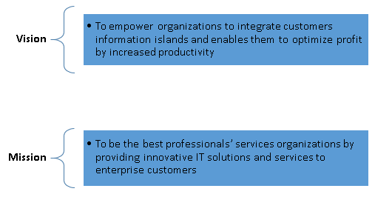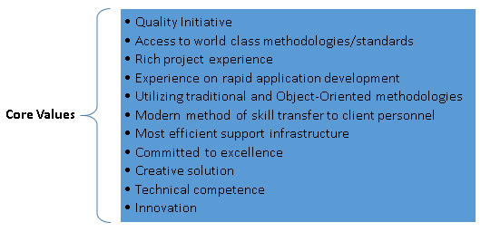
Figure 2. 1: Vision, mission and core values of Flora Telecom Limited
(FTL- Vision_Mission_Values, n.d.)

2.4 Strategic Alliance

As a leading company, Flora provides innovative, flexible and value-adding products and services to the wireless communication industry. It has strategic alliance with industry leaders so that it can ensure the brilliancy regarding technology in all its solutions.

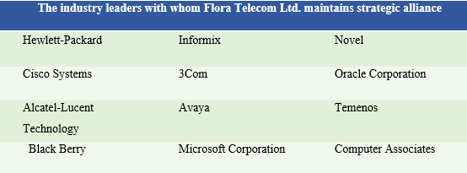


Table 2. 1: The industry leaders with whom Flora Telecom limited maintains strategic alliance
(FTL- Strategic Alliance, n.d.)

2.5 Company Organogram
An organogram is a descriptive representation of an organization’s structure. It presents the hierarchical relationships between managers and the people who report to them, as well as departments.
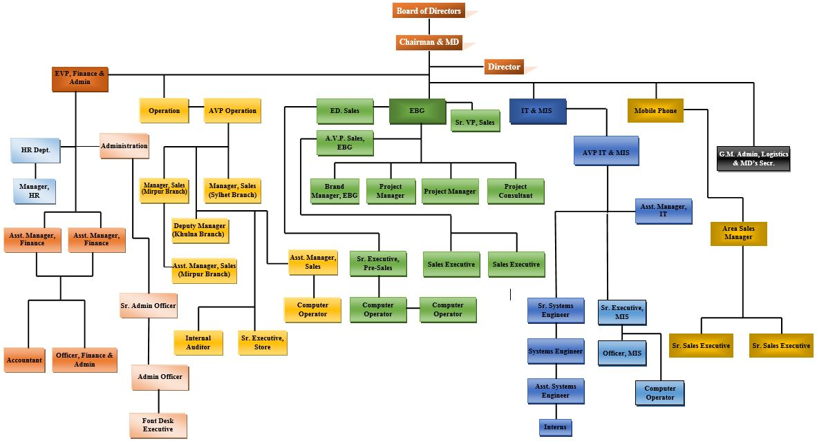
Figure 2. 2: Organogram of Flora Telecom Limited (Alam, Asst. Vice President, 2019)

2.6 Functional Department of Flora Telecom Ltd

Flora Telecom Limited operates its functions properly by major departments. These are:
- Enterprise Business Group (EBG)
- Human Resource Department
- IT Support Department
- Software Development Department
- Software Support Department
- Management Information System (MIS) Department
- Finance Department
The functions of these five major departments are described below:
- Enterprise Business Group (EBG)
This business group conducts one of the most Challenging tasks. It manages all the activities, like, targeting the market, designing and implementing strategies for increasing sales, growing distribution network, planning and implementing promotional activities, building communication network and relationships with public, selling the product to the target market etc.
- Human Resource Department
Human resource department also performs very significant roles in the organization. The main task of the human resource manager is to oversee, manage and control the human resource of the organization. The functions that are executed by the department are selection and recruitment, training and evaluation of performance, talent acquisition, compensation and benefits, assurance of employees’ health and safety, planning which can contribute to attain the objectives of the organization.
- IT Support Department
Flora Telecom ltd is an IT based company. They have more focus on technology. It has a large work team which works for IT support. They provide post sale service of hardware and network
- Software Development Department
As Flora Telecom is a technology-based company it has own software development department. Software development department works for developing the core banking software, which is called Flora Bank. Flora Bank is offering the solution of corporate banking, retail banking as well as Islamic banking product.
- Software Support Department
Flora Telecom provides the solution of corporate banking, retail banking and Islamic banking product to particular clients. Moreover, there is a team, which works for providing the software post sale support. They are continuously working for updating the system. For this purpose, they are adopting the latest tools and technology so that they can meet the incoming needs of the customers and make a powerful customer relationship with the clients.
- Management Information System (MIS) Department
This department is engaged to store all types’ data, information and records related to business in digital format from paper format. It makes easier to get any data at the time of necessity, to do response more rapidly to business demands, to minimize capital outlay and operating consumptions, to facilitate IT operations, to reduce costs etc.
- Finance Department
Flora Telecom has also focus on its finance department. The tasks of the finance department are to manage the accounts, prepare annual budgets, allocate all sorts of payments to the staffs and managers, manipulate all the revenue and expenses, conduct inside audit and maintain records via IT.
(Faruque, 2019)

2.7 Products and Services

The company, Flora Telecom Limited uses developed technology to simplify the effective and efficient distribution of products and services.
- Products:
The products provided by Flora Telecom Limited are given below:
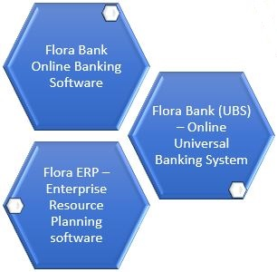
Figure 2. 3: The products provided by Flora Telecom Limited
In addition, Flora Telecom provides hardware solution and network solution as products.
(FTL-Products Overview, n.d.)

- Services:

The services provided by Flora Telecom Limited are mentioned below:
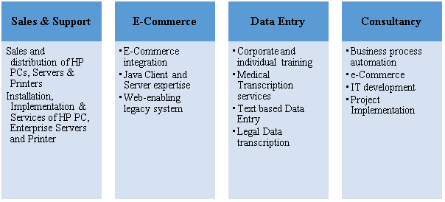
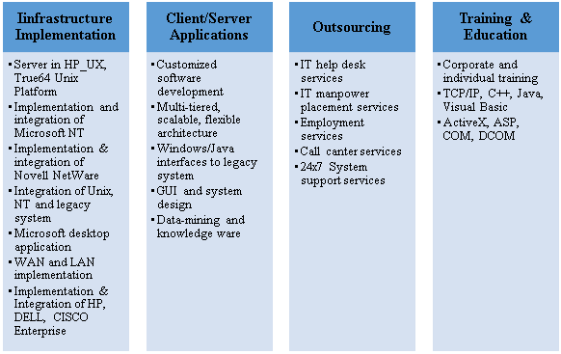
Table 2. 2: The services provided by Flora Telecom Limited
(FTL - Services, n.d.)

2.8 Customers

Many industry leaders and small, medium and large enterprises are Flora’s today’s customers, like-
- Different types of bank

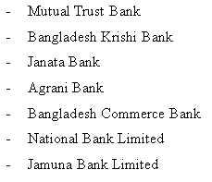

- Customized Software

A few of the biggest government ventures are utilizing large enterprise software developed by Flora Telecom Limited to automate their business process to function beneficially.

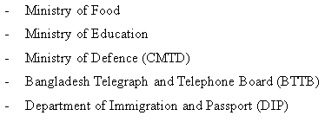
(FTL - Customer Overview, n.d.)

2.9Technology Focus
Their fundamental objective is to supply state-of-art technology. They are cozy in acting on all the available Platforms, Databases, Languages and Middleware Tools.
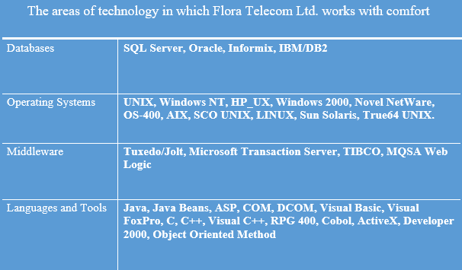

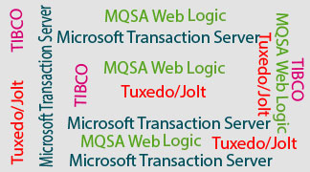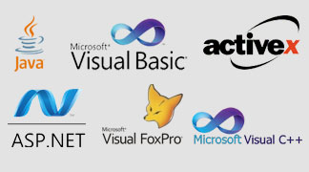
Table 2. 3: The areas of technology in which Flora Telecom Limited works with comfort
(FTL - Technology Focus, n.d.)

2.10 Key Business Domain
These are most exoteric areas where Flora telecom Ltd. operates its business. These are mentioned below:
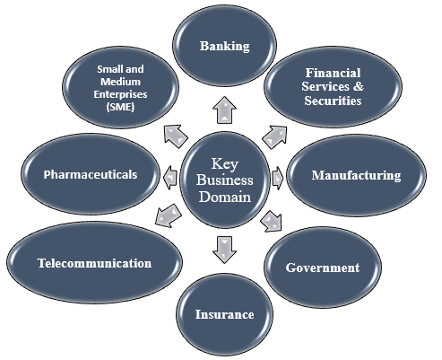
Figure 2. 4: Key business areas of Flora Telecom Limited
(Hossain, 2019)

CHAPTER: 3

Performance Appraisal System

3.1 Performance Appraisal System at Flora telecom

Performance appraisal is a systematic rating of an employee’s execution and commitment to an organization. Companies use performance appraisal to give feedback to the employees on their performance and acts and to justify pay increases and rewards and even termination decisions. Companies can be operated performance appraisal at any given time but tend to be yearly, semi-annual or quarterly. At Flora Telecom Ltd performance evaluation is conducted by the Human Resource Department with the help of every Departmental Head. The managers of Flora Telecom Ltd degree the compensation of employees based on performance and contrast it with their organization's purposes and goals. The managers assess what viewpoints got to be included to improve the performance of the employees. The supervisors in every department are accountable to lead the employees for a superior performance.

3.2 Objectives of Evaluation of employees’ Performance

The objectives behind the evaluation process are:
- To characterize the differences between the actual and anticipated performance
- Amplify the link within the supervisors and employees
- To provide feedback the personnel primarily on the basis of their preceding performance
- To counsel and develop insight of poor performers
- To determine individual training and developmental requirements
- To motivate employees to their works
- To set and measure the attempt toward goals.
- To identify the efficiencies and shortcomings of the employees to understand the training and development needs
- To evaluate an employee to decide the payment packages, wage structure, income raises, etc.

3.3 Performance Appraisal Techniques Used by Flora Telecom Ltd.

The performance appraisal techniques used by flora Telecom are given below:
- Ranking Method:
According to raking method the evaluator ranks all the employees forming a group on the basis of their performance. The best performer is ranked at the top and the last performer is ranked at the bottom of the rank. But sometimes it is happened that all employees perform in a similar way, then on the basis of the performance levels rater ranks among the employees. It is simpler way to distinguish the leading and most exceedingly bad performer.
- Graphic Rating Scale:
This technique is used more frequently by the rater to evaluate the performance. In this method rater uses a Likert scale to rank the position of the employees, such as- poor, fair, average, good and excellent.
- Field Review Technique:
It is done for administrative level promotions. This technique is done by outsider particularly the Human Resource Department.
- Essay Evaluation:
In this technique firstly an employee is evaluated and then a written assertion is prepared on that particular employee. The written assertion delineates the insight about the qualities, shortcomings, potentials, nature etc. It needs more descriptive information and more writing skills of evaluator than any other performance appraisal method. Moreover, it is difficult to conduct and analyze and come to a decision.
- Management by Objectives (MBO):
The method presents the system in which employees’ participation is allowed to set the objectives. Here both the manager and the employees set objectives for the employees together. Then periodically performance is evaluated and reward is also given based on the results.

3.4 Performance Rating System
The employees are rated based on the criteria. A sample is given below:
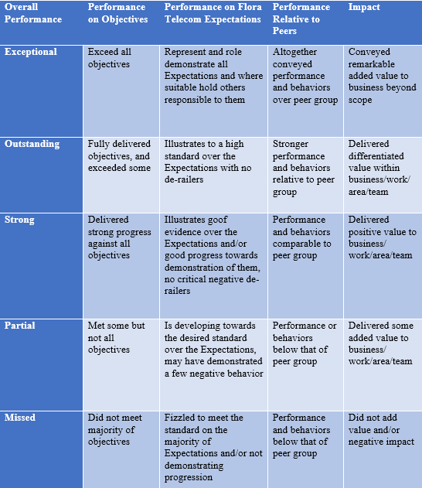
Table 3. 1: Sample of performance rating system

3.5 Performance Development Plan (PDP) of Flora Telecom Ltd.

At Flora Telecom Ltd performance development plan (PDP) is conducted by reviewing performance of the employees and based on the PDP objectives are set for the year. This PDP helps the employers to evaluate the skills, abilities, knowledge specifically overall performance of the employees that will reflect the company’s quality level and efficiency. Flora Telecom functionates PDP biannually and annually.
- Mid-year review: In this case all managers or sometimes supervisors sit at one place with their collaborators to set the long-term or short-term strategies and techniques through discussion for the favour of the company. It is documented also.

- Yearly review: Yearly review is held once a year in December. In case of yearly review, a Group discussion is held where Director (CEO) sits with the people who form the management team. On that discussion the overall performance of the organization is analysed. Furthermore, employees’ performance is also appraised. It is also observed that whether the performance of employees has met the organization’s objectives or not or how the organization meets the employees’ satisfaction.
The performance development plan (PDP) is formed with seven sections. They are-
- Part A- Performance Design and Objectives
It evidently narrates the prominent effects and allows five standards. These five standards (specific, measurable, action-oriented, realistic and time-based) ensured what the employees need to do to operate the task and these also helps the employees to define supervisor’s expectation level.
- Part B- Leadership Essentials
It focuses of its significance on leadership that is enabled to achieve the goals and objectives of Flora Telecom Ltd.
- Part C- Periodic Review
It is fixed up at various time in a year. It mainly allows the employees to develop themselves to attain objectives set by their supervisors. Moreover, it also enables them to be modified if it is necessary.

- Part D- Annual Review
It is held in December. At first the supervisor overlooks and then evaluates the consequences come from the Part-A and Part-B. Thereafter the entire consequences are analysed and documented in Part-D. But pay decision of an employee depends on the overall evaluation of an employee performance.
- Part E- Developmental Plan
Here personnel develop their KSA to be more efficient in their work and also prepare themselves for coming days.
- Part F- Developmental Plan Periodical Review
It happens several times in a year to observe the development in the development plan.
- Part G- Developmental Annual Review
Here it is set up once in a year and it is very essential because through this review client can participate in the assessing process.

3.6 The Key Performance Indicators’ (KPIs)

A Key Performance Indicator is used to measure the value that one is providing how much effectively and efficiently to achieve a company’s key business goals and objectives. The KPIs used in an organization are unique. Every organization is different and the KPIs should reflect that uniqueness. Like other Organizations Flora Telecom uses KPIs at multiple levels to value their attainment at reaching destinations. Like-
- Absence rate
- Employee productivity rate
- Employee satisfaction index
- Employee engagement index
- Employee innovation index
- Internal promotional rate
- Quality of hiring
- Turnover rate
- Training effectiveness etc.
(Alam, Asst. Vice President, 2019), (Faruque, 2019), (Hossain, 2019)

CHAPTER: 4

-Recommendations & Conclusion

4.1 Major Findings
It is a great opportunity for me to do internship at such a corporate place where I have got scope to learn numerous things. My main attempt was to acknowledge the performance appraisal system of Flora Telecom Ltd. During my internship period I have noticed several aspects regarding its performance appraisal system. Like-
- There is no explicit and structured performance appraisal strategy at Flora Telecom Ltd. for various graded employees.
- All employees and employers are not well informed and trained about performance appraisal system.
- Though at Flora telecom Ltd. there is an HR department, it was found in some cases inactive according to the standard. But they serve their purposes as their needs in their own way.
- Performance appraisal process is not properly clear to managers and employees in some cases. But managers try to encourage the employees.
- Flora Telecom Ltd. encourages in self-development.
- The appraisal process is modified rare. As a result, employees sometimes loss their interests and the appraisal system does not become effective.
- At Flora Telecom 360-degree performance appraisal system is not used. As a result, it cannot be possible to know clearly about the views or thoughts of his or her peers and subordinates regarding a particular employee.
- There is less cooperation within departments.
- There is no standard for measuring key performance indicators (KPIs).

4.2 Recommendations

Flora Telecom Ltd is continuously working to make its performance appraisal system more effective so that it can meet its objectives. If they could overcome these small loops from their appraisal system then its pathway to attain desired goal will be smoother.
- In Flora Telecom there should be more detailed structured performance appraisal strategy for different graded personnel.
- Like any well organized and managed organization Flora Telecom should treat performance appraisal as a routine work strictly.
- Employees should provide training to develop their performance.
- If employee with good performance can be deported to other country with better facilities.
- In some cases, Flora Telecom should need to provide more training and development to develop employee’s organizational performance.
- The HR activities should be more active in the organization.
- In several cases the performance appraisal system should be modified to make it more efficient and effective.
- Performance appraisal process should be more pleasant and clear to all employers and employees.
- Performance appraisal system should be motivating.
- They should use 360-degree performance appraisal system by which we can come to know about the peers and subordinates’ thoughts for that particular employee
- Policy and reward system should be more obvious toward employees so that they can take it more seriously.
- Need more collaboration and fellowship within departments.
- There should be flexibility in working hours.

4.3 Conclusion

From this discussion it can be easily comprehended that Flora Telecom Ltd. is one of the growing IT Company in Bangladesh. At this time the company is in growing situation. It offers proficient challenging openings for people who are youthful and can have attempt and hand of supportability on performance in the field of technology.
In our country the performance appraisal system is not studied and exercised properly by most of the local companies. As a result, sometimes employees and even managers or supervisors are not well informed about this system. Thus, it hampers the entire activities or process of the organization. So, organization should do the performance appraisal perfectly and it should assure the proper implementation of the policies and systems.
For any organization the worthiest resource is its knowledge based efficient personnel. So, the organization should give more focus on this issue ensuring the quality and ethics so that we can easily find out that the performance Appraisal method at Flora Telecom Ltd. is effectively working and employees are benefited.

Reference
AIHR Analytics. (n.d.). Human Resources KPIs: An In-depth Explanation with Metrics & Examples. Retrieved from analyticsinhr.com/: https://www.analyticsinhr.com/blog/human-resources-key-performance-indicators-hr-kpis/
Alam, M. U. (2019, December 7). Asst. Vice President. (T. Nowshin, Interviewer)
Alam, M. U. (2019, December 7). Asst. Vice President. (T. Nowshin, Interviewer)
Analytics in HR. (2019). Human Resources KPIs: An In-depth Explanation with Metrics & Examples. Retrieved from Analytics in HR Web Site: https://www.analyticsinhr.com/blog/human-resources-key-performance-indicators-hr-kpis/
Faruque, G. M. (2019, November 28). HR Manager. (T. Nowshin, Interviewer)
Flora Tel BD. (2019). Flora Telecom. Retrieved from Home: Flora Telecom Website: https://www.floratelbd.com/index.php
Flora Telecom. (n.d.). Flora Telecom. Retrieved from floratelbd.com: https://www.floratelbd.com/index.php
Flora Telecom Limited. (n.d.). CORPORATE OVERVIEW. Retrieved from Flora Telecom Limted - Corporate Overview: http://floratelbd.com/corporate.php
FTL - Customer Overview. (n.d.). Retrieved from Flora Telecom Limited - Customer Overview: http://floratelbd.com/customers.php
FTL - Services. (n.d.). Retrieved from Flora Telecom Limited - Services: http://floratelbd.com/services.php
FTL - Technology Focus. (n.d.). Retrieved from Flora Telecom Limited - Technology Focus: http://floratelbd.com/technology.php
FTL- Strategic Alliance. (n.d.). Retrieved from Flora Telecom Limited - Strategic Alliance: http://floratelbd.com/alliance.php
FTL- Vision_Mission_Values. (n.d.). Retrieved from Flora Telecom Limited - Vision_Mission_Core-Values: http://floratelbd.com/vision.php
FTL-Company Profile. (n.d.). Retrieved from Flora Telecom Limited- web: http://floratelbd.com/file/FTL-Company%20Profile.pdf
FTL-Corporate Overview. (n.d.). Retrieved from Flora Telecom Limited - CorporateOverview: http://floratelbd.com/corporate.php
FTL-Products Overview. (n.d.). Retrieved from Flora Telecom Limited - Products: http://floratelbd.com/flora_bank.php
Hossain, T. (2019, Novemebr 27). Sr. System Engineer. (T. Nowshin, Interviewer)
HR MP. (2019). Human Resource Management Practice. Retrieved from hrmpractice.com/: http://hrmpractice.com/what-is-kpi/
hrmpractice. (2019). What is KPI ? Retrieved from hrmpractice Website: http://hrmpractice.com/what-is-kpi/
Performance Appraisal Methods. (2020, February). Retrieved from corehr.wordpress.com/performance-management/performance-appraisal-methods/: https://corehr.wordpress.com/performance-management/performance-appraisal-methods/
Principles of Management. (n.d.). Retrieved from https://open.lib.umn.edu/principlesmanagement/chapter/4-3-the-roles-of-mission-vision-and-values/
PRINCIPLES OF MANAGEMENT. (n.d.). Retrieved from https://open.lib.umn.edu/principlesmanagement/chapter/4-3-the-roles-of-mission-vision-and-values/
Tanim, M. (2020, February). PERFORMANCE APPRAISAL & ASSESSMENT POLICIES OF HUMAN RESOURCE . (T. N. Promy, Interviewer)
Tanim, T. A. (2015). PERFORMANCE APPRAISAL & ASSESSMENT POLICIES OF HUMAN RESOURCE IN TRANSCOM LIMITED. Dhaka: dspace bracu.

Mr. Mahbub Ul Alam, Manager, IT Support & MIS, Flora Telecom Ltd.
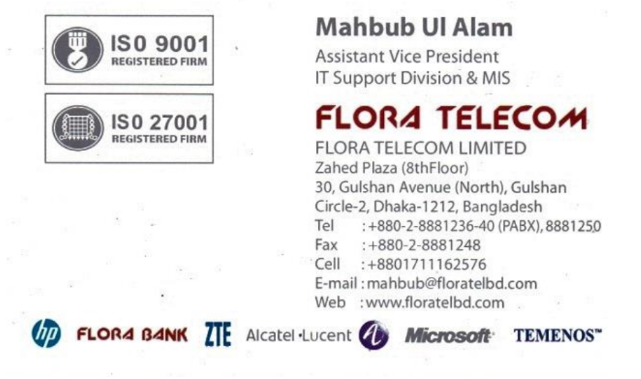
Mr. Tanvir Hossain, Senior system engineer, Flora Telecom Ltd.
