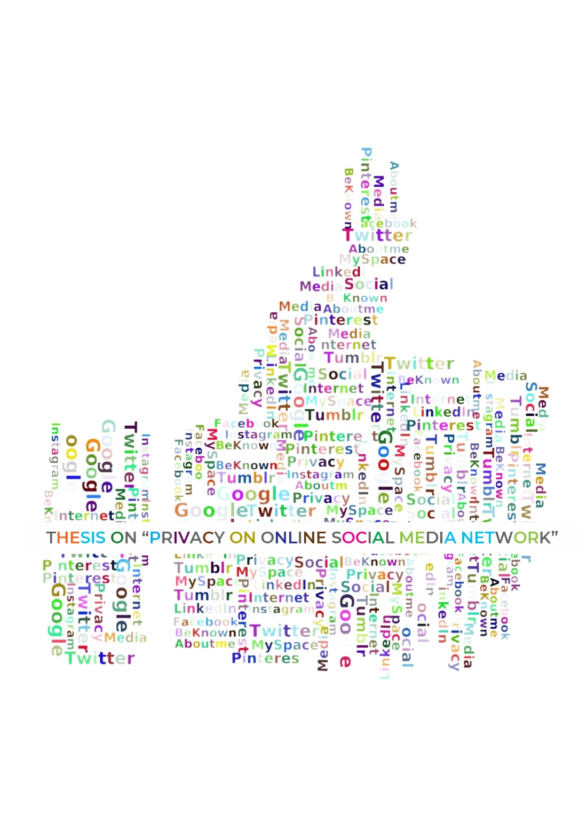


THESIS PAPER

“Thesis on Privacy on Online Social Network”

Submitted To
Ahmed Imran Kabir
Adjunct Lecturer (SOBE)

Submitted By
NAME | Sumaiya Binte Abdullah
ID | 111 151 440
DEPT. | Bachelor of Business Administration
MAJOR | Management Information System
TRIMESTER | Last

Date of Submission: 30th December, 2019
Letter of Transmittal

17 Dec, 2019

Ahmed Imran kabir
Adjunct Lecturer (SOBE)
United International University

Subject: Submission of the thesis paper on “Privacy on online social media network”

Dear Sir,
I would like to show gratitude you for your track and support you have assumed me over the length of this report. Without your support the thesis would have been hard to finish.
To set up this thesis paper I have collected what I took to be the most significant information to make my report as investigative and dependable as could reasonably be expected. We have concentrated my best exertion to accomplish the destinations of the report and expectation that my undertaking will fill the need. The handy information and experience accumulated during my report arrangement will unfathomably help in my future expert life.

I would truly be thankful on the off chance that you illuminate me with your contemplations and perspectives in regards to the report. Likewise, on the off chance that you wish to enquire about a part of my report, I would readily answer your questions. Much thanks to you again for your help and persistence.

Sincerely Yours

Sumaiya Binte Abdullah
ID: 111 151 440

Acknowledgement

At first, I am grateful Almighty who invigorated me and made me ready to finish this thesis paper. Besides, I want to offer my heartfelt thanks to my beloved course instructor Ahmed Imran Kabir(lecturer of SOBE, UIU) for his significant counsel, consolation, direction and supervision and furthermore for his help in finishing my thesis. On account of him for supporting me and provide me the correct guidance.
What's more, I am likewise appreciative to the individuals who were both straightforwardly and by implication identified with the thesis work, furnished me with critical data that help me to finish this report and those people who was my research audience. Ardent gratefulness is communicated to the accompanying audience for their important time and collaboration. I might want to express my significant towards our folks for their co-activity and support which served to helped me to finish this task.
At long last, I want to give an extraordinary gratitude to the United International University for this course by which I can get familiar with a ton of thing about association and by making this kind of report I can advance my insight about association too.

Abstract
This research endeavors to experimentally approve a social media networks privacy concerns instrument with six develops (privacy issues, privacy settings, passwords, control, unauthorized access). Each build incorporates five assigned things/variables. Information were gathered from 89 persons and analyzed utilizing exploratory factor investigation. The outcomes demonstrated that every one of the five develops of the instrument were dependable to quantify internet based life locales protection worries of clients. Proposals for future research are given.
As of late, Online Social Networks (OSNs) became a vital little bit of regular day to day existence for a couple of. Customers assemble unequivocal frameworks to deal with their social associations, either existing or new. Customers what is more each currently associate degreed once more move and provide an heaps of knowledge associated with their own lives. The potential security risks of such direct are habitually demonized or unemployed. as an example, customers as usually as doable uncover singular info to associate degree huge cluster than planned. Shoppers could even post info concerning others while not their consent. A nonattendance of expertise and care in customers, equally as appropriate instruments and structure of the OSNs, unfold matters. This paper intends to offer understanding into such assurance problems and appears, their connected security dangers, and existing assessment into courses of action. The ﬁnal objective is to assist acknowledge the assessment heading for the Kindred Spirits journey.

Table of Contents
Letter of transmittal iii
Acknowledgement iv
Abstract v
List of tables 7
Chapter I Introduction 8
1.1 Purpose of the study 12
1.2 Limitation of the study 12
Chapter II Literature Review 13
2.1 Introduction 12
2.2 Online social network analysis 14
2.2.1 Definition of OSNs 15
2.2.2 The rises of OSNs 15
2.2.3 Data on online social network. 16
2.2.4 Types of OSNs 18
2.3 Privacy in online social network literature 19
2.3.1 Protection from clients versus insurance from suppliers 20
2.3.2 User related security issues 21
2.3.3 Provider related privacy issues 22
Chapter III Research Methods 24
3.1 Research Instruments 25
3.2 Data collection 26
3.3 Research process 27
3.4 Research sample 28
Chapter IV Research Findings 42
4.1 Data analysis 43
4.2 Results 44
4.2.1 Descriptive analysis 44
4.2.2 Frequency table 48
4.2.3 Reliability test 56
4.2.4 Regression 62
4.2.5 Anova table 63
4.2.6 Coefficients 64
4.2.7 Correlation 65
Chapter V Conclusion 67
Chapter VI Reference 70

List of Tables
1 | Descriptive Analysis Statistics
2 | Frequency Tables
3 | Reliability Test (Scale: Privacy Settings)
4 | Reliability Test (Scale: Password)
5 | Reliability Test (Scale: Control)
6 | Reliability Test (Scale: Unauthorized Access )
7 | Reliability Test (Scale: Privacy Issues)
8 | Regression Analysis
9 | Anova Table
10 | Coefficients Analysis
11 | Correlation Analysis

CHAPTER I INTRODUCTION

CHAPTER I INTRODUCTION

Online media (social media networking, media sharing, websites, location services,
wiki, virtual universes, area based administrations, social bookmarking, bunch purchasing, composing community, survey destinations, and Internet discussions) have become progressively a piece of social, expert, and business settings. Online life is being utilized as a stage for every day correspondence to share data and make client created substance of numerous structures. The prominence of web based life use is, beyond question, taking off at an exponential rate. As of January 1, 2017, the main five well known web based life destinations as far as assessed novel month to month guests revealed by eBizMBA (2017) were Facebook (1,100,000,000), YouTube (1,000,000,000), Twitter (310,000,000), LinkedIn (255,000,000), and Pinterest (250,000,000). With the expanding ubiquity of online life use, client protection turns into a crucial issue. Writing has reported that clients via web-based networking media destinations, for example, the person to person communication locales, experience issues in dealing with their security alternatives. These troubles might be because of clients' absence of inspiration or potentially hesitance to control their security, clients' absence of comprehension of online life destinations' protection settings or clients' very own divulgence of data via web-based networking media locales paying little heed to the security settings. By and by, numerous investigations have indicated that person to person communication locales client’s call for full oversight of their protection. Also, expressed that protection is an essential worry of clients on person to person communication destinations. As clients become progressively worried about their security, online life destinations have started to execute different protection systems for clients to control their data protection. Online protection concerns, especially, the Internet security concerns, have been the focal point of many research contemplates.

The motivation to embrace the present investigation rose up out of an earlier research on the Internet security worries where the they created and approved a coordinated conceptualization of Internet protection worries with six adjusted measurements from earlier writing. These privacy measurements are: 1) Privacy settings, 2) Password, 3) Control, and 4) Unauthorized access and one dependent concern as variable is 5) Information collection
In the present research, the four privacy concern measurements (privacy setting, password, control and unauthorized access) were adjusted to explicitly depict the clients' security worries via web-based networking media destinations. Every security concern measurement is alluded to develop and characterized as follows:
Privacy Setting - not being made concern of data security rehearses by the online social networks. The protection worries for the privacy concern develop are then converted into the accompanying five things/variables:
- Being concern about user’s privacy while using OSNs.
- Using two-factor-authentication to log in user’s online social network profile.
- Modifying user’s privacy or protection settings.
- Reading the terms of use or privacy terms of user’s online social network.
- Thinking that OSN sites will follow their terms and conditions strictly.

Password- Secret key or phrase that using on online social media platform account to log in. The privacy concern for password construct are then translated into five variables are given below:
- Using very strong password.
- Using special character in user’s password.
- Changing your password after a certain period of time.
- Saving or remembered user’s password in any device and browsers.
- Using same password for OSN and other purpose.
Control - lacking command over close to personal data held by the OSNs. The security worries for the control develop are then converted into the accompanying five things/variables:
- Having control over friends may misuse user’s photos or personal information.
- Having control over what information user provide to social media sites.
- User should have control on showing advertisement on user’s front page.
- User have control over modify user’s personal info on OSN.
- Having control over taking decision of user’s data/ information will be used by OSN.
Unauthorized access - individual data held by the online networking sites that is promptly accessible to other people as well as not appropriately approved to be seen or got to by others. The protection worries for the unauthorized access build are then converted into the accompanying five factors:
- Being concerned about unauthorized access to user’s OSNs profile.
- Thinking about OSNs protect user from unauthorized access.
- Online social networks take steps to prevent unauthorized access to user accounts.
- Visiting or click on any unknown or unverified link.
- Logging in to user’s OSN account from unauthorized networks.

Privacy Issue- the impact of privacy concern on social networks. The security concerns for the privacy issue develop are then converted into the following five variables:
- Privacy settings affect social networking to help you connect with people?
- A strong password is positively related to the importance of the social relevance of online social media.
- The user's control over the information is positively related to information accuracy on online social networks.
- Unauthorized access is positively related to restricted access to online social networks.
- The number of third party app is positively related to self-disclosure on online social networks.

1.1 Purpose of the Study
The purpose behind this research was to experimentally approve an instrument with five develops/segments (privacy settings, password, control, unauthorized access and information collection) that estimates clients' protection concerns via online social networks. Each build/segment has five assigned things depicting the develop/ segment. The following exploration question, hence, rose up out of the thesis's motivation:
RQ1: Are the five OSNs construct (privacy settings, password, control, unauthorized access and information collection) of the instrument observationally approved to be reliable and interpretable among their assigned things?

1.2 Limitation of the Study
While leading the examination we have confronted a few deterrents,
• Some of the respondents were not able comprehend our inquiries which had an effect in our exploration procedure.
• Respondents delayed to fill our structure in light of the fact that our survey contained 17 inquiries.
• In a few cases, the respondents were in a rush so the denoted the appropriate responses without perusing the inquiries which greatly affected our investigation part.
• Answers to certain inquiries in the poll are obscure to the greater part of the individuals in such cases respondents furnished exceptionally fluctuating responses.
• We thought we had the opportunity to do the examination so we were taking every necessary step gradually yet then because of absence of time we needed to complete the exploration paper sooner than we expected and needed to work under tension.

• Lack of data accessible of web based life for achievement of the E-Commerce destinations.

CHAPTER II LITERATURE REVIEW

Review of the Literature
2.1 Introduction:
Online Social Networks have seen huge development and are accepting a lot of consideration in explore. Interpersonal organizations have consistently been a significant some portion of everyday life, however since an ever increasing number of individuals are associated with the Internet, their online partners are satisfying an undeniably significant job. Besides making a real system of social connections, numerous OSNs permit their clients to transfer mixed media content, convey in different ways and offer difference types of lives. As a result of the open idea of numerous informal communities and the Internet itself, substance can without much of a stretch be revealed to a more extensive crowd than the client planned. Restricted experience and consciousness of clients, just as the absence of appropriate instruments and plan of the OSNs, don't support the circumstance. We feel that clients are qualified for in any event a similar level of protection in OSNs, that they appreciate, all things considered, communications. Users have the chance to exchange some data for usefulness without that data getting accessible past the planned degree. For instance, a client of a self-improvement OSN like PatientsLikeMe, who experiences a given ailment probably won't need everybody to think about this, however simultaneously the client may need to meet individuals with a similar condition. This is the setting of the Kindred Spirits task, and its point is to give clients the capacity to meet what's more, associate with other (comparative) individuals, while safeguarding their security. This paper plans to give understanding into security issues and needs looked by clients of OSNs and their causes. The bits of knowledge picked up help make preparations to arrive safely at future work.
2.2 Online Social Network Analysis
Give us a chance to begin with the aid of encircling the concept of Online Social Networks, and notice why OSNs are as broadly applied as they may be today. This will assist us with understanding the requirements of OSN clients, the situations they explore, and potential dangers as examined in similarly areas.

2.2.1 Definition of OSNs:
Boyd and Ellison's broadly utilized definition catches the key components of any OSN:
Definition 1. An OSN is an electronic assistance that enables people to:
1. Develop an open or semi-open profile inside the administration,
2. Articulate a once-over of various customers with whom they share an association,
3. View and cross their once-over of affiliations and those made by others inside the organization.
The rundown of different clients with whom an association is shared isn't constrained to associations like companion (Facebook, MySpace) or relative (Geni), yet in addition incorporates associations like devotee (Twitter), proficient (LinkedIn) or endorser (YouTube).
2.2.2 The Rise of OSNs
SixDegrees changed into the first OSN to look the mild of day in 1997. SixDegrees allowed users to create profiles, list and e mail lists of their friends and traverse pals, for this reason matching the above description. Although there were millions of customers, in addition to texting, users did now not have that many direct friends and SixDegrees did now not offer lots of features. Finally, the website turned into close down in 2000[3].
Different sites began adding OSN highlights to their present substance all through and after this period, getting basically OSNs with restrictive degrees of progress. New OSNs began without any preparation in the years that went with and started offering usefulness past simply posting and perusing mates. Ryze and later LinkedIn customized to business contacts change experts, while Friendster fixated on relationship and finding new companions. Friendster have become a standard OSN and because of its fast development become encountering specialized (execution and equipment) and social (false profiles and companionship accumulating) issues. At last, the specialized issues and endeavors to adapt to social moves initiated clients to move to different OSNs. Friendster is as yet mainstream paying little heed to this, especially inside the Philippines, Indonesia and Myanmar [14].

The noticeable quality of Friendster empowered the generation of other similar OSNs, as MySpace and Orkut. While Myspace has gotten celebrated among youth around the globe, Google's Orkut has pulled in a fantastically Brazilian and Indian gathering [14]. Aside 2 from these self-evident "social OSNs", a wide variety of strength OSNs have risen, each considering a particular taste (see Section 2.4). Counting the social structure of an OSN can every now and again advance the fundamental organizations, making them continuously significant and engaging customers, or limiting customers to providers. Starting at now OSNs are a crucial bit of the web.
2.2.3 Data on Online Social Network
Boyd and Ellison's definition as of now recommends that OSNs paintings on two forms of user related data:
Profiles: A profile is hooked up to a client and is their portrayal to the outdoor world. Typically that is a self-portrayal, or the depiction of a modify sense of self (pen name, symbol).
Connections: A connection remains between two clients and may be of a few sorts, as companion, partner, fan, and so on. An assortment of connection can be spoken to through a chart.
Be that because it may, contingent upon the forms of extra administrations the OSN offers, differing types of records identified with clients are frequently included:
Messages: Messages within the biggest feeling of the particular word. Any bit of records that is traded among a consumer, additional customer or a meeting of customers, which may also include multi-media. This is the cause for extra OSN functionalities. Communication among clients has been perceived as a wealthy wellspring of records at the basic informal organization, much greater so than kinship charts [4].
Multi-media: Snippets of statistics that could be sent between clients, yet may additionally likewise be transferred to personal or open data spaces (for instance image collection, weblog, Facebook "Divider").
Models are weblog sections (content), photographs (pictures), tune or voice accounts (sound) and motion photograph cuts (video).
Tags: A tag may be characterized as a watchword (meta-information) related to content, via a purchaser (either the uploader or different clients). In Facebook phrasing, 'labeling' alludes to the unique situation where a consumer distinguishes the people delineated in a photograph, and labels the photo with their names, along these strains unequivocally connecting these individuals to the image.
Preference: Numerous OSNs furnish their customers with a few type of coordinating or suggestion usefulness for both substance and companions. Frequently, customers unequivocally determine tendencies, which might probably be brazenly unmistakable. At times, dispositions are gotten implicitly from client behavior.
Groups: An collection of clients. Normally bunches likewise share some asset, developments or benefits, for instance: a cooperative archive, regular dispositions or foundations, or access to an average space.
Conduct facts: Perusing history and sports tried via the customer while performing undertakings inside the OSN. Benevento et al. observe that this form of meta-data is especially wealthy [5]. Data, as an example, inclinations, companionships or even understood statistics, for instance, bodily area may be collected from it. Social data is likewise located in standard sites, in spite of the truth that conduct there isn't always identified with exploring a social organize.
Login certifications: Most OSNs require, or permit, the patron to login to make use of the administration. This login data is contained in the login certifications. This is something which could likewise be located in conventional sites.
As stated, not all OSNs include records from everything of the above classifications. This usually is based upon the media-wealth of a selected OSN, the usefulness it gives to customers, and its plan of action. Some facts is simply accessible to the OSN (for example its product or administrators), even as other statistics is additionally available to (a subset of) the OSN customers. Besides some facts is definitely supplied to the OSN, by using sports taken in the OSN, while other statistics is unequivocally provided, by using giving this facts.
2.2.4 Types of OSNs
Strongly any groupings for OSNs are in logical writing, albeit some unscientific on-line journals and advertising assets supply applicable concerns on the difficulty. Some sources take a goose at topical center [16,21], others at up-to-date clarity (or range of the consumer base) [19,22]. but completely different sources cluster OSNs enthusiastic about the willingness of the system [20], or the type of systems administration that goes on [15,17,18].
In the related to phase we are going to endeavor to structure our comprehension of what OSNs their purchasers shall. we are going to take a goose at the explanation or quality that AN OSN plans to supply to its consumer base. Instances of OSNs are given and these are named by the manner they promote themselves, some expressly embrace .com. AN expansive differentiation are often created between OSNs that focus on associations and people that stress on content.
Connection: The association of OSNs center a lot of round the associations purchasers have and misuse this principally by (re-)interfacing clients and by giving a social contact book.
Dating. Geological dating destinations are sites that expect to help purchasers with finding the love for his or her life, several of that fuse OSN viewpoints today. each consumer has login qualifications and generally a profile to drag in potential sweethearts. Associations are frequently as love interests, but kinship joins are to boot normal; gatherings could likewise exist. Crossing the OSN is often based on trying or suggestions rather than through exploring existing associations. Messages listed between purchasers are frequently unbroken non-public to those clients, despite the very fact that currently and once more remark areas, perceptible by associations, are publicized. Conduct knowledge are often unbroken by the OSN to administer higher suggestions. Models are PAIQ, Match.com and Plentyoffish.com.
Business. These OSNs conceive to offer specialists valuable business contacts. trying to find profiles doesn't typically need connexion. Profiles show a purchasers capacities and work field even as the simplest way to contact that consumer. this is often for the foremost half done through the OSN by suggests that of messages. purchasers will likewise add completely different consumers to their system (association) therefore different specialists can see WHO the client is functioning or has contact with. A case of this category is LinkedIn, which needs a membership for premium administrations.
Implementing real connections. These OSNs don't seem to be planned for locating new companions, in any case, (re)connecting with existing companions or colleagues. Models incorporate family homeward OSNs, college or ex-cohort targeted systems, for instance, MyLife, Oddnoklassniki and Plaxo.
Socializing. Fitting the plenty of customary perspective on informal organizations. Here purchasers can go along side current companions and understand new ones. a decent vary of knowledge found in associate degree OSN are in addition found throughout this class, oft a decent deal of this information is open. The gain for the OSN supplier often originates from promotions and selling information regarding the OSN, however can presently then be joined with a membership for more functionalities (as with Hyves). Thus on pull in and keep purchasers this sort of OSN as a rule contains a heap of extra functionalities, as an example, social and aggressive games. For a client the estimation of such associate degree OSN is usually to a decent extent determined by the amount of companions on the OSN. Some well-known instances of this class are Hyves, Facebook, Orkut and MySpace.
2.3 Privacy in on-line Social Networks Literature
Ensuring the OSN will perform wished conduct could be a bound one thing, nevertheless once sharing a abundance of (individual) data, one got to likewise trust what unwanted conduct could turn up. During this phase, we'll investigate protection, its job in OSNs, and potential dangers to clients' protection.
The word protection has varied quietly various implications, extending from individual security (which incorporates withdrawal and real protection) to knowledge security, every with their own definition. Protection on the net once all is alleged in done rotates for the foremost half around data Protection, as characterised below within the IITF diction that Kang utilizes [6]:
Data Privacy is "a person's case to regulate the terms underneath that individual knowledge recognizable to the individual–is gained, uncovered or utilised."
In a Web2.0 setting, wherever purchasers work along and share knowledge, security of individual knowledge seems to be very pertinent. In OSNs, purchasers have a degree as a primary concern after they transfer knowledge (see Palen and Dourish' grouping beneath). Protection includes keeping knowledge in its expected degree. Such associate degree extension is characterised by the scale of the cluster of spectators (expansiveness), by degree of utilization permissible (profundity), and term (lifetime). once knowledge is affected past its expected degree (be it accidentally or vindictively), protection is damaged. A rupture will happen once knowledge is imparted to a gathering for whom it had been not planned (exposure). It will likewise happen once knowledge is manhandled for a surprising reason compared to was planned, or once knowledge is gotten to when its projected life. we have a tendency to to boot observe this mirrored in data insurance laws, for instance, the information Protection Act 1998 within the uk [23], wherever confinements are forced to the degree and term of utilization of individual data.

2.3.1 Protection from purchasers versus insurance from suppliers
To put it plainly, we will acknowledge 2 basic categories of security dangers: those who embrace exposure to different "clients" (enlisted or not), and people that begin from the OSN specialist organization's facet. the first distinction between these gatherings is that the reasonably knowledge they will get to. A shopper or outcast will unremarkably simply read open knowledge. The OSN provider will for the foremost half see all data within the framework, as well as non-public transfers, perusal conduct, informatics addresses, then forth. Trust assumes a serious job within the association between a shopper and therefore the specialist co-op. Since the sort of access contrasts unbelievably, the 2 classifications of dangers need their possess specific protection instruments. To protect shopper data from individual purchasers, attentiveness what's additional, applicable instruments for overseeing and implementing access arrangements assume a main job [2, 9, 10]. This doesn't progress within the direction of fathoming problems that embrace untrusted specialist organizations. vaporisation and concealing touchy data from the suppliers [1,22], or body process them from the image utterly [7,8,11] are the final methodologies here, as we'll realize within the next phase.

2.3.2 User-related security problems
As a rule, protection is broken by individual OSN purchasers, or unregistered guests. This could be thoughtful (prying, hacking), or unintended (blunder of protection settings by the shopper, waiting information), and may have real results. offer U.S. an opportunity to analyze at numerous protection dangers that embrace divulgement to totally different purchasers.
Unknown individuals Views non-public Information: Users will deceitfully settle for some knowledge to be unbroken private, once all told existence it isn't. this may be owing to configuration imperfections on the a part of the OSN specialist organization (for example non-public images, recordings and on-line journals being hacked on Myspace [24]), or associate degree absence of understanding or thought of the shopper himself to the defense panels. Likewise, it might return from data maintenance problems, wherever associate degree quality could be erased or debilitated, nevertheless references thereto (thumbnails, messages on companions' pages then forth.) keep clear to the skin world. At the purpose once a additional abnormal views such non-public knowledge, this is often in strife with the revelation limit. The shopper has lost management over to whom his knowledge is uncovered. Issues, for instance, this are known together with your profile, associations to individual purchasers, messages, multi-media, labels or gathering enrollments. Rosenblum [13] shows that knowledge in OSNs is undeniably additional receptive associate degree across the board crowd than seen by its proprietors, and may even finally end up within the media [40]. Indeed, even internet security specialists will commit errors with unveiling knowledge [25].
Unable to hide info from a particular Friend or Group: by and enormous you'd need to disguise some information from a selected crony or a get-together of colleagues. perhaps you'd conceivably not ought to educate a crony that you just primarily are translation partner degree superb assemblage for his birthday, or other than disguise the images of your night out from your people. as a general rule, we tend to tend to adequately direct the actual social settings that we've a district with, nonetheless in OSN's the lines that completely different them will usually darken [10]. Not all OSNs provide the choice to hide info on such a fine-grained level. This issue is thought with Palen and Dourish' disposition limit as patrons don't have the administration to act multifariously towards one client or get-together of consumers, than towards others.
Various Users Posting info with reference to you: whereas you'll the board what information you may need to post to associate OSN, you've got no management over what terribly stunning patrons post within the equal OSN. Systematically, messages contain info with reference to numerous patrons within the OSN. This issue is thought with as way more doable, since info is created additional open than anticipated. it'll happen once another client posts info with regard to you which of them of them you'd value more highly to not be rapt to the OSN, or once info disclosed on the QT to associate alternate client is created receptive a significantly bigger cluster of observers. this might even be associate intentional demonstration [26].
2.3.3 Provider-related Privacy problems
A totally extraordinary variety of security danger includes the association between the shopper moreover, OSN provider, and specifically the trust that the shopper places into the provider. This goes outside shopper ability to regulate of information, in light-weight of the actual fact that the provider commonly planned or designed the frameworks basic the OSN. on these lines the provider has full access to any user connected data, as well as perusal conduct and message logs. The connected dangers are definite beneath.
Information Retention: once presenting knowledge on associate degree OSN it's oft impossible or terribly exhausting to expel that data. Facebook as an example doesn't furnish purchasers with the thanks to erase their profile, and has effectively blocked outsider programming that endeavors to cure this [27]. Indeed, even data that's clearly deleted still dwells away
on the OSN, as an example in reinforcements, to be found by others. this is often associate degree infringement of the fugitive limit as knowledge is accessible longer than expected. A case of this is often given by Bonneau [28] World Health Organization followed the accessibility of erased images. to boot Facebook would possibly need to store content constantly [29].
OSN worker Browsing non-public Information: The OSN provider have the full admission to the data and a worker of the OSN supplier could exploit this. It is often in strife with the verifiable trust that's needed within the OSN. All knowledge provided to the OSN is in peril during this issue, up to and as well as social knowledge. Conferences suggest that some Facebook representatives will see shopper knowledge and it's left to the organization to police this [31].
Selling of Data: The abundance of data or info that's place away on the (online social networks) OSNs, is maybe attending to be of incentive to outsiders and could be sold-out by the OSNs. Shopper inclinations, conduct and company associations would altogether be ready to enthusiasm for showcasing functions and examination into social components. Data deals will while not a lot of of a stretch be in strife with the verifiable trust the shopper has within the OSN. One case of associate degree OSN that offers shopper data to outsiders is PatientsLikeMe. To cite their site:
"PatientsLikeMe offers medicinal organizations the possibility to achieve and gain from a large range of patients with incessant ailments. Pursue their indications, medicines, results and tendencies. Assess real security and viability data, and direct targeted on clinical preliminary duty tour. These are solely some instances of however our arrangement of administrations drives associate degree incentive at every section of the medication advancement method."
Directed promoting Multiple snippets of information within the OSN are often consolidated to administer a high value profile of the shopper. This high value profile would then be ready to be utilised or on the other hand victimised to exhibit targeted on promoting to the shopper. This again could be a rivalry of the bound trust the OSN has, as knowledge is employed in associate degree surprising means compared to evidently by the shopper. A case of a corporation that utilizes OSN data for targeted showcasing is TrustFuse [30].
"The totality of this knowledge might sway be helpful for Rapleaf's third identical previous issue, TrustFuse, that sells data (yet not email addresses) to advertisers in order that they will all the additional possible target purchasers, as per TrustFuse's internet website"

CHAPTER III RESEARCH METHODS

CHAPTER III RESEARCH METHODS
3.1 Research Instruments
The adjusted instrument for the present investigation centers explicitly around online networking protection worries with five develops: privacy settings, password, control, unauthorized access and information collection. The adjusted instrument just reflects internet based life protection concerns, explicitly supplanting "business/government sites" with "online social networks" and minor tweaking of certain things. The instrument comprises of 20 things (five things for each develop). The instrument things were expressed as follows:
Online social networks (privacy setting) construct:
- I am concern about my privacy while using OSNs.
- I am use two-factor-authentication to log in my online social network profile.
- I can modify my privacy or protection settings.
- I read the terms of use or privacy terms of my online social network.
- I think that OSN sites will follow their terms and conditions strictly.

Online social networks (password) construct:
- I use very strong password.
- I use special character in your password.
- I change my password after a certain period of time.
- I don’t save or remembered your password in any device and browsers.
- I don’t use same password for OSN and other purpose.

Online social networks (control) construct:
- I have control over friends may misuse my photos or personal information.
- I have control over what information I have provided to social media networks.
- I have control on showing advertisement on my front page.
- I have control over modify my personal info on OSN.
- I have control over taking decision of my data/ information will be used by OSN.

Online social networks (unauthorized access) construct:
- I am concerned about unauthorized access to my OSNs profile.
- OSNs protect me from unauthorized access.
- Online social networks take steps to prevent unauthorized access to my accounts.
- I don’t visit or click on any unknown or unverified link.
- I don’t log in to my OSN account from unauthorized networks.

Online social networks (Privacy Issues) construct:
- Privacy settings affect social networking to help you connect with people.
- A strong password is positively related to the importance of the social relevance of online social media.
- The user's control over the information is positively related to information accuracy on online social networks.
- Unauthorized access is positively related to restricted access to online social networks.
- The number of third party app is positively related to self-disclosure on online social networks.

3.2 Data Collection
Data collection is the way toward gathering information from pertinent crowd to discover appropriate expected outcomes for the examination paper, testing the speculation and assessing the results.
In here, we used primary data collection strategy. Primary data collection technique is the information which didn't distribute anyplace and it's alluding to the main wellspring of information. Here, we have utilized quantitative information assortment technique. It's situated in figuring in various techniques and including polls to discover strategies for correlation of efficiency and regression of data, mean and median, reliability and others.
The participants for this research (N = 89) were random people who were different social media user people
3.3 Research process
We have made these following strides for our exploration paper:

• We have identified and built up our point: We have chosen our subject that “Privacy on online social media network.”
• We did a fundamental quest for our required data: Before starting our exploration, we have looked to assurance when there is sufficient data for our needs and we need to set the setting of our examination, at that point we discover our watchwords.
• We finding our materials: After looking through data, we need to find our materials, since we are inquiring about on (osn) privcay, we have chosen our materials as internet based life stages and person who will be the crowd for our research.
• We assessing our scores: For giving dependable, dependable and solid data, we assessed our paper for appropriate yield.
• We arranged our notes: Consulting the asset we are utilizing and then we noted the data we collected that will be helpful in our paper. We made certain to record all one of the foundations we direction, irrespective of whether we here is a chance you may not utilize that specific source. While making book index writers, titles, distributers, joins and another data will be needed later.
• Writing the paper and questionnaire: Then, we have composed our paper and making the study question.
• Citing the sources: We need to archive the asset utilized our exploration fills two needs: It will give legitimate credit to the proprietors or productions, and furthermore permits the individuals who are perusing our paper to copy our examination paper for their motivations.
• Proofread: Finally, handled to edit the paper we have made.

3.4 Sample
After a thorough research and survey we have got 89 response and different output relates to our expected instruments are: privacy settings, password, control, unauthorized access and information collection.

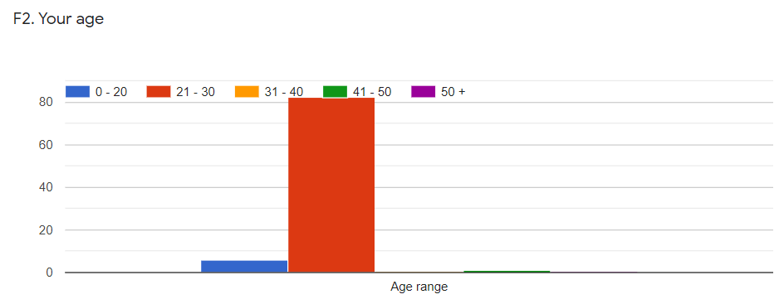
Age of the audience:
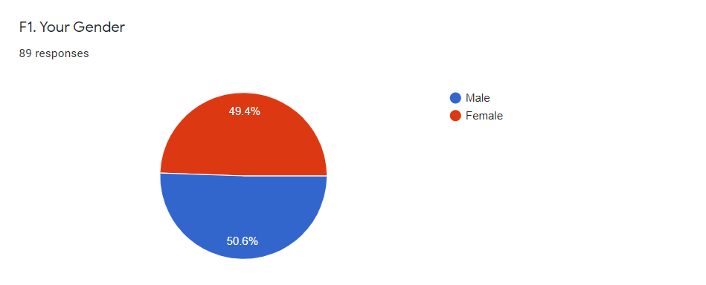
Gender of the audience:

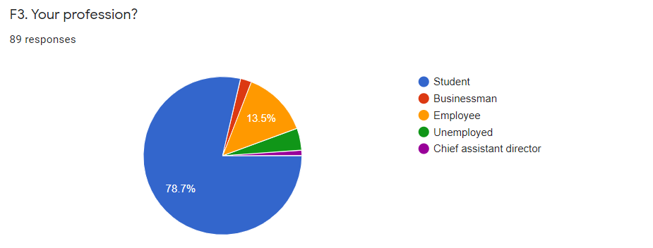
Profession of Audience:

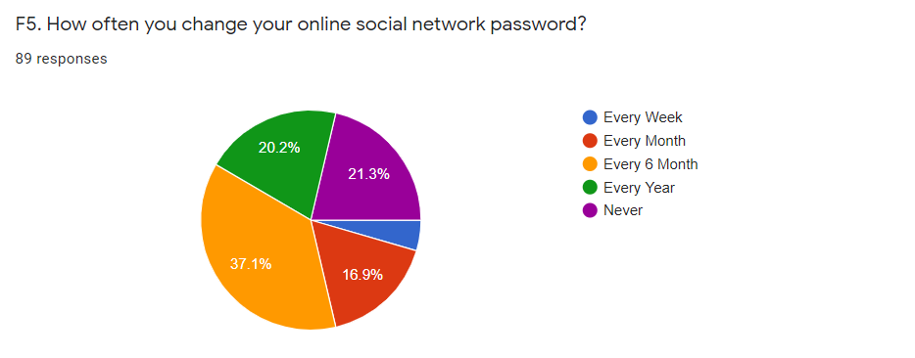
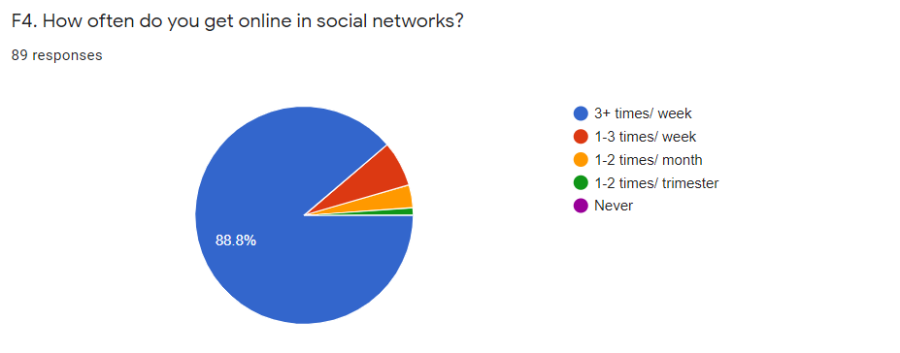

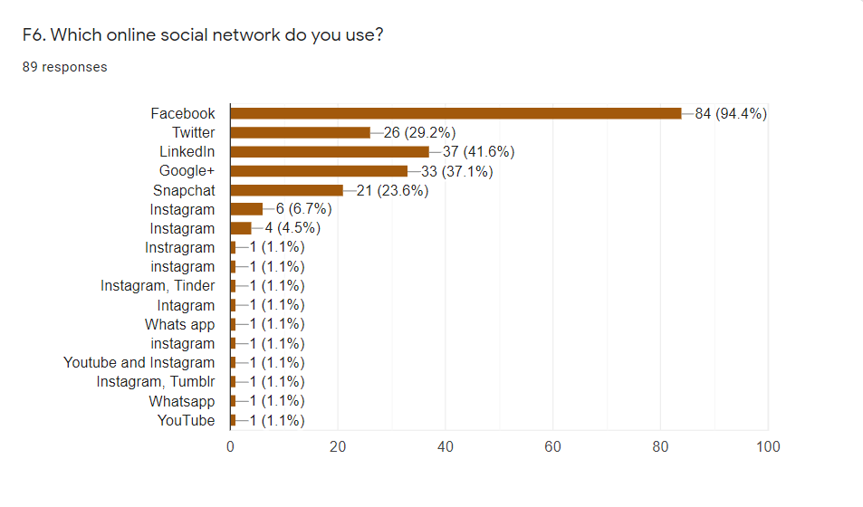
Dependent Variable- PI (Privacy Issues): Question PI-1 to PI-5
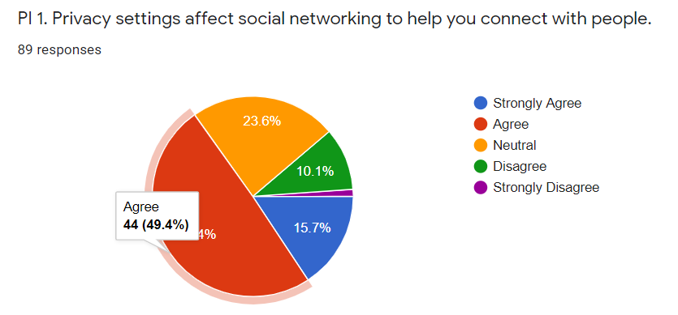
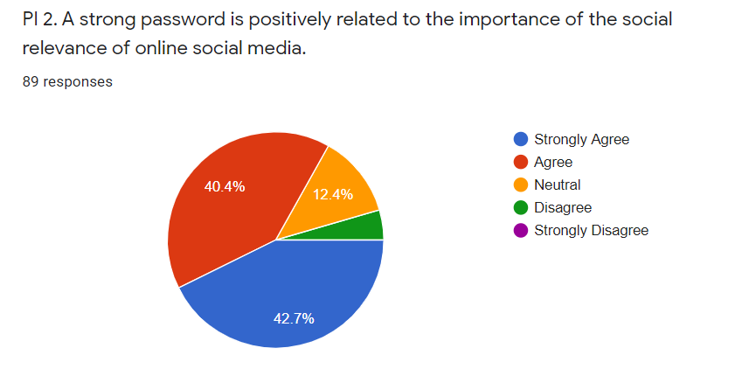
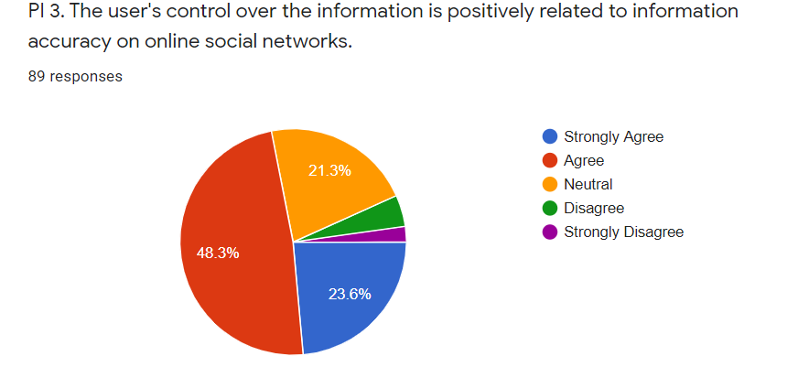
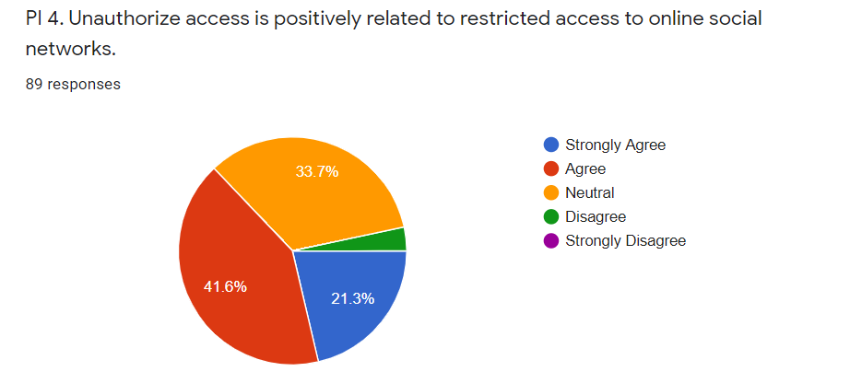

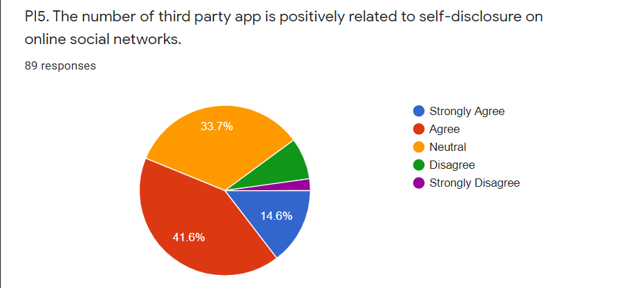

Independent Variable- PS (Privacy Settings): Question PS-1 to PS-5
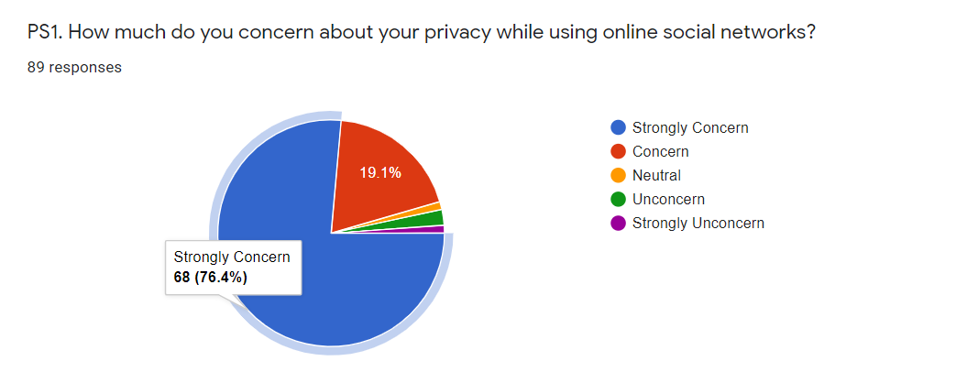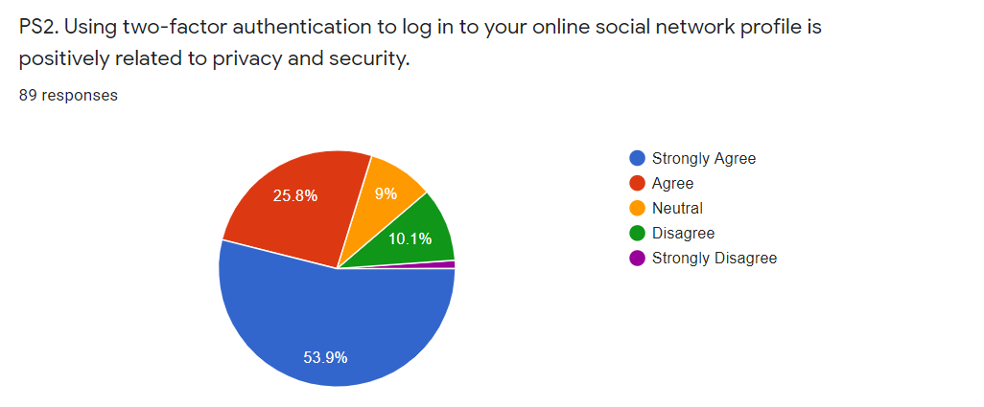

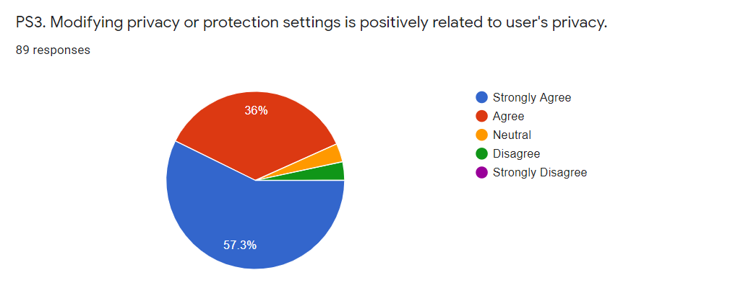
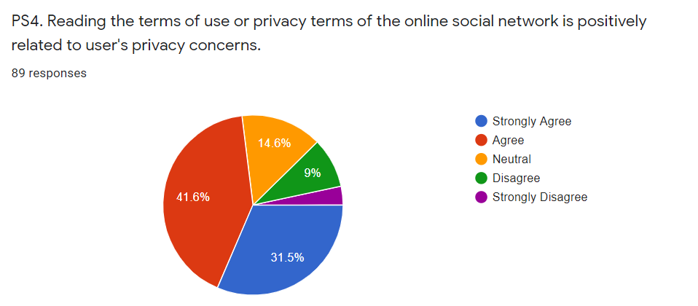
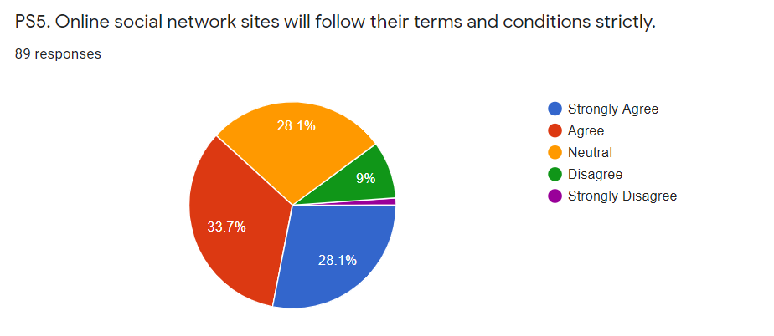

Independent Variable- PW (Password) Question PW-1 to PW-5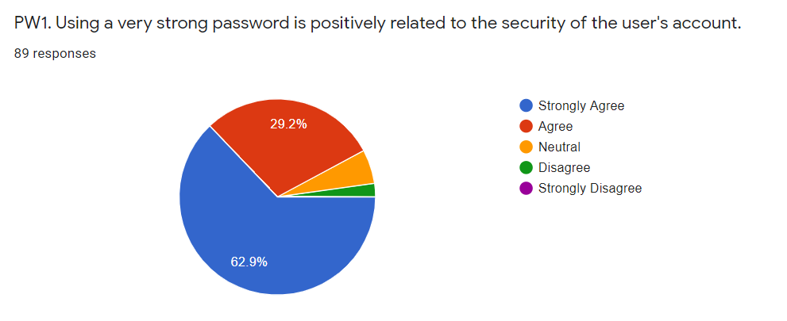
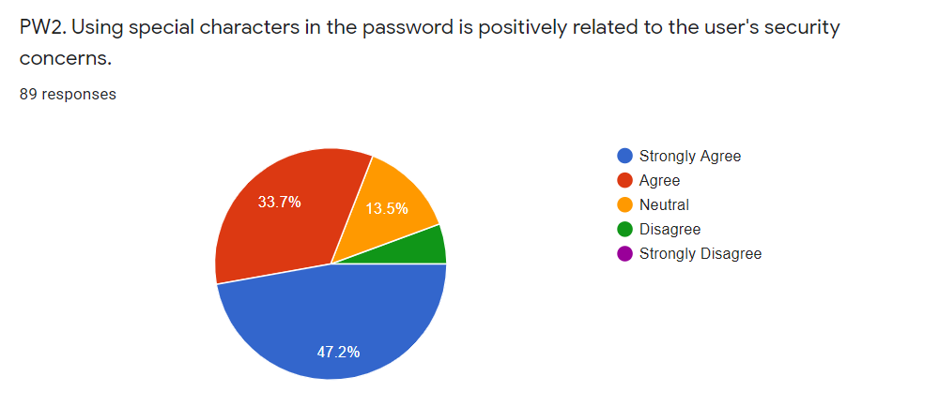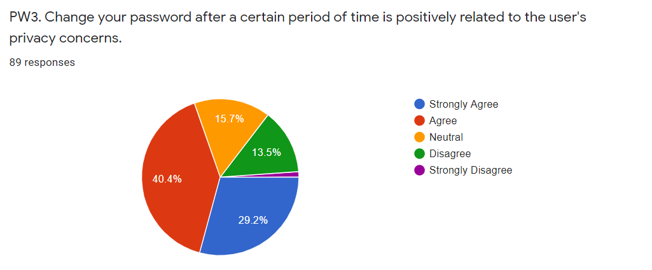
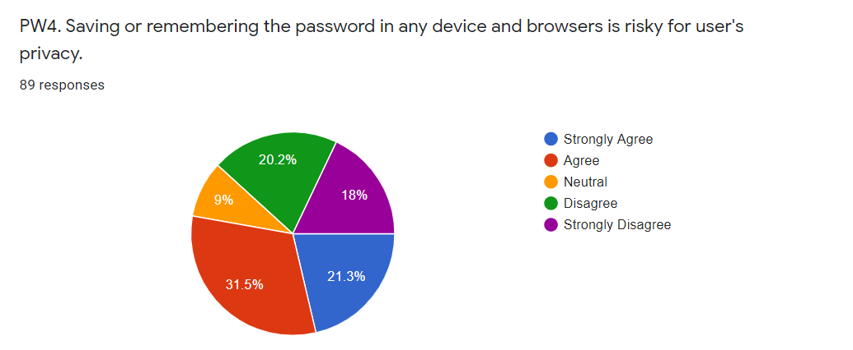

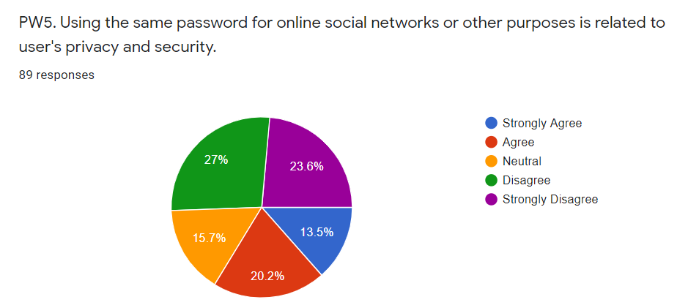

Independent Variable- CO (Control): Question CO-1 to CO-5
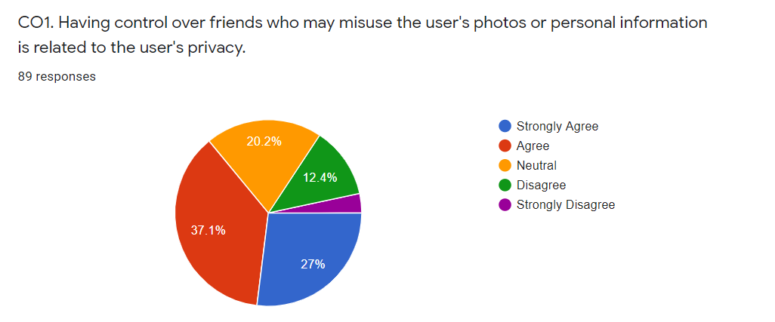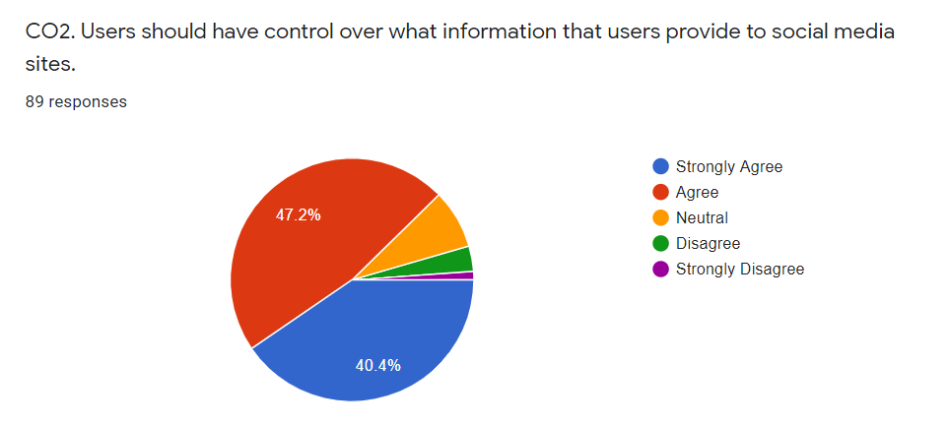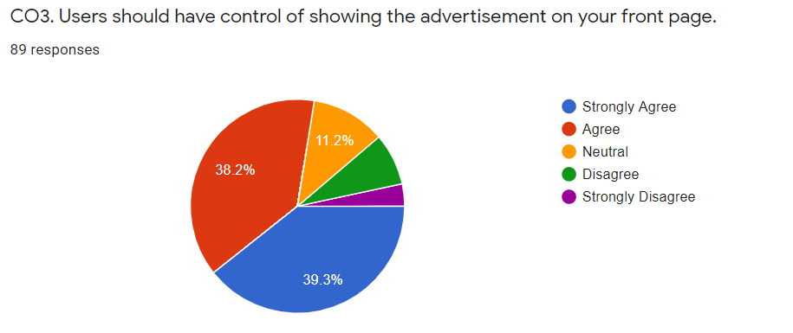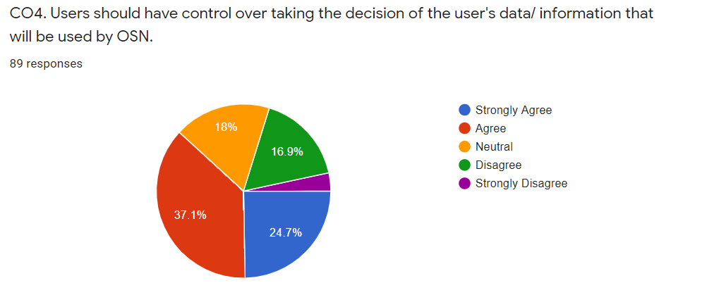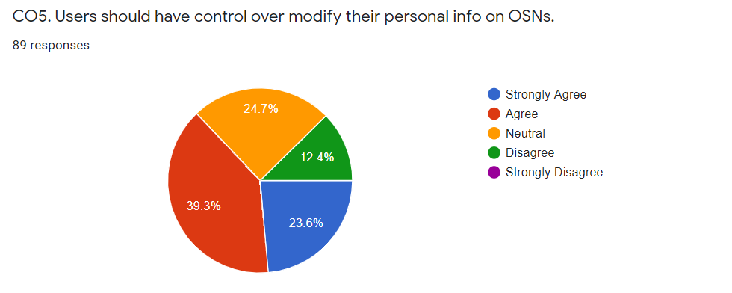

Independent Variable- UA (User Authentication): Question UA-1 to UA-5
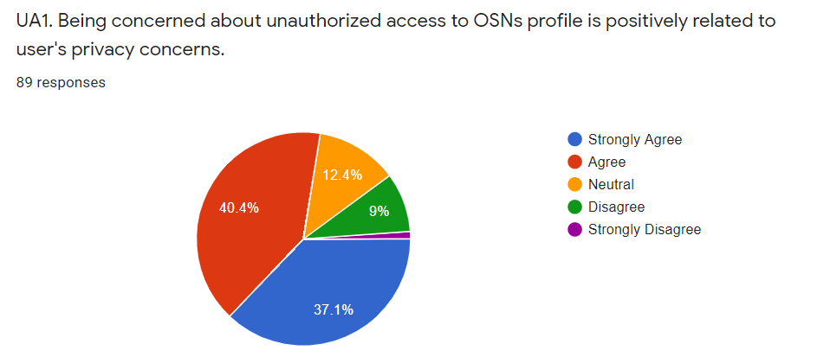
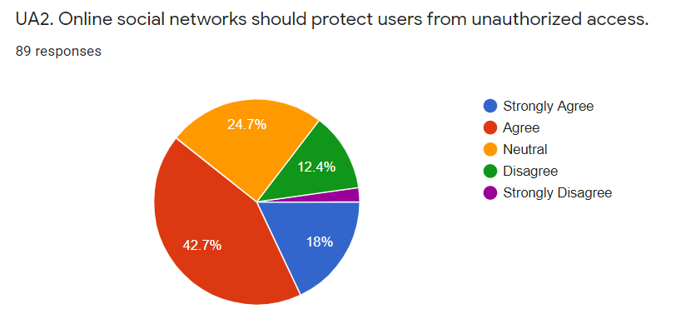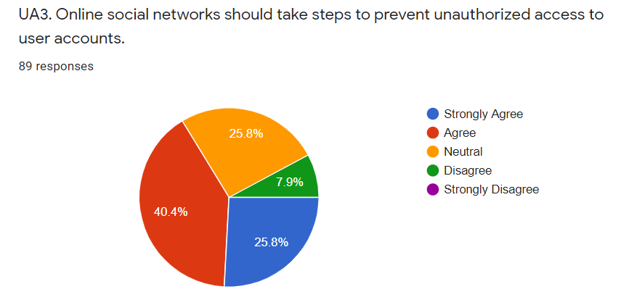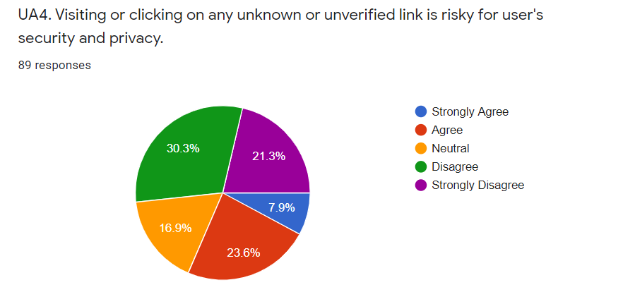

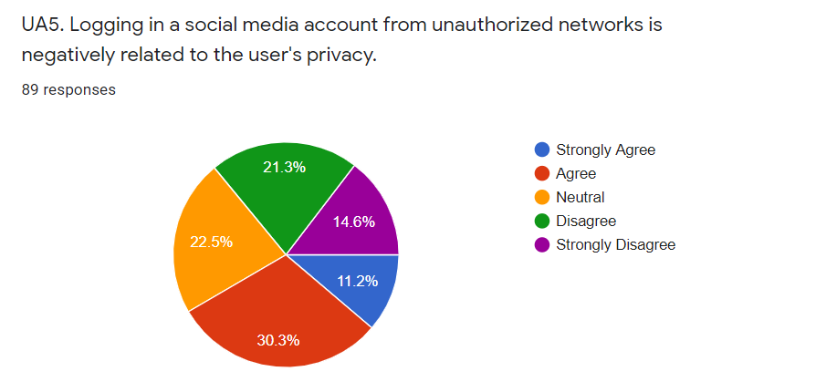

CHAPTER IV RESEARCH FINDINGS

CHAPTER IV RESEARCH FINDINGS

4.1 Data Analysis
i. Descriptive Statistics (Frequency Analysis): Frequency Analysis is Associate in Nursing illustrative factual strategy that shows the amount of events of each reaction picked by the respondents. once utilizing return examination, SPSS Statistics will likewise ascertain the mean, median and mode to help shoppers with breaking down the outcomes and create inferences.
ii. Reliableness Test (Cronbach’s Alpha): Cronbach's alpha is that the most well-known proportion of inward consistency ("reliability"). it's most unremarkably used once you have varied Likert inquiries in an exceedingly study/survey that structure a scale and you would like to choose whether or not the dimensions is dependable.
iii. Regression: simple regression is that the subsequent stage up once correlation. It’s used after we have to be compelled to foresee the assessment of a variable obsessed with the assessment of alternative variable. This variable we'd like to anticipate is understood because the variable quantity (or a number of the time, the result variable). The variable we tend to are utilizing to foresee the opposite variable's price is understood because the variable (or in some cases, the indicator variable).
iv. Correlation: A (Pearson) correlation could be a variety between - one and +1 that shows to what degree a pair of metric factors are directly connected.

4.2 Results
4.2.1 Descriptive Analysis
In descriptive analysis we've got got mean, median, mode, variance, variance, minimum and most.
The Mean or average is probably going the foremost normally used strategy for depicting focal disposition. To register the mean everything you are doing is embody each one of the qualities and separation by the amount of qualities.
The Median is that the mark found at the accurate midpoint of the arrangement of qualities. One method to register the center is to list all scores in mathematical request, and later on realize the score within the put concentration of the instance.
The mode is that the most often fashionable Associate in Nursing inducement within the arrangement of scores. to choose the mode, you will once more organize the scores as appeared on top of, and later on tally each one. The foremost each currently and once more happening price is that the mode.
The Standard Deviation could be a {progressively increasingly more Associate in Nursingd more} precise and itemized gauge of scattering in lightweight of the very fact that an anomaly will hugely overdraw the vary (as was valid during this model wherever the one exception estimation of thirty six stands separated from the rest of the qualities. the quality Deviation shows the affiliation that plan of notches should the mean of the instance.
The Variance is that the proportion of scattering in Associate in Nursing informational index. As such, it allots however unfold Associate in Nursing informational assortment is. it's determined by 1st finding the deviation of each element within the informational assortment from the mean, and later on by working out it. Variance is that the traditional of each square deviation.
Minimum is that the minimum worth of the information, and most is that the highest worth of the information.

STATISTICS
QUESTIONS | N |  | Mean | Median | Mode | Std. Deviation | Variance | Minimum | Maximum
QUESTIONS | Valid | Missing
Privacy settings affect social networking to help you connect with people. | 89 | 0 | 3.6854 | 4.0000 | 4.00 | 0.89944 | 0.809 | 1.00 | 5.00
A strong password is positively related to the importance of the social relevance of online social media. | 89 | 0 | 4.2135 | 4.0000 | 5.00 | 0.83219 | 0.693 | 2.00 | 5.00
The user's control over the information is positively related to information accuracy on online social networks. | 89 | 0 | 3.8652 | 4.0000 | 4.00 | 0.90693 | 0.823 | 1.00 | 5.00
Unauthorized access is positively related to restricted access to online social networks. | 89 | 0 | 3.8090 | 4.0000 | 4.00 | 0.81011 | 0.656 | 2.00 | 5.00
The number of third party app is positively related to self-disclosure on online social networks. | 89 | 0 | 3.5843 | 4.0000 | 4.00 | 0.91464 | 0.837 | 1.00 | 5.00
Users should concern about their privacy while using online social networks. | 89 | 0 | 4.7191 | 5.0000 | 5.00 | 0.62138 | 0.386 | 1.00 | 5.00
Using two-factor authentication to log in to your online social network profile is positively related to privacy and security. | 89 | 0 | 4.2135 | 5.0000 | 5.00 | 1.04959 | 1.102 | 1.00 | 5.00

Modifying privacy or protection settings is positively related to user's privacy. | 89 | 0 | 4.4719 | 5.0000 | 5.00 | 0.72441 | 0.525 | 2.00 | 5.00
Reading the terms of use or privacy terms of the online social network is positively related to user's privacy concerns. | 89 | 0 | 3.8876 | 4.0000 | 4.00 | 1.06000 | 1.124 | 1.00 | 5.00
Online social network sites will follow their terms and conditions strictly. | 89 | 0 | 3.7865 | 4.0000 | 4.00 | 0.99398 | 0.988 | 1.00 | 5.00
Using a very strong password is positively related to the security of the user's account. | 89 | 0 | 4.5281 | 5.0000 | 5.00 | 0.70855 | 0.502 | 2.00 | 5.00
Using a very strong password is positively related to the security of the user's account. | 89 | 0 | 4.2247 | 4.0000 | 5.00 | 0.88873 | 0.790 | 2.00 | 5.00
Using special characters in the password is positively related to the user's security concerns. | 89 | 0 | 3.8315 | 4.0000 | 4.00 | 1.03612 | 1.074 | 1.00 | 5.00
Saving or remembering the password in any device and browsers is risky for user's privacy. | 89 | 0 | 3.1798 | 4.0000 | 4.00 | 1.44255 | 2.081 | 1.00 | 5.00
Using the same password for online social networks or other purposes is related to user's privacy and security. | 89 | 0 | 2.7303 | 2.0000 | 2.00 | 1.37976 | 1.904 | 1.00 | 5.00
Having control over friends who may misuse the user's photos or personal information is related to the user's privacy. | 89 | 0 | 3.7191 | 4.0000 | 4.00 | 1.09740 | 1.204 | 1.00 | 5.00
Users should have control over what information that users provide to social media sites. | 89 | 0 | 4.2247 | 4.0000 | 4.00 | 0.82231 | 0.676 | 1.00 | 5.00
Users should have control of showing the advertisement on your front page. | 89 | 0 | 4.0225 | 4.0000 | 5.00 | 1.06576 | 1.136 | 1.00 | 5.00

Users should have control over taking the decision of the user's data/ information that will be used by OSN. | 89 | 0 | 3.6292 | 4.0000 | 4.00 | 1.13199 | 1.281 | 1.00 | 5.00
Users should have control over modify their personal info on OSNs. | 89 | 0 | 3.7416 | 4.0000 | 4.00 | 0.95974 | 0.921 | 2.00 | 5.00
Being concerned about unauthorized access to OSNs profile is positively related to user's privacy concerns. | 89 | 0 | 4.0337 | 4.0000 | 4.00 | 0.98222 | 0.965 | 1.00 | 5.00
Online social networks should protect users from unauthorized access. | 89 | 0 | 3.6180 | 4.0000 | 4.00 | 0.99437 | 0.989 | 1.00 | 5.00
Online social networks should take steps to prevent unauthorized access to user accounts. | 89 | 0 | 3.8427 | 4.0000 | 4.00 | 0.90326 | 0.816 | 2.00 | 5.00
Visiting or clicking on any unknown or unverified link is risky for user's security and privacy. | 89 | 0 | 2.6629 | 2.0000 | 2.00 | 1.26979 | 1.612 | 1.00 | 5.00
Logging in a social media account from unauthorized networks is negatively related to the user's privacy. | 89 | 0 | 3.0225 | 3.0000 | 4.00 | 1.25207 | 1.568 | 1.00 | 5.00
Privacy Issue (PI1 - PI5) | 89 | 0 | 3.8315 | 3.8000 | 4.00 | 0.60445 | 0.365 | 2.40 | 5.00
Privacy Settings (PS1-PS5) | 89 | 0 | 4.2292 | 4.2000 | 4.00 | 0.51483 | 0.265 | 3.00 | 5.00
Password (PW1-PW5) | 89 | 0 | 3.6989 | 3.6000 | 4.00 | 0.63827 | 0.407 | 1.80 | 5.00
Control (CO1-CO5) | 89 | 0 | 3.8674 | 3.8000 | 3.80 | 0.62809 | 0.394 | 2.40 | 5.00
Unauthorized Access (AU1-AU5) | 89 | 0 | 3.4360 | 3.4000 | 3.40 | 0.67120 | 0.451 | 1.80 | 5.00

4.2.3 Frequency Table
In the following model, we can quickly observe that the percentage of all respondents rate our course at any rate "Great". It is the relative recurrence for "Good" and all qualities that go before it - for this situation just "Generally excellent".
Cumulative frequencies, don't disregard that combined frequencies rely upon the request wherein values are recorded in a recurrence table. In the event that we'd turn around our table, the combined rate for "Good". This is the rate for "Good" or a more terrible rating.
Cumulative frequencies are not helpful for ostensible factors. This is on the grounds that their qualities don't have a characteristic request.

Privacy settings affect social networking to help you connect with people.
 |  | Frequency | Percent | Valid Percent | Cumulative Percent
Valid | Disagree | 8 | 9.0 | 9.0 | 9.0
Valid | Strongly Disagree | 8 | 9.0 | 9.0 | 18.0
Valid | Neutral | 18 | 20.2 | 20.2 | 38.2
Valid | Agree | 38 | 42.7 | 42.7 | 80.9
Valid | Strongly Agree | 17 | 19.1 | 19.1 | 100.0
Valid | Total | 89 | 100.0 | 100.0

A strong password is positively related to the importance of the social relevance of online social media.
 |  | Frequency | Percent | Valid Percent | Cumulative Percent
Valid | Disagree | 8 | 9.0 | 9.0 | 9.0
Valid | Strongly Disagree | 3 | 3.4 | 3.4 | 12.4
Valid | Neutral | 10 | 11.2 | 11.2 | 23.6
Valid | Agree | 31 | 34.8 | 34.8 | 58.4
Valid | Strongly Agree | 37 | 41.6 | 41.6 | 100.0
Valid | Total | 89 | 100.0 | 100.0

The user's control over the information is positively related to information accuracy on online social networks.
 |  | Frequency | Percent | Valid Percent | Cumulative Percent
Valid | Disagree | 8 | 9.0 | 9.0 | 9.0
Valid | Strongly Disagree | 4 | 4.5 | 4.5 | 13.5
Valid | Neutral | 18 | 20.2 | 20.2 | 33.7
Valid | Agree | 37 | 41.6 | 41.6 | 75.3
Valid | Strongly Agree | 22 | 24.7 | 24.7 | 100.0
Valid | Total | 89 | 100.0 | 100.0

Unauthorized access is positively related to restricted access to online social networks.
 |  | Frequency | Percent | Valid Percent | Cumulative Percent
Valid | Disagree | 8 | 9.0 | 9.0 | 9.0
Valid | Strongly Disagree | 3 | 3.4 | 3.4 | 12.4
Valid | Neutral | 26 | 29.2 | 29.2 | 41.6
Valid | Agree | 30 | 33.7 | 33.7 | 75.3
Valid | Strongly Agree | 22 | 24.7 | 24.7 | 100.0
Valid | Total | 89 | 100.0 | 100.0

Users should concern about their privacy while using online social networks.
 |  | Frequency | Percent | Valid Percent | Cumulative Percent
Valid | Disagree | 2 | 2.2 | 2.2 | 2.2
Valid | Strongly Disagree | 5 | 5.6 | 5.6 | 7.9
Valid | Neutral | 2 | 2.2 | 2.2 | 10.1
Valid | Agree | 12 | 13.5 | 13.5 | 23.6
Valid | Strongly Agree | 68 | 76.4 | 76.4 | 100.0
Valid | Total | 89 | 100.0 | 100.0

Using two-factor authentication to log in to your online social network profile is positively related to privacy and security.
 |  | Frequency | Percent | Valid Percent | Cumulative Percent
Valid | Disagree | 3 | 3.4 | 3.4 | 3.4
Valid | Strongly Disagree | 10 | 11.2 | 11.2 | 14.6
Valid | Neutral | 9 | 10.1 | 10.1 | 24.7
Valid | Agree | 19 | 21.3 | 21.3 | 46.1
Valid | Strongly Agree | 48 | 53.9 | 53.9 | 100.0
Valid | Total | 89 | 100.0 | 100.0

Reading the terms of use or privacy terms of the online social network is positively related to user's privacy concerns.
 |  | Frequency | Percent | Valid Percent | Cumulative Percent
Valid | Disagree | 5 | 5.6 | 5.6 | 5.6
Valid | Strongly Disagree | 11 | 12.4 | 12.4 | 18.0
Valid | Neutral | 12 | 13.5 | 13.5 | 31.5
Valid | Agree | 29 | 32.6 | 32.6 | 64.0
Valid | Strongly Agree | 32 | 36.0 | 36.0 | 100.0
Valid | Total | 89 | 100.0 | 100.0

Online social network sites will follow their terms and conditions strictly.
 |  | Frequency | Percent | Valid Percent | Cumulative Percent
Valid | Disagree | 2 | 2.2 | 2.2 | 2.2
Valid | Strongly Disagree | 12 | 13.5 | 13.5 | 15.7
Valid | Neutral | 24 | 27.0 | 27.0 | 42.7
Valid | Agree | 24 | 27.0 | 27.0 | 69.7
Valid | Strongly Agree | 27 | 30.3 | 30.3 | 100.0
Valid | Total | 89 | 100.0 | 100.0

Using a very strong password is positively related to the security of the user's account.
 |  | Frequency | Percent | Valid Percent | Cumulative Percent
Valid | Strongly Disagree | 3 | 3.4 | 3.4 | 3.4
Valid | Neutral | 7 | 7.9 | 7.9 | 11.2
Valid | Agree | 22 | 24.7 | 24.7 | 36.0
Valid | Strongly Agree | 57 | 64.0 | 64.0 | 100.0
Valid | Total | 89 | 100.0 | 100.0

Using a very strong password is positively related to the security of the user's account.
 |  | Frequency | Percent | Valid Percent | Cumulative Percent
Valid | Strongly Disagree | 5 | 5.6 | 5.6 | 5.6
Valid | Neutral | 10 | 11.2 | 11.2 | 16.9
Valid | Agree | 28 | 31.5 | 31.5 | 48.3
Valid | Strongly Agree | 46 | 51.7 | 51.7 | 100.0
Valid | Total | 89 | 100.0 | 100.0

Using special characters in the password is positively related to the user's security concerns.
 |  | Frequency | Percent | Valid Percent | Cumulative Percent
Valid | Disagree | 1 | 1.1 | 1.1 | 1.1
Valid | Strongly Disagree | 10 | 11.2 | 11.2 | 12.4
Valid | Neutral | 10 | 11.2 | 11.2 | 23.6
Valid | Agree | 34 | 38.2 | 38.2 | 61.8
Valid | Strongly Agree | 34 | 38.2 | 38.2 | 100.0
Valid | Total | 89 | 100.0 | 100.0

Saving or remembering the password in any device and browsers is risky for user's privacy.
 |  | Frequency | Percent | Valid Percent | Cumulative Percent
Valid | Disagree | 11 | 12.4 | 12.4 | 12.4
Valid | Strongly Disagree | 17 | 19.1 | 19.1 | 31.5
Valid | Neutral | 9 | 10.1 | 10.1 | 41.6
Valid | Agree | 24 | 27.0 | 27.0 | 68.5
Valid | Strongly Agree | 28 | 31.5 | 31.5 | 100.0
Valid | Total | 89 | 100.0 | 100.0

Using the same password for online social networks or other purposes is related to user's privacy and security.
 |  | Frequency | Percent | Valid Percent | Cumulative Percent
Valid | Disagree | 19 | 21.3 | 21.3 | 21.3
Valid | Strongly Disagree | 21 | 23.6 | 23.6 | 44.9
Valid | Neutral | 14 | 15.7 | 15.7 | 60.7
Valid | Agree | 14 | 15.7 | 15.7 | 76.4
Valid | Strongly Agree | 21 | 23.6 | 23.6 | 100.0
Valid | Total | 89 | 100.0 | 100.0

Having control over friends who may misuse the user's photos or personal information is related to the user's privacy.
 |  | Frequency | Percent | Valid Percent | Cumulative Percent
Valid | Disagree | 8 | 9.0 | 9.0 | 9.0
Valid | Strongly Disagree | 7 | 7.9 | 7.9 | 16.9
Valid | Neutral | 14 | 15.7 | 15.7 | 32.6
Valid | Agree | 32 | 36.0 | 36.0 | 68.5
Valid | Strongly Agree | 28 | 31.5 | 31.5 | 100.0
Valid | Total | 89 | 100.0 | 100.0

Users should have control over what information that users provide to social media sites.
 |  | Frequency | Percent | Valid Percent | Cumulative Percent
Valid | Disagree | 7 | 7.9 | 7.9 | 7.9
Valid | Strongly Disagree | 4 | 4.5 | 4.5 | 12.4
Valid | Neutral | 8 | 9.0 | 9.0 | 21.3
Valid | Agree | 37 | 41.6 | 41.6 | 62.9
Valid | Strongly Agree | 33 | 37.1 | 37.1 | 100.0
Valid | Total | 89 | 100.0 | 100.0

Users should have control of showing the advertisement on your front page.
 |  | Frequency | Percent | Valid Percent | Cumulative Percent
Valid | Disagree | 8 | 9.0 | 9.0 | 9.0
Valid | Strongly Disagree | 7 | 7.9 | 7.9 | 16.9
Valid | Neutral | 13 | 14.6 | 14.6 | 31.5
Valid | Agree | 31 | 34.8 | 34.8 | 66.3
Valid | Strongly Agree | 30 | 33.7 | 33.7 | 100.0
Valid | Total | 89 | 100.0 | 100.0

Users should have control over taking the decision of the user's data/ information that will be used by OSN.
 |  | Frequency | Percent | Valid Percent | Cumulative Percent
Valid | Disagree | 9 | 10.1 | 10.1 | 10.1
Valid | Strongly Disagree | 14 | 15.7 | 15.7 | 25.8
Valid | Neutral | 10 | 11.2 | 11.2 | 37.1
Valid | Agree | 31 | 34.8 | 34.8 | 71.9
Valid | Strongly Agree | 25 | 28.1 | 28.1 | 100.0
Valid | Total | 89 | 100.0 | 100.0

Users should have control over modify their personal info on OSNs.
 |  | Frequency | Percent | Valid Percent | Cumulative Percent
Valid | Disagree | 5 | 5.6 | 5.6 | 5.6
Valid | Strongly Disagree | 13 | 14.6 | 14.6 | 20.2
Valid | Neutral | 17 | 19.1 | 19.1 | 39.3
Valid | Agree | 32 | 36.0 | 36.0 | 75.3
Valid | Strongly Agree | 22 | 24.7 | 24.7 | 100.0
Valid | Total | 89 | 100.0 | 100.0

Being concerned about unauthorized access to OSNs profile is positively related to user's privacy concerns.
 |  | Frequency | Percent | Valid Percent | Cumulative Percent
Valid | Disagree | 9 | 10.1 | 10.1 | 10.1
Valid | Strongly Disagree | 7 | 7.9 | 7.9 | 18.0
Valid | Neutral | 8 | 9.0 | 9.0 | 27.0
Valid | Agree | 30 | 33.7 | 33.7 | 60.7
Valid | Strongly Agree | 35 | 39.3 | 39.3 | 100.0
Valid | Total | 89 | 100.0 | 100.0

Online social networks should protect users from unauthorized access.
 |  | Frequency | Percent | Valid Percent | Cumulative Percent
Valid | Disagree | 10 | 11.2 | 11.2 | 11.2
Valid | Strongly Disagree | 10 | 11.2 | 11.2 | 22.5
Valid | Neutral | 21 | 23.6 | 23.6 | 46.1
Valid | Agree | 29 | 32.6 | 32.6 | 78.7
Valid | Strongly Agree | 19 | 21.3 | 21.3 | 100.0
Valid | Total | 89 | 100.0 | 100.0

Online social networks should take steps to prevent unauthorized access to user accounts.
 |  | Frequency | Percent | Valid Percent | Cumulative Percent
Valid | Disagree | 9 | 10.1 | 10.1 | 10.1
Valid | Strongly Disagree | 7 | 7.9 | 7.9 | 18.0
Valid | Neutral | 19 | 21.3 | 21.3 | 39.3
Valid | Agree | 29 | 32.6 | 32.6 | 71.9
Valid | Strongly Agree | 25 | 28.1 | 28.1 | 100.0
Valid | Total | 89 | 100.0 | 100.0

Visiting or clicking on any unknown or unverified link is risky for user's security and privacy.
 |  | Frequency | Percent | Valid Percent | Cumulative Percent
Valid | Disagree | 26 | 29.2 | 29.2 | 29.2
Valid | Strongly Disagree | 23 | 25.8 | 25.8 | 55.1
Valid | Neutral | 13 | 14.6 | 14.6 | 69.7
Valid | Agree | 17 | 19.1 | 19.1 | 88.8
Valid | Strongly Agree | 10 | 11.2 | 11.2 | 100.0
Valid | Total | 89 | 100.0 | 100.0

Logging in a social media account from unauthorized networks is negatively related to the user's privacy.
 |  | Frequency | Percent | Valid Percent | Cumulative Percent
Valid | Disagree | 19 | 21.3 | 21.3 | 21.3
Valid | Strongly Disagree | 17 | 19.1 | 19.1 | 40.4
Valid | Neutral | 17 | 19.1 | 19.1 | 59.6
Valid | Agree | 24 | 27.0 | 27.0 | 86.5
Valid | Strongly Agree | 12 | 13.5 | 13.5 | 100.0
Valid | Total | 89 | 100.0 | 100.0

4.2.3 Reliability Test (Cronbach’s Alpha)
The alpha coefficient for the five things of the privacy settings (independent variable-PS) part was .856, proposing that the things have relatively the high inner reliability. The alpha constant for the five things of the control (independent variable-CO) was .891, recommending that the things have relatively the high inner reliability. The alpha constant for the five things of the password (independent variable-PW) segment was .860, recommending that the things have relatively the high inner reliability. The alpha constant for the five things of the unauthorized access (independent variable-UA) segment was .849, proposing that the things have generally the high inner reliability. The alpha constant for the five things of the privacy issues (dependent variable-PI) part was .908, recommending that the things have moderately the high inner reliability.
Independent Variable Reliability test:

Scale: Privacy Settings

Case Processing Summary
 |  | N | %
Cases | Valid | 89 | 100.0
Cases | Excludedª | 0 | .0
Cases | Total | 89 | 100.0
a. Listwise deletion based on all variables in the procedure.

Reliability Statistics
Cronbach's Alpha | N of Items
.856 | 5

Item-Total Statistics
 | Scale Mean if Item Deleted | Scale Variance if Item Deleted | Corrected Item-Total Correlation | Cronbach's Alpha if Item Deleted
Users should concern about their privacy while using online social networks. | 15.9438 | 12.985 | .754 | .809
Using two-factor authentication to log in to your online social network profile is positively related to privacy and security. | 16.3933 | 12.196 | .664 | .829
Modifying privacy or protection settings is positively related to user's privacy. | 16.1798 | 12.376 | .812 | .793
Reading the terms of use or privacy terms of the online social network is positively related to user's privacy concerns. | 16.6966 | 12.305 | .621 | .842
Online social network sites will follow their terms and conditions strictly. | 16.8090 | 13.361 | .550 | .857

Scale: Password

Case Processing Summary
 |  | N | %
Cases | Valid | 89 | 100.0
Cases | Excludedª | 0 | .0
Cases | Total | 89 | 100.0
a. List wise deletion based on all variables in the procedure.

Reliability Statistics
Cronbach's Alpha | N of Items
.860 | 5

Item-Total Statistics
 | Scale Mean if Item Deleted | Scale Variance if Item Deleted | Corrected Item-Total Correlation | Cronbach's Alpha if Item Deleted
Using a very strong password is positively related to the security of the user's account. | 13.9663 | 19.737 | .728 | .820
Using a very strong password is positively related to the security of the user's account. | 14.1461 | 19.535 | .752 | .815
Using special characters in the password is positively related to the user's security concerns. | 14.4045 | 19.380 | .711 | .823
Saving or remembering the password in any device and browsers is risky for user's privacy. | 14.8652 | 18.891 | .646 | .841
Using the same password for online social networks or other purposes is related to user's privacy and security. | 15.2921 | 19.346 | .586 | .858

Scale: Control

Case Processing Summary
 |  | N | %
Cases | Valid | 89 | 100.0
Cases | Excludedª | 0 | .0
Cases | Total | 89 | 100.0
a. List wise deletion based on all variables in the procedure.

Reliability Statistics
Cronbach's Alpha | N of Items
.891 | 5

Item-Total Statistics
 | Scale Mean if Item Deleted | Scale Variance if Item Deleted | Corrected Item-Total Correlation | Cronbach's Alpha if Item Deleted
Having control over friends who may misuse the user's photos or personal information is related to the user's privacy. | 14.8652 | 17.482 | .720 | .871
Users should have control over what information that users provide to social media sites. | 14.6404 | 17.551 | .775 | .859
Users should have control of showing the advertisement on your front page. | 14.8315 | 17.642 | .692 | .877
Users should have control over taking the decision of the user's data/ information that will be used by OSN. | 15.0449 | 17.112 | .697 | .877
Users should have control over modify their personal info on OSNs. | 15.0000 | 17.295 | .800 | .854

Scale: Unauthorized Access

Case Processing Summary
 |  | N | %
Cases | Valid | 89 | 100.0
Cases | Excludedª | 0 | .0
Cases | Total | 89 | 100.0
a. List wise deletion based on all variables in the procedure.

Reliability Statistics
Cronbach's Alpha | N of Items
.849 | 5

Item-Total Statistics
 | Scale Mean if Item Deleted | Scale Variance if Item Deleted | Corrected Item-Total Correlation | Cronbach's Alpha if Item Deleted
Being concerned about unauthorized access to OSNs profile is positively related to user's privacy concerns. | 12.5169 | 18.230 | .631 | .825
Online social networks should protect users from unauthorized access. | 12.9438 | 17.940 | .697 | .809
Online social networks should take steps to prevent unauthorized access to user accounts. | 12.7528 | 17.302 | .772 | .789
Visiting or clicking on any unknown or unverified link is risky for user's security and privacy. | 13.7865 | 18.624 | .539 | .851
Logging in a social media account from unauthorized networks is negatively related to the user's privacy. | 13.4382 | 17.431 | .671 | .815

Dependent Variable Reliability test:
Scale: Privacy Issues

Case Processing Summary
 |  | N | %
Cases | Valid | 89 | 100.0
Cases | Excludedª | 0 | .0
Cases | Total | 89 | 100.0
a. List wise deletion based on all variables in the procedure.

Reliability Statistics
Cronbach's Alpha | N of Items
.908 | 5

Item-Total Statistics
 | Scale Mean if Item Deleted | Scale Variance if Item Deleted | Corrected Item-Total Correlation | Cronbach's Alpha if Item Deleted
Privacy settings affect social networking to help you connect with people. | 14.8652 | 15.345 | .816 | .877
A strong password is positively related to the importance of the social relevance of online social media. | 14.4382 | 15.294 | .775 | .886
The user's control over the information is positively related to information accuracy on online social networks. | 14.7191 | 15.000 | .868 | .865
Unauthorized access is positively related to restricted access to online social networks. | 14.7865 | 15.579 | .789 | .882
The number of third party app is positively related to self-disclosure on online social networks. | 14.8090 | 17.929 | .594 | .920

4.2.4 Regression

SPSS Statistics will make many tables for a linear regression. In this section, we showed just the three primary tables essential to understand your outcomes from the conventional relapse methodology, compliant that no presumptions have been damaged. A total explanation of the yield we need to decipher while inspection our information for the five assumptions required to do direct relapse is given in our upgraded guide. This incorporates applicable scatterplots, histogram (with superimposed ordinary bend), Normal P-P Plot, case wise diagnostics and the Durbin-Watson measurement. Moreover, we focus on the outcomes for the straight linear regression as it were.
Our independent variables are PS, PW, CO & AU and dependent variable is PI.

Variables Entered/Removedª
Model | Variables Entered | Variables Removed | Method
1 | Unauthorized Access (AU1-AU5), Privacy Settings (PS1-PS5), Password (PW1-PW5), Control (CO1-CO5)^{b} | . | Enter
a. Dependent Variable: Privacy Issue (PI1 - PI5)
b. All requested variables entered.

The main table of intrigue is the Model Summary table, as demonstrated as follows:

Model Summary
Model | R | R Square | Adjusted R Square | Std. Error of the Estimate
1 | .735ª | .541 | .518 | .52947
a. Predictors: (Constant), Unauthorized Access (AU1-AU5), Privacy Settings (PS1-PS5), Password (PW1-PW5), Control (CO1-CO5)

This table gives the R and R2 values. The R regard speaks to the simple correlation and is 0.735 (the "R" Column), which proves the higher level of relationship. The R2 regard (the "R Square" section) proves the amount of the all-out variety in the dependent variable, Privacy Issues, can be clarified by the four independent variable, Privacy Settings, Password, Control, and Unauthorized Access. For this situation, 54.1% can be clarified, which is quite good.
4.2.5 Anova Table

The following table is the ANOVA table, which reports how well the regression equation fits the information (i.e., predicts the dependent variable) and is demonstrated as follows:

ANOVAª
Model |  | Sum of Squares | df | Mean Square | F | Sig.
1 | Regression | 27.082 | 4 | 6.770 | 24.151 | .000^{b}
1 | Residual | 22.988 | 82 | .280
1 | Total | 50.070 | 86
a. Dependent Variable: Privacy Issue (PI1 - PI5)
b. Predictors: (Constant), Unauthorized Access (AU1-AU5), Privacy Settings (PS1-PS5), Password (PW1-PW5), Control (CO1-CO5)
Regression df is the quantity of independent variable in our regression model. Since we just consider GRE scores in this model, it is 4.
Residual df is the complete number of perceptions (rows) of the dataset subtracted by the quantity of variables being evaluated. In this model, both the GRE score coefficient and the consistent are evaluated.
From the ANOVA table, the regression SS is 27.082 and the all-out SS is 50.070, which implies the regression model clarifies about 27.082/50.070 (around 54%) of all the variability in the dataset.

From the ANOVA table, the residual SS is about 22.988. By and large, the littler the mistake, the better the relapse model clarifies the variety in the informational collection thus we would for the most part need to limit this blunder.
Significance F — is only the p-esteem for the invalid theory that the coefficient of the free factor is zero and similarly as with any p-esteem, a low p-esteem demonstrates that a noteworthy relationship exists among needy and autonomous factors.

4.2.6 Coefficients
The following Coefficients table provides us the important data to anticipate value from four independent varibales, just as decide if pay contributes measurably essentially to the ideal (by captivating a gander at the "Sig." section). Moreover, we can use the makings in the "B" division below the "Unstandardized Coefficients" segment, as established as follows:
Coefficientsª
Model |  | Unstandardized Coefficients |  | Standardized Coefficients | t | Sig.
 |  | B | Std. Error | Beta | t | Sig.
1 | (Constant) | .624 | .332 |  | 1.881 | .064
1 | Privacy Settings (PS1-PS5) | .203 | .107 | .209 | 1.905 | .060
1 | Password (PW1-PW5) | .053 | .114 | .051 | .465 | .643
1 | Control (CO1-CO5) | .232 | .115 | .237 | 2.010 | .048
1 | Unautorize Access (AU1-AU5) | .354 | .104 | .361 | 3.397 | .001
a. Dependent Variable: Privacy Issue (PI1 - PI5)

To present the regression equation as:
Privacy Issue = 0.624+0.203+0.053+0.232+0.354(PS,PW,CO,AU)

4.2.7 Correlation

Correlations
 |  | Privacy Issue (PI1 - PI5) | Privacy Settings (PS1-PS5) | Password (PW1-PW5) | Control (CO1-CO5) | Unauthorized Access (AU1-AU5)
Privacy Issue (PI1 - PI5) | Pearson Correlation | 1 | .789** | .862** | .745** | .854**
Privacy Issue (PI1 - PI5) | Sig. (2-tailed) |  | .000 | .000 | .000 | .000
Privacy Issue (PI1 - PI5) | N | 88 | 88 | 88 | 88 | 87
Privacy Settings (PS1-PS5) | Pearson Correlation | .789** | 1 | .727** | .883** | .717**
Privacy Settings (PS1-PS5) | Sig. (2-tailed) | .000 |  | .000 | .000 | .000
Privacy Settings (PS1-PS5) | N | 88 | 89 | 89 | 89 | 88
Password (PW1-PW5) | Pearson Correlation | .862** | .727** | 1 | .828** | .737**
Password (PW1-PW5) | Sig. (2-tailed) | .000 | .000 |  | .000 | .000
Password (PW1-PW5) | N | 88 | 89 | 89 | 89 | 88
Control (CO1-CO5) | Pearson Correlation | .745** | .883** | .828** | 1 | .745**
Control (CO1-CO5) | Sig. (2-tailed) | .000 | .000 | .000 |  | .000
Control (CO1-CO5) | N | 88 | 89 | 89 | 89 | 88
Unauthorized Access (AU1-AU5) | Pearson Correlation | .854** | .717** | .737** | .745** | 1
Unauthorized Access (AU1-AU5) | Sig. (2-tailed) | .000 | .000 | .000 | .000
Unauthorized Access (AU1-AU5) | N | 87 | 88 | 88 | 88 | 88
**. Correlation is significant at the 0.01 level (2-tailed).

In the correlation table we need to check to ensure that we don't have multi-co linearity between the independent variables. In the event that a correlation is more than 0.7 or between (0.7-1.0), at that point the variables are viewed as strongest relation between variables. So the qualities should be under 0.7 however just between the free factors. Here in Pearson connection, the greater part of the qualities that speak to correlation between the independent variable are under 0.7. So none of them are multi-collinear. Moreover, we need the independent variable to associate with the dependent variable at a worth more prominent than 0.3. Here the value of correlation of the privacy on online social network for privacy issues 1, privacy settings .789, password .862, control .745. As every one of the values are near about 1.00 so the qualities completely meet the necessities and all variables have strong relations.

CHAPTER V CONCLUSION

CHAPTER V CONCLUSION
This research was attempted to experimentally approve an internet based life protection concerns instrument with six develops/parts (privacy issues, privacy settings, password, control, unauthorized access). Each build/segment included three assigned things portraying the construct/segment. The exploration question asked whether the six online life locales protection concerns develop (each independently) can be observationally approved to be dependable and interpretable among their assigned things. The discoveries showed the accompanying:
The online networking privacy concerns (privacy issues) part held all its five assigned things showing that the segment was observationally approved to be solid and interpretable among all its three things. The things held are worries around 1) Privacy settings affect social networking to help you connect with people 2) A strong password is positively related to the importance of the social relevance of online social media. 3) The user's control over the information is positively related to information accuracy on online social networks. 4) Unauthorized access is positively related to restricted access to online social networks. 5) The number of third party app is positively related to self-disclosure on online social networks.

The online networking privacy concerns (privacy settings) part held all its three assigned things showing that the segment was exactly approved to be solid and interpretable among all its five things. The things held are worries around 1) Being concern about user’s privacy while using OSNs. 2) Using two-factor-authentication to log in user’s online social network profile. 3) Modifying user’s privacy or protection settings. 4) Reading the terms of use or privacy terms of user’s online social network. 5) Thinking that OSN sites will follow their terms and conditions strictly.

The online networking privacy concerns (password) segment held all its three assigned things showing that the segment was exactly approved to be dependable and interpretable among all its five things. The things held are worries around 1) Using very strong password. 2) Using special character in user’s password. 3) Changing your password after a certain period of time. 4) Saving or remembered user’s password in any device and browsers. 5) Using same password for OSN and other purpose.

The online networking privacy concerns (control) part held all its five assigned things showing that the segment was exactly approved to be dependable and interpretable among all its five things. The things held are worries around 1) having control over friends may misuse user’s photos or personal information. 2) Having control over what information user provide to social media sites. 3) User should have control on showing advertisement on user’s front page. 4) User have control over modify user’s personal info on OSN. 5) Having control over taking decision of user’s data/ information will be used by OSN.
The online networking privacy concerns (unauthorized access) segment held all its three assigned things demonstrating that the segment was experimentally approved to be solid and interpretable among all its three things. The things held are worries around 1) being concerned about unauthorized access to user’s OSNs profile. 2) Thinking about OSNs protect user from unauthorized access. 3) Online social networks take steps to prevent unauthorized access to user accounts. 4) Visiting or click on any unknown or unverified link. 5) Logging in to user’s OSN account from unauthorized networks.
In outline, each of the five builds of the instrument ((privacy issues, privacy settings, password, control, user authentication) were seen as solid to quantify online networking protection worries of clients. The discoveries of this examination add to improved information about estimating clients' observation toward security worries via web-based networking media destinations. To improve the generalizability of the discoveries, future investigations should concentrate on bigger example populace from various foundations or potentially associations. Further research ought to likewise consider incorporation of conceivable developing clients' protection concerns measurements/builds on the social media networks.

CHAPTER VI REFERENCE

References
1. J. Anderson, C. Daz, J. Bonneau, and F. Stajano. Privacy-enabling social networking over untrusted networks. InJ. Crowcroft andB .Krishnamurthy, editors, WOSN, pages1–6.ACM, 2009.
2. E.-A. Baatarjav, R. Dantu, and S. Phithakkitnukoon. Privacy dominant for facebook. In R. Sekar and A. K. Pujari, editors, International Conference on data Systems Security, volume 5352 of Lecture Notes in technology, pages 273–286. Springer, 2008.
3. D. Boyd and N.B. Ellison. Social network sites: Deﬁnition, history, and scholarship. Journal of Computer-Mediated Communication, 13(1):210–230, 2007.
4. B. Viswanath, A.Mislove, M.Cha, and P.K.Gummadi. On the evolution of user interaction in facebook. In J. Crowcroft and B. Krishnamurthy, editors, Workshop on on-line Social Networks, pages 37–42. ACM, 2009.
5. F. Benevenuto, T. Rodrigues, M. Cha, and V. A. F. Almeida. Characterizing user behavior in on-line social networks. In A. Feldmann and L. Mathy, editors, web mensuration Conference, pages 49–62. ACM, 2009.
6. J.Kang. data privacy in cyber area transactions. Stanford Law Review,50(4):1193– 1294, 1998.
7. S. Buchegger and A. Datta. A case for p2p infrastructure for social networks - opportunities and challenges. In WONS 2009, sixth International Conference on Wireless On-demand Network Systems and Services, pages 161–168, Snowbird, Utah, USA, Feb 2009.
8. S. Buchegger, D. Schi¨oberg, L. H. Vu, and A. Datta. Peerson: P2p social networking: early experiences and insights. In SNS ’09: Proceedings of the Second ACM EuroSys Workshop on Social Network Systems, pages 46–52, New York, NY, USA, 2009. ACM.
9. B. Carminati, E. Ferrari, and A. Perego. non-public relationships in social networks. In ICDE Workshops, pages 163–171, 2007.
10. R. Leenes. Context Is Everything - nature and Privacy in on-line Social Network Sites, volume 320/2010, chapter 4, pages 48–65. Springer capital of Massachusetts, 2010.
11. A. Shakimov, A. Varshavsky, L. P. Cox, and R. Cceres. Privacy, cost, and accessibility tradeoﬀs in localized osns. In J. Crowcroft and B. Krishnamurthy, editors, WOSN, pages 13–18. ACM, 2009.
12. A. Tootoonchian, S. Saroiu, Y. Ganjali, and A. Wolman. Lockr: higher privacy for social networks. In CoNEXT ’09: Proceedings of the fifth international conference on rising networking experiments and technologies, pages 169–180, New York, NY, USA, Dec 2009. ACM.
13. D. Rosenblum. What anyone will know: The privacy risks of social networking sites. IEEE Security &amp; Privacy, 5(3):40–49, May 2007.
Web References
14. Pingdom.com. Social network quality round the world. Online. http://royal. pingdom.com/2008/08/12/social-network-popularity-around-the-world/.
15. D. Cardon. autoimmune disease style DE la visibilit : UN essai de typologie du internet two.0. online, 2 2008. http://www.internetactu.net/2008/02/01/ le-design-de-la-visibilite-un-essai-de-typologie-du-web-20/.
16. R.Dube and M.B.P. Adomaitis. What forms of social networks exist. online,32009. http: //socialnetworking.lovetoknow.com/What_Types_of_Social_Networks_Exist.
17. D. Emmett. Taxonomy of social networks. online, 6 2009. http://davemmett. wordpress.com/2009/06/15/taxonomy-of-social-networks/.
18. L. Gannes. A taxonomy of social networks? on-line, 2 2007. http://gigaom.com/2007/ 02/09/social-network-taxonomy/.
19. E. Burns. promoting to social networking sites, targeted. online, 4 2007. http://www. clickz.com/3625536.
20. B. Lunn. Social network sorts, motivations, and therefore the future. online, 9 2007. http://www. readwriteweb.com/archives/social_network_types_motivations.php.
21. Unknown. Forms of on-line social networks. Online. http://onlinebrandmanager.org/ social-media/social-network-types/.
22. Unknown. Forms of social networking websites. Online, 2010. http: //www.hudsonhorizons.com/Custom-Website-Solutions/Social-Networking/ Types-of-Social-Networks.htm.
23. UK parliament (1998) knowledge protection act. hmso, London
24. A. Jacob. a way to hack my space non-public proﬁle image and video. Online, 4 2007. http:// web.clazh.com/how-to-hack-myspace-private-profile-picture-and-video/.
25. D. M. Williams. On-line identity skilled loses management of nsfw r-rated online pics, 3 2009. http://www.itwire.com/your-it-news/home-it/ 23975-online-identity-expert-loses-control-of-nsfw-r-rated-online-pics.
26. W. Riddle. Cyberbullied teenaged sues ex-classmates, their oldsters, and facebook, 3 2009. http://www.switched.com/2009/03/04/
27. P. McNamara. Facebook blocks ’web two.0 suicide machine’. Online, 1 2010. http://www.networkworld.com/news/2010/ 010410-buzzblog-facebook-blocks-suicide-machine.html.
28. J. Bonneau. Attack of the zombie photos. Online, 2009. http://www. lightbluetouchpaper.org/2009/05/20/attack-of-the-zombie-photos/.
29. C. Walters. Facebook’s new terms of service: ”we will do something we wish together with your content. forever.”, 2 2009. http://consumerist.com/2009/02/ facebooks-new-terms-of-service-we-can-do-anything-we-want-with-your-content-forever. html.
30. S. Olsen. At rap leaf, your personals are public. Online, 8 2007. http://news.cnet.com/ At-Rap leaf,-your-personals-are-public/2100-1038_3-6205716.html.
31. N. O’Neill. ”anonymous” facebook worker interview: truth vs ﬁction, 1 2010. http://www.allfacebook.com/2010/01/ anonymous-facebook-employee-interview-fact-vs-fiction/.

