Impact of Employee Recruitment & Selection Process in HR Performance in IBBL




United International University

School of Business and Economics (SOBE)
Course Title- Intern/Project
Course Code- INT 4399

Submitted to
MD. Kazimul Hoque
Assistant Professor
School of Business and Economics

Submitted By-
Shahinur Akter
111151187

Letter of Transmittal
To
Md. Kazimul Hoque
Assistant Professor
School of Business and Economics
United International University, Madani Avenue, Badda.

Subject: Submission of report on “Impact of employee recruitment & selection process in HR performance in IBBL.”
Honorable sir,
With due respect, I am -Shahinur Akter ID 111-151- 187, is an undergraduate student of Bachelor of Business Administration (BBA) under the project
Though I am in the learning curve, this report has enabled me to gain insight into the core fact of recruitment and selection appraisal knowledge and HR functions. So, it becomes an extremely challenging and interesting experience. Thank you for your supportive consideration and formulating an idea. Without your inspiration, this report would have been e incomplete one.
If anything in the report is not understood clearly, please feel free to contract to the following e-mail address. Lastly, I would be thankful once again if you please give your judicious advice on effort.

Sincerely Yours,
Shahinur Akter
ID- 111-151-187

Letter of Declaration
I do declare that the entries project made by me in the Application Form is complete and true to the best of my knowledge and based on academic perspective. I agree to attend and participate in all the formal and informal teaching and relevant sessions for my course and understand that my attendance will be monitored. I declare that this project is fully unique and I provide a reference where I collect information from different sources.

Sincerely Yours,
Shahinur Akter
ID- 111 151 187
UNITED INTERNATIONAL UNIVERSITY

Acknowledgement
At first, I am thankful to Allah to gives me the strength to complete this report. Any work such as this must owe credit to multiple people. This is my humble effort to present gratitude in submitting this report which I have truly drawn upon own experience as a student of Bachelor of Business Administration.
First and foremost, I am indebted to my course instructor Md. Kazimul Hoque for his generous guidance through the work. His support, faith in me, and inspiration from this project was a tower of strength in putting the piece together and a source of encouragement. So, thanks to my honorable faculty for supporting me and giving me an adequate amount of information.
Moreover, I would like to thank Mr. Arifur Rahman and Md. Zakaria both are a senior officer of Islamic Bank Bangladesh Limited (IBBL) who is working at Dania Branch. Both person gave me support and helped to carry out my project to providing data and information. I am obliged to all the people who have helped me.

Contents
Executive Summary vi
INTRODUCTION 2
3.1 Current Products and services of Islami banks Limited: 10
3.1.1 Deposit Schemes 10
3.1.2 Investment Schemes 10
3.1.3 Investment Schemes 11
3.1.4 Rural development schemes 12
3.1.5 Foreign exchange business services 12
3.2 Organizational structure of Islami banks Limited: 12
Chapter-4 14
Impact of Recruitment & Selection process in HR performance 14
What is Recruitment? 15
4.1 Importance of Recruitment 15
4.1.2 The Purpose of recruitment: 15
4.1.3 Factors Affecting Recruitment 15
4.2 Recruitment Process& Planning: 17
4.2.1 Recruitment Process 17
4.2.2 Recruitment Planning 17
4.3 Recruitment Strategy 20
4.3.1 The steps involved in developing a recruitment strategy is given below- 20
4.3.2 Sources of Requirement: 20
_Toc212022774.5 What is selection? 22
4.5.1 Initial Screening: 23
4.5.2 Written Employment Test: 23
4.5.3 Work Sample Test: 24
4.5.4 The Interview: 24
4.4.5 Salary Negotiation: 24
4.5.6 Job Offer: 24
4.5.7 Reference Check: 24
4.5.8 Pre-joining document: 24
4.5.9 Provision Period: 25
4.6 The summary of Recruitment & Selection Process of IBBL: 25
5.1 SWOT Analysis 27

5.2 Questionnaire Analysis: 28
5.3 Recommendation 35
5.4 Conclusion: 35
5.5References
5.6 Appendix:

Executive Summary

The success of an organization greatly depends on the performance of its employees. So, it is so much important for an organization to recruit, hire, train, deploy and manage the employees. That’s what human resource management deals with. Employees are the working force and so it’s also being mentioned as a vital asset of an organization. So, without the proper management of the human resource, an organization cannot be able to achieve its goals and objectives. By managing human resource effectively an organization can gain a competitive advantage on the market. As a student, I collect information from IBBL HR consultant of to various sector of HRM function such as recruitment, the selection process is being discussed here. The main propose of the report is to provide a clear picture of the recruitment and selection process followed by through the analysis between the concepts of recruitment and selection process along with some recommendations.

Chapter-1 INTRODUCTION

INTRODUCTION

The human resource used as described as two responsibilities- who work for organization and HR department responsible for managing the resource. The aim of Human resource management enables employees to apply the principle of effective performance. The HR department is hurt by the organization for its activities. Human resource is the people who work for the organization or business sector. In previous, human capital was used as synonymously with human resource but human capital effected narrowly in human resource. HRM activity is relevant to recruiting and retains the talented staff, distribute the duties, measure each employees working performance.

1.1 Origin of the report

The reporters had to prepare a report for their educational purpose as a term paper under the bachelor of business administration (BBA) program. So, the selected topic is“Impact of employee recruitment and selection process in HR performance in IBBL”. The report was mainly covered by the students of Human Resource Management course. That was needed to submit about ending of their semester classes. It had been authorized by honorable course teacher Kazimul Haque.

1.2 Report Purpose:
The main purpose of preparing the report was to gain a practical idea about how recruitment performance appraisal is done by the HR department and how all the performance management process is linked up with selection procedure one another from the perception of Islamic Bank Bangladesh Limited.

1.3 Scope and Limitation
I want to understand the topic of my report impact of employee recruitment & selection process in HR performance of IBBL throughout the 3 months time period of my internship in IBBL where I have been joined as internee.

1.4 Objective of the report:

The report contains two major objectives, they are-
- General Objective
- Specific Objective

1.4.1 General Objective:
- Present the information regarding Impact of Employee Recruitment & Selection Process in HR Performance of IBBL.

1.4.2 Specific objective:
- Understand the HR policy of IBBL.
- To identify the various avenues for improving the HRM policies of Islami bank.
- Learn the system that is followed by IBBL.
- Compare the theoretical knowledge and experience all through the internship to understand the difference of real work life and learned lesson from university.
- To acquire in depth knowledge over the human resource department of the IBBL.
- Find out the get-out of their existing policy.
- Suggest to remove those loop holes.

Limitations
- Limitation of Information’s: Limitations of the Study Every research has its challenges. During data collection, most of the workers were on site so it was quite difficult getting in touch with them. Some senior members were reluctant in releasing vital information about recruitment and selection in their respective organizations. Due to the combination of studies and work the researcher also did have limited time.
- Limitations of time: First of all, I faced time limitation and that is why I did not get enough time to ask questions we just took the interview and got answers. Recruitment and selection process is very sensitive issues towards the candidates. So for Bangladesh perspective, it's true that I got a negative review from most of the candidates. But I also analysis the managers and employees opinion, what they said about the recruitment process, what types of employees they needed. To collect the data, it is true that time limitation also creates a problem for the project.

1.5 Methodology
The research methodology is specific to identify the selection and recruitment process of IBBL and analyses the information.
Report type: By nature, this research was a descriptive one. The descriptive report is providing the information on specific issues. It is an example of the results of an experiment. It was about an overview of the HR recruitment and selection Process and I collected the raw information by interview and divided the information into different subtopic.
Data Source: Here I used primary and secondary data. For collecting primary data, researcher arranged an interview about the bank's performance appraisal system by our (researchers) own efforts. For collecting secondary data, the researcher collected information through the guideline of the online article, websites related to performance appraisal procedures, the bank's website etc.
Data Collection: Data collection is the method of gathering and measuring information on target variables. I collected data by interviewing some employees who work in the HR department of Islamic Bank Bangladesh Limited.
Presentation method: We prepared it by MS Word and then printed it and submitted to our honorable faculty.

Chapter-2
Literature Review

Literature Review

Human resource management is a strategic and integrated approach for the development and progress of the condition of the workers in the organization that can help to gain competitive advantage and as a result, the organization can achieve the desired goal. The purpose and the functions of Human Resource Management, applicable to workforce planning to Impact of employee recruitment and selection process in HR performance.
Human Resource Management helps to improve the working environment of the organization. It helps to increase employee satisfaction and as a result, it reduces employee turnover. To ensure a friendly and flexible work environment, specify job responsibilities based on the job nature and recruit a proper employee at the proper position, effective human resource management is needed. Effective human resource management at the workplace makes the organization able to maintain a good relationship with employees that are too much needed in an organization to achieve its goals and objectives.
Recruitment refers to the overall process of short listing, attracting, selecting and appointing suitable candidates for the jobs. Recruitment and selection process is under the HR department activities. Organization managers, employees, department heads are observed the whole recruitment process to choose versatile employees for the organization. According to ACRP employer chose their employees for internal and external ways which belong to the different step maintained by the organization.

According to Edwin B. Flippo, “Recruitment is the process of searching the candidates for employment and stimulating them to apply for jobs in the organization”.
According to Robins, “The ideal recruitment effort will attract a large no of qualified applicants who will take the job if it is offered. A good recruiting program should attract the qualified & not attract the unqualified. This dual objective will minimize the cost of processing unqualified candidates”.
According to Korsten, and Jones et “Human Resource Management theories emphasize on techniques of recruitment and selection and outline the benefits of interviews, assessment and psychometric examinations as employee selection process.”
According to Price, “ in his work Human Resource Management in a Business Context, formally defines recruitment and selection as the process of retrieving and attracting able applications for the purpose of employment.”
According to Hiltrop (1996) was ”successful in demonstrating the relationship between the HRM practices, HRM-organizational strategies as well as organizational performance. He conducted his research on HR manager and company officials of 319 companies in Europe regarding HR practices and policies of their respective companies and discovered that employment security, training and development programs, recruitment and selection, teamwork, employee participation, and lastly, personnel planning are the most essential practices (Hiltrop 1999). As a matter of fact, the primary role of HR is to develop, control, manage, incite, and achieve the commitment of the employees. The findings of Hiltrop’s (1996) work also showed that selectively hiring has a positive impact on organizational performance, and in turn provides a substantial practical insight for executives and officials involved.
As discussed by Jackson et al. (2009), ”Human resource management approaches in any business organization are developed to meet corporate objectives and materialization of strategic plans via training and development of personnel to attain the ultimate goal of improving organizational performance as well as profits. The nature of recruitment and selection for a company that is pursuing HRM approach is influenced by the state of the labour market and their strength within it. Furthermore, it is necessary for such companies to monitor how the state of labour market connects with potential recruits via the projection of an image which will have an effect on and reinforce applicant expectations.”
Work of Silzer et al. (2010) “was largely concerned with Talent management, and through their work they were successful in resolving issues like whether or not talent is something one can be born with or is it something that can be acquired through development. According to Silzer et al (2010), that was a core challenge in designing talent systems, facing the organization and among the senior management. The only solution to resolve the concern of attaining efficient talent management was by adopting fully-executable recruitment techniques. Regardless of a well-drawn practical plan on recruitment and selection as well as involvement of highly qualified management team, companies following recruitment processes may face significant obstacles in implementation.”

Chapter-3
Company Profile

Company Profile
Islami Bank Bangladesh Limited was founded on 30 March 1983.at first; the bank was founded by Saudi and Kuwaiti investors. According to the Economist "Islamic bank was pioneering in financing rise as the apparel industry’s main production base outside China. IBBL is the owner of Islamic banking Bangladesh. The bank listed under the public limited company (act 1913) in 1983. The local shareholder's shares are 36.91% and foreign shareholders are 63.09%. Based on the December banking statistic 2016, IBBL has 344 branches; more than 15000 employees are working here. Now, IBBL has 650 ATM booth offices across the country. IBBL mobilizes around 29% of the country remittance. In 2015, it serves US$3,903.21 million out of US$15,316.75 million of total country remittance. The key people of Islamic bank Bangladesh is-
Chairman | MD. Nazmul Hasan PhD.
Managing director | MD. Mahbub-UL-Alom
Additional Managing director | Mohammed Monirul Moula
Additional Managing director | Muhammad Qaiser Ali

The IBBL is listed in both Dhaka stock exchange and Chittagong stock exchange. The company is providing banking service, ATM, internet banking, payment gateway, mobile banking, consumer banking, corporate banking and investment banking service. The major foreign shareholders of Islamic Bank are- Islamic Development Bank, AL Raji Bank, Kuwait finance house and Dubai Islamic Bank. Global Finance, a reputed US-based quarterly magazine, awarded IBBL as the best bank of Bangladesh for the Year 1999, 2000, 2004 and 2005, and the best Islamic financial institution of Bangladesh every year from 2008 to 2013.

Human Resource department is also known as people management department inside the organization. The recruitment process of IBBL is centralised. The HR department is processing the whole approaches by systematic criteria. Without HR department branch employees cannot complete the recruitment process. IBBL HR department includes some specific roles for an organization such as- job analysis, recruitment, selection, training, compensation, and performance appraisal.

3.2 Organizational structure of Islami banks Limited

Chapter-4

Impact of Recruitment & Selection Process in HR Performance

What is Recruitment? Recruitmentis one of the core functions of human resource management. It is process of identifying the demand of employee in the organisation, attracting potential employee, short listing and selecting for the required position.
Recruitment can be done internally, within the organization, or from external sources. The recruitment process is done within a specific time period.

4.1 Importance of Recruitment
Recruitment has many importance because if the recruitment process is efficient there will be-
- The productivity of the employee will increase
- Good working environment will create
- Employees will share good working relation
- Reduce dispute
- Increase overall growth of the organization.

4.1.2 The Purpose of recruitment:
The purpose and importance of recruitment in an organisation is given below-
- It identifies the future and current requirement of job.
- It increases the pool of job at the minimal cost.
- It helps to select the right candidates.
- It helps in reducing the probability of short term employments.
- It meets the organization’s social and legal obligations.
- Organisation can identify right job applicant for the required position
- Organisations effectiveness for both short time and long-time will increase
- Various recruitment technique can be evaluated effectively
- This process attracts potential employee to apply
- Identify the present and future demand of the organisation
- Connect the employers with the applicant
- The success ratio of selection process will increase

4.1.3 Factors Affecting Recruitment

Recruitment is a fundamental operation of HRM in every organisation. There are other factors that may affect the recruitment process. HR professionals should identify and understand those factors and take necessary action for the betterment of the organisation. Organisation should analysis the market changes time to time and identifies how the changes can affect the existing resources.
We have Internal Factors as well as External Factors that influence the recruitment process. These are-

a. Internal Factors
Organisation can control the internal factors that may influence their recruitment process. The internal factors are-
- Size of organization
- Recruiting policy
- Image of organization
- Image of job

Size of Organization
The sizes of the organisation affect the recruitment process. Whenever organisations decide to expand its operations, there more employees will be needed. As a result, hiring more resources will be needed. Those new employee will handle the future operations of the organisation.

Recruiting Policy
Every organisation has some policy regarding the recruitment whether they hire internally or externally. The policy may vary from organisation to organisation. It also effects the recruitment process.

Image of Organization
Organisation can attract skilled employees if they have good image in the market. Organisation can gain good image by maintain good relation with public, providing various public services. If they can enhance their image in the market, they can attain competent resources.

Image of Job
Image of job also plays an important role in recruitment function like image of the organisation. If jobs have good remuneration, promotion, recognition and good working environment with the opportunities of career development, it will create positive job image and can attain skilled candidates.

b. External Factors
Organisations can not the external factors. The recruitment process can be affected by the external factors. Those factors are-

- Demographic factors: The potential employee’s age, religion, gender, occupation, economic status is the demographic factors.

- Labour market – Demand and supply of labour are controlled by labour market. For example, if the there is a need of labour with specific skill but the supply is not sufficient to meet the demand then more effort will be needed for hiring. On the other hand, if supply is higher than the demand, hiring will be easier.

- Unemployment rate – If in any specific area unemployment rate is high, hiring new labour will be easier and simple. Because there will be more applicants search for job. On the other hand, if the rate of unemployment is low, hiring will be difficult as there is less number of resources.

- Labour laws − Labour laws are created by the central and state government. Social and political environment reflects through the labour laws. Labour laws includes compensation, working environment, safety, health regulations for different position. Whenever the government changes, the laws will be also changed.

- Competitors – competitors are one of the important external factor. There are many organisations in the industries. They are competitors of each other. For hiring the best resources organisation have to consider their competitors. Organisation should offer better package than the competitor’s organisation.

4.2 Recruitment Process& Planning:

Recruitment is a process of sourcing, attracting the skilled candidates for the Right positions in an organization. It find out, hires the candidates who has the abilities, skills and attitudes that are required for gain the objectives of the organisation.
It is a process of identify vacancy in the organisation, analysis the requirement of job, evaluate the applicant, short listing, select the right person for right position.

4.2.1 Recruitment Process
For creating a powerful resource base recruitment process is the first step. It is a systematic process from sourcing the resources to arranging and conducting interviews and at last selecting the right candidates for the right position with required skills.

4.2.2 Recruitment Planning

The first step of recruitment process is recruitment planning. In this step, the bare positions are analysed and described. It includes job details, education, experiences which are needed for the post.
Recruitment planning is mandatory for the organisation. So that they can attract and retain their employee. The candidates should be skilled, qualified to achieve the organisations objective.

4.2.3 Identifying Vacancy

The first step of recruitment plan is identifying the vacancy in the organisation. Different department send requisition to HR. Requisition form contains-
- Number of posts to be filled
- Number of positions
- Duties and responsibilities to be performed
- Qualification and experience required

When a vacancy is identified, it is the responsibility of HR team to find out whether the position is required or not, permanent or temporary, payment is full-time or part-time basis etc. before the recruitment this things should be evaluated. Organisation should have proper planning to select the right resource.

4.2.4 Job Analysis

Job analysis is a process of identify the duties of a particular job. Job analysis is done so that employee can know their responsibilities they have to perform. When employee will know their duties properly it can increase the productivity.

The following steps are important in analysing a job −
- Collect the job related information
- Based on the information make job description
- Determining the skills, knowledge and skills, which are required for the job
- After the job analysis job description and job specification are made

4.2.5 Job Description

Job description is an important document. It is descriptive in nature. It contains the final statement of the job analysis. For a successful recruitment process this description is very important
It includes the information related to the job. An employee can get clear idea about what he should do to meet the job descriptions requirements.

Job description is made for conducting the following-
- Classification and ranking of jobs
- Placing and orientation of new resources
- Promotions and transfers
- Describing the career path
- Future development of work standards

A job description provides information on the following elements −
- Job Title / Job Identification / Organization Position
- Location of the job
- Summary of job details
- Duties of the position
- Machines, Materials and Equipment
- The process followed for supervision
- Organisation working environment
- Health Hazards
- Job Specification

Job specification focus the employee’s physical, mental, emotional specification before HR team decided to hire the candidate. At first a list is prepared based on the jobs are available in the organisation. Then, the details of the jobs are identified and prepared a list on the information.

This information about each job in an organization is as follows −
- Physical specifications
- Mental specifications
- Physical features
- Emotional specifications
- Behavioural specifications

A job specification document provides information on the following elements −
- Education
- knowledge
- Training and development
- Skills requirements
- Work responsibilities
- Emotional characteristics
- Planning of career
- Job Evaluation

4.3 Recruitment Strategy
The second step of the recruitment process is recruitment strategy. It is made for recruiting the candidate. After job descriptions and job specifications, a strategy is to adopt for recruiting the qualified employee.
To prepare recruitment strategy, HR team considers-
- Make or hire employees
- Types of recruitment
- Geographical area
- Recruitment sources

It is a long process to make a recruitment strategy. But it is necessary for an organisation to attract and select the right labour.

4.3.1 The steps involved in developing a recruitment strategy is given below-

- Setting up a board team
- Analysing HR strategy
- Collection of available data
- Analysing the collected data
- Setting the recruitment strategy
- Searching the Right Candidates

4.3.2 Sources of Requirement:
Based on the job requirements searching process is done. Searching process is made for find out the right candidates. It is done after the recruitment strategy. There are two steps in this process-
- Source activation – when the line managers give requisition and permission about the current vacancy, search for right resources will start.
- Selling – in this steps organisation choose the media by which they want communicate and attract the candidates for the vacancy.
Searching process attracts the job applicant to apply for the position. There are two types of sources-
- Internal Sources
- Internal Sources

4.3.2.1 Internal sources of recruitment refer to hiring employees within the organization through:
- Promotions
- Transfers
- Former Employees
- Internal Advertisements (Job Posting)
- Employee Referrals
- Previous Applicants
- External Sources

4.3.2.2 External sources of recruitment refer to hiring employees outside the organization through:
- Direct Recruitment
- Employment Exchanges
- Employment Agencies
- Advertisements
- Professional Associations

4.3.2.3 Campus Recruitment
- Word of Mouth
- Screening / Shortlisting

Screening is an important step of recruitment process. It helps to identify the unskilled and unqualified candidates. In screening process organisation remove the candidates who are not right for the position. This process has three steps-

4.4 Reviewing of Resumes and Cover Letters:

- Step 1: Reviewing is the first step of screening candidates. Candidates resume is being checked, their education, work experience and overall background is being reviewed.
While reviewing the resumes, to ensure better screening of right candidates an HR must follow-
- Reason for change of job
- Longevity with each organization
- Long gaps in employment
- Job-hopping
- Lack of career progression
- Conducting Telephonic or Video Interview

- Step 2: The second step of screening candidates is telephonic or video interview. After the resumes screening, the hiring manager or HR manager contact with the candidates through phone or video. There are two outcomes-
- Verify if candidates are active and available at that time.

- It provides a quick clear-sightedness about the candidate.

- Step 3: Identifying the top candidates: It is the third step of the screening process. In this process, the best resumes are selected. The candidates who have the skill, knowledge, ability to match with the job requirement are shortlisted. HR team choose the right candidate within the top candidates.

This process has the following three outcomes:
- 5 to 10 resume are shortlisted
- Hiring manager can get idea and recommendation
- HR team can hire right employee

- Step 4: Evaluation and Control: It is the last stage of the process. Here the recruitment process is evaluated continuously and control the unwanted situation. Recruitment process is costly. so it is necessary to evaluate continuously, so that organisation don’t have to conduct the process again and again.

The cost includes are-
- Recruiters salary
- Agency and advertisement cost
- Administrative cost
- Overtime cost
- Cost incurred in recruiting suitable candidates for the final selection process

4.5 What is selection?
Selection is the second stage of the recruitment and selection process. It may be defined as the process of choosing the best one from among the number of candidates. The selection process is a series of specific steps used to decide which recruits should be hired. The process begins when recruits apply for employment and ends with the hiring decision.

Dale Yoder has defined, “Selection is the process by which candidates for employment are divided into two classes those who will be offered employment and those who will not”;

M. Ataur Rahman, “Selection is the screening and filtering process of job applicants who have been invited to apply for the vacant positions through which the process comes to an end”.

The Current Selection Process of IBBL:

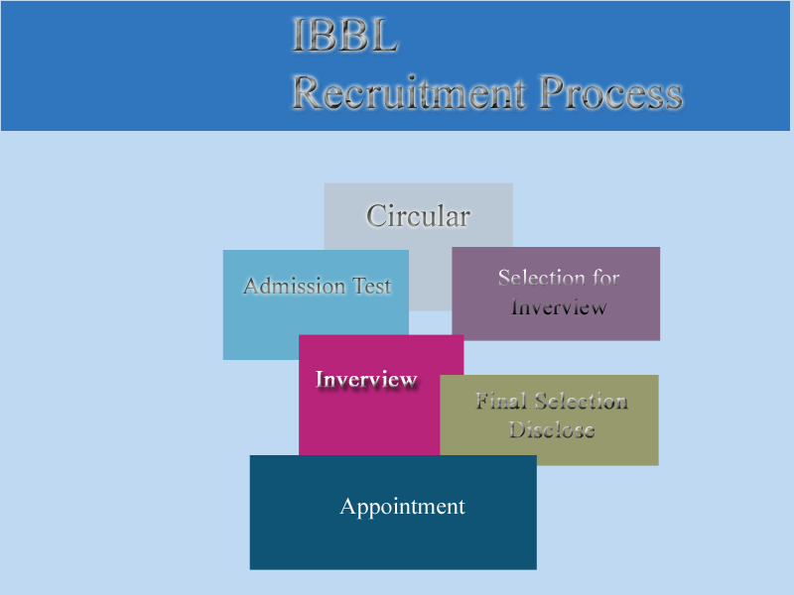

4.5.1 Initial Screening:
The process starts with initial screening- choosing from the CV’s that fulfil the specific requirements. After a vacancy is announced and CV’s are already collect from different sources.

4.5.2 Written Employment Test:
After the initial screening, next step is the written employment test. In IBBL, written test is applicable for assessment of all entry level positions. The written test is taken mostly to check the candidate’s knowledge on the subject matter for which he is to be taken and also to check his written communication skill.

4.5.3 Work Sample Test:
Work sample tests require the applicant to perform tasks that are actually a part of the work required on the job. The tests are carefully conducted by the IT Division to include the major job functions.

4.5.4 The Interview:
For entry level positions, the next step of the process is the comprehensive interview that is usually conducted by a panel comprising of the Managing Director, Additional Managing Director, Deputy Managing Director and The Head of Human Resources Division. The interviews are always unstructured and each interviewer grades the candidate based on motivational level, communication skill, confidence, how he handles difficulties etc.

4.4.5 Salary Negotiation:
For the entry level positions, the salary is fixed. For other lateral entries, the Head of HRD negotiates the salary with the suitable candidate whenever necessary. The negotiation for suitable designation also takes place during this phase.

4.5.6 Job Offer:
The Head of HRD offers the job to the selected candidate after the final approval is obtained. The Managing Director is the sole signing authority of any appointment letter up to Additional Managing Director, Non-Management and all contractual employees if any other person is authorized for special reason. The Chairman of the Board of Directors is the sole authority to sign appointment letter for the post of Managing Director.

4.5.7 Reference Check:
Reference checks allow obtaining information and opinions regarding the person’s character, quality of the work and suitability for the position. It is an opportunity to validate the information received from the candidate via their resume and the interview. Speaking to the candidate’s manager or other people whom they have worked with should also check internal candidates. The opinion of a referee who has worked can for an extended period is likely to be more accurate than the assessment from one to two hours of interviewing.

4.5.8 Pre-joining document:
The following documents are obtained from the candidate prior to his joining. Officers of Human Resource Division are responsible for the following documents:
- Five Years Bond on part of the MPO.
- Medical Report from the Designated Hospital.
- Verification of all certificates.
- Copy of Last Education and Professional certificates.
- Filled up setup papers (Service Recodes, Declaration of Fidelity, Employee Profile)
- Six copy passport size photo.

4.5.9 Provision Period:
Finally those employees who don’t have any experience must have to go from a privation period. It’s for a short span of time like for 2/3 month. But that who are skilled and have experience doesn’t need it.

4.6 The summary of Recruitment & Selection Process of IBBL:

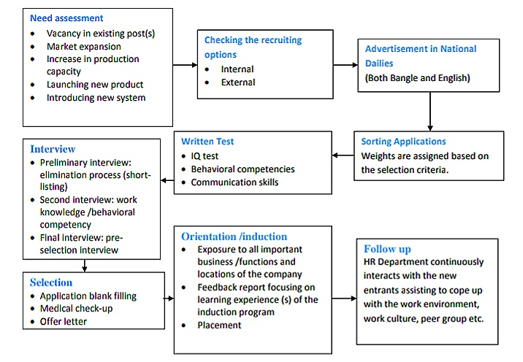

Chapter 5
Analysis, Findings, Recommendation & Conclusion

5.1 SWOT Analysis
The full form SWOT is strength, weakness, opportunity and threats. Every Business suffers from weakness and threats. SWOT analysis help to uncover opportunities that are well placed to exploit. And by understanding weakness of business organization can manage an eliminate threats that would otherwise catch the organization unaware.

Islami banks Limited’s SWOT analysis are given below:

a. Strengths:
- Good Management
- Numerous training program
- Active, energetic and high skilled team members
- Friendly working Environment
- Strong Financial position
- Goodwill, strong social position
- Good cooperation between employees.

b. Weakness:
- Lack of experienced employees in junior level management
- Mismanagement/ miscommunication between departments
- Violation of rules are not highly punishable
- Regular training arrangements makes the service slow
- Political negative issues.

c. Opportunities:
- Update employees with new knowledge& skills
- Growth of Sales Volume
- Different types of product class like from poultry to ice-cream
- Advanced use of technology
- Sophisticated & very informative website

d. Threats:
- Budget reduction for training program
- Competitors lucrative offers
- Deficit of well qualified peoples
- Violation of policies by the top level management

5.2 Questionnaire Analysis:

1) IBBL clearly defines about job description & specification in job advertisement to get right HR in right place.
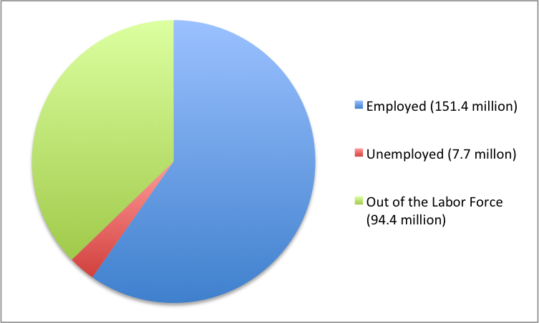
Now the first question I asked about their job description & job specification. 53.3% employees do agree & 20% strongly agree with the statement that when IBBL distributes a job circular the job description & job specification are on it properly.
2) IBBL propagates idea like “come grow with us” & “learning environment” to increase their HR performance.
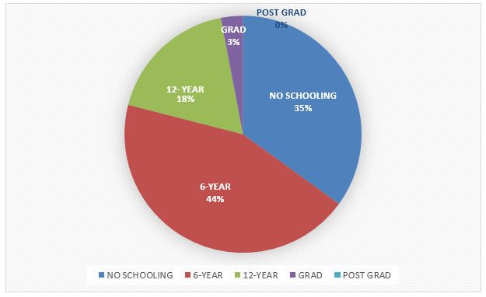

Islami bank always patronage new employees. They are willing to provide a learning environment so that employees might not feel that they are like other machines perhaps they will explore & learn something new every day that’s why more than 50% employees do agree on this statement.
3) IBBL HR acts like act as consultant to enhance the quality of applicant pre screening process to get highly qualified employees.
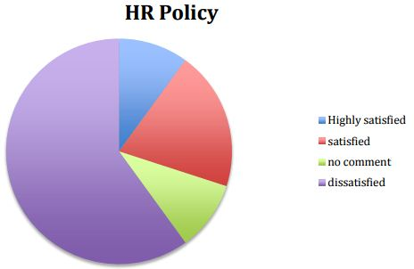

Learning and development is a part of HR now-a-days, but if the term consultant comes that it’s not related with learning. Sometimes employees might feel that in pre-screening process the authority act as consultant but that just not always happen. So here most employees are in the neutral position.
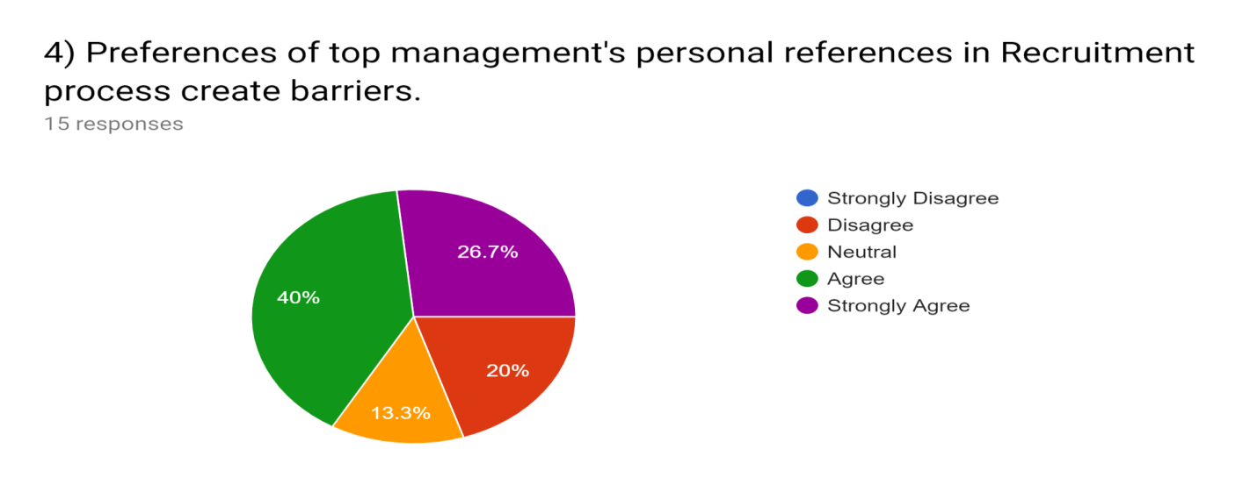
Biasness is very much unethical in every organization. If I talk about my survey than here 40% agreed & 26.7% strongly agreed that the top management put their personal reference in recruitment process. Which will definite creates barrier.
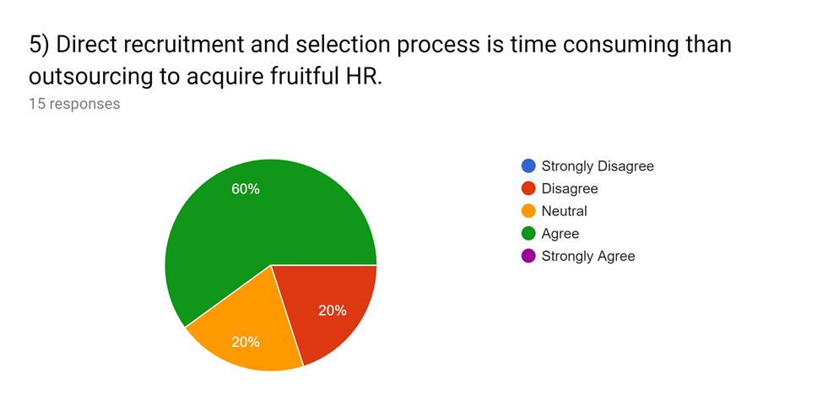
Direct recruitment process must have to gone through a lot of procedures. Each and every step must have design & perform sophisticatedly, which is very time consuming. In other case if employees can be recruited from outsourcing that it needs very little time to find out high skilled employees.
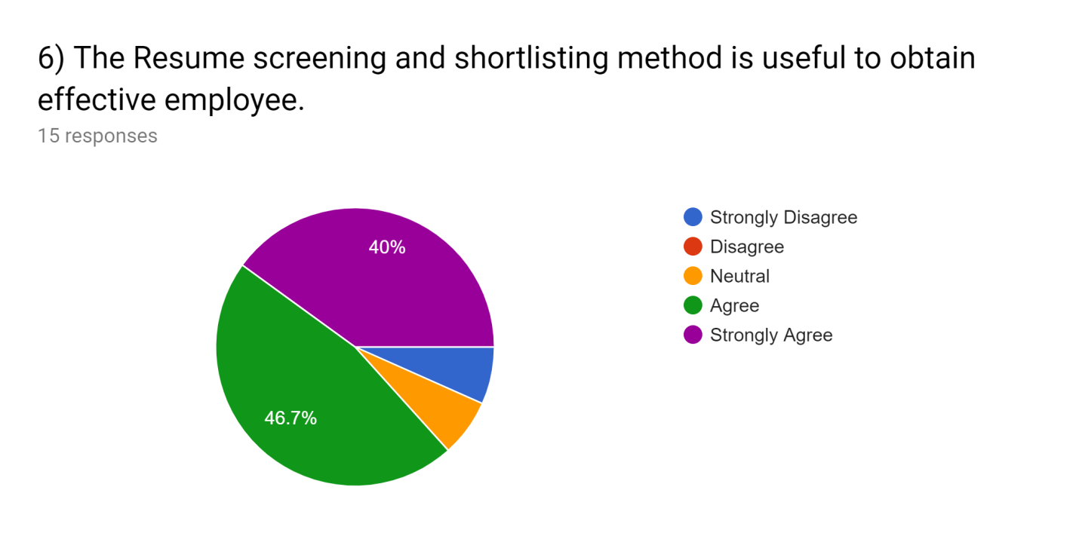
It is very obvious that in a re-known organization like Islami bank, lots of Co’s are dropped every day in job purpose. The HR teams try from their heart & soul to find out the best of best among those applicants. That’s why the % of agree & strongly agree is very high in this point.
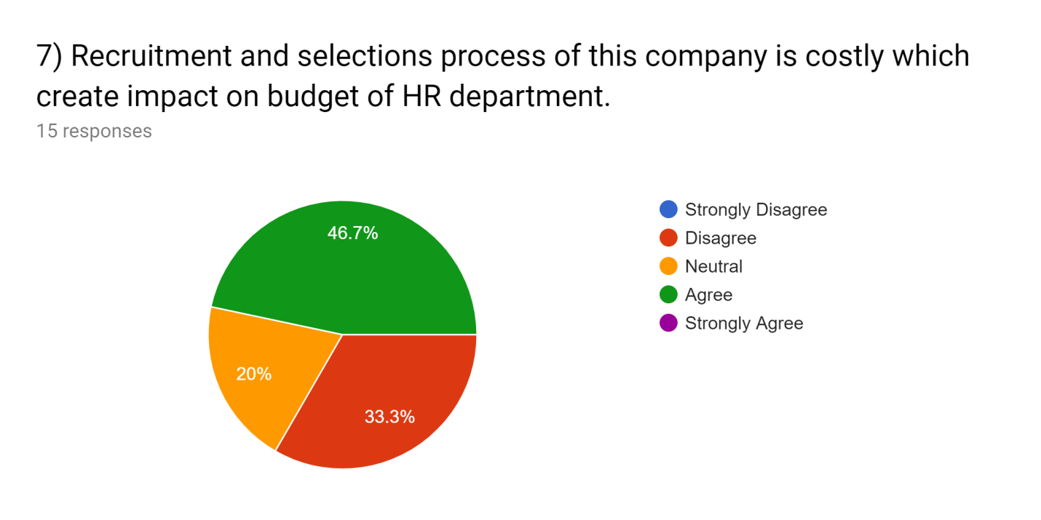
Recruitment & selection process need some financial support like to create an interview session there have to be some light snacks, written examination needs paper, pen etc. There is also medical check-up system, provision period system. So by considering this type of factors 46.7% of the employees agree on this point. But sometimes the factors can be ignored or can be taken so simply that it might look requirement system doesn’t cost much that’s why 33.3% disagree with the statement.
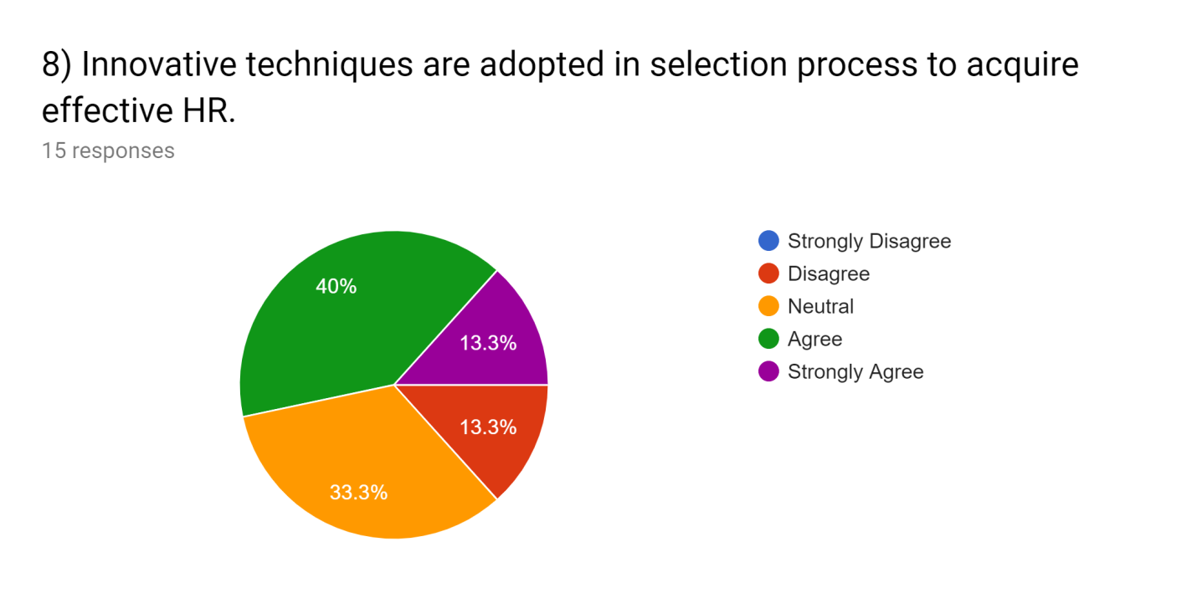
Recruitment and selection process is continuing from the very beginning of the industrialization. It is changing day by day, new technologies and innovation are introducing in it. Some organizations bring so much unique or innovative methods. Islami bank is also trying to adopt unique process but not with too much updated version.
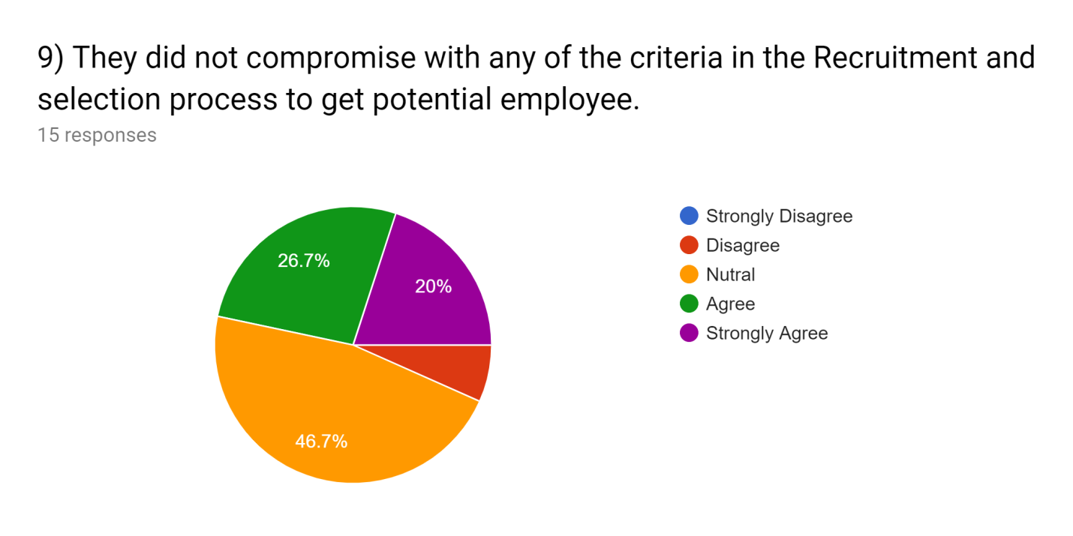
No human being in this universe is 100% perfect. Every person has some lacking. So in the point of view of this statement the employees of IBBL answer neutrally. Because sometimes they might compromise in some case sometime the might not.

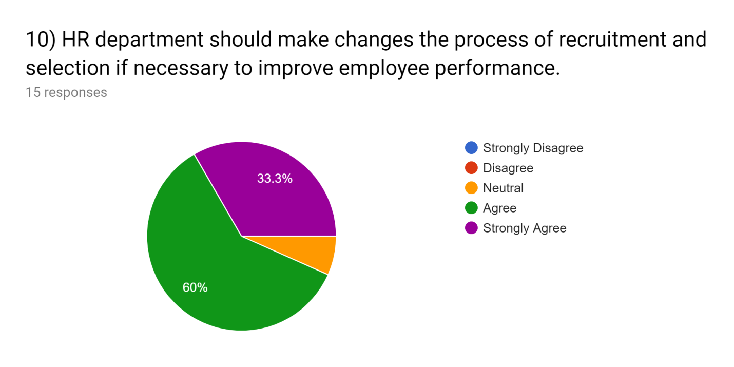
Based on this statement majority of the employees 60% agreed & 33.3% strongly agreed. Changes is a part of peoples life so if an organization want to achieve the highest position it must have to change its policies over time to adjust with the situation.
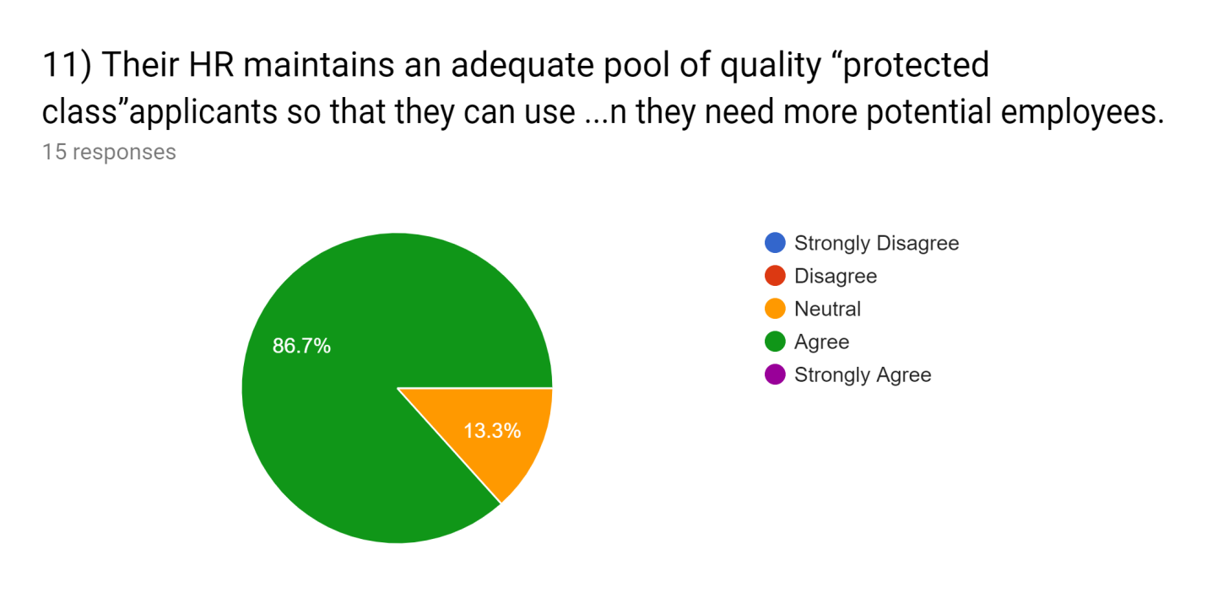
Their HR maintains an adequate pool of quality in this statement 86.7% employees agreed. None of the employee disagreed on this point. As IBBL is a big organization so they always try to maintain a protected class so they can maintain an adequate pool.
12) IBBL plays an affirmative action in the selection process to obtaion productive emlployees.
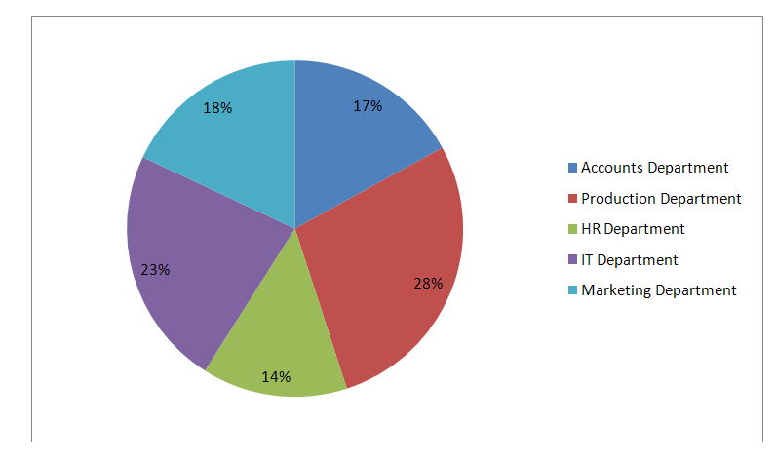

Islami bank always looks for productive employees. But due to some reasons sometimes the recruitment process might not obtain the expected level. For that reason 46.7% employees here are confused about it that’s why more person neutral with this statement.
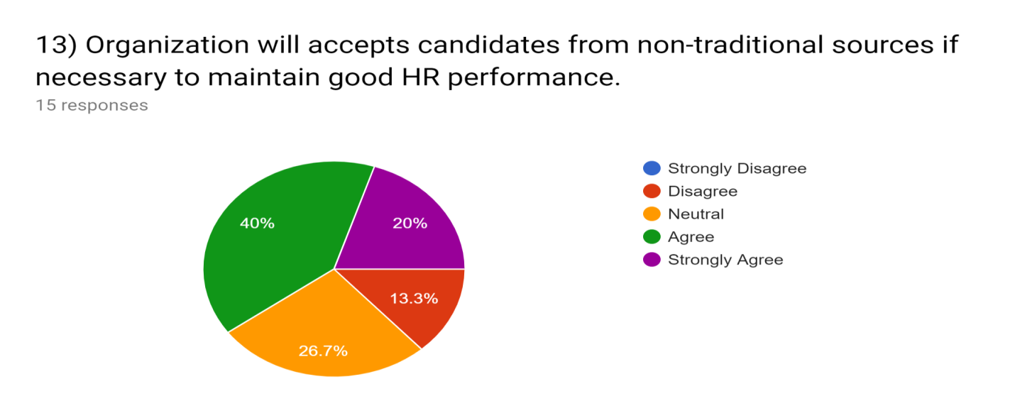
This statement came with a difference or mix type of answer. If IBBL gets opportunities than some think they will surely accept employees from non-traditional sources, some are in natural position.

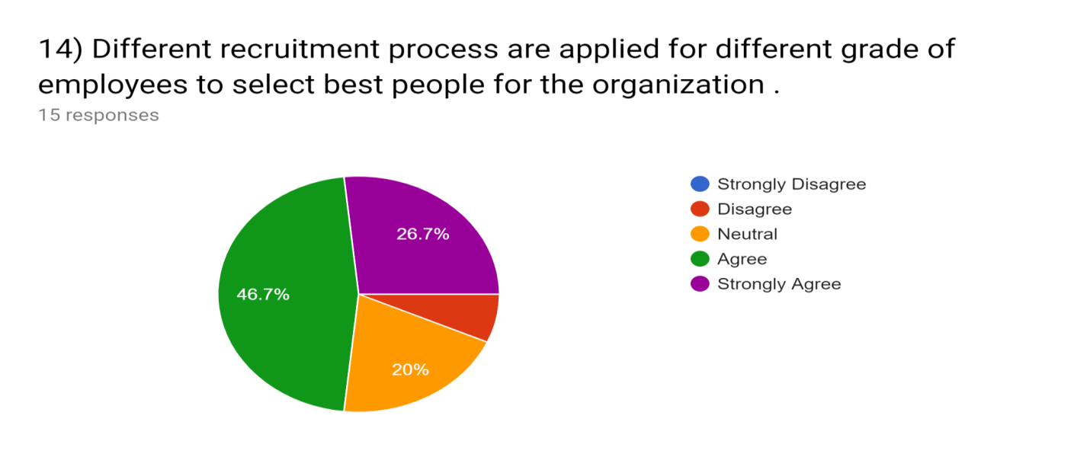
In an organization there is a hierarchy from top to bottom. To hire a top level employee the recruitment & selection process will be different than selecting a mid-level or low level employee. So for that reason different process are applied in their selection process for different Limited. 46.7% employees do agree on this. 20% neutral & only 6% disagree on this issue.

5.3 Recommendation
- Recruit efficient manpower in HRD to reduce the work pressure.
- In the Job advertisement the HR department of IBBL can mention their pay structure.
- The company can go for campus selection so that highly educated fresheners could get a chance
- Provide some motivational or recreational activities
- Online recruitment system should have to be more updated.
- HR recruitment and selection policy should be designed to attract more efficient workers for the organization for improvements.
- The organization should focus on their internal political issues; need to solve this problem because it might hamper their image.

5.4 Conclusion:
In modern time business is changing rapidly by the passing of time. The competition is getting wider and wider. So to match up with this competitive changing world every organization must have to apply its own unique theories, ideas & process. I have done my internship into a well-known organization of Bangladesh named “ISLAMI BANK BANGLADESH LIMITED”. As my major is in HR so I joined in there HR team as an intern for 3 months’ time period. The main focus of my intern report is “The Recruitment & Selection Process of Islami banks Limited”. So with the knowledge I have acquire through the whole BBA degree and with the practical corporate working experience I have prepared this report. In this report I have tried my best to identify the selection and recruitment process of IBBL followed by the process they use. As the competitors are flourishing day by day the developing situation is becoming critical. So to reduce this type of problems or to maintain a good position in market the company should give more emphasize on their product and service quality. As well as they should recruit more educated, energetic, skilled employees than their competitors. As we all know humans are the main asset of an organization.

5.5References
- https://www.google.com/search?client=opera&q=islami+bank+foundation+established&sourceid=opera&ie=UTF-8&oe=UTF-
- https://www.researchgate.net/publication/268210664_A_Study_On_Recruitment_Selection_Process_With_Reference
- https://www.toppr.com/guides/business-management-and-entrepreneurship/human-resource-management/selection-process/
- https://www.ukessays.com/essays/business/literature-review-recruitment-and-selection-process-business-essay.php
- Gareth Roberts – Recruitment & Selection
- Eric Garner- Recruitment & selection.

5.6 Appendix:

Particular | Strongly  Disagree  (1) |  | Disagree  (2) |  | Neutral  (3) |  | Agree  (4) |  | Strongly  Agree  (5)
Particular |  | % |  | % |  | % |  | % |  | %
1) “Islami bank” clearly defines job description and specification in job advertisement to get right HR at right place. | 2 | 10% | 0 | 0% | 2 | 10% | 8 | 40% | 3 | 15%
2) “Islami bank” propagate ideas like “Come Grow with us” & “Learning Environment” to increase their HR performance. | 1 | 5% | 1 | 5% | 1 | 5% | 8 | 40% | 4 | 20%
3) “Islami bank’s” HR Team act as a consultant to enhance the quality of applicant pre-screening process to get highly qualified employees. | 0 | 0% | 1 | 5% | 7 | 35% | 4 | 20% | 3 | 15%
4) Preferences of top managements personal references in Recruitment process creates barrier. | 0 | 0% | 3 | 15% | 2 | 10% | 7 | 35% | 3 | 15%
5) Direct recruitment & selection process is time consuming than outsourcing to acquire fruitful HR | 0 | 0% | 3 | 15% | 3 | 15% | 9 | 45% | 0 | 0%
6) The Resume screening and short listing method is useful to obtain effective employee. | 1 | 5% | 0 | 0% | 1 | 5% | 7 | 35% | 6 | 30%
7) Recruitment& selection process of this company is costly which creates impact on budget of HR department | 0 | 0% | 5 | 25% | 3 | 15% | 7 | 35% | 0 | 0%
8) Innovative techniques are adopted in selection process to acquire effective HR. | 0 | 0% | 2 | 10% | 5 | 25% | 6 | 30% | 2 | 10%
9) They did not comprise with any of the criteria in the recruitment and selection process to get potential employee. | 0 | 0% | 1 | 5% | 6 | 30% | 5 | 25% | 3 | 15%
10) HR Department should make changes the process of recruitment and selection if necessary to improve employee performance. | 0 | 0% | 0 | 0% | 1 | 5% | 9 | 45% | 5 | 25%
11) Their HR maintains an adequate pool of quality “protected Class” applicants so that they can use it when they need more potential employees. | 0 | 0% | 0 | 0% | 2 | 10% | 13 | 65% | 0 | 0%
12)“Islami banks” plays an affirmative action in the selection process to obtain productive employee. | 0 | 0% | 1 | 5% | 7 | 35% | 5 | 25% | 2 | 10%
13)Organization will accepts candidates from non-traditional sources if necessary to maintain good HR performance | 0 | 0% | 2 | 10% | 4 | 20% | 6 | 30% | 3 | 15%
14) Different recruitment process are applied for different grade of employees to select best people for the organization. | 0 | 0% | 1 | 5% | 3 | 15% | 7 | 35% | 4 | 20%
