

AN INTERNSHIP ON

THE PERFORMANCE APPRAISAL SYSTEM AT KAZI FARMS GROUP

27thDecember 2019
UNITED INTERNATIONAL UNIVERSITY
DHAKA, BANGLADESH
AN INTERNSHIP ON

THE PERFORMANCE APPRAISAL SYSTEM AT KAZI FARMS GROUP

SUPERVISED BY
NasrinAkter
Assistant Professor
School of Business and Economics
United International University

PREPARED BY
SaymaAkter
ID: 111143245
Bachelors of Business Administration
United International University
UNITED INTERNATIONAL UNIVERSITY

Letter of Transmittal
27th December 2019
To
Nasrin Akter
Assistant Professor
Faculty of Business and Economics
United International University
Subject: Submission of Internship Report on Performance Appraisal: A study on Kazi Farms Group.
Dear Madam,
I am here by submitting my Internship Report, which is part of the BBA Program Curriculum. It is great achievement to work under your supervision.This report is based on “Performance Appraisal system at Kazi Farms Group”. I have got the opportunity to work in Kazi Farms Group in Human Resource Department for twelve weeks, under the supervision of Alea Afroz, Senior Executive Manager, HR Department.
Throughout the internship program, I had learned several things at the same time period. First, the program taught me to practice my job responsibilities as an intern in a well-reputed organization of Bangladesh. Secondly, the program required the report to achieve the BBA degree, where I have to apply all my Human Resource Management learnings that I have learned theoretically in my university courses.
I want to ensure that the information given in the report is true and no information is directly copied from any resources.
I would be very grateful if you kindly accept my internship report and provide valuable comments. It would be a great honour for me if you found this report as a clear overview of my title relevant problem.
Sincerely Yours

---------------------
SaymaAkter
ID: 111143245
Bachelors of Business Administration
United International University

Acknowledgment

All praise to Almighty Allah, who gives me strength to complete this report. In the process of doing this research paper me, Sayma Akter would like to pay my gratitude and respect to some person for their kind co-operation to complete my internship report on Exploring Marketing Mix of the Brands: A Study on Kazi Farm Group.
First and foremost, I owe a debt of gratitude to my course instructor Nasrin Akter, Assistant Professor, School of Business & Economics, United International University for his benefiting guidance and encouragement, astute advice and endless endurance throughout the semester without which this paper have not been flourishing. Secondly, I would also like to thank, Mrs. Alea Afroz, Senior Manager of Human Resource Department, Kazi Farm Group Limited and my official supervisor for helping me to prepare this report with adequate and collect information.
Finally, I would like to express my gratitude to Sabrina Iqbal Nish and Amita Tawhid Uzma, executives, KFG for helping me through a lots of information on Kazi Farms Group so that I can prepare my study accurately.
In addition, the report might never have been completed without the necessary academic knowledge, assistance of reference books, web pages and some practical knowledge, assistance of The Kazi Farms Group Officials, and what is worth mentioning the sincere and enthusiastic cooperation from the course faculty. I would like to thank all those, especially the employees of the Office; who have assisted me to prepare the report, and special thanks to my course instructor, I will remain grateful to all of them.

Executive Summary

The internship report is prepared to describe the performance evaluation system or techniques that are performed by the Kazi Farms Group. The beginning of the eights chapter there is a introductory part that defines the internship program and the internship report information. Later, the literature review chapters discuss the basic performance related concepts to make these concepts easier to the reader of this report. Then, there is a complete overview of Kazi Farms Group as an organization. Later, the performance appraisal procedures of Kazi Farm is discussed, where we can see, Kazi Farm actually use two methods to evaluate its employee’s performance. The name of these two performance appraisal systems are behavioural performance appraisal system and functional performance appraisal system. There is also a questionnaire section, where responses are shown using graphical charts. Finally, there are the findings and recommendations are added according to my academic learnings of performance appraisal systems so that the Kazi Farm Group may improve their lacking in their current system.

Table of Contents
Chapter One: Introduction
1.1 Background of the report 2
1.2 Objectives of the study 2
1.2.1 Primary Objectives 2
1.2.2 Specific Objectives 2
1.3 Scope of the study 3
1.4 Methodology of the report 3
1.4.1 Primary data sources 3
1.4.2 Secondary data sources: 3
1.5 Limitations of the study: 4
Chapter Two: Internship Experience
2.1 Internship Experience 6
2.2 Job Responsibility: 7
Chapter Three: Literature Review
3.1 Performance Appraisal Definition 9
3.2 Core objective of performance evaluation 10
3.2.1 From the organizational perspective 10
3.2.2 From the Employee & Staff perspective 10
3.3 Performance Evaluation Methods 11
3.3.1 Essay method 11
3.3.2 Rating Scale 11
3.3.3 Management By Objectives (MBO) – A result oriented method 12
I. Disadvantages of MBO 12
II. Advantages of MBO 13
3.4 Advantages and disadvantages of using Performance Appraisal 13
3.4.1 Disadvantages of performance evaluation 13
3.4.2 Benefits of performance evaluation 14
Chapter Four: Company Profile of Kazi Farm Group
4.1 Company Profile of Kazi Farms Group 17
4.1.1 Mission 18
4.1.2 Vision 18
4.1.3 Values 18
4.1.4 Target Market 18
4.2 Current Product & Services of Kazi Farms Limited 18
4.3 Products of Kazi Farms Group 19
a. Feed 19
b. The layer of chicks and table eggs 19
c. Parents Broiler and broiler’s chicks 20
4.4 Kazi Food Industries 20
4.4.1 Kazi Farm Food 20
4.4.2 ZaNZee - Ice Cream of Kazi Farm 20
4.4.3 Kazi Media 21
4.4.4 Sysnova 21
Chapter Five: Performance Appraisal System of Kazi Farm
5.1 Performance Appraisal System of Kazi Farms 23
5.2 Performance Standards of Kazi Farm 23
I. Behavioral performance system 23
II. Functional performance system 24
5.3 Performance Evaluation Policy 24
5.3.1 Objectives of performance evaluation 24
5.4 Different categories of performance. 26
5.5 Example of Kazi Farm’s Performance Appraisal form 26
6.1 Analysis of Employee Opinion 33
Chapter Seven: Findings of the report
7.1 Findings of the Report 40
Chapter Eight: Recommendations and Conclusion
8.1 Recommendations for Kazi Farm Group 42
8.2 Conclusion 43
Reference

Chapter One: Introduction of the Study

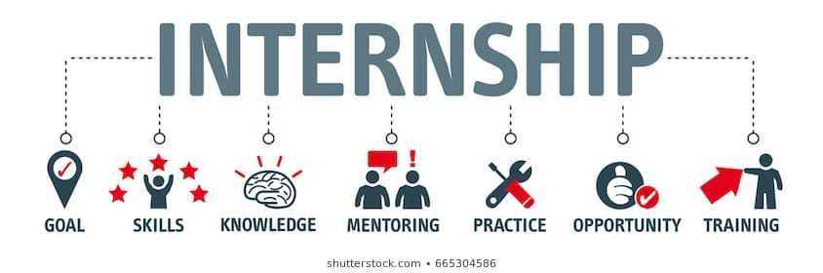

1.1 Background of the report
The internship program at the United International University is an under-graduate requirement for BBA students to achieve the BBA certificate. The main objective of an internship is to expose the student to the world of work. As an intern, the main challenge was to translate theoretical concepts into a real experience.

The internship program and studies have the following objectives:
- To make students capable to compare the real-world scenario with the academic knowledge learned at the United International University.
- To acquire detailed knowledge of current corporate responsibilities.
- To fully comply with the requirements of the BBA program.
- To discover the real world of business.

This internship report is the outcome of a three-month internship program conducted in the Kazi Farms group and is submitted as it is a pre-condition to achieving the certificate of the BBA program from United International University. Therefore, I have prepared and presented this report on "the Performance Appraisal system at Kazi Farms Group" that explains the standards KFG utilizes to measure the performance of its employees and staff inside the organization. Furthermore, the study also contains the general overview of Kazi Farms Group in Bangladesh, a general description of its products and services and so on.

1.2 Objectives of the study
The aims of the report are declared as objectives that defines a reader of the report the analysis that are specifically going to be conducted through the report:

1.2.1 Primary Objectives
The submission of the internship report within the internship period is a pre-requirement to obtain a BBA degree from United International University. Therefore, the study is conducted to meet the requirements.

1.2.2 Specific Objectives
The Internship report on The Performance Appraisal system at Kazi Farms Group especially going to cover the following aspects:
- To provide a general company profile of the Kazi Farms Group.
- To describe the employee performance appraisal system in Kazi Farms Group.
- To conceptualize how performance appraisal can motivate employees and reduce employee turnover.
- To analyze how this contributes to the success of the organization.

1.3 Scope of the study
I tried to cover the Kazi Farms performance evaluation process. It took about three months. There are different levels of the performance evaluation process. Due to time constraints and confidentiality, I was unable to cover entire areas. I followed the performance evaluation process below the management level and some intermediate level management positions. Data I have collected from primary and secondary sources.

1.4 Methodology of the report
To achieve the specific objectives of this study, data were collected using primary and secondary sources. To collect the specific performance appraisal based data sources, I communicated directly with the respective HR manager of the department, direct interaction with the employees and the opinion of the employees collected through a closed speaker. I used a random sampling technique to collect my samples and use the graphs to visualize them.
To collect secondary data, I have analyzed the Kazi Farms Group’s annual reports, performance evaluation reports form its website, and also collected several Kazi Farms newsletters, different types of records and brochures.

1.4.1 Primary data sources
• Through personal observation of human resource activities.
• Through direct conversation with the respective department managers.
• Through face-to-face conversation with the employee.
• Through employee opinions collected through questions.

1.4.2 Secondary data sources:
• Through Kazi Farms Group's annual performance evaluation forms.
• Various Kazi Farms Group brochures and annual reports.
• Through the Kazi Farms Group website.
• Several Kazi Farms Limited newsletters.

1.5 Limitations of the study:
Kazi Farm Group is a large organization with several departments involving in it and it is quite impossible to deal with all the activities during the internship period. And for this reason, I have faced various kinds of difficulties that are listed in the following as limitations.

- Short time Period: It is difficult to create such an extensive report based on information in a short period of time.
- Several performance appraisal technics implemented: Since the Farm constantly changes its operational system from time to time, it will be difficult to verify the true performance of employees each time.
- Busy working personnel: Few officers sometimes felt disturbed while doing their work. Sometimes they didn't want to look at us in front of their desks.
- Secrecy and data confidentiality: The farm's policy of not disclosing certain data and information for obvious reasons, which would have been very useful for the report.
- Increasing business competition matters: Performance evaluation is a very sensitive issue. So much information has not been revealed as much secret.

Chapter two: Internship Roles and Responsibilities



2.1 Internship Experience
I had joined Kazi Farms on 22th May 2019 and my internship end 8th September 2019. In this three months, I worked at the HR Department on the Development Team. I was working HR department in the head office of Kazi Farms Group as an intern. As an intern I was given all the liberty to work freely in Kazi Farms Human Resource Department. I was given specific tasks periodically which were important for the department.

In HRD there are three teams working together.

The first one is the HR Operation Team. The operation team maintains all the disciplinary activity, payroll activity, policymaking, conducting employee exit interviews, checking employees' personnel file documents and given employees necessary things like SIM, laptops, mobile modem and some other office equipment.

The second one is the Talent Management and Organization Development Team. Work of the development team is making employees goal sheet, making the organizational chart of the organization, succession planning of the employees, training, and development, working on performance appraisals and performance management, Task calculation of different departments, Process development, calculate employee’s behavioural and functional performance and update their working status on database.

The third one is the Recruitment Team. All recruitment related activities like conducting interview question paper of candidate, creating data of interview candidate, data entries of selected candidate for the interview and those who are recruited. Maintaining and updating database of employees, file processing, updating personal files, checking the documents of personal files, checking the reference and sending emails, making phone calls to customers, candidates. Maintaining external resumes and preparing final settlement data are the activity performed.

Kazi Farms has its own ERP (Enterprise Resource Planning) to maintain all kinds of HR activities. In each and every activity they entered on ERP and its final process.

2.2 Job Responsibility:
• Uploaded employee goal sheet on the ERP system.
• Made job descriptions for employees and upload them to the ERP system.
• Gave input in ERP employee's performance rating.
• Maintain Bale-curve and prepare a summary report.
• Upload peon performance appraisal in ACR.

Chapter Three: Literature Review

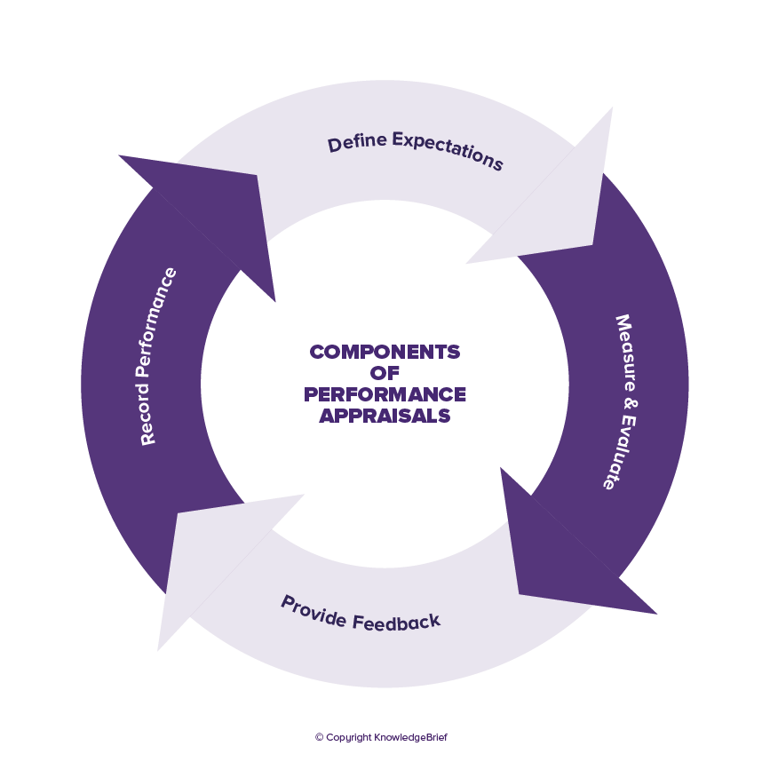

3.1 Performance Appraisal Definition
The well-known management expert, McGregor has defined the performance appraisal system as a formal performance appraisal plan, the main purpose of which is to meet the needs of the organization and provide a systematic judgment in support of wage increases, transfers, downgrades or layoffs. The assessments show employee performance and the changes needed for their behaviors, skills, and competences. Performance evaluation is the process by which leaders advise employees on how to perform organizational tasks. This change can generate motivation and professional ethics. Without a structured evaluation system, it is impossible to guarantee legal, fair and accurate judgments, regardless of whether employees' wages are reasonable. This process is closely related to the material results. If an employee's performance is deemed unsatisfactory, wages are deducted as a penalty. On the other hand, if your performance is better than your manager's expectations, then the reward will increase. This process gives a feeling of improvement or allows people to continue to function well. Sometimes this basic system has achieved the desired results. But most of the time it has failed. The original motivational researchers found that compensation was not the only factor to improve performance, but the motivation was also an important factor. We have found that employees can be paid the same way when looking for the same working ability, but at a different level of performance than motivated employees. These observations have been confirmed in empirical studies. Yes, payment rates are important, but that's not the only factor that influences employee performance.

Performance evaluation can be defined as a formal interaction between subordinates and supervisors in modern times, usually in the form of regular (annual or semi-annual) interviews, during which the performance of subordinates is checked. Discuss to identify improvements and skills development. In many (but not all) organizations, evaluation results are used directly or indirectly to determine the outcome of a prize. That is, the results of the evaluation are used to determine the best actors who should receive weaknesses and strengths, as well as most of the available raises, bonuses, and promotion opportunities (Goel, 2008). Similarly, the results of the evaluation are used to identify those who have poor performance, who may need some type of advice or who, in extreme cases, must be downgraded, fired or lowered. (Organizations should be aware of their country's laws, which may limit their ability to lay off employees or reduce wages.) If performance appraisal is used appropriately: the allocation and rationality of rewards and fines, this is a very uncertain and controversial issue.

3.2 Core objective of performance evaluation
An effective performance evaluation system consists of two basic systems that work together: an evaluation system and a feedback system. The main objective of the evaluation system is to identify performance gaps. This gap is a deficit that occurs when performance does not meet acceptable standards set by the organization. The main objective of the feedback system is to inform employees about the quality of performance. (However, the flow of information is not the only unidirectional flow. Experts also receive feedback from employees on labor issues, etc. One of the best ways to evaluate the purpose of the performance evaluation is to verify the performance from different angles. These two points of view are: organizations perspectives & employees' perspectives (cash, 1993).

3.2.1 From the organizational perspective
From an organizational perspective, one of the main reasons for having a performance evaluation system is to develop and support the principles of responsibility.
From the experiences of lots years, researchers have known that the main cause of organizational failure is "the unification of responsibility and responsibility." Bad location occurs when employees assume responsibilities and obligations but are not responsible for how those responsibilities and obligations are carried out (Cash, 1993). It often happens that different people or work units seem to play overlapping roles.
The overlap allows (in fact, actively encourages) that each individual or business unit "transfer money" to others. In the end, nobody is responsible for anything in a severely displaced system. In this case, the principle of responsibility has been completely destroyed. Organizational failure is the only possible outcome (Cash, 1993). In situations where non-alignment is not serious, organizations can continue to function, albeit inefficiently. Like a poorly designed or poorly regulated engine, a poorly located organization may work, but it is slow, expensive and unreliable. One of the main objectives of performance evaluation is to train people. The objective is to unify responsibility and responsibility at all organizational levels.

3.2.2 From the Employee & Staff perspective
From the employee's perspective, the objective of the performance evaluation is fourfold:
(1) Tell me how I do it
(2) Tell me what you want me to do
(3) Help me improve my performance
(4) Reward me for your outstanding performance.

3.3 Performance Evaluation Methods
According to a historical study of Locher and Teel (1977), the three most used performance evaluations are found that works successfully to evaluate the employee's performance. They are:
- Rating scales (56%)
- Test methods (25%) e
- Results-based methods or MBO (13%).
Some performance evaluation techniques have been extensively studied and some have produced better results than others.

3.3.1 Essay method
In adopting the essay method, the expert prepared a written statement on the employee to be evaluated. The statement usually focuses on describing specific job performance's strengths and weaknesses. It also proposes corrective measures to correct the problems encountered (Harry, 2007). The declarations can be drafted and reviewed by the Human Resource manager individually or in collaboration with experts.

3.3.2 Rating Scale
A performance rating scale is used in performance management systems to indicate the level of performance of employees. These scales are commonly used because they provide quantitative assessments, are relatively easy to manage, and help to distinguish employees. While no consensus has been reached on the most effective specific scale, most of the performance appraisal scales used by employers have common elements.

The rating scale can be a number (like 3, 4, 5) or a letter (like c, d, e), and the number or letter corresponds to an adjective, like "5 = excellent" or "c = satisfactory". Tables can also be descriptive. For example, a scale element may have "unacceptable performance", described as "not meeting basic requirements and objectives". Sales that provide positive information are becoming more and more popular. For example, scales Categories such as "acceptable", "effective" and "very effective" can be included.

3.3.3 Management By Objectives (MBO) – A result oriented method
In the 1950s, the famous management theorist Peter Drucker first widely supported the use of management objectives. The method to evaluate MBO performance (Management by Objectives) is results-oriented. That is, they try to measure the performance of employees by verifying how well they are fulfilling their scheduled work objectives. Often, the objectives are set by supervisors and subordinates. An example of a sales manager's objective could be to increase total monthly sales to $ 250,000 by June 30. When a goal is reached, employees are generally required to perform a self-examination; that is, to determine the skills necessary to achieve the goal. Usually, they do not depend on others to identify and explain their strengths and weaknesses. They must monitor their development and progress.

Disadvantages of MBO
- MBO performance evaluation methods can give employees a satisfactory sense of autonomy and results. Unfortunately, they can lead to unrealistic expectations of what can reasonably be achieved.

- Supervisors and subordinates must have excellent "reality check" skills to use MBO assessment methods. They will need these skills in the initial phase of setting goals and in self-control and self-control.

- Obviously, the obvious answer is to make the goal more fluid and efficient. However, the price of fluidity is a lack of clarity. Variable goals can cause confusion for employees. It can distort the target, hide or prove performance failures

- One of the advantages of the MBO method is that the objective of clear objectives comes from a series of clearly established objectives. But it could also be the source of weakness. It is clear that modern organizations must be flexible to survive. In essence, the objectives are often rigid.

- Unfortunately, research has repeatedly shown that humans often lack the necessary skills to perform "reality checks." These skills are also not easily disseminated through training. Reality itself is a strong personal experience that is affected by various forms of perceptual bias.

Advantages of MBO

- The MBO method is not a hypothetical feature but instead focuses on the actual results.

- The MBO approach recognizes the fact that it is difficult to carefully analyze all the complex and diverse elements that makeup employee performance.

- MBO advocates argue that employee performance cannot be divided into so many components because the engine that studies it can be disassembled. By bringing all the parts together, the performance can be observed and measured directly.

- The MBO approach solves some of the problems caused by the ability to reliably identify and measure the characteristics of the employees required for a successful job.

- The guiding principle of the MBO method is that direct results can be observed and the characteristics and attributes of employees must be guessed or inferred (which may or may not affect performance).

- If an employee meets or exceeds the established objectives, he is qualified for performance. Employees are judged based on actual results rather than their potential for success or people's subjective judgments about their abilities.

3.4 Advantages and disadvantages of using Performance Appraisal
Managers and employees often want to know why organizations are doing performance reviews. Anyone who accepts or receives performance reviews can say it's a waste of time as it has no effect. To understand performance appraisal clearly one may know the advantages and disadvantages of it. Performance appraisal is an assessment of employee performance over a period of time. As a transcript, it shows a company's overall performance over the past year. The advantages and disadvantages of performance evaluation are described below.

3.4.1 Disadvantages of performance evaluation
- Subject to bias
Some managers may assess a person based on their overall impression. For example, even if he excels in one area, he can score high in all conditions. Prejudices of evaluators also affect the process. One can see these situations when you underestimate himself because of religion, appearance, gender, preferences, and race.

- Generalized trend error.
This happens when the manager assesses everyone in a narrow range because he thinks that the average level of all employees is the same.

- Contrast error.
However, performance reviews are always based on specific criteria and if a score is obtained without taking the criteria into account, contrast errors will occur. This can also happen if the appraiser observes the employee's current performance based on past performance.

- Regency and major errors.
Employee behavior at the start and end of the evaluation period can affect processing time. For example, the seller's performance varies from season to season and can sometimes be low and high.

- Serious or generous.
The evaluation requires that the evaluator draw objective conclusions about the performance of the employees.

- Sampling error.
This occurs when the assessor reaches a conclusion using a small part of the employee's work.

As a general rule, an assessment is only valid if it is followed by its competent authority. Otherwise, it will make no sense.

3.4.2 Benefits of performance evaluation
- Improve performance.
Performance appraisal focuses primarily on improving employee performance, as it analyzes and assesses factors of opportunity such as social processes and technology.

- Staff development.
Performance appraisal can determine who needs more training, as it provides information on the strengths and potentials and disadvantages of employees.

- Correct the faults.
The performance appraisal can identify staff shortages and suggest corrective measures to be taken.

- Professional growth.
The assessment can be used as an employee career planning and development tool, as it helps to prepare a SWOT analysis for each employee.

- Promotion.
The assessment helps management determine which employees will be promoted, transferred or rewarded.

- Motivation.
The assessment encourages employees to work harder.

Chapter Four: Organization Overview



4.1 Company Profile of Kazi Farms Group
Kazi Farms Limited was founded in 1996 as an imported egg farm. The following year he opened his mother's farm. In 2004, our grandparents' farm (GP) started production. It was 2004 when he first exported hatching eggs and adult chicks from Bangladesh. That year, our CEO, KaziZahedul Hasan, was named the best entrepreneur of the year by the Daily Star/DHL Business Awards. By playing direct role in advancement of Bangladesh, through agro-based industry, Kazi Farms Group, by this time has come up into discussions. Role of Kazi Farms in Poultry, chick production, rearing, processing and in production of Poultry and fish feeds is praised abroad also, crossing the boundaries of the country. Kazi Farms, biggest in the country for production of poultry chicks, produces more than 50 million broiler chicks a year. By this time, Kazi Farms accomplished the work of establishment of very big Poultry feed factory. This firm started work from mid-2005.More than 1000 employees and workers are working in different firms of this group. Behind enviable success of Kazi Farms Group, whose talent, labor, perspiration had been used upto the highest level; he is the Chairman of the Group, KaziZahidul Hassan. KaziZahidul Hassan is one of the entrepreneurs who came forward when in the decade of 80’s for the first time Poultry industry activities commenced in the country. Under his skilled leadership, firms of Kazi Farms developed facing various adversities. By overcoming various disasters of Poultry industry including onslaught of Bird flue, Kazi Farms ascended upto the peak of success. Though the poultry industry of the country is still dependent upon import of day old chicks, this group is exporting parent stock including hatching egg to overseas markets. Kazi Farms is the first firm, which exported hatching egg to Saudi Arabia for the first time. To enhance export activities, this group has plans to enhance quality and production capacity. At present in the countries of Southeast Asia, Kazi Farm Group is holding the market of 10 Million Dollar a year. As per opinion of KaziZahidul Hassan, Chairman of the group, Poultry sector of the country is a sector of infinite possibilities. In order to utilize the same alongside skilled manpower, attention should be given towards protection of domestic and international markets. For this reason uninterrupted supply of chicks, appropriate price of poultry and security should be ensured. At present high price of poultry feeds and low standard of medicines is forcing farmers to fall into risks. Due to rise of production costs of eggs and broilers in comparison to the production costs, farmers are losing the capacity to survive during any mishap. On the other hand due to lack of dependable source of capital on different needs many farmers are being trapped by the usury of the usurers.

4.1.1 Mission
Kazi Farms Kitchen's mission is to "provide consumers with innovative, high-quality food products at an affordable price".

4.1.2 Vision
Kazi Farms Kitchen's vision is "to be one of the most trusted and reputable consumer food companies in Bangladesh".

4.1.3 Values
Everyone at Kazi Farms Kitchen appreciates the following philosophy:
- Kazi Farms Group believes in rapid progress.
- Kazi Farms Group believes in quality.
- Kazi Farms Group believes in innovation.

4.1.4 Target Market
- Family with an average monthly income of Tk. 50,000 and more.
- Premium / Upper is a middle-upper segment of the business.
- Husbands and wives who are busy with their work.
- Family decision-makers and influencers
- Educated and quality-conscious people.
- Group of newlyweds
- Single-family

4.2 Current Product & Services of Kazi Farms Limited
Main 3 parts of Kazi Farms Group

Kazi Farms have different product and project. Their product is very populer an agreculture industry. Besides, this Kazi Farms already took a place in food industry Bangladesh” “Bellissim’’ and ‘’ZA & Zees’’ are their populer ice-cream. They are trying to introduce their new business to customer.
Projects of Kazi Farms Group | Products of Kazi Farms Group
- Corporate Office  - Farms  - Hatchery  - Sales Office  - Feed Mills  - Compost Plant  - Biogas Plants  - Felling Station  - Try Factory  - Slaughtering Plant | - Broiler Chicken  - Eggs  - Poultry Feed  - Daily old Chicks  - Fertilizer  - Frozen Food  - Ice-cream

4.3 Products of Kazi Farms Group

Feed
The Kazi Farms Group extended its activities to the production of poultry feed in 2006. In no time it became a market leader in terms of quality and volume. To ensure the quality of the food, Kazi Farms Group received technical assistance from Cargill USA and Buhler Switzerland for the creation of a commercial food factory.
The Gajaria food mill uses disinfectant mills at the forefront of Buhler technology in Switzerland, manufacturer of the best food equipment in the world. By eliminating any possible bacterial contamination of food, Buhler disinfectant mills ensure that poultry farmers suffer fewer disease outbreaks and achieve better results.

The layer of chicks and table eggs
Kazi Farms Group is also the distributor of brown and white Hy-line diapers in Bangladesh. Hy-line International is the world's oldest poultry farm and the first layer breeder. Commercial farms at Kazi Farms make it the largest commercial table egg producer in Bangladesh.

Parents Broiler and broiler’s chicks
Kazi Farms Group is the affiliate of the Bengali grandparents of Avigen Indian River and Cobb-Vantress, recognized as the best meat breeds in the world. The broilers of the Kazi Farms group are considered to be the best performing chicks on the domestic market and are sold at a higher price than other meat breeds.

4.4 Kazi Food Industries

4.4.1Kazi Farm Food
The Kazi Farms Kitchen brand sells a range of frozen products. According to international practice, since hens are not treated with antibiotics within 7 days of slaughter, all patients are guaranteed to be free of antibiotic residues. It is also guaranteed that these meats are produced from chickens raised in foods that are free of MBM (Meat and Bone Meal) according to European standards. Meat products are guaranteed to be free of MSG and nitrates, as we do not use any of these chemicals when preparing food. (Kazi Farm, 2016).

4.4.2 ZaNZee - Ice Cream of Kazi Farm
Kazi Food Industries Limited is the latest company in the Kazi Farms Group. KFIL is headquartered in Beron, Ashulia, and produces and sells premium dairy ice cream with the Bellissimo brand and a milk fat content of at least 10% (based on international standards). (Kazifirms, 2016) Beauty means "cute" in Italian. We exist to provide joy and happiness. The ZaNZee brand also produces and sells another range of ice cream and popsicles. They offer customers sandwiches with premium vanilla ice, premium chocolate, premium strawberry, PremiumMango, and biscuits. They also offer flavors that have never been sold in Bangladesh:

Nutty Pistachio | Banana Chocolate Walnut | Mint Chocolate Chip
Nutty Almond | Butter Chocolate Almond | Cherry Chocolate Chip

4.4.3 Kazi Media
Launched in November 2015, Deepto TV has become the highest-rated Bangladeshi channel as measured by Total Rating Points (TRP). Kazi farms Ltd also have media center. From which they produce high standard animation movie and different types of comics for different newspaper. Kazi Media is also coming with satellite television. The television is coming as name of “Deepto satellite channel” which will telecast both News & program. For television center they have bought high quality and updated technology. Now for running television they are recruiting the talent and experienced candidate for different position. Hopefully Deepto television will go for on ear in December.

4.4.4 Sysnova
Sysnova Information Systems Limited is an IT company specializing in open source solutions. It supports all Kazi Farms Group companies with ERP.

Chapter Five: Performance Appraisal in Kazi Farms Group



5.1 Performance Appraisal System of Kazi Farms
Kazi Farms Group do performance appraisal for both management and non-management employees. They do performance appraisal KRA/KPI based for management level and for non-management level they do performance appraisal ACR not KPI based.
The PAS abbreviated as Performance Appraisal System is a tool for measuring an individual's performance and identifying gaps to enable better performance and to plan a future development plan. This is the Human Resource process to better results as it defines in advance what employees must do to be unique in competing for the market. The performance evaluation system is fairly structured in that it can assess both objectives and management skills. The Key Result Areas (KRA) are defined by specific key objectives through consultations with the relationship manager. These must be combined with the objectives of the function and, therefore, with the general objectives of the company. Management skill is a skill that implies success in managing an activity. The performance evaluation must be carried out according to the PAS format which will be promoted by human resources at the start of the year.
Requirements & qualifications for performance evaluation are provided below for reference:

5.2 Performance Standards of Kazi Farm
There are two types of performance evaluation systems. Kazi Farms is evaluating the following evaluation term:

Behavioural performance system
    - Exceeds Expectations (EE) (4.8-5.0)
    - Fully meets Expectations (FME) (4.0-4.7)
    - Expectation met (ME) (3.0-3.9)
    - Partially fulfilled expectation (PME) (2.0-2.9)
    - Requires significant improvement (RSI) (1.0-1.9)
    - Does not meet expectations (DME) (0)
Kazi Farms scores employees based on their behavioral skills. Given the work performance and results provided by the employee (judge quantity and quality) - one of the following:
- A Reasonable performer - Given the work plan/Closely Met target, but not fully satisfactory.
- A Strong performer - Given work plan satisfactorily within expectations/Met targets.
- A Stronger all performers - Given work plan above expectation/Reasonably Exceeded or target.
- A Strongest all-around performer - Exceptionally Exceeded targets/ given what plan for above expectations.

Functional performance system
    - Exceeds Expectations (EE) (4.8-5.0)
    - Fully meets Expectations (FME) (4.0-4.7)
    - Expectation met (ME) (3.0-3.9)
    - Partially fulfilled expectation (PME) (2.0-2.9)
    - Requires significant improvement (RSI) (1.0-1.9)
    - Does not meet expectations (DME) (0)
Kazi Farms performs functional performance assessments or assigns an employee an assessment based on the employee's KPI or "goal sheet".

The performance standard requires serious efforts to improve. The employee' who are classified as exceeding expectations, fully meeting expectations, meeting expectations and partially meeting, require significant improvement and do not meet expectations are eligible for incentives or promotions.

5.3 Performance Evaluation Policy
The performance evaluation process is led by the Human Resources Division to carry out this process smoothly and clearly.

5.3.1 Objectives of performance evaluation
The Kazi Farms performance evaluation system is limited to measuring employee performance. The main objective of the PAS is to improve employee performance in terms of knowledge and skills. The PAS of Kazi Farm pays attention to the questions given below:
- What task was assigned by the work plan or in terms of objectives?
- What were we waiting for?
- What was delivered?
- How was it delivered?
- What went wrong?
- What could have been done differently to improve?

First, it helps to upgrade the learning performance of past successes and failures.
Second, it analyzes professional skills and knowledge and then helps to find personal development for knowledge gaps.
Third, it analyzes leadership skills and behaviors for a confrontation with a true demonstration of behavioral skills by the work owner and helps to find skill gaps.
The Kazi Farms performance appraisal classification system supports the following:
- Individual development plan
- Skill and knowledge
- Commercial performance (work performance in terms of work plan/objectives/expectations)
- Behavioral skills (leadership)
Kazi Farms performs an annual performance evaluation. The objective is to model exceptional performance in a competitive manner to ensure the profitable and sustainable growth of the company.
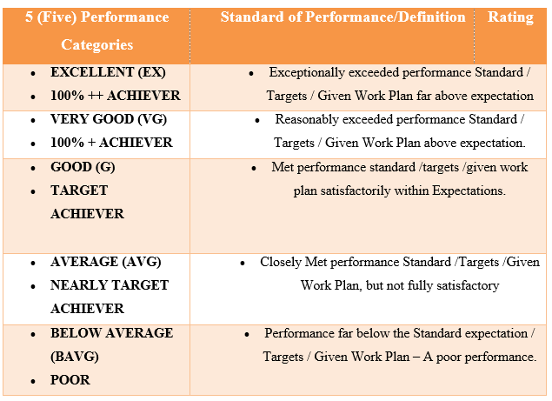

5.4 Different categories of performance.
Annual Performance Assessment and Standard Performance Distribution (SPD)
Every employee will be assessed annually by the supervisor according to the responsibilities indicated in the policy and directives and in accordance with the standard format. Human resources will guarantee the consistency of the stated principles.

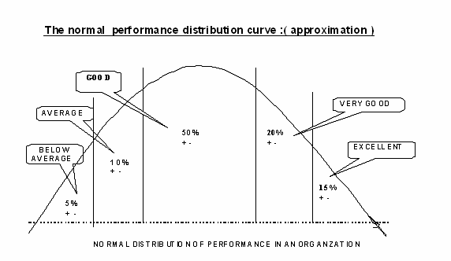

5.5 Example of Kazi Farm’s Performance Appraisal form
- Kazi Farms Limited has two types of performance evaluation modules.

One is for area managers or department heads and the other is for other employees who work under your orders.
Managers fill out this form and send it directly to the Human Resources Division as "RESERVED CONFIDENTIAL" documents. After receiving the document, the Human Resources Division informs the manager that the documents have been received and also checks the number of forms received. If the cover of the document is hardened, the Human Resources Division refuses to receive the document.

The process to complete the performance evaluation form:
The process of filling out two different types of forms will be discussed below to make it more understandable:
First, the manager's performance evaluation form will be mentioned:
- The form has four pages.
- At the beginning of the first page of the format, it is necessary to mention the year for which the organization evaluates its employees. So, the name of the expert (the person who evaluates), as well as the designation, age, the last date of the promotion, the period of service with Kazi Farms, etc. It must be mentioned.
- Service period of the current position and should also mention the workplace where the employee worked during this particular period of time.
- Next, the management committee must complete the section, where it should mention the earnings obtained by the regional director and the specific earnings that the authority has decided on.
- After completing Section A, management must complete Part B, which is called other strategic objectives that contributed to Part A. If A is achieved, B can be ignored. But if A is not reached, they must complete the percentages of the various factors mentioned in this particular area. After completing section B, they should complete section C. In this section, they should provide some points on the quality of the results.
- These results are the fulfillment of audits, new loans and the recovery of outstanding loans, the operating budget, employee development, etc.
- So, after finishing the first page, they should go to page 2. Here, they should complete an assessment of knowledge and behavioral skills only for a potential list.
- The notation will look like this:
- 1 = Exceeds Expectations (EE)
- 2 = Fully Meet Expectations (FME)
- 3 = Met Expectations (ME)
- 4 = Partially Met Expectations (PME)
- 5 = Requires Significant Improvement (RSI)
- 6 = Does not Meet Expectations (DME)

Here, employees have to answer almost 15 questions about managers' behavioral and knowledge competence factors. These questions may vary depending on the circumstances. The questions asked in this section are:
          - Knowledge of Kazi Farms products and services, organization, policies, and processes (update)
          - General knowledge profile in the assigned professional responsibilities (main job)
          - Understanding and customer service.
          - Computer literacy and computer skills related to agriculture.
          - Planning: ability to plan work activities and set priorities and guide actions to achieve results.
          - Assessment in the agricultural sector.
          - Awareness of compliance issues.
          - Interpersonal relationship
          - Attitude (a positive thinker and adaptable to change)
          - Speed ​​in action
          - Communication skills.
          - An entrepreneur with advice and initiative.
          - A team worker believes in team effort.
          - Ability to influence others and get involved.
          - Analytical capacity

These are the questions mentioned above that are mainly asked in that section andafter asking the questions:
- Management must check the number that the person (manager) deserves.
- Next, they should comment on question number 16 on their integrity and behavior in the service. It is a crucial part for the manager. Because it shows the sincerity of managers.
- In section D, the assessor attempts to identify two key areas that need to be developed.
- There are two areas, such as knowledge and behavioral competence.
- If the evaluation must be developed in these two areas, it is necessary to mention them in this table.
- Basically, employees are selected for training based on this information table.
- Section E provides the supervisor's general comment (summary and performance evaluation). In fact, it shows a summary of the assessment. This evaluation is entered directly into the performance evaluation calculation software. After completing this part, the assessor must sign below.
- In Section F, employees' opinions on the assessment and their professional willingness will be mentioned. If the assessment matches the manager's assessment, an agreement must be signed and signed. If the expert believes that the evaluation of his or her performance has been affected by discrimination or injustice and part of the trial, the expert can file a written complaint with the human resources supervisor.
- In this case, the human resources manager will be the first point of the contract. If the issue remains unresolved, it is sent back to the MD for review and decision making, in which case the MD's decision will be final.
- Special Suggestion: A justified site has been completed in Section G. If the consultant believes that the employee should receive annual growth, this should be filled in. It must also be mentioned if the employee is eligible for the next subsequent promotion. If the expert believes that employees should receive them at the same time, they should write them in this box for good reason.
- In Section H, there is a form for HR review and comment. If HR thinks you should add more than you can add here. Even if you think this assessment was not done correctly, you can write it here. Subsequently, appropriate measures will be taken later.
- The results of the interviews and the opinions of the Human Resources Steering Committee are written in the first part. If this person is recommended for promotion, this part is mainly considered. This section is optional and the HR department can enter this comment directly into the manager's profile. If this person is not recommended, this section is not counted or needs to be completed. These are the main elements to consider when evaluating a manager's evaluation form.
- Performance evaluation forms will now be explained for all employees except managers. In this case, the last three pages of the evaluation form are similar to the administrator form. The fundamental difference is the first page of the form. Therefore, the first page of the form will be described.
- At the beginning of the module, as before, it is necessary to mention the year the manager evaluated the employee. They must then fill in the name of the assessment (the person we are evaluating), as well as the name, age, date of last promotion, the term of service at Kazi Farm, term of service of the current position, and location of service. It also means that you are working in a specific Where to work during the time period.
- Subsequently, managers should briefly write down the employee's main responsibilities, goals, and work plan in this section. Here, you should mention all the work that employees did during a specific period.
- Therefore, the manager must complete Part B, called the Performance Category. Here, the diet should mention the category to which the employee belongs.

And finally, the managers must describe the category to which the employee belongs and must also check the right side of the form. After this section, all sections are similar to the manager module. The manager must complete this form accordingly.
To explain Kazi Farms Limited's performance appraisal system, we conducted a small case study describing the performance appraisal of respondents. For reasons of anonymity, the name of the accused was not released in this report.
This is a performance appraisal form for employees other than managers. Therefore, as mentioned above, Manager A should describe the main professional responsibilities of the employees. In this case, the main professional responsibilities of the employees are:

  - SWIFT management.
  - Prepare the customs declaration on the ground.
  - IT systems management.
  - TR expenditure and adjustments in the event of absence or overload of the personnel concerned.
  - Develop in the agricultural transporter and serve the company effectively and efficiently.
  - Improve the commercial value and marketing of products to increase the company's profits.
  - Other activities assigned from time to time by regional management.
  - Successfully achieved my business goals.

In section B, the operator must mention to which category the assessment belongs. In this case, the manager chose it for the EX (excellent) category. The expert also wrote a reason for the category.

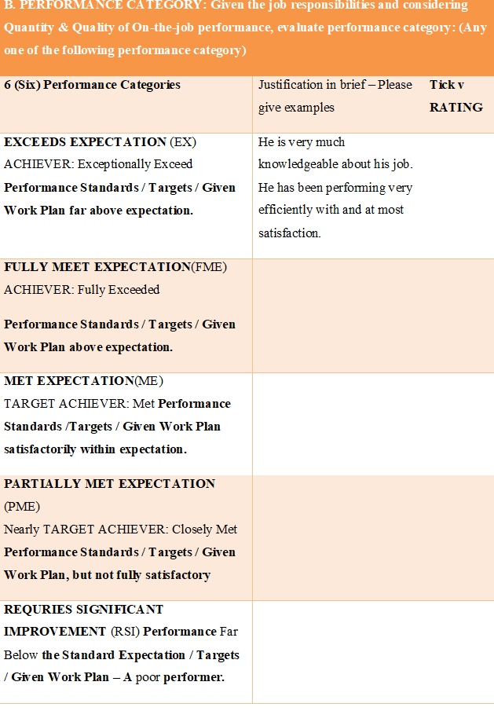

Chapter Six: Analysis and Interpretation of Data

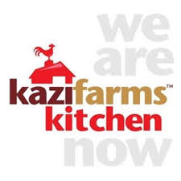

6.1 Analysis of Employee Opinion
I had chosen 15 employees randomly and collected data from them. Data are collected through face to face conversation and questionnaire. All of the employees of Kazi Farms Limited (Head Office) were cooperative. I organized the questionnaire in a way that can give a scenario of their likings. I have used 3 scales for judging their satisfaction level.

- Employee opinions on some important questions are given bellow:
Q.1) What is Performance Appraisal?
Answers | Evaluation of employee | Jobs satisfaction of Employees | Judging Performance of an Employee
Number of Employee | 0 | 4 | 11
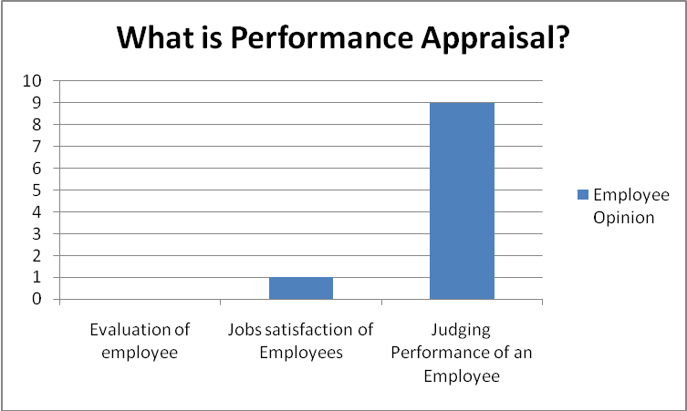

Comments: I asked this question to understand employee knowledge regarding performance appraisal system. All of them know about performance appraisal and the benefit of it. They have been gone through proper training that’s why they are familiar with this.

Q.2) Which method of performance appraisal followed by this organization?
Answers | Grading | Other | Merit based
Number of Employee | 0 | 0 | 12
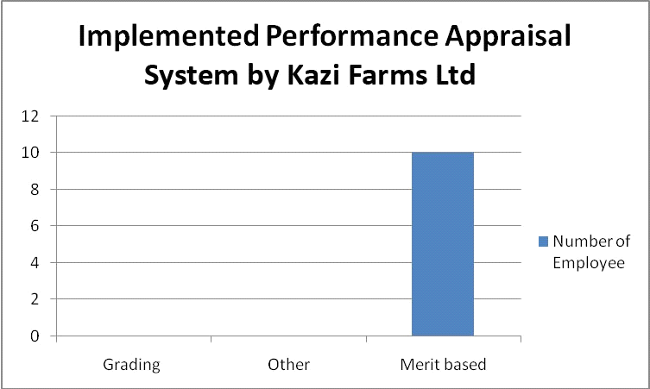

Comment:
All of the employees are not well aware of the followed performance appraisal system. They follow merit based performance appraisal system this is the system which differentiate them from other organization performance appraisal system.

Q.3) Do you receive any increment if your performance is up to the mark?
Answers | Never | Sometimes | Always
Number of Employee | 0 | 0 | 14
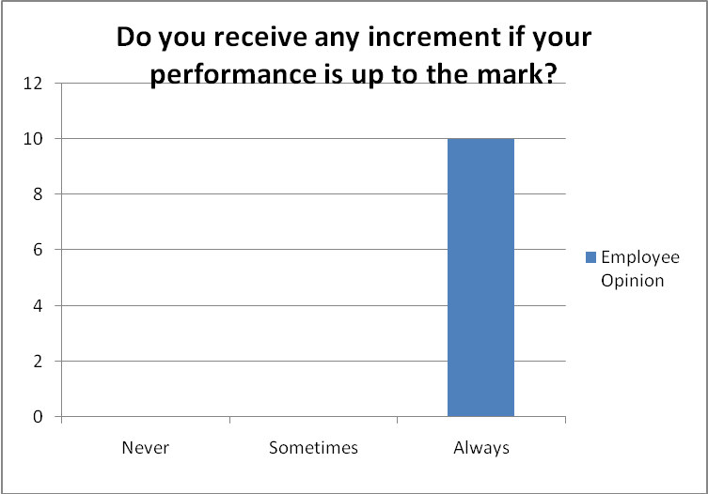

Comment: Most of the employee received increment after the performance appraisal. The entire sample said that they have got incentives after the evaluation. This is the clear identification of the success of this system.

Q.4) Performance appraisal improves motivation and job satisfaction of Kazi Farms Employee.
Answers | Never | Sometimes | Always
Number of Employee | 0 | 0 | 15
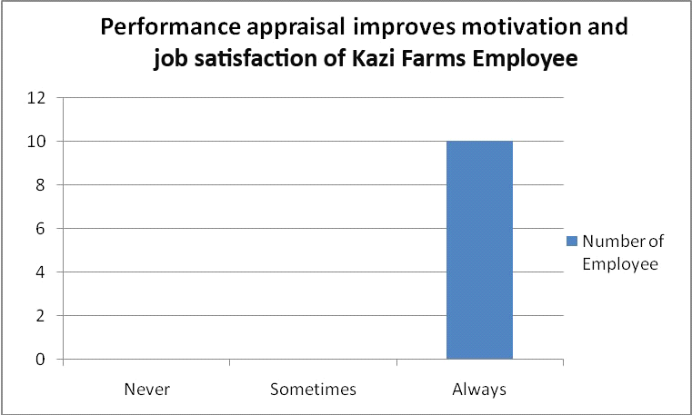

Comment: Kazi Farms employees are highly motivated because of their existing performance appraisal system. If their employees are not highly motivated enough then organization will not be able to achieve the target goal

Q.5) Does there any influence by the top level management during performance appraisal?
Answers | Yes | Sometimes | Never
Number of Employee | 0 | 0 | 14
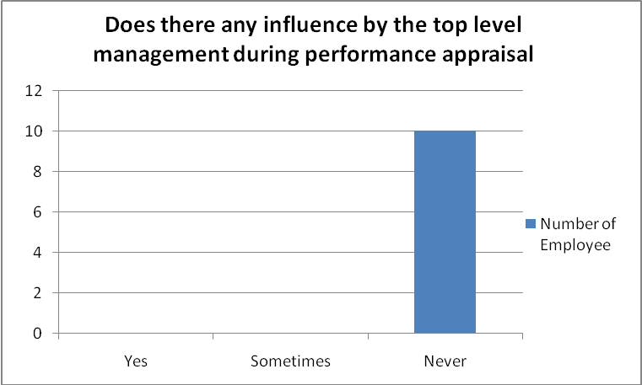
Comment: Performance appraisal system of Kazi Farm’s is fair.

Q.6) Performance appraisal has any impact on behavioral change of Kazi Farm’s Employee?
Answers | Never | Sometimes | Always
Number of Employee | 0 | 3 | 7
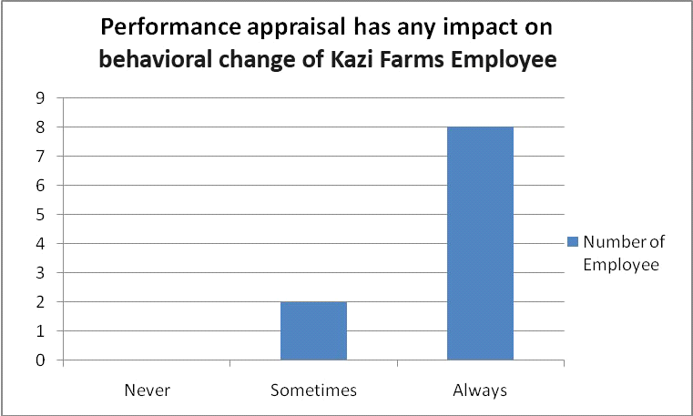

Comment: Yes, Performance appraisal of Kazi Farms creating impact on employee behavior.

Q.7) Do you satisfied with the performance appraisal system of Kazi Farms Ltd.?
Answers | No | Yes | Delighted
Number of Employee | 0 | 10 | 3
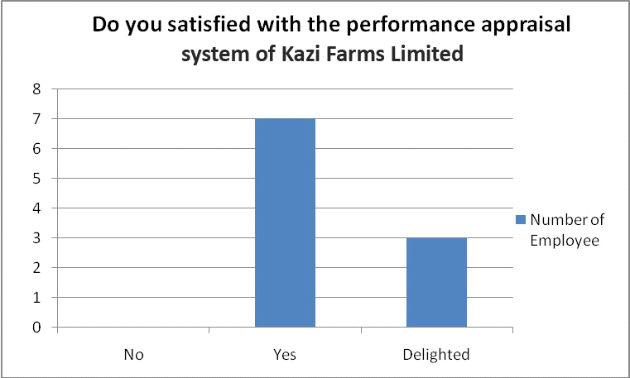

Comment: All of them are satisfied with this Farm’s Performance Appraisal System. Some of them are delighted as well.

Q.8) Is this Performance Appraisal System easily understandable to all?
Answers | No | Partially Understandable | Fully Understandable
Number of Employee | 0 | 10 | 5
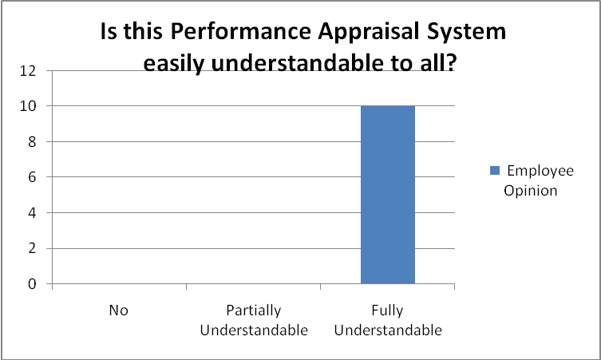

Comment: Their performance appraisal system is not easy to understand. A performance appraisal should be understandable.

Q.9) Does Kazi Farms Value your judgment during the time of performance appraisal?
Answers | Never | Sometimes | Always
Number of Employee | 0 | 10 | 4
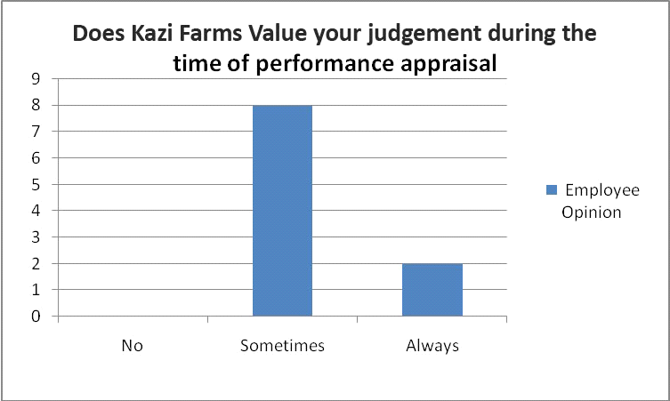

Comment: They sometimes value employee judgment during the time of performance appraisal.

Q.10) Do you want to switch your job to others?
Answers | Yes | Don’t Think Yet | Never
Number of Employee | 0 | 0 | 8
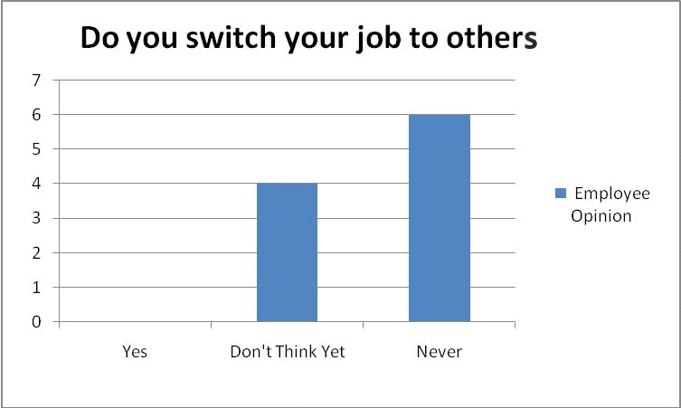

Comment: Employees of Kazi Farms are highly satisfied so they don’t think of switching their job to other organization.

From above graphical chart it has been figured out that all of the employees of Kazi Farms Limited are satisfied on their job and appraisal system.

Chapter Seven: Findings of the report



7.1 Findings of the Report
Findings of the report refer to the key findings that we have realized analyzing the performance appraisal of Kazi Farms Group; that is proposed, published or directed by the report. This generally refers to the totality of the results, rather than the conclusions or recommendations they have made.
- The links between other departments and staff are not strong enough.
- Before starting a new training program, they did not perform a proper needs assessment.
- No training on performance evaluation systems.
- Kazi Farms Limited has many training programs. Many employees participate in these programs every year. But the biggest flaw is that after the training course, they didn't take measures to measure employee efficiency. Training programs are useful or not useful for employees who don't have metrics. But this is not the right approach.
- There is no comparison between the pre and post evaluation performance in the system.
- Farm management does not follow the requirements of new employees.
- There is no correct feedback system.
- There was no two-way communication during the evaluation system.
- When supervisors evaluate their subordinates, they can create distortions between supervisors.
- The superior spend too much time writing and the subordinates have to ask them.
- The classification system requirements for lower levels are less clear.
- The evaluation system is the same non-manager and manager.
- Wage increases are based on performance appraisal levels.
- Your working environment is very good and your connection is high.
- They receive standard salaries based on their work.
- They will introduce a new unique online system: employees of the online system will complete their performance evaluation form, then discuss with their superiors and adapt based on mutual understanding.

Chapter Eight: Recommendations and Conclusion



8.1 Recommendations for Kazi Farm Group
The suggestions in this chapter are important recommendations for best practice in certain situations. The general idea proposed is to provide useful advice for the development of Kazi Farms Group, which not only solves some problems, but also brings beneficial results.

- Existing evaluation systems must be modified and new systems must be developed that show accurate results. The results can be used to assess training needs and help to take appropriate development plans.
- Kazi Farm has a strong power in the market. This is very necessary. It can maximize the profit rate by meeting the needs of its customers and employees.
- They must develop their activities through human resource management to improve employee growth and reach organizational levels.
- You must immediately follow the unique HR policies in your organization through your manager and those responsible for HR.
- They must change the assessment method so that employees can understand it. If other organizations evaluate in 5 steps, 6 steps are not required.
- Only higher salaries can meet the needs of higher levels of aggressive workers. Employees want their self-realization to be recognized and rewarded.
- They must develop resources and skills based on environmental needs to increase opportunities.
- They must evaluate previous performance, and after training, performance should identify areas for improvement. It will help the farm identify training programs that are useful for building staff skills.
- Kazi Farms has the potential to improve employee efficiency and help lead future leaders by providing high-level training.
- They should improve business plans, performance analysis, service delivery, evaluation, and review.
- The human resources department must establish appropriate links with other functional departments to obtain better services.

8.2 Conclusion
Kazi Farms Limited has created the feeling of maximum participation over the past 17 years through its various companies. The number of its employees is now around 10,000. They maintain their agri-food sector with their region. Kazi Farms Limited has started making profits since 1996. They are now the largest for-profit company among poultry farms. The report was sent to the human resources department. Kazi Farms Limited operates in the market with the desire to become a market leader. It is normal for a business in operation to provide customer service at high standards, at a level where standards exceed. Kazi Farms Ltd is committed to focusing all of its energy on customers and employees. Certainly, good HR practices will help the farm reach their destination. The HR department guarantees future benefits and a safe place to contribute and dedicate a high corporate culture and high professional experience.

Reference
(1) Kazi Farms holds dealers conference". The Daily Star. 2009-02-22. Retrieved 2019-10-29.
(2) "Turning chicken manure into organic fertilizer". Dhaka Tribune. 2019-01-17. Retrieved 2019-10-23.
(3) "Kazi Food Industries & Deep to TV launched | New Age".. 2019-12-10.
(4) "Achieving IT independence through open-source | Dhaka Tribune". Archive. Dhaka tribune.com. Retrieved 2019-10-29.
(5) "Brand war heats up in ice cream market". The Daily Star. 2013-04-17. Retrieved 2019-10-29.
(6) Abu-Doleh, J. & Weir, D. (2007). Dimensions of performance appraisal systems in Jordanian private and public organizations. International Journal of Human Resource Management, 18(1), 75-84
(7) Muczyk, J. P. & Gable, M. (1987, May). Managing sales performance through a comprehensive performance appraisal system. Journal of Personal Selling and Sales Management, 7, 41-52.
(8) Pettijohn, L., Parker, R., Pettijohn, C., & Kent, J. (2001). Performance appraisals: usage, criteria, and observations. The Journal of Management Development, 20, 754-771.

