Project Report on
Consumer Purchasing Behavior Towards Super shops in the Context of Bangladesh

Project Report on
Consumer Purchasing Behavior Towards Super shops in the Context of Bangladesh
Submitted to:
Dr. Seyama Sultana
Associate Professor
School of Business and Economics
United International University

Submitted by:
Abedatul Fatema Dolla
ID:111 163 060
Major: Marketing

School of Business and Economics
United International University


Date of submission: 08-12-2024

Letter of Transmittal
Date: 08-12-2024
To
Dr. Seyama Sultana
Associate Professor
School of Business and Economics United International University
Subject: Submission of Report on “Consumer Purchasing Behavior towards Super Shops in the Context of Bangladesh”
Dear Mam,

This report, titled "Consumer Purchasing Behavior towards Super shops in the Context of Bangladesh," fulfills the academic requirements for the BBA program at United International University. It explores the multifaceted factors that significantly influence consumer decision-making within the Bangladeshi super shop sector. Through this quantitative research, I have identified and analyzed the key factors impacting consumer buying behavior in Bangladesh's super shop industry. I am confident that this report adheres to the university's established criteria and effectively reflects the effort invested during the project.
Abedatul Fatema Dolla
ID: 111 163 060
School of Business and Economics, United International University

Declaration of the Student

This report, titled "Consumer Purchasing Behavior towards Super shops in the Context of Bangladesh," is submitted by Abedatul Fatema Dolla, a student of the School of Business and Economics at United International University, in partial fulfillment of the requirements for the Bachelor of Business Administration (BBA) program. The report is the product of quantitative analysis and independent effort.
All information included in this report is authentic, current, and derived from reputable sources. Established academic integrity guidelines have maintained ethical conduct Throughout the quantitative research process. The report is entirely free of plagiarism, and any concepts, ideas, or theories gleaned from external sources are appropriately credited.
I fully comprehend the consequences of academic misconduct, including plagiarism, and affirm that I have not engaged in any such activities.

Abedatul Fatema Dolla
ID: 111 163 060
School of Business and Economics
Major in Marketing
United International University

Acknowledgment

I would like to express my sincere gratitude to all those who contributed to the successful completion of this report, titled " Consumer Purchasing Behavior Towards Super shops in the Context of Bangladesh."
First and foremost, I extend my deepest appreciation to my supervisor, Dr. Seyama Sultana mam. Her guidance and expertise proved invaluable throughout the quantitative research process. Her insightful feedback and direction significantly enhanced the quality and depth of this report.
In conclusion, I would like to acknowledge the unwavering support and encouragement I received from my close friends and family members throughout this academic endeavor.

Abstract
The Bangladeshi retail landscape is witnessing a significant shift with the rise of super shops (Hasan, M. 2018). Inspired by the "super store" concept offering a one-stop solution for daily needs, these establishments have captured consumer attention (Islam, M. S., & Habib, A. H. 2016). This research delves into the multifaceted dimensions of consumer behavior within Bangladeshi super shops, employing a quantitative research methodology and leveraging internet surveys to gather in-depth data.
The resulting report provides valuable insights for various stakeholders, including super shop owners, policymakers, and industry practitioners. By shedding light on the key factors influencing consumer buying decisions within the super shop landscape (Hasan, M. 2018) the research equips stakeholders with actionable intelligence crucial for informed decision-making and strategic planning.
The findings highlight the critical role of product variety and pricing strategies in shaping consumer preferences and behaviors toward super shops. Recognizing the competitive landscape, which includes traditional grocery stores and the growing presence of online daily shopping platforms (Islam, M. S., & Habib, A. H. 2016).

Key Words: Super Shop, Convenience, Customer, Product Quality, Customer Satisfaction etc.
Table of Contents
Letter of Transmittal 3
Declaration of the Student 4
Acknowledgment 5
Abstract 6
CHAPTER 1: Introduction 8
1.1 Background of the study: 9
1.2 Problem Statement 9
1.3 Research Objective: 10
1.4 Motivation of the Study 11
1.5 Scope and Limitations of the study: 11
CHAPTER 2: Literature Review 13
2.1 Industry Analysis: 14
2.2 Size, Trend and Maturity of the Super shop Industry of Bangladesh 16
2.3 External Economic Factors 16
2.4 Technological Factors 16
2.5 Entry Barriers: 17
2.6 Supplier Power 17
2.7 Buyer Power 18
2.8 Threats of Substitute 18
2.9 Industry Rivalry: A Competitive Landscape 19
CHAPTER 3: Methodology 20
3.1: Research Design: 21
3.2 Questionnaire Design: 21
3.3 Data Analysis and findings 21
CHAPTER 4: Research Findings 31
CHAPTER 5: Conclusion 36
5.1: Conclusion 37
5.2 Recommendations 38
References 40
Appendix 43

Chapter 1: Introduction

1.1 Background of the study:
Bangladesh's urban retail landscape is experiencing a dramatic transformation, fueled by the irresistible rise of super shops. These self-service havens, overflowing with everyday essentials, are rapidly outpacing traditional grocery stores. While Agora, established by Rahimafrooz (Bangladesh) Limited in 2001, marked the initial foray, today, the market boasts a diverse array of players like Shwapno (ACI Limited), Daily Shopping (Pran-RFL Group), and Unimart (United Group), each vying for the hearts and wallets of Bangladeshi consumers.
The magnetism of super shops lies in their ability to cater to the time-pressed urban and semi-urban Bangladeshi consumer. Unlike traditional stores with a limited product range, super shops offer a cornucopia of daily necessities under one expansive roof. From fast-moving consumer goods like groceries, household items, stationery, and cosmetics to fresh produce encompassing meat, fruits, vegetables, and frozen foods, they provide a comprehensive shopping experience. This one-stop-shop convenience eliminates the need for multiple store visits, saving valuable time and energy for busy consumers.

Additionally, many super shops have implemented loyalty programs and reward points, incentivizing repeat customers and fostering brand loyalty.
This quantitative analysis delves deeper into the multifaceted consumer behavior within the Bangladeshi super shop market. It specifically focuses on understanding why consumers choose super shops over nearby department stores. By dissecting the factors influencing shopping decisions and preferences, the study aims to shed light on the evolving retail landscape and paint a clearer picture of consumer behavior in contemporary urban Bangladesh.

1.2 Problem Statement
Bangladesh's urban retail landscape is changing, with super shops rapidly replacing traditional grocery stores. However, a crucial knowledge gap exists: why exactly are consumers choosing super shops over established department stores? This lack of understanding creates a blind spot for both super shop operators and policymakers. Without this knowledge, they struggle to optimize the retail experience and effectively cater to the evolving needs of urban Bangladeshi consumers. To bridge this gap, a comprehensive investigation into the dimensions of consumer purchasing behavior within the Bangladeshi super shop is essential. This quantitative research will identify the key factors influencing consumer choices, providing valuable insights that can guide super shops in refining their strategies and policymakers in shaping the future of Bangladesh's urban retail landscape.

1.3 Research Objective:

Broad Research Objective:
To extensively research and analyze consumer purchasing behavior in the context of super shops in Bangladesh.

Short Objectives:
- To examine the role of convenience, product variety, pricing, and other factors in shaping consumer purchasing decisions within super shops in Bangladesh.
- To identify the key factors influencing consumers' preference for super shops over traditional department stores and local markets in Bangladesh.

1.4 Motivation of the Study:
Bangladesh's urban retail landscape is undergoing a seismic shift. Traditional grocery stores are rapidly losing ground to a new breed of competitor: the super shop. Pioneered by Rahimafrooz (Bangladesh) Limited with the establishment of "Agora" in 2001, these self-service havens offer a dazzling array of daily necessities under one roof. While the sheer convenience of size and variety is undeniable – super shops stock everything from groceries and household items to stationery, cosmetics, and even fresh produce – it is like there's more to their allure.
The ability to fulfill all your shopping needs in a single visit is a powerful draw in today's time-pressed world. Super shops eliminate the need for multiple store visits, saving consumers precious time and effort. However, a critical knowledge gap remains. Despite the convenience factor and the rapid rise of Super shops, a clear understanding of why consumers specifically choose them over established department stores is lacking. This lack of insight presents a significant hurdle for super shop operators and policymakers. Without a deeper grasp of consumer preferences, it becomes difficult to effectively cater to their needs and optimize the urban retail landscape in Bangladesh.

1.5 Scope and Limitations of the study:

While this quantitative research attempts to offer valuable insights into consumer purchasing behavior within the Bangladeshi super shop, the study acknowledges the following limitations:

- Geographic Scope: The research focuses on urban and suburban areas of major cities, potentially excluding insights from consumers residing in rural areas or smaller towns.
- Demographic Focus: The study targets consumers aged 18-35, potentially missing perspectives from other age groups that might exhibit different shopping behaviors.
- Data Collection Method: The specific data collection method employed (surveys) might influence the responses and potentially limit the generalizability of the findings.

Chapter 2: Literature Review

2.1 Industry Analysis:

Agora: Agora, launched in 2001 by Rahimafrooz Bangladesh Ltd., pioneered the Bangladeshi super shop industry. Currently the second largest chain, it boasts 19 stores and an estimated annual turnover of 500 crore BDT. Recognized for quality and ethical practices, Agora received ISO certification and inspired many in the industry. Seeking further growth, it secured investment from Frontier Fund (later acquired by Softlogic) for an estimated value between 181-249 crore BDT.
Shwapno, launched in 2008 by ACI Logistics, reigns as the leading super shop chain in Bangladesh with over 200 stores across 31 districts. Its aggressive expansion strategy secured a dominant 49% market share. Recognized for quality and convenience, Shwapno caters to over 35,000 households daily and has received multiple awards, including Best Retail Brand in Bangladesh. While prioritizing affordability, Shwapno achieved profitability in 2021, experiencing significant year-on-year sales growth. It has also embarked on international expansion, exporting produce to several countries.
Daily Shopping: A relative newcomer to the scene, Daily Shopping, part of the PRAN-RFL Group, has adopted an aggressive expansion strategy similar to Shwapno. Launched in 2014, it boasts 64 stores across Dhaka, Cumilla, and Chattogram, with a flagship store in Uttara and an e-commerce platform. Catering to over 100,000 customers with a diverse product range, Daily Shopping prioritizes affordability and accessibility for all income levels.
Prince Bazar Ltd: Established in 2005, Prince Bazar Ltd. focuses on providing the highest quality products at the most affordable prices, coupled with exceptional customer service. Currently operating four stores across Mirpur, Shyamoli, Mohammadpur, and Pallabi, they offer a diverse range of products including food items, personal care items, home essentials, and groceries.

Unimart: Founded in 2013 by the United Group, Unimart carved a niche as a premium hypermarket with a focus on innovative retail experiences. Spanning 40,000 square feet, it became the first of its kind in Bangladesh, pioneering a unique concept that combined conventional super shop services with "store-in-store" shopping options. Operating three outlets in Gulshan, Dhanmondi, and Wari, Unimart caters to around 200,000 customers at its Gulshan location alone. Known for embracing contemporary trends in products, services, and business practices, Unimart even partnered with Unilever in 2022 to introduce the first super shop refill machine in Bangladesh, demonstrating their commitment to environmental sustainability.
Meena Bazar: Established in 2002 by the Gemcon Group, is a well-known super shop chain with 16 stores across Dhaka, Chattogram, and Narayanganj. It offers 10,000+ products with a focus on convenience, competitive prices, and customer service. They source fresh produce and dairy directly from farmers, promoting quality and ethical practices. Their e-commerce platform, MeenaClick, gained popularity during the pandemic, winning an award in 2020. For further expansion, they implemented a franchise model, opening their first outlet in September 2022 with home delivery services.

2.2. Size, Trend, and Maturity of the Super shop Industry in Bangladesh:
The rise of the middle and affluent classes in Bangladesh has fueled the growth of super shops, particularly in Dhaka. The COVID-19 pandemic further accelerated this trend as consumers sought the safety and hygiene offered by these stores. Shwapno and Unimart experienced significant sales growth during this period.
Online grocery delivery services also witnessed a surge in popularity, with platforms like Chaldal, Pathao, and Foodpanda expanding their offerings. While some super shops like Shwapno, Meena Bazar, and Agora embraced online sales and delivery, the majority of customers have now returned to traditional markets and grocery stores post-pandemic, likely due to the additional VAT charges on packaged goods in super shops.

2.3 External Economic Factors:

- Economic Growth: Strong economic growth leads to higher consumer spending, benefiting super shops as people have more disposable income for groceries and other products.
- Inflation: Rising inflation can increase the cost of goods and services, potentially impacting consumer purchasing habits. Super shops might need to adjust their pricing strategies in response.
- Interest Rates: Higher interest rates make borrowing more expensive for both consumers and businesses. This can lead to decreased consumer spending and increased operational costs for super shops.
- Income and Employment: Consumer spending is closely linked to income and employment levels. When employment rates and incomes rise, people have more purchasing power, driving up demand for super shops goods.

2.4 Technological Factors:

- E-commerce Platforms: The rise of online grocery delivery platforms like Chaldal, Pathao, and Foodpanda has presented both challenges and opportunities for super shops. Some established chains, like Shwapno, Meena Bazar, and Agora, have embraced e-commerce by offering online ordering and delivery services. This caters to consumers seeking the convenience of online shopping while leveraging the established reputation and product range of these super shops. However, the post-pandemic shift back to traditional markets suggests a need for super shops to refine their online strategies and potentially address factors like additional VAT on packaged goods.
- In-store Technology: While not as prevalent as in developed countries, some super shops like Unimart are pioneering the use of in-store technology to enhance customer experience. Unimart's "store-in-store" concept and its partnership with Unilever to introduce the first super shop refill machine in Bangladesh demonstrate a forward-thinking approach.

Overall, technology plays a growing role in the Bangladeshi super shop industry. While challenges exist, particularly regarding online grocery delivery and additional VAT on packaged goods, super shops that strategically integrate technology can enhance customer convenience, operational efficiency, and overall brand image.

2.5 Entry Barriers:
Several factors make it difficult for new players to enter the Bangladeshi super shop industry:
- Economies of Scale: Established super shops have a significant cost advantage due to their ability to spread fixed costs over a larger volume of sales, leading to lower average costs per unit. This makes it challenging for new entrants to compete on price.
- Regulatory Hurdles: Navigating the numerous laws regarding zoning, licensing, and health and safety regulations can be expensive and time-consuming for newcomers, creating a barrier to entry.
- Location Barrier: Prime locations near busy areas are crucial for super shops success. However, securing such spaces can be difficult for new players, as existing super shops often occupy these strategic locations.

2.6 Supplier Power:
Various factors impact supplier power in the Bangladeshi super shops. Limited suppliers of necessities such as food give those suppliers more leverage when it comes to negotiating terms and prices. Certain products' exclusivity or distinctive features can also give suppliers more leverage, particularly if super shops largely depend on them. Another factor is switching costs; supplier power is reduced if super shops can quickly identify substitute suppliers with little difficulty or cost. Additionally, suppliers can sell their goods through additional channels and possibly avoid super shops entirely by participating in forward integration, opening their own retail stores, or entering the super shop industry.

2.7 Buyer Power:
The super shop industry in Bangladesh reveals a significant level of buyer power, which denotes the potency of consumers to impact and gain power over industry players. Bangladeshi consumers have a lot of options when it comes to shopping, which gives them a lot of buying power. The retail landscape is diverse due to the existence of independent retailers, national and international super shop chains, and traditional markets. As a result, switching costs are reduced because customers can quickly move between different super shops without having to spend a lot of money or effort.

2.8 Threats of Substitute:
In urban areas like Dhaka and Chittagong, online grocery platforms like Chaldal, Panda Mart, and Pathao Grocery pose the most significant threat to traditional super shops. Additionally, for both urban and semi-urban consumers, nearby departmental stores, grocery stores, and local markets serve as major alternatives. The rapid growth of online grocery stores and e-commerce platforms presents a potential challenge to super shops. The convenience of online grocery ordering with home delivery holds a strong appeal for consumers. Furthermore, for specific products like fresh produce, organic foods, or imported goods, customers may opt for local bazaars instead of super shops. During economic downturns, price-conscious consumers might be drawn to discount stores offering a wider selection of goods at lower prices. Farmers' markets also offer a competitive alternative, particularly for customers seeking fresh, locally grown produce. Direct interaction between farmers and consumers is a key advantage of these markets.

2.9 Industry Rivalry: A Competitive Landscape:
The Bangladeshi super shop industry is a dynamic and rapidly growing sector characterized by intense competition among key players.

Both Shwapno and Daily Shopping have adopted aggressive expansion strategies, aiming to capture a larger market share. Shwapno, the current leader, boasts over 200 stores across the country, while Daily Shopping, a relative newcomer, has established a presence in major cities like Dhaka, Cumilla, and Chattogram.

Differentiation through Value Propositions:
Each super shop chain strives to differentiate itself through a unique value proposition.

- Agora: Pioneering the industry, Agora prioritizes quality and ethical practices, securing ISO certification and inspiring industry standards.
- Shwapno: The market leader, Shwapno focuses on affordability and convenience, catering to a large customer base and achieving significant year-on-year growth. They have also ventured into international expansion, exporting produce to other countries.
- Daily Shopping: This newcomer emphasizes affordability and accessibility for all income groups, offering a diverse product range across their stores.
- Prince Bazar Ltd: Focuses on exceptional customer service and high-quality products at competitive prices.
- Unimart: Carves a niche as a premium hypermarket, offering a unique "store-in-store" shopping experience alongside conventional super shop services. They embrace contemporary trends and prioritize sustainability initiatives.
- Meena Bazar: Known for convenience, competitive pricing, and ethical sourcing practices. They offer a popular e-commerce platform.

CHAPTER 3: Methodology

3.1: Research Design:
I used the survey-based question for this research design, which is quantitative analysis. Data is gathered from online sources, journals, articles, reports, previous studies, and websites.

3.2 Questionnaire Design:
This report utilizes based on qualitative analysis by an online survey questionnaire to gather data from respondents and answer all questions based on consumer purchasing behavior towards super shops in the context of Bangladesh.
The online survey will consist of ten specific questions, each focusing on a key element influencing consumer purchasing behavior in super shops.

3.3 Data Analysis and Findings:
For this report, I used MS Word and Google Docs; for the survey, I used Google Forms. I have also used the pie chart to understand the results. Each pie chart likely focuses on a single factor, such as variety, convenience, employee service, pricing, hygiene, or loyalty. Discussed about the findings below:
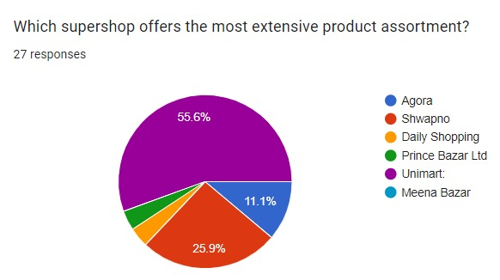
Product variety:

Product variety emerges as a critical differentiator for Bangladeshi super shop consumers, as evidenced by the survey results. A staggering 55.6% of respondents identified Unimart as boasting the most extensive assortment of products. This dominance likely stems from Unimart's commitment to a wide-ranging selection, encompassing not only groceries and daily necessities but also extending to clothing, vegetables, fish, meat, and beyond. This comprehensive product variety proves particularly appealing to high-class consumers residing in affluent areas like Gulshan and Banani, making Unimart their one-stop shop for all their daily needs. Shwapno follows closely behind, 25.9% of the vote for product diversity.

Convenience:

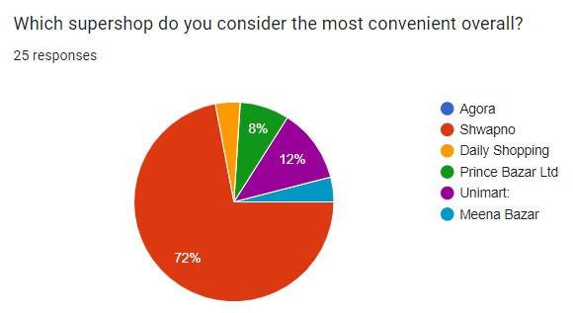

For Bangladeshi consumers seeking ultimate convenience in their grocery shopping, super shops are the clear winner. However, within the super shop landscape, one name stands out: Shwapno. A staggering 72% of respondents in our study identified Shwapno as the most convenient option. This dominance can be attributed to their strategic focus on accessibility. Shwapno boasts a presence in nearly every district, ensuring their outlets are conveniently located for a significant portion of the population.

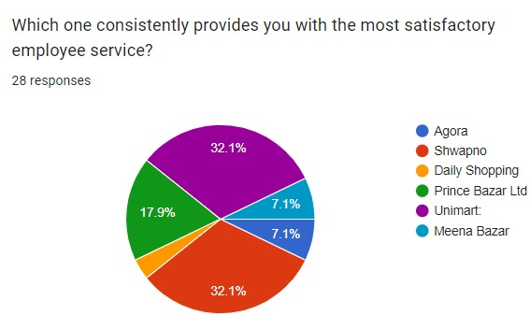
  - Customer Service/ Employee Service:

A staggering 32.1% of surveyed customers crowned Unimart the king of customer service, leaving competitors Shwapno (32.1%) and Prince Bazar (17.9%). This dominance likely stems from Unimart's strategic double play: offering a vast selection of products and placing stores conveniently. This combination creates a frictionless shopping experience (benefit), a major factor for over a third of customers. However, Shwapno and Prince Bazar's impressive scores (32.1% and 17.9% respectively) highlight a rising trend – customer service is becoming a battleground in the retail industry, with all three brands prioritizing customer satisfaction.

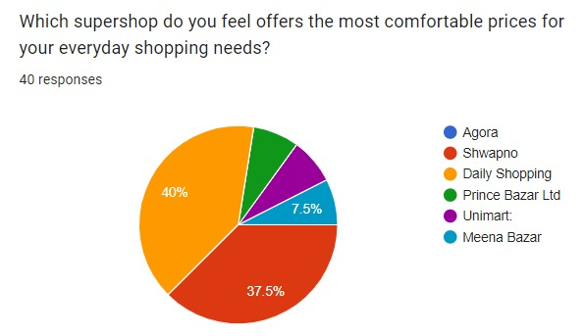
Pricing:

Price emerges as a critical factor for consumers, with Daily Shopping taking the lead by a significant margin. A remarkable 40% of respondents identified Daily Shopping as the most affordable option, primarily due to its exemption from Value Added Tax (VAT). This absence of VAT acts as a major draw for middle-class consumers seeking cost-effective shopping. Daily Shopping further strengthens its appeal by offering a wide variety of products at accessible prices. While Daily Shopping reigns supreme in affordability, Shwapno follows closely behind with 37.5% of the vote, solidifying its position as another attractive option for price-conscious middle-class shoppers. Based on the survey results, it's evident that Daily Shopping and Shwapno are perceived as the most budget-friendly super shops for the middle class in Bangladesh.

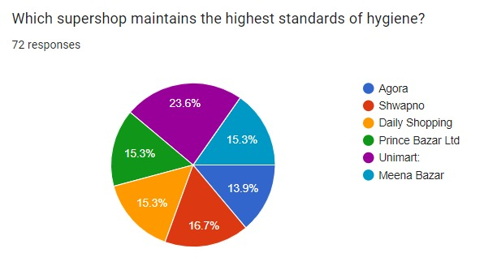
Hygiene:

In a tight race for the cleanest super shop crown, Unimart emerges victorious with a dominant 23.6% of surveyed customers praising their hygiene standards. This significant lead suggests Unimart places a high priority on keeping their stores sparkling clean, a factor clearly valued by nearly a quarter of customers. While Unimart takes the top spot, the competition isn't far behind. Prince Bazar, Daily Shopping, and Shwapno all received a respectable 15.3% of the votes each, highlighting a general industry-wide focus on hygiene. Even Agora and Meena Bazar, polling at 13.9%, demonstrate that maintaining a clean shopping environment is a shared priority for Bangladeshi super shops. These close percentages indicate that hygiene is becoming an increasingly important battleground for customer satisfaction within the super shop sector.

Brand Loyalty:

What is your preferred super shop chain that you visit most often?

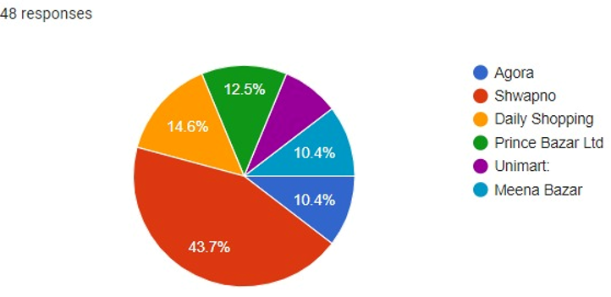
Examining brand loyalty in super shops, which considers both frequency of visits and preference over other options, reveals Shwapno as the top contender. Consumers visit Shwapno most frequently, followed closely by Daily Shopping.

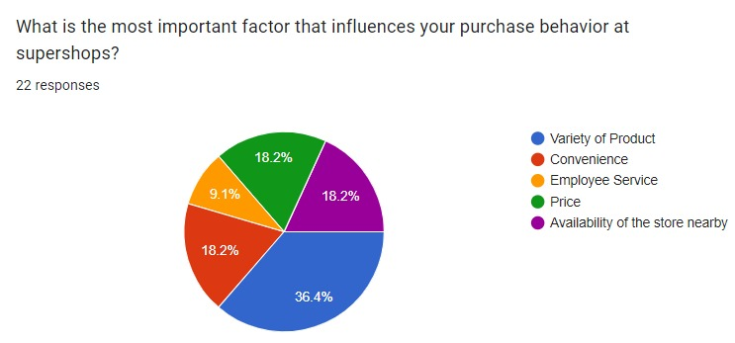

The pie chart indicates that product variety and availability hold the most significant sway over consumer decisions. This suggests that consumer prioritize having a wide range of products readily accessible at their chosen super shop. Interestingly, the pie chart shows that pricing and convenience hold equal weight in shaping consumer choices. This highlights the dual importance of affordability and accessibility for Bangladeshi consumers.

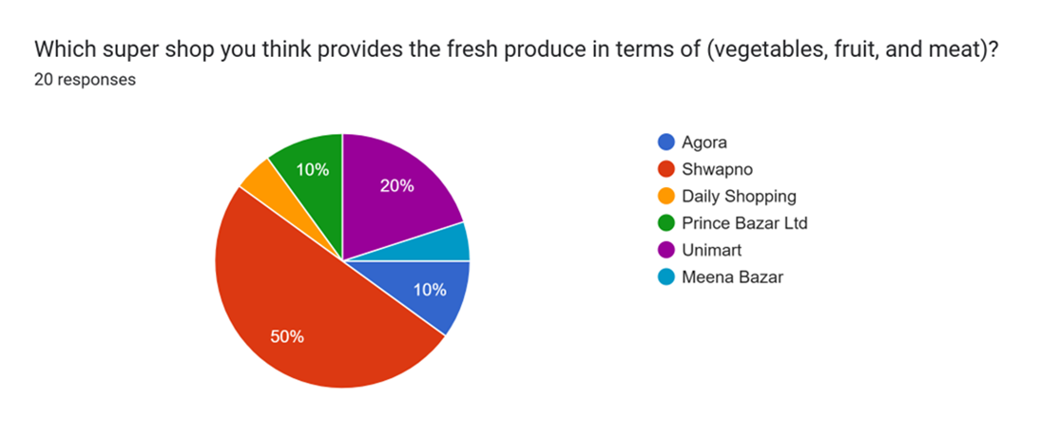

Results made it clear that Shwapno is perceived as the best provider of fresh produce (vegetables, fruit, and meat) followed 50%, Unimart 20% and Agora 10%. Here, shoppers have a clear preference, as they believe Shwapno provides the best taste and fresh product of this category—making it the most trusted name in this aspect.

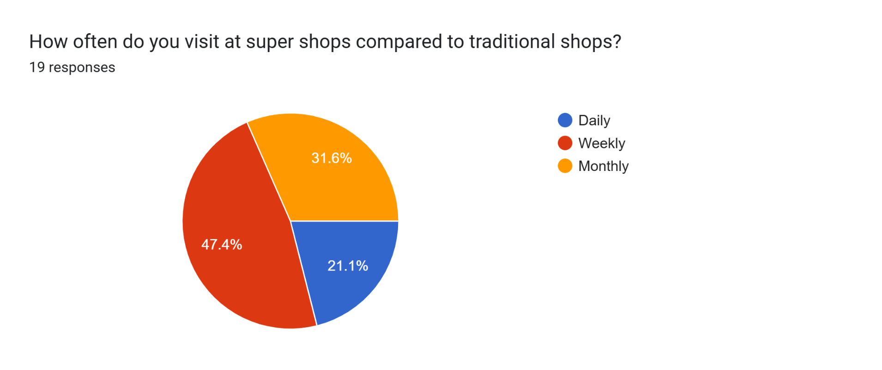

The pie chart shows more people 47.4% go to super shops every week. Finally, monthly is the second-most common with 31.6% choosing less frequent shopping. An even smaller section, 21.1%, shop at super shops on a daily basis, which means they do not necessarily depend on these for daily shopping.

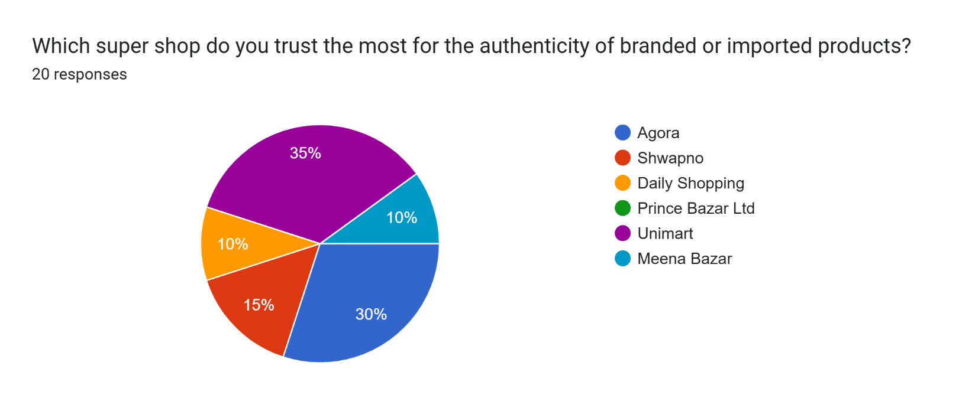

Unimart enjoys the largest share of consumer trust, obtaining 35%, meaning it is considered the most trustworthy. On the other hand, Agora is in second place at 30%, which is lower but still a significant level of trust. Only 15% for Shwapno, means trust is average about its originality. Both Daily Shopping and Meena Bazar each have 10% and share a small second place. That is why Unimart and Agora underscore the consumer's trust in the genuineness of these branded or imported products.

CHAPTER 4: Research Findings

Price Sensitivity (18.2%)
Nearly one-fifth of respondents (18.2%) identified price as a critical decision-maker. This is evident in the dominance of Daily Shopping, a budget-friendly option due to the absence of VAT on their products. Shwapno's strong showing also underscores the importance of affordability for a significant portion of the population.
Product Variety (36.4%)
Consumers crave a diverse selection, and Unimart emerges as the champion of product assortment. A staggering 36.4% of respondents indicated a wide variety as a major reason for choosing a super shop. This highlights the appeal of the one-stop shopping experience that eliminates the need to visit multiple stores. Shwapno's presence as the runner-up in the variety category further emphasizes the importance of diverse product offerings.
Convenience (18.2%)
For Bangladeshi consumers, convenience is king. Another 18.2% of participants highlighted convenience as a key factor. This is mirrored in the overwhelming preference for Shwapno (71.4%), likely due to its extensive network of outlets and easy accessibility. This finding suggests that consumers value super shops located close to their homes or workplaces, saving them valuable time and effort.
The Super shop Consumer: A Convenience Hunter
This quantitative research paints a clear picture of the Bangladeshi super shop consumer as a convenience hunter. They prioritize a one-stop shop for daily groceries, with affordability, product variety, and accessibility playing critical roles. Super shops that excel in these areas are most likely to attract and retain customers in the highly competitive Bangladeshi market.

While price, variety, and convenience emerged as the top contenders, other factors contribute to the overall shopping experience. Here's a quick look at some additional considerations:
- Hygiene: While hygiene standards are generally maintained across most super shops, Unimart takes the lead in this category.
- Customer Service: Customer service directly impacts brand loyalty, with Unimart, Shwapno, and Prince Bazar receiving recognition for their service quality.
- Brand Loyalty: When it comes to repeat customers, Shwapno and Daily Shopping reign supreme. This likely stems from their combined strengths in price, convenience, and product variety.

Availability of store nearby (18.2%):
A significant 18.2% of surveyed customers prioritize having a super shop conveniently located near their home. This makes perfect sense. In the daily hustle and bustle, when something is needed for the household, the most immediate thought is likely to be, "Where's the closest option?" This proximity factor significantly shapes consumer behavior, influencing which super shop they choose from the available options. After all, who wants to travel far to pick up everyday essentials?
Bangladeshi super shop consumers are driven by a compelling trifecta of factors: price, variety, and convenience. This study sheds light on these key drivers and how they shape shopping behavior.
Price reigns supreme for nearly a fifth of respondents (18.2%), reflected in the popularity of Daily Shopping, a budget-friendly option due to the absence of VAT on their products. Shwapno's strong showing also underscores the importance of affordability for a significant portion of the population.
Variety emerges as a shopper's nirvana, with a staggering 36.4% of respondents indicating a wide selection as a major reason for choosing a super shop. This highlights the appeal of the one-stop shopping experience offered by Unimart, eliminating the need to visit multiple stores. Results made it clear that Shwapno is perceived as the best provider of fresh produce (vegetables, fruit, and meat) followed by 50%, Unimart 20%, and Agora 10%. Here, shoppers have a clear preference, as they believe Shwapno provides the best taste and fresh product of this category—making it the most trusted name in this aspect.
Also, Unimart enjoys the largest share of consumer trust, obtaining 35%, meaning it is considered the most trustworthy. On the other hand, Agora is in second place at 30%, which is lower but still a significant level of trust. Only 15% for Shwapno, means trust is average about its originality. Both Daily Shopping and Meena Bazar each have 10% and share a small second place. That is why Unimart and Agora underscore the consumer's trust in the genuineness of these branded or imported products.

CHAPTER 5: Conclusion

5.1: Conclusion:
The quantitative research highlights a strong customer attraction to the features and benefits offered by super shops. These features encompass a wide variety of readily available products under one roof, competitive pricing strategies, convenient locations, and sometimes even additional services like home delivery.
Furthermore, the quantitative research delves deeper into specific dynamics that significantly influence consumer decisions when choosing a super shop. Affordability remains a crucial factor, with a significant portion of consumers prioritizing super shops like Daily Shopping due to their VAT-free pricing. The product variety is also highly sought after, as evidenced by the popularity of Unimart. Convenience plays a vital role, with Shwapno's extensive network of outlets attracting a large customer base. Additionally, maintaining high hygiene standards is essential, with Unimart leading the pack in this regard. Quality customer service contributes to brand loyalty, as seen with Unimart, Shwapno, and Prince Bazar. Finally, the frequency of visits and preference for specific brands like Shwapno and Daily Shopping indicate the influence of loyalty factors.
These findings offer valuable insights for both super shop owners and policymakers. By understanding the key drivers of consumer behavior, owners can tailor their strategies and offerings to better meet customer needs, focusing on aspects like product variety, competitive pricing, convenient locations, and high hygiene standards. Additionally, investing in customer service and building brand loyalty can further strengthen the market position. Policymakers, recognizing the importance of the super shop industry for consumer welfare, can utilize this quantitative research to inform policy decisions that support its growth and development. Policies promoting fair competition and encouraging the establishment of super shops in underserved areas can benefit consumers by expanding access and affordability. In conclusion, this quantitative research provides valuable insights for stakeholders within the super shop industry, ultimately contributing to a thriving and customer-centric market in Bangladesh.

5.2 Recommendations:

For Super shop Owners:
- Prioritize consumer needs: This quantitative research highlights the importance of product variety, affordability, convenience, and hygiene. Focus on offering a diverse range of products at competitive prices, ensuring easy accessibility through strategic store locations, and maintaining high hygiene standards throughout your super shops.
- Invest in customer service: Train staff to provide excellent customer service, fostering positive interactions and building brand loyalty.

For Policymakers:
- Promote fair competition: Implement policies that encourage healthy competition within the super shop industry, preventing monopolies and ensuring diverse options for consumers.
- Support industry growth: Consider policies that incentivize the establishment of super shops in underserved areas, improving access to essential goods for all citizens.

For Marketers:
- Target specific consumer segments: Conduct market research to identify and understand the needs and preferences of different consumer groups. Tailor marketing campaigns and product offerings accordingly.
- Highlight key differentiators: Emphasize the unique selling points of each super shop, such as product variety, pricing strategies, convenience factors, or loyalty programs.

For Academics:
- Conduct further research: Continue exploring the evolving dynamics of the super shop industry, focusing on emerging trends, consumer behavior patterns, and the impact of technology.

- Develop educational programs: Design educational programs and courses that equip future business professionals with the knowledge and skills necessary to thrive in the super shop industry.

References

- Khan, I. (2020). Factors Affecting Customer Inclination to Shop from Super markets in Dhaka, Bangladesh. [online] ResearchGate. Available at: https://www.researchgate.net/profile/Israt-Khan-3/publication/355425499_Factors_Affecting_Customer_Inclination_to_Shop_from_Supermarkets_in_Dhaka_Bangladesh/links/6199434d07be5f31b7a219e1/Factors-Affecting-Customer-Inclination-to-Shop-from-Supermarkets-in-Dhaka-Bangladesh.pdf [Accessed 26 Oct 2023].
- Islam, M. S. (2014). Final report(on super store). [online] SlideShare. Available at: http://103.109.52.4:8080/handle/52243/2932 [Accessed 26 Oct 2023].
- Business Inspection. (2023). Top Super shop Chains in BD. [online] [invalid URL removed].bd. Available at: https://businessinspection.com.bd/top-supershop-chains-in-bd/ [Accessed 26 Oct 2023].
- Dhaka Tribune. (2022). Super shops step up to ensure consumers' safety. [online] Dhaka Tribune. Available at: https://www.dhakatribune.com/business/commerce/245072/super-shops-step-up-to-ensure-consumers-safety [Accessed 26 Oct 2023].
- TBS News. (2022). Fixed price shops offer products at cheaper rates than kitchen markets. [online] tbsnews.net. Available at: https://www.tbsnews.net/bangladesh/fixed-price-shops-offer-products-cheaper-rates-kitchen-markets-808998 [Accessed 26 Oct 2023].
- Khan, G. F. (2016). The Bangladeshi Consumer Behavior and Attitude Toward Super stores. [online] Academia.edu. Available at: https://www.academia.edu/29730312/The_Bangladeshi_Consumer_Behavior_and_Attitude_Toward_Superstores [Accessed 26 Oct 2023].
- StudyMode. (2023). Consumer Behavior On Super Shop. [online] StudyMode. Available at: https://www.studymode.com/essays/Consumer-Behavior-On-Super-Shop-380056.html#google_vignette [Accessed 26 Oct 2023].
- TBS News. (2018). Super markets: Future of Retail. [online] tbsnews.net. Available at: https://www.tbsnews.net/economy/supermarkets-future-retail-47725 [Accessed 26 Oct 2023].
- Business Inspection. (2023). Super shop Industry in Bangladesh. [online] [invalid URL removed].bd. Available at: https://businessinspection.com.bd/supershop-industry-in-bangladesh/ [Accessed 26 Oct 2023].
- Ud Din, N. (2017). Factors Affecting Consumers' Buying Behavior in Super markets. [online] Academia.edu. Available at: https://www.academia.edu/30759213/Factors_Affecting_Consumers_Buying_Behavior_in_Supermarkets_Naeem_Ud_din_CIMS_Lahore_Pakistan [Accessed 26 Oct 2023].
- Haque, M. N. (2018). Factors Affecting Consumers' Buying Behaviour towards Super markets in Dhaka City, Bangladesh. [Unpublished master's thesis]. University of Dhaka.

Appendix
Questionnaire:

1. Which super shop offers the most extensive product assortment?
a. Agora
b. Shwapno
c. Daily Shopping
d. Prince Bazar Ltd
e. Unimart
f. Meena Bazar

2. Which super shop do you consider the most convenient overall?
a. Agora
b. Shwapno
c. Daily Shopping
d. Prince Bazar Ltd
e. Unimart
f. Meena Bazar

3. Which one consistently provides you with the most satisfactory employee service?
a. Agora
b. Shwapno
c. Daily Shopping
d. Prince Bazar Ltd
e. Unimart
f. Meena Bazar

4. Which super shop do you feel offers the most comfortable prices for your everyday shopping needs?
a. Agora
b. Shwapno
c. Daily Shopping
d. Prince Bazar Ltd
e. Unimart
f. Meena Bazar

5. Which super shop maintains the highest standards of hygiene?
a. Agora
b. Shwapno
c. Daily Shopping
d. Prince Bazar Ltd
e. Unimart
f. Meena Bazar

6. What is your preferred super shop chain that you visit most often?
a. Agora
b. Shwapno
c. Daily Shopping
d. Prince Bazar Ltd
e. Unimart
f. Meena Bazar

7. What is the most important factor that influences your purchase behavior at super shops?
a. Variety of Product
b. Convenience
c. Employee Service
d. Price
e. Availability of the store nearby

8 Which super shop do you think provides fresh produce in terms of (vegetables, fruit, and meat)?
a. Agora
b. Shwapno
c. Daily Shopping
d. Prince Bazar Ltd
e. Unimart
f. Meena Bazar

9. How often do you visit at super shops compared to traditional shops?
a. Daily
b. Weekly
c. Monthly

10. Which super shop do you trust the most for the authenticity of branded or imported products?
a. Agora
b. Shwapno
c. Daily Shopping
d. Prince Bazar Ltd
e. Unimart
f. Meena Bazar

