Internship Report on
Greenland Technologies Limited

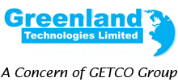
Internship Report
On
Financial and Accounting activities of Greenland Technologies Limited


Supervised By
Mr. Mosabbir Uddin Ahmad
Assistant Professor, School of Business & Economics

Submitted By
Humaira Nusrat
ID: 111 171 155
Major in Finance

Date of Submission
30.07.2022

Letter of Transmittal
Date: 30.07.2022
To
Mr. Mosabbir Uddin Ahmad
Assistant Professor,
School of Business & Economics
United International University

Subject: Submission of my internship report on “Financial and Accounting activities of Greenland Technologies Limited”
Dear Sir,
It is very much pleasure to submit an internship report on “Financial and Accounts activities of “Greenland Technologies Limited” (GETCO GROUP). I am very lucky that I have got the opportunity to make the report under your guidance of Getco Group”. I have tried my best to include sufficient information and relevant topics as much as possible along with the guidelines you have advised me.
I am very much obstructed for your directions and guidance provided throughout my report. I shall remain grateful if you kindly go through the entire report and assess my performance.
Sincerely yours,
Humaira Nusrat
ID: 111 171 155
Major in Finance

Acknowledgement

Firstly, I am giving thanks to Allah who made me qualify to make this report by giving me the strength to work. I am also thankful to all the individuals who assisted me to prepare this report.
I am very obliged to the Finance and Accounts department of “Greenland Technologies Limited” (GETCO GROUP) for granting me the opportunity to complete this whole internship report. Then I would like to express gratitude to my honorable direct supervisor SK Md Forkan Assistant Manager of Finance and Accounts department for his genuine support, cooperation, advices, and guidelines which favor me to create this report and understand variant practical aspects of Finance and Accounts activities and operations of administration in the Greenland Technologies Ltd. I am also grateful to all the coworkers and officers who boost me by make available information and support for me without which I might not be capable to make this report. I am also appreciative to the Head of Finance & Accounts Mr. Pobitra kumar, Assistant Manager of Training & Development Jihan Ahmed, and Accounts Executive Riaz Hossain who extended cooperation during my internship period.
My heartfelt gratitude to honorable supervisor of internship course Mr. Mosabbir Uddin
Assistant Professor in United International University, for his proper direction. Without him, this report could not have been a complete one.

Contents
Executive Summary………………………………………………………… 7
(Chapter-1)
Introduction………………………………………………………………… 9
Origin of the Report………………………………………………………... 9
Objectives…………………………………………………………………… 9
Broad Objectives………………………………………………………… 9
Specific Objectives………………………………………………………. 10
Methodology………………………………………………………………... 10
Limitations………………………………………………………………….. 10
(Chapter-2)
A Brief History……………………………………………………………… 12
Introduction…………………………………………………………………. 13
Products of GTL…………………………………………………………….. 15
Mission, Vision, Values……………………………………………………… 19
Institutional Framework……………………………………………………...20
SWOT Analysis………………………………………………………………..22
Strategies and Actions Formed by Management……………………………24
Company Information………………………...………………………………25
(Chapter-3)
Finance and Accounts Department………………………………………….. 27
Intern Responsibilities………………………………………………………...28
Challenges and Constrains…………………………………………………… 29
Ethics…………………………………………………………………………….30
(Chapter-4)
Financial Performance Analysis.................................................................…....32
Comparison………………………………………………………………………39
Consequences of Pandemic (COVID- 19)……………………………………...40
(Chapter-5)
Recommendation………………………………………………………...............43
Conclusion………………………………………………………………………..44
References…………………………………………………………………….......45

Executive Summary
Greenland Technologies Limited (GETCO GROUP) is one of the promoters in the telecommunications segment of Bangladesh. Greenland Technologies Limited has successfully introduced business in diverse sectors. A group of overseas knowledgeable people are overseeing the management. GTL is offering sales, services, post-sales support, consultancy etc. to the government, autonomous and private organizations. GTL also trades with several manufacturers, dealers in the area of tractor, material handling, cleaning product, racking system, air compressor and versatile industrial products.
While forming this report, I have included the financial performance analysis and SWOT analysis to detect some findings. Based on the observation some references and suggestions were included. I have added my propositions to impair the laxity of particular department. References and sources included at the end of the paper that were used.

Chapter -1

1. Introduction

1.1 Origin of the report

This report contains one of the requirements for completing the BBA program. This curriculum is included in the BBA program for real-world work experience. Only classroom learning will not enough for a student to deal with real-life situations. Working life Students can learn about the environmental elements of any business through internships. For professional life, only theoretical knowledge is insufficient. Internship is the greatest way to put academic knowledge into practice. The ideal venue to put academic knowledge into practice in the working world. Through an internship program, I can apply my theoretical knowledge in the workplace. I joined in work life as an intern in Greenland Technologies Ltd (GETCO Group) on November 01, 2021.

1.2 Broad objective
AS I have worked in the Accounts and Finance department of Greenland Technologies Limited, my broad objective of this report is:
• Knowing the progress of Greenland Technologies Limited (GETCO Group)
• Performance of the Greenland Technologies Limited compared to the similar organizations.
• To observe Greenland Technologies Limited’s general and advance activities, and their services.
• How the company conducts its operations as a single entity in various fields.
• What does Greenland Technologies Limited do to grow the national economy in Bangladesh?
• To gain overall realistic knowledge about a financial institution

1.3 Specific Objective
• To collect data about the financial system and its facilities.
• To predict Greenland Technologies Limited’s future position comparing to other similar financial organization
• To find out the reason of progress in financial sector.
• Presentation of an organizational introduction.
• To get an overall idea of Greenland Technologies Limited’s General and advance activities
•To assess the main areas of inefficiency.

1.4 Methodology

Research Approach: The internship report is actually a expositive type quest.
Data Collection: The study has arisen on information gathered by managing interviews with the executives and officers from several departments of GTL. Secondary sources like web based information, organization annual report were incorporated for data nearing.

1.5 Limitations
Although some limitations there were, the study and the report may abasement some fateful data:
- We know that function of a finance division mainly focused on organizational investment. Employees were not efficient to commend me ample time properly.
- Trainee assistance duration was not much long. It was difficult to pick up sufficient information with shortest possible time.
- Also the Covid-19 impacted very harshly on all of the students
- Because of their official constraint, they did not make me provide various information.
- All the tidings is not added in this report due to secrecy of organization.

CHAPTER- 2

2. A Brief of Greenland Technologies Limited (GETCO Group)

2.1 A Brief History

Greenland Technologies Limited is owned by:
- K.M. Khaled (Chairman of GTL)
- K.M. Rakib Hasan (Managing Director of GTL)
- K.M. Mobarak Hossain (Director of GTL)
Greenland Technologies Limited has established in 2011 but introduced its operation in the year of 2013.
Executive Director of GTL named Golam Arham Kibria help to establish the distributorship of

- Karcher
- New Holland
- Jungheinrich
- INGCO

GTL was started with only one salesman named Golam Arham Kibria who also later managed to bring the company from an infant company to a midsize company where now working about 230 employees, with 8 showrooms and 2 warehouses also its head and regional office is in Chittagong. call centers support the sales team. The showrooms and offices have now their own computers, printers and scanners. They have owned most famous audit firm AC NABI as their external auditor who audit most of the operation system for securing GTL’s as an internationally professed company for its operation.

2.2 Introduction
A concern of GETCO which is Greenland Technologies Limited has proudly terminated their business in several sectors. Many more overseas-educated persons are now engaged in the management sector. In government, semi-government, and private organizations, GTL now having agricultural product services, after sales support and multidimensional consultancy.
GTL deals with many several manufacturers, dealers in the area of tractor, material handling, cleaning product, racking system, air compressor and versatile industrial products.
GTL which has many activities for its prosperity in future. As many more brokerage businesses are operating in our country, GTL is operating successfully alongside with them. A lot of techniques has established by the company to serve their purchaser So that GTL has a shiny prospect.
Many viable methods and resolutions in the sector of farming and industrialization side are contributing by the company. As Bangladesh is hugely depends on agriculture and GTL is contributing its best way possible in this sector. Different kinds of Agro-machineries GTL has lunched for agriculture and industry. a big ratio of the population the organization has targeted to serve with the help of their modern technologies.

2.3 Currently they are working on some divisions. They are:
- Demag Overhead Crane
- Jungheinrich Material Handling Equipment
- Noveltek Forklifts
- Karcher Cleaning Equipments
- Boge Air Compressor
Demag Cranes & Components which is famous for cranes and hoists that includes bridge, traveling, freestanding, workstation cranes, electric chain and rope hoists.
A company situated in Germany named Jungheinrich initiated with number of 30 employees and exhibited over the succeeding decades which gins annual revenue of two billion euros. Jungheinrich is among top 2 firms for industrial truck engineering
Noveltek which is situated in Taiwan generates electric forklift, power pallet truck, power stacker, counterbalance reach truck, lift table, semi-power stacker and hand pallet truck, pallet jack.
Alfred Kärcher introduced his cleaning technology in 1950 will continue itself in future with its creative objects, innovative performance & solutions.
BOGE has more than 100 years of knowledge to produce and manufacture best quality compressor invention. BOGE assemblies wide range of oil lubricated and oil free screw.
New Holland technology serving the farmers around Europe over 110 years. It manufactures equipment like hay and harvesting, crop production, forage & materials handling.

2.4 Products of Greenland Technologies LTD
NEW HOLLAND
Agricultural vehicles & tools of New Holland are the main products of GTL and GTL is the distributor.
• Tractors- There are manly two types of tractors with series 3000 and 4000. Names of that are NH 332, NH 32/30, NH 3/37, NH 3/10, NH4710, NH 4/10.
• Cultivation tools- NH Disc Harrow

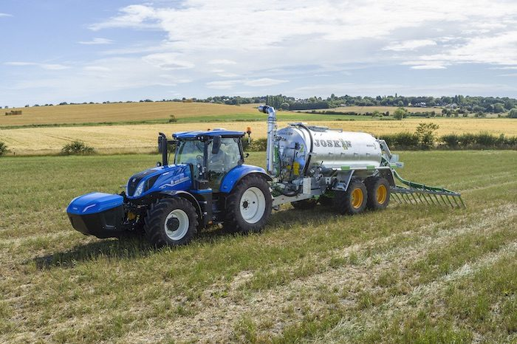

KARCHER
KARCHER is well known cleaning product brand. Tools are named Cold-Water High-Pressure HD 16M, Hot Water High Pressure HDS E 8 M, Cold Water Hight, Pressure HD 25S, Wet and Dry Vaccum NT 65 Tact etc
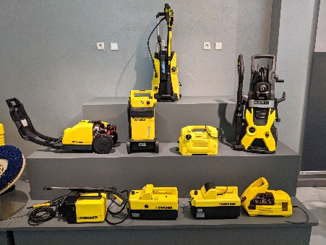



JUNGHEINRICH
A Germany company Jungheinrich is actually holding GTL as product distributor. The products are nmed: Forklifp, Paltets, Order Piker, Leviss Truck.
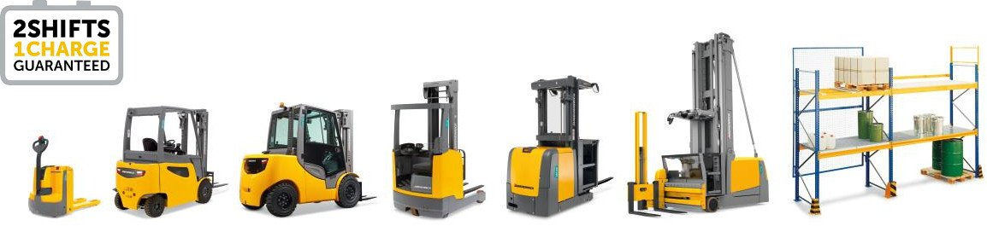


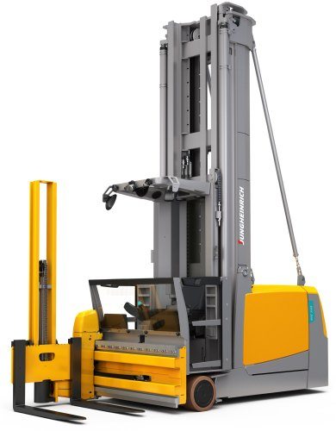

INGCO
INGCO has hand and power tools like CABLI2001.



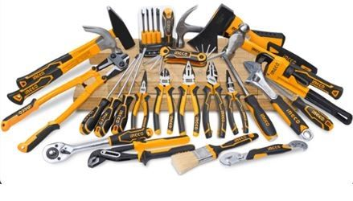

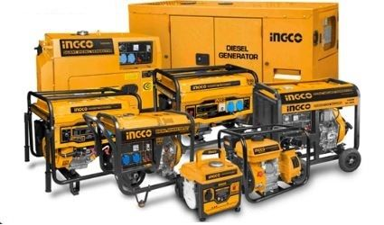

2.6 Mission of GTL

- Transparency: In all business trading, they are transparent. while obeying fame and assets, they are answerable to their team members, shareholders and customers for attaining goals
- Veneration: They ensure a protected and bloomy environment for team members, respect the differences in thinking of different peoples, backgrounds and cultures and also praiseful to team member growth.
- Headway: They always trace for something unique and best path of getting good things, deducting leftover and assemble improving.
- Customer Service: They work for serving the requirements of customers, upbringing a philosophy called “chain of support” versus “chain of command

2.7 Vision of GTL

To bring the easiest solution to practice easier life they always give attention on their customer satisfaction. Customer is their first priority in all matters.
They follow a values that respect resolution and continuous progress towards the coming objective of the company.

2.8 Values

They respect their employees because employee is their main and important strength. They figure out the issues at the time of creating value for the customers are given below:

- Safe and secure working environment
- High availability of equipment
- Cost-effective functions
- Proficient utilization

2.9 Institutional Framework of GTL
Greenland Technologies Limited’s corporate office is located in 26, Shamoli, BirUttam Chowdhury Road, Dhaka-1207. It consists of 3 corporate units. They are: finance & accounts, sales and operation unit. The top most evolving unit is operation & sales unit. Here, sales unit mainly handle company’s display outlet and this specific department hired multi-talented & skilled salespersons to manage various segment of buyer.
GTL’s financial department functions creatively and also maintains everything with expertness. At first, the finance team sustain every issues practically & successfully. Secondly, a super strong operative audit department for examining whole transactions which are correct or not. The Company has also VAT and Tax department which involve working with the Tax and Vat related issues that are related to transaction. The company having software called Tally to retain record of all the things related to transaction. GTL operates its daily official schedule for six days a week. Regular office hour is from 9.00 am to 6.00 pm.
GTL follows efficient segmentation process for its products. These are organic seeds, different kind of fertilizers, agricultural machineries and versatile industrial equipment. Display centers to the ever growing buyers, GTL serve their products with patience and compassion. It is really amazing that their organizational structure is very much complete in all portion for a mid-sized origination like GTL.

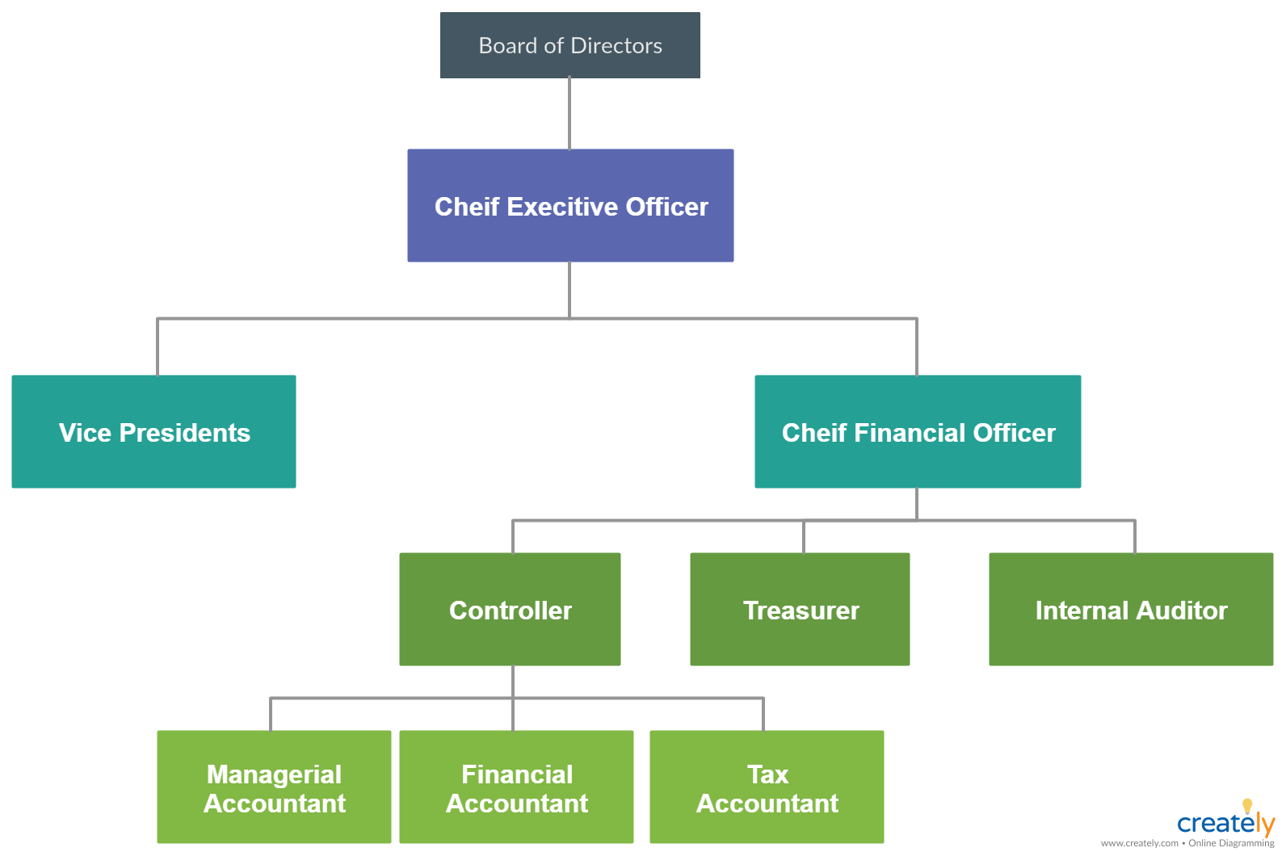

2.10 SWOT Analysis of GTL

Strength:
- This company’s software and technology is totally secured.
- This company is growing rapidly and highly potentiality to sustain
- Earning foreign currency.
- This company has less competitor in the industry.
- Employees feel more job security.
- Favorable brand image

Weakness:
- As the client and advisor cannot physically meet, a communication problem occurred.
- As it is totally new in Bangladesh that’s why employees need to train in detail which is very time consuming.
- Sometimes tradesmen most of time causes problems in cost minimization.
- Lack of attention in promotional activities.
- Less organized distribution
Opportunity
- As there is less competitor in Bangladesh it has high potentiality to grow rapidly.
- Exclusive Gratuity and Bonus Facility.
- Product sales by credit system
- Air-conditioned office rooms
- The company’s Market position is exceptionally better because its exponential growth in business.

Threat
- It is totally new in Bangladesh.
- Totally depend on third party Company in India.
- There are chances to make mistake as it is new to Bangladeshi people.
- Other similar product holder company whose have similar products
- A Continuous increasing of VAT and tax on imported goods.

2.11 Strategies and Actions Formed by the Management
- There are lots of methods, steps & strategies taken by the management team for the progress and betterment of the organization.
- GTL has obtained a renowned audit team named ACNABIN to handle and monitor accounts & all operation of the organization for making best quality of services.
- GTL has very effective sales department because the company gives 70% importance to the sales for achieving targeted sales.
- GTL arranges performance appraisal every after 3 months where it selects the employees who accomplished their work and activities best from every department.
- For ensuring better shipment, GTL merged with MM Cargo which has deal with organization to deliver the products on time to the customers.
- GTL depends on Tally software which is much helpful software and the employees are engaged in posting daily transections.
- The company has expert IT unit to keep up the TALLY and other software used by different department of the company and having a social media advertisement where details description of goods is tailored for the buyers.

2.12 Company Information

Name of Company: Greenland Technologies Limited
Established: 2011
Type of Company: Private Limited
Registered in: Bangladesh
Chairman: 1
No. Of Directors: 2
E-mail: info@greenland-bd.com

Hotline Number
+88 01713 14 87 00
Headquarters:
26 Shyamoli, Bir Uttam A. W. Chowdhury Rd, Mohammadpur Housing, Dhaka, 1207, Bangladesh

Website: www.greenland-bd.com

CHAPTER- 3

3. Undertaken Activities

3.1 Finance and Accounts Department
As an accounts and finance department’s intern I have the opportunity to learn and gain various experiences. I have performed research, work with financial reports and reconciling accounts and other duties.
For controlling cash flows operation, the company has finance & accounts department. They are responsible for running the operation very smoothly, the department assist the individual employee for knowing details about the prospect in financial job field. Here finance interns responsible for duties including preparations of various reports, keeping notes during seminar, data processing, and entail audit related tasks with executives.
Apart from this, I have completed paper work while observing related to portfolio management, accounting, financial reporting. GTL has an efficient and active team which having 15 human resources for departmental activities. The workforce implements the day to day tasks and strategies of the company. The executives prepare annual reports and statements every year to summarize company financial outcome. Employees keep every details and records of transactions regularly with the help of TALLY. The system of this software is a little difficult so that the employees are always careful in maintaining activities of accounts and finance.

3.2 Intern Responsibilities:
At the time of my internship period, I have worked in a tem which is a new team. Here, some of my responsibilities are given below:
- Working with bookkeeping software
- Support and prepare financial model
- Deliver accounting and financial related support
- Bank reconciliation task
- Understand annual budget reporting
- Preparing balance sheets and income statements, invoices, and other documents.
- Collaborate with different projects related to statistical data.
- Make automated software recommendations to the manager.
- Attend relevant meetings and vendor events.

3.3 Challenges and Constrains
During my internship at Greenland Technologies Limited, I have faced some obstacles and limits, which are detailed below:

Training
As it was a new department, so it takes more time to arrange a training session and it was arranged all of a sudden so first day we all have faced some technological problem. As I was not familiar with such type of work so, is took time to catch the overall idea. And I was only one intern in the training session, so I was very nervous.

Work Pressure
As I mentioned before that I am only one person in that department, so all the pressure is going through me. And every day I have to complete at least 4/5 bank reconciliation which is very difficult for me as I was new.

Technological problem
Sometime the internet connection is lost in middle of the work and its very irritating when sometimes I have to escalate any task urgently and also meeting the deadline. Sometime VPN also doesn’t work.

Limited access
In case of tally software there is limited access of the employee. There is only 35 access in the software and there is no access for intern. So many times I need to use tally but could not logged in because of access was not available for the intern. That time I was in very much difficulties. I had to wait for someone’s logging in. As almost all work is depending on tally software was very difficult in that moment.

Others
• We are unable to study any practical work during our education and are unaware of the realities of corporate life.
• During my studies, I conducted all of my calculations and assignments on paper. But things are different here. In paperless, I use a number of stuffs. For Example, When I come in the office, I punch my finger print, and the system records my sign-in and sign-out times automatically. I have addressed my course faculty as sir or madam in my academic life. The difference here is that I addressed my superiors & coworkers.

3.4 Ethics
To flourish morality among the employees and gain belief and confidence from stakeholders, GTL places some business ethics for ensuring that at least minimum trust and faith subsists between consumers and several market participants with businesses. Whatever commercial ethics are adorned in the labor law, they are minimum payout, business to business trade restrictions, and concern related to environment.
Further thing is that trading ethics actually described by organizational behavior. All parties including investor awareness on sustainable issues largely depends on the company's reputation. Ethics which support the company to run and continue the business activities resides in the periphery of the law, assure that no one is practicing offenses against anyone concerned in the practical field. They will be more likely to invest into the trade, by obeying the ethical code and conduct by leveraging established rules and regulations.

CHAPTER- 4

4. Financial
Performance Analysis

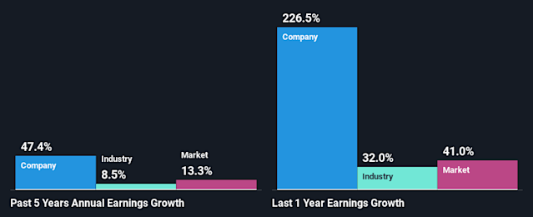

4.1 Financial performance analysis

Greenland Technologies Limited never pursue any elements of derivative market and also GTL never hedge the rate of currency. Yet, GTL explore its financial performance that is always connected to the exchange rate.
Net profit margin
Net profit margin helps to describe the amount of net profit against sales.
It is denoted as: Net profit/Total revenue
2018 | 2019 | 2020
24.70 | 21.56 | 17.54

Fig: Net profit margin of previous years
As from the diagram, it could be deduced that net profit margin declined from the year of 2020 which is the last year according to the diagram. It is also noticeable that, net profit went down because of cost of commodities sold. Pandemic COVID -19 outspread all over the world and such reason sudden hike of foreign currencies happened. As GTL never follows constant foreign currency rate, it faced a downfall. Even the inward currency transaction was stopped because of immobility in various countries identified as a prime reason of less profit.

Return on Asset
ROA actually display us how the assets raise the profit.
It is counted by:
Net profit/Total asset

2018 | 2019 | 2020
4.98 | 5.87 | 4.65

Fig: Return on asset of previous years
Here the diagram explained that ROA is much more fixed for last 3 years and also the noncurrent assets remains identical for past 3 years but it was observed that current assets value was not. Current asset decline as a reason of deficiency in asset inventory. Moreover, we know cost of shipment goes up as well as the weight charge becomes very high. As a result, the cost of products goes high and net profit fall down.

Return on Equity
ROE tells the amount of net profit created by exercise the equity.
The ratio is denoted by: Net profit/Total Equity
2018 | 2019 | 2020
26.43 | 21.89 | 19.43

Fig: Return on equity of previous years

ROE actually monitor by using total equity, in what extent a firm can create profit. It can be estimated from the diagram that, decline in ROE and also can mention that the whole equity increased significantly.

Debt to Equity ratio
Subject mentioned topics tells us if a business entities equity efficient to backing its debt or not. We know that in elevation debt to equity ratio is too much hazardous for business.
The ratio shown by:
Total debt/Total equity
2018 | 2019 | 2020
5.09 | 5.33 | 5.99

Fig: Debt to equity ratio of previous years

As from the diagram we look-out and notice the debt-to-equity ratio became upper for consecutive years. So there remains a hazardous situation of debt to equity ratio and GTL had higher debt to ratio in 2020. Liabilities of GTL stood also rise because of pandemic. COVID generated a hazard for GTL to conduct the leverage in accurate way.

Debt to Capital Ratio
This ratio provides whether business investment is able to conduct the indebtedness of a company or not. It indicates the ratio of debt verses its capital.
The ratio is mesured by:
Total Debt/Total Equity

2018 | 2019 | 2020
0.80 | 0.84 | 0.85

Fig: Debt to capital ratio of previous years
GTL’s this ratio is almost fixed and it is remarkable as well capital arrangement of the company. Although it has grown over the year but the rise is very low. Also the worldwide pendamic power did not touch the debt to capital ratio of the company deeply. The company was able to gather strong fund.
Debt to Asset Ratio
The ratio indicates the amount of obligations a business firm has outstanding to its total asset.
The topic is explained by:
Total Debt/Total asset
2018 | 2019 | 2020
0.877 | 1.28 | 1.42

\
Fig: Debt to asset ratio of previous years
From diagram, the subjected ratio is over 1. It is a very meagre symbol for GTL. This ratio over one notify that, liabilities exceeds the asset. GTL has faced an amount of current liabilities which was greater in size for the year 2020. At termination of year 2019, GTL operate few LCs on account but products appear delayed because of pandemic. So there happened increment in current liability & the debt to asset ratio became upper compared to the former years.

4.5 Comparison

There are mainly 2 competitors of GTL in Bangladesh. They are ACI Motors and Nitol Niloy Motors. GTL is doing comparatively good than competitors. Their ratios and other measurement are quite good as they have started their journey newly compare to the competitors. If we see in the year of 2018-2020, ACI Motors having Net profit margin which is smaller. It was 20.54 in 2018, 20.43 in 2019 and 22.65 in 2020 and for Greenland Technologies limited it was 24.70 in 2018, 21.56 in 2019 and 17.54 in 2020. The main cause was ACI Motor’s cost of goods sold was very high.
If we look at ROA of Nitol Niloy Motors from the year of 2018 to 2020 we noticeable that Nitol Niloy was holding much ROA relate to GTL. From 2018 – 2020 the ROA of Nitol Niloy Motors was 5.98, 6.89, 6.79 and GTL had their ROA from 2018- 2020 was 4.98, 5.87, $ 4.65. The current asset of the business risen from prior times however the inventories reduced for the reason of deficient onrush of business goods .
If we look at ROA of ACI Motors from the year of 2018 to 2020 it is observeable that ACI Motors have less ROA compare to GTL. From 2018 – 2020 the ROA of ACI Motors was 4.23, 4.87, 5.43 and GTL had their ROA from 2018- 2020 was 4.98, 5.87, 4.65.
If we see in 2018-2020 we can see that ACI Motors had more ROE but Nitol Niloy Motors had less ROE than GTL. It was 20.59 in 2018, 20.48 in 2019 and 22.34 in 2020 for Nitol Niloy Motors and for ACI motors it was 24.12 in 2018, 26.87 in 2019 and 22.54 in 2020. On the other hand ROE of GTL from 2018 – 2020 was 26.43, 21.89, 19.43.
So we can see that, GTL doing moderately good in the industry compare to their competitors.

4.2 Consequences of COVID 19 on exchange rate
There are many reasons of currency value fluctuations. COVID -19 was spread all over the world and declared complete shut down, therefore a sluggish economic progression fall out. So coinage value turn out in very downcast amount. Therefore from the fact, we can enumerate that economy regain without delay. When COVID invaded in China, China call a halt the exterior transection and the economy induced immensely powerless and then China take up arms against the virus and then the currency value started to bloom freshly. From this, we can state that vast stress on currency due to pandemic created trouble across the whole world.

4.3 Consequences of pandemic in Import business
Here upshot of pandemic causes broad effect in the importation section of Bangladesh. There happens economic downfall, financial exigency and many more reasons. According to Bangladesh bank annual report, Letter of credit amount curtailed by 24.34%. Letter of credit introduced by the ingredient corporations goes down by 0.574% and within the same time, import job fallen around 2-3 times greater. For this situation, the buying potency of individual slow down. Demand fell sharply as a result perishable demands & traders put an end in fetching products from other countries.

4.4 Consequences of pandemic in GTL
Due to pandemic situation worldwide, GTL faced critical situations as an import based business. Almost all the nations closed across borders because of lockdown. So transmission of products by shipment was not possible. Like, New Holland tractors of GTL which always imported from USA and at the time of COVID, USA was extremely invaded by COVID and locked down was announced. So, GTL failed to import tractor and unable to sell to the purchaser and it creates fall of the company’s profitability. Jungheinrick, German based organization with which GTL has a distributorship, but for COVID condition, it was impossible to import from Germany. So, again profit fallen. Here, it can be deduced, pandemic situation extremely attacked GTL business process.

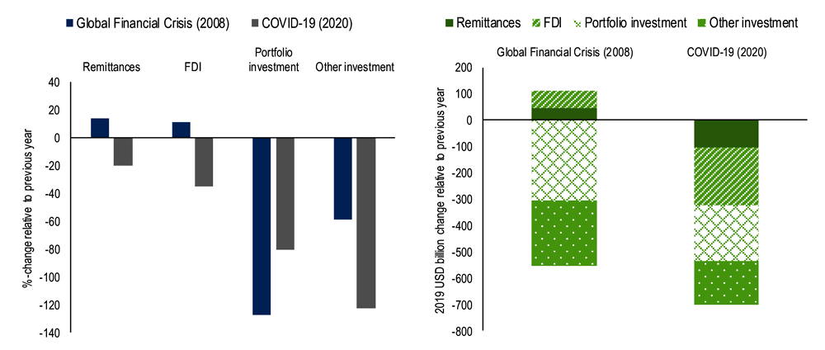

CHAPTER- 5

5. Recommendation and Conclusion

5.1 Recommendation
By working at Greenland Technologies Limited head Office, It was a great opportunity for me. Within this tenure, I came to learn various aspects of a business organization. From my gathered knowledge I have some recommendations as follows:
All new employees must develop themselves training on work related areas. So, it will be easier for employees if Greenland Technologies Limited provides an instruction for different kind’s tasks. They can make slip-ups as it is their first hands on. So, I also think Greenland Technologies Limited should make some samples of work for the new employees so that employees can practice.
As most of the activities of Greenland Technologies Limited is dependent on Tally software, the organization should increase the access of Tally for the interns. So that one doesn’t have to wait for the other to help.
After joining Greenland Technologies Limited, every new employee should receive sufficient amount training. It is necessary to arrange training session. Each department should have a clear mission for each department. So that new employees do not have to wait for training sessions to be scheduled.

5.2 Conclusion
In the first instance, this internship report would be conducive for business entity or institution involved in import based business beyond the border. This could be helpful for any future knowledge seeker will able to grab idea on Accounting and Financial activities of GTL.
The report includes the coinage rate variation and the company faced unstable foreign currency rate policy. It experienced a great deal of difficulties during and after pandemic period.
This report clarifies about in house import activity was vastly affected by the pandemic situation for more than two years. It has been clearly observed by the financial analysis report depicted on this paper.
It was a challenging task for accounts and finance department to formulate and publish annual financial reports on time. Every sections of the organization should be praised for this synchronous activity. Various financial aspects were depicted throughout the report by illustrating business ratios for current to previous years. Moreover, my recommendations that GTL can be praised for their best performance.
My internship supervisor Mosabbir Uddin Ahmad has helped me a lot to gather real life work experience during my tenure at GTL. I tried my best to illustrate my knowledge and experience along with company portfolio, business structure, procedure, inter department work assignment in this internship report. I will try to implement my gathered knowledge and technical expertise in future endeavor.

References

- https://www.dhaktribune.com/busness/econmy/2021/05/19/imports-decline-due-to-covid19
- https://www.bdttradeinfo.com/company/48883/greenland-technologies-limited
- https://www.unityjobsbd.com/about-company?cid/Greenland20Technologies%20Limited
- http://www.bdtellytyellowbook.com/catalog/BusinessServices/
- http://www.emeraldinsight.com/researchregister
- Imports decline due to Covid-19. Dhaka Tribune. (2021, May 17)

