

Internship Report
On
“Accounting Standard of NCC Bank PLC-An Overview”



Supervised By:

Dr. James Bakul Sarkar

Associate Professor

School of Business & Economics

United International University

Submitted By:

Sabrina Aurpa

ID: 111193018

Major: Accounting

Bachelor of Business Administration

United International University

Date of Submission: September 30, 2024



Acknowledgement:
Above all, I want to express my gratitude to Allah for enabling me to complete and submit the internship report on schedule. Internships require core things- self motivation, self-drive and time management, and I would also use this opportunity to thank all those that have inspired, guided, and supported me during the internship.
My genuine gratitude goes to Dr. James Bakul Sarkar my faculty advisor as well as to United International University for their support in writing my report. He was able to supervise and direct my work to avert the risk of delaying the completion of the task.
Moreover, I would like to real in Mr. Md. for assistance as well. I want to express my gratitude to Mr. Amzad Hossain, who is the Branch Manager of the Foreign Exchange department at NCC Bank PLC, for providing me with the opportunity to test my skills as a banker. A lot of thanks go to Jaima Juthi, senior officer who supported and made my work more productive and positive. Her assistance helped me in increasing the effectiveness of my internship such acquiring useful data. To all the staff at the NCC Bank Foreign Exchange Branch, I owe a great deal of gratitude for their assistance during my internship time.
Moreover, I wish to show my gratitude and thank Muhammad Shaiful Alam, credit in charge at NCC Bank, Foreign Exchange Branch, for broadening my comprehension of the banking system and for providing the insights of the Foreign Exchange Department that improved this report.
Regarding the final part of the report, I am thankful to the United International University for providing this internship opportunity to the students. this in a very efficient way prepares the students for professional career even before joining the business circle.

Letter of Transmittal:

September 30, 2024
Dr. James Bakul Sarkar
Associate Professor
School of Business & Economics
United International University (UIU)

Subject: Submission of Internship Report On “Accounting Standard of NCC Bank PLC-An Overview”
Dear Sir,
I’m writing report that I am turning in the final report on the “Accounting Standards of NCC Bank PLC – An Overview” for completion. I have completed three months of internship at the foreign exchange branch of NCC bank located at Motijheel. I have put forth my best effort to make sure that this report contains a thorough mix of knowledge from my academic background, professional experience, and internship learnings.
With the facts, figures, data, information, and insights gained from the activities of NCC Bank PLC, I have been able to compile a well-organized report. During the period of doing my internship, I undertook a variety of normal banking activities such as issuance and collection of cheque books, opening of accounts, cheque, and ATM card reconciliation, and assisting in the movement of funds from one entity to another. In addition, I was able to spend time working in the Foreign Exchange Department.
I thank you very much for all the assistance and other resources that were accorded to me towards the preparation of this report. It is because of your cooperation; I have made progress in acquiring practical knowledge and skills which will in a huge way benefit me in seeking opportunities in the job market with great competitiveness in the coming years.
Sincerely yours,
Sabrina Aurpa
ID: 111 193018
BBA Program
United International University (UIU)

Declaration by Student:
Submitting the report on "Accounting Standard of NCC Bank PLC – An Overview" is mandatory for graduating from the Bachelor of Business Administration (BBA) program.
I’m confirming that I have finished this internship report myself. I have collected diverse information and data from numerous sources to assist in creating the report. I have also strived to offer helpful information to enhance the relevance and validity of this report.
Sabrina Aurpa
ID: 111 193018
School of Business & Economics
United International University (UIU)

Table of Contents

Abstract 01
- Introduction 02
  - Introduction the topic 03
  - Overview of the organization 04-05
    - The legal and regulatory environment in Bangladesh 05
  - Objectives set by the study 06
    - Primary objectives 06
    - Secondary Objectives 06
  - Rational of the study 06
  - Scopes Defined by the study 07
  - Limitations Identified by the study 07
- Methodology used in the study 08
  - Type of Data 09
  - Data Collections 09
  - Sample size 10
  - Sampling Technique or Procedure 10
  - Scope 11
- Organizational Background and Industry Analysis 12
  - Industry Overview 13
    - Background Provided by the Industry 13
    - Before Independence 14
    - The Industry After Independence 14
  - The economy's contribution 15
    - Contribution to the Global Economy 15-16
    - In The Bangladesh Economy 17-18
    - In The Banking Sector 19
  - Historical Overview of the Organization 19-20
    - Mission Statement of NCC Bank PLC 21
    - Vision Statement of NCC Bank PLC 21
    - Values of NCC Bank PLC 22-23
    - NCC Bank PLC Corporate Information 24
    - Strategic Focus of NCC Bank PLC 25
  - Operational Activities 25
    - Product/Service line 25-29
    - Risk Management Framework of NCC Bank PLC 30
  - SWOT Evaluation of NCC Bank PLC 31-33
  - PESTEL Framework for NCC Bank’s 33-37
- Findings and Analysis of the study 38-39
  - Data Analysis and Interpretation 40
    - key Benefits of adopting IFRS 40
    - limitations of adopting IFRS 41
    - Clarifying the Role of IFRS in Enhancing Accounting Information 42
    - Understanding the Impact of IFRS on Financial Reporting 42-43
- Annual Report 44-51
- Conclusion and Recommendations 52
  - Conclusion 53
  - Recommendations 54
Reference 55

Abstract:
IFRS and IAS serve as the main rules for financial reporting worldwide, guaranteeing uniformity and clarity in accounting procedures. This report delves into NCC Bank PLC’s procedures & adaptation of IFRS, highlighting bank’s alignment with these standards. The objectives include examining the legal and regulatory framework essential for IFRS adoption and understanding the overall implementation process. Data for this study were gathered through an internship and secondary sources. The findings reveal that IFRS adoption has significantly enhanced the quality of financial reporting at NCC Bank PLC, giving stakeholders a clearer & more open look at the bank's financial well-being. Furthermore, the adoption of IFRS has contributed to better comparability and reliability in financial statements, fostering greater investor confidence. The report also identifies challenges faced during the IFRS implementation process, such as regulatory hurdles and the need for extensive staff training. These insights are crucial for appreciating the benefits and obstacles of IFRS adoption within the banking sector of emerging economies like BD.

- Introduction

Introduction

Introduction the topic

Accounting standards are essential principles that guide financial accounting practices, ensuring consistency and comparability across different entities fairness across fields. The primary principles are derived from the International Financial Reporting Standards (IFRS) and the International Accounting Standards (IAS).

These standards requires that organizations worldwide prepare and present their financial statements for external stakeholders, such as investors, regulators, and analysts. While financial statements might look similar internationally, differences can arise due to varying social, economic, and legal contexts, reflecting the specific needs and regulatory requirements of each country.
The IASB has a crucial role in aligning financial reporting standards globally. Its goal is to minimize the differences in accounting rules by encouraging the adoption of IFRS. These standards offer a uniform approach to financial reporting, enhancing transparency, consistency, and comparability of financial information across borders.

IFRS is now regarded as the leading global accounting standard, with over a hundred countries either requiring or allowing its use. This widespread adoption is driven by IFRS's ability to improve the comparability of financial statements, which is crucial for investors and other stakeholders. The standardization provided by IFRS simplifies financial reporting for multinational companies, fosters international investment, and supports financial stability.

The benefits of adopting IFRS include reduced capital costs for businesses, improved capital allocation efficiency, and enhanced investor decision-making. By providing a clear and consistent reporting framework, IFRS contributes to more transparent and reliable financial statements. This transparency mitigates reporting risks and ensures stakeholders have access to high-quality information, ultimately promoting more efficient global capital markets.

Overview of the organization

Accounting rules are the policies ordering how to manage accounting transactions in financial statements. Accounting regulations offer businesses clear instructions on the proper Way to prepare and present financial statements.
Prior to the implementation of accounting standards, each company had its own methods for creating and sharing financial data. After the financial crisis of 1929, the American Institute of Accountants (AIC) partnered with the New York Stock Exchange (NYSE) to establish the Commission on Accounting Procedures (CAP). This CAP proposed five basic accounting principles to establish uniformity in financial reporting.
Members of the Institute enhanced the calculation method and added another principle, resulting in a total of six. Businesses slowly enacted the Securities Act of 1933 and the Exchange Act of 1934, resulting in the establishment of the Securities and Exchange Commission (SEC). The SEC is tasked with conducting thorough reviews of companies' filings to guarantee adherence to SEC regulations, such as complete disclosure, comprehensive accounting, and comparability. Accounting has specific regulations that control the documentation and communication of financial transactions. This guarantees that crucial information is efficiently relayed to external entities like shareholders, banks, and regulators. Technical standards enhance accountability and transparency by setting clear limits between various financial reporting metrics.
IFRS outlines various transactions impacting finances and advises multinational corporations on how to handle and showcase their financial statements. It is a group of accounting rules that enables consumers, companies, and investors to assess financial data and make inferences. The aim of IFRS is to establish a uniform set of standards across the world to enhance transparency, efficiency, and accountability in international markets. IFRS suggests the factors. essential for businesses as they enable investors to put their money into companies that have transparent business operations. IFRS demands a range of financial statements, such as cash flow statements, comprehensive income statements, balance sheets, and equity changes statements. The International Financial Reporting Standards (IFRS) were established and endorsed by the independent private organization called the International Accounting Standards Board (IASB) to govern global financial reporting standards. The control of the IASB is managed by the IFRS Foundation. Founded in 2001, the IASB was established to replace the International Accounting Standards Committee (IASC).
According to the IFRS Foundation's Constitution, the IASB oversees overseeing all technical matters concerning financial reporting.

- Complete autonomy in deciding on technical matters: The IASB has the authority to establish and pursue its own technical agenda, although it must consult with the Trustees of the IFRS Foundation and the public.

- Preparation and Issuance of Standards: The responsibility of developing and issuing International Financial Reporting Standards (IFRS) and exposure drafts lies with the IASB, in accordance with the procedural rules outlined in the constitution of the IFRS Foundation.

- Approval of Interpretations: The IASB gives its approval to interpretations created by the IFRS Interpretations Committee and releases them to offer guidance on implementing IFRS standards.

The legal & regulatory environment in Bangladesh

ICAB is the primary organization in charge of approving and supervising the accounting industry in Bangladesh. ICAB pledged implement and enhance accounting standards within the nation. ICAB has embraced both IAS and BAS while making slight adjustments to fit local requirements to conform with global standards.
Once these guidelines receive official approval, the Bangladesh Securities & Exchange Commission (BSEC), mandated by the Bangladesh government, will implement them, monitors adherence to these regulations. BSEC ensures that publicly listed companies in Bangladesh adhere to BAS, thereby maintaining transparency and consistency in financial reporting across the corporate sector.

Objectives set by the study

Primary objectives:
To showcase how NCC Bank is applying Accounting Standard (IFRS & IAS) and the importance of integrating it into their accounting practices.

Secondary Objectives:
The goal of this research is to improve comprehension of NCC Bank PLC and its Accounting Standards. The research aims to achieve goals. Rewrite the following text using the same language and word count:

- Understanding accounting regulations and getting an introduction to NCC Bank PLC.
- Outline the key benefits of implementing IFRS.
- To guarantee restrictions in implementing IFRS.
- Explain the importance of IFRS in enhancing accounting data.
- The consequences of IFRS on financial statements.
- Evaluate the performance over the past three years.

Rational of the study

During my internship at NCC Bank PLC, an established private bank in Bangladesh, I have been assigned to the Foreign Exchange Branch, Motijheel. This study is a component of the BBA program offered by United International University (UIU), within the School of Business Administration. where I am majoring in accounting. The internship provides an invaluable opportunity to gain practical banking experience, which is essential for bridging the gap between academic knowledge and real-world applications. Completing this three-month internship is a mandatory requirement for the BBA program, and it has been instrumental in enhancing my understanding of the banking industry. This report will explore various aspects of NCC Bank PLC, focusing on its operations and the current environment within the banking sector

Scopes Defined by the study

The characteristics of NCC Bank and the current environment in the private banking sector will be examined in the report. During a quarter, my role at NCC Bank involved collaborating with and assisting a higher-ranking official. In the initial days, I watched each assignment closely after getting to collaborate with the officers.

Limitations identified by the study

The work over the topic throughout my internship gave me valuable information, but I did not have time to delve into this topic. Also, since it was an individual and confidential assignment, I had to manage the entire process independently. Because of time limitations, I couldn't carry out my work in a comprehensive and systematic way, which made this difficult to complete an in-depth qualitative analysis within the allotted time frame.

Methodology used in the study

Type of Data

There are two types of data: primary and secondary data.

Primary data: This information is gathered firsthand by the researcher through surveys, interviews, or observations.

Secondary data: This refers to information that has been gathered by other individuals and is available in books, reports, or online platforms.

Data Collections

Data Collections

Primary Data
Secondary Data
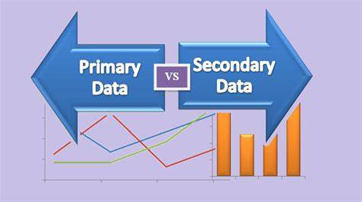

Primary Data: - I collect this information through direct experiences during my internship at NCC Bank Foreign Exchange Branch, where I participated in practical tasks and had informal discussions with my manager.
Secondary Data: - To obtain secondary data, I have done a thorough review of the official website of NCC Bank, its latest annual reports, and various related online articles. These resources together provided a thorough understanding of the bank's compliance with accounting standards and the importance of integrating IFRS and IAS
Into its financial systems.

Sample Size: -
Identifying the information, I aim to gather and the places I can obtain it from is referred to as research. At the start, I gathered information in various forms, including data from analysis, surveys, and secondary sources. There are many research possibilities to think about, but my focus is getting precise and reliable outcomes.
I did a thorough examination of theories and studied content for my internship report focused on Accounting Standards at NCC Bank PLC.

Sampling Technique or Procedure: -
The main sampling method utilized in this study was non-probability sampling, more specifically convenience sampling. This approach was chosen because data was collected on the availability and relevance of resources encountered during my practice. Primary data was collected from direct experiences and informal discussions, while secondary data was selected based on its accessibility and relevance to the subject of the Accounting Standards of NCC Bank PLC. This method allowed me to focus
the most important information while ensuring that the data was appropriate and manageable.

  - Scope: -
- Area: The purpose of this study was specifically focused on NCC Bank PLC, with a particular emphasis on the foreign exchange branch where my internship was carried out. This branch served as the primary hub for collecting firsthand data and overseeing the bank's activities in compliance with accounting regulations.

- Time: This study covers the data and experiences collected during my internship period, which spanned from June to September 2024. This time frame allowed a detailed review in the bank's practices & this collection into relevant data for a period of three months.

Organizational Background and Industry Analysis

Industry Overview

Background provided by of Industry
An institution that facilitates a wide range of monetary transactions, including the management of deposits and loans. Banks serve as intermediaries between individuals who deposit money and those who seek loans, thus playing a crucial role in the economy. They can be classified into several types, including investment banks, which focus on financial markets and large-scale investments; commercial banks, which handle everyday banking needs and business loans; and retail banks, which cater to individual customers with services such as savings accounts and personal loans.
In addition, the central bank is a primary institution responsible for overseeing the entire banking system of a country. In Bangladesh, this role is fulfilled by the Bangladesh Bank, which regulates and supervises all commercial banks and financial institutions. The central bank has a vital role in carrying out monetary policy, controlling inflation, and ensuring financial stability.
Banks not only manage the finances of individuals and businesses, but also contribute significantly to national development. By collecting deposits from the public, banks can provide loans that support various sectors of the economy, including trade, agriculture, and industry. This process of channeling funds to productive sectors helps drive economic growth and development, making banks an essential part of individual financial well-being and broader economic progress.

Before Independence

- 1770: Mr. Alexander and his associates established the Bank of Hindustan in Calcutta, which was the initial bank formed in Bengal and functioned until 1832.
- 1809: The Bank of Bengal acquires control of the Bank of Calcutta. The Bank of Calcutta was founded in 1806 and underwent a rebranding in 1809.
- 1846: The Dacca Bank, the first western bank, was founded in Dhaka. Afterwards, it combined with Bank of Bengal.
- 1873: Two branches of the Bank of Bengal were established in Dhaka.
- 1900: Another branch was established in Chandpur.
- 1947: At the time of partition of India, East Bengal had six branches of different banks.
- 1965: Eastern Banking Corporation had expanded to sixty branches.

The Industry After Independence
The banking sector in Bangladesh was established in 1971 with ambitious goals to promote social justice and economic equality. At the beginning, the sector included six domestic commercial banks, two state-owned commercial banks, and three global banks. The primary financial institution of Pakistan is the Central Bank. Which handled monetary policy and financial regulation, was restructured, and renamed Bangladesh Bank to assume its new role.
Bangladesh Bank is charged with a wide range of responsibilities, including currency management, credit control, fiscal policy implementation and foreign exchange administration. It also managed the government's currency reserves. In a significant policy change, the government nationalized 12 financial institutions, consolidating its control of the sector.
Initially, the banking system of Bangladesh was characterized by two main types of banks: nationalized banks and private banks. The regulatory framework required banks to obtain licenses to operate, with the Banking Companies Act of 1991 providing a structured legal environment. Under this Act, the Bangladesh Bank has controlled and regulated the country's 56 scheduled banks since 1972, ensuring compliance with banking rules and regulations.
These foundations laid the foundations for a rapidly developing banking sector that has grown and adapted to meet the demands of a developing economy, continuing to play a major role in the financial stability and economic progress of Bangladesh.

  - The Economy’s Contribution
3.2.1 Contribution to the Global Economy
The worldwide economy faced tougher conditions in 2022 than anticipated at first. The widespread spread of the Omicron variant of COVID-19 has prompted many governments to enforce fresh restrictions to manage the outbreak. This has led to higher-than-expected inflation, fueled by rising energy prices and supply chain disruptions, particularly affecting the US and many emerging and developing economies of development.
There has been a noticeable decrease in China's real estate market, along with a consumer spending recovery that is not as fast as anticipated. These factors have contributed to a downward revision of global growth forecasts, with growth expected to slow from 5.9% in 2021 to 4.4% in 2022. The country's strict zero-tolerance policy on COVID-19 and ongoing financial pressures on real estate developers have further tightened economic performance.
It is anticipated that inflationary pressures will persist for a longer period than previously thought, because of ongoing supply chain disruptions and increasing energy expenses. However, as the year progressed, inflation began to moderate gradually. This ease was attributed to a gradual realignment of demand and supply dynamics and the positive effects of monetary policy adjustments in major economies.
In 2023, the global economy continued to face recovery challenges. Despite ongoing uncertainties, economic conditions have begun to stabilize as countries adapt to the post-pandemic reality. Inflation rates have shown signs of slowing further, thanks to improved supply chains and rising energy prices. The growth outlook for 2023 was cautiously optimistic, with many economies expecting a gradual recovery as they adjust to new economic conditions and continued policy interventions aimed at promoting stability and growth.

3.2.2 In the Bangladesh Economy

The economy of Bangladesh has been greatly affected by the COVID-19 pandemic, leading to a decrease in GDP growth to 3.51% during the 2019-20 fiscal year. The emergence of the Delta variant in 2021 led to a second severe wave of infections, leading to strict control measures affecting production, exports, and imports.
The export sector in Bangladesh was initially negatively affected by the pandemic in 2020, and despite a rebound in July 2021, the country did not reach its export goals. However, as restrictions have been eased, export activity has picked up, with revenues rising from around $30 billion in the first 11 months of 2020 to more than $56 billion in the same period. in 2021.
Despite the recovery in exports, import expenditures also rose significantly, In the first ten months of 2021, the amount reached was approximately $42.15 billion, increased from $33 billion in the prior year. Increased costs of importing, driven by rising global commodity prices, were partially offset by higher export earnings, leading to a cautiously optimistic economic outlook.
Foreign reserves rose nearly 9% year-on-year, even as remittances, a major source of reserves, fell. After a good start to 2021, remittances have slowed down, By November 2021, the amount had dropped to $1.55 billion, marking the smallest figure in a year and a half.
In November 2021, inflation continued to be a concern, standing at 5.98%, up from 5.52% in the previous year. While the main data showed a manageable increase, the actual experiences of the increase in the prices of essential goods revealed a more serious impact. In 2023, Bangladesh continued to face post-pandemic challenges. Efforts are focused on economic stabilization and growth, with strategic investments in infrastructure and digital technology. The government aimed to improve export competitiveness and manage import spending to foster a balanced recovery amid ongoing inflation pressures and external economic uncertainties.

3.2.3. In The Banking Sector
Regardless of the continuing COVID-19 outbreak, Bangladesh's banking sector has shown remarkable resilience. The year-end results highlighted the stability of the sector, largely due to proactive measures by Bangladesh Bank, including stimulus packages and relaxations in loan classifications. The banks have faced challenges since the drop-in interest rates but managed to keep the exchange markets stable thanks to the prudent policies of the central bank.
In 2023, the industry continued to adapt, focusing on digital transformation, and strengthening risk management. The central bank's efforts to ensure liquidity and stability have supported a resilient banking environment amid global economic challenges.

Historical Overview of the Organization
(NCC Bank) holds a special place in the financial sector of Bangladesh, with a history that reflects its growth and strategic shape. The bank began its journey in 1985 as an investment company with the main objective of mobilizing local resources to promote the industrial and commercial development of the country. NCC Bank has been instrumental in shaping the capital market by utilizing its skills and funds to boost the country's economic development.
Initially operating with 16 branches, the company's strong performance and contribution to the financial sector led to its transformation into a private commercial bank in 1993, following the approval of the central bank. This transition allowed NCC Bank to expand its scope of services, offering a wide range of banking products aimed at both companies and individuals. Throughout the years, NCC Bank has developed a solid reputation for offering customized services within a technology-centric setting. The bank has implemented fresh guidelines in industrial, commercial, and foreign exchange transactions, consistently adjusting to meet the changing demands of its clients. Operating in 35 districts, there are 109 branches and 76 ATMs in 27 districts. NCC Bank ensures that its services are accessible across the country. The bank's focus on innovation, customer satisfaction and operational excellence continues to drive its growth and success in Bangladesh's competitive banking landscape.



Mission Statement of NCC Bank PLC

- Provide outstanding financial services that exceed customer expectations.
- To actively participate in the economic advancement and progress of the country.
- Ensure this satisfaction into customers, shareholders, and employees.
- Maintain the highest standards of integrity and ethical practices.
- Become the country's preferred banking institution.
- Provide advanced technology-driven solutions through our dedicated and professional team.



Vision Statement of NCC Bank PLC
Aiming to be recognized as a leading and valued commercial bank, committed to serving the nation with integrity and innovation. Our goal is to be an innovative and ethically conscious financial institution, connecting credit and business to boost shareholder value and attain long-term progress.

Values of NCC Bank PLC
Commitment

Integrity

Accountability

Values

Confidentiality

Professional

Respect for individual

Respect for nature

NCC Bank PLC is guided by a set of core values ​​that define its approach to business and its interactions with customers, employees, and the wider community:
- Commitment: We are committed to fulfilling our promises and obligations, ensuring customer satisfaction, ethical practices, and financial stability in all our operations.

- Integrity: We adhere to the highest moral principles, maintaining honesty and trust. Integrity is essential to creating and maintaining public trust in our banking services.

- Accountability: We take full responsibility for our actions and decisions, ensuring transparency, preventing fraud, and maintaining strict regulatory compliance to protect our stakeholders.

- Privacy: prioritize the protection of sensitive information, maintaining the privacy of our customers by securely managing personal and financial data.

- Professionalism: We maintain high standards of competence and expertise, providing quality services that build our clients' trust and enhance our reputation.

- Respect for people: We treat everyone with dignity and consideration, providing personalized service and responding promptly to customer needs and concerns.

- Respect for nature: We are committed to environmental sustainability, recognizing our broader corporate responsibility to promote sustainable practices in our operations.

NCC Bank PLC Corporate Information

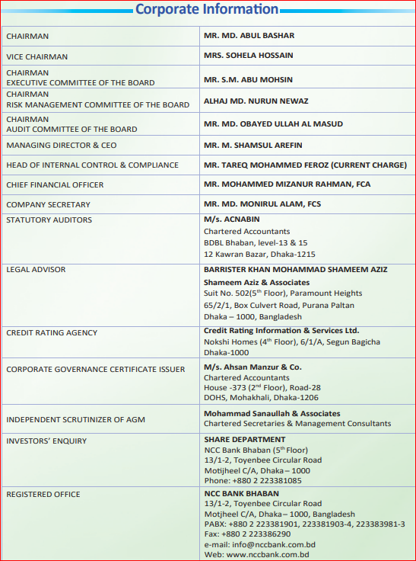

Strategic Focus of NCC Bank PLC
NCC Bank's strategy over the course of the year was centered on attaining long-term business expansion by enhancing the deposit mix, enhancing asset quality, and lowering operating expenses. Give top priority to enhancing operational efficiency & resource productivity, delivering superior providing quicker customer service, strengthening the risk management framework, and enhancing the corporate governance system.
NCC Bank, acting as a global institution, focuses on ensuring controlled and enduring profit expansion while maintaining responsibility, honesty, morality, and visibility in all its operations.

Operational Activities

Product/Service line
Retail Banking
Deposit Product A/C
Fixed Deposit

Money double Program

Savings Account

Current Account

School Banking

Monthly Savings Schemes

Instant Earning FD

Youngster money plant scheme

Short Notice Deposit

Monthly Benefit Schemes

NFCD Account

Special deposit scheme

Loan Products
Car loan scheme

Personal loan

Education loan

Home loan

Professional
loan

House building financing

Marriage
loan

Health loan

Home improvement loan

Services
Locker service
Remittance service

Treasury service

NCC Bank securities & financial service

Offshore banking unit
Enlisted surveyors/valuers

Card & ADC
NCC Bank credit card

Credit card value added service

NCC Bank card offers

NCC Bank debit card

NRB Banking
NCC Bank WDPS

NRB special savings scheme

NRB
millionaire
scheme

NRB plus savings account

Foreign remittance service

Treasury Products Money Market
Money at call

Money at short notice

Term placement

REPO / Reverse repo

Fixed Income Securities
Sukuk bond

Perpetual bond

Subordinated bond

Bangladesh bank
bill

Commercial
paper

Treasury bill

Treasury bond

Capital Market
Bond/Debenture

Share

Foreign Exchange
Swap

Forward

Spot

Term Placement

Risk Management Framework of NCC Bank PLC

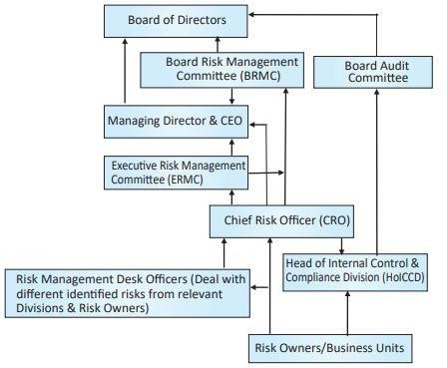

SWOT Evaluation of NCC Bank PLC

Strengths

- Company’s relationship: The close connection between employees and the company improves overall efficiency and productivity.

- Experienced Supervisory Team: NCC Bank enjoys a formidable and experienced supervisory team That contributes to efficient management and operations.

- Strategic Geographical Presence: The bank's strategic locations contribute to its competitive advantage and accessibility.

- Increase in net sales: Recent increases in net sales demonstrate financial growth and stability.

- Strong capital base: Strong capital reserves ensure liquidity and financial flexibility.

- Highly qualified staff: Employees are well trained and bring a high level of expertise to their roles.

- Excellence in business services: The bank excels in the management of export and import Transactions, thus strengthening its position in the market.

- Productive Workforce: Staff productivity has a positive impact on overall operational efficiency.

Weaknesses

- Adequacy of information: There are occasional delays in providing critical information, which can affect decision making and response.

- Limited technological infrastructure: Access to the latest Internet technologies is limited, which can hinder operational efficiency and innovation.

Opportunities

- Increasing customer base: The growing number of customers offers significat potential for expansion and increased market share.

- Expansion of the network of branches: The increase in interest for jobs in the bank leads to the continuous expansion of branches.
- Remote community development: The growth of remote communities offers opportunities for new banking services and products.
- Increased business activity: Increased import and export activity offers opportunities to improve banking services and increase income.
- Enhanced digital services: The availability of banking SMS and other online services can attract more customers and simplify operations.

- Expansion of ATM services: The presence of ATMs and ATM booths facilitates access and convenience for customers.

Threads

- Intense market competition: The presence of many competitors in the banking industry Creates a fierce competitive environment.

- Emerging financial institutions: New commercial banks and financial institutions often Introduce innovative products, increasing competition.

- Market skepticism: Global economic uncertainty and skepticism from financial experts can affect market confidence.

- Government Regulations: Tax and VAT regulations can affect profitability and operating costs.

- Currency fluctuations: Volatility in the exchange of the local currency against major currencies such as the US dollar represents a risk.

- Economic instability: Unstable economic conditions can affect the overall banking environment and financial stability.

PESTEL Framework for NCC Bank’s
The PESTEL analysis evaluates a company's external surroundings through the scrutiny of political, economic, social, technological, environmental, and legal factors to identify potential advantages and threats.

POLITICAL

- Stable political environment’s: A stable political climate promotes sustainable business operations and strategic planning.

- Facility and Government Policies: Favorable policies and incentives promote the growth and development of the banking sector.

- Consistent Regulatory Environment: Regular and predictable regulations create a safe operating environment for financial institutions.

ECONOMICAL

- Expected economic recovery: The expected economic recovery from the COVID-19 pandemic suggests possible opportunities for growth in the banking sector.
- Positive economic outlook: Optimistic economic forecasts encourage investments and the expansion of financial services.
- Use of economic components: Use of various economic elements, such as fiscal and monetary policies, to stimulate growth.
SOCIAL

- Enhanced digitalization: Increased digital adoption due to the pandemic supports the growth of online and mobile banking.
- Diversified income levels: A range of income opportunities in the population provides opportunities for suitable banking products and services.

- The financial sector as a public service: The role of banks in providing essential services to the public reinforces their importance in the development of society.

TECHNOLOGICAL

- FinTech Innovations: The growth of fintech is improving the efficiency and accessibility of banking services.

- Digital Banking Solutions: Implementing advanced digital banking solutions improves customer experience and operational efficiency.

- Business Automation: The adoption of automation technologies streamlines processes and reduces operational costs.

ENVIRONMENTAL

- Sustainable Banking Practices: The focus on sustainable banking practices aligns with global environmental goals.

- Green Finance Initiatives: Investing in green finance supports environmental sustainability and tackles climate change issues.

- Climate change considerations: Integrating climate change impact assessments into business strategy to mitigate environmental risks.

LEGAL

- Strong Legal Provisions: Strong legal frameworks ensure public confidence and protect the integrity of banking operations.

- Appropriate legal remedies: There are effective legal mechanisms to deal with problems such as non-payment and contractual disputes.

- Regulatory adaptability: The ability to adapt to changing legal and regulatory requirements ensures compliance and operational stability.
Component of the PESTEL Framework | Effect | Areas of Emphasis
Political | Enhanced regulatory vigilance into prevent any flow of anonymous money into the economy. In doing so, strict compliance requirements have been imposed on the banking sector to prevent money laundering and money transfers. | Close monitoring of the political environment and rigorous political risk mitigation plan. Extensive due diligence to identify politically exposed persons (PEPs).
Economical | The government is making efforts to maintain financial stability and expects the country's GDP to rise. Reassessing the value of assets based on the expense of deposits. | - Adopt a dynamic lending approach that guarantees the highest margin when reserving new assets.  - Strong efforts across the bank to improve non-performing loans.  - Put emphasis on different refinancing programs and on the recovery scheme of Bangladesh Bank.
Social | Limited awareness of banking services, particularly in areas beyond the city outskirts. | - Keep carrying out customized banking solutions with consideration for cultural factors such as gender, social norms, beliefs, etc.  - Aids in fostering entrepreneurship by providing loans.

Component of the PESTEL Framework | Effect | Areas of Emphasis
Technological | Technological innovation have increased customer expectations. In addition, threats from Fin Tech companies and other similar banks have forced continuous technological innovation. | - Significant investments in technology, as well as an increased focus on the digitization of banking solutions without compromising security.  - Features to stay ahead of competitors
Environmental | Sustainable financing, including green finance, is the demand of the time, which has been promoted by financial institutions and global development. Furthermore, strict regulatory adherence and reporting are already established for environmental concerns. | - Focus on reducing your carbon footprint by consuming less services such as water, electricity, fuel, paper, etc. and minimize the generation of waste from daily business operations.  - Search for environmentally friendly projects and establish a robust environmental screening procedure during project evaluation.
Legal | Rules and upgraded rules are set to be crucial in the upcoming days. | Adhere to the rules of the Banking Companies Act, 1991 (revised in 2013), WB circulars and instructions, country's list of regulations and securities laws, Companies Act, 1994; alongside the Income Tax Ordinance and Rules, 1984 and the Value Added Tax Act and Rules, 1991.

Findings and Analysis of the study
The NCC Bank PLC abides by the International Financial Reporting Standards (IFRS) as required by the Institute of Chartered Accountants of Bangladesh (ICAB). However, not all IFRS standards directly affect the financial statements of banks, as some are more suitable for public companies and SMEs. NCC Bank PLC, functioning as a commercial bank, strives to follow the most appropriate standards in its activities.
The International Accounting Standards Committee (IASC) released international accounting standards, referred to as IAS, between the years 1973 and 2001. Starting in 2001, the IASB, which took over from the IASC, started releasing IFRS, also known as international financial reporting standards. Even though IFRS reflects updated guidelines based on current trends in business practices and financial reporting, IAS is still applicable to traditional accounting principles that are still in use today.

Technically, IAS and IFRS are similar, with IFRS incorporating updates and improvements based on changes in the global financial landscape over the past two decades. The new standards are published as IFRS and in the event of a conflict between an existing IAS and a new IFRS, the IFRS takes precedence. This ensures that the latest accounting rules are followed. An important difference is that the IAS standards were developed to reflect accounting practices before the 2000s, while the IFRS standards are designed to meet the most contemporary accounting challenges and business dynamics. However, the two frameworks complement each other and NCC Bank's compliance with these standards ensures the transparency, reliability, and global comparability of its financial reports.

Data Analysis and Interpretation

key Benefits of adopting IFRS

The adoption of IFRS brings many advantages to companies like NCC Bank PLC. Unlike financial statements prepared according to different national accounting standards, IFRS ensures that financial reports follow common global standards. This consistency allows international investors to easily understand and compare the financial statements of different countries, helping local companies compete in the global market.

Here are some of the main advantages of adopting IFRS:

- Global Acceptance: IFRS standards are widely recognized and accepted worldwide, making it easier for companies to attract foreign investors.

- Clear and transparent reporting: IFRS standards ensure that financial data is clear, providing shareholders and stakeholders with improved insight into the company's performance.

- Elimination in multiple reports: Using one universal set of global standards can diminish the necessity for creating various financial reports specific to different countries.

- Simple data: IFRS helps minimize data duplication, making financial reporting more efficient.

The implementation of IFRS standards by NCC Bank PLC has resulted in the development of high-quality, transparent, and accurate financial reports. This allowed management to make informed decisions about the bank's future, assess risks and improve balance sheet control. IFRS standards provide reliable accounting data that helps the bank identify growth trends and plan for long-term sustainability. In addition, NCC Bank PLC is subject to internal and external audits, ensuring that the financial information presented is correctly verified and complies with the latest standards. The bank's financial reports, including that of December 2023, reflect this commitment to accurate and transparent information.

limitations of adopting IFRS
Although there are many advantages to adopting IFRS, there are also challenges. One of the main difficulties is the need to implement different accounting principles and standards, which can require considerable resources. This means that adopting IFRS standards can be expensive because the company needs trained and competent professionals to properly implement these standards. Hiring and training staff to meet these new requirements increases costs.

Another challenge is the lack of strict oversight in the current regulatory framework. Monitoring is not always sufficient to ensure that IFRS standards are followed correctly. In addition, ICAB may lack the necessary resources to completely uphold and oversee the integration of IFRS, potentially impacting the standard of financial reporting.

Clarifying the Role of IFRS in Enhancing Accounting Information
Accounting information systems play a crucial role in advancing the development of both businesses and economies. Accurate financial reporting is essential as it affects important decisions that can impact a company's success and sustainability in the long run. Accounting has a major impact on the economy because the data it provides helps both stakeholders and society by improving how resources are allocated and used. Trustworthy accounting data assists companies in comprehending and assessing their existing assets and foreseeing future expansion. High-quality financial data also allows companies to measure their performance at the end of each period and use this feedback to make better decisions for future.
By adopting (IFRS), companies can produce financial statements that reflect fair value, providing an accurate and transparent picture of their financial position. This ensures that businesses can make informed decisions, benefiting not only the company but also its stakeholders.

Understanding the Impact of IFRS on Financial Reporting
IFRS-compliant financial statements include:

      - The financial situation of the company
      - A report on income and expenses
      - Cash flow statements
      - Tables showing changes in capital
      - Explanatory notes

The information notes contain:

- Accounting rules apply
- Key management judgments in the application of important accounting rules
- Significant future assumptions and other factors affecting uncertainty

These financial reports offer an exact and transparent insight into how well a company is doing financially. For instance, the balance sheet shows the firm's assets and liabilities at a specific point in time. The revenue statement displays the funds entering and exiting, which is crucial for making decisions. Accuracy in figures such as pre-tax income, post-tax income, interest, depreciation, credits, and taxes is crucial. By following IFRS, companies ensure that their financial data is transparent and can be easily compared with other companies around the world, making decision making clearer for management and investors.

Annual Report
Annual Report
Name of the IAS:
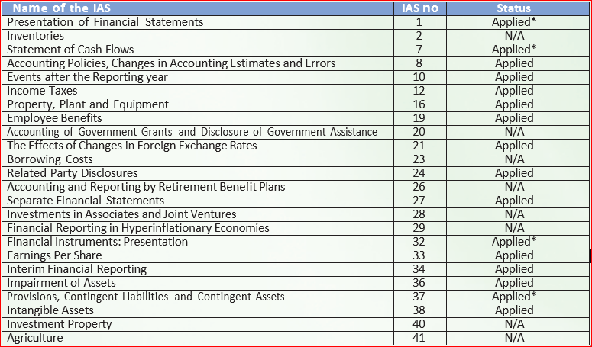
Name of the IFRS:
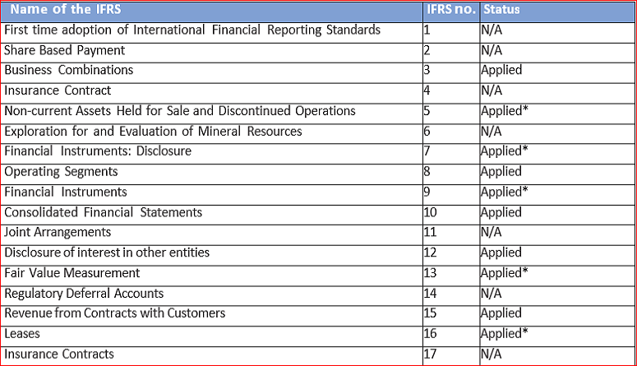

National Credit and Commerce Bank PLC.
Balance Sheet
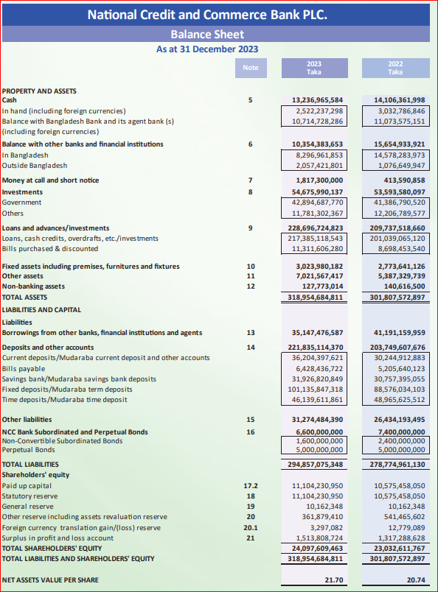
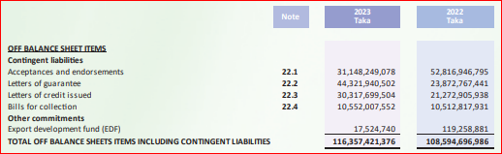

National Credit and Commerce Bank PLC.
Profit and Loss Account
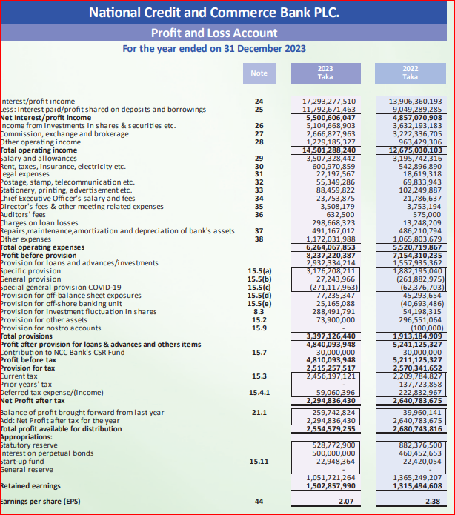

National Credit and Commerce Bank PLC.
Cash Flow Statement
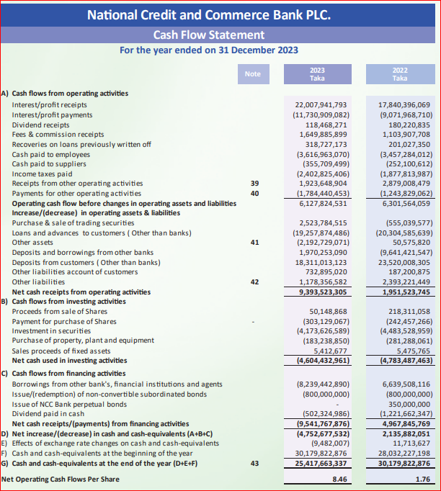

This IAS and IFRS used by NCC Bank PLC are as listed below.

NCC Bank PLC implements International Accounting Standards (IAS):

NCC Bank has applied several IAS standards in its financial reporting. Here is a summary of the IAS standards applied:

IFRS No. | Following by IFRS | Description | How IFRS Works in NCC Bank
IAS 1 | financial statement presentation | Describes the proper format for showcasing financial statements | Applied with adjustments based on Bangladesh Bank rules
IAS 7 | Cash Flow Statement | Provides guidance on preparing cash flow statements | NCC Bank employs both direct and indirect approaches as mandated by Bangladesh Bank.
IAS 8 | Accounting Guidelines, Adjustments in Assumptions, and Mistakes | Sets rules for accounting changes and fixing past errors | Used to update accounting policies and correct mistakes
IAS 10 | Events that took place following the conclusion of the period being reported on. | Details how into handle events after this financial year ends | Applied for reporting significant events after year-end
IAS 12 | Income Taxes | Provides guidelines on accounting for taxes | Used for determining and submitting tax payments
IAS 16 | Assets such as land, buildings, and machinery used by a company for its operations. | Covers how to account for fixed assets like buildings | Applied to manage and depreciate NCC Bank’s assets
IAS 19 | Employee Benefits | Sets rules for employee benefits like pensions and gratuity | Applied for NCC Bank's retirement schemes such as provident and gratuity funds
IAS 21 | The effects of changes in foreign currency exchange rates | It includes swapping one currency for a different one. | Utilized for managing transactions involving foreign currencies
IAS 24 | Disclosures on Relationships with Related Parties | Mandates reporting of transactions involving related parties | Used to report transactions with connected parties
IAS 27 | Stand-alone Financial Statements | Concentrates on the bank's specific financial statements. | Used in this development of personal financial statements.
IAS 36 | Asset’s impairment | Explains how to assess if an asset’s value has dropped | Applied to check for any drop in asset values
IAS 37 | Arrangements, Potential Debts, and Potential Gains | Addresses potential obligations that are not definite | Applied to manage provisions for possible future expenses
IAS 38 | Intangible Assets | Provides guidance on non-physical assets like software | Applied to manage and amortize software and similar assets

International Financial Reporting Standards (IFRS) Applied:
Similarly, NCC Bank applies several IFRS standards in its financial reporting. These are the key ones:

IFRS No. | Following by IFRS | Description | How IFRS Works in NCC Bank
IFRS 9 | Financial Instruments | Covers how to classify and measure financial instruments | Applied for recognizing and valuing financial assets, with some local adjustments
IFRS 7 | Revealing details about Financial Instruments | Needs specific details about financial tools. | Used to disclose information on financial instruments, with limitations from Bangladesh Bank
IFRS 10 | Consolidated Financial Statements | Outlines how to prepare group financial statements | Requested to create combined financial statements for the bank and its affiliate companies.
IFRS 13 | FairValue Measurement | Deals with measuring assets at fair value | Used to assess the market value of certain assets
IFRS 15 | Income earned from agreements with clients | Offers guidelines for identifying income | Applied for reporting income from services provided to customers
IFRS 16 | Leases | Explains how to account for leasing transactions | Applied for managing leases of buildings and equipment

Accounting Standards Specific to NCC Bank PLC:

NCC Bank also follows local regulatory guidelines and standards set by Bangladesh Bank. Here are some notable ones:

- Presentation of Financial Statements: While IAS 1 requires certain disclosures, Bangladesh Bank formats and schedules prevail in NCC Bank's reporting, leading to some departures.

- Investment in Shares and Securities: Bangladesh Bank prescribes a different valuation methodology than IFRS 9, such as marking investments in quoted and unquoted securities and mutual funds based on circulars.

- Provisions for Loans and Advances: Bangladesh Bank’s guidelines on provisioning for loans and advances are more stringent than those in IFRS 9. Provisions are made based on the classification of loans (standard, substandard, doubtful, and bad/loss loans).

- Recognition of Interest Suspense: Bangladesh Bank requires suspending interest income on classified loans, which deviates from IFRS.

- Off-balance Sheet Items: Bangladesh Bank states that off-balance sheet items should be disclosed separately, even though there is no such obligation under IFRS.

Conclusion

&

Recommendations

Conclusion
Bangladesh's low labor costs, strategic location, and expanding market make it a highly appealing destination for international investors. Numerous companies from Bangladesh are expanding globally, prompting the country to adopt IFRS to align with international standards. This allows companies to meet the accounting standards expected by international investors and helps them expand worldwide, increasing the visibility and value of their brad.

For NCC Bank PLC, the adoption of IFRS has helped to present clear and transparent financial reports to shareholders and stakeholders. As a reputable commercial bank, especially for remittance transactions, the use of IFRS ensures NCC Bank's ability to compete globally and maintain investor confidence.

Recommendations
Accountants are knowledgeable about the relevant standards, but they are not informed about the specific revisions. Thus, I recommend keeping up with the most recent updates in accounting and reporting regulations. This will enhance the financial report's informativeness and accuracy. Experienced accountants with specialized knowledge can work together and host workshops and seminars within departments. The following recommendations should be taken into consideration by NCC Bank to enhance its operations and tackle the existing challenges:
- Improve staff training: make sure all employees, including accountants, receive thorough and current training on the newest accounting standards and practices.
- Increased transaction limits: For business customers, consider increasing transaction limits to better meet their needs and encourage higher transaction volumes.
- Upgrade technology: Invest in faster and more reliable server infrastructure to improve service speed and efficiency.
- Check qualifications: Carefully check the educational and professional qualifications of new hires to ensure they meet the required standards.
- Communicate future plans: clearly communicate the bank's business plans and strategies to employees and agents to keep them motivated and aligned with the bank's goals.
- Improve location strategy: Place branches and service points in high-traffic areas, such as markets, to increase visibility and accessibility to customers. Increased awareness and promotions: Launch more awareness campaigns and promotional activities to inform customers about the bank’s services and benefits.

Reference

https://corporatefinanceinstitute.com/resources/accounting/accounting- standard/?fbclid=IwAR0OlcVcR3QSoe_W7OWiySq-s_N0yLdxBg8sej9ShvFLJvuJb-
ILZhL0kYU
https://www.iasplus.com/en/resources/ifrsf/iasb-ifrs-ic/iasb?fbclid=IwAR1GDdr93TIbiRpM5j4- BtNKLoEYDleTxHlK2IUTwhbAtu9TWCzW27XjGIM
Bangladesh Bank (bb.org.bd) - Search (bing.com)

