A Study on
The effect of COVID-19 on all of the Fast-Moving Consumer Goods (FMCG) Industry's HRM Practices. An investigation on Bangladesh's situation.




A Study On
The effect of COVID-19 on all of the Fast-Moving Consumer Goods (FMCG) Industry's HRM Practices. An investigation on Bangladesh's situation.

Prepared for
Mr. Jakowan
Assistant Professor
School of Business and Economics
United International University

Prepared by
Sirajum Monira Antora
ID 111 151 475
BBA Program

Submission Date: 15/02/2023

Transmittal letter
Mr. Jakowan
Assistant Professor
School of Business and Economics
United International University
United City, Madani Avenue, Badda, Dhaka-1212.

Topic: The effect of COVID-19 on all of the Fast-Moving Consumer Goods (FMCG) Industry's HRM Practices. An investigation on Bangladesh's situation.
Dear Sir,
I am grateful that I was able to conclude my project report on the effect of COVID-19 on all of the Fast-Moving Consumer Goods (FMCG) Industry's HRM Practices. An investigation on Bangladesh's situation. With your continual guidance. I now want to provide the report to you in order to complete the requirements for my BBA degree. I sincerely hope you will take the time to read over this project report if you get it.

Acknowledgment

I had the pleasure of finishing the project report for the BBA degree at United International University with the help of Mr. JAKOWAN. I wish to start by expressing praise to the merciful, all-knowing Allah for bestowing upon me the endurance and patience necessary to finish the project report on schedule. Then, I want to express my sincere gratitude to my honorable boss, Mr. JAKOWAN, for his excellent leadership and meticulous oversight. His advice has proven to be of the utmost worth to me. I am grateful for all the times he answered all of my inquiries patiently and relentlessly. I'd also want to thank several of my UIU seniors who assisted me in getting in touch with representatives from other FMCG firms. They really helped me finish the survey assignments. Last but not least, I would want to express my gratitude to all the employees from the various FMCG companies who took substantial time out of their tremendously busy schedules to take the survey and helped me by contributing data to this study.

Table of Contents
Executive Summary 7
CHAPTER ONE - INTRODUCTION 8
Origin 9
Scope 9
Objectives 9
Methodology 9
i. Types of data 9
ii. Data Collection Process 9
iii. 70 participants comprised the sample. 10
iv. Sampling Techniques 10
v. Research Topic and Duration: 10
Limitations 10
CHAPTER TWO-LITERATURE REVIEW 11
CHAPTER THREE-COMPANY HISTORY 13
Industry Scenario 14
Detailed information on the chosen Companies 15
Mehgna Group of Industries (MGI) 15
Unilever Bangladesh 16
City Group 18
PRAN-RFL (PRAN Foods) 19
ACI Foods 20
CHAPTER FOUR- DISCUSSION OF THE COMPANIES' CHOSEN HR FUNCTIONS 24
CHAPTER FIVE-ANALYSIS AND FINDINGS 27
1. Your organization is now facing a problem in managing business stability. 28
2. Managing day-to-day operations is a challenging undertaking for enterprises during this epidemic. 28
3. Increasing employee stress is an issue your organization is now confronting. 29
4. It might be difficult for new employees to socialize. 30
5. Compared to working in an office, working from home is more pleasant for you. 30
6. With your present work-from-home setup, you are productive. 31
7. How frequently did you work from home before Covid? 32
8. In comparison to working in an office, it is simple to communicate with your coworkers. 32
9. Do you have more optimism or pessimism about working from home this week compared to previous week? 33
10. Your company changed the reward policy. 34
11. Your company has reduced the employees' bonuses. 34
12. Employees' basic salary promotions have ceased. 35
13. During this epidemic, recruiting has been challenging. 35
14. Temporarily, recruiting has been halted. 35
15. Your boss has started the regularly scheduled daily check-ins. 36
16. Do you receive targets that are really clear? 37
17. Your work has received prompt feedback. 37
18. Your boss assists in locating and closing performance gaps. 37
19. Your supervisor is approachable and accessible for assistance 38
20. You were familiar with your business continuity strategy prior to the COVID-19 epidemic. 38
21. Learning and training have become more difficult. 39
22. There is no longer any interest in attending summits, seminars, or other events. 40
23. Your organization has set up a task force specifically to handle any scenario that may arise during this COVID-19 epidemic. 40
CHAPTER SIX-RECOMMENDATIONS & CONCLUSIONS 42
RECOMMENDATIONS 43
CONCLUSION 44
Source of Information 45
Questionnaire 47

Executive Summary

This project report analyzes the impact of the Covid-19 virus on the HRM practices used in the FMCG sector. The FMCG industry is one of the fastest-growing segments of the market. They have a significant role in and are tied to people's daily lives. Insight into what's going on in business organizations and how they're managing their human resource strategies in the face of difficult conditions is the report's express purpose. It will make the internal setting of the FMCG sector's HRM practices clear. The data needed for the project report was also gathered using primary and secondary sources. The third part of the study provides an overview of a few of the companies that provided important research data as well as information on the current situation of the FMCG sector. Chapter 4 discusses how the virus affected the HR operations and maintenance throughout the whole FMCG industry.

CHAPTER ONE - INTRODUCTION

Origin

Organizations nowadays must be alert and flexible in the face of unforeseen occurrences, such as external crises, which increase employee insecurity and directly endanger the organization's continued performance and survival. However, the present COVID-19 pandemic has pushed companies to traverse the uncharted and, as a result, find cutting-edge solutions to issues that have developed in several areas of their operations. As a result, in order to enroll in United International University's Bachelor of Business Administration program, completion of this project report is required. A report must also be completed as part of this curriculum and given to the esteemed professors and supervisor at United International University.

Scope

This research focuses on how the COVID-19 pandemic has affected HRM procedures in FMCG companies generally. We shall learn about the changes brought about by COVID-19 and the challenges each specific FMCG business has faced through this report. Additionally, how they are managing the most recent changes.

Objectives

The primary purpose of this project is to assess the impact of COVID-19 on human resource management in the FMCG sector as a whole.
Evaluation of general HR practices in the FMCG business is a secondary goal.
- To become familiar with the new HR practices that have been put in place in light of the ongoing coronavirus epidemic.
- To be acquainted with the internal organization of the management and administration.
- To recommend the crucial steps for resolving the problems.

Methodology

i. Types of data: Primary and secondary data are the types of data.
ii. Data Collection Process: The objective of this study, which employed a quantitative methodology, was to examine how the Covid-19 crisis affected FMCG firms in general and Human Resource Management in particular. The survey questionnaire's results are believed to be suitable since they give allow for experts' opinions and comments to be explored. The data were examined and analysed before a conclusion and set of suggestions were reached.
iii. 70 participants comprised the sample.
iv. Sampling Techniques: We must utilize a probability sampling approach if we want to get findings that are representative of the whole population since I will be doing quantitative research for this project. This implies that every responder and member of the demographic has a chance of having their opinion taken. The analysis has been done by using MS Excel.
v. Research Topic and Duration: The project's study topic was human resource management, and it took roughly three months to finish the research and produce the project report.

Limitations

The study's goals were generally achieved; however, several inescapable problems or situations did occur. The key limitations which have been most harmful are listed below:
There weren't enough secondary data sources since COVID-19 happened in 2020, which is an immediate problem. The sources may also give some erroneous, back dated, or inadequate information for the same reason.
There were difficulties in acquiring information because all the staff were willing in providing it.
It was unable to speak with and conduct a quick interview with HR specialists working inside of businesses because to the pandemic outbreak.
Some remarks may not perfectly match business standards and processes due to secrecy.

CHAPTER TWO-LITERATURE REVIEW

Organizations are made up of people, and those similar people are the business's most valuable strategic asset. Without people, no organization can accomplish its goals. Enterprises must efficiently employ human capital in order to reach high performance levels. To address the issues encountered by employees, effective human resource planning requires long-term capacity building. Therefore, efficient human resource management might help a company develop, advance, compete, and make money. Through effective human resources planning, the business meets all of its goals.
Price increases are a result of increased demand for food and other necessities due to the continuous lockdown. Customers are rushing to purchase a wide range of completed items that they require for everyday necessities. Let's imagine that the fast-moving consumer goods (FMCG) industry is now dealing with a unique difficulty. While some businesses have already adjusted, others are struggling. In contrast to luxury goods and accessory items, the FMCG industry has greatly benefited, with food and beverage, personal care, and home products all coexisting and gaining increasing government backing. The sector has quickly expanded its last mile logistics on the underpinnings of roads and highways and built a sophisticated national distribution network that serves mom-and-pop shops at the Small and Medium Enterprise level. By 2025, it is expected that the global market for this business will reach $1.54 trillion. Thus, the market for First Moving Consumer Goods in Bangladesh increased by 9% to $3.4 billion in 2017. Due to the introduction of e-commerce and a fast-expanding contemporary company structure, the sector today has some creative ways to spend money on development. The leading tobacco sector, PRAN, Square, and Unilever are now the top companies in the First Moving Consumer Goods business, which is helping the sector grow.

CHAPTER THREE-COMPANY HISTORY

Industry Scenario

One of the biggest sectors aiding national consumers of essential commodities in Bangladesh is the fast-moving consumer goods (FMCG) business. The country's growing middle class and per capita income have been major factors in the sector's expansion.
The mid-income and affluent class (MAC) population in Bangladesh is projected to increase to 34 million people over the course of the following five years, according to a report by Boston Consulting Groups.
Prices rose as a result of increased demand for food and other essential items during the pandemic lockdown. Customers are rushing to purchase a wide range of completed items that they require for everyday necessities. Let's imagine that the fast-moving consumer goods (FMCG) industry is now dealing with a unique difficulty. While some firms have already adjusted, others are not doing well. The FMCG business has done well despite the relative scarcity of luxury goods and luxuries, with food and beverages, personal care products, and household products all helping to fuel the sector's expansion.
Similar to this, the sector has effectively expanded its latest mile logistics and built a complicated allocation network across the country assisting Small and Medium Enterprise level mom-and-pop retailers with higher support from the government for the substructure of roads and highways. By 2025, it is expected that the global market for this business will reach $1.54 trillion. Thus, the market for First Moving Consumer Goods in Bangladesh increased by 9% to $3.4 billion in 2017. The advent of e-commerce and a swiftly evolving contemporary business corporation has given the sector some new avenues for development spending. The three largest companies in the First Moving Consumer Goods sector right now are Unilever, PRAN, and Square. The tobacco industry's top sector is BATB.

Organizations that will be a part of the study
For this study, I only selected the organizations from whom I could collect pertinent data. The companies I have selected from the FMCG industry are:
1. Unilever Bangladesh
2. City Group
3. PRAN
4. ACI Foods
5. British America Tobacco Bangladesh (BAT)

Detailed information on the chosen Companies

Mehgna Group of Industries (MGI)

More than 50,000 employees, 6,300 distributors, and 15,000 suppliers work for MGI, a global brand and business. It brings in more than $2.8 billion annually.
Meghna Group of Industries (MGI), one of Bangladesh's biggest and most powerful conglomerates, can trace its beginnings all the way back to 1976, when its predecessor, Kamal Trading Company, was in operation. The initial name of the conglomerate was Meghna Vegetable Oil Industries Ltd. It was established in 1989 on a small piece of land in Meghnaghat, Narayanganj.
MGI has a substantial international presence in addition to North and South America, the Middle East, Southeast Asia, Europe, South Africa, and North America.
As a result of its relentless expansion strategy, MGI has grown to be a prominent player in Bangladesh and over the past several years, has been the nation's largest investor in industrial development. Meghna Economic Zone, which was established by MGI as the country of Bangladesh's first private economic zone, was followed by the formation of Meghna Industrial Economic Zone and Cumilla Economic Zone. The firm has since expanded even further, and in 2020 it made an exceptional $451 million investment that allowed it to construct nine new industrial buildings within of its various economic zones.
Mostafa Kamal's unwavering commitment throughout this process has been extremely beneficial to the firm and the Bangladeshi economy. Popular businessman and patriot Mostafa Kamal has significantly aided Bangladesh's development in the areas of industry, healthcare, education, sports, and social welfare. The integrity and dedication he shown to MGI were essential to its ultimate success.

Vision: Wishing to be Bangladesh's most known and progressive global corporation.
Mission: We delight our customers and maximize value by utilizing innovative ideas, motivated workforce, embracing technological advancements, and living sustainably.
MGI Products:
1. Food Oil
2. Milk Powder
3. Water for drinking;
4. Flour; and
5. Condensed Milk
6. Salt
7. Sugar \s
8. Lentil
9. Rice
10. Puffed rice
11. Drink (Cold)
12. Beverages (Hot)
13. Spice
14. Confectionery
15. Cookies & Biscuits
16. Soup & Snacks
17. Bread & Buns
18. Cake

Unilever Bangladesh

Unilever, one of the biggest producers and suppliers of consumer goods in the world, offers 400 different brands in over 190 different countries.
Lever Brothers, a British soap business, and Margarine Unie, a Dutch margarine producer, merged on September 2, 1929 to form Unilever, a multinational consumer goods and food conglomerate with offices in London and Rotterdam.
Unilever, a global company that manufactures consumer goods, has headquarters in both London and Rotterdam. Lever Brothers, a British soap business, and Margarine Unie, a Dutch margarine producer, amalgamated on September 2, 1929, to establish Unilever.
On the second part of the 20th century, the company gradually expanded the variety of products made from oil and fat and also expanded its activities overseas. With 13 items selling more than €1 billion, Unilever, which has 400 8 brands, made €53.7 billion in sales in 2017.
Food goods, snacks (soft drinks and ice cream), home care, cosmetic products, and personal care are the four primary divisions of Unilever. Several nations, including China, the Indian subcontinent, the Netherlands, England, and the United States, offer these services.
The history of Unilever Bangladesh Limited, one of the most prosperous FMCG firms in the world with local business services, is explained to these groups for the formation and effects of trade. In Bangladesh, Lever Brothers Bangladesh Ltd., a subsidiary of Unilever, dominates the markets for food, personal care, and household goods. With a capacity to produce soap in the amount of about 485 metric tons, the eastern plant of Lever Brothers Pakistan Ltd., a private limited company in which Unilever owned 55% of the shares and the remaining shares were owned by the Pakistani government, was opened on February 25, 1964, in Kalurghat, Chattagram. The demolition of the eastern plant was planned for after the liberation battle.
Vision: In order for individuals who use the items to respect and enjoy life more, it is important to make cleanliness a standard, lessen the amount of work performed by women, improve wellbeing, and raise personal beauty.
Mission: Unilever's goal is to improve society. Along with grooming and personal care items from brands that help individuals feel great, look better, and have more energy, they provide daily nutrition services.

Objectives: The goals of Unilever in Bangladesh are to: Make high-quality products.
Make the most of every opportunity to advertise the products.
Producing in bulk to take advantage of economies of scale.
Making it possible for high-end products to be sold at fair rates.
Unilever Brands: Unilever has almost 400 distinct brands worldwide. The majority of them, like Fair & Lovely, are regionally specific and can only be made to a set quality. There are 18 UBL brands that are popular in Bangladesh and are divided into several market segments. The company mostly fell under two categories:
• Items for personal care and the home
• Food and beverages
In Bangladesh, there are four main product categories. which are:
- cleaning;
- washing fabrics
3. Special care
4. Foods

City Group

City Group is a leading corporation and a dependable producer of consumer goods in Bangladesh. With forty-eight years of trade bequest, the group has significantly developed over time in value generation and production. Currently, there are 40 sister businesses, each specialized in various products and services. The organization's dedication to keeping its supply obligations, unwavering focus on quality, and valued connections with customers, employees, and other societal groups are what give it its strength.
With the goal of creating a worldwide commerce agglomeration for the twenty-first century, City Group set out on its long journey in 1972. This idea conveyed the foundation's well-known consumer product brands and its dedication to provide top-notch customer service. At present, there are 40 sister firms, each specialized in a particular sector of product or service, including Fast-Moving Consumer Goods, feed products, PET bottles, printed and packaged goods, ship-builders, mass media, hospitals, etc. All of them are actively searching for greater chances
Vision: The company's vision is to develop into a leading Bangladeshi conglomerate that works assiduously and responsibly to improve society.
Mission: Combining creativity, global competency, and indigenous free enterprise to offer clients with excellence, sterility, and health
The City Group offers five brands.
The most well-known brand in the City Group is Teer, which is found in products including pet food, cooking oil, Atta, Maida, semolina, rice, and lentils. The name is closely associated with cleanliness, perfection, and good health.
2. Bengal: Bengal tea is entirely regular from picking to packing, giving a joyful and genuine tea experience. Bengal tea has remarkable Bangladeshi tradition.
3. Natural: Natural cooking oils are among the healthiest and most nutrient-dense options available. They are low in cholesterol and rich in antioxidants and vitamin E. City group businesses and products:
4. Sun: A company that encourages price-nature suggestions for the fundamental needs of the people is one of the most inspirational companies that produces a wide variety of items.
5. Jibon: Each drop of water that Jibon distills is prized as a symbol of life.

PRAN-RFL (PRAN Foods)

A visionary leader named Major General Amjad Khan Chowdhury oversaw the start of our story in 1981. He saw that Bangladesh's optimal growth environment was an outstanding business opportunity. This gave him the inspiration to create a revolutionary business that would transform the country's food production industry for the betterment of society and its people. In this way, PRAN was founded.
Later in 1986, PRAN broadened its business operations by entering the agricultural sector through contract farming. In 1992, PRAN opened a facility for food processing in Ghorashal, further strengthening its position in the industry.
Vision: improving livelihoods is the goal
Mission: Hunger and poverty are curses. Our goal is to create jobs, respect for ourselves, and dignity for our countrymen through successful businesses.
Beverages
Bread & Bakery
Culinary
Dairy
Snacks
Confectionery

ACI Foods

Advanced Chemical Industries (ACI) Limited is one of the leading businesses in Bangladesh and has a history of cooperating with other nations. To achieve corporate excellence via quality, we must recognize, accept, fulfill, and go above and beyond what consumers desire. In order to ensure consistent quality in our products and services and to satisfy consumers, we adhere to international standards for the quality management system.
We intend to change consumers' eating behaviors by providing more products that are both ready to cook and ready to eat. ACI Foods Limited exports goods under the Pure and Fun Brand to several countries, including Australia, the United Arab Emirates, Kuwait, Saudi Arabia, Bahrain, and Qatar.
Imperial Chemical Industries, a British multinational, opened a branch in what was then East Pakistan. After independence, the branch became ICI Bangladesh Manufacturers Limited, a company. In 1992, when ICI transferred its shareholding in Bangladesh to the management, Advanced Chemical Industries (ACI) Limited was created.
Advanced Chemical Industries (ACI) Limited, one of the largest companies in Bangladesh with a history of conducting business overseas, operates via four distinct core business divisions all throughout the nation. By offering cutting-edge and reliable pharmaceutical products, ACI Pharmaceuticals is dedicated to improving the health of Bangladeshi residents.
"ACI Consumer Brands" enhances the quality of consumers' daily lives through its companies in the fields of cosmetics, home care, hygiene, electrical, electronics, mobile, salt, flour, foods, rice, tea, edible oil, paints, and international commerce. "ACI Agribusinesses" is the largest integrator in Bangladesh for motorbikes, farm mechanization, livestock, fishery, and infrastructure development services. More than 45,000 households are served every day by the largest retail chain in Bangladesh, "ACI Retail Chain," which operates 144 SHWAPNO outlets, including 34 recently opened express stores. The Corporation contributed Taka 4,318 million to the National Exchequer in the form of company tax, custom duty, and value added tax during FY 2019-2020.
Mission: ACI's mission is to enhance people's quality of life via responsible use of information, technology, and skills. ACI is committed to pursuing excellence via premium products, innovative practices, and skilled staff in order to provide our clients the highest level of satisfaction
Vision: Our Goal In order to fulfill the Mission, ACI will
• Deliver high-quality goods and services that are reliable and consistent, giving our clients value for their money.
Strive for leadership positions in each of our business categories.
• Fostering employee empowerment and recognizing creativity will help us to grow our workforce.
• Encourage a culture of learning and personal development.
Why Achieve high levels of productivity across all of our activities by making efficient use of our resources and using the right technologies.
· Encourage and support our distributors and suppliers as they increase productivity to promote equitable growth.
Why Achieve better return on investment via prudent resource management, effective operations, and reliance on our core skills.
Pure Basic Spices are among ACI Foods' products.
Pure Spices, Mixed
Thai noodles alone
Rice Gold Coffee with Pure Aroma
Cake Xtra Fun for Fun Simple Cake is fun Puffed potatoes
FUN Mango drink called Chanachur
FUN Candy, FUN Chutney, FUN Fried Food
ACI Oil of pure mustard

British America Tobacco (BAT)

British American Tobacco (BAT), one of the biggest multinational firms, is active in Bangladesh and is listed on the stock indexes of both the Chittagong Stock Exchange (CSE) and the Dhaka Stock Exchange (DSE). Over a century ago, BAT began doing business in Bangladesh. With brands that are traded in around 128 different markets, it is a well-known tobacco corporation. They manufacture the cigarette that one in eight of the one billion adult smokers worldwide choose, with more than 200 brands in its portfolio and more than 55,000 workers.
As Imperial Tobacco Company Ltd., British American Tobacco Bangladesh (BATB) first operated in the subcontinent in 1910. After the separation, the Pakistan Tobacco Company (PTC), with its corporate headquarters in Karachi, was established in 1949. The East Pakistan office of the Pakistan Tobacco Company was then situated in Armanitola, Dhaka, and then relocated to Motijheel, Dhaka. At the time Bangladesh Tobacco Company PVT. Ltd. was established in 1972, following the liberation fight, British American Tobacco held the bulk of the shares.
Considering its clear separation from the other operating enterprises in the Group, Bangladesh Tobacco Company changed its name and legal status to (BTAB) British American Tobacco Bangladesh in March 1998.
BATB is one of the biggest and most established foreign companies doing business in Bangladesh. BAT Group, a division of British American Tobacco, controls 65.91% of the business. The Bangladeshi government owns 26.57% of the shares through some of its agencies, while private investors own 7.52%.
Vision: Their major objective is to supply smokes to customers faster than any other company on Earth.
Mission: The aim of the always changing consumer is to anticipate and be happy, which includes bringing pleasure, lowering risk, expanding choice, and giving people a sense of universal prosperity
Products of BAT: Benson & Hedges, John Player Gold Leaf, Pall Mall, and Star are four of BAT's main lead brands that it has been doing business with in Bangladesh since a very long time ago. The "Navy" brand of Dhaka Tobacco is Star's main opponent in the one-taka market.

CHAPTER FOUR- DISCUSSION OF THE COMPANIES' CHOSEN HR FUNCTIONS

The Fast-Moving Customer Goods (FMCG) industry is one of Bangladesh's key sectors for satisfying consumer demands. The population of middle-class people in the nation and the growing per capita income have both significantly assisted the industry's expansion. According to a BCG poll, 34 million middle-class and wealthy people will live in Bangladesh during the course of the following five years.
Contrary to luxury items and other needs, food and drink, household products, and personal care currently serve as the FMCG sector's foundations of development. The firm has successfully grown its final logistical component and created enormous distribution networks throughout Bangladesh that service SME mom-and-pop merchants with further government investments in road and highway infrastructure. The industry is anticipated to reach a $1.54 trillion global market size by 2025. As a consequence, Bangladesh's FMCG market grew by 9% in 2017 to reach $3.4 billion. The industry seems to have some new development plans in place with the emergence of e-commerce and a quickly growing leading retail sector. Currently, BATB is the market leader in the FMCG industry's tobacco category, followed by Unilever, Marico, and Square. The corona virus shutdown and the anticipated economic fall in market demand have had a significant negative impact on the FMCG industry for the following key reasons:
  - 1. The industry is not equipped to handle an excessive spike in demand as such, despite the fact that there is a short-term high rise in demand for commodities and important products. The majority of local shops and supermarket chains are already experiencing supply shortages as a result.
  - 2. Due to changes in the global supply chain, the majority of suppliers would find it difficult to get raw materials, which would result in a shortage of some items and an increase in their price.
3. The corona virus implications are significantly more common at the delivery end. To market their finished items to retail venues through their sales agents, the majority of FMCG firms collaborate with outside suppliers. Businesses have not yet reduced the amount of power they use to prevent the virus from spreading. Many businesses nonetheless carry on with their distribution practices, possibly putting lives in danger.
4. It is thought that an unnatural boost in demand for soap, hand sanitizer, hand washing, and personal care items has caused a temporary increase in price. To fully benefit from the price increase, manufacturers are holding an alarmingly big amount of merchandise on hand, which will hurt the ultimate customers.
Since an unchecked FMCG industry would have negative long-term impacts, the government must legally monitor the sector in order to solve these challenges. In the long term, the industry won't die if nothing is done, but it will stay unstable until the global supply chain returns to normal.

CHAPTER FIVE-ANALYSIS AND FINDINGS

Data analysis is necessary for any study since it summarizes the numerous concepts, hypotheses, procedures, and approaches that were used. In the end, it helps with deductions and showing the concept.
I developed a google form questionnaire with 23 questions that are relevant to the project's problem in order to gain insight into the current COVID-19 consequences on human resource practices in Bangladesh's FMCG company. With the 70 responders I choose, the survey's work is complete. I was able to gain more knowledge about the overall circumstance in the industry around the time of the Pandemic breakout because to that survey. I've presented and visually illustrated the information I've gathered below:

Your organization is now facing a problem in managing business stability.

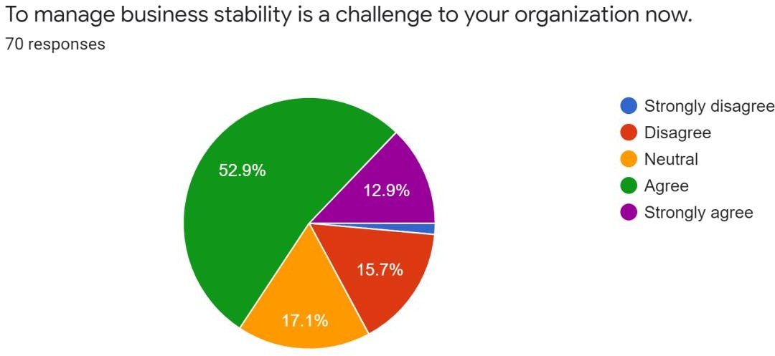
Interpretation: We are aware that nearly every company is dealing with the new commercial hurdles brought on by the COVID-19 epidemic. According to the survey's findings, 52.9% of respondents concur that maintaining the stability of their organization is tough. 17.1% of respondents selected neutral in answer to the question because they are unsure of what is happening in their corporate organization. 15.7% of respondents disagreed with the statement, 12.9% strongly agreed, and only a small number strongly disagreed.

Managing day-to-day operations is a challenging undertaking for enterprises during this epidemic.

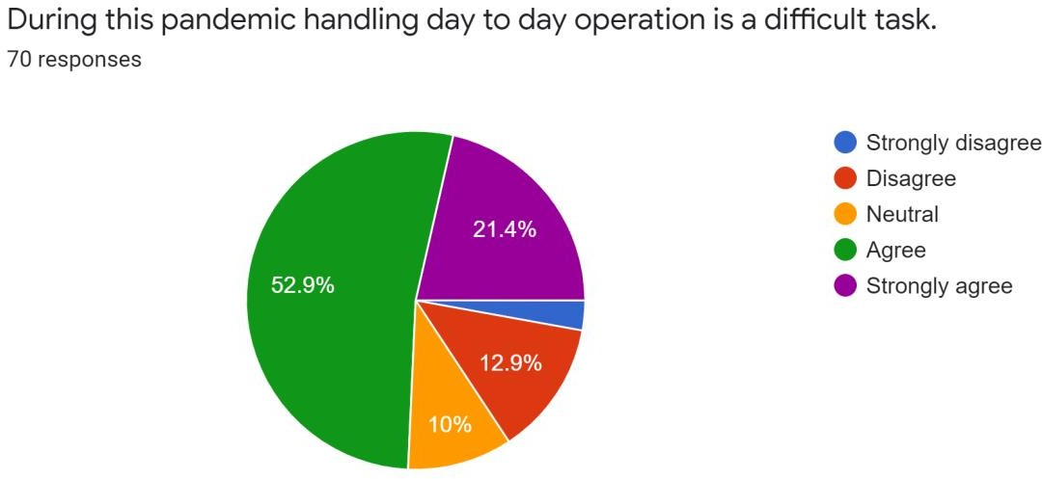

Interpretation: The largest number of respondents (21.4%), as indicated by the pie chart above, strongly agreed with the statement. A mere 12.9% of people disagreed. The number of people who strongly disagreed is unimpressive, and 10% of people are quiet. Increasing employee stress poses issues for your company right now.

Increasing employee stress is an issue your organization is now confronting.
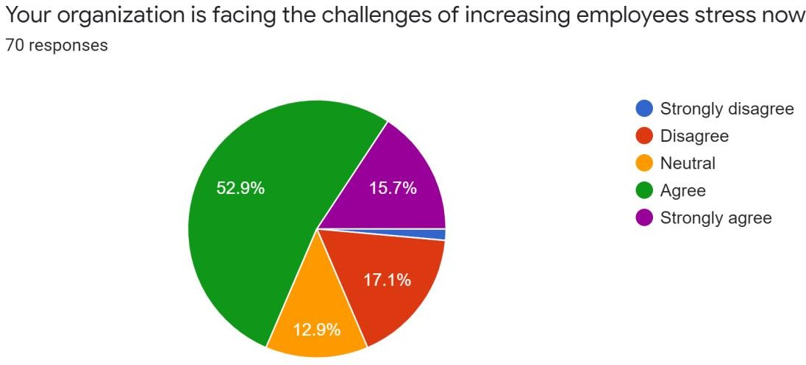
Interpretation: There is no doubt that people are more anxious and afraid right now since so many people are dying and so many people are touched by it. They have the concern that they could have the corona virus every day when they leave the house. Therefore, 15.7% of the population strongly agreed that stress is a problem for their staff. 12.9% of individuals were neutral, while 52.9% agreed. 17.1% of respondents disagreed with the claim that they deal with the problem of rising stress. Socializing of new employees is confronting as a challenge now-

It might be difficult for new employees to socialize.
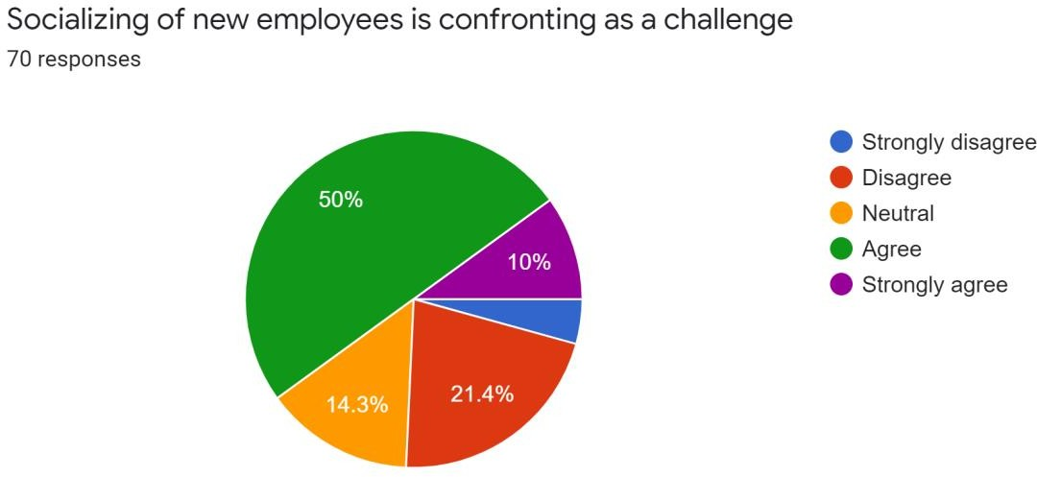

Interpretation: The majority of businesses now allow workers to work from home, making it more difficult for new hires to make friends. Even if there are social media platforms where individuals may interact with each other, not everyone finds them to be adaptable or comfortable. Therefore, 10% of the population strongly agreed, and 50% agreed with the assertion that they find it difficult to socialize new staff. A strong knowledge and successful use of social media by employers with their employees led 21.4% of the population to disagree. However, none objected forcefully, and 14.3% of them remained mute.

Compared to working in an office, working from home is more pleasant for you.

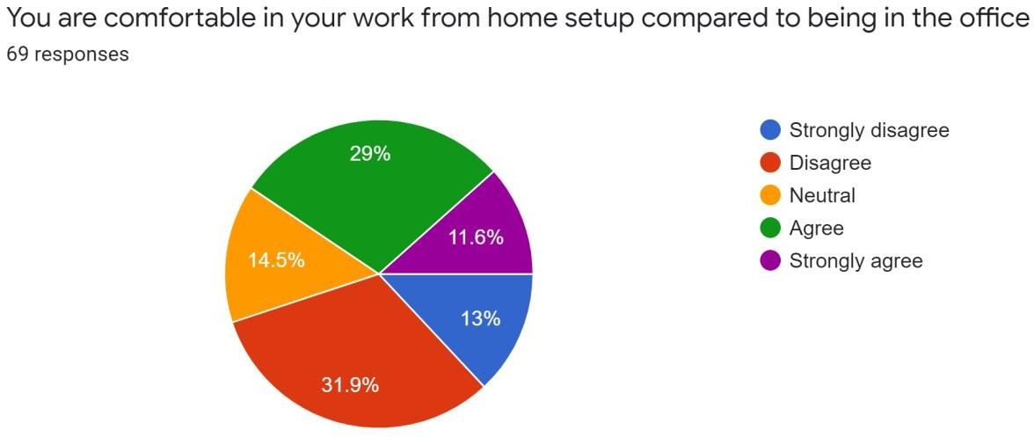
Interpretation: This claim refers to the employees' experience working remotely. If the workers feel at ease working from home, that is. Here, we can observe the employees' fairly equal and competitive replies. In this country, most individuals dislike working remotely. 11.6% of respondents strongly agreed with the statement, while about 31.9% disapproved. However, 29% of the population stated that they feel at ease with their work-from-home arrangement, and I presume that the majority of these people are women since they can spend more time with their loved ones when they work from home. 13% of people strongly disagreed, yet 14.5% chose to say nothing. You are productive in your current work from home set up.

With your present work-from-home setup, you are productive.
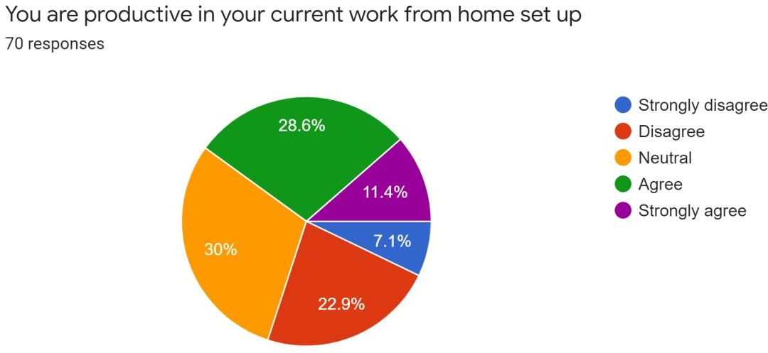

Interpretation: The outcome of this statement is evidence that professional work must be completed at the appropriate location at the appropriate time. In this case, 7.1% of respondents strongly disagreed, and 22.9% disputed that their existing work from home arrangement is not productive. The majority of them—30%—remain uncommitted on this question. Perhaps it is because being neutral is preferable than refusing. 11.4% of people strongly agreed with the remark, while 28.6% of people agreed with it.

How frequently did you work from home before Covid?
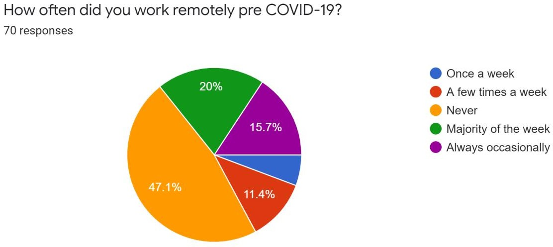

Interpretation: Diverse undertakings call for different approaches to completion. Pre-Covid-19, the majority of the population—about 47.1%—indicated they never worked remotely, while 20% stated they did so the bulk of the time. 15.7% of them claimed to have worked infrequently in the past, 11.4% claimed to have worked a few days each week, and one claimed to have worked remotely once per week prior to COVID-19.

In comparison to working in an office, it is simple to communicate with your coworkers.
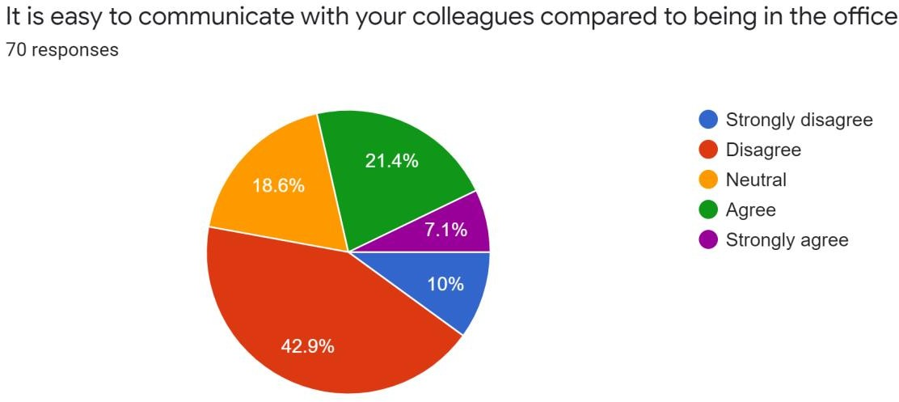

Interpretation: Communication with individuals and coworkers should not be an issue in this digital age, but there may still be several impediments. As we can see, 42.9% of employees disagreed, and 10% strongly disagreed, indicating that they have difficulty communicating with their coworkers. It is simpler to speak with their coworkers than it is to be in the workplace, according to 18.6% of the population, 21.4% of the population, and 7.1% of them strongly.

Do you have more optimism or pessimism about working from home this week compared to previous week?
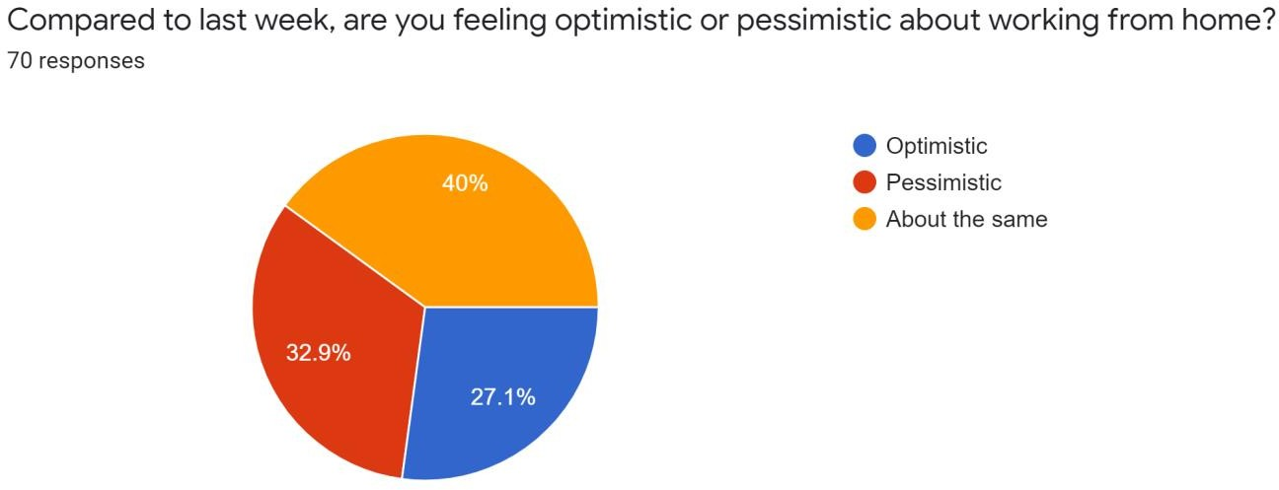

Interpretation: This one is really fascinating. 40% of respondents said they are feeling about the same as they did last week in response to the question about how they feel about the future days compared to last week, 32.9% said they are pessimistic, and the remaining 27.1% said they are positive about working from home. People should be hopeful about working from home under the current circumstances because the economic situation is deteriorating rapidly. Therefore, working remotely can protect individuals from this dangerous illness.

Your company changed the reward policy.
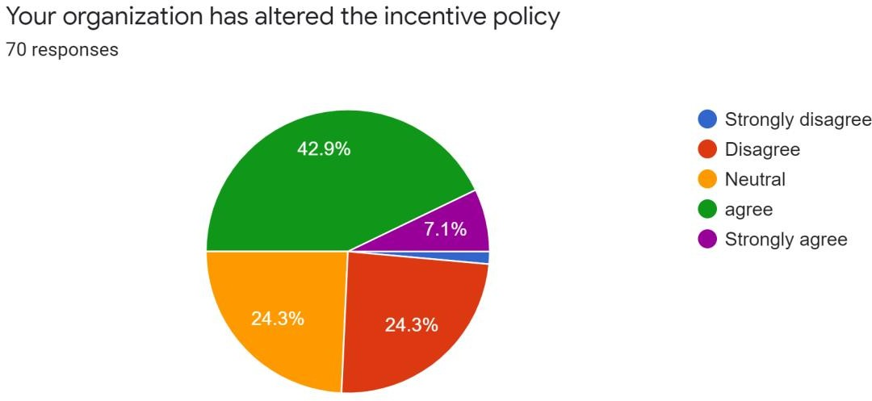

Interpretation: Most of the organization’s work has been impeded for the covid-19 predicament as well as their profit. And a lot of organizations changed their own policies. With this statement, 42.9% of the public strongly agreed, 24.3% were indifferent, 24.3% disagreed, and 7.1% highly agreed. Organizations have changed their incentive philosophy.

Your company has reduced the employees' bonuses.

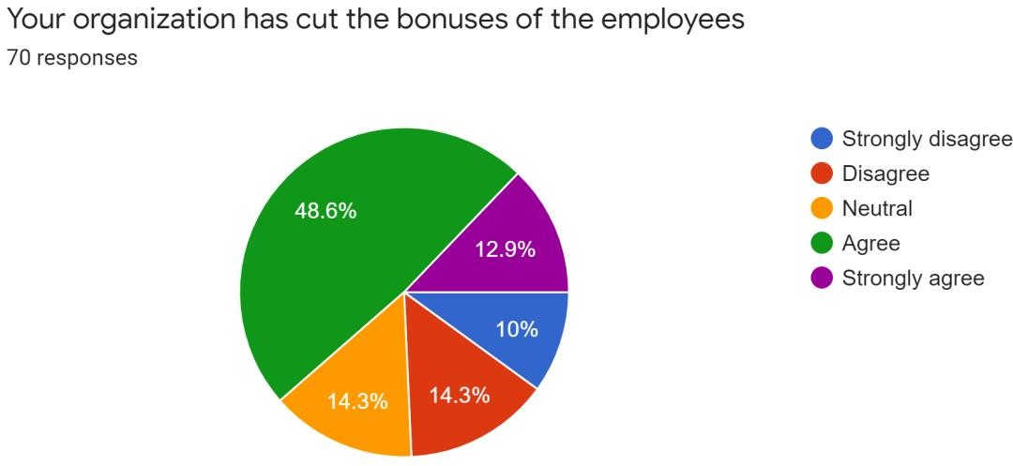

Interpretation: It is well known and obvious that the firms have stopped paying employee incentives, but we'll wait and see what the results show. The majority of the public, 48.6%, agreed that their firms had reduced employee bonuses, while 10% of the people strongly disagreed. 12.9% of the populace strongly agreed with the statement, 14.3% of employees disapproved, and 14.3% of employees remained indifferent.

Employees' basic salary promotions have ceased.
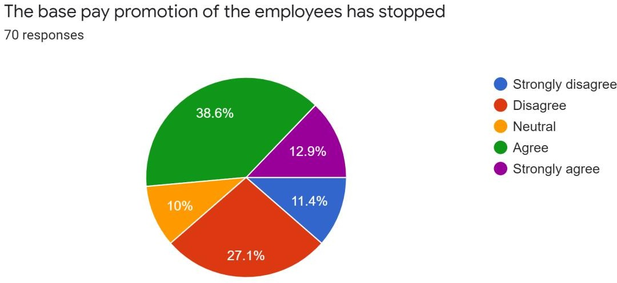

Interpretation: Employees' base salary promotions have ceased as a result of the statement. 12.9% of respondents said they strongly agreed with the statement, while 38.6% of respondents said they agreed. 27.1% of them disagreed with the assertion, with 11.4% of them strongly disagreeing since not all organizations do it. Some businesses genuinely care and view their staff as a resource. Only 10% of people still disagree with this assertion.

During this epidemic, recruiting has been challenging.
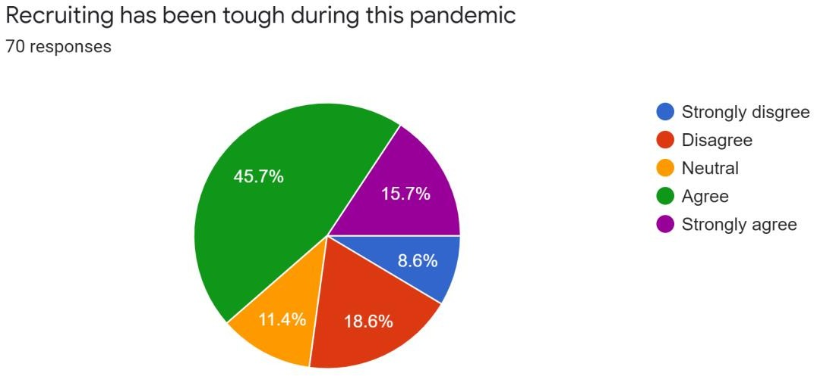

Interpretation: No matter how bad the present situation is, businesses will still require human resources to function. However, there must have been some alteration, and this outcome will tell us what it was. Recruitment has grown difficult, according to 15.7% of respondents who strongly agreed and 45.7% of respondents who agreed. Instead, 18.6% of them disagreed with them vehemently, 8.6% of them disagreed, and 11.4% were neutral.

Temporarily, recruiting has been halted.
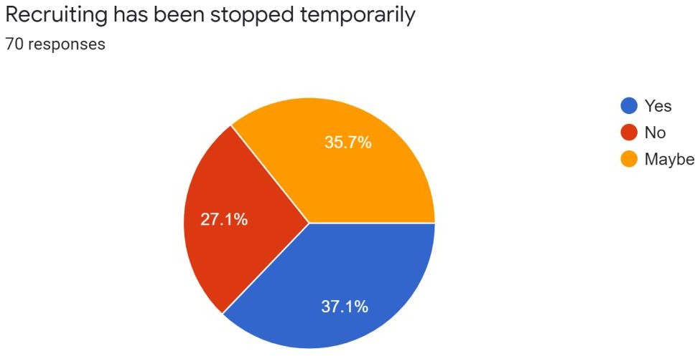

Interpretation: Some of the organizations could have momentarily ceased hiring, while others might not have. From this, we may deduce that 37.1% of respondents indicated that recruiting had temporarily halted in their company, 27.1% disagreed, and another 35.7% were unsure about the status of their recruiting policy.

Your boss has started the regularly scheduled daily check-ins.
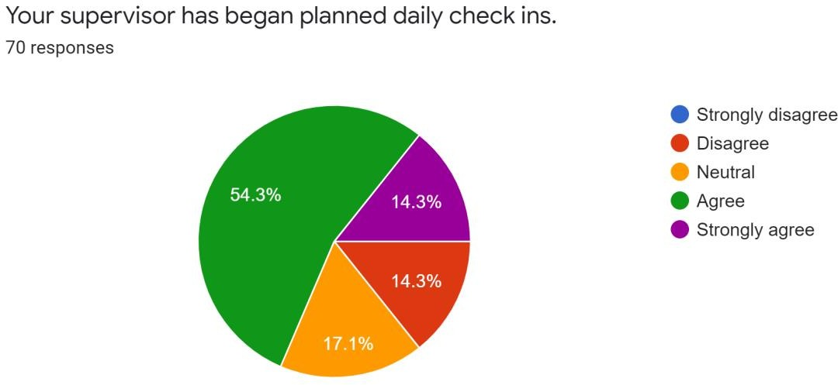

Interpretation: During this epidemic, supervisors are expected to be more involved and accountable than before. Therefore, we can observe that this statement—Supervisors have started planned daily check-ins—is true for 14.3% of respondents, 54.3% of whom agreed, 14.3% of whom disagreed, and 17.1% of whom are indifferent.

Do you receive targets that are really clear?
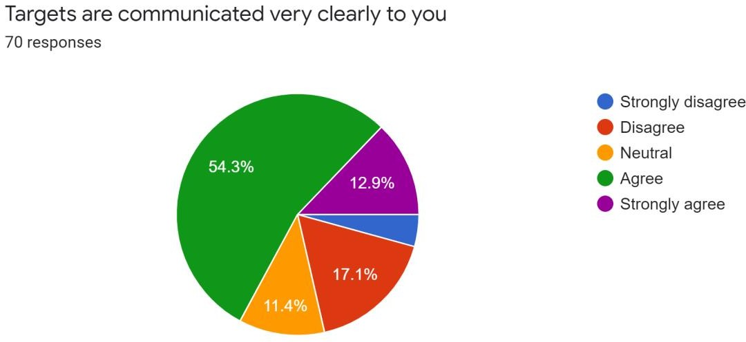

Interpretation: In response to the question of whether daily work or performance goals are conveyed to employees in a clear and understandable manner, 12.9% strongly agreed and 54.3% agreed that this is the case. Only 11.4% of respondents remained indifferent, while 17.1% disagreed.

Your work has received prompt feedback.
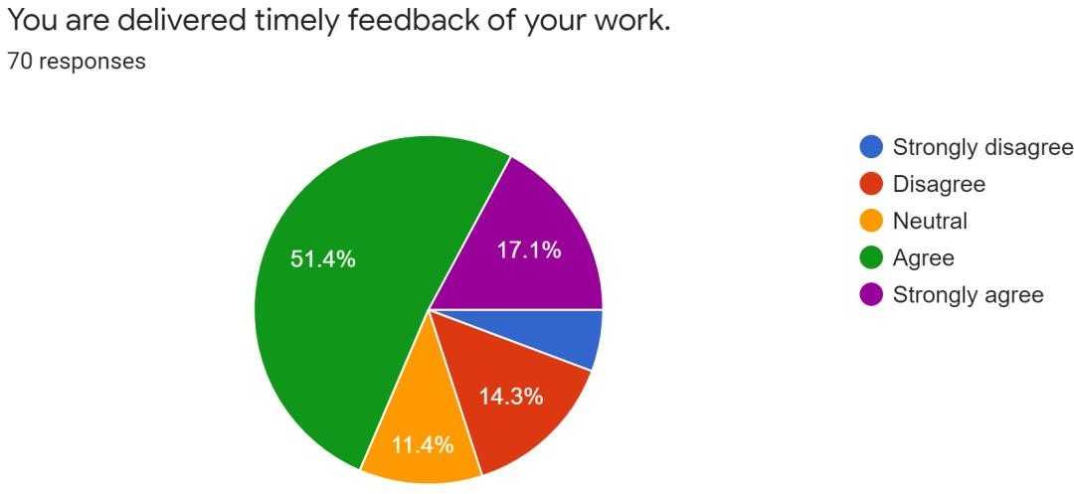

Interpretation: This annotation states that workers receive timely feedback on their performance, and 51.4% of the employees agreed with this statement, with 17.1% strongly agreeing. This is a highly encouraging development for any firm. 11.4% of respondents remained neutral, while 14.3% of persons disagreed.

Your boss assists in locating and closing performance gaps.

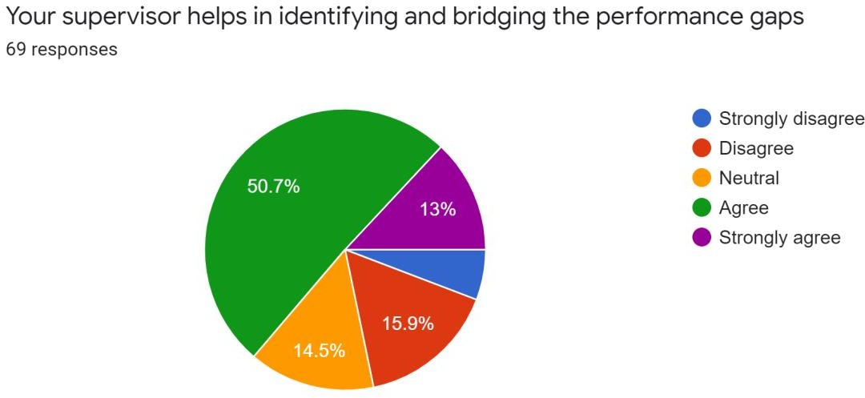

Interpretation: Supervisors are available to assist with this. In order to offset the losses brought on by the COVID-19 epidemic, everyone needs to exercise a little bit more caution and improve their performance index. 50.7% of the workers agreed, with 13% of them highly so, that their supervisors are assisting them in identifying and closing performance gaps. 15.9% of them disagreed with it, while 14.5% had no opinion.

Your supervisor is approachable and accessible for assistance
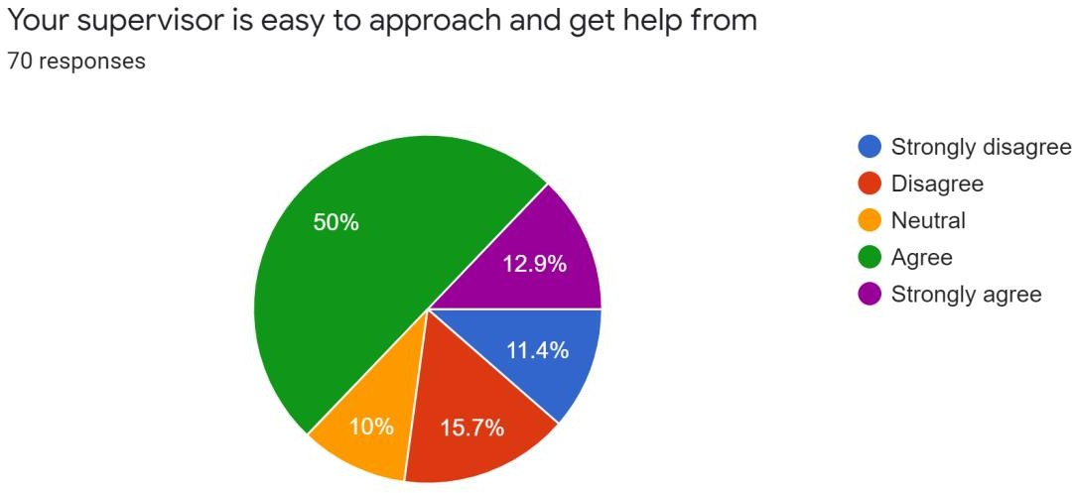
Interpretation: Here, it is demonstrated that 12.9% of workers highly agreed, 50% agreed, 15.7% objected, 11.4% strongly disagreed, and just 10% of the population remained neutral.

You were familiar with your business continuity strategy prior to the COVID-19 epidemic.
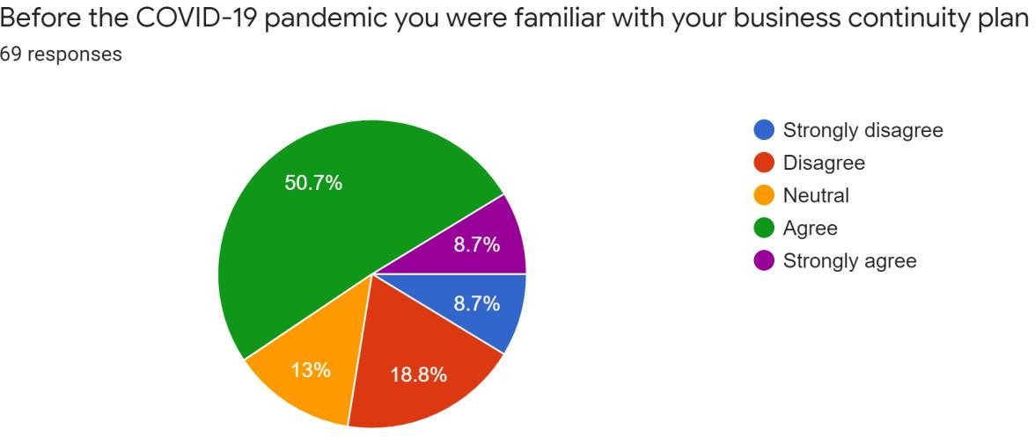

Interpretation: Almost every employee should be familiar with the organization's business continuity strategy. This is what protects the company against a potentially unpredictable disaster like the COVID-19 corona virus. Here, we can observe that 50.7% of respondents concur that they were aware of the organization's business continuity strategy, and 8.7% of respondents strongly agree. Only 13% of respondents chose to remain neutral, while 18.8% disagreed and 8.7% strongly disagreed with the statement.

Learning and training have become more difficult.
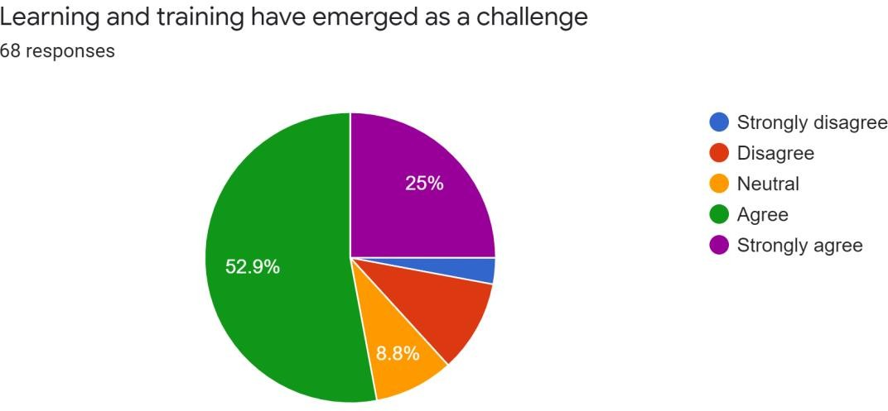

Interpretation: A very important aspect of company is staff learning and training. Because training increases employee skill levels, and we are aware of the value of a talented employee to a business. However, because this virus transmits through contact, the training session has mostly been suspended during this epidemic. Although there is some virtual training taking place, its efficacy is in doubt. Therefore, it is clear from this that 52.9% and 25% of respondents strongly agreed that the availability of training opportunities has become an issue.

There is no longer any interest in attending summits, seminars, or other events.
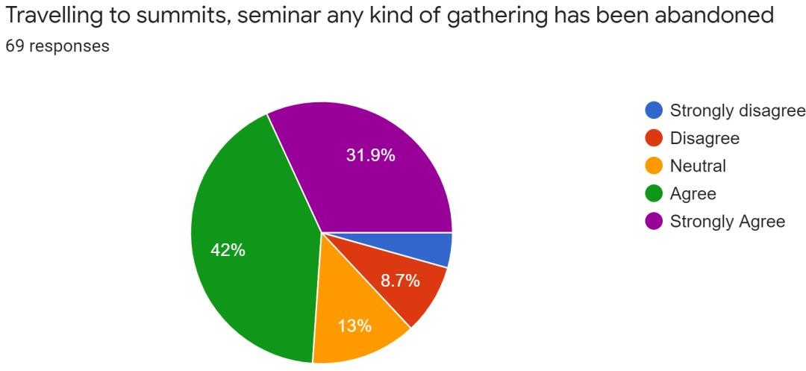
Interpretation: People are now avoiding any form of gathering, and as a result, summits and seminars are being postponed, as is evident from the results above. The results show that 42% of respondents agreed that summits, seminars, and other gatherings should be postponed, and 31.9% of respondents strongly agreed. Additionally, 13% of the population remained neutral, while 8.7% of people disagreed.

Your organization has set up a task force specifically to handle any scenario that may arise during this COVID-19 epidemic.
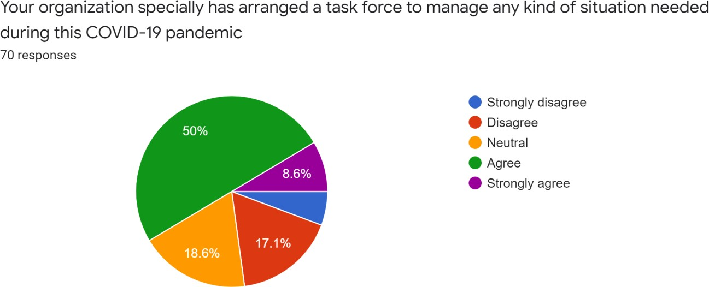

Interpretation: Good companies are always aware of potential hazards in the future and take appropriate action. Therefore, based on the aforementioned statement, we may infer that 50 percent of the public agreed that a special task force has been established to handle any issue that may arise during this pandemic and that 8.6% of the people strongly agreed. 17.1% of respondents disputed that, while 18.6% had no opinion.

CHAPTER SIX-RECOMMENDATIONS & CONCLUSIONS

RECOMMENDATIONS

Our research has led us to the conclusion that practically all FMCG companies are having trouble managing their operations, which has a negative impact on each company's profitability.
Many businesses continue to reject allowing some workers to work from home, and many already begun physically going to work. The stress and pessimism among employees are increasing. Their environment and thoughts are making them feel bad, which is impacting their mental health and ultimately their performance as well as the organization's overall performance. After reviewing the survey data, I have some recommendations that they may use to operate their business successfully throughout the pandemic. My recommendations are as follows;
I believe that reputation is built in trying times, not in happy ones. Despite the unfavorable situation right now, they shouldn't quit up. When it comes to standing out with their heads held high among the numerous commercial firms, this is actually the most important one. Naturally, they must work harder while following a clear plan and keeping the current situation in mind. They may also institute an open-door policy. This suggests that employees should feel free to get in touch with anybody at their place of employment at any time, and that everyone should be available to take calls, join video conferences, and send and receive chat messages. Numerous employees indicated, based on the findings, that they did not call their managers when necessary, yet this shouldn't be the case. If not in person, they should use virtual communication methods more enthusiastically than ever and stay in touch constantly.
The majority of employees are unhappy with the situation as it is. Their mental health is being compromised. As a result, it is the CEO or MD's responsibility to support them, give them hope, and assist them develop that optimism. The organization's leader might periodically organize a virtual meeting to inspire the workforce. As a consequence, the staff will feel inspired and excited about their work.
If activities are carried out locally rather than remotely, the corporation should be more cautious about worker safety and hygienic issues. All surfaces, door knobs, and machinery should be cleaned at the end of each workday. Organizations should form a specialized taskforce during this COVID-19 outbreak to tackle any crises that may occur.
One of the findings indicated that new hires are prevented from socializing with their coworkers because of the work-from-home situation. As a result, new recruits need to pick things up quickly. Relationship to key persons in the company. Instead of leaving the majority of these activities to HR, the recruit coordinator should be in close contact with the new hire throughout the recruiting and integration processes. The hiring manager can alert the rest of the organization's management when someone is hired so that their new coworkers can easily extend a warm welcome. The recruitment officer should send the new hire a list of all the significant people, including direct reports, a mentor, key employees, and other key function members, before they start working.
A "people first" concept ought to be adopted by organizations. During a pandemic, an organization's first concern should be the safety and wellbeing of its employees. When their safety and the safety of their families are at risk, workers find it challenging to concentrate on their duties. Therefore, whether staff are safe is the most crucial issue that businesses must address at the beginning of a pandemic outbreak, followed by whether they can handle essential services. Businesses must be able to keep control of the situation, maintain a safe workplace, and provide their staff with the support they require.

CONCLUSION

The success and stability of a company are mostly a result of its people resource. HR management helps to close the productivity gap between employees and the strategic goals of the firm. A good HR management team may also provide businesses a competitive edge. Human resources were not previously seen as having much value in the business world, but they are now seen as the most important asset for every corporation. A company's performance and profitability will increase in direct proportion to how well its human resources are handled. However, a peculiar virus known as COVID-19 is presently affecting how several businesses handle their human resources. It suddenly arose and is ruining the companies.
The bulk of FMCG companies provide goods including food, drinks, hygiene, and other necessities that customers need on a regular basis. They had to keep running their business despite the grave conditions, despite the virus spreading at the worst possible time, by conquering all challenges. The good news is that companies are doing their best to adapt. They have changed their business processes, strategies, and tactics as necessary. They are looking at alternatives and coming up with fresh, new approaches to complete the assignment. As specialized taskforces are formed, staff members are cooperating, participating in meetings, and obtaining virtual training
In truth, every company should be prepared for these unforeseen dangers; if not, swiftly adapt to the new situation and carry on with your business as usual. And it's great to see that, despite some of them lagging behind, Bangladesh's FMCG industry is keeping up with the pandemic scenario. We can predict and assume, nevertheless, that they will be boosting their HR efforts in the next days in a more effective and distinctive way based on how they performed throughout this Covid-19 pandemic.

Source of Information

I. Giaguri (2020, September 06). https://researchleap.com/. Retrieved from Research Leap on December 18, 2020: 10.18775/ijmsba.1849-5664-5419.2014.66.1002
R. Kibria (2020, March 25). https://www.lightcastlebd.com/. The following information was obtained on December 18, 2020, from LIGHT CASTLE ANALYTICS WING: https://www.lightcastlebd.com/insights/2020/03/25/bangladesh-fmcg-industry-tackling-covid-19- implications#::text=Globally%2C%20the%20market%20size%20of,mediums%20of%20growth%20laid%20out.
Joel B. Carrale and I. H. (2020, August). https://www.sciencedirect.com/. Science Direct was consulted for this information on December 18, 2020: https://www.sciencedirect.com/science/article/abs/pii/S0148296320303301#!
S. S. Pantho (2020). How Bangladesh's FMCG sector is handling the shutdown Daily Star, January.
R. Riasat (2020, July 02). https://thefinancialexpress.com.bd/public. Impacts of COVID 19 on the FMCG Industry: https://thefinancialexpress.com.bd/public/education/impacts-of-covid-19- on-fmcg-industry-1593628831, retrieved on December 18, 2020.
M. Shamsuddoha (2020, February 27). https://www.researchgate.net/. Research Gate was used to obtain this information on December 18, 2020: https://www.researchgate.net/post/Coronavirus and the Economy of Bangladesh
S. Silverthorne (2020, October 06). https://hbswk.hbs.edu/. Working Knowledge, retrieved December 18, 2020, at https://hbswk.hbs.edu/item/18-tips-managers-can-use-to-navigate-covid's-rising- seas Singh, M. (2020, May 10). https://hr.economictimes.indiatimes.com/. Retrieved December 18, 2020, from HR world.com: https://hr.economictimes.indiatimes.com/news/industry/impact-of-covid-19-on- hr-practices-and-future-workforce/75653859
D. Sweeney (2020, May). https://blog.mycorporation.com/. From My Corporation, retrieved on December 18, 2020: https://blog.mycorporation.com/2020/03/leading-teams-coronavirus/ Vnouková, L. (2020, May 05). http://52.226.65.210/index.php/relais/index. Revista Latinoamericana de Investigación Social (accessed December 15, 2020): 52.226.65.210/index.php/relais/article/view/2614
Group of Industries Meghna (n.d.). Retrieved February 5, 2023, from ACI Foods Ltd. at https://www.mgi.org (n.d.). https://www.aci-bd.com/our-companies/aci-foods-ltd.html was used to retrieve this information on February 1, 2023.

Questionnaire

- Your organization is now facing a problem in managing business stability.

  - Strongly agree
  - Somewhat agree
  - Neutral
  - Disagree
  - Strongly disagree
- Managing day-to-day operations is a challenging undertaking for enterprises during this epidemic.

  - Strongly agree
  - Somewhat agree
  - Neutral
  - Disagree
  - Strongly disagree
- Increasing employee stress is an issue your organization is now confronting.

  - Strongly agree
  - Somewhat agree
  - Neutral
  - Disagree
  - Strongly disagree
- It might be difficult for new employees to socialize.

  - Strongly agree
  - Somewhat agree
  - Neutral
  - Disagree
  - Strongly disagree

- Compared to working in an office, working from home is more pleasant for you.
  - Strongly agree
  - Somewhat agree
  - Neutral
  - Disagree
  - Strongly disagree
- With your present work-from-home setup, you are productive.

  - Strongly agree
  - Somewhat agree
  - Neutral
  - Disagree
  - Strongly disagree
- How frequently did you work from home before Covid?

  - Strongly agree
  - Somewhat agree
  - Neutral
  - Disagree
  - Strongly disagree
- In comparison to working in an office, it is simple to communicate with your coworkers.

  - Once a week
  - A few times a week
  - Never
  - Majority of the week
  - Always occasionally
- Do you have more optimism or pessimism about working from home this week compared to previous week?

  - Optimistic
  - Pessimistic
  - About the same.

- Your company changed the reward policy.

  - Strongly agree
  - Somewhat agree
  - Neutral
  - Disagree
  - Strongly disagree
- Your company has reduced the employees' bonuses.

  - Strongly agree
  - Somewhat agree
  - Neutral
  - Disagree
  - Strongly disagree

- Employees' basic salary promotions have ceased
  - Strongly agree
  - Somewhat agree
  - Neutral
  - Disagree
  - Strongly disagree

- During this epidemic, recruiting has been challenging.

  - Strongly agree
  - Somewhat agree
  - Neutral
  - Disagree
  - Strongly disagree
- Temporarily, recruiting has been halted.

  - Strongly agree
  - Somewhat agree
  - Neutral
  - Disagree
  - Strongly disagree

- Your boss has started the regularly scheduled daily check-ins.

  - Strongly agree
  - Somewhat agree
  - Neutral
  - Disagree
  - Strongly disagree
- Do you receive targets that are really clear?

  - Strongly agree
  - Somewhat agree
  - Neutral
  - Disagree
  - Strongly disagree
- Your work has received prompt feedback.

  - Strongly agree
  - Somewhat agree
  - Neutral
  - Disagree
  - Strongly disagree
- Your boss assists in locating and closing performance gaps.

  - Strongly agree
  - Somewhat agree
  - Neutral
  - Disagree
  - Strongly disagree
- Your supervisor is approachable and accessible for assistance

  - Strongly agree
  - Somewhat agree
  - Neutral
  - Disagree
  - Strongly disagree
- You were familiar with your business continuity strategy prior to the COVID-19 epidemic.

  - Strongly agree
  - Somewhat agree
  - Neutral
  - Disagree
  - Strongly disagree
- Learning and training have become more difficult.

  - Strongly agree
  - Somewhat agree
  - Neutral
  - Disagree
  - Strongly disagree
- There is no longer any interest in attending summits, seminars, or other events.

  - Strongly agree
  - Somewhat agree
  - Neutral
  - Disagree
  - Strongly disagree
- Your organization has set up a task force specifically to handle any scenario that may arise during this COVID-19 epidemic.
  - Strongly agree
  - Somewhat agree
  - Neutral
  - Disagree
  - Strongly disagree

