Project on
Factors affecting succession planning in an organization

UNITED INTERNATIONAL
UNIVERSITY
Project Topic
Factors affecting succession planning in an organization
Submitted To
Yeasmin Islam
Assistant Professor
School of Business and Economics
Submitted By
Sabrin Hossain
ID: 111 151 430
Date: 30-06-2019

Letter of transmittal

June 30, 2019
Yeasmin Islam
Lecturer
School of Business and Economics
United International University
Subject: Project on Factors Affecting Succession Planning in an Organization.
Dear Mam,
With due respect & humble submission, I am submitting a “Project on Factors Affecting Succession Planning in an Organization”. It is a part of the requirement of the course. Your guideline has been followed in every aspect of preparing this project. I am really grateful for working on this project under your guideline and we hope that my work would meet the level of your expectation.
However, any query on this project is appreciated. Finally I would love to express my gratitude for your supportive thoughts and kind considerations. I hope, you will like this report & oblige thereby.
Sincerely,
Sabrin Hossain
ID: 111 151 430

Acknowledgement

In preparing the project on factors affecting succession planning in an organization, firstly, I express my gratitude to our honorable faculty Yeasmin Islam, without her kind direction and proper guidance this project would have been a failure. In every phase, from topic selection to data collection and data analysis, her supervision has shaped this research paper.
I also want to thank to all HR staffs in total twenty organizations who provided all the necessary information that I required for the survey and others who gave their valuable time and information to successfully make this project.

Abstract

This study describes the factors that affect succession planning in an organization. This study has been fundamentally written after collecting information through online survey & offline survey. Succession planning means developing the leadership substitute. The main purpose of this study is to investigate internal & external factors that influence succession planning in an organization. The questionnaire for conducting the survey has been developed using Likert scale. The data or information has been collected through online, web sites & also from personal visit. This research will help to understand which factors is mostly influenced the succession planning in real situations and will also help to find out factors which are not important for the company and which factors the company should consider as important to make better succession planning. In this report descriptive and statistical methods have been used for analyzing the surveys which has been collected from different organizations. Twenty responses have been collected where 60% are male respondent & 40% are female respondents. They are mostly aged from 32 to 36 years. This study shows, high skilled internal candidate’s importance, selection for multiple candidates, strong management system, strong organizational culture, financial support, diversity in management, formal written plan, as crucial factors related to succession planning. This study revealed a need of a succession planning in all organizations to get a next best successor.

Table of Contents
Letter of transmittal i
Acknowledgement ii
Abstract iii
Chapter 1 1
Introduction 1
1.1 Background of the study. 1
1.2 Scope of the study 3
1.3 Objective of the study 3
1.4 Methodology of the study 3
1.5 Limitations of the study 4
Chapter 2 5
Literature review 5
2.0 Introduction 5
2.1 Succession planning 5
2.2 Reasons for and benefits of succession planning 6
2.3 Succession planning strategy and process 7
2.4 How Do Companies Currently Do Succession Planning? 7
2.5 Develop Employees for Succession Planning 8
2.6 Breaking down Succession Planning 8
2.7 Generally, setting up a successful business succession plan involves seven stages: 9
Chapter 3 11
Analysis and Findings 11
3.1: Descriptive analysis: 11
Chapter 4 27
Conclusion 27
References 28

Chapter 1

Introduction

Is it possible that a top positioned leader will remain in that position for his lifetime? Apparently someone will take the position of him after his retirement, termination, transfer, promotion or death. But the big question is, who will be the new leader who can take the company to the continued success or even more? With that thought, the modern concept “Succession planning” arises. Succession planning is consider as a process of acknowledging future leaders among the skilled employees of the organization & prepare them for taking the key position of former leaders when they about to leave the organization because of retirement, resignation, termination, transfer, promotion or death. In short, it means developing the leadership substitute. This process is now a must for a modern company to keep the highly talented employees in the organization by providing them the growth opportunities of becoming a top leader which will motivate them to retain & bring continuous success to that organization. In this systematic process, HR manager must find out candidate’s future career plans & interests are matching with the organization’s mission, vision & overall goals or not. For that, manager must consider some factors like family consideration, diversity, planning, management system & many more that can positively or negatively affect to identify the potential successor.

1.1 Background of the study.
Succession planning helps companies control their talent pipeline (Guin, 2000). The notion of succession planning ranges from any efforts to plan for top management succession to an expansive view of systematic internal talent development (Froelich, McKee, &Rathge, 2011).
Couch (2013) defines succession planning as a deliberate and systematic effort to identify leadership requirements, identify pools of high-potential candidates at all levels, accelerate the development of mission-critical leadership competencies in the candidates through intentional development, select leaders from the candidate pools for pivotal roles and then, regularly measure progress. According to Hills (2009), Succession planning is about more than filling the top spots. It is a smart talent management strategy that can drive retention of talent throughout the organization and make sure that the organization has the skill sit needs in place, or on hand, to respond to the rapidly shifting sands that make up today’s business environment.
Although, new career concepts like boundary-less careers (Arthur and Rousseau, 1996) and protean careers (Hall, 1996) emphasize individual responsibility in career development, no successful business can stop career management programs like succession planning to identify and develop the right people to ensure that the important skills are present in the organization over the long term (Barnet and Davis, 2008).
From risk management perspective, SP is a useful practice obstacle against risk. In fact, organizations fare better while they immediately appoint an internal successor (Worrell and Davidson, 1987). Bernthal and Wellins (2001) study in 14 countries showed that, succession planning increases satisfaction of future leaders and is a prerequisite for retention. Rothwell (2010) mentioned succession planning as a basic tool for organizational learning because it keeps lessons learned in the organizational memory.
The practice of succession planning is supported by employees. In a survey which is conducted by Bernthal and Wellins (2001), it was found that two–third of employees indicated that they would rather grow inside their present organization than leave. A 2004 survey of 711 human resource managers found that although 80 percent of the managers believed that succession planning was critical, less than half of their companies had a succession plan in progress (Taylor & McGraw, 2004) (Dehghanpour, 2011).
In Kenya, Christian Organizations and Nongovernmental organizations pointed out in a recent study that; key or high performing staff at all levels in every organization will lose for many reasons: family, promotion, external calls, resignations and even sudden death. Succession management that has become recently very modern is about making provisions for the replacement of such staff in an intentional manner by a concerned management (Dehghanpour, 2011).

1.2 Scope of the study
The project has been designed to understand the internal & external factors that influence the succession planning in an organization. This report will help to understand which factors is mostly influenced the succession planning in real situations and will also help to find out factors which are not important for the company and which factors the company should consider as important to make better succession planning.

1.3 Objective of the study
Two types of objectives of the project are:
General objective
To investigate internal & external factors that influence succession planning in an organization.
Specific objective
1. To investigate how internal candidate can affect the succession planning in an organization
2. To establish how effective management system can affect succession planning in an organization.
3. To investigate whether family considerations can create barrier in succession planning in an organization.
4. To establish how multiple candidate & diversity can create some influence on succession planning in an organization
5. To investigate candidate development opportunities are necessary for the succession planning or not.

1.4 Methodology of the study
Methodology means the widespread actions of investigation in the project. Basically, there are two types of methodologies: paper based and internet based, both have been used for the project purpose. Generally it includes two types of sources of information.
Primary sources of data
The primary sources comprise with personal visits to the company and other manual information. For this project, data has been collected by visiting some organizations for conducting offline survey.
Secondary sources of data- Secondary data includes information from books, web sites, magazines, newspaper etc. Various data has been collected from different secured website to conduct this research. Online survey has been conducted for the research.

1.5 Limitations of the study
1. No Responds:
However, large numbers of company’s HR staffs were asked to fill up the goggle form for survey purpose but they don’t respond to this.
2. Biasness:
Due to possible lack of time, maybe the interest to accurately fill in the questionnaire, HR manager or executive may have been negatively or positively be biased.
3. Timeliness HR manager take too much to fill up the form. I need to ask my known people to request their HR manager or executive several times to fill up the form.

Chapter 2

Literature review

2.0 Introduction
This chapter covers literature related to the study and is particularly based on areas namely, the concept of succession planning, different uses of the term succession planning, reasons for and benefits of succession planning, succession planning strategy and process, how do companies currently do succession planning? Develop employees for Succession Planning, breaking down Succession Planning, seven stages of succession planning.

2.1 Succession planning
Succession planning is the systematic process of developing talent to replace executives, leaders or other key employees when they are transferred to another role or they are fired or they leave the company or retire or die. Succession planning is significant to all companies, in both the profit and non-profit sectors, from the largest to the smallest. The main focus of this planning is to create a talent pipeline of successors that will not interrupt the operation of the organization when any staff changes take place.
Top management should fully support for the making of an effective succession planning. Senior staffs sometimes don’t want to train the junior staffs because senior management feels insecure of the existence of those skilled junior staffs in the company. Also, there should be support from the general staffs as well for the operation of the succession planning. Effective succession planning works by leadership development & creating long-term goals and strategies. HR department along with support from top leaders and other stakeholders is critical for the success of the succession planning.

2.2 Reasons for and benefits of succession planning
A gap is created if the key leader leaves but if a manager level employee leaves his or her position, it can be more difficult to find the same skilled employee, even at lower levels. In industries where there are needed special skill & talent, replacing employees can be a difficult task, and it can be time consuming to get an exactly same or nearly same skilled employee with full productivity.
So the need for succession planning created in a more widespread way, not just for the CEO, Executive Director. It is found in numerous studies that many companies fail to create a succession plan, even for their highest executives. Smaller businesses and family businesses can mostly sink because of the lack of proper planning. Because they don't have the sheer candidate numbers from which to choose. The reasons of succession planning, why it is needed in an organization is given below:
Finding the replacement of the employee costs time, productivity and money. According to a 2016 article in Harvard Business Review, this can run upwards of $1 billion, for the replacement of the top executives at a large public company.
Fewer employees are available with the skill set to replace senior executives, as more baby boomers are retiring.
Succession planning helps to overcome these factors and provides many benefits, including:
- Increasing employee engagement by providing them career development opportunity and making workers feel valued of their work;
- Helping the organization create a better brand value & reputation as a talent destination;
- Filling key roles more quickly to save money and for smoother business operations and delivery of uninterrupted excellence to the organization;
- Supporting HR and managers in creating and supporting proactive programs & fulfilling the vision of the organization;
- Supporting cross-functional cooperation (Rouse, 2018).

2.3 Succession planning strategy and process
Depending on the size of the organization and its goals, the strategic planning and process for success planning can vary wildly. Important factors are following:
- Attaining the support of key stakeholders, including the CEO or executive director;
- Preparing effective learning and development processes. The succession strategy will be supported by preparing effective learning and development processes. Especially experiential development process should be created, such as job shadowing and cross-functional moves;
- Fixing in support of the succession planning strategy and process which HR software will be used. (Rouse, 2018).

2.4 How Do Companies Currently Do Succession Planning?
Many companies have not utilized the concept of succession planning in their organizations. Others plan informally and verbally for succession for key roles when any staff change takes place. By this type of process, for example, Alif is identified as the strongest player on Maliha's team so he is likely to succeed Maliha when she is promoted or leaves.
In other companies, senior leaders teams put forth the names of employees whose they believe are strong players with great potential & talent in their organizations. This helps other top-level managers to know when any staff change takes place who is available for potential promotion or who is available to fill up the key role.
The mentors are committed and develop the employee so that he or she is ready to take over is the advantage of a written formalized system. In the above example of Alif taking over Maliha's role if she leaves or is promoted, developing his skills is a priority.
Organizationally, this planning allows all managers to know who the key & important employees are in all departments of the organization. So when any key role opens up, they know who are the strong players are.
For both employers and employee’s effective succession planning brings benefits and it's definitely worth the time (Heathfield, 2019).

2.5 Develop Employees for Succession Planning
For developing employees, organization need a proper succession plan. Organization can use practices to develop employees such as lateral moves, special assignments, team leadership roles, and both internal and external training and development opportunities.
Superior employees retain in the organization through the succession planning process because they appreciate the time, attention, skill development opportunity that organization are investing in them. When employees can see a career path for their continued growth and development, employees are motivated and engaged with the organization.
To effectively do succession planning in the organization, identifying the organization’s long-term goals is very important (Heathfield, 2019).

2.6 Breaking down Succession Planning
Evaluating each leader’s skills, their talents, finding out potential replacements for who can fill up the key role both within and outside the company which are all included in Succession planning. In the case of internal replacements, training & developing those employees so they’re prepared to take over, is also a part of succession planning. It is not a one-time event; succession plans should be reevaluated and potentially updated each year or as changes in the company dictate for identifying the better replacements. Sometimes organizations might want to create both an emergency succession plan, in the event of an unexpected leave of a key leader. For anticipated changes in leadership in future, a long-term organization goal is needed for succession plan that time.
In small organizations the owner alone may be responsible for succession planning. In large corporations, the board of directors, not just the CEO, also the other top level manager will be typically oversee succession planning. Also, succession planning impacts not only just owners and employees, but also shareholders in large corporations. Succession planning often means training & developing the next generation to take over the business for small businesses and family-owned companies. Mid-level employees might groom in a larger companies to one day take over higher-level positions (Finogent advisory, 2018).

2.7 Generally, setting up a successful business succession plan involves seven stages:
1. Survival -- When the business has survived the start-up stage of life cycle, the owner should consider a business succession plan.
2. Commitment -- The owner must be committed to give opportunity for the employees continuously so that they will be motivated to be a part in the organization. This commitment must be communicated clearly, extensively, and often so that employees don’t have trust issues about the organization.
3. Recruitment -- Recruiting high skilled & talented people always pays dividends and is an important area in succession planning.
4. Development – It will be vital to the organization’s success to invest time in developing family members, key employees, and management team members, and allowing them to exercise authority and control.
5. Selection – Developing a transition plan and recruiting the right people then selecting a successor or successors becomes easier. The selection process is simplified and the owners' options are enhanced by empowering a broad range of key people.
6. Announcement -- The owner should communicate that plan when it has completed. key management people and/or family successors should be properly communicated to get a clear understanding of the path to the future, as well as any role they may play in that path. It also allows them to begin setting future goals and objectives for themselves.
7. Implementation -- the owner must be ready to step aside and allow the successor(s) to take over when it is time for implementing the succession plan. The owner must be prepared to take on new challenges in retirement & he should know that his or her financial future is secure.
Finally, selecting qualified advisors, such as an accountant, attorney, insurance agent and financial planner, can help assure that the plan legally, profitably, and affordably considers the needs and objectives of the particular organization (Amundson, 1997).
Therefore, the succession planning process is meant to create a talent pipeline of successors that will help the organization to continue operate without any interruption when staff changes occur. It may also be used to indicate the passing of company ownership onto employees. Identifying the organization’s long-term goals is very important, for anticipating changes in leadership in future. Succession plans should be reevaluated and potentially updated each year or as changes in the company dictate.

Chapter 3

Analysis and Findings
The questionnaire for conducting the survey has been developed using Likert scale. The information has been collected through offline & online survey.
Total response: 20
Male: 12, which means 60% of total respondents.
Female: 8, which means 40% of total respondents.
Age: Respondent’s age ranges from 24 to 52 years. Mostly aged from 32 to 36 years.
The analysis is showing in different charts.

3.1: Descriptive analysis:
Particulars | Strongly  Disagree (1) |  | Disagree  (2) |  | Neutral  (3) |  | Agree  (4) |  | Strongly Agree  (5)
Particulars |  | % |  | % |  | % |  | % |  | %
1) Internal Candidates retention rate is high for succession planning. | 0 | 0% | 1 | 5% | 1 | 5% | 10 | 50% | 8 | 40%
2) Internal candidates are more knowledgeable than external candidates for succession planning | 1 | 5% | 4 | 20% | 2 | 10% | 10 | 50% | 3 | 15%
3) Internal candidates are more loyal than external candidates in succession planning | 0 | 0% | 4 | 20% | 0 | 0% | 9 | 45% | 7 | 35%
4) Developing candidates for succession planning is costly. | 0 | 0% | 7 | 35% | 6 | 30% | 5 | 25% | 2 | 10%
5) Having internal candidate for succession planning is less costly. | 0 | 0% | 1 | 5% | 0 | 0% | 15 | 75% | 4 | 20%
6) Financial supports are also important for succession planning. | 2 | 10% | 0 | 0% | 0 | 0% | 13 | 65% | 5 | 25%
7) Family members create influence in succession planning. | 1 | 5% | 4 | 20% | 6 | 30% | 8 | 40% | 1 | 5%
8) Nepotism can create barriers in succession planning. | 0 | 0% | 1 | 5% | 2 | 10% | 13 | 65% | 4 | 20%
9) Effective candidates are more important than family members. | 0 | 0% | 0 | 0% | 2 | 10% | 8 | 40% | 10 | 50%
10) Family members also need to go through candidate’s development activities like others. | 0 | 0% | 2 | 10% | 6 | 30% | 6 | 30% | 6 | 30%
11) Need to select multiple high skilled candidates for succession planning. | 0 | 0% | 0 | 0% | 0 | 0% | 9 | 45% | 11 | 55%
12) Selecting one candidate for succession planning can create critical failure in future. | 1 | 5% | 4 | 20% | 6 | 30% | 5 | 25% | 4 | 20%
13) Need to prepare rewards systems for non-selected candidates of succession planning. | 0 | 0% | 7 | 35% | 2 | 10% | 7 | 35% | 4 | 20%
14) Need to consider diversity in management for succession planning. | 0 | 0% | 0 | 0% | 2 | 10% | 14 | 70% | 4 | 20%
15) Succession planning is also critical for middle management. | 0 | 0% | 3 | 15% | 4 | 20% | 8 | 40% | 5 | 25%
16) Lack of formal written plan can affect succession planning | 0 | 0% | 1 | 5% | 1 | 5% | 11 | 55% | 7 | 35%
17) The CEO as well as HR managers need to involve in succession planning. | 0 | 0% | 0 | 0% | 0 | 0 % | 10 | 50% | 10 | 50%
18) Delayed promotion can result in low retention of best candidates of succession planning. | 0 | 0% | 4 | 20% | 0 | 0% | 7 | 35% | 9 | 45%
19) Delay in succession planning can create impact on business activities. | 0 | 0% | 0 | 0% | 2 | 10% | 9 | 45% | 9 | 45%
20) Ensuring skilled employee is important for succession planning. | 0 | 0% | 0 | 0% | 0 | 0% | 8 | 40% | 12 | 60%
21) Identifying potential candidates for development is time consuming. | 2 | 10% | 2 | 10% | 3 | 15% | 13 | 65% | 0 | 0%
22) A team is more effective to make succession planning decisions than a single person. | 0 | 0% | 0 | 0% | 0 | 0% | 7 | 35% | 13 | 65%
23) Strong organizational culture is important for effective succession planning | 0 | 0% | 1 | 5 % | 3 | 15% | 8 | 40% | 8 | 40%
24) Organization’s flat structure results in better communication which helps in implementing succession planning. | 0 | 0% | 4 | 20% | 2 | 10% | 9 | 45% | 5 | 25%
25) Succession planning needs supports from all levels of management. | 0 | 0% | 0 | 0% | 0 | 0% | 9 | 45% | 11 | 55%

Each question is showing in different pie charts.
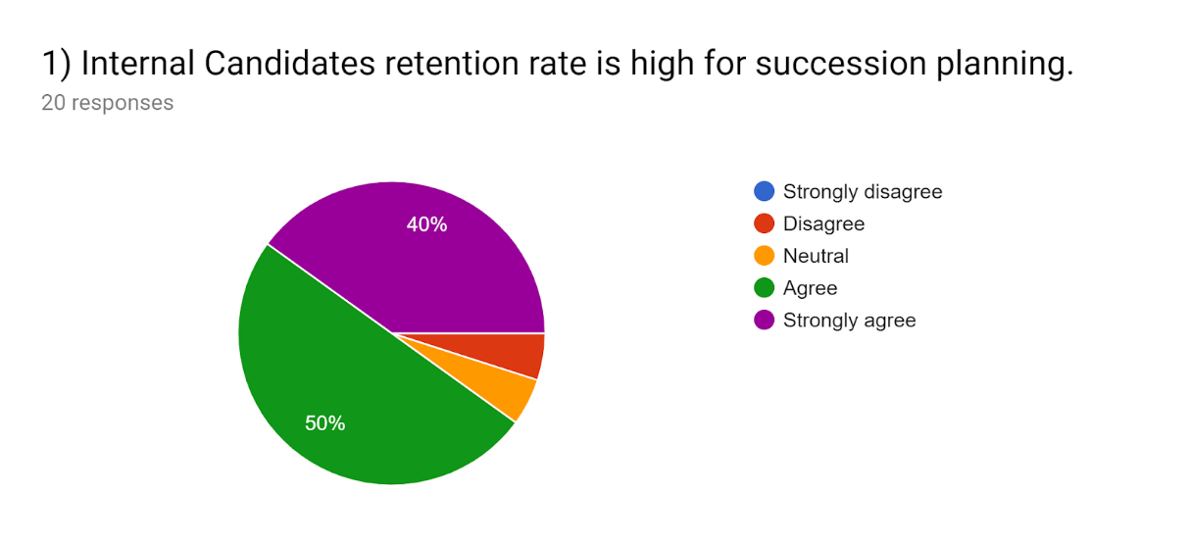
Figure 3.1: Internal Candidates retention rate is high for succession planning.

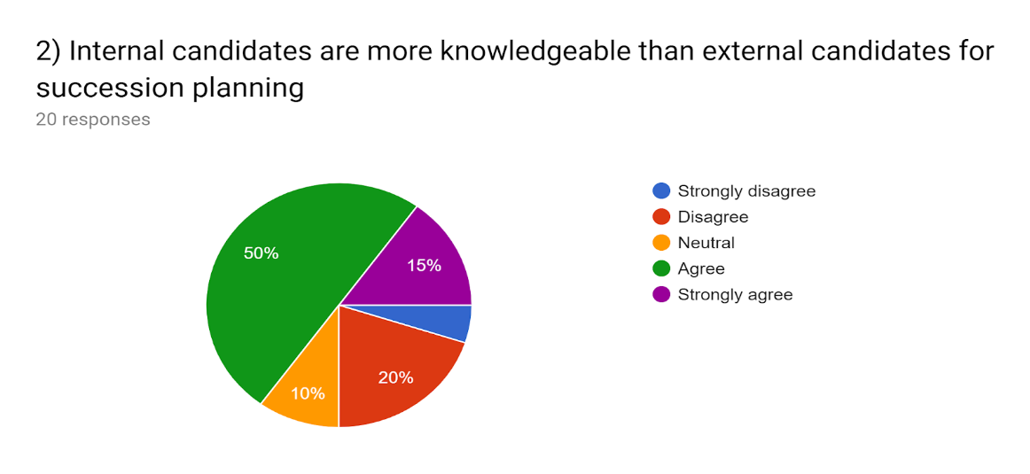
Figure 3.2: Internal candidates are more knowledgeable than external candidates for succession planning.
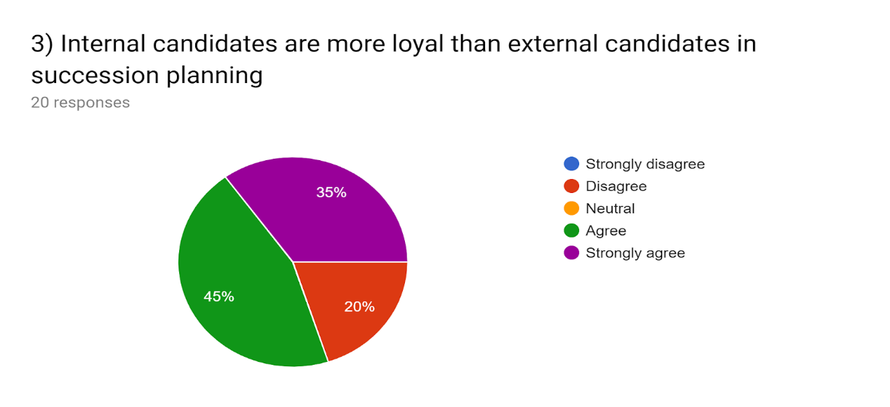
Figure 3.3: Internal candidates are more loyal than external candidates in succession planning.
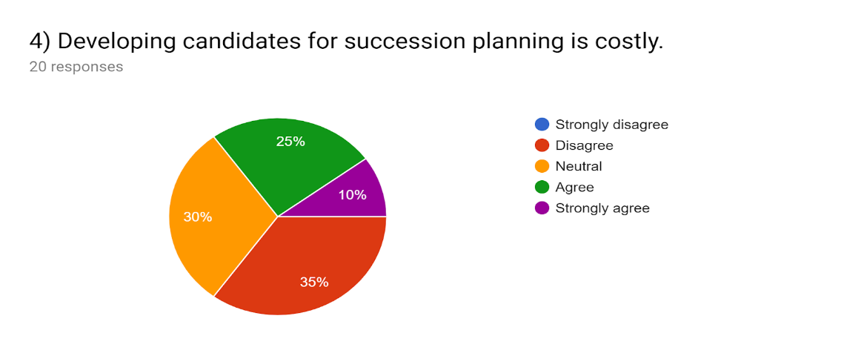
Figure 3.4: Developing candidates for succession planning is costly.
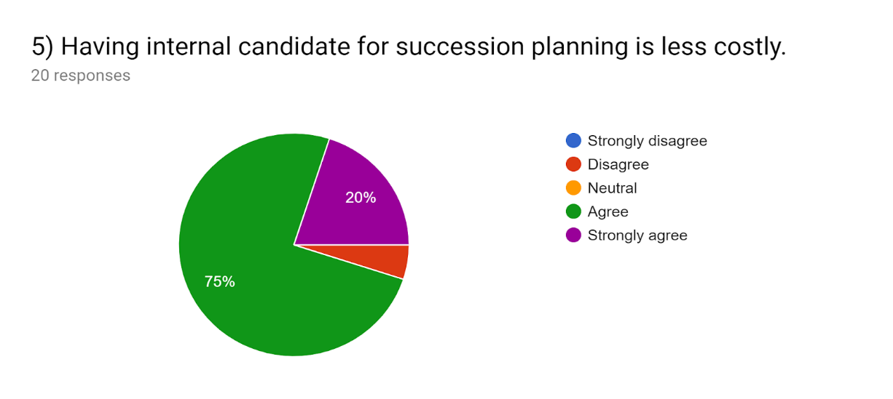
Figure 3.5: Having internal candidate for succession planning is less costly.
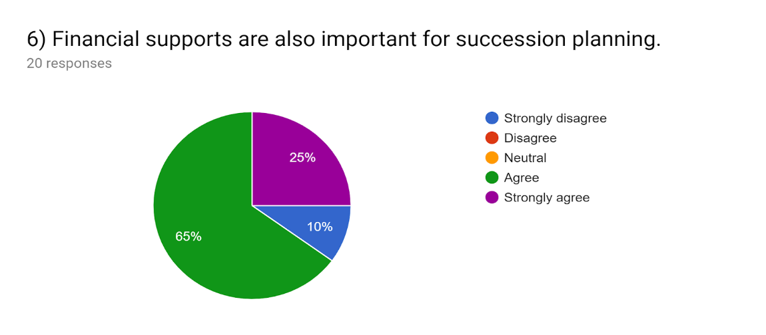
Figure 3.6: Financial supports are also important for succession planning.
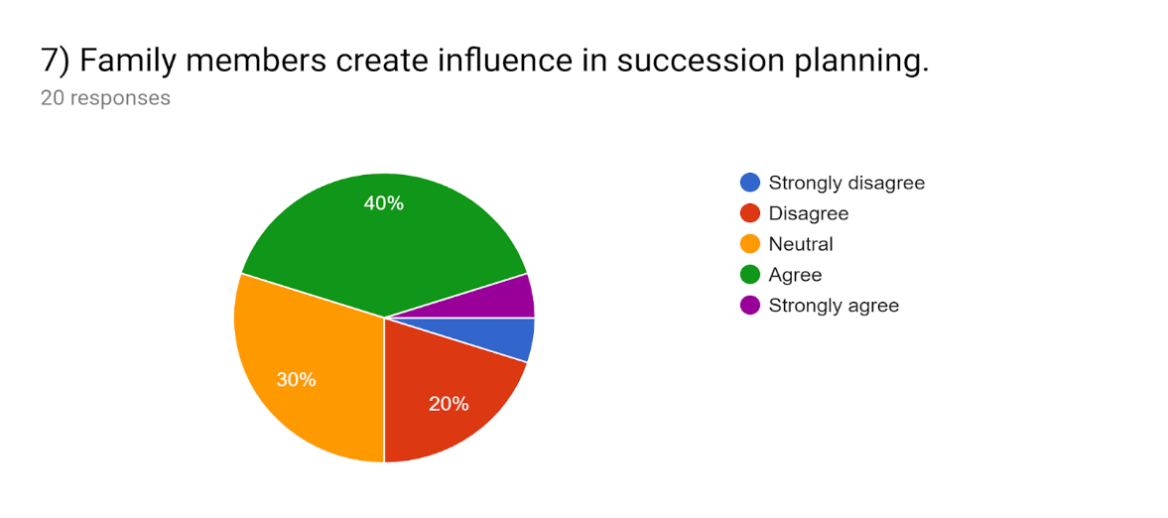
Figure 3.7: Family members create influence in succession planning.
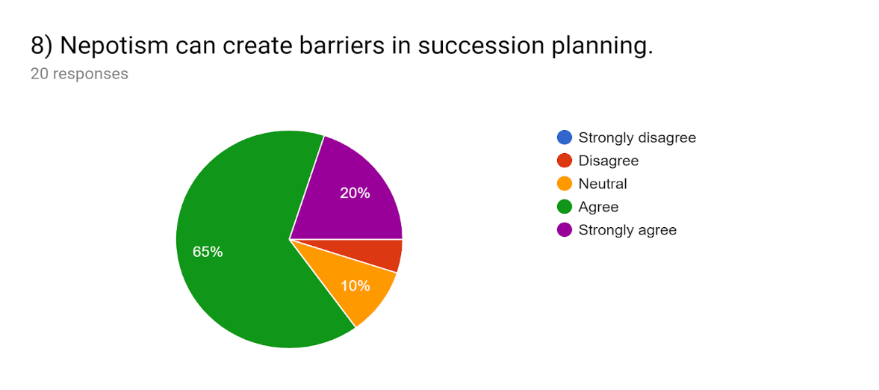
Figure 3.8: Nepotism can create barriers in succession planning.
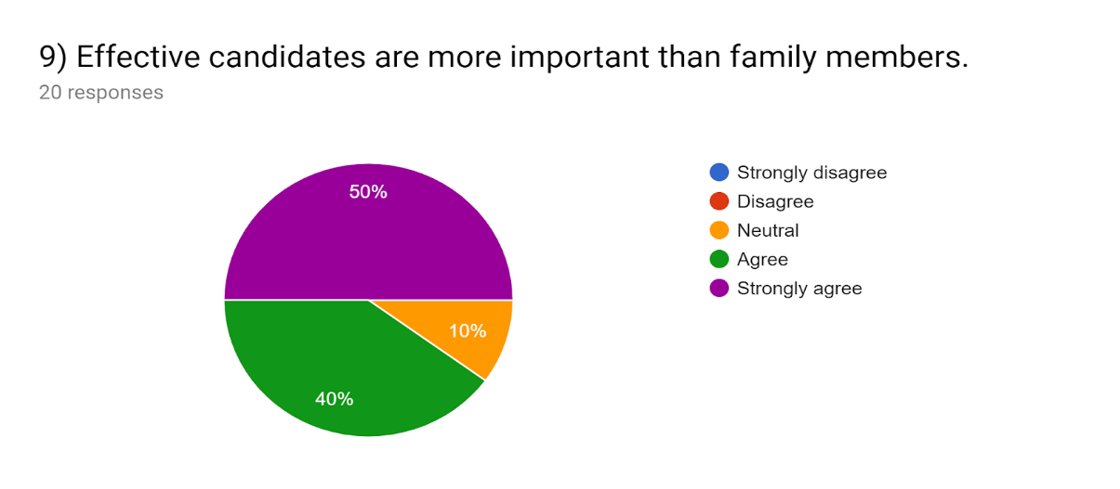
Figure 3.9: Effective candidates are more important than family members.
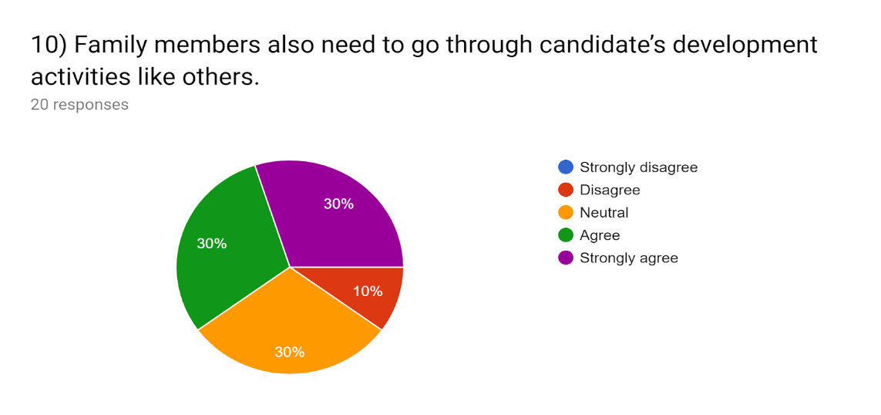
Figure 3.10: Family members also need to go through candidate’s development activities like others.
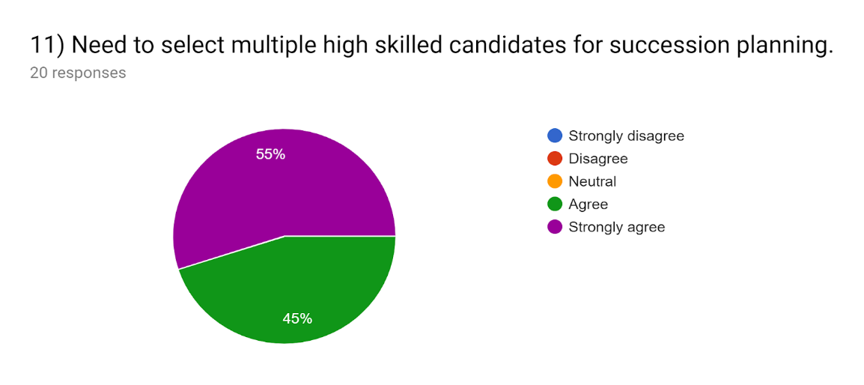
Figure 3.11: Need to select multiple high skilled candidates for succession planning.
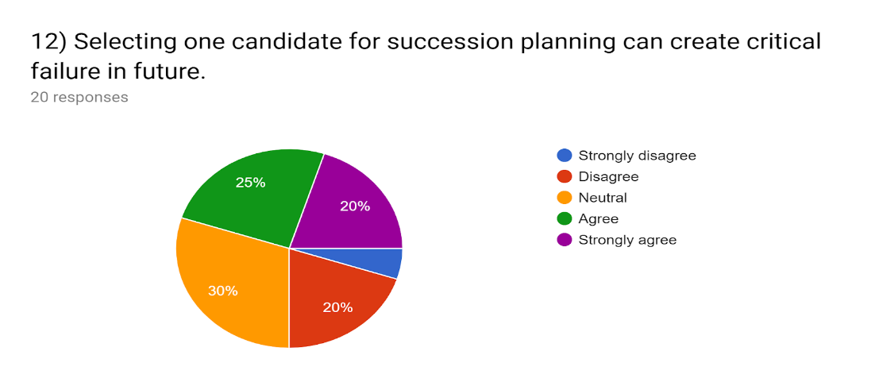
Figure 3.12: Selecting one candidate for succession planning can create critical failure in future.
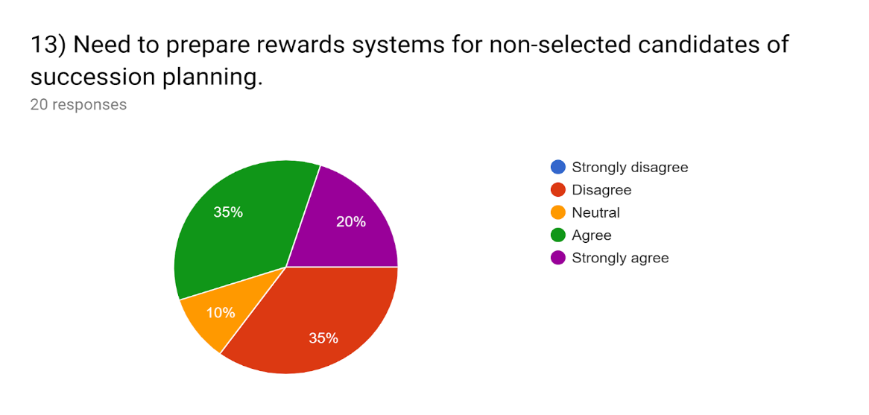
Figure 3.13: Need to prepare rewards systems for non-selected candidates of succession planning.
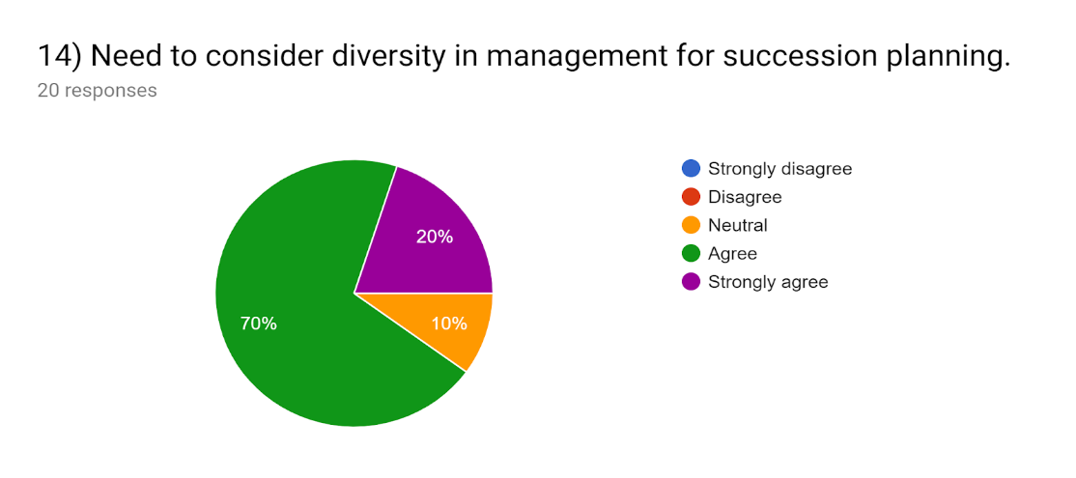
Figure 3.14: Need to consider diversity in management for succession planning.
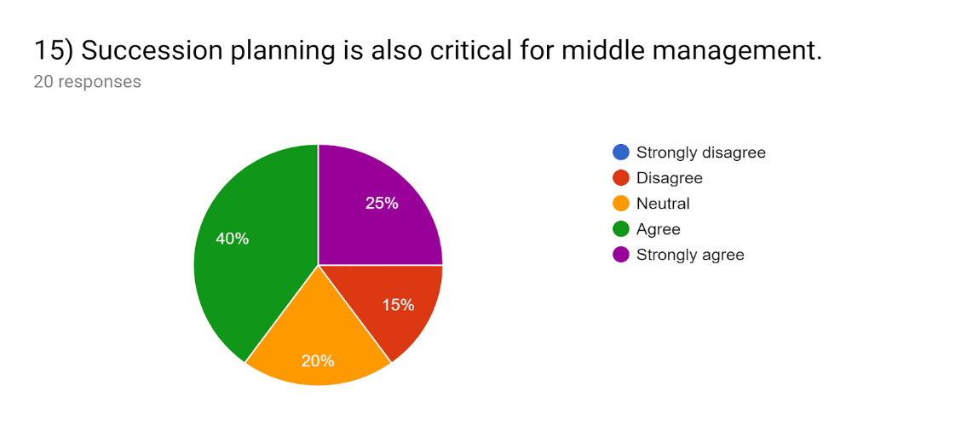
Figure 3.15: Succession planning is also critical for middle management.
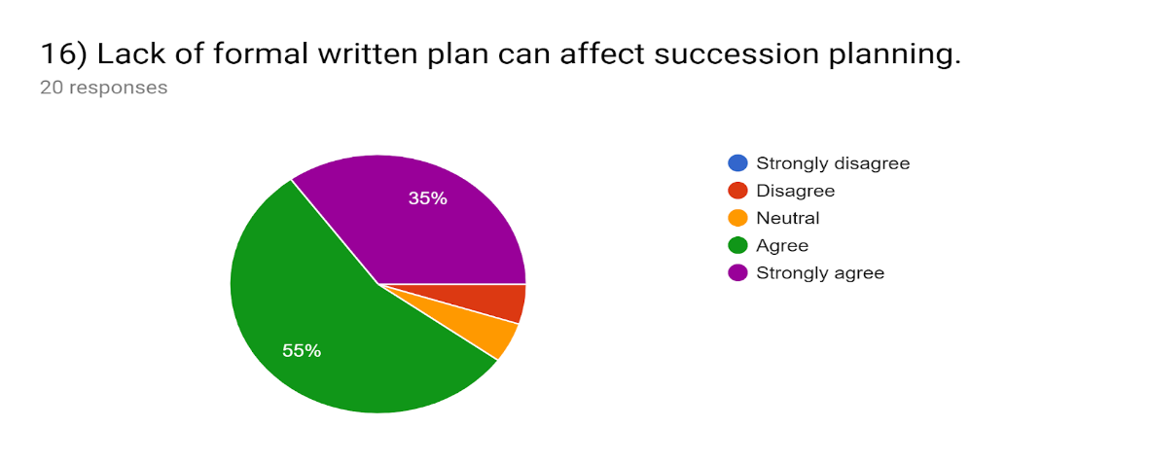
Figure 3.16: Lack of formal written plan can affect succession planning.
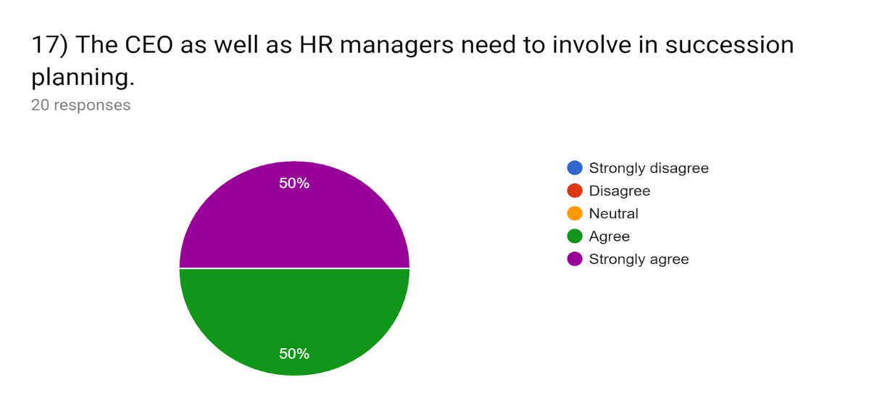
Figure 3.17: The CEO as well as HR managers need to involve in succession planning.
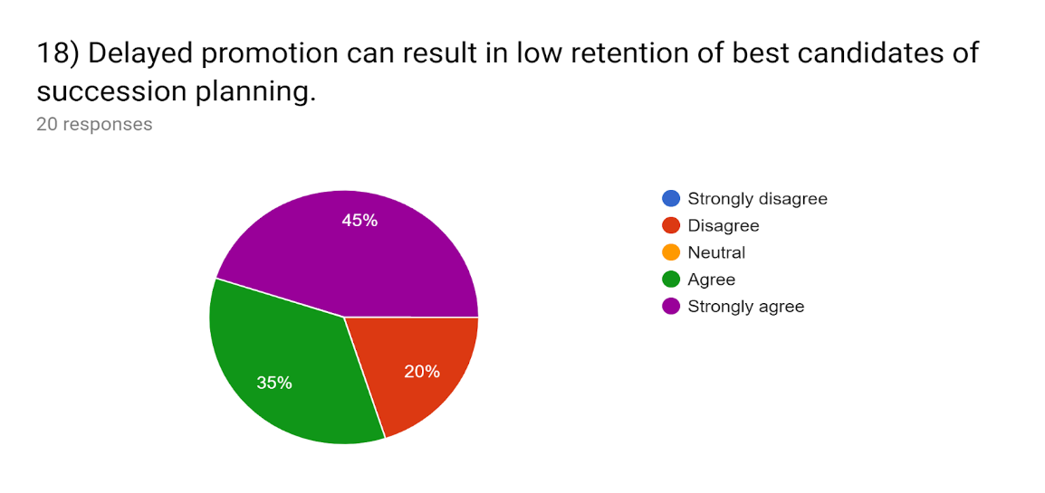
Figure 3.18: Delayed promotion can result in low retention of best candidates of succession planning.
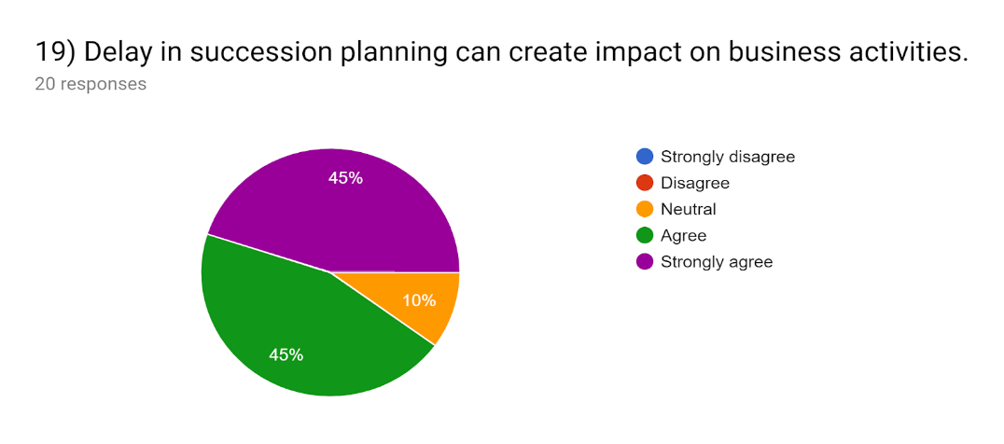
Figure 3.19: Delay in succession planning can create impact on business activities.
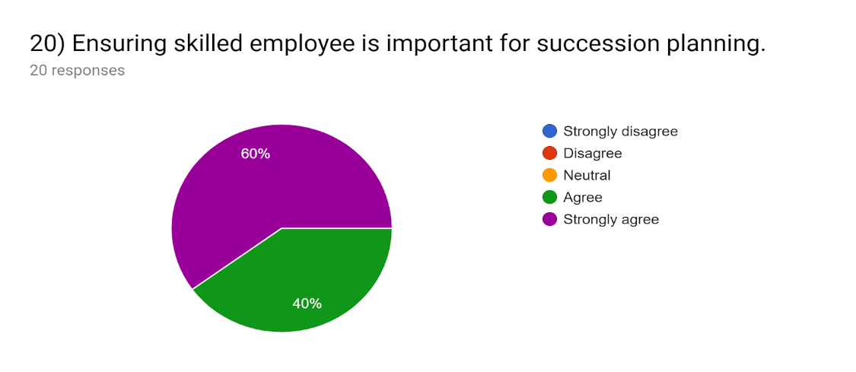
Figure 3.20: Ensuring skilled employee is important for succession planning.
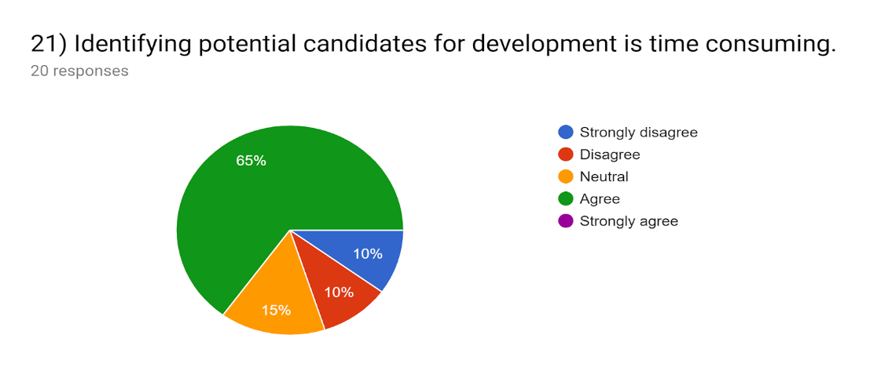
Figure 3.21: Identifying potential candidates for development is time consuming.

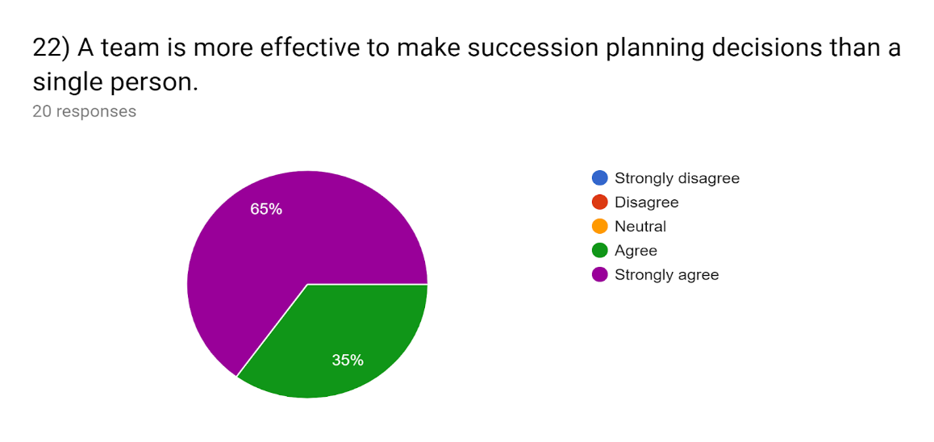
Figure 3.22: A team is more effective to make succession planning decisions than a single person.
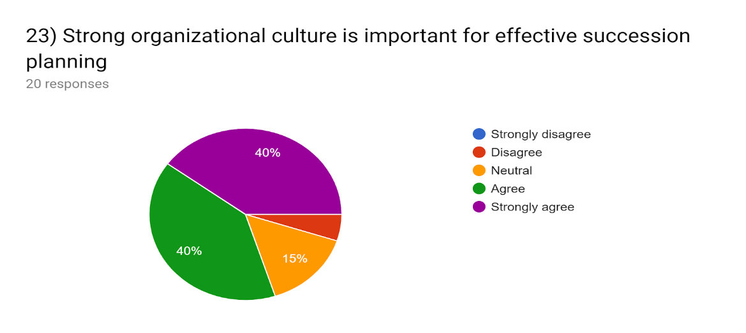
Figure 3.23: Strong organizational culture is important for effective succession planning
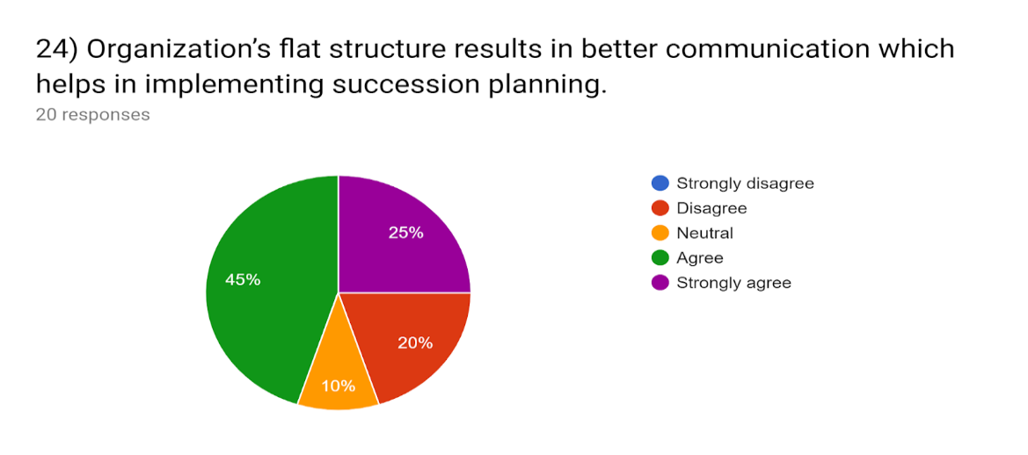
Figure 3.24: Organization’s flat structure results in better communication which helps in implementing succession planning.
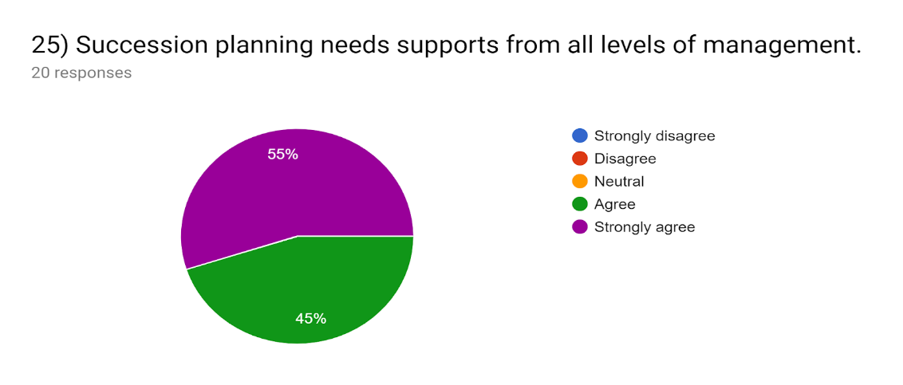
Figure 3.25: Succession planning needs supports from all levels of management.
After analyzing the pie charts, it has been found as follows:
- Internal candidates are more knowledgeable than external candidates as they know more about the company’s mission, vision, goal, culture, rules, and regulation that’s why they can be more effective candidates when any staff change occurs. This statement is strongly agreed by 15% & moderately agreed by 50%. Only 20% disagreed with the fact.
- Internal candidates are more loyal than external candidates, that’s why they are highly motivated to retain in the organization & they will keep the organization running when any staff change occurs. This statement is mostly agreed by the respondents with higher percentages which is above 70%.
- Candidates should be exposed to different parts of the company through assignments in various departments. So the candidate development programs can be costly for succession planning. This statement is moderately agreed by 35% as external candidates can require additional bonuses where other 35% also thinks this is not as much costly as people thinks. 30% are neutral about the fact. So this factor don’t influence succession planning that much.
- 90% respondents believe that financial supports for succession planning is important. Therefore, internal candidates, having a background at the firm, typically don't require as much additional compensation as external candidates requires, so having internal candidates for succession planning is less costly. This is highly agreed by the respondents which is above 90%.
- Family members create influence in succession planning. This is moderately agreed by the respondent which is 45% as business considerations should take precedence over family considerations when it comes to the welfare of the company. That’s why 90% respondents believe that effective candidates are more important than family members. Private relationships which interfere with the effective operation of the company can only be harmful and non-productive. So nepotism can create barriers in succession planning, it is agreed by 85% respondents.
- Family members should be given the opportunity to learn about the company and decide if they want to be a part of it. So family members also need to go through candidate’s development activities like others. This is agreed by 60% respondents while others are neutral about it.
- A company should select multiple high skilled candidates to take the place when any staff change occurs. This is highly agreed by the all of the respondents. So this factor highly influence succession planning. Need to prepare rewards systems for non-selected candidates who have been going through candidate development programs but couldn’t get the top level positon. There must be other development paths and rewards for them, unless the company is willing to watch talent walk away. This is agreed by over 50% but 35% think this is not as much important.
- Identifying potential candidates for development is time consuming. This statement is agreed by 65% & 20% think this is not time consuming. Selecting one candidate becomes a possible point of critical failure if he or she leaves or is unable to continue. This is moderately agreed by the respondents which is 45% & 30% are neutral about it.
- Need to consider diversity in management for succession planning which means choosing different religion and gender’s candidates for an effective succession planning. This is agreed by 70% respondents & strongly agreed by 20%.
- There should be succession planning for critical positions in middle management as there is a statistically higher chance of losing someone important below the level of top management. This is agreed by 65% respondents & 15% disagreed about the fact.
- A succession plan is a project for the company and its board, not for a particular individual. A team is more effective to make succession planning decisions than a single person. Succession planning needs supports from all levels of management. The CEO as well as HR managers need to involve in succession planning to ensure skilled employees are selected for the next successor. This statement is agreed by all of the respondents. So this factor is highly influenced succession planning.
- 90% respondent believe that formal written plan is very important for a succession planning. Too long a wait for promotion, potentially resulting in the best people leaving due to apparent inertia in the system. Then it can create negative impact on business activities. So ultimately it can badly affect succession planning which is agreed by 80% to 90% respondent.
- Strong organizational culture means employees can consider the organization’s values, beliefs, standards and paradigms as a guideline for their everyday performance which they need to follow to be selected as a candidate of the next successor. It is agreed by 80% of respondents & 15% are neutral about it.
- Organization’s flat structure will result in better communication and easier knowledge sharing in the organization, so top level manger can easily share his experience with the candidates and implement a successful succession planning. 70% agreed with the statement where 20% think this is not an important factor that influence succession planning.

Chapter 4

Conclusion

The results of the study reflected high skilled internal candidate’s importance, selection for multiple candidates, strong management system, strong organizational culture, financial support, diversity in management, formal written plan as crucial factors related to succession planning. The most important factor is succession planning needs supports from all level of management from HR managers to CEO, all should involve in planning to create a talent pipeline of successors. Internal candidates are more loyal & knowledgeable about the company and if they go through candidate’s development program they will charge less then external candidates. Family considerations should not take into consideration firstly because effective candidates are more important than family members. Multiple skilled employees should be selected from different religion or gender to ensure effective succession planning. This study revealed a need of a succession planning in all organizations as top positioned leader or someone important below the level of top management will not remain in that position for his lifetime. Apparently someone will take the position of him after his retirement, termination, transfer, promotion or death. So, before doing the succession planning, the CEO or other HR managers should consider these important factors to create a talent pipeline of successors.

References
Amundson, G. (1997, May 19). Louisville business first. Retrieved June 24, 2019, from bizjournals: https://www.bizjournals.com/louisville/stories/1997/05/19/smallb6.html
Brown, C. M. (2010, Dec 14). Inc. Retrieved May 25, 2019, from Inc.: https://www.inc.com/guides/2010/12/how-to-ensure-your-business-succeeds-you.html
Dehghanpour, A. (2011, May 4). Academic Journals. Retrieved May 25, 2019, from academicjournals: https://www.academia.edu/1278658/Succession_planning_and_its_effects_on_employee_career_attitudes_Study_of_Iranian_governmental_organizations
Finogent advisory. (2018). Finogent Advisory. Retrieved May 22, 2019, from finogentadvisory: https://finogentadvisory.com/business-planning-succession/
Fulmer, D. R. (2002). Graziadio Business Review. Retrieved May 25, 2019, from pepperdine: https://gbr.pepperdine.edu/2010/08/choose-tomorrows-leaders-today/
Heathfield, S. M. (2019, February 17). The balance careers. Retrieved May 22, 2019, from thebalancecareers: https://www.thebalancecareers.com/succession-planning-1918267
McNamara, C. ( 2018, June 25). Free management library. Retrieved June 22, 2019, from managementhelp: https://managementhelp.org/staffing/succession-planning.htm
Rouse, M. (2018, April). Search Hr Software. Retrieved May 22, 2019, from searchhrsoftware: https://searchhrsoftware.techtarget.com/definition/succession-planning
Wolfred, T. (2008). The Annie E. Casey Foundation. Retrieved May 25, 2019, from Compasspoint: https://www.compasspoint.org/sites/default/files/documents/526_buildingleaderfulorganiza.pdf

