Report
on
Emerging Issues In Accounting Literature
Submitted To
Mofijul Hoq Masum (MHM)
Assistant Professor
School of Business & Ecomomics
United International University
Submitted By
Takia Jahan
ID : 111 131 251
United International University



Date of Submission: 8 January, 2019

Letter of Acknowledgement

First of all I would like to express my Gratitude to almighty ALLAH for enabling me to complete this report Emerging Issues In Accounting Literature.
I have taken effort in this report. However it would not have been possible without the kind support and help of many individuals.
I convey my sincere gratitude to my academic supervisor, Mr. Mofijul Hoq Masum (MHM), Assistant professor, School of Business & Economics, United International University. Without his kind direction and proper guidance shaped this report to be complete in time.
I would like to express my gratitude towards my parents, friends and relatives for their kind operation and encouragement which helped me in completed this report and also express my special thanks to United International University.
For Offering such a course that assign me such report, those enlighten me this knowledge which will be very helpful for me in near future.

Takia Jahan
(…………………………………………………….)
ID No: 111-131-251
United International University

Letter of Transmittal

Date: 28th July, 2017
Mofijul Hoq Masum (MHM)
Assistant Professor
School of Business & Economics
United International University
Subject: Submission on Project Report.
Dear Sir,
Attach here the report on “Emerging Issues In Accounting Literature” which has been prepared as part of partial fulfillment of BBA degree. It is a great acquisition to work under your active supervision. I would like to take scope to thank you for the guidance you have provide to me during this course. To prepare the report i have collected what i believe to be the most similar information or data to take my report concise reliable as possible. I have tried my best to present the vastness and importance of the area of study. Though i lake my experience in the practical field, this report may contain some unexpected limitations. I hope you will not treat this kind of mistake as major. I have intent to my best effort to achieve objectives of the report and hope that my effort serve the purpose. This experience i have obtained during my project report preparation will help in my future professional life.
Lastly I remain extremely thankful to you for the permission you have accorded for submission of this report
Sincerely Yours,
Takia Jahan
(………………………………)
ID No: 111-131-251
United International University.

Executive Summary

This is the report on Emerging issues in accounting literature. Here we define what is Accounting, its purpose and its history. We collected all the accounting journals from ABDC master journal list and SCIMAGO journal through secondary sources.

We collected the number of 1500 journal issues, title, abstract and the keywords and the data were resolved and presented in the table. There are different types of software used in the report.

In this project the main thing is to assemble all accounting journal, issues, abstract and keywords from ABDC master journal list and SCIMAGO journal. The main objective is analysis the keywords that how much the keywords used in journal in every year.

Table of Content

 | Letter of Acknowledgement | i
 | Letter of Transmittal | ii
 | Executive summary | iii
 | Introduction:
 | What is Accounting | 5
 | Purpose of Accounting | 5
 | Accounting Basic: History of Accounting | 6
 | Emerging issues in Accounting | 7-9
 | Objective of the Study: | 10
 | Specific Objective | 10
 | Methodology of the Study: | 11
 | Data Design | 11
 | Sample Design | 12
 | Analytical Tools | 12
 | Top Keywords Table | 12-19
 | Findings and Analysis of the Study | 20-24
 | Conclusion | 25
 | References | 26-27
INTRODUCTION
Definition of Accounting
Accounting is the recording of financial transactions plus storing, presenting, summarizing the information in various reports and analysis. it is also a profession consisting of individuals having the formal education to carry out these tasks.
The part of accounting focuses on presenting the data or information in the form of general purpose financial statements to people outside of the company. these external reports must be prepared in accordance with generally accepted accounting principles often referred to as GAAP. This part of accounting is referred as financial accounting.
Accounting provides information on the resource available to a firm, the results achieved through their use.
The Purpose of Accounting
The purpose or motive is to accumulate financial information about financial position, performance and cash flow. This tidings is used to catch decision about how to manage the business or invest in it. This information is deposited an accounting records with accounting transactions. These are recorded either standardized business transaction or supplier invoices or more specialized transactions that known as journal entries.
This financial information are stored in accounting records. It include the following documents that are income statement, balance sheet, cash flows statement, retained earnings, disclosure of financial statements. Financial statements are collected a set of rules that known as accounting framework. Which is best known generally accepted accounting and international financial reporting standards. The accountant may generate reports for special purpose that the profit on sale of a product, these are considered to be managerial reports.

.
History of Accounting
In accounting history, Luca Pacioli first started the system of double entry bookkeeping that used by venetian merchant in his summa de arithmetica geometria, proportioni et proportionalita. pacioli was the first to describe the system of debits and credits in journal and ledgers. It is the basis of accounting systems.
In the industrial revaluation it inspired the advanced coat accounting system and the development of corporations that created large group for not part of a firm's management but had a strong interest in the company's results. Bondholders and shareholders provide external financing. American association of public accountants jointed together by thirty one accountants in 1887. A decade later the first standardized test for accountants and in 1896 the first CPAs were licensed.
In 1934, the great depression driven to the creation of the securities and exchange commission. Members of the accounting profession has been certified by the commission with periodic file reports. When the financial accounting standards board was established, the American institute of certified public accountants and its predecessors has responsibility for setting accounting standards until 1973. In the late 20th century, the large accounting firms expanded their services behind the traditional auditing function to many forms of consulting in the accounting industry gained. Accounting firms also began to get involved in corporate scandals.
In 2001, the Enron scandal had a big reflection for the accounting sector and the high accounting firms went out of business under the act of accountants faced restrictions on consulting engagements. so, the early part of the 21st century accounting scandals create more work for accounts and demand for their services continues.

Emerging Issues In Accounting

In this report our main topic is emerging issues in accounting. Here we briefly discuss in this topic. A number of accounting issues that are fraud, economic instability, transparency, corporate collapse driving the value of traditional accounting thinking. This module is created to help us to gain the major issues.
we will learn from the module that we understand the shareholder and market expectation, intangible value of accounting, gain an understanding of stakeholder expectation and sustainability, the balance between financial and non financial measures, change to meet uncertain dynamic environments.
The topic is designed for evaluating accounting concepts and accepted accounting principles. It provides a new standard that have been recently issued. The most recent updates are given below-
Accounting for Goodwill
To amortize goodwill on a straight line basis over 10 years.
Accounting for Leases
To be recorded as assets and liabilities on the balance sheet. It expected to be issued but not expected to be applicable until after 2017.
Revenue from Contracts with Customers
To eliminate the current differences in revenue recognition between US GAAP and IFRS.
Internal Control Integrated Framework
To make it easier to use and apply.
In this report the main thing is to collect accounting journals and that are given below:
- Accounting, organizations and society
- Auditing- A journal of practices and theory
- Contemporary accounting research
- The accounting review
- Journal of accounting and economics
- Management accounting research
- Review of accounting studies
- The European accounting review
- Journal of accounting and public policy
- Accounting regulation and policy
- accounting, auditing and accountability journal
- The journal of the American taxation association
- National tax journal
1. Accounting, Organizations and Society
This journal is a international journal that concerned between accounting and human behavior, institutional and organizational structures. The roles of accounting and connected emergent and practices in the structure of economic sectors. It publish high quality work that methodological and theoretical developments from across the social science.
The roles and relationship between accounting, organization, society and accounting, auditing, accountability, ethics. The performance of accounting practices to the emergence and maintenance of organizational and societal institutions. Accounting for human actors, sustainability and the environment etc are the journal covers.
2. Auditing a Journal of Practices and Theory
The purpose of auditing is to practice and theory that avail to enhance the practices and the theory of auditing. It encloses internal and external auditing activities. If the communication between research and practice are develop then it influence the present and future developments of auditing.
3. Contemporary Accounting Research
It published since 1984, that provides high quality research publication on worldwide accounting community.
4. The Journal of Accounting and Economics
It provides the highest quality draft or copy or manuscripts publication. The role and theory of accounting firm, accounting standards, some regulation of corporate disclosure etc are the wide range of methodologies that covered it.

5. Management Accounting Research
This journal accept original research papers that using case, field, survey that relevant method. It provides an international forum.
6. Review of Accounting Studies
This study provides a channel for important academic research in accounting. It include experimental theoretical actions. it is performed to prompt turnaround on the copy it receives.
7. The European Accounting Review
This journal emphasize flexibility and sincerity. It gives high quality accounting research.
8. National Tax Journal
The objective of this journal is to inspire high quality original research on governmental tax and expenditure. It focus on severe economic analysis of tax and expenditure issues.
9. Accounting, Auditing and Accountability Journal
This journal devoted to the advancement of accounting knowledge.
10. The Accounting Review
It was founded in 1926. It is a bookish journal that publish by the American accounting association and it is one of the oldest journal.
11. Journal of the American Taxation Association
It develops the study that the acquisition of knowledge with experiment that employs analytical, quantitative methods to oration tax topics.

Objective Of the study


The objective of the journal is to publish papers and understand the accounting illusion. This journal purpose to publish papers that
1. Adjust the area of research in a short and proper manner to assist academic learning and improvement of different research areas
2. Impending high quality multi method research that connected to taxation and auditing.
For research we do meta analyses, field study, book review and collecting critiques of papers that published in other journal.

Specific Objectives
In this project the main thing is to assemble all accounting journal, issues, abstract and keywords from ABDC master journal list and SIMAGO. The main objective is to analysis the keywords that how much the keywords used in journal in every year.

METHODOLOGY OF THE STUDY

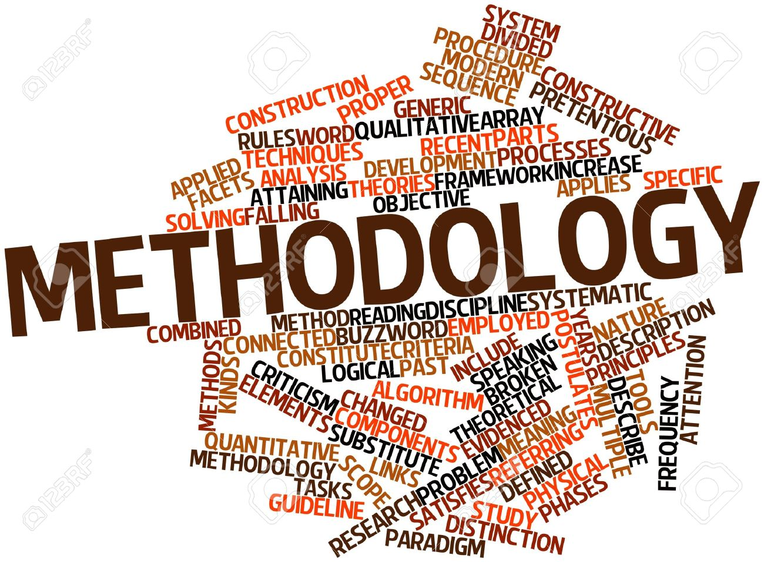
turnaround
1.Data Design
Collected data from secondary Sources.
- ABDC Journal List
- Scimago journal
2. Sample Design
Collected the number of 1500 journal issues, title, abstract and the keywords.

3. Analytical Tools
Collected data or information were analyzed and submitted in the form of table. Several software like MS-Excel, MS-word etc used to prepare the report. Final report is prepared according in the form of Microsoft word format
Top 20 keywords are given below -
1. Performance
2. Motivation
3. Sustainability
4.Auditing
5. Regulation
6. Voluntary Disclosure
7. Audit Fees
8. Accountability
9. Fraud
10. Audit quality
11. Earning Management
12. Audit Risk
13. Internal Control
14. Accrual
15. Incentives
16. Disclosure
17. Textual analysis
18. Performance Measurement
19. Tax Avoidance
20. Management Accounting
Journal- Accounting, Organizations and Society
Top keywords

2018 |  |  | 2017 |  |  | 2016
Voluntary disclosure | Textual analysis | Professional skepticism | Accountability | NGO | Textual analysis | Performance Measurement | Audit choice | Incentives
3 | 3 | 4 | 2 | 3 | 3 | 2 | 2 | 3

Voluntary disclosure
It is the conduct of information or data by company's management that generally accepted accounting principles. The data or information is believed to be relevant to the decision making users of the company's annual report.
Auditing: A Journal of Practice and Theory
Top Keywords
Year | Keywords
Year | Auditing | Audit Quality | Audit Fees | Internal Control | Audit Risk
2018 | 105 | 37 | 23 | 17 | 16
2017 | 88 | 18 | 14 | 12 | 9
2016 | 100 | 20 | 15 | 12 | 17

Accountability
It is a commitment that an individual or an organization will be evaluated on their performance or something for which they are responsible. So the basic definition is being called to account for one's actions.
Auditing
Audit is a systematic and independent examination of books, records, accounts of an organization to ascertain how far the financial statements.
Journal of Accounting and Economics
Top Keywords
Year | Keywords
2018 | Voluntary disclosure | Textual analysis | Auditing
2018 | 10 | 8 | 5

Year | Key words
2017 | Regulation | Textual Analysis | Disclosure
2017 | 8 | 5 | 6

Year | Keywords
2016 | Accruals | Voluntary Disclosure | whistle blowing
2016 | 7 | 6 | 5

Audit quality
Audit quality is the process of systematic examination of a quality system that carried out by an internal or external auditor or audit team.
Audit fees
A fee that company pays an external auditor in exchange for performing an audit.
The Accounting Review
Top Keywords
Year | Keywords
2018 | Auditing | Audit Quality | Audit Fees | Accruals | Performance
2018 | 117 | 42 | 24 | 15 | 26

Year | Keywords
2017 | Auditing | Audit Quality | Audit Fees | Performance | Accruals
2017 | 88 | 18 | 14 | 15 | 6

Year | Keywords
2016 | Auditing | Audit Quality | Audit Fees | Performance
2016 | 100 | 20 | 18 | 19
Internal control
Defined in accounting and auditing as a process for assuring of an organization's objectives in operational effectiveness and efficiency. reliable financing reporting and complains with laws, policies and regulations.
Audit risk
audit risk is the risk that the financial statements are materially incorrect, though the audit opinion states that financial reports are free of any material misstatements.
Review Of Accounting Studies
Top Keywords
Year | Keywords
2018 | Voluntary Disclosure | Earning Management | Disclosure | Regulation | Audit Quality | Audit Fees
2018 | 10 | 8 | 9 | 7 | 2 | 2

Year | Keywords
2017 | Voluntary Disclosure | Earning Management | Incentives | Fair Value Accounting
2017 | 6 | 8 | 10 | 10

Year | Keywords
2016 | Voluntary Disclosure | Accruals
2016 | 6 | 5

Regulations
Regulations are the rules that made by a government or another authority in order to control the things that done by the people.
Accruals
Accruals are records of revenue and expenses in the periods in which they are incurred.
Performance
It is a given task that measured by standards of accuracy ,speed, cost and it deemed to be the fulfillment of an obligation that release the performer from all liabilities.
Management Accounting Research
Top Keywords
Year | Keywords
2018 | Performance Measurement | Incentives | Performance | Management Accounting
2018 | 10 | 8 | 5 | 8

Year | Keywords
2017 | Incentives | Regulation | Management Accounting | Performance Management
2017 | 6 | 5 | 4 | 4

Year | Keywords
2016 | Management Control System | Performance Management System
2016 | 7 | 5

Disclosure
Delivery to the other side of legal matter to the topical documents or other instance.
Earning management
The use of accounting designs to produce financial reports that present a positive view of a business activities and financial term.
The European Accounting Review
Top Keywords
Year | Keywords
Year | Performance | Motivation | Voluntary Disclosure | Fraud
2018 | 506 | 304 | 12 | 21
2017 | 371 | 242 | 19 | 10
2016 | 328 | 205 | 5 | 6

Journal of Accounting and Public Policy
Top keywords
Year | Keyword
Year | Earning Management | Audit Fees | Internal Control | Voluntary Disclosure
2018 | 5 | 4 | 2 | 1
2017 | 3 | 4 | 1 | 2
2016 | 2 | 3 | 1 | 5

Fraud
The crime or fault of gaining money or financially benefits by lying or by a trick.
Motivation
The reason of actions, willingness and goal of peoples that derived from the word motive that requires satisfactions.
Sustainability
The process of maintaining change in a balanced fashion, investments, resources, technological developments all these thing that meet current and future human needs.
Tax avoidance
The legal uses of tax rule in a individual territory to one's benefit to reduce the amount of tax that is payable by the law.

Accounting, Auditing and Accountability Journal
Top keywords
Year | Keywords
Year | Sustainability | Accountability | Voluntary Disclosure | Regulation | Fraud
2018 | 266 | 58 | 23 | 51 | 27
2017 | 205 | 35 | 15 | 38 | 16
2016 | 145 | 24 | 7 | 23 | 8

Management accounting
Here, manager use the provisions of accounting information or data in order to better inform themselves before they decide matters in their organizations.
Journal of the American Taxation Association
Top Keywords

Year | Keywords
Year | Earning Management | Tax Avoidance
2018 | 15 | 9
2017 | 7 | 8
2016 | 12 | 7

Performance measurement
The process of reporting collecting analyzing information or data regarding the performance on an individual, firm or organization and group system.
Textual analysis
A research methodology used to described the structure content of the message.

FINDINGS AND ANALYSIS OF THE STUDY

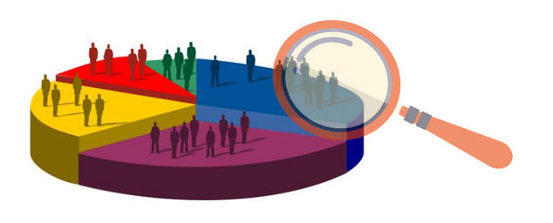

Top 20 keywords are given below-
Keywords | Total
Performance | 1270
Motivation | 751
Sustainability | 616
Auditing | 603
Regulation | 212
Voluntary Disclosure | 185
Audit Fees | 152
Accountability | 150
Audit Quality | 142
Fraud | 100
Earning Management | 88
Audit Risk | 78
Internal Control | 65
Accrual | 62
Incentives | 60
Disclosure | 56
Textual Analysis | 50
Performance Measurement | 45
Tax Avoidance | 42
Management Accounting | 40

Top Keywords - 2018
Keywords | Total
Performance | 506
Motivation | 304
Sustainability | 266
Auditing | 117
Accountability | 58

Top Keywords -2017
Keywords | Total
Performance | 371
Motivation | 242
Sustainability | 205
Auditing | 88
Accountability | 35

Top keywords - 2016
keywords | Total
Performance | 328
Motivation | 205
Sustainability | 143
Auditing | 10
Accountability | 24

CONCLUISION

It was a great opportunity for me to do this project report. In this report, we define what is Accounting, its purpose and its history. We collected all the accounting journals from ABDC master journal list and SCIMAGO journal through secondary sources and we know about that journals in a short way. We collected 1500 journal, issues, abstract and the top keywords were detached in the table and shown as column chart in last 3 years ( 2018, 2017, 2016) . We found top 20 keywords and defined them as well.

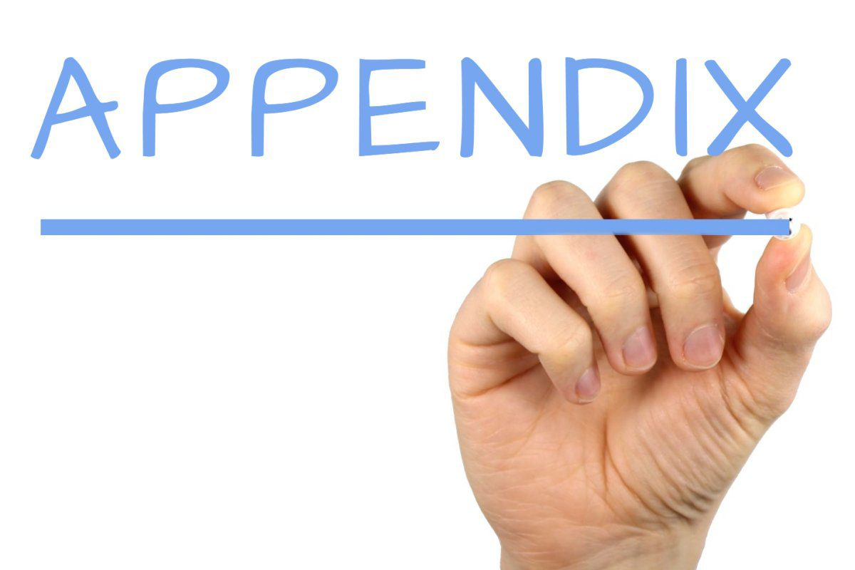
References:
https://www.journals.elsevier.com/accounting-organizations-and-society/
http://aaahq.org/Research/Journals/Section-Journal-Home-Pages/AUDITING-A-Journal-of-Practice-and-Theory
http://aaajournals.org/keyword/Audit%20Fees
http://aaajournals.org/keyword/Audit%20Quality
https://www.journals.elsevier.com/journal-of-accounting-and-economics
http://aaahq.org/Research/Journals/The-Accounting-Review
https://www.tandfonline.com/keyword/Motivation?startPage=&dateRange=&Ppub=%5B20180102%20TO%2020190102%5D
https://link.springer.com/journal/11142
http://www.ajms.co.in/sites/ajms2015/index.php/ajms/article/view/1365

