
United International University
Project Report
On
“Association between Corporate Governance and Profitability
– An empirical Study on some companies in Bangladesh”.

Submitted To
Rana Mazumder
Assistant Professor
School of Business and Economics
United International University

Submitted By
Jobaer Hossain Munna
ID No: 111 151 245
School of Business and Economics
United International University

Date of Submission: January 26, 2021

Letter of Transmittal
January 25, 2021
Rana Mazumder
Assistant Professor
School of Business and Economics
United International University

Subject: Submission of the project report on “Association between Corporate
Governance and Profitability – An empirical Study on some company in
Bangladesh”.

Dear sir,
This is to inform you that as per the requirement of completion of BBA program, I have completed this report on “Association between Corporate Governance and Profitability – An empirical Study on some company in Bangladesh”. I have completed this report as per your instructions that you have given me. Here I have given my best effort to achieve the objectives of the report. I hope that you will approve my report and grant it as unique one.
Therefore, I would sincerely appreciate if you accept my report and consider my work as good and unique.
Thank you.
Sincerely yours,

…………………………..
Jobaer Hossain Munna
ID No: 111 151 245
School of Business and Economics
United International University

Acknowledgement
All praises go to all mighty Allah, the most gracious and the most merciful without whose blessing I could not have completed this report. The accomplishment and completion of this report would not have been viable without the contribution of some accommodative people, who gave their valuable time from their busy schedule to guide me in doing my project report.
I would like to extend my heartiest gratitude to all those who directly or indirectly contributed to the competition of the report.
At the beginning, I would like to convey my gratitude to my respective Supervisor, Rana Mazumder, Assistant Professor at United International University for his guidance, valuable & thoughtful comments, and suggestion.
As per the requirement of completion of project report to complete BBA Program, I give my best level of effort to complete as per my supervisors’ directions. Therefore, I would like to give thanks to my supervisor to give some piece of his valuable time to complete the report.
Finally, I would like to say thanks to all who helped me to complete this project report.

Table of Contents
Chapter No | Topic No | Details of the Topic | Page No
1 |  | Introduction of the Study | 6
 | 1.1 | Abstract | 7
 | 1.2 | Rationale of the study | 8
 | 1.3 | Statement of research problem | 8
 | 1.4 | Objectives of the study | 10
 | 1.5 | Research Questions | 10
 | 1.6 | Research Hypothesis Statement | 11
2 |  | Literature review of the study | 12
 | 2.1 | Introduction | 13
 | 2.2 | Perspective of corporate governance | 14
 | 2.3 | Purpose and objectives of corporate governance | 15
 | 2.4 | Core attributes of an effective corporate governance | 16
 | 2.5 | Importance of Corporate Governance | 17
 | 2.6 | Elements of Corporate Governance | 19
 | 2.6.1 | Board Size | 19
 | 2.6.2 | Board Composition | 22
 | 2.6.3 | Board Skills and Competence | 24
 | 2.6.4 | Board Gender Diversity | 25
 | 2.7 | Other factors effecting profitability of an organization | 27
 | 2.8 | Theory of corporate governance | 28
 | 2.8.1 | Agency theory of corporate governance | 29
 | 2.8.2 | Theory of shareholder’s value | 30
 | 2.8.3 | Theory of stewardship in corporate governance | 32
 | 2.8.4 | Theory of shareholder in corporate governance | 34
 | 2.8.5 | Theory of resource dependency in CG | 36
 | 2.8.6 | Political theory of corporate governance | 38
 | 2.8.7 | Value-synergy approach to corporate governance | 39
 | 2.9 | Probability as a measure of organization’s performance | 41
 | 2.10 | Rationality of profitability measurement | 42
 | 2.11 | Association between corporate governance and profitability of organizations | 43
 | 2.12 | Review of empirical studies | 45
 | 2.12.1 | Review of empirical studies in other countries | 45
 | 2.12.2 | Review of empirical studies in Bangladesh | 47
3 |  | Research Design of this Study | 49
 | 3.1 | Research design | 50
 | 3.2 | Sample size and sample technique | 50
 | 3.3 | Methods of data collection | 51
 | 3.4 | Sources of data collection | 51
 | 3.5 | Model specification | 52
 | 3.6 | Measurement Variables | 54
 | 3.6.1 | Measurement of dependent variable (Profitability Indicators) | 54
 | 3.6.2 | Measurement of independent variables | 54
 | 3.7 | Limitation of the Methodology | 55
4 |  | Data presentation and analysis | 56
 | 4.1 | Data Presentation and Analysis | 57
 | 4.2 | Basic descriptive statistics analysis | 57
 | 4.3 | Correlation Analysis | 58
 | 4.4 | Regression analysis | 60
 | 4.5 | Result of test of hypotheses | 63
5 |  | Findings, Conclusion and Recommendations | 66
 | 5.1 | Summary of theoretical findings | 67
 | 5.2 | Summary of the analytical findings | 68
 | 5.3 | Limitation of the study | 69
 | 5.4 | Conclusions | 70
 | 5.5 | Recommendations | 71
References |  |  | 73-78
Appendix 1 |  |  | 79-80

Chapter 1
Introduction of the study

1.1 Abstract
Corporate Governance is the set of some factors that provides guidelines to a company how to be directed and controlled. Corporate governance promotes corporate ethics, fairness, accountability and transparency. At present, corporate governance is considered the most important factor for the researcher due to some scandals and corporate collapse of giant company occurred in the past few years in the world. Corporate governance is considered to make the corporate work ethically by following the ethical codes and conducts.
The objectives of this study is to analyze the association between corporate governance and profitability. In this project report, I am trying to find the answer of the question – “Are Corporate Governance and Profitability associated?” in the context of Bangladesh. In this report, I have chosen twenty companies of four different industries. I have chosen banking industry, textile industry, food and beverage industry and pharmaceuticals industry. I have focused on some corporate governance tools i.e. Board Size (BS), Board Composition (BC), Board Skill and Competence (BSC), Board Gender Diversity (BGD). The data was evaluated using the Ordinary Least Square multiple regression in a panel data framework using standard descriptive and inferential statistics. I here apply a series of statistical tools i.e. descriptive statistics, variance analysis, multiple regression analysis and significance test. The findings show that board size has positive association with return on equity (ROE) net assets per share at 5 per cent level of significance. Moreover, board composition has negative association with return on equity (ROE), but it has positive relationship with net assets per share. However, board skills and competence has negative association with return on equity (ROE) and also with net assets per share. Though there are mixed result in this study, it can be stated that the empirical result shows that there is a positive association between corporate governance and profitability. Thus organization should implement effective corporate governance practices for the rapid growth and long-term survival in Bangladesh. I hope, findings of this study will not only add value to the organization, required effective corporate governance, in Bangladesh but also add value to the academic literature.
Key words: corporate governance, profitability, board, banking industry, food and beverage industry, pharmaceuticals industry, textile industry, Bangladesh.

1.2 Rationale of the Study
Over the past few decades of last century, a significant changes and improvement has been occurred in the corporate world. An emergence of changes of ownership and management was undeniable due to the expansion and diversion of most of the companies into public limited companies. Hence, professional manpower was required to manage and operate the giant company so that wealth of the organization can be maximized. Ownership was transferred into many groups i.e. general people, institutions, government and foreign investors. As there so many owners are engaged with corporate body, it become a complicated matter to operate the organization. Organization’s problems started to exist. Therefore, corporate governance has emerged to assist the personnel of the organization to perform in the desired way. Now-a-days, performance of the organization highly depends on corporate governance and ownership structure. Moreover, corporate governance also influences the profitability of an organization. A lot of research paper have been published on the topic “Relation between Corporate Governance Profitability” to show the influences of corporate governance on organization’s profitability by considering some corporate governance indicator. Therefore, it is an important issue for any organization. For that reason, I have chosen this topic to analyze the impact of corporate governance on organization’s profitability in the context of Bangladesh. The study is designed to evaluate the association between corporate governance and profitability of twenty companies of four different industries listed in Dhaka Stock Exchange (DSE). Here, I have cover the data of two years that are 2018 & 2019.

1.3 Statement of Research Problem
In Bangladesh, most of the organizations don’t apply effective corporate governance policy. In most cases, they don’t abide by the standards of corporate governance. There are only a few companies who disclose their corporate governance policy and status. Most of the organization, also listed in Dhaka Stock Exchange or Chattogram Stock Exchange, don’t provide their corporate governance disclosure to its stakeholders and general publics. There are so many companies in Bangladesh who are not ready to implement corporate governance policy to enhance its effectiveness of direction and control. This situation is not only happened in Bangladesh, but also it is the common situation in most the countries in the world.

Hence, a question has been raised that is there any influences of corporate governance on financial performance or profitability in an organization? In Bangladesh banking industry, pharmaceuticals industry and textile industry are well organized, but food and beverage industry is not well organized. But our food and beverage industry need effective corporate governance policy because of growing demand. Recent data of Dhaka Stock Exchange shows that there are 30 banks are listed in DSE. At present our banking industry is at pick position of industry life cycle. There are 31 pharmaceuticals and chemicals companies listed in DSE. It means our pharmaceuticals and chemicals industry id big enough. Also there are 56 textile companies are listed in DSE. It also means that our textile industry is quite big industry. But our food and beverage industry is not big. There are only 16 companies of food and beverage are listed in DSE. Since there is a huge population in our country, a potential future is waiting for our food and beverage industry. The demand for food and beverage industries is growing because of growing demand of food. So that it is necessary to implement effective corporate governance policy.
Corporate governance, however, remains the core element that relies heavily on restoring corporate trust in sustainability and keeps the business principal flapping and the economy strong, sustainable and healthy. This ensures that corporate governance is a sustainability prerequisite and a measure of how stable the market structure of every country (Oluwafemi, et al. 2013). Corporate governance is important to achieve long-term growth for organizations (Nwonyuku, 2016). Though corporate governance practices in Bangladesh is not as standard, this study is trying to find whether any association between corporate governance and profitability does exist for a sample of twenty companies of four different industries by observing the annual report of 2018 & 2019 of these companies.
After considering the above research problems, I am trying my best to analyze the actual association between corporate governance and profitability of companies of banking, pharmaceuticals, textile and food and beverage industries.

1.4 Objectives of the Study
Generally, the objective of the study is to measure the association of corporate governance and profitability, but there are some specific objectives that are trying to be achieved in this study. The specifics are….
- To understand the theory of corporate governance and profitability through the literature of these topics.
- To measure whether the size of the board of the directors is positively associated with profitability of the organizations in Bangladesh.
- To measure whether the board composition has positive association with profitability of the organizations in Bangladesh.
- To measure whether the board skill and competence is positively associated with profitability of the organizations of Bangladesh.
- To measure whether the board gender diversity has positive association with profitability of the organizations in Bangladesh.

1.5 Research Questions
The following questions are designed to understand the nature of the association between corporate governance and profitability of banking, textile, pharmaceuticals and food and beverage industry in Bangladesh. These questions are…
- Is size of the board of directors associated positively with profitability of banking, textile, pharmaceuticals and food and beverage industry in Bangladesh?
- Is board composition associated positively with profitability of banking, textile, pharmaceuticals and food and beverage industry in Bangladesh?
- Is board skills and competence and probability have a positive association of banking, textile, pharmaceuticals and food and beverage industry in Bangladesh?
- Is board gender diversity associated positively with profitability of banking, textile, pharmaceuticals and food and beverage industry in Bangladesh?

1.6 Research Hypothesis Statement
To achieve the objectives of the study, there are four hypothesis formulated and operationalized for analysis and making conclusion on the association between corporate governance and profitability in the study.
Hypothesis 1
Ho1: The size of the board directors has negative association with profitability of banking, textile, pharmaceuticals and food and beverage industry in Bangladesh.
HA1: The size of the board directors has positive association with profitability of banking, textile, pharmaceuticals and food and beverage industry in Bangladesh.
Hypothesis 2
Ho2: The board composition has negative association with profitability of banking, textile, pharmaceuticals and food and beverage industry in Bangladesh.
HA2: The board composition has positive association with profitability of banking, textile, pharmaceuticals and food and beverage industry in Bangladesh.
Hypothesis 3
Ho3: The board skills and competence has negative association with profitability of banking, textile, pharmaceuticals and food and beverage industry in Bangladesh.
HA3: The board skills and competence has positive association with profitability of banking, textile, pharmaceuticals and food and beverage industry in Bangladesh.
Hypothesis 4
Ho4: The board gender diversity has negative association with profitability of banking, textile, pharmaceuticals and food and beverage industry in Bangladesh.
HA4: The board gender diversity has positive association with profitability of banking, textile, pharmaceuticals and food and beverage industry in Bangladesh.

Chapter 2
Literature review of the Study

2.1 Introduction
Financial performance i.e. profitability is considered as mirror of an organization. Every organization need to run its operation through sustainable profitability. To maintain high profitability, organization must practice corporate governance in making healthy strategic decisions. Cadbury Report (1992) in the United Kingdom stated us about the first corporate governance practices. The report tells us about the activities of board of directors and how they can set values of the organization. And corporate governance is different from organization’s day to day activities by full-time execution (FRC, 2014). Corporate governance assists directors to build structures and processes by which organized are controlled and directed efficiently and effectively to achieve the objectives of maximizing the wealth of the organization. Marketers and investors give high value to the organization which practices good corporate governance policy (SEBI, 2003). Good corporate governance is essential for long-term existence or an organization. It helps to rise investor’s confidence by ensuring them that good corporate governance results higher growth and profit. Therefore, without existence of effective corporate governance, organization cannot ensure high profitability in future (Aggarwal, 2013). Many researchers believe that corporate governance is the heart of corporate business. By considering the impact of corporate governance, we can refer corporate governance as: Corporate administration, Corporate command, Corporate guidance, Corporate law, Corporate politics, Corporate control, Corporate direction, Corporate culture, Corporate supervision etc. On the other hand, profitability is the mirror of an organization. Through profitability, financial position of the organization is clear to all. Profitability shows how is board of director activities well for the economic prosperity of the organization. Profitability is the full view of gain over the cost of the organization (Glautier, et al. 2011). It has been shown at present that most the giant organization has implemented good corporate governance policy and after that a significant growth in profitability has been noticed. Therefore, I can say that there is a strong association between corporate governance and profitability (Nwonyuku, 2016).

2.2 Perspective of corporate governance
Many researchers and authors are trying to approach the issue of corporate governance since it has become common phenomenon and widely studied. It does not have a widely agreed meaning, like most concepts of social science, that enjoys consensus of views in all circumstances and environments. This is due to the fundamental differences in countries' firm structural, cultural, social, fiscal, legal environments, as well as the opinions of scientists, regulators, and practitioners. Accordingly, corporate governance can be viewed from at least two main perspectives: "the narrow and the broad." The narrow viewpoint in this respect refers to the agency and shareholder value theories of corporate governance, while the broad perspective refers to the stewardship, stakeholder, capital reliance, political and value–synergy theories of corporate governance. The limited view, in a nutshell, defines corporate governance mainly as being concerned with ensuring that the business is managed in the best shareholder interest. The overarching aim here is to ensure that the art of corporate management is directed exclusively to optimizing shareholder value. Corporate governance is commonly described by the advocates of this viewpoint as the mechanism by which fund providers assert power over management to ensure that their money is not only protected from expropriation, but also gain a return on their investment. The drawback in relegating business politics suffers from this view of corporate administration when gazing at just one aspect of a company's several side components. Although recognizing only the importance and incentives of fund providers, it lacks the essential facets of the system and mechanism of governance that can contribute, among other valid classes, to the alignment of the interests of managers and shareholders. The broad view, on the other hand, sees corporate control mainly as being concerned with ensuring that businesses are managed in such a manner that the resources of organizations are used appropriately in the best interest of all impacted groups. The ultimate goal here is to ensure that the practice of corporate governance is used to make contributions to all stakeholders. It was also discussed that the broad viewpoint suffers from the failure to include the mechanisms and procedures for achieving the corporate direction's meditating position. Based on this perspective, several scholars have described corporate governance as a process that concerns ways in which all stakeholders involved in the well-being of the business aim to ensure that executives and other insiders take steps that safeguard the stakeholders' interest. From these two views, any other concept of corporate governance takes priority over the different theories of corporate governance. In the interests of shareholders and other stakeholders, the Cadbury Committee Report (1992) offers a valuable description of corporate governance as' the mechanism under which companies are guided and regulated'. This definition means that enterprises are guided and regulated both inside and outside the organization. The definition was perceived by Neuberger and Lank (1998) as a framework and mechanism to steer and manage companies and to account for their activities.
2.3 Purpose and objectives of corporate governance
The main objective of good corporate governance practices is to enhance corporate efficiency and transparency by controlling all groups within a corporation that manages investor-owned capital, and to build long-term shareholder value. The contributing objectives are to guarantee that the board of directors has an acceptable balance of power; to make the board of directors responsible for risk monitoring and management; to ensure the independence of external auditors; growing the level of trust and openness of all investors in business operations and thus fostering growth; ensuring that the enterprise is managed in a legitimate and ethical way; and creating power at the top that will "cascade" the organization down. The 2012 United Kingdom Integrated Corporate Governance Code and the FRC (2014) note that the aim of corporate governance is to promote efficient, entrepreneurial and wise management that can ensure the company's long-term performance and to align the interests of Cadbury people, businesses and society as closely as possible (2002). The core goals of corporate governance therefore include: ensuring that the board, as shareholder members, protects the capital of the company and allocates them in a way that serves the objective of the company; ensuring that its owners are adequately cared for by those who control and operate the company; and the avoidance or reduction of conflicts of interests; and to ensure that the company's funds are used adequately and productively in the best interests of its owners and other stakeholders (CFA Institute, 2013); and to ensure that shareholders and other stakeholders will and should hold the board to account for their management and control of the company (Ofo, 2011b; Farreira, 2010; Ajagbe, et al., 2011). Thailand's National Corporate Governance Committee (NCGC) offers the goal of corporate governance to build a consistent working atmosphere and increase the competitiveness of the business. According to the SEBI Committee on Corporate Governance (2003) report, the basic goal of corporate governance is to maximize the long-term benefit of shareholders while maintaining the rights of other stakeholders by enhancing corporate efficiency and transparency. Okereke (2013) and Sharafa (2014) describe corporate governance principles and relevance which include: ensuring that those responsible for controlling and regulating a company's operations conform with ethical norms and applicable legislation; restoring publicly perceived loss of trust in financial information and reporting; combating corruption and fostering fair labor practices and securing customer rights; stopping corporate robbery and forgery; and maintaining a sound internal management structure. Corporate governance is established with the main goal of fostering an open and productive structure that generates the law and order and encourages competent and objective separation of responsibility (CBN, 2014).
2.4 Core attributes of an effective corporate governance system
Many researchers have tried to address the issue of "what inspires the enthusiasm for good corporate governance." The response is in a philosophy of corporate behavior and behind that a collection of assumptions regarding human behavior, according to the research of Roberts and Young (2006). To make it efficient and consistent, it is necessary to consider the key values needed within the context of the corporate governance structure. By principle, certain qualities are expected to be effective on those entities who have specifically consented to this organizational tradition. As such, this business standard cannot be found in any single legal text. Yet "custom stays in the air as it was, both in theory and practice." It's there, but it's nowhere.' So, in the business consciousness lies what seems to be corporate tradition. The Cadbury Committee Report (1992) highlights three main corporate governance standards, which include transparency, fairness and responsibility. Mervyn King, Chairman of the 1994 King Commission Report, found out that 'moral integrity' is about strong corporate governance and not just holding to laws and regulations. The CFA Institute (2013) distinguishes five main characteristics of an efficient structure of corporate governance that include: privileges, obligations, responsibility, justice and equality, openness and consistency, security and enforceability, freedom and honesty. Aras and Crowther (2008) note that there are four values of corporate governance practices in practice, which are: openness, responsibility, accountability and justice, and ACAG (2010) added engagement and consistency in Akharayi (2015). Corporate governance is about fostering justice, openness, responsibility and ethical behavior in companies. Therefore, the basis for good corporate governance practices is the good conduct of the citizen, which is driven by the moral status of a person. In the creation of an acceptable moral norm, qualities that are relevant include: honesty, openness, freedom, dignity, clarity, responsibility, probity, accountability, credibility and judgment. Kocourek, Burger and Birchard (2003) stated that, once the directors share these values, merely making laws improvements would not enhance corporate governance. There have been calls to pay more attention to the personalities and actions of company executives and management in the light of ongoing corporate governance disputes and corporate scandals worldwide (Baker, 2009; Young, 2009; Clarke, 2010; Kirkpatrick, 2009; and OECD, 2009). The corruption of boards of directors was obviously seen as a significant contributory cause to the corporate crisis (Okoye, 2012:1). The United Kingdom formed a Walker Review Committee after the financial crisis of 2008, which offered guidance on the appropriate conduct of board members, and the results note that board behavior will not be monitored or regulated by corporate processes and controls itself. This is an indicator, according to Okoye (2012), that board members will not be limited to acceptable actions solely by the institution of systems and procedures of corporate governance. It is in this respect that the Walker (2009) UK Review suggested that, among other aspects, actions and encouragement evaluation should be used in the assessment of board members. In the United Kingdom and the United States, and also in Bangladesh, corporate governance systems have been more centered in recent years, according to A. Rouf (2011), the real activity of the business agents who put these systems to life is much less centered.

2.5 Importance of Corporate Governance
“Throughout contemporary theory, corporate governance is significant for several reasons: it enhances a company's control structure, which "improves management transparency and optimizes effective value formation." "Investment banks conclude that sound economic output is accomplished by proper management, and strong recommendations pay attention to regulation, because the organization is much more attentive to policy making. Customers and customers will be much more attracted to a socially conscious business; therefore, sales and share prices will increase. Moreover, it will not begin to seem routine, also dull, before we realize that critical the corporate governance mechanism is to social stability. Even without current corporate governance mechanism, the industrial development and technology advancement during the last few decades, spanning from blast furnaces, clothing gins and telegraph lines to cars, airlines and mobile phones to computers, DNA sequencing and mobile phones, would never have been feasible.' The crucial component of the method is to use the company's finite capital properly to generate high profitability. Corporate governance is mostly associated only with security of poor and broadly scattered owners towards executives and administrators who are self-interested. It seeks to avoid markets crash and optimizing the company's target of efficiency. Effective corporate governance often guarantees the trust of investors in every company (Ajayi, 2011), and the good governance and processes have to be well controlled for such a company to expand and prosper (Ajayi, 2011). (Akharayi, 2015), Good corporate governance will build anti-corruption and poor management protections and foster accountability and financial outlook. Economy by contributing exists at the root of forming relationships in corporate governance structures. Efficient corporate governance mechanisms thus allow organizations to conduct their operations with sufficient supervision and transparency, produce profits for investors through smart investment and creativity, and have risk-based management systems. Ganiyu and Abiodun (2012) consider corporate governance as a cultural growth method. Finally, strong corporate governance can result in a decrease in the occurrence of business errors, bad internal monitoring mechanism, weak management culture, both staff and employee indiscipline (Ganiyu and Abiodun, 2012). Effective corporate governance will improve public interest, draw overseas funding and show a country's adherence to accordance with international standards (Oteh, 2013). Although effective corporate governance can subsequent release to sustained economic growth by improving market growth and improving their access to external capital, bad corporate governance appears to undermine the capacity of an organization and can lead to significant issues but also financial troubles. Using deception (Oteh, 2013:19). Not even just do badly regulated firms represent a threat to themselves, also do to someone and may even negatively impact the Ganiyu and Abiodun financial markets (2012). In practically every recorded examples of business turmoil in the world, weak corporate governance has been described as among the key causes (Ajayi, 2009). Oteh (2013), notes that yields as well as strong corporate governance and proper procedure draw money. In other words, if an economy fails strong corporate governance, money exits the business (King I Report, 1994; Levitt, 1998; Oteh, 2013). Effective corporate governance is a practical means for stakeholders to achieve a profitable and rational financial return.
Statistics show that there was better expenditure efficiency for firms with good governance. Studies have found that strengthening the corporate structure of a business has a comparably larger effect on countries with poor ethical histories. They have indicated that by creating strong corporate governance just at level of the organization and offering reasonable financial stability, corporations would partly mitigate for inadequate legislation and rules. White (2013) argues that good corporate governance, as it represents social values, is of concern to countries. Therefore, how countries want to regulate their businesses influences the investing strategy of the organization; companies prefer to invest in countries with appropriate country's governance requirements. Ekineh (2009) suggests that "regardless as to how considering the important role strategies are, free trade may have not been achieved if organizations are not very well controlled by the micro." Latest national and overseas events testify as well and have therefore increased the value of effective leadership. Levitt (1999) asserted that corporate governance is 'essential to successful management in the sector.' Oteh-Oteh (2013) concluded that dividends as well as strong corporate governance and systematic approach draw money. When there has been a lack of strong financial regulation in a sector, just at push of a button, money will exit the market. If a nation does not even have a credibility for sound business activities, money will flow somewhere," Levitt (2000) concisely formulated." Money can move anywhere if buyers weren’t happy with the extent of transparency. If a nation opts for loose rules for financial reporting, money can move somewhere. Despite of how consistent the policies of a single corporation can be, all businesses within this nation bear the repercussions. Norwani, et al. (2011) stated that effective corporate governance is targeted at increasing economic growth and individual sustainability with the end goal of relatively expensive for long-term stakeholders. Panfilii and Popa (2012) claim that sound corporate governance would eradicate distrust among various parties, minimize investment costs and boost profitability, and avoid abuse of income and bribery (Cohen, et al, 2004) and Mervyn King, in the King Commission (1994) report, stated that money circulated to organizations that exercised this style of effective governance and would be compliant when complying with it.
2.6 Elements of Corporate Governance
There are also common features of corporate governance as a worldwide issue. This research based on four board features: the size of the board of directors, the board composition, the expertise and competence of the board and the diversity of boards as independent variables.
2.6.1 Board Size
Most of the literature has defined board size as one of the important factors of corporate governance. Board size applies to the cumulative number of directors on any business organization's board (Dozie, 2003; Ogbechie and Koufopoulos, 2010:6). It is extremely important to decide the optimal board size for a corporation as its number and caliber of directors in a corporation defines and affects the operation of the board and organizational profitability A practical appraisal method for routine assessment of boards of directors as a whole and individual director needs to be created. The mode and results of the measurement should be reported to the members at the Annual General Meeting and contained in the Annual Reports and Accounts of the firms. The procedure should be permitted by an independent appraisal agency. There is also a need to establish a quantitative evaluation model for assessing the performance of the board of directors and individual directors.), suggest that there is no agreed group of participants making up the optimal composition of the board. As per researchers, multiple researchers had diverged views about the number of individuals who could shape a suitable board of directors. Tornyeva and Wereko (2012) affirm that now the outstanding problem is to decide an effective particle size because businesses have diverse priorities and many considerations are taken into consideration when naming any individual to the committee of a corporation; as per them, some considerations involve aspects of the variety of the activity of the organization, necessity of expertise, shareholding arrangement, statutory compliance. 8In deciding the composition of the board, Lipton and Lorsch (1992) propose that there be around 8 and 9 board members. Jensen (1993) calls for 7 - 8 representatives; a board size of about 6 and 15 representatives was proposed by Brown and Caylor (2004); Tornyeva and Wereko (2012) endorse the optimal board size of 7 and 9. For a typical organization which is big, Tanko and Kolawole (2007) suggest around 10 to 15 board members. Section 246(1) of the Companies and Allied Matters Act, CAMA 1990, specifies that at least two (2) directors need to be held by any incorporated firm.
A limited board size is much more efficient since it improves quick decision-making and therefore can’t be abused by administration (John and Senbet, 1998; Dalton, et al; 1999; Dozie, 2003; 2015; Dabor, et al). Wide boards are far less successful and are quickly governed by the CEO, according to John and Senbet (1998). In addition, some contend that it's almost impossible to organize and to manage and resolve the corporate overall challenges when a board grew too high. Dalton, et al. (1999) suggest that a large board size is congested and therefore does not have space for the input of each participant; it is therefore less coordinated and unwilling to arrive at a definitive decision on time. Dozie (2003) also suggests that administrative challenges could be less burdened by a small commission, more capable of offering effective control of financial statements. Dabor, et al. (2015) consider some of the pitfalls presence of a large board, including high communication costs and delays in the passing of results, as well as inadequate tracking. Broad boards may also act as a testing ground for inept directors to conceal and spread complex concepts of direct supervision. As a result, the immense amount of compensation they earn could not be warranted by any of the management. Broad board size may also be characterized by lack of interest and devotion to work. Ganiyu and Abiodun (2012) have assumed that higher participation of the board will make it harder to find agreement in choice, and this appears to undermine the efficacy of corporate governance. As per Tornyeva and Wereko (2012), company and basic income problems may be faced by broader boards. Due to much more competing parties serving their same different views, the Organization concern grows with board size; even unrestricted grows as certain representatives ignore their oversight and management responsibilities to several other board directors (Nanka-Brune, 2009:32; Tanko and Kolawole, 2007). Lipton and Lorsch (1992) and Jensen (1993) suggest that big boards are much less powerful and are simpler to manage for a CEO. As per them, this becomes impossible to operate when a board is just too large results troublesome, significantly in relation of the decision-making method, and the expense of the organization would rise, thus diminishing the operational productivity and great result of businesses. It has also been suggested that larger boards have a greater influence on economic expenses because they use more economic and non-business capital. Small boards in the context of compensation and compensations (Gyakari, 2009:98); and very vulnerable to fictional account and alliances that prolong tactical statement processes (Forbes and Milliken, 1999). Yermack (1996) has concluded that as the board of shareholders grows, teamwork, connectivity and decision-making challenges gradually hinder organizational effectiveness. Yermack's (1996) analytical surveys; Eisenberg, et al, (1998); and Mak and Yuanto (2003), Aljifri and Moustafa (2007), limited group scale help. Furthermore, in Tanko and Kolawole (2007), Kyereboah-Coleman and Biekpe (2005) discovered that limited board sizes increase the efficiency of listed companies on the stock market. Even then, such opinions present the boards also as liability to the company instead of a pool of rationalism, store of money, and representation of expertise and diversification management knowledge that demands a huge proportion of boards to optimize organizational performance and increase the prosperity of all classes. Broad board sizes have an expanded team of talented, according to Forbes and Milliken (1999), since bigger boards were expected to get more skill and experience at their service to make good choices. Individuals are therefore effective to lessen the power of an overpowering CEO in order to control and then position the requisite controls and adjustments. Jensen (1993) finds out that once these directors attend the board, the oversight and guiding ability of the board is strengthened. In addition, it allows to include a huge proportion of supervisory board that act as the whole boards' thought center and promote swift and inclusive organizational decision-making processes. Wide boards must include flexibility to allow organizations protect essential capital and minimize health risks (Pfeffer, 1983; Pearce and Zahra, 1992; Goodstein, et al., 1994). Therefore, there is a possible trade-off between flexibility and collaboration as an independent participant is involved in the board (Uadiale, 2010). From either the point of view of economic dependence, Marlin and Geifer (2012) have assumed that higher board sizes will expand the amount of external connections and hence improve the ability to obtain the services required. The greater board size promotes the freedom of the owner. Larger boards have greater information to the entire world of that business, adverse selection and the procurement of important strategic capital required for company success, according to Pearce and Zahra (1992). This is because it is anticipated that the representatives will be a major head of the organization and its resources. Yawson (2006) claims that it strengthens the knowledge and understanding of firms due to diversity of the representatives of broader boards. In comparison, Berger, et al. (1997) observed that businesses with greater membership of the board had low control.
2.6.2 Board Composition
The board composition applies to the number of elected independent directors compared to the overall number of directors (Uadiale, 2010). It is the percentage of all those board members who may not hold managerial positions in the organization. The composition of the board is the proportion of non-executive and independent non-executive directors or external directors to the total size of the board. It is referred to by Goergen and Renneboog (2000) as the difference between representatives within and without. It is usually indicated, as per them, as the number from outside representatives sitting on the committee. It is essential to know that there really is no definite assumption about what the best function of the board ought to be. In comparison, John and Senbet (1988) suggest that boards of directors, whether they have several non-executive representatives, are much more autonomous. According to Higgs (2003), if the involvement of non-executive directorships would have a comparable influence on the success of the organization is practically unknown and little known. There is a huge movement, as per the research carried by Korn/Ferry and Egan (2002; 2005; 2005), to include a plurality of non-executive representatives on the panels. Their results show that this propensity to name further non-executive representatives than majority shareholders is almost a 3:1 influence. There seems to be an implicit assumption that committees of substantial institutional investors or non-executive representatives would render separate and maybe good information than panels controlled by managers or managing officers, while internal and outside board members provide their respective advantages and drawbacks. Pablo, et al., (2005) also affirm that such controlled groups many writers prefer. Independent directors are rewards for vigilant inspection, according to Fama and Jensen (1983), since they tend to preserve their integrity as successful corporate competence supervisors. Major shareholders are potentially further successful in avoiding managerial opportunism, therefore lowering department tensions, as they're in a stronger place to control leadership (Bhagat and Black, 2000; Siladi, 2006). Fama and Jensen (1983) and Baysinger and Butler (1985) stress that top executives will improve the factor of aims and independence in the corporate strategy of the organization and also contribute to provide autonomous appropriate leadership of the organization, thereby allowing the supervisory role of the board further successful.
There is, moreover, several other scientific and technology proof that does not favor an improvement in the size of an organization. Siladi (2006) notes out how a misconception of non-executive directors is that they are so occupied with other duties and are only interested on a portion level with the operation of the firm. It has often been noted that the typical supervisor expenditures just twenty-two days a year on his responsibilities; that's also scarcely sufficient to fulfill the key services, in reality it can be grasped if the directors who bring in under sufficient initiative can sufficiently discharge the responsibilities (Bosch, 1995: 106). Because the typical director works some more than 2 weeks per year on the role, something as much as a passing familiarity of the operations of their businesses is hard to create (Carter and Lorsch, 2004:45). It was also found that the internal directors are far more acquainted with the operations of the company and if they consider the potential to move into roles occupied by ineffective employees, they will serve as guides to higher leadership. "In addition, Siladi ((2006) notes that non-executive representatives may not usually get a "feet" mentality but are not typically well during the corporation, and therefore do not typically act rationally; and claims that it is deemed attractive to get a "rounded squad. Moreover, since they all come from outside, autonomous non-executive representatives will operate on the basis of prejudices and mischaracterization. They would favor the perspective of the observer over the analyst; they will thus act on assumptions, general statement, even on implicit prejudice. These habits will minimize its organizational performance, management intent and the profitability of the business will certainly decrease. As per Tornyeva and Wereko (2012), owing to many other obligations, non-executive representatives do not have complete devotion to the corporation's mission or may therefore be able to this would not be on top of the problems facing the organization and it would protect their identity to the organization's growth. White (2013) has proposed that a lot of major directors will create issues with restricted interaction with the day-to-day activities of the organization and inadequate managerial knowledge. In comparison, this favorable association regarding board structure and profitability is not confirmed by a reasonable range of analytical findings (Agrawal and Knoeber, 1996; Conyon and Peck, 1998; Ezzamel and Watson, 2002; Haniffa and Hudaib, 2006). A few of them record a statistically significant negative relevant correlation with the Q of Tobin (Agrawal and Knoeder, 1996; Yermack, 1996). Although some other results indicate that there is no major effect on economic success indicators on the ratio of non-executive directors on the board (Vafeas and Theodorou, 1998; Weir, Laing and McKnight, 2002; Haniffa and Hudaib, 2006). The research by Dalton, et al. (1998) in Tanko and Kolawole (2007) reveals that board structure has a weak association with organization success metrics. In addition, Hooghiemstra and Van Manen (2004) argue, given the broad poll of companies with non-executive directors in the Netherlands, that shareholders are typically not happy about the way non-executives work.

2.6.3 Board Skills and Competence
To work efficiently, boards need a significant level of advanced expertise and skills. Among the many features built to ensure effective corporate governance, the board of directors' expertise and competencies keeps going in enhancing firm knowledge and fundamental principle. Thus the, several of the foundations of board performance development is system skills and expertise. This implies the capacity to perform board operations for which a representative has been qualified and appointed as specified by the Corporate Governance Code. The experience and expertise often applicable to panels are in three facets, as per Ogbechie and Koufopoulos (2010), knowledge and skills in the integrating technology and company experience and expertise. According to them, expertise and skills in practical fields involve accounting, banking, communications, and law. In relation to this, expertise of management is needed. Board members are either able to obtain certain talents or have access to larger sources that can include them. Business-specific expertise and skills throughout this view relate to comprehensive facts about the company and an intuitive information about the project and challenges of top control. Nonaka (1994) claims that in prepared to comply successfully with major threats, boards also require this sort of 'tacit' expertise. Issues and challenges require corporate knowledge and experience to produce an outcome. In this sense, if directors are to successfully execute their service roles, members should be able to integrate their knowledge of different operational fields and better extend the awareness to company-specific problems. It is not shocking to see an increasing importance in team integrity. Currently, ample documentation of organizational failures clearly shows a legitimate use for it. Errors in organizational bodies around the world has led organizations to reflect on directors and how they fulfill their supervisory function, causing a series of reforms and mandates aimed at strengthening the performance and transparency of boards. So many organizational deficiencies have been linked by Tornyeva and Wereko (2012) to the reluctance of boards to recognize the concerns early enough even if they want nothing needed. As per Coulson-Thomas (2007), if directors wish to bring more benefit, create a huge effect on business success and develop a bigger world, they will need to doubt traditional wisdom and contradict existing procedures, and this will only be feasible if the board has gained the skills and knowledge required to have and articulate strong guidance, a unique sight, motivating. The Board is a vital advantage for any company and the requirement for the regulatory boards to be educated, active and efficient has possibly never really been increasing; as just that, and a need for increased trustees is motivated by intensified competitiveness for capital, converges faster and maturity and the demand for positive reinforcement (Brown, 2005).
Through more transparency on variables that lead to improved corporate governance, the representatives of certain companies are frequently selected without a good view of the work they are expected to do and without obtaining any data preparation on their positions, duties. If boards of directors are not allowed to do their duties, it is the organization that would profit from the failure of the group. Small (2000) observes that in particular, often supervisors are appointed to attend than on the grounds of specified abilities for their authority or resources. "As a result, "some boards are formulated up of really strong, competent individuals whose "The training and expertise do not correspond to the requirements of the committee." In these situations, the authority works out to have been an entity is lower than the sum of its entities; as such, the boards can simply be qualification (small, small, in 2000). As per Okereke (2013), it is important for the committee as a whole to provide representatives with specific organization and sector expertise. "Phil Cooke says:' Among the most destructive golden cows in companies is based on length of service rather than skill for employability.
2.6.4 Board Gender Diversity
In order for boards to be competitive, the board needs different viewpoints to challenge the thought of administration (Ogbechie and Koufopoulos, 1997:8), and because of the need for diversity of boards. It requires the addition of people with various appropriate personalities in the board composition through board diversity. According to Vander, Walt and Ingley (2003), the structure of the board and the arrangement of the various qualifications, features and skills of the particular groups in terms to decision-making and other procedures inside the board are diverse in the sense of corporate governance. Decenzo and Robbins (2005) suggest that the composition of boards reflects the varying personal aspects that render the staff coherent. This describes the condition in which the membership of the board consists of people of various abilities and qualifications, community, age, management experience, gender, nationality and other inspirational speech that will make the group a board full Human Capital Resource. Coffey and Wang (1998) provide operational history, technical expertise, and training; while Forbes and Milliken (1999) included regarding the possible of the committee as well as the numbers of committees represented by representatives (Marlin and Geiger, 2012). As a "brain bank" of an organization, the meaning of board diversity is to get a full bunch of alternative characteristics. In persons who are committee members, thus, diversity management may be applied to as the different personality attributes and physical distinctions that allow the committee cohesive (Ogbechie and Koufopoulos, 1997:8). Various academic views advocate gender equity on the executive (Dabor, et al, 2015). The theory of agencies, which effectively addressed the board's oversight position, needs varied capital from to conduct board strategic guidance and control for both female and male sexes. A representative board can be created with representatives from various communities so that no person or group of people will control the board's strategic thinking (Erhardt, et al, 2003). Management will be less likely to exploit a far more stratified committee at the detriment of the organization to pursue their own goals, and the monitoring role will be more successful if there is gender balance on the board that encourages a greater spectrum of views to be taken into account (Dabor, et al, 2015). Diversity also offers expression of the company's component parts classes for equality and justice through strategic management (Dabor, et al, 2015). From the viewpoint of governance, the board is also an expression of men and women who are committed, honest and transparent. Board diversity is encouraged in terms of reducing legal problem, find a middle ground between shareholders and the administration in terms of achieving target coherence. Boards can consist of men and women who have reverence for other's interests from the valuation model, as per this view, gender diversity naturally affects staff behavior and presents them only with feeling of mutual duty and connection that fuels their desire for greater engagement and results. The board is a reflection of the different social, cultural, financial and cultural environments focused on political theory, and these aspects make up culture. Thus, community appreciates every corporation with firm performance and sees how to better guide the aspects of the company that embraces the political melody of the community, including being a socially conscious entity but with the fragrance of liberal side. Board Plurality in the capital direction the theory of reliance considers the committee as a pool of energy; therefore, while they are in the context of variability, the strategy which helps to bring better outcomes. The board is also used as a natural asset that connects to numerous financial support (Walt and Ingley, 2003). Hillman, et al. (2007) discussed how corporate boards act as a result of the collision but the most critical company aspects of gender equity. Organizations may have these advantages by employing female directors by joining up with their owners (Luckerath-Rovers, 2011).
Broome, et al. (2011), nevertheless, note that a new article has found that, while demonstrating a somewhat wide support of the benefits of art in the literature, it is challenging for corporate shareholders to offer clear quantitative examples of cases or ways in which integration provides benefits to the committees; certain observational findings are inconsistent (Valsan, 2010). In New Zealand, longitudinal analysis by Bathula (2008) shows that gender diversity was directly associated to company success. Findings from Luckerath-Rovers (2011) suggest that businesses with female directors do higher than otherwise female board members, using Dutch corporations often with women on boards. Evidential study findings from Erhardt, et al (2003) suggest that corporate governance has a favorable correlation with corporate ’s performance. Rose (2007) study in Denmark on the effect of female board participation on the profitability of listed Danish firms revealed that gender diversity has a significant effect on the profitability of the company. Current studies suggest that gender balance on boards is not just a moral imperative, but seems to have a significant influence on business results (Ijas, 2012:2). A non-profit organization, the research by consulting firms McKinsey (2007) and Catalyst (2007) is associated with the favorable association between gender diversity and company results. Carter, et al. (2003) Study into the association among Tobin's Q and the involvement of women in Fortune 1,000 companies' boards noticed a clinically important connection among Tobin's Q and the involvement of women in Fortune 1,000 companies positive contact. Rose (2007), but at the other hand, was unable to create any association among board diversity and Tobin's Q.
2.7 Other factors effecting profitability of an organization
Previous findings have demonstrated that it would not necessarily result in strong firm performance to have good corporate governance in operation. It is enough to claim that an organization can show sound corporate governance, but it also has a poor degree of profitability. The assumption is that there might be other variables that may affect the sustainability of corporations, other than corporate governance functions. Liargovas and Skandalis (2010) indicate that there are already exhausting disputes on what are the right numbers of variables that impact business profitability. Tailab (2014) defines that many situational influences positively and significantly play an essential part in assessing profitability. All these company profitability predictors which is composed of: debt, cash, stock, company expansion, company age and company size. This analysis, nevertheless, may not have taken all these parameters as dependent variables into account. The size of the company in terms of net assets is assumed the dependent variable of this analysis work, considering the accessibility of evidence and the reliability of the findings. The size of the company may be described in terms of overall assets as well as in terms of total revenue. That is the considered to be a primary factor shaping organization profitability (Nunes and Serresaueiro, 2008). Regardless of the fact that perhaps the focus in evaluating company size lies in the influence of relationship with the profitability, as per Tailab (2014), there still is an exhausting dispute on whether big corporations have even more resources than small companies to improve their profitability by gaining advantage of economies of scale. Goddard, Tavakoli, and Wilson (2005) observed that the size of an organization had a detrimental association with profitability in this respect. A studies published by Nunes and Serrasqueiro (2008) revealed signs of an insignificant association between company size and profitability in big Portuguese companies, while maintaining that company size has a strong and meaningful connection with profitability in small and medium-sized companies. A research by Okougbo (2011) indicates that it is observed that business size calculated by the means of net asset book value is positively related to performance. This indicates that the larger the scale of the market, the larger the profitability of the firm. Thus, bigger corporations are more likely to have better than their larger competitive rivals because they are exposed to wider funding opportunities and prospects for development. In another growth, Lee (2009) reported that there was a favorable association between the rate of profitability and the firm size of U.S. public corporations.
2.8 Theory of corporate governance
Many researchers have found corporate governance as growing phenomenon over the past few decades that means there are some theories have been formulated by the study of different researchers. Within corporate governance theories and methods, only 7 of them have been explored in this report. In this section, the corporate theoretical approaches examined include the basis for the value of corporate government and also support explain the relation it does with profitability.

2.8.1 Agency theory of corporate governance
One of the theoretical structures reinforcing the problem of corporate governance is the agency theory generated by Jensen and Meckling (1976). They thought that "company profits" is generally understood as the organization’s valid target in agency philosophy, and the aim of corporate governance should be to blindfolding from this objective. Accordingly, as a theoretical framework on what comprises' good governance '(Fligstein, 1993; Lazonick and O' Sullivan, 2000), the concept of challenges and the realistic corporate governance remedies recommended by agency theory have proved very useful (Hansmann and Kraakman, 2001). According to Olaison, et al. (2013), the "optimized" vision of the organization and its management was used with similar vigor and intentional act in the accelerated adoption of good governance by individual countries as well as relevant international decorators and will continue to affect proposed laws on corporate governance. Corporate governance has potentially been governed by organization philosophy, according to Daily, et al. (2003). Therefore, a quite large group of scholars have reported that corporate governance concepts are typically designed to regulate management' internal and external centralization activities across weak internal control structures which also balance the interests of board members with stakeholders or specifically track them (Walsh, & Seward, 1990; Hill & Snell, 1998; Gibbs, 1993; Boyd 1994). The core functions of the reporting process are described by Hillman and Dalziel (2003) as: controlling the CEO, evaluating the strategic goals, preparing the progression of CEOs and reviewing and honoring the company's CEO and key management. In this respect, the effective corporate governance structure lays down the laws, norms, regulations on which management (agencies) steer and monitor the company's operations in order to fulfill the organizational assets (principals). The agency rule, as applicable to corporate governance, indicates a simple issue for missing or separated shareholders who pay competent administrators to work on their side. This increases the possibility, as per Roberts and Young (2006), that the director, as an agent, would represent their own needs instead of just those of the principal, the shareholder. This is the question with the department. The division of collective ownership effectively emphasizes the agency issues likely to be at the detriment of the shareholders in the forms of "moral hazard", "protected behavior", disposition effect or "missing patterns", administrative assets exploitation or self-centered management ambitions. Agency challenges and inadequate corporate governance not only add to low results and unpredictable forms of funding, but also contribute to macroeconomic disasters (Claessens and Joseph, 2003). The director would have to pay "agency costs" to mitigate those agency issues, expenses that result from the need to provide opportunities that balance the preferences of the director with those of the owners and costs caused by the responsibility to control executive actions to discourage the violation of the rights of the manager. The position of boards of directors to encourage effective corporate governance is essentially accrued by agency costs. The Boards of Directors have legal obligation to stakeholders to oversee, supervise and regulate the company's business practices. As a model for good corporate governance, agency philosophy also seeks to foster financial leverage by choosing limited board size to big board size, promoting massive groups of non-executive directors working on the board, diversity of board, division of the chairman and Chief executive officer office, development of board expertise and expertise, among other methods.
The philosophy of the Agency re-examines current fundamental concepts regarding natural processes in organizations by analyzing behavior in terms of a paradigm in which a principal and agent association is played out by characters. The philosophy takes into account how the partnership should be arranged such that the agent behaves in the best interests of the principal (Glautier, et al, 2011: 623). Nevertheless, Davis, et al. (1997); Olaison, et al. (2013), note that while agency theory tends to be the central concept driving most leadership experiments and interventions, scholars have proposed discipline of agency theory. Thus the, since the dynamics of corporate existence are neglected, absolute dependency on agency theory is unacceptable. Ghoshal (2005) finds criticism of its way of perceiving topics as indoctrinated without a concept of personal obligation. Agency theory is presented as constructing a consciousness and unverifiable paradigm in the vision of Zajac and Westphal (1995): the "actors" appear to act in accordance with the goal since a fundamental reasoning is prescribed by the model of its own; also, because the corporate governance is to ensure model does not function because of the issue of the organization (Pandey, 2010: 842).
2.8.2 Theory of shareholder’s value
Milton Friedman first formulated the stakeholder value principle. With the publishing of "Creating Shareholder Value" by the US scholar, Alfred Rappaport, in 1986, this one gained fame. It means that a company's primary duty is to maximize earnings. It is an application of the corporate philosophy of agencies. While the theory of the agency focuses on understanding the association between the agent (manager) and the principal (stockholder), the theory of shareholder value emphasizes on managers' value formation and management performance calculated by profitability indexes. This means that management should aim to earn as much money as feasible (ICAN, 2009). It is founded on the assumption that employees are employed to operate the company for their gain as the servants of the founders, "and hence they are ethically and morally obliged to serve their needs." Thereby, "just one prerequisite to make a lot of money as necessary on the principle is 'compliance with the essential norms of law, both those expressed in law and those expressed in ethical custom”. The notion that the aim and duty of administration is to improve valuation has achieved full equality. A failing to increase the worth of the shareholder leads in criticism from the executive committee and radical stakeholders (Wolfer, 2000). Consequently, it is proposed that the incentive to follow the production of shareholders’ equity is simply to fulfill some expectations of management concern and investors; instead of being a permitted goal. ICAN (2009) claims that, since common stockholders are, by regulation, the stockholders, management prefer to follow this goal. They have the company's sole leverage and collect remaining revenues (ICAN, 2009:8). The necessity to stop merger activity, as per Wolfer (2000), offered another strong motivation for administrators to concentrate on value formation. That's because accredited value creation is the most convincing acquisition protection. With the development of financial markets and their declining limits, if they are unable to generate profitability and thus draw stakeholders, economic processes will gradually operate out of resources (Wolfer, 2000). The theory of shareholder value has the possibility that the board of directors chosen by the stakeholders will incorporate power against the industry and government with the management. Board members may also contrive with many other directors (shareholders' representatives) who are involved in short-term benefits to obtain benefits from the program at the detriment of other owners. Denning (2014) considers the danger that by using equity buybacks, management can influence the stock price; managers take different measures at their discretion such that their personal gains are considerably greater than those of the common investors. Currently, some initial company owners have gradually lost their managers out of actual authority. The stakeholders are therefore the greatest losers in the loss of corporate governance due to corporate corruption, corporate dispossession, lack of proper oversight, poor leadership, and lack of impartiality, honesty, dignity and responsibility (Nwonyuku, 2012a:37). Furthermore, Denning (2014) identifies other different threats present in the path to investor valuation and included: the risk of systemic short-termism; the probability of combinations of manager and investors; the risk of distortions of asset prices; the risk of corporate bribery; the threat of converting potential into monsters (systematically removing valuation rather than generating it); the threat of undermining entire organization. The advent of these illegal behavior will lead to corporate profit reduction, deterioration, reduction of interest and power and the collapse of the whole company structure, as per Nwonyuku (2012a). In addition, ICAN (2009) describes the shortcomings of this concept to include: a scenario in which a corporation must raise extra money for the goal of raising its activities, however the increased income generated may not warrant the extra money gained and, in this case, revenues may rise, but return on equity may descend; a corporation may gain short-term income. In comparison, a prevalent critique of shareholder value is also the misconception that a valuation approach undermines the corporation's other owners (Wolfer, 2000) and thus mitigates the ideals of business ethics. The perception of shareholder value was due to "self-interested governance and short sighted emphasis on current stock prices along with financial distress and reductions of employees." The concern is that the theory was pushed to an end by certain companies. When all the uncertainty has already been eliminated from the process, they have participated in knee-jerk reducing costs.
2.8.3 Theory of stewardship in corporate governance
Referring to the negative conclusions of agency theory regarding administrators' personality and self-serving motivations, stewardship theory indicates the capacity for what it terms directors '"pro-organizational" motivations.' Roberts and Young (2006) conclude that the main benefit of stewardship theory resides in its criticism of the negative conclusions of agency theory about human existence. According to them, what influences success here is not an executive's associated ambition, but their intimate affiliation with the firm's goals and objectives. The concept of the philosophy of stewardship agrees with the findings of Donaldson and Davis (1991). The hypothesis is founded on the notion that stockholder desires and company interests are related, because leadership is driven to take actions that optimize the corporation's output and overall valuation (Tornyeva and Wereko, 2012). In comparison to the philosophy of agency, stewardship managers in the organization are stewards whose actions are consistent with their stakeholders' goals. The hypothesis suggests that administrators would still behave as conscientious guardians of the properties they administer, leaving according to their own. The philosophy of stewardship is used as a psychological and sociological style of leadership by Davis et al. (1997). For representatives derived from organizational philosophy, the stewardship theory suggests and focuses at a particular type of inspiration. The principles of management aim to overcome to some degree the conflict of interest between owners and managers and thereby encourage rational congruence. Managers are seen in this philosophy as obedient, disciplined and truthful to the business and engaged in good efficiency. The overriding motivation that directs executives to do their job is their willingness to do well. When thinking at it from the wrong viewpoint to that of the agency principle, it energizes the bond between the principal and agents. According to Donaldson and Davis (1991), the philosophy of stewardship assumes that, as a collective of best business leaders, the executive board would optimize the company's success, rather than its personal gain, to improve access capital. Htay, et al. (2013), suggest that because the goal of stewards is to increase the resources of stakeholders through business results, it encourages the coherence of the objective between stakeholders and top management. In particular, "managers are perceived as guided by the need to accomplish, to gain aesthetic pleasure by conducting inherently challenging work effectively, to exercise responsibility and authority, and thus to receive fame from colleagues and bosses." As per Tornyeva and Wereko (2012), the philosophy of stewardship assumes that cooperatives are more useful than individuals. This aims to minimize either group's consciousness and aim to minimize the issue of the agency while encouraging sound practice of corporate governance that can guarantee increased profitability. Directors are believed to operate professionally and sincerely in the needs of enterprise and shareholders, as per Pandey (2010), and they are self-directed and driven by strong successes and transparency in completing their tasks. In this principle, executives are shown to be more motivated by innate motivating power to produce efficiency. In this theory, Pandey (2010) thinks that executives are main objective and self-motivated and close completely if they are managed by external directors. Focused on this, the theory suggests that an organization wants a governance system that enables "harmonization between company owners to be accomplished most effectively." In the sense of the management structure of the business, "this circumstance is more easily accomplished if the CEO is also the chair of the company." This system of governance can help them achieve better success to the degree that the CEO retains full power over the company and that their position is extremely clear and unquestioned. Please know that it can be inferred, founded on the assumption of stewardship, that it is not appropriate to influence the senior management as they are the stewards to behave in the economic interest of the stewardship (Htay, et al., 2013). As a result, they favor the hybrid CEO and Board Chairperson oneness corporate board framework to ensure that the businesses are working in one position and to get more involvement from the top leaders (Wan, Wan, and Idris, 2012). "In this scenario, "control and power are centralized in a single entity," "the priorities of business governance would be simpler and more transparent with both managerial executives and other organizational board members. As a consequence, "there will be no scope for confusion as to who has competence or accountability for a specific issue;" and "the corporation will gain from unity of guidance and good command and control." However, the principle disproves the presumption that the interests and intentions of the board are contradictory to those of the stakeholders. It emphasizes that the manager and the shareholder both have a stake in optimizing a business's long-term stewardship. The philosophy of stewardship allows directors to be responsible to shareholders for the services they are provided with. This hypothesis is a mainstream position that opposes the idea that the board of directors is a vehicle for supervising conflicts of interest between owners and management (Dabor, et al. 2015). Supervisors secure and optimize stockholder capital by business efficiency, according to Davis et al. (1997), since their utility functions are greatly increased by doing so.
2.8.4 Theory of shareholder in corporate governance
Edward Freeman first introduced the principle of shareholder theory with his writing in 1984. It is the expansion to other shareholders of the obligation of top business leaders from the shareholder emphasis (Htay, et al. 2013). The principle of stakeholders contradicts agency beliefs regarding the primacy of the interest of shareholders. Instead, a corporation should be run in the best interests of all its owners, it suggests. These priorities comprise not only shareholder interests, but also a broad variety of other concerns, both direct and indirect. The executives have the main purpose of optimizing the capital of stakeholders from the philosophy of the agency and stockholder valuation viewpoints. The theory of stakeholders considers this view to be too myopic, limited, one-sided and unbalanced interest, particularly because managers' activities may have an influence on other stakeholders than just stakeholders. Freeman (1984) introduced the stakeholder principle in aims to discuss this discrepancy, with focus on the use of management instead of owners to provide organizational responsibility to stakeholders. Freeman (1984) describes stakeholders as "any group or person that can influence the sustainability of the objective of an organization or that is influenced by it." Shareholders were also identified as "those organizations without which assistance the company would stop existing" (Freeman, 1984: 31). Shareholders are recognizable associations or people that have a description in an organization, according to Donaldson and Preston (1995), and these values have inherent value. Shareholders are both legal participants to an association that guarantees that, in the best financial interest of the general groups, the requisite tools to achieve the overall aims of the organizations are continuously moving to the right path. The notion of mutual accountability is focused in this principle. It treats a legal group to the company as an important part of the company; so that an offense to a group is an offense to everyone; and an offense to the company is an offense to everyone. The principle therefore assumes that the success of the business is a reasonable belief, and not for a single party. According to Donaldson and Preston (1995), Shareholders are known by the real or possible losses and rewards they experience or expect as a result of the acts or inactions of the company. The philosophy of shareholders holds that corporations are responsible for their management of the capital provided to them by a group of diverse shareholders (Dabor, et al. 2015). Ever since the principle of stakeholders was developed, the viewpoint of corporate governance has been drawn from a limited mindset to a comprehensive scope. In addition, Erhardt et al. (2003) suggest that the principle exposes the role of the board of directors in utility theory development, thereby encouraging other output variables to gain their rewards. The opinion of the shareholders is that all owners, staff, vendors, consumers, borrowers, debt investors, auditors, corporate authorities, community and other stakeholders usually add to the success of the company and can gain financial rewards in exchange. Donaldson and Preston (1995) specifically noted out that the philosophy of shareholders reflects on how all shareholders are influenced by management decision making and no one pressure group should be capable of controlling everyone else. As per Tornyeva and Wereko (2012), the principle also recommended that the various legal interest groups be represented in the board of the association to facilitate coalition building and prevent conflicts of interest. This is in relation to the functions of stewardship and ideas of resource dependence. With the aim to accomplish this goal, the stakeholder principle boards of directors apply to their duties to act as judges where conflict of interests can exist between the different stakeholders and to insure that all stakeholders have an efficient contact and communications network in an appropriate and timely manner. This is supported by Donaldson and Preston (1995) as they argue that the board acts as negotiation for the shareholders' competing desires and carries in the stability required for the corporate priorities to be accomplished. Jensen (2001) states that administrators have been granted the enforcement authority to determine on what purpose to represent in this case. Jensen (2001) proposed that management should follow targets that would contribute to increasing the company's long-term quality in order not to lose focus, as this would not be accomplished by dismissing the needs of any of the shareholders. Seeking the company's long-term worth would also not render the managers unreasonable and any other shareholder will continue to profit from such interest, but the gain of the employee will end on the ground of gender, duration of employment, or any means that will allow the departure of that employee from the company. In relation to market efficiency, Roberts and Young (2006) claim that the principle of stakeholders has tended to minimize high employee compensation, which has impacted both the level of net profits and the level of profitability of the organization. Therefore, the credibility of the demand for "shareholder value" is compromised by disproportionate amounts of executive compensation and the way they have always followed along with the corporate downsizing program and all the harmful effect on staff and native inhabitants. In addition, the prominence now provided to company value statements, as well as the function of the board in defining standards of corporate morality and human and ecological reporting, all represent the appreciation of a larger range of corporate responsibilities far beyond distribution of shareholder value (Roberts and Young 2006).
2.8.5 Theory of resource dependency in corporate governance
Pfeffer first proposed the principle of resource dependence in 1973 and further expanded it through the work of Pfeffer and Salancik in 1978. The core argument of the principle of resource dependency is the need for environmental relations between the business and outside capital. The theory of resource dependence is the analysis of how organizations’ external capital influence the organization's conduct. The principle is based on external talent acquisition for a firm's development and sustainability. A significant doctrine of both the strategy and tactics leadership of every company is the acquisition of external capital. Therefore, the board is used as a pool of capital which can be obtained. Management boards try to engage the organization to external forces by co-opting the capital required to thrive (Pfeffer and Salancik, 1978). Seeing the board as a pool of capital for a corporation expands a very new way of life about the function of the board in producing high efficiency, as per Roberts and Young (2006). Therefore, when a company assigns a person to a board, it hopes that the person will chose to join the company, will be concerned with its concerns, will introduce it to others in different ways, and will try to help it (Pfeffer and Salancik, 1978:173). Although the theory of agency defines the function of boards of directors as mainly supervision and enforcement, the theory of resource dependency defines its function as fundamentally trade and settlement, resources and management expertise. Their initial theories, including agency philosophy, is experimentally extracted from observational experiments (Roberts and Young, 2006).
Hillman, et al. (2000), describe the different types of resource managers that offer data, expertise, connections to key stakeholders such as vendors, customers, legislators, social classes, and credibility to the business. In addition, Hilman and Dalzied (2003) note that resources can hold a handful of types, any of which can be claimed to contribute to a firm's "assets." Board resources has also been positively correlated with the provision of advice and guidance, the provision of company credibility and prestige, the provision of contact networks and the acquisition of resources from outside business, according to Gkliatis (2009). The Boards of Directors fulfill these roles through social and technological networking, according to Johannisson and Huse (2000). In order to boost company efficiency, they also use their popularity and potential financial embrace to draw business, financial and economic spokes.
The consequences of the theory of resource dependency consist around "the effective organizational functional departments, the hiring of board members and staff, company strategy, conventional systems, external organizational links, and many other concepts of organizational strategy." According to Roberts and Young (2006), their significant element is the creation of a non-executive function of a corporate objective. As per Pfeffer and Salancik (1978), the resource dependency hypothesis illustrates the interdependence between organizations and their setting. This implies that businesses are not self-sufficient and depend on the external world for existence, according to Hillman, Schropshire, and Cannella (2007). In this respect, the structure of the board offers the ability to enhance the operational productivity as it establishes the corporation's necessary ties with external capital. Johnson, et al. (1996), notes that businesses have to build ties with the external world, and one of those links should be served by directors. According to Hillman, Cannellas, and Harris (2002), the resource-dependence function of directors therefore implies that the structure of the board will influence external relations to the world of the organization. In the view of Marlin and Geiger (2012), the greater size of the board will expand the amount of external connections and thereby enhances the availability to secure the required resources. Following the principle of resource dependency, it may theoretically be to conclude that the bigger the size of board directors, the higher the company's performance as the boards are viewed as repositories of capital that are highly required for stronger company governance. Dalton, et al. (1999); Booth and Deli (1996); Booth and Deli (1996); Provan (1980) are also of the view that broader boards support the hypothesis. It would also promise to keep that including a higher percentage of gender on the boards of directors would thereby strengthen the relationship to achieve organizational productivity and facilitate strategic decision-making of the boards, having found the nature of diversity in extracting larger capital to pilot the organizations. Zahra and Pearce (1989) also assume that the directors' different backgrounds increase the consistency of their guidance, advice, knowledge and credibility.

2.8.6 Political theory of corporate governance
The government of a nation is shown to have a powerful political impact over businesses over the past few years (Yusoff and Alhaji, 2012). As a result, the political circle joins the governance system of the business process (Hawley and Williams, 1996). Mark J. Roe laid the groundwork for the political viewpoint of corporate governance in the 1990s and initiated the advancement of this emerging philosophy in his subsequent publications over the years. The political philosophy is that the original and continuing act on which the creation of the system of financial regulation is centered is based on a country's political decision. The political environment is what a nation does with its political doctrine and framework: the regulations that define the level of economic competitiveness within and between countries; the laws and directives that regulate banking, corporate finance, and the securities industry; the regulations that form the capital and labor markets; and the level of state intervention in the economy. Politics governs interpretations of the corporate governance structure, according to Roe (2003). Yet, politics that should have governed corporate governance issues is ignored by the numerous corporate governance scholars. The theory paves the way to investigating political effects on corporate policy and actions more generally (Gourevitch, 2003). It therefore seeks to assess the position of politics in corporate governance perceptions and to investigate the multiple definitions that can be assigned to political reasons, as well as offering a valuable ability to evaluate the position of politics in the contradictory definitions of corporate governance (Gourevitch, 2003). This is because nobody really disputes that politics has anything to do with corporate governance, but scholars differ dramatically in the role they assign to politics in an informal framework (Gourevitch, 2003).
A company's corporate governance system applies to structured and implicit legal agreements involving corporate stakeholders (Lashgari, 2004). Charreaux (2004) argues that the state is an important connection to a business entity's political path. This is because the new political system placed in place by the governance mechanism is the product of a developing organization. The same political migration that fired it up will degrade such a company as well. From the preceding debate on the existence of market failures and the functions of government in addressing problems of corporate governance, it is clear that effective corporate governance is inaccurate without stressing the role of the state in establishing and changing the structure of governance. As such, politics forms the economic contributions by all participants every day, regardless of the standardized requirements of business law (Roe, 2003). Corporate governance structures within the organization interfere closely with the politics of a country, according to Roe (2003). The key determinants of the level of shareholder dissemination and the partnerships between management, shareholders, staff and other shareholders of the company are political movements: party structures, political institutions, political orientations of governments and coalitions, philosophies and interest groups (Roe, 2003).
Whereas other corporate governance perspectives concentrate on productive corporate governance in terms of economic efficiency, philosophical, constitutional and historical studies focus on political philosophy. In doing so, a general concept that connects both the liberalization of corporate governance and the rise of economic output is established. The theory illustrates a trend of transition that represents a desire to democratize corporate governance, as per Gomez and Korine (2011). Corporate governance political philosophy is based around the assumption that the corporation is first and foremost a political entity, undoubtedly the single most important factor of modern world (Gomez and Korine (2011).
2.8.7 Value-synergy approach to corporate governance
The value-synergy approach is built on the basis of the philosophy of shareholders and the need to reduce the ambiguity of the shareholder viewpoint into some common steps. The value-synergy policy is focused on the company's staff-employees. It is planned, by inherent inspiration, ethics and morals, to promote self-regulation and social control. The fact that an organization is an idea that involves multiple entities with distinct embodiments of wealth remains at the very heart of value-synergy. It is in expectation that an organization from its schedule would definitely work with each other to enable its mission actually happen. And that, on the grounds of the advantages they are entrusted with, the citizens are chosen; and that the organization must use if it is to hold its vision alive. These distinct entities carry their financial resources on board, while some others are combined with their analytical or behavioral resources in order to extract the company's long-term interest. It is not just the incorporators that will meet the company's defined targets. The contributions of all human influences in this respect are of equal value. Employees sell their moral and physical assets while founders or incorporators provide physical or material wealth, allowing the concept of making the company thrive both as co-owners. As a result, just as stakeholders in the supply chain, workers should be given a fair and specific position. Employers should thus be treated as essential shareholders of the business and should be washed with healthy human relationships. Instead of being represented as a simple element of productivity and an asset exchanged in the labor market that can be employed and shot at a desire, the value-synergy initiative aims to officially identify workers as a clear shareholder in the company and as a central player in the management structure. In a shift to a more sustainable governance system, this modern perception of workers is a significant factor. Thus, the requisite energy of individuals may be utilized to enhance efficiency and be secured by encouraging effective human relationships. The employee is clearly a key shareholder, as per Roberts and Young (2006), and there have been lengthy disputes among governance scholars that workers are "residual risk-takers" in a corporation, just as stakeholders. According to Roberts and Young (2006), the engagement of an employee in company-specific expertise suggests that they too should have a say in the company's governance. Tipgos and Keefe (2004) point out that representation at all levels is at the heart of transforming corporate governance-shareholders, the board, top management and staff-consistent with the idea of mobilized or reengineered corporations.
Employees are powerful consumers, according to Garcia, et al. (2008), whose wellbeing is internalized to a certain degree by top management by founder governance schemes, providing limited percentages of the overall stock of the company in free-float, and rendering the salaries of executives not so dependent on current profitability. Our need for good corporate governance can only be fulfilled if the corporate governance structure is built to help to make the company's employees happier (Nwonyuku, 2015c). According to Nwonyuku (2015c), an organization should be used as a communication mechanism where interest is generated among specific contributors-investors, employees, credit facilitators, consumers, and suppliers for all asset stakeholders and government positions, and that none of these members should cause the power of external to undermine the value-synergy impact of the company. The board of directors, managers, and the other staff can also be the three main players in the organization structure, which should interact freely with each other inside and outside the board to exchange important knowledge about the company. In order to enhance corporate value with ease and confidence, equitable prospects for development without any factor of prejudice should indeed be granted to all parties involved. According to Nwonyuku (2015c), this can be accomplished by an egalitarian governance deals on: transparency (T), empowerment (E), accountability (A), confidence (C) and humility (H), which is the "TEACH" openness concept. This integrated leadership quality usually causes inherent intensity that will impact the behavior of workers to produce incredibly high efficiency. It is because the employee believes that his motivation is fully accepted in the corporate framework that the resulting and enduring satisfaction will generate the necessary intangible benefit that will create the right and profitable results for the business within the shortest period of time when paired with the benefit of the client (Nwonyuku, 2015c). Thus the, the value-synergy approach assumes that where the behavioral aspect of each company's owners is weighed, major issue will be large; as a consequence, any legal development services will avoid religious, social, and cultural difference or any form of discrimination process in the context of communication.
The value-synergy study analyzes that workers should be accepted and integrated as an inherent value supplier into the company's leadership system and distributes them fair opportunities to achieve the highest level of the enterprise. This approach further assumes that in order to shape and operate an organization, capital must work together. It is quite unreasonable and unacceptable to simply support the shareholders’ value only. Employee safety and security must therefore be pursued in order to guarantee the complete protection and integrity of the employees and of the capital markets in general.
2.9 Probability as a measure of organization’s performance
Tailab (2014) distinguishes two forms of metrics of results: financial performance and non-financial performance. Profitability, thus according him, is one of the methods to calculate financial efficiency. Profitability can be used as a metric for financial results, in the opinion of Omondi and Muturi (2013). Profitability, efficiency, debt and liquidity can usually be used in financial performance measures. The main metrics that can be chosen to assess corporate financial results are also, among other things, the roles of investigative concern and information quality. Centered on certain financial performance metrics that are practically and technically critical to the survival of the chosen firms, this analysis work aims to calculate company profitability. In that order, by concentrating on sustainability, the report will calculate the corporations' financial performance. Profitability reflects the quality and efficacy of managers using the firm's tools to gain profit and produce investor capital. Profitability is then the calculation of the financial output of the board members (management) in the use of the excess money (physical, material and human resources) of the corporation in achieving amount of profits in the sector for the shareholders. Profitability is the ability of the individuals responsible for directing and regulating a corporation's activities to produce income from the company's cash position in its basic word. It is the calculation of the rate of return over a specified period of time from properties or capital employed. Using certain key metrics such as profitability ratios, this calculation is carried out. As per Owolabi, Obiakor and Okwu (2011), "profitability analysis is used to assess the capacity or effectiveness of management to generate income within the organization." In the sections of this document, a company's profitability status is determined using the return on equity and net assets per share.
2.10 Rationality of profitability measurement
In order to measure corporate governance standards and to determine compliance standards, parameters are becoming a critical predictor. The benchmark criterion for financial efficiency is profitability. It establishes the basis for the measurement of overall company results. Therefore, high performance means a rise in equity for owners. To calculate the financial performance of the organization, profitability assessment is important. It is a fundamental aspect of the structure of corporate governance. The indicator of profitability therefore encourages management and workers at all levels of the company to work to accomplish the aims of the organization. Thus the, it is a vital component of inspiring people in an organization. Drucker (1968) argues that it is tragic that the word "profit" is treated as a term of violence because certain businesses often seek to increase profits at the expense of workers, clients and community. According to him, even in those unusual situations, in order to be able to raise capital from depositors for advancement and growth and to leads to community expenses for the welfare of society, it is a fact that adequate income must be obtained to support business activities. In order to succeed and expand over a significant duration of time, Pandey (2010) adds that a business should make money. In order to assess the firm's operational effectiveness, profitability metrics are significant. Creditors and shareholders, in addition to group managers, are also involved in the firm ’s survival. Creditors ought to annually induce significant and redemption of assets. Owners want their investment to earn the necessary rate of return. This is only necessary if the corporation receives adequate income (Pandey, 2010:594). The calculation of profitability is helpful in making significant business decisions. Stockholders use it depend on their research to make investment decisions. To determine the feasibility of investment in a business, prospective investors have to. Based on a firm's profitability calculation, investors can forecast dividend payments. Employees adopt metrics of profitability to assess the impact they will have on potential wages and job stability. In order to understand and build techniques for optimizing their processes, competitors associate their profitability calculation with competing enterprises in the same market and with similar scale. Governments often require a test of profitability to assess the accuracy of tax statements in tax returns.

2.11 Association between corporate governance and profitability of organizations
There has been an understanding that there is an association between corporate governance and company profitability. Theoretical structures and corporate governance regulatory authorities have strongly stressed the connection between the art of corporate governance and firm profitability. Development in corporate governance, functionally, implies potential change in corporate profitability. In order to examine the association between corporate governance and corporate profitability, Aggarwal (2013) observes that substantial theoretical and methodological analysis has been carried out internationally. The general inference of Eisenhofer (2010) is that' Effective Governance Does Compensate.' Selvaggi and Upton (2008) suggested that strong corporate governance is essential for enhanced business results. Oteh (2013) also reported that for a variety of corporate parameters and business performance metrics, a documented correlation between Corporate Governance and Organizational Performance showed good relationships. Therefore, the repeated organizational losses that have arisen in recent years are adequate to show that corporate sustainability is a central aspect of corporate governance.
In view of this, Pandey (2011) observed that there was a shortage of firm proof linking effective governance to great performance and conflicting findings were obtained from the various research. Mani and Sreedharan (2004) also affirm that across countries, the transistors of study differs. It is also interesting that the empirical correlations between the variables were not documented by many academic studies (Hermalin and Weisbach, 1998; Nickell, et al, 1997; Heracleous, 2001; Barkema and Gomez, Mejia, 1998; Michael, al., 2006). And study discovered in some other experiments that there were signs of negative associations between corporate governance and company results, as well as conflicting findings that make the findings unconvincing. Oluwafemi, al. (2013), has reported that there is a mixture of scientific research on the relationship between corporate governance and efficiency. Various comparisons chosen from scientific observations are regarded. The association between business-level corporate governance and company efficiency is discussed by Drobertz, Schillhofer, and Zimmermann (2003) and indicates that effective corporate governance contributes to higher capital structure (performance), because shareholders are able to pay a premium and poor companies. Balasubramanium, et al. (2008) noticed a favorable correlation between the India Corporate Governance Index and the Q Value of Tobin (used as a metric for the company's market value) and this correlation was greater for more profitable businesses and firms with better growth potential. Gompers, et al. (2003) and Sachs (2007) noticed that the investments made in poorly regulated firms are greatly outperformed by strongly processing operation research by MCkinsey (2003) noticed in Tanko and Kolawole (2007) that 80 percent of participants would pay a premium for well-governed firms. The analysis was capable of capturing the relative interest of investors eager to pay premiums for good corporate governance. Therefore, consumers appear to prefer firms that are considered to be well-governed. Aggarwal (2013a) suggests that corporate governance is related to financial results in a constructive and meaningful way. Brown and Caylor (2004) and Aggarwal (2013b) have found a negative relationship between corporate governance ratings and profitability. Governance Indicators International and Byun (2006) find better revenues and income in firms with higher governance scores. Mani and Sreedharan (2004) observed that the company's better corporate governance policies are strongly and substantially connected to the company's stock value. Klapper and Love (2003) note that improved corporate governance and better operational efficiency are strongly correlated. Van de Velde, et al. (2005) noted that strategies with perfect governance scores above outperformed portfolios with perfect governance scores below. Ashaugh-Skaife and Lafond (2006) found that businesses with better corporate governance ratings show reduced investor uncertainty and therefore have lower operating costs.
Therefore, the experiments in Tanko and Kolawole (2007) by Heracleous (2001); Yermack (1996); Claessens, et al. (1999); Klapper and Love (2002); Gompers, et al. (2003); and Black, et al. (2003) stated as their conclusions incomplete performance. Heracleous (2001) argues that research has tried to establish any compelling relation in corporate governance and organizational success between 'best practice'. Moreover, in Tanko and Kalawole (2007), Barkema and Gomez-Mejia (1998) conclude that the governance system of companies does not play a major role in the analysis of the CEO and business results. A survey done by Michael, et al. (2006) also concludes that there is no essential correlation between the system of governance regulation and development of ideas. Chidambaram, et al. (2006) noticed no substantial gap in results between companies with positive improvements in governing and companies with weak changes in management, and thereby dismissed the theory that improved governance results in better profitability. This outcome is associated with that of Center, et al (2006); and Statman and Gluskhov (2009), who find no major corporate governance-company success connection. Moreover, the conclusion of Azim (2012) showed that the relationship between corporate governance and business profitability is an inconsistent results outcome. Mukherjee and Ghosh (2004) argued that organizational governance and corporate financial results do not have a positive association. In addition, inconsistent results are shown in the stock of empirical research on corporate governance and firm profitability (Roth and O 'Donnell, 1996; Long, et al. 2013).
2.12 Review of empirical studies
In many of the advanced and emerging markets, the connection between corporate governance and profitability has been highly addressed. While several researchers have proved that corporate governance is essential to the success of the business because it offers the strategies, values and processes by which corporate capital is enhanced. There are several other observational studies that prove the association between corporate governance and business sustainability to be unfavorable and incomplete. The aim of this studies is to associated the use of profitability to determine the performance of corporate governance of banking, pharmaceuticals, textile and food and beverage firms in Bangladesh.

2.12.1 Review of empirical studies in other countries
Mixed findings are seen in a study of the scientific research on the effect of board size on efficiency. A research made by Kashif (2008) on the contrast of corporate governance and company success in Malaysia's growth and developed Austrian capital markets reveals that the size of the board is favorably correlated with the return on equity performance proxy. The same outcome was also shown by a related analysis done in Australia by Zubaidah, Nurmala, and Kamaruzaman (2009). Dehaene, et al. (2001), found that the size of the board is favorably linked to the success of the business. The findings of the association between board size and business efficiency analyzed by Tornyeva and Wereko (2012) suggest a significantly favorable but poor association between corporate governance and return on equity (ROE). As per them, the outcome means that bigger boards are healthier, because the greater the board, the better the company's results. This function is based on the basis that broader boards are comprised of members from diverse backgrounds who carry varying talents and technical experience to the board. It could make better decision-making possible and placed the board in a good situation to track management strategies. The outcome further confirms the principle of resource reliance, which assumes that administrators are not burdened and can thus not be used as a means of corporate confiscation of resources and growing organization costs. Nevertheless, the report carried out by Chiang 2005) indicates that there is a negative yet negligible association between the size of the board of directors and the return on equity metrics of operating success (ROE). Moreover, as board size increases, financial ratios relevant to performance and operational quality tend to decrease. In Malaysia, Amran (2011) used panel data technique to research the association between board features and company results, and the outcome showed that board size has a major negative association with corporate governance. In Ghana, Adusei (2011) study using board data on the relationship between board composition and company efficiency shows a negative correlation between board size and company profitability. The result shows that its profitability grows as the size of the board of directors of corporations declines. The consequence of this observation is that businesses with large boards tend to make less productive use of money and gain less revenue. Connelly and Limpaphayon (2004) note that there is no association between board size and firm results. In order to figure out the influence of board size on the corporate governance practices in the United Arab Emirates, Aljifri and Moustafa (2007) used cross-sectional correlation analysis techniques; and the study reported that board size has a negligible effect on the effectiveness of companies. After this, Haniffa and Hudaib's (2006) observations are incomplete.
Mixed findings are demonstrated from scientific statistics provided on the association between board structure and firm profitability. Dehaene, et al. (2001) found that the proportion of foreign directors (composition of the board) was positively connected to the success of Belgian businesses. Connelly and Limpaphayom (2004) argue that the makeup of the board has a favorable association with the viability of Thai businesses. In Pakistan, Ibrahim, et al. (2010), review the influence of corporate governance on the success of chemical and pharmaceutical firms in Pakistan; and the analysis findings show that independence of the board has a positive relationship with return on equity. At the declaration of the selection of an additional external director, Rosenstein and Wyatt (1990) discovered a strong stock market response, suggesting that the ratio of outside directors influences the equity of stakeholders. Tornyeva and Wereko (2012), however, discovered that ownership concentration has a significant and negative association with equity return. In addition, a survey performed by Dalton, et al. (1998) premised on factors such as the conceptual model of board size and the existence of the outcome measures in Tanko and Kolawole (2007) concludes that there is no confirmation of a constructive connection.
Combined effects are demonstrated by observational evidence of the association between board gender balance and firm profitability. Data from Erhardt, et al. (2003) in the United States of America suggest that board gender diversity has a positive association with profitability; and the inference is that a rise in the number of female board directors would result in improving firm profitability as it will broaden society, rules, systems, procedures, experience, skills, abilities and competencies Analysis by Bathula (2008) indicates that gender diversity has been positively related to organizational success. The effect of women's board representation on the firm financial results of chosen Danish firms was also analyzed by Rose (2007), and the finding showed that gender diversity has a direct effect on corporate performance. The involvement of one or more female directors on the board contributes favorably and substantially to the return on equity, as per the results of Luckerath-Rovers (2011) in the Netherlands. An important observation that results from her analysis is that for businesses with women on the board, greater return on equity is reliably and objectively relevant than for firms without women on the board. These findings show that the presence of women on the board is a distinguishing characteristic of higher performing firms on aggregate (Luckerath-Rovers, 2011). Chiang (2005) finds, in general, that firms with strong corporate governance have a major beneficial interaction with ROE organizational success metrics.

2.12.2 Review of empirical studies in Bangladesh
Many researchers have conducted studies of association between corporate governance and profitability in Bangladesh. They have chosen different factors of corporate governance and different organizations to conduct their studies. The result of A. Rouf, (2011) study on relation between corporate governance disclosure and profitability showed that higher profitability is positively correlated to the level of corporate governance disclosure (CGD). Rafi Uddin and Imran Hossain, (2019) examined an empirical study on banking industries in Bangladesh, found that firm’s capital structure is significantly and negatively influenced by the number of board meeting, large institutional shareholding and public shareholding. H. U. Rashid, S. A. Zobair, A. Iqbal and Azharul (2019) I. conducted a study on corporate governance and bank profitability and have found that in order to ensure the competitiveness and efficacy of banking institutions in Bangladesh, a board with an incompetent member could not be positive. Nibedita Datta (2018) noted that corporate governance has a significant impact on financial performance of DSE listed insurance companies in Bangladesh. Jamil Sharif and Ismail Hossain (2020) found that A positive and essential relationship between female board directors and ROE, and a major negative relationship between board family dominance and ROE. In addition, no independent variable has shown any important association with ROA. Yet there is a major positive interaction between the board's female directors and EPS, the efficiency of the accounting business, and the company's EPS. Furthermore, there is a major negative correlation between the board's family superiority and EPS. J. Islam, M. Sathye and H. Hu (2015) noted that the corporate governance practices by banks in Bangladesh improved significantly after the introduction of the code of corporate governance in this country. This research further studied the association between the Corporate Governance and Bank Systematic Index Efficiency. The variables of risk, effectiveness and ownership are bank efficiency is strongly and positively linked to CG.

Chapter 3
Research Design of this study

3.1 Research design
The research objective is the analyzing of the association between corporate governance and profitability of DSE listed banking, pharmaceuticals, textile and food and beverage companies in Bangladesh. This study is based on qualitative and quantitative evaluation. The qualitative evaluation is based on theoretical knowledge and studying previous studies on association between corporate governance and profitability. On the other hand, the quantitative evaluation is based on the collection of data of sample size which is drawn from population. The number of population of this study is 133 listed companies of four different industries in DSE. Recent data of Dhaka Stock Exchange shows that there are 30 banks listed in DSE. There are 31 pharmaceuticals and chemicals companies listed in DSE. Also there are 56 textile companies listed in DSE. There are only 16 companies of food and beverage listed in DSE. The sample size is 20 companies of the above listed industries. The sample size drawn using random sample technique on the basis of data availability and corporate governance disclosure. The data have drawn on the basis of two years which are 2018 – 2019.

3.2 Sample size and sample technique
From the population of 133 listed companies of four different industries in Bangladesh, sample size of 20 companies is the fifteen percent of the population. The sample size drawn using random sample technique on the basis of data availability and corporate governance disclosure. The data have drawn on the basis of two years which are 2018 – 2019. I have chosen 5 banks as sample among 30 banks, 5 pharmaceuticals company among 31 pharmaceuticals and chemicals companies, 5 textile company among 56 textile companies and 5 food and beverage company among 16 food and beverage companies listed in DSE. Table 3.1 shows the name of the companies chosen as sample.

Banks | Pharmaceuticals | Textile | Food and Beverage
National Credit and Commerce Bank Ltd (NCCBL) | Square Pharmaceuticals Ltd Bangladesh | Envoy Textile Limited | Agriculture Marketing Company Ltd. (PRAN)
United Commercial Bank Ltd (UCBL) | ACI Pharmaceuticals Bangladesh Ltd. | Square Textile Ltd. | Fu Wang Food Ltd.
Dutch Bangla Bank Ltd. (DBBL) | BEACON Pharmaceutical Ltd. | Paramount Textile Limited | Rangpur Dairy and Food Products Ltd.
Pubali Bank Ltd (PBL) | Renata Pharmaceutical Ltd. | Regent Textile Mills Limited | Apex Foods Limited
Eastern Bank Ltd. (EBL) | Orion Pharma Ltd. | H. R. Textile Ltd. | Olympic Industries Ltd.

Table 1: sample companies for research

3.3 Methods of data collection
In this study, documentation is employed as the primary method of data collection. The other methods of data collection i.e. interview, questionnaire etc. are time consuming, energy sapping and expensive to carry out. Document is considered as an already existing data material which is called secondary data instrument and that could be sourced from textbook, newspaper, magazines, journals and annual report of the company. The major limitation in this study is the worse situation of Covid-19 outbreak. Because of it meeting with anyone is normally avoided. The other limitation is the short of time. I don’t get enough time to follow primary data collection methods. Thus I have used secondary data source methods to collect data by using internet. I have also used data from annual report of selected company. This method is cheap, readily available and save time.
3.4 Sources of data collection
In this study, I have used documents which is called secondary data. I collect data mostly from the annual report of the selected company, because it is convenient, sufficient, accurate and available enough. As per Bajpai (2011), it will be certainly helpful for studies where collection of required data will be complicated and when researchers needs to access easily to the company’s information such as financial highlights of the company.

3.5 Model specification
In this study I have used Ordinary Least Squares (OLS) with Multiple Linear Regression Analysis framework to analyze the association between corporate governance and profitability of selected companies of four different industries in Bangladesh. The sample size is 20 companies and the time frame is 2018 and 2019. In this study I have formulated an equation to express the association between corporate governance and profitability. The model of the equation is formed as:
$Y_{it}$ = β0 + βnXit + εit
Here….
$Y_{it}$ = Dependent variable of the company, i (in time), t (company’s profitability indicators),
β0 = Constant term or intercept of the given variable regression line,
β = Slope or regression coefficient of the given variable (characteristics of corporate governance),
n = Serial number of regression coefficient of the given variable in the prediction model,
Xit = Independent variable in this model of analysis, I (in time), t;
εit = Error term or residual random element of the company, I (in time), t (assume to have zero (0) mean and independent across time period).

The analysis of this study is based on the following assumptions:
- The relationship between dependent variable, Yit, and independent variable, Xit, is linear.
- The independent variable, Xit, is not at random. There is no actual linear relationship between two or more of the independent variables.
- The expected value of the error term, εit, is zero.
- The variance of the error term, εit, is same for all observation.
- The error term, εit, is normally distributed.

After considering variable in this equation, I have found that:
Profitability (PROF) = ƒ (Corporate Governance)
PROFit = β0 + βn [(Corporate Governance)it ] + εit …………………………… (i)
Moreover, I need to ensure the effectiveness of the model to minimize some specified biasness, so I have to include control variables. Thus the original formula will be……
PROFit = β0 + βn [(Corporate Governance + Control variables)it ] + εit ……………… (ii)
After that, composing the four characteristics of corporate governance with this model i.e. board size (BS), board compassion (BS), board skills and competence (BSC), board gender diversity (BGD) as well as control variable of this study: firm size (FS), the model will be…
Profitability (PROF) = ƒ (BS, BC, BSC, BGD, FS)
If these variables are substituted in equation II, the will be restated and mathematically represented as:
PROFit = β0 + β1BSit + β2BCit + β3BSCit + β4BGDit + β5FSit + εit ……………… (iii)
Here,
Β1 – Β5 = Beta coefficient of the explanatory variables and control variables i.e. BS, BC, BSC, BDG, FS;
BSit = a vector of size of the board director’s variables of the companies, i in time, t;
BCit = a vector of board composition variables of the companies, i in time, t;
BSCit = a vector of board skills and competence variables of the companies, i in time, t;
BGDit = a vector of board gender diversity variables of the companies, i in time, t;
FSit = a vector of control variables of the companies, i in time, t;
As it is stated in the earlier part of the study that profitability indicator includes return on equity (ROE) and net assets per share (NAPS), thus two different model is formed for correlation and regression analysis to evaluate the significance of the association between corporate governance and profitability. Hence the two formed model are…
ROEit = β0 + β1BSit + β2BCit + β3BSCit + β4BGDit + β5FSit + εit ………………. (1)
NAPSit = β0 + β1BSit + β2BCit + β3BSCit + β4BGDit + β5FSit + εit …………….. (2)
Here,
ROEit = Return on Equity of the company, i in time, t;
NAPSit = Net Assets Per Share of the company, i in time, t;
Here, i represents the number of data (company) and t represents the time period of 2018 -2019.
3.6 Measurement Variables
In this study, to achieve the objectives of analyzing the significance of the association between corporate governance and profitability, there are three variables employed i.e. dependent variable, independent variable and control variable.
3.6.1 Measurement of dependent variable (Profitability Indicators)
Return On Equity: ROE is measured by the ratio of profit after tax divided by total number of shares. Which is….
ROE =$\frac{Profit after Tax}{Total Number of Shares} X 100\%$

Net Assets per Share: NAPS is measured by total number of shares divided by number of common shares outstanding for the given period. Which is….
NAPS = $\frac{Total Number of Shares}{Number of Common Stock Outstanding} X 100\%$
3.6.2 Measurement of independent variables
Board Size: this the general structure of the board of a company.
Board composition: this is the ratio of non-executive director divided by total number of directors. Which is….
BC = $\frac{Total Number of Non-Executive Directors in the Board}{Total Number of Directors in the Board}$ X 100%
Board Skills and Competence: Board of director must have enough skills and must be competent enough to control the firm. Board skills and competence is measured by number of director with minimum of first degree or equivalent by dividing total number of directors. Which is….
BSC = $\frac{number of director with minimum of first degree or equivalent in the Board}{Total Number of Directors in the Board}$ X 100%

Board Gender Diversity: BGD represent the number of female directors in the board dividing by the total number of directors in the board. Which is…
BGD = $\frac{number of female directors in the board }{Total Number of Directors in the Board}$ x 100%
Measurement of control variables
Firm Size: Firm size is measured by the total assets of the firm.
3.7 Limitation of the Methodology
Throughout the completion of the report, I have faced some problems which are….
- Company’s annual report doesn’t show the actual image of the strength and weakness of the directors.
- Firm’s factors that affecting profitability can change year to year which mislead the trend analysis of the firm.
- Presentation of the annual report of the companies does not follow the same structure over the year.
- In many cases, company doesn’t exclude its some financial information publicly.
In spite of the limitation of this study, the results of the study remain reliable and valid to conclude the association between corporate governance and profitability.

Chapter 4
Data presentation and analysis of the study

4.1 Data Presentation and Analysis
In this study, data are analyzed and presented to gain the objectives of the study. Here data are analyzed in three different result i.e. the basic descriptive statistics, correlation analysis and regression analysis for test of hypothesis.

4.2 Basic descriptive statistics analysis

 |  | Return On Equity | Net Assets Value Per Share | Board Size | Board Composition | Board Skills and Competence | Board Gender Diversity | Firm Size
N | Valid | 40 | 40 | 40 | 40 | 40 | 40 | 40
N | Missing | 0 | 0 | 0 | 0 | 0 | 0 | 0
Mean |  | 10.68 | 63.46 | 8.57 | 76.24 | 94.82 | 22.57 | 105358.93
Median |  | 8.62 | 35.46 | 7.00 | 81.66 | 100.00 | 21.11 | 15990.82
Std. Deviation |  | 8.86 | 67.35 | 3.76 | 19.26 | 7.96 | 15.01 | 160868.47
Skewness |  | 1.22 | 2.02 | 1.61 | -1.61 | -1.24 | -.033 | 1.28
Std. Error of Skewness |  | .374 | .374 | .374 | .374 | .374 | .374 | .374
Kurtosis |  | 1.367 | 3.346 | 2.184 | 2.086 | .209 | -1.39 | -.136
Std. Error of Kurtosis |  | .733 | .733 | .733 | .733 | .733 | .733 | .733
Minimum |  | 1.09 | 11.71 | 5.00 | 20.00 | 75.00 | .00 | 1234.33
Maximum |  | 36.63 | 268.79 | 20.00 | 95.00 | 100.00 | 42.85 | 474355.97

Table 2: Basic Descriptive Statistics Analysis of the sample data
Prepared by: Using SPSS Software

The above descriptive study represent that the variables are both positively and negatively skewed. In this study, variables of ROE, NAVS, BS and FS are positively skewed and variables of BC, BSC and BGD are negatively skewed. Variables which are positively kurtosis, represent that regression variables are peaked than the Gausian Distribution. The value of kurtosis greater than 3 represents the variable are Leptokurtosis. Here, only the value of NAVS is greater than 3. On the other hand, value of kurtosis less than 3 represents the variables are Platykurtosis. Here ROE, BS, BC, BSC, BGD and FS have value less than 3.
The mean of the Board Size is 8.75 which represent that average of 9 members in the board of all the companies which is comply with the corporate governance code of BSEC, 2018. The mean of Board Composition is 76.24% which indicates that majority of the portion of the board of directors are non-executive. Which means majority of the director have no direct influence on the activities of management. The mean of the Board Skills and Competence is 94.82% which shows that almost all the directors have first class degree or equivalent degree and they have enough skills to operate the company. The mean of the Board Gender Diversity is 22.57% which indicated that one fifth (1/5) of the directors are female which is comply with the corporate governance code of BSEC, 2018. It shows that our companies are willing to accept female director more. The mean of Return on Equity, Net Assets Value per Share and Firm Size is based on the firm’s natural ownership and performance. Here, the minimum vale of Board Size is 5 and maximum value is 20. By considering this minimum and maximum value of other variables, the value of ROE is 1.09 to 36.63; NAVS is 11.71 to 268.79; BC is 20 to 95; BSC is 75 to 100; BGD is 0 to 42.85 and FS is 1234.33 to 474355.97 respectively.

4.3 Correlation Analysis

Correlations
 |  | Return On Equity | Net Assets Value Per Share | Board Size | Board Composition | Board Skills and Competence | Board Gender Diversity | Firm Size
Return On Equity | Pearson Correlation | 1 | .093 | -.019 | -.045 | .220 | .291 | .099
Return On Equity | Sig. (2-tailed) |  | .570 | .907 | .785 | .172 | .069 | .544
Return On Equity | N | 40 | 40 | 40 | 40 | 40 | 40 | 40
Net Assets Value Per Share | Pearson Correlation | .093 | 1 | -.150 | -.130 | .121 | .075 | -.177
Net Assets Value Per Share | Sig. (2-tailed) | .570 |  | .356 | .425 | .455 | .646 | .275
Net Assets Value Per Share | N | 40 | 40 | 40 | 40 | 40 | 40 | 40
Board Size | Pearson Correlation | -.019 | -.150 | 1 | .265 | -.020 | -.247 | .778**
Board Size | Sig. (2-tailed) | .907 | .356 |  | .099 | .904 | .124 | .000
Board Size | N | 40 | 40 | 40 | 40 | 40 | 40 | 40
Board Composition | Pearson Correlation | -.045 | -.130 | .265 | 1 | -.162 | -.569** | .432**
Board Composition | Sig. (2-tailed) | .785 | .425 | .099 |  | .319 | .000 | .005
Board Composition | N | 40 | 40 | 40 | 40 | 40 | 40 | 40
Board Skills and Competence | Pearson Correlation | .220 | .121 | -.020 | -.162 | 1 | .003 | .121
Board Skills and Competence | Sig. (2-tailed) | .172 | .455 | .904 | .319 |  | .983 | .457
Board Skills and Competence | N | 40 | 40 | 40 | 40 | 40 | 40 | 40
Board Gender Diversity | Pearson Correlation | .291 | .075 | -.247 | -.569** | .003 | 1 | -.500**
Board Gender Diversity | Sig. (2-tailed) | .069 | .646 | .124 | .000 | .983 |  | .001
Board Gender Diversity | N | 40 | 40 | 40 | 40 | 40 | 40 | 40
Firm Size | Pearson Correlation | .099 | -.177 | .778** | .432** | .121 | -.500** | 1
Firm Size | Sig. (2-tailed) | .544 | .275 | .000 | .005 | .457 | .001
Firm Size | N | 40 | 40 | 40 | 40 | 40 | 40 | 40
**. Correlation is significant at the 0.01 level (2-tailed).

Table 3: Correlation Analysis of the sample data
Prepared by: Using SPSS Software

Correlation between independent variables shows how much they relate each other. In the above correlation chart I have found that some variables are positively correlated and some are negatively correlated. The degree of closeness of some variables are very high that means they are strongly correlated. Some of the value of correlation, having star (**) marks, represent that they are significantly correlated at significant level 0.01. according to Pearson correlation, there is no high degree of closeness between one independent variable and another through the firm. It means that independent variables are free from multicollenearity problem in each model. Thus it makes the regression coefficient very efficient.

4.4 Regression analysis
The analytical result of the ordinary least square (OLS) regression are shown in table 4 and table-5.
In table-4, The result shows the association between the dependent variable and independent variables. In this analysis, the dependent variable is ROE and independent variables are BS, BC, BSC, BGD and control variable is FS. Through this OLS regression model, coefficient of determination or R-square is 0.265735 represents that independent variables; BS, BC, BSC, BGD and control variable FS shows the weak ability to assume profitability factor – return on equity and accounts for about 27% cross sectional variation in the dependent variable of ROE. This indicates that 73% of variable are related with other variable that are not explained in the model. In this model, Durbin – Watson statistic test is also performed to check the auto correction among the independent variables. Here the value of Durbin – Watson statistic is 0.800171, which represents that there is no auto correction in model. The critical value is 5 per cent level of significance in this analysis. Here t-test value of BS is -1.523431 with probability of 0.1369 indicates that there is negative and insignificant association between Board Size and Return on Equity. The value of t-test of Board Composition is 0.830614 with probability of 0.4120 indicates that there is a positive and insignificant association between Board Composition and Return on Equity. The value of t-test of Board Skills and Competence is 1.045959 with probability of 0.3030 indicates that there is a positive and significant association between Board Skills and Competence and Return on Equity. The value of t-test of Board Gender Diversity is 2.993435 with probability of 0.0051 indicates that there is a positive and significant association between Board Gender Diversity and Return on Equity. Also the value of t-test of Firm Size is 2.095417 with probability of 0.0437 indicates that there is a positive and significant association between Firm size and Return on Equity. It also shows that a unit increase in FS will bring about 2.09 units increase in ROE.

Dependent Variable: ROE
Method: Least Squares
Date: 01/25/21 Time: 11:45
Sample: 1 40
Included observations: 40
Variable | Coefficient | Std. Error | t-Statistic | Prob.
C | -15.70131 | 20.54661 | -0.764180 | 0.4500
BS | -0.892069 | 0.585566 | -1.523431 | 0.1369
BC | 0.071931 | 0.086600 | 0.830614 | 0.4120
BSC | 0.182070 | 0.174070 | 1.045959 | 0.3030
BGD | 0.345959 | 0.115573 | 2.993435 | 0.0051
FS | 3.30E-05 | 1.58E-05 | 2.095417 | 0.0437
R-squared | 0.265735 | Mean dependent var |  | 10.68575
Adjusted R-squared | 0.157755 | S.D. dependent var |  | 8.869716
S.E. of regression | 8.140084 | Akaike info criterion |  | 7.168959
Sum squared resid | 2252.873 | Schwarz criterion |  | 7.422291
Log likelihood | -137.3792 | Hannan-Quinn criter. |  | 7.260556
F-statistic | 2.460966 | Durbin-Watson stat |  | 0.800171
Prob(F-statistic) | 0.052463
Table 4: Regression Analysis of the sample data
Prepared by: Using EView Software

In table-5, The result shows the association between the dependent variable and independent variables. In this analysis, the dependent variable is NAVS and independent variables are BS, BC, BSC, BGD and control variable is FS. Through this OLS regression model, coefficient of determination or R-square is 0.054546; represents that independent variables; BS, BC, BSC, BGD and control variable FS shows the weak ability to assume profitability factor – net assets value per share and accounts for about 5% cross sectional variation in the dependent variable of NAVS. This indicates that 95% of variable are related with other variable that are not explained in the model. In this model, Durbin – Watson statistic test is also performed to check the auto correction among the independent variables. Here the value of Durbin – Watson statistic is 1.268742, which represents that there is no auto correction in model. The critical value is 5 per cent level of significance in this analysis.

Dependent Variable: NAVS
Method: Least Squares
Date: 01/25/21 Time: 11:53
Sample: 1 40
Included observations: 40
Variable | Coefficient | Std. Error | t-Statistic | Prob.
C | -22.37452 | 177.0509 | -0.126373 | 0.9002
BS | 0.372643 | 5.045838 | 0.073851 | 0.9416
BC | -0.183174 | 0.746233 | -0.245465 | 0.8076
BSC | 1.182108 | 1.499970 | 0.788088 | 0.4361
BGD | -0.262459 | 0.995894 | -0.263541 | 0.7937
FS | -9.06E-05 | 0.000136 | -0.667690 | 0.5088
R-squared | 0.054546 | Mean dependent var |  | 63.46425
Adjusted R-squared | -0.084491 | S.D. dependent var |  | 67.35561
S.E. of regression | 70.14338 | Akaike info criterion |  | 11.47644
Sum squared resid | 167283.2 | Schwarz criterion |  | 11.72977
Log likelihood | -223.5288 | Hannan-Quinn criter. |  | 11.56804
F-statistic | 0.392316 | Durbin-Watson stat |  | 1.268742
Prob(F-statistic) | 0.850604
Table 5: Regression Analysis of the sample data
Prepared by: Using EView Software
Here t-test value of BS is 0.073851 with probability of 0.9416 indicates that there is positive and significant association between Board Size and Net Assets Value per Share. The value of t-test of Board Composition is -0.245465 with probability of 0.8076 indicates that there is a negative and insignificant association between Board Composition and Net Assets Value per Share. The value of t-test of Board Skills and Competence is 0.788088 with probability of 0.4361 indicates that there is a positive and insignificant association between Board Skills and Competence and Net Assets Value per Share. The value of t-test of Board Gender Diversity is -0.263541 with probability of 0.7937 indicates that there is a negative and insignificant association between Board Gender Diversity and Net Assets Value per Share. Also the value of t-test of Firm Size is -0.667690 with probability of 0.5088 indicates that there is a negative and insignificant association between Firm size and Net Assets Value per Share. It also shows that a unit decrease in FS will bring about 0.66 units increase in ROE.
  - Result of test of hypotheses

Variables | ROE | NAVS | Conclusion
Board Size (BS) | Negative and Insignificant | Positive and Insignificant | There are mixed and inconclusive result of association between BS and Profitability of chosen industry in Bangladesh .
Board Composition (BC) | Positive and Insignificant | Negative and Insignificant | There are mixed and inconclusive result of association between BC and Profitability of chosen industry in Bangladesh .
Board Skills and Competence (BSC) | Positive and Significant | Positive and Significant | Board Skills and Competence has a positive association with profitability of chosen industry in Bangladesh.
Board Gender Diversity (BGD) | Positive and Significant | Negative and Insignificant | There are mixed and inconclusive result of association between BGD and Profitability of chosen industry in Bangladesh .
Firm Size (FS) | Positive and Significant | Negative and Insignificant | There are mixed and inconclusive result of association between FS and Profitability of chosen industry in Bangladesh .

Table 6: Results of test of Hypothesis
Statement of hypothesis 1
Ho1: The size of the board directors has negative association with profitability of banking, textile, pharmaceuticals and food and beverage industry in Bangladesh.
HA1: The size of the board directors has positive association with profitability of banking, textile, pharmaceuticals and food and beverage industry in Bangladesh.
On the base of hypothesis one, there is a mixed and inconclusive association between the size of the board and profitability of the chosen industry in Bangladesh. Here board size has positive association with NAVS which is 0.073851 with probability of 0.9416 at significant level 5%. Therefore, the null hypothesis is rejected and the alternative hypothesis is accepted. On the other hand, the board size has negative association with ROE which is -1.523431 with probability of 0.1369 at significant level 5%. Therefore, the null hypothesis is accepted.

Statement of hypothesis 2
Ho2: The board composition has negative association with profitability of banking, textile, pharmaceuticals and food and beverage industry in Bangladesh.
HA2: The board composition has positive association with profitability of banking, textile, pharmaceuticals and food and beverage industry in Bangladesh.
On the base of hypothesis one, there is a mixed and inconclusive association between the board composition and profitability of the chosen industry in Bangladesh. Here board composition has positive association with ROE which is 0.830614 with probability of 0.4120 at significant level 5%. Therefore, the null hypothesis is rejected and alternative hypothesis is accepted. On the other hand, board composition has negative association with NAVS which is -0.245465 with probability of 0.8076 at significant level 5%. Therefore, the null hypothesis is accepted.

Statement of hypothesis 3
Ho3: The board skills and competence has negative association with profitability of banking, textile, pharmaceuticals and food and beverage industry in Bangladesh.
HA3: The board skills and competence has positive association with profitability of banking, textile, pharmaceuticals and food and beverage industry in Bangladesh.
On the base of hypothesis three, the board skills and competence has positive association with profitability of the chosen industry in Bangladesh. Here the board skills and competence has positive association with ROE which is 1.045959 with probability of 0.3030 at significant level 5% and positive association with NAVS which is 0.788088 with probability of 0.4361at significant level 5%. Therefore, in both cases, the null hypothesis is rejected and the alternative hypothesis is accepted that is the board skills and competence has positive association with profitability of banking, textile, pharmaceuticals and food and beverage industry in Bangladesh.

Statement of hypothesis 4
Ho4: The board gender diversity has negative association with profitability of banking, textile, pharmaceuticals and food and beverage industry in Bangladesh.
HA4: The board gender diversity has positive association with profitability of banking, textile, pharmaceuticals and food and beverage industry in Bangladesh.
On the base of hypothesis one, there is a mixed and inconclusive association between the board composition and profitability of the chosen industry in Bangladesh. Here board composition has positive association with ROE which is 2.993435 with probability of 0.0051 at significant level 5%. Therefore, the null hypothesis is rejected and the alternative hypothesis is accepted. On the other hand, board gender diversity has negative association with NAVS which is -0.263541 with probability of 0.7937 at significant level 5%. Therefore, the null hypothesis is accepted.

Chapter 5
Findings, Conclusion and
Recommendation of the study

5.1 Summary of theoretical findings
Taking carried out an analysis on Bangladesh's corporate governance rules, its regulatory system, and analyzed numerous different theories and frameworks, some theoretical findings on the essence of the association between corporate governance and profitability of banking, textile, pharmaceuticals and food and beverage industry in Bangladesh. These are:
- The corporate governance code of BSEC, 2018 states that the board size must be between 5 to 20 directors. It shows that large size of board of directors can influence more to direct and control the organizations. Industries in Bangladesh which are listed in BSEC, are bound to follow the minimum and maximum numbers of board size. The perception of large board sizes, however, is conflicting with agency theory, shareholder value theory and value-synergy methods, which show that large board size presence would raise agency costs and make decision-making process challenging, lead to wasting of a lot of resources and time, and can allow management to control board.
- In Bangladesh, board composition consists of number of non-executive directors which represent the influence of the outside directors over the board. It is not necessary that high board composition has great impact on profitability of an organization. Consequently, a larger proportion of non-executive directors in the sample firms would not ensure an improvement in organization's profitability. Whereas in Bangladesh, the philosophy of the agency, shareholder value theory and corporate governance codes all presume that the greater the number of non-executive directors a corporation would have, the greater the company's profitability.
- Directors qualification must be followed by the authority of the organization during the appointment of the directors. According to the corporate governance code by BSEC, 2018, all the director must have first class degree or equivalent qualification to become a director. In our country, almost all of the director have been found having first class degree.
- Proportion of women director in the board of director indicates the making of field for entrepreneur to be director. In Bangladesh, I have seen through this study that almost all the board have minimum requirement of women directors as per corporate governance code by BSEC, 2018. Corporate governance code by BSEC, 2018 requires that at least 1/5 of the director in the board must be female director.

  - Summary of the analytical findings
Beside the theoretical study, I have conducted some analysis to find out the association between corporate governance and profitability. After conducting, I have concluded the result in above and the summary of the result are shown below:
- The board size has a mixed association with profitability. Here board size has positive association with NAVS which is 0.073851 with probability of 0.9416 at significant level 5%. Therefore, the null hypothesis is rejected and the alternative hypothesis is accepted. On the other hand, the board size has negative association with ROE which is -1.523431 with probability of 0.1369 at significant level 5%. Therefore, the null hypothesis is accepted.
- The board composition has also a mixed association with profitability. Here board composition has positive association with ROE which is 0.830614 with probability of 0.4120 at significant level 5%. Therefore, the null hypothesis is rejected and alternative hypothesis is accepted. On the other hand, board composition has negative association with NAVS which is -0.245465 with probability of 0.8076 at significant level 5%. Therefore, the null hypothesis is accepted.
- The board skills and competence has positive association with profitability of the chosen industry in Bangladesh. Here the board skills and competence has positive association with ROE which is 1.045959 with probability of 0.3030 at significant level 5% and positive association with NAVS which is 0.788088 with probability of 0.4361at significant level 5%. Therefore, in both cases, the null hypothesis is rejected and the alternative hypothesis is accepted that is the board skills and competence has positive association with profitability of banking, textile, pharmaceuticals and food and beverage industry in Bangladesh.
- The board gender diversity has mixed association with profitability. Here board composition has positive association with ROE which is 2.993435 with probability of 0.0051 at significant level 5%. Therefore, the null hypothesis is rejected and the alternative hypothesis is accepted. On the other hand, board gender diversity has negative association with NAVS which is -0.263541 with probability of 0.7937 at significant level 5%. Therefore, the null hypothesis is accepted.

5.3 Limitation of the study
The present study, like other research projects, has certain limitations or drawbacks that offer resources to be discussed by potential researchers.
- Corporate governance is a comprehensive phenomenon that is impossible to quantify with rationality and can thus be arbitrary and not a systematic measure used in this report.
- It explored a small range of frameworks for corporate governance. Owing to data limitations, time and space, among other considerations, the analysis did not examine other corporate governance features. As a result, significant aspects such as insider ownership, board committees, ownership arrangement, oneness of Chairman/CEO, disclosure of CEO remuneration and duration of board meetings may not be considered, among other considerations. Getting extra corporate governance frameworks can help potential researchers.
- The report focuses primarily on the board composition and corporate governance structures without incorporating aspects of the board framework into the inquiry. Research study can learn from the emphasis on board process features of corporate governance frameworks.
- In addition, a firm's sustainability is impacted by more aspects than just strong corporate governance. Fairly relevant are civil, moral, economic and political problems. In contrast, other multiple control variables have not been included in the study, such as company age, expansion, debt, risk, research and development (R&D), business, etc. Moreover, the considered business size calculation was total assets. Further analysis should take into account the number of staff and the amount of sales. It is also proposed that any of these considerations investigating the effect of corporate governance on business sustainability should be included in additional research.
- The present study is narrow in scope since it concentrated primarily on defining the relation between corporate governance and the profitability of the Bangladeshi banking, textile, pharmaceutical and food and beverage companies listed under BSEC. The broad applicability of the study to other companies not listed on the Dhaka Stock Exchange and Chattagram Stock Exchange may be limited by this. The sample survey is also made up of enterprises in Bangladesh and may not be applicable to other countries.
- Instead of accounting-based indicators, market-based variables such as share rates, equity returns and business market valuation, among others, were overlooked.
- The study provides their opinions equal opportunities to all the theories of corporate governance, and as such, no clear theories were regarded as the key emphasis. As a result, no indicators of the regression coefficients of the explanatory variables may be predicted from the inquiry. Future scholars may learn from the emphasis on a single theory of corporate governance metrics and assign signals to regression coefficients depending on the theory's viewpoint.
- Finally, this analysis analyzed the success of the company only from the viewpoint of sustainability or financial performance. Future study will benefit from even a non-financial performance analysis and from the association between the features of corporate governance and performance throughout organizations.

5.4 Conclusion
The foundation of corporate governance activities is shown to lie in one fundamental policy objective: selling the idea to the business world. We ought to reassure organizations that they are represented by stronger corporate governance. An important characteristic of good organizations is an efficient and comprehensive corporate governance structure. Against this backdrop of exploring the link between corporate governance and profitability, it is really the target of this research to provide some new perspective on the role of corporate governance in profitability and to offer suggestions to boost its success in raising the bar for better business results. As a result, the success and effectiveness of every corporation is a feature of the firm's quality of corporate governance. Adopting sound corporate governance practices strengthens the integrity of the actions of the organization, guarantees responsibility, promotes risk control and strengthens the effectiveness of the company. In addition, it facilitates unity among the company's stakeholders and, most significantly, coincides the interests of shareholders with those of management and opens the door to increased profitability. The methodological and analytical results of this study suggest that, on aggregate, corporate governance has a positive association with the profitability of Bangladesh's banking, textile, pharmaceutical and food and beverage industries. Much of the board size, board composition and board gender diversity corporate governance attributes included in the study show a strong association with the profitability of Bangladesh's banking, textile, pharmaceutical and food and beverage industry firms, excluding board skills and competence. "This study's work also encourages the adoption of corporate governance, not as a "borrowed" discipline, but as a way to conduct businesses that take careful account of the needs and constraints of corporate strategy in Bangladesh." Ultimately, a company's twilight zone is corporate governance and profitability. Together, they create a system of guidelines and output metrics to support the effective harmony of all concern classes. This is enough to conclude that corporate governance is not just a process. It is a hope, as well. It is the expectation that general consensus and collective good, amid their discrepancies in corporate goals, will be sought, established and articulated between shareholders and between industries. It is the expectation that similar suitable conduct will be sought to regain corporate public trust from performance measurement and corporate disclosure to any organization's measuring performance and corporate transparency. This optimism is rooted in individuals who are solely responsible for holding the corporate powerhouse shaking powerfully.
5.5 Recommendations
The explanations provided in this report are based on the main research findings in the sense of the association between corporate governance and the profitability of Bangladeshi companies of four different industries. They are clarified as follows:
- This analysis has established that there is a linear association between corporate governance and organization's profitability. Corporate governance problems should also be deemed as relevant as revenue generation, since they are a major element in optimizing the benefit of stakeholders. As a result, as given in section 1(1) of the Corporate Governance Code, 2018 BSEC, the nominating and governance committee should be composed.
- 1. The results of this research have clearly demonstrated that the measures of profitability are related to good corporate governance. Any decline in profitability can then be seen as a risky indicator and should be reviewed promptly without concession by the company board.
- Most of the firm have medium board size. So, as per result of this study that the board size has mixed association, so the size of the board should be large enough.
- The result of the board composition of companies of banking, pharmaceuticals and textile and food and beverage of Bangladesh suggest that the board of all companies should reduce the boundaries of non-executive directors and take initiatives to enhance the effectiveness of non-executive directors.
- Board gender diversity result in this study suggest that companies are trying to obey the code of corporate governance but they are not willing to participate the women as a director. So the companies should create equal field for the women to be a director.
- Bangladesh Security and Exchange Commission should collaborate in work with the authority of the chosen industry to supervise the practices of corporate governance in the organization.
- A practical appraisal method for routine assessment of boards of directors as a whole and individual director needs to be created. The mode and results of the measurement should be reported to the members at the Annual General Meeting and contained in the Annual Reports and Accounts of the firms. The procedure should be permitted by an independent appraisal agency. There is also a need to establish a quantitative evaluation model for assessing the performance of the board of directors and individual directors.

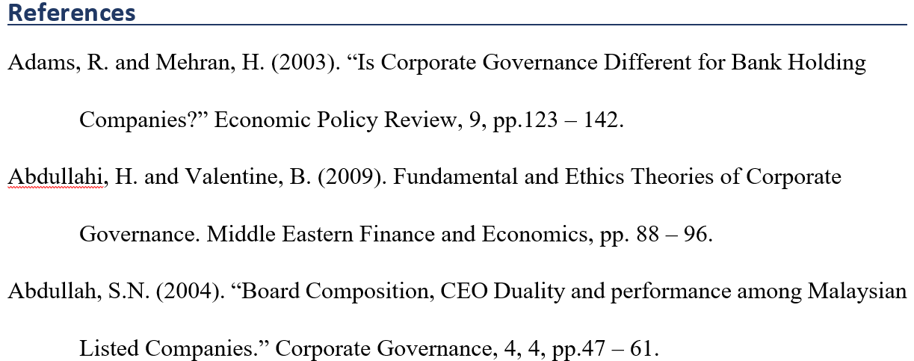

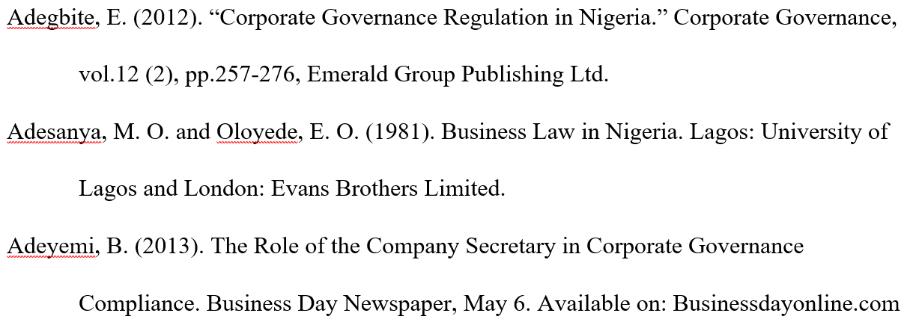
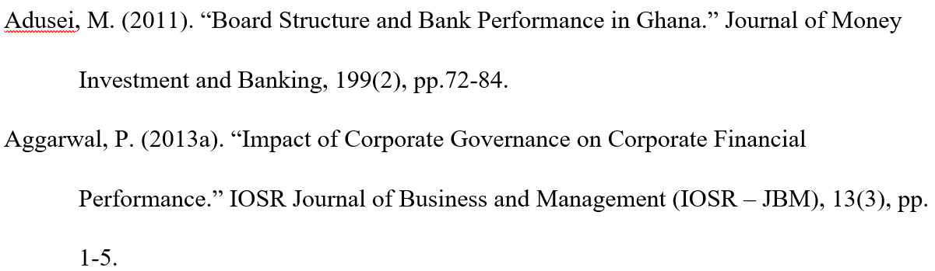
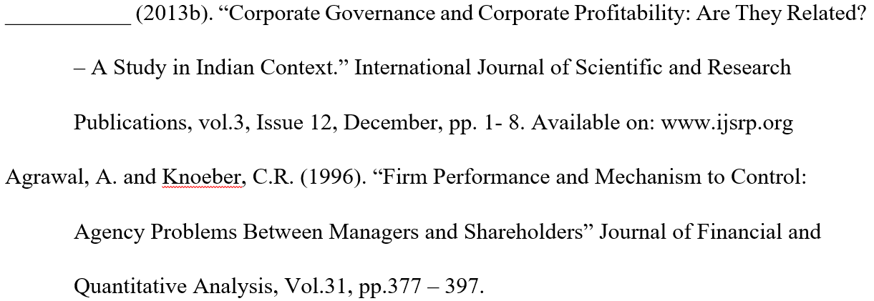

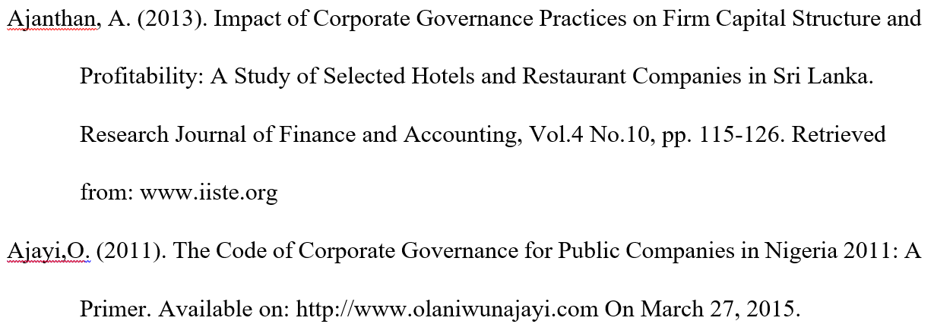
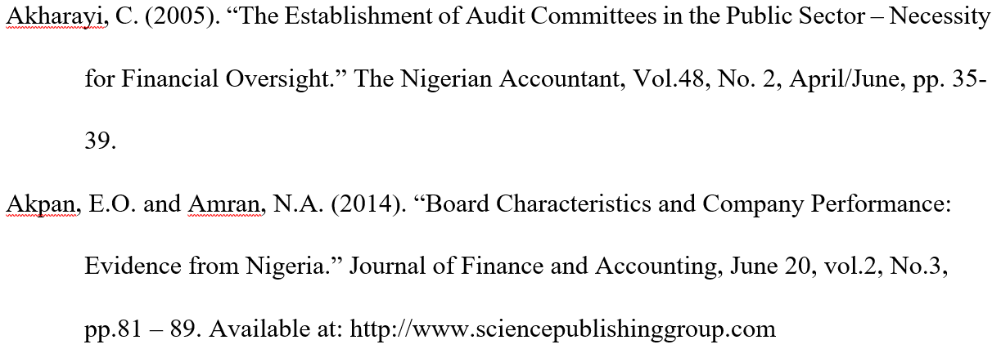

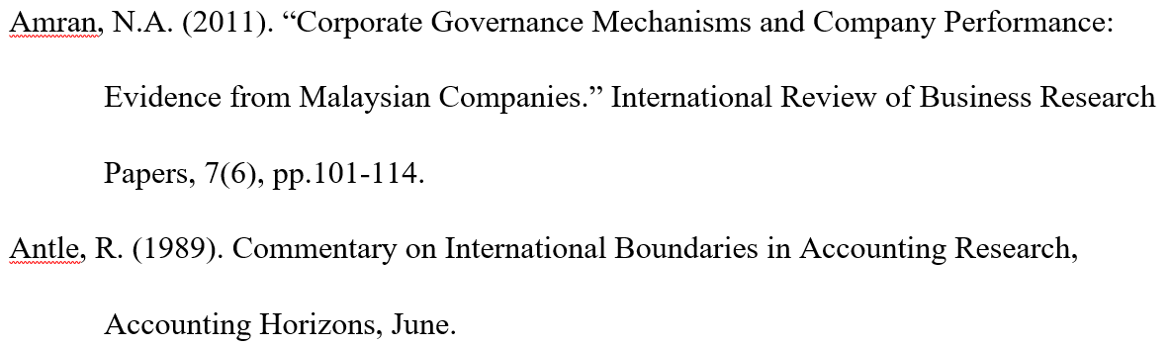

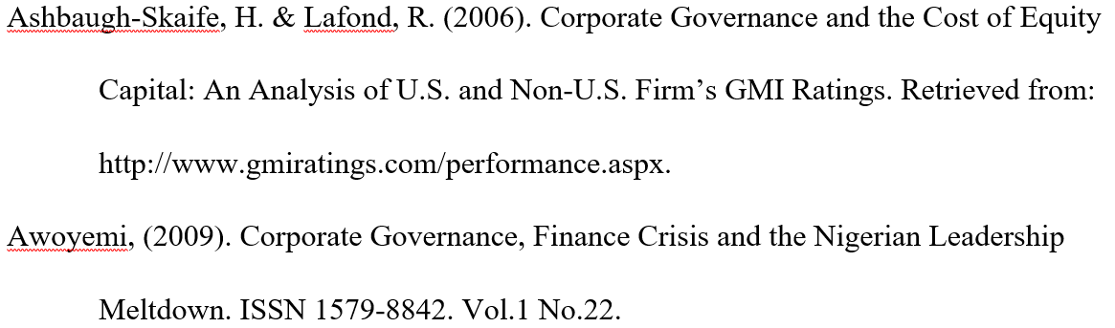
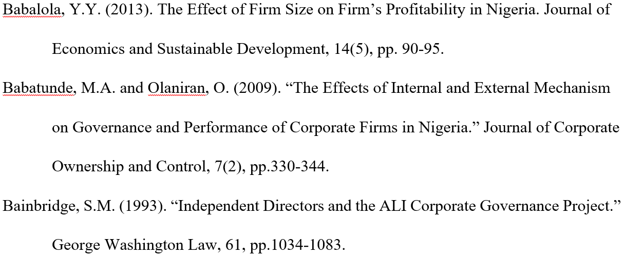
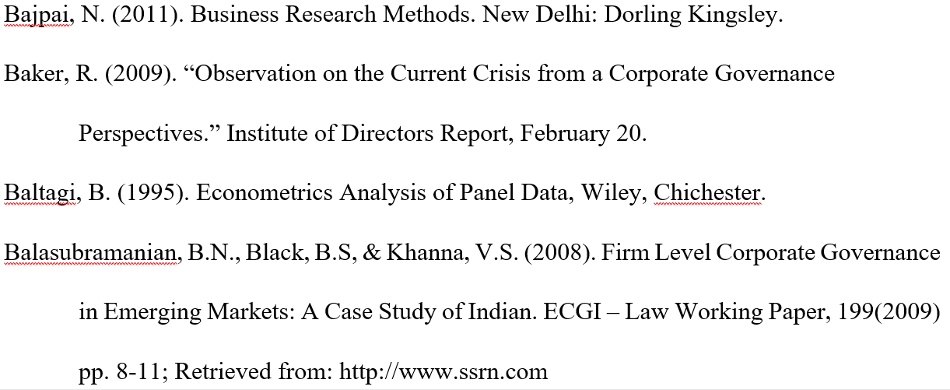
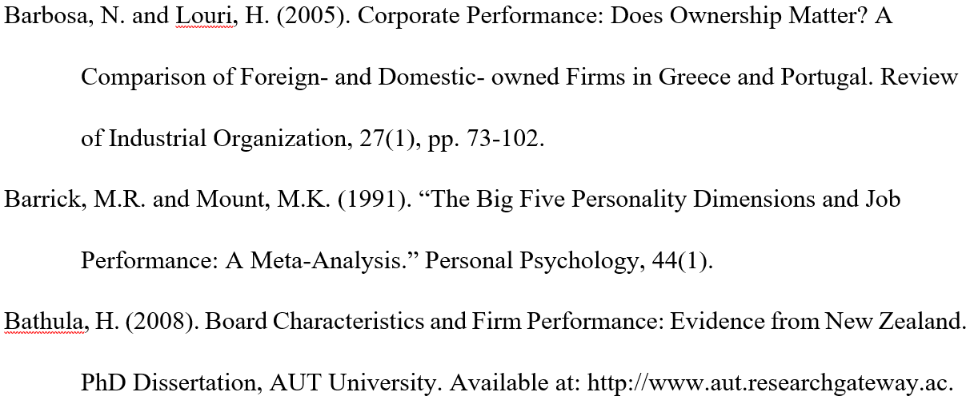

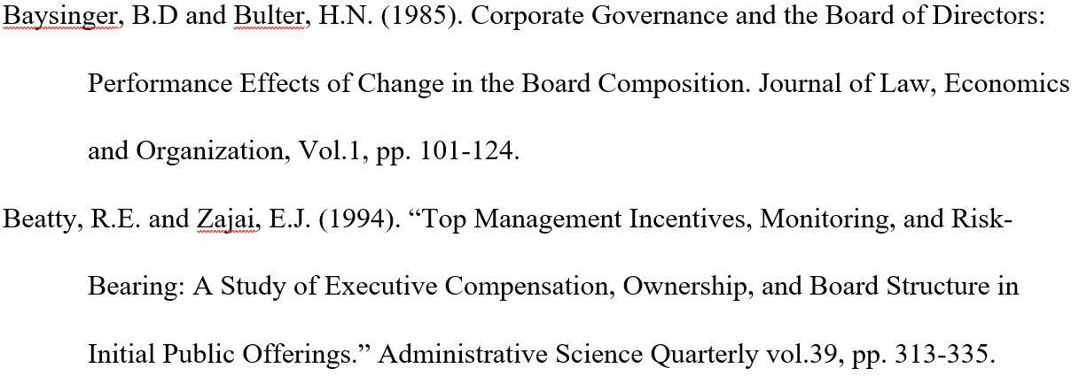

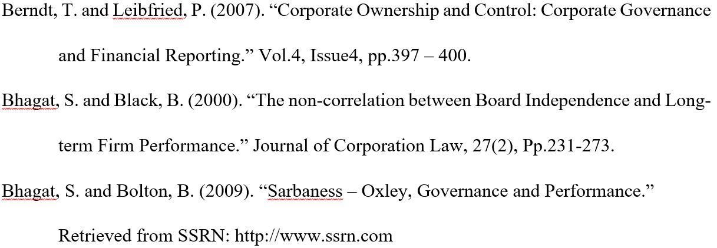
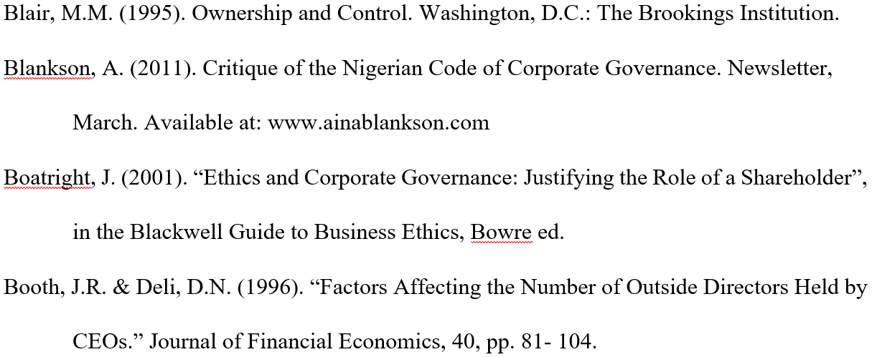
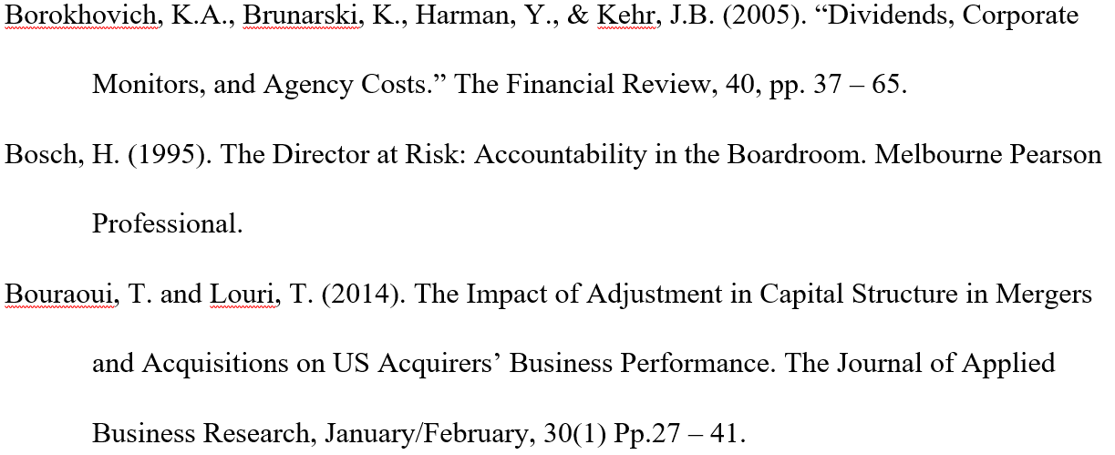
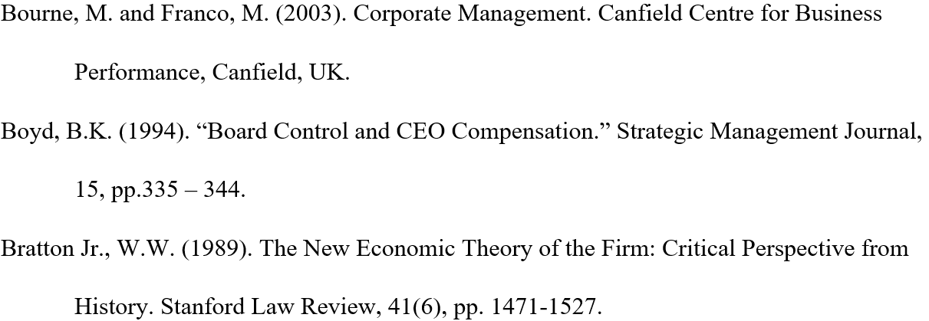

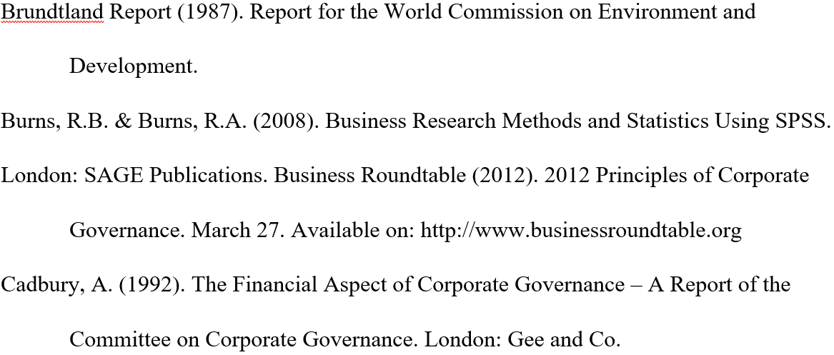
Appendix
Appendix 1: 40 observational data of the sample companies for the time period of 2018 and 2019.
Company Name | ROE | NAPS | BS | BC | BSC | BGD | FS
National Credit and Commerce Bank Ltd (NCCBL) | 11.51 | 20.88 | 15 | 93.33 | 86.67 | 13.33 | 340,925.88
National Credit and Commerce Bank Ltd (NCCBL) | 10.45 | 20.01 | 14 | 92.84 | 85.71 | 14.28 | 316,706.83
United Commercial Bank Ltd (UCBL) | 8.84 | 28.27 | 20 | 95 | 95 | 10 | 446,760.12
United Commercial Bank Ltd (UCBL) | 8.40 | 28.36 | 19 | 94.73 | 94.73 | 10.52 | 402,749.10
Dutch Bangla Bank Ltd. (DBBL) | 17.2 | 54.9 | 6 | 83.33 | 100 | 00 | 390,362.00
Dutch Bangla Bank Ltd. (DBBL) | 19.7 | 115.4 | 7 | 85.71 | 100 | 00 | 346,468.80
Pubali Bank Ltd (PBL) | 7.51 | 27.77 | 15 | 93.33 | 100 | 13.33 | 474,355.97
Pubali Bank Ltd (PBL) | 12.51 | 27.42 | 15 | 93.33 | 100 | 13.33 | 409,744.09
Eastern Bank Ltd. (EBL) | 11.41 | 31.49 | 11 | 90.90 | 100 | 9.09 | 335,163.00
Eastern Bank Ltd. (EBL) | 12.94 | 31.12 | 11 | 90.90 | 100 | 9.09 | 282,451.00
Square Pharmaceuticals Ltd Bangladesh | 17.43 | 82.74 | 7 | 71.42 | 100 | 14.28 | 74,350.80
Square Pharmaceuticals Ltd Bangladesh | 16.24 | 72.02 | 7 | 71.42 | 100 | 14.28 | 65,061.67
ACI Pharmaceuticals Bangladesh Ltd. | 11.15 | 268.79 | 9 | 88.88 | 88.88 | 22.22 | 40,013.51
ACI Pharmaceuticals Bangladesh Ltd. | 3.71 | 249.64 | 9 | 88.88 | 88.88 | 22.22 | 36,914.17
BEACON Pharmaceutical Ltd. | 3.95 | 12.90 | 7 | 57.14 | 100 | 28.57 | 4,871.01
BEACON Pharmaceutical Ltd. | 4.20 | 12.99 | 7 | 57.14 | 100 | 28.57 | 4,908.41
Renata Pharmaceutical Ltd. | 19.17 | 243.14 | 8 | 50.00 | 100 | 37.50 | 22,982.35
Renata Pharmaceutical Ltd. | 20.91 | 206.40 | 8 | 50.00 | 100 | 37.50 | 19,588.60
Orion Pharma Ltd. | 3.47 | 68.69 | 7 | 42.85 | 85.71 | 42.85 | 36,841.11
Orion Pharma Ltd. | 4.71 | 66.98 | 7 | 42.85 | 85.71 | 42.85 | 30,990.42
Envoy Textile Limited | 8.87 | 40.57 | 10 | 20.00 | 100 | 40.00 | 18,010.40
Envoy Textile Limited | 8.21 | 38.35 | 10 | 20.00 | 100 | 40.00 | 17,791.62
Square Textile Ltd. | 34.89 | 41.35 | 7 | 71.42 | 100 | 42.85 | 14,190.03
Square Textile Ltd. | 36.63 | 34.84 | 7 | 71.42 | 100 | 42.85 | 12,954.54
Paramount Textile Limited | 18.39 | 24.26 | 8 | 87.50 | 75.00 | 25.00 | 8,895.36
Paramount Textile Limited | 13.70 | 22.17 | 8 | 87.50 | 75.00 | 25.00 | 8,245.08
Regent Textile Mills Limited | 1.09 | 28.46 | 7 | 85.71 | 100 | 00 | 5,245.45
Regent Textile Mills Limited | 3.22 | 30.21 | 7 | 85.71 | 100 | 00 | 5,161.68
H. R. Textile Ltd. | 3.26 | 42.78 | 8 | 87.50 | 100 | 37.50 | 3,525.17
H. R. Textile Ltd. | 2.60 | 42.15 | 8 | 87.50 | 100 | 37.50 | 2,771.66
Agriculture Marketing Company Ltd. (PRAN) | 5.70 | 80.14 | 5 | 80.00 | 100 | 40.00 | 1,420.43
Agriculture Marketing Company Ltd. (PRAN) | 7.30 | 77.64 | 5 | 80.00 | 100 | 40.00 | 1,401.80
Fu Wang Food Ltd. | 1.50 | 12.01 | 5 | 80.00 | 80.00 | 20.00 | 1,948.64
Fu Wang Food Ltd. | 1.43 | 11.71 | 5 | 80.00 | 80.00 | 20.00 | 1,901.51
Rangpur Dairy and Food Products Ltd. | 2.11 | 14.50 | 7 | 85.71 | 85.71 | 14.28 | 1,294.06
Rangpur Dairy and Food Products Ltd. | 3.09 | 14.90 | 7 | 85.71 | 85.71 | 14.28 | 1,234.33
Apex Foods Limited | 1.56 | 120.63 | 5 | 80.00 | 100 | 00 | 1,714.46
Apex Foods Limited | 1.66 | 124.37 | 5 | 80.00 | 100 | 00 | 1,682.61
Olympic Industries Ltd. | 25.42 | 36.09 | 5 | 80.00 | 100 | 40.00 | 11,802.51
Olympic Industries Ltd. | 21.39 | 31.53 | 5 | 80.00 | 100 | 40.00 | 10,957.18

