INTERNSHIP REPORT
on
The Role of Dhaka Stock Exchange Ltd. in Bangladesh Capital Market

Submitted to

Mohammad Tariq Hasan, Ph.D. Associate Professor
School of Business and Economics United International University

Submitted by

Mehidy Hasan Emon ID: 114 171 030
School of Business and Economics



United International University
Date of Submission: 27th August 2022

LETTER OF TRANSMITTAL

August 27, 2022

Mohammad Tariq Hasan, Ph.D. Associate Professor
School of Business and Economics United International University

Subject: Submission of Internship Report on “The Role of Dhaka Stock Exchange Ltd. in
Bangladesh capital market”

Dear Sir,

With due respect, I would like to inform you that, I have prepared my internship report on the topic of “The Role of Dhaka Stock Exchange Ltd. in Bangladesh capital market” with my greatest effort after doing a proper analysis regarding the Dhaka Stock Exchange (DSE) and capital market. So, now it’s my pleasure to submit my internship report. In this report, I have given both the primary data and the secondary data. I have collected the primary data through direct interviews with the officers and staff of DSE and I have collected the secondary data from the websites, annual reports and articles. I also have provided some findings & recommendations for DSE.
Finally, I am completely done with my internship report after working hard and hope that you will be satisfied reading this report. I, therefore pray and hope that you will be kind enough to accept my report. Thank you very much for your kind co-operation.

Sincerely yours, Mehidy Hasan Emon ID: 114 171 030

DECLARATION OF THE STUDENT

I, Mehidy Hasan Emon, declared that this internship report is made on the topic of “The Role of Dhaka Stock Exchange Ltd. in Bangladesh capital market” which is prepared by myself after doing a proper analysis of the primary data and the secondary data. The internship period was a very valuable time for me to obtain knowledge regarding the Dhaka Stock Exchange (DSE) and the capital market.
I have collected lots of relevant information for preparing the report. I am assuming that this report is nicely prepared by myself. I also assure you that this report is one of the unique reports of the BBA program.

ACKNOWLEDGEMENT

I am grateful to the almighty Allah for giving me the strength to prepare the internship report successfully at a specific time.
First, I am thankful to my internship supervisor Dr. Mohammad Tariq Hasan for giving me this opportunity. I have prepared my internship report on the topic of “The Role of Dhaka Stock Exchange Ltd. in Bangladesh capital market”. I have made a broad and comprehensive report on this topic.
I am also thankful to some other people whose collaboration and instructions highly helped me to prepare my internship report.

EXECUTIVE SUMMARY

The capital market is a vital organization for the economic development of any country. The capital market deals with business organizations and the government regarding different securities. It engages in the exchange of stocks, bonds, treasury bills, notes and other capital instruments. It acts as an intermediary between the buyers and the sellers in terms of trading securities. The business companies and the government are able to sell different securities to the people through the capital market and get long-term funds. Though the capital market of Bangladesh is small compared to the other capital markets in Asia, it is among the largest capital markets in the South-Asian region. The capital market highly depends on the Dhaka Stock Exchange Ltd. The roles of the Dhaka Stock Exchange Ltd. significantly influence the capital market. Currently, there are two stock exchanges in Bangladesh, Dhaka Stock Exchange (DSE) and Chittagong Stock Exchange (CSE). The Dhaka Stock Exchange (DSE) is in the top position. Most of the companies in Bangladesh have business transactions with them. They are trading securities with the people through the Dhaka Stock Exchange (DSE). The DSE has so many products by which they are operating business and generating high profit. They are grown continuously since the foundation of their business. At present, this stock market provides around 515 securities for 248 companies. In this study, there are a total of five chapters. The first chapter is the introduction part. The second chapter represents the literature review, company & industry preview. In the third chapter, the methodology is specifically discussed. In the fourth chapter, my internship experience of myself is provided precisely. The fifth and last chapter represents the recommendations, findings and conclusion. Currently, the Dhaka Stock Exchange (DSE) has a high reputation and excessive clients and earns a high amount of revenue per month. It is developing gradually and it is predicted that the organization will be capable to implement more growth in future.

Keywords: Dhaka stock exchange, capital market, economic development, Bangladesh

TABLE OF CONTENTS

LETTER OF TRANSMITTAL 2
DECLARATION OF THE STUDENT 3
ACKNOWLEDGEMENT 4
EXECUTIVE SUMMARY 5
TABLE OF CONTENTS 6
CHAPTER ONE: INTRODUCTION 9
I.1 Background of the Report 9
I.2 Objectives of the Report 9
I.3 Motivation of the Report 10
I.4 Scope of the Report 10
I.5 Limitation of the Report 10
CHAPTER TWO: COMPANY & INDUSTRY PREVIEW 11
2.1 Capital Market 11
2.1.1 Definition of Capital Market 11
2.1.2 Structure of Capital Market 11
2.1.3 Capital Market Instruments 11
2.1.4 Market Participants in the Capital Market 11
2.2 Overview and History of Dhaka Stock Exchange Ltd. 12
2.2.1 DSE as an Organization 13
2.2.2 Vision 13
2.2.3 Mission 13
2.2.4 Objectives 14
2.3 Customer Mix 14
2.4 Product/Service Mix 15
2.5 SWOT Analysis 16
2.6 Monitoring, Investigation & Compliance (MIC) Department 17
2.6.1 Functional Areas of MIC Department 18
2.6.2 Human Resources of MIC Department 18
2.6.3 Organizational Hierarchy of MIC Department 18
2.6.4 Monitoring Activities of Dhaka Stock Exchange 18
2.6.5 Investigation Activities of Dhaka Stock Exchange 19
2.6.6 Compliance Activities of Dhaka Stock Exchange 20
2.7 Economic Factors 20
2.8 Roles of Dhaka Stock Exchange in the Capital Market 21
CHAPTER THREE: METHODOLOGY 22
3.1 Types of Data and Method 22
3.2 Data or Information Collecting Procedures 22
CHAPTER FOUR: INTERNSHIP EXPERIENCE 23
4.1 General Requirements 23
4.2 Specific Requirements 23
CHAPTER FIVE: FINDINGS, RECOMMENDATION AND CONCLUSION 24
5.1 Findings 24
5.2 Recommendation 24
5.3 Conclusion 25
Reference 26
APPENDIX 28

CHAPTER ONE: INTRODUCTION

Background of the Report

This report is basically prepared on the “The Role of Dhaka Stock Exchange in Bangladesh Capital Market”. Capital market is a financial organization which works as an intermediary between the buyers and sellers of long-term debt and securities such as stocks, bonds and others. Both the business organizations and the people of Bangladesh are very helpful by the capital market. The business organizations need money necessarily to run their business. They collect money from the people by providing shares and bonds to them. Different investors invest money in different companies and get shares and bonds from them. After that, they get dividends and interests from those securities in different particular periods. The business organizations and the investors are able to trade the long-term debt and securities between them by the capital market. Dhaka Stock Exchange Ltd. plays a significant role in terms of capital market. It performs the essential roles of the capital market. Thus, the capital market is highly benefitted by the Dhaka Stock Exchange Ltd.

Objectives of the Report

Primary Objective

The primary objective of this study is fulfilling the requirement for the completion of the BBA program and achieving the BBA program certification from United International University (UIU).
Secondary Objective

The specific objectives of this report is given below:

- Understanding about the meaning of capital market along with its structure and instruments
- Identifying the roles of the DSE in the capital market.
- Understanding about the overview and history, mission, vision, objectives of Dhaka Stock Exchange Ltd.

- Understanding about the functions, customer mix, products and services of Dhaka Stock Exchange Ltd.
- Representing the organizational structure & performance of Dhaka Stock Exchange Ltd.

Motivation of the Report

The motivation of the study is given below:

- Improving the interpersonal skills
- Learning about the theoretical knowledge
- Improving the communication skills
- Establishing high professionalism standards
- Analyzing the significant factors regarding the organization
- Learning more about the transactions with the clients

Scope of the Report

In this study, the overall background of Dhaka Stock Exchange Ltd. is discussed elaborately along with its mission, vision, objectives, functions, products and services. The organizational structure of DSE is also presented here as a chart. The overview of capital market and the role of Dhaka Stock Exchange in the capital market are also properly discussed here.

Limitation of the Report

There are some limitations in this report. I have faced some limitations while preparing the internship report. I was unable to get all of the data and information of the Dhaka Stock Exchange Ltd. (DSE). The relevant information of the DSE are published in the annual report and the official website of DSE. But all of the data and information of the DSE are not published in the annual report, official website and newspapers because of the privacy of the organization.

CHAPTER TWO: COMPANY & INDUSTRY PREVIEW

Capital Market

Definition of Capital Market

Generally, capital market is a platform which is recognized by Bangladesh Securities and Exchange Commission. Capital market is a market where long-term debt and securities are bought sold. It actually works as an intermediary to trade the stocks, bonds and other financial securities between the buyers and sellers.

Structure of Capital Market

Capital market can be categorized into four markets which are discussed at the below:

- Primary market: In the primary market, the stocks and bonds of the respective organizations are traded in order to increase their capital.
- Secondary market: In the secondary market, the issuer of the security doesn’t receive the funds from the buyers. The buyer provides the fund to the seller in the secondary market.
- Third Market: In the third market, the exchange listed securities are traded between the broker dealers and the institutional investors.
- Fourth Market: In the fourth market, the securities are traded from one party to another party without any third party or intermediary.

Capital Market Instruments

The capital market has lots of instruments by which it is doing business and earning profit. The instruments of the capital market are- a) Bonds (by coupon & by issuer), b) Equities (stocks), c) Investment funds, d) Derivatives, e) Structured finance etc.

Market Participants in the Capital Market

The list of the market participants of the capital market is available on appendix 1.

Overview and History of Dhaka Stock Exchange Ltd.

Before the independence of Bangladesh in 1952, the business of shares and securities of Pakistan was prohibited by the Calcutta Stock Exchange. After that, the government of Pakistan felt the importance of establishing a stock exchange in the East Pakistan. In order to establish a stock exchange in the East Pakistan, the Provincial Industrial Advisory Council of Pakistan built a committee. Few days later, several issue regarding the shares and securities were discussed properly under A. Khaleeli who was the chairman and also the secretary of the East Bengal government. At the meeting, nobody favored about the establishment of the stock exchange in the East Pakistan. But, the Pakistan government previously felt the necessity of establishing a stock exchange in Dhaka as a branch of Karachi Stock Exchange. The Pakistan government decided that the stock exchange will be founded at Dhaka or Narayanganj or Chittagong. In order to establish the stock exchange, a committee was organized with the commercial and industrial members. On the above meeting, the members of the chamber and the members of organizations under the chamber were requested by the chamber to join in the establishment of stock exchange. In July 7, 1953, a meeting was established at the chamber where 100 persons agreed in the establishment of stock exchange. M Mehdi Ispahani was the convener of that meeting. On that meeting, 8 persons were invited including M Mehdi Ispahani for promoting the exchange. They were authorized to publish the Memorandum and Articles of Association of the Exchange and register under the Company’s Act, 1913.

It was decided in the meeting that the membership fee will be RS. 2,000 and the subscription fee will be RS. 15 per month in the stock exchange. It was also decided that the maximum members will be 150 in the stock exchange. In September 3, 1953, a meeting was held at the chamber with the promoters where it was decided that Orr Dignam & Co. will draw the memorandum and articles of association of stock exchange. In April 28, 1954, the stock exchange was incorporated as “East Pakistan Stock Exchange Association Limited” by the 8 promoters who joined the meeting. Since, it was a public limited company, it was named East Pakistan Stock Exchange Ltd in 1962. After 2 years in 1964, the name was again changed to “Dacca Stock Exchange Ltd.”

When the stock exchange was established, the authorized capital of the stock exchange was RS. 3,00,000 which was divided by the 150 shares of RS. 2,000 each. After that in February, 1964, the authorized capital was increased at RS. 5,00,000 and that was divided by the 250 shares of RS. 2,000 each. The paid-up capital of the stock exchange was RS. 4,60,000 which was divided by the 230 shares of RS. 2,000 each. The history of Dhaka Stock Exchange Ltd. is presented in appendix 2.

DSE as an Organization

Dhaka Stock Exchange Ltd. is considered as a public limited company according to the Companies Act 1994. The organization is a well reputed organization whose activities are monitored by the following:
- Memorandum & Articles of Association,
- Companies Act 1994,
- Securities and Exchange Ordinance 1969,
- Securities and Exchange Rules 1987 and
- Other Bangladeshi laws.

Dhaka Stock Exchange Ltd. has its Board of Directors and the Management Committee for maintaining the organizational structure. The Board of Directors monitors the policy related issues of the organization. The Management Committee maintains the daily business operations by following the policies and rules established by the Board of Directors.

Vision

Becoming the leading stock exchange in the country and a chain of economic growth with technology and superior service for assuring trust and confidence among the stakeholders.

Mission

Running the business with the information & technology and also providing superior service to the customers. Developing economic growth of the country by making assets, providing access to the capital of the companies and increasing their revenue. Better corporate administration to increase the trust and confidence of the investors, regulators and intermediaries.

Objectives

Dhaka Stock Exchange has plenty of objectives in their organization. The objectives of Dhaka Stock Exchange are given in the following:
- Commercial:
  - Obtaining an average daily turnover of BDT 25 billion.
  - Assuring at least three fourth of total organizational investments in the market.
  - Attracting foreign investments in order to obtain a satisfactory level of percentage of the market capitalization.
  - Increasing the number of the listed securities.
  - Increasing depth and liquidity of the bond market.
  - Extending business by introducing new products.
- Knowledge Development:
  - Increasing knowledge among the investors in order to assure educated investors.
- Governance:
  - Separating the regulatory functions from the business operations effectively.
  - Increasing corporate governance and assuring the protection of the investors.
- Technology:
  - Establishing high standard technology in the organization through proper investment.
- Human Resources Development:
  - Providing effective training to the employees.
  - Establishing well organizational structure.

Customer Mix

Dhaka Stock Exchange Ltd. has abundant clients. There are huge companies in Bangladesh. Among those companies most of them sell stocks, bonds and other securities to the people. By this way, they are able to get capital to operate their business. Those companies sell their securities to the public through the Dhaka Stock Exchange which works as a third party. The list of clients of Dhaka Stock Exchange Ltd. are given in Appendix 3.

Product/Service Mix

- Equity Securities

Generally, there are two types of Equity instruments in DSE which are discussed at the below:
- Equity

Equity is the ordinary shares of the listed companies. Those companies which are listed by the DSE have plenty of shares. Those shares are not tradeable for a limited period of time. The free float shares of the listed companies are used to calculate the DSE Indices. The DSE conducts the free float for various purposes including non-tradable shares, institutional holdings, strategic holdings, sponsor-director holdings and government holdings. Sometimes, the members of DSE keep the shares on T+0 settlement cycles for a particular period in order to implement the record dates.

- Mutual Funds

Mutual fund is a very important instrument of DSE. These funds are closed end funds which is controlled by the Securities and Exchange Commission. The sponsors need to keep a minimum of 10% holding for at least 1 year and 1% holding for the entire life of the fund. There are effective staffs to maintain the mutual funds. The asset managers maintain the activities related to the mutual funds on the daily basis. The trustees maintain the investment strategies. The DSE trades the mutual funds in the T+2 settlement cycle. Sometimes, the shares are kept in the T+0 settlement cycles for a particular period in order to implement the record dates for organizational activities.

- Debt Securities

Generally, there are two types of Debt instruments in DSE which are discussed at the below:
- Corporate Bonds

DSE has 2 corporate bonds. Those bonds are traded in the T+2 settlement period. The fee of trading in T+2 settlement period is BDT 50 per transaction.

- Treasury Bonds

The Bangladesh Bank issued total 221 treasury bonds which were listed with the DSE. But, at present those bonds are not tradable anymore. Generally, the maturity of those bonds are 5 years, 10 years, 15 years and 20 years. The coupon rate depends on the time when the bonds were issued. The par value of each treasury bond is BDT 100,000.

- Debentures

Debentures are the debt instruments issued by the listed companies which are unsecured. These debt instruments have both variable and fixed interest rates. The debentures which are listed at the present are matured.

SWOT Analysis

- Strengths of Dhaka Stock Exchange
- It has a strong brand image and reputation across the country.
- It has a strong connection in all of the districts of Bangladesh.
- It is well effective to provide the necessary services to its branches.
- It is eligible to provide excellent services to the clients.
- It has potential and efficient staffs and employees to operate the business operations.
- The business infrastructure of the organization is superior and premium.
- The organization provides important advices to the clients.
- It takes orders from the clients and proceeds the orders properly and accurately.
- It is always well efficient to satisfy their clients.

- Weaknesses of Dhaka Stock Exchange
- It sometimes faces various problems in the IPO pricing operations.
- There is sometimes improper surveillance in the price of the shares in the organization.
- There are no proper guidelines for the investors of the organization.
- The decision making ability of the organization is weak.
- The audit department of the organization is also weak.

- Opportunities for Dhaka Stock Exchange
- Introducing brokerage houses in every districts of Bangladesh for increasing revenue.
- Introducing the investors regarding the digital method of stock market trading via online.
- Opening a new department named customer care and call center for responding in customer related queries.
- Organizing program and conference regarding the products and the overall infrastructure of DSE for increasing awareness among the investors.
- Utilizing the experiences of the foreign visitors regarding their countries' stock exchanges which they share with us while visiting in our country.
- Ensuring well settlement in the organization’s operations in order to save time.

- Threats for Dhaka Stock Exchange
- The inconsistency in the supply and demand of shares in the exchange may lead to different problems in the market.
- Because of the insufficiency in the electricity in the country, the investors are less willing to buy shares of different companies. So, it will affect the DSE highly.
- There are lack of expertise manpower in the DSE. As a result, it may fail to gain success in their business.

Monitoring, Investigation & Compliance (MIC) Department

Monitoring, Investigation & Compliance department is an important department of Dhaka Stock Exchange Ltd. This department is responsible for monitoring the organization by different cells, investigating various activities by investigation cell and compromising the claims and complaints of the clients and the investors. The Monitoring, Investigation and Compliance (MIC) department started its operation in the year of 2003. When it launched for the first time, the name of the department was Monitoring, Investigation and Grievance department. The size of the department was small at the initial time. But gradually, the department became to expand gradually. In the year of 2005, the name of the department was changed into Monitoring, Investigation and Compliance (MIC) department. In this department, currently there are 10 Executives, 8 Senior Executives, 1 Manager, 1 Assistant General Manager (AGM) and 1 Deputy General Manager (DGM).

Functional Areas of MIC Department

The main functional areas of the MIC department are presented in appendix 4.

Human Resources of MIC Department

The human resource of MIC department is presented as a framework which is available in Appendix 5.

Organizational Hierarchy of MIC Department

The organizational hierarchy of the MIC department is presented in Appendix 6.

Monitoring Activities of Dhaka Stock Exchange

Monitoring is a very essential activity of Dhaka Stock Exchange Ltd. All of the operations and activities of DSE should be monitored properly. Currently, DSE has total 248 member companies in their organization. Those member companies have excessive branches. The monitoring of those member companies is under DSE. DSE conducts the monitoring of the member companies by two cells, Surveillance Cell and Monitoring Cell.

- Monitoring Activities by Surveillance Cell

The purpose of monitoring activities by the surveillance cell is promoting the market in two ways:
- Monitoring the organization’s price and volume fluctuations.
- Maintaining default risk properly by appropriate actions.

The monitoring activities by the surveillance cell are divided into two segments which are below:
- Price Monitoring: Price monitoring refers to monitoring the price fluctuation issues of DSE products.
- Position Monitoring: Position monitoring refers to positioning the members of DSE based on their efficiency and effectiveness.

- Monitoring Activities by Monitoring Cell

The monitoring activities by the monitoring cell are given at the below:

- General Monitoring
- Special Monitoring
- Formal Monitoring
- Spot Monitoring
- Branch Office Monitoring

Investigation Activities of Dhaka Stock Exchange

There are lots of investigation activities in the Dhaka Stock Exchange Ltd. Some common investigation activities are given at the below:
- Investigation on the member companies.
- Investigation on the enlisted companies.
- Investigation on the clients’ complaints.

- Investigation on Companies Applied for DSE MDS Connectivity.
- Investigation on the market utilization.

Compliance Activities of Dhaka Stock Exchange

The compliance department is basically responsible to compromise the complaints and claims of the clients and the investors. Sometimes the clients of DSE complain to the management of DSE regarding different issues. The investors also claim regarding different issues of the organization. The members of the compliance department settle these situations by taking necessary steps. The compliance activities of DSE are below:
- Maintaining the stock and securities related compliance issues;
- Maintaining the instructions of the brokerage house;
- Obeying the duties & responsibilities of the brokerage house which is given by the managers and head of the brokerage house;
- Obeying the pre-requisite for creating new branch of brokerage house;
- Compromising the complaints and claim related issues of the clients and the investors;
- Compliance of the Securities & Exchange Rules, 1987;
- Compliance of Dhaka Stock Exchange (DSE) Regulations, 2000;
- Compliance of the Margin Rules, 1999;
- Compliance of Dhaka Stock Exchange (DSE) Automated Trading Regulations, 1999;
- Compliance of the Settlement of Stock Exchange Transactions Regulations, 1998;
- Compliance of the listing regulations;
- Compliance of the Banking Companies Act, 1991;
- Conducting training program for the employees.

Economic Factors

There are many economic factors which greatly affects the DSE economically. Those economic factors determine the prices of the shares of DSE. The economic factors include demand of shares, margin loan, money supply, interest rate, inflation, exchange rate etc. The most important economic factor is demand of shares. The demand of shares has WAS of 3.09. After demand of shares, the important economic factors are margin loan and money supply. The margin loan and the money supply have WAS of 3.05 and 2.92 respectively. The money supply of the stock market is monitored by the central bank which determines the price and the rate of interest of the shares. The interest rate, inflation and the exchange rate have WAS of 2.58, 2.47 and 2.10 respectively.
(See in Appendix 7)

Roles of Dhaka Stock Exchange in the Capital Market

The major functions of Dhaka Stock Exchange in capital market are:

- Listing all of the companies based on the listing regulations
- Providing automatic trading process of the listed securities
- Managing the trading according to the transaction regulations
- Approving the transaction of share outside the exchange
- Controlling & administrating the market properly
- Overlooking the market properly
- Publishing monthly & yearly review
- Maintaining the roles and activities of the listed companies
- Protecting the investors through appropriate funds
- Proclaiming the relevant information about the listed companies in the online.

CHAPTER THREE: METHODOLOGY

Types of Data and Method

There are two types of data, primary data and secondary data. Primary data are those data which are taken by the researcher. The sources of primary data are questionnaire, survey, observation, interview, experiment etc. Secondary data are those data which are collected by the other users. The sources of secondary data are books, newspapers, websites, journal articles, statements and records, print media etc.

Data or Information Collecting Procedures

In this study, two types of data are collected, primary data and secondary data. The primary data are collected by direct interview with the staffs and officers of the Dhaka Stock Exchange Ltd. (DSE). Different open ended and close ended questions were asked to the officers of different departments. After getting their opinions, the primary data are presented in the study. The secondary data are collected from the official website of Dhaka Stock Exchange Ltd. (DSE) and the other websites.

CHAPTER FOUR: INTERNSHIP EXPERIENCE

In my three months’ internship period, I had learned a lot of things from the staffs and employees of the organization. I also had done lots of activities practically in the organization. I have worked in different areas of the organization. So, I have become capable to gather lots of experience in my internship period. My internship experience is given at the below:

General Requirements

I learned lots of activities regarding the general requirements of Dhaka Stock Exchange Ltd. from the officers of the organization. After learning, I operated those activities practically and gained experience. Those activities regarding the general requirements are given below:
- BO Account verification
- Receiving letter
- Excel data entry
- File documentation
- Bill payable
- Invoice
- File scanning.

Specific Requirements

I also had learned different activities of specific requirements of Dhaka Stock Exchange Ltd. from the officers of the DSE. I obtained good experience by doing those activities practically. The activities of the specific requirements of DSE are below:
- Over time
- Loan
- Tax & TDS
- KPI
- Salary certificate & salary sheet. Working with DSE ERP, Excel and Tally software.

CHAPTER FIVE: FINDINGS, RECOMMENDATION AND CONCLUSION

Findings

- Insufficient Manpower: There are not sufficient manpower in the DSE. Because of the insufficient manpower in the organization, the business operations are getting hampered.
- Difficulties and issues in monitoring and controlling the activities: The business operations of every organization should be monitored and controlled properly. The owners of the client companies of DSE are also the owners of DSE. So, it is quite difficult to monitoring the activities of DSE.
- Influence of other members: There are some influential and dominant members who already have invested in DSE. They sometimes influence greatly in the investigation process of DSE.
- Investigation delay: Since there are low number of employees in DSE, it takes very long time to conduct the investigation operations.
- Inadequate Logistics Facilities: There are inadequate facilities in the logistics of DSE. So, the employees of the logistics department are suffering.
- Power of administration: DSE has lower administration power to control the member companies. It is difficult for them to monitor the member companies.
- Limited training: In DSE, the training of employees is very limited. It is a significant problem for the employees.

Recommendation

- Increase Sufficient Power: DSE should increase the manpower in the organization to successfully carry out the monitoring, investigation & compliance activities as well as other business operations.
- Improved Corporate Culture: The management of the organization should improve the organizational culture to attract people toward the organization and increase revenue. The corporate culture of the organization should be improved so that a clear understanding is possible that ownership and management is different.
- Increase no. of Investigation: A huge investigation should be ensured in DSE in order to control and monitor the business organization properly.
- Logistics Facilities: DSE should ensure sufficient logistics facilities in their organization in order to well maintain the monitoring, investigation & compliance activities.
- Provide Empower: The BSEC should give sufficient power to DSE for administrating the member companies. It will positively impact the DSE organization.
- Training Facilities: The HR of DSE should improve the training facilities to increase the employees’ efficiency and effectiveness for operating the monitoring, investigation & compliance activities.
- Increase Remuneration: DSE should increase the salary of the employees to motivate them into the organization.

Conclusion

Capital market is actually a very essential organization where people can invest their money for the purpose of earning money. The business organizations are also very much helpful by this organization. The business organizations are able to sell their stocks, bonds and other securities to the people through this market. The capital market has been increasing & improving gradually after starting its business. At present, the capital market is earning high value of profit in every month from its business operations. Since the capital market is increasing, the monitoring, investigation and compliance activities of Dhaka Stock Exchange Ltd. also need to be increased. The monitoring, investigation & compliance activities should be well conducted by the monitoring, investigation & compliance department. If somehow the monitoring, investigation & compliance department fails to properly maintain these activities, then the DSE organization will highly suffer. The monitoring, investigation & compliance department should conduct the monitoring, investigation & compliance operations on a large extension in order to well balance the Dhaka Stock Exchange. The DSE authority as well as the monitoring, investigation & compliance department should take the necessary steps for modernizing these activities toward the organizational goal.

Reference

Dsebd.org. 2022. Dhaka Stock Exchange. [online] Available at:
<https://www.dsebd.org/> [Accessed 1 August 2022].

En.wikipedia.org. 2022. Dhaka Stock Exchange - Wikipedia. [online] Available at:
<https://en.wikipedia.org/wiki/Dhaka_Stock_Exchange#:~:text=Dhaka%20Stock
%20Exchange%20(DSE)%20is,of%20this%20company%20is%20Tk.> [Accessed 1 August 2022].
Siddique, M., 2022. Overview of Dhaka Stock Exchange (DSE). [online] Academia.edu. Available at:
<https://www.academia.edu/26073967/Overview_of_Dhaka_Stock_Exchange_D SE_> [Accessed 1 August 2022].
The Lawyers & Jurists. 2022. Overview and Development of Dhaka Stock Exchange Ltd. And Its Contribution To Economy Of Bangladesh | The Lawyers & Jurists. [online] Available at: <http://www.lawyersnjurists.com/metarial/overview-and- development-of-dhaka-stock-exchange-ltd-and-its-contribution-to-economy-of- bangladesh/> [Accessed 1 August 2022].
2022. [online] Available at:
<https://www.researchgate.net/publication/361377268_Fundamental_Analysis_of
_Dhaka_Stock_Exchange_DSE_Listed_Top_Five_NBFIs_A_Study_on_Banglad esh> [Accessed 1 August 2022].
TrippleEe, V., 2022. SWOT Analysis of Dhaka Stock Exchange. [online] SWOT Bangla. Available at: <https://swotbangla.wordpress.com/2016/09/03/swot-analysis-of- dhaka-stock-exchange/> [Accessed 1 August 2022].

Investopedia. 2022. Capital Markets: What You Should Know. [online] Available at:
<https://www.investopedia.com/terms/c/capitalmarkets.asp> [Accessed 1 August 2022].
Corporate Finance Institute. 2022. Capital Markets. [online] Available at:
<https://corporatefinanceinstitute.com/resources/knowledge/trading- investing/capital-markets/> [Accessed 1 August 2022].

Appendix

Appendix 1:
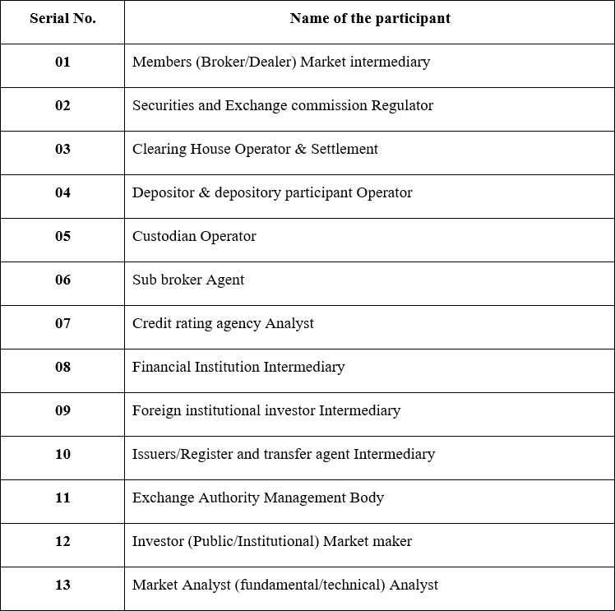

Appendix 2:
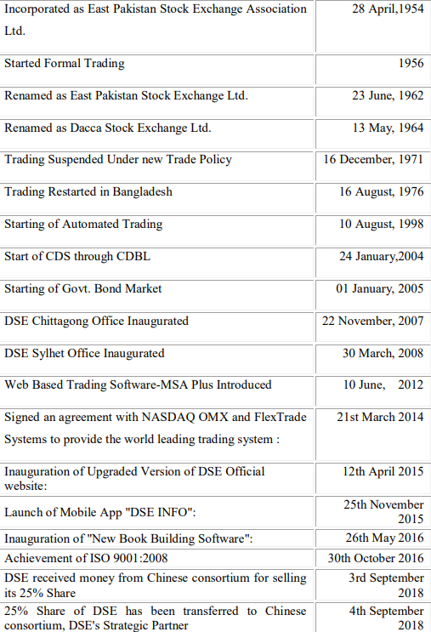

Appendix 3:
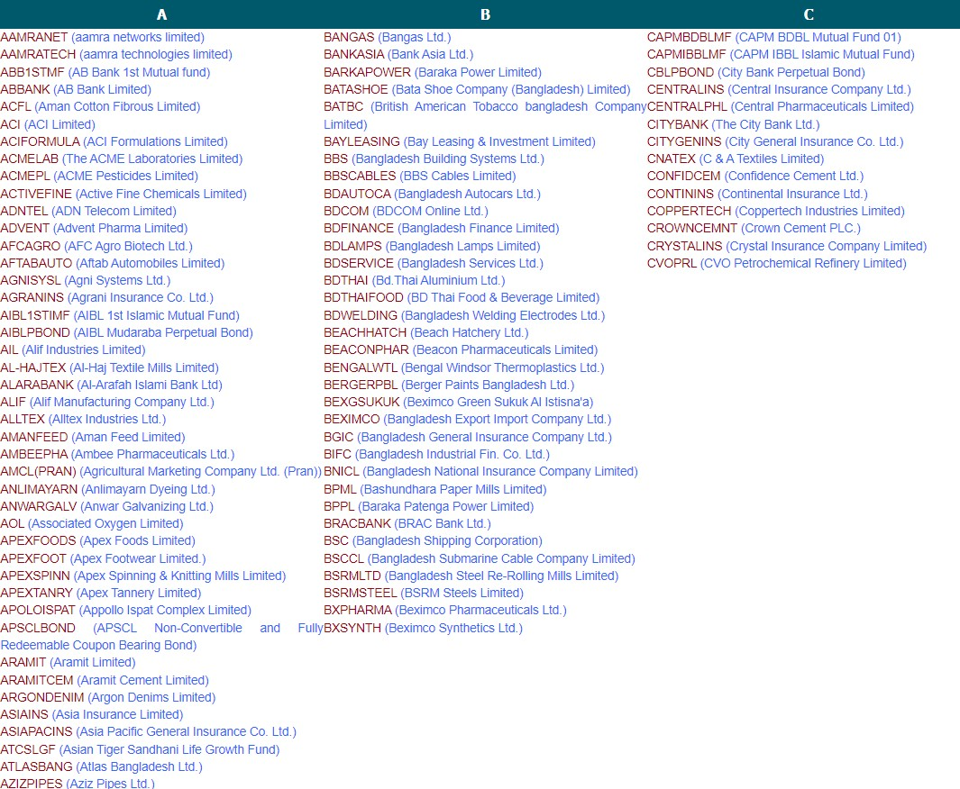

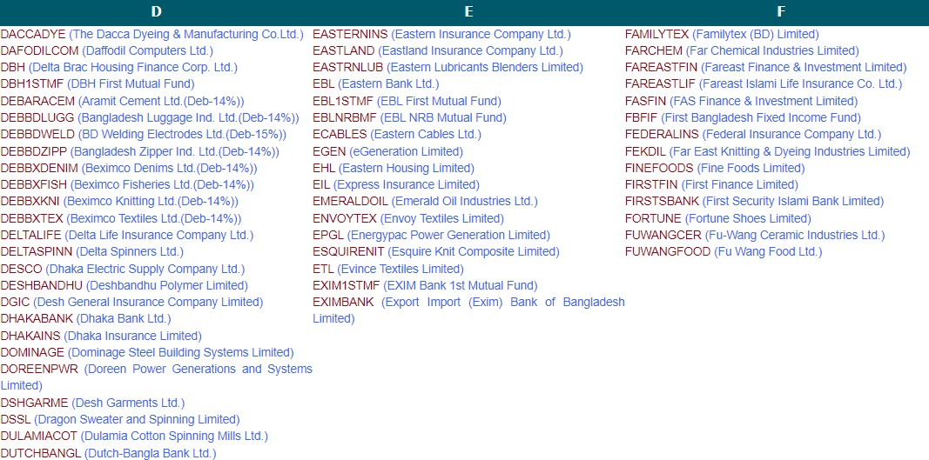
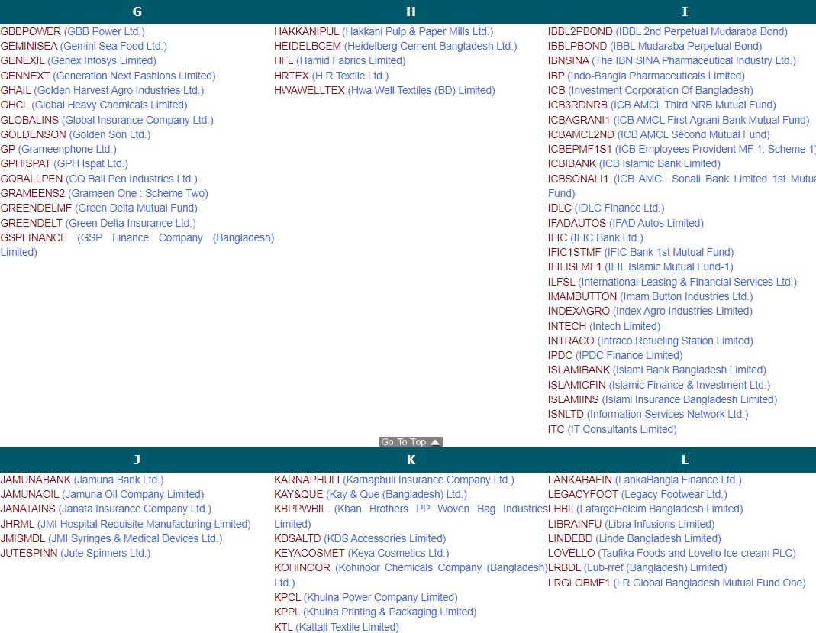

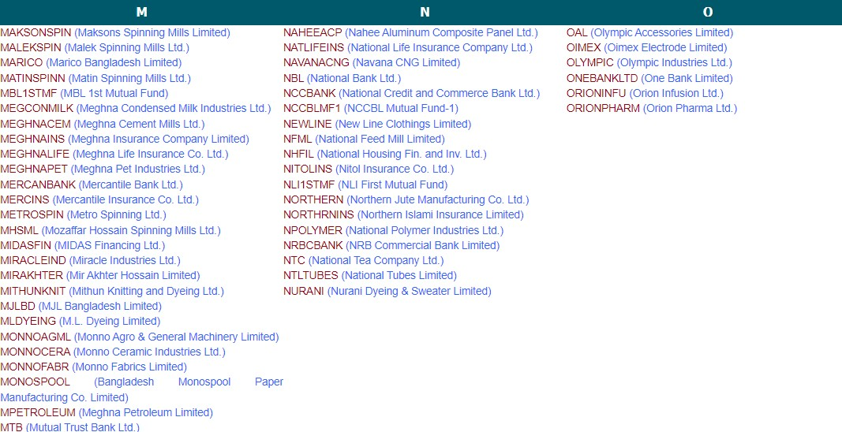
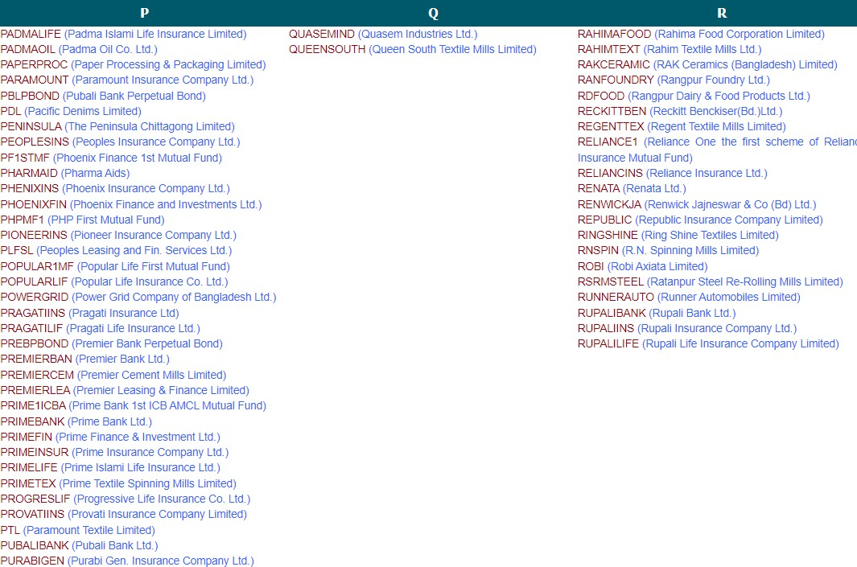

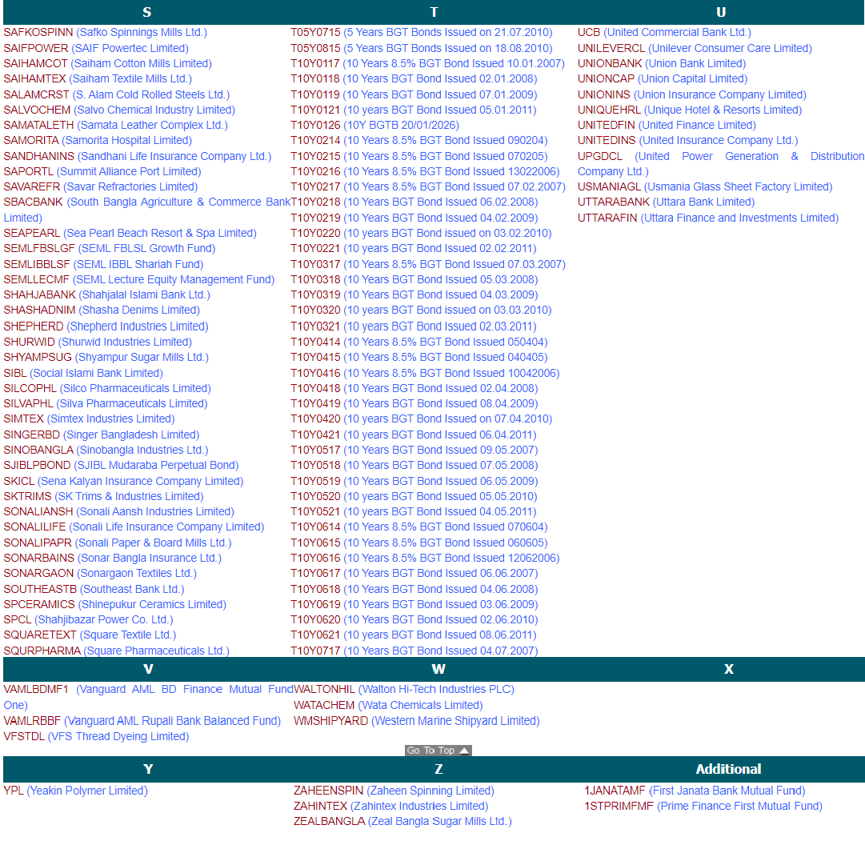

Appendix 4:

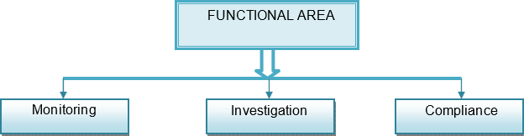

Appendix 5:

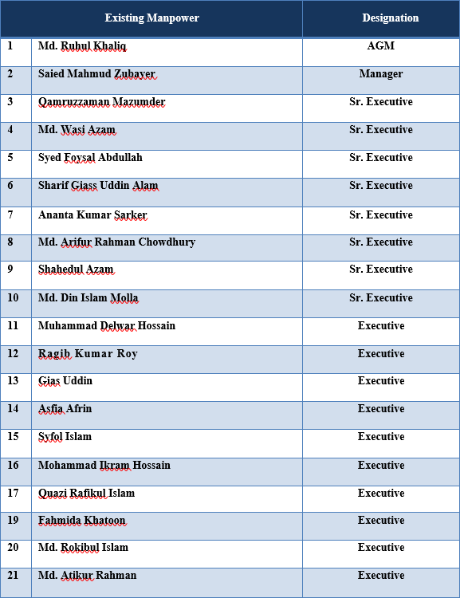

Appendix 6:

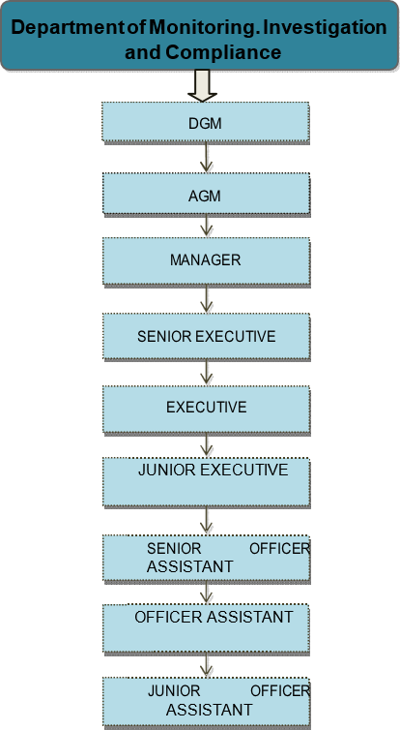

Appendix 7:

