

Internship Report on
Performance Appraisal of Mutual Trust Bank Limited

Tasfia Belal
ID: 111 171 170
Major: HRM
Department: School of Business & Economics

United International University


“Internship Report on”
Performance Appraisal of Mutual Trust Bank Ltd”
An Internship Report Submitted to the School of Business and Economics in Partial
Fulfilment of the Requirements for the Degree of Bachelor of Business Administration.

Submitted To:
Md. Kazimul Hoque
Assistant Professor
School of Business & Economics
United International University
Submitted By:
Name: Tasfia Belal
ID: 111 171 170
Date of Submission: 30th January, 2022

Letter of Transmittal
25TH January, 2022
Md. Kazimul Hoque
Assistant Professor
School of Business and Economics
United International University
Dhaka-1212.

Subject: Submission of internship report on Performance Appraisal of Mutual Trust Bank Ltd.

Dear Sir,
I would like to show you "Performance Appraisal of Mutual Trust Bank Ltd." through my internship report with the information that help me to make my report as explanatory as it possibly can be. I have tried several times to create the report accordance with your suggestions. If you could take the time to share your ideas with me, I would appreciate it.
Furthermore, I have tried every possible way to made it but there may be some faults in the report.
Please accept my apologies for any inaccuracies that may have occurred inadvertently. Thank you so much for your patience and understanding.

Yours sincerely,
Tasfia Belal
ID-111 171 170
Programme: BBA
Major: Human Resource Management

Acknowledgment

To begin, I'd like to offer my deepest appreciation to those individuals who have contributed to the preparation of my internship report and made it possible for me to succeed.
I'd like to express my gratitude to Farmida Afroze (Manager, MTB Mohammadpur Branch), AKM Zihad Rahman (Deputy Manager of MTB Mohammadpur Branch), Mashfiq Shikder (Senior Officer) for their warm welcomes and assistance in organizing this report, as well as for their esteemed knowledge and collaboration. With great pleasure, I would like to convey my appreciation to the MTB Human Resources division at their corporate headquarters for granting me access to certain critical material for my internship report.
For my last, I would like to convey my deepest appreciation to Md. Kazimul Hoque Sir, my internship supervisor, for his persuasive inspiration, gentle rules, critical comments, and encouragement during my internship period. which enabled me to complete my report on time.
Despite the fact that I put in every effort to prepare the report, it may contain errors. I hope you consider those mistakes as well as this report.

Executive Summary
Mutual Trust Bank Ltd's Performance Appraisal method is the subject of this research, which includes information acquired from many sources. Both secondary information and primary information are included in the way of findings and analysis process of this study. Primary data was acquired via face-to-face interviews with bank workers and customers, while secondary data was gathered from the company's annual reports, website, and other yearly reports. This report also contains information on Mutual Trust Bank Ltd.'s services, as well as my experience as an intern with them, as well as some facts about their training and development objectives for this year.
Since its inception, Mutual Trust Bank has grown to encompass wholesale banking, retail banking, privilege banking, treasury operations, and agent banking, SME among its diverse range of services. On the basis of fundamental values, Mutual Trust Bank does not compromise on its ever-reflective obligations to its employees, shareholders, customers, and the community in general. Through organizational excellence, Mutual Confidence Bank establishes a pleasant working environment in which MTB may progress ahead in order to assure their shareholders and gain public trust in their ability to manage their capital.
While working as an intern at the MTB Mohammadpur Branch, I gained valuable knowledge about banking and how a large financial institution performs its daily money operations, such as the creation of fixed deposits and savings accounts, among other things. Each year, almost all supervisors/managers are engaged in the planning course for their Performance Appraisal, and they are provided adequate support to stress their recommendations for the creation of the training package that is created for their employees. A draft of the training and development program is sent to the bank's concerned managers or supervisors in order to solicit their opinions and suggestions.
They have a specialized human resources team that conducts training for all MTB ltd. employees, including those in the company's operating divisions. MTB recognizes that in order to have a better future, it is necessary to provide better benefits to its workers. A specialized group of MTB representatives who can support both customers and the bank with their expertise is provided by the GHR as part of their commitment to excellence.

Table of Contents
Chapter 01 1
Introduction of the Report 1
1.1 Origin of the report 2
1.2 Scope of the report 2
1.3 Objectives of the study 2
1.3.1 Primary objective 2
1.3.2 Secondary Objective 2
1.4 Methodology 3
1.5 Limitations of the study 3
Chapter 02 4
Performance Review 4
2.1 Performance Appraisal 5
2.2 Fundamental Purpose 6
2.2.1 Employees viewpoints on performance assessments 6
2.2.2 Organization standpoint on performance assessments 6
2.3 Criticism of performance appraisal 6
2.4 Positive impact of Performance Appraisal 6
2.5 The negative impact of Performance Appraisal 9
Chapter 03 11
Organizational Overview 11
3.1 Company Profile 12
3.2 Vision 12
3.3 Mission 12
3.4 Core Values 13
3.5 Different Banking Process of MTB 14
Chapter 04 16
Performance Appraisal of MTB 16
4.1 Performance appraisal system in MTB 17
4.2 Performance Appraisal methods followed in MTB 18
4.3 MTB’s performance appraisal objectives 18
4.4 Performance Appraisal policy of MTB Ltd 19
4.5 Standard Performance Distribution & Annual appraisal 20
4.6 Types of Appraisal form used in MTB 21
4.7 The influence of Performance Appraisal on Employee Motivation 22
Chapter 05 25
Findings and Analysis 25
5.1 Analysis and Interpretation 26
Chapter 06 36
Recommendation and Conclusion 36
6.1 Recommendation 37
6.2 Conclusion 38
Reference 39
Appendix 40

Chapter 01

Introduction of the Report

1.1 Origin of the report
To get practical experience, it is essential for all BBA students to serve as interns for at least three months in any business. After three months, the intern must submit an internship report to the school. The internship, which was approved by the supervisory faculty, resulted in the creation of this report. It was in the Mohammadpur Branch of the famous bank that I completed my internship report, which was titled "Performance Appraisal of Mutual Trust Bank Ltd." In this report, I have concentrated on MTB’s strategies on employee evaluation, employee satisfaction, employee’s dedication towards their performance to achieve their goal.

1.2 Scope of the report
In this part, I would like to learn the topic of my report which is "Performance Appraisal of Mutual Trust Bank Ltd.". My appointment as an intern at the Mutual Trust Bank Mohammadpur Branch provided me with the opportunity to observe and assist them in their daily activities. Towards the conclusion of the internship season, they also supported me in getting all of the relatable and fundamental information from the Mutual Trust Bank Head Office in order for me to present an outstanding report about their company.

1.3 Objectives of the study
For the objective of this study, it will gather some important and representative information on the Performance Appraisal methods that MTB use in order to prepare and polish their human resource pool. MTB holds two major objectives. Those are:
- Primary Objective
- Secondary Objective

1.3.1 Primary objective
To understand MTB’s Process to evaluate employee performance

1.3.2 Secondary Objective
- To find out the importance of PA.
- To identify the limitations in MTB while assessing the performance.
- To find the issues company apply to make PA more effective.
- To identify the performance appraisal policy to improve their services.

1.4 Methodology
In this report, I employed certain methodologies to make a well-organized report. First, I have collected the data and continuing through analysis and interpretation.
Mohammadpur Branch is very small branch, there were over 19 employees. And I surveyed 12 of them. So, my sample size is 12 and data collected from different departments. Both primary and secondary data applied in my report. I was able to use primary data through communication with senior officer. And secondary data collected by learning prior studies on this issue.
For the survey, I employed 20 structured questionaries, mid-level and higher-level employees were provide their answers. In the analysis and finding’s part, I created pie chart to depict the replies as a percentage. I used Microsoft Excel to calculate the survey findings and display them in graphs to make them easier to understand.

1.5 Limitations of the study
During the course of putting up this study, I identified a number of limitations. However, there were some challenges in the present contemplation. Noteworthy is that in just three months, I've got the great opportunity to get a broad idea about the process of bank that runs in a poor country like ours, which has been quite beneficial. Although there was a general grasp of the structure, it lacked specificity. The following were my limitations:
- A major restriction was that three months is not enough time to learn all there is to know about a firm, thus I was unable to provide all of the facts of their training program due to this limitation.
- Because MTB's Mohammadpur branch is very busy. They were all really preoccupied with communicating with customers and completing official duties. As a consequence, I didn't get that time to question them about my report on a regular basis.
- As bank is quite confidential about their source so the authorities were hesitant to provide much specific information on their evaluation system. Because it’s against to the bank policy.

Chapter 02

Performance Review

2.1 Performance Appraisal
The history of the performance is short. Taylor's era started in the twenty-first century and will end in the twenty-first century. It was unproductive since everything was focused on existing human resource management. Over 65 years ago, the formal evaluation was employed to evaluate post-war performance in the United States. In other parts of the world, the evaluation system is already in operation.
People's decisions may result in concerns including motive, ethics, and the law. It will not be effective, fair, or legal unless it is done with sound judgment. The Appraisal approach hides a fundamental income structure that is present in the market. It contributes to the determination of a person's pay. As a result of this assessment technique, the following results were obtained: If an employee's performance does not meet expectations, his or her remuneration will be decreased. Employee performance assessment is a process of measuring and suggesting improvements in an employee's work performance. It is good to learn about each individual's achievements. Because it is a tool for ordaining and familiarizing personnel, the use of an evaluation system may be beneficial to both people and businesses.
The management provides performance feedback, which transforms the employees' anxiety into a cordial relationship, and the job is completed properly as a result. Employees may dislike when they think that the manager’s evaluation is not notifiable to instruct them. Because it takes time, many individuals despise performance evaluations. Workers consider it a burden rather than a valuable tool, rather than the other way around. Performance evaluation is used to analyze employee performance, inspire employees, and improve the overall performance of the firm. Workers are assessed by the completion of an evaluation form. Employees who are alert about that their performance is going to evaluated so they try to attempted their best to be considered for a promotion, award, or other recognition.
The achievement of the organization's goals is dependent on the effectiveness of its performance evaluation process. Performance review may uncover skills and training needs that were previously unknown. Identifying training gaps via performance evaluation enables firms to educate their employees and increase their productivity, thus increasing customer happiness. Employee productivity is increased as a result of performance evaluation, and they gain a competitive advantage.

2.2 Fundamental Purpose
There are two primary ways of assessing the performance of an organization's personnel. The first is an evaluation system, while the second is a feedback system, respectively. The most important element in the assessment method is to determine where the workers are falling short. (Parvin & Shamim, 2016)

2.2.1 Employees viewpoints on performance assessments
Explain employees about everything they need to accomplish and modify it and assist them to rectify their performance and reward them based on their performance.

2.2.2 Organization standpoint on performance assessments
The aim of performance assessment from an organizational standpoint is to establish and maintain responsibility. According to the experts, the failure of the assessment system is the result of a lack of responsibility and accountability among the participants. When workers fail to perform as expected and fail to accept responsibility for their actions, a mismatch occurs between the two parties.

2.3 Criticism of performance appraisal
In society, performance assessment is a mechanism for regulating the society that is held once a year for discussion, which is done by an individual to evaluate the performance of other persons and to identify areas for improvement in order to make the performance more efficient. There have been several studies conducted to determine the efficacy of performance appraisals. Many people believe that the assessment process is very difficult to carry out and that perfecting it is an extremely difficult task. Many believe that doing performance appraisals in the business is a necessary evil, while others believe and advise that it is the polar opposite and that it is a biased statement. Some individuals feel that appraisals are demotivating and have a bad impact on the workers, while many others say that they are a waste of time and a punishment for the employees rather than a source of incentive and encouragement for the employees.

2.4 Positive impact of Performance Appraisal
In present hectic working environment performance assessment is critical as it provides an opportunity for employees and supervisors to have a one-on-one discussion in order to solve an issue achieve the goal. It also aids in improving the overall performance of the organization.
Desire to perform is increased
Individuals' drive to improve their performance in the future grows as a result of obtaining feedback on a regular basis. Individuals who are aware of their own performance and who have received recognition for their prior accomplishments provide the motivation for future success. It allows for the identification of potential development regions. When workers get positive feedback on their performance, they are more likely to advance in their careers. Employees may establish a strategy for their own professional development if they get consistent feedback from their supervisors.
Boosting or increasing Self-esteem
Self-esteem of the employees will increase when they got feedback and employees are satisfy, want to acknowledged and also add their effort. It motivates employees to do effectively.
Manager develop knowledge about subordinates
The direct supervisor and manager in charge can enroll more about the individual who is being assessed. When employee receive effective or positive feedback then they will be more motivated to work hard. For this, employee engagement grows and continuous feedback makes employees feel cared by the management team.
The job descriptions and requirements are clarified
Employees might be informed about their own conduct as well as the results that are necessary to complete a certain task. Additionally, students get an understanding of how to be the greatest performance possible. It may be the sole opportunity for an employee to spend significant time with his or her boss and develop a positive working relationship.
Self-insight and development are enhanced
As a result of their participation in the development activities, the workers get a deeper knowledge of themselves via performance review. Workers' strengths and limitations are revealed via performance review and make sure that any employees need training or not.
Administrative actions are more proportionate
Performance assessment collects information that is reliable, and administrative measures such as promotion, merit raise, transfer, and termination are taken as a result of the information gathered. As a result, it guarantees that incentives are allocated on a fair and consistent basis. This form of effective management method contributes to the development of trust between workers and their supervisors.
Employees become more expert
The most notifiable and evident contribution is improvement in the employee's overall performance. Employees are made aware of their own inadequacies and the areas in which they need to improve on a daily basis. It brings the employee's and his or her coworkers' perspectives on the other colleague's disclose into alignment. It aids in reminding workers of why they are working for a particular company and how the organization's goal might be accomplished as a result of their efforts.
Employee misconduct is minimized
Employees may be discovered to be engaging in an improper activity such as exploiting overtime regulations, sending inappropriate gifts to customers, stirring up the customer's account, and utilizing company resources for own benefit. An effective evaluation process could avoid these issues from occurring and allow issues to be spotted early before it occurs, hence preventing any bad consequences from occurring.
Better protection from a lawsuit
Using the data acquired via performance assessment, it is possible to document compliance with regulatory requirements. It is possible to maintain workplace equality regardless of gender or background. The business will be subjected to a continuous stream of performance reviews, increasing its risk of being sued due to incomplete assessment.
Perspectives of Supervisors on performance are easily understandable
Supervisor can share their evaluations of the employee's performance with their peers. Accountability occurs as everyone understands what is expected of them and what their level of performance is. The manager's job becomes simpler when he or she assesses and monitors employee performance.
Increased motivation, dedication, determination to stay with company
When performance management results in employee satisfaction then the likelihood of workers remaining in their jobs increases. If the organization's goal is to reduce turnover, it must first ensure that workers are content with their jobs. Only then will employees be less likely to hunt for a new job in the following year or to consider abandoning their jobs.

2.5 The negative impact of Performance Appraisal
If performance assessment is not done appropriately, it may cause dissatisfaction, depression, and irritation among the staff. It is possible that workers will not improve themselves as a result of a lack of information and dissatisfaction. As a consequence, the workers' ability to be productive may be impaired. When a supervisor is responsible for evaluating the performance of a large number of workers, the supervisor may feel under pressure. Inaccurate ratings may occur as a result of the supervisor’s prejudice. Employees feel under pressure as a result of their performance evaluation. Because of their apprehension, some workers are reluctant to discuss their performance with their superiors. When it comes to encouraging workers, merit pay and promotion are effective tools. However, when the assessment result does not match the incentive offered, employees might become dissatisfied with the whole process.
Use of incorrect Information
In company, where there are multiple possibilities for false information about an employee's performance to be spread across the company.
Increased Turnover
Many employees will be displeased if the system is not seen to be fair, even some may leave the company due to the continuation of the situation. They may physically or mentally abandon the firm since they will put out less effort until they can get a new position someplace else. It is dependent on how the technique is followed.
Reduced self-esteem
When adequate feedback is not delivered in a timely and precise manner then self-esteem of the individual will be decreased. Employee unhappiness.
Emerging Biases
In order to reinstate corporate ideals Biases, personal values, and interpersonal ties are all likely to be restored.
Uncertain rating system
Employees may be uninformed of their own performance, awards and ratings. As a result, they may fail to put up the necessary effort to enhance their ratings. Furthermore, they are unaware that their ratings are significant in determining whether or not they will get incentives and whether or not they would be given additional chances.
Inconsistent and unjust standards and evaluations
Individual’s value and ratings are essential considerations since ratings may range between and within units and may be unfair.
Unmet expectations on managers and employee’s resources
An organization that does not have a suitable strategy and execution system will not be able to reap the advantages and will instead squander the time of managers and workers. Agreement competition and the allocation of resources will make such a system impossible to implement. This may be made worse if the management opt to disregard all of the systems entirely, in which caseworkers may experience an increased amount of pressure as a result of the decision.(Annual Report - Mutual Trust Bank Limited, n.d.)

Chapter 03

Organizational Overview

3.1 Company Profile
Mutual Trust Bank Limited commenced operations as a private commercial bank on October 5, 1991, under the supervision of Bangladesh Bank, in compliance with the Keeping Money Company Act of 1991, and began managing accounts in October 1999. According to the Corporation Act of 1994, the company was also required to provide a Certificate of Graduation of Commerce on September 29, 1999. This certification was granted with a BDT 1, 0000,000,000 authorized share capital divided into BDT 10,000,000,000 standard offers of BDT 100 each.
There are three development phases for molding their activities in accordance with the Bangladesh Bank's provided private banking framework: nationalization, privatization, and financial sector reform. MTB is headquartered in Dhaka, Bangladesh, and is a sister business of the MTB group. MTB provides Visa Debit cards, Mastercard Debit cards, Visa Credit cards, Mastercard Credit cards, MTB prepaid Card, MTB Co-branded Cards. They have 119 active branches and 5 Sub-branches, 302 ATMs, 140 Agent Banking, 1,925 Training and development programs and their corporate office is located in the heart of Dhaka's Gulshan-1 district. (About Us - Mutual Trust Bank Limited, n.d.)

3.2 Vision
Mutual Trust Bank's objective for managing its renowned organization in an economically developing country like Bangladesh is straightforward yet difficult to achieve. They are as follows:
- one of Bangladesh’s most successful banks
- The preferred financial institution
- A bank that is genuinely world-class bank.

3.3 Mission
They aim to be the most admired financial institution in the country by portraying themselves as an active, innovative, and client-centered organization that offers a variety of services include administrative services to their clients while reflecting their excellence in running such a thriving financial institution.

3.4 Core Values
In terms of basic principles, Mutual Trust Bank never compromises on their pledges to their:
Commitment
Shareholders- By employing an honest and efficient business model, they may create long-term economic benefits for their stockholders.
Community- MTB is dedicated to serving our country by providing secured jobs, hosting community initiatives and events that appreciate all differences, and valuing our society by participating in several beneficial CSR activities.
Customers- Providing cutting-edge service to their consumers by delivering a diverse product line and aiming to satisfy their banking needs to the best of their ability.
Employees- Mutual Trust Bank recognizes and respects its workers' abilities and rights as members of the MTB family. They strongly encourage their personnel to bring something fresh and distinctive to the table whenever there are changes in their operational environment.
Accountability
MTB examined purely on the basis of their ability to fulfill the obligations, expect and welcome this type of evaluation. They are responsible for offering the best quality of service while also adhering to regulatory standards and following ethical business practices.
Agility
They have the ability to perceive things from a variety of angles, they are adaptable and not confined by the ways they have done things in the past. They can react quickly and change their operations to suit stakeholder requirements and reach our objectives.
Trust
Mutual trust is important to them, and it includes open and honest communication between all parties.(Mission & Vision - Mutual Trust Bank Limited, n.d.)

3.5 Different Banking Process of MTB
MTB began their adventure in the banking business of Bangladesh in accordance with the Banking Companies Act of 1991, which was supplied by the Bangladesh Bank and also approved the reminder of affiliation.
Wholesale Banking
The wholesale banking procedure is overseen by 4 functionally-discrete units which include corporate business unit, Branch support unit, structured finance unit, cash management unit. MTB's wholesale banking procedure is decentralized, with strategically located branches around the country. MTB’s corporate business team contacts corporate clients to assign them to the most convenient branch for them. Branch corporate business is responsible for in World Business Dialogue by Branch Business Support.
Retail Banking
Bangladesh is regarded as one of the world's developing markets by financial institutions. MTB provides rapid development the economy by focusing more on the retail banking business. Economic growth of the nation, MTB has always offered capital loans with security. In 2016, they began to enter the house loan market as well. And blossoming of the real estate sector is considered as a factor for the construction boom. In 2017, retail portfolio has grown by 1592.17 million because of the hard work provided by retail relationship managers.
Privilege Banking
MTB Corporate Head Office has a cutting-edge privilege banking system. MTB began its privilege banking in October 2010. MTB has created seven new units by reorganizing the unit: six in Dhaka and one in Chittagong. There are now eight luxury banking divisions located in the Dhaka and Chittagong metro regions, adjacent to premium sector clientele. MTB privilege Banking developed their growth by 15.53% and booked 1014.57 million assets. (Report, n.d.)
Treasury Operation
MTB treasury operations are in charge of overseeing treasury tasks such as regulatory compliance, liquidity management, asset-liability management, and, most critically, risk reduction. They were able to keep one step ahead of the market by using good forecasting and effective strategy development in the face of excess liquidity in the domestic market and an imbalanced international market as a result of BREXIT and dropping crude oil rice. MTB Group treasury must fulfill a variety of duties in many risk areas in order to mitigate risks and achieve organizational performance. (Report, n.d.)
SME
To promote MTB's SME products, the SME Banking Division took part in the 'Banker-SME Nari Uddoktha Somabesh O Ponno Prodorshoni Mela 2019' held at Bangladesh Shishu Academy from March 8 to March 10, 2019. From September 28 to 29, 2019, the SME Banking Division attended the "Krishi Utshab Fair" in Khulna. MTB helps women entrepreneurs by offering low-interest loans through its Pre-Finance and Re-Finance schemes. MTB's SME Banking Division provides a variety of services to small businesses items designed to meet the diverse demands of micro, SME's (small and medium-sized businesses).
Agent Banking
MTB prefers to provide banking and financial services through its agent banking network to the country's unbanked people. MTB began its agent banking operations on June 6, 2016, with the opening of the first agent banking location in Jahapur Baazar, Mugdanagar, Cumilla. By utilizing agents under agency agreements, agent banking provides small-scale banking and financial services to the disadvantaged community. An agent, who is also the center's owner, handles financial transactions on MTB's behalf. In an agent banking situation, an additional distribution channel that provides ease and broadens the accessibility of high-quality, low-cost financial services
MTB opened ten agent banking outlets in Dhaka, Pabna, Comilla, Feni, and Tangail districts in December 2016. MTB agent banking has opened 2523 accounts with a total deposit of BDT 36.52 million as of December 2016. (Report, n.d.)

Chapter 04

Performance Appraisal of MTB

4.1 Performance appraisal system in MTB
An organization's purpose is to achieve success via its workers' performance. Performance assessment is a method of evaluating employees' performance by finding gaps and developing a strategy to close those gaps in order for the business to achieve success. It is also a practice that is carried out on a regular basis and which contributes to the development of a positive connection between the supervisor and his or her staff. Due to the fact that performance assessment is an organized process, it may be used to evaluate objectives and skills. At the beginning of the year, MTB set a goal and which was carried out under the supervisor or manager to achieve it. They made it more aligned with the organization's overall aim.
MTB’s every employee’s performance is evaluated based on self-declared objectives which include stretching, quantifiable, agreed-upon, reasonable and time bound. These objectives are established at the starting and reviewed twice a year. One in middle of the year and the other towards end of the year. And the branch manager is generally in charge of the evaluation. The appraisal process was developed in 4 elements which include ongoing job needs, operational efficiency, business development, cost reduction, system restructuring to simplify any service, contribution in projects and assignments, people development and self-development. Each factor is evaluated in 2 parts, one is self-assessment and other is assessment by the supervisor. They pay attention to how employees behave at work and records each employee's action and keeps in mind, all of the information. When it comes to final review after a set period of time or one year, the supervisor departs. Another supervisor participates in a conversation and rates each individual employee to reduce the biasness. Employees are rewarded based on their performance through wage raises, bonuses, and profit sharing. etc. As a result employees are motivated by these incentives. I have seen my senior officer has done PA calculations in excel file. And he carefully enters all of the data and double-checks it for accuracy. The findings are forwarded to management, who then decides on promotions, raises in compensation, and other matters depending on the PA results. If any of the employees have questions about their performance review, they can contact the supervisor for clarification. Furthermore, if someone is underperforming because he does not understand the task, he can seek advice from his supervisor and request assistance. However, if an employee's performance remains unchanged after two years of trying, the firm must fire him. This is how PA is assisting with employee evaluations.(Annual Report - Mutual Trust Bank Limited, n.d.)

4.2 Performance Appraisal methods followed in MTB
Employees will be happy only if they believe they can express themselves freely and that they can share their ideas with their colleagues. This enables the person to achieve their long-term objectives. A fair assessment, they believe, is one in which all employees are treated equally and in which they are given the opportunity to dispute the evaluation they have received. It should be communicated to workers who get unfavorable feedback that it was provided in order for them to improve their performance in the future. MTB follows different methods because each approach has its own set of benefits and drawbacks. As a result, an approach that works well for one company may not work well for another. As well as they don’t employ same strategy always. Following methods used in MTB to evaluate employee performance:
Rating method
One of the most often utilized method is rating scale. Employee performance is measured against a set of absolute standards, each of which is assessed on a scale. This strategy is used by MTB to assess the performance of its employees. The managers provide rated on a scale of 1 to 5 which include (need of improvement is 1, Average is 2, Good is 3, Very Good is 4 and Excellent is 5) based on a variety of factors. The majority of the time, this ranking is based on financial factors.
Ranking
Ranking is one of the most basic methods. Employees are ranked from the best to the poorest performers based on their performance and outcomes. MTB follow this strategy where managers evaluate their staff from best to worst performers after receiving the rating results. Management by Objectives (MBO) method
Employees and managers meet down to create some certain objectives. They evaluate the performance after a certain period of time, and rewards are provided based on the findings. This strategy enhances employee loyalty to the company.

4.3 MTB’s performance appraisal objectives
MTB set some objectives for applying performance appraisal
- Assessment brings to evaluate the workers performance and give them information for making decisions and improve the overall performance of the company.
- It may be used to identify the training and development requirements of workers, as well as to guarantee that each person has the ability to work and that the company achieves the highest productivity possible.
- Performance appraisals also aid in rewarding workers based on their achievements, which in turn aids in encouraging the workforce.
- Performance appraisals are also used to ensure that other human resource tasks like recruitment, selection, training, and development work smoothly.

4.4 Performance Appraisal policy of MTB Ltd
Human resources department makes sure that the policy is followed in order for the company to run smoothly. The company employs an appraisal process known as the 9box evaluation to do this. This approach is included in the appraisal equipment to ensure that the appraisal proceeds smoothly. They've been utilizing it since June of this year. Their new approach outperforms their old one in terms of effectiveness since it allows workers to see their own potential and develop themselves in accordance with it.
Personnel may determine their aim as well as the plan for reaching it using this 9box tool by defining their job criteria in the first box. It is carried out in accordance with KPI. Performance evaluation is the most important factor in achieving the organization's objectives. And by using the method of their 9box assessment, they are able to achieve the benchmark while also assisting the workers in achieving the organization's purpose.
MTB employs two kinds of performance evaluation methodologies, which are as follows:
Result-oriented approach to the job: The employer analyzes the workers by contrasting them with a representative of the organization in which they work. It is necessary to set a goal standard for the representatives of the company, and their performance is evaluated in relation to the attainment of that standard with the collaboration of the workers.
Behavioral agendas are based on the following: Employees who are productive and those who are not are separated on the agenda at this point. It is the greatest since it allows you to observe both the practice and the outcome of the personnel. They use the following method:
- In the event of consumer dissatisfaction, the customer may be ejected. Consult with the consumer about the situation.
- Gather specifics about the customer's issues and record them.
- Send the remedy to the consumer who is having an issue with it to their location. Make a strategy for your daily tasks in advance.
- Gather all of the customer information, as well as any necessary documents.
Performance management is carried out on a regular basis in the MTB with the use of software maintenance. It assists in keeping track of the performance of workers in relation to the goals that have been set for them. The supervisor provides continual feedback to the workers in order for them to learn, and if necessary, the supervisor takes the necessary actions to keep the workplace in good condition. It also helps to improve the management quality work along with the line manager. PA contributes to the achievement of the intended result of the company at the end of each year since it is done equitably and in accordance with employee performance.

4.5 Standard Performance Distribution & Annual appraisal
Every company will assign direct supervisor to assessed each employee for the performance criteria and attainment of the set goals. The department head of human resources is in charge of monitoring, guiding, and educating staff. The normal distribution curve is seen in the diagram below:
The common distribution curve of performance (approximate)
There will be held meetings between the supervisor and the workers which will take place prior to the performance assessment process. The first meeting takes place in order to discuss the self-appraisal method and set a date for the meeting between workers and supervisors to take place. This meeting is particularly significant for new workers since they will become full members of the company in the near future. The second appraisal meeting is dedicated to the self-appraisal process, during which personnel analyzes their own performance. Employees will benefit from this meeting since it will provide them with an opportunity. The third meeting is a traditional evaluation meeting in which workers and the supervisor are invited to participate and discuss. The compensation review will take place at the fourth meeting. If any modifications have occurred as a result of the performance, it is beneficial to mention them here. The fifth meeting is dedicated to discussing the training and development program for the personnel, should one be required. Sixth, the group discusses the formulation of objectives, which included both behavioral and measurable outcomes.

4.6 Types of Appraisal form used in MTB
In MTB, Generally, two types of appraisal forms used. First one used in department head and another used in the rest of the company’s personnel. The evaluation form for the department head was completed by the management committee, and the appraisal form for the workers was completed by the department head and relationship manager. This assessment form is sent immediately to the Human Resources department. If the form is correctly completed and submitted, the HR department will acknowledge receipt of the form.
The assessment form for managers is four pages long and contains a number of questions. The year of the assessment is stated at the top of the form, and the objective of the evaluation is also noted there. The application form is divided into three components. The first is divided into sections A and B, while the second is divided into sections B. Management begins by filling out Section A, followed by Section B, which is related to the strategic objectives of Section A. Section B may be skipped if the requirements of section A are met. If A is not finished, the following sections, such as advances, loans, deposits, bonds, remittance, must be completed. Following that, part C is introduced, which consists of rewarding them for their accomplishments by awarding them a point. Compliance with audit requirements, new recovery NPL, budget operations, and so on are all included. The total number of points is determined by completing all three parts of the form.
It’s all on the first page which needs to filled up and after that the second page which includes the behavioral competencies and scores are given from a 1-5 scale based on this, need of Improvement is 1, Average is 2, Good is 3, Very Good is 4 and Excellent is 5. There will be 15 questions for managers to answer and based on situation he questions could be different.
The specifics of the imputed job which is referred as a core job. The sense about the updated policies, products, and services.
- Banking Industry worry about prosperity.
- IT and computer skills that are relevant to the banking industry. The customer's well-being and support.
- Subservience has a negative impact on intellect.
- Attitude is related to being upbeat and receptive to new situations and circumstances. Teamwork and commitment Teamwork and commitment to the team Analytical talents Communication abilities Capacity to exert influence.
- Keeping a Relationship Alive.
- Ability to make decisions in a short period of time.
Following the question, the manager only has to mark the response that corresponds to the question and then answer about their dedication and duty, which is an extremely vital element of their work. Following that, the manager attempts to identify areas in Section D that need improvement. If further knowledge and behavioral abilities are required, they will determine this and provide customized training to help them develop. The last part, which is labeled E, contains a comprehensive assessment of the performance and a rating.

4.7 The influence of Performance Appraisal on Employee Motivation
When it comes to a corporation, human resources are the most crucial asset. The success of the company is dependent on the efforts of its personnel. If the personnel are not adequately structured, it will be difficult for the company to function effectively. The most important factor in achieving successful performance is to motivate personnel. Employees might be encouraged by providing them with performance reviews that are based on their achievements. In the absence of appropriate feedback, it is difficult for a business to retain staff productivity since performance is positively related to effort (motivation), ability, and willingness to work (training). Employees that are content with their jobs and loyal to their employers are more productive and productive.
Performance appraisals may be used to assess an employee's motivation and satisfaction level. It may have both good and bad impacts on workers, which can either encourage or demotivate them depending on the situation. Performance appraisals may be used to determine an employee's level of effort in a job. Employers may demonstrate that they are committed to their workers' progress by conducting performance evaluations on them. Employees may be devoted and loyal to a company when they believe that their efforts are being recognized and appreciated. Employees become more productive in this manner in order to get compensation for their efforts. Employees' absenteeism and turnover rates might be reduced as a result of receiving proper performance evaluations. Employees work really hard to prove themselves because they are encouraged to do so by an assessment, which assists the business in achieving its objectives. Following factors that impact employee commitment:

Reward
An annual performance appraisal is conducted by MTB to determine an employee's overall performance; a performance review of the employee's overall performance is conducted at the end of each year, and a reward is given depending on the overall performance of the employee. An appraisal form is distributed to the employees in order for them to recognize their own strengths and flaws so they can develop. Workers also receive written comments in order to promote employee’s confidence, they question and assisted in improving their performance in order to achieve the organization's aim. The appraisal form contains all of the information about the assessment procedure and award. Based on the evaluation, there are five different sorts of rewards that may be offered. One kind of reward is monetary which such as compensations, promotion, bonuses, merit pay, and so on; the other type of reward is nonmonetary such as recognition and prestige, learning opportunities, challenging task and so on. Company also provides advantages like income security, an emphasis on work-life balance, and allowances. Compensation is determined based on the individual's talent, time, and effort; a work-life balance is encouraged to assist workers to balance their job and non-work interests; and when an employee performs exceptionally well, they are recognized. Certificates, trophies, plaques, and other awards are included.
Increment
The increment granted those workers who have shown the highest level of performance and it is given once a year. It is determined from the hiring date of the workers, and employees who get an injunction letter will not be entitled to this benefit. It is distributed to employees in accordance with the financial condition of the firm.
Promotion
Supervisor cannot immediately promote an employee at MTB instead, the person must go through a promotional interview. Anyone who has worked for MTB for at least two years is eligible are scheduled for a promotional interview. Typically, the promotional interview is conducted by the Head of HRM. Promotion and performance evaluation are related in several ways. The assessment assists the supervisor in identifying those workers who are productive and should be rewarded, as well as those who are ineffective and should be demoted. Employees will be able to advance to a higher degree of responsibility as a result of the promotion. Employees may be promoted depending on the quality of their performance and the existence of that job in the organization. When it comes to promoting personnel, various firms have distinct policies and procedures. Employees are reviewed on an individual basis throughout the performance assessment process, and promotions are awarded to those who meet the requirements. In MTB, a supervisor cannot promote any of his or her staff. They have conducted an interview for the purpose of promoting personnel, and the employees must have worked for the company for a minimum of two years in order to be qualified for this interview. The interview was conducted by the head of human resources, the head of retail, the COO, and on occasion, the managing director was present. Depending on a variety of criteria such as interpersonal skills, communication abilities, presentation abilities and so on they are assessed and provided advancement opportunities. Each talent is assigned a number of points, 50 percent of which are used for promotion, and the other 50 percent is provided to workers by their supervisors for the purpose of performance review. This approach is employed in order to ensure that there is no discontent or prejudices in the minds of the workers and that the most qualified candidate is picked via this procedure. Contract employees were promoted based on their performance, while the promotional interview was reserved for the organization's permanent employees. Additionally, there is an amazing advancement structure in place for the personnel. It is presented to the person who is loyal, devoted, has promise, and is a notable performance.
Mentoring
Mentoring programs may be set up by businesses and organizations. In this way, a personal bond is established between the mentor and the protégées or subordinates. The flexibility to pick a mentor should be provided by the business so that workers may make their own decisions about who they wish to learn from. Junior workers might gain the necessary abilities to do their jobs from their mentor, who serves as a role model for them.
Participating in a conference
Company may support an employee to attend a meeting, and the workers who go must be provided with a report or presentation on the subject that he or she learned about while at the conference, among other things. It allows her to identify what she has learned, and it also allows her to share her information with a large number of others.
Job rotation
It is the approach that must be used in order to achieve the requisite abilities. Employees may gain knowledge about various aspects of their jobs and perform better as a result of work rotation programs. (Annual Report - Mutual Trust Bank Limited, n.d.)

Chapter 05

Findings and Analysis

5.1 Analysis and Interpretation
The purpose of this research is to determine MTB’s Performance Appraisal process. I have done this survey on the employees MTB to know their thinking about MTB’s PA process. As a result, I have taken a survey on 12 employees of the organization.
Now, I am going to analysis the survey by using chart.

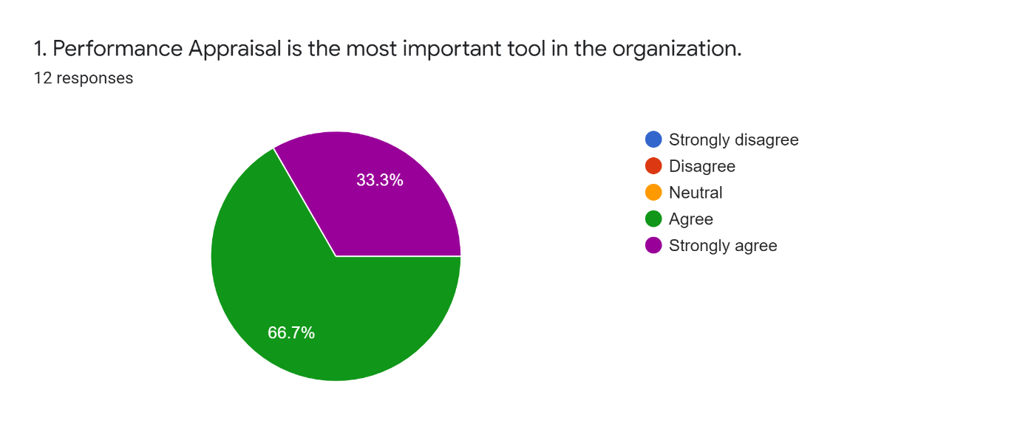
According to this chart, I have asked employees to figure out how seriously they take the PA process seriously. Here, 66.7% Agreed while 33.3% strongly agreed. Mean is 4.33 and median 4. As a result, every employee believes that performance evaluations are crucial. PA procedure is significant since it aids in the understanding of the disparity in their performance and provides an opportunity to close it. It also drives individuals to enhance their performance since they are rewarded with increased pay performance.
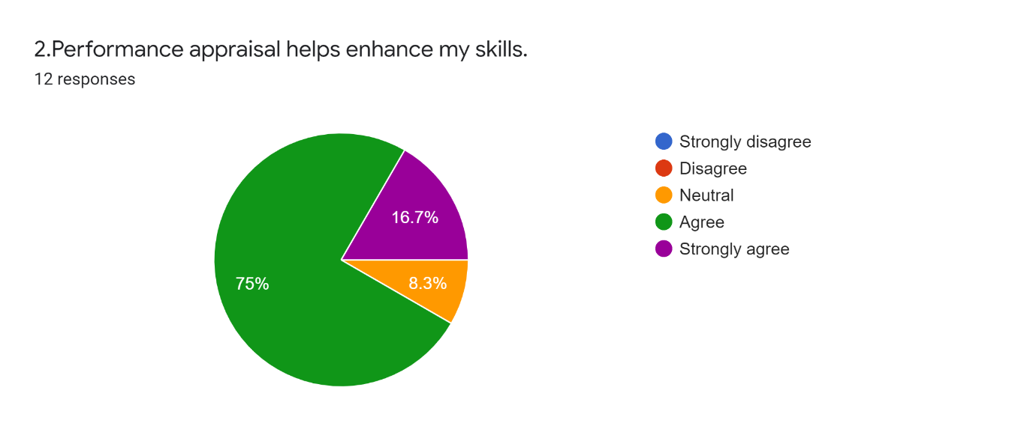
According to this chart, I have asked employees to figure out, PA helps to improve their skills or not? Here, 75% Agreed while 16.7% strongly agreed and 8.3% were neutral. Mean is 4.08 and Median is 4. As one of the primary goals of performance assessment is to enhance employee performance by identifying and removing weak areas. When employees are not performed well then MTB provides training session to improve their skill and also perform better.
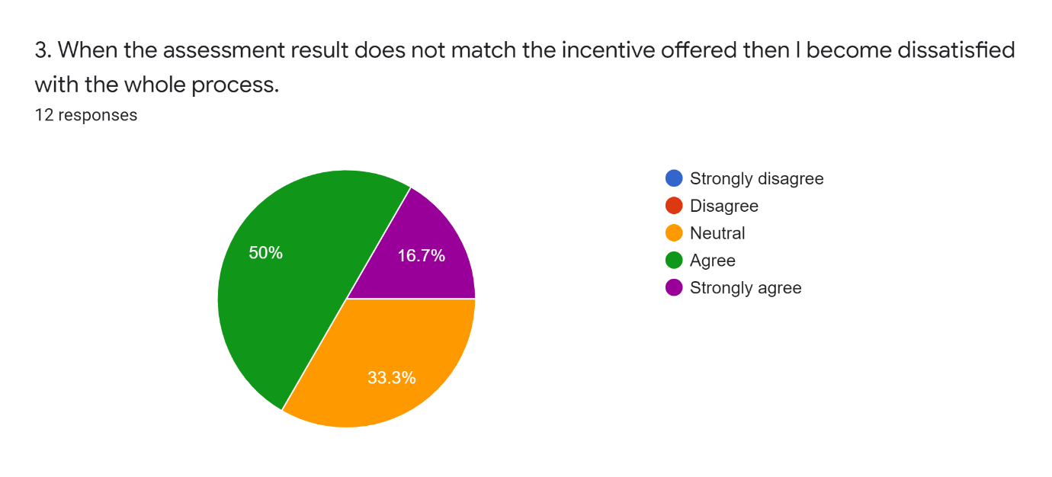
According to this chart, 50% agreed while 33.3% neutral and 16.7% strongly agreed. Mean is 3.83 and Median is 4. It indicates that when employees didn’t get expected incentive which is also not match with their result then they get dissatisfied. So, MTB should assure about the correctness of the employee evaluation.
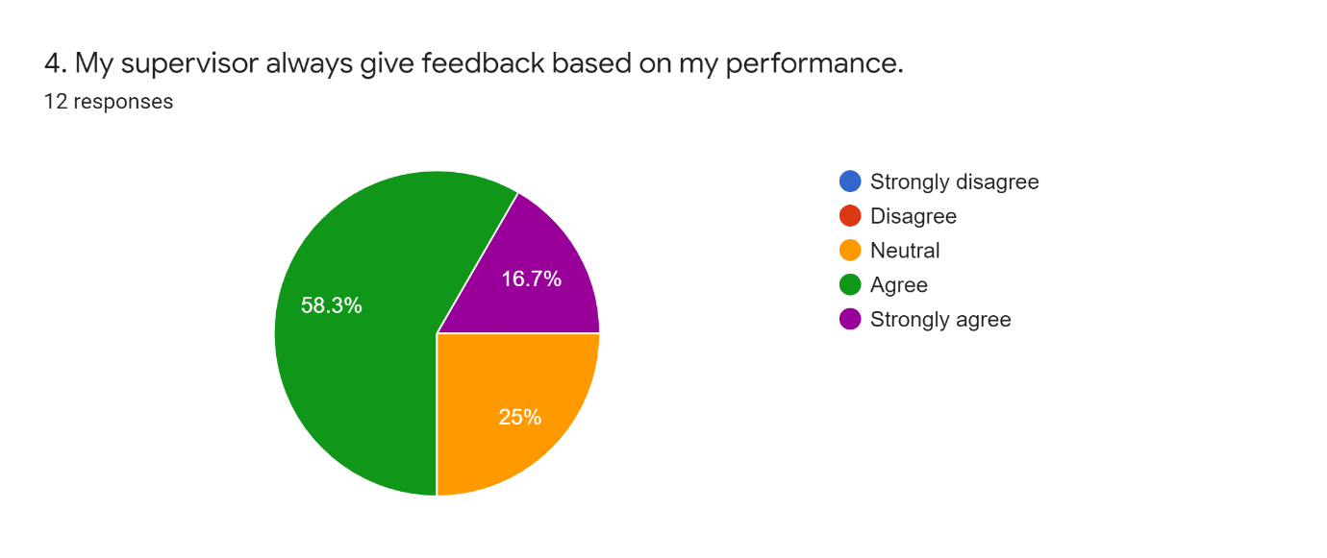
According to this chart, the greater proportion implies that they get feedback based on their performance with 58.3% agreed and 16.7% strongly agreed. Mean is 3.91 and Median is 4. But MTB should look that 25% were neutral which means some employees don’t get feedback on their performance.
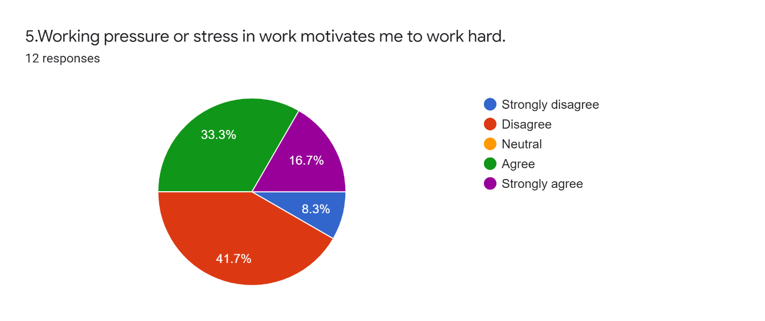
As we all know that banking sector is full of pressure. So, here, 33.3% agreed and 16.7% strongly agreed as they know about the working pressure and that reminds them to work on time. On the other hand, 41.7% disagreed and 8.3% strongly disagreed as they think When they are under too much job stress, it is tough for them to be more devoted to their work. As a result, job stress has a significant influence on employee commitment. Here, Mean is 3.08 and Median is 3.
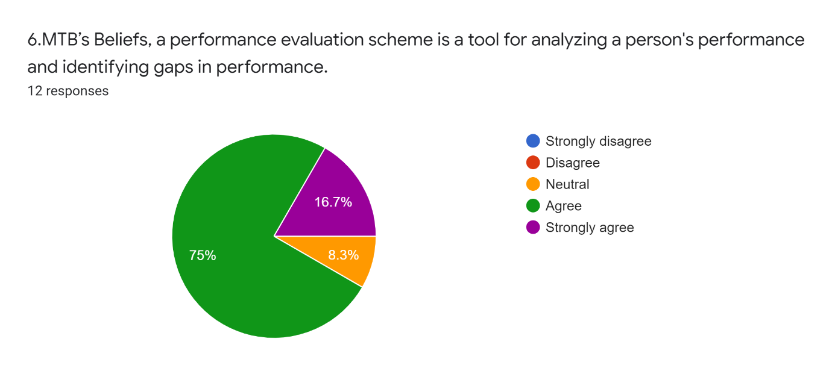
In this chart, 75% and 16.7% which means most of the MTB employees have agreed that performance evaluation helps to find out their performance and identifying their gaps in performance. On the other hand, 8.3% were neutral. Here, Mean is 4.08 and Median is 4.
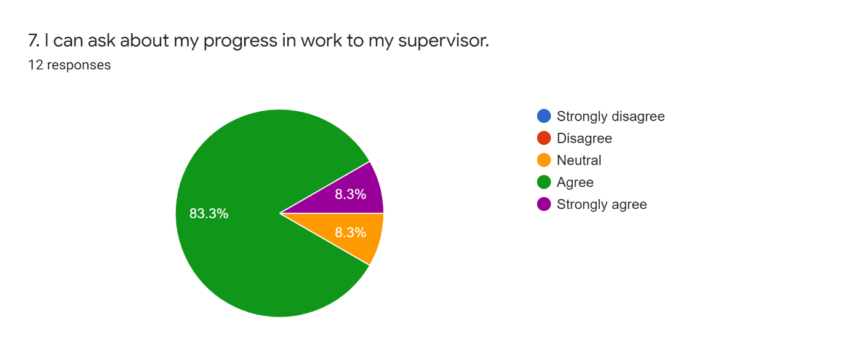
In this chart, a great outcome occurred with 83.3% agreed, 8.3% strongly agreed employees as they have the authority to communicate with the supervisor about their progress in work. But 8.3% employee were neutral so bank management should investigate about their opinion. Here, both Mean and Median is 4.
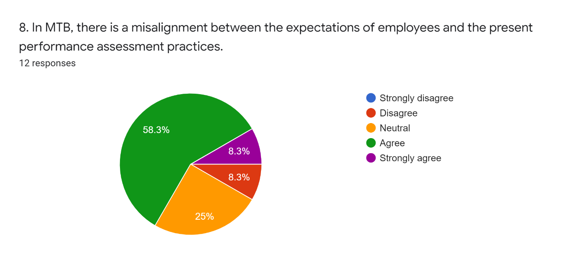
In MTB 58.3% employee agreed, 8.3% strongly agreed that there is misalignment between the expectations of employees and the present performance assessment practices as they think their performance evaluation is incomplete or not up to the mark due to present assessment system. 25% neutral employee also indicates this reason. Whereas 8.3% disagreed with this statement. Here, Mean is 3.66 and Median is 4.
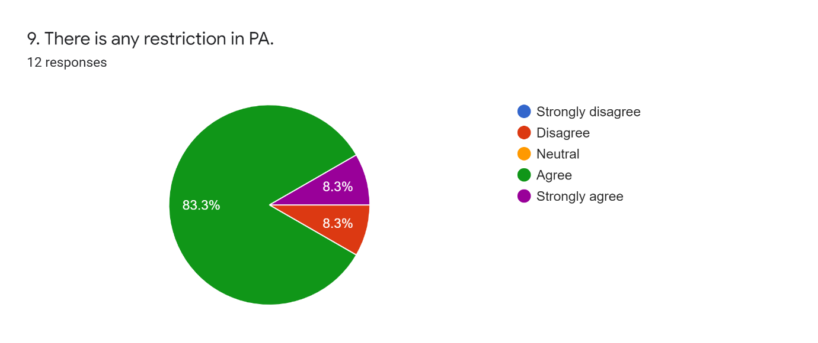
As there are some limitations or restrictions occurred in PA so 83.3% agreed with this statement. Also, there is 8.3% strongly agreed but 8.3% is disagreed with this statement. Mean is 3.91 and Median is 4.
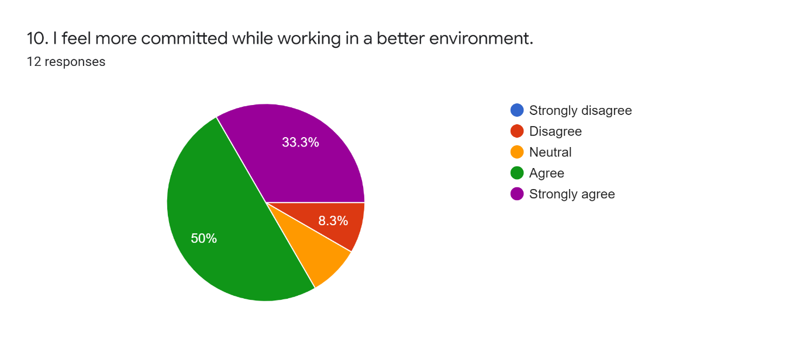
When employee gets better environment then they feel more committed to their work as any type of ownership benefits employees who believe they have a sense of significance and are a part of the decision-making process. The chart also shows that 50% agreed and 33.3% strongly agreed with this statement. Here, Mean is 4.08 and Median is 4.
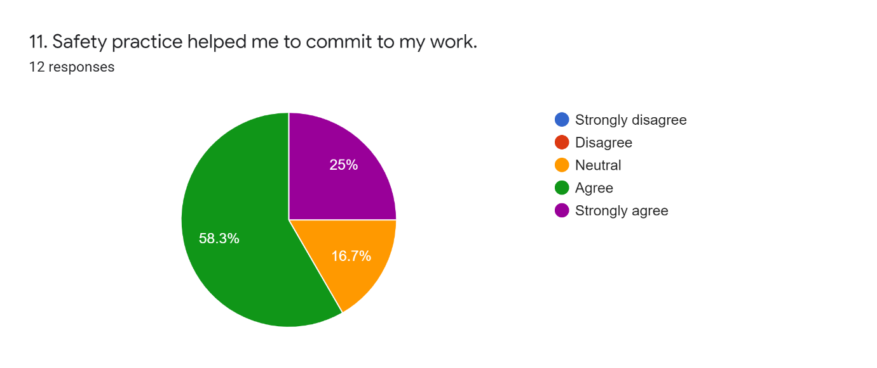
Employees who lack a high level of devotion from head to toe are more likely to be engaged in a high number of workplace accidents. A lack of commitment frequently leads a worker's eagerness and attention to be diverted away from a task or job that has been assigned to them. 58.3% agreed and strongly agreed 25% employee in MTB shows safety practice help to commit to the work. On the other hand, 16.7% natural think safety practice is not the one criterion that helps to commit to their work. Here, Mean is 4.08 and Median is 4.
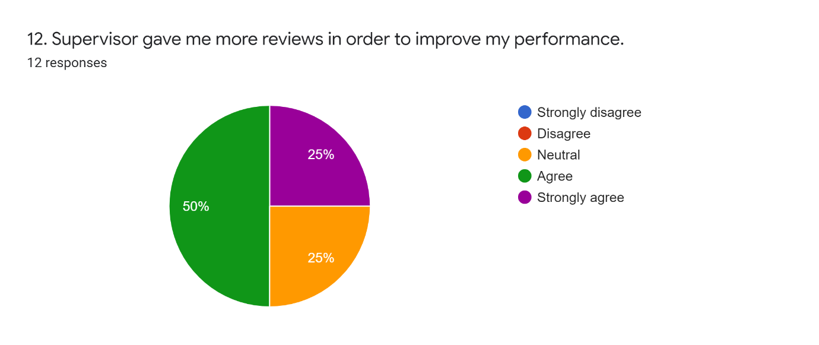
In this chart, employees agreed (50%) and strongly agree (25%) that they are receiving necessary feedback on their performance in order to improve. Employees neutral with that 25% of the time. Mean is 4 and Median is 4. The importance of feedback in the performance evaluation process cannot be overstated. When a supervisor provides feedback to employees, they learn what areas they need to work on. MTB employers provide individual employee feedback whenever it is required through meetings.
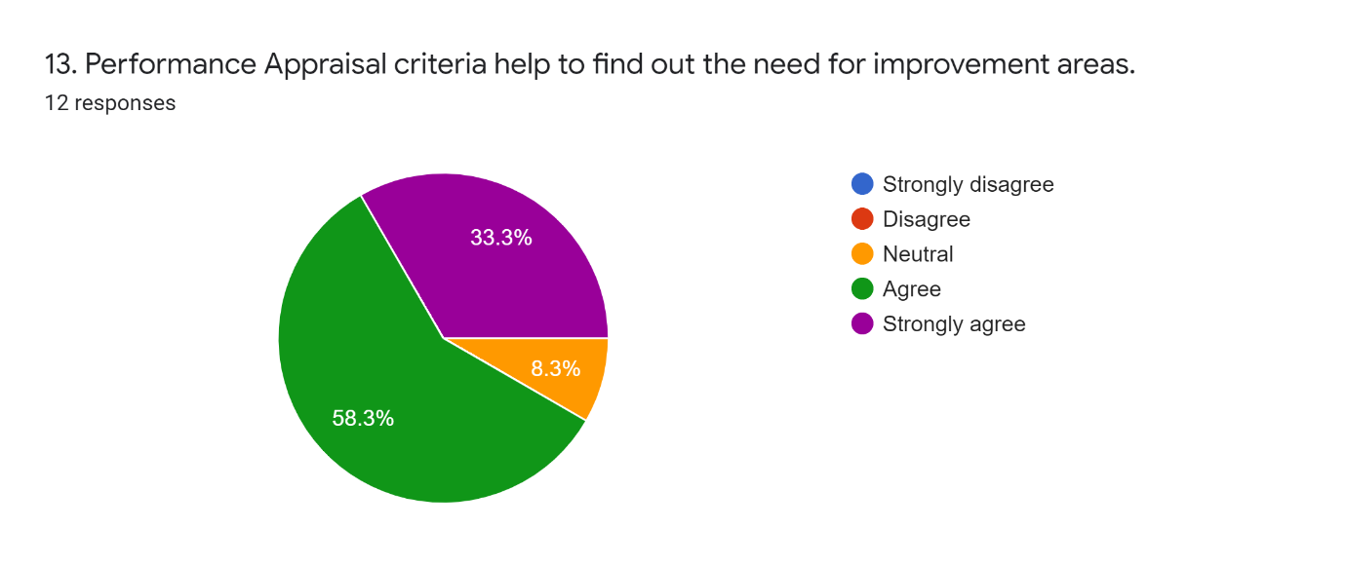
One of the primary goals of performance assessment is to enhance employee performance by identifying and removing weak areas. 58.3% of respondents agreed, 33.3% strongly agreed that performance is achieving the purpose. And 8.3% were neutral. When an employee's performance is poor, MTB offers advice and training. Here, Mean is 4.25 and Median is 4.
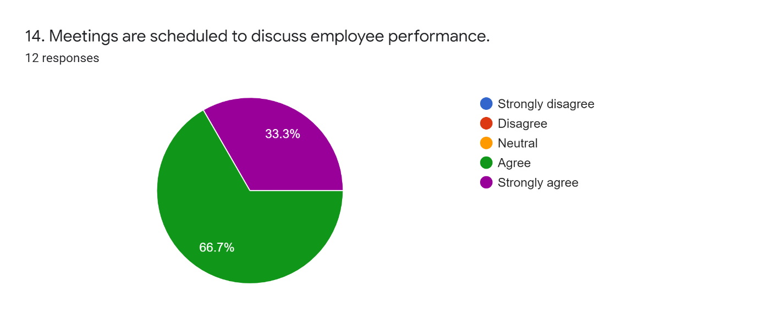
This chart clearly shows that overall, 100% employees agreed, strongly agreed that meetings are scheduled to discuss their performance where they can get information about their strong performance areas, their weak areas or need to improve areas as well. Here, Mean is 4.33 and Median is 4.
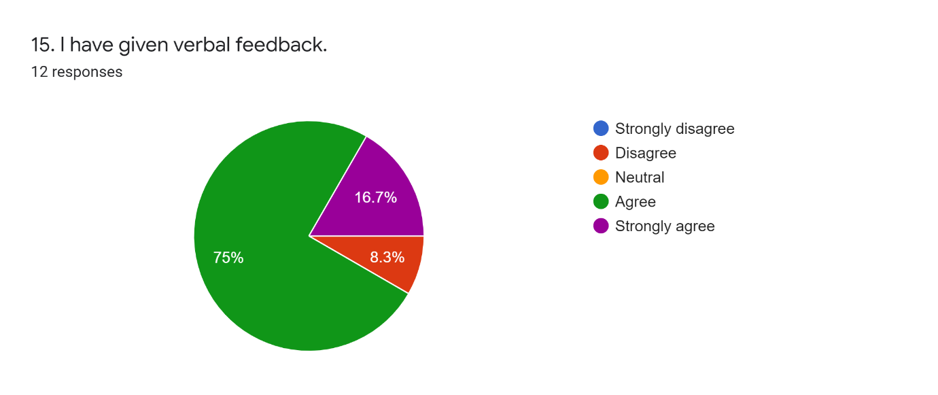
In this chart, 75% Agreed and 16.7% strongly agreed that they get verbally feedback. Verbal feedback is essential so that employee gets to know verbally about their progress in work or mistakes. Here, 8.3% also disagreed that they don’t get verbal feedback. Both Mean and Median is 4. In case of this, MTB management should take necessary steps.
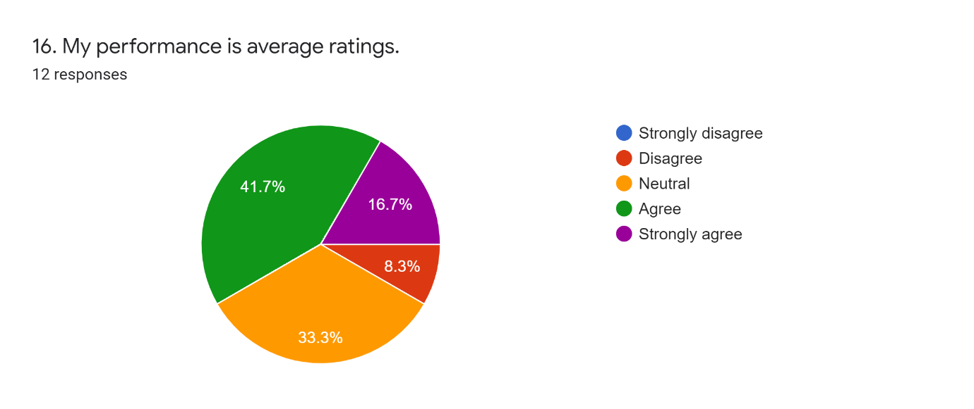
In this chart, 41.7% agreed and 16.7% strongly agreed as their performance is average while 33.3% were neutral and 8.3% disagreed because their rating might excellent or some might have poor rating by their supervisor. Mean is 3.66 and Median is 4. As rating is based on employee performance. And all employee’s rating will not same that’s why this result came out.
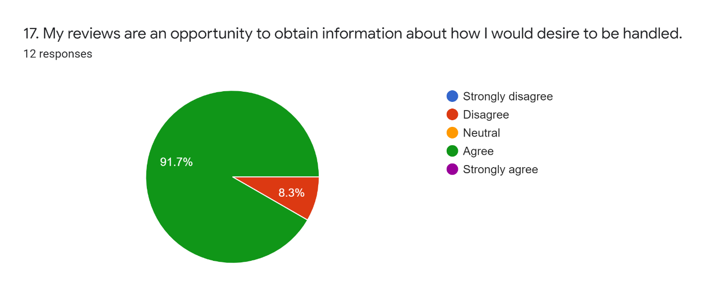
Reviews are important as it gives the opportunity to gain the information about how an employee desire to be handled. When employee get feedback, they know not only about the good performance but also their lacking’s or where they need to improve and how they deal with their needy improvements. Here, 91.7% agreed and it clearly shows that employees are agree with this statement. But 8.3% disagreed with this as they think only reviews are not only opportunity to obtain information. Here, Mean is 3.83 and Median is 4.
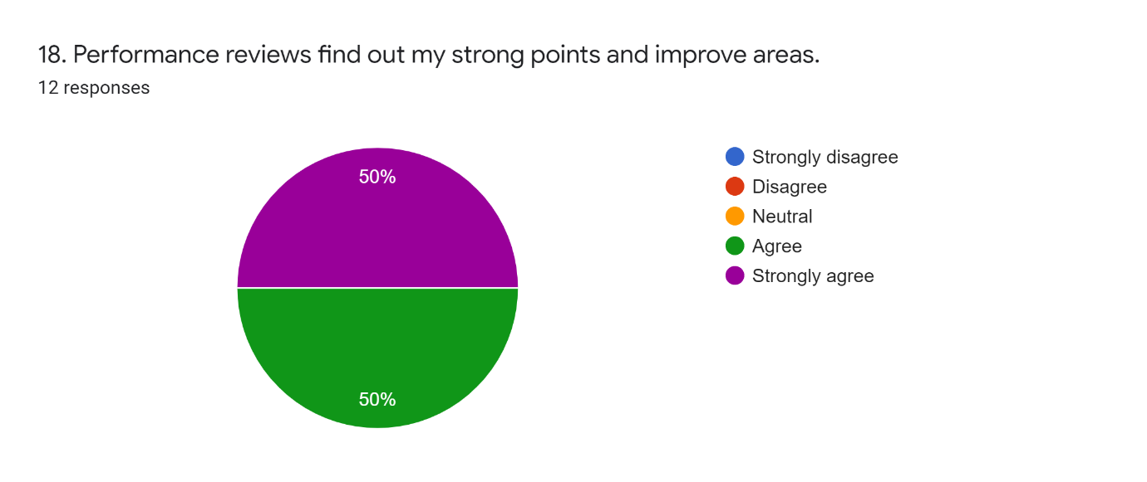
This chart clearly shows that overall, 100% agreed or strongly agreed with this statement. Both Mean and Median is 4.5. As Performance reviews find out the strength factors of an employee which will help to gain employee objective. It also improves the weak areas of an employee.
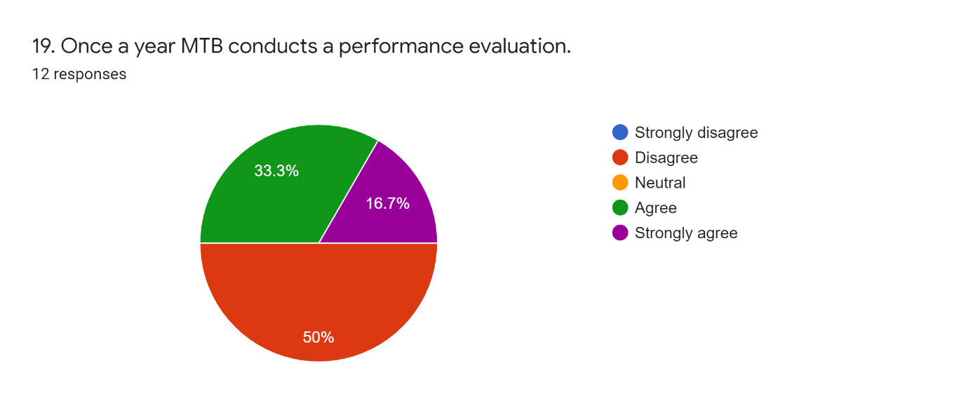
Performance evaluates conducted one in middle of the year and the other towards end of the year. So, 50% disagreed but sometime they evaluate employees in the year ending. And it based on their strategy and goals, there might be many trainings session in that year and lastly, they evaluate employee’s performance. That’s why 33.3% agreed and 16.7% agreed. Here, Mean is 3.16 and Median is 3.
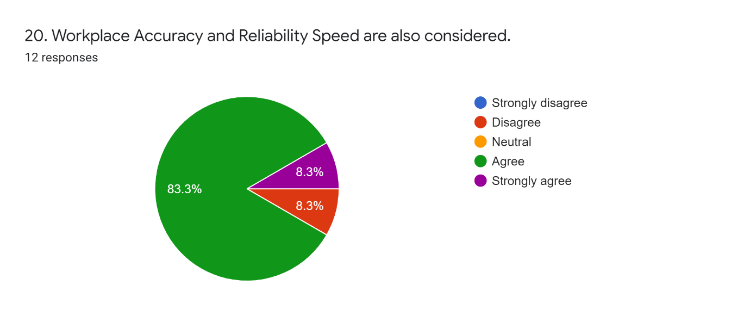
If employees will not train on the right process, they there will be no accuracy and in workplace there should be reliability on employee performance or the way they try to do their work. Employee should get the clear objectives. In this chart, 83.3% agreed and 8.3% strongly agreed with this statement. Here, Mean is 3.91 and Median is 4.

Chapter 06

Recommendation and Conclusion

6.1 Recommendation
MTB is considered to be the forerunner of the banking business, and as a result of its success, its client base continues to grow in size. They maintain a good assessment system for their personnel in order to ensure that they are pleased and loyal to the firm. Workers' effective performance is the most significant factor in the success of the business since performance assessment may help employees become more effective.
- A focused human resource strategy should be established as soon as possible, in which all departments will participate in order to promote the development of the workers' productivity.
- It is necessary to implement an appropriate training program so that employees may become more productive and skilled as a result of their participation.
- They should assess the performance of workers before and after they get training in order to determine whether or not the employees have improved, and this will assist them in determining the kind of training that the employees need to further their growth.
- As a highly useful tool when done correctly, performance assessment should be modified as required, and it should be completed with the assistance of an expert who is knowledgeable in this area so that errors may be avoided in future evaluations.
- Employees should be given a 360-degree evaluation as part of their performance review so that they may get a sense of what their coworkers thought of them.
- In order for workers to be self-motivated, it is important that the reward system and corporate policies be communicated to them.
- Supervisors should get enough training so that they can effectively interact with and comprehend their subordinates.
- Cooperation with the department as well as adaptable working hours should be taught to employees on a regular basis.
- Supervisor take detailed notes on employees’ day to day in a journal so that supervisor can keep track of every employee's performance and provide an accurate evaluation.
- Continuous feedback to workers is essential for them to realize their own shortcomings and strive to improve their performance.
- More incentives should be offered to qualified applicants in order for them to become more loyal and productive in their roles within the firm.
- Employees should be able to rate their bosses, allowing supervisors to be assessed on the basis of their conduct and attitude.
- When it comes to performance evaluation, it should be done with a plethora of figures and logic, which is a combination of quantitative and qualitative data.

6.2 Conclusion
Performance evaluation is the most effective method of ensuring that workers are properly conducted. A performance evaluation may identify the weaknesses of workers and the training requirements of the person in order to help them improve and become more motivated to perform at their highest levels. This is accomplished via the provision of continual feedback and reward. Employees are motivated and happy when they get positive feedback on their performance, which helps them achieve their goals. Performance assessment may help you retain your best staff while also maintaining a pleasant working environment. It assists the supervisor in keeping things up to date on a timely basis and determining the performance of the workers. If they discover a performance gap, they may teach the employees appropriately, and it helps them in identifying the best employees to award and promote. As a result, it may be said that performance assessment is an unavoidable need for the organization's success.

Reference
About Us - Mutual Trust Bank Limited. (n.d.). Retrieved January 25, 2022, from https://www.mutualtrustbank.com/about-us
Annual Report - Mutual Trust Bank Limited. (n.d.). Retrieved January 25, 2022, from https://www.mutualtrustbank.com/investor-relations/annual-report/?fbclid=IwAR2A1koTzhjdqn2moUPu9LK6KV53tXPb03LRX0wVTcuq1OVdRmEPjGsZxsM
Mission & Vision - Mutual Trust Bank Limited. (n.d.). Retrieved January 25, 2022, from https://www.mutualtrustbank.com/about-us/mission-vision/
Parvin, A., & Shamim, S. (2016). Human Resource Management Practices of Mutual Trust Bank Limited Bangladesh. International Journal of Business Marketing and Management, 1(3), 79–97.
Report, I. (n.d.). Marketing Procedure of.

Appendix

Survey Questionnaire

Serial no. | Question | Strongly Agree | Agree | Neither agree or disagree | Disagree | Strongly disagree
1. | Performance Appraisal is the most important tool in the organization
2. | Performance appraisal helps enhance my skills
3. | when the assessment result does not match the incentive offered then I become dissatisfied with the whole process.
4. | My supervisor always give feedback based on my performance
5. | Working pressure or stress in work motivates me to work hard
6. | MTB’s Beliefs, a performance evaluation scheme is a tool for analyzing a person's performance and identifying gaps in performance.
7. | I can ask about my progress in work to my supervisor
8. | In MTB, there is a misalignment between the expectations of employees and the present performance assessment practices
9. | There is any restriction in PA
10. | I feel more committed while working in a better environment
11. | Safety practice helped me to commit to my work
12. | Supervisor gave me more reviews in order to improve my performance
13. | Performance Appraisal criteria help to find out the need for improvement areas
14. | Meetings are scheduled to discuss employee performance
15. | I have given verbal feedback
16. | My performance is average ratings
17. | My reviews are an opportunity to obtain information about how I would desire to be handled.
18. | Performance reviews find out my strong points and improve areas
19. | Once a year MTB conducts a performance evaluation
20. | Workplace Accuracy and Reliability Speed are also considered.

