Internship Report
On
Overall Activities of “EMAD METAL”

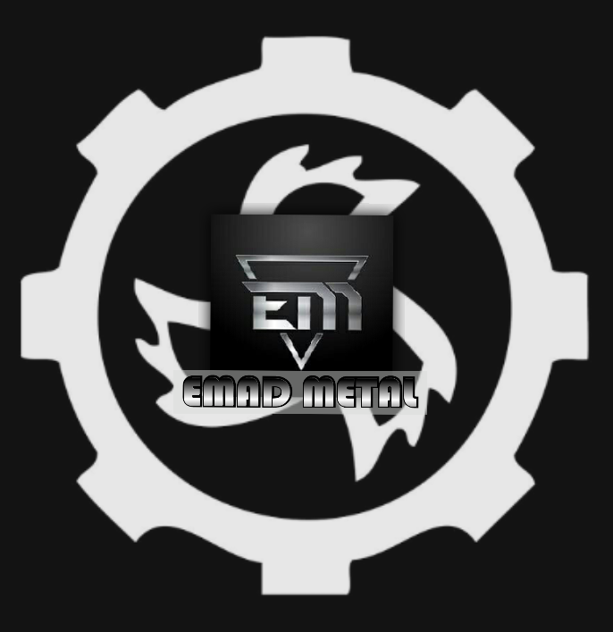

Title Page


United International University
Internship report
on
Overall Activities of Emad Metal (EM)
Submitted To :
Dr. Seyama Sultana
Assistant Professor
School of Business & economics
United International University
Submitted By :
Md Emad Hossain
Id : 111 123 072
School of Business & Economics
United International University
Submission Date:
24th April 2019

Letter of Transmittal
24th April, 2019
Dr. Seyama Sultana
Assistant Professor
School of Business & Economics
United International University

Subject : Submission of internship report.

Dear Ma’am

With due respect I would like to take this opportunity to thank you for the guidance and support you have provided me during the course of this report.
This report is a summary and analysis of my internship experience in Emad Metal. The topic of this report is “Overall Activities of Emad Metal”. I have practically worked and observed the company’s working patterns, management and other company activities, in order to gain experience about the corporate environment. To carry out the report, I have acquired various informations and periodicals etc. from my supervisor as well as from internet. On the basis of these data and practical observation, I have prepared the report later.

I request u to excuse me for my mistakes that may occur in the report despite of my best efforts. I would really appreciate it you enlighten me with your thoughts and views regarding the report . Also if you wish to enquire about an aspect of my report, I would gladly answer your queries.

Sincerely Yours,

Md. Emad Hossain
Id : 111 123 072
School of Business & Economics
United International University.
Executive Summary
This is an internship report of three months on the “Overall Activities of Emad Metal (EM)”. It has been prepared to fulfill the requirement of BBA program, United International University (UIU). As being completely new to practical, every hour spent in the EM gave me some amount of experience all the time all of which can’t be explained in words. But nevertheless, they were all useful for my career. In year 2005 EM started their journey, since 13 years. Metal industry is one of growing industry in Bangladesh and EM is one of well known company in this industry. I’ve prepared the report based on Emad Metal particularly as I have done my intern here. The main objective of the report is to figure out the activities of EM. This report has been prepared by data that are collected from the managers, owners and practical experiences working there.
This report consists of five chapters. In the First chapter I’ve discussed the introduction where I’ve discussed about the purpose of internship, sections in the report, and short introduction of the company where I’ve worked. Then I’ve discussed the background of the study. In the Second chapter I have discussed the literature review where I have discussed about the industry overview of Emad Metal, history of EM that how the company is here in this position and what they have faced. Then I have mentioned the mission, vision, values, morals and company policies of EM. After that I have discussed about the organizational structure of EM that includes formalization and centralization. Then I have discussed about the departments the organization has. Then, there are statistical data, SWOT analysis, 4ps analysis where I have discussed the details about the product, price, place, promotion of EM. After that I have discussed about the compensation system of Emad Metal. In the Third chapter I have discussed about my responsibilities what I have been doing there for three months. First three weeks I was observing the total activities of EM. After three weeks owners started appointing me for several tasks that I’ve discussed in this part of the report. In chapter four there are details about findings where I have discussed about strong brand, brand trustworthiness, brand attachment, brand equity. Then I have discussed in this chapter about the competitors of Emad Metal, the lessons I have gained from internship program. Finally, in the Fifth chapter I have given the recommendation and the conclusion.
I’ve worked in EM with almost every manager in every department that helped me to know about several working areas like HR activities, marketing activities, banking activities,
accounting activities. This is how I’ve gained a lot of experiences and it will be useful in my career.
Table of Contents
Chapter 1 : Introduction 7
1.1 Introduction 7
1.2 Background of the study : 8
Chapter 2 : Industry and Company Overview 8
2.1 Industry overview : 8
2.2 Competitors : 9
2.3 Company Overview 10
2.3 History of Emad Metal : 11
2.4 Mission : 12
2.5 Vision : 12
2.6 Values, Morals : 12
2.7 Company Policies : 13
2.7.1 Quality Policy : 13
2.7.2 Environmental policy : 13
2.8 Organizational Structure : 14
2.9 Departments : 15
2.10 Statistical data : 17
2.11 SWOT Analysis : 18
2.12 4ps Analysis of Emad Metal-EM 19
2.12.1 Products : 19
2.12.2 Price 26
2.12.3 Place 27
2.12.4 Promotion 28
2.13 Compensation : 28
2.14 Photos of Emad Metal : 30
Chapter 3 : Job Responsibilities 33
3.1 My Job Responsibilities : 33
Chapter 4 : Findings 35
4.1 Strong brand 35
4.2 Brand Trustworthiness : 38
4.3 Brand Attachment : 39
4.4 Brand Equity : 39
4.5 Lessons gained from Internship Program : 39
Chapter 5 : Conclusion & Recommendation 41
5.1 Conclusion 41
5.2 Recommendation 42
References : 44

Chapter 1 : Introduction

1.1 Introduction
An internship is a period of work experience offered by an employer to give students and graduates exposure of working environment, often within a specific industry, which relates to their field of study. Throughout an internship one can develop a variety of skills including communication skills, personal effectiveness, presentation skills, creative problem solving and influencing skills. Internship program is the most important period for a BBA student. It carries the best learning process to know about the organizational environment in such a way like professional employees. The experiences got by an intern during the internship period will make them more smart and professional in their future working sector.

In the first chapter I have discussed about introduction and background of the study. In the second chapter I have discussed about industry overview and company overview of Emad Metal, history of Emad Metal and organizational structure and few internal specifications of the organization . In the third chapter I have discussed about my responsibilities in Emad Metal. In the fourth chapter I have discussed on findings- Issues and problems. In the last chapter I have given the conclusion and recommendations.

‘Emad Metal’ the shorter form is ‘EM’ the name is given by the owners of the organization. Emad (Abrar Jahin Emad) is basically the name of one of the owner’s son. According to his name the owners had decided to set the name of the organization.
Emad Metal is a metal products making factory/industry and it’s one of 10 factories/companies in Bangladesh. The factory/company makes 3 metal items basically bt in variety of types. The three basic/core items are Clam, Tala, Jibba. There was another item named Wasar. But now they ain’t producing this product. All these items are made of Iron Flat Bar.

Emad Metal is located In Tawapotti, Zinzira, Keranigoanj, Dhaka, it’s by the side of Buriganga River(Beribadh) just few meters away from second Buriganga Bridge. Quality and honesty are the main objects of the founders of Emad Metal. “Uncompromising quality and honesty” the main force to be successful they believe.

1.2 Background of the study :
United International University, being the most reputed educational institution in this country, has always tried to incorporate the contemporary phenomena into its curriculum. In recent days market exposure and practical orientation have become very important for business students and therefore, the university has duly included a compulsory internship requirement of holding into its BBA program running under the UIU School of Business.

Internship program offers the students with a methodical and comprehensive insight of the current practices in the corporate world. An item can have knowledge about the specific industry under which he or she is currently working as well as can become acquainted with the corporate and industrial working environment and the prevailing culture.

Chapter 2 : Industry and Company Overview

2.1 Industry overview :
Emad Metal is a company in such an industry that is not so much old to contribute to the national income in Bangladesh. The industry where Emad Metal is running it’s business is called the Metal Industry. Though It is a new industry in Bangladesh, it’s contributing vastly in the national economy of the country. If this industry would not grow here in this country, the government had to import the products which are being produced in such industry. As a result of it the government is being able to save a huge amount indigenous currency by not spending money to abroad for importing such industry’s products.
This Metal industry is improving day by day. The industry is yet to become a large industry in future as in this industry only 10-11 companies are there including Emad Metal. Emad Metal itself doing well enough to sustain and contribute more in this metal industry along with the economy of Bangladesh.
On the basis of basic items, if we pick “Tala & Jibba” Emad Metal comes on top of all other companies. On the other hand if we pick “Clam” Emad Metal comes around 5-6th position among all the companies in this metal industry.

2.2 Competitors :
In business a competitor is a company in the same industry which offer similar product or service.
By working in Emad Metal, I have come to know a lot about the competitors that how a competitor plays a vital role or how a competitor can affect the business, how to tackle them and how to cope with the situations created by the competitors.
In Metal Industry all the companies are not the competitors of EM. Because there are different business areas and patterns. EM’s competitors are those companies who produce and supply similar kind of products as EM. Nayabazar, Nababpur and Imamgoanj are three places in Dhaka city EM supplies their products along with three more places outside Dhaka in marketplace. There are few companies who also supply similar kind of products :
- Master Metal
- Rokeya Metal
- Zakir Metal
- Ali Akbar Metal

As I mentioned earlier that I’ve worked as both marketing manager and production manager, I’ve faced and noticed different situations related to competitors.
- Following the productions: Competitors often follow the production quality and quantity of EM secretly so that they can tackle EM by producing better and greater.
- Good relationships : Competitors try to make good relationships with all the managers and also with few employees of EM so that they can have informations about EM’s activities.
- Syndicating : Few of competitors make syndicate among/between themselves to sell their products at lower price than Emad Metal.
- Holding expert employees : Competitors tries to hold or take expert employees so that EM or others can’t take the expert employees or hire temporarily that can increase the production or can be a cause of advancement.
- Spoiling the market : This is the biggest problem. A competitor can sell their products less than others. So parties move toward that particular company who is selling their product at lower price. Then other companies suffer along with Emad metal. This is the reason I’m saying a competitor can be the market spoiler.
EM’s costs are high as it’s not that small organization. So the company can’t sell their products at such lowest price. I’ve seen the company is suffering from such issue.
- Presenting : Competitors can overtake a company by presenting their product in different ways. In the market I have seen many times that EM’s competitor is sitting with the parties for such long time and trying to make better relationships by giving them something that is not even related to business or gifting them something. Then they are trying to convince the parties for anything related to the business. It can be either for collecting money or cheques with bigger amount or for taking more products from that particular company.
- Unwanted Delivery : competitors often force the parties to take their product and deliver the products forcefully even when the parties don’t need so that EM along with other companies can’t deliver them.
- Advantages to employees : Competitors tries to tackle EM along with other companies by facilitating to the employees more than EM and others. By having more facilities maybe the competitor tries to show EM’s employees that “we are better” or maybe tries to make their own employees realize that “U get more facilities than EM’s and others, so work harder than EM’s employees and give more outcomes”.

These are some issues and problems that Emad Metal faces in doing their regular business activities. And I have closely noticed all these working in EM. I’m not sure about the last one as it’s their total internal issue.

2.3 Company Overview
There are several contents I have shown below about Emad Metal- EM, one of well known company in metal industry.

2.3 History of Emad Metal :
In the history of business in Bangladesh the metal industry is not that old aged industry like other industries I mentioned earlier. So Emad Metal also is not an old company in the history of business in Bangladesh. It is sustaining with great success and prosperity. It was 13 years ago the company emerged into the market.
entrepreneurs, founders Haji Md. Zakir Hossain & Md. Azad Hossain the two brothers founded the organization in 2005 with single item that is ‘ Clam’ n there were varieties of that product. This was one of the most demanding iron product and still it is in the market.
In 2007 the founders of emad metal decided to produce another item named ‘Wasar’. It was profitable along with ‘Clam’. Then in 2009 the company had started producing ‘Tala’ & ‘Jibba’ together. As it was more profitable than previous two products.

At first there wasn’t that much competitors in the market but when few investors had seen the profit line here, they started doing business in this sector. So Emad Metal had faced some difficulties when new factories were entering into the industry.

At the beginning the owners of Emad Metal had appointed a production manager, also as marketing manager as he was one of the most reliable person of Md. Zakir Hossain. Everything was going good but the manager betrayed in the middle. He was caught in 2012 that he had been cheating with the owners of Emad Metal. He had been stealing money from the market, the money Emad Metal was about to get from the buyers of the product. He had been stealing frequently and made it a huge amount that EM had started suffering. For such loss Emad Metal hasn’t been able to reach at the targeted position yet. Though the company was sustaining a lot before the tragedy. It was in better position than today.
In 2012 a nephew of the owners Ridoy Islam joined as production and marketing manager in the company in place of the previous manager. In 2013 one of relative of the owners Rintu Ahmed joined as production manager, and he has been appointed as HR manager at a time. Then Ridoy Islam has been set as marketing manager only.
In 2017 Ridoy Islam left this company and in place of him Md. Josim Mollah & Md Hasan (owners cousin) got appointed as marketing manager.
In 2018 the owner Md. Zakir Hossain’s son Abrar Jahin Emad has entered into the business after completing his graduation from United International University.

In 2009 the owners left one of product’s production ‘Wasar’ because the company was facing difficulties. This is because of the loss the company had faced for the first manager’s activities I’ve mentioned. So the owners had to shorten the size of the company to overcome. Now it’s trying to improve again.
From such small beginning it had expanded into on of top company in the metal industry in the middle, then a tragedy had changed the condition. Now EM is doing well with medium sized factory having 18 high powered machines & required manpower and generating profit. Emad Metal is proud of it’s integrity and quality of the products it serves in the market valuing the customers, and trying best to provide merchandise to suit the needs of each customers into the market. Emad Metal has never limited their aim to profit making only. The non-profit making concerns of the company are involved in sustaining the progress of Bangladesh. Just government’s proper focus is needed in this industry. A medium number of people are employed here as employees. The company makes some best relationships with the employees, bothers about them, creates friendly environment. It’s a Family.

2.4 Mission : Shaping the future of the Metal Industry by creating novel value and opportunity for our customers, employees, investors.

2.5 Vision : To be one of well known company that best understands and satisfies the products and self-fulfillment needs of customers, always keeping in mind that all employees are important in the success of the company and so honesty & integrity.

2.6 Values, Morals :
Emad Metal :
- Acting with honesty and integrity
- Treating people with respect
- Conducting business lawfully
- Accepting individual and corporate responsibility
- Never be wasteful
- Working effectively & efficiently
- Strives for customers satisfaction
- Believing in quality and excellence
- Believing in personal responsibility, active participation
- Believing in integrity
- Building culture of learning based on team work, accountability and cooperation

2.7 Company Policies :
2.7.1 Quality Policy : Emad Metal targets to achieve business success through quality by understanding, accepting, meeting, and exceeding customer expectations. Emad Metal ensures consistent quality of products to achieve customers satisfaction. It also meets all national regulatory requirements relating to its current business.
the management of Emad Metal commits itself to quality as the prime consideration in all its business decisions. All employees in Emad Metal must follow documented procedures to ensure compliance with quality standards. The organization is very aware of that.

2.7.2 Environmental policy : The environment is dusty n noisy as the organization’s activities are all about Iron or Metal products and 12 hours a day the machines are run. But Emad Metal has some policies to make the environment sustainable to run daily activities :

Emad Metal :
- Complies with local and national environmental regulations.
- Conserves natural resources like water & energy, avoid wastage.
- Ensures appropriate communication & cooperate with internal and external interested parties on environmental issues.
- Creates awareness on environmental issues among employees and suppliers.
- Manages time to clean daily’s garbage.
- Tries to prevent environmental pollution though it’s tough in this industry.

2.8 Organizational Structure :
The Emad Metal is compiled in two building naming ‘Bishwa Market’ situated in Tawapotti, Zinzira, Keranigoanj, Dhaka. The company has no branch. The productions are run in the ground floor and all the business formalities also.
Emad Metal maintains a mechanistic organizational structure where bureaucratic environment prevails in the work place. The organization includes a high degree of organizational formalization and centralization. Decision making processes are very centralized towards the directors/owners the top level executives. Organogram of the organization is graphically shown in the following :

Owners
Md. Zakir Hossain
Md. Azad Hossain

Marketing Manager
Josim Mollah & Md. Hasan
Production and HR Manager
Rintu Ahmed

Employees

Parties & Banks

According to the organogram shown above, owners make decisions of overall activities and it’s centralized. Owners take decisions and communicate these with the production/ manager and with marketing managers. Then the production/HR manager communicate and deals with employees. The marketing managers deal with banks and parties. Communications also take place directly between owners and parties & banks in case of negotiations.

2.9 Departments : There are few departments :

- Finance and accounting department : controlled by both the owners Md. Azad Hossain and Md. Zakir Hossain.
Some of major areas are :
- Treasury
- Risk management
- Costing
- Credit management
- Accounts management (payable/receivable)
- General accounting
- Collections (cash/check)
- Audit Department : controlled by Md. Zakir Hossain, and Audit is weekly basis
- Administration Department : The two owners and one of owner Md. Zakir Hossain’s son Abrar Jahin Emad are the members. Specially work to maintain friendly working environment through proper monitoring with the company policy.
- Human resource department : As the marketing manager is appointed as HR manager at the same time, also Abrar Jahin Emad are the members of this department .
- HR policies, procedures for recruitment & selection, manpower planning and succession planning.
- The qualitative aspects for performance appraisal and performance evaluation.
- Policies regarding loans, gratuity and hospitalization. The organization offers leave fare assistance, festival bonus, performance bonus and other financial assistances.
- Respect & love for the employees.
- Strictness in every aspect for the employees.
- Emphasizing attendance
- Youth Employees are treated affactionately.

- Purchase department : Controlled by Md. Azad Hossain one of the owner, also the senior most employee named Md. Solayman is a member of this department.
Azad hossain deals with different parties to purchase raw materials. Md. Solayman deals with mechanical business parties. For example : if any of machine gets obsoleted , immediately he has to go to mechanical parties to deal to repair the machine. He also purchase oils, grease and aluminium cables that is used to tie the ready products to deliver into the markets.

- Electronic Department : Jakeer Mohammad controls this department.
In term of any electric issue for example, if a machine is not working for electric issue, or if any short circuit happens he himself can fix it. If any dealing outside is required, he does it.

- Transport/distribution Department : Md. Monir, Md. Kamal, Md Basir are the members who work in it . They are in this department to either deliver the products to the market or loading the raw materials into the factory.
- They Are aware of time
- Use - By road & By water way to distribute products.
- Products are distributed through many skilled manpower by vans(by road) and boats(by water).
- They unload tons of raw materials from trucks & and bring them into the factory.

- Marketing department : Md. Josim Mollah, Md. Hasan are appointed to deal in this department. Also from owners pannel Md. Azad Hossain and Abrar Jahin Emad (new) work in it .
- They sale the products to the markets in a certain rate by convincing parties.
- Often they make relation with new parties.
- If new rate is to set from Emad Metal to sale the products, marketing managers inform the parties in the market before finalizing new rate.
- They collect orders from the markets then inform the owners an then production manager .
- Respect & Love for parties are two most important things for these marketing people.

2.10 Statistical data :
Emad Metal is not a public limited company and not enlisted in the stock exchange market. It’s a complete privately owned organization with no external share or link. All the products of Emad Metal are entitled as profitable and that can make the organization financially strong in the market. The organization is now into growth phase and it’s in slow growth phase as owners want to see revenues climb, new product developed, more employees hired so on. The organization is in growth through direction stage. The central coordination is remaining into the hands of the entrepreneurs. It has lack of autonomy but it’s not in bigger height. One or two except owners, have the autonomy to share their ideas.
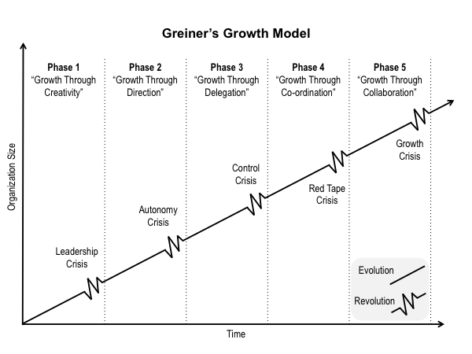
So according to Greiner’s Growth Model, Emad Metal is in Phase 2 “ Growth Through Direction” and there is autonomy crisis as well though it’s not in bigger height.

Some statistical facts of Emad Metal is stated below :
- Total number of employees : 40 approx
- Total number of machines : 18
- Total annual sale(quantity on average) in 2017 : ‘Tala + Jibba’ together 408 ton or 408000 Kgs(approx) and ‘Clam’ 816 ton or 816000 kgs (approx).
- Annual turnover (revenue) in 2017 : 64056000 taka or 64.056 million approx.
- Total annual sale(quantity on average) in 2018 : ‘Tala + Jibba’ together 528 ton or 528000 Kgs(approx) and ‘Clam’ 720 ton or 720000 kgs (approx).
- Annual turnover (revenue) in 2018 : 73920000 taka or 73.92 million approx.

Revenue increased in 2018 but there are different ups and down states in sales. Tala + Jibba sales increased in 2018 whereas the quantity of sales of “Clam” decreased in 2018. The huge amount of increase in sales of Tala + Jibba backed well the decrease in sales of “Clam”. As a result of it revenue increased.

2.11 SWOT Analysis :
It’s a framework that identifies the strengths, weaknesses, opportunities, threats to evaluate company’s competitive position. SWOT analysis is a directional and basement model that measures what an organization can or can not do.
An organization can also study it’s current position through SWOT analysis. So SWOT analysis is considered as a very important tools of making changes in the strategic management of an organization.
Through direct observation and discussion with the officials in Emad Metal, I have been able to point out some major strengths, weaknesses and opportunities, threats regarding various issue of Emad Metal.
Strength :
- Top management
- Multi(more than one) product
- Strong employee bonding

Weakness :
- Future profitability
- Cost
Opportunities :
- Growing economies
- Growing demands
- New parties
- Government’s focus
Threats :
- Increase in labor cost
- Lack of labor or employees interest
- Growing competition
- Lower profitability

2.12 4ps Analysis of Emad Metal-EM
The 4ps analysis of a company involves detailed study of the company’s Product, price, Place, and Promotion.

2.12.1 Products :
Emad Metal(EM) believes in providing optimum quality products to value its customers. All the high powered machineries and factory site is established to enhance the capability to satisfy consumer needs in a profound quality processed manner. EM has the plan of introducing more different products in their product line and even they are planning to diversify more on their product line.
The product line is shown below :

Tala | Jibba | Clam (2” width flat bar) | Clam (2.5” width flat bar)
- Plain Tala( Shoja Tala) 1.5” size  - Plain Tala(Shoja Tala) 2.0” size  - Fold Tala(Vaj Tala) 2.0” size  - Double Tala 2.0” size | - Jibba 1.5” width size  - Jibba 2.0” width size | - Clam ‘দ’( fold) shaped – Black/Nickel color  - Clam ‘খুঁটি’(stake) shaped 2.0”- B/N color  - Clam‘খুঁটি’(stake)shaped 4.0” B/N color  - Clam ‘খুঁটি’(stake) shaped 6.0” B/N color  - Clam ‘খুঁটি’(stake) shaped 8.0” B/N color  - Clam ‘খুঁটি’(stake) shaped 10.0” B/N color  - Clam ‘খুঁটি’(stake) shaped 12.0” B/N color  - Clam ‘খুঁটি’(stake) shaped 16.0” B/N colo B/N color ur  - Clam ‘খুঁটি’(stake) shaped 18.0” B/N color  - Clam ‘খুঁটি’(stake) shaped 14.0” B/N color  - Clam ‘খুঁটি’(stake) shaped 9.0” B/N color  - Clam ‘খুঁটি’(stake) shaped 5.0” B/N color | - Clam ‘খুঁটি’(stake) shaped 16.0” B/N colo B/N color ur  - Clam ‘খুঁটি’(stake) shaped 18.0” B/N color  - Clam ‘খুঁটি’(stake) shaped 12.0” B/N color

2.12.1.1 Product Description :
Raw materials “Flat Bar” for manufacturing the “Clam , “Tala”, “Jibba” are brought from the following companies :

- Alif Re Rolling Mills, Narayanganj
- Ali Ahmad Re Rolling Mills, Narayanganj
- Shahjalal Re Rolling Mills, Narayanganj
- Khan Steel, Narayanganj
- Shah Sundar Re Rolling Mills, Narayanganj
- Afzal Iron & Re Rolling Mills, Narayanganj
- Sharmin Steel, Narayanganj
- Rajdhani Re Rolling Mills, Narayanganj
And so on.
Those companies who are paid by EM on the behalf of Re Rolling Mills :
- Sonali Iron Mart, Chattogram (one of company who is paid on the behalf of few Re Rolling mills in Narayanganj, as flat bar making materials come to the mills from such companies in Chattogram. Re Rolling companies have to pay the Chattogram’s companies as they bring materials. So on the behalf of mills, EM pays the bill directly to the companies in Chattogram by bank instead of paying few Re Rolling mills in Narayanganj. Then Re Rolling companies make raw materials-Flat Bar with that materials and deliver EM).
- Sakib Enterprise, Chattogram (Same as above)

The raw materials “Flat bar” used in the production of Emad Metal are made in Bangladesh. Emad metal bring their raw materials from those companies mentioned above. Weekly twice or thrice Emad Metal brings raw materials for the use. There are variations in size of Flat bar. EM bring the Flat Bar the size of 1.5” and 2.0” the most and 2.5” rarely.
Detailed description of the products is provided below:

Clam
This is the most selling and running product of EM but they sell it with less profit than other two products. The main reason is the competitors. The biggest competitor is ‘Zakir Metal’ who has been selling their product at lowest price so that EM and others can’t tackle them.
Clam is made of Iron flat Bar of two different width sizes (2.0” & 2.5”). To complete a Clam 4 high powered machines are used. There are two colors of Clam, one is Black another is Nickel White. The Nickel white Clam is colored in another company where iron products are colored by Nickel. There are size varieties as well. There is a clam which is called “Clam ‘দ’( fold)” shaped. Rest Clams are called “Clam ‘খুঁটি’(stake)” shaped. “Clam ‘খুঁটি’(stake)” has variations in size : 2” 4” 5” 6” 8” 9” 10” 12” 14” 16” 18”. Clam is delivered by packing 50kg together in each sack in the market. Products photos are given below :

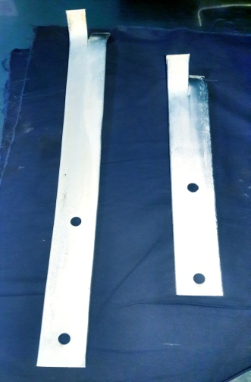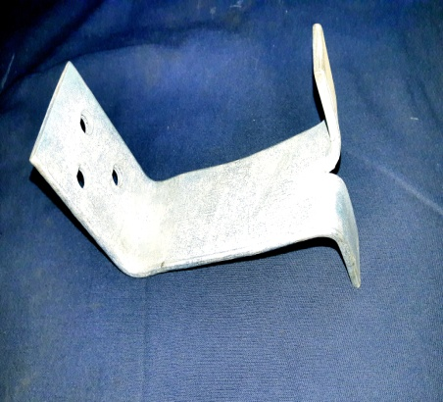
Photo : Clam ‘খুঁটি’(stake) shaped 18.0” Nickel color Photo : Clam ‘দ’( fold) shaped – Nickel color
&
Clam ‘খুঁটি’(stake) shaped 10.0” Nickel color

Tala
Tala is one of three product of EM. Actually Tala & Jibba both are the products boosted Emad Metal to come in better position. Tala is one of the most demanding product in the market. Only few companies manufacture this product in metal industry and Emad Metal is on top.
There are variations.
- Plain Tala( Shoja Tala) 1.5” width size
- Plain Tala(Shoja Tala) 2.0” width size
- Fold Tala(Vaj Tala) 2.0” width size
- Double Tala 2.0” width size

So Plain Tala can be sized in 1.5” width and 2.0” width as made of these two width sizes of flat bar. EM manufactures the Double Tala only of 2.0” width and there is Fold Tala of 2.0” width. The most demanding one is 2” width Plain Tala.
Three machines are used to make Plain Tala. One is for cutting the Flat Bar by required size. Then the bars are carried to another machine that is Round Cutting machine. Then these are carried to make hole in the middle of that bar into the Vim Machine. Then finally these are carried to Color Machine to make it silver color. It takes 1 hour to to make 500kg Tala silver color. Then these are ready to deliver. Before delivering these are tied 100 pieces together with strong steel cable.
Double tala making process is same as Plain Tala as it’s a plain tala as well. Just it has two holes. That means it needs to cut in bigger size so that two holes can be made in two corners.
On the other hand to make Fold Tala two extra machines are used. One is to Fold or Carve the Tala into Folding Machine and another is to make small two holes on the folded or carved part of the Tala into Mini Vim Machine. Products photos are given below :

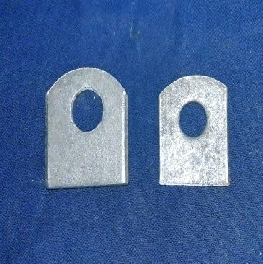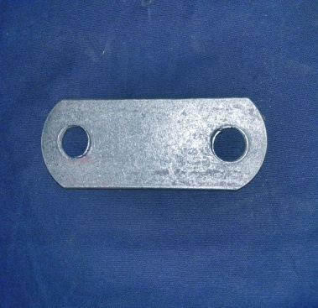
Photo : Plain Tala(Shoja Tala)
2.0” and 1.5” width size Photo : Double Tala 2.0” width size

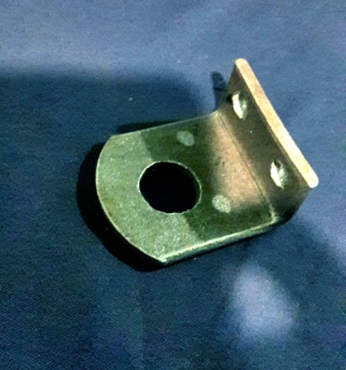
Photo : Fold Tala(Vaj Tala) 2.0” width size

Jibba
Actually a Jibba is used with Tala as companion product. We see this set ‘Tala & Jibba’ together in Steel or Iron made doors by which the doors need to lock. But parties take Jibba separately as they don’t sell as companion product but as separate item. So EM don’t produce or sell Jibba as companion product.
There are only two sizes of Jibba one is 1.5” width Jibba another is 2” width Jibba as these are also made of two different width sizes of flat bar. Both sizes are equally demanding.
Making Jibba is easier than Tala. Three machines are required to make. After cutting the Flat Bars by required size in Cutting Machine these are carried to shape the top into another Round Cutting Machine. Then these are carried to make length holes into another strong Vim Machine. Finally these are sent to Color Machine to make silver color. The photos of the products are given below :
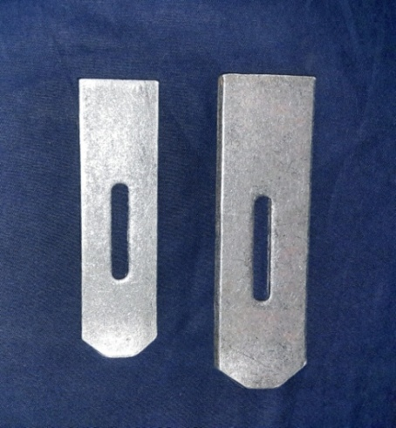
Photo : Jibba 1.5” width size and Jibba 2.0” width siz

2.12.1.2 Product development matrix :
Product development matrix or product/market growth matrix suggests that a business is attempting to grow depending on whether it’s marketing new or existing products in new or existing markets.
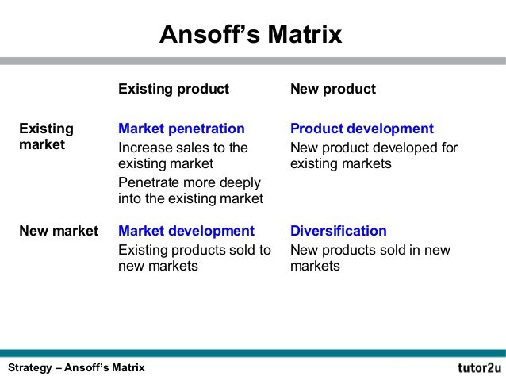

As per Emad metal’s portfolio, the assortment of the products in respect to the product/market development matrix is provided below :
P/MDM | Products
Market Penetration | Plain Tala 2.0” width size  Fold Tala  Double Tala
Market Development | All the types of Tala & Jibba
Product Development | All types of Clam ‘খুঁটি’(stake) shaped making with 2.5” width Flat Bar
Diversification | Nothing
Most of the products of EM have been developed in the current market. Actually there’s no new product for new market.

2.12.2 Price
Pricing is one of the crucial aspects of a products destiny to success and failure. There are many different methods of pricing a company can employ. But the main thing is to strategically set the pricing that facilitates the company and the product as well. Various sorts of pricing methods are stated below :
- Competition Based Pricing
- Cost Plus pricing
- Creaming or skimming
- Market Oriented Pricing
- Loss leader
- Premium pricing
- Limit pricing
- Penetration pricing
- Price discrimination
- Predatory Pricing
- Contribution margin based pricing
- Dynamic Pricing
- Psychological pricing
- Price leadership
- Target pricing
- Marginal cost pricing
- Absorption pricing

In the metal industry of Bangladesh ,people are quite pricing sensitive and thus prices of almost all the competing products are same. EM does its products pricing in three steps :
Step 1
It is the first step where EM calculates all the production related cost of its product to estimate a gross price.
Step 2
Profit margin is being added in this step by Emad Metal.
Step 3
The ultimate price is then analyzed by EM using two methods :
- Competition based pricing : Here Emad Metal identifies whether its product price is similar to the competitors or not. As metal market is price sensitive, thus price cannot be more than competitors and even can not be very less than competitors. Otherwise it will impact the profitability. So the price has to be close to the competitors price.
- Market oriented pricing : Here Emad Metal justifies whether the price of its product is a price that will be accepted in the market and considered to be a market-oriented price rather than a price that will imbalance the market pricing philosophy.

2.12.3 Place
Where is the company selling or distributing it’s product and how the company is doing these. Getting the products in front of consumers is the goal of business. Placement or distribution is one of the most important thing in business. A company have to position and distribute the product in a place that is accessible to the buyers. In some cases, placement may refer to distributing products in certain stores.
In the case of Emad Metal, it distributes the products in three places in Dhaka city and few places outside Dhaka :

Place | Items
Imamgoanj, Dhaka | Clam
Nawabpur, Dhaka | Tala & Jibba
Nayabazar, Dhaka | Tala & Jibba
Mohammadpur, Magura (New) | Clam
Kanaipur, Faridpur (New) | Clam
Ullapara, Sirajganj (New) | Clam

First one is Imamgoanj where EM distributes ‘Clam’ only, second and third one are Nayabazar and Nawabpur where EM distributes Tala & Jibba. EM started selling it’s products outside Dhaka like Sirajganj, Faridpur, Magura. Few more markets will be added soon in their list.
EM distributes the products directly to the certain parties in first three markets. It doesn’t go with distributors. But outside Dhaka EM delivers it’s products through transport agency.

2.12.4 Promotion
It is a very important element of marketing as it can boost a brand/company’s recognition. Promotion is the marketing communication about a particular product to the market. There are marketing communication strategies like : advertising, sales promotions, special offers, public relations. Whatever the channels are used, these should be suitable for the product, the price and the place.
In the case of Emad Metal,
- it does advertisement by sponsoring in few events either with the business association (TKKSS) they are in or individually.
- EM keeps focus on public relations as well. EM being in the business association named ‘Tawapotti Khudra o Kutir Shilpo Shomiti(TKKSS)’ arranges program where there is opportunities for public to have lottery and to get gifts.
- As a result of it positive ‘word of mouth’ of public can play an important role to promote or boost the recognition of EM.

2.13 Compensation :
It is the non-cash and cash payments that an organization gives to the employees in exchange for their activities or works for that organization. It is the biggest expenses for the organization with employees. Compensation is more than employees regular paid wages.
Compensation management is one of function in a business that allows businesses to retain and attract key talent, keep the employees happily and enable the business to work profitably.

It includes many types of benefits and wages :
- Base pay
- Sales commission
- Tip income
- Bonus pay
- Recognition or merit pay
- Overtime wages
- Benefits regarding insurances, standard vacation policy, retirement.
- Stock option
- Other non-cash benefits.

In Emad Metal workers are paid on the basis of attendance of them in a week. That means EM makes payment weekly not monthly. Among all the types of compensation benefits EM provides the following benefits :

Base pay : It is the initial payment that is received by the workers from the company in exchange for the service. It excludes extra compensation like bonuses or overtime pay and other benefits as well. Employees base pay can be given as hourly or weekly rate, monthly or annual salary. In Emad Metal, the base pay is given weekly on the basis of the attendance of an employee in a week.

Bonus Pay : A bonus payment is usually given to the workers or employees in addition to their base salary. It is the money given to the employees beyond the existing fixed wages. It can be given as gift and reward. The bonus payment can be given to all or few of selected employees in an organization.
In EM employees are given one month’s bonus (4 weeks*base salary) in two Eids, also the bonus payment is made in “pohela boishakh”. Few selective employees get bonus often without occasion as well for their performances.

Merit Pay : It refers to performance related payment which includes bonuses or base pay increase of employees who complete the target or perform effectively following measurable criteria within a specific time period.
In Emad Metal there are few employees who are given a contract to do a specific work related to raw material(Flat Bar) within a specific time. If they do it effectively, owner gives extra payment to them for this.
Non-cash benefits : There are some benefits that do not provide employees cash benefits or compensation. The employer pays the non cash benefit in a private nature.
Some of non cash benefits are : rent free house, telephone for private use, school fees, free power/water/gas, free foods, free clothes etc.
In Emad Metal there are not so many non cash benefits, but what the employees get is free foods from the owner. Employees get seasonal fruits specially in summer. Often selective ones get free oil, rice or egg from the owners. Employees get free clothes in Eid Ul Fitr as gift. Often the owners give their own used clothes to few employees.
Selective Employees in EM get some other benefits like school fees for children, house rent, transportation cost, and medical expenses in emergency.

2.14 Photos of Emad Metal :

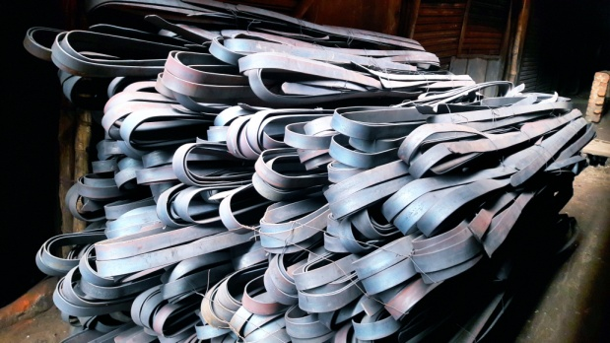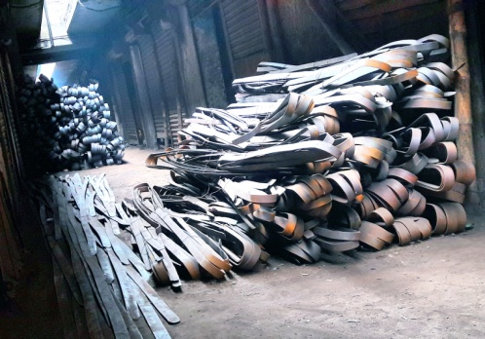
Photos : Raw Materials (Flat Bars)

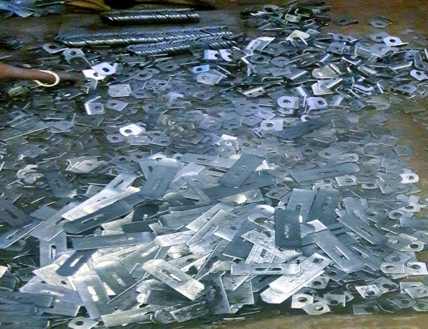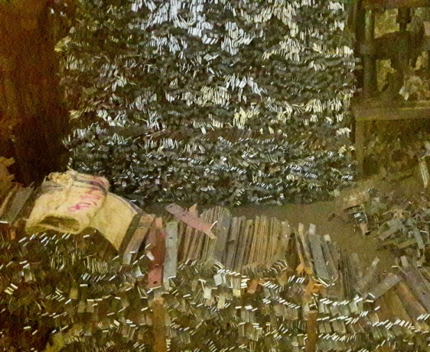
Photo : Tala , Jibba, Clam are being bundled/packed to deliver

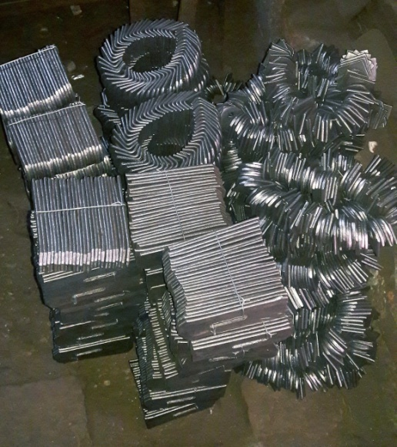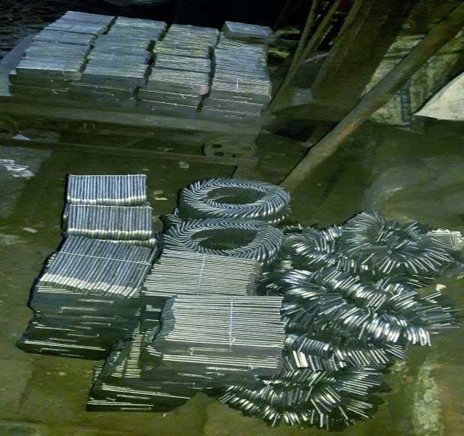
Photo : Tala & Jibba are ready to deliver

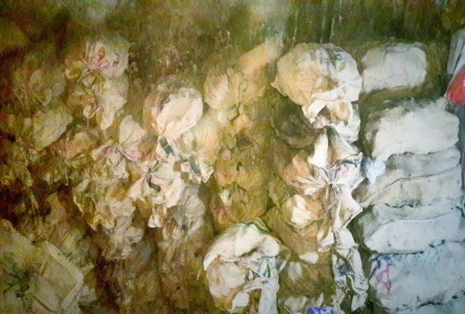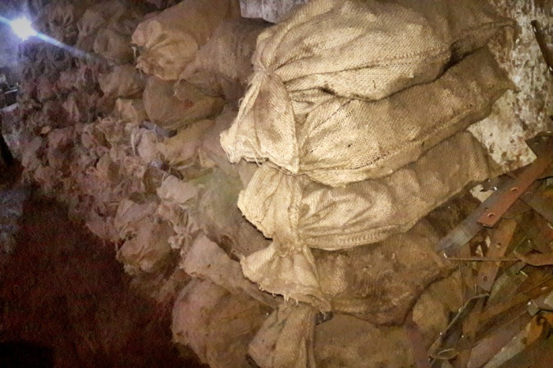
Photo : Clams are packed in sack, stored and ready to deliver

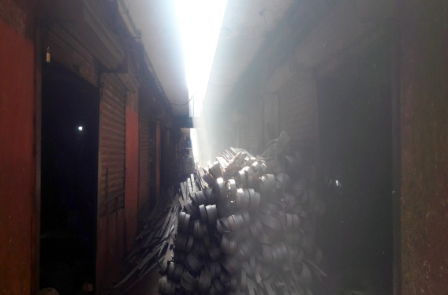
Photo : Emad Metal’s outer space

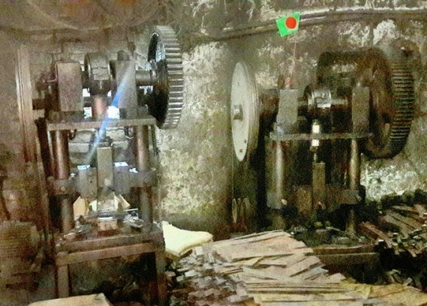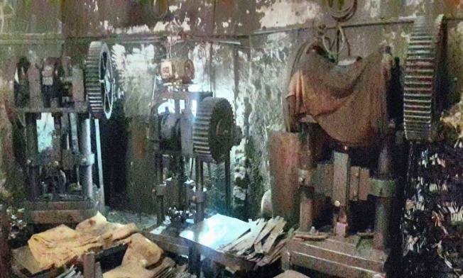
Photo : Clam making machines

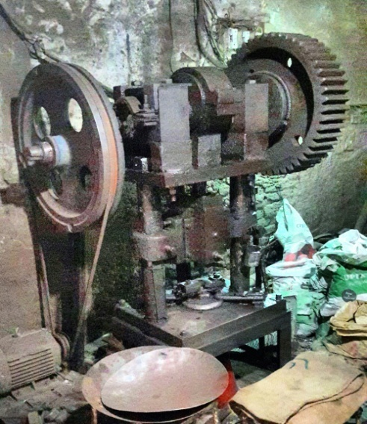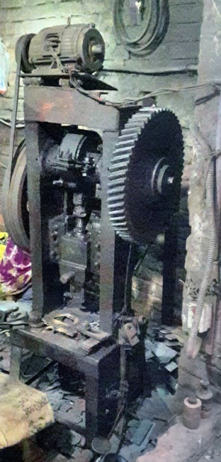
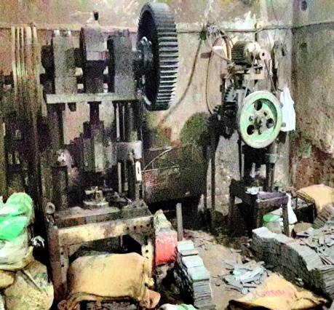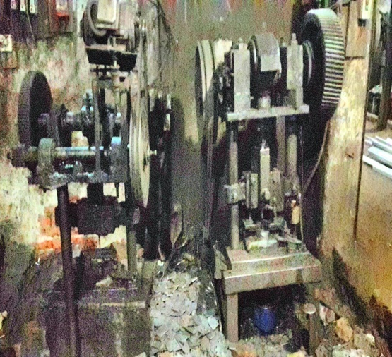
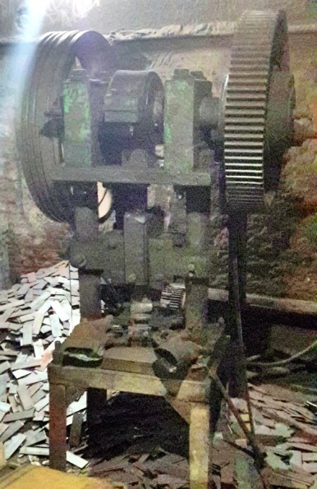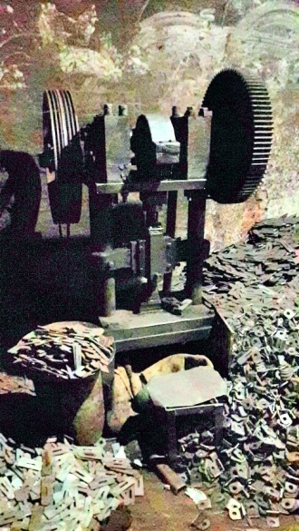
Photos : Tala & Jibba making machines

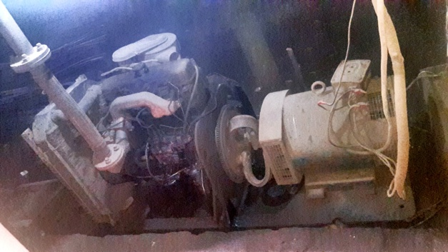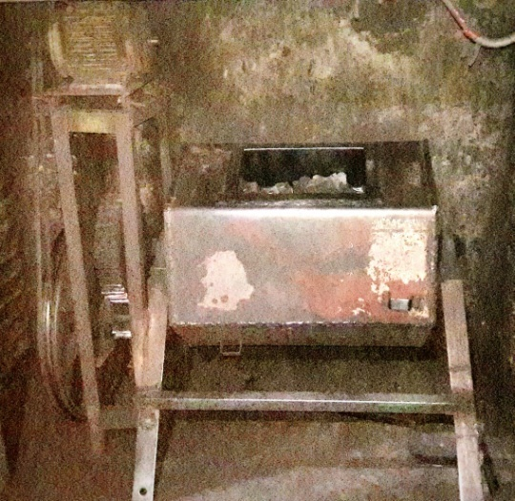
Photo : Generator Photo : Barrel Machine (Tala & Jibba coloring machine)

Chapter 3 : Job Responsibilities

3.1 My Job Responsibilities :
Emad Metal is a metal products manufacturing company. In this company there is no need of huge number of employees. As I’ve done my intern here in this company, there were some job responsibilities of mine.
Actually in this company I wasn’t assigned for one or two particular activity but my activities or tasks were given or often set according to the need or requirement of the company. It’s like when needed as needed. And these are related to any of the area or department .

I have stated below some of my job responsibilities over my internship period :

Coordinating production manager : The production manager works hard from the opening to closing time of the factory. So I was assigned as his co-worker to aid him in some cases.
- I was assigned to look after the quantity of products are being produced per day.
- I along with the production manager had to balance the supply and demand in production.
- At the absence of the production manager, I had to control and look after the production activities.

Partial roles in HR department : As the production manager plays role of HR manager and I was set as the co-worker of that manager, I had to play some partial roles of this area as well.
- Looking after the employees
- Supervising their works
- Bothering and taking care of their needs
- Setting up the employees for certain works
- Motivating them by words
- Taking part of employees salary giving program

These are some of the roles that I had to play partially in this area. First five I had to do under the supervision of the production come HR manager. And the last one that is ‘Taking part of employees salary giving program’ I had to do with the senior owner Zakir Hossain.

Marketing activities : Owners often sent me to the market with marketing managers to cooperate in their activities. Often they sent me as replacement of marketing manager.
- I had to cooperate the marketing managers by talking with the parties when the manager was busy talking with other parties.
- I was assigned to inform the parties about the new price that will be set by the owners soon.
- If there was any complain from the parties in the market, I had to collect them and inform the owners.
- I had to receive the orders given by the parties in the market.
- Parties ordered products to me or to the marketing managers. The products were sent to the parties through delivery man with the main memo. When I went to the market having the copy memo, I met & contacted with the parties to make sure whether they have got the right products or not & they are okay with the products delivered. Then I would give the copy memo to them to finalize the process.
- I was also assigned to collect money or cheques given by the parties. Often I had to convince them by my words with my presence of mind as Emad Metal does business in balance as well.
- I was assigned to act as connector between the owners of Emad Metal and their parties.

So. There were several activities that I had to do in this organization. I think it was really helpful for me as I was getting to know so many things related to all these areas. To make me capable at several things at a time, The owners asked me to do multi tasks.

Chapter 4 : Findings
Brand equity, brand management, brand awareness, brand positioning , brand culture, brand environment , brand functions all are adjoined of one single noun : Brand. The word brand finds its origin in ancient times where livestock, criminals, or slave got permanently marked with a branding iron to identify ownership.

4.1 Strong brand
Emad Metal is a strong brand in metal industry. A strong brand is clear on its mission and purpose. A strong brand is clear on its mission and continues to stand up for what it believes in, no matter that. Your conviction which is motivated by your core values is at the heart of the work you do and is what continues to drive you forward.
Branding principles are a necessity. Kotler and Pfoertsch (2006) argue that successful branding relies on the five branding principles, namely :

- Consistency : For any organization, this is one of the most important branding principles. Organizations should leverage this with a holistic approach to become consistent, far beyond the brand or product. It affects each and every single contact point between the organization and her stakeholders.
- Clarity : It makes the brand more understandable and tangible. Clarity is based on the vision, mission, core values and core competencies of the organization. These should be easy to communicate and understand in such a way, that it enables stakeholders(people) to position the brand topicality in their mind.
- Continuity : Stakeholders (people) trust the brand that it will deliver whatever it promised based on past experience, they know what to expect. Hence continuity is an important principle to develop brand equity and trust on the long term.
- Visibility : Brand visibility is all about increasing brand exposure and developing brand awareness.
- Authenticity : Brand authenticity is the undisputed origin of behaviorism of all organizational members with the objective of creating the feeling for the customer to own, use or direct a unique valuable product or service.

In a way to illustrate the key steps in which companies should succeed in order to create a brand that will build a long term relationship – an unshakeable bond – between the company and its customers, the following model.
What is intended with this model is to analyze the separate steps in order to create a strong brand’ where brand owners have a key role in determining the brand strategy and its elements, which managed in a sustainable way, will contribute to achieving higher brand equity, reinforced by the brand communication at the other hand. Both brand strategy and brand communication are important tools in creating brand equity. In this process brand equity and its components are the core in creating a brand that will build a long term relationship – an unshakeable bond between the company and its customers. Such a strong brand creates value to the customer, increase corporate profits over the long term, and this way enhances the overall corporate value.

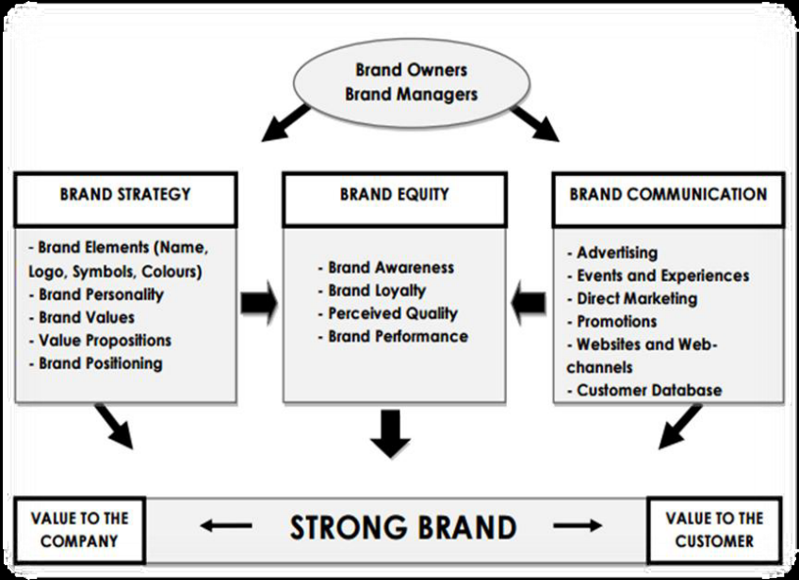

Doing business has never been as competitive as it has been in this modern time. Business has now come out of its traditional production and selling activities, and evolved to a great extent. The revenue of a company now relies as much as on the presentation of a product as it relies on its quality.
I have closely worked with the Marketing department as well as Production department of Emad Metal, which helped me thoroughly to examine the activities of a renowned company in metal industry.
Emad Metal is a friendly and supportive environment that encourages their people to develop their potential to an optimum level. From the previous discussion it can be deduced that among 3 types of products (Tala, Jibba,Clam) of Emad Metal, most consumed and preferred product is Clam and demand varies by all 8 different sizes of this product. Though Emad Metal’s main target is to grow up with Tala & Jibba. Packaging plays a vital role and that is only for carrying safely not for the look. Products are tied by steel wire and packed by the sack. In Metal industry “Wasar” is no one ranked product. Emad Metal used to manufacture Wasar but they skipped it later. But they manufacture different sizes of “Clam” that is number two rank in metal industry.
There is a Business Association where Emad Metal is doing business, formed by many companies owners related in Metal industry. Emad Metal’s owner Zakir Hossain is one of key member of this association by the name of the company (Emad metal). The association is called “ Tawapotti Khudro & Kutir Shilpo Shomiti (TKKSS) ”. In this association the competitors of Emad Metal are also the members. The association often organize events like :
- Yearly picnic
- Lottery program
- Dinner program
- Get together meeting with reputed persons in the society
- Social activities/events

All the companies invest money along with Emad Metal in these events to increase the value and to spread up the name.
These can influence and attract people toward the companies who are members in this association. As Emad Metal’s owner is also a member by the name of his company, he n his company Emad Metal gets many benefits either by having goodwill or by having profit.
Emad Metal capture their market easily for their product quality and goodwill.

4.2 Brand Trustworthiness : Every small business owner wants to succeed and every business has a brand. Success and business’s brand are intimately linked. Consumer’s perception of a company is their brand name, and without the perception of trustworthiness, a business will rarely succeed. When a customer is thinking a purchase from a brand or company, there’s one factor that rises above all others in importance : trust. Consumer can recognize a brand , interact with a brand, even genuinely like a brand, but if u don’t trust that brand, you are not going to buy from it. So trust should be a major priority.
Emad Metal gives a strong focus on trustworthiness. The company has a goodwill in the market by honesty and quality product and as a result of it parties trust the company.
But often few competitors try to distract, try to underestimate Emad Metal by selling their own product at lower price than Emad Metal and few, tries to give the parties a think that Emad Metal sells their product at higher price. As a result of it trustworthiness can hamper.

4.3 Brand Attachment : The degree of loyalty the customer feels toward the brand.
In a breakout session by Joann Sciarrino at Content Marketing World, brand attachment was defined as “ The emotional connection between humans and brands”. Thus, just as people can be attached to a person, they can also by and for a most of reasons become attached to a brand.
Emad Metal takes care of it. Tries hard to keep the customers (parties) attached happily with EM. Tries to make the connection more strong so always tries to keep the words given to the parties and tries to go flow with their needs and wants. As Emad Metal is a production company, often production hamper for several reasons. So often it gets tough to keep the word. As a result of it few parties get dissatisfied and look for alternative. Then again Emad Metal is always ready to make them convinced by apologizing.

4.4 Brand Equity :
Brand equity refers to a value premium that a company generates from a product with a recognizable name, when compared to a generic equivalent. Companies can create brand equity for their products by making them memorable, easily recognizable, and superior in quality and reliability.
Brand equity is customers subjective and intangible assessment of the brand, above and beyond its objectively perceived value. Three key drivers of brand equity are customers brand awareness, customer brand attitudes, and customer perception of brand ethics.
Emad Metal is aware of such brand equity. EM creates brand equity for their products by their equivalent works, supportive activities and make them memorable, easily recognizable and superior in quality and reliability

Lessons gained from Internship Program :

Internship is a phenomenon which is created for the fresh graduate students as a part of their graduation program for the development purpose. Under the developmental aspect, I came across many things. I have developed myself effectively over last 6 months. I have become more punctual and professional now. The main lesson that I learned from my experience in the last six months was the practical application of the knowledge gained from what I have learned from studying at United International University-UIU and now just this, Emad Metal-EM has built me up to think out of the box now. My supervisor and others were very cooperative in case of sharing their knowledge and helped me in every aspect of my learning process. The supervisor helped to developed my skills that are definitely going to help me in my future life.
The skills that I have learned in the time of working in Emad Metal are listed below:

- Team skills
I have achieved team skills as all the tasks are separated from different division. Each had different team of employees and managers as well as different target to achieve. Such experience has sharpened my ability to work in a team environment effectively.

- Ability to work under pressure
There was time when I had to handle multiple tasks at a time under severe pressure. I’ve mentioned earlier I had to work in multiple areas like as a production manager or often as marketing manager. I had no certain area though I worked the most as production manager with the senior one. The reason of giving me such multi-task activities was to make me used to and building ability of multiple area at the same time. I had to be able to handle such working pressure. I was feeling pressure but at the end of the internship now I’m feeling like “yes I know many things” and those were helpful.

- People skills
This internship has enriched my communication skills as I have been able to communicate with my colleagues, supervisors, and other executives outside. The internship has also enhanced my interpersonal skills as I have communicated with different executives regarding different queries. Overall it has boosted my confidence to interact better with people both formally and informally
.
- Technical skills
During the six months in Emad metal, I’ve also worked in the office to record the transactions (sales only) and to do some of accounting activities often. I have learned few important things by improving my technical skills there. I have been able so enhance my technical skills and that will be very helpful in my future.

- Personal development
In the period of my internship, it developed a sense of professionalism in me like – dressing up gently to look smart and confident, having punctuality’ maintaining confidentiality and working with responsibility. Moreover, it helped to know various rules and regulations in the working environment or in an organization and how to fit in there.

Chapter 5 : Conclusion & Recommendation

5.1 Conclusion
Emad Metal is one of top ranked company in metal industry in Bangladesh. The company has been doing good from the beginning with having the slogan “Uncompromising Quality & Honesty”. In any kind of situation the owners of the company always follow the honest ways and deliver the best quality metal products.
Goodwill is the greatest asset- following this value the owners run their business here. Except some minor dissatisfactions, everyone including me working here in EM is happy to work in it. Parties don’t have major complaints about the products. Tough conditions come n go in business in Bangladesh, still EM go with the flow normally in systematic ways and try to cope with every situation .
EM wants to deliver their products in more districts as well, the company started selling their products outside Dhaka. These metal products are exported as well in India by few parties so the demand is increasing though the profit isn’t that high if I measure with the investment.
The Bangladesh government isn’t focusing strongly in this industry to promote compared to other industries like food/garments. The metal industry is giving shock with the efforts and improvement that different medias are coming in the companies to observe and outreach the progress. The medias are coming in Emad Metal as well. As such industry is not that focused and attracted and does’t have enough publicity, these are helpful for such companies like EM to get promoted.
However it must be kept in mind that due to time and resource constraint and due to some limitations the report might not be fully accurate. But adequate effort was provided so that maximum accuracy could be attained.

5.2 Recommendation
There are several recommendations which I have observed from the whole internship program. Some of them are mentioned below :
- Create more Identity :
EM or Emad Metal needs to be active in social media because nowadays almost everyone is active there though activating in social media with metal products will not be suitable and will seem weird. But by activating in social media new customers who are willing to buy metal items can find the products of Emad Metal by using their facebook or other social media. If the company is able to make a good impression into the mind of customers then they can grab the market. To aware customers newspaper ads, banner ads, sponsoring events individually can play important role.

- Customer demand forecast & conduct market survey :
Sales forecast is very important for any kind of product because based on the sales target and sales forecast company produce products. EM should forecast about the sales for the upcoming year more accurately and to forecast sales it should conduct market survey. It will help the marketer and the owner of EM to know the feedback of the consumer and will give a chance to the customer to share their opinion about the products and to provide recommendation if required.

- Minimizing Tax :
Emad Metal should try to persuade government to minimize the tax on such kind of business as in such industry costs are high. So generating profit is tough. If they keep giving high tax, it will get more problematic to generate better profit. So EM should work on it being in Business Association where many of companies are members.

- Facilitating Employees :
Employees in such industry work really hard. Employees get benefits but in such industry employees are not much respected around. They work in dusty place, The works they do it’s risky as well as it’s all about metal products & machine works ,so there should be more medical facilities. Although they have such facilities, I think it should be better.

- Office room :
The office room should be more organized and nice. I saw few usable things of manufacturing zone have been kept inside the office. As a result of it there used to be dust into the office as well. So there should be another room where such things can be stored

- Direct sell outside Dhaka :
The owners can take a step of selling their products outside Dhaka directly. By doing this they will be able to generate more profit. Moreover the products EM make are used in rural area of outside Dhaka the most.

- Data base :
Using data base is important in any kind of businesses in modern time. Emad Metal don’t use it but they will soon. Owner Md. Zakir Hossain’s son is already thinking on it. Business based on ‘data base’ is easier than old traditional system. As it take less time to find anything related to business or details about transaction or anything.

- Pricing :
While setting up price they should keep in mind the market condition and competitors position. They should react defensively and attacking depending on the situation. Often they can set the price similar as the competitor by doing contract with few of them like “we will sell at this price” . This defensive mode is only for the purpose of boosting the market.

References :

https://smallbusiness.chron.com/mechanistic-organizational-structure-58785.html
https://study.com/academy/lesson/mechanistic-structure-definition-example-quiz.html
https://www.legacee.com/potpourri/the-organizational-life-cycle/
https://en.wikipedia.org/wiki/Organizational_life_cycle
https://www.toolshero.com/strategy/greiner-growth-model/
https://www.investopedia.com/terms/s/swot.asp
https://www.van-haaften.nl/branding/corporate-branding/121-branding-principles
https://www.tutor2u.net/business/reference/ansoffs-matrix
https://www.investopedia.com/terms/f/four-ps.asp
https://www.patriotsoftware.com/payroll/training/blog/what-is-compensation/

