


Internship report on
Aarong's Customer Relationship Management
Prepared For
Dr. Khandoker Mahmudur Rahman
Associate Professor &
Director, BBA Program
School of Business & Economics
United International University (UIU)

Prepared By
Anika Tahsin
ID - 111 143 041
School of Business & Economics
United International University

31st December, 2018

Letter of Transmittal
12 December, 2018

Dr. Khandoker Mahmudur Rahman
Associate Professor &
Director, BBA Program
School of Business and Economics
United International University

Subject: Submission of the Internship Report

Dear Sir:

I would like to submit my internship report titled “Aarong's Customer Relationship Management”, which has been prepared as a requirement for the completion of the BBA Program of United International University.
While working on the report, I have tried to follow each and every guideline that you have advised. It has been a very enlightening experience to work in this new venture and I have thoroughly enjoyed my internship period at Aarong. The authority of Aarong has also extended their cooperation whenever required.

Sincerely,
Anika Tahsin
ID No: 111 143 041

ACKNOWLEDGEMENT
I would like to thank the internship Supervisor, Dr. Khandoker Mahmudur Rahman who has helped me in every step of my internship. I am very much grateful to on-site supervisor Mr. Muradul Mustakin for giving me the opportunity to complete my internship at Aarong.. I am sure that their dynamic managerial activities will give inspiration to anybody to build one’s career properly.
I also want to thank all the team members at the CRM and the marketing department at Aarong, for their support that I have been provided for preparing my report. I practically work with them, try to share their perception, feelings and on the basis of my realization, I prepared report from my own point of view. Then at last I shall be grateful to those people who read this report and who shall get benefit from this report at present and in future.

DECLARATION

I am Anika Tahsin, student of School of Business and Economic (Marketing) of United International University, Bangladesh, do hereby declare that the internship Repot on “Customer Relationship Management in Aarong” is an original work and has not been previously submitted for any degree, diploma, title, or recognition.

________________
Anika Tahsin
ID No: 111 143 041
School of Business and Economics
United International University

Contents
Executive Summary 1
1 BACKGROUND OF THE REPORT 2
1.1 Introduction 2
1.2 Topic of the report 3
1.3 Origin of the report 3
1.4 Background of the Report 3
1.5 Objective of the Report 4
1.5.1 General objective 4
1.5.2 Broad Objective 4
1.5.3 Specific Objective 4
1.6 Scope of the report 5
1.7 Methodology of the report 5
1.7.1 Primary sources 5
1.7.2 Secondary sources 6
1.8 Limitation 6
2 ORGANIZATION PART 7
2.1 Overview of the Organization 7
2.1.1 Vision 8
2.1.2 Mission 9
2.1.3 Goals & objectives of Aarong 9
2.1.4 Values of Aarong 9
2.2 PORTFOLIO 11
2.2.1 Product line of Aarong 11
2.2.2 Promotional channels of Aarong 12
2.2.3 Process flow of Aarong 13
2.3 Competitor analysis of Aarong 13
3 PROJECT PART 15
3.1 Strategy SWOT matrix of Aarong 16
3.2 Porter’s five model at Aarong 16
3.3 PESTEL analysis on Aarong 18
4 FINDINGS 21
4.1 Aarong 40 years festival 21
4.2 CRM Activities 24
4.3 Loyalty Card Programs 24
4.3.1 MARC 24
4.3.2 Club Taaga 26
4.4 CRM Campaigns 27
4.5 Partnership Alliances 30
4.6 VOCM & Feedback Kiosk 31
4.7 CRM Server 37
4.7.1 There is given a latest registration list in the below: 39
5 Conclusions and Recommendations 41
5.1 Recommendations 41
5.2 Conclusion 41
6 Appendix 42
6.1 References 42
6.2 List of Acronyms 43
6.3 Tables, Charts, Graphs 44
6.3.1 List of Aarong outlets 44
6.3.2 3. Loyalty program of local brand 45

List of Tables
Table 1 CRM campaign achievements, 2018 36
Table 2CRM registration list, Dec 2018 38
Table 3 List of all outlets of Aarong 41
Table 4Loyalty Programs of competitors 43

List of Figures
Figure 1Aarong organogram 10
Figure 2 Promotional Channels of Aarong 12
Figure 3 Process flow of Aarong 13
Figure 4 Competitor analysis of Aarong 14
Figure 5: Strategy SWOT matrix of Aarong 16
Figure 6 Porter’s five factor at Aarong 17
Figure 7 MARC Benefits 24
Figure 8 Club Taaga Plans 25
Figure 9 Tonic Campaign News and Events 27
Figure 10Wedding capmaign promotional banners 28
Figure 11 Aarong’s partner alliances 29
Figure 12 VOCM steps 30
Figure 13 VOCM process flow 31
Figure 14: Feedback process flow 32
Figure 15Weekly feedback report demo 33
Figure 16Weekly Customer feedback rating 33
Figure 17Overall transaction experience 34
Figure 18CRM Server Outlook 35

Executive Summary

Aarong, a name associated with one of the most popular lifestyle chains in Bangladesh, was established in 1978 with a purpose of reducing poverty from the rural areas. Working under BRAC, a non-profitable NGO, Aarong operates its production as a part of social enterprise. Born from humblest of beginnings, Aarong is now Bangladesh’s largest lifestyle retail chain owning a total of 21 outlets all over the country. Aarong has turned 40 this year and it operates 13 AAF centers while ensuring the livelihood of over 70,000 artisans spreading throughout the country. The primary objective of this report is to get hands-on experience of CRM of Aarong and applying the theoretical knowledge in real life situation.
CRM entails all ways of interactions which a company uses to communicate with its customers whether it is sales or service related issues, or how they are going beyond even after a purchase has been made. Aarong is operating two loyalty marketing program for maintaining CRM. The loyalty marketing program means a company’s membership card holder customers own to get discounts or privileges from Aarong and all their brand alliances. Aarong provides a membership card policy named “My Aarong Rewards Program” and "Club Taaga" for its regular customers depending on the purchase value of Aarong and Taaga & Taaga Man products. There are three types of membership cards for both MARC and Club Taaga.
There are some very important issues and information that I have learned about during the internship period. I could not share those issues and information because of being too much confidential. However I have tried my best to work with all the important CRM activities and to provide all the valid and legal information in the report.

BACKGROUND OF THE REPORT

Introduction

Aarong is one of the most popular lifestyle brands of Bangladesh. The word ‘Aarong’ which means ‘village fair’ in Bengali. Being a sister concern of the world’s largest NGO ‘BRAC’, Aarong is meant to invoke a deeper connection with people to their rural roots with a purpose of women empowerment and reducing poverty of rural people.
Arong, the ethical brand has been founded by Ayesha Abed, the wife of Sir Fazle Hasan Abed, founder of BRAC (NGO) BRAC in 1978 with a humble project of removing poverty by creating opportunities for rural people with skills of theirs crafting work and artisans. With the goal of supporting poverty stricken rural people, Aarong has created a unique market segment that created a ray of hope for many crafters.
Born from humblest of beginnings, Aarong is now Bangladesh’s largest lifestyle retail chain owning a total of 21 outlets all over the country. Aarong has turned 40 this year and it operates 13 AAF centres while ensuring the livelihood of over 70,000 artisans spreading throughout the country. Serving as a social business, Aarong uses decentralized system for its manufacturing process to accomplish its goal by employing production workers in a various rural and semi-urban areas.
Aarong boasts a product line consisting of clay pots, diamond jewelry, silk and cotton fabrics to brass and leather merchandise. And these are all backed by the marketing activities of Aarong which has turned them into a household name in Bangladesh. And it has been acknowledged internationally, when The Asian Marketing Federation (AMF) awarded Aarong with the Marketing 3.0 award promoted by renowned marketer Philip Kotler on September 23rd 2016. (Aarong, 2018) An overview of the organization structure, organogram of marketing department, SWOT analysis, some process flows and a bunch of data shown in various tables & graphical forms are outlined in the appendix part.

Topic of the report

In order to make this report, I had to select a topic to work with. This very topic will the key of discussion for my report, The topic that I have worked on is "Customer Relationship Management in Aarong".

Origin of the report

This report will the proof that I have used my academic knowledge which I can put to use in the real business world. only having a degree is not enough if I am unable to put it any use for the betterment of the economic world. This report will show that not only Aarong just makes clothing items and accessories, but a lot of thought goes into place to make sure how it will fit into their lifestyle and how being a loyal customer will bring them additional privileges from other brands too.

Background of the Report

The very last course of my undergrad program is the internship. this will actually prove whether I was able to put my academic knowledge in the business world. I got to work closely with the people of a Aarong and learn about the functions of that organization. This program has enabled me to develop my analytical skills and scholastic attitude. And thus for my internship program, I got the opportunity to work in the Aarong Centre Tejgaon, as an internee for 3 months. This report would be based on- The Customer Relationship Management in Aarong.

Objective of the Report

Internship program is a realistic and practical subject to understand the situation nearly. It is a career development activity help a student to build their career. The internship program provides me the following things:

General objective
The general objective of this study is to complete the report. Obviously, the report would lead us towards what information we want from the market. Therefore, it is very important for us to have objectives of our own to carry out the report in order to have a proper guideline throughout the report.

- Visit the outlets to see the effective operations of the campaigns.
- To know how to work in practical market field, neck to neck competing with the leaders.
- To develop my knowledge about marketing field that helps me to build my career as marketing department in future.

Broad Objective
- To have an overview of customer relationship management of Aarong as one of best lifestyle brands and as retail industry of Bangladesh.
- To meet academic requirements.
- To prepare my internship report.

Specific Objective
- To explore the unity of all departments of Aarong in sync to achieve a single goal.
- To identify the potential scopes, opportunities and possible solutions for upcoming rising problems.
- To know about the practices of Aarong CRM department for attaining higher sales volume as well as customer satisfaction, and placing the image of Aarong as something beyond a lifestyle brand.
- To bring out the indicators of successful CRM campaigns.

Scope of the report

During the whole internship program, it was a great learning to know how CRM tools are deployed across all customer-facing parts of Aarong. The study helped me to know about the indicators of customer satisfaction for lifestyle brands. I got the opportunity to learn about the effectiveness of CRM campaigns and marketing campaigns while working with the CRM professionals. This study will help learners to explore CRM more effectively. It will also help individuals working in lifestyle brands to improve their customer satisfaction. It will generate ideas for marketers to learn about their strengths and weaknesses and how they can satisfy their customers more with the help of innovative CRM campaigns. It will also provide some evaluations which will help the professionals to take decisions choosing better CRM tools. They can focus on some additional factors such as ease of shopping and inquiries through online, continuously taking customer feedbacks to fix any room for errors or how they can meet up with their expectations, updating customers about new collections and events and privileges they can enjoy through brand alliances, etc in their further project work.

Methodology of the report

The study is descriptive in nature and contains the data which have been received from Aarong Centre during the internship program. The reason for conducting this study is to give an overview of Aarong’s CRM department and the tools used by them to attain business strategies. It results in preferring qualitative approach mostly. The primary data used in this study are required to understand the key factors and indicators of CRM. In addition, the secondary data are presented through different tables, figures and graphs

Primary sources
- Practical Brand development
- Marketing Activities
- Face to face conversation with the Project Supervisor
- Direct observations
- Face to face conversation the employees/managers at different outlets

Secondary sources
- Official website of Aarong
- Advertising journals
- Credential books
- Research paper

Limitation

In preparing this report certain limitations were faced:
- Time limitation is the main to complete this report.
- The unavailability of related information and data.
- Not having access to all data and information as being an intern.
- Confidentiality while using the collected data is another constraint completing this report in a broader way.
.

ORGANIZATION PART

Overview of the Organization

The inception of Aarong
The ethical brand Aarong started its journey under BRAC in 1978 with an aim to empower rural artisans to rise above poverty. The purpose was dedicated to create economic opportunity for disadvantaged artisans and rural women through the revival and promotion of their traditional handicrafts. In 1970, BRAC, the world’s largest development organization was examining any and all possibilities for alternative forms of productive livelihood, especially for women, and the proper channels of arts and crafts turned out to be a promising option. In 1976, Ayesha Abed, the wife of Sir Fazle Hasan Abed, founder of BRAC (NGO) BRAC, initiated many of the major activities of Aarong by identifying and experimenting with various crafts that women could produce at home such as nakshi kantha, embroidered goods, baskets, mats and items made of cane, bamboo and jute. Over the past four decades, Aarong has carved out a unique market segment for handicrafts, reviving Bangladesh’s rich heritage and impacting the lives of more than 325,000 people through 850 small entrepreneurs and the Ayesha Abed Foundation. The foundation acts as Aarong’s production hub, where artisans find employment and access to BRAC’s holistic support including, maternal health care, hygiene awareness and subsidized latrines, micro-credit, legal aid, day care and education for their children. Its growing presence outside of Bangladesh – through fair-trade networks and the online shop– continues to broaden the market for Bangladeshi crafts globally, creating more opportunities for artisans to protect their age-old art and livelihoods.
Aarong also wanted their products to have a deep meaning that will stay embedded in the minds of the people. For that purpose they put a lot of thoughts in it and came up with the logo that we see today.
Today, Aarong's reach has spread beyond Manikganj to the rest of the 64 Districts of Bangladesh districts of the country. It has grown into a thriving enterprise showcasing ethnic wear to crafts from silks, handloom cotton, endi to terracotta, bamboo, jute and much more. From a single shop, Aarong has grown into one of Bangladesh's biggest retail chains, with 21 stores spread across the major metropolitan areas of the country – in Dhaka, Chittagong, Comilla, Khulna, Sylhet, Narayanganj, Bogra and Mymensingh. The company also operates 13 AAF centres while ensuring the livelihood of over 65,000 artisans.

The logo shows an image of peacock that reflects festival look of village fair. The orange color of the peacock in the logo reflects energy. This unique logo of Aarong communicates that the products are as stunning and unequalled as a peacock. It emphasizes its natural and eco-friendly products by the logo. And whenever we look at the image of an peacock and the colour orange, Aarong will immediately pop in our minds.
Aarong recently celebrated their company turning 40 years at the Army Stadium. It was a three day event which celebrated their artisans, their crafts and all their achievements in the past 40 years.
Day 1, October 25
Inauguration
Producer Awards
Live Performance by Runa Laila
Day 2, October 26
Aarong Fashion Show also featuring TAAGA, TAAGA MAN and HERSTORY
Day 3, October 27
Concert featuring Nagar Baul James, Joler Gaan, Nemesis and Minar
There were also live crafts stall held jewellery making, pottery making, block painting, tie dye, and many more.

Vision
Aarong’s vision is to establish itself as the market leader of Bangladesh and being world’s one of the famous fair trade fashion house throughout its business. It has a dream to develop more artisans in Bangladesh and to attract more and more foreign customers towards Bangladesh as it has expended its business in international arena.

Mission
“To make Aarong the best in the world in providing a unique Bangladeshi lifestyle experience to empower people and promote Bangladesh while protecting our environment.”

Goals & objectives of Aarong
- Empowering destitute rural women by providing opportunities for employment and income generation.
- •Ensuring commercial success of the enterprise of women producers.
- •Reviving traditional skills of rural artisans.

Values of Aarong
Aarong’s value has remained a constant source of inspiration, encouragement and pride with over 300,000 people across the country benefiting by Aarong’s initiatives. Aarong values innovation which is reducing poverty by creating opportunities for the poor. Aarong values integrity which is the most essential elements for work ethics for them. Aarong’s commitment to inclusiveness ensures the recognition of the value and support of all members. Aarong’s value of effectiveness is constantly creating challenges for them to perform better and to improve and deepen the impact of our interventions.

Director Aarong, AAf & BDFP
Managing Director BRAC

HR Department

Design Studio
Finance Department

Retailed Department

CRM

Creative

Branding & Buzz

Public Relations

Marketing Research & Product development

E-commerce

Sustainability

Marketing Manager

Logistic & Maintenance Department
Social Compliance
Marketing Department

Export Department

Figure 1Aarong organogram

PORTFOLIO

Aarong clothing:
- Aarong
- Taaga & Taaga Man
- Herstory

Product line of Aarong
The vast range of innovative products of Aarong which are backed by a robust supply chain and distribution network has made it a household brand in Bangladesh. The products starting from clothes, accessories to home wares are unique and traditional as well as appealing to modern customers in both home and abroad. More than 3000 weavers and designers across the country are involved with the Aarong’s clothing lines’ production. The jewelry department of Aarong creates elegant jewelries using gold, silver, pearl, emerald and diamonds with a touch of contemporary yet traditional reflection. The other accessories like bag, sandals and produced using leather, jute, bamboo etc. In home ware and decorative Aarong produces pottery vases and sculpture of wood, bamboo, brass and clay etc.

Promotional channels of Aarong

Figure 2 Promotional Channels of Aarong

Process flow of Aarong
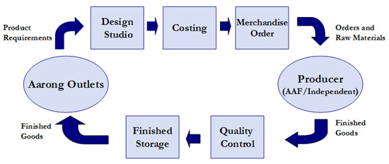
Figure 3 Process flow of Aarong

Competitor analysis of Aarong

Being one of the leading lifestyle brands of Bangladesh, Aarong’s top competitors are: Yellow, Sailor, Artisan and Ecstasy and Deshi Dosh. There are some other brands who are potential competitors for Aarong in future: Cats Eye, Rang, Dorjibari, Kay Kraft, Bibiana, Jatra, Anjan’s etc. Aarong has its own unique way of its competitive analysis as having high competitive advantages over its top competitors on almost every factors including product features, quality, supplier, technology, finance, distribution, product innovation and costing.

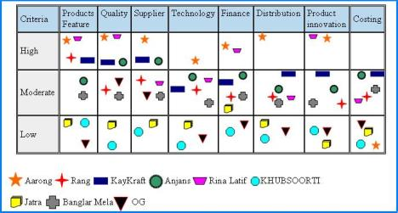

Figure 4 Competitor analysis of Aarong

PROJECT PART

SWOT analysis is the most useful tools for an analysis of the internal and external situation and it is used in almost every organization for knowing its strength, weakness, threats and opportunities to deal with its competitors in the market place. Though this powerful tool is mainly based on an imaginary situation, it’s very effective to evaluate the inner strength of successful organizations like Aarong.
Aarong’s strengths are included strong financial foundation, legal enterprise, good brand image as well as good brand awareness, handmade & unique products, traditional, dedicated workforce, socially responsible, backward linkage, fair trade leader, good office environment and one stop shopping. Dependence on BRAC, decentralized production, lack of standardization & automation in quality, lack of inter-departmental coordination, lack of planning & implementation follow up, high production lead times and low salary structure of stuffs comparing high price product are the main weakness of Aarong. The potential opportunities of Aarong are E-commerce and m commerce, new outlets, growing craft factory, franchise ventures and abundance of artisans. Besides, the threats are new competitors, economic crisis and commitment of the political parties, smuggled goods, westernization and higher price sensitivity in market.
The SWOT analysis of Aarong is done based on three consecutive steps which are:
- Identifying the four key elements: strength, weakness, opportunities and threats with contrast of Aarong’s resources and capacities.
- Applying the major strengths and opportunities that meet up Aarong’s mission and goals and make improvements in business situation over competitors.
- Reducing the major threats and weakness to implement action oriented activities to improve Aarong’s business strategies.

Strategy SWOT matrix of Aarong


- High price.
- New competitors.
- Lower quality and less uniqueness of products.
- Globally expand its business.
- Exploring online business.
- New distribution channel.
- Inability to supply.
- Higher price.
- Lack of proper training
- Valuable physical asset.
- Zero production damage.
- Market advantages.

STRENGTHS

OPPORTUNITIES

WEAKNESSES

THREATS

S
O
W
T
SWOT ANALYSIS

Figure 5: Strategy SWOT matrix of Aarong

Porter’s five model at Aarong

This theory is based on the concept that there are five forces that determine the competitive intensity and attractiveness of a market. Porter‟s five forces help to identify where power lies in a business situation. This is useful both in understanding the strength of an organization‟s current competitive position, and the strength of a position that an organization may look to move into.
Aarong uses Porter‟s five forces to understand whether new products or services are potentially profitable. By understanding where power lies, the theory can also be used to identify areas of strength, to improve weaknesses and to avoid mistakes.
Porter’s five forces of competitive position analysis:

Figure 6 Porter’s five factor at Aarong

Porter’s five model at Aarong
- Supplier power
An assessment of how easy it is for suppliers to drive up prices. This is driven by the: number of suppliers of each essential input; uniqueness of their product or service; relative size and strength of the supplier; and cost of switching from one supplier to another. The bargaining power at Aarong is low because Aarong has determines the price of the product for the supplier.

- Buyer power
An assessment of how easy it is for buyers to drive prices down. This is driven by the number of buyers in the market; importance of each individual buyer to the organization; and cost to the buyer of switching from one supplier to another. If a business has just a few powerful buyers, they are often able to dictate terms. Handicraft based retail industry like Aarong has a strong potential buyers, so they may reduce their switching cost as well as increase the buyers value.
- Competitive rivalry
The main driver is the number and capability of competitors in the market. Many competitors offering undifferentiated products and services, will reduce market attractiveness. Aarong follow the differentiated market strategy for different segmented customer. So its status in competitive rivalry is moderate.
- Threat of substitution
Where close substitute products exist in a market, it increases the likelihood of customers switching to alternatives in response to price increases. This reduces both the power of suppliers and the attractiveness of the market. Aarong may face moderate threats but because of its differentiated market strategy and quality of product customer are not willing to switch to alternatives.
- Threat of new entrants
Profitable markets attract new entrants, which erodes profitability. Unless incumbents have strong and durable barriers to entry, for example, patents, economies of scale, capital requirements or government policies, then profitability will decline to a competitive rate. As handicraft based lifestyle retail industry encourages new entry, Aarong creates high entry barrier through its high level of quality and brand value. so Aarong has a high threats on new entrance.

PESTEL analysis on Aarong

A PESTEL analysis is a framework or tool used by marketers to analyze and monitor the macro-environmental (external marketing environment) factors that have an impact on an organization. The result of which is used to identify threats and weaknesses which is used in a SWOT analysis.

Political Factors
These are all about how and to what degree a government intervenes in the economy. This can include – government policy, political stability or instability in overseas markets, foreign trade policy, tax policy, labor law, environmental law, trade restrictions and so on.
It is clear from the list above that political factors often have an impact on organizations and how they do business. According to political agreement of Bangladesh government Aarong is now export their product in UK and USA. Organizations need to be able to respond to the current and anticipated future legislation, and adjust their marketing policy accordingly.
Economic Factors
Economic factors have a significant impact on how an organization does business and also how profitable they are. Factors include – economic growth, interest rates, exchange rates, inflation, disposable income of consumers and businesses and so on.
These factors can be further broken down into macro-economic and micro-economic factors. Macro-economic factors deal with the management of demand in any given economy. Governments use interest rate control, taxation policy and government expenditure as theirmain mechanisms they use for this. Aarong concentrates on economic factors and they ask customer for tax through Vat with the actual price of the product.
Micro-economic factors are all about the way people spend their incomes. This has a large impact on B2C organizations in particular.
Social Factors
Also known as socio-cultural factors, are the areas that involve the shared belief and attitudes of the population. These factors include – population growth, age distribution, health consciousness, and career attitudes and so on. These factors are of particular interest as they have a direct effect on how marketers understand customers and what drives them. Aarong follows the social factor and by concentrating on that, it determine its target customer and marketing strategies.
Technological Factors
We all know how fast the technological landscape changes and how this impacts the way we market our products. Aarong established online shopping for distributing their product to their target customer. It follows social media as well as electronic media for communicating with their target market as well as for their promotional activities.
Environmental Factors
Aarong considers environmental factor important due to the increasing scarcity of raw materials, pollution targets, doing business as an ethical and sustainable company, carbon footprint targets set by governments. These are just some of the issues marketers are facing within this factor. More and more consumers are demanding that the products they buy are sourced ethically, and if possible from a sustainable source.
Legal Factors
Aarong follows legal factors include - health and safety, equal opportunities, advertising standards, consumer rights and laws, product labeling and product safety. It is clear that companies need to know what is and what is not legal in order to trade successfully. If an organization trades globally this becomes a very tricky area to get right as each country has its own set of rules and regulations.

FINDINGS

The customer relationship management department in Aarong deals with the cases of how they can retain their old customers, how they can attract new customers into their loyalty programs and how they can serve their customers even after their purchases are done. The main goal of the Customer Relationship Management (CRM) is to use the tools for integrating and automate sales, the marketing campaigns and to provide top notch customer support. The CRM department uses practices of the Customer Relationship Management and incorporates it with technologies to collect data and analyze their achievements in sales through the campaigns and the loyalty programs. They also use it to enhance the achievements of service objectives throughout the customer life cycle stages of customer acquisition, retention and development, at the same time, supporting broader organizational goals simultaneously. This is known as POS (Point of Sale).
But this year Aarong had something big for their loyalty card members.

Aarong 40 years festival

Aarong turned 40 this October and it held a 3 day grand event to celebrate it. This was not any ordinary event. As promised, their loyalty card members were invited, and were given additional privileges too
The Gold and Platinum card members were invited along with the VIP entry pass, with a plus one. Apart from that, they were also given the VIP seats for the Fashion Show.
This just shows that they delivered their promises of providing their loyalty card members with additional privileges even when they were done with the purchases.
Aarong wanted to go a mile further and wanted theri customers to know who Aarong is and what makes Aarong, this lifestyle brand that has embedded their mark in our lives.
There were live craft demonstrations, that showed how the products were made and how much perfection to details are there to ensure a product of high quality.
The live craft demonstration included tie-dye, block, embroidery, pottery, woven and wooden craft, rickshaw painting, jewellery making and production of silk.
The visitors were even allowed to participate in these workshops to get a feel of how Aarong's producers spend their time and talent to craft them by hand to perfection.
CRM was performed even during the preparation of the event. We had to make sure that the food vendors would cater the needs of our visitors to their heart's content. We needed to look for food vendors who would fit out targeted group that were partaking in the 40 years event. We had our loyalty card members and then there were the general audience. Combing these two and locking food vendors was not an easy thing to do. But we did came up with a fine list of caterers who were able to amaze us with their menu in a short span of time. The list includes Grassroots,Mad Chef, Secret Recipe, Garlic n Ginger, Brac Chicken and Aarong Dairy.
Day 1 of the event held the producer award night. This was done to pay respect and tribute to the producers who have given more than half of their life's time to Aarong. This also made the customers see that the clothes they wear have come from these very humble who are more than happy that their works and talents are being acknowledged by Aarong through the Ayesha Abed Foundation.
Day 2 was the fashion show where the people got to see the new lines of designs Aarong is going to launch in the market in the year 2019 for Aarong, Herstory, Taaga and Taaga Man. Along with that, a new line emerged inspired by peacock for females.
Day 3 was the much awaited concert where Aarong celebrated turning 40.
Aarong also organized a special VIP lounge sponsored by IPDC, for their privileged loyalty card members where they can sit and relax, enjoy snacks sponsored by BRAC Chicken and get them pampered from the Tonic Spa Zone sponsored by Tonic. Locking contacts with them was also a major part of the CRM department.
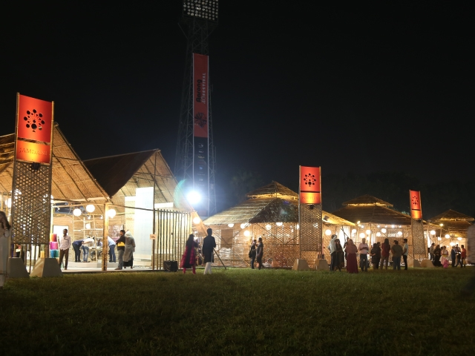
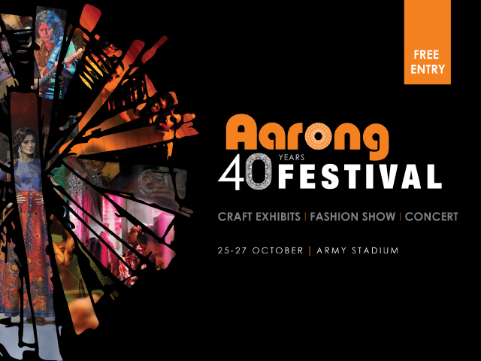
Figure 7 40 years festival highlights

CRM Activities

Aarong’s CRM activities include:
- Attitude changing procedures towards customers.
- Acquiring potential customers and retaining existing customers.
- Providing better CRM campaigns than other competitors.
- Loyalty program development for better service
- Partnership alliances
- Providing gifts to the loyalty card holders and birthday bonuses to them as well.
- VOCM & feedback Kiosk for improving customer satisfaction

Loyalty Card Programs

Aarong provides "My Aarong Reward Programs" for the customers who purchases the Aarong products and there is "Club Taaga" for the customers who purchase from Taaga and Taaga Man, another fashion line of Arong.

MARC
The first one is the MARC (My Aarong Reward Card) programs. Anyone can become an insider upon purchasing any amount of products from Aarong. And the more points the customers earn, the upgrade will be made according to that.
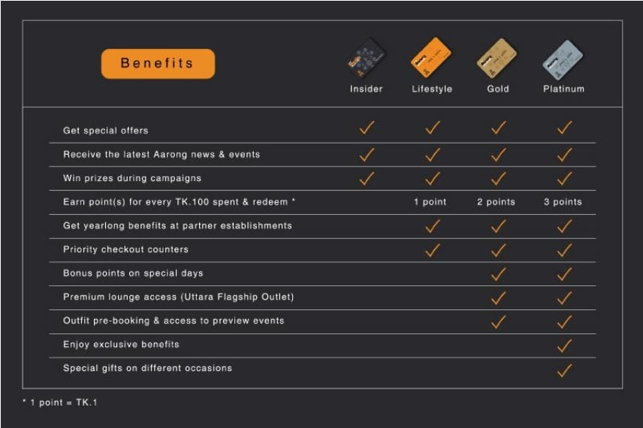
Figure 8 MARC Benefits
The procedure is simple, a customer will be automatically registered as an insider upon purchasing any Aarong products. All they have to do is share their contact number while making the payment. To be eligible for availing the members of Lifestyle, 10,000 taka or above worth of products needs to spent.
To be upgraded from Lifestyle to Gold, 3,000 points needs to be collected by the Lifestyle members within 2 years of the membership. And to be upgraded from Platinum to Gold, the Gold member needs to collect 8000 points within 2 years of being upgraded to Gold from Lifestyle.
Allocation of points are given below:
- Lifestyle members earn 1 reward point
- Gold members earn 2 reward points
- Platinum members earn 3 reward points
*100 taka per point, 1 point equals to 1 taka

Club Taaga
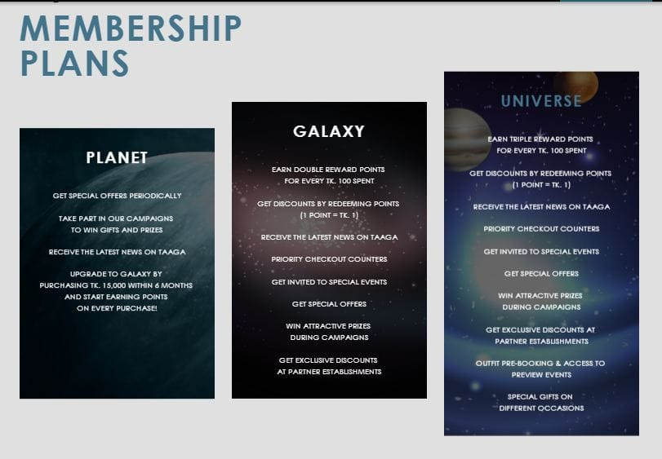
Figure 9 Club Taaga Plans
Any customers making a purchase of Taaga or Taaga Man products till 9,999 taka will be automatically registered as a Planet.
In order to be upgraded to Galaxy from Planet, the member needs to make a 15,000 taka purchsse on Taaga products within 6 months of subscription.
And to upgrade from Galaxy to Universe, the member needs collect 6,000 points within the next two years of subscription.
Allocation of points are given below:
- Planet members will get zero points
- Galaxy members will earn 2 reward points
- Universe members will earn 3 reward points
*100 taka for every points earned

CRM Campaigns

Aarong launches campaigns on different occasions to boost sales and to attract new customers to partake in their loyalty program plans. The main objective is to let to customers know that Aarong does not only sell clothing items, but they make sure that their customers choice and preferences get matched according to seasons. Aarong has a higher brand image and brand awareness among its loyal customers which makes the campaigns successful. These campaigns are aimed for their MARC card holders, it is also for Club Taaga, but since it is fairly new, the main target group are MARC.
During my internship program, Tonic Campaign and My Aarong Wedding Campaign were in operation. My Aarong Wedding campaign is still in operation though and will end in the month of February 2019.
Tonic Campaign started after the 40 year festival. Aarong gave selected My Aarong Reward members free Tonic Astha coverage for 3 months if they make any purchases from any Aarong outlets. Apart from that all My Aarong Reward members will get additional telco benefits, such as up to free 4GB data and other benefits on making any Aarong’s products till the 17th of October 2018.
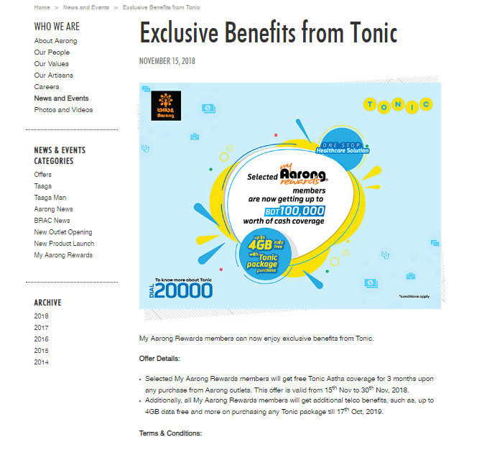
Figure 10 Tonic Campaign News and Events

Another exciting campaign to highlight this wedding season is the My Aarong Wedding campaign. The rules were simple, the bride or groom has to purchase any clothing item from the Aarong for the purpose of their wedding. And one winner will be given free packages from Dream Weaver, who will shoot and cover their entire wedding for free. There will be total 10 winners. One winner will be announced per week.

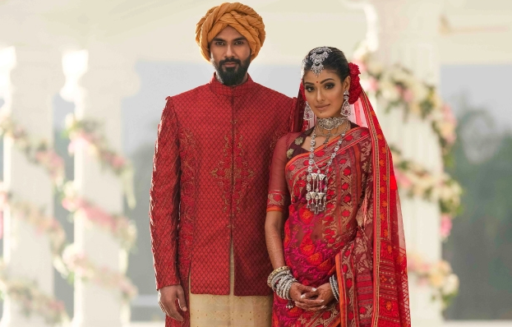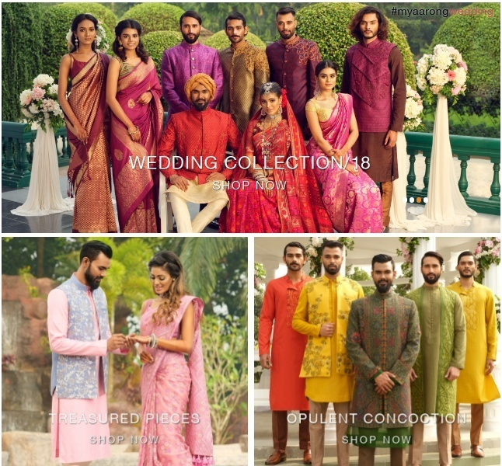
Figure 11Wedding capmaign promotional banners

Partnership Alliances

Aarong creates alliances to serve their MARC holders and Club Taaga members. The main is to lock at least 2 alliances a week. During my internship period, I have noticed that the ones Aarong has done campaigns with, they try to block alliances with them too. Even during the 40 years event, Aarong locked alliances with almost all of the food vendors.
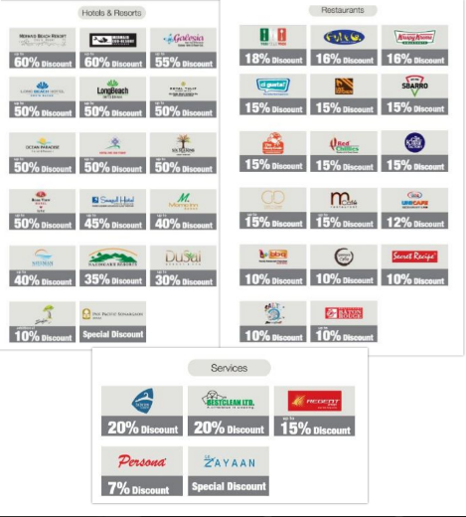

Figure 12 Aarong’s MARC partner alliances
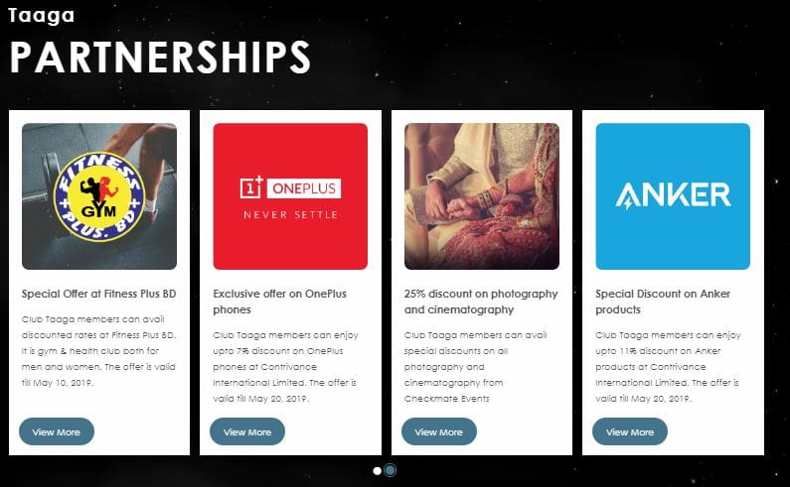

Figure 13 Aarong's Club Taaga Alliances

VOCM & Feedback Kiosk

Tablets have been given to all the outlets of Aarong to collect the customers' feedback in a regular basis. These are later analyzed and motored from the head office in order to interpret the outcomes in the report. The main objective of this is to see that all the queries and complaints are solved and that there should be an repeat of that particular solved query or complaint. NPS is used to get the feedback from the tablets or kiosk. The main purpose of NPS is used to measure the customers' experience during their shopping and how likely they are to refer Aarong to their friends, relatives or peers.The following steps are done throghout the feedback process.

Figure 14 VOCM steps
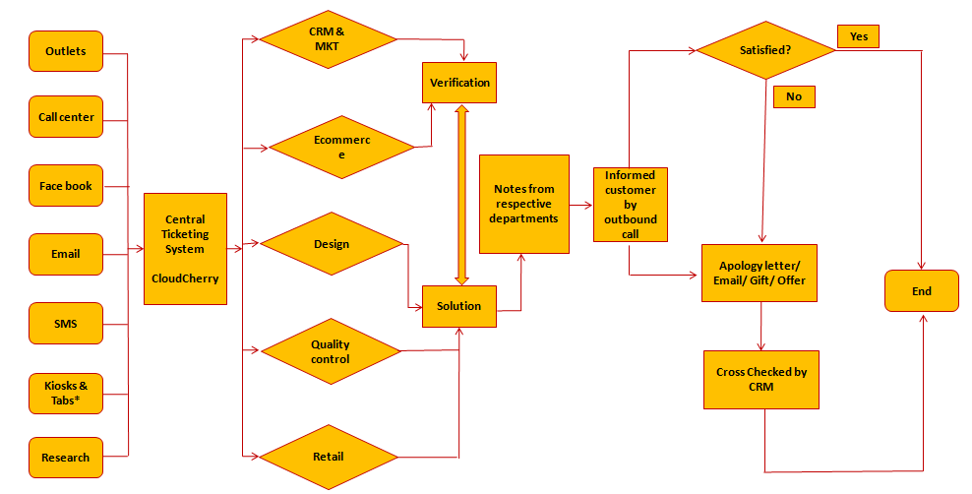
Figure 15 VOCM process flow

Customer feedback
Submit feedback
SMS/E-mail
Promoters
Detractors
Call center | Outlet Manager | CRM
Feedback database
Weekly/Monthly report published
Real time
SMS will send to promoters & Detractors
E- mail alert received by CRM & call center, Customer & Outlet manager will get SMS

Figure 16: Feedback process flow

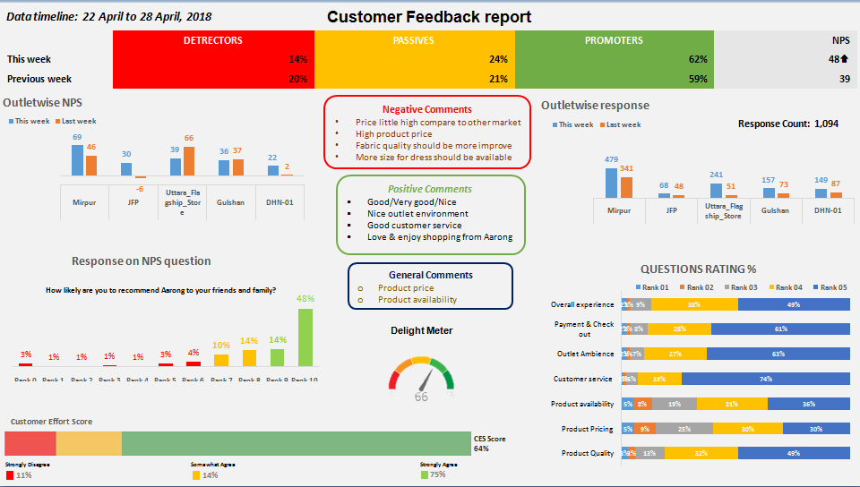
Figure 17Weekly feedback report demo

Figure 18Weekly Customer feedback rating

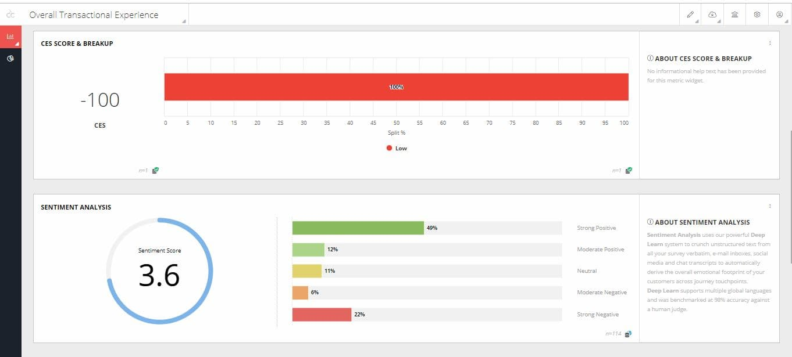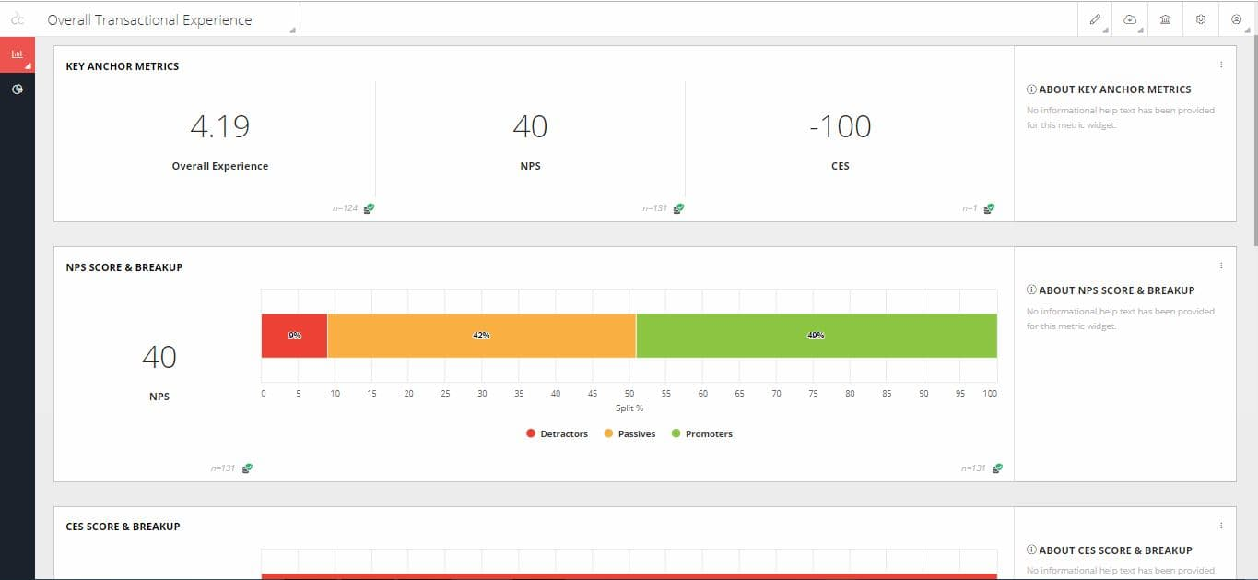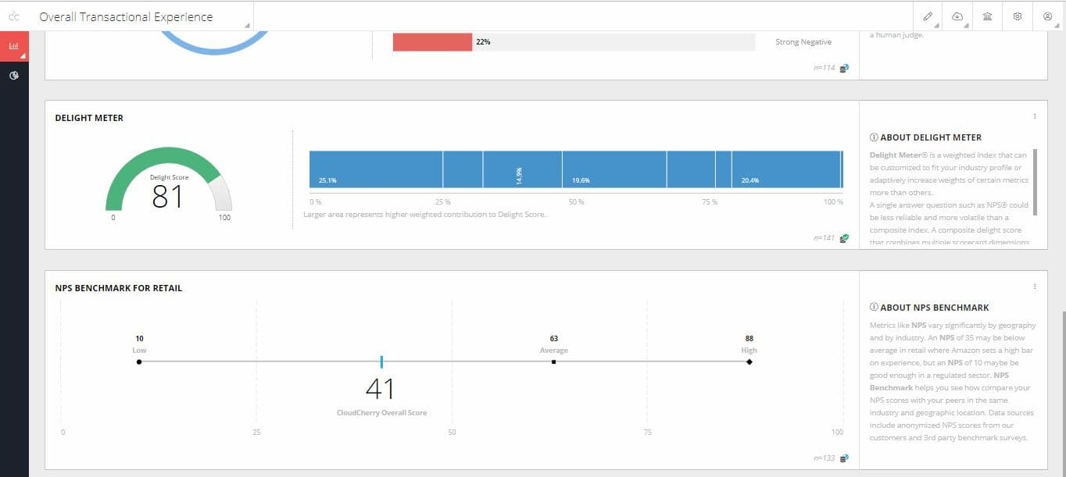

Figure 19Overall transaction experience

CRM Server
To keep the CRM department updated, Aarong uses CRM server. This keeps track of all points and details of the customers i.e. from Lifestyle to Platinum and from Planet to Galaxy. There are other uses of the server too, but as an intern I was given access to manual registration and of daily registered Planet and Galaxy members counts.
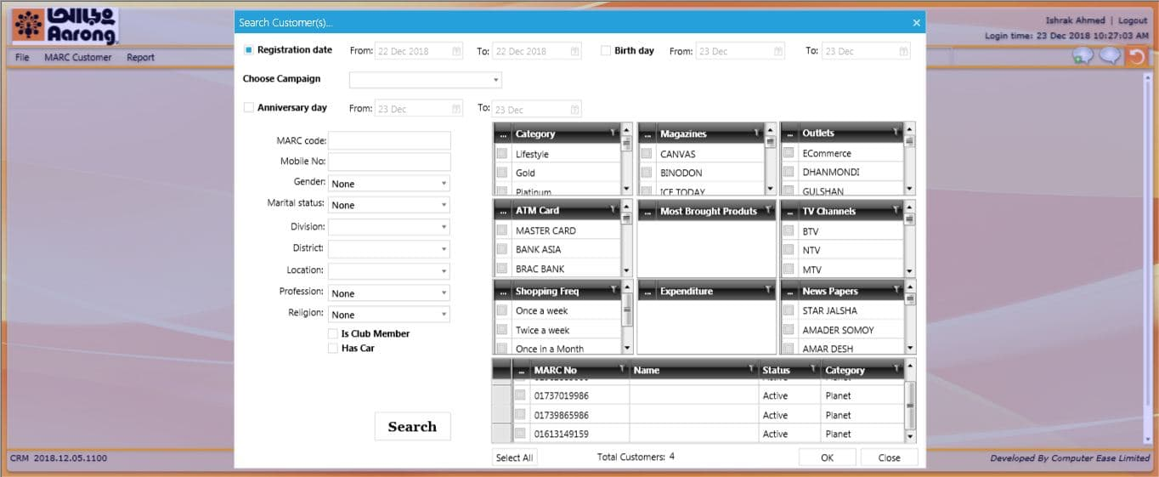
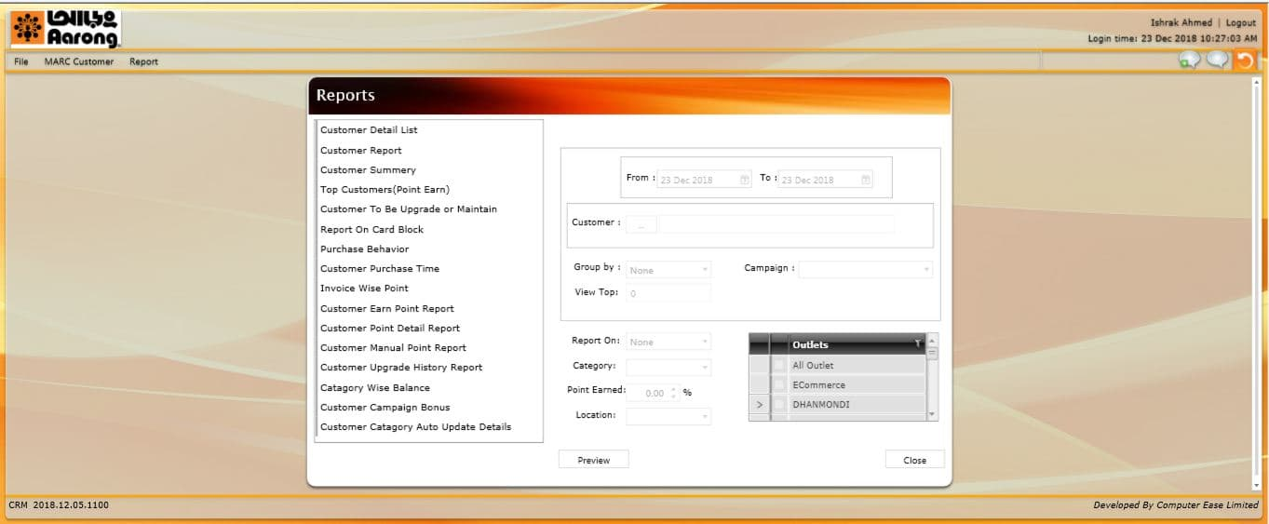Figure 20CRM Server Outlook

My time as an intern in the CRM department at Aarong showed me that there is a lot of process that goes while implementing a campaign. A lot of thinking and considerations are made not only for their existing loyalty members but also for the potential customers. A lot of thought goes in to the process for even making alliances and the CRM department goes through multiple organizations and picks one of the same category for their brand alliances. The outcomes are also evaluated of the campaign, this ensures that the campaigns were successful. The findings are:
- The success of a CRM campaign is positively related to sales.
- The positive NPS and quick responses leads to higher customer satisfaction.
- Solving the tickets as soon as possible leads to positive customer experience.
- The effectiveness of carrying out the campaigns leads to high turnover of sales which leads to higher registration of the loyalty programs.
The following two tables are the analysis of my internship findings.
CRM Campaign Achievements
Month | Campaign Name | KPI | Achievement | Engaged customers
September | Insider launch Sep 2 | - 95% invoice under Insider | - 50% Invoice under Insider  - Insider: 42,366 (Sep)  - Insider into Lifestyle: 000  - Insider sales: 6,95,98,002 | Total Insider till Date  115770
September | ABV Boost campaign  (Sep 12 – 25) | - Targeted Sale:  BDT 11,991,715  - TargetedAvailer: 1,944 | - Actual Sales:BDT 35,766,686  - Actual Availer: 3,956  - Actual Responder: 14,655  - Sales target achievement:298.26%  - Actual availer hit rate: 3.53%  - Average ABV boosted: 110% | 18611
November | Tonic CRM Campaign  Nov 15 - 30 | - Targeted Availer- 4000 | - Actual Sale: BDT 3,688,689  - Actual Availer: 1294 | 1294

Table 1 CRM campaign achievements, 2018

There is given a latest registration list in the below:
 | Oct_2018 |  |  |  | Nov & Dec_2018
 | Outlet name | Registration Target | Total_Oct | Achievement (%) | Outlet name | Registration Target (Nov & Dec) | Total_Nov | Achievement (%)
 | Ecommerce |  |  | 0% | Taaga outlet
 | Dhanmondi | 205 | 300 | 146% | Ecommerce |  |  | 0%
 | Gulshan | 333 | 422 | 127% | Dhanmondi | 521 | 218 | 42%
 | Moghbazar | 120 | 162 | 135% | Gulshan | 713 | 338 | 47%
 | Sholoshohor | 165 | 243 | 147% | Moghbazar | 331 | 115 | 35%
 | Sylhet | 66 | 166 | 250% | Sholoshohor | 386 | 144 | 37%
 | Khulna | 20 | 44 | 226% | Sylhet | 161 | 82 | 51%
 | Uttara | 169 | 189 | 112% | Khulna | 40 | 48 | 120%
 | Halishahar | 60 | 51 | 85% | Uttara | 500 | 155 | 31%
 | Mirpur | 96 | 128 | 133% | Halishahar | 105 | 31 | 30%
 | Comilla | 25 | 61 | 247% | Mirpur | 307 | 94 | 31%
 | Narayanganj | 31 | 62 | 199% | Comilla | 82 | 34 | 41%
 | Rankin Street | 48 | 134 | 279% | Narayanganj | 86 | 36 | 42%
 | JFP | 116 | 128 | 111% | Rankin Street | 235 | 85 | 36%
 | Dhanmondi-02 | 134 | 206 | 154% | JFP | 291 | 106 | 36%
 | Banani | 59 | 110 | 188% | Dhanmondi-02 | 312 | 123 | 39%
 | Bashabo | 49 | 66 | 134% | Banani | 179 | 75 | 42%
 | Bashundhara City | 155 | 197 | 127% | Bashabo | 88 | 41 | 47%
 | Bogra | 26 | 69 | 265% | Bashundhara City | 432 | 256 | 59%
 | Mirpur 2 | 91 | 52 | 57% | Bogra | 90 | 37 | 41%
 | Mymensingh | 96 | 100 | 104% | Mirpur 2 | 100 | 40 | 40%
 | Total | 2,063 | 2,890 |  | Mymensingh | 350 | 30 | 9%
 |  |  |  |  | Total | 5,309 | 2,088

Table 2CRM registration list, Dec 2018

Conclusions and Recommendations

Recommendations
- In terns of their promotional activities, Aarong needs to be come up with new ways of promotional activities so that their campaigns will be able to generate more buzz, the best method will be to go for digital banners as it is more eye catching
- Aarong needs to create videos too, alongside their photo shoot.
- Aarong needs to arrange more training programs since there is a huge gap between the outlets and head office.
- Aarong should introduce flash sale and special hour sales for their MARC and Club Taaga members.
- Aarong should find a better way of improving their customer care service further so that the tickets can be solved as soon as possible.

Conclusion

Being a fashion house for 40 years in the market who has embraced the traditional side of Bengali heritage, Aarong has grown a lot and has spread all over Dhaka and parts of Bangladesh in the form of 21 outlets and is striving to grow more. The aim of Aarong was simple to aid their producers for their hard work and that they will not be cheated. Even today, Dr. Fazle Abed has kept his promise and their producers are still dedicated to Aarong, the proof was seen in the 40 years festival where there were producers who have given more than 30 years of their lives to Aarong.
And keeping up with the modern Marketing mechanisms, the CRM department of Aarong is coming up with new and eye catching campaigns and are always striving to give benefits and privileges to their customers, even after their purchases have been made.

Appendix

References
- My Aarong Rewardsofficial website
http://www.aarong.com/marc/
- Club Taaga official website
https://www.clubtaaga.com/
- BRAC Official Website regarding the AAF and the producers
http://www.brac.net/brac-enterprises/item/878-aarong
- Facebook and other social media regarding the campaigns.

List of Acronyms

1. BRAC = Bangladesh Rural Advancement committee
2. CRM = Customer relationship management
3. VOCM = Voice of customer management
4. MARC = My Aarong reward card
5. AAF = Ayesha Abed Foundation
6. PR = Public Relations
7. NPS = Net promoter score

Tables, Charts, Graphs

List of Aarong outlets
Location | Date of Inception
Sobhanbag, Dhaka (Closed) | 1978
Sholoshahar, Chittagong | 1983
Moghbazar, Dhaka | 1984
Zindabazar, Sylhet | 1985
Lalmatia, Dhaka | 1989
New Market, Khulna | 1995
Gulshan, Dhaka | 1997
Wari, Dhaka | 1998
Uttara, Dhaka ( Flagship Outlet) | 2001
Halishahar, Chittagong | 2008
Mirpur, Dhaka | 2010
Ranir Bazar, Comilla | 2012
Ukilpara, Narayangonj | 2013
Jamuna Future Park, Dhaka | 2014
Dhanmondi, Dhaka | 2015
Banani, Dhaka | 2015
Bashabo, Dhaka | 2016
Bashundhara City, Dhaka | 2017
Jaleshwaritala, Bogra | 2017
Mymensingh | 2018
Mirpur-2, Dhaka | 2018

Table 3 List of all outlets of Aarong

3. Loyalty program of local brand
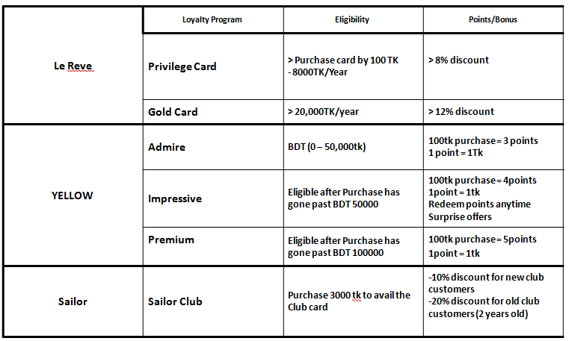

4. Loyalty program of international and local brand
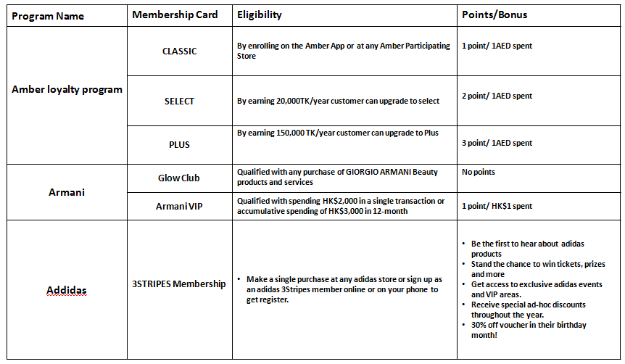
Table 4Loyalty Programs of competitors

