Internship Report on
“Training and Development on The City Bank Limited”

Submitted By:
Name: Humaira Rahman Happy
ID no: 111 133 087
School of Business and Economics
United International University

Submitted To:
Md. Abdul Mohaimen
Assistant Professor
School of Business and Economics
United International University

Date of submission: 24/11/2018

“Training and Development on
The City Bank Limited”

Letter of Transmittal

Date: 24.11.2018
Mr. Md. Abul Mohaimen
Assistant Professor
School of Business and Economics
United International University

Subject: Submission of Internship Report

Dear Sir,
With great pleasure I am submitting my Internship Report on “Training and Development on The City Bank Limited” based on my three months internship period. This report has been submitted as an important requirement of BBA curriculum. The internship program has provided me with an opportunity of having an exposure to the working environment and on the job experience in a renowned private commercial bank, The City Bank Limited Ltd. I have found the study to be quite interesting, beneficial & insightful.
I have tried my level best to prepare an effective & creditable report. I hope you will find this report significance of all the labor I have put in it.
I welcome your entire query & take pride to answer them.

Yours sincerely,

………………………
Name: Humaira Rahman Happy
ID No: 111 133 087
BBA Program (HRM)
United International University

Acknowledgement
The internship program is very helpful to bridge the gap between the theoretical knowledge and real life experience as part of Bachelor of Business Administration (BBA) program. This internship report has been designed to have a practical experience through the theoretical understanding.
It is my privilege that I had the opportunity to do internship in The City Bank Limited, on their Islampur Road Branch. I would like to thank all the people on whom I carry out my internship. I express my deep gratefulness to Mr. Nitai Chandra Datta (VP & BM), Md. Riad Hossain Bhuyain (CSO), Md. Mirza Shamim Ihsan (CSM), Md. Anamul Haque (CSM), Md. Jubear Hasnat (ARM) of The City Bank Limited giving me the opportunity to work with them and get three months experience in my internship program on their branch. Also I express my deep gratefulness to all employees of for cooperated to collect various requirement supports from various sources & help me to complete this internship report.
Finally, I would like to thank my respective faculty lectures of United International University for sharing their knowledge, experience and understanding throughout the entire length of my Bachelor of Business Administration Program at United International University.

Table of Contents
1. Chapter-1: Introduction of the Report 8
1.1. Introduction 8
1.2. Origin of the report 8
1.3. Objectives of the report 9
1.4. Scope of the study 9
1.5. Limitations of the study 9
1.6. Methodology 10
1.6.1. Data collection technique 10
1.6.2. Sampling 11
2. Chapter-2: Company Overview 15
2.1. Overview of company 15
2.2. Mission Statement 16
2.3. Vision Statement 16
2.4. Organogram: 17
Chapter 3 18
3. Chapter-3 : Literature Review & My discussion 19
3.1. Literature Review 19
3.2. My discussions 26
3.2.1. TRAINING POLICY 26
3.2.2. Training Need Identification 26
3.2.3. Training Categories 27
3.2.4. Training Calendar 28
3.2.5. Training Approval 28
3.2.6. Training Cost 28
3.2.7. Training Bond 28
3.2.8. Responsibility 29
3.2.9. Training evaluation 30
3.2.10. Training History 30
3.2.11. Management Trainee Performance Management 32
3.2.12. Management Trainee Graduation & Placement 32
3.2.13. Training need collection and Training Calendar Preparation Procedure 33
3.2.14. Training Coordination Procedure - International Training 34
3.2.15. Training Payment Procedure 35
3.2.16. Learning & Development Initiatives: 2017 35
4. Chapter-4: Analysis and Interpretation 44
5. Chapter-5: Conclusion and Recommendations 53
5.1. Recommendations: 53
5.2. Conclusion: 53
6. Bibliography 57

Executive Summary

The report is based on the “Training and Development on The City Bank Limited”.
Internship program is the pre-considered necessary for the commencement in BBA. Classroom discussion can't make a student best in coping with the actual commercial enterprise scenario; consequently it is an opportunity for the student to know approximately the real existence situation through this application. A file has to be built for the university and organization requirement. The topic of the report is “Training and Development on The City Bank Limited”. The main purpose of the report becomes very clear from the topic of the report. The report is broadly categorized in five different parts. At first there is introduction, origin of the report, statement of the problem, objectives of the study, Scope of the Report, Methodology of the study, and limitation, data collection technique, sampling. Part two describes the overview of THE CITY BANK LIMITED, vision, mission, values, activities of the company, organogram, product and services. Part three focuses on a literature review which is a scholarly paper, which includes the theoretical knowledge including about Training and Development, Types of Training, Vital issues in Training and Development, Strategic Focus in Training, Relevance of Training, Planned Training, Training Objectives, Training Proposal and Planned of Training , Training Aids and Support Materials, Evaluation of Training, Responsibility for Training, Why Training Fail, Trainers and Training, Training Cycle, Training Methods, Training Administration. Part four focuses on employee satisfaction level. Part five narrates a concluding, summery, bibliography, and appendix.

Chapter 1
(Introduction of the Report)

Chapter-1: Introduction of the Report

Introduction
The City Bank Limited is a full service scheduled commercial bank. It has each local and international Institutional shareholder. The financial institution is basically pushed with a view of making opportunities and pursuing market niches not historically meet by using conventional banks. The City Bank has been motivated to provide “best-in-the-class” services to its diverse assortment of customers spread across the country under an on-line banking. These days, the city bank is one of the fastest developing banks. With a view to support the deliberate increase of its distribution, community and its numerous enterprise segments, the bank is currently looking for marvelous aim orientated, enthusiastic, individuals for numerous commercial enterprise operations. The financial institution wants to build a profitable and socially responsible monetary group. It cautiously listen to the marketplace and commercial enterprise potentials, it is also helping stakeholders to build an innovative, healthful, democratic and poverty free Bangladesh. The internship program of BBA is a partial requirement to take a taste of real existence project carried out through the intern and it is a crucial a part of BBA program. This report presents the outcomes of the course of the internship on The City Bank Limited.

Origin of the report
This document is an internship file prepared as a demand for the completion of the BBA program. The number one purpose of the internship was to provide ‘on the job’ publicity to the pupil and an opportunity for translation of theoretical conceptions in real existence state of affairs. The students are placed in organizations, groups, research institutions as well as development initiatives.
In this connection, after the completions of the BBA program, I was assigned to Training and Development on The City Bank Limited for practical orientation. I chose the topic
“Training and Development on The City Bank Limited” for my internship report under the supervision of Mr. Nitai Chandra (BM of City Bank), Mr. Riad Hossain Bhuiyan (CSO), Mr. Mirza Shamim (CSM) department of Customer service of The City Bank Limited.

Objectives of the report
The objective of the study is to gather practical knowledge HR and Training and Development on The City Bank Limited. This internship gives us a chance to co-ordinate with the theoretical knowledge and the practical experience. The following are of objective for internship in bank:

- To apply theoretical knowledge in the practical field.
- To know the banking operation.
- To know the process of training.
- To know their development by training programs.

Scope of the study
The report covers retail banking offerings, processes and activities of The City Bank Limited. This record mainly emphasizes on the gathering technique and jobs.

Limitations of the study
There were some barriers whilst accomplishing the report, those are summarized here:
- The major impediment is while making ready this report on time. As the internship program was for limited period, so it is not viable to focus on the entirety deeply.
- Work pressure within the office changed some other issue proscribing this report from being more distinctive or analytical.
- Confidentiality of information is became another barrier that hindered the study. every employer has its personal secrecy that is not revealed to a person outdoor the agency. While gathering information on the city bank limited, personnel did not disclose sufficient information for the sake of confidentiality rule of the organization.

Methodology
For smooth and accurate study everyone has to follow some rules & regulations. The
study inputs were collected from two sources:
- Primary sources
    - Practical desk work
    - Face to face conversation with the officer
    - Direct observations
- Secondary sources
    - Annual report of The City Bank Limited Ltd.
    - Files & Folders Memos & Circulars
    - Daily diary (containing my activities of practical orientation) maintained by the researcher,
    - Various publications on Bank,
    - Websites,
    - Different circulars sent by Head Office and Bangladesh Bank.

Data collection technique

Sources of Data Collection:
The data are collected from two sources --
Primary sources:

- Practical banking work.
- Discussion with the employees of the City Bank limited.
- Personal Observation.

Secondary sources:
- Annual report, publications, training materials
- Periodical statements of the bank, brochures, booklets etc.
- Official Website of the City Bank Ltd.
- Documentary file of the City Bank Ltd.
Data Process and Analysis:

- Collected information based on my own experience.
- Detailed analysis, working variable future projection and working definitions are incorporated in the report.

Sampling
- Population: Population sampling is the process of taking a subset of subjects that is representative of the entire population. The sample must have sufficient size to warrant statistical analysis. Sampling is done usually because it is impossible to test every single individual in the bank. It is also done to save time, money and effort while conducting the research.
- Sampling Unit: A single section selected to research and gather statistics of the whole. For example, they have 102 branches so I pick their islampur road branch as sampling unit.
- Sample Frame: A sampling frame is the source material or device from which a sample is drawn. It is a list of all those within a population who can be sampled, and may include individuals, households or institutions. I have selected 20 individual from the population of the city bank ltd.
- Sampling Design: A sample design is made up of two elements. Sampling method refers to the rules and procedures by which some elements of the population are included in the sample. Some common sampling methods are simple random sampling, stratified sampling, and cluster sampling.
- Sample Size: Sample size determination is the act of choosing the number of observations or replicates to include in a statistical sample. The sample size is an important feature of any empirical study and here the sample size is 20, in which the goal is to make inferences about a population from a sample.

- Research Questions:
Questionnaire for “Training and Development”
Personal Information
Gender:
- Male
- Female
Age:
- 15-25
- 26-35
- 36-45
- 46 and above
Designation:
Working Period: ____Year____Month
-----------------------------------------------------------------------------------------------------------
Please read each statement carefully, think in terms of your opinion about ‘The
City Bank Limited’ and circle the number which most closely related to your thinking.
Please do not hesitate to answer; this research is for only academic purposes.
Your information will be kept confidential. Thank you.
1  Strongly Disagree | 2  Disagree | 3  Neither Agree or disagree | 4  Agree | 5  Strongly Agree

- I need training by terms.
1 | 2 | 3 | 4 | 5

- I am satisfied with the training I received from my present job.
1 | 2 | 3 | 4 | 5

- I am getting on the job training from my supervisor.
1 | 2 | 3 | 4 | 5

- I think my training duration was sufficient.
1 | 2 | 3 | 4 | 5

- My training environment was favorable.
1 | 2 | 3 | 4 | 5

- The training was relevant with my job.
1 | 2 | 3 | 4 | 5

- The existing training method is suitable to adopt the changing technology.
1 | 2 | 3 | 4 | 5

- The training process and method need to be change.
1 | 2 | 3 | 4 | 5

- Management gives priority to train the executives.
1 | 2 | 3 | 4 | 5

- My organization evaluates my performance effectively for training selection.
1 | 2 | 3 | 4 | 5

- After completion of training that add value and enhanced skill.
1 | 2 | 3 | 4 | 5

- I am independent to express my feedback about training and development to the concern management.
1 | 2 | 3 | 4 | 5

Chapter 2
(Company Overview)

Chapter-2: Company Overview

Overview of company
The City Bank Limited, with institutional shareholdings by way of international Finance organization (IFC) and Shore cap international, has been the fastest growing bank in 2005 and 2006. at the 12 months quit of 2006, The city bank ltd. had recorded a 103 percent growth in assets, and a 65 percentage increase in liabilities, with an working income of eighty four percentage over the previous 12 months 2005.
A completely operational industrial bank, The city bank ltd. specializes in pursuing unexplored marketplace niches within the Small and Medium corporation enterprise, which hitherto has remained in large part untapped within the country. in the closing 4 year of operation, the bank has dispensed over BDT 1200 crore in loans to almost 32,000 small and medium entrepreneurs. The management of the Bank believes that this sector of the economy can contribute the most to the rapid generation of employment in Bangladesh. the most established private Commercial Banks working in Bangladesh. it's miles a best bank some of the maximum installed five industrial Banks inside the kingdom which began their operations in 1983. The bank started its adventure on twenty seventh March 1983 thru commencing it’s to begin with department at B. B. road branch inside the capital, Dhaka city. It turned into the visionary business enterprise of around thirteen community businesspeople who overcame the colossal vulnerabilities and risks with mettle and enthusiasm that made the inspiration and forward walk of the bank attainable. the ones guide chiefs started the excursion with just Taka 3.4 crore really worth of Capital, which now's a respectable Taka 2311.78 crore as capital and shop. The bank now has add up to one hundred twenty branches which incorporates ninety nine on line branches, 1 simple Islamic Banking department, 1 SME gain recognition and eleven SME/Agri branches spread over the period and expansiveness of the country. apart from these traditional conveyance focuses, the bank is likewise extremely dynamic inside the choice conveyance quarter. It presently has 311 ATMs of its own; and ATM providing course of action to associate banks that has more than 1150 ATMs set up; SMS Banking; internet Banking et cetera. It as of now began its patron name middle operation. The city bank is the fundamental financial institution in Bangladesh to have issued twin currency credit Card. The bank is a vital man or woman from VISA international and it issues both nearby forex (Taka) and overseas foreign money (US dollar) card confines in a solitary plastic. VISA Debit Card is another accepted object which the financial institution is pushing tough maintaining in mind the stop goal to returned out the strains on the branch made with the aid of its surprising base of about 400,000 retail customers. The dispatch of VISA prepaid Card for the travel vicinity is as of now in progress. The city bank has propelled American Express Credit Card and American Express Gold credit card in November 2009. This bank is the close by overseer of the brand and is in charge of all operations assisting the issuing of the new mastercard, consisting of charging and bookkeeping, client benefit, credit administration and charge approvals, and also showcasing the cards in Bangladesh. It moreover offers remarkable benefits anywhere during the globe with extra than 13,000 provide at extra than 10,000 shippers in seventy five countries.
(https://www.thecitybank.com/highlights.php).

Mission Statement
- .Offer wide array of products and services that differentiate and excite all customer segments.
- .Be the ‘Employer of choice’ by offering an environment where people excel and leaders are created.
- .Continuously challenge processes and platforms to enhance effectiveness and efficiency.
(https://www.thecitybank.com/highlights.php)

Vision Statement
The Financial Supermarket with a Winning Culture Offering Enjoyable Experiences. (https://www.thecitybank.com/highlights.php)

Organogram:
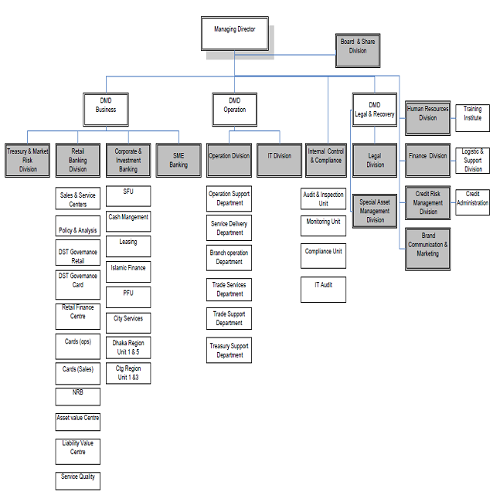

Chapter 3
(Literature Review & My discussion)

Chapter-3: Literature Review & My discussion

Literature Review
Introduction:
The last goal of every training and development program is to feature fee to human useful resource. Organizations must make training and development of their personnel a continuous activity.
According to Obisi (2001) training is a method via which the capabilities, expertise and information of an employee is stronger and accelerated (Obisi, Employee development, Issues and dimensions,, 2001). He argues that training need to take region simplest whilst the need and targets for such schooling have been diagnosed. Scott, clothier and Spriegel (1977) agree that training is the nook-stone of sound control, for it makes employees greater powerful and productive (Scott. Clotheir and Spriegel, 1977). According to Mamoria (1995) training is a realistic and critical necessity because it permits employees to increase and upward push within the corporation and increase their marketplace cost, incomes electricity and activity protection. Mamoria explains that training facilitates to mold personnel’ attitudes and help them to make a contribution meaningfully to the business enterprise (Mamoria, 1995). The enterprise advantages due to better performance of employees. He similarly states that a properly educated employee might make a better and financial use of substances and device which might move an extended manner to limit wastages.

Types Of Training:
There are two predominant kinds of training, on-the -job training and off- the -job training as recognized with the aid of Alo (1999): On-the-job training, is typically treated by way of colleagues, supervisors, managers, mentors' to assist personnel modify to their job and to equip them with suitable process associated capabilities (Alo, 1999). According to Armstrong, on-the-job training is the only way to develop and practice the specific managerial, team leading, technical, selling, manual, and administrative skills needed by the organization and it has the advantages of actuality and immediacy as the individual works, learns and develops expertise at the same time (Armstrong, 1995).

Off-the-job Training
According to Ejiogu (2000) off-the-job training might consist of lecture, vestibule education, function gambling, case examine, dialogue and simulation. Armstrong (1995) indexed institution sports, group building, distance gaining knowledge of outside and workshops as a part of off-the-job training (Ejiogu, 2000).

.Understanding Training and Development
According to Obisi (1996) the standards, training and development are used interchangeably (Obisi, Personnel Management, 1996). however, it is able to be differentiated from the alternative. Training is for particular task motive and at the same time it improves the past specifics, but improvement covers no longer. most effective those activities which enhance task performance, and additionally the ones which bring about growth of character. In training, you the usage of one stone to kill one fowl whilst in improvement you operate one stone to kill two birds Mamoria, (1995) (Mamoria, 1995).

Vital issues in Training and Development
According to Armstrong (1995) the following issues are relevant to Training and development effectiveness (Armstrong, 1995).

- Organization training and development philosophy
- Strategic focus in Training
- Relevance of training
- Training process
- Identifying Training Needs and Training Needs analysis
- Identifying Training Objectives
- Evaluation of Training

Strategic Focus in Training
According to Armstrong (1995) training method takes an extended- term view of what abilties, understanding and degrees of competence personnel of the company need (Armstrong, 1995). training must be an essential a part of the management process which in turn calls for managers to study frequently with their groups and the individuals reporting to them, overall performance with regards to agreed targets.
Planned Training
According to Kenney and Reid (1995) deliberate training is the planned intervention geared toward attaining the learning essential for progressed activity overall performance. planned training in line with Kenney and Reid consists of the subsequent steps:
- Identifying and defining the training needs
- Outline the learning required in phrases of what capabilities and understanding need to be learnt and what attitudes need to be modified.
- Define the main objectives of the training secessions
- Plan training applications to satisfy the desires and goals with the aid of the use of proper mixture for training strategies and locations.
- Decide who provides the training and must evaluate training.
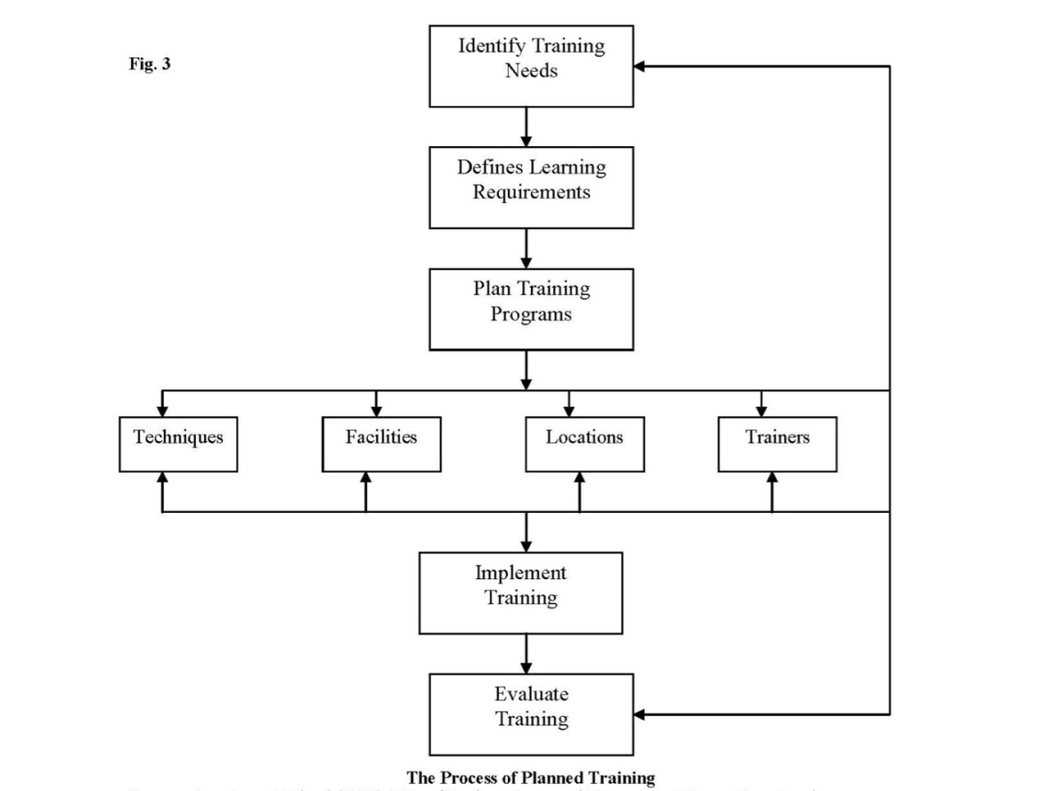
Source: Armstrong Michael (1995) A Hand Book on Personnel Management Kogan Page London.
Armstrong (1995) gives a clearer expertise of what is meant by way of training desires. He writes that the space among what people realize and may do and what human beings ought to realize and be capable of do is referred to as training need (Armstrong, 1995). therefore when an enterprise observes that there's a gap between what's occurring and what must manifest, there's a training need.
Analysis of training need: There are 4 most important methods of studying training desires.
- .Analysis of jobs
- Overall performance appraisal
- Engaging in training surveys
- Enterprise and human resource analysis (Armstrong, 1995).

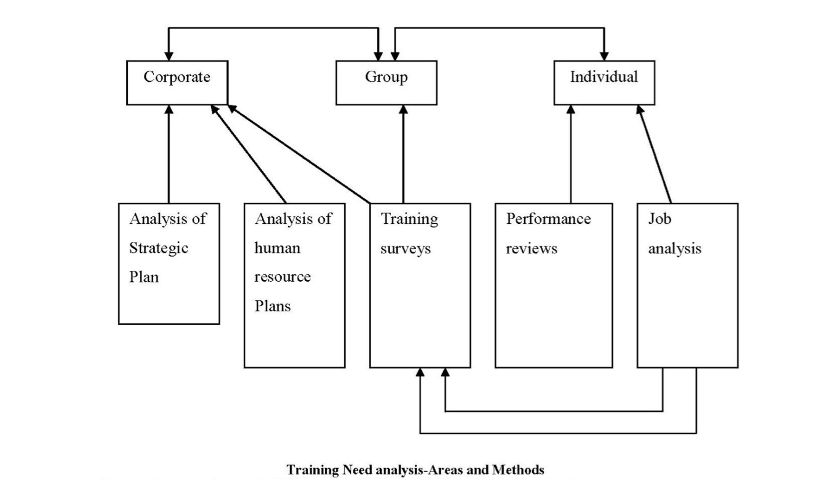

Training Objectives
Goals of training are what employees might obtain and benefit after present process the training program. The advantages of a training program check with the goals. Before personnel embark on any training program, it's far assumed that there are handicaps. If the handicaps are conquering after present process the training application it method that objectives were carried out.

Training Proposal and Planned of Training
Employee training is not cheap. It is a costly affair as care should be taken in drafting training proposal. The following steps should be taken into consideration, while drafting a training proposal
- Identify the needs of training
- Develop a theme for the training program.
- Introduce the theme to the employees.
- Identify the objectives of training program
- Set the content of training
- Tells participants about their benefits
- Measure the organization’s benefits
- Make employees as human resource
- Set the exact duration of training program
- Calculate the total cost
- Select the training method properly
- Select a Venue
- Set the time
- Target group
- Feedback, Monitoring and follow-up

Training Aids and Support Materials
According to Mamoria (1995) training substances need to be organized with care and allotted a number of the trainees in order that they'll come properly-organized to a session and are capable of recognize the operations and demonstrations fast and effectively (Mamoria, 1995). Mamoria argues that the subsequent are the kind of equipment and system applied to impart powerful training.
- Lecture
- Role gambling
- Case studies
- Use of pamphlets, charts, brochures, booklets, guide and many others.
- Pictures, images, books, slides, film projector, movie strips, tape information.
- Study room and libraries
- Teaching machines.
Evaluation of Training
Hamblin (1974) writes that evaluation of training program is any try to gain statistics (remarks) at the consequences of a training application, and to evaluate the cost of the training within the mild of the data received (Hamblin, 1974).
Assessment of training program might permit corporation discover whether or not or now not the training has carried out its cause and goals. one of the methods of comparing training programs is through getting reactions from the trainees via asking people who attended the training to put in writing a document or by means of designing a complete questionnaire which ought to be allotted to individuals who attended the education program. Records received from the questionnaire ought to be analyzed for fulfillment or failure of the education. training can also be evaluated via task performance.

Why Training Fail
.Organizations training practices can fail for lots reasons. Burak, Elmer and Smith Robert (1977) give the following reasons:
- The advantages of training are not clear to the top management.
- The pinnacle management rarely rewards supervisors for sporting out effective training.
- The top control hardly ever fixed a plans and budgets money for training.
- Training outside to the employing unit once in a while teaches strategies on technique opposite to exercise of the contributors scheduling.
- Trainer offers restricted counseling and consulting to the relaxation of the corporation. (Burak, 1977).

Training Cycle
According to Management Services Commission (1981) training Cycle includes figuring out deficiencies, designing inputs, out places and figuring out studying techniques which ought to be evaluated to provide remarks which may be used to enhance next training. in keeping with Imanyi (2002) systematic training cycle could consist of the subsequent: Figuring out training desires, Planning the training, Carrying out the training and Evaluating the training to understand whether or not the training program is profitable (Imanyi, 2002).

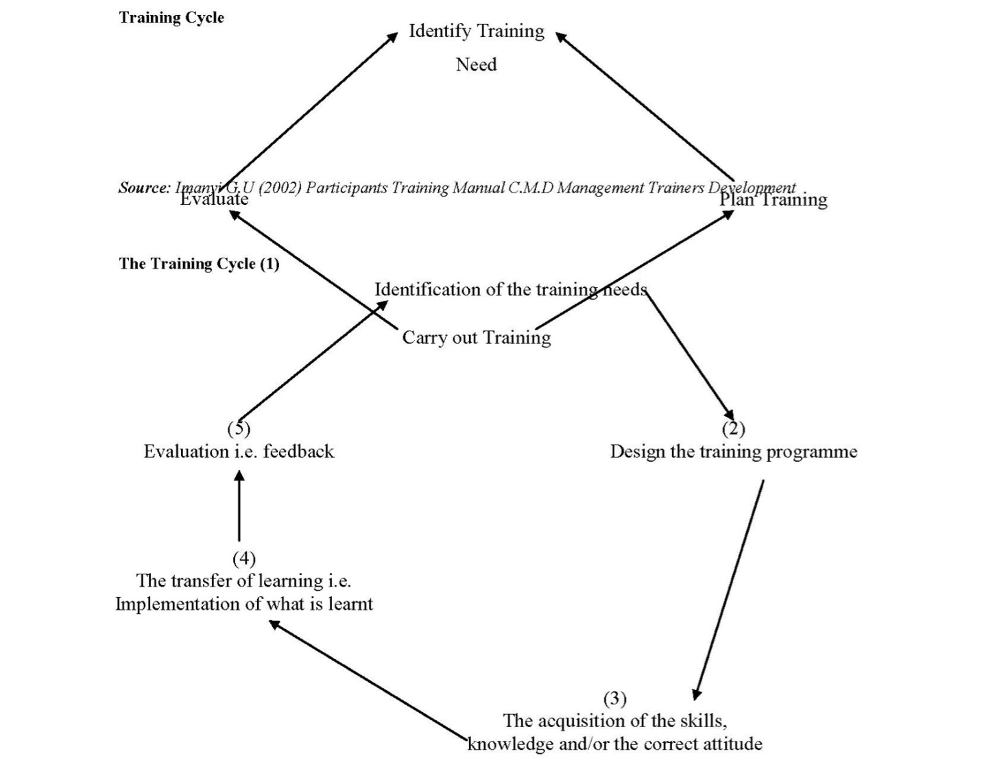

Source: Atiomo (2000) Practical Human Resource Management Malthouse Press Ltd Lagos.

Training Methods
According to Armstrong (1995) there are a huge type of training strategies that may be used. those can be divided indaily: On-the-job strategies, which might be practiced on a foundation or as a part of a mainly tailor-made training programs. those consist of activity rotation, deliberate enjoy and menday-to-dayring (Armstrong, 1995).
.Off-the-job strategies are which might be utilized in formal training path far from the place of job. those consist of lectures, talks, simulation, case examine, position playing, workshops and so on (Armstrong, 1995).

Training Administration
According to Fashola (2002) the collection of activities are undertaken via the coordinator. At some point, a programme makes sure its achievement and training administration is the deploying of all essential inputs, to reap the goals of a training programme (Fashola, 2002).

Conclusion:
Training must consequently be primarily based at the need of the company. It should gain the employee in terms of overall performance and understanding that allows you to in turn affect the enterprise. As it's far, a number of the micro and macro establishments designed to teach and equip personnel with the important capabilities and understanding aren't doing thoroughly in phrases of variety of humans those institutions teach.

My discussions

TRAINING POLICY
At City Bank Ltd. (CBL) we believe that people are our major assets and thus we need to invest behind the development of our talents to prepare them for further career and leadership growth. The Bank believes that appropriate forms of training/learning interventions and enabling opportunities contribute to Human Resources development by the way of upgrading the functional competencies, leadership competencies and existing potentials which benefits both the employee and the organization.
Apart from institutionalized training, on the job training, coaching, mentoring, assigning challenging jobs and other interventions of similar kind will also be done for employee development.

Training Need Identification
At CBL, development needs of employees are identified through a two-layered approach, namely macro & micro. The macro approach tends to identify the key development areas (both functional and leadership) of people in the organization, which will have a direct impact on the success of the business strategy. This is done through an interactive discussion between the divisional top team and HR using a structured ‘needs analysis matrix’.
The micro approach tries to discover the development areas of an individual through the annual performance appraisal process. Under this approach, the individual’s needs are identified in line with the performance gaps in the current role and future career aspirations. It is the primary responsibility of the line managers to identify individual training needs for their employees with integrated support from the employees themselves and the divisional head.

Training Categories
Training and development interventions cater for two major purpose, one it helps individuals pick up the skills to do their current job properly and second it aids in developing the employee’s skills to move to the next level. All training and development initiative at CBL will focus on developing functional competencies and leadership & managerial skills of CBL employees. The following are the categories of training at CBL.

Local training:
This refers to all training interventions done locally at through external local or international vendors. Local trainings can be further of two following types –

Local In house:
This is done by internal resources of CBL and these are often customized training.

Local External:
These are trainings catered by external vendors at local institutes or through international vendors. Also, customized training by external vendors will be classified under this category of training.

International training
This refers to all trainings programs held outside Bangladesh.

Identifying training vendor
In case of local or international training it’s primarily the responsibility of the HR to choose the training vendor/institute. The respective division will provide assistance where necessary. It will be the sole responsibility of HR to communicate with all training providers & trainers. In case line function communicates with any trainer/training institute, it will do so in conjunction with HR.

Training Calendar
Upon series of all the desires and finalization/choice of training vendors, HR will put together a yearly training calendar primarily based at the recognized training wishes of the employees. The control team will assessment and approve the calendar earlier than implementation.

Training Approval
All training nomination needs to be approved by line manager and divisional head before the employee can attend the training. In case of international training the training and travel authorization must be taken from MD. For details of advance collection process and policy for international travel please follow the CBL TADA policy. Following approved nominations, final list of participants for training will be finalized by HR in consultation with the divisional heads.

Training Cost
When an individual has been nominated by CBL to attend a specific training, all training cost will be born by CBL.

Training Bond
Training bond will apply in case of international training only and an employee needs to sign a bond as per the following schedule.

Training Cost | Bond Year
BDT 100,000 – 300,000 | 1 year
BDT 300,000 – 500,000 | 1.5 years
BDT 500,000 and above | 2 years

An employee attending more than one foreign training/workshop must sign bond for each training separately.

- The time duration in Agreement will start from the date of completion of the first training/ workshop. In case of simultaneous training the amount applicable for the employee will be the sum of the two bond amount and the date till which the bonds will be applicable will be counted from the latest training completion date.
- During this agreed period if the employee wants to leave the Bank, the employee shall have to reimburse/ compensate the bond amount on a prorated basis.
The bond amount will include all costs associated with the training. HR will inform the participant about the bond amount and duration. Only after confirmation from the participant that he/she will attend the training upon signing the bond, HR will proceed with the finalization of the training execution. Participation at international or local business meetings, conferences, seminars and the likes will not be considered as training.

Responsibility
Training is a shared responsibility of the individuals, supervisors and of the Company. The responsibilities for training are divided as follows:
- The Human Resources/Division - is responsible for coordinating local and foreign training for CBL employees according to the requirements of the Divisions. In addition, HR is also responsible for planning, coordinating and implementing in-house management training programs. HR must be informed of any training organized within divisions. HR will finalize the participants list for training in consultation with division heads.
- Division/Department (line manager) - is primarily responsible for individual’s development and identification of training needs of the employees and selection of participants for particular external course.
- Participants – it is the primary responsibility of the participant to make the most of their learning intervention. If an employee fails to join a training/orientation/induction or any other learning intervention, for other business priorities, he/she must notify HR at least 3 days prior to the program with due approval from division head in writing (email).
- Eligibility All permanent and contractual employees of CBL will be eligible for training and development initiative taken by CBL. Training and development of temporary employee will be catered through local training in case of special need.

Training evaluation
HR will be responsible for collecting the training evaluation feedback from the participants to be able to make useful assessment about the course, the trainer and the training institute. This step is a part of the process of continuous improvement that CBL wants to drive.

Training History
It is the responsibility of HR and the individual employee to keep the training history of each CBL employee updated.

Withdrawal from Training
In case a participant needs to withdraw from training for any emergency, he/she must first inform the line manager and divisional head. If the reason is thought justified by the divisional head he/she shall recommend the withdrawal of the participant to Head of HR in case of local trainings and MD in case of international trainings. Upon approval from Head of HR and MD in respective cases HR shall do the necessary to address the withdrawal. In a situation where an alternative participant is necessary, it will be the responsibility of HR and the line function to arrange for it.

New Employee Orientation Policy
When a new employee joins the Company, she or he needs to be introduced to his/her job as well as to the Company. The targets of the orientation are to welcome the incumbent, orient him/her approximately the business enterprise's imaginative and prescient, reason, values, carrier regulations, primary divisional sports and so forth. This will make a brand new recruit feel that s/he is part of the agency.
HR will set up two orientation program at the last week of each month for the brand new joiners of that month. The representatives from every division will make divisional presentation. Each worker has to attend the next available orientation program from the date of his/her joining.

New Employee Induction Policy
The Induction program is a more extensive program that the Orientation and helps the employee get a hands on feel and understanding of the business. The Induction will be a 5 day program and an employee will be eligible for the induction program at least 3 months after joining.

Management Training Development Policy
The Management Trainee program plays a crucial role in the development and strengthening of City Bank Limited’s Talent Pipeline. The MT Program is a one year program where the MT spends 2 days in Orientation, 1 month in Foundation Program and 11 months in cross functional rotations (business awareness & functional development) supported by structured coaching & mentoring sessions and formal leadership training programs. The MT Program requires few enablers to make the execution smooth and successful.

- The Coach, who acts as the line manager for the MT period of 1 year. The Coach is responsible for the successful implementation of the MT Program.
- Assignments Managers (AM) who are the functional specialists or managers from the blocks where MTs will have the cross functional rotations.
- ƒ Mentor, who is a senior executive from the Management Committee to support in the leadership development of the MT.
- ƒ HR will play a major role in terms of designing and facilitating the MT program.

Management Trainee Performance Management
The objective of the Performance Appraisal is to understand the learning and achievement of the MTs against the expected set standard.
At the start of each block attachment the MT is given a plan which spells out the objective of the attachment and the critical success factors of the attachment. As soon as an attachment period comes to end, the MTs will write down the outcomes against respective critical success factor & key performance indicator and submit to the Assignment Manager of that block & present the learning in a formal presentation session to the AM and Coach. The AM and the Coach will rate the performance as per the following rating scale:

- Rating – Exceed (1): Results for the period were outstanding. The MT consistently and clearly exceeded challenging CSFs and KPIs.
- Rating – Succeed (2): The level of performance expected from an MT fully qualified to carry out all key activities of the job to the required standard.
- Rating - Need Improvement (3): Several key personal results did not match expected levels of performance.
The Performance Evaluation form will be recorded and signed off by all three parties.

Management Trainee Graduation & Placement
The final year-end rating for a Management Trainee will be the highest number of rating that the MT received in the one year MT Program. In the case where number of exceed equals to succeed, succeed will be considered as the final year-end rating. An MT’s Graduation will depend on the performance of the MT, and an MT getting an overall rating of Succeed or below will not graduate from the program and will be absorbed in the bank as regular SO position. The placement in a division will depend on the MT’s aspiration, identified competencies over the MT period, and final Management decision.

Training need collection and Training Calendar Preparation Procedure
The training at CBL is a three step process. The first step is the training need collection followed by training calendar and budget preparation, then final approval of the training calendar and budget from MANCOM and finally circulation of the training calendar to the organization.

Training Need Collection
The first step of initiating training at CBL is the training need collection. This is done at two phases as described in the policy. The training needs are first identified at the macro level through a meeting amongst the divisional head and his/her direct reportee and HR. The macro training needs are identified based on the business focus and identifies the key functional and leadership areas that needs to be developed. After collection of the divisional training needs HR and the divisional head prioritizes the needs. Next needs are identified at micro level through discussion during performance appraisal session. The micro need focuses on the development need of the specific employee and this is identified through their performance appraisal session. Once all the performance appraisal forms are collected, HR is to add the micro training needs to macro training needs, identify overlapping needs and finally prepare a final training plan for each division. The training plan is shared with divisional heads for their final endorsement.
Training Calendar and budget preparation
Once the training plan is prepared for each division at CBL HR will start looking for training solutions/institute/vendor. Once a suitable vendor is locked for each of the training, HR will prepare the training calendar and the yearly training budget. This is then approved by MANCOM before implementation. Any change required to the training calendar needs to be done at this stage.

Training Calendar circulation
The approved training calendar is circulated at the CBL intranet for visibility to all. The trainings will be rolled out as per the communicated training calendar. If any changes need in timing or trainee profile there must need to talk and it should be concerned by HR. The training calendar will be prepared for July – June and the final calendar will be uploaded by June.

Training Coordination Procedure - International Training
- The participants for international training are to apply for training and travel approval in the Training & Travel form upon confirmation from HR that they have been selected for a specific training program.
- Upon die approval of the training, HR is to collect the training cost quotation from the vendor and provide them with a PO.
- Participant will provide relevant Passport information to HR and admin to arrange for Visa invitation letter, air ticket booking and the likes.
- HR will communicate with the vendor to collect Visa invitation letter for the participant from the training institute, and HR will provide the NOC for the participant.
- HR will provide the Visa invitation letter, NOC and training details to admin for air ticket and hotel booking for the participants. The participants air travel class and hotel accommodation will be as per the CBL TADA policy.
- The admin department will assist the training participant with the Visa processing.
- Upon receiving the Visa, HR will ensure that the participant sign the applicable training bond before going to the training.
- Upon arrival from the training HR is to collect the training feedback.
- The training participant needs to settle the TADA amount as par the CBL TADA policy.

Training Coordination Procedure- Local Training
The participant will take due approval on the Training form upon confirmation from HR that they have been selected for a specific training program.
- HR will collect training quotation from the vendor and provide them with the PO.
- The participant will attend the training as per the schedule.
- In case an international facilitator is traveling into Bangladesh to provide training for CBL, HR is to arrange for their Visa invitation letter and coordinate with Admin for the logistical arrangement.

Training Payment Procedure
HR will be responsible for collecting the bill from the training institute and coordinate with Finance for local payment, and with Trade support for international remittances. In case where the actual training cost exceeds the previously approved limit, another approval will need to be taken from Head of HR and CFO.

Learning & Development Initiatives: 2017
In 2017, the learning interventions of City Bank Learning & Development unit reached new milestones. By the end of 2017, L&D covered the highest number of participants in the training history of City Bank; even greater than the previous year‟s record. The feats undertaken by L&D were a success because the two phases of training management were completed smoothly- the first phase consisting of executing the existent calendar of 2017, and the second phase being conducting the complete training need analysis and preparing the comprehensive calendar of 2018 circumscribing the requirements of all the divisions. Let us take a look at L&D initiatives in 2017 with a bird's eye perspective.
The City Bank Learning & Development unit started off the year with composed goals: create in-House experts in the process of development of employees; invite the best seasoned trainers available in the market; increase the number of trainings hosted through reducing relative training cost and ensuring maximum participant coverage while maintaining optimum effectiveness.
In 2017, with the agreed objectives, L&D arranged a total of 149 trainings in 256 sessions. Amongst these there were 85 planned sessions and 171 ad-hoc sessions. 5145 participants in total were covered in Local training within which 2775 participants were covered through planned trainings and 2370 participants were covered through ad-Hoc trainings. L&D exceeded the total training participation number in 2017 by 658 participants compared to 2016 which is an all-time high for L&D team.

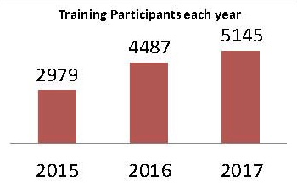
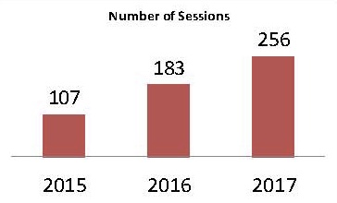

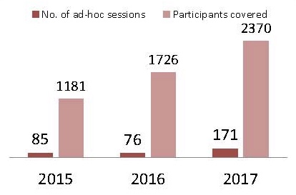

L&D consistently provided all learning requirements by the bank's different divisions whilst maintaining due diligence in the compliance requirements. Specific needs of learning from other divisions were treated with importance and it was made sure that with all resources available, learning was optimized for all employees. In 2017, the total number of ad-hoc sessions has increased compared to the year before and the number of participants trained had increased by more than 35%.

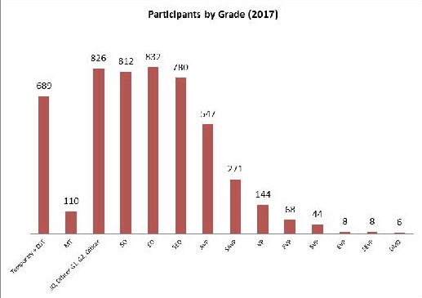

A noticeable trend in the participants' distribution for the trainings in 2017 was that the entry and midlevel employees were provided more training in order to strengthen the operational backbone and executional expertise of the company. Additionally, the frontline sales force were provided specialized trainings on a comprehensive basis to ensure greater sales in retail Asset, Liability, SME, Cards and Payroll business.

TRAINING INITIATIVES ALIGNED WITH COMPLIANCE REQUIREMENTS
ISS REPORTING
L&D arranged & coordinated countrywide training schedule on "ISS Reporting" which was scheduled from June through October through the assistance of ISS Desk. This said topic originated its knowledge need followed by an instruction from Bangladesh Bank. The objective of the training was reducing errors in, and ensuring correct submission of the ISS forms on time. The training was focused on personnel taking on the roles of Branch Managers, Branch Operation Managers and relevant stakeholders compared to 2016, an increment of 117 (more than 40%) participants took place in the subjected training.
Total number of programs: 12
Total number of Participants: 408

CYBER SECURITY AND RELATED ICT GUIDELINES AND COMPLIANCE IN BANKS
Awareness on Cyber Security was one of the core concerns of the central bank among other issues. Because secure access and fraud prevention are top priorities for banking financial institutions, L&D plans to cover a greater number of participants in 2018.
Total number of programs: 4
Total number of Participants: 160

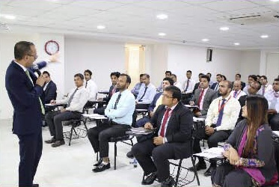
ANTI-MONEY LAUNDERING Training programs on “Prevention of Money Laundering and Terrorist Financing” were held in 3 sessions including the BAMLCO conference held in April„17. The objective of the training sessions was to create awareness regarding Anti-Money Laundering, terrorist financing and Trade-based Money Laundering. Training on the said topic is to be covered on a larger scale in the coming year.

Total number of programs: 3
Total number of Participants: 246

IDENTIFICATION OF GENUINE NOTES AND AWARENESS ON MICR READER UV MACHINES

As per the central bank’s instruction, inclusion of trainings in the training calendar was advised for the year regarding topics covering the knowledge dissemination on the identification of genuine bank notes. With external resources and in-house experts on the topic, L&D arranged trainings in order to comply to Bangladesh Bank’s regulatory requirements and to ensure safer teller transaction environment.

Total number of programs: 3
Total number of Participants: 169

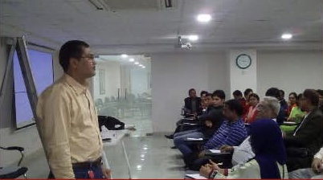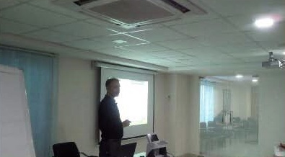

TRAINING INITIATIVES ALIGNED WITH BUSINESS NEEDS
IN-HOUSE FOUNDATION PROGRAM

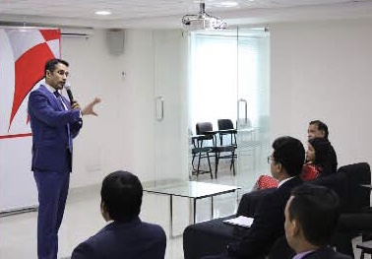

Similar to the previous year, 2017 included the in-house Banking Foundation training which received some of the greater appreciations from the participants and from the supervisors. The training course was facilitated by our in-house experts from different divisions & external BIBM officials on specialized topics. The training was held through 9 working days and was offered to the personnel with need of Banking Foundation knowledge.

Total number of programs: 01
Total number of Participants: 31

L&D INITIATIVES AND COLLABORATIONS ALIGNED WITH ORGANIZATIONAL NEEDS

CITY LEARNING CENTER
The new training center, „City Learning Center‟, has been fully operational from the end of March, 2017. With a much larger space for accommodation and arrangements, CLC has been the learning venue for most of the in-house trainings organized by L&D team within Dhaka. With a separate room with computer lab facilities, CLC ensures the smooth running of learning events organized by L&D or meetings by other divisions.

COLLABORATION WITH IFC AS LEARNING PARTNER
The incorporations of IFC‟s learning requirements for participants added a separate training calendar to the existing planned annual calendar, starting off with Train-The-Trainer modules to create our very own pool of trainers certified by IFC and followed through with the trainers providing separate training sessions on customer service and sales techniques for the employees of the bank. The rollout of all the 91 sessions covering 1352 participants was a success due to the support from all stakeholders.

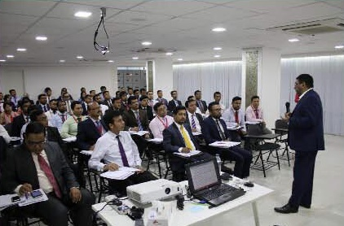

WOMEN‟S LEADERSHIP DEVELOPMENT SKILLS PROGRAM
In line with our organization‟s promotions to diversity and uniformity at the same time, the requirement of women‟s leadership has arisen in recent times. Associating with the female ambassadors of our bank, the Women‟s Leadership Development Skills Program took place with the facilitation of Ms. Nasreen Sattar, Consumark, covering 29 personnel.



TRAINING ARRANGEMENTS ABROAD
17 delegates from CBL received trainings abroad in 2017 in various functional topics. Affiliation with vendors abroad for trainings in India, Bahrain, Singapore, Malaysia, Thailand and Netherlands were arranged for personnel throughout the bank as per divisional need.

ASSOCIATION WITH INTERNATIONAL TRAINERS FOR IN-HOUSE TRAINING ARRANGEMENTS

In order to provide the attendees with top-notch trainings, L&D team made efforts to bring in and incorporate facilitators who are well-known in the arena of their training and are acclaimed internationally. Mr. Ayan Banerji and Mr. Madhusudhan Dutta were amongst the soft-skill trainers who have trained a total of 89 personnel during the year in topics such as Negotiation and Leadership. In addition, Mr. Milan Tomik, FIKonsult, trained 91 personnel in the segment of Environmental and Social Risk Management in Banking.

ONLINE EXAMINATION
Online examination on Banking Laws and Regulations was held in 2017, which aims to revising all eligible employees‟ knowledge of the laws and regulations to abide by for bankers. A total of 1805 participants engaged in the examination throughout the country among whom 1707 participants passed, which is a success percentile of almost 95%.

Chapter 4
(Analysis and Interpretation)

Chapter-4: Analysis and Interpretation
There are twelve questions and each question represents each employee’s opinion, the survey is done with 20 employees of The City Bank ltd. There are five different scales of points. Each and every question is percentile based on all employee’s collective opinion. There are given below:
- I need training by terms.
Strongly Disagree | Disagree | Neutral | Agree | Strongly Agree | Total
0 | 20 | 10 | 50 | 20 | 100

The above question state that employees are need training by terms, 50% employee are agree, 20% are strongly agree, 10% are neutral and 20% are disagree.

- I am satisfied with the training I received from my present job.
Strongly Disagree | Disagree | Neutral | Agree | Strongly Agree | Total
0 | 0 | 5 | 80 | 15 | 100

From this question we can see the employees are highly satisfied with their present job training. 80% employees are agree, 15% are strongly agree and 5% are neutral on it.

- I am getting on the job training from my supervisor.
Strongly Disagree | Disagree | Neutral | Agree | Strongly Agree | Total
10 | 5 | 0 | 60 | 25 | 100

The above data shows a positive response that they got on the job training from their supervisor. The 60% of employees are agreed, 25% are strongly agree, 10% are strongly dis agree and 5 % are disagree on it.

- I think my training duration was sufficient.
Strongly Disagree | Disagree | Neutral | Agree | Strongly Agree | Total
10 | 10 | 5 | 60 | 15 | 100

We can say the training duration of the employees is sufficient. The 60% employees are agree, 15% are strongly agree, 10% are strongly disagree, 10% are disagree and 5 % are neutral on it.

- My training environment was favorable.
Strongly Disagree | Disagree | Neutral | Agree | Strongly Agree | Total
0 | 10 | 15 | 50 | 25 | 100

About the training environment, the result is positive because employees get their training environment in their favorable. The 50% employees are agree, 25% are strongly agree, 0% are strongly disagree, 10% are disagree and 15 % are neutral on it.

- The training was relevant with my job.
Strongly Disagree | Disagree | Neutral | Agree | Strongly Agree | Total
0 | 0 | 0 | 45 | 55 | 100

The result is positive. From the above graph we can see 45% employees are agree, 55% are strongly agree, 0% are strongly disagree, 0% are disagree and 0% are neutral that’s mean their training was relevant with their job.

- The existing training method is suitable to adopt the changing technology.
Strongly Disagree | Disagree | Neutral | Agree | Strongly Agree | Total
0 | 25 | 0 | 60 | 15 | 100

We can measure the positive result from this graph that the existing training methods of employees are suitable to adopt the changing technology. The 60% employees are agree, 15% are strongly agree, 0% are strongly disagree, 25% are disagree and 0% are neutral on it.

- The training process and method need to be change.
Strongly Disagree | Disagree | Neutral | Agree | Strongly Agree | Total
0 | 0 | 15 | 65 | 20 | 100

From the above question we can measure the positive result that the training process and method need to be change. The 65% employees are agree, 20% are strongly agree, 0% are strongly disagree, 0% are disagree and 15% are neutral on it.

- Management gives priority to train the executives.
Strongly Disagree | Disagree | Neutral | Agree | Strongly Agree | Total
0 | 0 | 0 | 30 | 70 | 100

The result is positive that management gives priority to train the executives. The 30% employees are agree, 70% are strongly agree, 0% are strongly disagree, 0% are disagree and 0% are neutral on it.

- My organization evaluates my performance effectively for training selection.
Strongly Disagree | Disagree | Neutral | Agree | Strongly Agree | Total
0 | 0 | 0 | 15 | 85 | 100

The 15% employees are agree, 85% are strongly agree, 0% are strongly disagree, 0% are disagree and 0% are neutral that indicates a positive result from the employees, The City Bank evaluates their performance effectively for training selection.

- After completion of training that add value and enhanced skill.
Strongly Disagree | Disagree | Neutral | Agree | Strongly Agree | Total
0 | 0 | 0 | 35 | 65 | 100

The result is positive. The 35% employees are agree, 65% are strongly agree, 0% are strongly disagree, 0% are disagree and 0% are neutral. After completion of training that add value and enhanced skills of employees.

- I am independent to express my feedback about training and development to the concern management.
Strongly Disagree | Disagree | Neutral | Agree | Strongly Agree | Total
0 | 10 | 0 | 60 | 30 | 100

The answer is yes, the 60% employees are agree, 30% are strongly agree, 0% are strongly disagree, 10% are disagree and 0% are neutral. Employees are independent to express their feedback about training and development to the concern management.

Chapter 5
(Conclusion and Recommendations)

Chapter-5: Conclusion and Recommendations

Recommendations:
It is hard to give suggestion about the City Bank Human Recourse Department from its findings and analysis. But for the betterment of the organization I would like to recommend some suggestion for the bank’s Training and Development sector.
- Training and Development program should be clear to all and it must be understandable to each and every one.
- They should organize the training programs on their working days. Because organize a training program in holiday makes employee demotivated for joining.
- They have started their online training program so they should focused more to develop the training methods.
- They should more concern on their employees training performance, and give proper concentration to the employee’s pre & post training.
- There are few employees who give the survey answer neutral that means they are not clear about the functions so they should concern about the matter.
- They should maintain Performance Appraisal form to each employee. And every month checked the marks and sees the development result of each one.
- All recruitments of The City Bank could be made on the basis of merit. If it is possible, the bank will get the quality employee.
- The trainer should be well qualified to motivate and teach the employees about the new technology and technique.

Conclusion:
Training and development is the tonic employees need to enhance their performance and potentials that will in turn enhance organization effectiveness. City Bank concern to employees training and development and requires careful systematic and planned training activities. Bank invests money on training for their employees to increase value and make them skilled. City Bank makes effort to organize many training programs for their employees. It ought to advantage for the employee in terms of performance and understanding as a way to in turn have an effect on the organization.
Appendix:
Questionnaire for “Training and Development”
Personal Information
Gender:
- Male
- Female
Age:
- 15-25
- 26-35
- 36-45
- 46 and above
Designation:
Working Period: ____Year____Month
-----------------------------------------------------------------------------------------------------------
Please read each statement carefully, think in terms of your opinion about ‘The
City Bank Limited’ and circle the number which most closely related to your thinking.
Please do not hesitate to answer; this research is for only academic purposes.
Your information will be kept confidential. Thank you.
1  Strongly Disagree | 2  Disagree | 3  Neither Agree or disagree | 4  Agree | 5  Strongly Agree

- I need training by terms.
1 | 2 | 3 | 4 | 5

- I am satisfied with the training I received from my present job.
1 | 2 | 3 | 4 | 5

- I am getting on the job training from my supervisor.
1 | 2 | 3 | 4 | 5

- I think my training duration was sufficient.
1 | 2 | 3 | 4 | 5

- My training environment was favorable.
1 | 2 | 3 | 4 | 5

- The training was relevant with my job.
1 | 2 | 3 | 4 | 5

- The existing training method is suitable to adopt the changing technology.
1 | 2 | 3 | 4 | 5

- The training process and method need to be change.
1 | 2 | 3 | 4 | 5

- Management gives priority to train the executives.
1 | 2 | 3 | 4 | 5

- My organization evaluates my performance effectively for training selection.
1 | 2 | 3 | 4 | 5

- After completion of training that add value and enhanced skill.
1 | 2 | 3 | 4 | 5

- I am independent to express my feedback about training and development to the concern management.
1 | 2 | 3 | 4 | 5

Bibliography
Alo, O. (1999). Human Resource Management. Nigeria: Business science Books, Lagos.
Armstrong, M. (1995). A handbook of personnel Management Practices. London: Kogan Page Limited.
Burak, E. a. (1977). Personnel Management A human resources systems approach. New York: West publishing Company.
Ejiogu, A. (2000). Human Resource Management towards Greater Productivity. Lagos: Generation Press Ltd.
Fashola. (2002). Management Trainers Development. Lagos: Participants Training Manual C.M.D.
Hamblin, A. C. (1974). Evaluation and Control of Training. McGraw-Hill Maidenhead.
https://www.thecitybank.com/highlights.php. (n.d.).
Imanyi, G. U. (2002). Participants Training manual C.M.D Management Trainers Development. Lagos.
Mamoria, C. (1995). Personnel Management. New Delhi: Himalaya Publishing House.
Obisi, C. (1996). Personnel Management. Ibadan: Freman Publications.
Obisi, C. (2001). Employee development, Issues and dimensions,. Unical Journal of public Administrator, Sept Vol. 1.
Scott. Clotheir and Spriegel. (1977). Personnel Management: Principles, practices and point of View. New Delhi, Sixth Edition.: Tata McGraw-Hill Publishing Company Ltd.

