An Analysis of Procurement Operation and Purchasing Practices of Fariha Knit Tex Ltd.

Zinnatul Ferdous Chowdhury

This report is submitted to the school of Business and Economics, United International University as a partial requirement for the degree fulfillment of Bachelor of Business Administration

Submitted to:
Dr. Md. Shariful Alam
Professor
School of Business & Economics (SoBE)

Submitted By:
Zinnatul Ferdous Chowdhury
ID: 111-191-070
Major: Supply Chain Management


School of Business and Economics
United International University

Date of submission: July 26, 2026



Fariha Knit Tex Ltd (FKTL)( Asrotex Group)

Letter of Transmittal

26 July, 2026
Dear Dr. Md. Shariful Alam,
School of Business & Economics (SoBE)
United International University
Subject: Submission of the Internship Report
Dear Sir,
The Supply Chain Management and Corporate practice at An Analysis of Procurement Operation and Purchasing Practices of Fariha Knit Tex Ltd. – the report is hereby submitted for your kind perusal. The largest benefit for me has been your instruction, which I truly appreciate. I followed your and my company's supervisor's guidance while writing this report.
The experience of working with United group has been incredible. I think the skills and information I picked up from my internship will help me greatly in my future professional endeavors. I sincerely hope you will look over this report and offer your wise comments. If my report gave you a better understanding of the problem and relevant information, I would be extremely happy.
Sincerely,
Zinnatul Ferdous Chowdhury
ID- 111-191-070
Program: BBA
Major: Supply Chain Management

Declaration of the Student

As the author of the project report titled An Analysis of Procurement Operation and Purchasing Practices of Fariha Knit Tex Ltd, I, Zinnatul Ferdous, hereby acknowledge full responsibility for the content and findings presented herein. All data and information used in this report were carefully collected, verified, and analyzed prior to inclusion. I affirm that every fact presented is accurate, relevant, and supported by appropriate authorization and approval from relevant sources.
No part of this report has been copied or reproduced from external sources without proper citation and acknowledgment of the original authors. I have strictly adhered to academic and ethical guidelines throughout the preparation and writing of this report.
I followed all academic guidelines throughout the writing of this report.
Regards,
Zinnatul Ferdous Chowdhury
ID: 111-191-070
Bachelor of Business Administration United International University

Acknowledgement

I would like to express my gratitude to Almighty Allah for providing me with the strength and capacity to complete all the BBA courses and for allowing me to submit my report on time. This publication is the result of a great deal of research and work that took up the entire attention of multiple persons. Without their direction, assistance, cooperation, and navigations, this report would not have been possible.
I express my gratitude to all those who helped with the compilation of this report. For his assistance with my internship report from the start, I would especially want to thank Dr. Md. Shariful Alam, Professor, School of Business & Economics (SoBE), my supervisor at United International University (UIU). As I was writing my report, I received frequent guidance and comments from my esteemed supervisor. This report would not have been possible without his help.

Executive Summary
This report elucidates in depth the procurement practices at An Analysis of Procurement Operation and Purchasing Practices of Fariha Knit Tex Ltd, one of the best Garments in Bangladesh. It is a major player in the garment industries, known for the quality of its service and its innovation in business. This paper seeks to evaluate the procurement process within the organization, considering its objectives, structure, and strategies, along with the challenges it faces in achieving procurement goals and contributing to potential improvements.
The report includes description of the enterprise including background, mission and vision. As a part of An Analysis of Procurement Operation and Purchasing Practices of Fariha Knit Tex Ltd has grown into a renowned name in Apparel and Textile manufacturing business unit of Asrotex Group industry since its establishment in 1997. The platform specializes in clothing, and its fast and convenient procurement processes contribute to its reputation in the market.
The firm's purchasing activities consist of sourcing identification, supplier selection, relationship management and order execution. In this paper we discuss the finer points of these operations and study some long-term plans to increase the efficiency and reliability of these operations.
This report also deals with the major challenges that this retail unit faces, like inefficiencies in the purchasing process, supply chain disruptions and price volatility, and supplier unreliability. It proposes several strategic solutions, such as leveraging data analytics for improved forecasting, implementing dynamic pricing tools, and enhancing quality control measures.
The report also highlights the company’s commitment to sustainability, demonstrating how environmental and social considerations are integrated into procurement decisions. An Analysis of Procurement Operation and Purchasing Practices of Fariha Knit Tex Ltd. has taken great strides in developing sustainable supply chains in line with its corporate responsibility ethos displaying its commitment to ethical and responsible business practices.

Table of Contents for Internship

Table of Contents
Letter of Transmittal i
Declaration of the Student ii
Acknowledgement iii
Executive Summary iv
List of Figures vii
List of Tables viii
List of Acronyms & Abbreviations ix
Chapter 1: INTRODUCTION 10
1.1 Background of the Report 10
1.2 Objectives of the Report 11
1.3 Motivation of the Report 11
1.4 Scope and Limitations of the Report 12
1.5 Definition of Key Terms 13
CHAPTER II: COMPANY AND INDUSTRY PREVIEW 14
2.1 Company Analysis 14
2.1.1 Overview and History 14
2.1.2 Trend and Growth 14
2.1.3 Customer Mix 15
2.1.4 Product Mix 16
2.1.5 Operations 18
2.1.6 SWOT Analysis of Fariha Knit Tex Ltd. 19
CHAPTER III: Industry analysis 21
3.1 Specification of the Industry 21
3.2 Size, Trend, and Maturity of the Industry 22
3.3 External Economic Factors 24
3.4 Technological Factors 25
3.5 Porter's Five Forces Analysis 26
3.6 Industry Opportunities and Challenges 29
CHAPTER IV: INTERNSHIP EXPERIECNE 31
4.1 Position, Duties and Responsibilities 31
4.2 Training 33
4.3 Contribution to Departmental Functions 34
4.4 Evaluation 35
4.5 Skills Applied 36
4.6 New Skills Developed 37
4.7 Application of Academic Knowledge 38
4.8 Learning Outcomes 38
CHAPTER V: CONCLUSIONS AND KEY FACTS 39
5.1 Recommendations for Improving Departmental Operations 39
5.2 Key Understanding 41
5.3 Conclusion 43
Reference 44
Appendix-A 45

List of Figures

Figure 1. Product Mix 18
Figure 2. Operations 19
Figure 3. Size, Trend, and Maturity of the Industry 23
Figure 4. Evaluation 36
Figure 5. Observations and practical experience 40

List of Tables

Table 1 xi

List of Acronyms & Abbreviations

ERP | Enterprise Resource Planning
PI | Proforma Invoice
LC | Letter of Credit
BOQ | Bill of Quantities
ETA | Estimated Time of Arrival
ETD | Estimated Time of Departure
OS&E | Operating Supplies & Equipment
FKTL | Fariha Knit Tex Ltd.
SCM | Supply Chain Management
MOQ | Minimum Order Quantity
SKU | Stock Keeping Unit
RMG | Ready-Made Garments
FCL | Full Container Load
LCL | Less than Container Load
PD | Project Division
FMEA | Failure Mode and Effect Analysis
AQL | Acceptable Quality Level
Table 1

Chapter 1: INTRODUCTION

1.1 Background of the Report
Internship is an essential part of the Bachelor of Business Administration (BBA) program, allowing students to apply theoretical knowledge in a real business environment. It helps bridge the gap between classroom learning and professional practice by exposing students to organizational operations and workplace responsibilities.
This report is based on my internship experience at Fariha Knit Tex Ltd., where I was assigned to the Procurement Department. During the internship, I became familiar with procurement activities such as processing purchase requisitions, communicating with suppliers, preparing procurement documents, verifying invoices, and coordinating with the store and accounts departments. The report highlights these practical experiences while explaining how procurement contributes to the smooth operation of a garment manufacturing company.

1.2 Objectives of the Report
The main objective of this report is to present an overview of the procurement practices followed by Fariha Knit Tex Ltd. and to evaluate the knowledge and skills gained during the internship.
The specific objectives are:
- To understand the procurement system of Fariha Knit Tex Ltd.
- To observe the procedures involved in purchasing materials and selecting suppliers.
- To analyze procurement documentation and coordination among different departments.
- To identify practical challenges faced during procurement activities.
- To relate academic concepts of supply chain and procurement management with real workplace practices.

1.3 Motivation of the Report
The main aim of this report writing is to present the practical knowledge and professional experience gained during the internship. Working in the Procurement Department gave me a great understanding of the purchasing process, communicating with suppliers and internal coordination needed in a garment manufacturing company.
The report writing process is an opportunity to reflect on the experience acquired during the internship, evaluate organizational practices and demonstrate how academic learning can be applied to solve real business problems.

1.4 Scope and Limitations of the Report
Scope
The report is based on procurement activities of Fariha Knit Tex Ltd. It covers all major functions of Procurement Department like purchase requisition processing, supplier quotation analysis, procurement documentation, bill verification, purchase co-ordination, communication with Stores and Accounts departments. The report also includes the part played by procurement in backing the company’s manufacturing operations.
Limitations
While every effort has been made to prepare a comprehensive report, some limitations were encountered:
- The internship period was short which limited the chance to observe all procurement activities in detail.
- Some of the organizational information was confidential and thus could not be incorporated in the report.
- Collecting extensive data from all departments wasn’t possible due to the time limitations.
- The report is primarily based on observations within the Procurement Department and does not represent the entire organization.

1.5 Definition of Key Terms
Procurement is the process of obtaining the goods and services an organization needs to carry out its operations, including planning, supplier selection, purchasing and payment.
• Purchase Requisition (RQSN) – An internal request made by a department for approval to purchase needed materials.
Purchase Order (PO): A formal document issued by the procurement department to a supplier specifying the purchase of designated goods and services under stipulated terms.
Comparative Statement (CS): A document prepared to compare quotations of different suppliers on the basis of price, quality, delivery schedule and other purchasing criteria.
Supplier: A person or organization that provides products or services to meet the organization's procurement needs.
Credit Purchase: An agreement to purchase something on credit and pay for it after a certain credit period, e.g. 30 days.
Bill Verification: The process of reviewing supplier invoices and supporting documents to ensure that the delivered materials and billed amounts match the approved purchase records.

CHAPTER II: COMPANY AND INDUSTRY PREVIEW

2.1 Company Analysis

2.1.1 Overview and History
Fariha Knit Tex Ltd. is a leading export-oriented knitwear manufacturer of Bangladesh and a strategic business unit of Asrotex Group. The company produces high-quality knitwear for international apparel brands and has earned a strong reputation for its commitment to product quality, technological advancement and sustainable manufacturing. According to the information provided by the public company, Fariha Knit Tex Ltd. started its operations in the mid-1990s and has developed into a vertically integrated manufacturing facility that undertakes knitting, dyeing, printing, embroidery, garment production, washing, and trims production within the same industrial complex.
The manufacturer’s factory is located at Baroibag, Enayet Nagar, Fatullah, Narayanganj and corporate office is located at Banani, Dhaka. The company is a member of the Bangladesh Garment Manufacturers and Exporters Association (BGMEA) and adheres to internationally accepted manufacturing standards. It supplies garments to customers in Europe, North America and other global markets.
Fariha Knit Tex Ltd. has increased its production capacity over the years through continuous investment in modern machinery, development of employees and improvement of processes. Such efforts have enabled the company to respond to evolving customer needs, while ensuring consistent product quality and delivery performance

2.1.2 Trend and Growth
Fariha Knit Tex Ltd.’s growth is a reflection of the overall growth of Bangladesh’s ready-made garment industry. It started out as a knitwear manufacturer, but has steadily increased its productive capacity, diversified its product range and expanded its export operations. It now runs multiple sewing lines and fully integrated textile plants.

The company has undergone a big growth through modernization. Investments in equipment for knitting, dyeing, washing, printing, embroidery and finishing have improved operational efficiencies and reduced dependence on external suppliers.” Such vertical integration allows the company to have better quality control, reduce production lead times and respond quickly to buyer requirements.
The organization has not only increased its production capacities but also intensified its efforts in the field of environmental sustainability, such as the introduction of wastewater treatment plants and participation in globally recognized sustainability programs. These initiatives will improve the company’s competitiveness in the international apparel market.

2.1.3 Customer Mix
Fariha Knit Tex Ltd primarily caters to the international buyers and global apparel brands. The company is a 100% export-oriented garment manufacturer, producing garments for customers located in Europe, North America and some Asian countries. Instead of selling products directly to local consumers, it concentrates on business-to-business (B2B) links with international retailers, fashion brands and sourcing organizations.
The company reduces business risk through a varied customer base, not dependent on one market. Long-term relationships with international buyers lead to continuous improvements in quality, compliance, innovation and delivery performance, all of which are key to maintaining competitiveness in the global apparel industry.
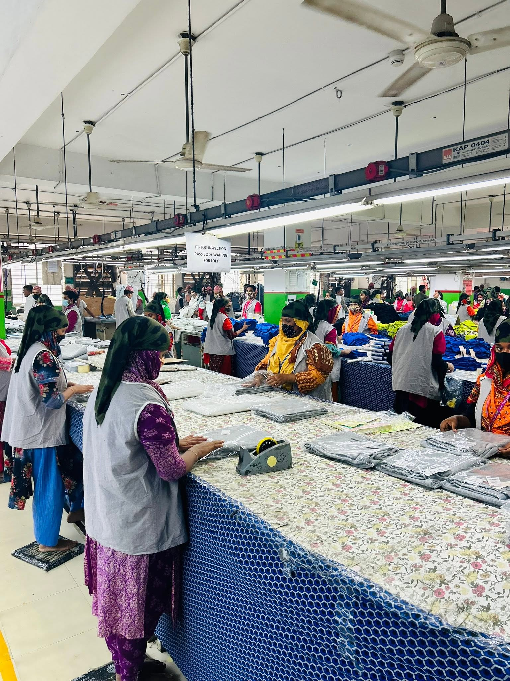
Figure 1. Product Mix

2.1.4 Product Mix
The company manufactures a wide range of knit garments designed for men, women, and children. Its major product categories include:
- T-Shirts
- Polo Shirts
- Jackets
- Trousers
- Sportswear
- Ladies' Tops
- Nightwear
- Children's Wear
- Knit Fashion Apparel
In addition to garment manufacturing, the company performs knitting, dyeing, embroidery, printing, washing, and trims production through its integrated production facilities. This integrated approach improves operational flexibility and product quality.

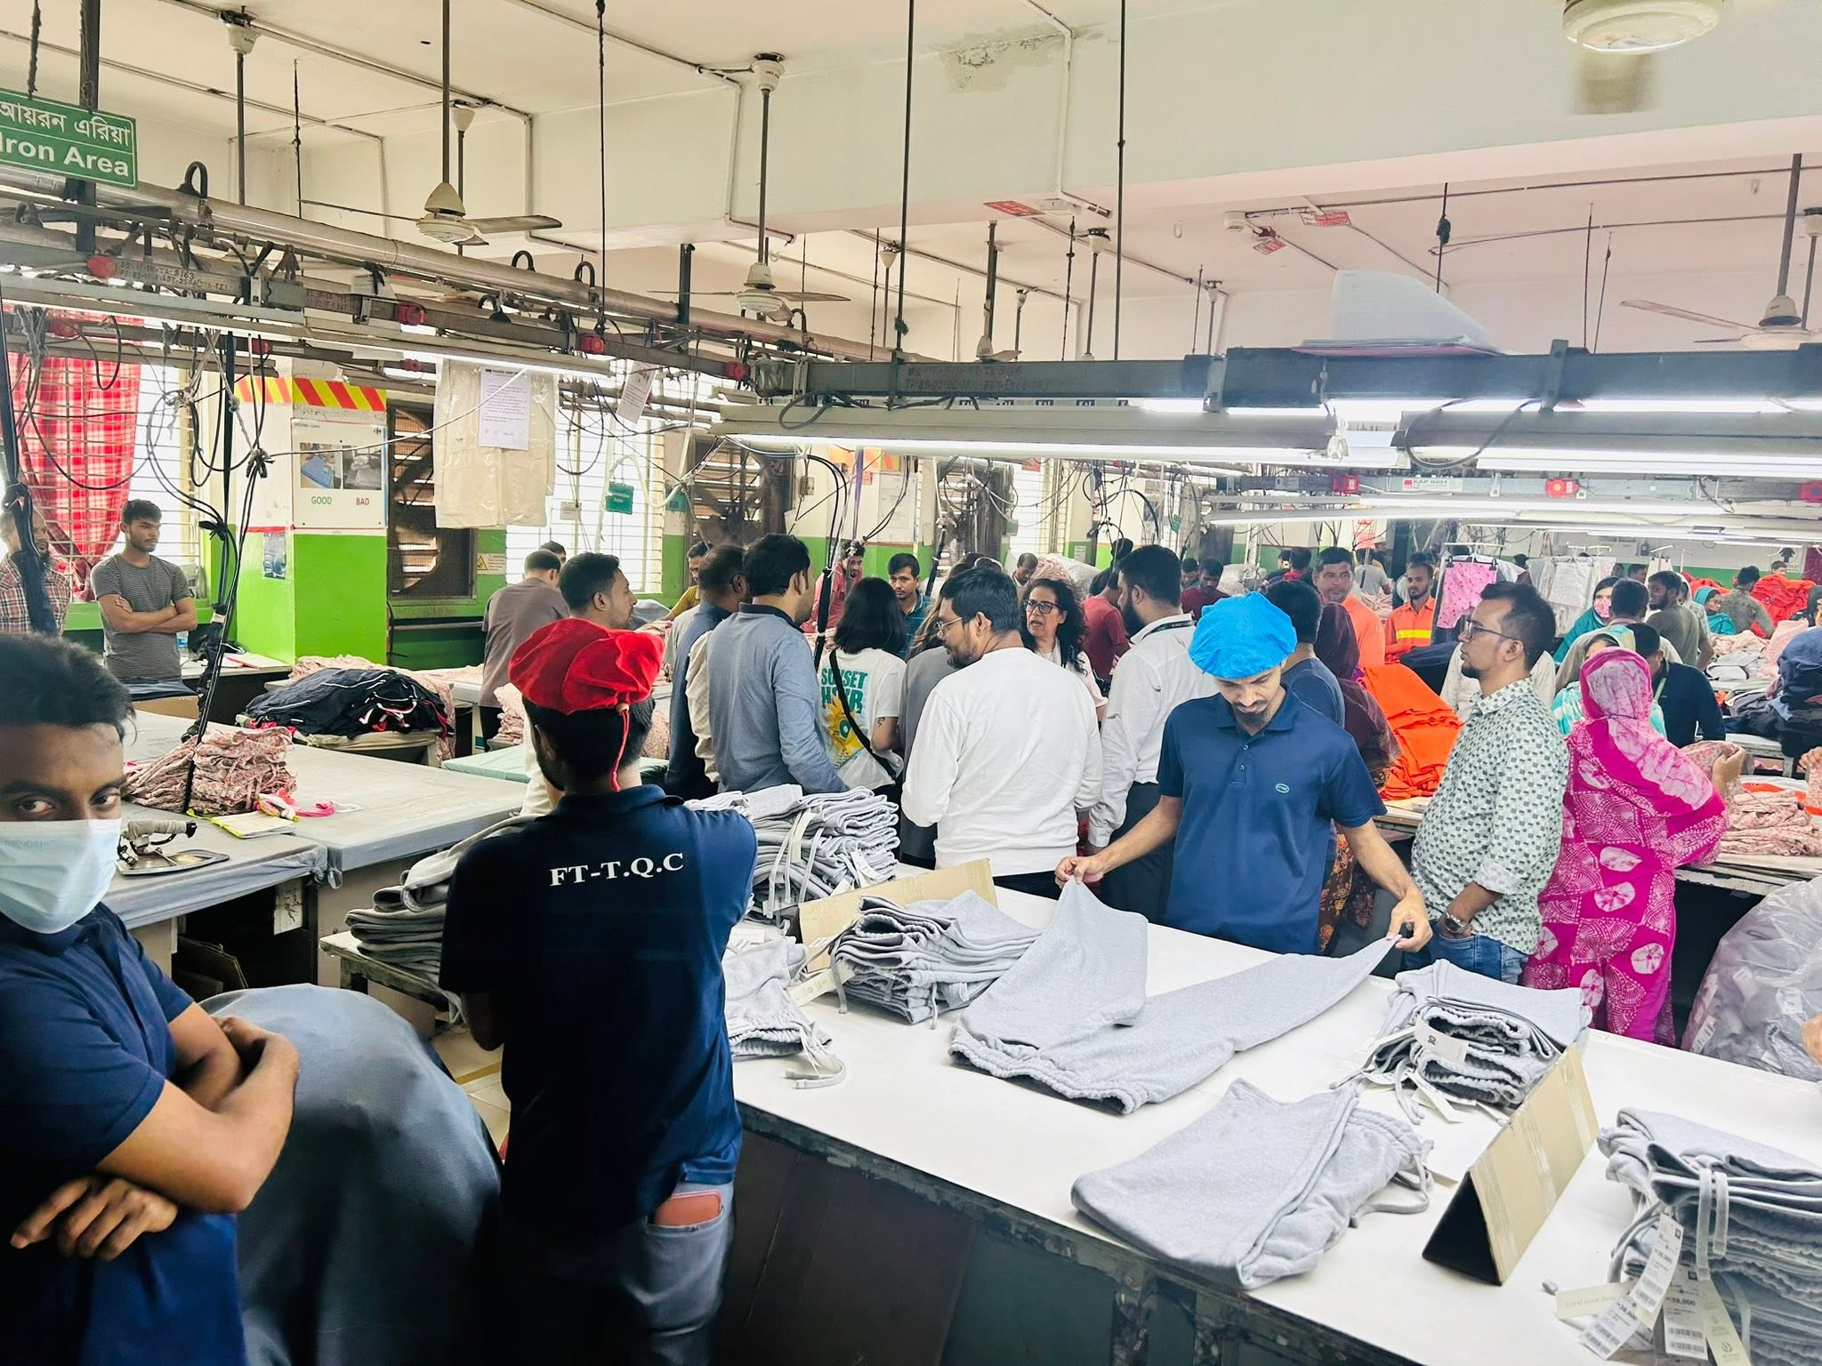
Figure 2. Operations

2.1.5 Operations

Fariha Knit Tex Ltd. carries out its operational activities through integrated manufacturing system covering all the steps of garment production. The production process generally includes raw material procurement, knitting, dyeing, fabric inspection, cutting, sewing, printing, embroidery, washing, finishing, quality inspection, packaging and shipment.
The Procurement Department plays a significant role in supporting these operations by ensuring the timely availability of raw materials, accessories, spare parts, chemicals, and operational supplies. During my internship, I observed that procurement activities included collecting purchase requisitions (RQSN), verifying material requirements, preparing comparative statements (CS), evaluating supplier quotations, coordinating purchases under approved budgets, verifying supplier invoices, and communicating with the stores and accounts departments before payment processing. These activities contributed directly to maintaining uninterrupted production schedules.

2.1.6 SWOT Analysis of Fariha Knit Tex Ltd.
SWOT analysis is a handy strategic tool, which helps to evaluate the internal strengths and weaknesses of the organization, and the external opportunities and threats, which affect its business performance. The next discussion is the SWOT analysis of Fariha Knit Tex Ltd. based on my internship experience and observation.
Strengths
Fariha Knit Tex Ltd. is strong by virtue of its vertical integrated manufacturing system. It means the company is managing several stages of garment production under one roof. This integration increases efficiency in production, quality control and timely order completion. The company also has a skilled workforce, modern production facilities and experienced management which help to maintain high manufacturing standards. Furthermore, its long-standing relationships with international buyers, as well as its commitment to global quality and social standards, enhance the company's reputation in the international apparel market. During my internship, I found that the effective coordination between the Procurement, Production and Store Departments was significant for smooth manufacturing operations.
Weaknesses
Fariha Knit Tex Ltd. has some operational strengths but it also has a number of internal challenges. Some products depend on imported raw materials and accessories and procurement activities are thus susceptible to international supply disruptions and price fluctuations. The increase in utility costs, compliance costs and production costs also drives operational efficiency. During my internship I observed that occasionally, the lag in the receipt of certain materials created some stress on the procurement planning and entailed additional coordination with the suppliers to prevent production delays.
These issues indicate that improving supplier diversification and inventory planning could further strengthen operational performance.
Opportunities
The company has many prospects for further development in the global garment industry. The growing demand for sustainable and socially responsible clothing provides opportunities to attract new international customers and develop existing markets. Investing in automation, digital procurement systems and advanced manufacturing technologies can improve productivity and reduce operational costs. Besides, expanding the product portfolio with value-added garments and exploring emerging export markets will assist the company in strengthening its competitive position and accomplishing long-term business growth.
Threats
Fariha Knit Tex Ltd. also has some external threats in its business operations. The company faces a highly competitive global market, with manufacturers from Vietnam, China, India and Cambodia vying for the same international buyers. Fluctuations in raw material prices, foreign exchange rates, and shipping costs may increase production expenses and reduce profit margins. Moreover, changes in international trade regulations, buyer compliance requirements, and global economic uncertainty may influence export demand and operational performance. To remain competitive, the company must continuously improve its efficiency, maintain high-quality standards, and strengthen its supply chain management practices.

CHAPTER III: Industry analysis

3.1 Specification of the Industry
The Ready-Made Garment (RMG) sector is one of the biggest manufacturing sectors in Bangladesh, and is important to the country’s economy. The main activity of the industry is the production of apparel products like knitwear, woven garments, sweaters and other textile-based products for the international markets.
Bangladesh’s RMG sector is a major export-oriented industry supplying garments to global fashion retailers and brands. The industry has different stages of production such as sourcing of raw materials, manufacture of fabric, dyeing, cutting, sewing, finishing, quality inspection, packaging and shipment.
The sector is divided into two major categories:
1. Knit Garment Industry:
This segment produces products made from knitted fabrics, including T-shirts, polo shirts, sweaters, leggings, and casual wear. Fariha Knit Tex Ltd. operates mainly in this category.
2. Woven Garment Industry:
This division produces garments made from woven fabrics, such as shirts, trousers, jackets and formal wear.
The RMG industry has a huge network of suppliers, manufacturers, buying houses, logistics providers, financial institutions and supporting industries. This coupled with the interconnected supply chain makes Bangladesh competitive in the global apparel market.

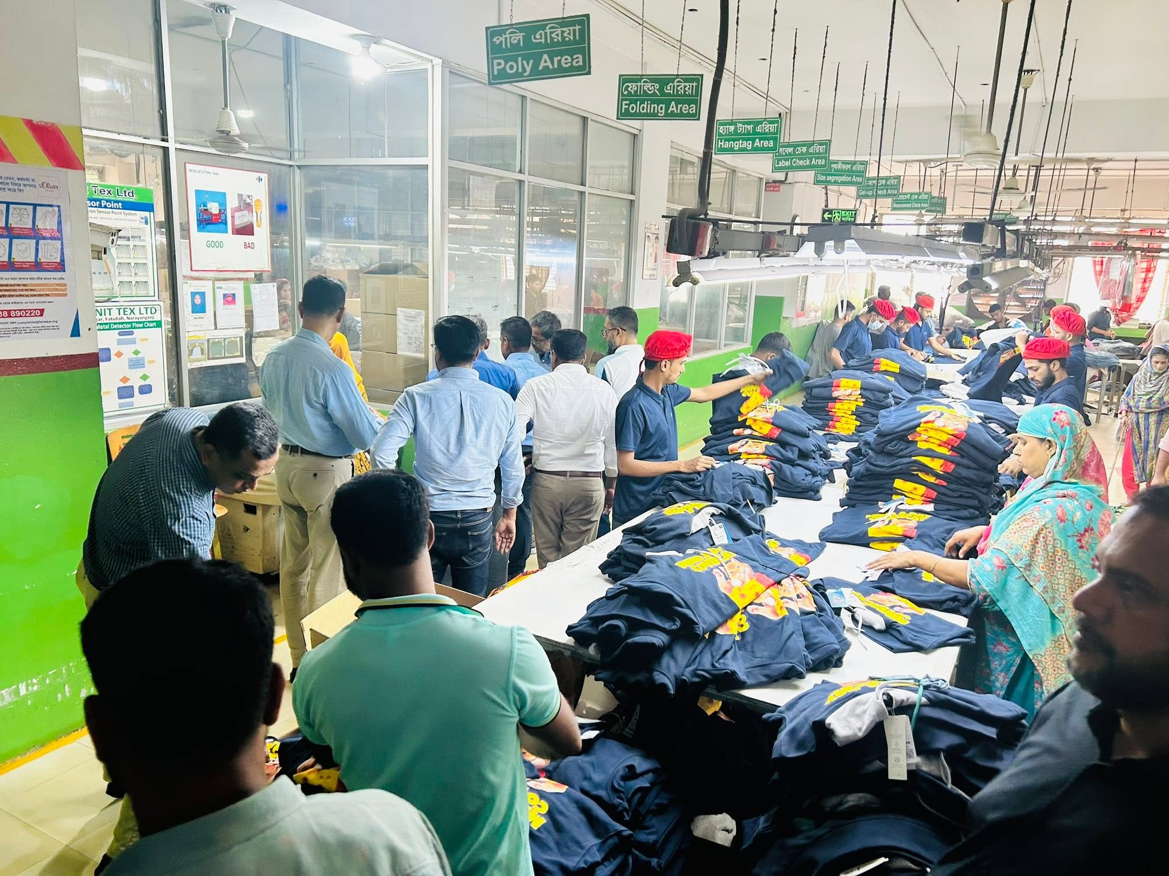
Figure 3. Size, Trend, and Maturity of the Industry

3.2 Size, Trend, and Maturity of the Industry
The RMG industry of Bangladesh is among the largest apparel manufacturing sectors in the world. The industry has grown significantly in the past 40 years because of competitive labor costs, skilled labor, improved manufacturing capabilities and strong links to global buyers.
It also contributes substantially to the export earnings of Bangladesh and provides employment to millions of people today. The industry has gradually evolved from basic garment manufacturing to higher value products, improved compliance standards and sustainable manufacturing practices.

Major Industry Trends:
1. Shift Toward Sustainable Manufacturing
International buyers are paying more attention to environmentally responsible production. As a result, many manufacturers are adopting green factory concepts, energy efficient technologies and waste reduction practices.
2. Product Diversification
Bangladesh is moving up from basic products like T-shirts and trousers to higher value products such as sportswear, technical garments and fashion apparel.
3. Automation and Digital Transformation
Garment manufacturers are using automated cutting machines, ERP systems, digital inventory management and production monitoring technologies to improve efficiency.
4. Compliance and Quality Improvement
The global buyers are now concerned about workplace safety, ethical sourcing and international compliance standards. Manufacturers are also spending more on worker welfare and quality control.
The industry is now at a mature stage with intense competition, and manufacturers need to focus on innovation, efficiency and sustainability to stay in the market.

3.3 External Economic Factors
Several external economic factors influence the performance of Bangladesh's RMG industry.
Exchange Rate Fluctuation
Clothes are sold all over the world, changes in the value of foreign currencies directly affect the company's income and profits. Currency depreciation means an increase in export competitiveness, but it also raises the price of imported raw materials.
Raw Material Price Changes
International market prices considerably affect many textile raw materials such as cotton, chemicals, dyes and accessories. Rising Raw Material Prices Impact Production Costs and Profit Margins.
Labor Cost
Traditionally, Bangladesh’s competitive advantage has been its relatively cheap labor.
Global Economic Conditions
Changes in consumer demand, inflation, and economic uncertainty in major export markets such as Europe and North America can influence garment orders.
Government Policies
Trade agreements, export incentives, labor regulations, and customs policies significantly impact the growth and competitiveness of the industry.

3.4 Technological Factors
Technology has become an important factor in improving productivity and maintaining competitiveness in the garment industry.
Major technological developments include:
Automated Production Systems
Modern factories use automated cutting machines, computerized sewing equipment, and advanced finishing technology to increase production accuracy and reduce wastage.
Enterprise Resource Planning (ERP)
Many garment companies use ERP systems to manage procurement, inventory, production planning, finance, and supply chain activities.
Digital Supply Chain Management
Technology helps manufacturers track inventory levels, monitor supplier performance, manage orders, and improve communication between departments.
Sustainable Technology
Factories are adopting energy-efficient machinery, water treatment systems, and environmentally friendly production methods to meet global sustainability requirements.
For companies like Fariha Knit Tex Ltd., technological advancement supports better production planning, quality control, procurement efficiency, and timely delivery.

3.5 Porter's Five Forces Analysis
1. Threat of New Entrants (Barriers to Entry)
The threat of new entrants in the RMG industry is moderate. Although establishing a garment factory is possible, new companies face several challenges, including:
- High initial investment requirements
- Need for skilled manpower
- Establishing relationships with international buyers
- Maintaining compliance standards
- Competition from established manufacturers
New companies must develop strong production capability, quality assurance systems, and supplier networks to compete effectively.

2. Supplier Power
Supplier power in the garment industry is moderate because manufacturers depend on suppliers for raw materials such as:
- Fabrics
- Yarn
- Dyes and chemicals
- Garment accessories
- Packaging materials
The bargaining power of suppliers increases when raw materials are imported or when specialized materials are required. However, large manufacturers can reduce supplier dependency through long-term relationships, multiple sourcing options, and vertical integration.
3. Buyer Power
Buyer power in the RMG industry is high because international buyers and fashion brands have significant influence over manufacturers.
Major buyers can negotiate:
- Product prices
- Quality standards
- Delivery schedules
- Compliance requirements
Since many countries compete for garment orders, manufacturers must maintain competitive pricing, high quality, and reliable delivery performance to retain buyers.
4. Threat of Substitutes
The threat of substitutes is relatively low because clothing products have essential consumer demand. However, competition exists among different production locations, such as:
- Vietnam
- China
- India
- Cambodia
- Pakistan
Buyers may shift sourcing destinations based on cost, quality, political stability, and production capacity.
5. Industry Rivalry
Competition within the Bangladesh RMG industry is high due to the presence of thousands of manufacturers competing for international orders.
Companies compete based on:
- Product quality
- Production capacity
- Cost efficiency
- Delivery performance
- Compliance standards
- Sustainability practices
To remain competitive, manufacturers need continuous improvement in technology, workforce skills, and supply chain management.

3.6 Industry Opportunities and Challenges
Opportunities
Expansion into High-Value Products
Bangladesh has opportunities to increase exports of premium garments, sportswear, and technical textiles.
Sustainable Manufacturing
Growing demand for environmentally friendly products creates opportunities for companies investing in green technologies.
Technological Advancement
Automation and digital transformation can improve productivity and reduce production costs.
New Export Markets
Manufacturers can explore emerging markets beyond traditional destinations.

Challenges
Raw Material Dependency
Dependence on imported raw materials creates risks related to price increases and supply disruptions.
International Competition
Competition from other garment-producing countries continues to increase.
Increasing Production Costs
Higher wages, energy costs, and operational expenses affect profitability.
Compliance Requirements
Meeting international safety, environmental, and labor standards requires continuous investment.
Supply Chain Disruptions
Global events can affect transportation, raw material availability, and delivery schedules.

CHAPTER IV: INTERNSHIP EXPERIECNE

4.1 Position, Duties and Responsibilities
Fariha Knit Tex Ltd. was my workplace as Procurement Intern in Procurement Department. Through the internship I got a practical exposure on the purchasing activities of a garment manufacturing organization. Procurement Department plays an important role in ensuring availability of required materials and supporting production operations without any interruptions.
My major responsibilities during the internship were as follows:
1. Collection and Verification of Purchase Requisition (RQSN)
I was responsible for collecting Purchase Requisitions (RQSN) from Store Department. These requisitions gave details of items required, quantities, specifications and the requirements of the departments. I gathered the requisitions and assisted in reviewing the requirements to determine if the materials requested were in stock or needed to be purchased.
2. Delivery Status Monitoring
I assisted in monitoring the delivery status of previously ordered items. This activity enabled the procurement team to follow up with suppliers on pending deliveries, follow up with suppliers, and ensure that required materials reached the company within the expected timeframe.
3. Budget and Purchase Coordination
I gained practical knowledge of coordinating purchasing activities with the Accounts Department. Before proceeding with purchases, budget availability and payment procedures were considered. I also learned about supplier credit purchasing systems, where approved suppliers provide materials with a specific payment period, such as a 30-day credit facility.

4. Supplier Communication and Quotation Collection
I assisted in communicating with suppliers for quotations and product details. Multiple supplier quotations were collected for comparison to identify suitable purchasing options considering price, quality, delivery time, and supplier reliability.
5. Comparative Statement (CS) Preparation
One of my key learning areas was preparing Comparative Statements (CS). The CS helped compare different suppliers based on:
- Product price
- Quality specifications
- Delivery schedule
- Payment terms
- Supplier conditions
This process supported management in making effective purchasing decisions.
6. Bill Verification and Documentation
I participated in the review of supplier bills and other supporting documents. The verification process included a reconciliation of invoices with received items, purchase documents and approved purchasing records for accuracy prior to payment processing.
7. Reporting to Procurement Management
I assisted in the preparation of updates and reporting Procurement related information to the Procurement Manager. Reports on purchasing progress, supplier updates, pending deliveries and documentation status.

4.2 Training
In my internship I had a practical training on procurement operations and supply chain activities. The training helped me to understand how theoretical concepts of procurement management are applied in real business situations.
The major areas of training included:
Procurement Process Training
I understood the entire procurement process from receiving purchase requisitions to coordinating supplier payment.
Documentation Training
I gained knowledge about important procurement documents such as:
- Purchase Requisition (RQSN)
- Supplier Quotation
- Comparative Statement (CS)
- Purchase Order (PO)
- Delivery Challan
- Supplier Invoice
Supplier Management Training
I learned how organizations communicate with suppliers, evaluate supplier offers, and maintain professional relationships.
Garment Manufacturing Process Understanding
I developed basic knowledge about garment production requirements and how procurement activities support manufacturing operations.

4.3 Contribution to Departmental Functions
During my internship period, I contributed to several activities of the Procurement Department.
My contributions included:
- Supporting the collection and organization of purchase requisitions.
- Assisting in supplier quotation collection and comparison.
- Helping prepare procurement-related documents.
- Supporting invoice checking and documentation accuracy.
- Maintaining records related to purchasing activities.
- Coordinating information between Procurement, Stores, and Accounts departments.
Through these activities, I helped improve documentation management and supported the smooth execution of procurement tasks.

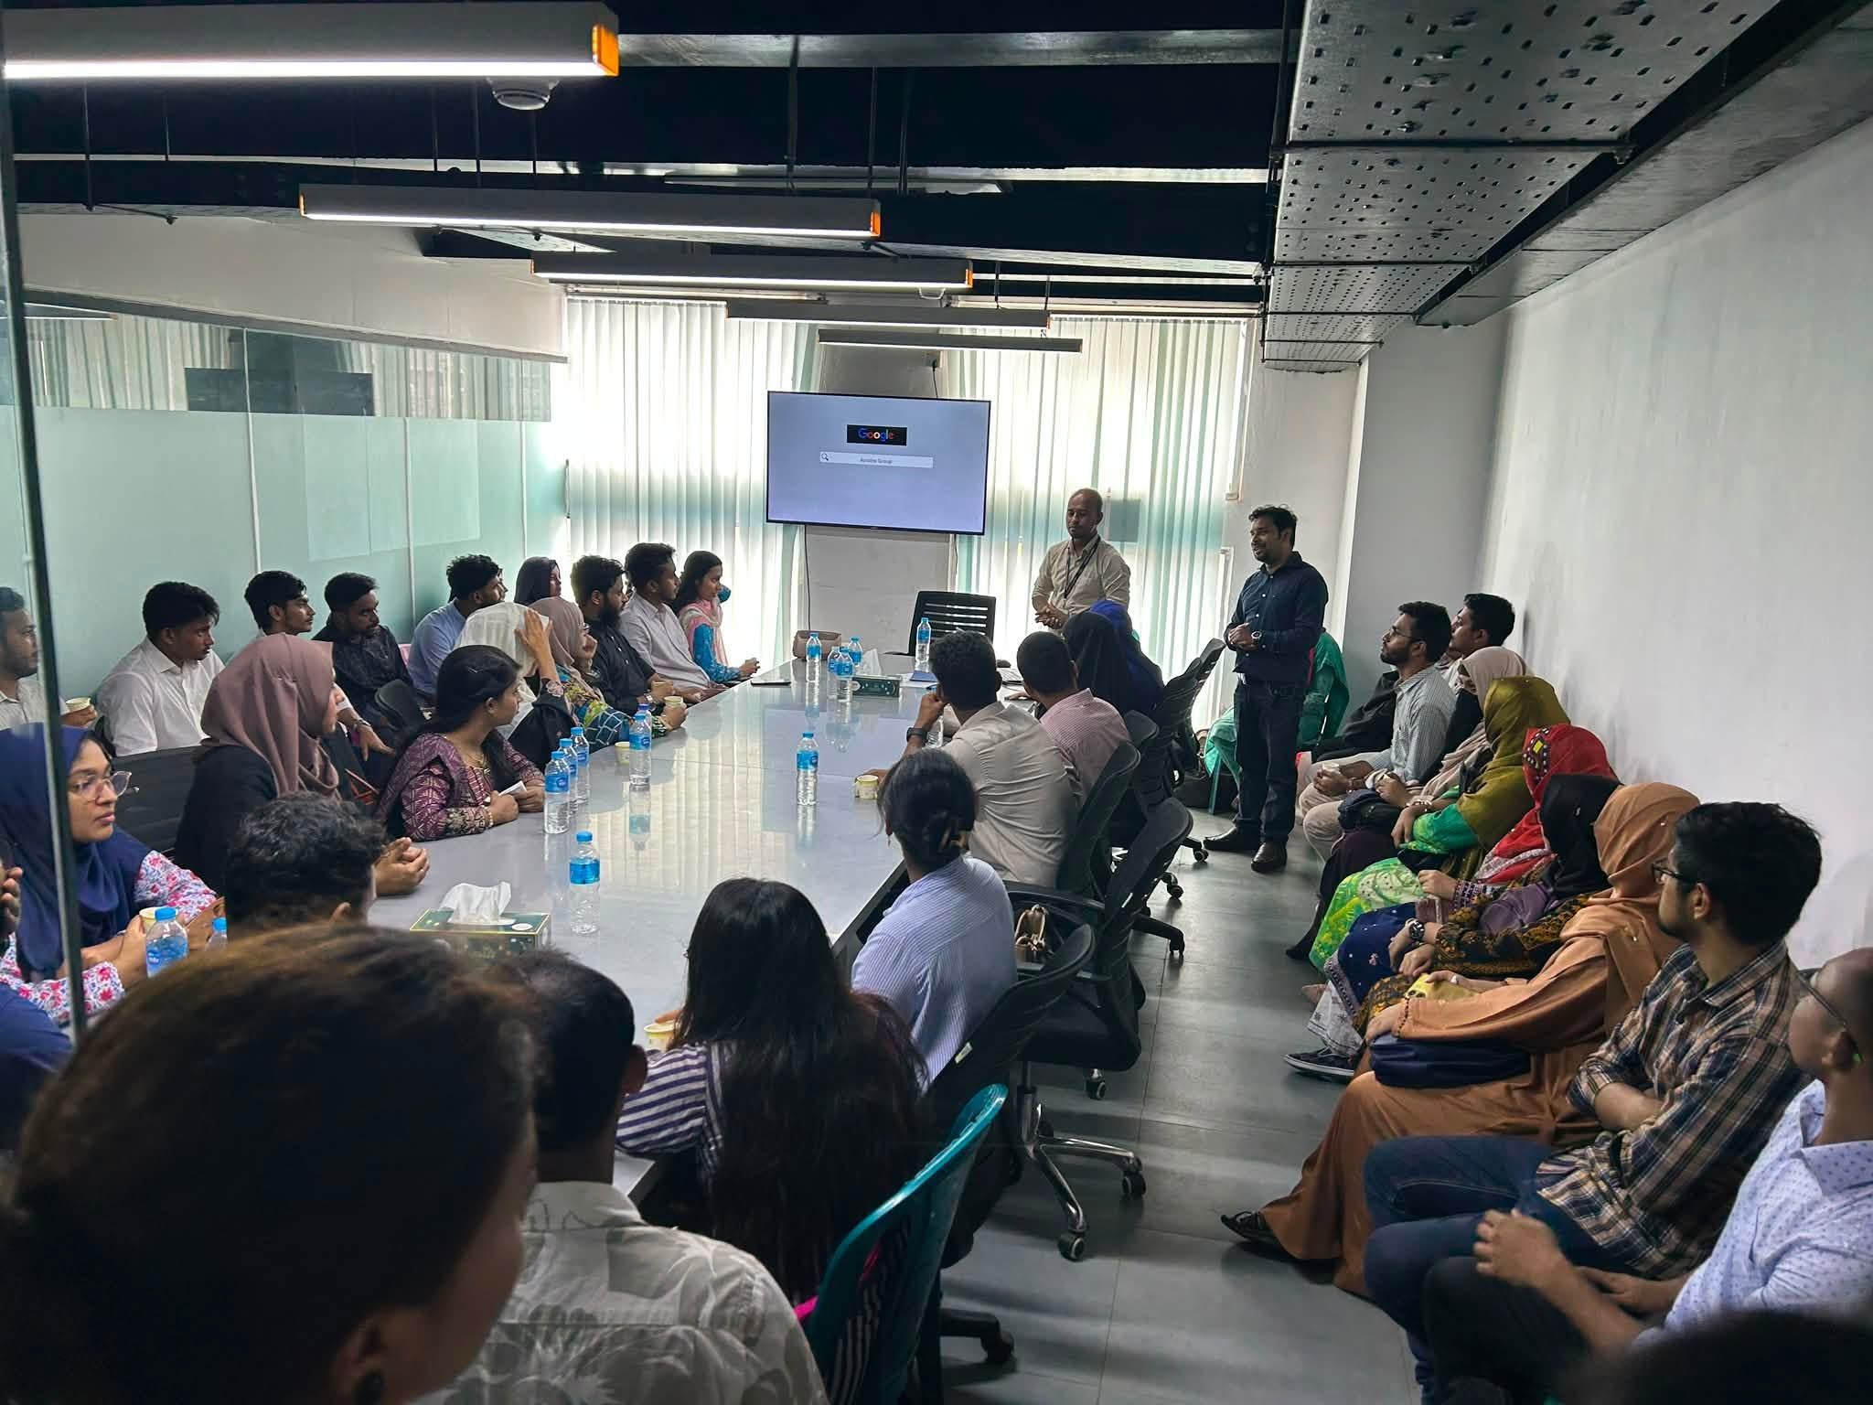
Figure 4. Evaluation

4.4 Evaluation
The internship experience gave me the chance to evaluate my professional skills and identify aspects for development. I learned more about professional responsibility, teamwork, communication and discipline in the workplace.
The practical environment of Fariha Knit Tex Ltd. helped me to know how procurement decisions affect production efficiency, cost management and supply chain performance.

My internship evaluation was based on:
- Understanding of procurement activities
- Ability to perform assigned tasks
- Accuracy in documentation
- Communication skills
- Adaptability to organizational procedures
- Professional behavior and teamwork

4.5 Skills Applied
During the internship, I applied several academic and professional skills, including:
Supply Chain Management Knowledge
I applied concepts related to procurement, supplier management, inventory coordination, and supply chain processes.
Microsoft Excel Skills
I used Excel for organizing procurement information, maintaining records, and preparing comparative data.
Communication Skills
I applied communication skills while coordinating with suppliers and different departments.
Analytical Skills
I used analytical thinking to compare supplier quotations and understand purchasing decisions.

Time Management
I managed assigned responsibilities within deadlines while maintaining accuracy.

4.6 New Skills Developed
The internship helped me develop several new skills that will support my future career.
Practical Procurement Knowledge
I gained real-world understanding of purchasing procedures and procurement decision-making.
Supplier Handling Skills
I learned professional communication methods for dealing with suppliers.
Documentation Management
I improved my ability to prepare, organize, and verify business documents.
Garment Industry Knowledge
I developed an understanding of procurement requirements in the garment manufacturing sector.
Workplace Professionalism
I improved my adaptability, teamwork, discipline, and professional communication.

4.7 Application of Academic Knowledge
The internship allowed me to apply concepts learned during my BBA program to practical business operations.
The knowledge of Supply Chain Management helped me understand procurement planning, supplier relationships, and material flow. Concepts from Operations Management helped me analyze how procurement supports production activities. Additionally, knowledge of Business Communication helped me communicate effectively with colleagues and suppliers.
The practical experience demonstrated the importance of coordination between procurement, stores, accounts, and production departments in achieving organizational efficiency.

4.8 Learning Outcomes
At the end of my internship, I gained a practical understanding of procurement operations in a garment manufacturing company. I learnt a lot in terms of technical knowledge, professional skills and confidence to take responsibilities in a work place.
The internship made me understand that procurement management is not only about purchasing materials but also about supplier evaluation, cost control, documentation accuracy, timely delivery and coordination between different departments.

CHAPTER V: CONCLUSIONS AND KEY FACTS

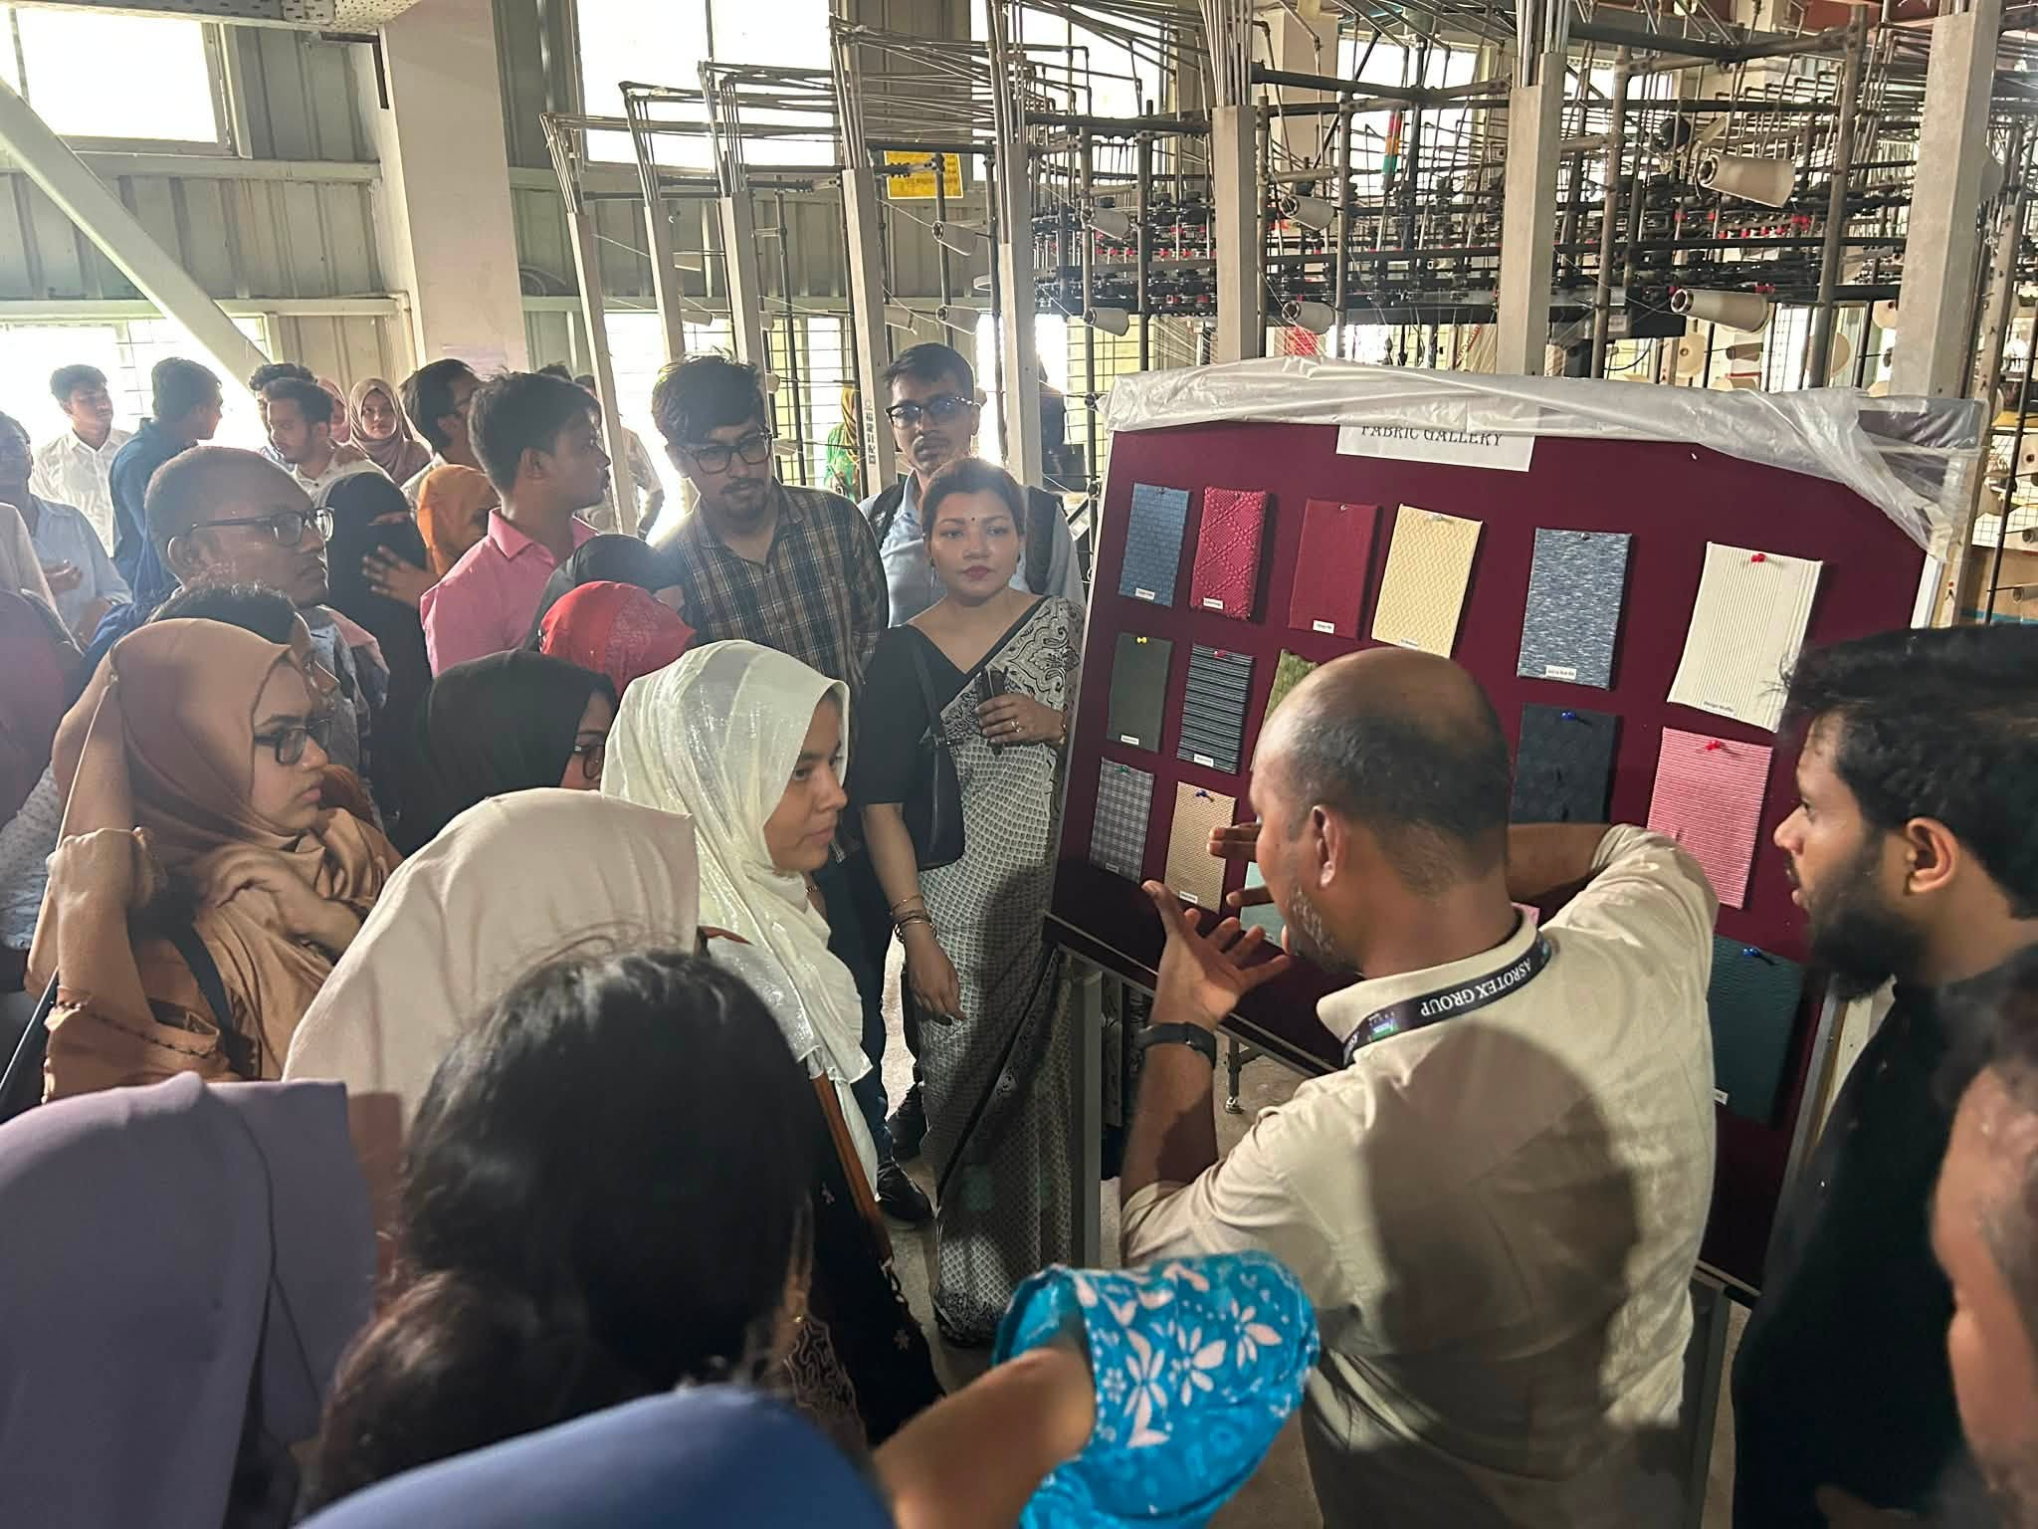
Figure 5. Observations and practical experience

5.1 Recommendations for Improving Departmental Operations
During my internship at Fariha Knit Tex Ltd., I have come to realize that the Procurement Department plays an important role in ensuring the smooth flow of materials required to manufacture garments. Based on my observations and practical experience some recommendations are given to improve procurement efficiency:

1. Implementation of a More Integrated Digital Procurement System
The company can also improve the efficiency of procurement by reinforcing digital systems for purchase requests, supplier communication, order tracking and documentation management. A centralized system can cut down on manual labor, reduce mistakes and increase transparency.
2. Development of a Supplier Performance Evaluation System
A regular supplier evaluation process can help measure supplier performance based on:
- Product quality
- Delivery accuracy
- Pricing competitiveness
- Response time
- Compliance with company requirements
This will help the company maintain strong supplier relationships and select reliable suppliers.
3. Better Inventory and Procurement Coordination
Improved coordination between the Procurement and Store Departments can help maintain optimum inventory levels. Regular inventory reviews can reduce emergency purchases and prevent excess stock accumulation.

4. Maintaining an Updated Supplier Database
A well-organized database of suppliers, past purchase and pricing history, as well as performance data, can help expedite and improve purchasing decisions.

5. Enhancing Data Analysis in Procurement Decisions
You can use advanced Excel functions, dashboards, or business intelligence tools to analyze purchasing trends, supplier performance, and cost variations. Data-driven decisions can help you manage costs and run your business more efficiently.

5.2 Key Understanding
The internship at Fariha Knit Tex Ltd. was an eye opener in terms of practical knowledge about procurement operations of the garment manufacturing industry. During my internship, I learnt how procurement activities are an integral part of the overall supply chain process.
The major key learnings from the internship are:
Understanding of Procurement Workflow
I have learnt that procurement is a systematic process which starts from material requirements, supplier selection, quotation analysis, purchasing, delivery monitoring to payment processing.
Importance of Supplier Management
I understood that maintaining good relationships with suppliers is essential for ensuring quality materials, competitive pricing, and timely delivery.
Role of Documentation
The internship emphasized the significance of precise documentation in procurement activities. Documents like Purchase Requisition (RQSN), Comparative Statement (CS), Purchase Order (PO), invoices, and delivery documents provide transparency and proper control.
Coordination Between Departments
I have learnt that for procurement to be successful there has to be effective coordination between the Procurement, Stores, Accounts and Production Departments. Good communication avoids delays and ensures uninterrupted manufacturing operation.
Practical Application of Supply Chain Concepts
The internship helped me to apply the academic theories of supply chain management, procurement, inventory control and supplier relationship management to the real organizational practices.

5.3 Conclusion
The internship at Fariha Knit Tex Ltd. was an enriching learning experience and provided practical exposure to various procurement activities in the garment manufacturing industry. It made me understand the importance of procurement management in ensuring that the required materials are available, controlling costs and supporting the efficiency of the production.
During the internship I was exposed to handling of purchase requisitions, analyzing supplier quotations, preparation of comparative statements, bill verifications and co-ordination with various departments. These activities helped me gain a better understanding of how procurement decisions impact the overall supply chain performance of a manufacturing organization.
This experience also enhanced my professional skills such as communication, teamwork, analytical thinking, documentation management, and adaptability to workplace. The meeting point of academic knowledge and practical exposure, this internship has played a vital role in my professional development and has prepared me for future career opportunities in supply chain and procurement management.
Overall, the internship gave a good base to understand real procurement practices and underscored the importance of effective supply chain management for achieving organizational success.

Reference
https://www.facebook.com/FarihaKnitTexLtd.Official?mibextid=wwXIfr&rdid=PctGeqFRGPelEGUs&share_url=https%3A%2F%2Fwww.facebook.com%2Fshare%2F1W2Q7UNRKb%2F%3Fmibextid%3DwwXIfr#
Accessed on: 05 July, 2026
https://asrotexgroup.com/?fbclid=IwY2xjawTJ5pZleHRuA2FlbQIxMABicmlkETFhM1N0eDZFZG5CTXBGd0VVc3J0YwZhcHBfaWQQMjIyMDM5MTc4ODIwMDg5MgABHkJX6CgorvRy39XSVM4lpkkY6Vq0cHbZzNqCpFi77rjyrZO0aI6pd1ziB8HD_aem_OphgLGfilwY2fYUk7FARYA
Accessed on: 10 July, 2026
https://www.bgmea.com.bd/member/1287?utm_source=chatgpt.com
Accessed on: 11 July, 2026
https://www.linkedin.com/company/fktlasrotexgroup/about/
Accessed on: 12 July, 2026
https://www.ccifb.com.bd/wp-content/uploads/2021/06/FARIHA-KNIT-TEX-LTD.pdf
Accessed on: 12 July, 2026
https://www.wto.org/
Accessed on: 13 July, 2026
https://www.ilo.org/
Accessed on: 13 July, 2026

Appendix-A
