Credit Disbursement & Recovery Process of IDLC Finance Limited

MD. MOSHIUR RAHMAN

This report is submitted to the school of Business and Economics, United International
University as a partial requirement for the degree fulfillment of Bachelor of Business
Administration
This report is submitted to the school of Business and Economics, United International
University as a partial requirement for the degree fulfillment of Bachelor of Business
Administration
This report is submitted to the school of Business and Economics, United International University as a partial requirement for the degree fulfillment of Bachelor of Business Administration

Credit Disbursement & Recovery process of IDLC Finance Limited

Submitted to:
Zinnatun Nesa(ZN)
Assistant Professor
Department of Finance

Submitted by:
Md. Moshiur Rahman
ID- 111 161 229
Major- Finance
Trimester- 12th


School of Business & Economics
United International University

Date of Submission
28th June, 2020

Letter of Transmittal

28th June, 2020

Zinnatun Nesa(ZN)
Assistant Professor
School of business & economics
United International University, United City, Madani Avenue, Badda, Dhaka 1212

Dear Sir,
Here is the internship report that you assigned me to prepare on “Credit Disbursement & Recovery process of IDLC Finance Limited”. In this report I have basically tried to include how IDLC Finance Limited gives loan to their client, how they continue their loan, how they recover their loan, what types of analysis they do before giving the loan. I have covered all the necessary techniques and analysis that should be included in this report. Besides, I am still student and I am in a process of developing my skills. So, I hope that you will be kind enough to consider the limitations of this report.
Thank you for giving me such an opportunity for working on the topic. I will be honored to provide you any additional information, if necessary.

Sincerely,
Md. Moshiur Rahman
ID- 111 161 229
Department of BBA
United International University

Certification of Supervisor

This is to certify that Md. Moshiur Rahman, a student of BBA program, ID- 111 161 229 under department of finance on United International University (UIU). He has successfully completed his Internship Program & submitted the internship report entitled on “Credit Disbursement & Recovery process of IDLC Finance Limited” for the award of the degree of BBA.
To the best of my knowledge & as per his declaration the report is an authentic work on the issue & has not been submitted to anywhere for awarding any degree. He is permitted to submit the internship report & I wish his best success & prosperity.

Zinnatun Nesa(ZN)
Assistant Professor
School of business & economics
United International University, United City, Madani Avenue, Badda, Dhaka 1212

DECLARATION of THE STUDENT

I, Md. Moshiur Rahman, hereby declare that the internship report entitled “Credit Disbursement & Recovery process of IDLC Finance Limited” is uniquely prepared by me after successful completion of three months internship program in IDLC Finance Limited. This internship report is being submitted as a partial fulfillment of BBA.
I also confirmed that this internship report is prepared only for my academic requirement, not for any other purpose. It has not been previously submitted to any other purpose any other university for an academic qualification.

Sincerely Yours,

Md. Moshiur Rahman
ID- 111 161 229
Program- BBA
Department of Finance
United International University

Acknowledgement

It is a great contentment for me to express my deep sense of gratitude to my honorable teacher Zinnatun Nesa(ZN) for giving me an opportunity to prepare report on “Credit Disbursement & Recovery process of IDLC Finance Limited” as part of this course.
My honorable course teacher helped me from time to time on different issues regarding the report. I also took the course materials provided by my honorable advisor, text and reference books. I also thanked the almighty Allah for his guidance & blessing on my success in writing & completing this report. I also thank to United International University for giving me excellent academic environment that helps me carry out study & give opportunity to obtain knowledge fairly. I also thank them who helped me regarding the collection of any information which was necessary for accomplishing the report by providing data & information.

Finally I want to pay my gratitude to my course teacher for giving the greatest opportunity to work on such a internship report that will be very helpful in the future.

Executive Summary

Internship is the program which gives the opportunity to earn practical knowledge from different organization. It also gives the opportunity to experience a new corporate environment. Internship program helps a student to earn theoretical & practical experience. This is the internship report which is prepared on the basis of four month work experience at IDLC Finance Limited. I was the intern on the department of SME operation which is sub department of Credit Administration Department (CAD).
The main objective of this report is to know how IDLC maintain their Credit Administration Department. That’s why I am presenting a client who has necessity of loan & how IDLC manage that client by using the process of credit disbursement & recovery policy.
I have designed this report on the basis of four categories. In the 1st category, I have presented the introductory part where I discuss about the report like, internship experience, limitation of the report, objective of the report, methodology that I used etc. in the 2nd part of this report, I have added the organizational details where I was intern. In this part, I also discuss the loans term & conditions. In the 3rd stage of this report, I am giving the practical example or I am presenting a practical client who is required a start-up loan from IDLC. In this part, I am adding all the details about this project like market specification, marketing goal, company goal, company structure, design of the company etc. in the last part of this report; I have discussed whole process from credit disbursement to recovery. In this part, I am adding all types of analysis which is doing by the CAD of IDLC Finance Limited. In this part, I am adding all types of financial document which is necessary for the analysis.
After completing this report, I have gathered such a sufficient knowledge practically as well as theoretically.

Table of Contents
CHAPTER 01 INTRODUCTION 1
Objectives of the study on SME financing 2
Limitations of the Report Making 2
Internship Experience 3
Observation 3
Objective of the Internship 4
Broad Objective 4
Specific Objectives 4
Methodology 4
Primary Data 4
Secondary Data 4
CHAPTER 02 IDLC at a glance 6
(Where SK Agro Farm Apply for the Loan) 6
Brief Description about IDLC Finance Limited 7
Company Vision 8
Company Mission 8
Company Values 8
Corporate divisions and departments: 9
Organizational Chart 9
Product Lines and Services: 10
Capital Markets Operations 10
Green Financing 12
Brief Description about SME Sector of IDLC 12
SK Agro Farm is Applying for Start-up Loan 12
Start-up Loan 12
Terms & Conditions of Start-up Loan 13
Service Request Form for Loan 15
CHAPTER 03: Project at a Glance (SK Agro Farm) 16
History 17
Startup Expenses 17
Company Description 17
Mission Statement 18
Vision 18
Objectives 18
Company Structure 18
TARGET MARKET SPECIFICATION & MRKETING GOAL & OBJECTIVES 19
Market Segmentation 19
Target Market 19
Positioning 20
Marketing Goals 20
Marketing objectives 20
Financial Objectives 21
Project Design & implementation 21
Activities of the SK Agro Farm: 21
Network Diagram 23
Critical Path 23
Gantt chart 24
Earn Value Analysis 24
Responsibility Matrix 26
Crashing 27
Quality Control of Tasks 27
CHAPTER 04: Loan Disbursement & recovery policy of IDLC Finance Limited Client- SK Agro Farm 29
Loan Disbursement & recovery policy of IDLC Finance Limited: 30
Step 01; Prospective Client Search: 30
Step 02; Information checklist & Document Submission: 31
Step 03; Loan Assessment: 38
Step 04; Loan Approval Process: 46
Step 05; Loan Recovery: 48
CHAPTER 05: Recommendation & Conclusion 49
Recommendation & Conclusion 50
References xi
Appendix xii

List of Figure:

Figure I: Department of IDLC Finance Limited 9
Figure II: Organizational Chart of IDLC 9
Figure III: Product & services of IDLC 10
Figure IV: IDLC Securities Limited 11
Figure V: IDLC Investments Limited 11
Figure VI: IDLC Asset Management Limited 11
Figure VII: Service Request Form of IDLC 15
Figure VIII: Structure of SK Agro Farm 18
Figure IX: Increasing Profit Margin of SK Agro Farm 20
Figure X: Netwark Diagram 23
Figure XI: Gantt Chart 24
Figure XII:Process of Loan Disbursement & recovery policy 30
Figure XIII: Information checklist for a new Client 31
Figure XIV: DEBT SERVICE COVERAGE RATIO for 1st three Years of SK Agro Farm 41

List of Table:
Table I: Identity Proof of SK Agro Farm 32
Table II: SK Agro farm at a Glance 33
Table III: Start-up cost of SK Agro farm 35
Table IV: PROFITABILITY STATEMENT of SK Agro Farm 36
Table V: CASH - FLOW STATEMENT of SK Agro Farm 37
Table VI: BALANCE SHEET of SK Agro farm 38
Table VII: DEBT SERVICE COVERAGE RATIO for 1st three Years SK Agro Farm 40
Table VIII: RETURN ON INVESTMENT of SK Agro Farm for the 1st Three years 42
Table IX: Loan recovery policy of IDLC 48

CHAPTER 01 INTRODUCTION
Objectives of the study on SME financing
Limitations of the Report Making
Internship Experience
Observation
Objective of the Internship
Broad Objective
Specific Objectives
Methodology
Primary Data
Secondary Data

Objectives of the study on SME financing
For gathering the practical knowledge about SME sector, I am preparing a project proposal (SK Agro Farm) for SME loan from IDLC Finance Limited. I am including all the details about SK Agro Farm like financial performance of the project (if SK Agro Farm takes the loan from IDLC Finance Limited), Market analysis, Industry analysis, project design, quality management of the project etc. I am also including all the details like how a client get loan, what types of analysis IDLC use & I am also including the loan disbursement related all information.
The objectives of the study primarily is to know about SME sector in details, necessity of the SME sector, overall Credit Disbursement & Recovery process of IDLC Finance Limited, the product that IDLC currently offer. Moreover this study help me and us the whole process of SME disbursement & recovery of IDLC Finance Limited. Some other objectives were:
- Studying the financial concept of IDLC and relate it with our practical life by giving a practical example.
- To find out a complete scenario regarding Credit Disbursement & Recovery process of IDLC Finance Limited.
- Find out the analysis process that IDLC use on the time of client selection.
- Gather and enhance my knowledge about IDLC and SME sector through this report.
- To find suggestion regarding the process of Credit Disbursement & Recovery process of IDLC Finance Limited

Limitations of the Report Making
Although I have tried my best to prepare this report with maximum possible effort and dedication there still exists some limitations of this report. They are as follows:
First of all I have failed to give proper time to make this report. I have learned a lot of things during my internship and it required very hard work that’s why I couldn’t get enough time for collecting raw data from my office. However, it was not enough for me to learn and develop knowledge about all the activities and operations of the department. Hence I was unable to conduct more in- depth and detail oriented analysis and include that in my report.
However I was not satisfied with the data and information regarding current SME condition or problem which is facing by this industry in Bangladesh. The information was not enough in my sense. Also RMG industry is a vital part of SME sector but I couldn’t give any concentration on it.

Internship Experience
I joined at IDLC Finance Limited on 9th September, 2019 as an intern for three months. After that on the basis of my performance, my supervisor extends one more month to continue their support. My Department is SME operation which is the sub department of Credit Administration Department. I am working with loan settlement team as a supportive staff. Mainly the job of my department is to close the loan, adjust all the closing account, collect all collateral & cheque, and send the entire document to the client with NOC. Everyone in my team is friendly and they welcomed me dearly and made me comfortable from my joining day. I want to mention that I have worked in Dilkusha branch(Motijeel). The name of my supervisor is Nilufa Amin (Senior Manager and Head of Credit Administration-Small Enterprise Financing at IDLC Finance Limited). There is also one more person I would like to mention- Md. Maher Ullah (Assistant manager, Credit Administration) he guided me about all the works and is still a support in the work place.

Observation
IDLC Finance Ltd is a great place to work. Here everyone is helpful and most important thing they are too much friendly. They treat intern as their employees; the environment of the workplace is flexible. I also consider myself as an employee not intern because of their behavior and environment. The management of the company is very much conscious about job performance of the employee of the company, because of reporting work sometimes they need to stay office after office time but surprisingly they don’t feel brother about this and keep working by their own motivation which inspire me a lot and I am taking lesson from it to be used in my future career.

Objective of the Internship

Broad Objective
To get an overall idea about the Credit Disbursement & Recovery process of IDLC Finance Limited.

Specific Objectives
- To know the overall disbursement & recovery process of IDLC Finance Limited on the department of Small Enterprise Financing (SEF).
- To know the special asset management process on the of loan recovery.
- To know the analysis process of IDLC how they judge a client
- To know the checking process of required document for various type of accounts.
- To know about their product that they currently offering.
- To know about the various interset rate for various types of loan.
- To know how they close a loan account & collect collateral from different department & send these document to the client.

Methodology
I have followed two kinds of methodology for presenting this report. The two ways in which I have composed information:

Primary Data
I have collected this data with the help of a company supervisor, talk directly with my department colleagues also discuss with customer service support team consumer division.

Secondary Data
My secondary method of statistics collected from different sources. Those are:
- Going through the websites.
- Annual reports of IDLC finance limited (2018-2019).
I will also include various figures which will properly showcase the various aspects which encompass the SME Division and how it functions along with some analysis represented through some charts learned through some calculations done with the help of tools like Microsoft Excel. The financial representation will include correlation and a complete financial analysis of the firm, including its operational performance, its financial performance.

CHAPTER 02 IDLC at a glance

(Where SK Agro Farm Apply for the Loan)

Brief Description about IDLC Finance Limited
Company Vision
Company Mission
Company Values
Corporate divisions and departments
Organizational Chart
Product Lines and Services:
Capital Markets Operations
Green Financing
Brief Description about SME Sector of IDLC
SK Agro Farm is Applying for Start-up Loan
Start-up Loan
Terms & Conditions of Start-up Loan
Service Request Form for Loan

Brief Description about IDLC Finance Limited
IDLC Finance Limited is a full-administration NBFI with a profoundly settled in nearness in Bangladesh. We are centered around meeting the financing needs of organizations and people, while giving broad monetary arrangements and worth included administrations. We accentuate on making sure about the drawn out riches goals of our store holders. Also, we actualize the business and speculation commands of our retail and institutional clients with speed and guarantee.
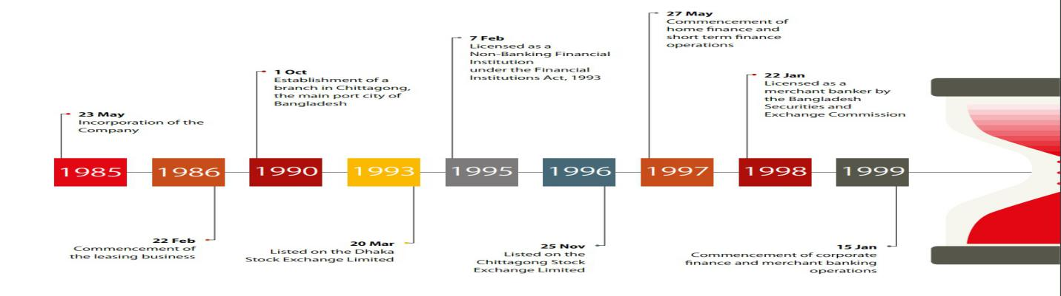
IDLC began its excursion as a leasing organization in 1985 with just 5 staff individuals. Be that as it may, following 33 years of steady flourishing it has become the biggest multi-item, multi-section NBFIs in the nation. It is one of the most regarded and notable budgetary brand in the business and it holds a solid and broadened territory in corporate SME, retail, and capital market fragments. Today IDLC is acting in 20 urban communities in the nation with 38 branches and corners. It has a work power of 140 representatives which are serving 45000 customers. Despite the fact that making benefit is significant however the primary witticism of IDLC Finance LTD. Is to endeavor to assist individuals with accomplishing their fantasies - the fantasy about possessing a home, the fantasy about sending their youngsters to best instructive foundation, the fantasy about going on an outing in the family vehicle, the fantasy about beginning a business, or that of extending it, the fantasy about producing greater work, the fantasy about taking the country to more prominent statures.
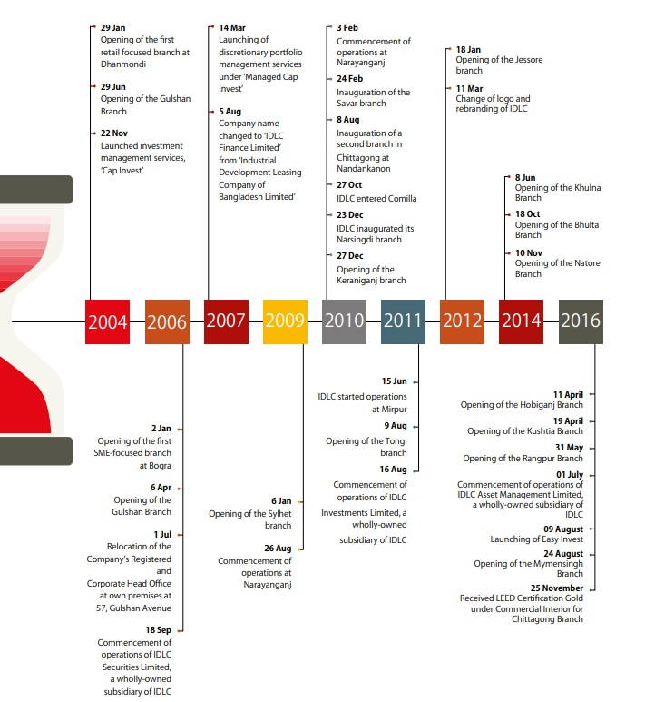

Company Vision
“We will be the best financial brand in the country” ( (Limited, IDLC Finance Limited, 2020).

Company Mission
“We will focus on quality growth, superior customer experience and sustainable business practices” ( (Limited, IDLC Finance Limited, 2020).
For the Company: Relentless pursuit of customer Satisfaction through delivery of top quality services.
For the Shareholder: Maximize shareholders wealth through a sustained return on the investment.
For the employee: Provide job satisfaction by making IDLC a center of excellence with opportunity of career development.

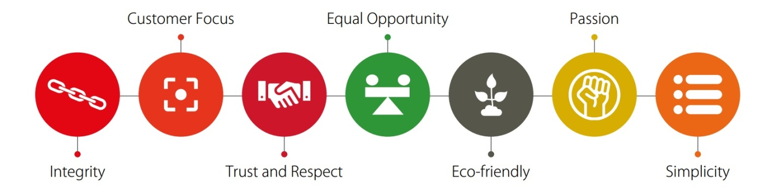
Company Values

Corporate divisions and departments:
There are lots of department in the organization and each of them has their designated important duty to perform. Here are some of them which are very important ( (Limited, Annual Sustainability Report 2016, 2016).

Figure I: Department of IDLC Finance Limited

Organizational Chart
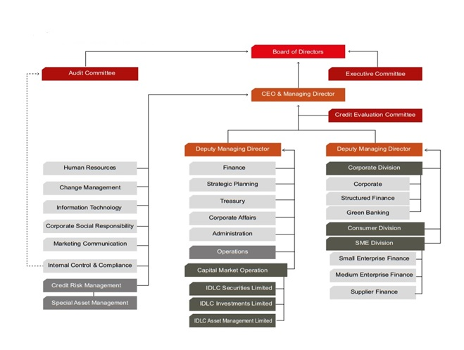
Figure II: Organizational Chart of IDLC

Here it can be seen that there are two subpanels who are accounted to the Board of directors, Audit committee and Executive Committee. The executive committee handles with all the business, operations and Board of directors approves. On the other hand, the Audit committee prime works is to deal with all kinds of money related matters and internal control and compliance.

Product Lines and Services:
IDLC Finance Limited segments their product & services so that they can capture their client easily. Here are the product categories that they offer in the market;

Figure III: Product & services of IDLC

Capital Markets Operations
On capital market operations IDLC Finance Limited segment their services on the basis of three categories, like;
- IDLC securities limited
- IDLC investment limited
- IDLC asset management limited

IDLC Securities Limited

Figure IV: IDLC Securities Limited
IDLC Investments Limited

Figure V: IDLC Investments Limited
IDLC Asset Management Limited

Figure VI: IDLC Asset Management Limited

Green Financing
IDLC Finance Limited works for green financing for the better development in future. They make the slogan for green financing which is ‘’Towards a Better Future’’. IDLC financed around 15.21 million BDT for Eco Friendly Brick Manufacturing. BDT 130 millon was the total cost of this project. About BDT 26 million are investing in RMG factories in Narayanganj and Narsingdi for effluent treatment plant. IDLC invest around 3 million of taka on Organic Compost Project in Bogra. IDLC has set up a laboratory for nursing Derma, the very basic element for producing Tricho compost (Limited, Annual Sustainability Report 2016, 2016).

Brief Description about SME Sector of IDLC
IDLC’s SME division provides a wide bouquet of loan products and solutions to small and medium enterprises (SMEs), helping them meets their aspirations of achieving sustainable business growth. Our suite of loan facilities and financing solutions, including term loans, working capital, project financing, Abashan loans or rent loans for small enterprises and working capital and project financing loans for medium enterprises, among others, have created a real impact in the market and led to the division’s sustainable growth over the years (Limited, IDLC Finance Limited, 2020).

SK Agro Farm is Applying for Start-up Loan
SK Agro Farm can use this loan for daily transactional needs in the form of Working Capital Finance or procurement of Fixed Assets. Slogan of this product is

Start-up Loan
PRODUCT FEATURES (Limited, IDLC Finance Limited, 2020)
- Loan Limit: Up to 25 lac
- Loan Tenure: Up to 5 years
- Grace period of 3 to 6 months
- Repayment method: Equal monthly installment or structured payment


Terms & Conditions of Start-up Loan
Following are the terms for Conversion of Interest Rate Mode (Limited, IDLC Finance Limited, 2020):
- Conversion Fee is 1% of the outstanding loan amount / URPA plus VAT.
- Conversion will not be allowed in the 1st year of the loan tenor.
- Conversion is allowed once in the entire loan tenor.
- IDLC Credit Risk Management Department may apply credit assessment parameter and may ask for any relevant / up to date documents (if required) in this regard.
- One will not be eligible for this Conversion facility if there is one or more Overdue Instalment during the last 9 months before the date of application.
- Satisfactory CIB Report must be received before Disbursement.
- Prevailing Asset Rate Matrix will be applicable for the Interest Rate Conversion.
- Conversion Fee may change at any time as per approved Schedule of Charges or due to regulatory policy.
Following are the terms for Prepayment / Foreclosure:
- Minimum amount for prepayment is Tk. 100,000/-, but not more than 70% of the Principal amount.
- Application should be made within 20th day of any month for effecting the revised EMI due to prepayment from the following month.
- Prepayment request is allowed after payment of first 6 (six) EMIs and but not on partly drawn loan amount.
- Early Settlement Fee 2% and VAT is applicable.
- Overdue Installment(s) and / or Charges (if any) must be paid before prepayment.
- Foreclosure or prepayment is accepted only after the payment of the current month’s installment.
- After availability of Settlement Amount of the loan and Redemption of Mortgage the title documents relating to property shall be available at the concerned branch for delivery within next 7 to 10 working days.
- After prepayment a letter containing revised terms of the loan will be issued within 10 working days.
- New tenor or revised EMI will be effective from the following month’s EMI schedule.
- Any receivables identified subsequently in your Loan A/C shall be recoverable and can be claimed even after full settlement of the Loan A/C. IDLC will provide supporting documents in this regard.

Service Request Form for Loan
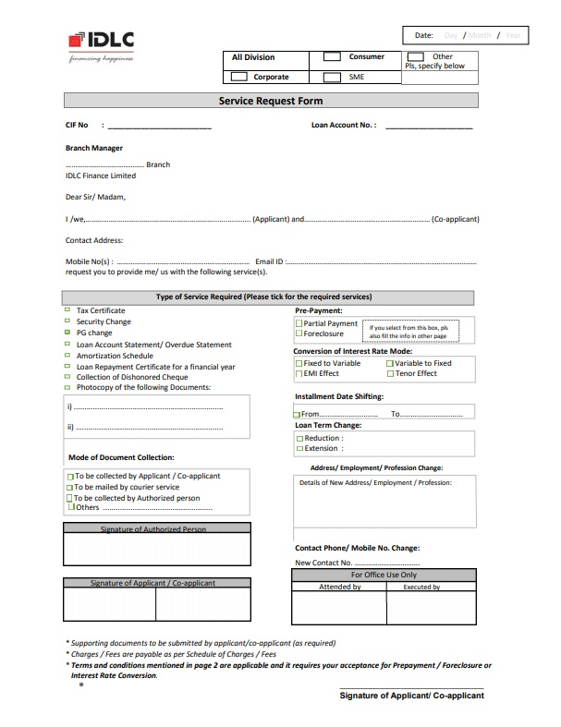
Figure VII: Service Request Form of IDLC

CHAPTER 03: Project at a Glance (SK Agro Farm)

History
Startup Expenses
Company Description
Mission Statement
Vision
Objectives
Company Structure
TARGET MARKET SPECIFICATION & MRKETING GOAL & OBJECTIVES
Market Segmentation
Target Market
Positioning
Marketing Goals
Marketing objectives
Financial Objectives
Project Design & implementation
Activities of the SK Agro Farm:
Network Diagram
Critical Path
Gantt chart
Earn Value Analysis
Responsibility Matrix
Crashing
Quality Control of Tasks

History
Fish production is the big sector in Bangladesh which has potentialities & a huge contribution in our economy comes from fish production. Fish production is the big dynamic & productive sector in Bangladesh. The growing rate of this sector is continuously increased day by day. From 1971, after independence of Bangladesh, a noticeable development occurs in fish production sector. For the last few years, so many young entrepreneurs started their career by utilizing this sector. SK Agro firm is one of them. SK Agro Firm mainly started their business to meet the fish demand of the nations. They started their business from 2016 as a fisheries firm which is located at Gopalpur, Tangail, Dhaka. It’s a partnership business. Initially SK Agro Farm started their business as a fisheries firm, but in the future, they have another plan. SK Agro Farm will expand its business by sales volume and by introducing more product lines in future.

Startup Expenses
SK Agro Farm initially invests around tk3300000, which will be discussed on the next part of the report. SK Agro Farm has the next plan to establish a feed production house, so that they can extend their business & it will be supportive for their own fish production. If SK Agro Farm buys feed from outside suppliers, it is very costly for fish production.

Company Description
Before starting the business, SK Agro Farm follows so many criteria which are needed for the fish ponds. That’s why it will reduce the risk of project.
- The source of water, quality of water and quantity of ponds must be important for the fish production.
- The soils should be secure to water
- Pond must be fulfill by the water and drain must be using properly to giving outside water to the pond. Sometimes drain is cost effective for the project.
- Dike of the pond must be able to resist the water stress & high sufficient to preserve the water of the pond from ever running over its top.
- The open land area adjoining to the ponds need to be extensive ample to allow taking walks in or adequate area for vehicles/tractors.
Mission Statement: to be self-employed, for the opportunity to others by creating employment, to provide fresh & healthy product to customer.

Vision
SK Agro Farm will maintain their reputation within their province and community for a high standard of:
- Fish quality, creativity and presentation.
- Consistent superior service and price value.
- Sanitation, appearance and overall professional attitude.
Team work and good personality traits are the only tools which can helps them to reach their objectives.

Objectives
The objectives of SK Agro Farm are
- Increase monthly business sales to 5lac.
- Increase gross margin by 150%.
- Position SK Agro Firm as a Market toper.
- Introduce 2 more product lines after 2 years.
- Introduce 1 more wing in business.

Company Structure
Initially 2 partners started SK Agro Farm business which is known as fisheries business. In a future when they will extend their business, their organization structure will be changed & that structure should be like these;
Figure VIII: Structure of SK Agro Farm

TARGET MARKET SPECIFICATION & MRKETING GOAL & OBJECTIVES

Market Segmentation
Market segmentation is an important part for launching a new Product in a market. As SK Agro Farm is a fisheries business, so concern about their customer segmentation following:
- Geographic’s.
- Demographics.
- Psychographic.
Geographic segmentation
SK Agro Farm is targeting all classes of people in-
- Local market at Gopalpur
- Town market at Tangail
- wholesaler market at kawran bazaar, Dhaka
- Mega shop all over the country
And SK Agro Farm targeted place is local wholesaler market at Tangail & for the small fishes, targeted local fisheries business owner.
Demographic segmentation:
SK Agro Firm also focus on demographic segmentation which is based on
- Local fisheries business owner who buy the small fishes from hatchery.
- Local fish hunter who have no fish pond, but they are the fish suppler who supply the fish from one person to another fisheries business owner.

Target Market
On the consumption of fish, there are no cultural, regional, religious barriers, Customers will be the local market, retailers, and sometimes it will be a big mega shop. In future, SK Agro Firm have the plan to export in the global market when the local market is satisfied & they will earn foreign currency.

Positioning
SK Agro Farm will position itself by its tag line that is “Having a Trustworthy Fisherman”. And it will be an opportunity for people who want to enjoy the wants to buy the best & healthy fish with a reasonable cost.

Marketing Goals
SK Agro Farm’s sales plan is to determine and maintain position not only for our local customers but also the big wholesaler all over the country. The strategy is to create more customers so that they can extend revenue. SK Agro Farm will focus on making all our customers happy with our best quality of fish.
SK Agro Farm mainly maintains their business in a seasonal basis, but for the better understanding we show the sales projections on the monthly basis. Monthly gross profit is 3,426,700tk for the 1st year operation. Our total cost of goods sold is capped at 33% of total sales. So our profit will be 67% on the base of sales. We expect sales to increase 5% after Year 1.

Figure IX: Increasing Profit Margin of SK Agro Farm

Marketing objectives
- To maintain positive, strong growth for each of the segment.
- To achieve a remarkable increase in market positioning.
- To increasing customer loyalty.
- To become a best agro firm brand in our country.

Financial Objectives
- To increase the profit margin by 1 percent per quarter through efficiency and economy of scale gains.
- To achieve a double to triple digit growth rate for the first three years.

Project Design & implementation

Activities of the SK Agro Farm:
Different types of activities of fish farm project;
(A) Site selection: Project location will be selected on the basis of accessibility, communication, power supply etc.
(B) Purchase and delivery of pumps: We need a submersible pump for water supply. That’s why we have to purchase a pump at first.
(C) Hire an Excavator: Rent an excavator through a local construction machinery rental company & choose the correct excavator for the job.
(D) Digging: Design the pond on the basis of project planning. Map out the exact shape of the pond & using marker flags.
(E)Soil Test: The laboratory tests should provide such required data like - liquid limit, plastic limit, plastic index, pH limit etc.
(F) Preparing the Pond: Preparing Bottom of the pond. Bottom should be flat & sloping toward the outlets.
(G) Construction of dike: Pond dike should be able to resist the water pressure & high enough to keep the pond water from ever running over its top.
(H) Dike Protection: To protect dike, we need to Compacting soil. To compact the rock type of soil by hand we can use a thick stick, a metal tamper etc.
(I) Give the lime & Observation: Give the lime to protect the soil from insect & germ.
(J) Construction of outlets: Main reason to construction of outlets is to keep the water surface in the pond at its optimum level.
(K) Construction of inlets: During the construction of inlets, filters should be used in the channel so that unwanted fish and other materials do not enter into the pond.
(L) Construction of internal roads: Construct an internal road for accessibility.
(M) Construction of pump house: We need to construct a pump house.
(N) Installation of pumps: For running pump, we have to set up the pump.
(O) Protection from insects & germ:After giving water, use Insecticide & Chemical fertilizerto protect the pond water from insect & different types of germ.
(P) Checking and testing: For testing we can give some fist & observe some days.
 |  |  | Time (Days)
List of Activities | Activities | Predecessor | a | m | b | Expected Time (T.E.) | Variance (σ²)
Site selection | A | None | 3 | 5 | 7 | 5 | 0.44
Purchase and delivery of pumps | B | A | 14 | 14 | 14 | 14 | --
Hire an Excavator | C | A | 1 | 3 | 5 | 3 | 0.44
Digging | D | C | 15 | 20 | 22 | 20 | 1.36
Soil Test | E | D | 3 | 3 | 3 | 3 | 0.00
Preparing the Pond | F | D, E | 10 | 12 | 14 | 12 | 0.44
Construction of dike | G | F | 8 | 10 | 12 | 10 | 0.44
Dike Protection | H | G | 12 | 15 | 16 | 15 | --
Give the lime & Observation | I | F, G | 7 | 7 | 7 | 7 | 0.00
Construction of outlets | J | I | 3 | 3 | 3 | 3 | 0.00
Construction of inlets | K | I | 2 | 2 | 2 | 2 | --
Construction of internal roads | L | J, K | 7 | 9 | 10 | 9 | 0.25
Construction of pump house | M | B | 6 | 7 | 10 | 7 | --
Installation of pumps | N | B | 2 | 2 | 2 | 2 | --
Protection from insects & germ | O | N | 7 | 7 | 7 | 7 | --
Checking and testing | P | O | 3 | 4 | 7 | 4 | --
 |  |  |  |  | Total, σ2 |  | 3.39

Network Diagram
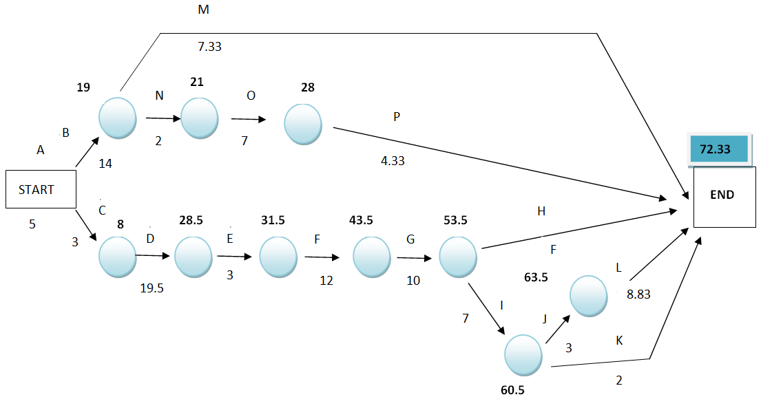

Figure X: Netwark Diagram

Critical Path
ACDEFGIJL= 72 Days
If 90% probability, than Z=1.25
$$Z=\frac{D-μ}{\sqrt{δ^{2}}}$$
Or, 1.25=$\frac{D-72}{\sqrt{3.39}}$
Or, D= 74.30 Days
If 95% probability, than Z=1.65
$$Z=\frac{D-μ}{\sqrt{δ^{2}}}$$
Or, 1.65=$\frac{D-72}{\sqrt{3.39}}$
Or, D= 75.04 Days

Gantt chart
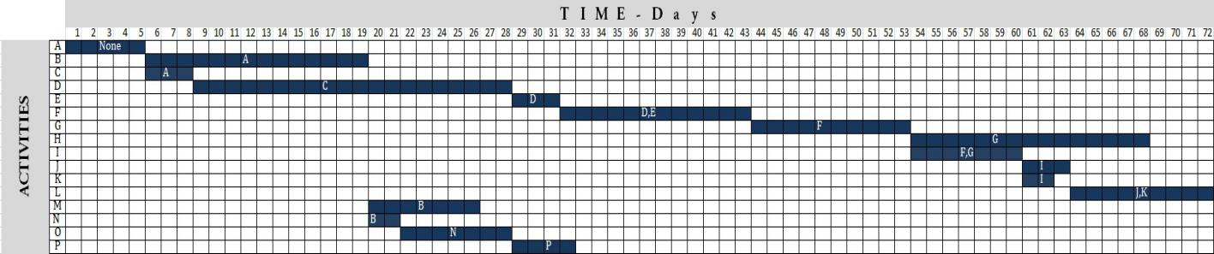
Figure XI: Gantt Chart

Earn Value Analysis
List of Activities | Activities | Predecessor | Expected Time (T.E.) | Cost/Day | Total Cost
Site selection | A | None | 5 | _ | 1000
Purchase and delivery of pumps | B | A | 14 | _ | 20000
Hire an Excavator | C | A | 3 | _ | 500
Digging | D | C | 20 | 20000 | 400000
Soil Test | E | D | 3 | _ | 20000
Preparing the Pond | F | D, E | 12 | 1000 | 12000
Construction of dike | G | F | 10 | 1000 | 10000
Dike Protection | H | G | 15 | 700 | 10500
Give the lime & Observation | I | F, G | 7 | _ | 1000
Construction of outlets | J | I | 3 | _ | 4000
Construction of inlets | K | I | 2 | 700 | 1400
Construction of internal roads | L | J, K | 9 | 2000 | 18000
Construction of pump house | M | B | 7 | _ | 20000
Installation of pumps | N | B | 2 | 700 | 1400
Protection from insects & germ | O | N | 7 | 400 | 2800
Checking and testing | P | O | 4 | _ | 1000
Field Visit after 20 days
Activities | Actual % Complete | Actual Cost
A | 100 | 800
B | 100 | 20000
C | 100 | 300
D | 70 | 250000
E | 0 | 0
F | 0 | 0
G | 0 | 0
H | 0 | 0
I | 0 | 0
J | 0 | 0
K | 0 | 0
L | 0 | 0
M | 10 | 1500
N | 50 | 700
O | 0 | 0
P | 0 | 0

Activities | Actual Cost | Earned Value | Planned Value | CPI | CV | SPI | SV
A | 800 | 1000 | 1000 | 1.25 | 200 | 1.00 | 0
B | 20000 | 20000 | 20000 | 1.00 | 0 | 1.00 | 0
C | 300 | 500 | 500 | 1.67 | 200 | 1.00 | 0
D | 250000 | 280000 | 268000 | 1.12 | 30000 | 1.04 | 12000
E | 0 | 0 | 0 | 0.00 | 0 | 0.00 | 0
F | 0 | 0 | 0 | 0.00 | 0 | 0.00 | 0
G | 0 | 0 | 0 | 0.00 | 0 | 0.00 | 0
H | 0 | 0 | 0 | 0.00 | 0 | 0.00 | 0
I | 0 | 0 | 0 | 0.00 | 0 | 0.00 | 0
J | 0 | 0 | 0 | 0.00 | 0 | 0.00 | 0
K | 0 | 0 | 0 | 0.00 | 0 | 0.00 | 0
L | 0 | 0 | 0 | 0.00 | 0 | 0.00 | 0
M | 1500 | 2000 | 2900 | 1.33 | 500 | 0.69 | -900
N | 700 | 700 | 700 | 1.00 | 0 | 1.00 | 0
O | 0 | 0 | 0 | 0.00 | 0 | 0.00 | 0
P | 0 | 0 | 0 | 0.00 | 0 | 0.00 | 0

Responsibility Matrix
Actual responsibility | 1
General responsibility | 2
Must be consulted | 3
May be consulted | 4
Must be notified | 5
Final approval | 6
List of Activities | Activities | MD | CFO | Project Manager | Team Leader | Developer | Business Analysist | Consultant
Site selection | A | 6 |  | 1 |  | 2 |  | 3
Purchase and delivery of pumps | B |  | 2 | 2 | 1 |  | 3
Hire an Excavator | C |  | 5 | 1 |  | 2
Digging | D | 5 | 3 | 3 | 4 | 1 |  | 4
Soil Test | E |  | 5 | 4 | 1 |  |  | 3
Preparing the Pond | F |  | 5 | 2 | 1 | 1 |  | 3
Construction of dike | G |  | 5 | 2 | 1 | 1 |  | 3
Dike Protection | H |  | 5 | 2 | 1 | 1
Give the lime & Observation | I |  |  | 1 | 1 |  |  | 3
Construction of outlets | J |  |  | 2 | 1 | 1
Construction of inlets | K |  |  | 2 | 1 | 1
Construction of internal roads | L | 2 | 5 | 2 |  | 1 |  | 4
Construction of pump house | M | 4 | 5 | 1 |  |  |  | 3
Installation of pumps | N |  | 5 | 2 | 1
Protection from insects & germ | O |  |  | 1 |  |  |  | 3
Checking and testing | P | 6 |  | 1 |  |  |  | 5

Crashing
List of Activities | Activities | Normal Duration | Crash Duration | Normal Cost | Crash Cost | Crash Cost/Day
Site selection | A | 5 | 3 | 1000 | 1400 | 200
Purchase and delivery of pumps | B | 14 | 12 | 20000 | 22000 | 1000
Hire an Excavator | C | 3 | 2 | 500 | 900 | 400
Digging | D | 20 | 18 | 400000 | 440000 | 20000
Soil Test | E | 3 | 2 | 20000 | 21000 | 1000
Preparing the Pond | F | 12 | 10 | 12000 | 15000 | 1500
Construction of dike | G | 10 | 9 | 10000 | 11000 | 1000
Dike Protection | H | 15 | 12 | 10500 | 13500 | 1000
Give the lime & Observation | I | 7 | 6 | 1000 | 1200 | 200
Construction of outlets | J | 3 | 2 | 4000 | 5000 | 1000
Construction of inlets | K | 2 | 1 | 1400 | 1700 | 300
Construction of internal roads | L | 9 | 7 | 18000 | 20000 | 1000
Construction of pump house | M | 7 | 6 | 20000 | 21000 | 1000
Installation of pumps | N | 2 | 1 | 1400 | 2800 | 1400
Protection from insects & germ | O | 7 | 5 | 2800 | 3600 | 400
Checking and testing | P | 4 | 3 | 1000 | 1500 | 500

Quality Control of Tasks
List of Activities | Quality Control of each Task
Site selection | Consultant with advisor, business analysist & developer ,than take the decision
Purchase and delivery of pumps | Compare with different company's pump& select the better quality of pump from the reputed brand
Hire an Excavator | Hire an excavator on the basis of effectiveness
Digging | Appoint an experienced developer for better of digging
Soil Test | Give the soil to reputed private firm for the better & accurate result
Preparing the Pond | Continuously measure the labor productivity
Construction of dike | Consult with site engineer for perfect measurement of dike
Dike Protection | Follow the engineer instruction for dike protection
Give the lime & Observation | Give the better quality of lime & continuous observation.
Construction of outlets | Using RFL or GAZI pipe & using water filter in front of the pipe for protection of outside dust.
Construction of inlets | Construction of drain by using sand & cement.
Construction of internal roads | For constructing strong, stable internal road, we can use thick stick & metal temper.
Construction of pump house | For constructing pump house, we can use better quality of tin shed.
Installation of pumps | Digging deeply to reach the perfect water level.
Protection from insects & germ | Using better quality of insecticide for protection of pond from insect & germ.
Checking and testing | For checking & testing, we can take advise from the advisor.

CHAPTER 04: Loan Disbursement & recovery policy of IDLC Finance Limited Client- SK Agro Farm

Loan Disbursement & recovery policy of IDLC Finance Limited:
Step 01; Prospective Client Search:
Step 02; Information checklist & Document Submission:
Identity Proof
Proof of Business:
Financial Documents
Step 03; Loan Assessment:
Analysis of SK Agro Farm
Business performance of SK Agro Farm
Step 04; Loan Approval Process:
Step 05; Loan Recovery:

Loan Disbursement & recovery policy of IDLC Finance Limited:
IDLC Finance Limited tries to reduce risk, so that they developed a suitable & accountable policy for credit disbursement & recovery. IDLC Finance Limited annually disburses loan & recovery their loan on the basis of following aspects; like,
- Economic sectors
- Geographical locations
- Client’s product quality & productivity
- Client’s previous reputation
IDLC Finance Limited always follows the guideline of Bangladesh Bank so that can manage their credit policy on effectively. Following steps are followed by IDLC Finance Limited for credit disbursement;

Figure XII:Process of Loan Disbursement & recovery policy

Step 01; Prospective Client Search:
Sales executives of IDLC Finance Limited are always searching a prospective client for loan. They always doing research about client business market conditions, client reputation etc. based on their information, IDLC’s Credit Administration Department (CAD) analysis all the information about client’s business & give the approval letter to the client.
In this case, SK Agro Firm first contract to the sales executive & sales executive physically visit to the project & collect all the information that IDLC’s CAD need to require for the analysis. After collecting all the information, they provide it to the CAD.

Step 02; Information checklist & Document Submission:
When SK Agro Firm is applying for loan from IDLC Finance Limited, they need to provide an information checklist on the basis of their requirement. Following information Checklist are required by IDLC Finance Limited;

Figure XIII: Information checklist for a new Client

Identity Proof
SK Agro Farm provide all types of identification proof like trade licence number, bank details, address proof etc to IDLC Finance limited.
Name of the Business: | SK Agro Farm
Full Address of the business: | Union-Mirzapur, Upozela- gopalpur, District- Tangail, Division- Dhaka
Starting of the Business: | From 2016
Types of the Business: | Partnership Busniess
Trade Licence Number: | SK Agro Farm- 1141
Bank Details | A/C name: Md. Moshiur Rahman A/C Number: 123456123789 Bank Name: National Bank Limited Branch: Gopalpur,Tangail Types of A/C: joint Account
Table I: Identity Proof of SK Agro Farm

Proof of Business:
All the information about SK Agro Farm, that already discuss in the chapter 3.
PROJECT AT GLANCE :
1 | Name | : | SK Agro Farm
2 | Address | : | Union-Mirzapur
 |  |  | Upozela- gopalpur
 |  |  | District- Tangail
 |  |  | Division- Dhaka
3 | Nature of Business | : | Fisheries Business
4 | Constitution | : | Proprietorship
 | Proprietor | : | 2

5 | Particulars | Total
5 | Operational Cost | 817000
5 | Land (8093.71 Square Metre) | 2000000
5 | Fencing the land | 180000
5 | Genarator & Construction a Building | 200000
5 | Purchase and Installation of pumps | 22000
5 | Feeding Equipment | 20000
5 | Cultivating Equipment | 35000
5 | Dalivery van | 5000
5 | Equipment for Monitoring, Repair & Maintenance | 8000
5 | Other Cost | 13000
5 | Total | 3300000
5 | Means of Finance:
5 | Particulars | Total
5 | Proprietor Contribution | 1200000
5 | Term Loan from IDLC Finance Limited | 2100000
5 | Total | 3300000

6 | Debt Equity Ratio | : | 1.75
7 | Debt Coverage Ratio | : | 4.20
8 | Gross Profit Ratio | : | 64.99%
9 | Net Profit Ratio | : | 28.52%
10 | Return on Investment | : | 121.12%
Table II: SK Agro farm at a Glance

Financial Documents
SK AGRO FARM
TANGAIL
STATEMENT NO. 1
COST OF THE PROJECT:
The project cost has been estimated at Taka 33 Lakhs
Brief details of the project cost is given below
Serial No. | Activities | Amount (TK)
A | Land & Machineries
A | Land (8093.71 Square Metre) | 2,000,000
A | Fencing the land | 180,000
A | Genarator & Construction a Building | 200,000
A | Purchase and Installation of pumps | 22,000
A | Total | 2,402,000
B | Pond Costruction
B | Site selection | 1,000
B | Hire an Excavator | 500
B | Digging | 400,000
B | Soil Test | 20,000
B | Preparing the Pond | 12,000
B | Construction of dike | 10,000
B | Dike Protection | 10,500
B | Give the lime & Observation | 1,000
B | Construction of outlets | 4,000
B | Construction of inlets | 1,400
B | Construction of internal roads | 18,000
B | Construction of pump house | 20,000
B | Protection from insects & germ | 2,800
B | Checking and testing | 1,000
B | Total | 502,200
C | Fingerling
C | Cost of Fingerling (Average price per piece 3tk * 90000piece) | 270,000
C | Cost of Feeding | 44,800
C | Total | 314,800
D | Feeding Equipment | 20,000
E | Cultivating Equipment | 35,000
F | Dalivery van | 5,000
G | Equipment for Monitoring, Repair & Maintenance | 8,000
H | Other Cost | 13,000
 | Total Startup Cost | 3,300,000
Table III: Start-up cost of SK Agro farm
SK AGRO FARM
TANGAIL
STATEMENT NO. 2
PROJECTIONS AND PROFITABILITY STATEMENT
PARTICULARS | Operating Years
PARTICULARS | 0 | 1 | 2 | 3
A. Cash Revenue:
Fish Sold | 5,450,000 | 5,995,000 | 6,594,500 | 7,253,950
B. Expenses
Labor Cost | 120,000 | 120,000 | 120,000 | 130,000
Chemicals | 48,000 | 40,000 | 41,000 | 35,000
Fuel | 300,000 | 320,000 | 300,000 | 280,000
Fingerling | 150,000 | 160,000 | 160,000 | 170,000
Feed | 936,000 | 1,030,000 | 1,030,000 | 1,100,000
Digging end of the year | 250,000 | 200,000 | 50,000 | 100,000
Other Variable Cost | 150,000 | 170,000 | 120,000 | 120,000
Depreciation | 69,300 | 58,905 | 50,069 | 42,559
Cost of Operations | 2,023,300 | 2,098,905 | 1,871,069 | 1,977,559
C. Gross Profit (A-B) | 3,426,700 | 3,896,095 | 4,723,431 | 5,276,391
D. Interest: on loan | 287,301 | 220,743 | 143,486 | 53,809
E. Selling & Adminstration Cost | 600,000 | 630,000 | 661,500 | 694,575
F. Profit Before Tax [C-(D+E)] | 2,539,399 | 3,045,352 | 3,918,445 | 4,528,007
G. Income Tax @30% | 761,820 | 913,606 | 1,175,533 | 1,358,402
H. Profit after Tax [F-G] | 1,777,579 | 2,131,746 | 2,742,911 | 3,169,605
I. Depreciation added back | 69,300 | 58,905 | 50,069 | 42,559
J. Cash Availabe [H+I] | 1,846,879 | 2,190,651 | 2,792,981 | 3,212,164
K. Repayment of Term Loan | 414,034 | 480,592 | 557,849 | 647,526
L. Net cash Available [J-K] | 1,432,845 | 1,710,060 | 2,235,132 | 2,564,638
Table IV: PROFITABILITY STATEMENT of SK Agro Farm
SK AGRO FARM
TANGAIL
STATEMENT NO. 3
CASH - FLOW STATEMENT :
PARTICULARS | Operating Years
PARTICULARS | 0 | 1 | 2 | 3
A. Source of Funds :
Profit after Tax | 1,777,579 | 2,131,746 | 2,742,911 | 3,169,605
Depreciation | 69,300 | 58,905 | 50,069 | 42,559
Proprietor Contribution | 1,200,000 | - | - | -
Term Loan from IDLC Finance Limited | 2,100,000 | - | - | -
Total Souce of Funds | 5,146,879 | 2,190,651 | 2,792,981 | 3,212,164
B. Application of Funds :
Fencing the land | 180,000 | - | - | -
Genarator & Construction a Building | 200,000 | - | - | -
Purchase and Installation of pumps | 22,000 | - | - | -
Feeding Equipment | 20,000 | - | - | -
Cultivating Equipment | 35,000 | - | - | -
Dalivery van | 5,000 | - | - | -
Equipment for Monitoring, Repair & Maintenance | 8,000 | - | - | -
Other Cost | 13,000
Repayment of loan | 414,034 | 480,592 | 557,849 | 647,526
Total Application of Funds | 897,034 | 480,592 | 557,849 | 647,526
C. Opening Balance | - | 4,249,845 | 5,959,905 | 8,195,037
D. Net surplus ( A - B ) | 4,249,845 | 1,710,060 | 2,235,132 | 2,564,638
E. Closing Balance | 4,249,845 | 5,959,905 | 8,195,037 | 10,759,675
Table V: CASH - FLOW STATEMENT of SK Agro Farm

SK AGRO FARM
TANGAIL
STATEMENT NO. 2
BALANCE SHEET
PARTICULARS | Operating Years
PARTICULARS | 1 | 2 | 3
ASSET
Non- Current Asset:
Land | 2,000,000 | 2,000,000 | 2,000,000
Fencing the land, Generator, Pump, Feeding Equipment, Cultivating Equipment, Dalivery van | 462,000 | 392,700 | 333,795
Total Non-Current Asset | 2,462,000 | 2,392,700 | 2,333,795
Current Asset:
Cash & Bank | 4,142,960 | 5,959,905 | 8,195,037
Total Current Asset | 4,142,960 | 5,959,905 | 8,195,037
TOTAL ASSET | 6,604,960 | 8,352,605 | 10,528,832
Equity & Liabilities
EQUIRY | 1,200,000
Investment | 2,000,000
Reserves & Surplus | 1,777,579
Liabilities
Secured Loan | 1,685,966
Total Equity & Liabilities | 6,663,545
Table VI: BALANCE SHEET of SK Agro farm

Step 03; Loan Assessment:
After collecting all the information from SK Agro farm, the sales executive of the IDLC Finance Limited provided that document to the Credit Risk Management (CRM) department. CRM of IDLC Finance Limited would analysis all the document & give approval to CAD (Credit Administration Department).

Analysis of SK Agro Farm
CRM of IDLC Finance Limited uses 7C’s of credit for analyzing SK Agro farm;
Character: IDLC Finance Limited is always concern about their client’s integrity and they are confidence about client’s willingness to repay the loan. Certain questions are important here,
- Has IDLC met the customer?
- What is his reputation in the community?
- Is he an upstanding guy or is he a dead beat?
- IDLC may consider checking references with other business-owners with which the customer does business.
CRM of IDLC Finance Limited first visits SK Agro Farm physically. After visiting the project, CRM are able to sure that, the reputation of SK Agro Farm is very good with their customer or their competitors & their suppliers. On the other hand, CRm also report that, IDLC has always met with the Sk Agro farm. So overall character analysis of SK Agro farm, CRM report that, Sk Agro Farm is highly qualified for the loan.
Credit History: Credit History is the most important aspect for IDLC Finance Limited on the time of giving loan. Client’s past success is the key to determine of his future prospects.
- Is it a successful business venture?
- Is he a credit defaulter in the past?
- Is the relationship good with the other bank?
In this case, this is the first time loan application for SK Agro Farm. So SK Agro Farm Has no Credit history, but the relationship with the National bank Limited (where they maintain their deposit join account) is good.
Capacity: Credit officer analysis all the important ratio for understanding the business conditions. Certain questions are important here,
- Are they capable to repayment the loan on timely basis?
- What are their business conditions?
- What will be their future prospects after giving the loan?
Credit officer find following data after analysis of SK Agro Firm;
SK AGRO FARM
TANGAIL
ANNEXURE NO. 3
DEBT SERVICE COVERAGE RATIO :
SK Agro Farm | Operating Years
SK Agro Farm | 0 | 1 | 2 | 3
A. SOURCES :
Profit after tax | 1,777,579 | 2,131,746 | 2,742,911 | 3,169,605
Depreciation | 392,700 | 333,795 | 283,726 | 241,167
Interest on loan | 287,301 | 220,743 | 143,486 | 53,809
TOTAL OF ' A ' | 2,457,580 | 2,686,284 | 3,170,123 | 3,464,581
B DEBT :
Term loan installment | 414,034 | 480,592 | 557,849 | 647,526
Interest on Term Loan | 287,301 | 220,743 | 143,486 | 53,809
TOTAL OF ' B ' | 701,335 | 701,335 | 701,335 | 701,335
C Debt Service Coverage Ratio
DSCR [ A / B ] | 3.50 | 3.83 | 4.52 | 4.94
D Average DSCR | 4.20
Table VII: DEBT SERVICE COVERAGE RATIO for 1st three Years SK Agro Farm

Figure XIV: DEBT SERVICE COVERAGE RATIO for 1st three Years of SK Agro Farm
A debt service coverage ratio of 1 or above indicates that a company is generating sufficient operating income to cover its annual debt and interest payments. A ratio that high suggests that the company is capable of taking on more debt (Silver, 2019).
After analyzing debt service coverage ratio, credit officer find that their business conditions continuously increase. So that is the good signal for IDLC Finance limited. On the other hand, their Average DSCR is 4.20 that are also good.
ANNEXURE NO.4
ANALYSIS OF RETURN ON INVESTMENT :
(A HDPE/PP Fabrics Project)
1. Return on Investment = | Average Return x 100
 | Capital Employed
2. Return = | Profit before tax + Depreciation + Interest on loan
3. Capital Employed = | Cost of the Project
RETURN ON INVESTMENT :
PARTICULARS | O P E R T I N G Y E A R S
PARTICULARS | 0 | 1 | 2 | 3
Profit before tax | 2,539,398.97 | 3,045,351.77 | 3,918,444.80 | 4,528,006.92
Depreciation | 392,700.00 | 333,795.00 | 283,725.75 | 241,166.89
Interest on Term Loan | 287,301.03 | 220,743.23 | 143,485.95 | 53,809.22
Return | 3,219,400 | 3,599,890 | 4,345,657 | 4,822,983
Average Return | 3,996,982
Capital Employed | 3,300,000
Return on Investment | 121.12%
Table VIII: RETURN ON INVESTMENT of SK Agro Farm for the 1st Three years

Debt Equity Ratio | : | 1.75
Debt Coverage Ratio | : | 4.20
Gross Profit Ratio | : | 64.99%
Net Profit Ratio | : | 28.52%
Return on Investment | : | 121.12%

The debt to equity ratio is the financial leverage ratio which is calculated by dividing the farm’s total liabilities & the total contention of Proprietor of the farm. There re some key idea about Debt to equity ratio, which is
- The debt-to-equity ratio is a financial leverage ratio, which is frequently calculated and analyzed, that compares a company's total liabilities to its shareholder equity.
- The D/E ratio is considered to be a gearing ratio, a financial ratio that compares the owner's equity or capital to debt, or funds borrowed by the company.
- The optimal D/T ratio varies by industry, but it should not be above a level of 2.0.
- A D/E ratio of 2 indicates the company derives two-thirds of its capital financing from debt and one-third from shareholder equity.
After analyzing the debt to equity ratio,it indicates that SK Agro farm should take less than two third of total amount of the loan. And after analysis of debt coverage ratio, analysisest of the IDLC recommend that the farm is capable to repayment the loan.
Capital: Capital refers to borrower’s net worth, the total amount of their asset minus total amount of their liabilities. Certain questions are important here,
- How much capital they have?
- What is the borrower’s financial net worth?
After collecting all information about SK Agro farm, Credit officer refers that SK Agro farm’s Net worth is 4758426tk after 1st year operations that means it is good for a business.
Career History: IDLC asks about the borrower’s business.
- Is This a successful business?
- Has he bad reputation history in his industry?
After analyzing all the financial data or qualitative data, credit officer suggest that SK Agro Farm’s future conditions is satisfactory & they will become a successful business venture. On the other hand, their past business conditions was not bad. They are continuously on the growing process.
Collateral: Collateral refers to an asset that a bank receives as security purpose for giving a loan to a client. If the borrower defaults on their loan payments, the banks may take control the collateral and sell it to recover their losses.
IDLC Finance Limited requires a guarantee in addition to collateral. For the business start-up loan, IDLC can take following types off collateral;
- Business or personal real estate
- Home equity
- Business property like machinery or specialized equipment
- Business or personal vehicle
- Farm assets and products
- Accounts receivable
- Inventory
- Natural reserves
- Insurance policies
- Investment accounts
- Paper investments
- Business savings accounts
In this case, SK Agro Farm is capable to give business real estate as collateral before taking loan.
Conditions:
IDLC continuously makes beyond any doubt the conditions of the deal are clear and in writing, signed by the borrower. This incorporates installment dates and amounts. In the event that he defaults on any of the conditions, IDLC’s collection efforts will go much more easily on the off chance that the conditions of the credit are clear.
In this case, Credit officer is evaluating the financial health of SK Agro Farm, their local market & Competition. After analyzing, credit officer get positive results.
Account Relationship:
Credit officer of IDLC Finance Limited takes the access of SK Agro Farm’s account turnover last one or more years to know the present conditions of SK Agro farm business.

CIB Report:
CIB report refers to the details information of a credit holder that is very confidential & sensitive. In 1972, Bangladesh Bank gave direction & guideline on uses of credit information confidentially which is published in the article 46 of Bangladesh Bank order. In this article, it also mentioned that it’s a restriction to use of credit information are not disclosed to the client or others (Bank, October,2015).
For assessing a loan proposal IDLC has to verify the proposer’s credit paper provided by the Credit Information Bureau (CIB). CIB provides necessary about the credit condition of the proposer. This CIB paper is very much important for assessing a loan proposal. If the paper is favorable for the proposer only then IDLC go for further assessment. Otherwise they reject the proposal immediately.

Business performance of SK Agro Farm
Credit Officer IDLC Finance Limited assessed business performance of SK Agro Farm by the following ways;
- Last 3 years sales, purchase, production, expense, profit, inventories etc.
- SK Agro farm’s equity of the business.
- Growth rate of sales, profit, expenses, retained earnings etc.
Credit Rating:
Credit rating policy depends on different types of credit. If the loan amount wills more than 1 cores, than IDLC Finance Limited will go on credit rating. Otherwise they don’t do it.
In this case, SK Agro Farm’s loan amount is less than 1 core, so SK Agro Farm is not applicable for credit rating policy.
After assessment of all information about SK Agro Farm, Credit officer find out that SK Agro Farm is capable for the loan. So Credit officer transfer all the documents to the CAD (Credit Administration Department) for the future process.

Step 04; Loan Approval Process:
The Credit Administration Department (CAD) is the department which plays an important role on the time of issuance of loan. After collecting all the information from client, it sends to the CAD for future assessment.
- Issuance of Sanction Letter: 1st, CAD create an appraisal letter & approve it from authority. After that, they make a sanction letter on favor of SK Agro Farm & Send this letter to unit of the business. Finally, this letter will send to the SK Agro Farm.
- Documentation: CAD always maintains all types of security or important document. SK Agro Farm Gives all the important document to the CRM & CRM gives the entire document to the CAD & CAD verifies it by the legal department. After Variation, CAD justified that all the documents is authentic & they go on disbursement process.
- Disbursement: Before disbursement, CAD always checked that, all set of documents are in take place, all financial data is available & deferral memo is approved by the manager. After that disbursement data will gives the input to the software 7 the disbursement memo is approved by the authority & handed to the SK Agro farm.
- Interest Rate & frees: After analyzing all the financial data & financial health of SK Agro Farm, IDLC Finance Limited fixed its interest rate at 15% on the yearly basis. It also mentioned that, their early settlement fees will be 2% & VAT will be applicable.
Operating Financial Software
FLEXCUBE software is used by IDLC Finance Limited for keeping record of their client. They use it from the disbursement to final step approval. They also called it LOM (Loan Origination Module). Before disbursement, Credit Analyst input data to the LOM software & it is compulsory. It calculates the amount of loan & measuring all other risk.
On the time of operations, IDLC’s FLEXCUBE software follows 3 steps;
1st Step, The initial step of the LOM is giving input 3 things like interest rate, Loan amount & loan terms. Collateral is the most important issue here. After giving input of all data, click the save option. If all the documents input accurately, it will be saved otherwise all input has to give again.
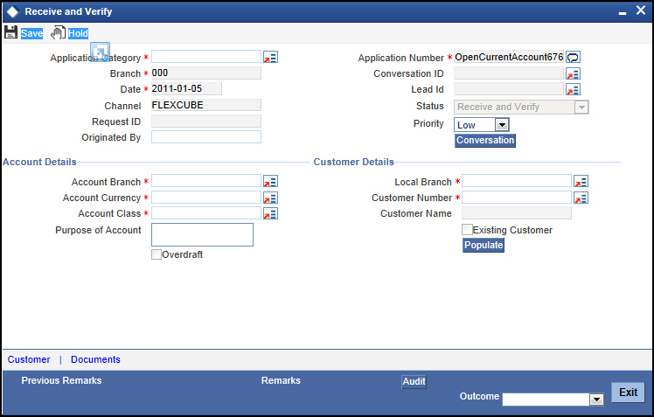

2nd Step, in this step, such types of data need to input;
- Liability Number: Liability number is represent CIF number
- Liability Name: SK Agro Farm
- Main Liability No: To again confirmation, it needs to input CIF
- Liability Branch: The branch has selected the of this client’s file
- Overall Limit: Again input the approved loan.
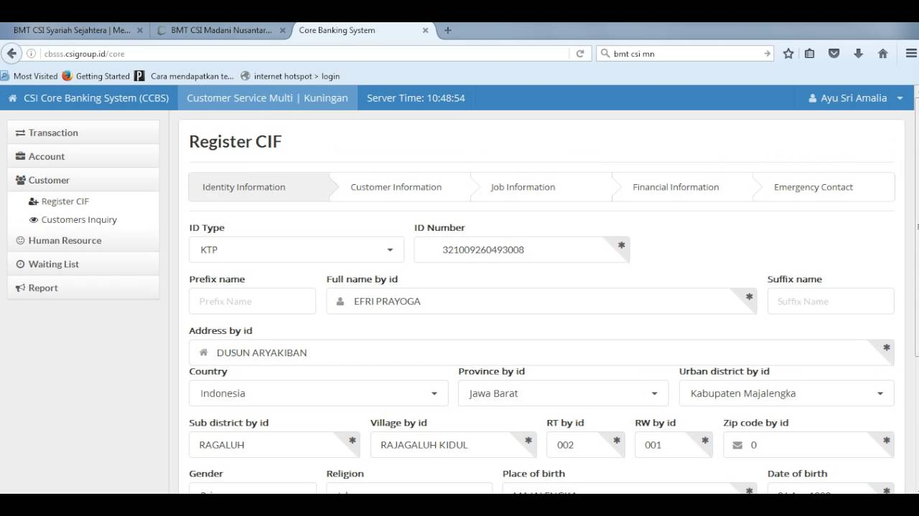
After completing this step, they need to click save button. Like 1st step, if all input given correctly, than it will be saved ((Kabir, 2018).

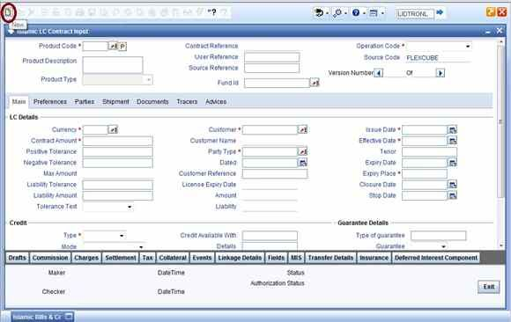
3rd Step, in this step, they need approval of 2nd step. There are only 5 managers of CAD, who has the authority to give the approval of 2nd step. After approval, 3rd step will be completed.

Step 05; Loan Recovery:
If Client fail to repayment the installment time to time, than IDLC 1st give the reminder to the client & after that they take legal action. Loan monitoring officer is responsible for these types of activities.
Days Past Due | Collection Action
1-15 days | Give notification letter, follow up & call over the phone
16-30 days | 1st reminder letter
31-45 days | 2nd reminder letter
46-60 days | - 3rd reminder letter  - Visit by team member  - Follow up over phone
60-90 days | - Final reminder  - Call up loan  - Legal proceeding start
Above 90 days | - Legal proceeding continue  - Collection effort continues by officer & agent
Table IX: Loan recovery policy of IDLC

CHAPTER 05: Recommendation & Conclusion

Recommendation & Conclusion

Recommendation & Conclusion
In the recent year, SME is the most growing sector of industry setup in Bangladesh. Nearly 30% of our GDB comes from SME sector which is huge contribution for a developing country like Bangladesh. 30% of employment opportunity creates for these SME sector growing.
As a Non-Banking Financial Institution, IDLC finance limited has significant contribution towards the growth and development of SME sector. Even though IDLC finance limited continue their operations more successfully.
Through examining the entire paper, there are certain recommendations that I would like to offer and these can enhance the exercises of CRM all the more correctly of IDLC finance limited.
The propositions are given below:
- They have enough feasibility for their customer, but they need more improvement on their post sales services so that they can please their existing customer.
- It is more effective to catch their client is cloud-based marketing (e.g. Facebook, twitter, online services, Linked in etc)
- They can provide more training program for their employees to increase their efficiency. So that they can do their job more precisely & more organized way.
- IDLC Finance limited can give improves their facility on SME sector.
- IDLC should started seminar program or road show on the district level so that they can provide available information about SME financing & they can get more customer on their SME sector.
- IDLC should start training program about scientific method of agriculture sector so that young entrepreneur should increase & IDLC can inspire them to get SME loan from their bank.
- IDLC credit policy is good, but can decrease interest rate for SEF(Small enterprise Financing) client. It will be more flexible for SEF client & IDLC should get more customers.
- Lanka Bangla Finance Limited has started “Swarnali Loan” for agro business. IDLC should give on more focus on agro business loan scheme which will grow their customer base and also retain their position in the competitive market.
The appraisal system should be more realistic and transparent. They should develop credit rating system in order to highlight the strength and weakness of clients. As a result, it will be easier for them to make any lending decision.

References

Bank, B. (October,2015). Policies and guidelines for New CIB Online Solution. Dhaka: Credit Information Bureau.
Kabir, K. H. (2018). Customer Relationship Management (CRM) Through CAD . Dhaka.
Limited, I. F. (2016). Annual Sustainability Report 2016. Dhaka: IDLC Finance Limited.
Limited, I. F. (2020, May 12). IDLC Finance Limited. Retrieved May 12, 2020, from www.idlc.com: https://idlc.com/our-philosophy.php
Limited, I. F. (2020, january 12). IDLC Finance Limited. Retrieved January 12, 2020, from www. idlc.com: https://idlc.com/apply-for-loan.php
Silver, C. (2019, June 10). investopedia. Retrieved June 10, 2019, from investopedia wb site: https://www.investopedia.com/terms/d/dscr.asp

Appendix

APPENDIX A:
SK AGRO FARM | DEPRECIATION SCHEDULE
TANGAIL
Particulars | written-down value (WDV) at the year ended
 | 0 | 1 | 2 | 3
Fencing the land, Generator, Pump, Feeding Equipment, Cultivating Equipment, Dalivery van | 462,000 | 392,700 | 333,795 | 283,726
Depreciation @15% | 69,300 | 58,905 | 50,069 | 42,559
WDV | 392,700 | 333,795 | 283,726 | 241,167

APPENDIX B:
Amount Borrowed | 2100000 | Amortization Schedule
Period | 48
Rate | 0.0125
Payment | 58445
Months | Begaining Balance | PMT | Interest | Principal Amont | Ending Balance
1 | 2,100,000 | 58,445 | 26,250 | 32,195 | 2,067,805
2 | 2,067,805 | 58,445 | 25,848 | 32,597 | 2,035,208
3 | 2,035,208 | 58,445 | 25,440 | 33,004 | 2,002,204
4 | 2,002,204 | 58,445 | 25,028 | 33,417 | 1,968,787
5 | 1,968,787 | 58,445 | 24,610 | 33,835 | 1,934,952
6 | 1,934,952 | 58,445 | 24,187 | 34,258 | 1,900,695
7 | 1,900,695 | 58,445 | 23,759 | 34,686 | 1,866,009
8 | 1,866,009 | 58,445 | 23,325 | 35,119 | 1,830,889
9 | 1,830,889 | 58,445 | 22,886 | 35,558 | 1,795,331
10 | 1,795,331 | 58,445 | 22,442 | 36,003 | 1,759,328
11 | 1,759,328 | 58,445 | 21,992 | 36,453 | 1,722,875
12 | 1,722,875 | 58,445 | 21,536 | 36,909 | 1,685,966
13 | 1,685,966 | 58,445 | 21,075 | 37,370 | 1,648,596
14 | 1,648,596 | 58,445 | 20,607 | 37,837 | 1,610,759
15 | 1,610,759 | 58,445 | 20,134 | 38,310 | 1,572,449
16 | 1,572,449 | 58,445 | 19,656 | 38,789 | 1,533,660
17 | 1,533,660 | 58,445 | 19,171 | 39,274 | 1,494,386
18 | 1,494,386 | 58,445 | 18,680 | 39,765 | 1,454,621
19 | 1,454,621 | 58,445 | 18,183 | 40,262 | 1,414,360
20 | 1,414,360 | 58,445 | 17,679 | 40,765 | 1,373,595
21 | 1,373,595 | 58,445 | 17,170 | 41,275 | 1,332,320
22 | 1,332,320 | 58,445 | 16,654 | 41,791 | 1,290,529
23 | 1,290,529 | 58,445 | 16,132 | 42,313 | 1,248,216
24 | 1,248,216 | 58,445 | 15,603 | 42,842 | 1,205,375
25 | 1,205,375 | 58,445 | 15,067 | 43,377 | 1,161,997
26 | 1,161,997 | 58,445 | 14,525 | 43,920 | 1,118,078
27 | 1,118,078 | 58,445 | 13,976 | 44,469 | 1,073,609
28 | 1,073,609 | 58,445 | 13,420 | 45,024 | 1,028,584
29 | 1,028,584 | 58,445 | 12,857 | 45,587 | 982,997
30 | 982,997 | 58,445 | 12,287 | 46,157 | 936,840
31 | 936,840 | 58,445 | 11,711 | 46,734 | 890,106
32 | 890,106 | 58,445 | 11,126 | 47,318 | 842,788
33 | 842,788 | 58,445 | 10,535 | 47,910 | 794,878
34 | 794,878 | 58,445 | 9,936 | 48,509 | 746,369
35 | 746,369 | 58,445 | 9,330 | 49,115 | 697,255
36 | 697,255 | 58,445 | 8,716 | 49,729 | 647,526
37 | 647,526 | 58,445 | 8,094 | 50,351 | 597,175
38 | 597,175 | 58,445 | 7,465 | 50,980 | 546,195
39 | 546,195 | 58,445 | 6,827 | 51,617 | 494,578
40 | 494,578 | 58,445 | 6,182 | 52,262 | 442,316
41 | 442,316 | 58,445 | 5,529 | 52,916 | 389,400
42 | 389,400 | 58,445 | 4,868 | 53,577 | 335,823
43 | 335,823 | 58,445 | 4,198 | 54,247 | 281,576
44 | 281,576 | 58,445 | 3,520 | 54,925 | 226,651
45 | 226,651 | 58,445 | 2,833 | 55,611 | 171,040
46 | 171,040 | 58,445 | 2,138 | 56,307 | 114,733
47 | 114,733 | 58,445 | 1,434 | 57,010 | 57,723
48 | 57,723 | 58,445 | 722 | 57,723 | (0)
Interest on Term Loan is calculated at 13% per annum liquidated in 4 years

