

United International University

Internship Report

On

Evaluation of the “People” Element of Service Marketing Mix:
A Study on Kazi Farms Group

An Internship Report Submitted to the School of Business & Economics in Partial Fulfillment of the Requirements for the Degree of Bachelor of Business Administration.

Submitted To:
Muhammad Hasan AL-Mamun
Assistant Professor
School of Business & Economics
United International University

Submitted By:
MD. Mehedi Hasan
ID: 111-151-371
BBA Program
School of Business and Economics
United International University

Date of Submission: September 24, 2019

Evaluation of the “People” Element of Service Marketing Mix:
A Study on Kazi Farms Group
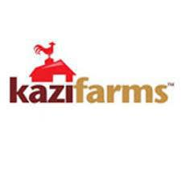

Acknowledgement

It is always a matter of pleasure to recall the faculty members of the School of Business & Economics, United International University, who guided me throughout my journey in completing Bachelors of Business Administration degree with clear theoretical understandings of the subjects

My cordial thanks go to Muhammad Hasan AL Mamun, Assistant Professor - Marketing, School of Business & Economics, United International University. Without his proper guidance it would be impossible for me to give this report an executive and professional look.

My heartfelt thanks goes to my honorable supervisor Akhtarul Hassan, Senior Officer, HR, Kazi Farms Group for his deliberate guidance, inspiration and sharing of information which not only helped me in completing this report but also helpful for shaping my future career.

I would also like to mention about some recognizable personnel from HR department, Kazi Farms Group:

- Anwarul Hasnat, Senior Manager, HR

- Somrat Joardar, Executive, HR

- Gopal Ghosh, Senior Officer, HR

Letter of Transmittal

September 28, 2019

Muhammad Hasan AL Mamun
Assistant Professor - Marketing
School of Business & Economics
United International University

Subject: Submission of internship report.

Dear Sir,

With due respect I would like to express my enormous pleasure to submit the internship report on “Evaluation of the “People” Element of Service Marketing Mix: A Study on Kazi Farms Group” which you assigned me to work on.

This report mainly focuses on the “people” element of the services marketing mix. But this report narrows down the people element to employees only ignoring the customer aspect of the “people” element.

If you have any queries please contact me on: +8801677071636 or send me an email
at: Togor01677@gmail.com.

Yours Sincerely,
MD. Mehedi Hasan
Student ID: 111-151-371
BBA Program
School of Business & Economics

Executive Summary

Marketing mix is the foundation of modern marketing practices. There are 7Ps in service marketing mix including place, promotion, price, product, people, physical evidence, and the process. Here we are talking about People elements including customer, other customers and employees. Here employees indicate human factors who participate in service delivery.

Here the study in hand is mainly concerned with the employee aspects of the people element of the service marketing mix. Such aspect is usually managed by the Human Resource Management division of the organization.

Human resource is the total knowledge, skills, creative abilities, talents and aptitudes of an organization’s work-force as well as the values, attitudes and benefits of an individual involved. Human resource is the most valuable assets of an organization, not money or physical equipment. An organization’s performance and resulting productivity are directly proportional to the quality and quantity of human resources.

Kazi Farms is known as one of leading poultry farm of the country since its commencement 18 years ago. It continues to remain updated with the latest products and services, considering consumers and client’s perspectives. Kazi Farms commits to nation by taking a lead in Farming sector through not only its strong financial position but also through innovation of products and services. It also ensures higher values for its respected customers and shareholders.

The Evaluation of the “People” Element of Service Marketing Mix of Kazi Farms Group is to measuring performance of employees, the purpose of the Performance Management System (PMS) is to improve employee performance in terms of “Skill and knowledge” as well as “Leadership”. The PMS focuses first on the “Job performance” and then other issues are taken into consideration. Each employee will be apprised by the coordination with the divisional/ Department Heads. The process will ensure compliance of maintaining the standards in “Performance Distribution” amongst population in a department/section. Each head of the function does so in joint consultation with HR. The currently practiced process will ensure that the employee aspect of the people element of service marketing mix will contribute to the attainment of organizational objectives.

Key Words: Employees, People Element, Service Marketing Mix

Table of Contents
Introduction 5
Organizational Background 6
Current Products and services of Kazi Farms Group 8
Organizational Structure 13
Competitive Analysis 14
Evaluation of the “People” Element of Service Marketing Mix: 16
A Study on Kazi Farms Group 16
Methodology of the Study 20
Performance Management Policy 23
The Completion Process of Performance Management Form: 25
Findings & Discussions 29
Advantage of the Study 37
Recommendations 38
Conclusion 39

Introduction

Marketing mix is the foundation of modern marketing practices. There are 7Ps in service marketing mix including place, promotion, price, product, people, physical evidence, and the process. Here we are talking about People elements including customer, other customers and employees. Here employees indicate human factors who participate in service delivery.
Here the study in hand is mainly concerned with the employee aspects of the people element of the service marketing mix. Such aspect is usually managed by the Human Resource Management division of the organization.

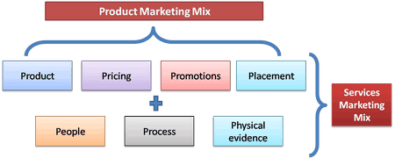

Kazi Farms is known as one of leading poultry farm of the country science its commencement 18 years ago. It continues to remain update with the latest products and services, considering consumers and clients’ perspectives. Kazi Farms commits to nation taka a lead in Farming sector through not only its strong financial position but also through innovation of products and services. It also ensures higher values for its respected customers and shareholders.

Objectives of the Study:

Broad Objectives

- To know in depth about how a company like Kazi Farms Group (KFG) have positioned themselves in the industry; their goal, mission, values and beliefs.
- To get an extensive idea about the performance management system in relation to the evaluation of the employee aspects of people element of service marketing mix.
.

Specific Objectives

- To know about the background of Kazi Frams Group (KFG); its company profile, mission, vision, philosophy, goal.
- To know its organizational structure;
- To find out about the departments operating under KFG.
- To figure out the strengths, weaknesses, opportunities and threats of the company.
- To analysis the present performance management system of the organization and recommend the way to improved deficiency of PMS for this organization.

Organizational Background

Kazi Farms is one of the leading poultry farms in our country since its commencements 18 years ago. It was established in 1996 as a hatchery for imported eggs; the following year it started its own parent farms. In 2004 production started in their grand-parent (GP) farms. It is continues to remain with the latest products as services, considering consumer and clients perspective. Kazi farm has thus been able to keep their customers and client trust while upholding their reliability across time. In addition to producing breeder feed to meet their own requirements, in 2006 they established the largest and most advanced feed mill the in the country with technical assistance from Cargill USA and Buhler Switzerland. Kazi Farm Group is the largest grand-parent franchisee of Cobb-Van tress USA for Cobb 500 which is acknowledged as world-wide to be the best broiler. They have also a smaller number of grand-parents of the popular Ross broiler from Aiagen USA. Regarding layer they are the Bangladeshi distributer for Hy-line USA, the world leading layer breed. They were the first exporter of hatching eggs and day-old chicks from Bangladesh. Now Kazi Farms Group has over 70 broiler parent farms, layer farms, broiler grand-parent (GP) farms, hatcheries, feed mills and sales offices in different locations through Bangladesh. (kazi farms,2016)

Kazi Farms is in a unique position to understand the interrelationships between nutrition, hygiene and farms care. They can do this with their strong science in bio-security capability and their locally rooted consumer inside. Kazi Farms commits to nations to take a lead in the farming sector though not only its strong financial position, but also through innovation of products and services. It also ensures creation higher value for its requested customers and shareholders. The farm has focused to bring services at the doorsteps of its customer, and to bring millions into farming channels those who are outside the mainstream farming area Kazi Farms has continuously invested into its biggest asset, the “human recourse” to drive forward with its mission “to be the best performing farm in the country”. (kazi farms, 2016)

Corporate Information of Kazi Farms Group:
Name of the Company: Kazi Farms Group
Type: Private
Industry: Poultry
Founded: 1996
Founders: Kazi Zahedul Hasan
Owners: Kazi Zahedul Hasan
Employees: 7000
Corporate Office:Ahmed Kazi Tower,
House-35,Road-02,Dhanmondi,Dhaka-1205
Telephone:+880-2-9612290-93,9612184

Current Products and services of Kazi Farms Group

- Kazi Food Industries Limited: KFIL, is one of the sister concerns of Kazi Farms Group. It started operating as a venture of Kazi Farms Group in the year of 2013. KFIL have its factory located in Beron, Ashulia, Gazipur, Dhaka. Brands of KFIL. KFIL owns three brands and a sub-brand. It started its journey with Bellissimo brand of premium ice cream. Then extended the brand into Bellissimo Creations, a sub-brand under Bellissimo, which produces parlor quality ice cream. Another, more popular brand of ice cream it produces under the name of Za 'n Zee. The third one is Kazi Farms Kitchen, which sells its frozen food products and also it has franchise outlets operating all over Bangladesh under the same name.
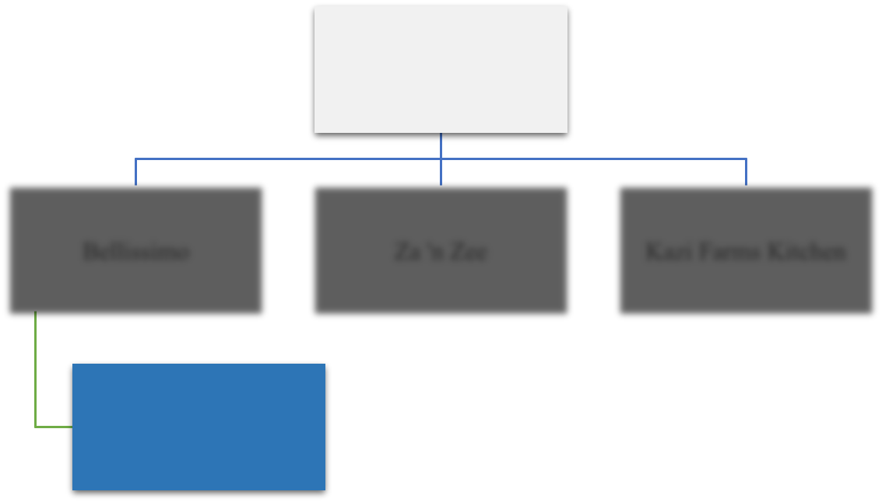

Kazi Food Industries
Limited

Bellissimo |  | Za 'n Zee |  | Kazi Farms Kitchen

Bellissimo Creations


- Bellissimo Premium Ice Cream
Kazi Food Industries Ltd. Started its operation with Bellissimo in 2013. Bellissimo Premium Ice Cream brand is made to give people of Bangladesh the taste of international quality ice creams. It is the very first premium ice cream brand in Bangladesh hence the market leader of premium ice cream. The “premium” goes with the brand is because it is made with 10% milk fat and natural flavors

which gives it creaminess, texture and unmatched taste. It is reasonable to mention that it is the only ice cream brand in Bangladesh which uses at least 10% milk fat. The ice creams are rich, dense, creamy and flavorful and made with real ingredients. Bellissimo achieved superstore leadership among other brands sold in superstores.

- Za 'n Zee Ice Cream

KFIL launched Za 'n Zee brand of ice cream in 2014 to meet the mass demand of people in the country. Za 'n Zee brand produces ice creams that are delicious, fun to consume and are at affordable prices. This is the popular ice cream brand among youth of Bangladesh and competing head to head with other popular ice cream brands in the industry. Za 'n Zee is well known for its brand ambassador, Bangladesh’s popular and favorite cricket super star Sakib Al Hasan, who is seen in every advertisement of Za 'n Zee.

- Kazi Farms Kitchen

Kazi Farms Kitchen, abbreviated as KFK, has more than 130 franchise outlets all over Bangladesh and has its own range of frozen products. It launched its frozen food products at superstores in November, 2013. And the first franchise outlet launch took place in October, 2014. It is
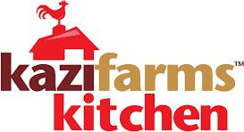

One of the leading frozen food producers in Bangladesh. It operates in 100% Halal way. KFK has products based on chicken, vegetable and fish. All KFK’s chicken based products are made with chickens that are vegetable-fed, completely free of tasting salt, antibiotic residue and preservatives. As per international practice, KFK’s chickens are not fed any antibiotics within 7 days of slaughter. As per European standards, chickens are raised on feed not containing MGM (Maggot-meal). During food preparation no MSG and Nitrate are used so the chicken meat is also guaranteed to be free of these chemicals. The amount of franchise outlets it owns arerapidly growing.

- Kazi Media: Launched in November 2015, Deepto TV has become the highest rated Bangladeshi channel as measured by Total Rating Points (TRP).

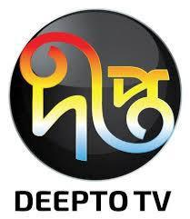

  - Sysnova Information Systems Limited: Sysnova Information Systems Limited is an IT company specializing in open source solutions. It supports all Kazi Farms Group companies with Adempiere ERP.

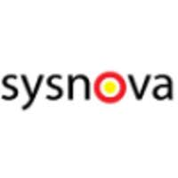

- Broiler parent chicks and broiler chicks: Kazi Farms Group is the Bangladesh franchisee of Cobb-Vantress USA for the Cobb 500 broiler, acknowledged to be the best broiler in the world. The Cobb 500 parent and broiler chicks of Kazi Farms Group are considered to be the best performing chicks in the domestic market, and are sold at a premium over other broiler breeds. (kazi farms, 2016)

- Layer chicks and tableeggs: Kazi Farms Group is also the distributor for Hy-line brown and white layers in Bangladesh. Hy-line International is the oldest poultry breeding company of the world, and is the leading breeders of layers. Kazi Farms' own commercial layer farms make it the largest producer of commercial table eggs in Bangladesh. (kazi farms, 2016)

- Feed: Kazi Farms Group expanded its operation into poultry feed manufacture in
2006. Within a very short period |  |  |  | it | has | become |  | recognized |  | as a | market
leader | in | both | quality and | volume The |  | Gajaria |  | feed | mill | uses state-of-the-
art sanitizing pellet mills from |  |  |  |  | Buhler | of | Switzerland, manufacturer |  |  |  | of the
world's | best | feed | equipment. By | eliminating |  | any | possible |  | bacterial contamination
From this feed, the Buhler sanitizing pellet mills ensure that poultry farmers experience fewer disease outbreaks and see better results. (kazi farms, 2016)

- Associates and Sister Concerns of Kazi Farms Group:

- Central Women’s University – the first private university in Dhaka, Bangladesh for women established in 1993.

- Kazi Zahural Huq College (Gopinathpur, Gopalganj) (kazifarms,2016)
- Kazi Hatchery Ltd.

- Kazi Breeders Ltd.

- Kazi Foods Ltd.

- North Bengal Eggs Ltd.

- Tetulia Eggs Ltd.

- Bhaluka Farms Ltd.

- Royal Bengal Chicken Ltd.

- Hybrid Farms Ltd.

- Kazi Shivpur Hatchery Ltd.

- Kazi Grand Parents Ltd.

- Kazi Broilers Ltd.

- Kazi Chicks Ltd.

- Kazi Chicken Farms Ltd.

- Taragonj Hatchery Ltd.

Organizational Structure
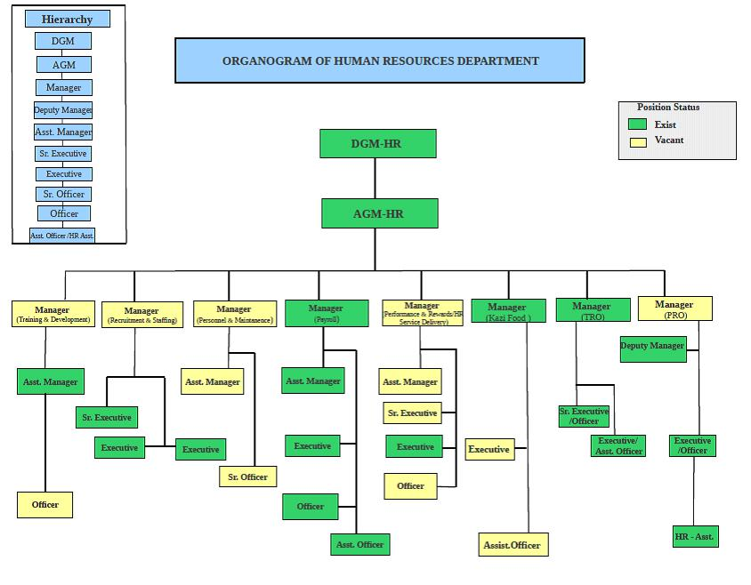

Competitive Analysis

Porter’s Five Forces Model of competitive analysis is a widely used approach for developing strategies in many industries. The intensity among firms varies widely across different industries. In the farming Industry, the competition level among the different farms is also seen. Due to the emergence of many farming company in Bangladesh, there exists a competitive environment as all the farms try their level best to stay in the challenging competitive environment.
Porter’s Five Force Model is given below-

- Threats of new entrants: This force is related to the possibility of new firms to enter the industry (Porter, 2008). The main business of Kazi Farm is poultry. Poultry industries in Bangladesh is now becoming more interesting today’s. Many local and multinational companies are trying to opening poultry farm in Bangladesh. New entrants companies are trying to do business in different ways or a new ways. For Kazi Farms Group, there are also threats of new entrants as the new poultry farming industries entering this industry with higher quality product or service at a lower prices and substantial marketing resources. Kazi Farms Group is concentrated on the current and future market condition so that new entrants do not penetrate the market.

- Bargaining power of Suppliers: Suppliers are those who supply the organization with what it needs to produce the product or service. (Porter, 2008).
In Poultry industry Day-old-Chicks (DOC) is the primary resource on any poultry farm and there are two major suppliers. They are-
- Workers
- Supply Chain Management
By utilizing these two major suppliers, the farm can be sure that they have the necessary resource required to service their customers’ borrowing needs. The power of the suppliers is largely based on the market. If worker are available and the supply chain management are good enough than bargaining power of suppliers will slow down.

- Bargaining power of Buyers: Buyers are the organizations immediate customer not necessarily the ultimate customers. Here buyers can have such high bargaining power that their suppliers are hard pressed to make any profits at all. (Porter, 2008). In poultry farming industries there are lots of buyers. Now a day people love to buying frozen food. Many hotel, restaurants and fast food shops are the main buyers.

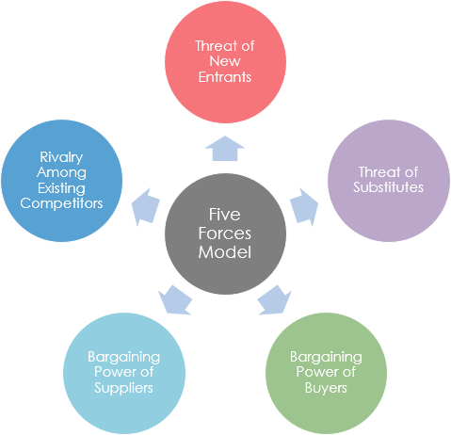

- Threats of substitutes: Substitutes are products or a service that offer a similar benefit to an industries product or services a different process. Substitutes can reduce demand for a particular class of products as customer switch to the alternative. (Porter, 2008). The main business of Kazi Farms is selling eggs, chickens, frozen foods. So threats of substitutes are like meet from alternative source and eggs of other birds and change of food habit.

- Competitive rivalry: Competitive rivals are organizations with similar product and service aimed at the same customer group. (Porter, 2008). Kazi Farms faces lost of competitive rivalry in poultry business. There are competitor are CP, Aftab, Index Agro Industries. This farm are similar type of product of the Kazi Farms have. So Kazi Farms thing about lots because the other competitor trying to dominate this industries.

Evaluation of the “People” Element of Service Marketing Mix:

A Study on Kazi Farms Group

Evaluation of the “People” which introduced Performance Management System, is a principal tool in achieving corporate objectives in that it links those objectives with employee goals and achievements. It focuses on improving performance through matching outcomes against individual, departments and organizational objectives, and to the training and development needs of employees at all organizational levels. Managers using performance management system effectively are generally more concerned with performance planning and improvement and performance assessment. Performance management system is an accepted management practice operating within organizations because it can be a valuable process for employees and employers alike. It provides for both recognition of high performance and early detection of performance that is not meeting expectations, allowing prompt remedial action to be taken.
Benefits of performance management system at a macro level performance management assists organizations to match outcomes with company objectives. It provides a system for improving organization performance and outcomes, within the company’s objectives and policy framework, while maintaining good industrial relations. It generates benefits throughout organizational functions and processes. Performance management system recognizes that people are the organization’s most valuable resource, and that people are the key to an innovative, professional and service-oriented public service. Performance management emphasizes the relationship between the management and development of people and an effective organization, and provides a fair and equitable environment for improving performance.

A performance management system
-Links achievements at all levels of the organization with corporate, business and departmental objectives.
It provides the framework for:
-Clarifying expectations, roles, responsibilities and resources required to achieve goals;
-Improving communication and understanding between managers and employees in terms of work requirements, expectations, performance criteria and achievements;
*linking individual, team or unit performance with quality assurance, continuous improvement and evaluation processes of the organization;
-Facilitating, encouraging and assessing performance;
-Encouraging structured feedback from employees and supervisors on performance and career planning and from the community on organizational performance;
-Introducing an outcome focused culture and increasing motivation;
-Collecting data and information needed for management decision making or external review (e.g. by auditors);
-Increasing the organization’s capability to meet future requirements and to improve outcomes for the community;
-Identifying performance which requires improvement; and
-Recognizing and acknowledging performance.
Performance management System reflects the value of people to organizational performance, including:
1. Performance of individuals / departments
2. Employee skill levels / gaps if any.
3. Employee position in the development plans.
4. Corporate values, goals and ethical standards are clearly reflected in the performance management system;
5. Clear identification of expectations and responsibilities of individuals
6. Employee allocated responsibility for ensuring improvement and performance strategies at all levels of the organization.
7. Specific expectations and responsibilities of managers, supervisors, teams and individuals for their role in the process.
8. Linking the individual’s contribution to organizational objectives
9. Training and development are linked to the achievement of optimal organizational and individual performance;
10. The system is regularly reviewed, with particular attention given to key elements (e.g. process of reviewing individual performance; provision of helpful feedback; updating of key accountabilities, criteria and indicators; and training and development plans);
11. Accountability is assigned to senior managers to ensure that performance, outcomes and training and development activities (relating to individuals, teams or units) are appropriate.
12. Employee work plans contain agreed, clear and measurable performance criteria which are modified as changes occur in organization policies, priorities or environment;
13. The system enables assessment of the individual’s contribution to the achievement of corporate goals;
14. Transparent links exist between performance assessment and performance reward;
15. The system is clearly linked to the organization’s strategic management framework and is not treated as an isolated function; etc.

Performance management system of Kazi Farms is quite structured that it can measure of assess both goal (What) and the management competencies (How). Goals-Key Result Areas (KRA) is the specific major objectives to be set at the beginning of the year through consultation with the reporting manager or supervisor. These need to be aligned to the objectives of the function and consequently to overall objectives of The Farm. It is an HR process for driving business outcomes.

Background of the study:

Kazi Farms Group is a well-known Bangladeshi company which has made their golden
footprint in poultry farm as well as frozen food, information technology, ice cream and
television channel. This company is one of the largest players of the poultry industry in Bangladesh. Their market share is 25% of day-old chicks (DOC) and 20% of broiler feed (Kazi farms, 2016). To operating the whole business process they need huge manpower. Human resource is the most important assets for any companies. If any company properly uses their manpower they can get sustainable competitive over their competitor. Kazi Farms Group has more than 7000 employees. To maintain this huge number of employee they have a well-structured HR policy. In every HR functions like employee recruiting, salary and leave policy, and employee welfare Kazi Farm follows the labor law. But on the other HR functions like employee evaluation, employee performance management or appraisal system, organization development, setting organization culture, they have their own rules and policies. Now a day, performance management system is an important element or tool used by organizations to guide employee performance alignment with organizational strategy. It is a big process to successfully maintain employee performance management. When employee performance is increased ultimately it is helpful for the organization to achieve its own goal. There are many performance management system used by organization such as Management by Objective (MBO), Graphic Rating Scales, Key Performance Indicator (KPI) and many others. The main theme of my research background is to find out how effectively and efficiently Kazi Farm uses performance management tool for their employees and to gain sustainable competitive advantage over their competitor.

Problem Statement:

Performance management is a process for setting up a shared understanding of what is to be achieved at an organization level. It involves the alignment of organizational objectives with the individual’s agreed measures, skills, competency requirements, development plans and the delivery of results. (Rajendran, 2016)

Kazi Farms uses KPI to measure their employee performance. In this process which a manager can use to get the team members to achieve the team’s objectives and targets, improve overall team effectiveness, develop performance capabilities, review and assess team and individual performance, and reward and motivate.

But sometimes employees cannot understand this performance measurement process clearly. They think that their supervisor forced them to work on time with accuracy. Supervisor gives them extra task in addition their regular task. So some employees think that it is burden for them.

So the problem statement for this research is Firstly, Performance management system is not properly aligned with time management. Secondly, Team member are not cooperative with each other. Thirdly, no solid mechanism for decision making and finally, unclear job instruction.

The main objective of this report is to get an extensive idea about the performance management system at Kazi Farm Group. And to analysis the present performance management system of the organization and recommend the way to improved deficiency of PMS for this organization.

Methodology of the Study

Research Question:

How effective and efficient is the present performance management system of Kazi Farm Group?

Type of research:

The research falls in the category of descriptive research. Prior to that, the organizational part is helpful for the clear understanding of the existing position of the company also serves the purpose of the descriptive research.

The Performance management System (PMS) of Kazi Farms is limited to measuring performance of employees; the purpose of the PMS is to improve employee performance in terms of skills & knowledge as well as leadership. The PMS focuses first on the job performance and considers the following parameters for a given period of time:

- What assignment was given by the work plan or in terms of targets?

- What was expected of?

- What has been delivered? How has been delivered? What has gone well?

- What has gone wrong?

- What could have been done differently to do better?

First, getting these answers it will help in finding newer ways and means to improve performance learning from past successes and failures. Second, it examines the professional skills

- knowledge which is required in a job, the actual skill & knowledge level, a job holder possesses and thus helps in finding skill /knowledge gaps to be addressed for personal development. Third, it reviews the leadership behaviors i.e. competencies or abilities which are required in a job in comparison with real demonstration of behavioral competencies by the job holder and thus helps finding competency gaps to be addressed for personal development.

Therefore, the management system of Kazi Farms takes care of the following:

- Business performance(on the job accomplishment in terms of a work plan/targets/expectation)

- Skill & knowledge

- Behavioral competencies ( leadership)

- Individual development plan

Kazi Farms conducts its performance management annually and in the process review progress quarterly for correction of directions enabling an individual to achieve his / her objectives. On the whole, the objective is to shape outstanding performance in a competitive way to ensure sustainable profitable growth in business.

Basic Research Method:

For achieving the specific objective, data was collected from both primary and secondary sources. To collective primary of data, I directly communicated with the respective officers of the hr department, marketing department, it department, sales department and accounts department make face to face conversation with the employees and employee’s opinion collected through close ended question.

To collect the secondary data I visited the website of Kazi Farms, reviewed different newsletters of Kazi Farms, and accessed annual performance appraisal records of it.

Sampling Plan:

Because of time limitation I used convenient sampling technique to collect sample and use graphical chart to show the opinions about performance management system on Kazi Farms.

Target Sample:

There are three hundreds employee on Kazi Farms head office so in three month time periods it is very difficult to taka interview on them. I choose five departments and each department I choose two people randomly so my target is to taking sampling on 10 employees.

Scope of the study:

The scope of the study is basically limited to the analysis of the present performance management system of Kazi Farm and to the analysis of the strengths and weaknesses of the system to recommend the best practice for them.

Time Plan:

My data collection time period is three month so I will complete my research within three (03) months.

Performance Management Policy

Performance management process is conducted by the HR Division. So the policy is also made by the Human Resources Division to conduct this process smoothly and clearly.

Performance Standard:

For conducting employees performance management Kazi Farms consider the following term for-

First of all indication key job responsibilities/ targets/ work plan of the employee for the year. Secondly performance on the job. Thirdly knowledge level. And finally behavioral competence level.

The performance standards are:

- Exceeds Expectation (EE) (4.5-5.0) = 91-100,

- Fully Meet Expectation (FME) (3.5-4.5)= 71-90,

- Met Expectation (ME) (2.5-3.5) = 51-70,

- Partially Met Expectation (PME) (1.5-2.5)= 31-50 and

- Requires Significant Improvement (RSI) (1.0-1.5) = 0-30

- Consider on the Job Performance and the results delivered by employee (Judge Quantity and Quality) - anyone of the following:

- A Strongest all around performer, Exceptionally Exceeded targets/ given what plan for above expectation.

- A Stronger all performer, Reasonably Exceeded or target/ given work plan above expectation.

- A Strong performer Met targets/ given work plan satisfactorily within expectation.

- A Reasonable performer, Closely Met target/ given work plan, but not fully satisfactory.

- HR in coordination with the Divisional / Departmental Heads will monitor, educate & guide and ensure policy compliance.

- Performance standard is Well Below, targets/ given work plan, needs serious tanning and serious efforts to improve.

Those who are performed in Excellent, Very Good, and Good are eligible for incentive bonus or promotion.

Types of Performance Management Form

Kazi Farms Group has two types of performance management forms.

- One is for the area managers or department heads

- Another is for the other employees who are working under them.

The performance management form of the relationship managers or the department heads are filled by the management committee. And the employees other then Managers performance management forms are filled up by the relationship managers of the region and the department heads. Managers fill this performance management form and send it directly to the HR Division as “TOP CONFIDENTIAL” papers. After receiving the document HR Division informs the manger that the documents are received and also make sure that how many forms they received. If the document cover is tempered then HR Division refuses to receive the document.

The Completion Process of Performance Management Form:

It is already mentioned that there are two types of forms one is for the managers and another one is for the employees who are working under them that means other than managers. Now the completion process of two different types of forms will be discussed bellow to make it more understandable: At first the performance management form of the managers will be mentioned: The form consists of four pages. At the beginning of the format page one it needs to mention the year for which the organization is evaluating his employees. Then the name of the appraise (the person who is evaluating) and also the designation, age, last promotion date, service period with Kazi Farms etc information have to be mention. Service period of the present position and also need to mention the job location means where the employee was working on that particular period of time. Then the Management Committee have to fill up the section A(See appendix) where they need to mention the profit that the regional Manager achieved and the targeted profit that was decided by the authority. After finishing section A management have to fill up section B (See appendix) which is named other strategic targets contributed to part A. If A is achieved then B may be ignored. But if A is not achieved then they must fill up the percentages of different factors that are mentioned in that particular area. After completing section B they have to complete section C (See appendix). In this section they have to give some points about quality of achievements. These achievements are audit compliances, operating budget, employee development etc. after completing this three part they put the marks below and add them. If the average is:

Less than 0-30% | 31-50% | 51-70% | 71-90% | Equal or above
Below Average | Average | Good | Very Good | 91-100%
 |  |  |  | Excellent
Far below | Near to target | Achieved target | Exceeded target | Exceptionally
target |  |  |  | exceeded target

Then after completing first page they have to move to page 2. Here they need to fill up some Assessment of Knowledge & behavioral competence for Potential Listing only.

Scoring will be like this:

1 = Requires Significant Improvement,

2 = Partially Met Expectation,

3 = Met Expectation,

4 = Fully Meet Expectation &

5 = Exceeds Expectation.

Here they have to fill up nearly fifteen criteria about the knowledge & behavioral competence factors of

Managers. These criteria vary according to the situation. The criteria that are asked in this section are:

  - Overall Knowledge profile in assigned job responsibilities (core job)

  - Knowledge about Kazi Farms’ product & services, Organization, Policies & Processes

(updated)

  - Appreciation in farming business

  - Computer literacy & IT knowledge relates to farming

  - Planning: Ability to plan own job activities and able to prioritize and drive actions for results

  - Customer understanding and care

  - Awareness about compliance issues

  - A self starter with drive & initiatives

  - Attitude (a positive thinker & adoptable to change)

  - Analytical ability

  - Communication ability

  - Inter-personal relationship

- A team worker believes in team commitment

- Ability to influence others & gain commitment

- Speed in action

Management has to put tick mark on the number that the person deserves. This is a very crucial part for the employee. Because it shows the job sincerity of the employee.

In section D (See appendix) the evaluator tries to identify two key areas that should be developed. There are two areas like Knowledge and Behavioral competence. If the appraise needs any development in this two areas then they have to mention them in this box. Basically from this box information employees are selected for training on that basis.

In section E (See appendix) Supervisor’s overall comment (Performance Summary & Rating) is given. Actually it shows the summary of the appraisal. This rating is directly entered into the performance management calculation software. After completing this part appraiser have to sign below.

Employee view point about this management and own career wishes will be mentioned in the section F (See appendix). If appraise agrees with the appraisers evaluation then he has to write agreed and sign below. If any appraise feels that their performance evaluation by the line managers is influenced by discrimination or unfair and biased judgment the appraise may appeal to Head of HR with their grievance in writing. In such cases the Head of HR will be the first point contract. If the issue remain unresolved than it will referred to the MD for his/her review and decision and in that case the decision is final.

In section G (see appendix) there are a box for special recommendations (career etc.) and this are place with justification. If the appraiser thinks that the employee should get the annual increment then they have to write it in this box. If employee is eligible for next higher level promotion then it also has to mention there. If the appraiser thinks that the employee should get both of them then he must write that in this box with proper justification.

In section H (see appendix) there is a box for HR review and comment. If HR thinks that there should be added any more things than they can add it here. Even if they think that this evaluation is not properly completed then they can also write it here. Then the proper actions will be taken further.

Interview outcome & comment by HR Steering Committee is written here in section I (see appendix). This part is mainly considered if the person is recommended for promotion. This part is optional. HR can directly put this comment in the Managers personal file. If the person is not recommended then this part does not count or necessary to complete. These are the main things that are to be considered when the appraisal form of the managers evaluated.

With a view to explaining the performance management system of Kazi Farms Limited a sample form of performance management has been undertaken I attached the performance management sample form on appendix section. For the sack of anonymity the name of the respondent has not been disclosed in the present report.

Findings & Discussions

From discussion and data analysis I have found positive and negative view point about performance management system of Kazi Farms Group. These findings are below:

I have chosen 10 employees randomly and collected data from them. Data are collected through face to face conversation and questionnaire. All of the employees of Kazi Farms Limited (Head Office) were cooperative. I organized the questionnaire in a way that can give a scenario of their likings. I have used 4 scales for judging their satisfaction level.

Employee opinions on some important questions are given bellow:

- Does your organization use formal performance management system?

Answers | Yes | No
Number of | 10 | 0
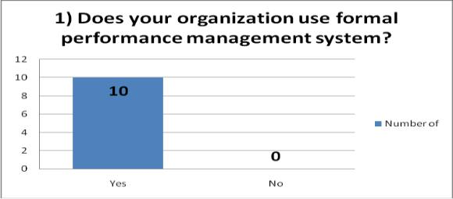

Figure 1.1

Comment: I asked this question to know Kazi Farms use formal performance management system or not. Most of the employee said Kazi Farm use formal performance management system. All of them know what performance management is and what the benefit of it is. They have been gone through proper training that’s why they are familiar with this.

2) What are the techniques that are used in your organization for assessing performance?
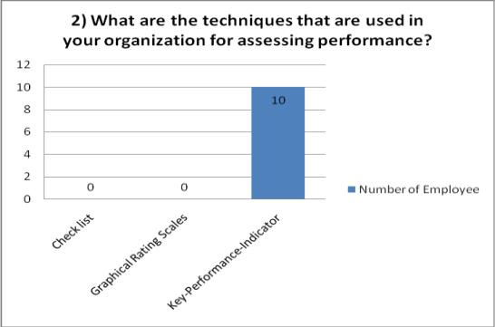
 |  | Graphical | Key-
 | Check | Rating | Performance-
Answers | list | Scales | Indicator
Number
of | 0 | 0 | 10

Figure 1.2

Comment: All of the employees are well aware of the followed performance management system. They follow key-performance-indicator (KPI) this is the system which differentiates them from other organization performance management system

3. In your opinion Performance Management is?
 |  |  | Judging
 | Evaluation | Job | performance
 | of | satisfaction | of an
Answers | Employee | of Employee | employee
Number
of
Employee | 3 | 2 | 5
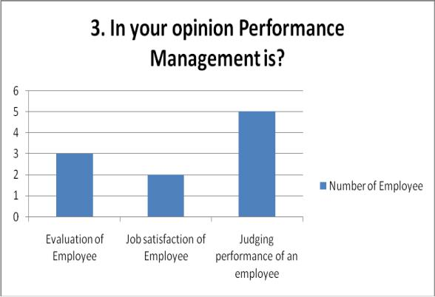

Figure 1.3

Comment: I asked this question to know their opinion on performance managnment. I asked 10 employees on of them` 5 of says that performance managnement is judging performance on employee, 3 employees says its evulation process on employee and 2 persons says its job satisfaction of employee.

- Do you receive any increments if your performance is up to the mark?

 |  | Some | All
Answers | Never | times | times
Number of
Employee | 0 | 2 | 8
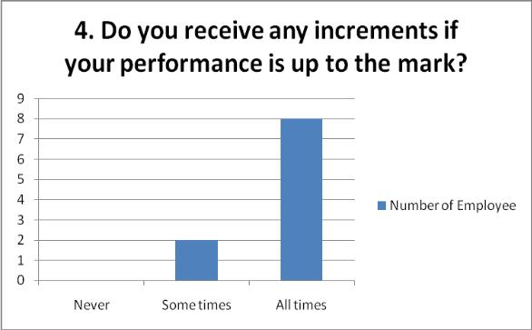

Figure 1.4

Comment: Most of the employee received increment after the performance appraisal. The entire sample said that they have got incentives after the evaluation. If they perform well they get the incentive

- Do you have sufficient opportunity to take part in goal setting?

 |  |  | Some | Do not
Answers | Yes | No | what | know
Number of
Employee | 0 | 10 | 0
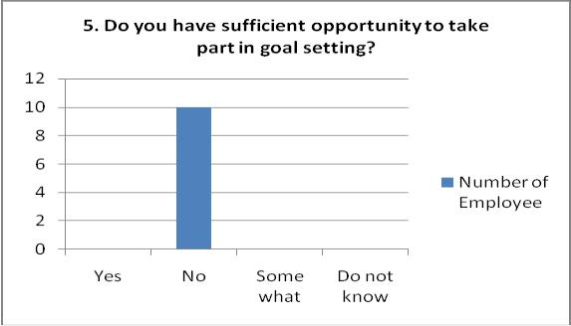

Figure 1.5

Comment: This graphical chart and analysis show that employees of Kazi Farms have not getting an opportunity of taking part on goal setting. Only supervisor and higher authority set goals

6. Is self rating is useful for PMS?
 |  |  | Some | Do not
Answers | Yes | No | what | know
Number of
Employee | 10 | 0 | 0
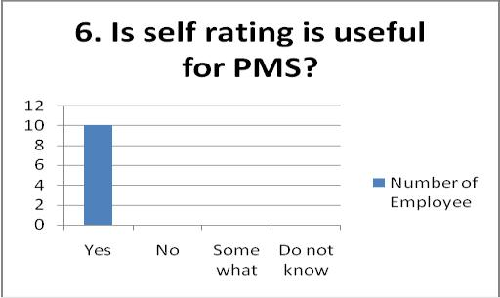

Figure 1.6

Comment: Most of the employees says that self-rating is very useful for PMS. Where Kazi Farms not use self-rating or self-appraisal. Only supervisor apprise them

- Do your superiors assist you at the time of your need?

 |  |  | Some | Do not
Answers | Yes | No | what | know
Number of
Employee | 6 | 4
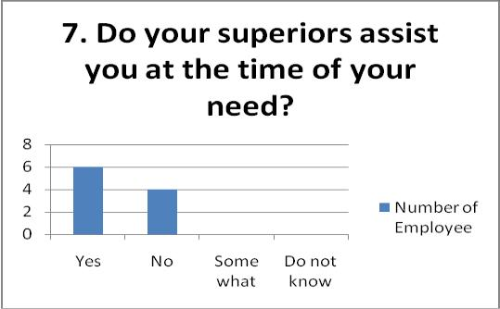

Figure 1.7

Comments: Here most number of employees says that their superior help then when they need. Its clearly understands that there is friendly working environment.

Limitation of the Study
- Continuous Updating Performance Management System- Kazi Farms Group (KFG) updates their Performance Management System on regular basis which creates dilemma to understand. As a result employee may face difficulty and hard to meet their expected rate.

- Performance Management Training- There is no training regarding the performance management system. As a result employee does not know how they should improve themselves.

- Department linkage with HR department- Other Departments linkage with HR department is not strong enough. There are a lots of department under Kazi Farms Group and its very bad side that there are no link or close connection between HR department and other department of this organization. As a result employee of the other department do not get proper feedback or any kind of information from HR department.

- They don’t go for proper needs assessment before starting a new training
program. However employee do not interest to get assessment.

- Employees are unable to taking part to goal setting only higher authority set goals. They do not have any kind of decision taking power as a result higher authority set their restriction and employees are bound to follow those rules and regulation so they can’t set goal to improve their career.

- Comparison between pre performance management and post-performance management is not present in the system. Employee do not know how much range he/she improved against the previous performance system and s/he do not evaluate by him/herself.

- New employee orientation is not followed by The Farm
management. Every organization try to convey their new employee about their organizations rules, regulations, policy etc through orientation program but at Kazi Farms Group I have not seen this types of activities. Although they have start this types of activity but this is not enough for new employee as well as organization.

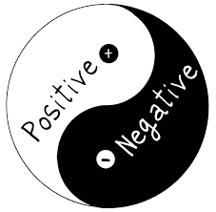
- At Kazi Farms Group there have not proper immediate feedback system. For example, an employee have done wrong task as a result no one will be concern about this wrong issue. After a certain period or after a certain days authority telling that employee about his or her mistake.

- Sometimes employee’s fells work burden in this organizations.
Because organization do not maintain and organize their employee as a proper way that why employee fells demotivated and they fells burden task among this organization.

- Most important things is that the duration of the internship period, that’s why I cannot find enough information

Advantage of the Study

- It allows the employee to monitor and track their progress against their yearly objectives and development plan. As a result employee can know about his or her current situation and know about his or her current performance. If there have any lacking then employee can handle and improve themselves to meet the performance standard system point.

- The information form may be used in the talent review process to provide feedback to the employee on their career development and to allow Kazi Farms Management to forecast the future talent needs of the corporation. Kazi Frams Group try to improve their employees skill through some training session like digital marketing training, learning English, how to operate computer and software in a better way.

  - They give chance to the employee to appeal for a higher grade if they are not satisfied with their appraisal outcome. If employee thinks that employee have an opportunity to doing something for increasing or meet higher grade then he or she can do it. Kazi Farms Group motivated to their employee to meet their expected grade.

    - They are going to introduce a new online system which is unique, In that online system employees will fill up their own performance management form and later on they discuss with their superior and adjust it based on mutual understanding. Kazi Frams Group doing their most of the task through their own software and server. Employee can do their performance task through those software.

    - Recognition and reward – There is recognition and reward management system on this organization. I see that its very essential and helpful for employee that employee can get rewars and recognition by their performance, and organization provide employee reward by giving price money or bonus or allowance, gift , award or vacation which for a long term.

    - Employees get proper support from their Supervisor. Every department of Kazi Farms Group have immediate supervisor or manager that employee can assign by them or organize by theme. As a result if employee doing any types of wrong task immediately manager or supervisor can handle those wrong issue and solving the problem.

    - Employees are feels free to discuss all the matter of work with their supervisor. Kazi Fams Group are too much flexible about this issue, higher authority can hear if employee may face any kinds of problem.

Recommendations

After completing my internship program with Kazi Farms Group (KFG), HR Division, Head office, I think the following recommendations will help them to improve the employee satisfaction and also the HR Division:

Identical Human Resource Policy: There should be a unique HR policy in the organization
immediately; through the recognition of HR policy is under progress supervised by the Manager and the head of HR.

Human Resource Development: There should be all kinds’ development activities as individual, career and organizational by the Human Resource Department for enhancing the employee’s growth as well as achieve organizational hierarchy.

Training Need Assessment: KFG has all the potential capabilities to make its employee more efficient and help being the future leader. Training is a common practice for the employees of any organization.
This training should be organized by the human resource department only through need assessments. It can be examines through the performance evaluation process by which HR Division will determine where he/she should have some more exposure.

Post Training Assessment: KFG has many training programs. Many employees sent to these programs every year. But a biggest loophole is they don’t take any steps to measure the efficiency of the employees after the training program. The training program is helpful or not for the employees they don’t measure it. But this not the proper way. They should evaluate the previous performance and the after training performance to identify the improvements. It will help the farm to identify which training program is helpful for which skill development.

Linkage among Other Division: A department like HR Division cannot perform isolated where Human Resource Department is in the core of all other department with the responsibilities of maximizing the employee’s benefits as well as achieving organizational objectives. For better services, HR Division must establish a proper linkage within the other functional departments.

Reward and Recognition: Only higher salary package cannot satisfy a self motivated and exposed employee in higher level. The employee wants recognition and reward for their self actualization. There are few reward and recognition options is available in KFG should review for deals with employee turnover. The workforce should be structured and the standard functional designation should be in act.

Conclusion

Like every other company Kazi Farms Group has its own strength and weakness. In spite of only developing a business in poultry, hatchery, feed mill, IT, and media sector, Kazi Firm is one of the leading farms in the poultry business. Kazi Farm is doing great business and they are one of the successful companies of Bangladesh but they have to think about the need of their employees. This is because if employees are happy only then an organization can reach to its desired position, Kazi Farms is doing that and they are trying to overcome their weakness and fight with their threats.

- Kazi Farms Group https://www.kazifarms.com/
- Kazi Food Industries LTD. https://kazifoodbd.blogspot.com/p/company-profile.html
- ERP 172.16.253.3/webui
- Akhtarul Hassan, Senior Officer, HR Department, Kazi Farms Group
- Michael E Porter, Harvard business review 86(1):78-93, 137 · February 2008 The five competitive forces that shape strategy
- https://www.researchgate.net/publication/5581445_The_Five_Competitive_Forces_That_Shape_Strategy

- Porter, M. E. (2008). The five competitive forces that shape strategy. Harvard business review, 86(1), 25-40.

- Bubli, S. A. (2006). A Market Share Analysis and Competitor Analysis of Kazi Farms Group Day-Old Chick Broiler Production. Independent University, Bangladesh: http://sb. iub. edu. Bd/internship/spring2006/0020120. pdf (July 21, 2008).

- Hossain, S. (2019). Performance management system of Kazi Farms Group.

- Asha, S. R. (2019). Branding Practices of Kazi Food Industries Limited: A Case Study on Bellissimo and Za'n Zee Brands.

- https://smallbusiness.chron.com/service-marketing-mix-57548.html

Appendix

This is a performance management form of an employee who is other then manager. So as it mentioned earlier that in section A manger have to describe the key job responsibilities of that employees. In this case the employee’s key job responsibilities are:

- Management of SWIFT.
- Preparation of Land Customs statement.
- Management of TI systems.
- TR disbursement and adjustment when related officer is absent or overloaded.
- To develop myself in farming carrier and serve The Farm effectively and efficiently.
- To improve business worthiness & Marketing of the products to improve company profit.
- Other assignment as assigned by the regional management time to time.
- Successfully achieved my business target.

In section A manager has to mention in which category the appraise fall into. In that case the manger selected him in as EX (excellent) category. Appraiser also wrote the justification for that category.

B. Performance Category: Given the job responsibilities and considering Quantity & Quality of on the job performance, evaluate performance category: (Any one of the following performance category)
5 (Five) Performance Categories | Justification in brief – Please give examples | Tick √ RATING
Exceeds Expectation: Performance Standard/target/given work plan for above expectation | He is too much knowledgeable for his job. He has performed very much efficiently with at satisfaction
Fully Meet Expectation: Reasonably Exceeded Performance Standards/ Targets/Given Work Plan above expectation.

Met Expectation: Met
Performance Standards/Targets/
Given Work Plan
Satisfactorily within expectation

Fully Meet Expectation: Closely Met Performance Standards/Targets / Given Work Plan, but not fully satisfactory

Performance Far Below the Standard Expectation / Targets / Given Work
Plan – A poor performer.

In section C Manager has to assess the knowledge and behavioral competences of the employees. In this case the employee rating was in this manner.

Assessment of Knowledge & behavioral competence for Potential Listing only)
1=Need development, 2=Average, 3=Good, 4=Very Good & 5 =Excellent

Knowledge & Behavior Competence Factor | 1 | 2 | 3 | 4 | 5
Knowledge about Kazi Farm’s product & services, Organization, Policies & Processes (updated)

Appreciation in farming business

Computer literacy & IT knowledge relates to farming

Overall Knowledge profile in assigned job responsibility
Customer understanding and care

Awareness about compliance issues

A self-starter with drive & initiatives

Attitude
Analytical ability

Communication ability

Inter-personal relationship

A team worker believes in team commitment

Ability to influence others & gain commitment

Speed in Action

So it is visible that in this category the employee did very well. His performance was very satisfactory to his managers. His average in this section was (6*5) + (9*4)/15 = 4.4 which is very much satisfactory.

Then the manger has to write about the integrity & conduct in service of the employees. In this case manger commented as follows:

- Integrity & Conduct in service ( comment ) :
………………… is the honest sincere & well behaved person. He has the
good communication skill and he has ability to attract the customers to our products.

In section D Mangers have to identify the areas in knowledge and behavioral competence that should be developing in employees characteristics. In this case manger identified two knowledge factors that should be improved. These are

D. Development Needs – 2 (Two) areas in knowledge and 2(two) areas in behavioral competence
Knowledge |  | Behavioral competence
1. | Marketing & profitability | 1...
2. | Customer Relationship | 2...

After finishing that section manger commented on the supervisor’s overall comment box which is in section E. it can also described as the summary of the management form where supervisor make comment and give the final grade. In this case the manager has given the respondent the following comment and grade in his evaluation form:

E. Supervisors overall comment performance summary & rating | - Rating
Consistently performs his job with high satisfaction and he has sound knowledge about the farm rules and regulations.  Supervisor (Appraiser) | Exceeds Expectation
 | Fully Meet Expectation
 | Met Expectation
 | Partially Met Expectation
 | Requires Significant Improvement
So according to the manger the employee got overall Excellent rating. This rating will be entered in the performance management software. So from this box it is easily identified that the manger is completely satisfied with the performance of the employee.

After this section there is a box for employee view point about this appraisal form which is in section F. Here employee comments about the grading. In this case the employee gave the comment as follows:

F. Employee view point about this appraisal and own career wishes: Agreed.

Employee (Appraise)

Here employee is completely agreed with the managers rating. So the appraise wrote agreed. If appraiser feels that performance evaluation by the line manager is influenced by discrimination or unfair and biased judgment then he may appeal to Head of HR with his grievance in writing. In such cases

The Head of HR will be the first point contract. If the issue remain unresolved than it will referred to the MD for his review and decision and in that case the decision of MD will be final.

After that part there is the box for special recommendations. In this case Manger things that the appraise is eligible for recommendation. So the remark was as follows:

G. Special Recommendation (career etc.) - Place with justification:

Recommended for annual increment and promotion to the next higher level
Supervisor (Appraiser)

So this is the total performance management form for this employee. This form is included only for better understanding about the performance management system of Kazi Farms Limited.

