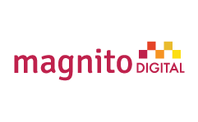  Internship Report | Client Service and Content Design at Magnito Digital

Contents
Acknowledgment iii
Executive Summary 1
List of key concept Abbreviation, Technical Terms 2
Abbreviation 3
Introduction 4
Origin of the report 5
Purpose of the report 5
Objective of the report 5
Methodology of the data collection 6
Research Method 6
Primary Sources 6
Secondary Sources 6
Limitation of the report 6
Literature Review 7
What is Digital Marketing? 7
Why Does it Matter? 8
5D is of Digital Marketing 8
Why Digital Marketing? 9
Why opt for digital marketing? 9
The importance of digital marketing for B2B 10
Different types of Digital Marketing 11
How to develop B2B through Digital Marketing 11
Contribution of Digital Marketing in Organization 16
Top Digital Media Platforms in Bangladesh 18
Industry & Organizational Overview 19
Industry Overview 19
Current profile of Leading Digital Marketing Agencies 20
Key Market Rivals 21
About “Magnito Digital” 22
Goal of the Organization 22
Company Profile 23
Key Clients 24
Management Directory 25
Strategic Objectives 25
Functional Strategy Operations 25
Finance 25
Marketing 26
Services Portfolio 26
Functional Departments & Their Responsibilities 27
Strategic Planning Department 28
Client Service Department 28
Content & Planning Department 28
Creative Department 30
SWOT Analysis 31
Strengths and Weaknesses 31
Opportunities & Threats 32
Overview of My Internship (Job) 33
Description about Job 33
Client Service & Query Management 33
Content Department 38
Designing for GP Wowbox 39
Limitations Faced 40
Environment of Magnito Digital 41
Assessment of organizational culture 41
Assessment of works done & behavior of co-workers’ 41
Difference between Expectation and Experience 42
Influence of Internship on My Future Career Plan 44
Recommendation 45
Critical Observation with Recommendation 45
Recommendation how they can increase client satisfaction 45
Here are some guideline for B2B 46
Conclusion 51
Bibliography A

Executive Summary
Magnito Digital is the largest digital agency of Bangladesh with a team of more than 70 people. They are very well known for their working quality and friendly culture. They are serving prominent organizations for quite a while like Grameenphone, Fresh, Huawei, Atomgum and so on. The office has helped fabricate marks in the computerized space and are the go-to-office for dealing with their advanced item and administration. Being a standout amongst the most granted advanced organizations of Bangladesh; Magnito Digital won various remarkable worldwide honour.
This internship report is based on the six months long internship program that I have successfully completed in Magnito Digital in Client Service and Content Design sector, as a requirement for the fulfillment of my BBA degree. This report is the outcome of my internship period and contains a clear idea about my activities, learning, and performance during the whole internship period.
The First section of the report is the introduction part. The introduction part mostly included the background, purpose and objective. This section is very informational because for any internee it is essential to recognize the organization before being a part of it. The following section describes my overall assignments and works conducted during the internship program. Here, I have emphasized mostly about my daily responsibilities and how much I was able to contribute to the organization. Further I have mentioned the learning that I had from those workshops in my internship career. Afterwards I have provided a short description about the difficulties I have faced throughout the internship journey and my methods of overcoming them. It is certainly true that this internship has impacted a great inspiration in my career plan. It got me involved in a lot of held regarding where I had the possibility to go ahead. Finally, in the last few sections I have drawn consideration towards the findings and recommendations by stating what the corrections could have been.

List of key concept Abbreviation, Technical Terms

- Digital Marketing: The utilization of the Internet and related advanced innovations in con-intersection with customary correspondences to accomplish promoting destinations (Chaffey and El-lis-Chadwick, 2012).
- B2B marketing: Business-to-business advertising, in some cases alluded to as "B to B", "B2B","business showcasing" or "mechanical promoting", is the act of people or association showcasing items or administrations to different organizations or associations (Hall, 2017).
- Paid Media: Known as purchased media, an immediate instalment jumps out at a site proprietor or an advertisement arrange when they serve a promotion, a sponsorship or pay for a tick, lead or deal produced (Chaffey and Ellis-Chadwick, 2012).
- Owned Media: Different types of online media controlled by an organization including their sites, websites, email rundown and web based life nearness (Chaffey and Ellis-Chadwick, 2012).
- Content Marketing: "A key showcasing approach concentrated on making and appropriating important, applicable, and steady substance to pull in and hold a plainly characterized group of onlookers and, at last, to drive gainful client activity" (Content Marketing Institute, n.d.).
- Above the line (ATL): Above The Line (ATL) alludes to limited time exercises done at full scale level. It is done at national, territorial or at greater region; level and mass gathering of people is canvassed in this sort of advancement. A brand picture is made about the organization and its item. Media, for example, TV, film, radio, daily papers, and magazines are utilized to make an effect about the organization and its item.
- Below the line (BTL): Below The Line (BTL) correspondence is offbeat in nature, done at smaller scale level and structures some portion of non-media correspondence. Measures incorporate direct mailing, dispersion of flyers, pamphlets, and utilization of sponsorships, advertising, tele promoting and purpose of offer.
- Through The Line (TTL): "Through the line" alludes to a promoting technique including both above and underneath the line interchanges. This vital methodology enables brands to draw in with a client at numerous focuses (for instance, the client will see the TV advertisement, hear the radio advert and be given a flyer in the city corner).

Abbreviation
Ad = An advertisement
B2B = Business-to-business
B2C = Business-to-consumer
PPC = Pay per click
ROI = Return On Investment
SEO = Search Engine Optimization
SEM = Search Engine Marketing
SMEs = Small and Medium Enterprises
SERPS = Search Engine Result Page

Introduction
Advertising is one of the major components in brand and venture interchanges, which presents records, which can likewise help, take a grand purchasing choice by methods for the clients or shoppers. In fact, intentional correspondence is the last result of publicizing, which may advance business undertaking items or contributions to the objective gathering. This intentional correspondence charms, supports and in particular it might educate and offer. At the point when this intentional correspondence is extremely viable, it achieves the customer or client and the rest of the objective of imparting is accomplished.
An outsider known as advertising organization ordinarily does publicizing. A publicizing office is an administration-based business devoted to making, arranging, and taking care of promoting for its customers. An advertisement office is autonomous from the customer and gives an outside perspective to the exertion of offering the customer's items or administrations. An organization can likewise deal with largely showcasing and marking systems and deals advancements for its customer’s .Types of ad agencies are-
- Full service agencies
- Creative agencies
- Specialized agencies
- In-house agencies
- Digital agencies or new media agencies
This report is completely talking about advanced or new media organizations. There was before a period when Television was the most mainstream medium for Marketer to advance, unfurl awareness and create leads for their items however now the vogue has changed and Digital media has had its spot. Primary driver for this substitute used to be:
- Traditional strategies are costly. Contrasted with computerized showcasing channels, you could surrender spending numerous greenbacks more. In this report, an example is given dependent on this issue.
- Traditional advertising channels neglect to concede prompt remarks and surveys about who saw or heard an advertisement, and made a move. This data is amassed long after the underlying advert affect is made (and still at that point, the data are some separation from particular numbers).
Computerized displaying, on the distinctive hand, alludes to publicizing techniques that allow associations to perceive how a battle is performing progressively, for example, what is being seen, how regularly, to what extent, as legitimately as various data, for example, deals changes.

Origin of the report
The report, titled “Client Service and Content Design at Magnito Digital” has been geared up to satisfy the partial requirement of my Internship of BBA Program of United International University (SOBE), supervised with the aid of MD. SHARIFUL ALAM (Ph.D.) Associate Professor, Marketing, Department of School of Business & Economics, United International University. I have been attached with the Client Service and Content Department and Visuals and Design Department of Magnito Digital and I have organized this file in association with my assigned responsibilities.

Purpose of the report

- The purpose of the report is to make a bridge between theoretical & amp; practical studies.
- To identify the role of Digital Marketing practices in the business development
- Providing recommendations for Magnito Digital to ensure satisfaction & reliability.
- To examine primary & secondary documents relating to the challenges and development of Magnito Digital’s client service.

Objective of the report

- Broad Objective
The Primary target of this report is to secure the jobs of computerized promoting and over the conventional highlighting from the buyer perspective to situate out how advanced advertising is helping customary publicizing process.

- Specific Objectives

- To know the entire procedure of making proposition for clients.
- To know the adequacy of advanced promoting in this focused time.
- To know about the hugeness of computerized promoting for brands.
- To find out the major strategic choices Digital marketing.
- Find out which source organizations uses more for Digital Marketing Process.
- Comparing Client satiation in digital marketing at B2B service.
- To know how it contributes to the organizational success.
- To solve the arising problems of the organization, regarding Digital Marketing.

Methodology of the data collection
Methodology refers to the comprehensive actions of research in my internship report. To achieve the required results to establish the objective, some methods are used. This section will clarify the methods I used to do this project.

Research Method
Research was done by collecting information from general people of Magnito Digital and some data were collected form internet.

Primary Sources
This study was mainly based on primary data that was collected through direct communication. To accomplish this, I talked to every people of Magnito Digital.

Secondary Sources
Some data and other necessary information were collected from the internet and websites of Magnito Digital.

Limitation of the report

- As this report, work conducted only for academic purpose that is why the main constrain was cost and time. For the in depth analytical purpose, adequate time is required. However, inadequate time was a major hindrance to prepare such an in-depth study.
- I got only 3 months experience with Magnito Digital for which I couldn’t get excess to some resources which I have assume for this report.
- Resource problems: In digital marketing, every job depends on images. We cannot use every image. There are some legal issues. Sometimes we do not get the exact image what we want.
- Work limitations: There are many work limitations from client side. They have budget issues, which hamper our works.
- Communication gap: There are always communication gap between creative team and content team.

Literature Review

What is Digital Marketing?
Advanced highlighting incorporates all promoting endeavors that utilization an electronic contraption or the web. Organizations use advanced channels, for example, web crawlers, inte
The utilization of the Internet are not based life, email, and their sites to join with present day and planned clients. d other computerized media and mechanical mastery to encourage 'present day promoting' has given an upward push to a puzzling scope of marks and language made by method for the two speakers and experts. It has been known as advanced promoting, Internet advertising, e marketing and web promoting and these decision terms have grouped through time.

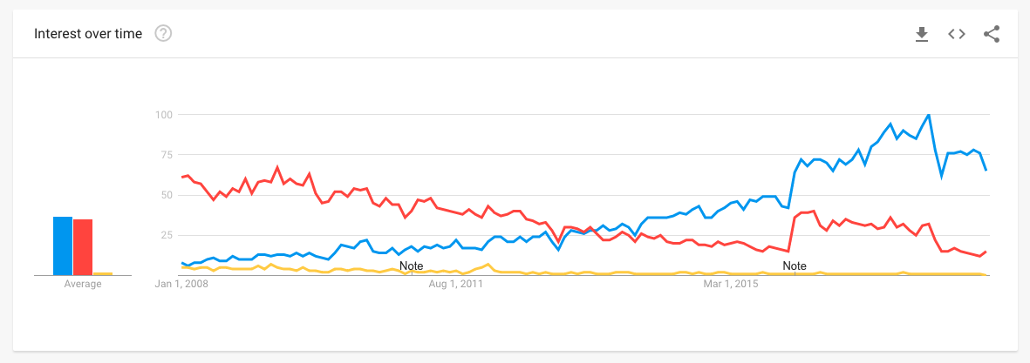
Picture 2. 1: Internet Over-Time.
As a result of the most recent discussion about the utilization of the term 'computerized promoting', we thought it is helpful to bind precisely what advanced means through a definition. Do definitions make a difference? We guess they do, given that particularly inside an association or between a business endeavor and its clients, we require intelligibility to encourage the wants and exercises that help Digital Transformation. As we will see, a considerable lot of the diverse definitions are deluding.
Come down to its least difficult frame, computerized publicizing and promoting is portrayed in my book Digital Marketing: Strategy, Implementation and Practice as just:
"Achieving marketing goals through applying digital technologies and media."
On this meaning of advanced promoting and showcasing to clarify that, practically speaking, computerized advertising comprises of overseeing unique assortments of on-line association nearness and existences, for example, association sites, cell applications, and web based life business pages. This is related to on-line interchanges methods, for example, any semblance of web index promoting, internet based life showcasing, web based publicizing, email publicizing and organization courses of action with various sites.
These procedures are utilized to control the objectives of acquiring new customers and granting contributions to exhibit customers that help advance the supporter relationship by means of E-CRM and advertising computerization. In any case, for computerized promoting to be fruitful, there is in any case a need for mix of these systems with standard media, for example, print, TV and post office based mail as segment of multichannel publicizing and highlighting correspondences.

Why Does it Matter?
There is a point of convergence on advancement of stock and administrations the utilization of computerized media as a substitute than an additional all-encompassing definition securing customer encounters, relationship change and focusing on the significance of multichannel coordination. In this manner, for us, the extent of the term needs to incorporate exercises over the buyer lifecycle:
- Digital media and communications channels.
- Digital and cell experiences such as web design and mobile apps.
- Prospect and customer relationship management through advertising automation.
- Digital approach and integrating multichannel communications and experiences.
- Digital technologies and structures to manage all digital marketing activities.
The job of computerized structures in supporting incorporated multichannel showcasing is an important thing area of advanced promoting, yet is regularly neglected. From multiple points of view, this features that it is so important to harm down storehouses among 'computerized' and 'customary' promoting and advertising offices. Online channels can also be figured out how to direct the aggregate looking for strategy from pre-deal to deal to post-deal and further change of customer connections.

5D is of Digital Marketing
To capture the hugeness of advanced promoting to the eventual fate of advertising in any business, it's valuable to expect about what target showcase associations we have to secure and oversee. Computerized publicizing and showcasing these days are about numerous a bigger number of sorts of target advertise cooperation than site or email... It includes overseeing and tackling somewhere in the range of '5Ds of Digital' that I have portrayed in the prologue to the advanced supplant to my Digital Marketing: Strategy, Planning and Implementation book. The 5Ds diagram the conceivable outcomes for customers to collaborate with producers and for associations to reach and concentrate from their groups of onlookers in uncommon ways:
- Digital Devices: Groups of onlookers venture marks as they collaborate with business sites and cell applications normally by means of a blend of connected contraptions, which incorporates cell phones, tablets, smart phones, and gaming gadgets.

- Digital Platform: Most connections on these gadgets are through a program or applications from the real structures or administrations, that is Facebook (and Instagram), Google (and YouTube), Twitter and LinkedIn.

- Digital Media: Exceptional paid, claimed and earned interchanges channels for achieving and alluring crowds, which incorporate promoting, electronic mail and informing, web indexes and interpersonal organizations.

- Digital Information: The knowledge bunches accumulate about their objective market profiles and their associations with organizations, which currently wants to be canvassed by utilizing law in many nations.

- Digital Technological Know-How: The promoting innovative information or market stack that offices use to make intuitive encounters from sites and cell applications to in-store stands and email crusades.

Why Digital Marketing?
Customary publicizing and advertising incorporate showcasing and advancement of items and administrations on print media like flyers, blurbs, business ads on radio and TV, hoardings, dispatch loads up and distinctive expensive ways. Around then, online networking or web were never again used for advancement. Two Traditional promoting had the restricted extension and customer reach. Be that as it may, after the innovation of advanced showcasing, there are a few on-line channels through which you can advance your endeavor carefully. In the event that a business endeavor is going advanced, exclusively then it can keep on existing in this day and age.

Why opt for digital marketing?
- Interaction with the targeted audience: With digital marketing businesses can interact with their customers and engage them with valuable points to understand what their targeted audiences wish for.
- Generate more conversation: Online marketing of products and services can generate more leads and subscribers than the traditional form of marketing.
- Reduced cost of advertising: For people having small business, digital marketing is proven better and cost-effective platform than the traditional marketing.
- Customer Satisfaction and retention: Digital Marketing can be considered as real-time marketing. When business provide real-time help and solutions to their customer problems, they gain customer satisfaction and retention.
- Revenue Generation: With digital marketing techniques, higher conversations can be achieved that result in prominent revenues.
- Build Brand reputation: Digital marketing techniques help businesses to increase their customer reach and visibility. Therefore, they can build a unique identity among customers.

The importance of digital marketing for B2B

Digital advertising levels the on the net having exciting area. When it pertains to an organization’s exposure online, like opening a shop, the location is each little thing. Being conveniently apparent online, obtaining a company’s title available, and upgrading information often will bring clients to its door.
Today, the Internet is a boon that provides endless possibilities for your small, medium or massive business. Currently, extra than half of the international populace makes use of the Internet. Experts say that in coming years above 80% of the world population will be online. Therefore, digital advertising has turn out to be a quintessential part of marketing.

- Cost Effective
Digital advertising is one of the most low-priced mediums of marketing. Traditional advertising techniques such as print, broadcast, etc. require a lot of cash and provide confined output. On the other hand, Digital Marketing is cheap; it fits all kinds and sizes of business.

- Reach Mobile Consumer
Mobile users are growing day by using day. Currently, a giant component of grownup population uses smartphones. With digital marketing, one can easily goal their cell audience, and convert into their customers. Reaching cellular buyers is the key for business growth.

- Contents connects customers
Digital Marketing allows you to use content to get related with customers. The gain of content material is that it allows you to talk more and express more. Hence it a superb medium to bring a clear message and entice big website visitors for the cause of growing sales.

- Get High ROI
Return On Investment (ROI) is an essential thing in any advertising strategy. Traditional marketing strategies have low return on investment and don’t suit all sorts and sizes of business. Whereas, Digital advertising is the satisfactory method to amplify patron base and achieve excessive return on investment.

Different types of Digital Marketing

There are obvious sorts of electronic publicizing and advancing open, for instance, Search Engine Optimization (SEO), Pay Per Click Advertising (PPC), Social Media Marketing (SMM), Content Marketing, Affiliate Marketing, etc. You can choose any kind of advancing and exhibiting relying upon your business create, business size and business adventure goals.

- Tap Social Media
Web based life is on the ascent. Directly from adolescents to old matured individuals, we all is via web-based networking media. You can enhance the proficiency of your showcasing effort by method for precisely focused on your possible customers dependent on their age, zone and interests. In addition, it is an awesome technique to enhance mark perceivability and friend’s mindfulness.

- Build Credibility
Trust plays out an essential position in changing over a conceivable customer into client. Advanced Marketing systems will push you to locale your organization on first page of Search Engine Results Page (SERP). Being in the principal page of Google not just builds up trust, anyway moreover will expand site traffic. As the aftereffect of which, you get new customers easily.

- Easy to Measure Outcomes
Consequences of ordinary advertising techniques are trying to gauge. Without understanding point by point result, it is hard to check the accomplishment of a battle. This is not true anymore with advanced advertising. Each and every advanced advertising strategy you use is quantifiable. You can complete an inside and out assessment of current impacts and top of the line tune to increase some other milestone.

How to develop B2B through Digital Marketing

- Increased Brand Awareness
Online life is a standout amongst the most inside your methods computerized promoting procedures used to syndicate content material and extend your business' perceivability. Executing an online life technique will considerably increase your image insight since you will allure with an expansive target gathering of people of shoppers.
To begin, make internet based life profiles for your business undertaking and start cooperating with others. Get representatives, venture accomplices, and patrons to "like" and "offer" your page.
Essentially having people cooperate with your substance will expand organization acknowledgment and start constructing your acknowledgment as a business. Each distribute that is shared will be conveyed to another network of people, which can lead them to getting to be feasible clients, and the additional individuals who comprehend about your business, the better. By contributing just a couple of hours out of each week, more than 91% of advertisers guaranteed that their social promoting endeavors generously extended their presentation. There is almost certainly that by methods for just having an online networking page your maker will profit, and with regular utilize, it can create an expansive target showcase for your business.

- More Inbound Traffic
Without publicizing your business via web-based networking media, your inbound website guests is controlled to your conventional clients. The general population comfortable with your image are likely searching for the indistinguishable key expressions you effectively rank for. Without utilizing web-based social networking as a component of your publicizing technique, you will have tons additional trouble achieving everyone outside of your reliable buyer circle.
Each internet based life profile you add to your publicizing and promoting blend is a passage to your site, and each bit of substance you post is each other chance to accumulate another client.
Online networking is a blend of phenomenal sorts of people with different foundations and practices. With various individuals come particular needs and select methodologies of reasoning. Syndicating your substance on whatever number structures as could be expected under the circumstances allows these people to naturally achieve your business. For example, maybe any one out of a more established statistic of purchasers will look for your web webpage the utilization of a specific catchphrase on Facebook, however a millennial should start their inquiry by means of utilizing an alternate internet based life stage totally, because of the reality they scan for items certainly in an unexpected way. By advertising via web-based networking media, you can proficiently open your business undertaking to a more extensive assortment of flexible purchasers everywhere throughout the world.

- Improved Search Engine Rankings
In spite of the fact that posting via web-based networking media would potentially get your undertaking some site online movement, more exertion than that is required to see full-measure achievement. Site design improvement is extremely crucial for achieving more prominent site page rankings and getting activity to your undertaking site. While web-based social networking doesn't specifically extend web index rankings, Social Media Examiner expresses that more prominent than 58% of business people who have been the use of web based life for one year or longer still observe extended web search tool rankings. Being skilled to rank in the best positions for your key expressions will upset your guests and keep on creating pleasant outcomes for your business.
Give us a chance to confront it, each individual influences utilization of Google to find data, and they presumably won't explore past website page 1 in light of the fact that their answer generally is on the main page of results. On the off chance that your business venture site isn't positioned toward the highest point of web index results, you likely alter your site design improvement methodology.
To give yourself the top notch peril of positioning higher by means of internet based life, make high acceptable substance material that incorporates your focused watchwords. Substance, for example, web journals, infographics, contextual analyses, business data, and worker pictures will make your business' online networking profile captivating and trustworthy. When you begin posting top notch content, you will begin to develop a web based life neighborhood the place adherents will "like" and "offer" your substance. Above all, it offers you more chances to get before big business influencers who will expound on your business and give joins returned – which will help to immediately increase internet searcher rankings.

- Higher Conversion Rates
With expanded perceivability, your business great focuses more open doors for transformation. Each blog entry, picture, video, or comment may also lead watchers to your organization's web website and increment activity. Web based life showcasing lets in your business to give a fine effect through an acculturation factor. At the point when makers are intuitive by sharing substance, remarking, and posting statuses via web-based networking media, it exemplifies a brand. Individuals pick to do business undertaking with other individuals, rather than organizations. More than 51% of advertisers asserted that setting aside the opportunity to build associations with purchasers affirmed awesome outcomes in deals. The better influence you make on a guest, the more probable they are to think about your undertaking when the need for your item or administrations emerges. Studies have likewise demonstrated that internet based life has a 100% more noteworthy prompt close rate than outbound advertising. At the point when an organization is intelligent on the web, customers who watch your image's records as often as possible start to additional unquestionably have confidence the believability of your business. Individuals utilize online life stages to remain identified with their companions, family, and networks. Since individuals are as of now talking, why now not toss your image in with the general mish-mash? More perhaps than not, they will make reference to your maker to a companion when your stock or administrations are required, fundamental providing your business endeavor with social verification of its quality.

As recommended by method for Social Media Examiner, around 66% of business people saw lead innovation focal points by means of the utilization of online networking stages no less than 6 hours of the week. Putting your organization in a biological community the place people are sharing, preferring, and talking, can exclusively enhance the change rates on your present movement.

- Better Customer Satisfaction
Web based life is a systems administration and verbal trade stage. Making a voice for your venture by means of these stages is imperative in acculturating your organization. Clients regard realizing that when they set up remarks on your pages, they will get a customized reaction on the other hand than a programmed message. Being able to surely understand each comment demonstrates that you are mindful of your guests' needs and plan to give the immense experience.
Each buyer interaction on your business' web based life cash owed is a chance to freely demonstrate your empathy for your clients. Regardless of whether a man has an inquiry or an objection, web based life affirms you to address the recall the utilization of relational discourse. A maker focused on customer joy that sets aside the opportunity to form individual messages would characteristically be seen in an eminent light, regardless of whether reacting to a customer grumbling.

- Improved Brand Loyalty
One of the significant wants of almost all gatherings is building up an unwavering client base. Thinking about that customer fulfillment and brand steadfastness normally go as an inseparable unit, it is vital to frequently connect with clients and initiate growing a bond with them. Internet based life is not simply kept to presenting your image's stock and special battles. Clients see these structures as a supplier channel where they can discuss instantly with the business.
The millennial innovation is recognized for being the most maker faithful customers of all. Conceived between the mid 1980's and the mid 2000's, recent college graduates are the greatest time in US history– and will soon certainly devour the market. Studies show that this area of clients is 62% more faithful to makers that quickly communicate with them via web-based networking media. Since these innovation locals require discussion with their brands, organizations should put in power online networking showcasing to get the enthusiasm of their most compelling buyers.

- More Brand Authority
Consumer loyalty and brand dependability each play a stage in making your business additional definitive, however everything comes down to correspondence. At the point when purchasers see your office posting via web-based networking media, for the most part answering to customers and posting unique substance, it makes you appear more trustworthy. Frequently associating with clients shows that your endeavor thinks about consumer loyalty, and is close by to answer any inquiries that they may have. Fulfilled clients are anxious to unfurl the word about a prominent item or administration and they as a rule swing to online life to express their conclusion. Having customers call attention to your business via web-based networking media will advance your business, and show new movement your expense and friends specialist. When you accomplish a couple of comfortable clients who are vocal about their awesome purchase understanding, you can give the showcasing a chance to be executed for you with the guide of genuine customers who making the most of your item or administration.

- Cost-Effective
Web based life promoting and showcasing is perhaps the most sensible piece of a publicizing and advertising methodology. Joining and building up a profile is free for all long range informal communication stages, and any paid advancements you make sense of to make interests in are a particularly low value contrasted with various promoting strategies. Being minimum costly is such leeway since you can see a higher degree of profitability and safeguard a greater spending plan for various promoting and operational expense.
On the off chance that you decide to utilize paid promoting and showcasing via web-based networking media, always start little to perceive what you anticipate. As you develop to be more agreeable, pleasant tune your technique and endeavor developing your financial plan. Just by methods for investing a little measure of energy and money, you can broadly broaden your change charges and at last get rate of profitability on the trade you out the starting contributed.

- Gain Marketplace Insights
A standout amongst the most important favors of online life is commercial center understanding. What higher approach to comprehend the thoughts and wishes of your customers than by method for straightforwardly talk me to them? By checking the undertaking on your profiles, you can see client' pastimes and conclusions that you may not generally know about if your business did not have an online networking nearness. Utilizing web based life as a correlative query instrument can help accomplish measurements that will help you in understanding your industry. When you harvest an extensive after, you can utilize additional hardware to break down the socioeconomics of your customers.
Another shrewd thing of internet based life publicizing is the capacity to section your substance syndication records essentially dependent on theme, and find which sorts of substance create the most impressions. These instruments supply you the ability to gauge changes dependent on posts on a significant number web-based social networking structures to find the perfect blend for producing income.

- Thought Leadership
Posting smart and elegantly composed substance material on your online networking is a fantastic method to rise as a master and boss in your field. There is nobody approach to wind up a thought boss – it requires work that can be upheld by methods for on-line organizing apparatuses. To set up yourself as a specialist, be sure to use online networking structures and build your essence. Be informative, interface with your gathering of people, share content, and advance your power. At the point when your online life promoting effort is lined up with various publicizing endeavors, your capacities will be featured and devotees will admire you. Being in a situation to quickly associate with your customers makes a relationship that they will esteem, enabling you to develop to be a wonderful influencer in your field.

Contribution of Digital Marketing in Organization

- Branding: In the present scene, brands are worked in the computerized world. Your site shows a region to bond your message. Interpersonal organizations, online journals, and motion pictures give you an expertise to create and sharpen your voice. Computerized promoting presents a chance to extoll the benefits of your transporter to the individuals most engaged with them. With all the excellent variables of computerized promoting, organizations have a moderate method to characterize their brands without a moment's delay to customers like not the slightest bit previously.

- Visibility: On the off chance that your venture does not exist on the web in 2016, it can likewise as legitimately not exist. An endeavor with the exception of a web nearness is an undertaking that 99.9% of the world has not the slightest bit knew about. On the distinctive hand, an association with a strong advanced nearness can develop its intended interest group in strategies organizations should exclusively have longed for a long time prior. Today, it is reasonably more than likely that the larger part of customers will get their first attention to a producer on the web.

- Education: This B2B Community article notes, "Corporate chiefs reach as far as 67% of the way by means of their purchasing cycle before consenting to talk about to any sellers.” What does that let us know? It reveals to us customers (in these exact case B2B clients) swing to web to take a gander at partnerships or philanthropies before they work with them. They may moreover never again round out a contact frame—yet don't figure individuals aren't the utilization of your site, social profiles, and the various advanced insights out there to analyze more about your association.

- Access: The additional doorways you have to your association, the more individuals are probably going to come inside. That, generally, is the thing that computerized publicizing and advertising is a gathering of entryways principle individuals to explore more noteworthy about your association. A man may moreover have known about your organization previously, yet maybe it is a common social set up or an email bulletin that leads them to find your site and burrow somewhat more profound. On the off chance that that entryway was not there, they couldn't have opened it.

- Community: Most organizations have a system in locale that is important to business building—individual experts, previous customers, teams up, sellers, advisors, and so forth. Computerized publicizing and advertising offers you the possibility to develop practically identical systems on the web. For instance, you may likewise have your Twitter circle the place you share measurements and fabricate associations with people in your industry. This can likewise prompt referrals or amazing associations that wouldn't have occurred something else. Such is the enchantment and intensity of advanced neighborhood building.

- Data: A superb aspect concerning advanced publicizing is it leaves a trail for you. These are such a significant number of examination available to show you matters like who is seeing what, what number of people were keen on a one of a kind piece content, or what email got the acceptable reaction. What's more, you can see these certainties in a split second. Computerized realities displays an incredible plausibility to break down additional about each your customers and your image, and understand new or undiscovered chances.

Top Digital Media Platforms in Bangladesh

- Facebook: Largest social media platform used by more than 67M subscribers in Bangladesh, among which more than 22M users in Dhaka alone.

- Google : Most visited website in Bangladesh with the 2nd highest digital media spend in Bangladesh

- YouTube: A YouTube channel is a Channel you can create for personal or business use. First, you have to have a personal Channel on YouTube and then, you can create your business YouTube channel.

- LinkedIn: Largest professional network in Bangladesh with 1.49M subscriber.

- Twitter: Almost non-existent platform in Bangladesh in terms of regular use. Among 1.3M subscribers, 1.1M male

- Instagram: Second largest social media platform with 1.5M subscriber in Bangladesh.

- Snapchat : An Upcoming platform with 300K accounts in Bangladesh

- Messenger: Facebook Messenger (commonly known as Messenger) is a messaging app and platform. Originally developed as Facebook Chat in 2008, the company revamped its messaging service in 2010, and subsequently released standalone iOS and Android apps in August 2011.

- Google Ad Words: According to Stat Counter (2018), Google accounts for 91.81% of search engine market share worldwide. Within the UK, the difference is not significant as Google still dominates the market with 90.57% of market share. Therefore, it is safe to say that when it comes to search engine PPC, investing in Google would bring highest ROI. The P PC Online advertising of Google is called Google AdWords. Display marketing shows ads across Google Display Network in front of customers who have visited a site.

Industry & Organizational Overview

Industry Overview
In easy words, digital advertising and marketing is the promotion of products or brands by using one or greater varieties of digital media. Digital marketing differs from ordinary advertising in that it includes the use of channels and methods that enable a business enterprise to analyze advertising campaigns and recognize what is working and what is not – usually in actual time. With the proliferation of smartphones, web connectivity and social networking in Bangladesh, the digital advertising and marketing industry is gaining momentum. This growth style has been surprising over the remaining few years with the wide variety of organizations and sectors investing in digital advertising and marketing increasing at a rapid pace. Even though normal advertising methods are still predominant with an excessive center of attention of agencies on TV advertisements, billboards, and newspaper ads, the market situation is geared up to be transformed. These exclusive record ambitions to analyze the repute quo and the attainable of the digital marketing enterprise in Bangladesh. With GDP per Capita hefty increase ($1754, 2017-2018), which is rather expected to sustain over the next years as well, the buy energy of Bangladesh is increasing, especially in technological products such as Smartphones, Tablet Computers, Laptops, Smart TVs which is comforting humans to enter the Digital Frontier. Businesses are now trying to increase their communication - information, supplying and advantages over the digital media, which is developing great possibility for the humans to observe and be informative about their brands. And also, there is a develop in Ethical Consumers who likes to watch over the brands they are buying for day to day lifestyle, are very active to have interaction with their brands over the digital/social medias. There are 14 million energetic Facebook users in Bangladesh and a new subscriber is introduced to Facebook every 20 seconds. Additionally, early life include of nearly half of the country’s complete population, while 50% of the population is beneath the age of 30, making media consumption increasingly skewed closer to digital as this age group is usually involved in digital and electronics usage. These elements are increasing the credibility of digital frontiers in Bangladesh. Moreover, the upward shove of the telecom organizations and authorities spreading the advantages of third Generation network has been any other key elements in Bangladesh’s Digital Agency’s growth. According to BTCL, Bangladesh, having 131 million internet enabled cell network person and 63million internet user, the standpoint of Digital Marketing Corporation is huge. Since 2008, there have been upward push in companies that specialize in digital media carrier to all of the companies running in Bangladesh.

Current profile of Leading Digital Marketing Agencies

There are more than 50 new and old agencies working in the industry. Among which, 20 good and active agencies are:

Company | Founded
Analyzen | 2008
G & R Ad Network | 2009
19 (Nineteen) | 2009
Invento Bangladesh | 2010
Zanala Bangladesh | 2011
Solutions 360 Ltd. | 2011
Cookie Jar | 2013
Beatnik | 2013
Magnito Digital | 2013
iDigital (Impress Group) | 2013
Interspeed Marketing | 2013
Webpers | 2013
Red Orange Media & Communications Ltd | 2014
Bagher Bachcha Digital | 2014
Stratgeek | 2014
Boomerang Digital | 2014
Jarvis Digital | 2014
Taskeater | 2014
Webable | 2014

Key Market Rivals

- Analyzen: It was started as a web and mobile application development company based in Dhaka, Bangladesh. Since their beginning, they have constantly grown and excelled in services like Web based software, android and iPhone based mobile applications, game development, social media marketing and digital strategy making. Not only is Analyzen the first ever Digital Media agency in Bangladesh, it is also the first Bangladeshi Digital Agency to go global (Analyzen Singapore). They have the biggest client base in Social Media Bangladesh. Some of our clients are - Samsung Mobile, Unilever, Standard Chartered Bank, Dell, Reckitt Benckiser, British American Tobacco, Pran, Berger Paints, Cats Eye, Banglalink, Radio Foorti, QUBEE, Global Brand Pvt Ltd, Rohto Acnes.

- Cookie Jar: Cookie Jar is a sister concern of Asiatic Ltd., skilled in Content Marketing, Content Creation, Campaign Management, Facebook Advertising, Google AdWords and Google Analytics and everything with Online Advertising and Campaign Management. Currently their clients are, Telenor, Samsung Mobiles, Banglalink, Robi, Recitt Benkiser.

- StrateGeek: StrateGeek Digital is an award-winning digital marketing agency based in Dhaka, Bangladesh, that takes pride in conceptualizing and delivering some of the most ground-breaking online campaigns in Bangladesh history. Officially established in 2014.StrateGeek was previously the digital wing of Maverick Studios. As an independent SBU, the company benefits from razor-sharp industry focus, while retaining the content- production and development capabilities through partnerships with its sister concerns, Maverick Studios (maverickbd.com) and Ice9 Interactive Ltd.

- WebAble: Based in Bangladesh, WebAble is a digital creative agency delivering brand experiences. With a team of passionate marketing technologists, WebAble aims to simplify digital interactions for a select pool of ambitious clients. WebAble’s select clientele in Bangladesh includes Kaspersky, Aarong, Bay Developments, Rahimafrooz, Bangladesh Brand Forum, British American Tobacco, Bitdefender, Akhoni.com and Dell. WebAble offers digital advertising, social media marketing, web development, design and digital strategy and analytics services.

About “Magnito Digital”

Before the operations of Magnito Digital started, back in 2007, CEO and Founder Riyad Shahir Ahmed Husain realized that there is huge gap where designing and visual advertisements were concerned. There were only the big agencies like Bitopi, Grey Dhaka, Leo Burnett etc. and they used to serve bigger companies like Grameenphone, Banglalink etc. There was none to serve small and medium enterprises like Akij Group, Rahimafroz and so on. The advertising companies were such big where small companies could not afford. Therefore, he along with a partner started a communication agency Root Marketing Services. Their target was to design as per our client need and upon value addition, earn profits. The small office was at Gulshan 2. Interestingly, this venture faced many criticisms from the surroundings because of having no initial investment to start up. After generating good profit, Riyad decided to shift to a new place at Baridhara DOHS. Then the NGOs like USAID, IFC, and UNDP became their client. Root started from 2 persons, then there 6 and so on. In 2012, Root realized that there will be drastic change in the conventional marketing. The stakeholders started researching and finally realized that digital marketing is the future. Thus began the drumroll taking steps to embrace this change and prepare ahead. In 2013, began the journey of Magnito Digital and until now it is the local market leader in the country. Recently they have acquired the contract from Grameenphone and becoming the Digital Marketing partner of Grameenphone. This is a tremendous success as for the first time Grameenphone gave 100% of their digital marketing section to a local agency, which was previously Grey Dhaka’s.
Magnito Digital is a digital agency, which is driven by passion, inspired by brands, technology, and committed to providing true value to brands by utilizing the ever-changing digital ecosphere sphere all around the digital web. The name of the agency portrays a brand that brings customers closer, in a magnetic way through innovative ideas and execution. Being the first full service digital agency of Bangladesh, Magnito works throughout the digital universe and provide 360 digital marketing solutions. Bangladesh Brand Forum on “Rest of the South Asia” Category has awarded them as Best Digital Agency 2015 & 2017.
Bangladesh’s Internet penetration is growing at an exponential rate. With a connected population, consumers will inevitably, somehow or the other, interact with brands online. The need to manage and measure those interactions are driving brands to go digital. They serve their clients across the digital universe, covering search, social, display and mobile marketing.

Goal of the Organization

To satisfy the valued customers, meeting their expectations by providing quality services on time and offering them the best value in terms of standard, quality, price, environment and other ethical practices.

Company Profile

Address | Floor – 3, Plot – 7, Road – 23/B, Gulshan 1, Dhaka – 1212, Bangladesh
Telephone | +88 02 9821812
Website | Magnitodigital.com
E-Mail | info@magnitodigital.com
Year of Establishment | 2013
Total Number of Employees | 60+
Key Service | Social and Mobile and Web marketing

Key Clients




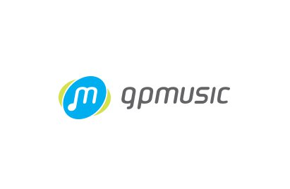

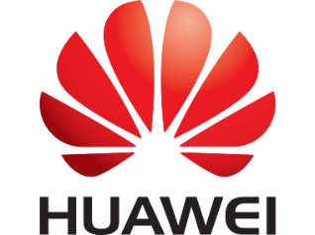

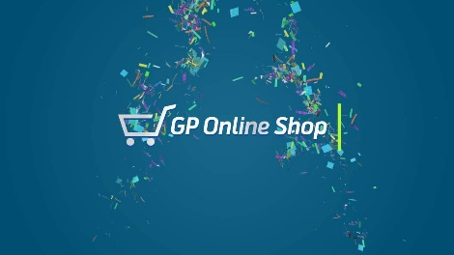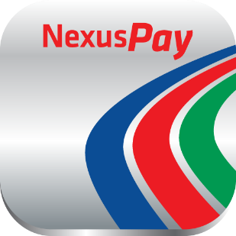


Management Directory

Chief Executive Officer | Riyad Shahir Ahmed Husain
Chief Operating Officer | Vicky Khawar Ahmed
Chief Finance Officer | Fayaz Taher
Chief Marketing Officer | Amer Khan
Accounts Director | Arif Rahman

Strategic Objectives
- Gaining competitive advantage by lowering overall cost compared to that of competitors.
- Overtaking competitors by proving quality customer service.
- Achieving technological leadership among the peer group.
- Strengthening the company’s brand position in national and international market.
- Keeping good relation with valued and top priority customers.
- Providing necessary support to the customers

Functional Strategy Operations

- Achieve 80% collection of monthly billing on the next month.
- Offer most customized services for the clients (like web site, event management)
- Increase and exercise more control over the various production jobs
- Pursue clients for job that is not used to be done by the agency but mutually beneficial (Example: Digital media buying and maintenance.

Finance

- Increase capital involvement in media which will result in higher commission margin for the company.
- Take benefits of early payments wherever permitted.
- Increase clients’ capital involvement on external or third party production or other jobs beforehand.

Marketing

- Increase the awareness and image of the company to not only the existing client but also other potential clients; cultivate better relationship with the clients beyond the business relationship.

Services Portfolio

Digital Strategy
With years of brand management experience, team of energetic strategic planners will formulate client’s ideal digital strategy, to position brands in the right way and reach out with the right contents to the right people at the right time and place.

Design and Visuals
The creative visual department of Magnito Digital has an exciting team of creative perfectionists, who designs the look and feel of the brand communication and customers’ journey in the digital space with unmatched user experiences.

Content
Whether it is a set of innovative html5 rich media banners, an engaging video content or even a content-rich podcast, the in-house capabilities allow the agency to deliver digital contents at unparalleled scale.

Campaigns and Activations
Magnito has deployed award winning digital campaigns for leading brands. Based on client’s brand’s strategy, strategic planners will design and develop the right campaign, which will magically transform the engagement to business results.

Web Solutions
Being the pioneers in Bangladesh for introducing web based, mobile optimized campaign applications, Magnito Digital design and develop responsive websites that compliment any client’s business goals.

Social Media Engagement
Magnito Digital’s social media group will develop a traditional into a talkative brand, creating meaningful conversations with your customers using the most edgy social media strategies.

Mobile Marketing Solutions
With proven international track record and one of the strongest expertise in the market for managing mobile based technological products, Magnito Digital can create mobile platform landscape to meet the client’s need. Whether the objective is to engage consumers with captivating mobile contents or to drive sales with a mobile strategy, Magnito Digital will find the right fit.

Digital Asset Management
Magnito’s team of in-house developers will develop digital assets in ways that compliment your brand. It focusses on responsive and mobile compatible products, which deliver an intuitive and smooth user experience for its customers.

Digital Media Analysis
As a Digital Agency, it understands the value of delivering profit laden contents to the right people at the right time at the right place. A team of digital media experts will devise the savviest digital media plan and execute it seamlessly to maximize the brand’s reach and return on investment.

Offline Events
With a decade of experience in managing large scale events, the event wing, Magnito Events will take the ownership of integrating online campaigns with a meaningful offline presence. It will design and execute events and brand activations for you, which will have digital legs, to maximize your brand’s experience.

Functional Departments & Their Responsibilities

Strategic Planning Department

Strategic planning department is one of the major departments of this company. This team is considered as the backbone of Magnito. They are responsible for giving campaign plans and approvals for clients. They are also responsible for setting different route to serve effectively and efficiently customers. Moreover, they are also responsible for making pitch/presentations for new clients.

- Researching and gathering date to develop well-informed strategic plans for clients.
- Examining clients’ businesses to get to know their brands and understand their objectives.
- Producing cohesive and intelligent plans to bring success to campaigns and Generating original ideas with other members of the team.
- Liaising with senior members of staff to receive feedback and create improvements.

Client Service Department

The basic function of the client service department is to maintain relationship with the clients and prospects. They communicate the thought of both the parties between two parties. They are one of the most important parts of Magnito Digital because they are the persons to sort out the things customer needs and finding the need is one of the most useful ways to keep the client happy. This department is the heart of the whole organization and it co-ordinates within the functions of the various department in the agency.
- Client Services is also important for research purpose. This gives some important information to the management, like :
- Effectiveness of the digital communication campaign.
- Customer reaction and feedback about the digital communication campaign.
- Finding out the reasons that make communication campaign fail to have more reach or engagement and brand experience.

Content & Planning Department

Content department of Magnito has two different types of sector. They are content development team and Community response team. Main duty of their content team is to provide contents for the clients. On the other hand, a main responsibility of community response team is providing information to the customers, answering different quires of customers, which have been asked through Facebook pages.

Hierarchy of this Department
Head of Content & Plaining Mohammad Meraj
Strategic Planner
Sameer Chowdhury
Executive Content and Plaining
Shuvro Protim
Senior Copywriter
Jarin Tasnim Ona
Content Manager
Jannatul Islam Shikha
Executive Copywriter – 6
Tasnuva Islam Sineka,
Golam Imran
Zara Noushoba
Mussabir Ahnaf
Tahmid Khan
Israt Jahan Piya

Creative Department
This is the mind of the organization because it is them whom make Magnito Digital popular and effective to the clients. They perform certain acts. Some of them are given below.
- Developing copy for communication on social media
- Developing weekly post calendar for communication for social media
- Designing the post creative for digital communication
- Google advertisement, Facebook advertisement design

Hierarchy of this Department
Head of Creative Department
Nahid Ahmed
Senior Visualizer - 2
Khondokar Ishtiyakh Ahmed Nafiyan &
Tanveer Ahmed
Graphic Designer
Shezan Rahman
Senio Graphic Designer - 5
Zohura Mithun,
Jannat Ul Fardous Hira
Chow Shew Ching
Kyiosai Marma
Taher Ferdous Kano
Senior Graphic Designer & Rich Media
Sazzad Hossain

SWOT Analysis
S.W.O.T. is an abbreviation, which represents Strengths, Weaknesses, openings and Threats. A S.W.O.T. investigation is a consolidated rundown of any business substance's qualities, shortcomings, openings and dangers.

Strengths and Weaknesses
These are the initial factors, which in a business context may include financial resources, human resources, facilities, equipment, process and systems. They may include elements such as business, certifications, reputation and leadership.

Strength of Magnito
The main strength of Magnito Digital is their creativity skills and leadership and business process. Magnito manage their employees very well that they get motivation to work and give their best performance. Most of the digital content of Magnito are basically made with the help and idea of all level of employees. Their friendly discussion process can bring some extraordinary digital content ideas. Magneto has an open environment that the employees can easily share and implement their ideas with the management and the technology is very good. We use 5G internet in office and all the new technology in graphic designing is available here.

Weakness of Magnito
The main problem of Magnito is space. The office space is too small and also the employee numbers. People left the place after few months or years. So Magnito lost some genius mind.

Opportunities & Threats
The outer components impacting the business may incorporate market patterns, outside subsidizing, client socioeconomics, providers, the monetary atmosphere, political and condition issues, and different elements. The examination can help distinguish new business openings and zones for development just as issues that could ruin a venture or business attempt. Outer variables are normally crazy – much climate and regular changes can impact business objectives. Foreseeing these variables early can enable the business to group prepare and remain adaptable when they happen. Some portion of the investigation is to inspect how outer chances and dangers identify with inner qualities and shortcomings so as to decide if a goal is even feasible and make a system for pushing ahead.

Opportunity of Magnito
The opportunity of Magnito is, it is a growing company. We follow all the new technology, new trends in social media. We reach all of them like Facebook, YouTube, Instagram, snap chat etc.

Threats of Magnito
As digital marketing is rapidly growing everywhere, from small family business to enterprise every company is seeking the help of digital marketing agencies to grow business firm. Upcoming new agencies in digital marketing field is the biggest threat for magneto.

Overview of My Internship (Job)

Description about Job

Client Service & Query Management
The main duty of client service department is to maintain a relationship with the clients and prospects. They create a relationship between content and creative department and clients. This department is one of the most important parts of Magnito Digital because they are the persons to sort out the things customer needs and finding the need is one of the most useful ways to keep the client happy. I mainly worked under client service department.

Supervisor:
Shafayet Shanoor Executive, Client Service
Me

My Assignments and Contributions

In this department, I have to do some regular jobs like:
Respond facebook pages:
I look after fresh pages like Fresh, Fresh Milk Powder, Fresh Tissue, Fresh Soyabean Oil, Fresh Premium Tea, Fresh Drinking Water, No.1 and Fresh beverage pages (Gear, Soul up, Mejanda)
Prepared Report:
At the end of each month I have to make reports for each page. These reports included total post in a month, how many new likes the page achieved in that month, total comments in different post etc.

This is the front page of every report. Here we give the summary of the report. No. of posts means the number of total post we posted in August. New fans means the new likes in this month, how many new people liked the page in the month, August. Page reach indicates that how many people we can reach by any post. It can be increase or decrease. If we boost any post then the number of total reach will increase. Page engaged shows the number of people who involved with the post, liked, gave comments, shared etc. The number can vary. In August total comments in different posts are 54 and 2,315 people liked the posts. It can also increase or decrease.
After the summary, we include every published post with total reach, total like, comment, reaction and share. The number of total reach can be increased or decreased. If the post is boosted, or the post in engaging then the number will increased. There are different types of posts like:

- Engagement Post: Where people are asked to comment something or share. After reading, the post people will give an answer. It can be quiz also. The sample I attached here is an engagement post.
- Product Post: Where the benefits of the product is described.
- Tips Post: These types of posts are useful for consumer or the people watching the post. Health tips, cooking tips, recipe anything can be given under tips post.

Here are some sample of a creative content with all the data that needs to be shown in a monthly report-
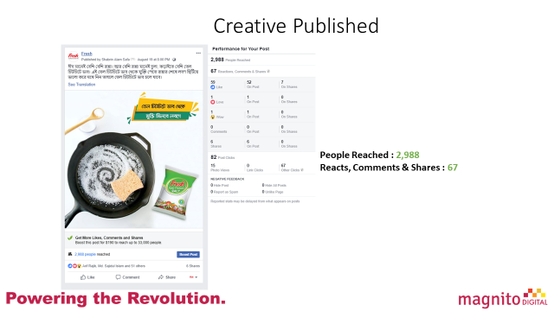

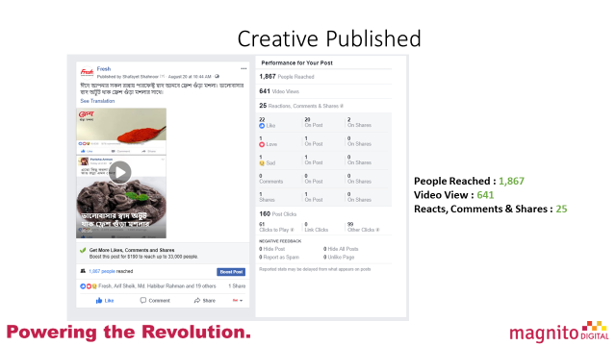

Data Analyzing
At the end of the report, we analyze some data and compare with each other like:
- Daily New Likes Vs Daily Unlikes: Here we compare how many people like the page and how mane withdraw their like. It can be also increased or decreased. It depends on the works of the page.
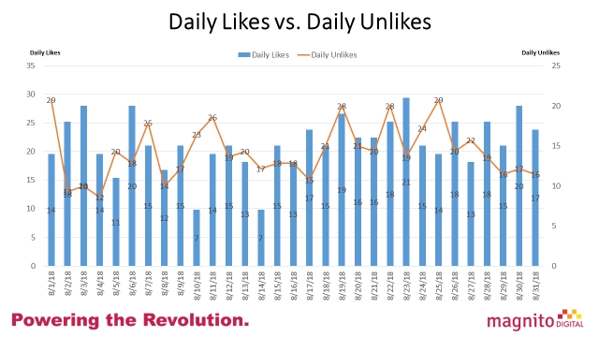
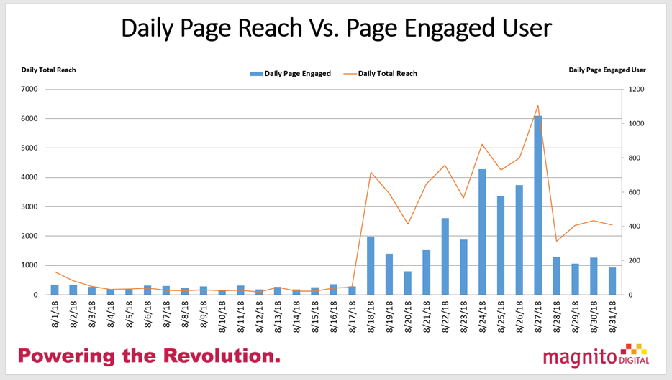
- Daily Page Engaged Vs Daily Reach: It describe how many people actually watching any post and how many people liking or commenting on that post. The number of page engaged can be increased if the post is engaging posts.

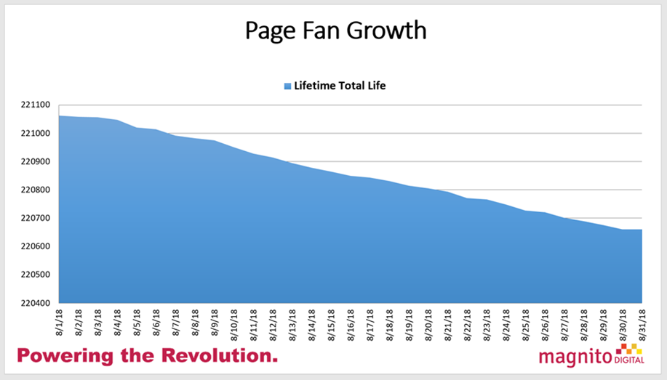
- Page Fan Growth: It describe the amount of new likes in a month

- Daily Organic Reach Vs Daily Paid Reach: Here, we describe the organic reach and paid reach. If any post is boosted then after boosting, how many people the post is reaching and without, boosting how many people can watch the post,
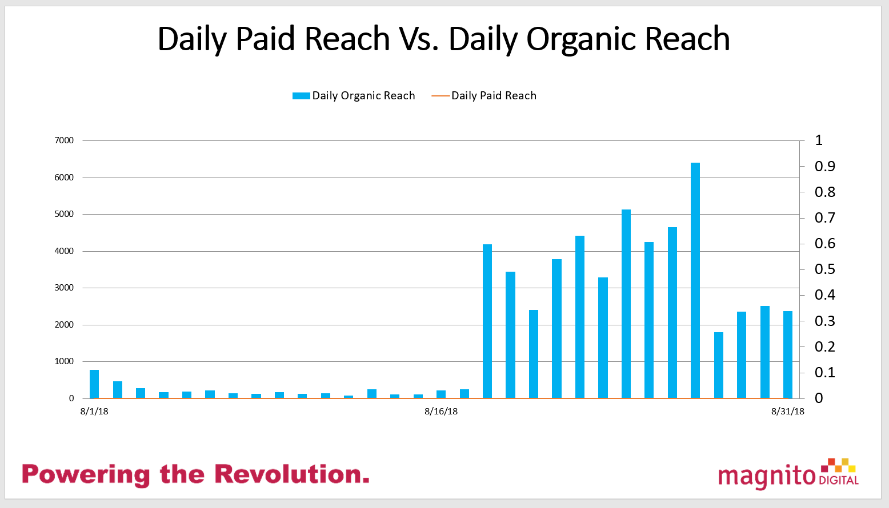

Content Department

This is very important part of Magnito Digital. It talks about all brands. It gives life to the brands. This department gives content for each brands, copywriting, and caption all done by this department. On the other hand, a main responsibility of community response team is providing information to the customers, answering different quires of customers which have been asked through Facebook pages.

Supervisor:
Jannatul Islam Shikha
Content Manager

Me

There works I have done during my internship in client service department. Apart from this I have also worked with content team. Where I worked with copy, captions, content etc.
Here are some samples of the content that I have made for Fresh Drinking Water:
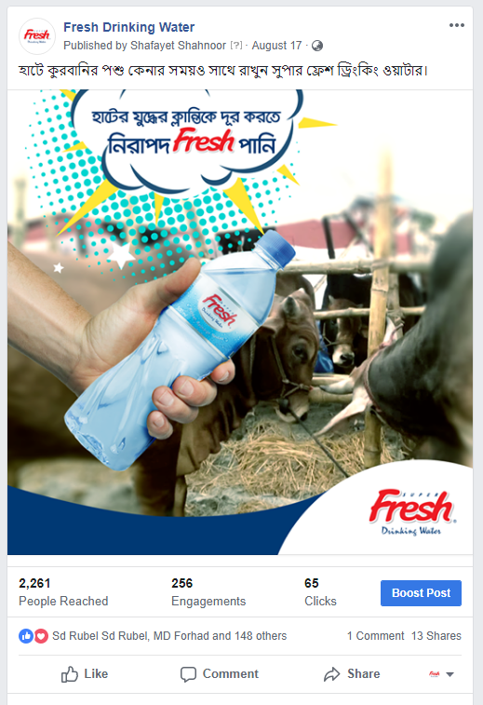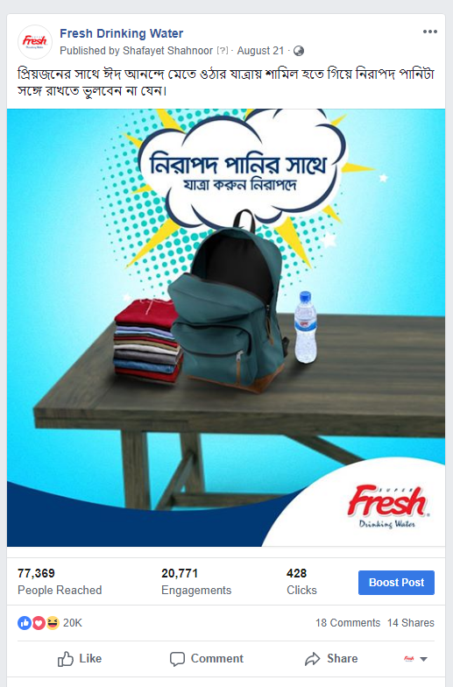

Designing for GP Wowbox

About GP Wowbox

WowBox is the number one lifestyle application of the Country which can be browsed for free without any data charge. Moreover WowBox offers 20 MB free for its users every week. In addition to browsing the full range of content offered in the app: including daily news updates, lifestyle tips, games, sports, horoscopes, jokes and competitions - you can earn tokens (which are reward points) that you can use to purchase internet offers

Comic Design and Coloring for Wowbox

There are a number of comics that are publish through the wowbox app and I have the privilege to draw and paint and design characters for the chapters / episodes of these comics.

Here is a sample of the episode I have done for the app and for a Facebook post –

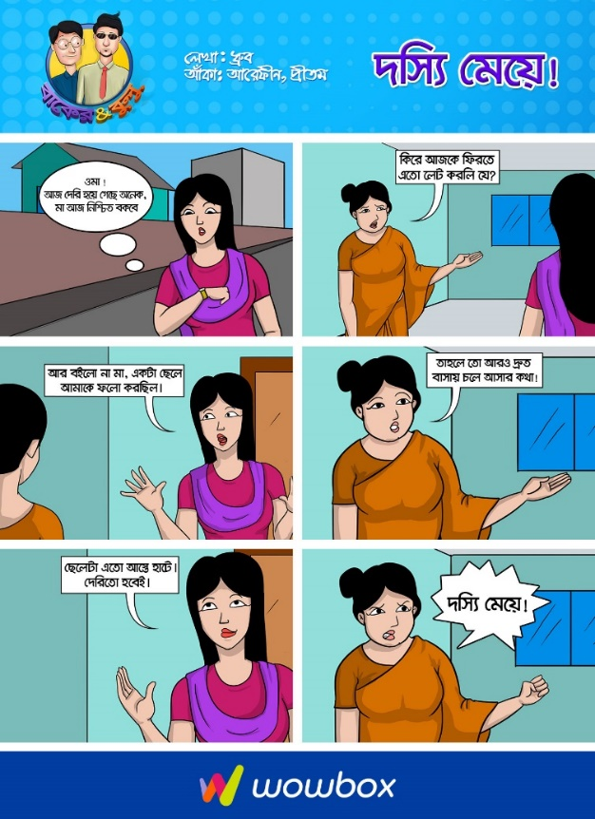

Limitations Faced
Though we try to give our best, there are some limitations in every job. There are also some limitations-

- Deadline meet: In every work there is a deadline. Sometimes it is tough to finish the work in deadline specially if there is any occasion like Eid or any world cup or campaign.

- Understanding the brief: Sometimes there are some communication gap for that client service executives don’t understand the brief. As digital advertising depends on imagination, Sometimes client imagine something but failed to explain it then the problems occurs.

- Opinion: Sometimes client service executives cannot provide their opinion to the clients. It makes problems.

- Brain storming: Sometimes brain storming gives us better ideas but because of shortage time we don’t get that much time.

Work limitation: We face work limitations. As we want to do something but there are limitations from the client. That creates problem for us.

Environment of Magnito Digital
As indicated by widely acclaimed clinician Frederick Herzberg, working condition of an association has a noteworthy impact in representative's activity fulfillment. A positive, community oriented, imaginative workplace is the thing that holds representatives over the long haul, and inspires them to work more enthusiastically. A standout amongst the best highlights of Magnito Digital is its workplace. The workplace of Magnito Digital is essentially extraordinary.

Assessment of organizational culture
In the corporate world, nobody can accomplish his/her ideal accomplishment without having a sound connection with unrivaled and colleagues', and a similar thing is appropriate for an understudy. Being an understudy, I have constantly attempted my dimension best to keep up a sound connection with my chiefs and associates'. In Magnito, the working climate was nice to the point that each time at whatever point I confronted any kind of challenges or issues right away they bailed me out from that circumstance. Remarkably, all individuals from the division helped each other to make the more noteworthy authoritative progress. They were profoundly proficient, reliable, and devoted regarding their everyday movement. As an assistant, I have likewise endeavored to demonstrate my polished methodology, timeliness, and commitment towards the work. At whatever point I needed to speak with any representative of the division, I have dependably pursued the expert method for correspondence. Every one of the representatives of the office are exceptionally proficient with regards to carry out their responsibilities. Then again, when anybody required help, they were dependably there to help one another. From the principal day, at whatever point I had any inconvenience in understanding anything, which I should concede that it happened a ton on my underlying long stretches of entry level position, every one of the division's associates' had helped me all around they could. The vast majority of the things I may have learnt in my entry level position involvement, the credit for that goes specifically to my boss. He has helped me massively amid my entry level position days. He, as well as alternate associates have additionally been extremely useful and never said no when I required their assistance.

Assessment of works done & behavior of co-workers’
On top of that, all the employees of Magnito are very friendly in nature. At first I was little worried that how I would work with so many people who are older than me and because of that reason I was a bit stiff in my starting days of internship. But within the first week my colleagues eased me up. And within no time I felt part of the huge Magnito family. We often used to have lunch together and also hanged out after the office hours. The treatment I got from them was very much appreciated.
The people within the department used to make the department very lively. Starting from the boss to the other employees, everyone used to make jokes and share incidents which used to make the place much more alive than the other departments. The physical environment too was excellent. Each department had multiple cubicles with PC for their employees. With sufficient lighting and fully air conditioned department makes the working environment much more pleasant. After judging all the factors, I had to admit, the working environment is excellent at Magnito Digital.

Difference between Expectation and Experience

There was a gap between my desires and what I have encountered in my temporary position program. As an understudy of Marketing, it was my fantasy to seek after my temporary job on that specific zone where I can demonstrate a portion of my investigative abilities of critical thinking and assemble some thought regarding venture administration procedures and when I have begun my entry level position program in an advertising organization, I have discovered a few contrasts:

- Academic Theories vs. Real Life Implementation: Scholarly taking in is especially not quite the same as experiential learning. Amid my class time, we have just taken in the hypotheses and the terms identified with the fields. Nonetheless, in down to earth, it is important to be inventive and being refreshed with the data about the business, you are working in. Showcasing courses were in a perfect world of incredible help to me. These Courses helped me a ton, as I procured the essentials of Microsoft Excel amid the Marketing Projects. Be that as it may, I figure our courses ought to be more commonsense based as opposed to hypothesis based.
- Don’t Work Hard, Work Smart: At first I thought working harder, quicker, and rapidly is the key in an association. Nevertheless, from my experience, I found that it was not the situation. Working astutely is the way to improve the situation. Working quicker and snappier than every other person is not the perfect arrangement here. Alternatively, maybe from my experience, I think working with full coordination of asset and cooperation takes the necessary steps legitimately while keeping every other person upbeat. At the point when distinctive individuals are included, the work is done effortlessly with less exertion. It is like gathering works in my college life. What is more, on the off chance that you work quicker, it will work in your favorable position however; it can likewise make an impediment. The burden was that in the event that you work quicker than it will raise one's desire. Hence, an individual ought not to endeavor to beat others mercilessly by giving their full 100%; rather s/he should work superior to anything other ought to by cooperating. It will likewise decrease the contention among colleague.
- Formal vs. Informal Work Life: One exceptionally striking key point is that, I was expecting that in the association, everybody ought to dependably wear formal dress, talk formally, and function as hard as would be prudent. Nevertheless, I found from my experience that convention is required in a few circumstances yet we ought to be more easygoing. Easygoing dresses and easygoing conduct were invited progressively and a strict office hour was occasionally kept up. In Team360 Digital, working hour is 11.00am-8:00pm. The greater part of the occasions, some of the time my colleagues would remain at office until 9pm or 10pm and finish their work before going home. Now and again, it would stretch to in excess of 10 pm. Therefore, it was very adaptable and inverse to my desires. We just expected to utilize convention in some particular cases. Everybody is enabled to do his or her work openly here. Working under various pioneer and division likewise conveys an incentive to work and it thus enhances the profession.
- Importance of Job Experience: What I comprehended while doing this temporary position program was involvement in employment is significantly more important than scholastic information. There were numerous choices taken just dependent on experience. There were times when I saw the investigators were not giving requests for creation despite the fact that the customers had great bank explanation and pledges. Those choices were made simply because of past learning and experience, which can't be instructed by anybody. Through this entry level position understanding, I have discovered that genuine experience and scholarly learning are not constantly comparable. Genuine circumstances are unquestionably down to earth and touchy to various variables, and these circumstances as often as possible are alterable. In any case, scholastic learning can be extremely useful in managing genuine issues and can give us a legitimate rule.
Subsequently, it tends to be said that genuine experience and scholastic information are not comparative dependably. Genuine circumstances are undeniably down to earth and delicate to various elements and these circumstances much of the time changes. Be that as it may, in the event that we shape our scholarly learning as indicated by the necessities of genuine application, this scholastic information can be extremely useful in managing genuine issues and can give us a rule as I was helped over the span of my temporary position program.

Influence of Internship on My Future Career Plan
As I have done my major in Marketing, I generally had a fantasy to see myself working at an industry that has gigantic development prospect. Working in a promoting office was likewise a plausibility for me and subsequent to working here for most recent couple of months, I should state, I see myself working in this part significantly more. I have heard numerous individuals saying that these employments are low development work et cetera. Be that as it may, in my experience I think it is a fun employment in the event that we work in a decent situation and with ideal individuals. I got only that in my temporary job at Magnito Digital.

Motivational variables I have perceived how mindful and timely representatives are with regards to serve their prospects. Taking care of business dependably gets most extreme need. Everybody dependably put spotlight on meeting their due date of submitting and finishing an occupation. And yet, there is a cordial domain and everybody is helping one another. This workplace dependably alleviates a man and they feel that they have a place there and they are not pariahs which occurred with me too.

This entry level position method has influenced me to understand that I have a place in this sort of workplace and I may consider this later on and I may assemble my profession in this part. Albeit future is dubious and nobody recognizes what will occur later on. I may wind up elsewhere however I might particularly want to see myself filling in as a worker later on. I adored the liberality with which my partners guided me all through my voyage. They continually persuaded me and showed me diverse things about working in this area. I additionally enjoyed that there is dependably a levels of leadership in the association and each choice pursues a similar rule and is managed most extreme consideration. At whatever point I had any inconvenience, my manager and different associates dependably aided and I knew they will dependably give me right direction. This temporary position has unquestionably given me a rude awakening. This activity may not be that simple, once in a while it very well may be somewhat extreme however the experience somebody gets by working in such an industry is unquestionably worth the durability of the activity somebody needs to experience. Regardless of whether colleagues are useful and well disposed, that torment and sturdiness of the activity will rapidly blur away as I have encountered with myself.

Recommendation

Critical Observation with Recommendation

Recommendation how they can increase client satisfaction
According to the analysis and findings, there are some recommendation for the client satisfaction based on the study-
- Digital Marketing Agencies should do something that can make the female entrepreneurs encouraged to use digital media, which may increase the number of female entrepreneur base in Bangladesh.
- Those businesses that are still thinking of doing only conventional marketing should start investing in digital media and make their communications more effective.
- Whoever doing businesses especially online shopping related businesses should take some important measures to make client information secure and give a good customer experience. Client’s Privacy and customer experience should be the concern of all agencies.
- Digital marketing communication is less costly than any other media but content management in digital marketing communication is very important. So agencies should give more emphasize on content management and integrate that with conventional media and invest effectively both in digital and conventional media.
- According to a research by Nielsen, the reason of brands failing today is low budget allocated for digital media communications; digital media communication gets on an average only 1.2 % of the total communication and promotion budget. Therefore, brands should go digital and increase the digital marketing communication budget.

Here are some guideline for B2B

Figure 1- DISPLAY – GOOGLE DISPLAY NETWORK

Figure 2- PAY-PER-CLICK – GOOGLE ADWORDS

Figure 3- Website streamlining (On location streamlining – Optimizing watchwords)

Give away | Collaboration | Background Work | Content For Media | Other Content Ideas
•Create free instruments  •Conduct free online courses and post documented duplicates online •Create sharable layouts  •Give away free preliminary and sneak looks of your items •Sponsor or turn into a speaker at an occasion  •Create and distribute valuable asset list | •Send out joint official statement when fuse with different organizations •Partner with organizations in a similar industry  •Create co-advertising organization •Befriend with different website admins, all things considered  •Do master gatherings to manufacture connectio | •Consistently keep up blog with awesome substance  •Link to different online journals on your blog  •Search and screen notices of your image •Search and screen inbound connections of your rivals  •Install social sharing gadgets in your presents •Volunteer on be the subject of a contextual investigation | •Write official statement about energizing organization news •Making visitor blog entries for media outlets  •Do media outreach when you have huge news  •Set up press demands alarms and search for chances to send | •Write presents relating on news •Write contextual investigations about your most striking clients •Administer reviews  •Write book audits  •Make infographics and other type of visual substance  •Make Slide Share introductions •Make interesting substance on occasion •Ask for surveys
Figure 4- Site design improvement (On location streamlining – Optimizing watchwords)

• Either increment mark mindfulness, Increase achieve, Increase site activity or Increase lead age.
• Single Image, Single Video, Carousel or Slideshow.
• Canva is a valuable apparatus to make visual substance.
• Base on area, socioeconomics, interests, conduct and associations.
Figure 5- Facebook – Facebook Advertising

Figure 6- Twitter – Twitter Advertising

Figure 7- EMAIL MARKETING

Figure 8- LinkedIn – Grow network on LinkedIn

Conclusion

In the wake of finishing my temporary position program at Magnito Digital, it was my acknowledgment that I was so blessed to be a piece of one of the main promoting organization of Bangladesh. Filling in as an understudy and being a piece of the Magnito Digital family was an amazing privilege for me. In addition, the information I have procured from such association will dependably be an exercise for me. I trust that such temporary job preparing will assist me with furnishing my future profession. All the learning in Magnito Digital amid my entry-level position would surely advance my resume and increase the value of my aptitudes with the goal that I can seek after my profession in any industry. Composing this experience report has helped me find my abilities, and inadequacies. It helped me to center in my inadequacies and take in more exercises so I can reinforce my aptitudes and learning. All the gaining from substance branch of the Magnito Digital has given me top to bottom learning about the how business is led in this part. Amid this time, I confronted a couple of detours, yet I have figured out how to defeat them by sorting out my works and limiting oversights in transit. Temporary job residency at Magnito Digital has conveyed what I anticipated. I accomplished everything, which I anticipated that would, and the temporary position made my experience something other than the standard scholastics.

Bibliography
(n.d.). Retrieved from https://medium.com/: https://medium.com/@shufemedia/importance-of-digital-marketing-in-todays-scenario-eecbef3ce481?fbclid=IwAR0e5c1ZxFWQ3BSfZPFkhy1YonePVsW98VyuJAS1Uo2TwbySpusau8UBU4A
Belch, G. E. (n.d.). advertising and Promotion : An Ibtregrated Marketing Communication Perspective (10th ed.). USA: McGrew-Hill Education .
Bui, V. (2018). Digital marketing guide for B2B start-up Case Circology.
Digital marketing guide for B2B start-up. (2018). Retrieved from http://www.theseus.fi/bitstream/handle/10024/141690/Thesis_VietBui_Publication.pdf?sequence=1&isAllowed=y
firstrank. (n.d.). Retrieved from https://www.firstrank.co.uk/: https://www.firstrank.co.uk/importance-of-digital-marketing-in-todays-scenario/?fbclid=IwAR0xF-gM9-uNu87znDPKv0sq0hLwFCdH6UY-Icd9GsgP-9XCeb9XGB7ci1g
Hasan, M. F. (2016). Internship Report (BUS400) On Roles of Digital Marketing Communications over Conventional Marketing: A Perspective on Ogilvy & Mather Communications (Pvt.) Ltd . Dhaka.
Hasan, M. F. (2016). Internship Report (BUS400) Roles of Digital Marketing Communications over Conventional Marketing: A Perspective on Ogilvy & Mather Communications (Pvt.) Ltd. Retrieved from http://dspace.bracu.ac.bd/xmlui/bitstream/handle/10361/6175/12104035_BBA.pdf?sequence=1&isAllowed=y
keller, K. L. (2012). Strategic Brand Management : Building,Measuring & Managing Brand Equity (4th Global Edition ed.). New-Jarsey: Prentice-Hall Inc.
Leon G. Schiffman, L. L. (2017-2018). Consumar Behavior. (10th ed.). Pearson.
Magnito Digital. (n.d.). Retrieved from http://magnitodigital.com/.
Shammi, S. S. (2015). “HOW AGENCY WORK TALE BEHIND A BRIEF”. Retrieved from http://dspace.bracu.ac.bd/xmlui/bitstream/handle/10361/4547/11304084.pdf?sequence=1
Shammi, S. S. (2015). A REPORT ON “HOW AGENCY WORK TALE BEHIND A BRIEF”. Dhaka.
smartinsights. (n.d.). Retrieved from https://www.smartinsights.com/: https://www.smartinsights.com/digital-marketing-strategy/online-marketing-mix/definitions-of-emarketing-vs-internet-vs-digital-marketing/?fbclid=IwAR1Wbc120ZHNuzyOyz3GOs0QP9fnH6ZwzYaCtSKCAmXrptBT3bmhcP1zB68
Spire . (n.d.). Retrieved from http://www.asim.rankmeup.in/: http://www.asim.rankmeup.in/blog/importance-of-digital-marketing/?fbclid=IwAR2DHMsNndOjz84hnkZf_6AFnhacbLNIp0ebxG-Qe-CFgAWpw5MlQrL0HjU

