Internship Report

On

“Strategic Human Resource Management for Competitive Advantage on the Perspective of the City Bank Ltd”

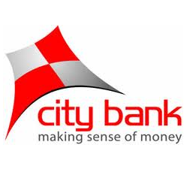


“A Report on the Strategic Human Resource Management for Competitive Advantage on the Perspective of the City Bank Ltd”

Submitted to
Prof. Dr. Abu Saleh Md. Sohel-Uz-Zaman
Professor

Submitted by
Israt Sultana Mim
ID: 111 141 317

Date of Submission: 21-05-2018


Letter of Transmittal

April 30, 2018

To
Prof. Dr. Abu Saleh Md. Sohel-Uz-Zaman
Professor
United International University
Subject: Submission of Internship Report.
Dear Sir,
I’m glad to submit the internship report on the topic you’ve assigned me which is “Strategic Human Resource Management for Competitive Advantage on the Perspective of the City Bank Ltd”. While preparing this report I tried my level best to follow your and my organization’s supervisor’s instructions.
The entire report is based on the practical knowledge I have gained from my 3 months of internship program while working in the City Bank Ltd, VIP Road Branch. The knowledge I’ve gained from here will add a huge advantage to my career.
It would be highly grateful if you kindly receive this report and I will be pleased to answer to any of your queries regarding this report.
Thanking You
Sincerely
Israt Sultana Mim

Acknowledgment

My three months of internship program would always be one of the best experience of my life. First of all I would like to thanks the City Bank Ltd for giving me this wonderful opportunity to work in their organization which helped me a lot to understand the real corporate world. I must also express my deep gratitude to my University Professor Dr. Abu Saleh Md. Sohel-Uz-Zaman Sir, for his kind guidance and instructions to conduct my internship report successfully. His continuous help and support was really helpful.
This internship program helped me a lot to learn about the corporate world and office environment which increased my confidence level as well. I would like to thank my seniors from the City Bank Ltd who continuously helped me to learn about general banking. Without their help it would be very difficult to learn any practical knowledge and prepare this report. I am thankful to all of them.
Executive Summery

Strategic human resource management is the key factor to the development of an organization. Human resource is the trigger machine for any organization. To understand strategic human resource management we have to understand the concept the human resource management. We will discuss how the human resource helps the City Bank Ltd in achieving its desired goals and competitive advantage.
The City Bank Ltd is one of the top commercial banks of Bangladesh which established in 1983. Their first branch was at B.B. Avenue Branch in Dhaka. The City Bank Limited has both local and international shareholders. The City Bank always try to provide ‘best-in-the-class’ services to its customers. They are always concerned about recruiting the best employees to provide the best service to their customers. They also started giving their customers 24 hours customer care service. Today City Bank is the fastest growing bank in the country and they also got the Best Bank Award in Bangladesh in global financing. They always look for enthusiastic, hardworking and impressive employees for running their operation. This report is the outcome of my practical experience during my internship at The City Bank Limited.
Table of Content
Topic Name | Page Number
Chapter 1: Introduction
1.01Origin of the Report | 2
1.02 Research Objectives of the Report | 2
1.03 Methodology of the Report | 3
1.04Limitation of the Report | 3
Chapter 2:
2.01 Company Overview | 6-7
2.02 Human resource of the City Bank Ltd | 8-11
Chapter 3: Literature Review | 13-18
Chapter 4: Human Resource Practice at the City Bank Ltd and Their Contribution to Success | 20-27
Chapter 5:
5.01 SWOT Analysis of the City Bank Ltd | 29-30
5.02 Findings of the Study | 31-32
5.03 Recommendation | 33-34
Chapter 6:
6.01 Conclusion | 36
6.02 References | 37
6.03 Appendix | 38

Chapter 1

Introduction
1.01 Origin of the Report
This report is the practical outcome of my three months of internship program at the City Bank Ltd which is the requirement of the BBA program. My honorable supervisor advised me to a report on the strategic human resource management of the City Bank Ltd.
I hope this report will provide a clear idea about the human resource management of the City Bank Ltd. I commenced internship on January 18, 2018 and completed the 12 weeks of internship period. My organizational supervisor was Gazi Azizul Hoque, Branch Manager of the City Bank Ltd, VIP Road Branch.

1.02 Research Objectives
The main purpose of this report is to find out how the human resource team can help an organization to reach its peak level of success, to gain the competitive advantage. The City Bank Ltd is one of the leading banks of Bangladesh and they have a broad area of HR division. The City Bank Ltd has achieved the Best Bank award in Bangladesh by Global Finance. And it is so obvious that the main credit goes to its employees and their management. The main objective is to analyze the HR team and how they are contributing in making this bank as the number one bank. The other objectives are:
- Analyzing the HR strategies, policies, processes, programs and practices.
- How the HR team adopt strategic approach on their day-to-day basis.
- How HR team supports to achieve the business strategies on a continuous basis.
- Analyzing the employee work and reward systems.
- Analyzing the corporate social responsibilities

1.03 Research Methodology
Both primary and secondary data have been used to collect information for the report.
Primary Data
I have collected primary data from discussions with employees and customers. I’ve done face to face discussions with the employees of The City Bank VIP Road Branch to know about their feelings and satisfaction toward their job. I also provided questionnaires to the customers to know about their experience about the service they have been provide. The surveys are enclosed with the report.
Secondary Data
Secondary data have been collected from the annual report of The City Bank Ltd, from online articles and websites, periodical statements of the bank, booklets etc, documentary file of the City Bank Ltd, training materials and some related books such as, “Strategic Human Resource Management”- Michael Armstrong, “Human Resource Management”- Gary Dessler etc.

1.04 Limitations of the Report
- Complexity in gaining information as the human resource department is the most confidential department for any organization and as an intern I was allowed to get limited information for my study.
- Lack of adequate practical knowledge about their HR department. Because although I was recruited by the HR department of the City Bank Ltd, I got very less chance to work with the human resource department. Mainly I was worked with the Service Quality Department.
- In some cases, up-to-date information is not published.
- Time limitation was a major constraints in this report because three months is not so sufficient to learn about an organization’s human resource department.

- Unavailability of sufficient documents required to make the report.
- It’s the bank’s policy not to disclose many confidential information for many reason.

Chapter 2
2.01 Organizational Overview
The City Bank Ltd is one of the leading private bank in Bangladesh. It is one of the oldest private Commercial banks in the country which started their operations in 1983. Mr, Mohammed Shoeb is the current Chairperson of City Bank Ltd. According to the Chairperson, “our dedication and commitment enabled us to look at banking in an innovative way and do things differently”. Its first branch was at B.B. Avenue Branch in Dhaka city. The journey started with the visionary entrepreneurship of 13 local businessmen who took the risk of investing Taka 3.4 crore of capital with immense uncertainty. That 3.4 crore Taka is now a respectable 2311.78 crore as capital. The support of their shareholders is the key factor which helps them to being the number one bank. City bank do not follow any traditional, decentralized branch based on business or profit model. The bank manages its operation from the head office through 5 different units. Those business units are as follows:
- Business Unit
- Branch Banking
- Risk Unit
- Operations Unit
- Support

Such centralized banking system ensures best treatment and services to the bank’s different customer segments.
The City Bank currently operates total 120 branches in the country. They also have an Islamic Banking Branch ‘City Manarah’. City Manarah helps to guide a customer in a fully Islamic Shariah Compliant way. It offers verities of investment and deposit products which are as follows:
- Manarah Savings
- Manarah Current
- Manarah Term Deposit
- Manarah Monthly Deposit Schemes
City bank is also operating 1 SME service center and 11 SME branches across the country. This bank also has 311 ATMs of its own and more than 1150 ATMs with partnership with others. This bank also provides SMS Banking, Internet Banking and Customer Call Center service. Recently City Bank also introduced CityTouch banking system through which customers can operate the banking functions without going to the branches. It’s a hassle free system. City Bank also launched Citymaxx American Express card. It’s a unique card linked to customer’ Savings Account which gives 5% Cashback all year round. According to the official website of City Bank, their Vision, Mission and Values are as follows:

Vision
“The Financial Supermarket with a Winning Culture Offering Enjoyable Experiences”.

Mission
- Offer wide array of products and services that differentiate and excite all customer segments.
- Be the “Employer of choice” by offering an environment where people excel and leaders are created.
- Continuously challenge processes and platforms to enhance effectiveness and efficiency.
- Promote innovation and automation with a view to guaranteeing and enhancing excellence in service.
- Ensure respect for community, good governance and compliance in everything we do.
Values
- Result Driven
- Accountable & Transparent
- Courageous & Respectful
- Engaged & Inspired
- Focused on Customer Delight

2.02 Human Resource of the City Bank Limited:

Regular employee
The regular employees are also knows as permanent employees. They get bonus, incentives and other festival bonuses along with their salary.
Contractual Stuff
The contractual employees are not entitled to any kind of service agreement. They are recruited through outsource agencies and their job will be confirmed by the Division Head of HR.
Intern
The City Bank also provide paid internship opportunity to the fresh graduated students for the development of their career. This program is of 3 months and students can gain practical knowledge about the job field.
Management Trainee Officer (MTO)
Management Trainee Officers highly qualified students of The City Bank Limited. The MTO’s are regular employee but they have to learn as a student inside BRAB Bank for the period of one year. After one year if they can complete their learning period successfully they will become a senior officer directly from the MTO.
Management Team
Management team of THE CITY Bank includes the following positions and each position contains one member.
- Managing Director & CEO
- Deputy Managing Director
- Chief Information Officer
- Head of Credit
- Company Secretary & Head of Regulatory & Internal Control
- Head of Probashi Banking
- Head of Human Resource Management
- Head of Treasury & Financial Institution
- Head of Marketing & Corporate Affairs
- Head of Corporate Banking
- Head of Impaired Asset Management
- Head of Enterprise Risk Management
- Chief Financial Officer
- Head of Technology
- Head of Retail Banking

Figure 1: Organogram of City Bank Limited
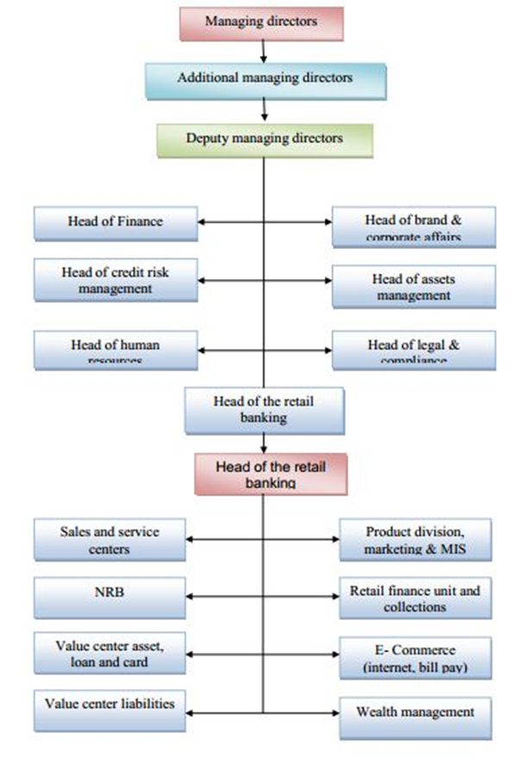

Source: Annual Report of the City Bank Ltd

Figure 2: Management Hierarchy of the City Bank Ltd

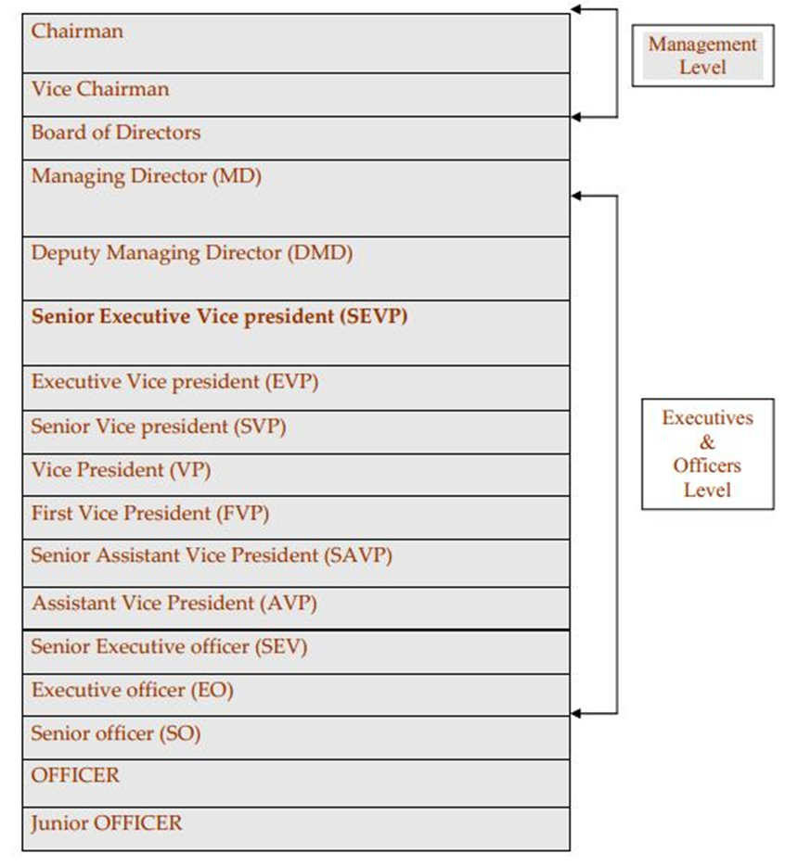
Source: Annual Report of the City Bank Ltd

Chapter 3

Literature Review
The ultimate success of an organization lies in its human resource. The better management of human resource will to ultimate success of the organization. According to the author “Human resource management is defined as a strategic and coherent approach to the management of an organization’s most valued assets – the people working there, who individually and collectively contribute to the achievement of its objectives”.
CONCEPTS OF STRATEGIC HRM
The concept of strategic HRM is supported by three concepts:
- Resource based view
- Strategic fit
- Strategic flexibility
Resource based view
The philosophy of HRM is largely based on the resource based view. This concept states that the human resources of an organization produce unique characteristics and creates competitive advantage. The resource based view builds a whole framework for the field of strategic human resource management. Competitive advantage arises when firms are diverse with respect to the strategic resources they control and these resources are not moving across the firm. Sustained competitive advantage depends on the unique resources and capabilities a firm brings to competition in its environment. These resources include the experience, knowledge, risk taking tendency of the firm. To create sustained competitive advantage, a firm’s resource should have four attributes:
- Valuable
- Rare
- Imperfectly imitable
- Non-substitutable

Strategic fit
According to Wright and McMahan strategic fit refers to the two dimensions that differentiate strategic HRM: ‘First, vertically, it entails the linking of human resource management practices with the strategic management processes of the organization. Second, horizontally, it emphasizes the coordination or congruence among the various human resource management practices.’
Strategic flexibility
Strategic flexibility is the firm’s ability to respond to continuously changing environment and adapt to changes in its competitive environment. Predictable environment could be developing people with a narrow range of skills but in a dynamic and unpredictable environment the human resource can possess a wide range of skills and they can engage in a wide variety of ‘behavioral scripts’.
The Matching model of HRM
Michigan School made one of the first statements of the HRM concept. According to them HR functions and organizational functions should be merged in a compatible way. That’s why the name of this model is Matching Model. They also described that there is a human resource cycle which is consist of four function which are:
- Selection
- Appraisal
- Rewards
- Development
The Harvard framework
The Harvard framework is based on the belief that the problems lies in the historical personnel management can be solved when a viewpoint is developed by the general managers and how they want to see the employees involved in the organization and what HRM practices can help to achieve these goals.
According to this model HRM had two features:
- Line managers possess more responsibilities to achieve the competitive strategy.
- Personnel is involved in setting policies that determines how personnel activities and developed and implemented.

HUMAN RESOURCE SYSTEMS
- HR philosophies, describes the values and principles to guide people.
- HR strategies are the overall guidelines and directions.
- HR policies, helps to implement these values, principals and guidelines.
- HR processes are the formal procedures to implement the strategic plans.
- HR practices are the informal procedures to manage people.
- HR programs helps to implement the HR policies and strategies according to the executed plan.

AIMS OF HRM
The ultimate aim of HRM is to achieve the organizational success through people.
According to Ulrich and Lake ‘HRM systems can be the source of organizational capabilities that allow firms to learn and capitalize on new opportunities.’

The conceptual framework of strategic HRM
- Commitment oriented
- Human capital should be treated as assets.
- Strategic HRM is a management driven activity
- Focuses on business and social values.

STRATEGIC HRM DEFINED
Strategic HRM is the process of achieving organizational goals by attracting, developing, rewarding and retaining human resource.

BASIS OF STRATEGIC HRM
Strategic HRM is based on three propositions:
1. The human resources play a major role in bringing competitive advantage for the company.
2. HR strategies should not veer away from the business plans.
3. Individual HR strategies should be linked to each other to provide mutual support.

PRACTICAL IMPLICATIONS OF STRATEGIC HRM THEORY
The HR theory addresses major people issues that are affected by the strategic practices of the organization.
- Sustained competitive advantage can be achieved by bringing unique resources and methodology than other competitors.
- Competitive advantage can be achieved when the organization has more competitive human resource than its competitors.
- Competitive advantage depends on how effectively an organization can manage its employees.
- Improved performance can be achieved by bringing together the HR practices so that the complement each other.
SPECIFIC HR STRATEGIES
Specific HR strategies set out what the organization intends to do in areas such as:
- Human capital management- the process of analyzing and reporting data to analyze strategic and operational decisions.
- High performance management means developing and implementing high performance work environment.
- Corporate social reasonability means to manage the business in an environment friendly way to create a positive impact on the society.
- Organizational development means to plan and implement organizational programs in an effective way.
- Engagement- the development of organizational policies to increase the level of employee’s engagement toward the organization.
- Knowledge management means to create, share and use knowledge to enhance learning for the overall development.
- Resourcing- attracting and recruiting high quality employees.
- Talent management mean how to manage the human resource to achieve the business goals.
- Learning and development- creating an environment where employees can learn continuously and develop themselves.
- Reward- rewarding the deserving employees who achieve the business goals and meet the need of its stakeholders.
According to the Chief executive, Peabody Trust, ‘A good strategy is one which actually makes people feel valued. It makes them knowledgeable about the organization and makes them feel clear about where they sit as a group, or team, or individual. It must show them how what they do either together or individually fits into that strategy. Importantly, it should indicate how people are going to be rewarded for their contribution and how they might be developed and grow in the organization.’
An organization can follow the ‘Best Practice ‘approach which will provide them superior organizational performance. The organization can achieve it in the following ways:
- By providing employment security
- High compensation system based on performance
- Training the employees to make them skilled
- Sharing information with the workforce
- Ensuring a flexible job design.
- Communicating with employees.
- Employee Gratuity Fund Policy Formulation

In a nutshell, the most important features of strategic HRM for organizational development are a clear and meaningful business strategy should exist and those strategies should be concerned in the development of organization.

Chapter 4

4.01 HR Practices at the City Bank Ltd and Their Contribution to Success
‘Business objectives are accomplished when human resource practices, procedures and systems are developed and implemented based on organizational needs, that is, when a strategic perspective to human resource management is adopted.’
The aim of City Bank Ltd is improve their overall business performance through their human resource. They are always focused to meet the need of their employees. Employee’s well-being is their major concern.

Figure 3: HR Practices Leading to Competitive Advantage
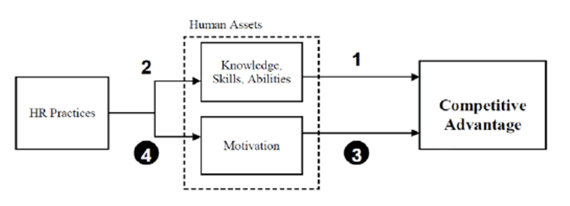
Source: Strategic Human Resource Management- A guide to action- Michael Armstrong, 4th edition
Human resource strategies and practices are always linked to the reinforcement of the firm’s competitive advantage. The City Bank Ltd determines what their desired outcome is. According to this plan they identify and implement essential human resources actions. Their excellent human resource management skill is contributing to the bank’s success. Some of their HR practices are as follows:
- They provide regular training to their employees for their improvement of knowledge, skills and abilities. So that their employees can stay up-to-date and work efficiently.
- Generally there are two approaches followed by the City Bank ltd in strategic human resource management.
- Outside-in approach, which focuses on the business problems arising from the external environment such as industry structure, competition, consumers etc.
- Inside-out approach, this approach is established to overcome problems when outside-in is not able to fulfil the needs and challenges of competition in a dynamic and competitive environment. Strategic human resource management is determined by a firm’s internal capabilities and competencies.
- City Bank review and improve their strategy and human resource policy time to time since there are so many competitors in the same field. It is a continual cycle that needs to be improved periodically.
- They continuously adapt, reformulate their human resource strategies to deal with the environmental changes, strategic fit is the keyword in the process of formulating and implementing strategy. Their strategy fit the contingency factors both in external and internal factors. Strategic fit is the most important part of contingency approach which acts as a bridge between the outside-in and inside-out approach to gain a sustainable competitive advantage.
- To gain dynamic and innovation capabilities, the City Bank pushes its employees to create values through their capabilities to answer to all the challenges in the environment of the firm.
- The human resource practice at the City Bank Ltd is done by the recruitment and selection process, training and development, performance management and compensation system.

Recruitment and Selection of the City Bank Ltd:
The City Bank Ltd employs individuals with appropriate level of competencies and behavior. To deal with rapidly changing environment and to ensure superior performance and competitive advantage, City Bank is always forced to face demand of the flexibility of employees, both internally and externally. They select the best employees to make the best team and to compete with other competitors in the same field.

Training and Development of the City Bank Ltd
According to Hatch and Dyer, “superior learning performance is obtained from the best HR practice and from the best practice to develop specific human capital owned by firm and a sustainable learning activity”.
A firm with and excellent training facility will create positive attitudes among employees and it will eventually increase their organizational commitment. And City Bank in always one step ahead in motivating their employees. Higher innovative performance can be reached when firm provide sustainable training and development facilities to employees to improve their capabilities so that they can perform their duty properly.
City Bank always tries to provide job related training to their employees to make them up-to-date. They have resourceful training institute. Experienced bankers provide training to the employees.
Training program can help and employee to improve his/her skills to perform the job. Customer’s satisfaction depends on the customer’s experience with the products and services. Hence City Bank always trains their employees on how to provide the best service and bring competitive advantage.
Development is also a related process. Development is a process that helps employees to become a better human being. It helps the employees to meet their specific objectives or requirements. Training and development programs are very important to get the best output from their employees. The City Bank Ltd provides the following training for the development of their employee:
- On-the-Job Training
- Off-the-Job Training
- Orientation Training
- In-house Training
- Job specific Training
- Need based local/foreign Training
- Peer or Supervisor’s coaching
- E-learning: Online training and evaluation
They also offer some executive and general courses to their employees. Such as Executive Development Course, Foundation Course for Executive officers, Assistant Executive Officers, Industrial Credit and Project Financing Course, English Language Course and so on. Some computer courses are offered by the bank to make the employees more competitive, such as:
- Basic Computer Training
- Hardware Maintenance, Trouble Shooting & Networking (For Officer)
- User Training on New Salary Software
- Computer Course for Executives (Outside Dhaka)
- Computer Course for Executives (Dhaka-Evening)
- Banking Application Software, LAN and Software Maintenance
- Networking & System Administrating with MS Windows 2000 Server
Course Objectives:
- To strengthen capacity of the participants on over all banking procedure.
- To transform a group of officers’ into efficient bankers.
- To increase resources of the bank to strengthen future capacity.
- To transform trained officers to asset of the bank in commercial running of branches
- To increase profitability through banking by trained staff.
- To enhance human & material resources for achieving the goals of the bank branches
- To create permanent resources in branches of the bank.

Performance management of the City Bank Ltd:
Performance evaluation helps to identity, evaluate and develop employee performance to meet organizational goals. To create the best manpower they periodically review their employee’s performance. Purposes of performance appraisal in the City Bank Ltd are:
- To review past performance
- To assess training needs
- To help develop individuals
- To audit the skills within an organization
- To set targets for future performance
- To identify potential for promotion
- To provide legal and formal justification for employment decision
- To diagnose the hidden problems of an organization

The performance appraisal process is done by:
- Supervisors
- Subordinates
- Peers
- Clients/Customers
- Self-appraisal
- 180/360 degree approach
The City Bank Ltd also take regular exams of their employees to evaluate their employees. An annual audit program is also held every year where the whole year of services is evaluated by the auditors. These all are needed to achieve the organizational goals.

Compensation management of the City Bank Ltd:
Feedback from the performance management works as a reference for the management to make decisions on compensation, career development, individual development training etc. These will result into employee satisfaction, organizational development and achievement of competitive advantage.
Compensation management helps to increase employee motivation, commitment, and work satisfaction and reduces employee turnover. Compensation strategy also helps an organization to control the attitude and behavior of the employees. The City Bank Ltd always focuses in designing and implementing a correct and fair compensation strategy. This ensures employee job satisfaction and commitment which play significant role in improving employee performance inside the firm. Finally the compensation system is expected to motivate employee to do the best for their organization. This will as a result force employees to keep learning and developing their capabilities and forcing the firm to be more innovative and creative. City Bank also made available non-compensation system to their employees:
- Protection in case of health & accident
- Income upon retirement & termination.
- Besides providing good compensation package, City Bank also ensures employee safety, which ensures all kinds of job safety such as insurance of employees, employee health, such as- free medical checkup, health care facilities and so on, employee working condition, providing best working condition for the employees.
Incentives of the City Bank Limited:
The City Bank Ltd also provides individual, group and companywide incentives to their employees to motivate them. It controls costs because the employees are being pain for his/her extra effort and for the benefit brought to the organization.
Individual incentive plans:
- Awards bases on individual Employee Performance vs. company standards
- Awards bases on individual performance standards using objective & subjective criteria
- Monthly sales- How much sales was generated
- Work safety record- How many hazard or errors are being reduced
- Work attendance- If absenteeism is reduced or attendance is good.
Group incentives:
- Official cost savings
- Material cost savings
- Reduction in accidents
- Services cost savings

Company-Wide Incentives:
- Company profits
- Cost containment/prevention
- Market share Sales revenue

Figure 4: Strategic HR Practices at the City Bank Ltd

Chapter 5
5.01 SWOT Analysis of the City Bank Limited:
By SWOT analysis we can come to know about the organization’s strengths, weakness, opportunity and threats. A SWOT analysis helps to determine how an organization can achieve its objectives, how can it overcome their obstacles and what is the future of that organization.
Strengths of the City Bank Ltd
- Capability of management
- According to Baumol and Danneels, in this economic environment, organizations should focus on their product’s innovation ability if the firm wants to keep alive and success. That’s why City bank always focus on the level of competency and dynamic capabilities of their human resource.
- Sufficient capitalization
- Satisfactory profitability
- Rapid growth of business
- Skilled employees
- Good ambience
- Provides satisfactory service
- Best in quality
Weaknesses of the City Bank Ltd
- Entry level employees are not much experienced
- Centralized work system
- Lack of negotiation
- Lack of business communication
Opportunities of the City Bank Ltd
- Opportunity to contribute in national growth rate
- Scope to reduce unemployment percentage
- Opportunity to introduce a new sector
- Opportunity to serve the society
Threats of the City Bank Ltd
- Many other foreign and private banks are doing business in Bangladesh
- Government interruption
- Service of village areas get interrupted by the local village politician.

5.02 Findings of the study:
From the above discussions we can find that City Bank Ltd provides continuous training to their employees and they try to develop their employees and motivate them to get the competitive advantage of being the best bank in country. According to the resource based view they create sustainable competitive advantage by producing valuable, rare products which are very difficult to imitate for their competitors. According to strategic fit they links their human resource management with the strategic management process of the organization and they coordinate among the various human resource management practices. According to strategic flexibility they are very flexible and able to respond to any type of changing environment. According to the Matching Model of HRM they select their employees, evaluation their employee's performance and then they reward and develop their employees. According to the Harvard Framework there are some situational factors at the City Bank Ltd such as workforce character, business strategy, labor markets, laws and social values which influence their stakeholder’s interest. After that they manage the human resource and the human resource becomes more committed and competent which results into long term positive consequences such as individual well-being, organizational and social well-being. According to the conceptual framework of HRM, it helps the City Bank Ltd to get employee productivity, employee commitment through staffing, training, performance, compensation, promotion and empowerment which leads to best organizational performance. The City Bank Ltd also follows the best practice approach of HRM. According to this approach they put poeple first by providing employment security, selective hiring, extensive training, sharing information, by reducing status differentials and paying high to their employees.
In a nutshell, the City Bank Ltd is always aware of bringing the best HRM approach to provide the best service and create superior values. Their human resource plays a major role in bringing the competitive advantage and it consequently helped them to win a lots of awards. And they won the award “Strongest Bank in Bangladesh” award. It became possible because of their best HR policies and practices and for providing the best service to their valued customers.

Figure 4: Strategic Human Resource Practice Process at the City Bank Ltd

5.03 Recommendations:
- The human resource department of the City Bank Ltd should analyze the modern HRM system and apply all the functions properly for the entire development of the organization.
- Standard performance appraisal should be prepared because the success and failure of an organization depend of its human resource. If employees get rewarded for their performance, they can be motivated which will help them to attain the organizational goal and competitive advantage.
- The human resource department should establish standard pay structure to reduce high employee turnover. No doubt City Bank is doing great in this sector though. Their employee turnover rate is very low.
- Some branches should be better decorated and ambience should be more attractive to attract more customers.
- Any kind of biasness regarding performance appraisal should be avoided so that efficient employees can get proper reward for their performance.
- Extra workload of employees should be reduced.
- More incentives and bonus systems will encourage the employees which will eventually help the organization to get sustainable competitive advantage.
- The control of the human resource department should be structured.
- Arranging proper training for the employees. After training evaluation program should be arranged.
- A careful plan of action should be made which will ensure least possible disruption to the person’s responsibilities and to the organization’s effectiveness.
- The human resource planning, recruitment and selection policy of the City Bank Ltd should be more standard.
- City Bank should follow the performance appraisal method more accurately. Because employees often do not get their deserving reward. Employees with same efficiency are given different score by different author.
- The pay structure should be more competitive than other banks operating in Bangladesh.
- In some branches of City Bank, there is lacking of proper employees. Which means “lack of right people in right place”. They should be more concerned about this issue.
- In some branches, service is very slow. This happens when employees are not more focused and motivated toward their work. So City Bank should encourage their employees more so that they feel motivated.
- Often employees feel extra workload which can lead to employee dissatisfaction. As a result banks can loss employee attractiveness.
- The HR division is only contained by the head office and all the HR activities are controlled from the head office. That’s why employees have to wait for a long time to solve any issue when any HR problems arise.
- Training and evaluation systems should be properly used or maintained.
- City Bank should be more focused on succession planning where senior executives periodically review their top executives and those in the next lower level to determine several backups for each senior position.

Chapter 6
6.01 Conclusion:
The City Bank Ltd is the fastest growing bank in Bangladesh which ensures best service to their customers as well as to their employees. The knowledge I have gained by working as an intern at the City Bank Ltd was very helpful and going to be helpful enough in my corporate life.
In this era of huge competition, it becomes very difficult for the companies to survive. There are many alternative options to the customers. If they do not get served properly they can switch to another company. So organizations should develop the best strategic human resource and sustainable competitive advantage. Sustainable competitive advantage is an advantage which competitors cannot easily imitate.
The City Bank Ltd sees its employees as a strategic resource for the achievement of competitive advantage. As Allen and White stated, ‘The central premise of strategic human resource management theory is that successful organizational performance depends on a close fit or alignment between business and human resource strategy.’
The HR strategy should be made to bring changes on a broad front to achieve competitive advantage through the efforts of the people. The biggest challenge for any organization is to maintain their competitive advantage and to do that organizations should maintain and attract high quality people. The key differentiator on anything any company does is fundamentally the people. Sometimes people tend to forget that the most important asset for an organization is the practice of strategic HRM. Money can be held easily but good people cannot be. All they need to do is to train their manpower which is directly linked to business improvement and sustainable competitive advantage.

6.02 References
Strategic Human Resource Management- A guide to action- Michael Armstrong, 4th edition.
www.thecitybank.com
Annual report of The City Bank limited. 2009.
Website – Bangladesh Bank.
Gary Dessler, “Human Resource Management”, Pearson Education, 12th edition.
Wendell French, Human Resource Management, 6th edition.
Ahuja, G. (2000). Collaborative networks, structural holes and innovation: a longitudinal study. Administrative Science Quarterly, Vol. 45, pp. 425-455.
Barney, J.B. 1991. Firm resources and sustained competitive advantage. Journal of Management, 17: 99-120.
Beugelsdijk, S. (2008).Strategic Human Resource Practices and Product Innovation. Organization Studies, 29(06): 821–847
Bhattacharya, M., Gibson, D. E., & Doty, D. H.(2005).The Effects of Flexibility in Employee Skills, Employee Behaviors, and Human Resource Practices on Firm Performance. Journal of Management.
Chan, L. L. M., Shaffer, M. A. &Snape, E. (2004). 'In search of sustained competitive advantage: the impact of organizational culture, competitive strategy and human resource management practices on firm performance', International Journal of Human Resource Management, 15: 17-35.
Michie, J. & Sheehan, M. (2005).Business strategy, human resources, labor market flexibility competitive advantage.
International Journal of Human Resource Management, 16: 445-464.
Rose, R. C., & Kumar, N. (2006). The Influence of Organizational and Human Resource Management Strategies on Performance’, Performance Improvement Journal.
Wernerfelt, B. (1984). A resource based view of the firm. Strategic Management Journal.
6.03 Appendix
Customer Survey Form of the City Bank Ltd
