Internship Report
On
Training and Development Process of Energypac Engineering Company Limited

Submitted to:
Jerin Haque Chhanda
Lecturer
School of Business and Economics
United International University

Submitted by:
Nusrat Sharmin
ID: 111 153 183
School of Business and Economics


Date of Submission: 12-05-2023

Training and Development Process of Energypac Engineering Company Limited



Letter of Transmittal
May 12, 2023
Jerin Haque Chhanda
Lecturer
School of Business and Economics
United International University

Subject: Submission of Internship report on ‘Training and Development Process of Energypac Engineering Company Limited”

Dear Madam,
With due respect, I am presenting my internship report based on the information and experiences I gathered during my internship period at EEL. By using both primary and secondary data, I have tried to analyze the training and development process of EEL. In addition, I have provided some recommendations for the betterment of the training and development program of EEL. With your excellent supervision, I have tried to develop a resourceful and informative internship report. This report helps me to make an alignment between the theoretical knowledge and the practical application of training and development which will help me in my future professional career.
I would like to express my gratitude to you for your patience and support throughout the period. I hope this internship report would be worth reading. I am looking forward to any query or clarification that you would like me to explain. I am hoping that you will consider some minor errors and this internship report would meet your expectation. Cordial thanks once again for your guidance and supervision.

Sincerely yours,

Nusrat Sharmin
ID: 111 153 183
School of Business and Economics
Acknowledgment
First of all, from the deepest part of my heart, I want to thank our Almighty Allah. Without His blessings, I believe that none can achieve anything and I am no different from that. I am grateful for getting His blessings.
Second, I want to expose my gratefulness to my parents and my elder sister. Throughout my life, I get the support from them and during the internship period, they immensely guide and support me. They also support me mentally during this period.
Third, I am also grateful to my supervisor at Energypac Engineering Company Limited. He is Shakil Ahmed, Deputy Manager of the HR department. He was supportive and friendly enough that helped me to gather different information about the training and development process of EEL. His cordial support also helped me to gain some practical corporate knowledge.
Forth, before thanking this person, I can express one thing that I am very lucky enough to have this faculty member as my internship supervisor. I don’t think any other faculty would be more supportive, kind, generous, and caring to me. With the help of her time-to-time guidance, I have completed my report successfully. The person I am talking about is none other than, my honorable supervisor, Jerin Haque Chhanda. I will be grateful to her forever.

Executive Summary
Talented employees are one of the most important resources for any company. Whether a company will sustain long-term success that depends on the skills, knowledge, efficiency, and productivity of its employees. Thus, companies need to provide Training and Development (T&D) to the employees to improve their job-related competencies. The main objective of this report is to analyze the training and development process of Energypac Engineering Limited Company (EEL). The report also intended to evaluate the different applications of On-the-Job and Off-the-Job training used by EEL and their outcomes after the training session. It is one of the renowned electrical engineering solution providers in Bangladesh originated in 1982.

EEL provides electrical solutions in the form of products and services to homes, businesses, and industrial clients. Their transformers are used in different top projects in Bangladesh. They export their products to 15 different countries with the vision of becoming a top performing multinational company. To better understand training and development, a theoretical framework has been conducted where the concept of T&D, differences between training and development, advantages, and the process of T&D have been discussed.
The training process of EEL starts with analyzing the training needs based on analyzing the organization, person, and task. These analyses tell the company which training will support its objective, who needs training, suitable training methods, etc. EEL uses different On-the-Job training methods (cross-training, coaching, job rotation) and Off-the-Job methods (lectures, audiovisual/presentation, simulation, a combination of team training with case studies, local and international seminars, and psychological and mental health training). To evaluate the training programs, they measure the training outcomes (Reaction, Learning, Behavior, results) by using surveys, written tests, interviews, and collecting data during and at the end of training programs. After that, a SWOT analysis has been conducted to find the strengths, weaknesses, opportunities, and threats of the T&D program of EEL.
SWOT analysis ensures that although EEL is very willing to invest in training programs, but they are not focused on career development programs. Thus, they may not get future leaders for their company. Again, they mostly used traditional training methods, but in this modern time, they should introduce different modern and E-Training methods like virtual classrooms, micro-learning, web eLearning, etc. to get better outcomes. Lastly, this report along with my internship experience has helped me to make an alignment between my theoretical knowledge and practical experiences.
Keywords: Training and Development, Energypac Engineering Company Limited

Table of Contents
Chapter 1: Introduction of the Report 1
1.1 Background of the Study 2
Chapter 2: Organizational Profile 5
2.1 About the Organization 6
2.2 Evolution of EEL 7
2.3 Mission of the Company 8
2.4 Vision of the Company 8
2.5 Products and Services 8
2.6 Organogram of the Company 11
Chapter 3: Objectives and Methodology 12
3.1 Objectives of the Study 13
3.2 Methodology of the Study 13
3.3 Limitations of the Study 14
Chapter 4: Theoretical Framework 16
4.1 Concept of Training and Development 17
4.2 Advantages of Training and Development 18
4.3 Training Design Process 20
Chapter 5: Findings and Analysis 23
5.1 Training Need Analysis 24
5.1.1 Reasons for Conducting Training Need Analysis by EEL 24
5.1.2 Training Need Analysis Process of EEL 25
5.1.3 Techniques Used by EEL for Training Need Analysis 28
5.2 Training Methods Used by EEL 29
5.2.1 On the Job Training Methods 30
5.2.2 Off the Job Training Methods 32
5.3 Choosing Training Methods by EEL 37
5.4 Training Effects/Outcomes to Measure 38
5.5 SWOT Analysis of Training and Development Process of EEL 42
Chapter 6: Conclusion and Recommendations 46
5.1 Recommendations 46
5.2 Conclusion 48
References 49

Chapter 1: Introduction of the Report

1.1 Background of the Study
A few decades ago, companies had no knowledge about how important an employee can be for the betterment of the company. So, the employees were treated like slaves. The owner’s perception was that they are paying money for the job, so the employees are bound to do anything. The owners prefer to consider cash, machines, and factories as their resources. However, with the flow of time, companies had started to realize that tangible assets are not enough to get long-term success. They need different ideas, knowledge of different technologies, skills of employees, and efficient and motivated employees to get a competitive advantage in the industry. After that, the companies realized that employees are not just paid humans for them. Actually, they can be the best resource for the company if they are treated well. After this realization, companies started to consider the employees as human resources and for managing human resources, many companies started to open separate human resource departments for the development of the employees.
Besides different tasks like recruitment, performance evaluation, compensating employees, and motivating employees, providing training and development is one of the vital and important tasks for the human resources department. Because when a fresh graduate joins a company, he or she has just theoretical knowledge. He or she may have very less practical and industrial knowledge. Especially in a country like Bangladesh where the education system is mainly focused on providing theoretical knowledge, so the fresh graduates have no idea about how the real jobs are done in the company. So, companies need to prepare the employees before getting the best output from them. So, providing effective training is vital for employee development. Training simply helps the employees to achieve job-related competencies. It seems like providing training is costly for the company, but it cannot be denied that a skillful, efficient, productive, knowledgeable employee can be the best resource for them. After the training, the employee will serve the company. Then the company can earn more return than the cost incurred in the training process.
In this era of the competitive market, companies need to fight hard with each other for long-term success. To do so, they need the best employees. So, companies with promising visions always invest a lot in training programs. If we analyze the top companies, we will find that they invest a lot of money in training and development programs every year and so, their employees are the most efficient and productive ones. These employees are one of the main reasons for their success. With their lead, nowadays, mid-level and even small companies are aware of the importance of training and they are trying to provide the training to their employees based on their budget. We can see this trend in different Bangladeshi companies as well. Top companies are sending their potential employees abroad to improve their skills and knowledge.
The companies cannot just provide training because other companies are providing it too. Then they will never have that expected outcome from their training. Before providing the training, each company must analyze the need for the training, choose the right employees to provide training, design a suitable training program with clear content and objectives, select experts as trainers, provide the best environment for the training, select the right training methods, evaluate the training from time to time, analyze whether the employees can transfer the training back to their job, create a budget. All these tasks must be done perfectly before going for training. Then the company will get the best benefits from the training programs. In this report, I am going to analyze the training and development process of Energypac Engineering Limited Company (EEL) where the top management is also ensuring good quality training to their employees.
As I am conducting my BBA program with HRM as a major, so I must have clear knowledge about all the topics of HRM to have a better career in the HR field. This internship program gives me an opportunity to have practical knowledge of a few HR topics that I learned during my degree. As I think that training and development programs one of the vital issues that HR handles, so I choose this topic for my internship report. During my internship program, I got clear ideas about how a well-known company runs its training program in detail. Based on the information and the observations, I prepare this report with the alignment of theoretical knowledge. I think the internship experience and this report will help me to get success in my professional career to some extent.
This report has been prepared based on five chapters. The first chapter is furnished with the introduction part where I put a background of the study, objectives of the study, methodologies of the study, and limitations of the study. Then the second chapter is titled by Organizational Profile where I put the mission, and vision of EEL, their products and services, company origin with some basic information, and the company’s organogram. The third chapter’s title is Theoretical Framework where I provide an intensive discussion about why the training and development program is so vital by putting different topics like the concept of training and development, the difference between training and development, the advantages of training and development, and the process of training and development. The title of the fourth chapter is Findings and Analysis where I elaborately discussed the process of the training and development program of EEL by using different headings like training need analysis, training techniques used by EEL, training effects to measure, how EEL chooses training methods, and SWOT analysis of its training programs. The last chapter is the conclusion part where I included a basic conclusion with some recommendations so that EEL can have a better training program in the future.

Chapter 2: Organizational Profile

2.1 About the Organization
Energypac Engineering Company Limited (EEL) is one of the renowned Bangladeshi-originated multinational companies which provide the ultimate solution to different electrical engineering requirements through their diversified products and services. It is a subsidiary company under the Energypac Group. It originated in 1982 with the hope of becoming a giant company in the electrical engineering industry of Bangladesh. With continuous success in the last four decades, EEL is now a pioneer player in the electrical engineering industry. With continuous effort, today EEL is known not only as an electrical products manufacturer; rather they are well known as a transformer manufacturer for the turnkey substation. They have supplied a notable number of transformers in different giant projects in Bangladesh and other countries as well.
With the flow of time, EEL’s manufacturing facilities get the ISO certification which makes EEL more trustworthy to the customers. They have also an internationally accredited power engineering laboratory. This international accreditation is not available to other engineering laboratories in Bangladesh. With the help of their innovation, quality, and customer satisfaction, they became able to expand their business in the global arena. Now they export electrical products to 15 other countries like India, Nepal, Bhutan, Malaysia, Yemen, Nigeria, Vietnam, Sudan, etc. Businesses and industries are not their only customers; they also provide electrical solutions to individual customers stayed at home. Along with the production site in Bangladesh, they have other two production sites situated at Kolkata; India, and Brescia; Italy which indicates their success.

2.2 Evolution of EEL

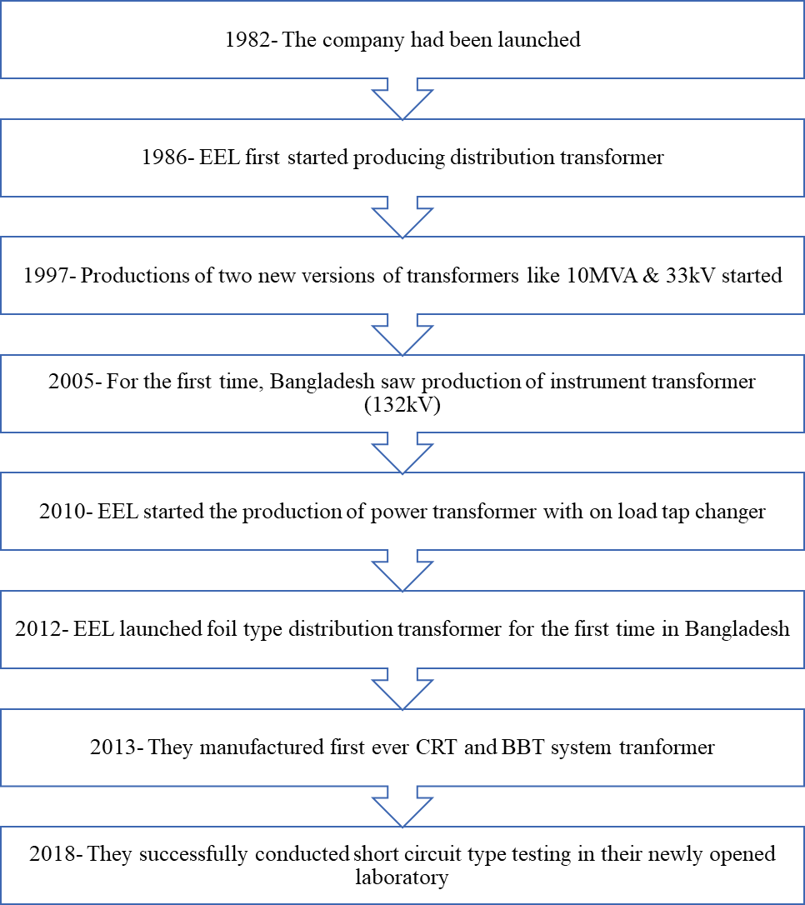
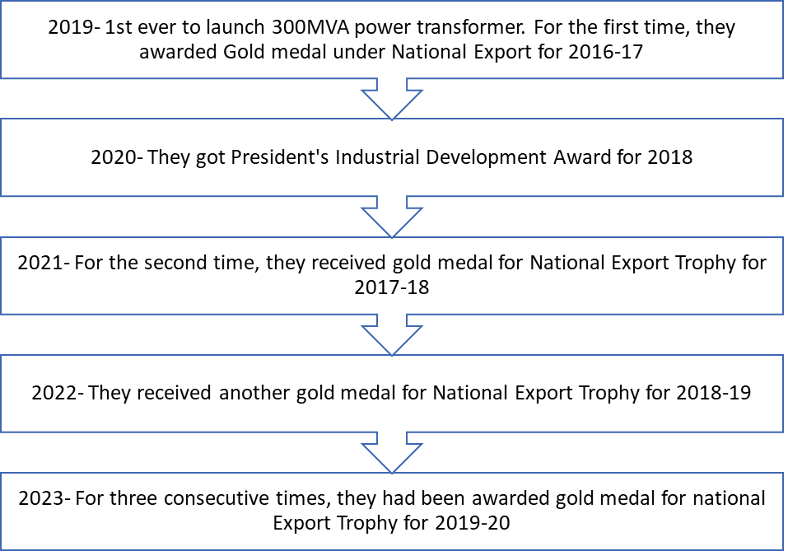
(EEL, 2023)

2.3 Mission of the Company
The mission of EEL is to provide end-to-end engineering solutions to customers with the highest value addition.

2.4 Vision of the Company
The vision of EEL is to become a giant multinational player in the electrical engineering industry.

2.5 Products and Services
EEL provides engineering solutions to customers in the form of products and services. They provide a wide range of products with different versions and new technologies. Their services have become the ultimate solutions for home, business, and corporate clients.

Products of EEL
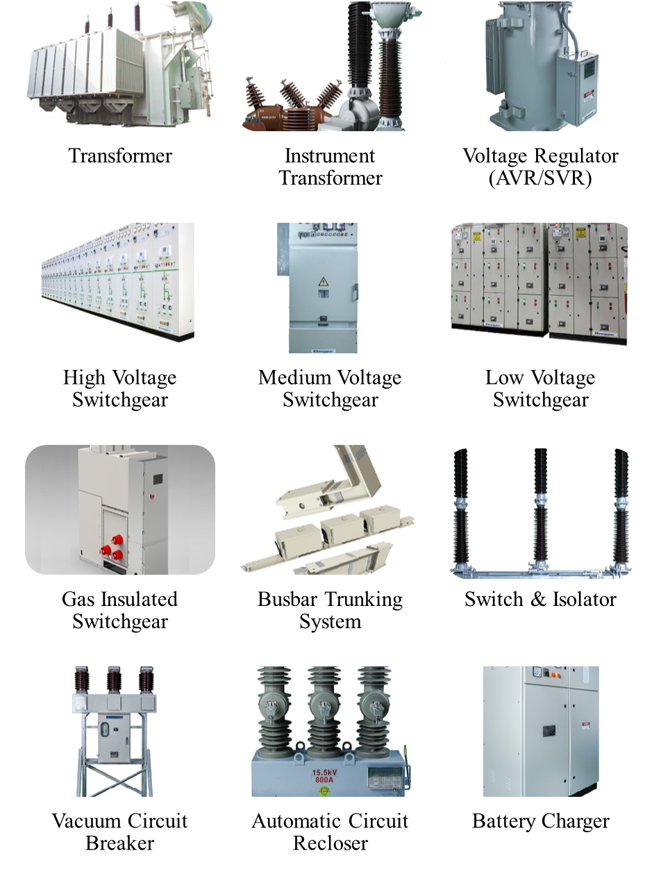
Services of EEL
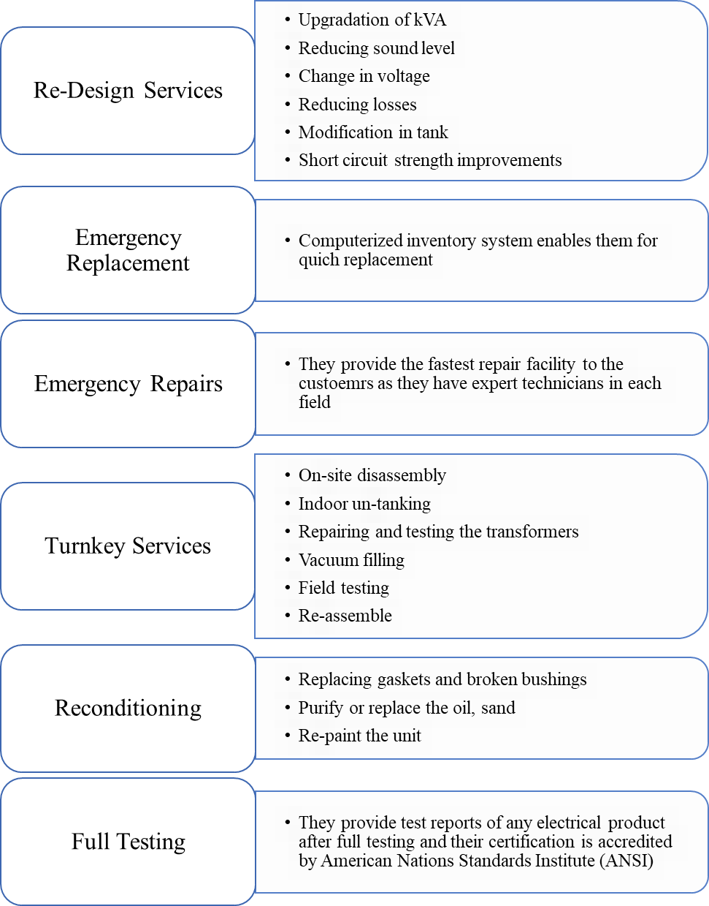

2.6 Organogram of the Company
Based on the information that I collected during my internship program, I have tried to prepare an organization chart or organogram for EEL for the Bangladesh business.
Organogram of Energypac Engineering Company Limited (Partly)
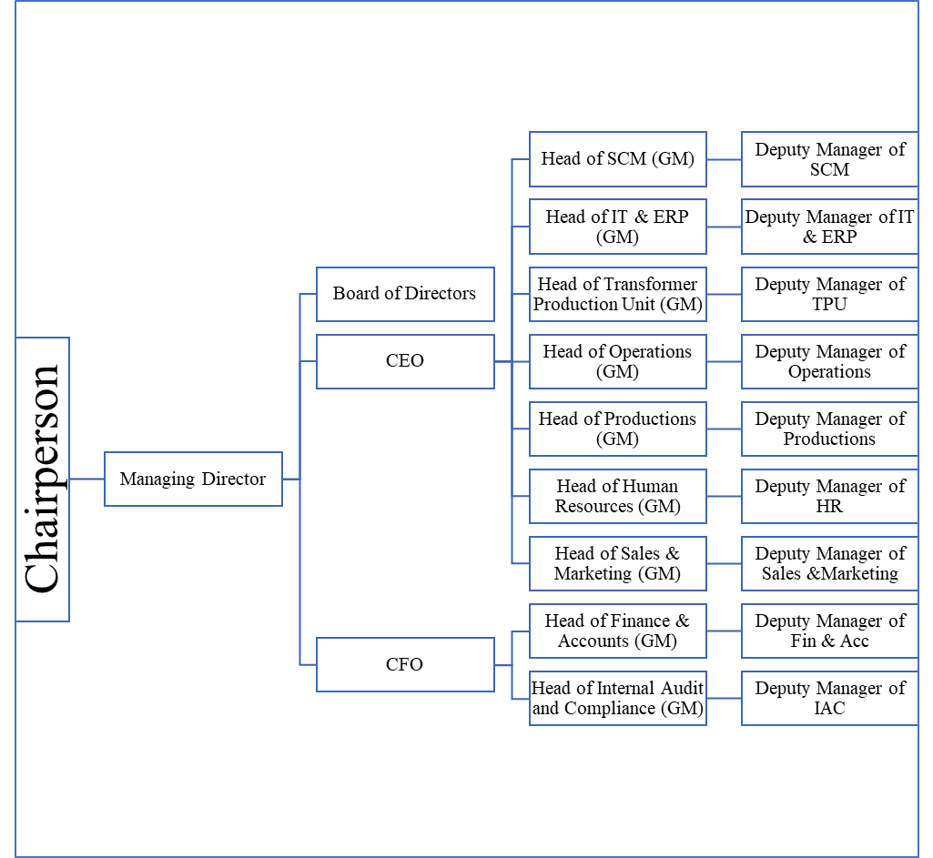
According to the above diagram, in EEL, Under the Deputy Manager of each department, 1 or 2 senior managers are assigned. Under the Senior Manager, 1 Manager is assigned. Managers have senior executives and executives under him or her. All the technicians need to directly report to the managers of the Productions and Transformer Production Department.

Chapter 3: Objectives and Methodology

3.1 Objectives of the Study
Broad Objective
The broad objective of the study is to present the overall training and development process of Energypac Engineering Limited Company (EEL) by aligning the practical information and the observation from the internship program with the theoretical knowledge.
Specific Objectives
To achieve the broad objective of the study, I have specified some objectives for the study such as,
- To learn why training and development program is so vital for the success of any company by developing a theoretical framework.
- To analyze how the training needs analysis process is conducted by EEL before conducting the training program
- To examine and analyze which On the Job and Off the Job training methods are used by EEL and how they are used
- To evaluate how EEL measures the effects or outcomes of the training program under the training evaluation process
- To put some recommendations and suggestions for the EEL which may help them to develop the training program in a better way in the future

3.2 Methodology of the Study
This report has been prepared based on the internship program that I participated in the HRM department of Energypac Engineering Limited Company (EEL). During my three months internship program, I collected different data and observed their activities so that I can prepare the report by using them. For collecting data, I have taken informal interviews with my supervisor. For taking the interviews, I prepared some questions from home and took the interviews based on those questions. All the data sources from where the data collected have been used in this report which can be divided into sources such as,
- Primary Sources: This source is referred to original data that have never been collected or published by anyone. Under the primary source data, I collected data from the HR department of EEL while doing the internship program. As an intern at the company, I had access of going through different documents (not confidential ones) from which I collected data. Like, in measuring the Reaction outcome, I got access to some documents from where I have known which questions are asked under the survey method to the trainees. Besides, my supervisor was friendly enough to share different stories and experiences related to the training programs organized by the EEL in the past from which I got the idea of how EEL arranges training and which methods are used.

- Secondary Sources: This source is referred to the data that have already been published or collected by someone. For conducting the report, I had to collect data from different secondary sources besides the primary source data. To conduct the theoretical framework, I went through different websites to collect data on training and development programs with the help of the search engine Google. I also looked through the different textbooks that I learned during the BBA program. Besides, I have visited the website of EEL to prepare the organizational profile. Again, during my internship, I have gone through different brochures of EEL to know more about the company.

3.3 Limitations of the Study
Although I got the chance to collect data from my supervisor during my internship program, I faced some limitations while preparing the report such as,
- I collected most of the primary data from my supervisor through informal interviews. However, I could not get a chance to talk with some trainees while they were taking training because of their busyness. Personally, I didn’t find the trainees enough willing to share their experiences of the training program.
- Because of the confidentiality of EEL, I didn’t get the chance to go through some documents like the survey form, questionnaire, and interview questions that are used in the training programs. With those documents, my report would have been more resourceful and informative.
- Although I worked there as an intern for three months, I saw a huge workload of all the employees and so, I didn’t get enough opportunity to talk with other HR executives to get more information. Even, it was very hard to talk with my supervisor too because of his busyness.

Chapter 4: Theoretical Framework

4.1 Concept of Training and Development
To get productive and efficient results from an employee, employees must have some job-related competencies along with academic knowledge. These competencies can be both interpersonal or motor skills and also knowledge of tasks and companies. To put these competencies, the company initiates a short-term learning process for the employees which can be referred to as training. The main purpose of the training is to master the employees based on knowledge, skills, behavior, and attitudes and be able to transfer the learning to the job. Many companies nowadays are creating training programs with the alignment of their strategic objectives to get a competitive advantage in the industry. This training program helps the employee to make an expert in the current job.
Again, Development refers to an ongoing process that focuses to develop an employee completely for the entire professional career with the help of developing formal education, job experiences, assessment, and interpersonal relationships. It doesn’t focus on a particular job, rather it tries to improve the attitude and personality of an employee in such a way so that he or she may be ready to face future challenges. Although it seems like training and development programs are the same, there are some crucial differences between these two (GG, 2023).
Differences between Training and Development
Training | Development
1. It is a short-term-oriented program that may run for hours, days, or weeks. | 1. It is a long-term-oriented program that is an ongoing process.
2. It helps an employee to develop performance in the current job. | 2. It helps an employee to develop for the entire career. The development program focuses on developing an employee to make fit into different positions and jobs in the company.
3. Companies provide training to all the employees based on the need analysis to improve their skills, efficiency, and productivity. | 3. Companies provide development programs, especially to those employees who have managerial potential.
4. Improving skills, giving more knowledge about products or companies, and developing behavior are some of the approaches followed in the training program. | 4. Developing formal education, continuous assessment, job experiences, and interpersonal relationships are some of the approaches used in the development program.
5. Company takes full responsibility to provide training with the help of trainers. | 5. It is mostly a self-assessment act where the company helps to some extent.

4.2 Advantages of Training and Development
Training and development programs are equally important for both the company and its employees. One recent survey shows that 93% of employees are interested to continue their job in the same company where they get proper training and development opportunities. Again, companies that provide continuous training and development programs face a 41% lower absenteeism rate, and a 17% higher productivity rate (OU, 2021). Some of the advantages are discussed below,
- Nowadays employees are more career-oriented. They don’t continue in a single job. They are always looking forward to a better opportunity where he or she will get chance to develop careers. Now if a company gives an opportunity to an employee for career development, then the efficient and good employees feel motivated to continue their career in the same company for years. So training and career development program help the company to retain the best employees which may help the company to gain a competitive advantage.
- No company can get long-term success if it is not led by good leaders. The existing leaders will retire one day. So, companies need to prepare young potential employees for their future leaders. Training and career development programs may help the company to give future leaders who will successfully run the company in the future.
- A fresh graduate can never be a good human resource for a company unless he or she can get the chance to develop the competencies. Training gives the opportunity to learn or develop new skills, gain more knowledge about products; cultures; policies of the company, change in behavior, etc. which will make the employee more productive and efficient. These employees will not only provide better performance to the company, but they may also earn promotions or pay rise for their own.
- Many companies, especially technological or electrical-based companies update their product lines with new technologies very often. To provide the best satisfaction to the customers with these new products, employees must be enriched with the knowledge of new technologies. Training can help employees to adapt new technologies easily.
- After the COVID-19 pandemic and different recent global wars, most of the countries have faced economic downward which makes the lives of the companies more difficult. Companies are bound to reduce the workforce to decrease expenses. Customers are looking forward to more savings and less consumption. So, less demand is creating immense competition. Many companies have been bound to reduce the salary of the employees and employees are also bound to continue their job with the reduced salaries. In this situation, employees are becoming more dissatisfied with their job. Companies can arrange Mental Health Training programs for the psychological benefit of the employees. Employees may regain the motivation to put their best in their jobs. Then they will be more productive and efficient which will ultimately benefit the company.
- When companies invest in employees for training purposes, then the employees feel appreciated and valued. This feeling leads them to put the best of themselves to the company and makes them loyal as well. Thus, the rate of absenteeism and turnover goes down.
- Trained employees are more efficient which leads them to use fewer resources of the companies to provide more outcomes. So, the cost of the companies will go down and wastage will be less. For example, if a worker gets proper training on cutting and sewing clothes properly, he or she will cut and sew the clothes in a way so that most of the clothes portion will be used.
- This is the era of modern technologies. Many companies are eliminating the traditional approaches and they are bringing in new technologies to help the employees and improve productivity. But old generation employees may face difficulty with using machines. Unless they are not trained, they will lose their productivity with the new machines. So, they may lose their jobs. So it is better to provide them with training because if they learn how to deal with the new technologies, they would do better than a young employee as they have years of experience.
(Energage, 2022), (OU, 2021)

4.3 Training Design Process
Companies need to invest resources in training programs. So before investing, they need to analyze whether the training programs will provide the expected outcomes. For doing so, they need to undergo a systematic training design process which can be divided into 7 steps.

Step 1: Analyzing Need of Training: As the companies need to spend a huge amount on training, so at first, they need to analyze whether training is necessary or not. Based on the organizational analysis (whether training suits the company’s strategy, available resources perception of top management and peers), person analysis (finding out who needs training and whether the training is the solution to develop the lack of skills and knowledge), and task analysis (which task needs training so that employees can handle the task efficiently). After these three analyses, the company can decide whether the training is the ultimate solution to the problem or not.
Step 2: Analyzing Trainee’s Readiness: Training cannot improve the skills of those employees who don’t have the basic skills and knowledge. For example, if a company wants to develop the excel skills of employees, then employees must have basic knowledge about what is excel, what does it do, and how to run the basic functions. Without the basic knowledge, the employees will not learn advanced excel skills from the training. Then the employees must have the motivation to learn something new or develop skills through training. An employee who is not happy with the salary may not be motivated enough to learn well from the training.
Step 3: Preparing a Learning Environment: Companies must ensure a suitable learning environment for the training programs. Suppose, a training program doesn’t have an air conditioner and trainees are continuously sweating. They will never be able to give their full attention. Again, while doing audiovisual training, if the projector cannot provide clear resolutions, then trainees will not clearly see the content. So, companies must prepare good training content by aligning with objectives, providing equipment and materials, creating enough practice, and feedback opportunities, etc.
Step 4: Ensuring Transfer of Training: Providing training is not enough to get the best outcome. Companies must ensure that employees will get easy chances to apply those learnings in their jobs. After returning to the job, the supervisor and co-workers must support the employee in applying the new learnings into action. The training environment must be similar to the work environment in order to ensure the transfer of learning. For example, if a trainee uses EVIEWS software for the statistical model run in the training and gets STATA software in the work, then he or she may not deliver the exact learning. So, HR must measure training transfer before conducting training.
Step 5: Establishing an Evaluation Plan: After that, the company must establish an evaluation plan. Under the plan, they must decide which training outcomes will be measured, which criteria will be considered, choose a proper evaluation design to measure the training outcomes with the expected ones, and evaluate the investment cost and benefits received from the training. Many companies try to calculate return on investment to analyze the cost-benefit of the training. Without a proper evaluation plan, the company will never find any fault with the existing training model and will follow the same model again and again. Thus, they will not get the best benefit from the training.
Step 6: Choosing Training Method: Before conducting the training, the company must decide which training methods would be more suitable for their trainees according to training objectives and environment. Training methods can be either On the Job or Off the Job. Trainers must decide which methods will best fit or choose the combination of different methods. For example, for teaching how a new machine runs, the simulation method would be the most appropriate one. Again, for a newly hired employee, lectures or an audio-visual method would be suitable to provide the basic knowledge of the company and job. Different E-Training or new technology-based methods are available now.
Step 7: Monitoring and Evaluating the Training: This step is conducted during the training program and at the end of the training. Usually, trainers are given the responsibility to conduct the training. However, sometimes top management must monitor the training programs to check everything. While doing the observation, if the top management feels for any change, they can edit the training design and restructure it (Talent, 2022), (Noe, 2010).

Chapter 5: Findings and Analysis

5.1 Training Need Analysis
Although it is considered that training is one of the best solutions to improve the performance, efficiency, and skills of employees, it is not the solution for all the problems. It can be used unnecessarily for a performance problem. It is not always right that one particular employees’ s performance is poor because of the lack of skills or job knowledge. It may happen that the employee has a lack of motivation for doing his or her best or he or she may be suffering from depression. So it is vital for a company to know whether there is a need for training or not before executing a training program. Otherwise, the company will lose resources for the training, but will not get the desired results.

5.1.1 Reasons for Conducting Training Need Analysis by EEL
EEL is aware of the need for training need analysis. Before conducting any training program, they properly analyze the training need. Some of the reasons for conducting training need analysis are given below which are observed by me during the internship period,
- EEL provides a vast area of services to their customers where they need efficient technicians who must have the knowledge of the latest machines and technologies. Before providing the training to the technicians, EEL needs to ensure whether the technicians have the basic or prerequisite skills to understand the training program.
- To make an alignment between the outcome of the training programs with the set objectives.
- Performance problems may be occurred due to the problem in job design, employees’ dissatisfaction with the job, and unsatisfied job environment. In these cases, providing training would not bring the solutions of the performance problem.
- To identify the suitable training content, which employee will require which type of training, duration of the training, and required resources for the training.
- Again, when EEL introduces any new product in the market or any new technology, EEL goes for a training need analysis.

5.1.2 Training Need Analysis Process of EEL
EEL is a totally technology-based company whether its products and services are directly related to technologies. So, providing training is vital for their success. Based on my observations and collected information, I have understood that they follow the standard process for their training need analysis which contains three elements of need analysis such as Organizational Analysis, Person Analysis, and Task Analysis. In practice, they do not follow any particular order for these three elements.

Organizational Analysis
In general, at first organizational analysis is conducted among the three elements of need analysis process by EEL. Because by doing this, they can know whether training programs support the strategic objective of the EEL. Again, this analysis tells whether top management along with department heads and other employees support the training or not. Again, it tells whether the company has sufficient funds and expertise to conduct the training. In this regard, I can mention one of the incidents of EEL that happened in 2013 when they introduced the Fireproof Transformer in the market. After launching, because of no expert people, they could not provide training to their own technicians. So, they had to give a contract to a third-party consultant company for the six months period for the maintenance of the Fireproof Transformer. Within this period, they brought one expert from China who provided training to their technicians and engineers.
The strategic objectives of EEL support the need for training. Because EEL’s one of the main objectives is to provide the best after-sale service to the customers of their products. Again, providing services like re-design, emergency replacements, emergency repairs, reconditioning, etc. are core functions of the company. These services require the most skillful and efficient employees and for that, the technicians and engineers must be well-trained from time to time. So, EEL’s objective and core function support the training program always. If resources don’t make any problems, they conduct the training program at regular intervals.
A key factor in getting success from the training program is to have a positive attitude of managers and employees towards the training. A lot of technicians and engineers are directly associated with providing different services to the customers which is one of the core functions of the company. As these services have technological aspects, so they need proper skills and knowledge. Again, technologies are being updated from time to time. So, without proper training, employees will not be able to adapt to those new technologies. Again, EEL has a performance bonus for all their employees. Again, EEL reviews the performance of its employees after every six months. Technicians may lose job if their performance is below average. So, all the employees are always motivated to get training for their self-development in order to remain in the job and get performance bonus. Again, all the department heads have a positive attitude towards the training. During my internship period, I noticed this attitude as I was working under the HR head of EEL.
Before executing any training program, the top management of EEL evaluates the budget, time, and available resources for conducting the program. As EEL is a technology-based company, so they need to provide training from time to time. So, I have been informed that EEL keeps 10-15% of its profit amount for the training program each year. Again, whenever any department Head realizes the need for training, they present the proposal to the top management. Then the CEO and other top managers evaluate the proposals and decide whether an in-house expert will be sufficient to conduct the training or whether an outside consultant needs to be hired.

Person Analysis
Before providing the training, EEL analyses who needs training and which type of training is required. For doing so, they have an ongoing process. All the technicians and engineers are assigned under a supervisor. The supervisor continuously takes notes about their performance. The supervisor makes a half-yearly report for each of the employees at the end of six months based on the collected data. Then the supervisor sends the report to the department head of those employees who may have lack of skills, poor performance. After that, the department head calls for a meeting with that particular employee and tries to know whether the employee needs any training or not. Based on the feedback, the employees are sent for a short or mid-term training program which is basically on the job training under an expert.
EEL provides training to all employees at the beginning of the job. Again, when a new technology comes in front, EEL decides to provide training to those employees who will be directly associated with the new technology.

Task Analysis
Task analysis is performed by EEL when a new technology, new product, or new service is included in their product and service line. Under the task analysis, they try to find which activities must be done to perform the task and which skills, knowledge, and abilities are required for the task. I am presenting their task analysis process with an example.
Five months ago, a new version of Voltage Regulator has been included in their product line which is called SVR. Their senior technician has the utmost knowledge about this SVR version. So, the senior technician provided the basic knowledge about how to run the SVR version to other technicians. After that, 12 technicians were assigned to run the SVR for the next 7 days as a trial basis. After that, all 12 technicians were given a survey form to rate the task based on one parameter which is ‘Difficulty’, and also to share the problems that they experienced. Then, information is also gathered about the frequency of use and importance of the new machine based on the sale from the marketing head, engineers, and senior technicians. Based on all reports, the task is analyzed and the authority decided whether the task is required further training or not.

5.1.3 Techniques Used by EEL for Training Need Analysis
Several techniques or methods are used by EEL for their training need analysis. Based on the tenure of employees, employee characteristics, nature of the task, and the importance of task, techniques are chosen.

- Observation: This technique is mostly used for technicians especially those who are associated with providing different services to customers. The supervisor or senior technician observes their task and notes down the data if found any deficiencies. By doing so, employees’ work is not interrupted compared to other techniques.
- Interviews: This technique is mostly used with those employees who get a poor rating from their supervisors during their performance. Then both the supervisor and department head try to know exactly why his or her performance is below the expectation level. After the interview, if it is found that the employee’s poor performance is due to a lack of skill or knowledge, then the employee is assigned to any required training. All the Department Heads of EEL are very generous towards their employees. They really care for their employees and this interview system is one of the proofs. Because after talking, the department head also tries to help the employee with the lack of motivation, dissatisfaction with the job environment, any family crisis, or mental depression of that employee. Although this interview technique is very time-consuming and also difficult to analyze, EEL believes the success of this technique in training need analysis.
- Surveys: This is used when EEL introduce any new product, service, or technology in their product line. Because all the new products or technology are used by the employees for a few days as a trial basis. After the trial, a questionnaire is given to the employees and EEL tries to know about the new products from their experience. Based on the data, EEL can conduct the Task Analysis and decide for the necessity of any training. Again, at the end of each year, all the employees of all departments go through a survey process where they are asked to give answers to different questions related to the job design, job environment, performance of their supervisor, any dissatisfaction towards the company, whether they feel to get training on a particular skill, etc.
- Documentation: This technique includes presentation, video recording, technical manuals, and speeches, especially for all the newly joined employees. All the newly hired employees go through this technique to provide information about the job and try to analyze whether their skills and knowledge are sufficient to perform their assigned tasks.
- Focus Group: EEL has divided all its electrical products into five different groups. Each group is formed with one engineer and four technicians. Each team handles all the technical-related issues of the products of that group. The groups are Group A (all types of Transformers), Group B (all types of Switchgear), Group C (all types of Circuit Breaker), Group D (Regulators and all types of Battery Chargers), Group E (all the remaining products). If any new technology comes at the market of a particular group, then the group goes for a Focus Group discussion to analyze the tasks of the new technology. All the members take decisions combinedly.

5.2 Training Methods Used by EEL
As EEL is a company that provides the solution to different electrical engineering requirements which is directly related to high technology. So, engineers and technicians need sound knowledge about all the technology. EEL is aware of this and so, they provide a variety of training by using different training methods after analyzing the organization, person, and task. However, besides engineers and technicians, they have different employees working under Finance and Accounts, Marketing, HRM, and Operation department. EEL arranges training for those employees as well. They provide both traditional and technology-based training whichever is necessary. After gathering information during my internship period, I can divide all their training methods under two broad categories: On the Job and Off the Job training.

5.2.1 On the Job Training Methods
It is one kind of training method while employees take training and do their jobs simultaneously. For this kind of training, companies don’t need to give leaves to their employees for the training and so, the working process is not hampered. It is the least expensive method as well. However, on the job training methods are not applicable to teach all the skills and knowledge. EEL uses cross training, coaching, and job rotation methods under the on the job training methods.

Cross Training
The majority of the services provided by EEL are conducted by a team. So the importance of team performance is vital for the long-term success of EEL. Each supervisor has the responsibility to handle all the teams under his or her supervision. EEL is aware that if all the team members have a maximum number of skills and knowledge about the technologies, then they would be able to provide better services. Because it may happen that on a particular day, one team member may be absent for any reason or leave the job at any time. Now if that employee’s skill is not available to other team members, then that team would suffer and so, customers would be disappointed. So Cross Training is important where each member will try to help other members to teach skills among themselves. They will share their knowledge and experiences among themselves while doing the job. Because arranging formal training needs time and resources. So if the team members help each other with the small learnings, then it would be better for both the company and the employees. Because EEL provides a performance bonus every month.
While doing the performance appraisal, the employee who helps other team members get additional points which helps the employee to get a promotion and pay rise. The supervisor monitors this behavior throughout the period. So, while doing the internship, I found a very friendly relationship among the employees. All the employees are ready to help each other to fulfill any lacking of knowledge or skill of another employee.

Coaching
This coaching training method is one kind of informal method which is an ongoing process. Whenever an employee joins the company, then it becomes the responsibility of the immediate supervisor to tell him how to conduct the tasks until the employee goes for any formal training program. Again, after doing the Team Training, the employee who has an issue with the behavior or skills, then it becomes the duty of the supervisor to talk with the employee and solve the problem. While doing the internship program, I saw that all the supervisors of HR department are very helpful to their subordinate to help in their tasks. Even as an intern, I get guidance from my supervisor from time to time. Even they are friendly enough to solve any personal problem so that the employee can give 100% focus on the job. The coaches or the supervisor gets an additional point at their performance appraisal based on their coaching performance. I think this is another reason of getting success from this Coaching method.
Job Rotation
It is another On the Job training method for EEL in order to teach the employees different skills and knowledge of different services. Under this job rotation technique, employees are rotated from department to department and also from one task to another task. EEL has different fixed teams for each of the services like replacement of different electrical products, transformer setup, kVA upgrades, voltage change, tank modification, etc. Usually, each team is assigned one year period for a particular service. After one year, the performance of all team members is evaluated. Then few team members’ jobs are rotated and they are shifted to another team that is assigned for providing another service. By doing so, each employee can have a variety of knowledge of different services. Usually, the employees who cannot meet the expectation are faced with this job rotation. Even sometimes, when an employee becomes an expert in a particular service or exceeds the expectation, then he or she also faces this job rotation to develop new skills along with a monetary bonus.
As an electrical solution provider, job rotation is a very convenient, cheap, and effective training method for EEL to develop employees for the long term. This job rotation can also help them when a particular employee from a team suddenly leaves the job or be absent. Then, a team member from another team can help that team. This job rotation system is being applied to another department as well. During my internship period, I noticed that one executive from the Marketing department has been shifted to the HR department and included him in the performance evaluation task. When I talk with my supervisor, he mentioned that they saw potential in that employee as an HR executive as well. As HR needed one extra employee immediately, so they made this rotation.

5.2.2 Off the Job Training Methods
It is the opposite of On the Job training method where the employees are released from the job for a particular time period for attending the training program. To develop any complex skills, Off the Job training is a must, especially for the companies like EEL where they deal with a variety of technological products and services. EEL uses lectures, audiovisual/presentation method, simulation, a combination of team training with case studies, local and international seminars, and psychological and mental health training.
Lectures
EEL arranges lecture classes for newly hired employees in order to provide information regarding their job, job environment, company policies, cultures, etc. The head office of EEL has a seminar room where these lecture classes are conducted. Especially the department head takes these lectures. It is one of the least time-consuming and least expensive training methods of EEL which is usually arranged for 1-2 classes. This is also one kind of Orientation program for the newly hired employees of EEL.
Again, whenever a new product or technology comes into their product line, then the employees are given elaborate information regarding the product or technology to their employees. Before going for the video presentation and simulation training method, these lecture classes are provided in order to give theoretical knowledge of the new technology. Especially, front line engineers are given this kind of lecture. Sometimes, experts from other countries are brought to take these lectures.
I can mention one lecture training program which was organized during my internship period. Four months ago, EEL arranges a lecture program for their electrical engineer in order to provide theoretical information regarding the new version of High Voltage Switchgear. A 2 hours class was conducted by the Chief Electrical Engineer of EEL. Trainees got the chance to ask any further questions about this new product as well.

Presentation / Audiovisual Method
When a new product, service, or new technology is launched by EEL, at first Lectures are given to the engineers and technicians for theoretical knowledge. However, after the lecture, 1-2 classes are conducted where different videos are presented before the trainees to show how the new product functions. As the technicians are directly associated with providing technology-based services like short circuit strength improvements, kVA upgrades, changes in voltage, LTC modernization, etc., so these video presentations are very vital for them before the simulation training. PowerPoint slides are also presented in this presentation class. Sometimes, these videos are collected from the original producer of the products or they are prepared by the senior technician of EEL at the factory. After this presentation, the employees are sent for simulation training if it is needed. The employees get access to these videos so that they can watch those multiple times and make themselves well-prepared before the simulation training.
Besides engineers and technicians, this presentation method is also used for other employees as well. During my internship tenure, I experienced such presentations for the sales team. All the employees who are related to the sale team, especially the new or inexperienced sales executives attended that presentation where different videos were shown to teach them how to deal with the organizational clients. Videos of different top marketing experts were presented along with the presentation slides.

Simulation Method
This is the most important and result-oriented method for EEL as it is a totally technology-based company where that provide a variety of electrical problem solutions. So, they consider this simulation method is the most effective one for teaching the employees, especially the engineers and technicians. This simulation method is used in their manufacturing unit or in their international accredited power engineering laboratory by using all the real products. In this method, the technicians are given a live demonstration about how to run a product or conduct any particular service like tank modification, vacuum filling, reducing electricity losses, how to replace gaskets; broken bushing, repairing different products, etc. by the senior technician or the engineer. Then the technicians are asked to replicate the program again and again until they get perfection. This simulation is an ongoing process. There is no fixed duration for this training program. Whenever a new product or new technology comes to the product line, this simulation training is given after completing the lecture and presentation classes. After the simulation, the employees get both theoretical and practical knowledge. Then the employees become ready to perform in a real situation.

Combination of Team Training and Case Studies
All the services provided by the EEL are performed by a particular team. The team is formed of a minimum of 3 persons and a maximum of 6 persons depending on the task’s complexity and importance. So, the success of providing accurate service doesn’t only rely on the skills of employees but also depends on how the team will communicate, coordinate with each other, adapt to the situation, and understand each other. So, team training is very important for providing services for EEL. The success of team performance depends on three attributes which is given below. So, this team training is provided to teach these three attributes.

For the team training, EEL mostly used both Case Study and Simulation methods. Based on the collected information, I am providing the process of Team Training of EEL below,
- At first, all the supervisors and department heads decide which employees will be selected for the team training. It is usually a 2-day training program.
- Then, the team training is divided into two parts. One part is conducted based on case studies and another part is conducted based on simulation.
- First part of the training is conducted in the seminar room of the head office. During the training, all the members are divided into different groups. All the tasks during the program must be done within the group.
- On the first day of training, each group gets different case studies written on paper. They get 45 minutes to solve the cases and provide the answers after discussing them with each other. All the cases are related to some hypothetical problems that may occur while providing different technical services to customers. These case studies are designed in a way so that they can test the attitude, knowledge, and behavior of each member of the team.
- On the second day of training, all the teams are sent to the manufacturing unit for the simulation test. The senior technician creates real problems with the real products. Then each team is given a short brief about what to do. Within a particular time period, each team must solve the problems. While doing the task, trainers observe them and take notes. Each team is given three problem-solving tasks on the same day.
- After collecting all the information from days 1 and 2, trainers and department heads analyze them and try to rate all the employees based on knowledge, attitudes, and behaviors. If any employee has behavior and attitude problems, then those employees go for the Informal Learning Method (Discussion has been given above) to solve their issues. For example, during team training, if it is found that one particular employee has the tendency to solve the majority of the tasks all alone, then he needs to learn how to coordinate with other team members. Because it is not ideal to solve all the problems by alone. Again, if it is found that any employee has an anger issue or communication problem, then it is also solved.
- If any employee has lack of knowledge about the task, then he or she goes for the Coaching or Job Rotation method ((Discussion has been given above) for the better learning.

Local and International Seminars
Before bringing any new product or new technology into their product line, EEL sends their top engineers to participate in different local and international seminars to gather knowledge about the new product or technology. Sometimes engineers are sent to the factories of the foreign inventor of a particular product. All the costs of these seminars are bear by EEL. Sometimes top management of EEL participates in different online seminars conducted by foreign experts to increase their management skills and know better about the industry and international market.

Psychology and Mental Health Training
The top management of EEL is very much aware of the current socio-economic situation of Bangladeshi people, especially after the COVID-19 pandemic. In the last two years, the inflation rate has been increasing continuously which is hampering the budgets of the employees. Due to the different problems in business like LC opening problem due to lack of foreign currency availability, and decreasing amount of sales, it is not possible for EEL to increase the salary with the alignment of the inflation rate. But they try to provide a performance bonus. Still, this may not be enough for many employees of EEL, especially for the technicians. EEL is aware of this situation. Again, different family and physical health issues are creating problems for the employees which lead them to mental illness or severe depression. So, from June 2021, EEL has decided to arrange 2 days of Psychology and Mental Health Training or Seminars for all the employees of EEL after every 4 months, and attending the seminars is mandatory. As an intern, I found this very much important considering the current situation. During my internship program, I also took part in one mental health seminar where I saw attending top clinical psychologists of Bangladesh. I saw Dr. Mehtab Khanam, a Professor of the Clinical Psychology Department of Dhaka University and one of the renowned psychologists of Bangladesh attended in that seminar.
(Noe, 2010)

5.3 Choosing Training Methods by EEL
For providing training to employees, it is not easy to choose the right training methods within a large number of training methods. HR personnel who is related to designing training program needs to carefully decide the methods so that both the employee and the company get the desired outcome by using the least resources. As my supervisor was directly associated with handling the training and development issues, so I get the opportunity to know how EEL chooses the training methods. Based on the collected information and my theoretical knowledge, I am presenting the process of choosing training methods by EEL.
- At first, HR needs to decide which outcomes are expected to get after the training program. These decisions are made after a meeting with the supervisor of that employee who needs training, the department head, and HR. The outcomes can be knowledge, learning of new motor skills, improving existing skills, attitudes, etc.
- After deciding the outcomes, they decide which training method would be able to provide that outcome. For example, if it is found that employees have a lack of coordination while doing team tasks, then they decide to provide team training with case studies.
- After identifying the training method, they need to analyze whether this method would be able to facilitate learning and transfer of learning when the employees will return to work.
- Then, they need to estimate the budget for the chosen program. Budget or costs can be two types: Development Costs (cost of designing the program) and Administrative Costs (costs related to materials, instructors, and other costs). If the budget is sanctioned by the top management, then they can finalize the method. But if top management doesn’t sanction the budget, then they need to find another cheap method that may provide almost the same outcomes. For example, if EEL doesn’t have the budget for Team Training, then they may go for a Coaching system where the respective supervisor will try to solve the coordination problem among the team members.
- After that, they need to prepare the training program in such a way that the objectives of the program must be clear to the employees, the contents of the program would be meaningful, and the trainees would get interested in participating.

5.4 Training Effects/Outcomes to Measure
We can find many companies suffering for a long period of time whereas few companies may have great success within the same industry. The power of human resources is one of the main reasons behind these differences. If we analyze the top companies, we will see that they spend millions of dollars for training and development purposes, because they know that a productive, efficient, skillful, and knowledgeable employee is one of the main pillars for long-term success. So, they invest huge money every year. However, they are also aware that spending money on training programs is not enough for getting the expected outcomes. The training programs must be evaluated on a continuous basis. Whether the training programs are providing the expected outcomes that must be measured. Otherwise, the company’s resources will be wasted. EEL is very much aware of that. In order that, after completing any Off the job training, the HR department forms a team to measure the outcomes of the training based on some criteria. Based on the information that I collected during my internship program, it has been found that their training program effectiveness is measured based on four outcomes which are given below,

Training Outcomes to Measure Sequentially

1. Reaction Outcome: In EEL, at the end of the training program and just before joining the job again, the trainees are needed to express their perception or opinions towards the training program, content, performance of trainers, methods of training, materials, facilities provided in the training, etc. This reaction outcome is the first outcome that is measured by the training evaluation team of HR. It is a very much important outcome that must be measured under the training evaluation process because the opinions of trainees are very important for designing the training program or selecting the trainers in the future. If this outcome is skipped to measure, it may happen that a particular company is providing training with the same design and same instructor for years and years in which the trainees are not getting the best input from the training. Then the company will not get the expected outcome from the training programs.
Usually, EEL uses questionnaires under the survey technique to collect information from the trainees. After discussing with my supervisor, I found some questions that are asked in the surveys which need to be rated by the trainees. For getting an unbiased rating, EEL gives the chance to the trainee to fill the form anonymously. Based on those questions, I have presented a hypothetical survey form that is used by EEL.

Hypothetical Survey Form for Measuring ‘Reaction Outcome’ based on Collected Information
Read the statement carefully given below. Based on your experience and understanding of the training program, rate the statements by using the scale given below.
Strongly Agree (1) | Agree (2) | Neither Disagree or Agree (3) |  | Disagree (4) |  |  | Strongly Disagree (5)
1. Trainers were fully prepared with the content |  |  | 1 |  | 2 | 3 |  | 4 | 5
2. Trainers were friendly enough to accept feedback and clear the doubt |  |  | 1 |  | 2 | 3 |  | 4 | 5
3. Training environment was suitable for the learning |  |  | 1 |  | 2 | 3 |  | 4 | 5
4. The training content was enriched |  |  | 1 |  | 2 | 3 |  | 4 | 5
5. I learned what I expected to learn from the training |  |  | 1 |  | 2 | 3 |  | 4 | 5
6. I will be able to transfer the learning into my job |  |  | 1 |  | 2 | 3 |  | 4 | 5
7. The training met the desired objectives |  |  | 1 |  | 2 | 3 |  | 4 | 5
8. The facilities and equipment provided were sufficient to learn |  |  | 1 |  | 2 | 3 |  | 4 | 5
9. Enough time had been given to learn |  |  | 1 |  | 2 | 3 |  | 4 | 5
10. I am satisfied with the overall training program |  |  | 1 |  | 2 | 3 |  | 4 | 5
Suggestions for the Future:

2. Learning Outcomes: After measuring the reaction outcomes, the HR team of EEL goes for measuring the learning outcomes in which it is measured whether the trainees are well familiar with the techniques, process, and facts of the training at the end of the program. In short, they try to measure the knowledge that the trainees gained during the program. Before returning to the job, trainees are measured based on this outcome. Usually, EEL uses a simple written test where few questions are asked about the rules or principles of the tasks, the detailed process of the tasks, which techniques have been used, etc. With the answers to these questions, it becomes easy for the team to analyze how much theoretical knowledge has been gained.

3. Behavior Outcomes: These outcomes are measured to evaluate the practical knowledge of the trainees that they gain during the program which means the technical or motor skills and the changes in behavior or attitudes. These data are collected by EEL both at the end of training and while doing the job after the training. For example, in the audiovisual or presentation techniques, at the end of the training, each trainee is given 1 hour time and given a particular topic to be prepared for giving a 5-minute presentation. Like, it may be asked a technician to give a presentation on how to change the voltage during a system loss. Within this one hour, the technician needs to prepare a presentation based on the learning of the training and present it in front of everyone. Again, in the simulation training method, each trainee is asked for a final test where they need to perform a task in front of the trainers where the trainer will carefully observe and give advice if required. In addition, when the trainees return to their jobs, the immediate supervisor is responsible for observing the tasks performed by the employees that they have just learned in the training. The supervisor also monitors any change in the behavior of that particular employee. The HR evaluation team gathers all this information and tries to measure the motor skills that the trainees learned from the training.

4. Results: EEL needs to invest money in its training programs every year. So, they need to measure how much they are paid off after the training. To do so, the HR evaluation team tries to gather information about whether productivity and efficiency have been increased for the trainees. As an electrical solution provider company, the employees face different accidents and equipment downtime in their manufacturing unit. After the training, it has been measured whether these situations have been improved. Again, if EEL provides any Excel training to their employees, then it is measured whether they can do their excel staff within a shorter period of time after returning to the job. To evaluate the result outcomes, EEL calculates the Return on Investment (ROI) which refers to how much a company gets in monetary benefit compared to the costs of the training. At the time of preparing the annual report, they calculate this ROI. Due to a lack of information, I could not discuss this ROI calculation elaborately.

5.5 SWOT Analysis of Training and Development Process of EEL

Strengths of the T&D Process of EEL
EEL is very much aware that without having a perfect training need analysis, they will not get the expected outcomes, rather their investment will go in vain. So, the HR team carefully conducts the need analysis to find the suitable training that will be linked to the strategic objective of the company, the perfect budget, the right employees to be trained, which task must go through training, and the interest of managers and peers about the training. During the training program, they provide a similar job environment so that trainees can easily transfer the learning into the job. For example, during simulation training, the trainees are being learned by using the real machines and equipment that are used in the factory. Again, EEL provides performance bonuses to all employees every month along with salary. To get the bonus, employees need to improve their skills and productivity. So, the employees are very much interested to take training for their own development. So, trainee engagement is very high which helps the EEL to get a better outcome from the training.

Weaknesses of the T&D Process of EEL
EEL provides different types of training, but they don’t provide any sort of training that will develop the leadership skill of the employees. In addition, they are very much focused on providing training only, but not on career development. Thus, they will not get any future leaders from potential young employees. They are getting success with the short-term oriented training programs, but may not get long-term success. Good employees will not continue their job because of fewer career development opportunities. Although it is the time of modern technologies, EEL is still comfortable with providing traditional training methods. To some extent, they are using modern technologies like audiovisual techniques.

Opportunities of the T&D Process of EEL
With the success of the last four decades, EEL is now expanding its businesses across international borders. They are exporting their products and opening production sites in different countries which is helping them to generate more revenue. Thus, they will be able to invest more in training and development programs to ensure better results. They can easily bring E-Training methods into the list like video modules, virtual classrooms, micro-learning, web eLearning, mobile learning, etc. to provide modern learning to the trainees.

Threats of the T&D Process of EEL
The COVID-19 pandemic and different global wars are hampering the economic conditions of different countries. Bangladesh is not free from that. We are facing huge inflation, reduced foreign currency reserves, less foreign orders which are creating problems in our economy. So, companies are facing problems as well. They need to cut down their cost as much as possible. Recently, EEL has reduced 25% of the annual budget for their training programs which will hamper the development of their employees. Again, some of their competitors have good career development programs which may attract their employees to shift into those companies.

Chapter 6: Recommendations and Conclusion

Chapter 6: Recommendations and Conclusion

5.1 Recommendations
Based on my three months of experience in my internship program and this report, I have presented some of the recommendations for EEL in order to get better outcomes from their training and development program.
- We know that training improves the current job performance of an employee of a particular job. But career-oriented and talented employees are seeking for their continuous development. So, ensuring a suitable career development program will help EEL to retain good employees, and also they will get future leaders for their company. The top management now should focus on this issue.
- With the flow of time, we need to adapt ourselves to modern technologies. Although EEL is getting success with their traditional training methods with a few modern techniques, they should extend the modern and electronic training methods like virtual classrooms, micro-learning, web eLearning, mobile learning, etc. in their training methods. Thus, they will get better outcomes with cost-effectiveness.
- Although they have the vision to become a top giant multinational company, they don’t have any plan to develop future leaders. At least, they can arrange a Leadership Training program to find potential leaders for their company.
- During my internship, I took part in one of the lecture training where sales executives were being given training about how to deal with corporate clients which last only for two sessions. I think arranging more sessions would allow the trainees to make practice among themselves. Even their simulation methods last for two days only. They can think of arranging longer periods of time for their training programs.
- At the end of the simulation and audiovisual training programs, they take tests to evaluate their learning. If they arrange a reward system based on the test result, I think employees will be more motivated to pay more attention in the training.
- I noticed that EEL arranges lectures or orientation programs for newly hired employees in order to provide only information about the company, policies, cultures, and their jobs. At the initial level, new employees find difficulty to adapt with their tasks. Because the supervisor doesn’t have enough time to guide them. So, it requires many days to get better performance from the new employees. So, simple training can be arranged to teach how to conduct their tasks in detail.

5.2 Conclusion
In this modern era, no company can get sustainable success until it treats its employees as human resources. Those employees must be nurtured from time to time. Efficient and productive employees will be real gems for the company. However, this effectiveness and productivity don’t come automatically. The company needs to invest in training and development programs. As one of the top electrical engineering companies of Bangladesh, EEL provides training to their employees. Their strong training need analysis determines which training will be aligned with the company’s objective, who needs training, and which techniques will give the best outcomes. Their different On the Job and Off the Job training methods help the employees to improve their skills and knowledge. Although they don’t use many E-Training methods for their training purpose, they are getting results from their traditional methods. But for retaining good employees and fighting with the competitors, sooner or later, they should adopt more modern techniques. Again, in order to get future leaders from their talented employees, they need to focus more on the career development program. Through my internship experience and this report, I have figured out how the theories of training and development are used in a company in a practical way.

References
EEL. (2023). About Energypac Engineering Ltd. Retrieved February 21, 2023, from Energypac Engineering Ltd Company: https://energypac.com.bd/about
Energage. (2022, August 15). Benefits of Employee Training & Development. Retrieved February 27, 2023, from Top work place: https://topworkplaces.com/benefits-of-employee-training-development/
GG. (2023, February 21). geeksforgeeks. Retrieved February 28, 2023, from Difference between Training and Development: https://www.geeksforgeeks.org/difference-between-training-and-development/
Noe, R. A. (2010). Employee Training and Development (5th ed.). Ohio: The McGraw-Hill Companies. Retrieved February 04, 2023
OU. (2021, January 25). Ottawa University Online Blog. Retrieved February 28, 2023, from Why is training and development important : https://www.ottawa.edu/online-and-evening/blog/january-2021/5-benefits-of-training-and-development#:~:text=Training%20and%20development%20helps%20companies,and%2017%20percent%20higher%20productivity.
Talent. (2022, December 13). 7 Steps to an Effective Employee Training Program. Retrieved February 05, 2023, from talenteam: https://talenteam.com/blog/employee-training-program/

