Report On
Balance Scorecard for performance measurement

Title of the project:

Balance Scorecard for performance measurement

Supervisor
Mofijul Hoq Masum
Assistant Professor
School of Business & Economics
United International University

Submitted by
Marjia Kajol Rekha
Id-111 132 185
Dept- BBA
United International University

Submission Date:
20 September 2018

LETTER OF TRANSMITTAL

24 January 2019
Mofijul Hoq Masum
Assistant Professor
School of Business & Economics
United International University
Subject: Report on “Balance Scorecard for performance measurement”.
Dear Sir,
It gives me an immense pleasure in submitting to you the report on“Balance Scorecard for performance measurement” this is the topic under my observation.
While preparing the report, I closely focused on the topic & tried to collect most complete information available. I believe that it will provide you a clear scenario of the topic.
“I thank you for giving me the opportunity to do a report on the above mention point. This report will definitely give me experience which I can use in my professional life. I will be always available for any further query and to answer any questions on this report.”
Thank you.
Thanks and Regards,
Marjia Kajol Rekha

Acknowledgement

“At first I express my deep sense of gratitude to almighty ALLAH for His infinite grace that allowed me to complete this assignment successfully. I sincerely express my thanks to our honorable course Instructor Mofijul Hoq Masum sir for giving me the task to prepare this assignment. It is an experience which will certainly help me in future. It will enhance my skill to a great extent. I am very grateful for his invaluable and caring guidance and suggestions.”

While conducting the study, I had visited many websites, journals and project works of other knowledgeable people to prepare a resourceful assignment. I thank those entire people who prepared those informative reports which really help me in all the steps of my study.

Table of Contents
Introduction: Balanced Scorecard 6
Importance Of The Balanced Scorecard (BSC) 8
Combining Strategy with Performance Measures 9
Major Viewpoints Of a BSC 11
The Trade Handle Perspective 11
The Client Perspective 12
The Financial Perspective 12
The Four Points of view: Cause and Impact Relationship 13
Building and Implementing The System Using a BSC 17
The Balance Scorecard Model 20
The Model – and the Explanation: 20
Featuresofagood Balanced Score Card: 22
Advantage of Balance Score Card 22
Disadvantages of Balance Score Card 23
The BSC as a strategic Management Tools 23
Translating the Vision 23
Business and its Planning 24
Feedback and Learning 24
Conclusion 25
Bibliography 25

Introduction: Balanced Scorecard
Nowadays, organizations are in such a transformation where previously age competition is diverting to Informational age of competition. The opposition organizations dealing with in the previously, has pressured them to seem to be for improvement initiatives. In reference to that, Total Quality Management, Just-in-Time (JIT) systems; Activity primarily based value management, Employee empowerment and Re-engineering are the most frequent practices. Although the noted practices effects in extended shareholder value, but their formation was focused on the momentary elements like only the renovation of existence of the firm.
The initiatives are centered on accomplishing an outstanding overall performance via monitoring and controlling economic previous enactment .The rear-ender among and within unstoppable pressure for construct extended period competitive abilities however the secure object of the historical cost financial accounting model has led to a new strategy.
The balanced scorecard is a strategic planning system that is used in an increased extent in commercial enterprise and industry, government, and other kind of agencies through the world to set up a connection between commercial enterprise activities to the vision and approach of the organization. It will enhance all kind of communications and reveal enterprise performance comparing and the define planned areas.
It was developed by using “Drs. Robert Kaplan (Harvard Business School) and David Norton as an overall performance dimension framework that added strategic non-financial overall performance measures to normal monetary metrics to give managers and executives a greater 'balanced' view of organizational performance. ”two
While the phrase “BALANCED SCORECARD” was new in the early 1990s, during this origins of the this type of method are profound, moreover the consist of the pioneering work of “General Electric” on overall performance dimension reporting in the 1950’s and the work of French manner engineers (“who created the TABLEAU DE BORD – literally, a "dashboard" of performance measures”) in the early part of the twentieth century.
The “balanced scorecard” requires changed from its beginning for the use as an easy concert to define the performance size framework to a full strategic planning and management system. The “new balanced scorecard transforms an organization’s strategic plan from an attractive but passive document into the marching orders" to the business enterprise on an each day basis. It affords a context that not solely presents “performance measurements”, and support developers become aware which are partnered to be develop and which part need to update out and dignified. It permits managers to absolutely perform the set plans.
The newly define strategy to strategic supervision were once first distinct during a collection of books and articles with the aid of “Drs. Kaplan and Nosrton”. Knowing the weaknesses or the part of it and imprecision of previous administration methods, the ”balanced scorecard” approach provides a clear prescription as to what corporations should measure in order to “balance” the financial standpoint. The “balanced scorecard” is an administration process (dimension system is not only an option) that enables groups to clarify their imaginative and prescient and strategy and translates them into action. It gives remarks round both the interior enterprise procedures and external results in order to continually enhance strategic overall performance and results. When utterly deployed, the transforms strategic of “balanced scorecard” planning from an educational exercising into the nerve core of a define initiative.
In one word, the importance to a non-financial which is link economic measures of overall performance and identifying key performance measures led to the appearance of “Balanced Score Card strategy developed by using Norton and Kaplan (1992) in the U.S. The Balanced score card is defined as a method to the provision of data to administration to assist strategic policy formulation and achievement. It emphasized the need to provide the consumer with a set of information, which addresses all applicable areas of performance in an objective and unbiased fashion”.
”Kaplan and Norton “recognized 4 views on behalf of the essential sides of group. The points are:
1. Points of financial view of mothered to appearance for owners
2. Customer viewpoint: the way they view our points
3. Inside commercial enterprise point of view (what we are doing as a planner?)
4. “Innovation & Learning” point of view: how we can create value continue enhance
These 4 perspectives signify the view of any organization in a balanced way. The balanced rating card is simply a body work. The hassle of this is it does no longer identify what the unique measures should be. People working in the company will determine upon. There will be extraordinary set of measures for every organization. Score card’s success will depend on how those actions are agreed, the way of the process of the implemented and the process they acted upon is very important. Mentioned technique is designing a rating of card and that is as vital as the “score card” it.

Importance Of The Balanced Scorecard (BSC)
The balanced scorecard is used to consider organizational, business unit or department’s success;
● Long and shorter movements of a business is measured;
● It identifies different measures of success like Financial, Customer, Internal Operations, Human Resource Systems & Development (Learning & growth)
Why Balance Scorecard is needed?
The reason for any dimension gadget is to motivate all the employees which include managers to enforce the commercial enterprise strategies successfully. The corporations that is capable of implementing their method into dimension gadget can certain for executing the strategy. Reason lying behind, the way of the communication of the goals and their searches efficiently. In this case, verbal exchange helps managers and employees to center of attention on their drivers which allow them for bring into line of funds, initiatives and actions and strategic goals undertaking.
In earlier time, for any enterprise has been financial for measurement gadget. Accounting used to be viewed for the language of enterprise. Innovations in measuring the economic performance of the industrial age businesses played an essential role in their successful growth. And economic innovations, such as the Return on Investment “ROI” metric, and operating and cash budgets, were critical to the success of these corporations.
However, an over emphasis on accomplishing and preserving momentary monetary results can motive agencies to cover make investments in momentary fixes and to beneath invest in long-term fee creation, in particular in the intangible and intellectual property that generate future growth. The pressure for non-permanent economic overall present action frequently reasons businesses to reduce overall sources spent on redefine a product manner, human useful resource development, Information technology, improvements, development, databases and methods for customers and for development of market. In the brief run, the monetary accounting model reviews these spending cutbacks as increases in said income, even when the reductions have cannibalized a company’s stock of assets and its abilities for creating future monetary value. In short, these businesses use the economic and performance of non-financial solely for tactical comments and manipulate of short period of processes.

Combining Strategy with Performance Measures
The define truth need of the “balanced scorecard” is based entirely on the integral proposal which are inside businesses where goals are define and able to evaluate gets measured. Though, groups don’t constantly get what they measure. If measurement, by means of itself, had that lots influence on behavior of human, then weighing scales never fat everybody that.
An applicable dimension machine is one that helps the employees to do what the employer needs them to do. So, the proper starting factor for developing any overall performance dimension gadget for a association have to have a clear mission, goals and strategy of resultant. A mission of organizations is the core feature in society and is the cause of its existence. An approach is an understanding about how the organization’s mission will be completed in the enterprise environment. Strategic questioning are for customers will focus on its competitors. It also focuses on the inner energy and resources. It is consists of the firm’s competitiveness, nice of output and tiers of client service. Quantified overall measures of performance enables all personnel consisting of managers to recognize what will be the approach is like the performance connected with the typical policy. “The relationship between Mission, Objectives, Strategy and Performance Measures is depicted in.”
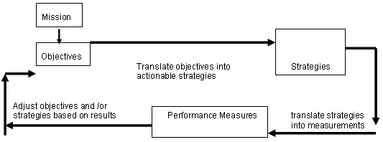
There are no less than three reasons why offices should, and routinely do, measure their execution:
1. To join mission, methodology, qualities and conduct
2. To upgrade the correct things
3. To characterize the that methods for achievement in setting of numbers

Major Viewpoints Of a BSC
The center objective of the Adjusted Scorecard is to help supervisors and alter in help of the longer-term procedure in arrange to oversee execution. The scorecard distinguishes what the company and the methodologies are. It works as a catalyst for bringing within the ‘change’ component within the organization. This instrument could be a total system which considers the taking after points of view and tries to urge answers to the taking after questions – 1. Money related Viewpoint - How do we show up at shareholders?
2. Client Point of view - How have to be we show up to our customers?
3. Internal Commerce Forms Point of view - What need to we exceed expectations at?
4. Learning and Development Point of view - Can we proceed to make strides and make value?
Hence, from the over strains able to say that this gadget has considers each the financial result and the components which certainly power a company toward future victory. The gadget has given push on the diverse zones which are required to ‘balance’ the monetary perspective.
The Learning & Development Point of view
This point of view comprises of specialist instruction and company social states of mind related to each man or lady and corporate self-improvement. In a knowledge-worker organization, human creatures -- the as it were store of information -- are the transcendent asset. Within the current climate of rapid mechanical alter, it is turning into pivotal for understanding individuals to be in a nonstop acing mode. Government businesses regularly find themselves incapable to delegate modern specialized laborers, and at the break even with time there's a decline in instruction of current representatives. Usually a driving marker of 'brain drain' that needs to be turned around. Measurements can be put into area to data supervisors in centering preparing cash where they can help the foremost. In any case, considering and development speak to the basic premise for victory of any knowledge-worker organization. Kaplan and Norton emphasize that 'learning' is more noteworthy than 'training'; it moreover comprises of things like tutors and guides within.

The Trade Handle Perspective

This point of see is related to inward commercial venture forms. Variables related to this perspective empower the directors to know how well their commerce is going, and whether or not its stock and offerings are pleasant client necessities (the mission). These components have to be be cautiously outlined by way of those who comprehend these approaches exceptionally well. In expansion to the key administration prepare, two sorts of undertaking approaches may also be distinguished: a) mission-oriented forms, and b) help forms.
Mission-oriented methodologies are the extraordinary capacities of specialists workplaces, and numerous uncommon issues are experienced in these forms. The bolster procedures are more tedious in nature and for this reason easier to degree and benchmark the utilization of far reaching metrics.

The Client Perspective
Recent organization hones are showing rising acknowledgment that the significance of customer and their confirmation of fulfillment in any undertaking is vital. These are the key markers: on the off chance that clients are not fulfilled, they will eventually switch to other providers that will meet their needs. Destitute generally execution from this point of view is as a result a driving pointer of future decrease, indeed in spite of the fact that the modern-day budgetary picture may also appear to be good. In creating measurements for fulfillment, clients ought to be judged in expressions of sorts of clients and their particular see around the item or service.

The Financial Perspective
“Kaplan and Norton” do not expel the standard need for money related information. Opportune and exact subsidizing data will continuously be a need, and directors will do something necessarily to supply it. In truth, habitually there's more than satisfactory managing with and preparing of budgetary information. With the usage of a corporate database, it is trusted that additional of the handling can be centralized and computerized. But the point is that the modern-day accentuation on financials leads to the "unbalanced" situation with respect to diverse perspectives. There is maybe a have to be include extra financial-related information, such as risk assessment and cost-benefit information, in this category.

The Four Points of view: Cause and Impact Relationship

Four viewpoints as famous over are generally interlinked. There's a consistent association between them. The clarification is as takes after: On the off chance that an organization centers on the picking up information of and the development angle, it is unquestionably progressing to lead to higher commercial venture forms. This in turn would be watched by implies of extended buyer fetched by utilizing creating superior items which in the long run offers upward shake to quickened financial performance.
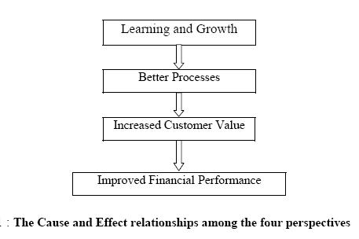
“A strategy is a set of hypotheses about cause and effect. The chain of cause-and- effect should pervade all four perspectives of the Balanced Scorecard therefore a properly constructed Balanced Score Card should tell the story of the company's strategy.”(figure 2)
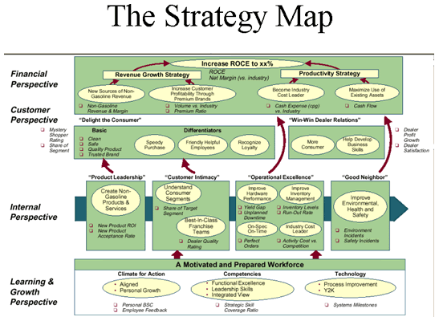
Figure 2
Performance Drivers
“A good Balanced Score Card must have a combination of outcome measures (lagging indicators) and performance drivers (leading indicators). Outcome measures without performance drivers do not communicate how the outcomes are to be achieved or give an early indication about whether the strategy is being implemented successfully. Conversely performance drivers without outcome measures (may achieve short term operational improvements) fail to reveal whether operational improvements have translated into expanded business with enhanced financial performance.”Example (Figure 3)
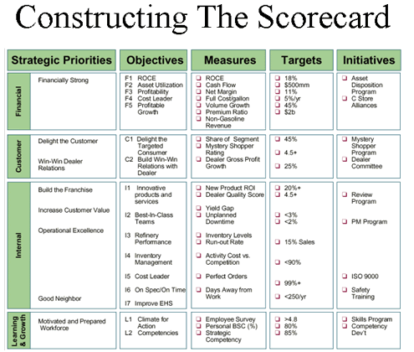
achieved organizational score card wants to have the following components:
▪ Strategic Themes Identified
▪ Strategic Objectives Identified
▪ Measures for the execution of the strategic objectives
▪ Competitive Bench Marks for the measures chosen
▪ Short Term and Long term objectives for identified measures
▪ Initiatives aligned to the Strategic objectives for execution and review.
Once the organizational score card is prepared and finalized the scorecard is to be used as an enjoyable method of alignment see (figure 4). Departmental, Process, and Individual score singing cards aligned to score of business card will translate your method to each day management.
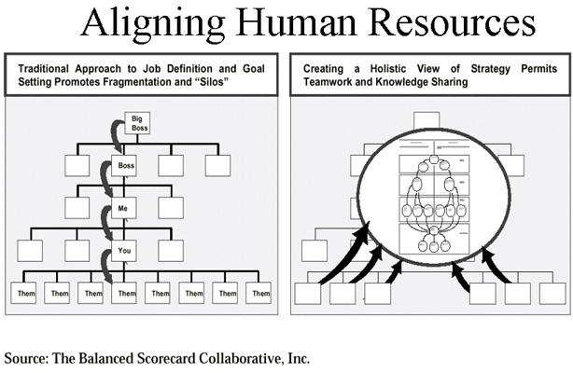
Links to Six Sigma
Six Sigma is a significant strategy that reduces organization strategy for Business improvement. The most effective part of Six Sigma is in the utility of the rigorous DMAIC philosophy to projects to greater of patron satisfaction and Business results. While Six Sigma helps groups in elimination of waste in their pursuit to excellence the Balanced Score Card lays the basis for the implementation of an tremendous Six Sigma strategy.
When one attempts to view the evolution of quite number size systems you ought to see that Balanced Score Card encompasses Financial, Strategic and Operational measurements. See (Figure 5).It is clear to visualize that implementation of Balanced Score Card followedby way of the deployment of Six Sigma is a betterapproachtowards Six Sigma deployment. While the validated statistical tool set of Six Sigma operates at the operational degree the Balanced Score Card gives the intent for identification of areas for improvement.
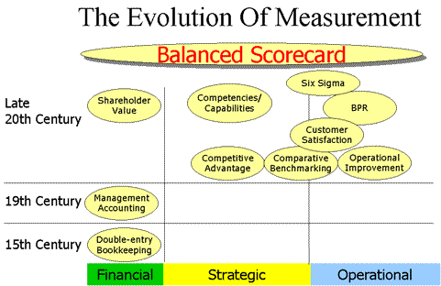

Building and Implementing The System Using a BSC
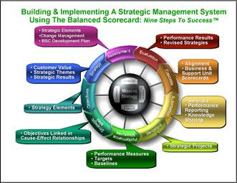

Step One of the scorecard building strategy starts with an evaluation of the organization’s Mission and Vision, challenges (torments), enablers, and values. Step One furthermore comprises of making prepared an substitute administration plan for the organization, and conducting a centered communications workshop to find key messages, media outlets, timing, and messengers.
In Step Two, variables of the organization’s procedure, which incorporates Vital Comes about, Vital Topics,and Viewpoints,are created by utilizing workshop people to central point intrigued on supporter wishes and the organization’s fetched proposition.
In Step Three, the key components created in Steps One and two are decayed into Vital Targets, which are the essential building squares of approach and characterize the organization's key expectation. Goals are to begin with started and labeled on the Vital Topic level, classified by implies of Viewpoint, connected in cause-effect linkages (Technique Maps) for each Vital Subject, and after that afterward combined collectively to create one set of Key Targets for the total organization. In Step Four, the reason and affect linkages between the enterprise-wide Vital Goals are formalized in an enterprise-wide Methodology Outline. The sometime recently created subject Methodology Maps are blended into an commonplace enterprise-wide Methodology Outline that appears how the organization makes taken a toll for its clients and stakeholders. Collectively to create one set of Vital Targets for the total organization.
In Step Five, Execution Measures are created for each of the enterprise-wide Vital Goals. Driving and slacking measuresare distinguished, anticipated aspirations and edges are set up, and standard and benchmarking data is developed.

In Step Six, Key Activities are created that back the Key Targets. To develop responsibility at a few point of the
organization, ownership of Execution Measures and Key Activities is allotted to the awe inspiring workforce and reported in insights definition tables.
In Step Seven, the usage strategies tarts by implies of making utilize of execution estimation program program to urge the right in general execution data to the proper people at the right time. Mechanization gives shape and self-discipline to upholding the Adjusted Scorecard framework, makes a difference truly alter dissimilar corporate truths into actualities and information, and makes a difference communicate by and large execution data. In brief, robotization makesdifference human creatures make superior choice since it gives speedy get right of passage to authentic in general execution data.
In Step Eight, the enterprise-level scorecard is “cascaded” down into trade and help unit scorecards, meaning the organizational level scorecard (the primary Level) is deciphered into undertaking unit or help unit scorecards (the second Level) and after that afterward to team and character scorecards (the third Level). Cascading deciphers high-level approach into lower-level destinations, measures, and operational points of interest. Cascading is the key to organization arrangement circular strategy. Team and individual scorecards linkday-to-day work with division never land corporate vision. Cascading is the key to organization arrangement circular methodology. Execution measures are created for all goals at all venture levels. As the scorecard administration machine is cascaded down through the organization, objectives blend as more prominent operational and strategic, as do the by and large execution measures. Responsibility takes after the goals and measures, as ownership is portrayed at each level. .
In Ninth step, an evaluation of the selective out scorecard is define. During this evaluation, the company tries to reply questions such as, “Are our strategies working?”, “Are we measuring the right things?”, “Has our environment changed?” and “Are we budgeting our cash strategically?”

The Balance Scorecard Model
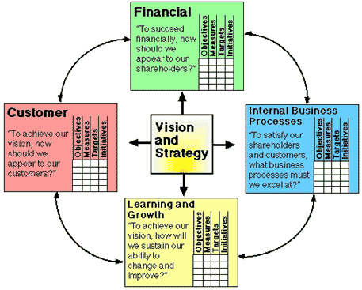

The Model – and the Explanation:
The mentioned model is to define the strategic management tools and which could be done from the aforesaid model, his need to be understand one so as to utilize the Balanced Scorecard as a strategic management tool:
1. Ultimate objectives is need to set for each of the perspectives.
2. Measurement of the performance need to be define under every purposes. This would shortest the organization forunderstand the set goal for each of the perspectives. And these will act as constraints in dimension of the development.
3. Then comes another important step and that and the set target for define areas of explanation. This can be used as a standard for performance appraisal.
Based on the process a performance measurement tools will be created by considering the seriousissues. Any deviation from the organization should flag the voice to the supervision committee. And then management can investigate the reasons for selective deviation and resolve the issue.
4. The appropriate strategies and the action plans that are to be taken in the various activities should be decided. Then they should act to pursue the pre-decided goals. Because of this reason, the Balanced Scorecard is often referred to as a blueprint of the company strategies.
This example will explain the management to identify the problems. Few of the measures and objectives are define as below.
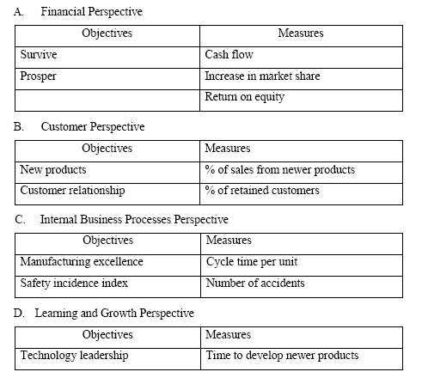
The above given data shows that all the four areas are given equal importance in measuring performance level. The objectives and the measures and, however, to depend upon the type of business the organization is doing. The financial data summary canaccompanied by the non-financial unites. However, goals and objectives are usuallyconfigure for each of the critical success factors under each of the heads; it brings about a focus on the strategic vision. Thus, all activities would be directed to achievement for the long-term areas which would have been define by the top supervision. The documents of the key result parts help an institute forgrowing big through strategic direction. The mentioned tool creates a communication between targets, objectives, targets, initiatives and measures. It is, thus, this can be said that this tools can be determine the efforts and the designed through the Balanced Scorecard which is the facts and the points institute efforts, customers, management, communication, motivation, manage, designing and other individuals which are staffs, supervisor, managers, owners, staffs, stockholders and for the customers.

Featuresofagood Balanced Score Card:
1. A proper Balance Score Card can define layer of the strategy of a company’s to identifies the behind reason and the relationship effect.
2. It helps to talk the method to all participants by interpreting of the employer for the strategy. It hyperlinks set of measurable operation targets and understandable.
3. A balanced rating card highlights non-financial of actions and the section of data to forecast future act of financial
4. The balanced rating card reduce the variety of actions to figure out only the part of important domineering. The purpose in the focal point manager’s interest on measures that most affect to the strategy implementation.
5. The BSC highpoints less than most excellent tradeoffs that chiefs may also regulate the ineffective reflect on consideration on operational and financial measures together.

Advantage of Balance Score Card

The BSC is generally used for various businesses in the practice of the global institutes due to the its competitive advantages this process is able to generate below benefits:
- To communicate the purposes of the organization
- To supports the strategic of the involved stakeholders to achieve the longer goals.
- To define the method and vision into noticeable action.
- To determine the planned connected within the organizations.
- It connect every individual within the organization for the involvement of the individuals within a business entity.
- It support the business participate for the programs. like: reengineering, quality and patron service actions.
- Define the measurement of strategic to the down level for the unit staffs, operator’s superiors, and employees can understand what is required to achieve the goal.
- It define a path for compensating employees for success.
- The scorecard presents remarks for senior administration while method is occupied.
- Set goal to the complete or agency on the BSC to determine excellent performance driver.

Disadvantages of Balance Score Card

● This is actually hard to enforce this device due to involves so many subjective issues.
● This device is a whole lot extra complicated likened to the different implements
● To measures the need has been taken are depending on type of situation, commercial and enterprise the corporation within.
● The modification is however needed to be attained for the underset an dabble to every participant related within the institute.

The BSC as a strategic Management Tools
The process or the tools can be used as defense for any business institute to determine the conflicting interests, prioritization of objectives, pressure points, objectives background, budgeting and planning. The four important steps which will need to address are given below and those steps need to implement as well.

Translating the Vision
This is keeping in thought that the idea of any connotation have to be determine through every and all employee of the organization. However, viewed of the pinnacle only organization, which is supposed to be sure for the corporation will not work to translate the objective. Before starting any of the plan desperation system, the companies want to ensure about the goal of the actuality of its purpose. The managers construct an agreement round the system of the business institute imaginative and prescient and policy. The policies, will derive for the goal and target of the business organization where skill that might define a connection needs to be shaped among the plans of the unique professional devices and the imaginative and prescient of the institute. The condescending reports must be interpreted into a built-in set of targets and strategy’s. Moreover, by resources of the usage of this system, the ordinary strategic goals for the organization receives elucidated which may determine to improvement agreement and through same type of enterprise implements on the complete planned goals for the business establishment.

Communicating and Involving
Communicating the strategies and the visions no longer a given up in the subject.
The tactical requirement sand the events need to be set in the specificanges need to be plan accordingly. The long term strategic visions need to be interpreted into each team and man or goals of woman which need to done with aligned for each different in order to comprehend the long term objectives. More than that, all of the same of kind steps in the order of organizational desires to be accomplished about the motion plans and motives to do the compliant and the same as desire. The device consists of the information in three stages:
(i) It elaborate the organization measures, targets and the objectives
(ii) It help to understand the result of enterprise unit objectives and
(iii) it determine the inclosing the departmental for the man or woman targets this process will help the process to achieving the initiative for more clearly it will process the achievement for the organizational objectives. Personnel are assigned with their self-choice to understand overall goal, target and the recreations attainment for which would cross the business enterprise to process proper strategic plan. The recompense of the stage is connected for performance level of each individual when reality contains so many choices.

Business and its Planning
This step assists in the allocating resources. It is saved in idea that targets shape necessary standards in identifying the resources must be treated carefully. No strategy can deliver profitable effects to an organization unless the sources are allotted properly. This allocation is established on the budgeted estimates which are determined based on the objectives. Hence, by means of this step the Balanced Scorecard brings about integration between strategic planning and the budgeting exercise. The momentary desires are also vital to be figured out which in totality brings about a linkage between strategic dreams and the budgets. This technique helps in actualizing what has been set by using the organization. Thus, this step brings about a shift from the ‘thinking’ exercising to the ‘doing’ stage and the organization tries to reap the long-term desires thru the momentary actions.

Feedback and Learning
First steps which is already mentioned above (three) are associated to strategic implementation process. But, to pick out whether or not the agency is successful to accomplish the targeted goal dreams and whether it is in the right track, it is very vital to use the system of feedback and learning. The strategic gaining knowledge of capability obtaining know-how about in that process an institute is heading to, judging the process of properties viewed previously maintain genuine for than and present condition and ultimately doing the changes any where compulsory. The counter active actions are required to enable the employer pursue the right path.
In addition to that, an association comes to study whether or not the cause-and-effect relationships amongst the distinctive views genuinely hold real or not. If holds then more than the level they are in tensely connected and also do it or not advantageous outcomes are existence attained. In case of any institute identify any difference of the gap and effect of any interactions effect, they want to take an immediately corrective measure and this is needed due to that a tremendous relationship can be made between the numbers of reasons. Therefore, the balance score card with its description for the causativeness lotion among complete performance processors and targets permits company and the commercial enterprise component purposes management to use their periodic evaluation periods to maintain the consider the validity of the unit’s method and the excellent of and the practice of it. Thus, this comments and mastering workout may additionally pressure a corporation to trade the actions define in each of the points and assume those, the managed process will safeguard the process of the define business strategy and the corporate policies.

Conclusion
The Balanced Scorecard is very essential strategic administration device which I helpful to measure only the performance and figure out the best techniques which are wished to be fit in longer goal o be achieved. And in another thought, the used of this system of this tool ensures the stability of imaginative and prescient and motion which is again one step closer to the increase of a profitable organization. Also, its suitable implementation can make certain the development of advantage for a business institute which will assist the organization to increase an aggressive benefit besides this is expect to overtake its competitors.

Bibliography
www.valuebasedmanagement.net.
http://en.wikipedia.org
www.thebalancedscorecard.com
www.managementhelp.org
ucsfhr.ucsf.edu/files/implementationguide.doc
www.fibre2fashion.com
www.managementparadise.com
www.citehr.com
www.ukessays.com
www.vidyasagar.ac.in
www.symphonytech.com
www.mcg.cc
www.balancedscorecard.org
Student paper Submitted to XLRI Jamshedpur

