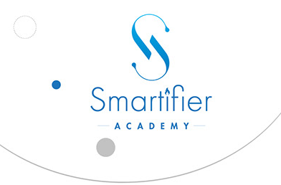

Human Resource Management Practices of

Smartifier Academy and

The Changes during Pandemic



Project report on Human Resource Management Practices of Smartifier Academy and
The changes during Pandemic

Submitted to
Ishrat Sultana
Assistant Professor
SOBE, United International University

Submitted by
Umme Tasnin Shanta
ID: 111 161 033

Date of Submission
April 12, 2022

Letter of Transmittal

April 12, 2022
Ishrat Sultana
Assistant Professor
SOBE, United International University

Subject: Submission of project report on ‘Human Resource Management Practices of Smartifier Academy and the changes during Pandemic’

Dear Madam,
With due respect, I am humbly presenting you the assigned project report on ‘Human Resource Management Practices of Smartifier Academy and the changes during Pandemic’. I am honored to have the guidance from you to complete this project report as an integral part of completion of my BBA program in UIU. I tried to give my utmost effort to compile up all the information regarding the preparation of this report.
I, therefore, fervently request and ardently hope that you will go through the project report and I also hope that the report will be able to fulfill your expectation as per requirements.

Sincerely,
Umme Tasnin Shanta
ID: 111 161 033
Student of BBA program, UIU
Signature: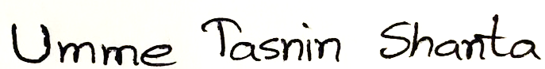

Declaration by the Student

I am Umme Tasnin Shanta having ID: 111 161 033, a student of School of Business and Economics (SOBE), Majoring in Human Resource Management and Marketing of the BBA program of United International University hereby declare that the project work on ‘Human Resource Management Practices of Smartifier Academy and the changes during Pandemic’ is my original work derived from various work experiences and interview for the completion of my BBA program work project focusing on HRM. I have provided due reference and recognition of any authors or organizations’ work. No work of other individual’ work or of any other organizational sites is copied in this project report.

Signature:
Student Name: Umme Tasnin Shanta
ID: 111 161 033
Program: BBA (Major in HRM and Marketing)
School of Business and Economics,
United International University

Acknowledgement

At the very beginning, with utmost gratitude I would like to convey my thankfulness wholeheartedly to the almighty ALLAH for giving me the strength, ability and knowledge to pull off the project report completely.
I am blessed to have the supervision of my honorable faculty Ishrat Sultana, Assistant Professor, SOBE, United International University. She has been immensely caring, supportive and an understanding faculty for which reason it has been less difficult for me to complete the report during pandemic situation. Her guidance was to the point and she had cleared out all the confusions with proper instructions. I pray for her success and good health for her goodness.
I would also like to express my gratitude to the founder of Smartifier Academy, Md. Sohan Haidear for allowing me to do the project report on the organization. It has been a privilege to have the understanding of a startup from him as a mentor. I am also grateful to the team members of Smartifier Academy to provide me their valuable time and effort by answering my interview queries.
Moreover, I would like to convey my thankfulness to my respected parents, my father- Hasan Ali, my mother- Razia Hasan for their support and sacrifices to make my life beautiful. They are the cause of my every success. Specially I would like to mention my husband- Mohammad Rakibul Hossain as a good-hearted fellow and a support giver throughout the rough journey. My family has been a blessing to me for completing the whole journey of BBA in United International University. I am thankful to all the members in the University.

Contents

Executive Summary x
Chapter 01: Introduction
1.1Topic of the Report 11
1.2Background of the Report 11
1.3Scope of the Study 11
1.4Objective of the Study 12
1.5Methodology 12
1.6Limitations 13
Chapter 02: Literature Review
HRM Functions 16
Human Resource Planning 17
Recruitment and Selection 17
Training and Motivation 18
Performance Management 18
Compensation 19
Industrial Relation 19
Employee Health and Safety Measurement 20
Employee Record Keeping 20
Labor Law 21
HR Audit 21
Corona Virus Pandemic and HRM 22
Chapter 03: Company Overview
3.1 The Journey of Smartifier Academy 24
3.2 About the Managing Director and CEO 24
3.3 Logo of Smartifier Academy 25
3.4Mission 25
3.4 Vision 26
3.5 Values 26
3.6 Product & Service 26
3.6.1 Product: 26
3.6.2 Service: 27
3.7 Organogram of Smartifier Academy 29
Chapter 04: Human Resource Management Practices of Smartifier Academy
HRM in Smartifier Academy 30
4.1 Human Resource Planning in Smartifier Academy 31
Right Employee with Right Skill 31
Strategic Aim Achievement 31
Enhancing Profitability 31
Growth Mindset 32
Employees Interpersonal Skill 33
4.2 Recruitment and Selection in Smartifier Academy 33
Hiring Plan 33
Recruitment Source 34
Vacancy Circulation Media 34
CV collection and Screening process 35
Interview and Selecting candidates 35
4.3 Training and Motivation in Smartifier Academy 36
Nurturing & Motivating Employees 36
Connecting with Employees 37
Designing Training Program 37
Transferring the Training Learnings 37
Need For Training and Motivation 39
4.4 Performance Management in Smartifier Academy 39
Supervision of Employees 40
Smart Objective Implementation 40
Reinforcing Action Plan 40
Follow up 41
Focus on Goal 41
Monitoring Activities 41
KPI Recognition 42
4.5 Compensation and rewards in Smartifier Academy 42
Form of Compensation 43
Salary and Bonuses 43
Pay rate Balance 43
Individual Equity 44
Competitive Industry based Payment 44
Payment Procedure 45
Rewards and Leave Plans 45
4.6Industrial Relations with Smartifier Academy 46
Industrial Collaboration 46
Behavior of Employee & Employer 46
Management of Resources 47
4.7 Employee Health and Safety Measures in SA 48
Maintaining Employees Health 49
Mental Health Support 49
Geographical Placement 49
Etiquette 50
Layoff and Turnover 50
4.8 Employee Record Keeping in SA 50
Employee Records for Employment 50
Need for Employee Records 51
Employees’ Health information 51
Trained Employee Records 51
Chapter 5: The Changes of HRM Practices in Smartifier Academy during Pandemic
5.1 Changes in Human Resource Planning due to Pandemic 53
5.2 Changes in Recruitment and Selection due to Pandemic 53
5.4 Changes in Performance Management due to Pandemic 54
5.3 Changes in Training and Motivation Due to Pandemic 54
5.5 Changes in Compensation and Rewards due to Pandemic 55
5.6 Changes in Industrial relations for Pandemic 56
5.7 Changes in Employee Health and Safety Measures due to Pandemic 56
5.8 Changes in Employee Record Keeping for Pandemic 57
Chapter 6: Analysis and Findings
Analysis of Interviews and Findings 58
Strength 60
Weakness 60
Opportunities 60
Threats 60
Profitability through HRM 61
Chapter 7: Recommendation and Conclusion
Recommendation 62
Conclusion 63
References 64
Appendix 65
The Interview Questionnaire 65
Questionnaire for the Founder of Smartifier Academy 65
Smartifier Academy & Founders’ Profile 65
Smartifier Academy’s Functionality 65
Training, Recruitment & Compensation 66
Employee Management 66
Organizational Activities 67
Futuristic Plan 67
Pandemic Effects and SWOT 67
Questionnaire for the Employees of Smartifier Academy 69
Employee Tenure and Responsibilities 69
Office Facilities 69
Recruitment, Compensation and Training 69
Industrial Relationship 70
Employee Health and Pandemic 70

Executive Summary

This project report is the representation of HRM functions in pandemic situation of a startup named Smartifier Academy. The report sheds light on how the HRM evolved along with the attack of pandemic in this growing training and consultancy organization. This report showcases the functional areas of work, product, services and its changes to protect the reputation of the organization while continuing their service in the knowledge field. The methodology of collecting data from the recognized sources has worked in its authenticity improvement. The journey of Smartifier Academy in the HRM field is shown here by pointing out the Human Resource Planning (HRP), Recruitment and Selection, Training and Motivation, Performance Management, Compensation and Rewards, Industrial Relations, Employee Health and Safety Measures, and Employee Record Keeping in Smartifier Academy.
The report also shows the practical changes due to the pandemic in particular field signifying the output of its’ action on HRM field. The changes are discussed sequentially from the changes in HRP, changes in Recruitment and Selection, changes in Performance Management, changes in Training and Motivation, changes in Compensation and Rewards, changes in Industrial Relations, changes in Employee Health and Safety measures, and changes in Employee Record keeping due to pandemic situation all over the world.
Later on, the analysis of the interviews and findings with strength, weakness, opportunity, threat (SWOT) are presented with the HR impact on its profitability in the organization. Finally, the report concludes with a hope and view of recommendation for the upcoming success of the organization.

Chapter 01: Introduction

Topic of the Report

‘Human Resource Management Practices of Smartifier Academy and the changes during Pandemic’ is the assigned project report topic.

Background of the Report

To beat the pandemic in this 20th century the world is trying to progress with the effort of every individual from big organizations to new startup companies. This project report is a submission for fulfilling the requirements of Bachelors of Business Administration (BBA) program in United International University (UIU) which represents the pandemic work pattern & Human Resource Management function in a startup organization named as Smartifier Academy. This project report is an upshot of the utilization of learning about the Human Resources Management functions in the BBA program to the real life implementation through Smartifier Academy.

Scope of the Study

This report is a receptacle of the working pattern of a startup organization through which their functioning in Human Resource Management field is focused and their development process along with the challenging working pattern in the Corona situation is covered. This study is a representation of real life HRM related dealings of the employees in Smartifier Academy in pre-pandemic time and during pandemic time.

Objective of the Study

The most important objective for the completion of the project study is to meet the requirements of the BBA program in United International University. This requirement of the project works as a gateway to accomplish the quench of thirst for discovering the unknown possibilities of working pattern in the global pandemic situation by a startup organization and to implement & relate the learning from the HRM subject major.

Methodology

The methodology of the report is constructed in a qualitative manner. The theoretical process of data collection includes primary data & secondary data which are described below.
    - Primary Data
According to the instruction of my supervisor, the primary data for the project is collected with the help of the interviews of the respondents who work for Smartifier Academy directly or have worked here previously. I have included the founder’s interview and the employees’ interview in a descriptive manner so that their response can be adorned along with the functional need of HRM. The total interview was done by using messenger phone call &WhatsApp due to Corona. The total duration of the interviews was 4 hour 30 minutes approximately during pandemic.
Moreover, as I have worked in Smartifier Academy as an Intern for three months and then as an Associate Business Developer for five months before pandemic, so I have put my understandings and learning’s about the organization to improve the authenticity of the report.

    - Secondary Data
To comply with the theoretical learning of HRM and to show the relation of HRM in an organization like Smartifier Academy, I have collected information from different publications like books of different authors, online journals, and some official website related to my project subject.

Limitations

It has been challenging to pull off the report by maintaining authenticity and timely representation due to the contagious pandemic Corona virus. Some problematic issues which worked as limitations for the project are stated below.
- The interviews are conducted through using telecommunication system which lacked the human touch due to corona. For this reason, I had to concise the interview timing.
- Two of the respondents were attacked by Corona directly which caused challenges to take their interview.
- Though the respondents have been co-operative mostly throughout the interview, but some of the questions were skipped by them due to their personal reason or to maintain the official protocol of secrecy.
- Due to corona the organization is changing their strategies swiftly which might not comply with the current collection of their answers used in the report.
- It took me a lot of time to complete the report. The collection of the information during this pandemic and to set a manageable time for every respondent for the interview has been a strenuous work.

Chapter 02: Literature Review

Human Resource Management works as the process of proper utilization of available skilled workforce in an organization by acquiring, training, appraising, compensating employees, and of maintaining their labor relations in compliance with labor laws of the land, and of focusing on their health, safety and fairness concern to help the organization to gain competitive advantage. Human Resource Management (HRM) has emerged as a popular subject within a very short time. HRM entails the improvement of the organization as well as the employees of the organization which is indispensable for the success of an organization in any industry.
The evolution of ‘Human Resource Management’ is from ‘Personnel Management’. It is also said that Personnel management is the prominent predecessor of the Human Resource Management. Robert Owen (1771- 1858) is known as the father of ‘Personnel Management’. Personnel management focuses on hiring and developing personnel in the organization to become valuable to the organization. Robert Owen initiated the eight-hour daily labor for any human so that everyone has the scope of eight-hour rest and eight-hour recreation daily which will make the employees productive and will lessen their burden. This Eight-hour day movement of 1817 later signified the Labor Day and as ‘May Day’ which is still celebrated around the world. After the Second World War in 1945 the actual development of Personnel Management started to evolve. Personnel Management did not have a big futuristic aspiration and it was not that much challenging at that time. It emanated due to the optimization of the organizations’ profitability by unifying labor unions so that it gets easier for them to train them at a particular time by improving the quality of the employees. The process of training employees helped the organizations to reduce operating cost as well as having the trained employees the productivity got increased which gave a positive output to increase the revenue. For this reason, the organizations took Personnel Management earnestly and focused on shaping it on a more strategic manner to keep pace with the competitive market. The importance of employees was being recognized with the improvement of companies’ sustainable growth for Personnel Management which later on helped the Human Resource Management to evolve with a committed workforce.
George Elton Mayo (1880- 1949) is known as the father of ‘Human Resource Management’. Human resource management has the strategic approach to the effective management of the organization and its people by forecasting the need to gaining the competitive advantage. The field of ‘Human Resource Management’ evolved in the early 20th century which was influenced by ‘Scientific Management’ by Frederick Winslow Taylor (1856–1915). HRM got its big breakthrough after the mid- 1980s. After George Elton Mayo’s involvement in ‘Hawthorne studies’ in 1928 the study glorified the impact of workers responsiveness to their managers and the working ambience effect on the output. Earlier the employees were not regarded as valuable resources to the organization. After the study, it was prominent that the management of employee’s matter. George Elton Mayo gave indication that only hiring and firing is not the only way of managing the skilled workforce, the manger has to do more to gain the highest output throughout the management of the employees. Mayo also expressed that the success of a plant does not depend on the management of single employees rather management of the working group. The proportion of success or failure depends on the awareness or ignorance by the group of any department as authority and leader.
According to Ivancevich and Glueck (1989) in his book ‘Foundations of Personnel: Human Resource Management’, the function of HRM is performed in the organization which facilitates the most effective use of the employees to achieve organizational and individual goal.
Another author Pigors and Myers (1981) in the book ‘Personnel Administration’ expressed their thought about HRM as a method of developing potentialities of the employees so that the employees have the feeling of maximum satisfaction and this way, they give their best efforts to the organization.
Jeffrey A. Mello (2011) in his book ‘Strategic Human Resource Management’ manifested that strategic approach to HR provides an organization different benefit like having focus of high-quality workforce, cost effective utilization of labor, facilitated adaptation of planning and assessment of uncertain environment and forces that impacts the organization.
Gary Dessler (1973) in his book ‘Human Resource Management’ explained HRM as the process where the employees are acquired, trained, appraised, and compensated. Also, the employees’ labor relations, health & safety and fairness concerns are also processed through HRM.
Dipak Kumar Bhattacharyya (2017) in his book Compensation Management referred to different factors such as search for competitive advantage, failure of Personnel Management, changes in the workforce and the nature of work as the reason which revolutionized the concept of traditional Personnel Management and developed the concept the concept of Human Resource Management.

HRM Functions

Human Resource Management (HRM) as a department in an organization is responsible for achieving the organization’s goals by managing the employees which is followed by different functions like: human resource planning, recruitment & selection, performance management, training & motivating, career planning, compensation & rewards, industrial relation, safety to employees, employee record keeping, human resource auditing, and compliance to labor laws. These functions vary with the diversity of the employees in an organization which depends on the industrial structure of the organization. The Human Resource Managers’ proficiency for the management of the team is imperative as the HR Manager has to preside over and implement the HRM process.
HRM is a continuous process which is very much of people centered and focused on results. The functions of HRM actually varies according to the pervasive nature of the organization otherwise the primary functions of HRM are very similar for every organization. In early days of personnel planning, the work of probable HRM was supposed as hiring and firing, but later on with the scientific management of Human Resource, the concept of workforce got evaluated as valuable resources. This created the demand of modernization of the functions of HRM for various organizations with multipurpose goal settings for different industries. The functions of HRM are operated with the primary need realization of qualified employees for the organization.

Human Resource Planning

Human Resource Planning (HRP) ensures the organization to have quality employees by continuing the systematic planning in the organization. By avoiding the manpower shortages or surpluses the organization finds the best fit between the job and the employees for the company or institute. The top-level executives in any organization are responsible for HRP as it helps the organization to maintain its human resources as the most important resource in the organization. E. W. Vetter (1964) has defined the HRP as the process where the management decides the movement of the organization from the current manpower position to the intended manpower position. This planning of human resources helps the organization to have right kind of people at the right places, at the right time to do or complete things which help both the organization and the individual employee to receive maximum long-range benefits. The process of core HRP mostly follows four steps. The organization observes the present employee or labor supply in the organization. Later the organization forecast the need of employees or employees. Then the organization matches the need and demand of the workforce with the supply. This way finally the process of HRP meets the plans which support the organizations goals.

Recruitment and Selection

Recruitment and selection process come right after the realization of the organizations need for new employees or labor force in the organization. Recruitment is the process where the eligible and potential applicants are found for the organization and are encouraged to apply for the required job. The process of recruitment follows the planning for the probable employees, strategy development to search for the right type of workforce, screening their capabilities to justify for the need assessment of the organization and finally to evaluate and control the workforce. The co-founder of Apple incorporation, Steve Jobs (1955- 2011) in a conference said that the secret of his success is because he has gone exceptional lengths to hire people who are best in the world. After all the functions of recruitment, the process of selecting the employees comes.

Selection is the process of hiring the shortlisted candidates who have passed through all the screening and does match the requirements and needs of the organization. After announcing the job, the organization reviews the candidates’ application and goes through initial level screening so that it gets easier to allocate the potential employees which matches with the organizational objectives and eliminates the less competent applicants so that the organization do not have to invest their time over them. Later on, the organizations mostly go through a in person interview process so that the probable applicant can be hired on the base of their competency and also the recruiters can be assured of the ability of the applicant. If all the process goes well then in some organization the applicants go through a probation period of work before finalizing the job or they are finalized as the selected employees for the organization as the recruiters get satisfactory output from the applicant. Phil Korsby (1979) expressed that the largest part of coaching is to select the right person for the right job.

Training and Motivation

Training and motivation are required to improve the individual employees’ knowledge and to complete the work in an effective manner with ownership. To impact the corporate bottom line and to create a productive work environment for the individuals, training and motivation is exceptionally required. To increase the knowledge and expertise on the job field training is required for every employee. Training is also considered as a motivational factor as it also helps to grow and improve the intelligence of the employee and creates a feeling of achievement and self-satisfaction with the new earned knowledge. This way the job expectations are fulfilled and their fear of failure or incompetency is removed which helps to increase growth mindset among the employees by creating a skilled workforce. Henry Ford (1863- 1947) an American business magnet said that the only thing which is worse than training the employees and losing them is to not train the employees and having them stay in the organization.

Performance Management

Performance management is required to be operated in the organization to continue the effective competitive attitude among the employees and to evaluate the quality or quantity of the employees work according to the desired level for the company or institute. Performance management is a corporate management tool & this process helps the managers to monitor and evaluate the activities and outputs of the employees so that their work meets the required result of the organization effectively and efficiently. Ms. Farhana Rashid in a lecture of Human Resource Planning at UIU in 2020 said that one should perform the assigned duty with diligence as the work performance of one person might affect hundreds of other people. Performance management creates an ambience of accountability & transparency between the workforce and the managers. This way the concrete rules are established. The organization meets the standard outcome with the help of performance management process as it fosters the creative and effective outcome from the employees.

Compensation

Compensation is a sub-discipline of HRM which refers mostly to the cash rewards in exchange of the services the employees do for the organization. It represents both the intrinsic and extrinsic rewards as the employees receive for performing their jobs and having a membership as an employee in the valued organization. The compensation does not completely refer to the monetary payment only like salary, wages, bonuses, incentives or commissions but it also includes non-monetary rewards and various benefits. On the completion of various goals, the organization sanctions rewards to their employees such as vacation for two days. Job seniority level, performance levels, learning of job-related knowledge or skills are described as an exchange of pay effort bargain and thus it is focused as monetary compensation program. Joseph J. Martocchio in 1998 in his book ‘Strategic Compensation’ explained that both HR strategies and competitive business strategies are reinforced with the designing and implementation of strategic compensation system. To leverage the value of Human capital as revered resource compensation performs a significant role.

Industrial Relation

Industrial relation works as a multidisciplinary field where the relationship between the employees and employers or the supervisor/ managers is maintained. To manage employee retention, engagement & to improve their careers, it is highly appreciable to maintain a good industrial relationship for the employers with the employees. This complex interrelation between the employees and employers are maintained to increase the profitability by continuing the communication and production of the organization by maintaining a healthy relationship between the two groups. Industrial relations are a dynamic field to indicate the socio- economic development on various aspects like the pattern of the state, the legal system, capital structure, compensation of labor force, the relation between the employee and the employer, study of market force etcetera. The concept of industrial is denoted as an extended version by including the relations among the workers/ employees, employers and other organizations and groups of different labor unions.

Employee Health and Safety Measurement

Employee health & safety measurements are one of the primary concerns for the employers as all the employees/ workers or laborers are entitled to it as their basic right. The working environment should be enough supportive for not only their physical well-being but also mental and emotional well-being. The organizations have their safety goals to attend according to the required working ambience. The changes of risk factor according to the industry also have an impact over the health & safety measures set up of the organization. The employees are also responsible to take care of themselves as well as their colleagues and to ensure the usages of protective safety measurements provided by the author of the organization. This form of cooperation supports the employees to be safe and to create a welcoming ambience for their healthy working environment.

Employee Record Keeping

Employee record keeping is an assortment of information pertaining to the employees in a book, file, diary, or in any other form of record including all the particulars related to the employees’ employment, capability, training history, performance review, job experience, compensation history and their personal information like their nationality and education. Employee record helps the organizations’ managers to find out the performance and relativity of the person as a suitable employee. This is also required for the legal purpose to maintain a balance in the HRM system.

Labor Law

Compliance to labor law is necessary to avoid fine imposed for discrimination, harassment, prejudice, nepotism, politics, mistreatment even favoritism to maintain a professional ambience to work for the employees in every country. The labor law not only protects the employees by ensuring the establishment of their legal rights but also helps the employers of the organization to balance the protocol and have a manageable authority over the employees.

HR Audit

Human Resource Audit is an extensive process of marking out the need for improvement & augmentation of the human Resource management functions in any organization by verifying the employee records, hiring and on boarding process, termination criteria and process, performance evaluation, compensation and benefits justification, training and other HR related current practices, policies and documentation in a comprehensive manner. HR Audit helps the organization find its strength point and rectify its mistakes to avoid fines. It ensures the effective utilization of Human resources thus supports the management by instilling confidence and improving employees’ satisfaction for the verified policies.
Human Resource Management (HRM) helps the organization to uphold its institutional principle by maintaining the policies and norms in an effective rational manner so that both the organization & employees have a disciplined and well-polished work place where the human are valued as resources. The scientific approach of HR also contributes the organization by recognizing merit and contribution of the employees which increases their productivity and ultimately the employee’s productivity results in to the increased profitability of the organization. The organization also can handle the manpower of its capability and can justify the removal of the demand of any employee if not required. HRM helps to eliminate the confusion among the employees by resolving the conflicts which flourishes the internal relationship among the team and improves the work life balance of the employees. This feeling of creating the belongingness among the employees with the employers boosts up the energy level and improves the team spirit which is a gateway to attain success in the competitive market with sustainability.

Corona Virus Pandemic and HRM

Organizations of the world are thriving for success by developing their activity in every factor among which HRM plays a major role. Though organizations try to take pragmatic measures to avoid disastrous unprecedented events, sometime those unexpected occurrences are beyond imagination to handle such as war, pandemic, natural calamities, or economic crisis. In 21st century COVID- 19 pandemic hit the world with Corona Virus and the impact is drastically challenging for all the people. The global harmony has been imbalanced due to the effect of pandemic as it is highly contagious. To fight back with the current situation from March 2020, most of the countries including Bangladesh planned a lockdown for the safety of the people for a certain time. Though in 2021 some vaccines were invented and applied but with all that there have been new stems of Corona Virus for which vaccine does not seem effective to eliminate the corona virus. The work of the organizations has not sat still or been closed totally for this pandemic. It is found that some organizations had to lay off a big part of their employees to sustain in the industry by searching for an economic stability but it has not been a feasible solution for many of the organizations. Majority of the organizations are negatively affected due to COVID- 19. To create a new normal lifestyle remote working practice like home office or social distanced working has been applied in many organizations.
The work practice and socialization with human touch is not as flexible as it was before the pandemic. The people management term is taking a new turn while the meetings are now done by video chatting through Google meet, Zoom or any other media of social interaction. Also, the use of mail is expanding as the uses of face-to-face interactions have been decreased. But all the employees of the organizations do not have the necessary equipment for the functioning technological employee engagement thus there comes a different type of challenge to ensure the remote working system by effective communication to support, engage, manage and re-designing. Not all the workers work from home for the organizations, a large number of employees devote themselves by continuing to work outside of their home in a space which might be hazardous due to Corona virus. The HR experts nowadays have to redesign and prepare their workforce by providing proper safety precautions & protection to the employees because all the people are valuable to the organization. The roles of HR professionals have significances to support the organizations’ production and to improve the employees’ efficiency so that the economy of the organization continues with success and the employees’ physical & mental well-being and economical safety is ensured. This way the HR professionals can play their role as a savior of the organization as well as a supporter to the economic growth of a country to beat a pandemic.

Chapter 03: Company Overview

3.1 The Journey of Smartifier Academy

Smartifier Academy (SA) started its journey as a startup organization in 2018. It is a fast-moving training and consultancy organization which aims to provide their services to their clients by applying Meta learning skills such as soft skills development like presentation skill, communication skill, time management skill, job readiness, productive employee mindset, emotional intelligence, NLP techniques, storytelling etcetera. Smartifier Academy mostly works with university students and young professionals. They work both on Business to consumer (B2C) & Business to Business (B2B) medium but due to Covid19 pandemic they are mostly focusing on B2C medium. In B2C for example they launched a training program online named as ‘Young Professional Smartification’ (YPS) in 2020 where 3,333 people & students from 41 universities from 40 districts of Bangladesh participated as it was a free training program aired in their Facebook group ‘Smartifier Academy Fight Club’ in pandemic. Around 28 trainers came forward for the success of the training. This was a milestone to overcome the losses of pandemic without wasting their resources. In B2B Smartifier Academy communicate with any organization and after understanding their requirements, SA designs their training program with a view to provide effective & efficient solution by fulfilling the focused objectives of the clients such as their training program on ‘Meta learning skills’ at Co-Design office and ‘Developing International Employee Mindset’ at The Daily Star. The specialized trainings are costly and take more time than any other random training. Smartifier Academy hopes to alleviate the lacking of soft skill training in Bangladeshi people and to improve the market with eligible and competent skilled workforce.

3.2 About the Managing Director and CEO

Md. Sohan Haidear is the founder, CEO and chief trainer of Smartifier Academy. He is a certified NLP practitioner from Malaysia. He completed his BBA from North South University, MBA from IBA Dhaka University and film making from University of West London. He has also won 2 South Asian Digital Media Awards with his team in Daily Star. With a diverse study field, he understood the importance of self-improvement& corporate grooming need. He realized the lack of training as a problem area which works as a hindrance of success for the emerging youth of Bangladesh. So, with a view to furnish the future of skilled human resource in Bangladesh Md. Sohan Haidear started off as an entrepreneur for building Smartifier Academy. He believes the change will not happen in a day, it will take time and effort and with dedication the brand awareness of his organization will reach more people and will make them self-aware about being a skilled workforce for any sector. He is happy to serve as a trainer and thinks that the skilled workforces are future investment for the country.

3.3 Logo of Smartifier Academy



3.4Mission

- Train people to be strategic with task management.
- Provide them with practical and relevant case studies.
- Design interactive, ‘gamified’ exercises.
- Decrease distractions from the workplace.
- Increase the attention span of people.
- Make trainings fun.
- Track results of trainees and help them evolve.
- Inspire growth mindset.
- Boost financial performance of clients.

3.4 Vision

We aim to improve profit, peace, and performance of individuals, teams, and companies through boosting productivity.

3.5 Values

- Focus on the users and the rest will follow.
- Always apply validated learning, avoid assumptions.
- Apply build-measure-learn modality of operation to thrive.
- Regular training boosts performance.
- Take failures as feedback.
- Protect the resources.
- Track mistakes, reasons behind them and never repeat them.
- Practice makes perfect.

3.6 Product & Service

3.6.1 Product:

Smartifier Academy is primarily a service providing organization. But they have some products too for their valued customer by the founder. During the pandemic in 2020 SA launched their first ‘E- book’ named as ‘Smart Career’ written by Md. Sohan Haidear in Bengali language. It was sold over 500+ copies all around the country. Also, in collaboration with other writers Md. Sohan Haidear from Smartifier Academy has already published two other books named as ‘Time Machine’ and ‘Personal Branding’ which is also available through Rokomari dot com. These books are also written in Bengali language which makes it easier to understand by the readers.
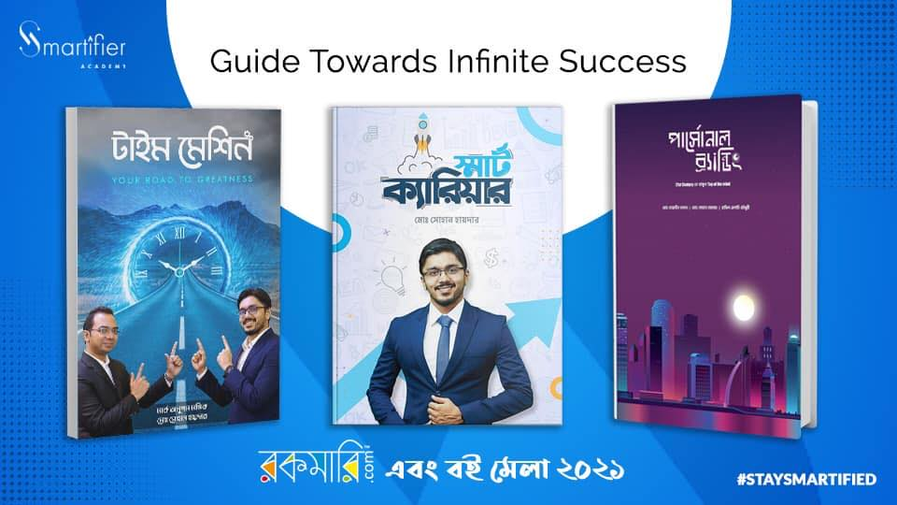
These are the books from Smartifier Academy and its Founder.

3.6.2 Service:

The services of Smartifier Academy are soft skills training and one to one consultation which are categorized into four sections.

- Job Readiness: Career mindset, Career mapping, CV writing, Interview skill, Salary negotiation skill.

- Employee Performance: Basic presentation skill, Communication Skill.

- Employee Excellence: Leadership skill, Persuasion skill, Negotiation Skill.

- Fourth Industrial Revolution (4IR): Decision making, Critical thinking, Creativity, Innovation, Problem solving and other skills referred by World Economic Forum.

These services are divided into two levels according to the client variation which is for B2C and B2B customers.

For B2C they provide:
- Presentation
- Public Speaking
- Communication
- Young Professional Smartification (YPS)
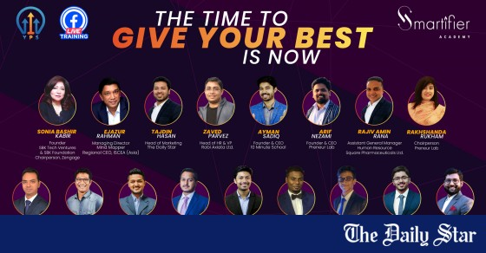
This is a promotional picture including some trainers at YPS.

For B2B they provide:
- Employee Smartification
- Sales Smartification

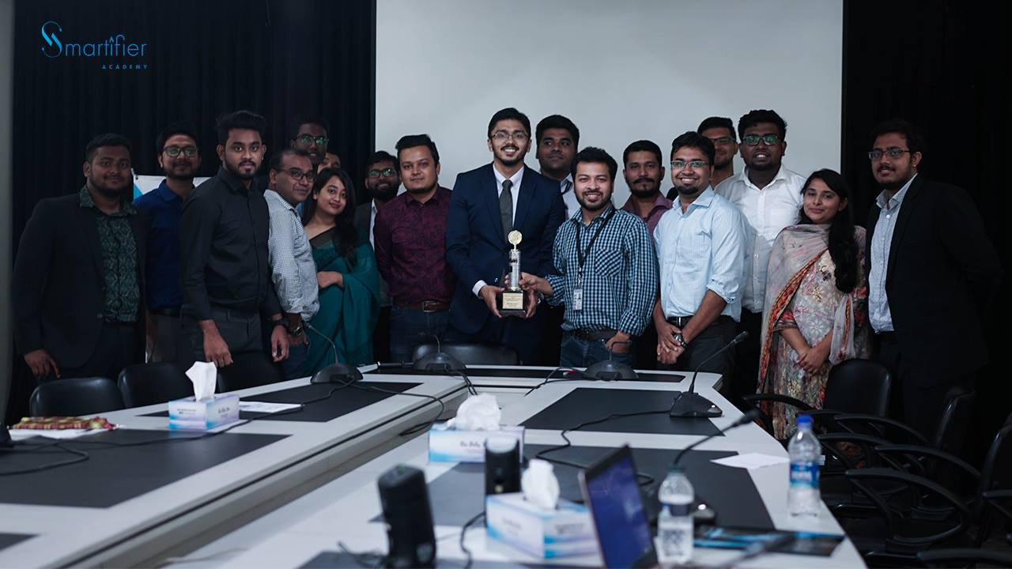
It is a picture from daylong training session on ‘Developing International Employee Mindset’ at Daily Star office.
Along with their training SA provides supplementary training book, pre & post training form for assessment, quiz, and certification according to the training requirements.

3.7 Organogram of Smartifier Academy

The organogram of SA is very short as it is a startup organization. Instead of creating a large bunch of sections, they concise it to the only required sectors only. The founder works as the manager and follows up everything occurring in SA. There are 3 people who work as full timers, and 60 people work as part timers and intern. The HR, Business Developer and the marketing Manager works as full timers. The Associates work as both part timer and full timer. In social media & graphic designing sector the graphic designing is done separately by specialized employees who are sometimes part timer or full timer. The full timers divide the work among other employees according to their expertise in any sector. Below is hierarchy of the working organogram of Smartifier Academy.
CEO & Manager

Marketing Manager & Graphic Designer
Business Developer
HR & Admin

Associate Social Media Manager & Graphic Designer
Associate Business Developer
Associate HR

Designated Interns

Designated Interns
Designated Interns

Chapter 04: Human Resource Management Practices of Smartifier Academy

HRM in Smartifier Academy

Smartifier Academy is a specialized organization with an aim of building skilled human resources for the betterment of the young professionals as well as for the establishment of a developed country. Their mission is revolved with a growth mindset where individuals and the organization will be able to improve their performances as well as making profit as the valued clients of Smartifier Academy. To make the result-oriented approach SA as an organization also thrives to develop the employees prepared for every sort of challenges. The scientific approach of HR also contributes the organization by recognizing merit and contribution of the employees which increases their productivity and ultimately the employee’s productivity results in to the increased profitability of the organization. The organization also can handle the manpower of its capability and can justify the removal of the demand of any employee if not required. HRM as a theoretical function helps to eliminate the confusion among the employees by resolving the conflicts which flourishes the internal relationship among the team and improves the work life balance of the employees.
To implement the challenges with positive success SA hones its employees with training, motivation and required skill set so that as an individual every employee remains prepared for any sort of challenges. SA not only focuses on its clients for improving its revenue, but also nurtures its employees as valued resources. As a startup organization Smartifier Academy follows the prominent steps of HRM which is required time to time according to the functional changes in the organization.

4.1 Human Resource Planning in Smartifier Academy

Smartifier Academy plans to ensure that they have quality employees without overstaffing or understaffing with the help of Human Resource Planning (HRP). This way without overstaffing SA has the ability to cut down the cost on unnecessary employment and overcrowding the employees in the office. Moreover, to meet the clients’ demands of services, adequate number of qualified employees are recruited.

Right Employee with Right Skill

SA also ensures that their organization has the right employees with right skills. It is important for the success of the business. If the employees can align their belief and values with the organizational requirements then it will be a win- win situation for both the organization and the employee. The matching of the planned human resource also helps the business to grow by maintaining its organizational standards to sync with the fulfillment of an individual employees’ goal and achievements.

Strategic Aim Achievement

To achieve the strategic aims of the organization having equipped human resource is compulsory as a significant management action. The internal source of strength of SA is the people element as valuable employees. The employees deal with the clients, customer and execute the probable task with dignity to uphold the company’s value in the competitive market.

Enhancing Profitability

A proper human resource planning helps startup like SA to reach its desired profitability index in financial and economic aspects. The cost cut in overstaffing any employees, having the opportunity to shape and build the existing employees eligibility is considered as a strength point in industrial level. The prospective fulfillment of demand and supply of manpower in an organization is quintessential for the success. HRP helps SA that their current human resource is used properly.
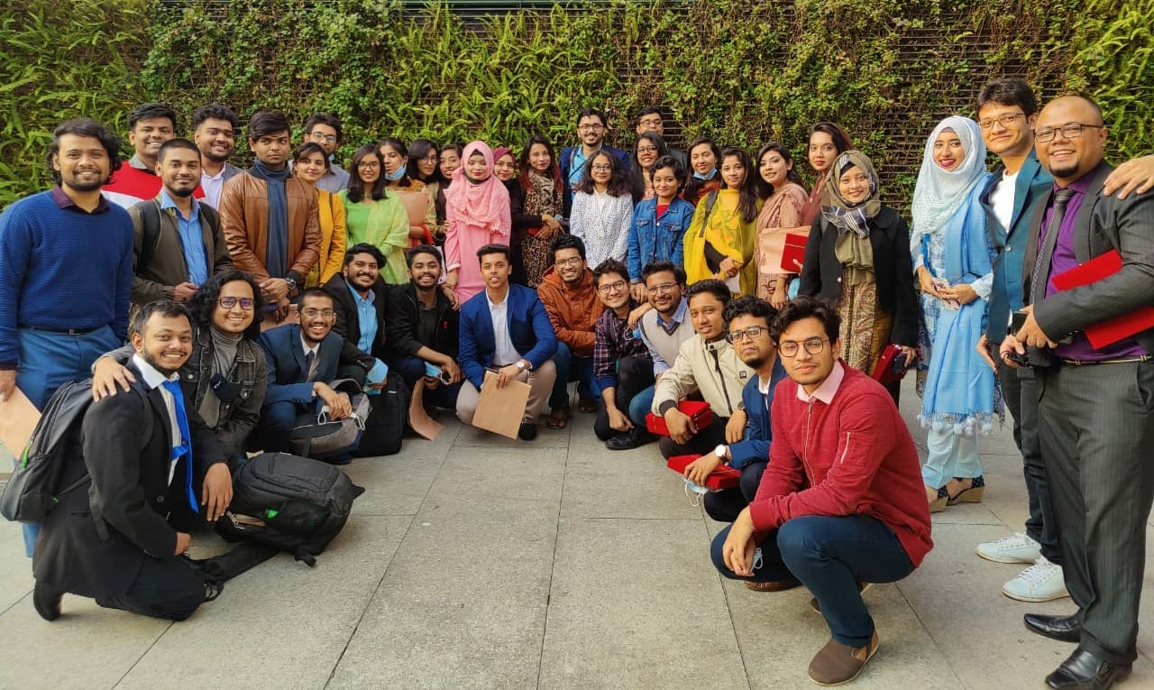
A picture of the team members of Smartifier Academy

Growth Mindset

Though Smartifier Academy seems to be a small organization as a startup but they do actually have the need of HRP just like any other organization with a well-groomed HR workforce. HRP helps the organization to forecast the right type of employees at a right time frame. Though as a developing country Bangladesh has unemployment problem, but it is just a face of one side of the coin as on the other side our country has also shortages of equipped and efficient workforce as employees. So, with the changes of technological advances, the demand for skilled employees remains high and thus create a competition of decreasing the turnover rate of skilled employees in all organization such as SA. So, meet the diversification and the growth mindset of the employees, the organization has to keep updated with their HRP strategies.

Employees Interpersonal Skill

They encourage employees with good work habit and interpersonal skills. The attitude of the employees towards their work and towards their respective clients matters a lot for the success of the organization as a plan of their HR strategy. It also motivates the employees for the positive changes which will be also helpful for the improvement of the employees.
Smartifier Academy wants to unite the goals and objectives with its employees as this way the employees will feel more like a valued member of the organization. For this reason, whenever any department needs to have more or less staffing, the members have the open access to discuss it with their supervisor or even the manager.

4.2 Recruitment and Selection in Smartifier Academy

The recruitment and selection process come right after the need of employment through HRP in SA. It is difficult to over emphasize the importance of effective recruitment for a startup organization like Smartifier Academy which is now thriving to reach at its growth stage by competing with all the industrial influencers in a world of fourth industrial revolution. Employees are the heart of the organization. The more efficient and skilled the employees are, the easier possibility of productivity and profitability will be by the organization. A skilled work force helps the organization to bloom at its best possible way thus so much effort and time is given to choose a particular employee as a source of operating engine for the organization.

Hiring Plan

To fill the gap of an employee firstly Smartifier Academy circulates their job vacancy or hiring plan through using various media like face book, online job search portal like Youth Opportunities, LinkedIn and other social media. They include the requirements in a candidate, job description, job duties, required knowledge for the post and other qualification.

Recruitment Source

The process of job vacancy circulation differs at every media. The source of recruiting is sometimes the internal source of candidates and sometimes the outside source of candidates. Smartifier Academy has also option for re hiring because most of the employees are students and for their studies, they take short term or long-term break for the continuation of their studies which is crucial for them. So, by keeping the option open for re hiring the old employees SA gets the benefit of having the employees with previous organizational knowledge.

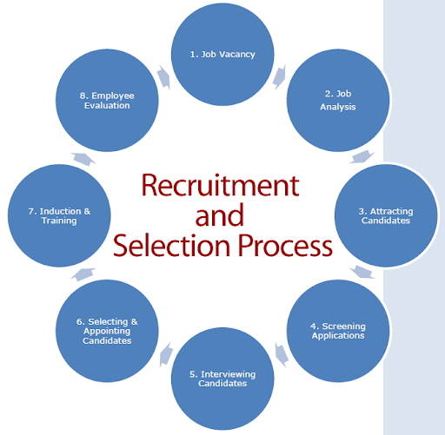
This picture shows Smartifier Academy’s employee recruitment and selection process.

Vacancy Circulation Media

Smartifier Academy mostly uses Face book to link with the vast young professionals for which reason it is seen to have more updates in Face book posts through Smartifier Academy than of any other media. Also, for professional purposes and to reach more quality employees SA focuses on LinkedIn, Youth Opportunities and BD jobs online portal. They also circulate their vacancy through the current employees so that they can expand the news among their peers.

CV collection and Screening process

The desiring candidates send their CV following the rules of the job. After that the CV are evaluated by the SA team members and the manager. In Smartifier academy selection is the process of hiring the shortlisted candidates who have passed through all the screening and does match the requirements and needs of the organization. After announcing the job, the SA team reviews the candidates’ application and goes through initial level screening so that it gets easier to allocate the potential employees which matches with the organizational objectives and eliminates the less competent applicants so that the organization do not have to invest their time over them.

Interview and Selecting candidates

Later on, an interview by the founder and the department heads are conducted to justify the selected CV and the candidates’ potential. The candidates are thus selected by the interview panel and after the probation period of serving in the organization which is around 3 months including the organizational orientation, training and motivation the selected candidates get permanent recruitment signal from SA if their work capability is up to the mark throughout the whole evaluation process. The recruitment and selection process are unbiased as SA opts to choose the skilled and deserving candidate selection through their recruitment process.

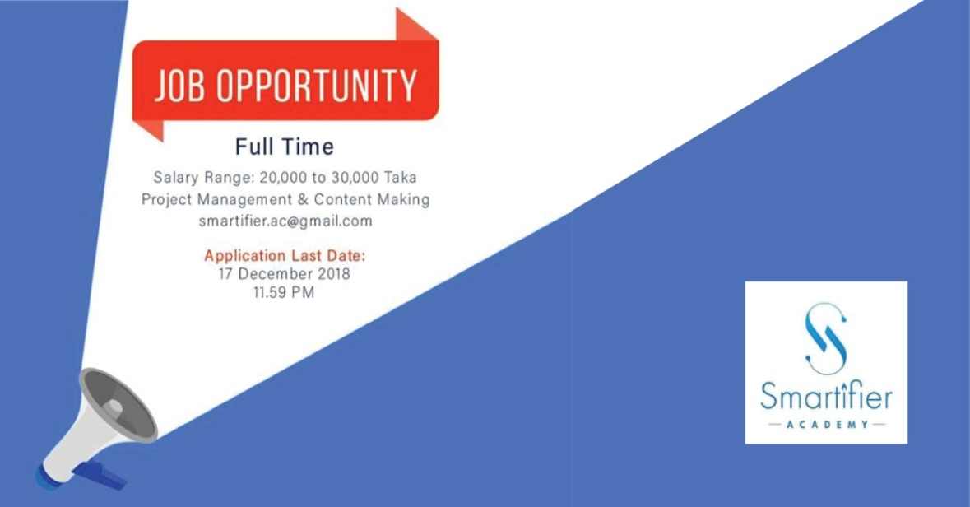
This is a vacancy announcement post from Smartifier Academy for social media interaction.

4.3 Training and Motivation in Smartifier Academy

To impact the corporate bottom line and to create a productive work environment for the individuals, training and motivation is exceptionally required for the members of Smartifier Academy. Moreover, as a training and consultancy firm they have to stay ahead with the completion of perfect training and motivation for its employees so that as an output the valued employees of Smartifier Academy remains prepared to serve the respected clients with best services they acquired from SA as a byproduct.

Nurturing & Motivating Employees

The training and motivation part along with development in Smartifier Academy happens for newly recruited employees and also for the current employees to nurture them. It is because only carefully selecting employees with high potential does not guarantee that they will be able to work efficiently. No task can be completed if the employees do not know what to do or how to do it. At the same time if the old employees do not get the feeling of belongingness with the organization where they are valued as a resource and if they are not nurtured then several problems like dispirit, dissuade, lackadaisical and so on may arise. Also, to keep the employees updated and advanced with the new industrial changes it is highly important for them to connect the employees via training and motivation.

Connecting with Employees

To begin with the orientation part of the newly joined employees or intern, Smartifier Academy provides each employee a particular day when all the employees will come and meet the existing members through the virtual presentation of ‘Employee Introduction’ or the real-life presentation through a meeting. The CEO introduces the employees with the organizational protocol, the employee rules, organizational values, mission, vision, goals. If it is required the new employees are also let known by the organization regarding the current project. The scope of innovation and creativity is always open at Smartifier Academy so even the newly joined people can contribute by sharing ideas and thoughts to redesign or discover new way of output for any work or project. The employees are then assigned to certain division under different supervisors where they work as a team and learn o collaborate with other teams with different work objective at Smartifier Academy.

Designing Training Program

Furthermore, Smartifier academy focuses each step of designing a training program individually. The individualism is maintained to have the record of adaptive attitude of the employees to various actions of training designing methods. Three things are focused most importantly for designing a training program which are accomplishments of training objective, training delivery method availability and the final result through evaluation through the understanding and performance of the employees for the training program. They always try to make the training program meaningful.

Transferring the Training Learnings

As a startup company it is definitely a costly investment to the employee training program. So Smartifier Academy opts for reinforcing the learning of the employees and ensures the transfer of learning to the job. Through the training program the team supervisors make the employees about the importance of goal setting priority. It is seen that the employees seem to transfer the training learning’s through the exposure of their work and attachment of training and project designing facility which can be counted at 35% involvement increase. So, the team always tries to keep pushing their limits and face the renovation and challenges to overcome the percentage with better percentage.
The employees are put in a situation through training that they feel like at ease space where they are actually working for the completion of any project. They are given proper instruction and indication about the whole job where some employees who are actually working on the project help them to learn and discover the nook and crook of the working system of Smartifier Academy.
Having training as an individual or in a group the employees feel a form of satisfaction of motivation and enrichment as a valued employee and more over as an irreplaceable part of the team in SA. The motivational system instigates the development of the organizational development process.

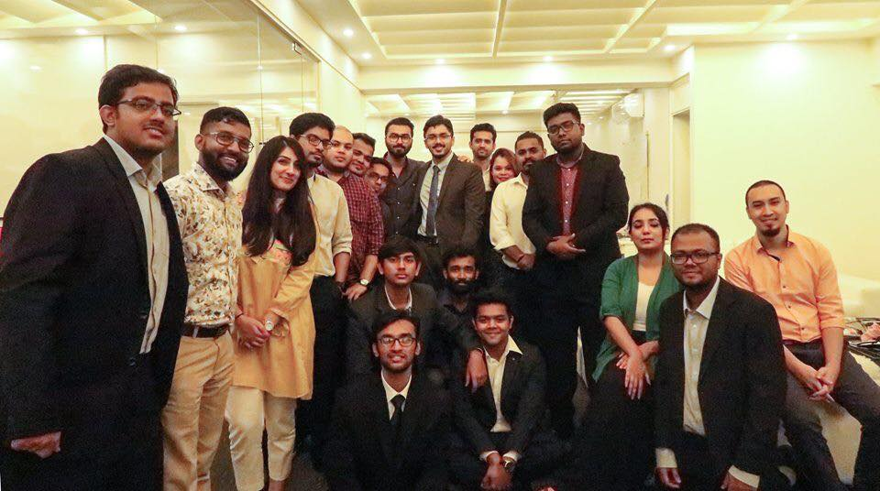

This picture is from the Meta learning training session at Co-Design Office.

Need For Training and Motivation

Training the employees might seem like a waste of time and money for any organization that are not known about training and development adequately. But the fact is for an organization like Smartifier Academy as a startup it is highly required to train the employees about every nook and crook of the work procedure of the organization. If proper training is not delivered then the impact of negligent training might affect the third party for the organization who could be possible clients or customers for the organization. Also, improper handling of human resources might cause troubles like lawsuit filing, monetary penalty or seizing the business license of the organization.
In Smartifier Academy there is always a weekly presentation and training session for all the members of the organization. Mostly on Saturday the training sessions are conducted where each employee learns from the founder and sometimes by the guest trainers specially arranged for the SA members. These training sessions can be conducted by the employees as well as the individual employees’ expertise which exceeds the knowledge or learning of other employees. This way a diverse way to learn is possible throughout these weekly training and motivation meetings.

4.4 Performance Management in Smartifier Academy

Performance Management process is followed to continue the effective competitive attitude among the employees and to evaluate the quality or quantity of the employees work according to the desired level for Smartifier Academy. With the help of performance management process Smartifier Academy can evaluate the time, effort, and commitment are shown by the employees for the success of the organization. The valuable time of the employees at completing any task of the company is crucial. It helps the development process of every department significantly and separately.

Supervision of Employees

The cautious monitoring of the supervisors over the employees has been seen as an effective process of correcting the work faster and better manner. The feedback of the clients and customers shows the scope of improvement as well as keeping the best possible method intact. The commitment of the workforce for the improvement and success of the organization is seen through performance of individual effort of the employees.

Smart Objective Implementation

Performance management process in Smartifier Academy starts with a view to fulfill the objective and goals of the organization. It starts with a plan of setting smart objectives which will be completed as a task by every individual employee. With an agreement from the employees the organization creates a development plan for all the objective implementation for which reason different departments sometimes merge together. This way the Smartifier team updates a role profile for the team members’ first process of performance management.

Reinforcing Action Plan

Later on, action plan of the selected objectives is achieved by the team members. The members carry out their respective role by communicating with all the team formed for a project. Smartifier Academy mostly completes any project at a time so that the work remains better in quality and the monotonous work pressure does not destroy the creativity of the employees. After fulfilling the respective roles, the organization also focuses on the implementation of the employees’ personally shared development plan for any project or any task so that the performance by the team gets creative, productive, challenging and also unique which also creates an internal competition among the team members to generate new ideas to share with the company. This process of employees’ competitive nature of performance improvement helps the organization as a startup to create more profit.

Follow up

Performance management process is followed in SA as a regular activity, but not a ‘once a year activity’. The actions of the employees are tracked continuously so that the correction or improvement process of any work does not lag behind and the working process remains smooth for the completion of any project.

Focus on Goal

The knowledge, skills and ability of the employees are developed by this continuous process of performance management by aligning the goals of the organization with the individual and team spirits. If the supervisors and the manager do not keep their focus on the employees need and review their work then there is huge possibility of having a group of demoralized, unengaged and unmotivated bunch of employees in the organization. Thus, Smartifier Academy reviews every work of the employees before the final publication of any content.

Monitoring Activities

The selected supervisors of the employees take note on the attendance and presence of the employee, work submission timing, deadline meeting and work perfection of each employee and then the supervisors have to report the activity of the employees to the manager in very weekly meeting. If the performance management of the employees need extra monitoring or if any individual seems to have problem with their work, then the supervisors or the manager intervene to the assigned task completion as all the task has to be completed timely.
Performance management in Smartifier Academy is not only necessary for the review of the project work to know whether it is happening at an aright way or not, in fact it is also important to improve the morale of the employees by giving reward which helps to boost their upcoming performance. This way the employee remains motivated and energetic to embrace new challenges.
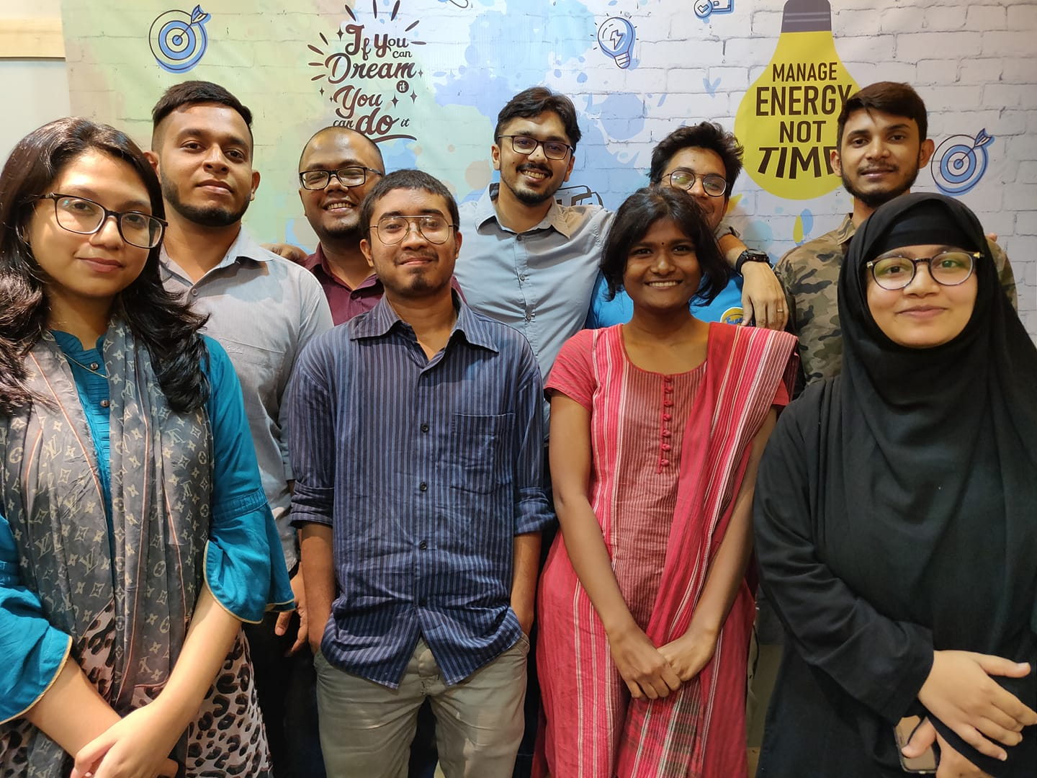
This is a group picture after an in-house meeting in Smartifier Academy office before pandemic.

KPI Recognition

In SA there are many sub departments under a supervisor for example, the social media marketing department has different functions for YouTube, LinkedIn, Facebook and for these departments they have team named such as Tube tone for YouTube managers. All of the team members do brainstorm and their final work is presented through meeting. Then the winning team of any project which meets their Key Performance Indicator (KPI) gets a gift or recognition from the manager. This way of performance management process also helps the organization to grow as a team and bring competitive success for the organization.

4.5 Compensation and rewards in Smartifier Academy

Form of Compensation

Compensation as an exchange of the services of the employees represents both the intrinsic and extrinsic rewards as the employees receive for performing their jobs and having a membership as an employee in Smartifier Academy. Compensation is mostly done in monetary form and even rewards or bonuses can be monetary, though the rewards and bonuses are sometimes non-monetary too for SA.

Salary and Bonuses

The salary range for the full-time employees are BDT 13000TK to 30000TK, and for the part timers or intern are BDT 2000TK to 5000TK according to their skill, they also have interns who are not paid but they are having the facility to learn from the organization. From the interview of the employees, they shared that the founder used to give EID bonuses to all employees and according to the work efficiency any employee would have 500BDT to 2000BDT for the excellence of the work.
The salaries of the employees include the base pay and the other facilities like bonus, over time or rewards are not included here. The differentiation of the payment procedure helps the organization to count on the employees’ effort according to their work. Smartifier Academy provides significantly different recognition or rewards to the current employees to boost up their morale and work ethic practice.

Pay rate Balance

Smartifier academy as a startup gives the pay rates by following the equity among the similar working group of employees. They treat the employees according to their merit, effort and performance for the organization. Overpaying might backfire only on the base of preference to any certain employee, because if Smartifier Academy do not treat well other employees then it is extremely possible that the performance of the discriminated employees will degrade, morale and respect for the organization will be lower, and for the worst possible scenario the turnover rate of the employees might accentuate without any further notice.

Individual Equity

By focusing on such probable problems, Smartifier Academy tries to implement the pay rates following the equity theory of motivation. This way if the employees try to compare their current position in SA with same position in different organization, they might feel similarity in payments. This also happens in internal equity where different position in same organization is compared for fair job pay rate. Moreover, individual equity is also maintained by following the coworkers’ payment and fairness treatment by the organization.

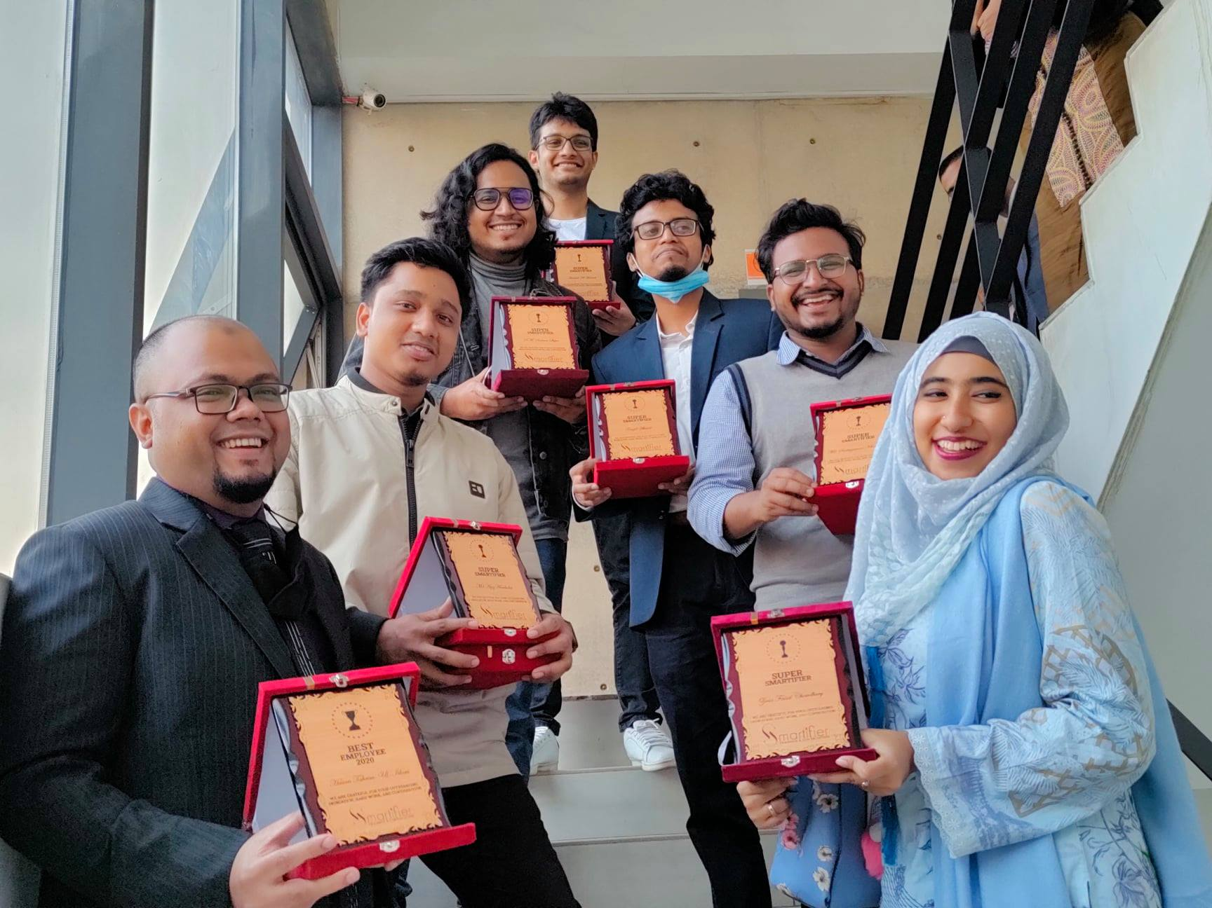
This picture is from the employee recognition program by Smartifier Academy.

Competitive Industry based Payment

The payment of the employees goes through job evaluation method as well where the job is compared with the other job in similar industries. In this training and consultancy organization the method of providing their services encounters many complications of using the appropriate law to figure out the payment method. The industry includes also educational and social welfare sector which has variant of payments. In Smartifier Academy the full time employees, part time employees and also voluntary or interns a short time employees are available for which reason the payment procedure according to the division of work, caliber, performance, working time in the organization differs highly which creates a complex module to find the exact payment category for each employees. Considering these compensable factors, Smartifier Academy focuses on individual employees’ effort, dedication and work and thus fixes a salary for the employee. This is a big reason behind their publication of job circular with a salary range rather than a fixed salary or payment amount with a market competitive pay plan.

Payment Procedure

The payment procedure of Smartifier Academy includes cash transfer, online payment by using Bkash or by using the individual employees’ bank account. The amount of salary payment is transfer at the first week of each month. But for the rewards or any other achievements which is monetary, is given to the employee directly by using cash transaction. But if there is any problem during the transfer of cash then the other two methods are followed accordingly.

Rewards and Leave Plans

Other than compensation, Smartifier Academy focuses on individual and group work rewards as well so that the bondage among the employees remain strong and the benevolence towards each other helps the organization to achieve competitive advantage. The non-monetary rewards include food feast like pizza treat, outing with group members, special training or meet up session with particular organization or individuals, or accolades like crest to honor their members’ work as recognition.
During Ramadan the members were also invited by the manager for team Iftar and after any successful event they would get sweet treat from the office often. Employees have the facility of taking leave which does not include payment. These leaves are mostly sick leaves, or leaves for exam purposes as most of the employees still pursue their study while working.

4.6Industrial Relations with Smartifier Academy

It is impeccable for a training and consultancy organization like Smartifier Academy to have good rapport with other organizations in the same industry as this way they will be able to have more trainees to know about them. Industrial relations are a dynamic field to indicate the socio- economic development on various aspects like the pattern of the state, the legal system, capital structure, compensation of labor force, the relation between the employee and the employer, study of market force etcetera. The concept of industrial is denoted as an extended version by including the relations among the employees, employers and other organizations and groups of different labor unions.

Industrial Collaboration

Primarily we can see that an organization has three parties including the employer, employees and definitely the government. But for the industrial collaboration and maintaining industrial relations other parties like similar organization, labor and human resource organization stay in touch for building up the whole process. This industrial relation is important to solve any unwanted dispute or interference of any trouble maker from the outsiders. Smartifier Academy has its Tax Identification Number (TIN) which gives it an authenticity of operating the business according to the law and government rules and regulations.

Behavior of Employee & Employer

Smartifier Academy’s having good industrial relations with the other organizations safeguards it as a startup with a good reputation in the work ground. Various factors affect the industrial relation of an organization. The individual behavior of the employees and employer affects the business highly. If the employees are not responsive and tactful a then they might create havoc in the organization even for their mistakes an organization might lose their potential customer no matter what facilities or service the organization provides. So, the behavior, attitude and appropriate training for each employee are essential for startups like Smartifier Academy. Not only the employees sometimes employers may create problem in business by not operating their management and by poor handling of leadership skill. So as a training organization Smartifier Academy tries to organize their functioning as efficient employer and tries to build better employers as well through their training.

Management of Resources

A good organizational structure is important where the hierarchy of the superiors is clear and prominent, also the delegation and decision-making power by the individual employees are explicit and evident enough to represent their thought. Moreover, the psychological aspect of the members of the organization has a face value to the outsiders where they can judge the reputation and feasible interaction among the employees and the stakeholders. To hold on to any business financial and economical solvency is the primary concern so as a new startup Smartifier Academy always tries to have the forecast of their capital and thus they use the resources according to the solvency. This does not keep their status as a miser instead they always value their resources and being frugal Smartifier Academy tries to hold on to their current assets by using and investing at perfect moment or profitable business services. They value their employees with utmost care and give them motivation and hope to become personally adaptable, resilient, knowledgeable and technologically advanced so that they are always ready to beat or overcome any challenges as an individual or as a team member. Smartifier Academy always develops the mindset of proactively acting among their employees to stay ahead in the industrial competition as well.
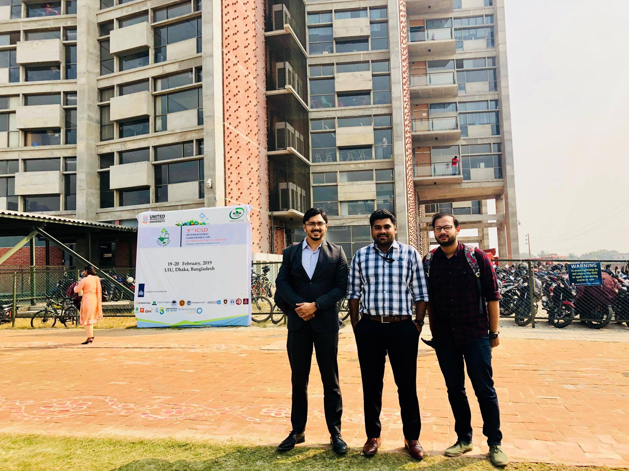
Visit at UIU by Smartifier Academy manager for training session arrangements.
Smartifier Academy tries to have good contact with the people they work professionally whether they are their clients or employees. This way they are being able to create better brand value with the positive word of mouth of the people in acquaintance of SA.

4.7 Employee Health and Safety Measures in SA

SA believes that if the employees remain healthy and fit then they will be able to serve the organization more profoundly. The working environment of SA is enough supportive for not only their physical well-being but also mental and emotional well-being. The hygienic maintenance of SA has been really good.

Maintaining Employees Health

Healthy employees are less prone to absenteeism and much more productive for their work. The cost of hiring and training new employees can be deducted by maintaining a healthy and safe atmosphere for the current employees. Employees are valuable assets for every organization. The way it is the duty of the employees to deliver perfect work for the betterment of the organization, similarly it is also wanted that the organization will help and support to take initiatives for the wellbeing of the employees. The members of the organization are like a family, if a member of the family gets unwell then it is obvious that others will notice and will take necessary steps to stop or control the problematic situation. If the team sees any employee to be absent for several days without prior notice, abnormal behavior by the employee or addiction for any special substance then it is required for the employee to get special treatment. These are some significantly small but noticeable factor to have special attention to employees.

Mental Health Support

Along with the physical wellbeing the mental health support for the employees are also necessary. Most of the employees are young professionals in Smartifier Academy. So other than their working schedule for the SA, they have to also work for home task and studies from universities or other institutions. Some employees also work double shift to get extra earnings for their family. It is an unspoken activity for the organizational members along with the organization itself to provide special care and necessary support for these individuals.

Geographical Placement

The safety issue for the organizational members is another concern for Smartifier Academy. This startup building is resided in a two storied semi residential area where emergency services like fire extinguisher, medicine store, hospital, police station, food stalls everything are really nearby to the organization. This office is situated in two storied building at a commercial space in green road, Dhanmondi which is an ideal location for such type of organization as startup. The employees have also access to have their food from home takeaway box which is a healthy choice of having safe food. They have separate place for prayers as well.

Etiquette

The employees are aware about the proper etiquette of putting their shoes on the shoe rack, maintaining privacy, washroom etiquette, dining etiquette and also most importantly to keep their working space clean and tidy.

Layoff and Turnover

Moreover, the layoff rule or termination policies for the employees are too strict where only the highly offensive work will be resulted as the punishable offence like termination. Other than that, Smartifier Academy always tries to follow the organizational protocol served by Bangladesh government rules. So, there is fair treatment to all the employees without any discrimination for gender, religion, medium of school, age or previous working position.

4.8 Employee Record Keeping in SA

Employee Records for Employment

In Smartifier Academy all the particulars related to the employees’ employment, capability, training history, performance review, job experience, compensation history and their personal information like their nationality and education are considered as employee record and these are required to continue their job in Smartifier Academy. With the help of this record the legal purpose to maintain a balance in the HRM system is fulfilled easily. In SA it starts with the attendance keeping of every employee in the office during office time in the morning this way the seriousness to work of the employees are measured here.
Employee record keeping is seen mostly in the large-scale HR departments of big organizations. But after understanding the importance of employee record keeping by the other organizations, the small or medium organizations started to embrace the characteristics of the employee record
keeping nature. This process of record keeping contains factual and authentic information about the employees past and present information’s like the nationality, health related issues, turnover tendency, or forceful dismissal by any other organizations. It is also handy to know about the employees past training and development history. This way organization can have an idea about the resourceful employees with talent and skill.

Need for Employee Records

The previous records of the employees are a way to find out the bad records of the employees too. The organizational certification or completion of any work or course mostly carries a recommendation letter or an appraisal letter of work. If the previous organization or the law enforcement agencies find any cruelty or abnormality in nature of the employees then the recommendation might have some warning or indication of taking precautions about recruiting the employee with such nature.

Employees’ Health information

The health of the employees is a big concern for any organization. Some diseases like hysteria, diabetes, blood pressure fluctuation, brain or heart related diseases or some other diseases which requires assistance of other person has to be handled carefully even though the employees are highly qualified or efficient for the work of the organization. Recruiting such employees for a startup like Smartifier Academy is slightly risky as well.

Trained Employee Records

Though Smartifier Academy does not discriminate about the institutional study area or school of medium of the employees, still the records of academic results and co-curricular activities are given priority just like an extra skill or an effort of taking challenging actions to judge and justify individuals’ personal skill. For this reason, the previously kept educational records are also necessary. As from this Smartifier Academy has an opportunity to know the probable talent of an employee and as a golden opportunity the organization can use their knowledge for the futuristic
upcoming training module reformation. Also, the training cost for previously trained employees are reduced as the trained employees are already skilled enough to tackle the barriers of the obstruction. Trained employees add value by understanding the futuristic problem by identifying it with their intuition.

Chapter 5: The Changes of HRM Practices in Smartifier Academy during Pandemic
There are various HRM functions but as a startup organization Smartifier Academy follows some selective HRM practices which is necessary for their company. During this pandemic to increase the percentage of economic and financial profitability of the organization they prefer to cut the less important expenditure which is sometimes intrinsic and sometimes extrinsic costs for the organization as well as for the employees.SA values its customer also gives importance to its employees and try to nurture them as their valued resources. The best part about SA is they have not lain off any of their employees during this crisis situation of pandemic. SA recognizes the negative impact over the employees for the pandemic which is mental and financial as well. Following are some explanations of the changes in HRM practices in Smartifier Academy during Covid-19 pandemic.

5.1 Changes in Human Resource Planning due to Pandemic

At the starting period of year 2019 Smartifier Academy was on the verge of growth period with a good number of successes in training field as they had already conducted several training sessions in various universities, private organizations and many more. For this reason, Smartifier Academy was planning to recruit a greater number of permanent employees instead of part timers with their increased revenue to enlarge their working functions. But due to the starting of lockdown in March 2019, SA had to change their plan of having new recruits. As the working space of training reduced in different organizations thus the need for having more people to control over the new work in SA reduced side by side.

5.2 Changes in Recruitment and Selection due to Pandemic

There have been vast changes due to pandemic in recruitment and selection process. The face to face interview system in an interview panel was an option to identify the candidates’ behavioral pattern in a more observant way. But now the interview system has changed to phone or zoom interview system as Smartifier Academy mostly tries to avoid mass conglomeration due to the contagious pandemic. So, though the opportunity calling system for the new recruitment has not changed much but the most change happened in interview system. Due to pandemic most of the interns are now nonpaid and there are few numbers of full-time employees though they did not have any salary cut.

5.4 Changes in Performance Management due to Pandemic

As there is less human interaction due to the pandemic thus the supervisors have to face problem to justify all the requirements fulfillment of the employees in Smartifier Academy. Though they still continue their regular office meeting via Zoom or any other social networking operations, but still it gets difficult as the meeting time and the official presence timing has huge difference. Due to the excess use of electronic devices rather than earlier time, all the employees including the top-level manager has to face health hazards like dizziness, eyesight burning sensation, back ache, head ache and much more. It was easier to solve a problem in office environment rather than solving it through online meeting. So, though the manager tried to shorten the meeting by minding the health precautions for the employees, but still there remains lacking in performance for the online functionality due to Covid19. Moreover, the work-life balance has been interrupted due to pandemic.

5.3 Changes in Training and Motivation Due to Pandemic

On the strong ground of the contagious pandemic Smartifier Academy had to change their training pattern for their employees as well as to their valued clients. Earlier there was face to face interaction where it was easier to judge the gesture, posture for the presentation of the employees. But now in-home office they have to attend the trainings by using Zoom media, WhatsApp, and messenger or just mailed messages.
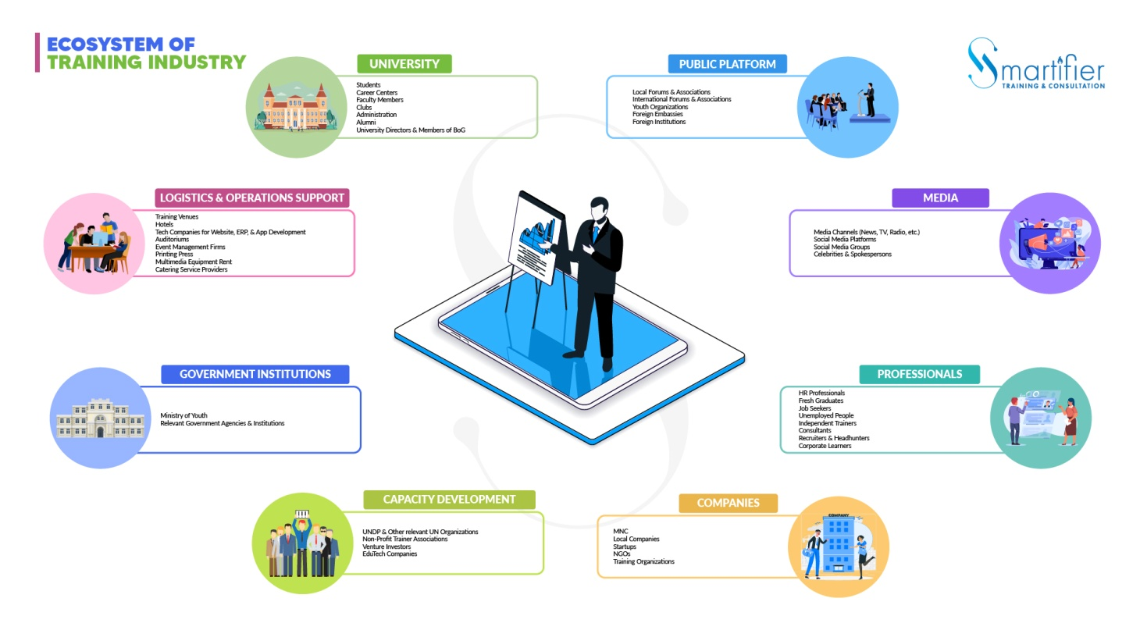
This is the graphical representation of ‘Ecosystem of Training Industry’ by the CEO and founder of Smartifier Academy.
The loss of human interaction has definitely put on a negative effect. Moreover, the training schedule has been shortening down by bearing in mind about the health issues. So, there is a lack of training module which also affects their motivation level to grow.

5.5 Changes in Compensation and Rewards due to Pandemic

There have been huge changes due to pandemic in compensation and rewards planning at Smartifier Academy. Though it is seen that many organizations are going through lay off policy or salary cut to reduce the expenses of the organizations to tackle the loss due to pandemic, but in SA they did not lay off any of their employees. Instead, their plan for recruiting new members for the organization as permanent employee was put on hold to reduce the expenditure on salary.
Smartifier Academy chooses to recruit more interns for a certain time which is around 60 people without any basic pay. But these interns were given all other facilities as the member of SA such as in-house training and skill development opportunity. Also, the employees get food delivery in their home as rewards for team work success in this pandemic. Moreover, the leave of absence system is still similar as pre pandemic days.

5.6 Changes in Industrial relations for Pandemic

There have been some obvious changes in industrial relations due to pandemic. Most of the organizations are trying to cut their cost to minimize losses for which reason they sometimes overlook the cost of rapport building with other organization along with an indirect indifference to train their employees. This way the impacts of outside organizations are also having impact on maintaining good industrial relationship by Smartifier Academy.

5.7 Changes in Employee Health and Safety Measures due to Pandemic

The office of SA has remained close for the whole lockdown and even after lockdown the functions of office work has been minimized. By keeping in mind, the safety of the employees, the manager and founder has decided to function their work from office at a limited number and only a few numbers of employees are allowed to work in the organization by maintaining proper safety.
Due to Corona virus pandemic the health hazards are at high-risk zone. The employees are facing various emotional imbalances along with health-related issues by themselves and by their family members. Different employees are facing different problems like blood pressure fluctuation, obesity, body ache, headache, pain in back side of body due to sitting for longer duration, dried out eyes and cornea, loss of hair, vitamin deficiency, concentration break, memory loss, fatigue, diabetes, increase in cholesterol level, mental break down, depression and most drastic effect of loss of family members and relatives have been seen in an increase number to the team members of Smartifier Academy. They are strongly feeling that all these havocs created at a large number are the cause of bad impact due to Corona virus. They are also scared for the new variant of the emerging viruses and the lack of availability or impact of the vaccines may create a future with uncertain difficulties.
One employee explained it in details that after pandemic each employee were allowed to start working after washing their hands, face, feet with soap, wearing mask and using personal sanitizers by sitting at a distance from each other than the regular times. But after the second wave of Corona virus, the official meetings and other operations are mostly conducted from home of team members of Smartifier Academy.
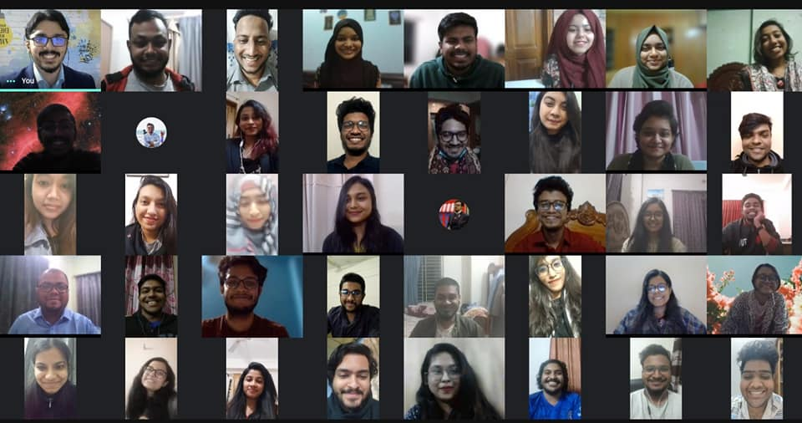
This is the picture of a Zoom group meeting of Smartifier Academy during pandemic Covid-19.

5.8 Changes in Employee Record Keeping for Pandemic

Due to the fatal pandemic the regular attendance process has been stopped in Smartifier Academy. The records of the employees work are now put on in a bunch like a group work method mostly. Though there has been no drastic change of keeping the old record about the employees because it is an evidence for the organization. The best thing about Smartifier Academy is that there have been no lay off of the team members for the Corona virus pandemic.

Chapter 6: Analysis and Findings

Analysis of Interviews and Findings

The extensive interviews of the manager and the employees of Smartifier Academy revealed a lot of exciting information as a startup organization. The founder of the organization expressed that he is happy with the Smartifier team and he wants the employees to prosper in life. The employees expressed that as an understanding boss, the founder helps them as a mentor for which they feel valued. They also said that their ideas, innovations, and thoughts are well discussed and kept with value in official meetings. They are happy with the office culture as it is friendly, welcoming and positively competitive to do better for the organization. The employees also expressed their thankfulness to the manager as he talks with every employee at least through a meeting without considering the seniority, age, class, gender or medium of school.
However, besides so many positive sides of Smartifier Academy as a startup, they have some lacking too. Though the employees have flexible working time in online office but the office meetings schedule is creating problems in keeping their standard work life balance. To keep up with the work pressure they feel the need of more senior level workers who will be able to serve with excellence.
The entire report is an observational representation on the HRM practices of Smartifier Academy where the current effect of pandemic is highly contemplated. But to analyze the report, I must give the respective references of other aspects of the organizational activity. Following write up is a short evaluative indication for the analysis of the report to showcase a gateway of success for the organization.
The marketing aspect has a huge role for increasing the demand of Smartifier Academy as a startup training and consultancy farm. Only having theoretical knowledge of marketing among the employees won’t bring any success to this organization. Instead creating, understanding and designing a customer value driven strategy to sustain in the market with the competitors and to achieve customer value by earning profit are the ultimate necessity for a startup like Smartifier Academy. The application of marketing process in Bangladesh has been very traditionally monetary profit achievement oriented. So here as a training and consultancy organization which itself is a big concept to evolve has to go through a rough journey of rejection, re-examination for validation in the society and it has to showcase a big impact of its activity with consistency and dedication. Otherwise, the brand image it has been able to pull off by successfully implementing training programs like ‘YPS’ for thousands of people all around Bangladesh will be grounded with the emerging new ideas of other organization. As Smartifier Academy has not invested separately on CSR, so utilizing the YPS as a marketing stunt to increase profitability might see the door of success.
According to personal observation in the organization, Smartifier Academy should focus on developing new designs for their marketing channels. It needs to get more furnished in terms of modernizing their website like ‘HubSpot Academy’ and ‘Coursera’. It will help the organization to have the grasp of a large number of people in contact where they can offer their courses to the customers for free trial along with the monetized version of courses. Their marketing process has been more focused on Facebook as a social media connector. They should also focus on other social media like Instagram, LinkedIn for the emerging number of trainees to get connected with. The connectivity program before the Corona virus pandemic with other universities and different companies need a change in plan. Organizing different webinar, online meeting planning through Zoom along with other application use like trello, slack can create ease for their work purpose.
As a training organization real time presentation of accounts where the members can see how the monetary value of training or a cost leaves impact in their life as well. Such as operating a successful event can cause the increase in their salary or a better office treatment. The team members experience will get honed through it as well, because they will be able to see the real picture of their effort as an out come at a certain significant point to achieve the estimated goal. But most of the time it might get challenging as the privacy of actual data is a secret to get kept.
The finance part of Smartifier Academy is very precise as per my observation. The members submit any cost related bill to the manager directly to pay for it in advance or through postpaid method. Also, the distribution of remuneration, gift, public relation souvenir for investors or other monetary transaction is done by the manager. This creates a strong base of transformation of data with each employee where they are relied upon by the manager for a certain financial action for justification. It is a time-consuming action for which one might think appointing a financial operator can help the manager with the huge task. But to manage overall financial cost cutting for the Smartifier Academy during the squeezed pandemic situation, the operation of finance by the manager is a necessary.
The strategic management process of Smartifier Academy is slightly complex as it is a startup which revolves around product marketing mix and service marketing mix. The manager as a founder plays a huge role here. He has to analyze the environmental relationship of the objectives and the resources to build a strategy. He has to select the strategy on particular requirements fulfillment like supply of resources, support of team members and availability of data for his training and other works’ strategic development. If the strategy plan seems effective and the content of the whole process has better operational possibility then the manager along with his Smartifier team implements it according to the strategic planning. The main achievement of this strategic management depends on available resources and capabilities.
If the functions are break down for the organization such as their strength, weakness, opportunities and threats (SWOT) then it might show a possible outcome of profitability and probability of successfulness on the emerging training field.
Strength  - Certified NLP trainer  - Creative young professionals  - Author of several books  - Dedicated employees  - National YPS program organizer | Weakness  - High startup maintenance cost  - Under developed industry  - Less permanent employees
Opportunities  - Unique vision in training industry  - Quick access to customers  - High investment convenience | Threats  - Local training in cheap price  - Governments` Vat on training  - Foreign trainers` invasion

Profitability through HRM

HRM has helped the organization to grow and emerge its profitability which might seem surprising. Because most of the time HR resource is seen as a means of controlling the paperwork. Smartifier Academy has gone beyond this old school thought and has proved their nurtured employee’s potential through their profitability. The recruitment of right person for a certain function shows the right fit in the organization. This way the recruitment cost and nurturing time expense of an employee is reduced. Moreover, to avoid lawsuit action for any faulty behavior of the employees is mitigated for the better human resources of the Smartifier Academy. This way the organization do not have to spend unnecessary money over any litigation. There is also an ethical and emotional intelligence part for having a better HR team in Smartifier Academy. In between the horrendous pandemic journey there has been zero turnover rate in Smartifier Academy. Furthermore, this Startup was able to pull off a national program like YPS, publish books all in the pandemic situation. This shows the dedication level of the employees along with the HR management success of Smartifier Academy as an organization.

Chapter 7: Recommendation and Conclusion

Recommendation

It is a strenuous work to build a start up like Smartifier Academy as it takes years of knowledge, dedication, sacrifice, monetary and non-monetary investment and moreover a dream to make it successful. With my limited knowledge earned through the interview and the work experiences in the organization, I would be humbly presenting my ideas below as recommendations to solve their current issue with a hope that it will bring positive changes in Smartifier Academy.
- Fix a working time in online office just like the offline practical office days. This will shorten the period of work span as most of the employees will be available to work on time.
- Hire multitasking employees with efficient knowledge to work on any project base work. This way the work pressure on heavy duty days will reduce the burden of regular permanent employees and also will save cost on salary as the project worker will be paid according to the project only.
- Introduce some certified training materials for the people to purchase online.
- They need to develop their website at a fast pace because due to pandemic people are frequently using online materials over the hard copies.
- Other than prioritizing Face book, they should introduce more contents at other social media platforms and online website to reach more people.
- They should search for opportunity to collaborate with international training and educational platform to widespread their resources of Smartifier Academy.
- The number of employees needs to be increased who will work as full-time employees.
- The salary payment plan has to be redesigned to keep up with the competitive educational and technological industrial environment as well as to bear with the financial dilemma for pandemic.
- To cope up with the financial pressure for pandemic they may opt for funding from international foundations if required.

Conclusion

Smartifier Academy has been able to reach its target customer with positive success and their motive to make people aware about training and consultation is having the silver lining. The researches on personal branding, organizational improvement activity, time management and all over the meta learning skills are getting developed by the leading developed countries. In such a situation a startup organizations’ journey in a developing country like Bangladesh in between several social and economic barriers has been highly challenging. The implementation journey for Smartifier Academy itself is highly tenacious let alone becoming a training and consultation practitioner. To tighten the situation, the hit of pandemic right at their growing stage created a loophole where it was possible to lose the grip over the situation and fall on the ground with nothing in hand. It might have to face legal challenges over lack of control over the organizational management. However, Smartifier Academy was able to pull off the hurdles successfully by organizing a successful national event along with book publications.
Smartifier Academy has been able to pull off all the hardships, challenges with their honed Human Resources where the competency-based performance management system showed the guidelines for development of the organization. Their strategic compensation system to increase the engagement with the employees a s a team member seems successful. The managers’ policy of giving positive feedback, timely communication with the employees, and giving recognition seems to be a good organizational practice to keep the employees energized and devoted to their profession. The manager of Smartifier Academy as a founder did not forget to nurture and train its team on the way of battling to train others.
To sum up everything that has been started so far, this organization is serving the people of the country to make them skillful and eligible around the world. In developed country it is very valuable to have certified professional trainings. Bangladesh also hopes to reach the success point with the eligible trained workforce where organization like Smartifier Academy plays major role as a certified organization.

References

- http://www.whatishumanresource.com/the-historical-background-of-human-resource-management#:~:text=Industrial%20welfare%20was%20the%20first,should%20be%20male%20factory%20inspectors. [Last access on 5th April, 2022]
- https://hrmhandbook.com/hrt/hrm-history/personnel-management/
- http://www.eajournals.org/wp-content/uploads/Impact-of-Human-Resource-management-on-Organizational-performance-1.pdf
- https://www.bl.uk/people/elton-mayo#
- https://onlinelibrary.wiley.com/doi/abs/10.1002/hrm.3930030205
- https://quotepark.com/authors/elton-mayo/
- https://www.economicsdiscussion.net/human-resource-management/definition-of-human-resource-management/31830
- https://quotefancy.com/quote/1150246/Phil-Crosby-Selecting-the-right-person-for-the-right-job-is-the-largest-part-of-coaching
- https://www.hrmexam.com/2019/05/17/difference-between-personnel-management-and-human-resource-management/
- https://www.clearreview.com/resources/guides/what-is-effective-performance-management/
- https://theinvestorsbook.com/industrial-relations.html

- Book: Strategic Management of Human Resources- Jeffrey A. Mello, 3rd Edition.
- Book: Human Resource Management- Gary Dessler, 14th Edition.
- Book: Human Resource Planning- Dipak Kumar Bhattacharya, 2nd Edition.

- Interviewed people
- Md. Sohan Haidear (CEO & Founder of Smartifier Academy)
- Nihal Habib Ahmed (Business Development Executive)
- Hasan Tahrimul Islam (Marketing Executive)
- Zinia Faisal Chowdhury (HR Executive)
- Nadim Anjum Rubaiyat (Associate Business Developer)

Appendix

The Interview Questionnaire

Questionnaire for the Founder of Smartifier Academy

Smartifier Academy & Founders’ Profile

- Please tell me about Smartifier Academy and its functions.
- What is the mission, vision, and goal of SA?
- Who are your clients and why do they choose you?
- What made you choose to be a trainer than to be a secured job holder?
- What are your qualifications/certifications as a trainer?
- hat is the story behind starting Smartifier Academy?
- What is the learning’s you got from your start up organization SA?
- Do you feel comfortable to train through online or through practical presence?
- Do you invite other trainers (paid/ unpaid) for your training sessions? Why?
- What are the products and services of SA and how do you promote these?
- What do you provide your trainees and how does it add value to them?
- Do you have any backup support to run Smartifier Academy?

Smartifier Academy’s Functionality

- Please describe the functional departments & current organogram of SA.
- Do you change your plan very often? Are there any changes during pandemic?
- How the internal collaborations between the teams are managed?
- How do you solve the challenges (internal conflict, external conflict) if it occurs?
- How many people are currently working at Smartifier Academy?
- How does the HRM function work in Smartifier Academy?
- Does Smartifier Academy have its personal website?

Training, Recruitment & Compensation

- What does SA do to recruit an employee? Share the criteria & process of recruitment.
- Do you train your employees?
- What is your compensation plan?
- Were there any changes in compensation plan due to pandemic in SA (layoff, salary cut)?
- How does your compensation plan differ from other organizations?
- What are the reasons to fire any employee in Smartifier Academy?
- What are the priorities to choose/ recruit an employee for SA? (Medium of school, gender, age, experience, acquaintance links, religion)
- As the founder & CEO do you fix the salary for yourself from the profit of SA?

Employee Management

- How do you measure the performance of your employees?
- How many hours are the employees required to work in a day? Is there any day off or sick leave facility?
- How do you motivate yourself and your employees?
- What is the hygiene factor maintained in SA? Do you’ve adequate office supplies for the employees?
- Do you use any particular application for the ease of communication (for ex: zoom)?
- Who controls the work in your absence?
- Do you communicate with all of your staffs? How do you manage the communication?

Organizational Activities

- What have been the successful works of Smartifier Academy & why?
- As a CEO what are you actually managing in your organization?
- Does Smartifier Academy have worked on any CSR activities?
- Could you provide some examples of the way SA has worked to make a difference?
- How is the goal attainment practice in Smartifier Academy?
- What do you expect from your employees & what do you do when you do not get satisfied output from their work?

Futuristic Plan

- How do you manage the official cost when there is no profit for a long time?
- How are you planning to evolve your service offering other than training through SA?
- What is the one thing you would like to keep in SA and you would like to change from SA?
- What have been the major changes in office culture since the establishment of SA?

Pandemic Effects and SWOT

- What has been your biggest obstacle to run SA before pandemic?
- What challenges are you facing due to the pandemic? How are you continuing your office work during pandemic? (Home, office)
- How ‘work from home’ has affected the office work in Smartifier Academy?
- Does the excess use of electronics for pandemic affect you? (Eye sight issue, backache, headache, insomnia)
- Are you facing any financial trouble to generate profit for SA due to Corona pandemic?
- How do you manage your role as a trainer in pandemic?
- Is there anything good happened due to the pandemic?
- Please share the e- book launch story during pandemic.
- Who/ what is your biggest success and what are the opportunities as a training organization in Bangladesh?
- Could you share the survival plan during pandemic?

Questionnaire for the Employees of Smartifier Academy

Employee Tenure and Responsibilities

- How long have you been working for Smartifier Academy?
- What is the role of you in Smartifier Academy? Share your job responsibilities.
- How many hours are you required to work in your office daily?
- What has been the most successful work of yours in SA?

Office Facilities

- How’s been the working environment in your office before pandemic?
- Is there any opportunity of weekly day off/ sick leave/ study leave?
- Do you have proper office supplies for your work? (Computer, pen, paper etc.)
- Do you find any difficulty to work from home? (For ex: Time management issue, concentration break, misunderstanding due to communication)

Recruitment, Compensation and Training

- Could you please share your recruitment journey?
- What type of training do you get from SA? Are these training effectives for your official & personal growth or not?
- How often are you rewarded for your work?
- Have you faced salary cut for any of your work in SA as punishment? (Crossing deadline, late coming, faulty work)
- Do you find your compensation adequate for your work?
- Do you get any bonus for any festival/ occasions?

Industrial Relationship

- How is the overall office culture in SA? (Office politics, favoritism, blame game)
- How is the behavior of your colleagues? (Friendly, kind, helpful, opportunistic, dishonest)
- How do you manage your office work and study/ other personal activities?
- How is the behavior of your supervisor/ CEO to you?
- Are your suggestions valued in the office meeting?
- What would you change in Smartifier Academy to make it a better organization?

Employee Health and Pandemic

- Are you facing any health hazards due to excess use of electronic gadgets for the office work? (Back ache, head ache, fatigue, eyesight issue)
- What type of hygiene factors are maintained in your office? Are these adequate?
- Do you have to visit your office during pandemic? Is it mandatory?
- What are the changes in your working pattern due to Pandemic?

