

INTERNSHIP REPORT



Internship Report
On
General Banking Activities of Southeast Bank Limited

Course code: INT 4399
Submitted to:
Name: Dr. Md. Shariful Alam
Designation: Associate Professor

Submitted by:
Name: Tasnim Rayda Binte Jahir
Id: 111 141 466

Submission Date:

DECLARATION
I, undersigned, hereby declare that the piece of work has been prepared by me under the guidance of as a requirement for the accomplishment of BBA Program from the department of Business Administration, United International University of Dhaka. It is also declared that, this report has been prepared for academic purpose only and has not been/will not be submitted elsewhere for any other purpose.

-------------------------
Tasnim Rayda Binte Jahir

Letter of Transmittal

Date: 20th February, 2019

Dr. Md. Shariful Alam

Associate Professor

School of Business and Economics

United International University

Subject: Submission of Internship report.

Dear Sir,

With due respect, I would like to submit the report on “General Banking Activities of Southeast Bank Limited” which was the topic of my internship program. I would like to say that this report was prepared by me under the supervision of my internship supervisors.

This specific report empowers me to get a knowledge of the execution of SEBL and how they make an incentive for their partners. I have broken down a few proportions and information to pass judgment on the execution of SEBL.

I believe that this internship program has given me a vast opportunity to enrich both of my knowledge and experience. I made my best effort to fulfil the objective of the report and believe that it will meet your expectation.

In preparing this report I have tried utmost to include all the relevant information and analysis to make the report comprehensive as well as workable one.

I, therefore, hope that you will enjoy reviewing this report.

Thank you.

Tasnim Rayda Binte Jahir

ID- 111 141 466
BBA in Marketing.
United International University.

Acknowledgement
First of all, I would like to express my gratitude to almighty God for enabling me to complete this project report on “General Banking Activities of Southeast Bank Limited”.

I have taken efforts in preparing this report. However, it would not have been possible without the kind support and can help of many individuals. I would like to extend my sincere thanks to all of them.

I convey my sincere gratitude to my Academic supervisor, Dr. Md. Shariful Islam, Associate Professor of BBA Department, School of Business and Economics, United International University. Without his kind direction and proper guidance this study would have been a little success. In every phase of the project his supervision and guidance shaped this report to be completed in time.

I might likewise want to thank the Southeast Bank Limited for giving me the chance to do my internship in their bank. The experience and learning picked up in Southeast Bank Limited helped me to comprehend diverse components identified with my investigation. I might want to offer gratitude to AB MD. Saifur Rahman (Senior Assistant Vice President and Head of Agargaon branch).

I am additionally thankful to each and every employees of this branch for their heartfelt acknowledgment. They have been extremely useful in demonstrating to me the work procedure and gave significant data to my report at whatever point I drew closer. It was an incredible chance to do internship in Southeast Bank Limited. The experience I have assembled will be a benefit for my future profession arranging.

I would like to express my gratitude toward my parents, friends and relatives for their kind co-operation and encouragement which helped me in completion of this project.

I would like to express my special gratitude and thanks to United International University (UIU) for offering such a course that assigns me such report; those enlighten me with knowledge which will be very helpful for me in near future.

Executive summery
For every bank general banking area plays significant role. I have obtained knowledge on General Banking procedures by getting chance as an intern in SEBL. I have worked there for three months as a prerequisite of internship part of BBA program under the Department Of Business Administration Of United International University. I have chosen the subject ‘General Banking Activities of SEBL’. SEBL intends to play a primary role in the financial activities of the country. Through adapted service, inventive practices, vibrant advance and well organized administration, it has made a distinct mark in the area of private banking division by now. General Banking is the main point of discussion in this report. General banking operation includes general accounts opening, requirements of opening accounts, schemes, rate of interest on deposit, cheque clearing and bills department sections, collection sections, local remittance department, customer service etc.

In chapter one, a brief introduction of this report is given. It includes Background of the report, Rational of the report, Scope of the report, Objective of the report and Methodology and Limitations of the report for this study.

Secondly, in chapter two I have discussed the methodology that was chosen for this study which includes data collection process and types of data collected.

Thirdly, in the organizational part covered the detailed information about the organization with its company profile, Corporate Vision and Mission, product & service and resources, SWOT Analysis for the organization, Operational activities of this organization etc.

In chapter four, some findings about SEBL are included along with the analysis of those findings using related table, chart and graph etc.

Finally, I have tried to give some suggestion to the base of my knowledge and experience which I have achieved during internship at SEBL Agargaon Branch Office, for further growth in General banking and convenience in General banking management and expansion of this Bank.

The whole system has been described elaborately keeping in mind the most important segments. While preparing the report I always tried my level best to make it authentic and at the same point easily understandable.

Table of Contents
Chapter | Section | Topic | Page #
 |  | Declaration | iii
 |  | Letter of Transmittal | iv
 |  | Acknowledgement | v
 |  | Executive summery | vi
1 |  | Introduction
 | 1.1 | Brief Introduction of the Organization | 10
 | 1.2 | Objective of the report | 11
 | 1.3 | Rational of the report | 11
 | 1.4 | Scope of the Study | 11
 | 1.5 | Limitations of the Study | 12
2 |  | Methodology of the Study
 | 2.1 | Methodology of the Study | 14
 | 2.2 | Data Collection | 14
3 |  | Organizational Background & Industry Perspective
 | 3.1 | Industry Scenario | 16
 |  | Background of the Industry | 16
 |  | Economical Contribution of the Industry | 16
 |  | Scopes of the Industry | 17
 | 3.2 | Historical Background of the Organization | 17-18
 | 3.3-3.6 | Vision, Mission, Corporate Slogan, Core Values | 18-19
 | 3.7-3.8 | Strategic Priorities, & Organizational Profile of SEBL | 19-21
 | 3.9 | Corporate Organogram | 22
 | 3.10 | Organizational Structure | 23
 | 3.11-3.12 | Division wise Branches & SEBL Agargaon Branch | 23
 | 3.13 | Operational Activities of SEBL | 24
 | i | Products | 24
 | ii | Overview of SEBL Services | 24
 | a | Conventional Banking | 25-26
 | b | Islamic Banking | 26-27
 |  | Account Opening & Closing Procedures | 27
 | c | Loans & Advances | 27-29
 | d | SEBL Cards | 29-31
 | e | Foreign Remittance | 31
 | f | Locker Service | 32
 | g | ATM Services | 32
 | h | Foreign Trade | 32-33
 | i | Off-shore Banking | 33
 | j | SWIFT | 33
 | k | SME Banking | 34-35
 | l | Instant Banking | 35
 | m | Bill Payment | 35-36
 | n | E-Statement Service | 36
 | o | SMS Banking | 36
 | p | Internet Banking | 36
 | 3.15 | General Banking Sections | 37
 | 3.16 | Functional Divisions of SEBL | 37-38
 | 3.17 | SWOT Analysis | 48
4 |  | Findings & Analysis
 |  | Findings & Analysis | 40-41
5 |  | Conclusion & Recommendations
 |  | Recommendations | 43-44
 |  | Conclusion | 45
 |  | References | 46

Chapter-1
Introduction
1.1Brief Introduction of the Organization:

Bank is a financial institution which deals with money. It is a financial establishment that invests money deposited by customers, pays it out when required, makes loans at interest, and exchanges currency. Banks are the institutions that provide a wide range of financial services. Southeast Bank, already a strong Bank, is rising to be stronger in close collaboration and association with its stakeholders. SEBL sustains and nourishes their relationship with; from customers, employees and shareholders to suppliers, business partners and wider community. They expect to collectively growing their business together in the upcoming years.

As a veteran Bank, they always have the first-mover advantage to pay off the best-in-class value-added services to their customers. Their ripen understanding of corporate social responsibility is part and parcel of our approach to move their business forward. Today the Bank is more economical, suppler and better structured. It is a power station with prominent solutions and fascinating products for customers, worthy opportunities for employees and exceptional dynamic for investors. In the growth graph, the Bank has been always making proper profit and declaring lump sum dividend to shareholders. The curve of growth keeps increasing upward every day. Every year, they release an ineffaceable mark of fruition on the annals of Bank’s history.
The Southeast Bank Ltd takes charge of all types of banking transactions to assistant the improvement of trade and commerce of the country. Southeast Bank Ltd. was founded by a group of renowned entrepreneurs inventing an idea of forming an ideal banking institution with various appearance to grant the valued customers, an extensive range of financial facilities and innovative products for viable joint development and enrichment. The promoters are well known personalities in the field of trade, commerce and industries.
The Bank is being succeeded and functioned by a group of highly enlightened and specialized team with expanded experience in finance and banking. The Management of the bank continually focuses on considerate and antedating customers’ needs. The situation of banking business is varying day by day, so the bank’s accountability is to scheme strategy and new products to cope with the shifting atmosphere. Southeast Bank Ltd. has already attained marvelous growth within few years. The bank has already graded as one of top excellence service providers & is known for its majesty.
Currently, the Bank has actual unified online banking branches (Urban & Rural) all over the country. Besides the bank has ATM of its own, distribution with other partner banks & Consortium through the Country.

1.2 Objective of the Study

The main objectives of the study are follows:

Primary Objectives
- To achieve the prerequisite for the accomplishment of BBA program.
- To perceive the general banking activities of SEBL and its administrations.

Secondary Objectives
- To increase information about the general banking
- To know the improvement & development of banking operation of SEBL
- To find out the complications & scenarios of banking operation & dealings under Islami Banking system
- To identify prevailing bank-customer relations
- To increase information about customer management.
- To obtain an in gravity considerate of the tasks of each department

  - Rational of the Study

In this report, I have shown the general banking actions of a commercial bank. For educational motive, each student is essential to work in a selected institution as an intern to improve the applied knowledge and experience. After finishing the internship, an internship report should be ready on the knowledge of internship. For the accomplishment of this internship program I have been employed in the bank named “The Southeast Bank Limited”. I fixed to work on the general banking actions of the bank. Here, I have exercised some structures and individual experience over general banking activities of a commercial bank such as The Southeast Bank Limited.

  - Scope of the Study

I have tried to focus on the academic features of general banking activities, the general tasks of each department and ladders of account opening. The scope of this report is restricted to the general banking activities of The Southeast Bank Limited. The report focuses only overall general banking activities.

  - Limitations of the Study

To prepare a report on the topic like this in a short duration is not easy task. In preparing this report some problems and limitations have encountered which are as follows:

• The key restraint of the study was inadequacy of information.
• Requisite extra time for this kind of case study.
• Only for internship program administration limited some matters.
• Some information cannot be shared due to safety and other corporate compulsions.
• As the data are not in organized way mostly, the bank botched to deliver all information.
• Due to time restriction, many of the parts could not be conferred in the existing report.
• Since the bank staffs were very busy, they could not givve enough time.
• Inadequate of chance to entree to core documents.
• Absence of news or kin journals. All the customers whom I interrogated did not want to deliver essential data.

Chapter-2
Methodology of the Study

2.1 Methodology of the Study

Methods pursued to fulfil a task or conducting activities to complete a task is called methodology. In conducting this report the following methodology was adopted in data & information, planning of reports etc. Both qualitative and quantitative techniques were applied for preparing this report.
The main focus is on theoretical data in preparing the report. Different data and information are required to meet the goal of this report. Those data and information were collected from various sources, such as, primary and secondary which is showed below:

2.2 Data Collection
I have collected different data from several sources, by interviewing the respective officers and from journals published by the authority - Annual Reports, Prospectus, Brochures, CRM Manual, Bangladesh Bank Policies, Related Bank notice and various Policies. I have also collected data from their Training Institution’s papers those are supplied to the trainee.
Primary Sources
- Personal investigation.
- Face-to-Face discussion with the separate officers and staffs
- Working at accounts department.
- Conversations with departmental head.
- Practical working experiences

Secondary Sources
- General Banking Management Manual.
- Daily Affairs of SEBl of Agargaon branch office.
- Relevant books, Research papers
- Newspapers and Journals.
- Banks’ website
- Study materials
- Bank annual report

Chapter-3
Organizational Background and Industry Perspective
3.1 Industry Scenario:
A bank is a financial organization that receives money as a form of deposits from the customers and generate credit. Loaning activities can be achieved either directly or indirectly through capital markets. Due to their significance in the financial constancy of a country, banks are highly structured in most countries. In addition to other procedures planned to certify liquidity, banks are usually subject to minimum capital requirements based on an international set of capital ideals.
- Background of the Industry:
Banking has been around for a significant period of time and has expected to develop with changing human needs. In the present computerized age we have seen an imperative change in the money related administrations industry. What was for a long time a generally constant industry, is by and by persistently creating, with various banks doing combating to keep up. The act of safe-holding dated back to 2000BC. Old-fashioned societies had techniques for keeping and putting away riches. They bolstered this through loaning expenses and charges. Shipper banks were the principal banks, with dealers exchanging items like grain, attributing it to farmers and vendors who conveyed stock between urban networks.
The Bank of England was the original bank to issue permanent banknotes in 1965. These were at first transcribed and issued on deposit or as a credit. They would pay the carrier the estimation of the note on demand. By the 18th century, banks offered clearing facilities, security speculations, cheques and overdraft insurance. Cheques were broadly utilized from the point on, and changed the manner in which money was exchanged.
The formally known ‘State Bank of Pakistan’ was retitled as ‘Bangladesh bank’ right after Bangladesh’s freedom. The Bangladesh Bank mechanically developed official foreign exchange reserve institute. It was too responsible for currency control, monitoring exchange and credit control. In the early 1970s the Government decided to certificate foreign banks to endure their business and nationalize the native banks.
After the independence, banking industry in Bangladesh commenced its journey with six nationalized commercialized banks, two estate owned specialized banks and three foreign banks. In the 1980s banking industry attained important extension with the entering of private banks. At present, banks in Bangladesh are primarily of two types:
- Scheduled Banks
The banks which acquires license to function under bank Company Act, 1991are called as Scheduled banks. There are 57 scheduled banks in Bangladesh who function under full governor and management of Bangladesh Bank. Scheduled banks are categorized into four clasees.

- Non Scheduled Banks
These banks are licensed only for specific functions and objectives, and do not offer the same range of services as Scheduled Banks. There are total Non-Scheduled banks in Bangladesh such as, AnsarVDP Unnayan Bank, Probashi Kollayan Bank, Grameen Bank etc.

- Economical Contribution of the Industry:

Private Banks are also making a significant role to the economic sector of the country alongside state-owned banks. They have been assuming a fundamental job in the economy by giving credit to business and in the meantime gathering cash as stores from overall population through various kinds of storehouse motivating forces. Agriculture is the chief sector of our economy. According to the new measurement system, it offers about 22% of our GDP. Industrial sector which aids as the key contributor to GDP in developed countries, is still a very frail sector here and its role to our GDP is only 17.79%.

But the sector rests to be the chief receiver of credit from commercial banks. Banks are one of the principle weapons for the Administration for annihilating destitution by actualizing distinctive ventures. As the parts of the banks are accessible wherever from downtown territory to remotest corner of the nation, the Administration utilizes these banks to give budgetary advantages to the general population. The banks have embraced current innovations to give better support of the clients and make their exercises less demanding. Thusly, banks are additionally making profitable commitment to financial advancement of the nation nearby state-possessed business banks.

- Scopes of the Industry:
According to Schumpeter (1934), the banking sector is the main source of fund for long term investment and the sector is the foundation of economic growth. Over the previous decade there has been an expanding assembly between the exercises of speculation and business banks, on account of the deregulation of the money related division. A few banks in the industrialized world are going into ventures, guaranteeing of securities, portfolio the executives and the protection organizations. Taken together, these progressions have made banks a significantly progressively critical element in the worldwide business network. Retail Banking has encountered extensive changes since decades. Presently how about we have a look at the five patterns that will majorly affect Retail Saving money and consider the seismic move in technique required to stay fruitful in 10 years' time.
Present world is changing rapidly to go up against the trial of forceful free market economy. It is all around seen that there is a basic prerequisite for better, qualified organization and better-readied staff in the dynamic worldwide monetary market. Bangladesh is no exceptions of this example. Managing an account Division in Bangladesh is going up against difficulties from different focuses anyway its prospect is awesome later on.

  - Historical Background of the organization:
- Southeast Bank Limited is a second-generation bank that was established i
The Bank’s glorious journey began as a Public Limited Company on March 12, 1995 through receiving the certificate of Commencement of Business from the Registrar of Joint Stock Companies and Firms on that date. Its Banking License from the Bangladesh Bank was received on March 23, 1995. The Authorized Capital of the Bank today is BDT 15,000 million. It’s Paid-Up- Capital and Reserve reached BDT 33,765.13 million as on December 31, 2017. The Bank had 2,704 Staff of whom 266 were Executives, 1,928 were Officers and 510 were other Staff as on December 31, 2017.

Southeast Bank was set up by driving business identities and prominent industrialists of the nation with stakes in different portions of the national economy. The officeholder Executive of the Bank is. Alamgir Kabir, FCA, an expert Sanctioned Bookkeeper. The Bank's Overseeing Chief is M. Kamal Hossain, an innovative, experienced and famous broker of the nation with 35 years of involvement in saving money amazingly.

Their operational procedures are organized to address the uncommon and frequently complex needs of the clients. In the development diagram, the Bank has produced benefit of BDT 1,168.63 million after arrangement and salary impose in the year 2017. The bend continues taking off upward ordinary making it one of the main and best keeping money establishments in Bangladesh with an aggregate resource base of BDT 339,288.05 million as on December 31, 2017.

The bank drives a broad assortment of business managing an account activities. This inside business of the Bank includes trade support, term fund, working capital and corporate back. The Bank is in like manner giving individual acknowledge; organizations recognized for neighborhood and outside settlements and a couple of things related organizations. The arrangement of the bank, which is proposed to empower the settled salary gathering to accumulate in raising standard living is forcefully assessed and has been commonly esteemed by the customers. The bank has gained ground in all divisions and end up with the most critical reliably working advantage, which is 19% higher than that of the most recent year. The achievement has been possible because of the able organization, committed and submitted organizations given by all elements of the board and staff or all the more all the trust and assurance that the regarded client had rested in the bank.

  - Vision:

Southeast Bank settled their vision proclamation to accomplish their long haul targets and objective. Their vision is to emerge as a pioneer keeping money establishment in Bangladesh and contribute fundamentally to the national economy. SEBL’s vision statement is:

- To be a premier banking institution in Bangladesh and contribute significantly to the national economy.

  - Mission:

Southeast Bank is very much concern about their mission because it can only be revealed by the manager and resolved through the mission statement. The mission of the hank is stated below:

- High quality financial services with state of the art technology.
- Fast customer service.
- Sustainable growth strategy.
- High ethical standards in business.
- Steady return on shareholders’ equity etc.

  - Corporate Slogan:

A Bank With A Vision.

  - Core Values:

- Integrity
- Respect
- Fairness
- Commitment
- Service Excellence
- Insight and Spirit
- Enthusiasm for work
- Business Ethics

  - Strategic Priorities of SEBL:

The saying of the Southeast Bank Limited is to discover new innovative keeping money in a robotized and modernized condition. It goes for giving one stop advantage and sets itself up to stand up to the new difficulties of globalization and 21st century. In this way, the primary key needs the bank has taken are as per the following:

- To give strong focus on to an extraordinary degree cost-capable and green organization through web saving money, electronic store exchange, mechanized checks clearing, e-bank proclamation, sms alert and so forth.

- To try practical business improvement by ensuring shopper dedication through quality and opportune organizations.

- To revive advance towards money related consolidation with development by up-level of web, Mobile Banking and Agent Banking.

- To mount cutting edge advancements and receive imaginative thoughts for money related incorporation.

3.8 Organizational Profile:

Name of the Company : Southeast Bank Limited

Legal Form : Public Limited Company
Date of Inception : March 12, 1995
Principal Activity: Commercial Banking
Authorized Capital : BDT 15,000 million

Company Registration No. : C-27985 (1831)/95
Paid Up Capital : BDT 9,169.50 million

Registered Office: Eunoos Trade Centre
52-53, Dilkusha C/A
(Level 2,3,4,6 & 16), Dhaka-1000, Bangladesh

Tax Payer Identification No.: 555495486932
VAT Registration No.: 19011025625
Chairman: Alamgir Kabir, FCA
Vice Chairperson: Duluma Ahmed
Chairman of the Audit Committee: A.H.M. Moazzem Hossain
Managing Director: M. Kamal Hossain
Chief Risk Officer: S. M. Maindin Chowdhury
CAMLCO: A.K.M. Nurul Alam
Company Secretary: A.K.M. Nazmul Haider (Acting)
Chief Financial Officer : Rasedul Islam, ACA (Acting)
Auditors : Pinaki & Company, Chartered Accountants
Tax Consultant : Abbas Khan & Co.
Credit Rating Agency: Credit Rating Information and Services Limited (CRISL)
Date of Opening of First Branch: May 25, 1995
Year of Initial Public Offer : 1999
Number of Employees: 2,837
No. of Branches 134
No. of Islamic Banking Branches: 05 (five)

Cont.

No. of Ladies Branches 02 (two)
No. of Off-Shore Banking Units : 02 (two)
No. of Foreign Correspondents : 825
Listing Status (Shares): Dhaka Stock Exchange (DSE)
Symbol: SOUTHEASTB, Listing Date: April 10, 2000
Chittagong Stock Exchange(CSE) Symbol: SOUTHEASTB Listing Date: April 24, 2000
Market Price Information: DSE: BDT 22.20, Category A
(as on 31.12.17) CSE: BDT 22.20, Category A
Investors’ Enquiry: Investor Relations Division
Phone:+88 02 9567271, Fax: +88 02 9567273
Eunoos Trade Centre, 52-53, Dilkusha C/A (Level-2), Dhaka-1000
Name of the Bank’s Subsidiaries: Southeast Bank Capital Services Limited
Southeast Financial Services (UK) Limited
Southeast Financial Services (Australia) Pty Limited
Southeast Exchange Company (South Africa) Pty Limited
Website www.southeastbank.com.bd
Telephone No. (8802) 9550081,9567271-2

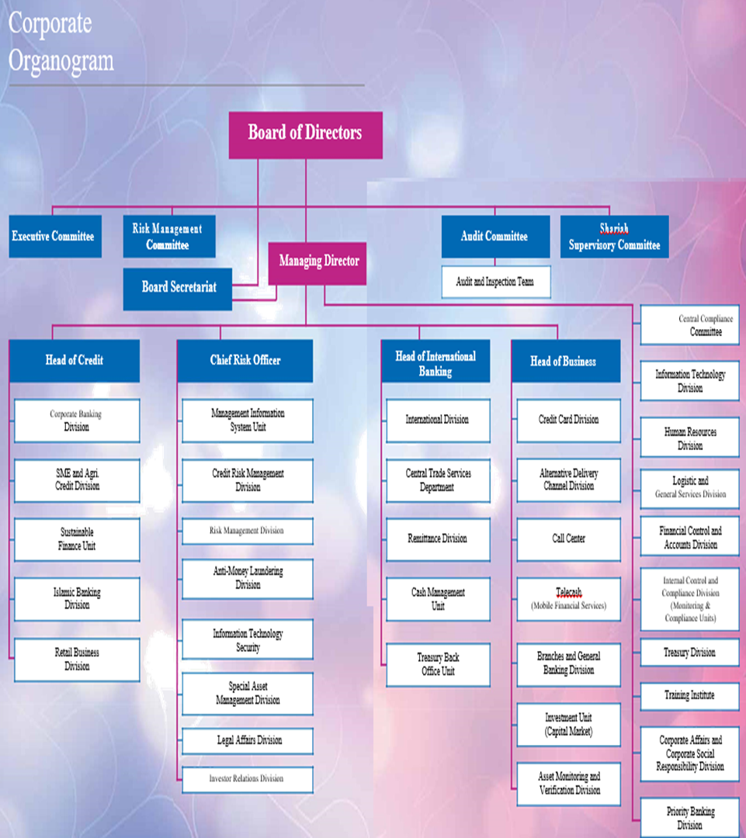
3.9. Corporate Organogram:
3.10. SEBL’s Organizational Structure:
The Chairman is the leader of the Board of Directors. There is one Managing Director who is additionally the President for the most part controls and administers the real division of the bank. One Deputy Managing Director reports to him. Four Executive Vice Presidents (EVP) and one Senior Executive Vice President (SEVP) answer to the Deputy Managing Director. Official VP Control the Senior Executive Vice President controls the human asset and promoting divisions. Four Vice Presidents work under Executive Vice Presidents.

The association structure of Southeast bank Limited is very level were every individual reports to just a single individual which alludes to an exceptionally bunch working condition for instance. Each officer reports to the FAVP or AVP or FVP or VP or SVP or EVP, AVP or FVP or VP or SVP or EVP reports to the SEVP; SEVP answer to the Deputy Managing Director and he answer to the Managing executive.

In the association structure of Principal Branch, SBL we can likewise see that every individual reports to just a single individual. One Executive Vice President is the head of branch one First Vice President (Operation Manager) and the in Charges of credit and remote trade office specifically answer to the EVP. The Operation Manager controls the general saving money, money, records and PC division.

3.11. Division wise Branches:
Southeast Bank Limited has 64 branches in the country. Divisional distribution are, Dhaka (31), Chittagong (17), Rajshahi (4), Syhlet (8), Khulna (1), Barishal (1), Rangpur (2).

3.12. About Southeast Bank Ltd Agargaon Branch:
Agargaon Branch opened on. 29 December 2002. The area of the branch is Plot# E-4/B (first Floor), Agargaron Administrative Area, Shere-e-Bangla Nagar, P.S. Mohammedpur, Dhaka. The remaining burden in this branch is dependably in high volume. The absolute labor of the branch is 22. There are One Manager, One Manager Operation, Two Executive Officer, Two Senior Officer, One Probationary Officer, Two Officer, Five Junior Officer, Two Trainee Cash Officer, Two Messenger, Three Guard, and One Tea Boy.
AB MD Saifur Rahman is available chief of the branch. The capacity of the branch predominantly isolated into two wings. General Banking task and Investment activity. General Banking task done by different segment, for example, Chase area, Bill and Remittance segment, Clearing and Collection segment, Account Opening segment, Credit segment, Fringe Exchange Transaction and Sundry segment. The branch can open L/C. The branch gives on-line managing an account, ATM-money benefit. Exchange hour is monitored by equipped security watches. The branch takes a stab at a client situated keeping money culture, with reasonable, loaning and alluring store plans.

3.13. Operational Activities of SEBL:
- Products:

- Overview of SEBL Services:

Foreign Exchange
General Banking

-Accounts Opening
-Account maintaining.
-Account closing
-Issuing Pay order.
-Demand draft
-Opening of Fixed
Deposit.

-Letter of credit
-Parties to Letter of Credit
-Operations of Documentary Letters Of Credit
-L/C Application
-Scrutiny of Documents

-Investment Scheme for Doctors
-Small Business Investment Scheme
-Housing Investment
Scheme
-Small Transport Scheme
-Car Loan Scheme

-Transport Investment
Scheme.

Agriculture Implements

Investment Scheme

-Education Savings scheme (ESS)
-Marriage Savings Scheme (MSS)
-Pension Savings Scheme (PSS)

Investment Service
Other Saving Services

- Conventional Banking:

Account Opening
Account opening segment is the most vital segment for a bank just as branches since it builds up the connection between a broker and the client. Just the record opening isn't sufficient at some point determination of client for opening a record is critical on the grounds that there are numerous extortion individuals who manage illicit thing through bank .So the Bank takes in its choice of clients cautiously. The accompanying work are done this area. There are two officers performing different capacities in this office. The available accounts those are two acknowledged by SEBL might be characterized into: a) demand deposit b) time deposit.
Savings Account (SB):
Savings Account (SB) is intended for individual savers who need to spare a little piece of their pay which might be utilized sooner rather than later and furthermore mean to have some productive profits for such investment funds. They can store a little sum and can pull back at whatever point they want however the absolute quantities of withdrawals over some undefined time frame are restricted.
Current Account (CD):
Current Deposit (CD) Account is a value-based record where there is no limitation on number of exchanges in the record. Current Deposit (CD) Account can be opened for people and business concerns including non-benefit associations.
Special Notice Deposit (SND):
Special Notice Deposit (SND) Account is an enthusiasm bearing store account where notification ahead of time is required for withdrawal.
Fixed Deposit Receipt (FDR):
Fixed Deposit Receipt (FDR) offers the chance to contribute a settled sum for a settled period at a settled rate important to guarantee the most extreme return against the well-deserved cash of clients.
Fixed Deposit for
a. 1 (one) month | 3.50%
b. 3 (three) months | 6.00%
c. 6 (six) months | 6.50%
d. 1year | 7.00%

Short Term Deposit (STD) Account:
The account should kept for no less than seven days for having interest. The loan cost is not exactly the investment funds stores. Frequent withdrawal is disheartened and requires earlier notice. STD account opening strategy are comparable as investment account.

Monthly Savings Scheme (MSS):
Southeast Bank offers Monthly Savings Scheme (MSS) to enable you to assemble your riches at generally safe with secure returns, wellbeing and accommodation.
Pension Savings Scheme (PSS):
Pension Savings Scheme Offers customers to spare their well-deserved cash each month for an anchored future.
Apart from these popular schemes SEBL also has 2 (two) schemes. They are:
- Monthly Income Scheme
- Millionaire Deposit Scheme

- Islamic Banking:
The Bank began its Islamic Banking Operations on July 28, 2003. The Bank opened 03 (three) Islamic Banking Branches in the year 2003 and 02 (two) Islamic Banking Branches in the year 2004. At present, the Bank has 05 (five) Islamic Banking Branches out of complete 56 branches, 10 SME Service Centers and 1 seaward Banking Unit. To additionally streamline Islamic managing an account activities of the Bank inside the domain of Bangladesh Bank BRPD Circular No. 15 dated November 09, 2009, the Islamic Banking Wing of the Bank has just been changed over into an undeniable Islamic Banking Division from December 27, 2009.
Mudraba Savings Account:
Mudaraba Savings Bank (MSB) Account is intended for savers who need to spare a little piece of their pay to be utilized sooner rather than later and furthermore plan to have some salary on such funds.
Al-Wadiah Current Account:
Al - Wadiah Current Deposit (CD) Account is a value-based record where there is no confinements on number of exchanges in the record. It is a simple - to - use money account.
Mudraba Special Notice Deposit:
Mudaraba Special Notice Deposit (MSND) Account is a benefit bearing store where notification ahead of time of 7 to 30 days is required for sum withdrawal. SND A/C is generally opened by Firms, Corporate Financial Institution.
Mudaraba Term Deposit Reciept (MTDR):
Mudaraba Term Deposit Receipt (MTDR) offers the chance to contribute a settled sum for a settled period at a settled rate of benefit (temporary) to guarantee the most extreme return against the well-deserved cash of clients.
Mudaraba Monthly Savings Scheme (MMSS):
Southeast Bank offers Mudaraba Monthly Savings Scheme (MMSS) to help its customer build their wealth at low risk with secure returns, safety and convenience.
Mudraba Pension Saving Scheme:
Mudaraba Pension Savings Scheme Offers customers to spare their well-deserved cash each month for an anchored future.
SEBL has also other 2 (two) Islamic schemes apart from the above. Those are:
- Mudaraba Monthly Income Scheme (MMIS)
- Mudaraba Millionaire Deposit Scheme (MMDS)
Account Opening Procedure:
The account opening procedure is listed out below:
- Applicant fill up the relevant application form in prescribed manner
- He/ She is required to signature on specium signature card
- For individual information is needed by account holder
- The Authorized officers analyze the introduction and examine the documents submitted
- Issuance of deposit slip deposit must be made on cash no cheque or draft is accepted
- After depositing the cash one cheque book & pay-in-slip book is issued
- Thus the account is opened

Closing Account:
A banker can likewise close the record of his client or stop the task of the record under after extensive conditions:
• Death of client. Client's craziness and bankruptcy.
• Order of the court one Specific charge for misrepresentation imitation.
• Stop installment of cheque and release unpredictable accounts.

- Loan and Advances:
The Bank proceeded with its extension of advances and advances portfolio during the time 2009 by reasonable choice of borrowers. The Bank exploited the chances and difficulties in the financial and business situation of the nation and extended credit in all portions including need areas of Government of Bangladesh like SME and Agriculture. The available loans and advances of Southeast Bank Ltd. are:
- Working Capital Finance
- Overdraft
- Project Finance
- Syndicate Loan
- Packing Credit
- Loan Against Export Bill
- Loan Against Trust Receipt

Working Capital Finance:
This is an advance office intended to meet everyday activity of business concerns and assembling organizations.
Expenses and Charges:
- 13% p.a. at quarterly rests subject to change(s) that might be made by the Bank every now and then
- Standard preparing charge

Overdraft:
This is an interest credit office to meet every day operational prerequisites.
Expenses and Charges:
According to Bank's overarching financing cost (Same as Working Capital Finance).
Project Finance:
A feasible business case, venture attainability report, credit application and sets of reports dependent on sort of task and nature of financing necessities etc. are needed in this loan.
Packing Credit:
SEBL gives pre - shipment back as Export Packing Credit (PC) to help money streams for assembling or pressing products for fare from Bangladesh. .
Expenses and Charges:
- Application Form for demand for credit office – Taka 250/ - .
- 2% on affirmed advance sum
- Half yearly Service Charge
- Taka 1,000/ - on each record for urban customers
- Taka 500/ - on each account for rustic customers

Loan against Export Bill:
This is an interest credit office for the exporters as arrangement or acknowledgment of fare charges by the Bank.
Expenses and Charges:
- Document transaction charge @ least TK. 1000 for every records.
- Postage charges at real
- Application Form for demand for advance office Taka 250/ -
- 2% on affirmed credit sum.
- 7% or 13% p.a. at quarterly rest or as settled by Head Office every once in a while

Loan against Trust Receipt:
SEBL gives post shipment back for example LTR to oversee prompt liquidity of shippers.
Expenses and Charges:
- Half yearly Service Charge
- 2% on affirmed credit sum.
- 13% p.a. at quarterly rests subject to change(s) that might be made by the Bank every once in a while
- Application Form for demand for advance office – Taka 250/ - .
- Taka 1,000/ - on each record for urban customers
- Taka 500/ - on each record for country customers

- SEBL Cards:
The bank is additionally mindful of the changing patterns in electronic installment framework. Whenever, anyplace, any gadget and quick shipping are the desires for the clients now daily. Development of social stage trade and innovation driven creation like portable applications, man-made reasoning has critical job in changing patterns of installment framework. In this way, the bank is likewise concentrating on contact less card, E-wallet, QR code based installment and so on so as to address the up and coming well known changes.

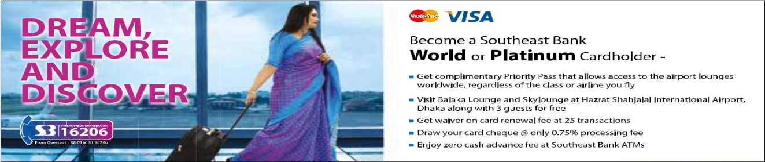

SEBL Credit Card:
Credit Card is a special purchaser monetary item that offers credit and gives the methods for installment in the meantime. Credit Card likewise encourages charge free reimbursement period and reimbursement in portions. It is no big surprise that Credit Card is getting to be prevalent in Bangladesh step by step and in the end will wind up key to the money related existences of the most Bangladeshi shoppers in future. Like earlier years, 2017 is additionally a fruitful year with great business development to the tune of 39% development in net benefit, 26% development in card base and 37% development on exceptional parity over the situation of the most recent year.
Types of Credit Cards:
Southeast Bank Limited is one of the main business banks in Bangladesh. The bank issues Master Card and Visa Cards structured with the best of highlights at focused charge alongside the condition of craftsmanship innovation and great client administrations. Their available Credit cards are:
- Master Card World
- Master card Platinum
- Master Card Titanium
- Master card Standard
- Master card Gold
- Visa Platinum Dual
- Visa Local Gold
- Visa Classic Local
- Visa Classic Dual

SEBL Debit Card:
1. SEBL Express Card:
Client can get Express Card from any SEBL Branch immediately and get to his/her account inside a solitary day. New re-designed procedure of Debit Card Operation has added accommodation to clients by staying away from rehashed visit and expanded security by sending moment warning after Debit Card actuation. Clients can likewise dynamic Personalized Debit Card all day, every day through Call Center.
Fees & Charges:
Daily transaction limit for POS & ATM (combined): BDT 50,000 only.
2. SEBL Personalized Card:
SEBL offers Personalized Debit Card which is issued against funds, current and STD accounts kept up with any part of SEBL. Access your record every minute of every day without utilizing any check.
Fees & Charges:
Daily transaction limit for POS & ATM (combined): BDT 50,000 only.
3. SEBL Student Card:
SEBL offers School Banking Debit Card for your little champ. It is absolutely reciprocal. By utilizing their School managing an account Debit Card Customer’s adolescent can straightforwardly make buys through POS (Point of Sale) machine for buying item and furthermore pull back money from any ATMs. Clients can present their adolescent with the most recent managing an account innovation.
Fees & Charges:
Daily transaction limit for POS & ATM (combined): BDT 2,000 only
4. SEBL My Remit Card:
My Remit Card is a kind of Debit Card practically indistinguishable to SEBL’s exclusive card. Just Foreign Remittance can be saved in My Remit Card.
Some SEBL’s Debit & Credit Cards Picture:
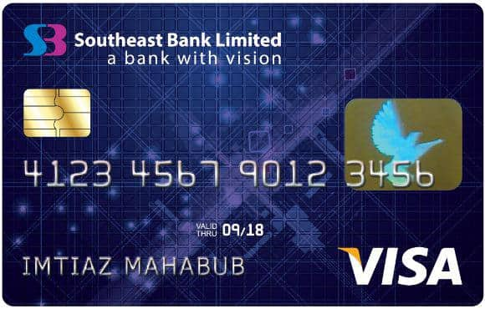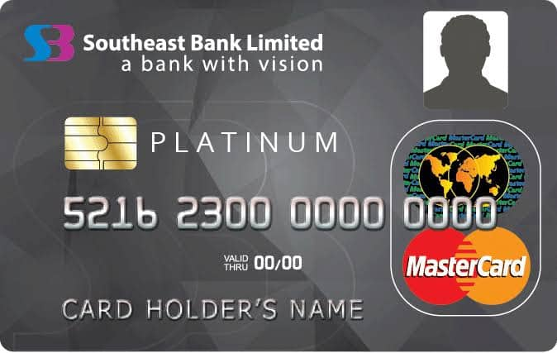
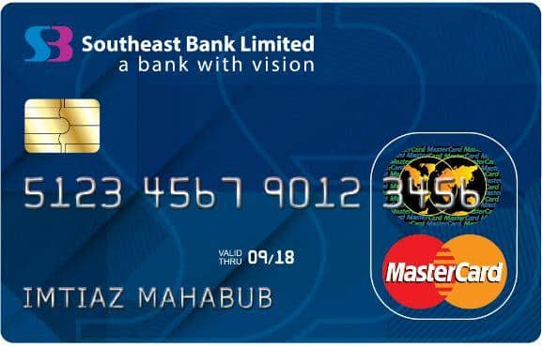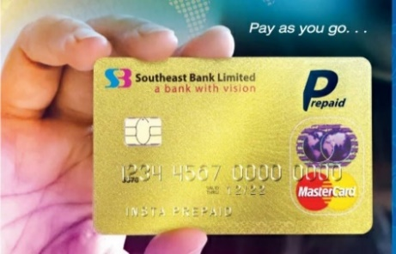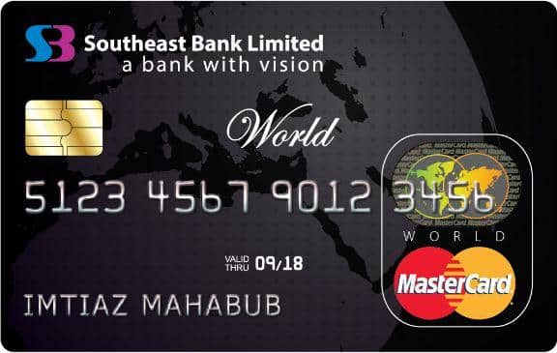
- Foreign Remittance:
In a creating nation like Bangladesh, Foreign Inward Remittance is a standout amongst the most critical drivers of the economy. Remote Inward Remittance altogether supporting the economy of Bangladesh through its commitment in Balance of Payments and Gross Domestic Product (GDP). Thinking about this significance, the Southeast Bank is assuming an imperative job in bringing hard earned remote internal settlement of Bangladeshi ostracizes through saving money channel. From the earliest starting point of 2017, the Bank was in positive development slant in outside settlement business. 2017 was another achievement year for the Bank as it accomplished 48% development in settlement business than 2016. The Bank has accomplished this through utilizing its best staff, client centered items and administrations just as wide system both in gathering and conveyance end.

Overseas Partner:
The Global Partners of SEBL in the field of foreign remittance are:
- Western Union Money Transfer Services
- Continental Exchange Solution ( Ria Financial Services)
- Moneygram International
- Xpress Money Services
- Trans-Fast Worldwide Remittance LLC
- Locker Service:
Southeast Bank has locker service facilities. A customer must have a SB or CD or STD account in the separate branch where the customer needs to profit the locker benefit.
Fees and Charges of Locker Services:
Security Deposit

TK 2500/= (Refundable) for all types of lockers.
Locker Service | Yearly Charge
Small | TK 750/=
Medium | TK 1250/=
Large | TK 2000/=

- ATM Services:
Southeast Bank Limited is giving nonstop ATM Services the nation over through its 164+ ATMs and 9000+ ATMs of part Banks under National Payment Switch of Bangladesh (NPSB). Southeast Bank Limited is an individual from the E-money Shared ATM Network. E-Cash has a system of 32 ATM's situated in deliberately vital areas on five vital urban communities/towns of the nation to be specific: Dhaka, Chittagong, Sylhet, Cox's Bazar and Rajshahi. SEBL are giving ATM benefit inclusion to our 30 branches.
Total 136 ATMs of SEBL:

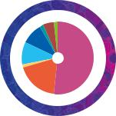

Dhaka 71

Chittagong 25

Barishal 2

Khulna 14

Rajshahi 13

Rangpur 2

Sylhet 7

Mymensingh 2
Eligibility:
SEBL issue ATM Cards against SB, CD & STD Accounts.
Fees & Charges:
Taka 500/= for Annual or Renewal Fee.
- Foreign Trade:
By including imaginative item arrangements, SEBL has consistently overhauled its administrations for its corporate customers to adapt to the regularly changing pace of Globalization. The Bank offers different kinds of exchange items to its clients, for example, Import and Export Letters of Credit, Foreign Guarantees, Standby Letters of Credit, Discounting and so on. In spite of worldwide money related strife that genuinely influenced the import and fare exchange business around the world, the Bank has accomplished a sound development in both import and fare area in 2009. Albeit out of 56 parts of the Bank, just 21 branches are Authorized Dealers to deal with outside exchange activities, practically every one of the branches are enough outfitted with expert labor and infrastructural offices to give exchange back offices to their corporate clients through the AD branches.

- Off-Shore Banking:
Southeast Bank began its Offshore Banking activities in Dhaka EPZ from 30th December, 2009. So as to take into account the back and managing an account needs of 100% remote claimed enterprises in Dhaka Export Processing Zone (EPZ), the non-inhabitant. Bangladeshis working abroad and the non-inhabitant outside establishments, Our OBU (off-Shore Banking Unit) expects to give keeping money items, for example, Savings/Current/Term Deposits/Loans and Advances (Working Capital Finance) and Export Bills limiting office subject to endorsement from Bangladesh Bank.
Their OBUs give money related administrations, for example, deposit taking, settlement, exchange fund, credit offices, and so on.
Business Highlights of OBU: |  |  |  |  |  |  | Figures in million
 |  | 7 |  |  | 2016 |  |  | Growth %
  2017
 |  | USD |  | BDTBDT | USD |  | BDT | Growth %
Total Deposits & Borrowing |  | 97.91 |  | 8,096.87 | 77.68 |  | 6,114.44 | 26.04%
Total Loans & Advances |  | 98.24 |  | 8,124.62 | 80.38 |  | 6,327.72 | 22.22%
Total Operating Profit |  | 2.15 |  | 173.24 | 1.38 |  | 107.79 | 55.80%

- SWIFT:
The Society for Worldwide Inter Bank Financial Telecommunication ("SWIFT") works a worldwide money related informing system. Messages are safely and dependably traded among banks and other money related organizations. Southeast Bank Limited has SWIFT administrations. The Bank's SWIFT location is SEBD BD DH.
- SME Banking:
Small and Medium Enterprises (SMEs) have risen as an exceptionally lively and dynamic segment of Bangladesh economy. SMEs assume a basic job in giving expansive scale business openings and furthermore encourage comprehensive development. SEBL offers a far reaching suite of saving money items and answers for SMEs for meeting their business and development prerequisites. Their long-standing background of banding together with SMEs has empowered them to create non-customary methods for surveying credit dangers. These strategies are interesting and give proper arrangements tweaked to their necessities. The Bank has set up devoted work areas crosswise over branches to help SMEs. The Bank gives credit services to the small and medium business visionaries to be increasingly gainful and stable. The business person ought to be gifted in dealing with his/her business and has involvement of effectively dealing with the business for no less than 2 (two) years. The proficient business person is given inclination. The age of the business person must be inside the scope of 20 to 50. The business person must be socially worthy. An unmistakable progression plan for the business visionary must be available. On the off chance that the business person is an individual, he/she should be a national or lasting occupant of Bangladesh. In the event that the business visionary is an organization/firm or different business element, it must be enrolled in Bangladesh with dominant part shares possessed by Bangladeshi and legitimate licenses for the business.

Year | 2012 | 2013 | 2014 | 2015 | 2016 | 2017
Target | 21,000 | 21,200 | 25,000 | 27,500 | 30,000 | 40,000
Achievement | 18,126 | 26,501 | 30,877 | 35,349 | 40,000 | 37,491

Sector-wise Disbursement in SME:

Some SME Policies of SEBL:
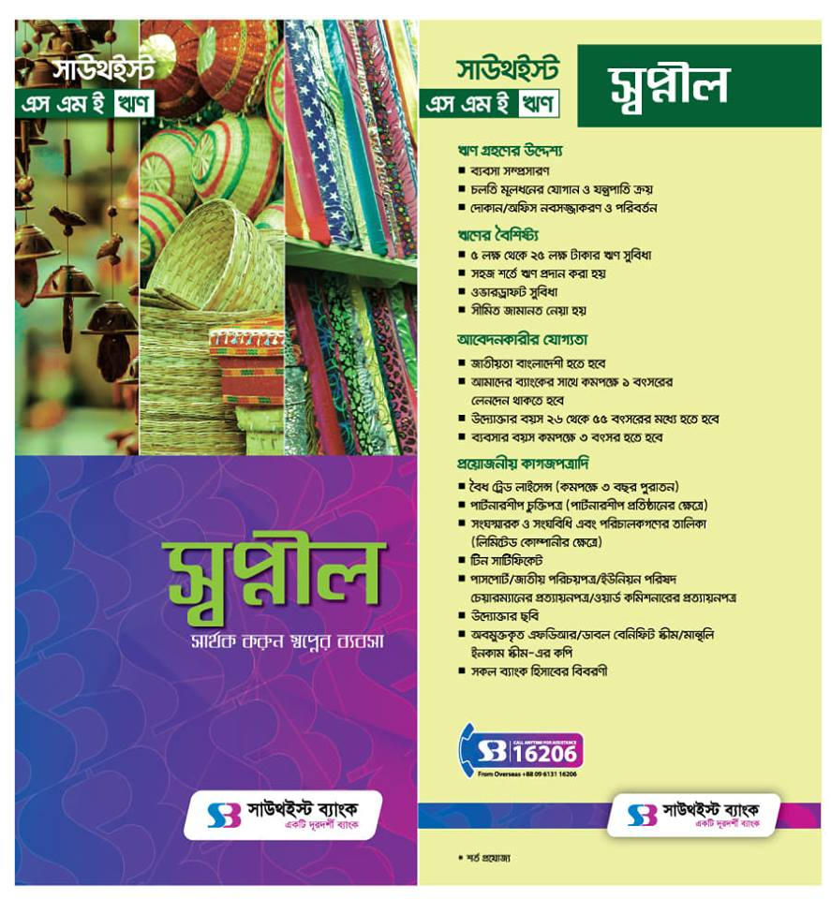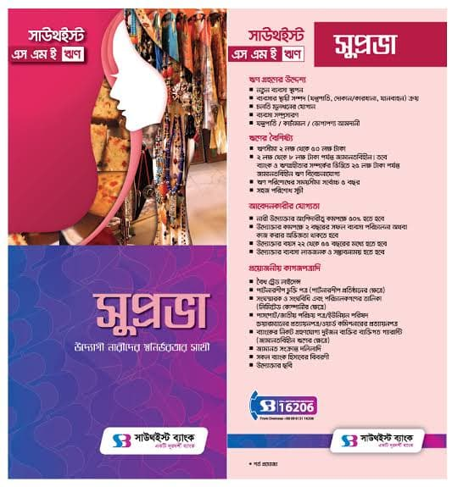

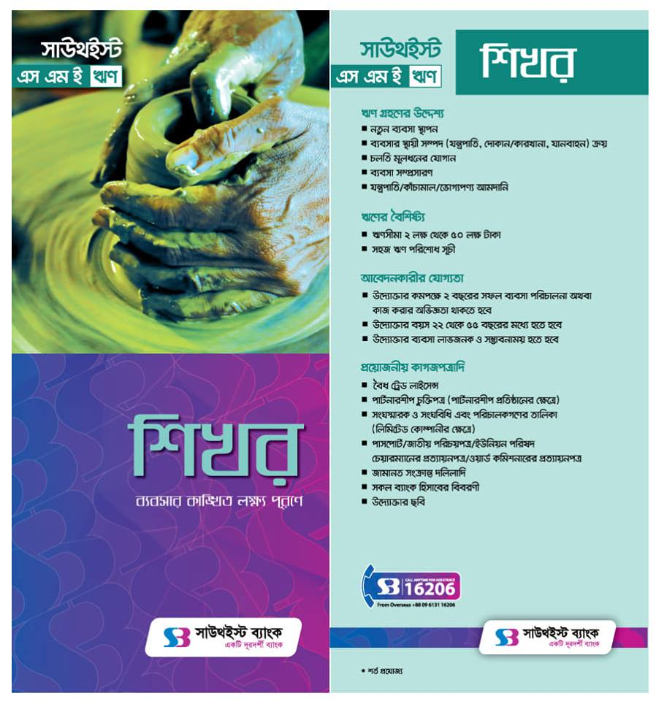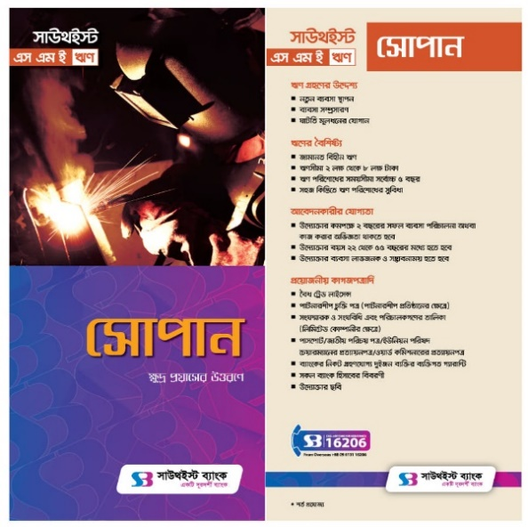

- SEBL Instant Banking:
With the end goal of extending impression in current managing an account, Southeast Bank presents SEBL Instant Banking. SEBL Instant Banking is an Electronic Booth and best in class innovation which furnishes clients with ongoing money acknowledgment and apportion office alongside numerous other managing an account administrations every minute of every day nonstop.
- Bill Payment Service:
Utility Bill:
- Dhaka WASA Bill
- DESCO Bill
- BTCL Telecom Bill
- Electricity Bill
- TITAS GAS Bill.

Tuition Fees Bill:
- North South University
- BRAC University
- United International University
- University of Asia Pacific

- SEBL e-Statement Service:
Features:
- By benefiting this administration, customers may profit day by day/month to month/quarterly/yearly record articulation through their enrolled messages.
- No charge will be connected for this administration.

- SMS Banking:
SEBL’s SMS Banking facilities includes services such as:
Ready Services:
- Record Debit/Credit Alert.
- Clearing Check Return Alert.
- Credit/Time/Scheme Deposit Maturity Alert
- email alert is additionally accessible

- Internet Banking:
SEBL’s Internet Banking includes services like:
Balance Inquiry Services:
- Student Tuition Fees Payment
- Mobile Recharge
- Clearing Cheque Status.

Payment Of:
- Utility Bill
- Tuition Fees
- SEBL Credit Card Bills

  - General Banking Sections:
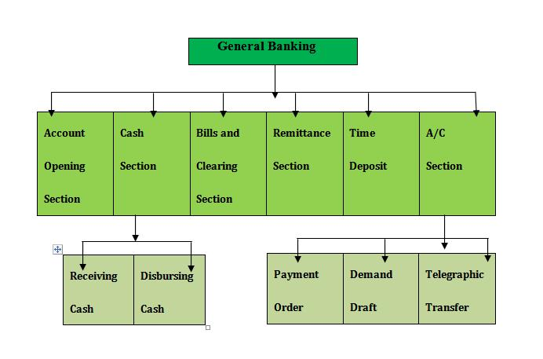

Figure: Different activities of General Banking section

  - Functional Division of Southeast Bank Ltd:
- Board & Share Division
- System & Operation Division
- Treasury Division
- Human Resources Division
- International Division
- Public Relation & Brand Communication Division
- Information Technology Division
- Credit Division
- SME Division
- Risk Management Division
- Credit Monitoring Division
- Agri/rural Credit division
- Retail Banking Division
- Card Division
- Anti-money laundering Division
- Branch Management & Operation Division
- Law & Recovery Division
- Islamic Banking Division
- Credit Administration Division etc.

3.17. SWOT ANALYSIS:

Chapter-4
Findings & Analysis of the Study
  - Findings & Analysis:
While working at Agargaon Branch office of Southeast Bank, I have achieved more up to date sort of understanding. After the gathering and examination of information I have a few discoveries. These discoveries are totally from my own perspective. Those are given beneath:
- As Southeast Bank has no branches in numerous areas in the nation, they can't work by and large activities in the economy of the nation. It has only 134 branches all over the country which is insufficient to provide quality service to the mass target customers of this industry. People have absence of information about SEBL as they have restricted of branches in some particular locale. Moreover, the Southeast Bank Limited does not have satisfactory current communication materials. In The Southeast Bank Limited regular advising programs are not accessible for the employees

- Southeast Bank Limited has officially settled a positive fame in the banking industry of the nation. It is one of the main private division commercial banks in Bangladesh. The bank has just appeared huge development the benefits and stores segment. But the productivity of marketing segment of SEBL is less. The bank can hold the position that they can accomplish if they can bring improvement here. The people groups ought to know about the exercises of SEBL

- Absence of adequate employees keeps stress on the current employees on their works. That is the reason once in a while the employees commits error and customers get disappointed. The employees here and there disturb the association among customer and them. There is likewise noise contamination in the service giving point

- The bank centers around client amicable promoting approaches by offering different productive conveyance of customized keeping money administrations at the customers entryway steps and takes into account the regularly developing financing needs of demographic at a competitive cost. But the operational charges of SEBL are high from others bank makes demoralization of the people groups work with it

- The available training programs are not sufficient for the employees of SEBL.SEBL provides traditional training programs for their employees such as, orientation training, leadership training etc. But with the change of time they have not introduced the modern types of training like, cross cultural training, IT training etc.

- At SEBL, all the decisions are taken by the top management, CEO, DMD and board of the directors. Consequently, because of this type of practice there is only top down management approach and communication process. The extent of bottom up approach is very low and the communication scope is also very limited
- SEBL doesn’t develop their website for the employees and also for the customers. Sometimes, it is quite difficult to get proper information of their services from their website. In addition, the bank software is not that much updated. Sometimes, it is troublesome and time consuming to perform banking tasks for the employees

- The bank concentrated on building superb HR with ability and expert aptitudes embracing the Human Resources Re-designing and Development Plan with the end goal of making a fantastic customer base administration condition for extreme accomplishment of continued benefit development making no includes with the quality resource creation

- Employee enlistment criteria ought to be increasingly powerful as less effective people groups may not be selecting. Training programs isn't adequate particularly for the lower and mid-level officer in this bank. The SEBL's regular advising programs are not accessible for the employees.

- The Southeast Bank Limited does not have sufficient new correspondence materials. As clearing house get electronic, IT area have not adequate worker to hold this successfully. SEBL has a few numbers of ATM booth all over the country. Because of absence of quality number of ATM booth facilities, the bank can't draw in new stores and consequently loaning capacity of the SEBL is in string now.

South East bank has an intelligent corporate culture the workplace is agreeable, intuitive and casual. Also, there are no shrouded obstructions or limits while correspondence between pass on unrivaled and the subordinate. This corporate culture gives as an extraordinary inspiration factor to the employees.

Chapter-5
Conclusion & Recommendations
5.1. Recommendations:
Southeast Bank is one of the most thriving banks of Bangladesh with wide development openings the business. This report gave important acumen of knowledge about where upgrades were important to enhance the nature of service. Southeast Bank with its solid corporate picture and association quality can effectively use the introduced dependent on the discoveries. There are some recommendations given from my point of view:
- Southeast Bank should open more branches to work increasingly successful activities in the nation

- The administration should give careful consideration to existent contact implements and also security framework, since now daily's communication and security is huge concern.

- Promoting Sector ought to be enhanced and successful. SEBL should seek after a incursive promoting to come up into spotlight. Campaign so as to develop a solid picture renown among the potential clients. Campaign, for example, promotion in the paper and magazine, bulletin, neon signs, attention message. SEBL can explore promotion Campaign with its clients especially the corporate customers to develop a solid report. Television advertisement is likewise a famous technique for pulling in the potential clients. As it is an old bank, a methodology of presenting the bank to the general population must be taken with the goal that general individuals will mindful about the development and development of the bank. Sponsor in organization’s picnic and organize or support in cricket match can be way of promote.

- SEBL should open enough ATM booths in Dhaka city as well as all over the country. It will also increase the customer base and the number of deposits.

- A training program or workshop can be arranged to allow the officers know about the technological changes also the ins and outs of different account opening and deposit forms. Long time training is mostly needed for the mid and low level employees. Enormous counselling facility should be available for the employees. Moreover, they should give more focus to the existing guards, messengers that can develop their motivation which is much necessary.

- Southeast Bank Ltd should start evening banking for the portion of customer. They should improve the quality of 24hour customer service. It may gratify the customers. SEBL should also improve their online banking services for their clients. They should also employ customer service officers in all branches to solve customers’ issues and enquiries

- Being one of the commanding banks in Bangladesh SEBL should give equal importance in every departments of banking service. SEBL also need to improve the service of Tele Marketing. This will sleek the procedure of them to enhance their sales.

- The bank needs to develop their deposit policies. The deposit policies of the bank has to be more diversified according to various needs of the customers. Moreover, new investment schemes should be initiated to fulfill client’s demands to lead ahead in the competition and properly satisfy customer requirements.

- The management have to perform the regular review of the inactive and worse accounts. The bank is overburdening the clients by imposing much documents and papers which supposed to the clients being irritated by the relevant officer. The procedure of customer serving process should be more yieldable and easy. The bank software should also easy to perform and less time consuming.

- Lastly, to attain the goal, a bank should found and sick to sufficient and customer friendly policies, practices and procedures for judging the quality of asset and the similarity of loan provision and reserve.

5.2. Conclusion:
In this three-month term internship program at Southeast Bank Ltd. Agargaon branch, I learned numerous parts of present workplace and collected understanding by working with the skillful officers in the branch. They are extremely useful and condition is very fully informed regarding current things. This experience will help me a ton in my profession in job market.
There are 48 commercial banks with various quantities of branches and the challenge is high in part of this industry. In this situation, SEBL is playing essential job in economy of Bangladesh. Most of the clients are pleased as there are no late services and rest guaranteed their property is in safe hand. SEBL gives easy loan to poorer gatherings of individuals in provincial regions and with negligible loan cost SMEs are helped by the bank. The organization is recorded as AA in Bangladesh Bank which is really demonstrating they are in the correct way. In the event that we take a look at their yearly report of ongoing years, the number demonstrates the positive edges which implies their development is expanding each year.
The significance of banks is expanding among the customers continuously which prompts increment rivalry too. All the Commercial Banks are putting forth nearly similar items and services and their function system is practically same. But, the manners in which they give the services are not the same as one another. So individuals pick their bank as per their fulfillment and need. Furthermore, they will favor the bank of which benefit is effectively available and reasonable. Then again, bank advance new items and administrations to draw in their ideal clients. So, SEBL is such a Commercial Bank which is rendering all business saving money administrations to the clients.

References:

- (2018, December 18). Retrieved from https://www.academia.edu/35271725/Internship_Report_on_General_Banking_Activities_of_Social_Islami_Bank_Limited
02. (2018, December 22). Retrieved from http://www.academia.edu/5038465/General_Banking_Activities_of_Southeast_Bank_Limited
03. (2018, December 23). Retrieved from http://www.academia.edu/19589813/Presentation_on_The_General_Banking_Activities_of_Standard_Bank_Limited_SBL_
04. (2018, December 28). Retrieved from http://dspace.bracu.ac.bd/xmlui/bitstream/handle/10361/8944/14364043_MBA.pdf?sequence=1&isAllowed=y
05. (2018, December 29). Retrieved from http://dspace.bracu.ac.bd/xmlui/bitstream/handle/10361/7843/11304017_BBA.pdf?sequence=1&isAllowed=y

