Resilience & Scope of Sustainable Livelihoods in the Haor Area

The thesis work has been done for partial fulfillment of the requirements for the degree of Master in Development Studies (MDS) of United International University

Submitted by
Umayer Abu Omar
ID: 125 173 002
MDS 698: Thesis
Trimester: Fall 2018

Supervisor
Dr. Hamidul Huq
Professor
Department of Economics
United International University (UIU)



United International University
United City, Madani Avenue,
Badda, Dhaka- 1212
Resilience & Scope of Sustainable Livelihoods
In the Haor Area

Abstract

The purpose of this thesis research was to understand the haor area of Bangladesh and what initiative should be taken to establish resilience and sustainable livelihood there. The north-eastern part of Bangladesh is one of the most critical areas to live in because of natural disasters; mainly because of the flash flood. People of haor area live a diverse life with extreme hardship, this research tried to find out, what can be done to make their life easier. Research was conducted using the qualitative approach which is guided by the knowledge of secondary data review. Sustainable development teaches us to leave no one behind but, people of haor area are those unfortunate people, who always end up staying behind. The main objective of this thesis research is to find out how to increase resilience & scope of sustainable livelihood in the haor area for development of the people.

Acknowledgement

In the beginning, I would like to thank Almighty Allah for giving me the scope to study and complete my research work.

My foremost and heartiest thank goes to the Director and Professor of Institute of Development Studies and Sustainability Dr. Hamidul Huq for having faith on me & giving permission to work on this project work. His cooperation by giving advice, support and all kinds of academic facilities helped me while completing my research work.

I am grateful to my Teacher, Tapas Ranjan Chakraborty, Guest Lecturer, Institute of Development Studies and Sustainability, United International University for his support, guidance & valuable advice. His supervision and constructive discussion throughout the study has given me the courage to complete my research work.

Last but not the least; I am grateful to my Mother for inspiration and blessings, which helped me to give my heart and soul in my research work.

Table of Contents

- Chapter One: Introduction
  - Background and context……………………………………………………….…...……01
  - Literature review………………………………………………………………………...04
  - National Policies for Haor……………………………………………………………….07
  - Geographical location of the study………………………………………………………14

- Chapter Two: Objective of the Research
  - Objectives……………………………………………………………………………….16

- Chapter Three: Methodology of the Research
  - Methodology…………………………………………………………………………….17
  - Flowchart of the Methodology…………………………………………………………..18
  - Detail process……………………………………………………………………………19

- Chapter Four: Analysis and Findings
  - Analysis…………………………………………………………………………………21
    - Resilience Frameworks & SDG Review………………………………………….22
    - Field Research Analysis………………………………………………………….29
  - Findings…………………………………………………………………………………41

- Chapter Five: Recommendation and Conclusion
  - Recommendation……………………………………………………………………..…45
  - Conclusion………………………………………………………………………………46

Reference……………………………………………………………………………………47

Checklist…………………………………………………………………………………….49

List of Tables

Resilience Frameworks Review……………………………………………………………...22
Resilience Components according to the selected Frameworks ………………..…………….24
SDG indicators that related to the Resilience Components…………………………………...25
Climate-induced disaster in Bhabanipur village, Tahirpur…………………………………...30
Climate vulnerable sector in Bhabanipur village, Tahirpur…………………………………..32
Flash Flood and Crop (Rice)………………………………………………………………….34
Flash Flood and Vegetables…………………………………………………………..………36

List of Maps

Haor basin of Bangladesh……………………………………………………………………01
Study area Map……………………………………………………………………………….14
Resource map of Study Area…………………………………………………………………29
Acronyms

BDT: Bangladeshi Taka
BRAC: Bangladesh Rural Advancement Committee
CARE: Cooperative for Assistance and Relief Everywhere
FGD: Focus Group Discussion
GDP: Gross domestic product
INGO: International non-governmental organization
KII: Key informant interview
NGO: Non-governmental organization
OXFAM: Oxford Committee for Famine Relief
SDG: Sustainable development goals
UN: United Nations
UNDP: United Nations Development Programmer

Chapter One
Introduction

1.1. Background and context

Bangladesh a land of diversity. Different culture, social system or way of living is present all over the country. But one of the most diverse, challenging scenario of life can be seen in the haor area of Bangladesh. The haor area is challenged by the rage of the nature, natural disasters and variant ecosystem.

The wetland ecosystem in the northeastern part of Bangladesh is called haor. Physically it is bowl-shaped shallow depression (MK Alam, 2004). During monsoon season surface water runoff from rivers and canals into haors and they turn into a vast inland sea. Villages of those areas appear as islands and then they all dry up in the post-monsoon period. In the winter season, these haors become vast stretches of green land (Alam, Mohd Shamsul, 2012).
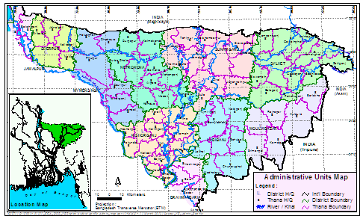
(Map: haor basin of Bangladesh)

The haor basin of Bangladesh is spread over the northeastern part of the country. Sunamganj, Habiganj, Moulvibazar districts and Sylhet Sadar Upazila, as well as Kishoreganj and Netrokona districts outside the core haor area. It is a mosaic of wetland habitats, including rivers, streams and irrigation canals, large areas of seasonally flooded cultivated plains, and hundreds of haors and beels. This zone contains about 400 haors and beels, varying in size from a few hectares to several thousand hectares (Alam, Mohd Shamsul, 2012).
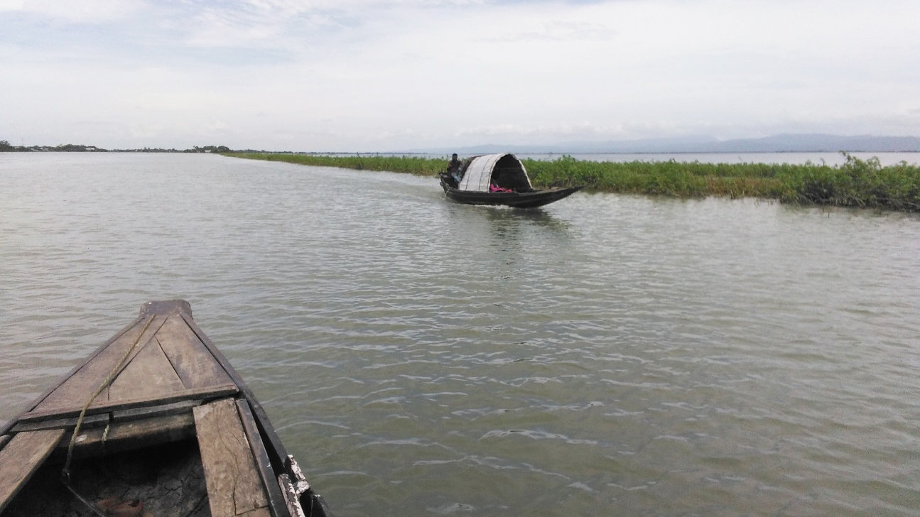
(Picture: Bhabanipur village, during Flashflood, 2018)

Natural disasters are common incident in haors. Flash flood is one of the most dangerous kinds of floods which occurs every year in the haor area. Flash flood is a sudden flood which occurs with destructive power and incredible speed. Generally, it occurs because of heavy rainfall in the upstream. When heavy rainfall occurs, rainwater comes from hill area with full force and hit in the haors because haor area of Bangladesh is located in the foot of the Meghalaya Mountain range. Haors are mainly low land so rainwater flows directly to the haor and causes flash flood.

Flash flood plays a destructive role in the haor area. Every year flood water comes and does not dry up for a very long time; generally, more than six-month haor area stays under water. Flash flood damages asset, crop, houses, communication system and literally everything of haor area. People of haor use boats as their daily vehicle. Rice is the most common crops of this area and various fish Species can be found in haor too. People of the haor area generally takes harvesting and fishing as their main occupation. When flood water drains away people focus on harvesting and when flood water is present harvesting is not possible so they focus on fishing. Besides of cows and goats, a huge number of ducks can be seen in these areas.

In Bangladesh, sustainable development have been practicing which meets the needs of the present without compromising the ability of future generations to meet their own needs. Sustainable development teaches to leave no one behind. But people of haor always end up staying behind because of less concern or unsustainable initiative towards them.

One of the main problems for the people of haor is sustainable livelihood scope and Resilience. Livelihood is the way someone makes his/her living and pay for the basic things he/she needs in life. People of haor needs sustainable livelihood, therefore livelihood scope have to be sustainable and maintainable at a certain rate or level throughout the year. Resilience means the capacity to recover quickly from difficulties; toughness. Which people of haor have to absorb too.

Diverse nature of haor area brings new challenges for the people who live there and flash flood makes haor area worse to survive. This thesis research will help to find the Scope of Sustainable Livelihood and Resilience in the Haor Area.

1.2. Literature review

1. Volume II of ‘Master Plan of Haor Areas’ by Government of Bangladesh, explains why approximately one-third of the population in the Haor area is still living below poverty line despite having an advantage of diversified natural economic resources, and the amount of economic damage they face per year.

‘The haor area is still under-developed due to its physical and hydrological settings, although it is one of the major economic production zones of the country. Agriculture and fisheries are the main bade of the diversified economic resources of the area. A total of about 0.71 million ha of net cultivable land is available in this area, which produces more than 5.25 million tons of paddy each year. However, sudden intrusion of flash flood may destroy agricultural production from about 0.33 million ha, worth Tk. 3,486 million or 3% of the national agricultural contribution to the GDP.’
Master Plan for Haor Areas, Main Report Vol.II, Bangladesh Haor and Wetland Development Board. April 2012.

2. ‘Haor basin is a tectonic depression and is being pushed down as the Indian plate collides with the Eurasian plate. The Sylhet sub-basin is sinking at 2.1cm per year because of down-thrusting under Shillong massif. However, based on analysis of sediment thickness, some say the rate of sinking is much less at 2-4 mm/year. In any case, this sinking will mean that annual flooding will become more extensive.’
Flood and Sustainable Agriculture in the Haor Basin of Bangladesh: A Review Paper, Md. Kamruzzaman & Rajib Shaw, 2018.

3. ‘During the period from 2000 to 2004, Boro crop areas in Sylhet division that has been fully and partially damaged by flash floods were about 4.7 lakh and 3.0 lakh acres respectively. Loss of boro paddy production during these periods was about 5.7 lakh metric tons. In 2003 over 80% of rice amounting to 0.6 million tons was completely damaged due to flashfloods. In 2007, the Haor basin has lost about 1.30 million tons of rice due to severe flood. In 2010, flash flood took place in April just prior to the boro harvesting season and about 30,000 hectares boro cultivated area were ruined and accounted for a loss of about 150,000 metric tons of rice.’
Flood and Sustainable Agriculture in the Haor Basin of Bangladesh: A Review Paper, Md. Kamruzzaman & Rajib Shaw, 2018.

4. Social exclusion and gender equality part of a study, published and financed by CARE-UK, states, ‘Local elites in the Haor region control the key formal and informal institutions that determine poor people’s access to resources and services, including local forums for dispute arbitration (salish), employment opportunities, water bodies and agricultural land, and moneylender loans. They tend to exercise their control of these resources to ensure their political advantage, sometimes by the use of violence. The inequitable management of the valuable Haor fisheries is a key constraint on the livelihoods of PEP households in the region.

Women and girls in Haor communities experience multiple forms of gender inequity and discrimination, which are reinforced by the prevailing religious conservatism of the region. In particular, they face higher rates of malnutrition and maternal mortality than in other parts of Bangladesh, but have more limited mobility, engagement in economic activities and participation in groups and networks. Women and girls also have limited access to basic services of healthcare and education due to the difficulties of transport during the flood season.’
Gillingham. Sarah (PhD), February 2016.

5. ‘Despite improvements in communications and access to basic services of healthcare and education in recent years, local government institutions in the Haor region are still considered as being very weak in terms of their effectiveness and accountability, and levels of citizen participation in local development processes are very low. The local level political culture in the region is accordingly characterized as one in which public office is viewed as a means of accumulating wealth, sometimes based on the use of violence to control valuable resources. These undemocratic ways of working are widely accepted by PEP women and men who have no access to community platforms through which they can raise their collective voice to claim their rights. High transaction costs resulting from the remoteness of many Haor communities, especially during the flood season, are a significant constraint on the effectiveness of both supply- and demand-side governance processes. Women, including Union Parishad women members, are particularly marginalized from decision-making processes at the community level and beyond. The weakness of citizen participation in local decision-making processes and the limited transparency and accountability of local governance processes undermines the effective and equitable delivery of services, including social safety nets, to assist poor and marginalized groups.’
Gillingham. Sarah (PhD), February 2016.

6. A 2011 study speaks of the agricultural constraints in the haor region. The findings suggest that the major constraints are the high input prices that consists of fertilizer, seed, labor etc., and the transportation cost of the harvested crops to the market as most areas do not have modern asphalt roads.

‘Lack of short duration modern varieties as a constraint was mentioned by most of the sample farms. Since early flash flood causes severe crop loss in most of the years, plantation of early maturing (short duration) rice variety would enable farmers to escape crop damage from early flash flood. Lack of water control dam also appeared to be an important problem in the haor areas.’
Crop Production in the Haor Areas of Bangladesh: Insights from Farm Level Survey, M. Shahe Alam, M.A. Quayum and M. A. Islam, 2011.

7. ‘In order to balance human needs and wetlands conservation, a mainly community-based wetlands management approach has been taken in Bangladesh, but this is not enough to prevent the degradation of wetlands. Therefore, Bangladesh now needs a comprehensive strategy combining political, economic, social, and technological approaches to stop further degradation of wetlands. Therefore, wetlands management should be incorporated into a system of integrated land and water use and, indeed, into the socioeconomic system of the country. Policies, strategies, and management plans for sustainable use and conservation of wetlands of Bangladesh must be based on solid knowledge and understanding of their ecological and socioeconomic functions and processes.’
State and management of wetlands in Bangladesh, Talukder Byomkesh, Nobukazu Nakagoshi & Rashid Md. Shahedur, 2008.

1.3. National Policies for Haor

The Government of Bangladesh has taken initiatives for the betterment of the haor area. Many policies have been taken by the government which are relevant directly and indirectly to development of haor area. All the Information’s related to Policies have been collected from “Master Plan of Haor Areas (Volume II, Main Report) Bangladesh Haor and Wetland Development Board, 2012.” Government important policies for Haor are given below.

National Environment Policy, 1992
The National Environment Policy was developed in 1992. Important Policies relate to the haor area are given below:
- Keeping haors, baors, beels, jheels and rivers pollution free.
- Introducing “ecosystem”-wise land use systems
- Conservation of wetland and migratory birds
- Conservation of wetlands which are exclusive to fish culture and prevention of encroachment of wetlands
- Taking necessary measures against industrial pollution
- Taking necessary measures against chemical and artificial pesticide and fertilizer used in agriculture
- Overall improvement of sustainability of nature and environment through conservation and development of the environment
Haor Board (2012) Master Plan for Haor Areas, Main Report Vol.II. Page: 47

National Forestry Policy, 1994
The National Forest Policy was developed in 1994. Major objectives relate to the haor area are given below:
- To bring about 20% of the total area including forest lands, fallow lands, lands not useful for agriculture, hinter lands and other possible areas of the country under various afforestation programmes to meet the basic needs of the present and future generations and to ensure greater contribution of the forestry sector to economic development.
- To enrich biodiversity in the existing degraded forests by conserving the remaining natural habitats of birds, both local and migratory, as well as animals.
- To strengthen agriculture by extending assistance to those sectors related with forest development, especially by conserving land and water resources.
- To fulfill national responsibilities and commitments by implementing various efforts and government ratified agreements relating to global warming, desertification and the control of trade and commerce of wild birds and animals.
- To provide for and implement afforestation programmes on both public and private lands. Therefore as per the Policy, forests and wetlands of conservation value will be identified and developed for ecotourism.
Haor Board (2012) Master Plan for Haor Areas, Main Report Vol.II. Page: 44

National Fisheries Policy, 1998
The National Fisheries Policy was developed in 1998. Important Policies relate to the haor area are given below:
- Laws will be formulated to ban the disposal of any untreated industrial effluents into water bodies.
- Fish habitats will be preserved from damage. Appropriate care should be taken during the implementation of all development activities such as flood control, irrigation and drainage (FCD/I) projects as well as agriculture, industries, road and urban development projects.
- Lakes, beels, ditches-canals and other open water bodes should not be completely dewatered.
- Water bodies such as haors, baors and beels would be revived for fish culture and not be reduced in size.
- Local fisher communities will be given priority for fish culture in baors, and technical and socio-economic support will be provided.
Haor Board (2012) Master Plan for Haor Areas, Main Report Vol.II. Page: 42

National Policy for safe water supply and sanitation, 1998
The National Policy for safe water supply and sanitation was developed in 2010. Important Policies relate to the haor area are given below:
- Facilitating access to basic water supply and sanitation services for all citizens
- Bringing about behavioral change regarding use of water and sanitation
- Promoting sustainable water and sanitation services
- Ensuring supply of quality water through observance of accepted quality standards
- Removal of arsenic from drinking water and supply of arsenic free water from alternate sources in arsenic affected areas
Haor Board (2012) Master Plan for Haor Areas, Main Report Vol.II. Page: 44

National Water Policy, 1999
The National Water Policy was declared by the government in 1999. Important Policies relate to the haor area are given below:
- Natural water bodies such as beels, haors, and baors should be preserved for maintaining the aquatic environment and facilitating drainage. Haors that naturally dry up during the winter will be developed for dry season agriculture.
- Help each other to understand the current and emerging problems in the management of the shared water sources a co-operative attitude and system needs to be developed with co-riparian countries.
- Designation of flood risk zones and taking appropriate measures to provide desired levels of protection. It also calls for the development of early warning and flood-proofing systems, development of water resources of the major rivers for multipurpose use including irrigation, fisheries, navigation, forestry, and aquatic wildlife as well as delineation of water-stressed areas based on land characteristics and water availability.
Haor Board (2012) Master Plan for Haor Areas, Main Report Vol.II. Page: 41

National Agriculture Policy, 1999
The National Agriculture Policy was declared by the government in 1999. Important Policies relate to the haor area are given below:
- Irrigation from surface water will get priority.
- Infrastructure will be built for capturing surface water from khals, beels and small rivers and increasing availability of irrigation water by using high capacity power pumps.
- Small rivers, khals, dighees, derelict ponds, etc. which have silted up will be re-excavated so as to augment water flow for expanding irrigation facilities and fish production, while tree plantation will be done on both sides of khals.
- Research will be strengthened in order to assess the present status and determine future programmes on the availability of irrigation water, utilisation and impact of irrigation technologies etc.
- Supplementary irrigation will be ensured in severe and extremely severe drought affected areas.
Haor Board (2012) Master Plan for Haor Areas, Main Report Vol.II. Page: 42

National Land Use Policy, 2001
The Land Use Policy was declared by the government in 2001. Important statements relate to the haor area are given below:
- Regulation should be imposed over the wetlands so that they are not filled up but kept available for fish culture
- Reservation of large water bodies (e.g. haors, baors. beels, rivers etc.) are the responsibility of the government
- Regular maintenance and rehabilitation of wetlands need to be done when necessary
- Maintenance of the embankments need to be done so that they do not cause drainage congestion
- Water bodies should be used in a way that does not contradict the Fisheries Policy and still contributes in agricultural irrigation
- Fish production should not be hampered in rivers, haors, baors, khals etc. due to crop production
Haor Board (2012) Master Plan for Haor Areas, Main Report Vol.II. Page: 47

National Rural Development Policy, 2001
The National Rural Development Policy was introduced in 2001. Important statements relate to the haor area are given below:
- Construction of buildings, new settlements etc. on cultivable agricultural land will be discouraged, and measures for planned construction of houses will be taken
- Research for innovation and development of technologies of low cost housing for rural areas will be undertaken
- Residential areas and cultivable areas in villages will be separately demarcated wherever possible for more profitable use of agricultural land and for facilitating improved technology-based cultivation
- Families that have become landless, displaced, and shelter less due to river erosion, will be provided with shelter within a short time on a priority basis and rehabilitated in the nearest government Ashrayan/ Adarsha Gram Project area
Haor Board (2012) Master Plan for Haor Areas, Main Report Vol.II. Page: 48

National Livestock Development Policy, 2007
The National Livestock Development Policy was developed in 2007. This policy will be applied for haor region too.
- Promotion of smallholder dairy and poultry development through private sectors participation.
- Rearing of goats, buffaloes and ducks in high potential areas through special projects.
- Privatization of vaccine production and veterinary services.
Haor Board (2012) Master Plan for Haor Areas, Main Report Vol.II. Page: 43

National Tourism Policy, 2009
The National Tourism Policy was developed in 2009. The main objectives of the Policy are to:
- Ensure sustainable tourism by developing the tourism sector
- Create employment opportunities for ensuring socio-economic development involving local people
- Maintain environmental balance
According to the Policy some of the areas in the haor region that are suitable for development of ecotourism are Tamabil, Jaflong, Madhubkunda, Sreemongol, the Lauachara forest in Sylhet, and the haors of Sylhet-Sunamganj.
Haor Board (2012) Master Plan for Haor Areas, Main Report Vol.II. Page: 46

National Jalmahal Management Policy, 2009
“The government adopted the Jalmohal Management Policy in 2009 for increased production and biodiversity conservation of fisheries resources as well as khas water bodies in favour of real fishers and for earning revenue. The basis of the Policy is "Jal jaar, jola taar" which basically means “right is might”. The Policy defines jalmohals as “the water body where water remains sometimes or throughout the year and is known as haor, baor, beel, jheel, pond, ditch, lake, dighi, khal, river, sea etc.” Such jalmohals could be closed or open. Closed jalmohals have a defined boundary unlike open jalmohals. For increased production and to conserve biodiversity, some areas or the entire jalmohal will need to be converted into fish sanctuaries. Jalmohals designated as fish sanctuaries will be transferred to the Directorate of Fisheries according to the Policy.”
Haor Board (2012) Master Plan for Haor Areas, Main Report Vol.II. Page: 50

National Health Policy, 2010
The National Health Policy was developed in 2010. It covers some aspects of the industrial sector in the haor area.
- Sustainable health within 2015 will be promoted to fulfill the Millennium Development Goals (MDGs)
- Improvement of public health status can be attained through access to basic health care and sanitation services, upgrading the level of health service, behavioral change, preventing contamination of water supply and integrated health & family planning.
- Training and education on health, nutrition, balanced diet and hygiene for both men and women
Haor Board (2012) Master Plan for Haor Areas, Main Report Vol.II. Page: 45

1.4. Geographical location of the study area

Bhabanipur village of Dakshin sreepur union of Tahirpur upazila a deeply haor basin area of Sunamganj District. Bhabanipur is situated at the foothill of Meghalaya mountain area. Historically this place was under the state of Gouripur landlord of greater Mymensingh. Low caste Hindus were the residence of this village.

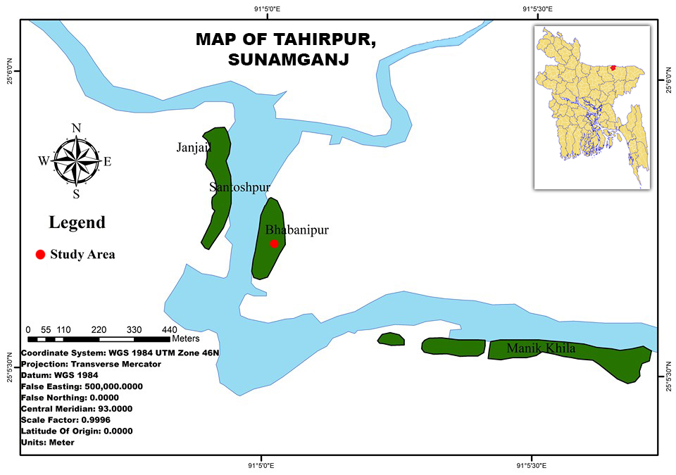
The residence of this area historically depended on harvesting and fishing. In the past, most of the haor basin of that area was covered with swamp forests and reed lands with a characteristic feature of flooded forests that made the entire haor basin suitable habitats for fish and other wildlife including huge numbers of migratory and native birds. Livelihoods of the haor dwellers were largely dependent on the haor resources for food, nutrition, grazing, boating, housing, income and other forms of livelihood securities.
(Map: study area)
The total population of study village is 1,898 where total 939 is women. The Population density is about 371/ sq. km. There have total 345 household and the average household size is about 5.5. The average homestead and cultivable land found 2.42 & 92.07 decimals respectively where about 6% households have no homestead land and 32% households have no cultivable land. The income level of selected household found in BDT/month lowest 2,500 and highest 25,000 and the average was 7,065 (Field Study, 2019).

Chapter Two
Objective of the Research

2.1. Objectives

According to the background, Objectives of the Research are,

- To find out the Livelihood activities during & after flash flood in Haor area.

- To find out the scopes of diversified Livelihoods in Haor area.

- To find out how to increase Resilience & Sustainable Livelihood in Haor area.

Chapter Three
Methodology of the Research

3.1. Methodology

The method of The Research is Qualitative. Research was conducted by collecting primary data from field and analyzing them on the basis of Indicators for Resilience & Sustainable Livelihood of Haor.

Firstly, resilence frameworks have been reviewd, then identified common commponents of those Resilience Frameworks which can be Fitted for Haor Area. SDG and it’s indicators have been also reviewd whiches are related to the Common Resilience Components. To set the Indicators for Resilience & Sustainable Livelihood of Haor.

Secondly, primary data have been from the study area Bhabanipur village,Tahirpur upazila of Sunamganj District. Focus Group Discussions, Key Informants Interviews, Participatory Resource Mapping and Seasonal Calendaring was conducted for collecting primary data. It was necessary to understand corrent livelihood of Haor and potential livlihood options.

And thirdly, primary data/field study data (flash flood, corrent livelihood and potential livlihood options, situation of haor area) have been reviewd based on the Indicators for Resilience & Sustainable Livelihood of Haor. By reviewing it gave the findings of the Study.

3.2. Flowchart of the Methodology

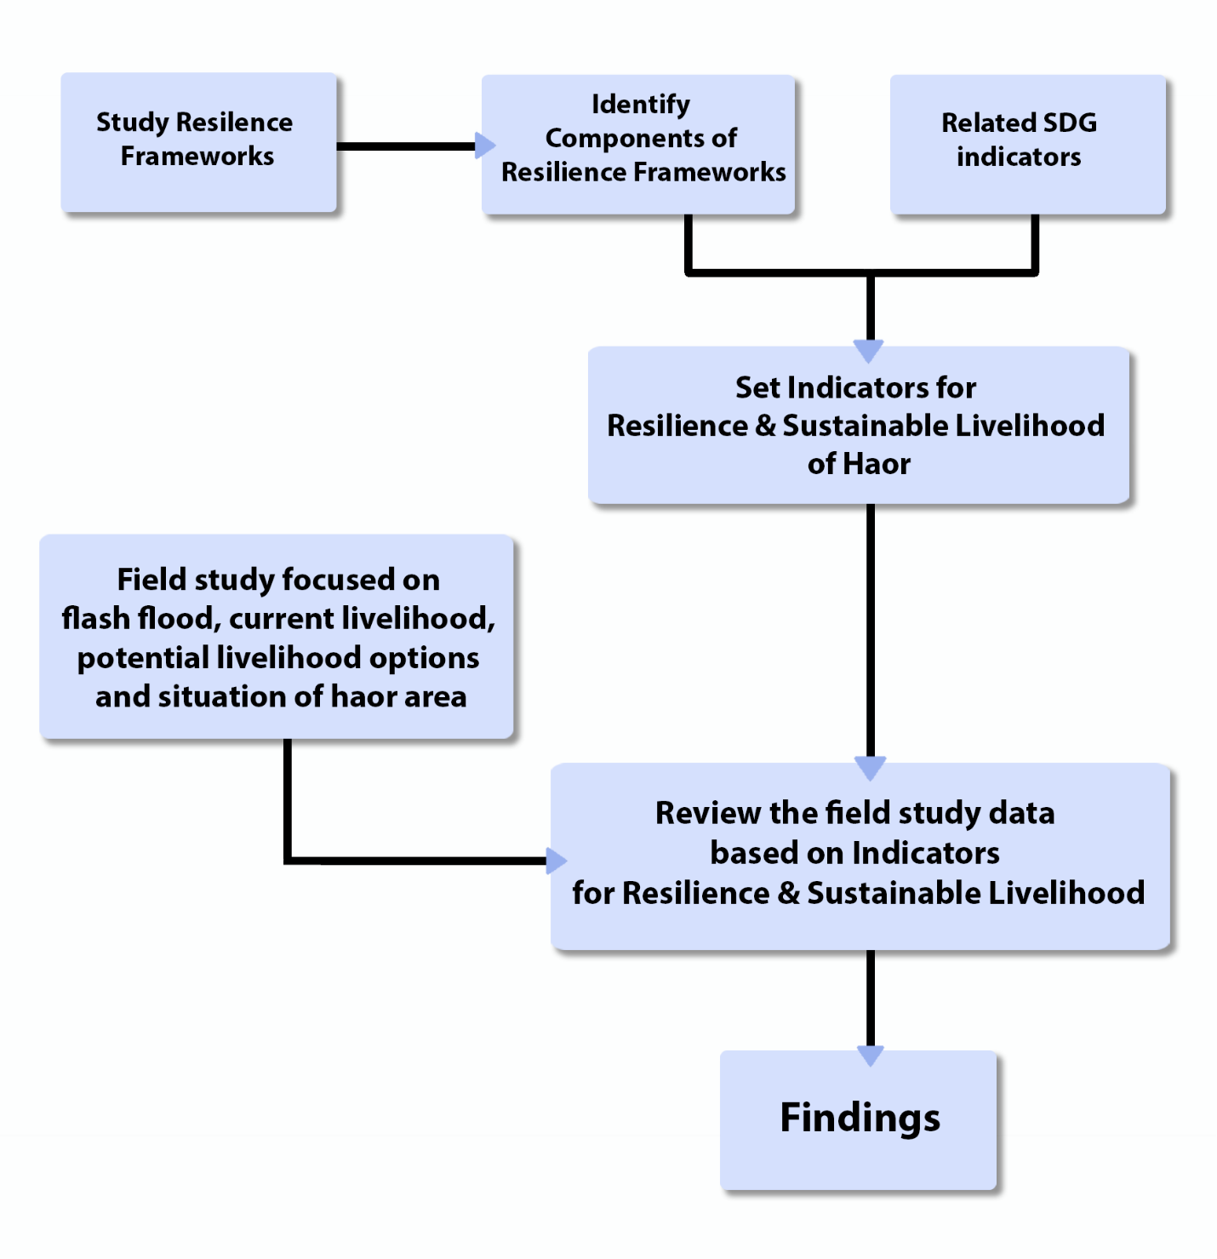

3.3. Detail process

Secondary Data Review
In order to understand Haor Context, Resilience and Sustainable livelihood reviewing have been done of available secondary documents. These are,

- Master Plan of Haor Areas (Volume II, Main Report). Bangladesh Haor and Wetland Development Board, 2012.
- Sustainable Development Goals -UNDP
- Resilience Frameworks:
  - Oxfam GB Multi-Dimensional Approach to Measuring Resilience.
  - ARUP/Rockefeller Foundation City Resilience Framework.
  - DFID Building Resilience and Adaptation to Climate Extremes and Disasters (BRACED) projects.
  - USAID Measurement Framework for Community Resilience.
  - IFRC Framework for Community Resilience.
  - FAO Resilience Index Measurement and Analysis Model (RIMA II).
  - Climate Resilience and Food Security.
  - Strategic Framework for Resilient Livelihoods in Earthquake- Affected Areas of Nepal.
  - Community Resilience: Conceptual Framework and Measurement Feed the Future Learning Agenda.
Secondary documents provided the general understanding of the Haor Context, Sustainable development goals & indicators, Resilience and what will be needed to achieve Resilience. Secondary Data Review also helped to formulate an appropriate questionnaire and checklists for primary data collection.

Primary Data Collection
To know about Livelihood activities during & after flash flood, scopes of diversified Livelihood. And how to increase Resilience & Sustainable Livelihood in Haor area, Primary data are collected from the local communities and actors, including, NGOs and other relevant stakeholders through Participatory Resource Mapping, FGD, KII and Seasonal Calendaring.

Research Tools
Primary Data Collection was anchored by Focus Group Discussion (FGD) and Key Informant Interview (KII) tools. A set of questions were developed based on literature review and objectives of the research. Participatory Resource Mapping and Seasonal Calendaring (crops & hazards) also conducted to get need data for the research. All the required tools and techniques were developed at the earlier stage of the research.

Tools | Targets
Participatory Resource Mapping | (#1)
Seasonal Calendar | (Crops, Hazards)
FGD | (#2) (Women 10), (Man 10)
KII | (Tapas Ranjan Chakraborty /Oxfam,  Ashraful Hossain/ NCCB,  Noor Muhammad Burhan/ Local School Teacher.)

Chapter Four
Analysis and Findings

4.1. Analysis

In this research, Analysis has been done into two steps. Firstly, study of resilience frameworks & sustainable development goals has been done to originate “Indicators for Resilience & Sustainable Livelihood of Haor”. Secondly, analysis of field research data has been done to study haor area, livelihood, and effect of the flash flood. Eventually, this analysis leads to the findings of the research which suggests recommendations to achieve Resilience & Scope of Sustainable Livelihood in the Haor Area.
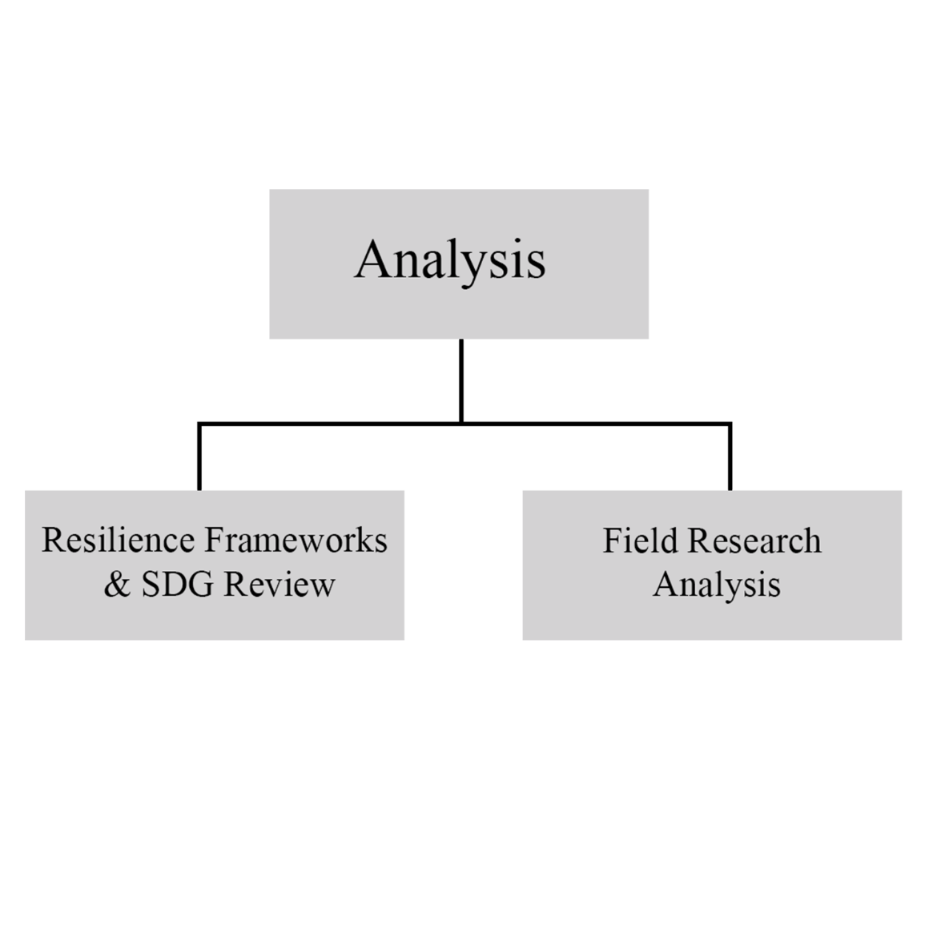
4.1.1. Resilience Frameworks & SDG Review

Resilience frameworks have been studied to learn how to achieve resilience and what are the main considered issues of those Resilience Frameworks. Different types of Resilience Frameworks have been selected to understand resilience from different point of views.

There are Resilience Frameworks such as ARUP/Rockefeller Foundation City Resilience Framework which mainly considered urban area and focuses on City Resilience, IFRC Framework for Community Resilience which mainly considered rural area and focuses on Community Resilience. On the other hand Oxfam GB Multi-Dimensional Approach to Measuring Resilience which considered both Urban & Rural areas. It focuses on multi-dimensional approach. So reviewing different type of resilience frameworks was essential for this research, it helped to understand community resilience, climate and food security, resilience and adaptation to climate, city resilience & multi-dimensional approaches of resilience.

Resilience Frameworks Review
No. | Frame Work | Main Land type Considered | Main issue Considered | Remarks
1 | Oxfam GB Multi-Dimensional Approach to Measuring Resilience | Urban/Rural | Multi-Dimensional Approach | Fit for Haor Area
2 | ARUP/Rockefeller Foundation City Resilience Framework | Urban | City Resilience | ---
3 | DFID Building Resilience and Adaptation to Climate Extremes and Disasters (BRACED) projects | Urban/Rural | Resilience and Adaptation to Climate | Fit for Haor Area
4 | USAID Measurement Framework for Community Resilience | Urban/Rural | Community Resilience | Fit for Haor Area
5 | IFRC Framework for Community Resilience | Rural | Community Resilience | ---
6 | FAO Resilience Index Measurement and Analysis Model (RIMA II) | Rural | Resilience Measurement and Analysis | Fit for Haor Area
7 | Climate Resilience and Food Security | Urban/Rural | Climate and Food Security | ---
8 | Strategic Framework for Resilient Livelihoods in Earthquake- Affected Areas of Nepal | Urban/Rural | Resilient Livelihoods in Earthquake | ---
9 | Community Resilience: Conceptual Framework and Measurement Feed the Future Learning Agenda | Urban/Rural | Community Resilience | Fit for Haor Area
(Source: Secondary Data Review, 2019)

After studying these different type of Resilience Frameworks, three Frameworks have been selected which can be fitted in Haor context of Bangladesh. Selected three Frameworks are,

- Oxfam GB Multi-Dimensional Approach to Measuring Resilience.
- DFID Building Resilience and Adaptation to Climate Extremes and Disasters (BRACED) projects (THE 3AS).
- FAO Resilience Index Measurement and Analysis Model (RIMA II).

Resilience Components according to the selected Frameworks
Oxfam GB | DFID Building Resilience and Adaptation (THE 3AS) | FAO Resilience Index Measurement
Livelihood viability  (Extent livelihood strategies can thrive in spite of shocks, stresses, and uncertainty.) | Anticipatory capacity  (Refers to the ability to anticipate and reduce the impact of climate variability and extremes through preparedness and planning.) | Access to Basic Services (ABS)  (ABS refers to both access to services and the quality of access and services.)
Innovation potential  (Ability to take appropriate risks and positively adjust to change.) | Adaptive capacity  (Refers to the ability of adapt to multiple, long-term and future climate change risks, and also to learn and adjust after a disaster.) | Assets (AST)  (An asset is usually a “stock” that can be drawn upon, built upon, or developed, as well as a resource that can be shared or transferred across generations.)
Contingency resources & support access  (Access to back up resources and appropriate assistance in times of crisis.) | Absorptive capacity  (Refers to the ability of using available skills And resources, to face and manage adverse conditions, emergencies or disasters.) | Social Safety Nets (SSN)  (Access to transfers, whether cash or in-kind, represents a major source of poverty alleviation In many developing countries. Public and private transfers make up a substantial portion of poor households’ annual income, providing important cash to generate additional income.)
Integrity of natural & built environment  (Health of local ecosystems, soundness of natural resource management practices, and robustness of essential physical infrastructure.) | Transformation  (Transformation can describe an unintended change, but generally refers to deliberate attempts to changes required to achieve a desired goal or outcome.) | Sensitivity (S)  (S relates to exposure to risk as well as to persistence or resistance to shocks. Risk exposure refers to the extent to which a household livelihood is affected by a specific shock.)
Social and institutional capability  (Extent formal & informal institutions are able to reduce risk, support positive adaptation, and ensure equitable access to essential services in times of shock/stress.) | --- | Adaptive Capacity (AC)  (Adaptive capacity represents household ability to adapt to the changing environment in which it operates.)
(Source: Secondary Data Review, 2019)

After that study have been done over Sustainable Development Goals and indicators, and relate them with Resilience Components. By relating Resilience Components with SDG and its Indicators, Indicators for Haor to analyze its Resilience & Sustainable Livelihood have been created.

SDG indicators that related to the Resilience Components
Resilience Components | Sustainable Development Goals |  | Related Indicators for Haor
Resilience Components | SDG # | Indicators | Related Indicators for Haor
Absorptive capacity: | 13 | (13.1.1) (13.1.2) (13.3.1) | Livelihood Diversification,  Access to Natural Resources
Access to Basic Services: (ABS) | 1 | (1.1.1) (1.2.1) (1.4.1) | Access to Natural Resources,  Institute and Governance
Access to Basic Services: (ABS) | 2 | (2.1.2) (2.3.1) (2.4.1) (2.5.1) | Access to Natural Resources,  Institute and Governance
Access to Basic Services: (ABS) | 3 | (3.1.1) (3.1.2) (3.2.1) (3.2.2) (3.7.1) (3.7.2) (3.8.1) (3.c.1) | Access to Natural Resources,  Institute and Governance
Access to Basic Services: (ABS) | 4 | (4.1.1) (4.2.1) (4.3.1)  (4.4.1) | Access to Natural Resources,  Institute and Governance
Access to Basic Services: (ABS) | 5 | (5.1.1) (5.2.1) (5.3.1) | Access to Natural Resources,  Institute and Governance
Access to Basic Services: (ABS) | 6 | (6.1.1) (6.2.1) | Access to Natural Resources,  Institute and Governance
Adaptive capacity – (2): | 9 | (9.1.1) (9.3.1) (9.3.2) | Livelihood Diversification,  Access to Natural Resources
Adaptive capacity – (2): | 13 | (13.1.1) (13.1.2) (13.1.3) (13.2.1) (13.3.1) (13.3.2) | Livelihood Diversification,  Access to Natural Resources
Adaptive capacity – (2): | 14 | (14.2.1) (14.3.1) | Livelihood Diversification,  Access to Natural Resources
Adaptive capacity – (2): | 15 | (15.2.1) (15.3.1) (15.5.1) (15.7.1) | Livelihood Diversification,  Access to Natural Resources
Adaptive capacity – (2): | 16 | (16.1.1) (16.1.3) (16.2.1) (16.3.1) (16.5.1) | Livelihood Diversification,  Access to Natural Resources
Anticipatory capacity: | 9 | (9.1.1) (9.2.1) (9.3.1) (9.a.1) (9.b.1) (9.c.1) | Livelihood Diversification,  Access to Natural Resources
Anticipatory capacity: | 11 | (11.1.1) (11.2.1) (11.a.1) | Livelihood Diversification,  Access to Natural Resources
Anticipatory capacity: | 12 | (12.1.1) (12.2.1) (12.5.1) (12.8.1) | Livelihood Diversification,  Access to Natural Resources
Anticipatory capacity: | 13 | (13.1.2) (13.1.3) (13.2.1) (13.3.1) | Livelihood Diversification,  Access to Natural Resources
Anticipatory capacity: | 16 | (16.1.3) (16.2.1) (16.3.1) (16.5.1) (16.6.1) (16.9.1) | Livelihood Diversification,  Access to Natural Resources
Anticipatory capacity: | 17 | (17.1.1) (17.1.2) (17.3.1) (17.9.1) (17.10.1) | Livelihood Diversification,  Access to Natural Resources
Assets (AST): | 9 | (9.3.1) (9.3.2) | Access to Natural Resources
Assets (AST): | 14 | (14.2.1) (14.5.1) (14.7.1) (14.b.1) | Access to Natural Resources
Assets (AST): | 15 | (15.1.1) (15.8.1) | Access to Natural Resources
Contingency resources & support access: | 1 | (1.a.1) (1.b.1) | Institute and Governance
Contingency resources & support access: | 6 | (6.5.2 ) (6.6.1) | Institute and Governance
Contingency resources & support access: | 7 | (7.1.1) (7.2.1) | Institute and Governance
Contingency resources & support access: | 11 | (11.2.1) | Institute and Governance
Contingency resources & support access: | 12 | (12.2.1) | Institute and Governance
Contingency resources & support access: | 13 | (13.a.1) (13.3.1) | Institute and Governance
Contingency resources & support access: | 14 | (14.2.1) (14.5.1) (14.7.1) (14.b.1) | Institute and Governance
Contingency resources & support access: | 15 | (15.1.1) (15.8.1) (15.c.1) | Institute and Governance
Innovation potential: | 7 | (7.1.1) (7.3.1) | DRR and Climate Action
Innovation potential: | 8 | (8.2.1) (8.3.1) (8.6.1) | DRR and Climate Action
Innovation potential: | 9 | (9.3.1) (9.5.1) | DRR and Climate Action
Integrity of natural & built environment: | 11 | (11.1.1) (11.6.1) (11.7.1)  (11.a.1) | Access to Natural Resources
Integrity of natural & built environment: | 12 | (12.2.1) (12.4.1) | Access to Natural Resources
Integrity of natural & built environment: | 13 | (13.1.1) (13.1.2) (13.1.3) | Access to Natural Resources
Integrity of natural & built environment: | 14 | (14.1.1) (14.2.1) (14.3.1) (14.4.1) (14.c.1) | Access to Natural Resources
Integrity of natural & built environment: | 15 | (15.1.1) (15.1.2) (15.3.1) | Access to Natural Resources
Livelihood viability: | 1 | (1.2.1) (1.2.2) | Livelihood Diversification
Livelihood viability: | 4 | (4.4.1) | Livelihood Diversification
Livelihood viability: | 5 | (5.4.1) (5.5.1) (5.a.1) | Livelihood Diversification
Livelihood viability: | 8 | (8.1.1 ) (8.2.1) (8.3.1)  (8.5.1) (8.5.2) (8.9.1) (8.b.1) | Livelihood Diversification
Livelihood viability: | 10 | (10.1.1) (10.2.1) (10.4.1) | Livelihood Diversification
Livelihood viability: | 16 | (16.4.1) | Livelihood Diversification
Social and institutional capability: | 5 | (5.1.1) (5.c.1) | Institutes and Governance
Social and institutional capability: | 8 | (8.1.1) | Institutes and Governance
Social and institutional capability: | 9 | (9.5.1) (9.5.2) | Institutes and Governance
Social and institutional capability: | 10 | (10.2.1) (10.3.1) | Institutes and Governance
Social and institutional capability: | 11 | (11.4.1) (11.a.1) | Institutes and Governance
Social and institutional capability: | 16 | (16.2.1) (16.5.1) (16.6.1) (16.8.1) (16.a.1) | Institutes and Governance
Social and institutional capability: | 17 | (17.15.1) | Institutes and Governance
Social Safety Nets: | 8 | (8.5.1) (8.5.2) (8.6.1)  (8.7.1) | Institutes and Governance
Social Safety Nets: | 11 | (11.a.1) (11.c.1) | Institutes and Governance
Social Safety Nets: | 16 | (16.2.1) (16.5.1) | Institutes and Governance
Transformation: | 9 | (9.1.1) (9.2.1)  (9.3.1) | DRR and Climate Action,  Institute and Governance
Transformation: | 11 | (11.1.1) (11.2.1) (11.c.1) (11.a.1) | DRR and Climate Action,  Institute and Governance
Transformation: | 13 | (13.1.1) (13.1.2) (13.1.3) (13.3.1) | DRR and Climate Action,  Institute and Governance
Transformation: | 16 | (16.6.1) (16.7.1) (16.8.1) | DRR and Climate Action,  Institute and Governance
(Source: Secondary Data Review, 2019)

By studying sustainable development goals and indicators that related to the Resilience Components, Four “Indicators for Resilience & Sustainable Livelihood of Haor” are originated. These Indicators are given below,

- DRR and Climate Action.

- Livelihood Diversification.

- Access to Natural Resources.

- Institute and Governance.

4.1.2. Field Research Analysis

Study area Bhabanipur is a small village and a deep haor basin area of Sunamganj District. People of this village are depended on fishing and harvesting. Bhabanipur village has one union Parishad and one primary school. Though most of the people practice Hinduism as their religion there are some Muslim families too; so that two temples and one mosque are situated in the village. There are ponds and canals in the southwest corner of the village.
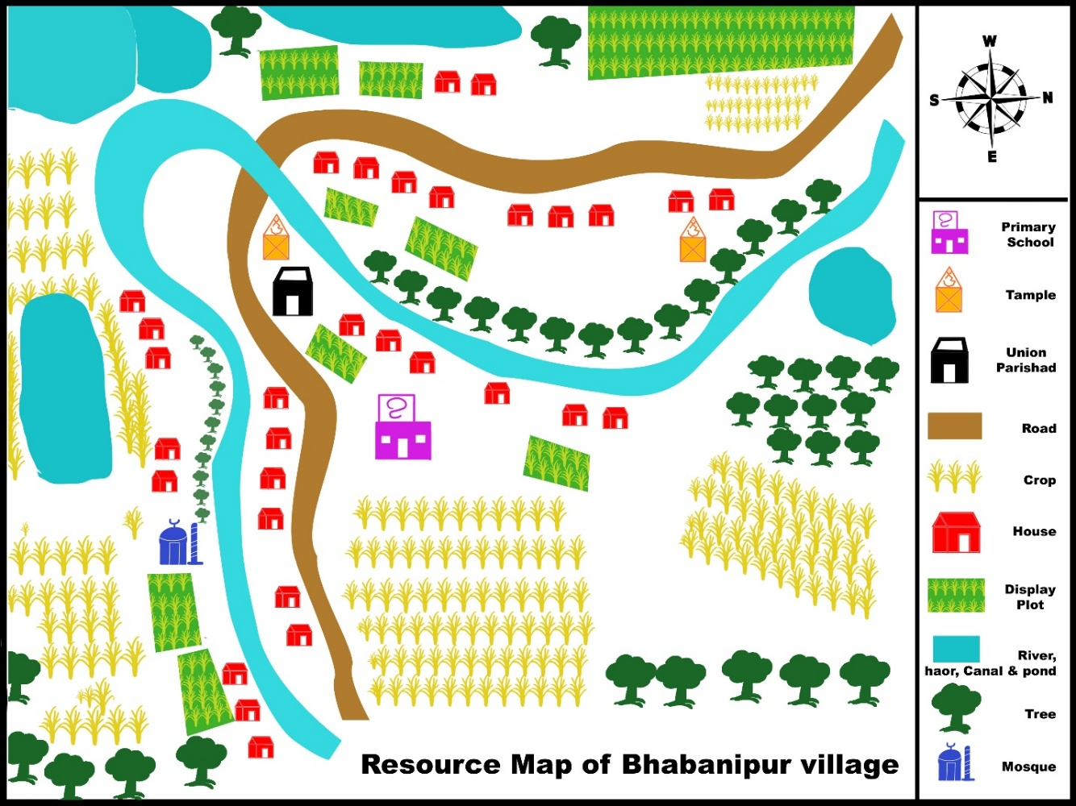
(Source: Field Study, 2019)

Villagers house are scattered all over the village but west and south part of the village is crowded by the locals. Most of the lands are generally located on the eastern side but villagers try to use most of their land to do harvesting when there is no flood water. There can be seen a bunch of display plots by local NGOs here and there. Bhabanipur has a road beside the village which plays an important role when it comes to communications. But because of the flash flood, like rest of 70% -75% of the village that road goes underwater at flash flood period (Field Study, 2019).

The study area Bhabanipur village is mostly climate vulnerable area. Flash flood is a common climate-induced disaster in Bhabanipur village. There are several disasters can be seen in haor area such as cold wave and fog, drought, heat wave, flash flood, river bank erosion, sand storm, wind storm temperature raising but in the study area, cold wave and drought occur beside the destructive flash flood.

Climate-induced disaster in Bhabanipur village, Tahirpur.
Study Area |  | Cold wave & fog | Drought & heat wave | Flash  Flood | River bank erosion | Sand storm | Wind storm | Temperature raising
Bhabanipur
Index | High
Index | Medium
Index | Low
Index | N/A
(Source: Field Study, 2019)

Flash flood is so destructive that the major part of the area goes under water when the flood occurs. Because of flash flood destroys the crop, villagers’ house and regular communication system which effects in the life of the people who lives in haor very badly. People fail to earn their livelihood, crops land goes underwater, and they have to stay away from all kind of agricultural activities. They can’t even grow vegetables properly in flash flood period because they don’t get much land outside of the water. During flash flood period vegetables are grown in house yard only.

Moving one place to other place becomes costly because of flood water. Though people use the boat for commute in haor, boatmen take more charge during the flash flood period. People can’t go to work, kids face difficulty while going to school. Patients and pregnant women face worse difficulty if they have to go to the hospital during the flood. Their cattle get badly affected because of flood water, cattle can’t move around the field to field and eat grass. It causes shortage of cattle food, eventually, cattle become weak and unhealthy. Meanwhile, flood brings the happy time for ducks and fishes. Ducks can move freely because of the wide water body, a huge amount of fishes can be found in the water body. People depend on fishing in this period to earn the livelihood.
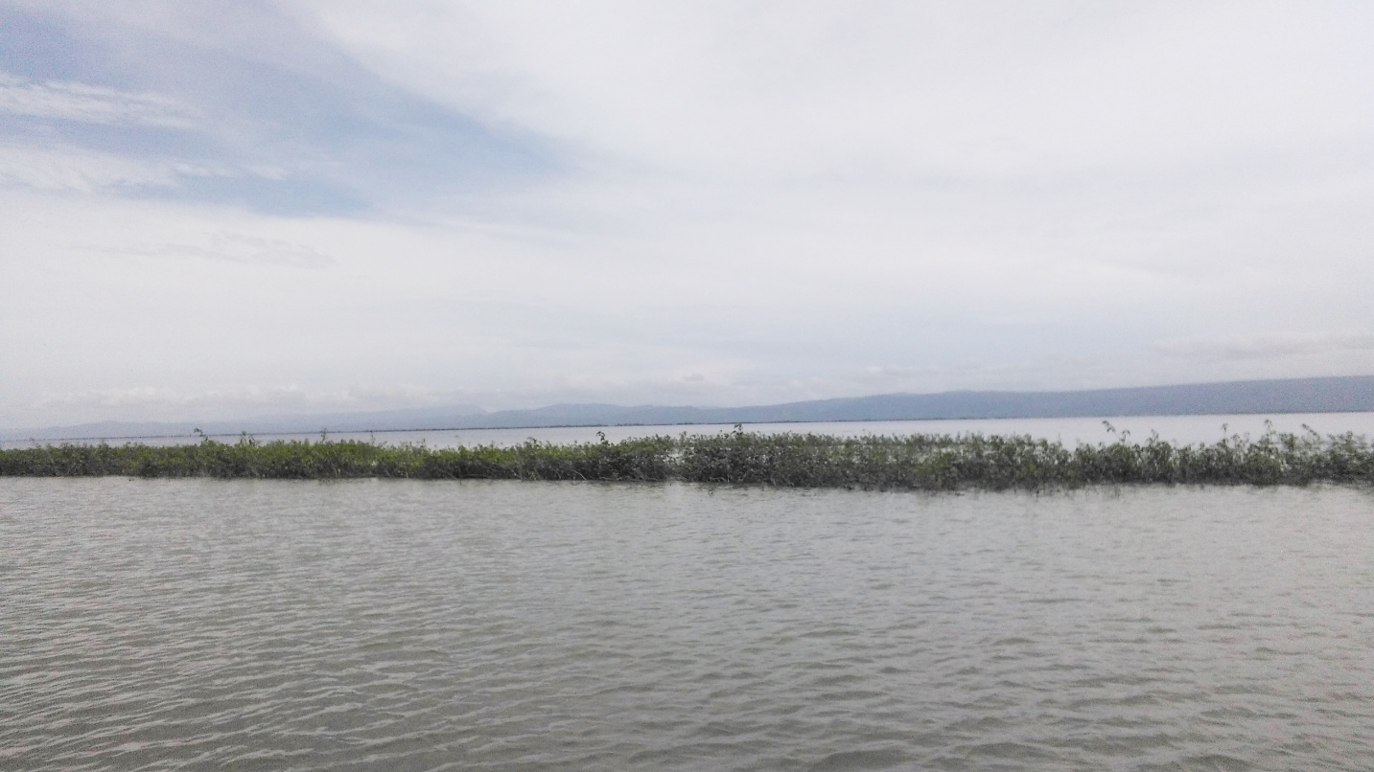
(Picture: Bhabanipur village, during Flashflood, 2018)

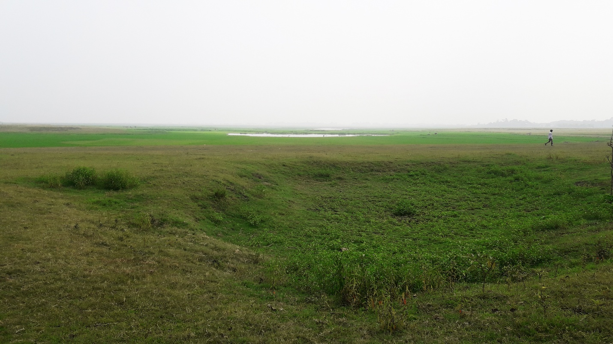
(Picture: Bhabanipur village, before Flashflood, 2019)
Bhabanipur villages various sectors are affected because of climate vulnerability and climate-induced disasters. Bhabanipurs agriculture, Rabi crops, water & health, natural resources, and livestock faces the rage of nature every year. Because of the flash flood, Nor-wester, cold wave & fog agriculture of this area get damaged. Heavy rainfall, flash flood are harmful to Rabi crops but cold wave & fog dose more damage to it.

Climate vulnerable sector in Bhabanipur village, Tahirpur
Vulnerability Sector | Cold wave & fog | Flash  Flood | Nor-wester | Heavy rainfall | Thunder/hail storm
Agriculture
Rabi crops
Livestock
Water & Health
Natural Resources
Index | High
Index | Medium
Index | Low
Index | N/A
(Source: Field Study, 2019)

All the natural resources get damaged more or less because of cold wave, heavy rainfall, and flash flood. Water becomes polluted which causes harm to the health of the people. Besides having all these vulnerable situation livestock damages become unbearable for the people of haor area.

To know how flash flood destroys the agriculture of haor one must understand the timing of flash flood correctly. Flash flood generally occurs in the middle of April & May month, according to Bengali calendar its Boishakh month. After completing the monsoon period eventually flood water dry up in the middle of October & November month, according to Bengali calendar its Kartik month. The main crop of the study area is Rice. Farmers Starts harvesting in the middle of March & April month, according to Bengali calendar its Choitro, the last month of the Bengali calendar. Advance flash flood has become a common scenario of haor basin, Because of climate change, the flash flood comes one month earlier, in the middle of March & April month. This is the time of harvesting, Choitro month. Farmers start gathering a ripe crop from the fields. But advance flash flood ruins all the ripe crop before gathering. Farmers wait for 4/5 months for the crop to grow and harvesting, flash flood destroys farmers’ labor of half a year in the blink of an eye.
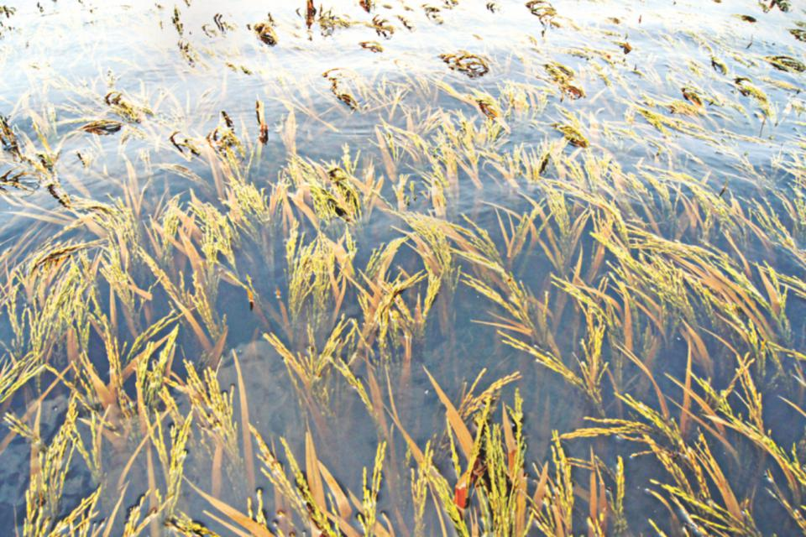
(Photo: advance flash flood ruined ripe crop. Photo credit: the daily star)

Farmers get preparation for Planting Rice from the middle of the October and November month though they start planting from the middle of the December and January because cropping is a very long process. So before planting they have to prepare the field, collect seeds and fertilizers. After planting they have to apply the insecticide, water irrigation, fertilizer application and eventually comes the period of harvesting. Rice takes around 4/5 months to become ripe and harvestable. Farmers should rethink about Rice, because it takes a long period of time to get ripe, and because of climate change flash flood is becoming much more destructive every year little by little. Farmers should start thinking about the alternative of rice. Wheat can be alternative of rice because wheat takes lesser time to ripe than rice. It takes only 3 months, therefore wheat can be a smarter choice than rice. But rice is the main crop of haor area as well as the whole country, so shifting from rice to wheat won’t be easy, but should be taken under consideration.
Flash Flood and Crop (Rice)
Gregorian calendar |  | Jan  Feb | Feb  March | March April | April  May | May  June | June  July | July  Aug | Aug  Sep | Sep  Oct | Oct  Nov | Nov  Dec | Dec  Jan
Bengali calendar |  | Magh | Falgun | Choitro | Boishakh | Jyoishtho | Asharh | Srabon | Bhadro | Ashvin | Kartik | Ogrohayon | Poush
flood | Flash flood
flood | Advance Flash flood
Rice | Seed collection
Rice | Seeding
Rice | Fertilizer collection
Rice | Field Preparing | For Planting |  |  |  |  |  |  |  |  | For Seedling | For  Seedling | For Planting
Rice | Planting
Rice | Weed control
Rice | Applying Insecticide
Rice | Water irrigation |  |  |  |  |  |  |  |  |  | For Seedling | For  Seedling
Rice | Fertilizer application |  |  |  |  |  |  |  |  |  | For Seedling | For  Seedling
Rice | Harvesting
(Source: Field Study, 2019)

Growing vegetables can be a better alternative for farmers. Because of the flash flood, their lands stay underwater half of the year, vegetables takes lesser time to grow than rice and other crops. During flash flood, villagers can grow vegetable easily in their yard and over the tin shade. When the flood water dries off villagers can go verities of vegetable in one land rather than depending on one crop. Collecting seed and fertilizer is tough for the people of haor. Villagers may get seed and fertilizer at a low price with the help of Government and NGOs but if they have to move far to collecting all these commute costs becomes higher. Commute system is very poor in haor area.
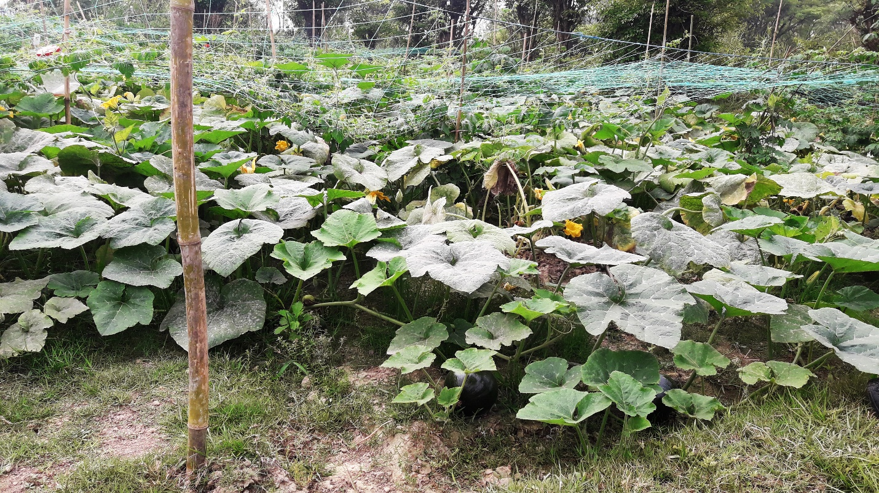
(Picture: cultivating vegetable, Bhabanipur, 2019)
Another obstacle for the people of haor when it comes to cultivating is water irrigation. In the post-flash flood period water irrigation becomes one of the biggest problems for the villagers. Without natural water body, there is no other source of water for irrigation. And after flash flood period the water level of water bodies become lower. Deep tube well can be a solution to this problem. By digging deep tube well for water irrigation, all the villagers and farmer would be able to prepare their field for crop and vegetables. Two deep tube well will be sufficient for covering whole Bhabanipur villages and water irrigation problem of the area.

Flash Flood and Vegetables
Gregorian calendar |  | Jan  Feb | Feb  March | March April | April  May | May  June | June  July | July  Aug | Aug  Sep | Sep  Oct | Oct  Nov | Nov  Dec | Dec  Jan
Bengali calendar |  | Magh | Falgun | Choitro | Boishakh | Jyoishtho | Asharh | Srabon | Bhadro | Ashvin | Kartik | Ogrohayon | Poush
flood | Flash flood
flood | Advance Flash flood
veg. | Bean |  |  |  |  |  |  |  |  | Planting | Grows | Grows
veg. | Gourd |  |  |  |  |  |  | Planting | Grows | Grows
veg. | Chili pepper |  |  |  |  |  |  |  |  |  |  | Planting | Grows
veg. | Malabar spinach |  |  |  | Planting
veg. | stems vegetables |  |  |  |  |  |  |  |  | Planting
veg. | Radish |  |  |  |  |  |  |  |  |  | Planting
veg. | Round potato |  |  |  |  |  |  |  |  |  |  | Planting
veg. | Onion  garlic |  |  |  |  |  |  |  |  |  |  | Planting
veg. | Eggplant |  |  |  |  |  |  |  |  |  | Planting
veg. | Cabbage  turnip carrots |  |  |  |  |  |  |  |  |  | Planting
veg. | pumpkin |  |  |  |  |  |  |  |  |  |  | Planting
veg. | Papaya
(Source: Field Study, 2019
Bean, gourd, chili pepper, malabar spinach, stems vegetables, radish, potato, onion, garlic, eggplant, cabbage, turnip carrots, pumpkin, and papayas are generally cultivated in the study area. Villagers plant the bean in the middle of September to October month, after growing they get beans from the field for at least 5 months. Same goes for the gourd, chili pepper, eggplant and papaya, its obvious villagers get more benefits in lesser time if they cultivate vegetables.
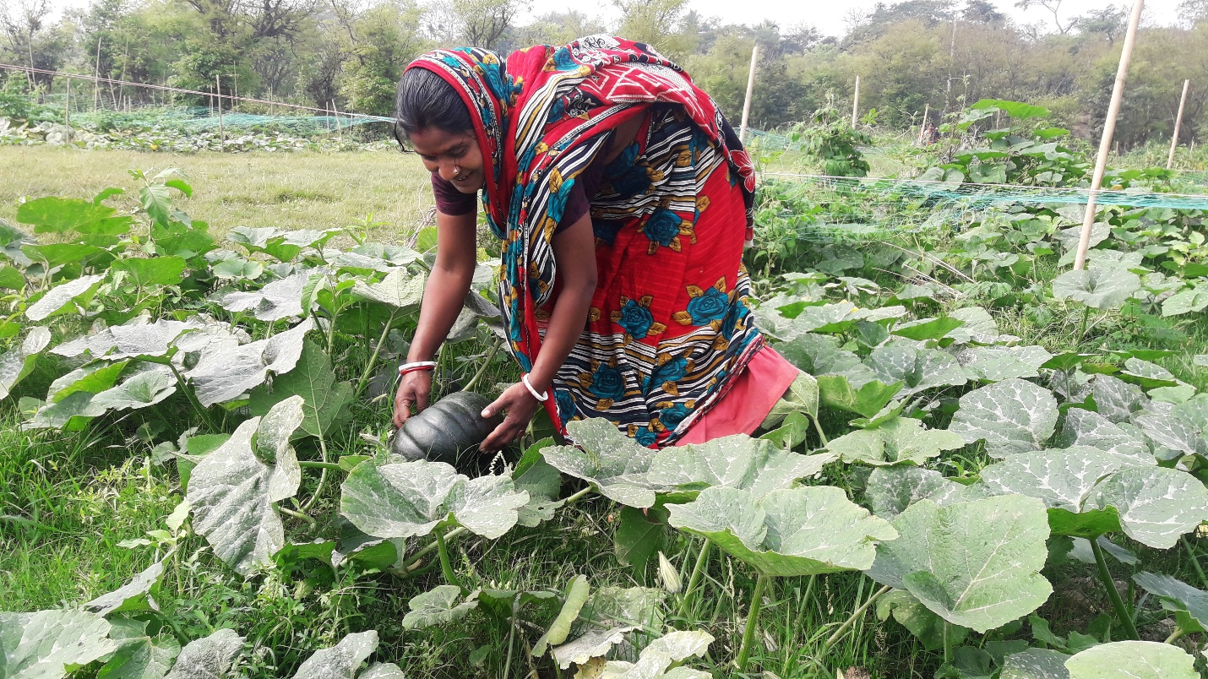
(Picture: women cultivating vegetable, Bhabanipur, 2019)

Not only men, but women are also involving themselves in cultivating vegetables. It is profitable and they can grow different kind of vegetables in one land. During flash flood, villagers can use sack technic and tower technic in their yard to cultivate vegetables. Many NGOs such as BRAC, CARE, OXFAM and CNRS are working in the haor area and teaching people how to get the best profit with whatever they have to work with.

Frustration is another big problem for the people of the haor area. People of haor are hardworking but most of them don’t have any work. Earning living is a big challenge so that people are migrating towards the capital of the country and other cities for finding jobs and earning their living. Other livelihood options are needed for the people of haor. During the flash flood, people can’t go out or do field work because of flood water. If they get work which can be done from their house, would be a problem-solving initiative for them. There are some works which can be done by females and daughters of the house too. Such as sewing, embroidery, carton or bag making and other home crafts. They can make “Shital Pati” to earn livelihood. If they can get big orders from Dhaka or other cities of the country they would be able to make “Shital Pati” in a large range. The main obstacle would be raw material for making “Shital Pati” in a large range, the material has to be imported from outside of the area. But communication system of haor is too poor, commute cost is super high also.

They have a huge number of Cattle in this area. Most of the houses have their own domestic animal which can be used for increasing their economic situation. In post flash flood period, these cattle roam around in the haor area, during flash flood they can’t move freely and fail to eat grass from the fields. So people have to stay aware of these animals food during the flash flood period. Cattle can be used for economic betterment, but feeding them during flash flood is tough.
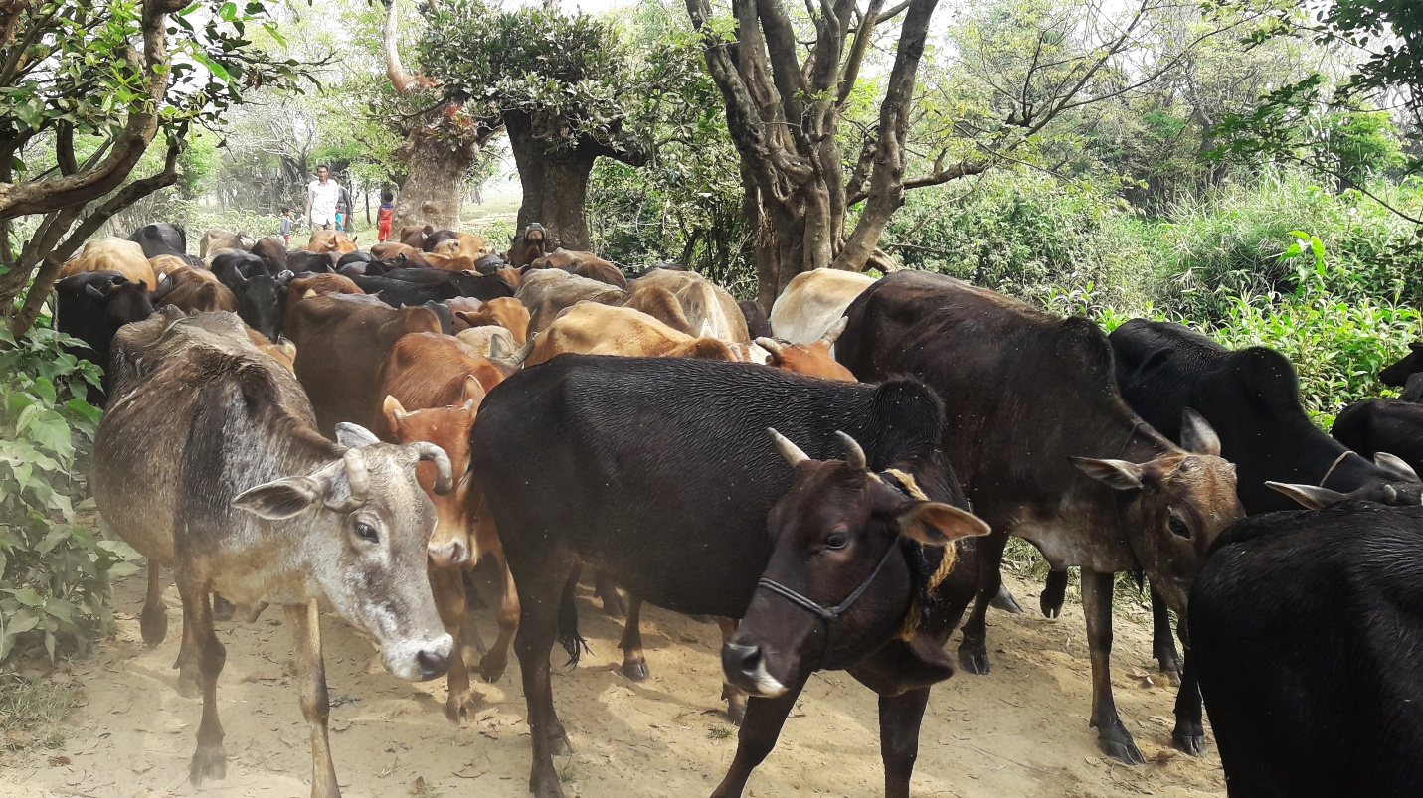
(Picture: cattle roaming around, Bhabanipur, 2019)

One of the most eco-friendly pet for the haor area are ducks. They can be seen there in large number. Haor area stays under water for a long time during the flash flood, it’s like a heaven for the ducks. So ducks can be farmed naturally in this area on a large scale for economic development without facing many difficulties.
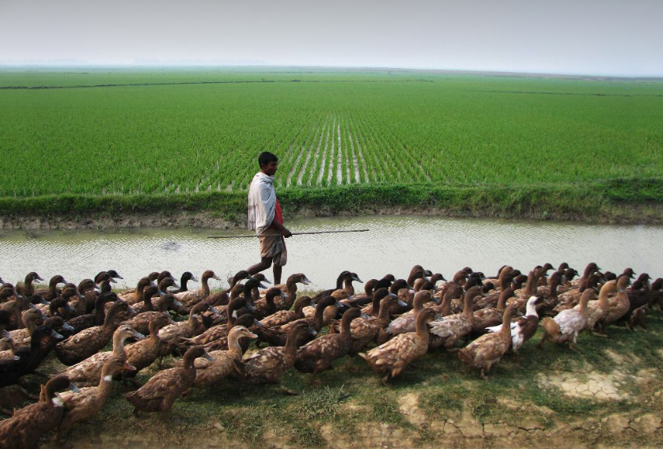
(Picture: ducks of haor area. Photo credit: the daily star)

Ducks roam around freely in this ecosystem and get their food from the environment. But when flood water dries out ducks eat fish eggs which cause big risk in the reproduction process of fishes. An initiative has to be taken to save fish eggs from the ducks in post flash flood period and increase the number of ducks at the same time.

Fish are one of the most important elements of the Haor area. People of haor earn their livelihood by fishing. A huge number of fishes can be found in haor, so fishing could be sufficient enough to meet people’s need of this area but the lease is the main obstacle against fishing. Because of the leasing system, general people can’t go fishing. Haor is a natural resource of livelihood, community people have the right to earn a livelihood from haor. This leasing system made fishing prohibited in the haor for community people. Large areas of haors have gone under the leasing system, which narrow downs the scope of livelihood of the people.

The government of Bangladesh and Non-Governmental Organizations have taken many steps for the haor area. Now the government should take initiative on river digging. Many elderly villagers mentioned that river digging can be helpful for the haor area. By digging, river would be able to hold more water naturally, because of that in flash flood period less area would be flooded. And after the flash flood there would be enough water in the water body to do irrigation in the field. In some areas, river digging has been started with the initiative of the government of Bangladesh. River digging should be increased for the betterment of the people of haor.

4.2. Findings

Findings have gotten by reviewing “field study data” based on Indicators for Resilience & Sustainable Livelihood of Haor. Findings are given below,

1. DRR and Climate Action:
Climate-induced disaster of Bhabanipur village are cold wave & fog, drought & heat wave, flash flood, river bank erosion, sand storm, wind storm, and temperature raising. The Government of Bangladesh and NGOs are working on Disaster risk reduction and climate action.

The flash flood is one of the most dangerous kinds of floods so controlling it is not possible. Any kind of dams or embankment is not helpful to control destructive power and incredible speed of flash flood. So Government and NGOs should be careful about flood forecasting and warning. Flood forecasting at the right time will help the people to move quickly to the flood shelter.

Proper distribution of relief among the vulnerable people have to be ensured. Flood shelters have to be large enough for people of the haor area to fit in with their valuable things. It has been seen, some people don’t move to flood shelters because they can’t take their valuables with them. Safety in the Flood shelter have to be ensured, women should get their needed privacy and hygiene facilities.

2. Livelihood Diversification:
Because of the flash flood, farmers are failing to harvest rice. Middle of March & April month is harvesting time, but flash flood comes in advanced and ruins all the crops before harvesting. It’s a big loss for the farmers of the haor area. People of study area depended on harvesting and fishing. So Flash flood destroys one of the most important livelihood options of the people. Finding diverse option of livelihood is must.

Rice takes 4/5 months to grow for harvesting; as the advanced flash flood is the main problem farmers should go for smarter crop option which takes lesser time to grow and ripe. Wheat can be alternative of rice because it takes only 3 months to grow completely when rice takes 4/5 months. Harvesting wheat will be completed in short time and flash flood won’t be able to destroy it. Rice is one of the main crops so shifting from rice is not easy.

Growing vegetable in large scale can be an alternative livelihood option for the people of haor. Vegetable grows whole year and can be grown in the yard or over tin shades of the house during flashflood. Bean, Gourd, Chili pepper, Malabar spinach, stems vegetables, Radish, Round potato, Onion, garlic, Eggplant, Cabbage, turnip carrots, pumpkin, Papaya, and many more vegetables grow in this area throughout the year.

Not only men, women and daughters also can play a very important role in earning a livelihood by Sewing, embroidery, carton or bag making and other home crafts. They can make “Shital Pati” which can be sell in a higher price range with the right marketing strategy. Getting raw material for “Shital Pati” is a challenge in this area, but it villagers get a large number of order for “Shital Pati” they can bring raw material for other places.

Livestock can bring opportunities for Bhabanipur village. A large number of Cattle and ducks can be seen in this area. If villagers take initiative to pet their animals and ducks in an organized way, they can increase the number of their Livestock. By selling milk and eggs they can get economic stability.

During flash flood, villagers have to be careful about their cattle because cattle don’t get the privilege to roam around and eat grass from the field because of flood water, so villagers have to manage food for their cattle in flash flood period. After the flash flood, they have to be aware of their ducks. When floodwater dries out, the water level of water body goes down too. So that duck becomes furious for lack of natural food and starts eating fish eggs which is harmful to the fish and ecosystem of the haor. Destruction of fish eggs damages the rate of fish production of the area. For this reason, villagers have to keep the ducks in a specific place so these ducks won’t be able to eat fish eggs. Fish are one of the most important elements of the Haor. People of haor depends on fishing for earning livelihood too.

3. Access to Natural Resources:
Fish is the natural resource of haor. It is one of the most important elements of the haor on which people depends for their livelihood. Haors are full of various kind of fish. People of haor used to do fishing independently in these haors and sell fishes in the market to earn livelihood. But because of the leasing system, things are not the same anymore.

Many haor areas are restricted for fishing, so the community people can’t catch fish from those areas because of the leasing system. The government should reconsider this leasing system because people of haor are dependent on fishing. People of haor live in a very tough situation where earning livelihood is already tough, leasing system narrowing down the scope of livelihood which making earing livelihood tougher.

4. Institute and Governance:
The government of Bangladesh and Non-Governmental Organizations are working for the haor area. All the needed policies are present for development of haor area, government have to take initiative for proper implementation of the policies. Non-Governmental Organizations such as BRAC, CARE, OXFAM and CNRS and many more are working for the development of people of haor area. NGOs are helping them by teaching how to deal with vulnerability and properly use whatever asset they have. NGOs are helping them with agriculture, people are getting seeds and fertilizers in a cheaper rate. How to do agriculture in scientific way to grow more crops have been taught by the NGOs.

Communication system of haor area is too poor, people face difficulty to move from one place to another, and commute cost is high. Government take care of this matter.

Government should take initiative to dig deep tube well, it would be helpful for people of haor for farming and water irrigation. Water insufficiency happens when flood water dries away, most of the water bodies of the area becomes dry after flashflood period.

And after flash flood period the water level of water bodies become lower. Deep tube well can be a solution to this problem. By digging deep tube well for water irrigation, all the villagers and farmer would be able to prepare their field for crop and vegetables. Two deep tube well will be sufficient for Bhabanipur village’s irrigation problem.

Government should consider river digging for development of haor area. Digging will make the rivers deep and it will help rivers to hold more waters. So that in flash flood period, haor area would be less flooded because water body will hold more water in them. Besides that after flash flood period there would be enough water in water bodies for farming and irrigation.

Chapter Five
Recommendation and Conclusion

5.1. Recommendation

After completing all the analysis this research has recommendations for development of haor and the people who live in haor area. Recommendations are given below to establish resilience and sustainable livelihood in the haor area of Bangladesh.

Flood forecasting and warning have to be on time. Flood shelters have to be large and safe. Proper distribution of reliefs has to be ensured.

People have to find an alternative crop of rice, which takes lesser time to ripe. Vegetable should be grown in large scale, vegetable should be grown in the yard or over tin shades of the house in flash flood period.

People should start doing sewing, embroidery, carton or bag making and other home crafts to earn livelihood. A large number of cattle and ducks will help in Production of milk and eggs. The government should rethink about the leasing system, which deprives community people of fishing.

The government has to take care of Communication system of haor area. Commute cost is too high, and people of haor is poor. They face difficulty to move from one place to another.

The initiative should be taken by the government to dig deep tube well for farming and irrigation. River digging will bring advantage for the haor area. Deep rivers will soak and hold more water so there will be less flooding and, in the drought season people will be able to use water from the rivers for farming and irrigation.

5.2. Conclusion

Bangladesh has been recognized as a developing country by The United Nations. After getting independence in 1971 Bangladesh gradually developing and in the near future this country will become a developed country of South Asia.

Bangladesh is walking through the path of sustainable development, which suggests pursuing economic, social and environmental development altogether. To achieve sustainable development we have to ensure that “no one will be left behind”, but in Bangladesh people of haor area always end up behind.

The Government of Bangladesh has many policies which are directly and indirectly relevant for the development of the haor area. But because of nonperformance situation of haor isn’t changing. Other areas of Bangladesh is developing but people of haor area are still facing the worst struggle. They face the rage of nature, live a vulnerable life, and can’t work sustainably to earn a livelihood because of the diversity and challenges of the haor area.

This research suggests a few recommendations which will help to achieve resilience & scope of sustainable livelihood in the haor area. These recommendations are rational and directly connected to the problems of the haor area. Such as flood forecasting, alternative crop, vegetable cultivation, home crafts, improving communication system, digging rivers and deep tube well.

If the Government of Bangladesh pays attention to the problems and take initiatives by following recommendations, problems of the hoar area would stat minimizing little by little. Therefore people of haor will achieve a resilient life & new scopes of sustainable livelihood in the haor area.

Reference

Aditya Bahadur & Katie Peters. 2014. DFID Building Resilience and Adaptation to Climate Extremes and Disasters (BRACED) projects.

Alam, Mohd Shamsul; Hossain, Md Sazzad (2012). "Haor". In Islam, Sirajul; Jamal, Ahmed A. Banglapedia: National Encyclopedia of Bangladesh (Second ed.). Asiatic Society of Bangladesh.

ARUP & Rockefeller Foundation. 2014. City Resilience Framework.

Master Plan for Haor Areas, Main Report Vol.II (April 2012), Bangladesh Haor and Wetland Development Board.
Bio-ecological Zones of Bangladesh; International Union for Conservation of Nature and Natural Resources, IUCN, Bangladesh Country Office; 2002

FAO (2016), Resilience Index Measurement and Analysis Model (RIMA II).

Golam Rasul & Bikash Sharma (2015/6), Strategic Framework for Resilient Livelihoods in Earthquake- Affected Areas of Nepal, Publisher???

IFRC (2014), IFRC Framework for Community Resilience.

Khokon, Leaquat Hossain, 64 Jela Bhraman, 2007, p. 79, Anindya Prokash, Dhaka, ISBN 984-8740-19-8.

Livia Bizikova & José Luis Solorzano. 2013. Climate Resilience and Food Security.

M. Shahe Alam, M.A. Quayum and M. A. Islam. 2011. Crop Production in the Haor Areas of Bangladesh: Insights from Farm Level Survey.
Md. Kamruzzaman & Rajib Shaw. 2018. Flood and Sustainable Agriculture in the Haor Basin of Bangladesh: A Review Paper.
MK Alam; Wave attack in Haor areas of Bangladesh and cement concrete blocks as structural revetment material; Progress in Structural Engineering, Mechanics and Computation: Proceedings (ed. Alphose Zingoni); page 325; Taylor & Francis; 2004; ISBN 90-5809-568-1

Oxfam GB. 2013. A Multi-Dimensional Approach to Measuring Resilience.

Talukder Byomkesh, Nobukazu Nakagoshi & Rashid Md. Shahedur. 2008. State and management of wetlands in Bangladesh.

USAID. 2013. Community Resilience: Conceptual Framework and Measurement Feed the Future Learning Agenda.

Checklist

- What is the current situation of haor? What kind of difficulties people of haor have to face?
- What is the general timing of Flash Flood, is there any Disaster Management Policy have been taken because of Flash Flood.
- What are the livelihood options of haor area?
- What are the livelihood activities during & after flash flood in haor area?
- What initiative should be taken to create Sustainable Livelihood options in haor area?
- What are the Natural Resources of Bhabanipur village?
- What are the main crops of Bhabanipur, what level of damage happens to the crop because of flash flood?
- Rice is the main crop of this area but is there any alternative crop that can replace rice?
- What is your opinion about Growing vegetables in Courtyard and Duck farming? Would it be Profitable?
- Do villagers have the freedom of fishing in Haor? I have heard about lease system of haor? Does not it a barrier for the villagers if they want to take fishing as their livelihood?
- What policy have been taken by the government for the haor and people of haor?
- Dose any other organization is working here for the betterment of the people?
- Many Non-Governmental Organization are active here, how are they helping people of haor?
- From your point of view, what initiative should be taken to achieve Resilience and Sustainable Livelihood in haor area?

