PROJECT REPORT- SPRING 2018

Impacts of Board Characteristics on Corporate Performance: Evidence from Bangladeshi Listed Companies.

Submitted By: Maksudur Momin Khan
ID: 114 133 013
Department: BBA- Accounting & Information Systems
School of Business & Economics
United International University

Submitted To: Mofijul Hoq Masum
Assistant Professor
School of Business & Economics
United International University

Submission Date: May 16, 2018

LETTER OF TRANSMITTAL

Mofijul Hoq Masum
Assistant Professor
School of Business & Economics
United International University

Dear Sir,
Here is the project report you assigned me to prepare on “Impacts of Board Characteristics on Corporate Performance: Evidence from Bangladeshi Listed Companies.” In this report I tried to assess perfectly the impacts on the given topic. I have done all the necessary steps that should be included in this report. Verily, your support and guidance make me able to complete this report. So, I hope that you would be kind enough to consider the limitations of this report.

Thank you for giving me such an opportunity to work on this kind of topic. Really, I learnt a lot of new thing to complete this report and I think these learning will help me in my future studies.

Sincerely yours,
Maksudur Momin Khan

ACKNOWLEDGEMENT

First of all I would like to say “All Praises be to Allah (SWT).” Secondly, I would like to thank my family members for their support. Finally, I would say with a great pleasure to express my deep sense of gratitude to my honorable instructor Mofijul Hoq Masum for giving me an opportunity to prepare a report on “Impacts of Board Characteristics on Corporate Performance: Evidence from Bangladeshi Listed Companies” as part of the Project report. Whenever I needed help on different issues my honorable instructor gave me his valuable support and guided me regarding this report. I also took the help from few materials- Journal papers, Articles and Websites provided by our honorable instructor. I’m also thankful to few websites for letting me download the “Annual Reports” of Dhaka Stock Exchange (DSE) listed companies.

ABBREVIATION

ROA= Return on Assets
ROE= Return on Equity
L_TA= Log of Total Assets
L_S= Log of Turnover (Sales)
LEV= Leverage
B_F= Foreign Member on Board
B_O= Board Member’s Ownership
B_S= Board Size
B_I= Percentage of Independent Directors on Board
B_W= Percentage of Women on Board

ABSTRACT

The purpose of this study is to explore the Impacts of Board Characteristics on Corporate Performance based on Bangladeshi listed companies. To support this study I set up 5 board Characteristics and 3 tools for corporate performance- ROA, ROE, and LOG of Turnover. Sample size was 101 listed companies. Basically, I took one third (1/3) of each industry. Annual reports was used for the data collection and I used annual report of 2015- 2016 for the fiscal year and 2016 for the calendar year. To test the impacts, hypothesis was being tested at 1%, 5%, and 10% significant level and there I found some correlation between Board Characteristics and Corporate performance. This study will ensure Bangladeshi companies to focus perfectly on Board Characteristics. This study indicates a mixed results there are both positive and negative link between board characteristics and corporate performance. If Bangladeshi companies focus its board characteristics perfectly they will have a good balance on corporate performance though all the characteristics don’t have the influencing power.

TABLE OF CONTENTS

LETTER OF TRANSMITTAL I
ACKNOWLEDGEMENT II
ABBREVIATION III
ABSTRACT IV
TABLE OF CONTENTS V
LIST OF TABLES AND FIGURES VI
1 INTRODUCTION 1
2 LITERATURE REVIEW 4
3 RESEARCH METHODOLOGY 5
4 RESULTS AND DISCUSSION 10
5 CONCLUSION AND RECOMMENDATION 23
6 APPENDIX 24

LIST OF TABLES AND FIGURES

LIST OF TABLES
Table 1 Population and Sample design. 6
Table 2 Summary of Variables and their measurement with Sources 8
Table 3 Descriptive Statistics 10
Table 4 Variables Entered/Removed ª 10
Table 5 Correlations 11
Table 6 Model Summary ^{b} 12
Table 7 ANOVA ª 12
Table 8 Coefficients ª 13
Table 9 Collinearity Diagnostics ª 14
Table 10 Residuals Statistics ª 14
Table 11 Descriptive Statistics 17
Table 12 Variables Entered/Removed a 17
Table 13 Correlations 18
Table 14 Model Summary ^{b} 19
Table 15 ANOVA ª 19
Table 16 Coefficients ª 20
Table 17 Collinearity Diagnostics ª 20
Table 18 Residuals Statistics ª 21

LIST OF FIGURES
Figure 1 Normal P-P plot of Regression Standardized Residual 15
Figure 2 Scatterplot 16
Figure 3 Normal P-P plot of Regression Standardized Residual 21
Figure 4 Scatterplot 22

INTRODUCTION

Impacts of Board Characteristics on Corporate Performance is not new us. Literature review shows lot of different results both the positive and neutral or no relationship. But in this study I am going to find is there any impact or not. And if there is any impact then what type of characteristics is it. The overall aim of this study is to understand the effect of Board characteristics variables; Foreign member on board, Board member’s ownership, board size, Independent directors, and Women on board of 101 Bangladeshi listed companies in relation to their financial performance; Return on Equity (ROE), Return on Assets (ROA). Board characteristics has a significant effect on the financial performance of Bangladeshi listed companies but few characteristics are neutral that means they don’t have any influencing power.
The main purpose of this study is to provide empirical evidence concerning board characteristics and firm performance. Board of directors is seen as the most important corporate governance mechanism that monitors and advises the top management in performing their responsibility to protect the shareholders’ interest. Therefore by investigating board characteristics such as foreign member on board, Board member’s ownership, board size, Independent directors, and Women on board bring new approaches for researchers and regulators on the importance of board director’s characteristics and firm performance. In addition, prior research has shown that one stream of researchers found that board characteristics were able to provide positive impact on firm performance whereas another stream of researchers found that there is no relationship between board characteristics and firm performance. To reconcile the inconsistencies and inconclusive findings from previous studies this study investigated the relationship between board characteristics and firm performance for the 101 Bangladeshi listed companies. According to Jensen (1993), companies with oversized Boards tend to become less effective. Clearly, a high number of decision-makers in any committee may reduce their effort and give rise to some degree of free-riding. Prabowo and Simpson (2011) in their research in Indonesia found that the presence of independent directors has an insignificant relationship to the firm’s performance. On the other hand, independent directors have positive impact to corporate transparency (Saiful et al., 2012) and financial reporting quality (Rusmin, 2011). Other board characteristics such as board size is also important as it relates to firm performance and prior research show varying results. Several studies in big public companies showed a negative relationship between board size and firm performance. This is true in US (Yermack, 1996), Europe (Bennedsen, Kongsted, & Nielsen, 2008; Eisenberg, Sundgren, & Wells, 1998), and Asia (Mak & Kusnadi, 2005). Yet, studies on public companies in Indonesia showed that board size positively impact corporate transparency (Saiful et al., 2012) and the quality of earnings (Rusmin, 2011). A number of research has examined the board characteristics which will maximize firm value. However, the results are inconclusive and dependent on each company’s specific condition. This research aims to understand the impacts of board characteristics on corporate performance. Most Boards are dominated by men and on average, the number of women on Board does not exceed 2. There are many Boards with no female directors. The maximum number of woman in the Board is 6. Women do not have majority in any firm.

There is only one firm that has greater percentage of women on the Board. This paper is designed as follows- Section 2 describe Literature Review, Section 3 represents Research Methodology whereas Section 4 discuss about Result & Discussion and Section 5 is about Conclusion & Recommendation.

To complete this report all I needed to collect the information about “Board Characteristics & Corporate Performance.” And these 2 information can be perfectly collected from “Annual Report”. That means all I needed to have the annual reports of the listed companies.

Scope:
- Annual reports are usually available
- Main information- board characteristics and corporate performance also be found available
- Accurate information of board characteristics and corporate performance can be found in annual report

Limitation:
- To collect the “Annual Reports” from Dhaka Stock Exchange, it needs tk. 50 for each company & there are almost 340 companies.
- I collected most of the annual reports from company’s own website but the quality of the reports is too poor. Information could not be copied from the pdf that’s why I had to put maximum information manually.

This paper is designed as follows- Section 2 describe Literature Review, Section 3 represents Research Methodology whereas Section 4 discuss about Result & Discussion and Section 5 is about Conclusion & Recommendation.

LITERATURE REVIEW

The literature review shows that there appears to be few evidence to show that the board characteristics have an impact on firm financial performance and that good board of directors practices contribute to investor confidence in the firm which in return result in improved financial performance and continued success of firms (Langat, 2006). However this is not consistent and is also dependent on the financial performance measure used (whether accounting or market based measures). Using firm size as the control variable in this study is motivated by the fact that it has been found to be associated with companies with different characteristics. Lehn et al. (2003), argued firm size and growth are important determinants of the size and structure of the boards. According to Aguilera (2005), the Board of Directors on behalf of shareholders oversees the management team, and serves as a bridge between shareholders and management team. The board structure and financial performance of organizations have the potential to support the strategic direction of organizations in implanting social and ecological activities into their business exercises. They found that firm size is directly related to the size and inversely proportional to the proxy for growth opportunities, that insider representation is inversely proportional to firm size and directly related to the proxy for opportunities growth and thus, a firm size has an effect on the firm performance. Mishra and Nielsen (2000) contended that industry-particular components represent a vast extent of execution inconstancy in an example of firms, and may cloud the connection between board structure and execution.
There are many researchers who discuss about this topic but always there was varieties of results. Sometimes Board Characteristics is found as influencing factor sometimes it is not. Basically, it depends on the nature of the industry, country and variables also.

RESEARCH METHODOLOGY

- Data Design: Basically, my main findings was about “Board Characteristics and Corporate Performance.” And these 2 data can be found correctly from “Annual Reports.” First of all, I had to collect all the annual reports of the selected listed companies. And I collected maximum annual reports from the company’s website. When I had all data in my hand I started finding data about board characteristics and corporate performance from annual reports. There are 10 different types of data I collected for this study. Basically collected 10 types of data but into 3 classifications- Control Variable, Independent Variable, and Dependent Variable.

- Control Variable consists of types of data- Log of Total Assets (Size of the company) & Log of Turnover (Sales).
- Independent Variable consists of 5 board characteristics- Foreign Member on Board, Board Member’s Ownership, Board Size, Percentage of Independent Directors on Board, and Percentage of Women on Board.
- Dependent Variable consists of corporate performance and it is all about Return on Assets (ROA), Leverage, and Return on Equity (ROE).

- Sample Design: This study was on Bangladeshi listed companies and there are 302 perfect listed companies except Financial Instruments like Debentures, Bonds etc. So, my population was about 302 companies and I decided to take one third (1/3) of the total population 302. That means my sample size is close to 100 companies.

Table 1 Population and Sample design.
SL NO. | Name of the Industry | Population | Sampling Technique (1/3) | Sample
1 | Bank | 30 | 10 | 10
2 | Cement | 7 | 2.33 | 2
3 | Ceramics | 5 | 1.67 | 2
4 | Engineering | 36 | 12 | 12
5 | Financial Institution | 23 | 7.67 | 8
6 | Food & Allied | 18 | 6 | 6
7 | Fuel & Power | 18 | 6 | 6
8 | Insurance | 47 | 15.67 | 16
9 | IT | 8 | 2.67 | 3
10 | Jute | 3 | 1 | 1
11 | Miscellaneous | 12 | 4 | 4
12 | Paper & Printing | 2 | 0.67 | 1
13 | Pharmaceuticals & Chemicals | 28 | 9.33 | 9
14 | Services & Real Estate | 4 | 1.33 | 1
15 | Tannery | 6 | 2 | 2
16 | Telecommunication | 2 | 0.67 | 1
17 | Textile | 49 | 16.33 | 16
18 | Travel & Leisure | 4 | 1.33 | 1
Total |  | 302 | 100.67 | 101

- Analytical Tools: To record the data and to process the data we must use some analytical tools which usually help us make things easier and better. Here I use few tools for the analytical part. First of all, I used Microsoft Office 2016 software- more specifically the Microsoft Excel Worksheet to store all the data collected from annual reports. Not only to store but also to calculate the percentage of Independent directors and Women on Board and most importantly the Log of Total Assets & Turnover (Sales). After that to process this collected data I used most the known statistical software IBM SPSS. With the help of IBM SPSS I calculated liner regression model and the significance level of this study.

- Variable Design: All the data were collected based on 3 variables. Basically, I classified all the data into 3 categories- Dependent Variable, Independent Variable, and Control variable. I design these 3 variables to identify the impacts of board characteristics on corporate performance. And as a sample I took 101 Bangladeshi listed companies to find out the impacts.

- Dependent Variable: As dependent variable I used the performance of the companies- Return on Assets (ROA), Leverage, and Return on Equity (ROE). ROA was calculated divided the net profit after tax for the year by the Total Assets. And the ROE was calculated on the same process- net profit after tax for the year by the Total Equity and here Leverage belongs to the Debt to Assets ratio.

- Independent Variable: As the Independent variable I considered 5 board characteristics- Foreign Member on Board, Board Member’s Ownership, Board Size, Percentage of Independent Directors on Board, and Percentage of Women on Board. Foreign Member on Board and Board Member’s Ownership was calculated based on (0-1) scoring. If companies have foreign member and ownership then score is “1” otherwise it is “0”. And other 3 variable was calculated with the exact number and the percentage.

- Control Variable: I used the log of total assets and log of turnover as control variable to check the relationship between that 2 variables. And I used control variable as a dependent variable to see the relation between the independent variable. Here I used size of the company- Log to total assets and Log of Turnover (Sales).

Table 2 Summary of Variables and their measurement with Sources
Types of variable | Variable | Measurement | Source
Independent | Foreign Member on Board | If there is at least one foreign member on board then score is 1 otherwise 0. | Giannetti et al. 2015
Independent | Board Member’s Ownership | If there is board member’s ownership on shares then score is 1 otherwise 0. | Said et al. (2009)
Independent | Board Size | Total no. of Directors. | Said et al. (2009)  Darus et al. (2015)
Independent | Percentage of Independent directors | Independent directors by Total no. Directors | Said et al. (2009)
Independent | Percentage of Women on Board | Women on board by Total no. Directors | Hafsi and Turgut (2013)  Yusoff, et al. (2015)
Dependent | ROA | Net profit after tax for the by Total Assets. | Elizabeth Cooper (2017)
Dependent | Leverage | Total Debt by Total Assets | Omar and Simon (2011)  Haniffa & Cooke, 2005  Lucyanda & Siagian, 2012
Dependent | ROE | Net profit after tax for the by Total Equity | Murcia and Souza (2012)  Omar and Simon (2011)
Control | Log of Total Assets | Total Assets under Log Function | Lassaad and Khamoussi (2012)  Murcia and Souza (2012)  Othman et al. (2011)
Control | Log of Turnover | Total Sales under Log Function | McWilliams and Siegel (2010)

- Model Specification: To find the impacts of board characteristics on corporate performance I used liner regression model and there I found the outcomes about the impacts of board characteristics on corporate performance and their significance levels. Here I am going to discuss about 2 models and their outcomes. Basically, these following models were developed to test the significance level of this study.

- Model 1:
ROE= β0 + β1 (B_F) + β2 (B_O) + β3 (B_S) + β4 (B_I) + β5 (B_W) + ɛ
Here the outcomes of this model is-
ROE= 0.320 + 0.092 (B_F) – 0.158 (B_O) – 0.007 (B_S) – 0.122 (B_I) + 0.096 (B_W) + ɛ

- Model 2:
L_TA= β0 + β1 (B_F) + β2 (B_O) + β3 (B_S) + β4 (B_I) + β5 (B_W) + ɛ
Here the outcomes of this model is-
L_TA= 9.572 + 0.156 (B_F) – 0.452 (B_O) + 0.051 (B_S) + 1.350 (B_I) - 1.402 (B_W) + ɛ

Where,
ROE = Return on Equity
L_TA = Log of Total Assets
B_F = Foreign Members on Board
B_O = Board Member’s Ownership
B_S = Board Size
B_I = Percentage of Independent directors on Board
B_W = Percentage of Women on Board
ɛ = Error

RESULTS AND DISCUSSION

Since, I wanted to evaluate the impacts of board characteristics on corporate performance. I considered all the board characteristics as independent variable and to check the corporate performance I considered ROE as a dependent variable. Which means I am going to discuss the Model 1 first.
Results & Discussion of Model 1
Here, table 3 shows the Mean value of the all sample companies and Standard Deviation as well. Mean value of board size is very higher and standard deviation of board size is also higher.
Table 3 Descriptive Statistics
Descriptive Statistics
 | Mean | Std. Deviation | N
ROE | .1288 | .15004 | 101
B_F | .2574 | .43940 | 101
B_O | .8812 | .32518 | 101
B_S | 9.7228 | 4.34769 | 101
B_I | .2314 | .09595 | 101
B_W | .1811 | .14796 | 101

Table 4 indicates the variable used in this model including the dependent variable.

Table 4 Variables Entered/Removed ª
Variables Entered/Removed ª
Model | Variables Entered | Variables Removed | Method
1 | B_W, B_S, B_F, B_O, B_I ^{b} | . | Enter
a. Dependent Variable: ROE
b. All requested variables entered.

It is very important to find there is any correlation exist or not. Table 5 presents the collinearity of the variable. If there is any correlation of 1 with the other variable then one should be eliminated to get the better outcomes. And there is no correlation of 1 with the other variable. There are so many correlations but I am going to discuss only the correlation between Dependent variable and Independent Variable. B_F has a Positive Weak correlation with ROE. B_O has a Negative Weak correlation with ROE. B_S has a Negative Weak correlation with ROE. B_I has a Negative Weak correlation with ROE. B_W has a Negative Weak correlation with ROE.

Table 5 Correlations
Correlations
 |  | ROE | B_F | B_O | B_S | B_I | B_W
Pearson Correlation | ROE | 1.000 | .346 | -.403 | -.159 | -.015 | -.024
Pearson Correlation | B_F | .346 | 1.000 | -.274 | -.004 | .072 | -.132
Pearson Correlation | B_O | -.403 | -.274 | 1.000 | .012 | .069 | .217
Pearson Correlation | B_S | -.159 | -.004 | .012 | 1.000 | -.398 | .085
Pearson Correlation | B_I | -.015 | .072 | .069 | -.398 | 1.000 | -.101
Pearson Correlation | B_W | -.024 | -.132 | .217 | .085 | -.101 | 1.000
Sig. (1-tailed) | ROE | . | .000 | .000 | .056 | .442 | .408
Sig. (1-tailed) | B_F | .000 | . | .003 | .484 | .237 | .094
Sig. (1-tailed) | B_O | .000 | .003 | . | .453 | .245 | .015
Sig. (1-tailed) | B_S | .056 | .484 | .453 | . | .000 | .199
Sig. (1-tailed) | B_I | .442 | .237 | .245 | .000 | . | .158
Sig. (1-tailed) | B_W | .408 | .094 | .015 | .199 | .158 | .
N | ROE | 101 | 101 | 101 | 101 | 101 | 101
N | B_F | 101 | 101 | 101 | 101 | 101 | 101
N | B_O | 101 | 101 | 101 | 101 | 101 | 101
N | B_S | 101 | 101 | 101 | 101 | 101 | 101
N | B_I | 101 | 101 | 101 | 101 | 101 | 101
N | B_W | 101 | 101 | 101 | 101 | 101 | 101

Table 6 shows the most important information about the model. From this table we can identify 2 information about variable and others information is about its outcomes. First of all I want to focus on the value of “Sig. F Change- 0.000” which simply indicates this model is significant. So, this model is accepted now let’s discuss about Adjusted R Square. Here, Adjusted R Square shows the value of 0.222 which means the accuracy of this model is 0.222. It simply shows the model’s accuracy. And from this table it is clear about R value and R Square value.

Table 6 Model Summary ^{b}
Model Summary ^{b}
Model | R | R Square | Adjusted R Square | Std. Error of the Estimate | Change Statistics
 |  |  |  |  | R Square Change | F Change | df1 | df2 | Sig. F Change
1 | .510ª | .261 | .222 | .13237 | .261 | 6.696 | 5 | 95 | .000
a. Predictors: (Constant), B_W, B_S, B_F, B_O, B_I
b. Dependent Variable: ROE

Basically, to cross check the significance level of this model I used the ANOVA table. Table 7 represents the ANOVA table there I found the same significance level for this model. Here is the same significance level as I found in the model summary Sig. 0.000^{b}. In this ANOVA table Residual and Regression are also clearly mentioned.

Table 7 ANOVA ª
ANOVA ª
Model |  | Sum of Squares | df | Mean Square | F | Sig.
1 | Regression | .587 | 5 | .117 | 6.696 | .000^{b}
1 | Residual | 1.664 | 95 | .018
1 | Total | 2.251 | 100
a. Dependent Variable: ROE
b. Predictors: (Constant), B_W, B_S, B_F, B_O, B_I

Here table 8 represents the Coefficients table with lot of important information. I put the value on the Model 1 from this table. ROE= 0.320 + 0.092 (B_F) – 0.158 (B_O) – 0.007 (B_S) – 0.122 (B_I) + 0.096 (B_W) + ɛ. This value was drawn from table 8 which follows Unstandardized B chronologically. Here t-value is clearly shown in the table. Now I am going to discuss the Sig. value- the p-value & the Collinearity statistics. Here (B_F) and (B_O) are accepted at 1% significant level. And (B_S) is accepted at 5% significant level. And (B_I) & (B_W) are rejected above 10% significant level. From the Collinearity statistics it is good that Tolerance will not be lower than 0.10 and VIF will not cross 10. And in this scenario it looks good.

Table 8 Coefficients ª
Coefficients ª
Model |  | Unstandardized Coefficients |  | Standardized Coefficients | t | Sig. | Collinearity Statistics
 |  | B | Std. Error | Beta | t | Sig. | Tolerance | VIF
1 | (Constant) | .320 | .068 |  | 4.687 | .000
1 | B_F | .092 | .032 | .270 | 2.919 | .004 | .911 | 1.098
1 | B_O | -.158 | .043 | -.342 | -3.630 | .000 | .879 | 1.138
1 | B_S | -.007 | .003 | -.193 | -2.003 | .048 | .837 | 1.195
1 | B_I | -.122 | .152 | -.078 | -.799 | .426 | .821 | 1.218
1 | B_W | .096 | .093 | .095 | 1.038 | .302 | .934 | 1.071
a. Dependent Variable: ROE

Table 9 is all about the Collinearity Diagnostics which means it will show the variance proportions with one another. Basically 0ne variable is how much variant than other variable. Here (B_W) has a constant variance of 0.99 but others are 0.00 variance including the ROE.

Table 9 Collinearity Diagnostics ª
Collinearity Diagnostics ª
Model | Dimension | Eigenvalue | Condition Index | Variance Proportions
 |  |  |  | (Constant) | B_F | B_O | B_S | B_I | B_W
1 | 1 | 4.585 | 1.000 | .00 | .01 | .00 | .01 | .00 | .01
1 | 2 | .762 | 2.453 | .00 | .78 | .00 | .00 | .00 | .04
1 | 3 | .322 | 3.775 | .00 | .09 | .01 | .00 | .06 | .83
1 | 4 | .213 | 4.640 | .00 | .00 | .00 | .40 | .19 | .06
1 | 5 | .090 | 7.144 | .00 | .09 | .79 | .13 | .28 | .04
1 | 6 | .028 | 12.792 | .99 | .03 | .19 | .45 | .47 | .01
a. Dependent Variable: ROE

Table 10 is about residual statistics. It represents the Predictive value and the Residual Value and with standard Predictive value and the Residual Value which focus on Std. deviation and mean value with its maximum and minimum value. Here maximum Std. residual value is 6.395 and minimum is -1.385 with 1.000 and .975 std. deviation respectively.

Table 10 Residuals Statistics ª
Residuals Statistics ª
 | Minimum | Maximum | Mean | Std. Deviation | N
Predicted Value | .0176 | .3824 | .1288 | .07659 | 101
Residual | -.18337 | .84651 | .00000 | .12901 | 101
Std. Predicted Value | -1.453 | 3.311 | .000 | 1.000 | 101
Std. Residual | -1.385 | 6.395 | .000 | .975 | 101
a. Dependent Variable: ROE

Figure 1 represents the following graph of Normal P-P Plot of Regression Standardized Residual which confirms the normality of the sample data. There is a Normal line drown in this graph. Close to this line represents the normality of the sample data. In this graph data is not that much normal.
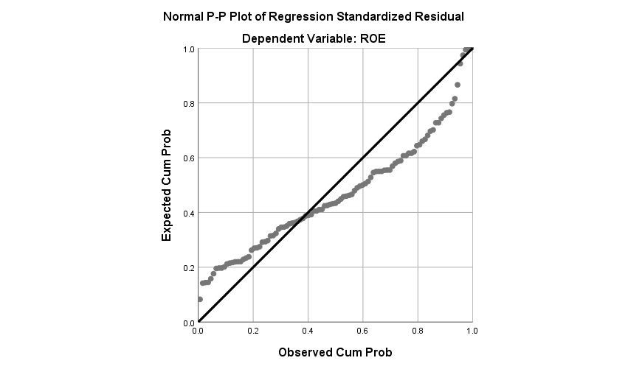
Figure 1 Normal P-P plot of Regression Standardized Residual

Following figure 2 is all about the graph of Scatterplot. There are 2 axis in this scatterplot- Vertical and Horizontal axis. Vertical axis represents the Regression Standardized Residual and Horizontal axis represents the Regression Standardized Predicted Value. Basically, Data needs to be in the form of a rectangular shape. If it is in the rectangular shape then it is okay. And all the data should be within ± 3. Here all the data are in the rectangular shape not within ± 3.
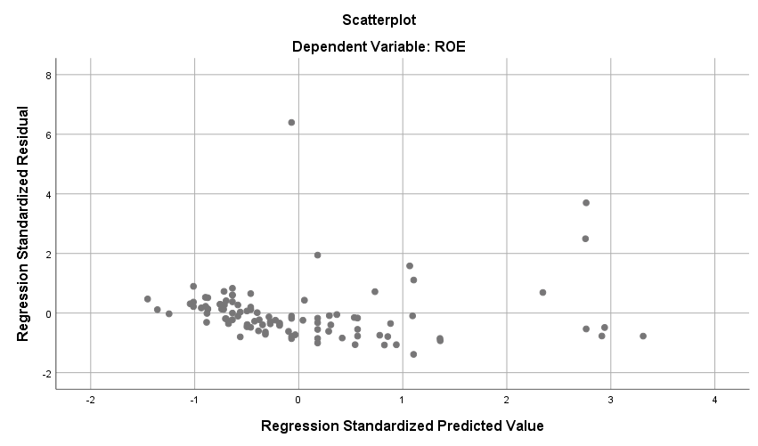
Figure 2 Scatterplot

Final Discussion of Model 1: If I consider the model 1 then it can be found that (B_F) and (B_O) are accepted at 1% significant level. And (B_S) is accepted at 5% significant level. And (B_I) & (B_W) are rejected above 10% significant level. If I stablished hypothesis about these board characteristics then first 3 hypothesis will be accepted and Board Independent and Women on Board will be rejected that means these 2 will not be able to influence the corporate performance in this case.

Results & Discussion of Model 2
Table 11 shows the Mean value of the all sample companies and Standard Deviation as well. Mean value of board size is very higher and standard deviation of board size is also higher.

Table 11 Descriptive Statistics
Descriptive Statistics
 | Mean | Std. Deviation | N
L_TA | 9.7659 | .81400 | 101
B_F | .2574 | .43940 | 101
B_O | .8812 | .32518 | 101
B_S | 9.7228 | 4.34769 | 101
B_I | .2314 | .09595 | 101
B_W | .1811 | .14796 | 101

Table 12 indicates the variable used in this model including the dependent variable. Only difference is I used L_TA as a dependent variable.

Table 12 Variables Entered/Removed a
Variables Entered/Removed ª
Model | Variables Entered | Variables Removed | Method
1 | B_W, B_S, B_F, B_O, B_I ^{b} | . | Enter
a. Dependent Variable: L_TA
b. All requested variables entered.

It is very important to find there is any correlation exist or not. Table 13 presents the collinearity of the variable. If there is any correlation of 1 with the other variable then one should be eliminated to get the better outcomes. And there is no correlation of 1 with the other variable. There are so many correlations but I am going to discuss only the correlation between Dependent variable and Independent Variable. Sample used in this model is 101. B_F has a positive weak relation with L_TA. B_O has a negative weak relation with L_TA. B_S has a positive weak relation with L_TA. B_I has a positive weak relation with L_TA. B_W has a negative weak relation with L_TA.
Table 13 Correlations
Correlations
 |  | L_TA | B_F | B_O | B_S | B_I | B_W
Pearson Correlation | L_TA | 1.000 | .178 | -.245 | .184 | .070 | -.298
Pearson Correlation | B_F | .178 | 1.000 | -.274 | -.004 | .072 | -.132
Pearson Correlation | B_O | -.245 | -.274 | 1.000 | .012 | .069 | .217
Pearson Correlation | B_S | .184 | -.004 | .012 | 1.000 | -.398 | .085
Pearson Correlation | B_I | .070 | .072 | .069 | -.398 | 1.000 | -.101
Pearson Correlation | B_W | -.298 | -.132 | .217 | .085 | -.101 | 1.000
Sig. (1-tailed) | L_TA | . | .038 | .007 | .033 | .242 | .001
Sig. (1-tailed) | B_F | .038 | . | .003 | .484 | .237 | .094
Sig. (1-tailed) | B_O | .007 | .003 | . | .453 | .245 | .015
Sig. (1-tailed) | B_S | .033 | .484 | .453 | . | .000 | .199
Sig. (1-tailed) | B_I | .242 | .237 | .245 | .000 | . | .158
Sig. (1-tailed) | B_W | .001 | .094 | .015 | .199 | .158 | .
N | L_TA | 101 | 101 | 101 | 101 | 101 | 101
N | B_F | 101 | 101 | 101 | 101 | 101 | 101
N | B_O | 101 | 101 | 101 | 101 | 101 | 101
N | B_S | 101 | 101 | 101 | 101 | 101 | 101
N | B_I | 101 | 101 | 101 | 101 | 101 | 101
N | B_W | 101 | 101 | 101 | 101 | 101 | 101

Table 14 shows the most important information about the model. From this table we can identify 2 information about variable and others information is about its outcomes. First of all I want to focus on the value of “Sig. F Change- 0.001” which simply indicates this model is significant. So, this model is accepted now let’s discuss about Adjusted R Square. Here, Adjusted R Square shows the value of 0.154 which means the accuracy of this model is 0.154. It simply shows the model’s accuracy. And from this table it is clear about R value and R Square value.

Model Summary ^{b}
Model | R | R Square | Adjusted R Square | Std. Error of the Estimate | Change Statistics
 |  |  |  |  | R Square Change | F Change | df1 | df2 | Sig. F Change
1 | .443ª | .196 | .154 | .74876 | .196 | 4.637 | 5 | 95 | .001
a. Predictors: (Constant), B_W, B_S, B_F, B_O, B_I
b. Dependent Variable: L_TA
Table 14 Model Summary ^{b}

Basically, to cross check the significance level of this model I used the ANOVA table. Table 15 represents the ANOVA. And there I found the same significance level for this model. Here is the same significance level as I found in the model summary Sig. 0.001^{b}. In this ANOVA table Residual and Regression are also clearly mentioned.

Table 15 ANOVA ª
ANOVA ª
Model |  | Sum of Squares | df | Mean Square | F | Sig.
1 | Regression | 12.999 | 5 | 2.600 | 4.637 | .001^{b}
1 | Residual | 53.260 | 95 | .561
1 | Total | 66.260 | 100
a. Dependent Variable: L_TA
b. Predictors: (Constant), B_W, B_S, B_F, B_O, B_I

Table 16 belongs to the Coefficients table with lot of important information. I put the value on the Model 2 from this table. L_TA= 9.572 + 0.156 (B_F) – 0.452 (B_O) + 0.051 (B_S) + 1.350 (B_I) - 1.402 (B_W) + ɛ. This value was drawn from table 16 which follows Unstandardized B chronologically. Here t-value is clearly shown in the table. Now I am going to discuss the Sig. value- the p-value & the Collinearity statistics. Here (B_F) is rejected above at 10% significant level and (B_O) is accepted at 10% significant level. (B_S) is accepted at 1% significant level. (B_I) is rejected above 10% significant level and (B_W) is accepted at 1% significant level.

Table 16 Coefficients ª
Coefficients ª
Model |  | Unstandardized Coefficients |  | Standardized Coefficients | t | Sig. | Collinearity Statistics
 |  | B | Std. Error | Beta | t | Sig. | Tolerance | VIF
1 | (Constant) | 9.572 | .386 |  | 24.818 | .000
1 | B_F | .156 | .179 | .084 | .874 | .384 | .911 | 1.098
1 | B_O | -.452 | .246 | -.181 | -1.842 | .069 | .879 | 1.138
1 | B_S | .051 | .019 | .271 | 2.696 | .008 | .837 | 1.195
1 | B_I | 1.350 | .861 | .159 | 1.568 | .120 | .821 | 1.218
1 | B_W | -1.402 | .524 | -.255 | -2.678 | .009 | .934 | 1.071
a. Dependent Variable: L_TA

Table 17 is all about the Collinearity Diagnostics which means the variance proportions with one another. Basically one variable is how much variant than other variable. Here (B_W) has a constant variance of 0.99 but others are 0.00 variance including the L_TA.

Table 17 Collinearity Diagnostics ª
Collinearity Diagnostics ª
Model | Dimension | Eigenvalue | Condition Index | Variance Proportions
 |  |  |  | (Constant) | B_F | B_O | B_S | B_I | B_W
1 | 1 | 4.585 | 1.000 | .00 | .01 | .00 | .01 | .00 | .01
1 | 2 | .762 | 2.453 | .00 | .78 | .00 | .00 | .00 | .04
1 | 3 | .322 | 3.775 | .00 | .09 | .01 | .00 | .06 | .83
1 | 4 | .213 | 4.640 | .00 | .00 | .00 | .40 | .19 | .06
1 | 5 | .090 | 7.144 | .00 | .09 | .79 | .13 | .28 | .04
1 | 6 | .028 | 12.792 | .99 | .03 | .19 | .45 | .47 | .01
a. Dependent Variable: L_TA

Table 18 is about residual statistics. It represents the Predictive value and the Residual Value and with standard Predictive value and the Residual Value which focus on Std. deviation and mean value with its maximum and minimum value. Here maximum Std. residual value is 2.176 and minimum is -1.735 with 1.000 and .975 std. deviation respectively.

Table 18 Residuals Statistics ª
Residuals Statistics ª
 | Minimum | Maximum | Mean | Std. Deviation | N
Predicted Value | 9.0829 | 10.8315 | 9.7659 | .36055 | 101
Residual | -1.17770 | 1.62943 | .00000 | .72980 | 101
Std. Predicted Value | -1.895 | 2.955 | .000 | 1.000 | 101
Std. Residual | -1.573 | 2.176 | .000 | .975 | 101
a. Dependent Variable: L_TA

Figure 3 represents the following graph of Normal P-P Plot of Regression Standardized Residual which confirms the normality of the sample data. There is a Normal line drown in this graph. Close to this line represents the normality of the sample data. In this graph data is not that much normal.
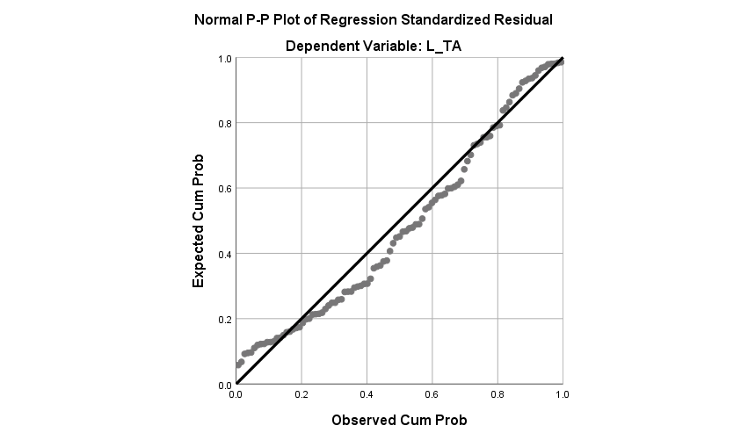
Figure 3 Normal P-P plot of Regression Standardized Residual

Following figure 4 is all about the graph of Scatterplot. There are 2 axis in this scatterplot- Vertical and Horizontal axis. Vertical axis represents the Regression Standardized Residual and Horizontal axis represents the Regression Standardized Predicted Value. Basically, Data needs to be in the form of a rectangular shape. If it is in the rectangular shape then it is okay. And all the data should be within ± 3. Here all the data are in the rectangular shape not within ± 3.

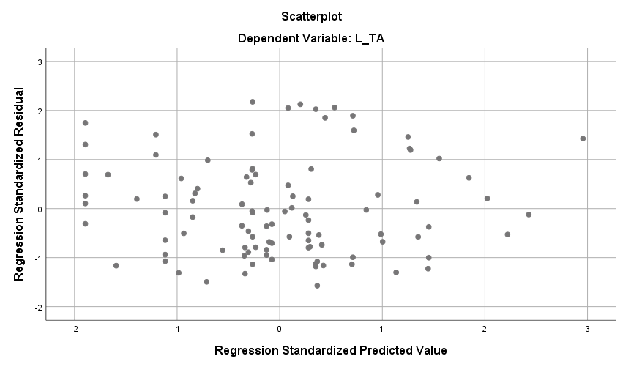
Figure 4 Scatterplot

Final Discussion of Model 2: If I consider the model 2 then it can be found that (B_F) is rejected above at 10% significant level and (B_O) is accepted at 10% significant level. (B_S) is accepted at 1% significant level. (B_I) is rejected above 10% significant level and (B_W) is accepted at 1% significant level. If I stablished hypothesis about these board characteristics then (B_O), (B_S), & (B_W) these 3 hypothesis will be accepted and Board Independent and Foreign Member on Board will be rejected that means these 2 will not be able to influence the corporate performance in this situation.

CONCLUSION AND RECOMMENDATION

It was found a lot of different statements about the relationship between board characteristics and firm performance. So, the conclusion will be different. In this study I tried to find the purpose from the 2 point of views and that’s why I dealt with two models to find is there any variety or not. From both the models I found 3 accepted hypothesis and 2 rejected hypothesis. For both the models board size and board member’s ownership can be found accepted that means these 2 board characteristics have a influencing power over corporate performance. If Bangladeshi companies focus perfectly on board characteristics they may enjoy a good corporate performance. Ownership of the board members influences to perform well because they have a great advantage and return.

APPENDIX

References
Adams, R. B., & Ferreira, D. 2009. Women in the boardroom and their impact on governance and performance. Journal of Financial Economics, 94(2), 291-309.

Bozec, R. 2005. Boards of directors, market discipline and firm performance, Journal of Business Finance & Accounting, 32, 1921-1960.

Aduda, J. (2011), the relationship between executive compensation and firm performance in the Kenyan banking sector. Journal of Accounting and Taxation, 3(6), 130-139.

Bozec R and Dia M (2007), “Board Structure and firm technical efficiency: Evidence from Canadian state-owned enterprises”, European Journal of Operational Research, 177: 1734-1750

R. M. Haniffa and M. Hudaib, “Corporate governance structure and performance of Malaysian listed companies,” Journal of Business Finance and Accounting, vol. 33, no. 7, pp. 1034-1062, 2006.

Ameer, R., Ramli, F., & Zakaria, H. (2010). A new perspective on board composition and firm performance in an emerging market. Corporate Governance, 10(5), 647–661.

Bennedsen, M., Kongsted, H. C., & Nielsen, K. M. (2008). The causal effect of board size in the performance of small and medium-sized firms. Journal of Banking & Finance, 32(6), 1098–1109. doi:10.1016/j.jbankfin.2007.09.016

Adams, R.B. & Mehran, H. 2005. Corporate performance, board structure and its determinants in the banking industry. Working Paper, SSRN.

Adjaoud, F., Zeghal, D., & Andaleeb, S. (2007). The Effect of Board Quality on Performance: A Study of Canadian Firms. Corporate Governance: An International Review, 15(4), 623–635.

Bonn, I. (2004). Board structure and firm performance: Evidence from Australia. Journal of the Australian and New Zealand Academy of Management, 10(1), 14–24.

Van Essen, M., van Oosterhout, J. Hans, & Carney, M. (2012). Corporate boards and the performance of Asian firms: A meta-analysis. Asia Pacific Journal of Management, 29, 873–905.

Fallatah, Y., & Dickins, D. (2012). Corporate governance and firm performance and value in Saudi Arabia. African Journal of Business Management, 6, 10025–10034.

Brick, I. E., Palmon, O., & Wald, J. K. (2006). CEO compensation, director compensation, and firm performance: Evidence of cronyism? Journal of Corporate Finance, 12, 403–423.

Brown, W. A. (2007). Board development practices and competent board members: Implications for performance. Nonprofit Management and Leadership, 17, 301–317.

Johl, S. K., Kaur, S., & Cooper (2015). Board characteristics and firm performance: Evidence from Malaysian public listed firms. Journal of Economics, Business and Management, 3, 239–243.

Kato,T., Kim, W., & Lee, J. H. (2007). Executive compensation, firm performance, and Chaebols in Korea: Evidence from new panel data. Pacific-Basin Finance Journal, 15, 36–55.

Kyereboah-Coleman, A., & Biekpe, N. (2006). The link between corporate governance and performance of the non-traditional export sector: Evidence from Ghana. Corporate Governance: The International Journal of Business in Society, 6, 609–623.

Abdelkarim, N. & Alawneh, S. (2009). The relationship between corporate governance and the performance of Palestinian firms: An empirical study. The International Journal of Business and Finance Research, 3(2), 105-120.

Chen, G., M. Firth, D. N. GAO and O. M. Rui (2006). ‘Ownership structure, corporate governance, and fraud: Evidence from China’, Journal of Corporate Finance, 12, pp. 424-448.

Erickson, J., Y. W. Park, J. Reising and H. H. Shin (2005). ‘Board composition and firm value under concentrated ownership: the Canadian evidence’, Pacific-Basin Finance Journal, 13, pp. 387-410.

Ghosh, S. (2006). ‘Do board characteristics affect firm performance? Firm level evidence from India’, Applied Economic Letters, 13, pp. 435-443.

Joh, S. W. (2003). ‘Corporate governance and firm profitability: evidence from Korea before the economic crisis’, Journal of Financial Economics, 68, pp.287-32.

Lefort, F. and F. Urzúa (2008). ‘Board independence, firm performance and ownership concentration: evidence from Chile’, Journal of Business Research, 61, pp. 615–622.

Liang, N. and J. Li (1999). ‘Board structure and firm performance: new evidence from China’s private firms’, (China Center for Economic Research (CCER) at Peking University, No. E1999008).

Filatotchev, I, Yung-Chih Lien, and J. Piesse (2005). ‘Corporate governance and performance in publicly listed, family-controlled firms: evidence from Taiwan’, Asia Pacific Journal of Management, 22, pp. 257-283.

Mak, Y.T. and Y. Kusnadi (2005). ‘Size really matters: Further evidence on the negative relationship between board size and firm value’, Pacific-Basin Finance Journal, 13, pp. 301-318.

Adams, R., & Ferreira, D. (2009). Women in the boardroom and their impact on governance and performance. Journal of Financial Economics, 291-309.

Conyon, M., & Peck, S. (1998). Board size and corporate performance: evidence from European countries. The European Journal of Finance, 291-304.

Francis, B., Hasan, I., & Wu, Q. (2012). Do corporate boards matter during the current financial crisis? Review of Financial Economics, 39-52.

Guest, P. (2009). The impact of board size on firm performance: evidence from the UK. The European Journal of Finance, 385-404.

