INTERNSHIP REPORT
On
Financial Performance Analysis of United Hospital LIMITED





INTERNSHIP REPORT
ON
Financial Performance Analysis of United Hospital Limited

Submitted To:
Muhammad Enamul Haque
Assistant Professor
School of Business and Economics
United International University
Submitted by:
Syed Misam Abbas Rizvi
Id: 111 161 162
Date of Submission: January 22, 2022
Letter of Transmittal

January 22, 2022
Muhammad Enamul Haque
Assistant Professor
School of Business and Economics
United International University
Dhaka, Bangladesh
Subject: Submission of Internship report on “Financial Performance Analysis of United Hospital Limited.
Dear Sir,
Assalamu Alaikum, I would like to submit my Internship Report titled "Financial Performance Analysis of United Hospital Ltd." with great importance and joy as a partial requirement of the Bachelor of Business Administration Degree.

It is an honor to work at one of Bangladesh's top private company after completing courses, and I am grateful to United International University for offering this internship opportunity. I hope you will accept my Internship Report with gratitude because it shows all of my hard work and lessons acquired.

Syed Misam Abbas Rizvi
ID-111 161 162
United International University

DECLARATION OF THE STUDENT

I, Syed Misam Abbas Rizvi, a student of United International University's finance department, hereby announce that this internship report, titled "Financial Performance Analysis of United Hospital Limited," has been organized under the direct supervision of Professor Muhammad Enamul Haque, Assistant Professor of Finance, and United International University Dhaka.
As a result, I declare that this report was written on my own initiative following the end of a four-month internship program at United Hospital Limited, and that it has never been submitted to any other school for an academic credential or degree.
The report is written solely for academic purposes and has no ambition.

Sincerely yours

Syed Misam Abbas Rizvi
ID-111 161 162
Program BBA
United International University

Acknowledgement

First, I thank Almighty Allah for his compassion in providing me with the opportunity to complete an internship program and successfully produce an internship report on time.
I want to express my gratitude to my esteemed faculty Muhammad Enamul Haque for his constant advice, specific ideas, unwavering support, and unwavering enthusiasm throughout the report-writing process.
My esteemed boss has aided me in every way possible to ensure that the report is solid and well-coordinated. I want to express my gratitude to United International University for providing an exceptional academic atmosphere in which I was able to complete my BBA degree.
Thank you is insufficient for the personnel of United Hospital Ltd. who assisted me at every step of the way in preparing this report. I would like to express my gratitude to Abu Rayhan Sir, Deputy General Manager, and Bishazit Das, Assistant Manager of Finance & Planning of UHL Ltd. for providing me with the chance to work in a pleasant environment while also assisting me in learning about the organization and the corporate world.
I would also want to express my gratitude to the rest of the Finance & Planning Team members who assisted me in preparing this report with the utmost care and confidence.
Lastly, I would want to thank everyone who helped me finish the report by contributing their time and effort whenever I needed it.

Executive Summary

United Hospital Ltd. is one of the best healthcare service providers in Bangladesh. It’s a sister concern of United Group. I did my internship report on financial performance analysis of United Hospital Limited. To do the analysis, I applied the widely used performance measurement technique of ratio analysis. The analysis is being conducted on the basis of five major areas like liquidity ratio, solvency ratio, efficiency ratios, and profitability ratios.
The analysis shows that the liquidity position has been declined over the study periods for United hospital. It maintained a consistency in utilizing its assets in the business and therefore, has been able to generate the stable earnings. On the other hand, it was found that United Hospital has increased level of borrowed funds used in the business relative to the equity funds.
I can conclude from the ratio analysis that although United Hospital failed to accelerate its overall performance but has been maintained a steady earnings from the business operations over the years.

Table of Contents
Chapter: 1 9
Introduction 9
1.1 Background of the Study 9
1.2 Origin of the Study 9
1.3 Objective of the Study 9
1.4 Scope of the Study 10
1.5 Methodology of the Study 10
1.6 Limitations of the Study 10
CHAPTER: 2 11
Overview of United Hospital Limited 11
2.1 Mission 11
2.2 Vision 11
2.3 UHL Environmental Policy 11
2.4 SWOT Analysis of UHL Ltd. 12
2.5 Department wise SWOT Analysis 13
CHAPTER: 3 14
FINANCIAL PERFORMANCE ANALYSIS 14
3.1 Liquidity ratios 14
3.2 Efficiency ratios 17
3.3 Profitability ratios 22
3.4 Solvency ratios 26
Chapter: 4 28
Findings of the Report 28
4.1 Profitability Ratio 28
4.2 Liquidity Ratio 28
4.3 Asset Management Ratio 29
4.4 Debt Management Ratio 29
Chapter 5 32
Recommendations 32
Chapter 6 33
Conclusion 33
Bibliography 35
Appendix 36

Chapter: 1

Introduction

1.1 Background of the Report
In the current world, the healthcare industry plays a crucial part in our survival as we are encircled by a plethora of diseases, and the amount of individuals affected is growing eventually. As a result, it's critical that we improve our healthcare systems. Many new illnesses are emerging all around the world and having a significant influence on our lives. As a result, this sickness is extremely difficult to detect and acquire. Although Bangladesh is still a developing nation with many modern amenities lacking, certain organizations are working hard to bring such basic services to the country. United Hospital LTD is one of them in the healthcare industry. United Hospital is one of the greatest in Dhaka, Bangladesh, and offers an international standard of care. Since August 2006, United Hospital LTD has been serving the nation as a private limited corporation. It has been incredibly successful and well-known as a result of its high-quality service and tremendous hard work.

1.2 Origin of the Report
To complete and conclude our BBA program is very necessary to do few months’ internship in an organization and the report. My internship report is conducted under the guidance of my supervisor Mr. Muhammad Enamul Haque sir. It has been a wonderful journey and learning experience under his supervision.

1.3 Objective of the Report
The main purpose of this study is to look at the financial performance of United Hospital Ltd.
The other objectives of this report are:
- To gain an overview of the healthcare industry and United Hospital.
- Calculate UHL's five-year financial performance using ratio analysis.
- Examine UHL's financial status as a whole.
- Calculate the rate of growth.
- To identify problems and offer suggestions for change.

1.4 Scope of the Report
The purpose of the report is to evaluate the work of a healthcare practitioner. Determine whether the report has been processed and saved to the database. The major focus of the report is on United Hospital Limited's financial performance. This will provide a wonderful impression of the exact circumstance over previous years. It also offers an indicator of how the hospital may perform in the future, based on the ratios.

1.5 Methodology of the Report
To make the report more informative, data is gathered from a variety of sources. Primary and secondary data sources are the two categories of data sources. Both data sets were used in the report.
Major sources of Primary data
- Data & Information gathered from the united head office.
- Conduct an informal interview with United Hospital ltd's staff and communicate with them.
- Try to learn the required files as directed by the UHL supervisor.
- Having daily office hours has helped in gathering additional information.
Major sources of Secondary data
- Journals & Articles.
- Audit Report & Annual report.
- Uhl website & other related websites.

1.6 Limitations of the Report
To make the report more informative, data is gathered from a variety of sources. Primary & secondary data sources are the two categories of data sources. Both data sets were used in the report. There was a shortage of current information; Time limits were a hurdle, requiring extra time for any sort of study. Fears for their safety prohibit them from disclosing classified information. It is impossible to finish a large-scale analysis in a short period of time.

CHAPTER: 2

Overview of United Hospital Limited

United Hospital Ltd. was founded with the goal of providing a comprehensive one-stop healthcare solution to the people of Bangladesh. This hospital, which opened its doors in August 2006 and is located next to the stunning Gulshan Lake, is one of Bangladesh's largest private sector healthcare facilities. United Hospital is dedicated to addressing the needs of a varied set of patients, with a capacity of 500 beds and a total area of approximately 450,000 square feet. Their gynecology, pediatrics, orthopedics, and cardiology departments are operated by some of the best specialists in their occupations. A look at our cardiology department, for example, reveals that we have performed over 2300 open heart surgeries and over 8300 angiograms and angioplasty procedures to far. Since our inception, we've performed over 12 heart-related surgeries per day. They strive to be the best healthcare provider not only in Bangladesh, but also in the Asia-Pacific region, by combining cutting-edge technology, knowledge, and a wide range of facilities and services with the help of our pleasant employees.

2.1 Mission
The mission of UHL is to improve people's lives via the appropriate application of knowledge, skills, and technology. To achieve the highest degree of customer satisfaction, UHL is committed to pursuing superiority through topnotch goods, innovative methods, and empowered personnel.

2.2 Vision
To provide individuals in Bangladesh and around the world with a comprehensive one-stop healthcare solution.

2.3 UHL Environmental Policy
UHL is dedicated to developing and carrying out all of its operations in an environmentally friendly manner, ensuring continual improvement in resource utilization and the avoidance of pollution or environmental harm. Comply with all applicable rules and regulations on a local, state, and federal level. Conserve natural resources such as water and power, and adopt ecologically friendly practices for long-term development. Ensure that all effluents are properly treated before being discharged. Ensure that environmental issues are communicated effectively to internal and external stakeholders. Bring environmental issues to the attention of our employees and contractors. Continuous technological advancements will ensure environmentally appropriate garbage management.
2.4 SWOT Analysis of UHL Ltd.
SWOT Analysis is a simple yet effective way to evaluate a company's strengths, weaknesses, opportunities, and threats. It allows you to capitalize on your strengths, improve your shortcomings, lower your risks, and increase your chances of success.
Some of Bangladesh's most famous doctors work at our hospital's cardiology and heart surgery divisions.
Strength
• A multidisciplinary team that works 24 hours a day, 7 days a week: Within 24 hours after a patient's admission, this team is ready to respond to their requirements.
Famous cardiologists and heart surgeons are employed by United Hospital Ltd and are legally compelled not to work in other hospitals while engaged here, therefore patients must come to this hospital for help.
WEAKNESS
• Our strongest fields are cardiology and cardiac surgery, but gastroenterology and endocrinology are weaker, and we need more nurses and personnel to deliver the best possible treatment to our patients.
Opportunity
• We see opportunities in nephrology, oncology, and child care as a result of innovative and diverse treatments and services.
This is a fantastic opportunity because the hospital is working on making this sector world-class and is attempting to emulate some of the world's most recognized hospitals in order to bring this hospital up to par.
Threat
• We are facing a physician scarcity in the field of neurology, as well as other issues in the medicine department.
Other hospitals are considerably ahead of United Hospital Ltd in this area. Other hospitals have the best doctors, the most up-to-date equipment, and the most advanced technology.
SWOT analysis is used to determine a company's strengths and weaknesses as well as prospective opportunities and threats. A company's position in the present market can be determined using a SWOT analysis, which can also be used to make strategic decisions. Based on personal observations, a SWOT analysis of UHL Ltd. is provided below.

2.5 Department wise SWOT Analysis

CHAPTER: 3

FINANCIAL PERFORMANCE ANALYSIS

3.1 Liquidity ratios
Liquidity ratios are a set of financial measures that determine a debtor's willingness to fulfill existing debt commitments without the use of extra cash. To estimate a company's readiness to meet financial commitments and its safety margin, liquidity ratios use variables such as the current ratio, quick ratio, and cash flow ratio. Liquidity ratios are illustrated in the following cases.

Current Ratio: The current ratio is a liquidity calculation tool. This assesses whether the current assets of a firm or organization are sufficient to meet its obligations. After studying United Hospital Ltd.'s balance sheet, I calculate the current ratios from 2016 to 2020.
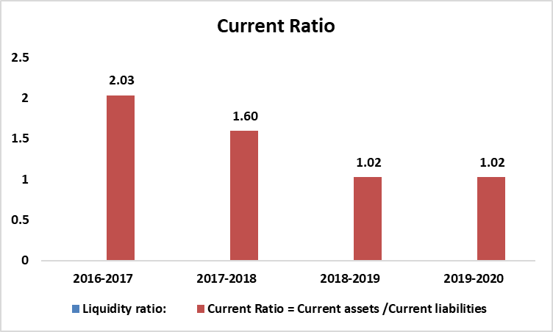

Year | 2016-2017 | 2017-2018 | 2018-2019 | 2019-2020
United Hospital Ltd | 2.03 | 1.60 | 1.02 | 1.02

United Hospital Ltd. had a current ratio of 1.02 in 2016-2017.It means that the company's current assets are worth 2.03 times its current liabilities. After that, United Hospital ltd.’s current ratio has been steadily falling. The current ratio is every year until 2019-2020 has a decrease. It also means that the company's cash or assets are currently insufficient to satisfy its debts. Rather than holding money for future debt, they are now investing it.

Quick ratio: The quick ratio of a corporation is a measure of its short-term liquidity. It evaluates a company's capacity to cover current liabilities with quick assets like inventory. As a result, the fast ratio looks at whether current assets that can be converted into cash quickly are enough to cover current liabilities. A fast ratio of greater than indicates that the company's current obligations can be paid with cash on hand.
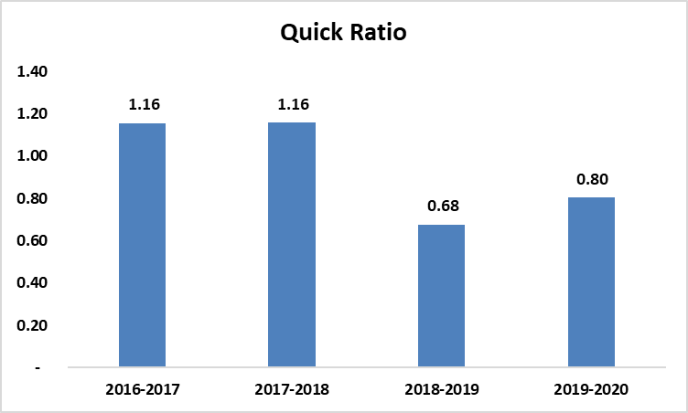
Year | 2016-2017 | 2017-2018 | 2018-2019 | 2019-2020
United Hospital Ltd | 1.16 | 1.16 | 0.68 | 0.80

According to the calculations, in 2016-2017 the UHL. The quick ratio of 1.16, which implies current assets are worth 1.16 times current liabilities, indicating that the company is in good shape and can fulfill its obligations with short-term cash and assets. However, the company's current liquidity is poor in 2018-2019, but inventory and sales have all been increasing in 2019-2020.As a result, it might be a positive indicator for businesses.

Cash ratio: The cash ratio depicts a company's cash and cash equivalents in relation to its current liabilities. Creditors can use the statistic to decide how much debt they are willing to issue to the inquiring party because it calculates a company's ability to repay its short-term debt.
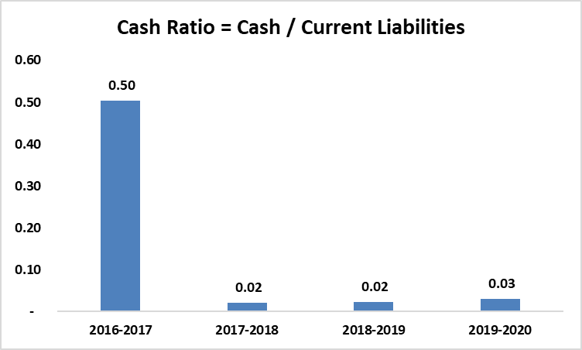

Year | 2016-2017 | 2017-2018 | 2018-2019 | 2019-2020
United Hospital Ltd | 0.50 | 0.02 | 0.02 | 0.03

According to our calculations, the UHL. cash ratios for the next four years are 0.50, 0.02,0.02, 0.3, implying that the company's cash and cash equivalents are smaller than its current liabilities and hence is unable to satisfy its short-term obligations or settle its accounts payables on time. Cash should not hold more because will affect the investment.

3.2 Efficiency ratios
Efficiency ratios measure a company's overall ability to use its assets and manage its liabilities effectively. Efficiency ratios include inventory turnover ratios, asset turnover ratios, and receivables turnover ratios. These ratios evaluate a company's ability to manage its assets and how effectively it employs those assets to generate revenue.
Inventory Turnover: The inventory turnover ratio measures how efficiently inventory is managed by comparing the cost of things sold over time to total inventory. It defines how many times a business's average inventory is converted or exchanged throughout the course of a lifetime, or how many times a business's average inventory is converted or exchanged.
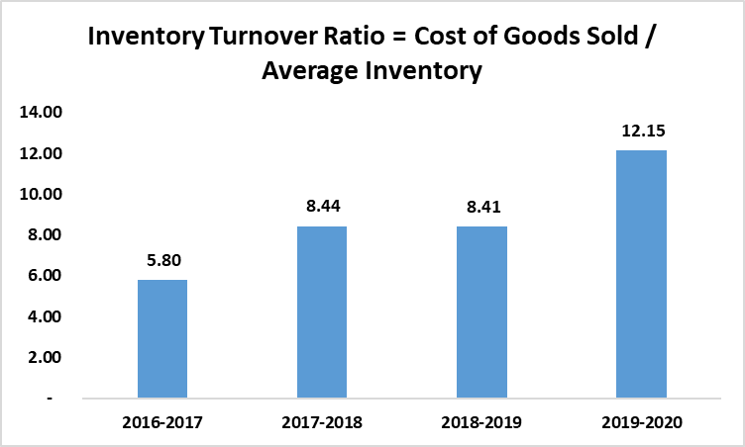
Year | 2016-2017 | 2017-2018 | 2018-2019 | 2019-2020
United Hospital Ltd | 5.80 | 8.44 | 8.41 | 12.15

According to our calculations, UHL's inventory turnover ratio during the past four years has been 5.80, 8.44, 8.41, and 12.15. Because of UHL, hospitals must store up on emergency supplies. However, the ratio has risen with time, reaching 12.15 in 2019-2020, which is significantly higher than prior years. The ratio grew because the corporation was able to sell more of its inventory over these years.
Total asset turnover: Another efficiency ratio that shows a company's capacity to produce sales from its assets is the asset turnover ratio. As a result, this ratio demonstrates how effectively a corporation can create sales using its assets.
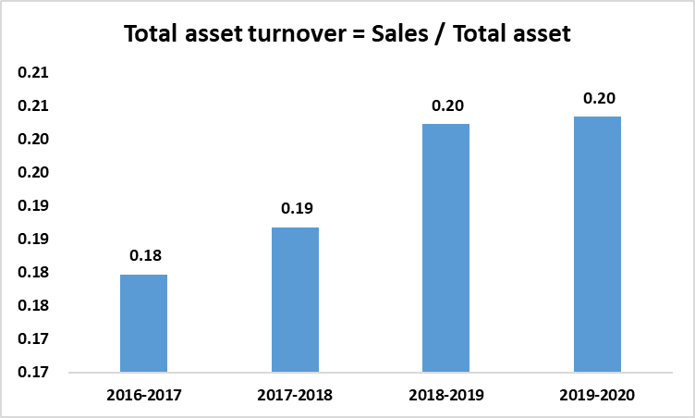
Year | 2016-2017 | 2017-2018 | 2018-2019 | 2019-2020
United Hospital Ltd | 0.18 | 0.19 | 0.20 | 0.20

Based on a study of four years of data, I determined that the UHL asset turnover ratio for 2016 to 2020 is 0.18, 0.19, 0.20, and 0.20, respectively. As a result, they make effective use of their resources. The ratio begins to rise, indicating that their ability to earn revenue from assets has improved over the years.
Fixed asset turnover: The fixed asset turnover ratio, which compares net sales to fixed assets to measure a company's return on investment in fixed assets such as property, plant, and equipment, as well as long-term investments, is another efficiency ratio. In other words, it determines how productive a company's fixed assets (machines and equipment) are in producing sales.

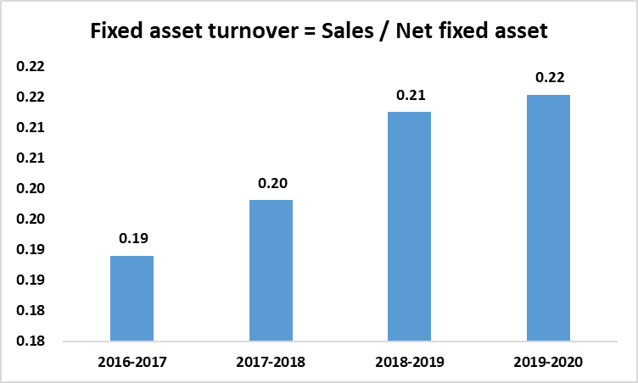
Year | 2016-2017 | 2017-2018 | 2018-2019 | 2019-2020
United Hospital Ltd | 0.19 | 0.20 | 0.21 | 0.22

Our calculated fixed asset turnover ratios over the last four years are 0.19, 0.20,.021, and 0.22. As a result, the company produced in 2020.There were 0.22 times more sales than the assets' net book value. Then during the next four years, the ratio began to climb.
Net profit margin: This ratio shows how much profit a company may make from its overall sales. A high net profit margin indicates that a corporation is pricing its products appropriately and controlling costs.

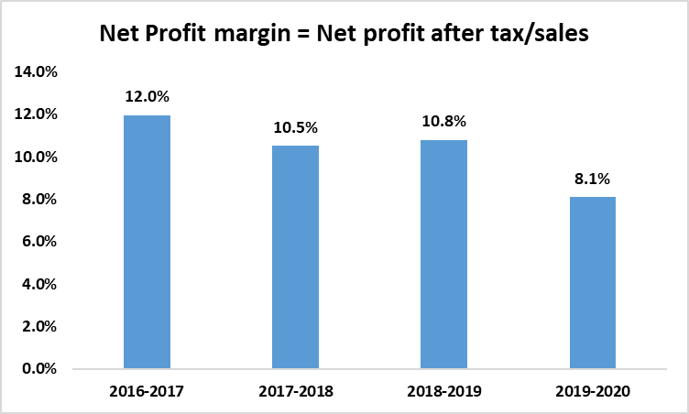
Year | 2016-2017 | 2017-2018 | 2018-2019 | 2019-2020
United Hospital Ltd | 0.12 | 0.10 | 0.11 | 0.08

UHL Ltd's net profit margins for the last four years have been 0.12, 0.10, 0.11, and 0.08, respectively. The ratio has been somewhat moveable in recent years, but it is expected to decline in 2019-2020 due to the Covid disaster.
Operating efficiency ratio: To assess how effective a company's management is, the operating efficiency ratio compares its total operating expense (OPEX) to its net revenues. The operating ratio measures a company's ability to keep costs down while increasing revenue or sales. The smaller the ratio, the more efficient the company is at generating revenue in relation to total expenses.

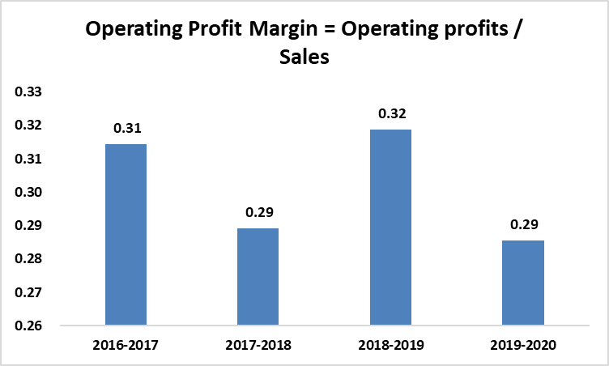
Year | 2016-2017 | 2017-2018 | 2018-2019 | 2019-2020
United Hospital Ltd | 0.31 | 0.29 | 0.32 | 0.29

UHL Ltd.’s net profit margins for the last four years have been 0.31, 0.29, 0.32, and 0.29, respectively. The ratio has been similar some growth and declining. It has been looked like quite same.

3.3 Profitability ratios
Profitability ratios are used to evaluate a company's overall performance by determining how profitable it is. They're calculated by connecting profit figures to sales and assets on the one hand, and vice versa. I calculated five ratios based on the profitability component.

Return on equity (ROE): The return on equity (ROE) ratio is a profitability metric that evaluates a firm's ability to generate returns from its shareholders' investments. In other words, the return on equity ratio calculates the profit generated by each BDT of common stockholders' equity.

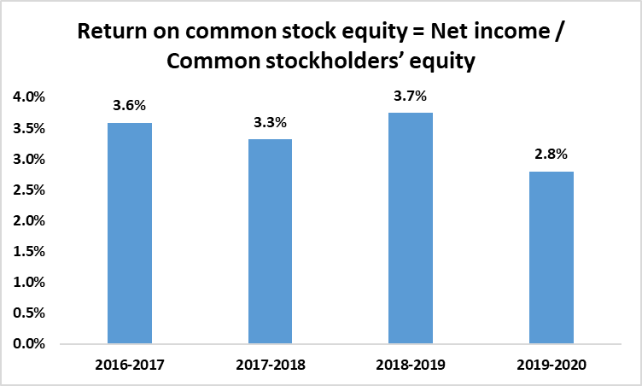

I computed ROE ratios for UHL Ltd that are- 3.6%, 3.3% 3.7% 2.8% of Common Stockholder equity. In 2019-2020 the ROE is very low because of COVID Impact. As we can see this is increasing before Covid impact. It will increase in the period.

ROA: The return on assets ratio is a profitability measure that calculates the net income generated by total assets over a period of time by comparing net income to average total assets.
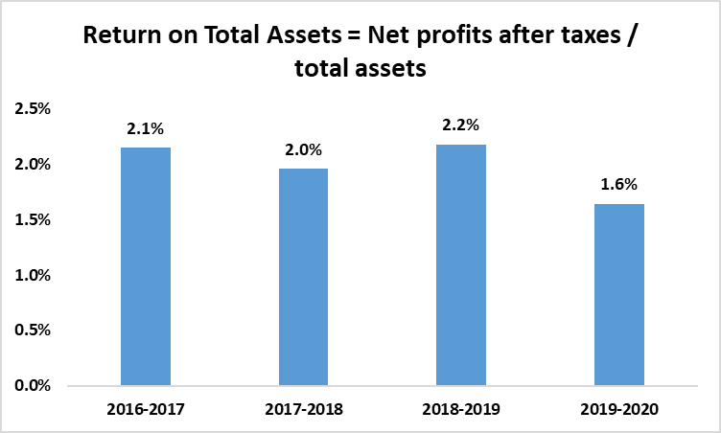

The return on assets ratio, or ROA, is a metric that assesses a company's ability to properly manage its assets in order to generate profits over time. UHL's calculated ratios are 2.1 percent, 2.0 percent, 2.2 percent, and 1.6 percent, indicating a rise in the firm's ability to create sales utilizing its assets rather than 2019-2020 Because to covid and lockdown, ROA will be substantially lower in 2019-2020.

Gross profit margin: The gross profit margin ratio, or gross margin, is the percentage of gross profit margin expressed as a percentage of sales. A company's gross margin reveals how much profit it makes after paying off its Cost of Goods Sold.
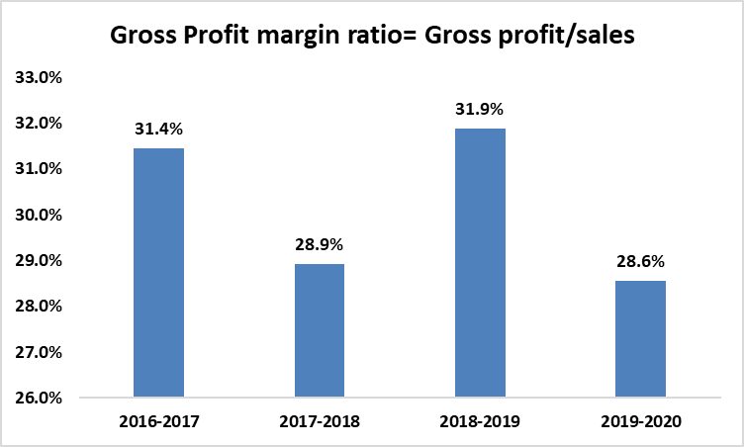

For the past four years, the UHL corporation has had a significantly different ratio. Then, in 2017-2018 and 2019-2020, it declined by 8 percent and 10 percent, respectively, meaning that the firm has less taka left over to pay for basic operational expenses and profit in these years.
Basic Earning Power Ratio: The basic earning power ratio (BEP) is a statistic that evaluates a company's earning capacity before income taxes and financial debt are factored in. To arrive at this ratio, profits are divided by total assets before interest and taxes (EBIT).

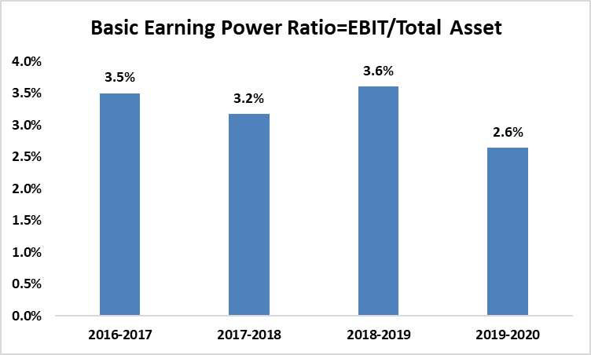
Here we can see that UHL has the lowest earning power ratio in 2019-2020, indicating that UHL was faced with certain unpredictable challenges such as pandemic (Novel Covid Starting Faces), resulting in a profit level that is not favorable for UHL Ltd.

3.4 Solvency ratios
The ability of a corporation to meet its long-term debt obligations demonstrates its financial strength and secures its long-term survival. It is critical for an analyst to investigate a company's solvency. We calculated numerous ratios based on this dimension.

Debt ratio: The debt ratio is a financial leverage ratio that determines how much of a company's resources are financed through debt. A "leveraged" corporation is one with a high debt-to-equity ratio. UHL's calculated debt ratios are.025,.038,.05, and.058.
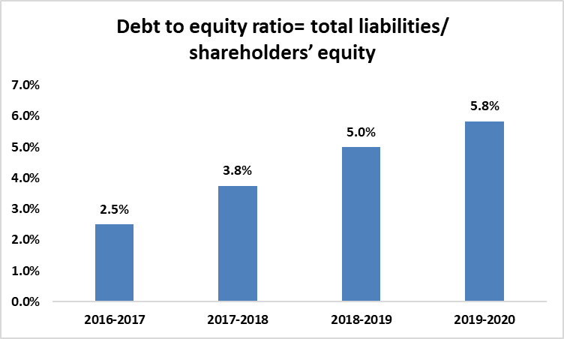
A company that has a debt-to-equity ratio of more than.5 is considered levered. We can see a positive trend here, as the debt ratio has risen over the previous four years, showing that debt was used to fund the firm's resources first. As a result, debt financing increased in the following years.
Debt equity ratio: The debt-to-equity ratio shows how much of a company's funding comes from creditors and shareholders. When the debt-to-equity ratio is higher, it means that debt is used more frequently than equity.

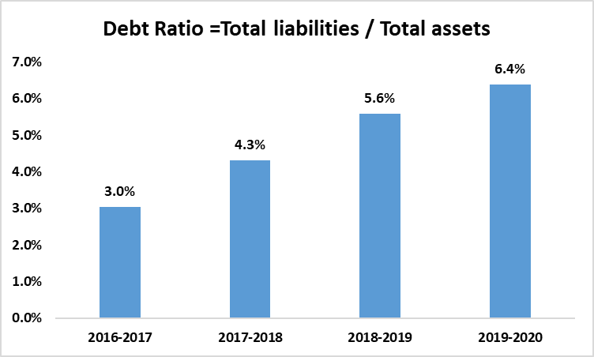
The computed debt to equity ratios from four years of UHL data are.03,.043,.056,.064, indicating that they are afraid to run the company using debt. This is advantageous to the overall financial condition, but the debt should provide some safety to satisfy the necessities. As a result, we can see that debt-taking intent is increasing as a result of some relative advantages, such as tax benefits.

Chapter: 4

Findings of the Report

Because ratio analysis is part of the everyday tasks, the study focuses primarily on the Finance & Planning procedures. It is used by many parts of the company to help them figure out what kind of financial procedure changes the company and its business units need. With that in mind, I'd like to offer some of my observations based on the Major Ratios we looked at before.

4.1 Profitability Ratio
At first we know in healthcare industry profit margin is very low. Now in concerns of the group's profitability, while the gross profit margin is improving, indicating opportunities to profit more, the rest of the ratios are not looking promising. Operational expenditures are rising, resulting in a smaller operating profit margin as a proportion of sales. However, it is logical that a rising company like UHL ltd. would need to increase spending in certain areas. However, in 2016, the Net Profit Margin, ROA, and ROE have all decreased significantly. ROA means that for every BDT 100 asset, a net profit of BDT 2.50 was earned. This is a huge reduction from the prior year. The low proportion indicates that due to asset management errors, the resources have been unable to create as much profit as the company expected. The percentage earned in relation to the percentage of the company's investors' equity is known to as the return on equity (ROE). It shows how the money of investors is put to use in investments.

4.2 Liquidity Ratio
The liquidity ratio shows the group's current asset and current liability misbalance if the company can meet its short-term obligations. However, the analysis indicates that if the current trend continues, UHL may encounter difficulties. It shows that the corporation does not have sufficient current assets to pay its short-term obligations on the other can say they were taking more project investment. The current ratio in 2016 was higher than in next years. After that they was started the operation in credit and payment was made by cheque.

4.3 Asset Management Ratio
Total Asset Turnover is rising, indicating that the company is producing as many assets as it should. Because a higher value indicates a more efficient use of the resources. The ratios were 0.18 times in 2016-17, indicating a better degree of asset management efficiency. However, in 2017, it increased to 0.19 times. The highest inventory turns in 2017-2018 and 2019-2020 have the greatest numbers of 8.44 and 12.15 times. Because things need very urgent base they must be keep more stock with proper treatment.

4.4 Debt Management Ratio
Debt ratio shows that the company is more capable to cover up the company debt by shareholder equity. Because this is a sister concern of United Group owners has lots of assets to convey the debt of this organization. As we can see by the ratio it is increasing regularly.

Chapter 6

Recommendations

UHL is one of Bangladesh's largest conglomerates, and we can't help but be proud that a major corporation is working its heart and soul to ensure that millions of people can meet their basic necessities. However, UHL, like any other system, has some defaults that must be addressed. I discovered several recommendations after conducting a financial ratio study of UHL Ltd. I came across some recommendations such as:

- Because of UHL is a growing company; it has to invest in more viable enterprises in order to get out of debt.
- UHL should reduce their Days Payable Outstanding (DPO) so that they may retain strong relationships with their creditors, such as suppliers, who can help the group by providing high-quality raw materials, allowing them to develop their products in comparison to their market competitors.
- Although UHL has 26 distribution locations, not all products are delivered to clients. Many consumers are unaware that such products exist. As a result, they should hire more skilled personnel to distribute the items evenly around the country.
- UHL Ltd is successful in the market, but it is critical to examine debt management in order to reduce financial risks in the long run.
- Asset management must be closely monitored in order to boost ROA. As a result, the net profit margin will increase.
- Credit sales should be kept to a minimum in order to reduce Days Sales Outstanding.

Chapter 7

Conclusion

A hospital is essential in any economy and in any world. A number of factors influence the private hospital sector in Bangladesh. Hospitals are struggling to stay afloat. Government policy, illicit actions, and adversity can all have an impact on this industry. The worldwide economy will be attacked with a new Corona Virus by 2020. It has a bad impact on our entire industry as well. The country currently has a vast number of hospitals. They contribute to the well-being of our country. Hospitals are becoming more technologically advanced. They provide assistance in our town and neighborhood. The number of hospitals has increased in the recent decade. Barriers exist in the healthcare sector, which is not uncommon. This research examines United Hospital Ltd.'s growth, power, weaknesses, and possibilities. My internship was done there as well. Here, I've learned a lot of things. I was involved in a variety of projects. I was involved in a variety of projects. I've obtained new knowledge and skills.
United Hospital Ltd should focus on improving their weak areas. They should back up their words with actions. Employees should be treated with more respect. They should drop out of a number of social initiatives. Interns must be educated. I also make recommendations for myself in this paper. In terms of preparation, I should be more cautious. In my employment, I need to be upbeat.
We believe the pandemic will be over soon. Our economy, as well as the healthcare industry, will swiftly return to normal. After a long period of darkness, we know there will be light. This internship report is really important to my future success. In this report, I'm striving to express my realistic and theoretical knowledge based on real-life events.
With the changing climate, UHL Ltd. is working to give the best products with the highest care to Bangladesh. And in order to achieve that aim, many people are giving it their all in the hopes of one day realizing their goals while maintaining their principles. The company's Finance and Planning division devotes a big portion of their lives, as well as their important time, to serving the group so that they can be a part of a tremendous success. It is obvious from seeing and learning about the group's divisional procedure that a complicated corporate structure is being followed throughout the group and within the business divisions. Many activities cannot go without one's input for a day, and a very cordial communication is followed from top management to lower levels of taskforce so that no one becomes demotivated. Financial analysis is carried out in a time series format. The company did not have any significant fluctuations in terms of its performances with regard to all the major areas studied in the report. The final conclusion can be made that United Hospital maintained a consistent performances over the years.

Bibliography

- https://united.com.bd/companies/healthcare
- https://www.uhlbd.com/
- https://en.wikipedia.org/wiki/United_Hospital_Limited
- https://www.uhlbd.com/publications/index
- https://www.thedailystar.net/health/healthcare/hospitals/news/united-hospital-observes-world-heart-day-2187306
- Annual Report of UHL Ltd. 2016-17
- Annual Report of UHL Ltd. 2017-18
- Annual Report of UHL Ltd. 2018-2019
- Annual Report of UHL Ltd. 2019-2020

Appendix

