UNITED INTERNATIONAL UNIVERSITY


Internship Report
On
Strategic Brand Management of ACI Sandal Soap

Submitted to
Muhammad Hasan Al-Mamun
Assistant Professor
School of Business & Economics
United International University
Submitted By
Jerin Jahan Malik
ID: 111 141 111
BBA Program
School of Business & Economics
Date of Submission:


Strategic Brand Management of ACI Sandal Soap

Acknowledgement

I have taken efforts in this Report. However, it would not have been possible without the kind support and help of many individuals and organizations. I would like to extend my sincere thanks to all of them.
I am highly indebted to the head of management of ACI Limited for their guidance and constant supervision as well as for providing necessary information regarding the assignment and also for their support in completing the assignment.

I would like to express my special gratitude and thanks to industry persons for giving me such attention and time.
My thanks and appreciations also go to my colleagues in developing the assignment and people who have willingly helped me out with their abilities.

Letter of Transmittal

To
Muhammad Hasan Al-Mamun
Assistant Professor
School of Business and Economics
United International University
Dhaka, Bangladesh

Subject: Submission of Internship Report
Dear Sir,
It is a great pleasure to submit my Internship Report to you as a part of my BBA program under your direct supervision on the topic titled “Strategic Brand Management of Sandal Soap”. I am fortunate enough that ACI limited permitted me to learn corporate practices under Personal Care Department. I got the opportunity to work in their marketing team for collecting various information. The provided information in this report is based on the data collected during my internship period through market visits, performing different job responsibilities and all other sources available to me in that period of time. I tried my best to provide the appropriate information in the most meaningful and coherent way. I hope you will find the report very informative. If you need any clarification and/or explanation then I would like to assure you that I will present the desired clarification.

I would like to express my sincere appreciation and gratitude to you for helping me to prepare this report.

Sincerely Yours
Jerin Jahan Malik

Executive Summary

The report is basically based on the “Strategic Brand Management of Sandal Soap”. ACI Limited has four SBU’s and ACI Consumer Brand is one of them and ACI Consumers Brand produces and markets several products and female Beauty department is one of them. Today women are very concerned about their health and skin. For that reason, the Beauty industry is expanding day by day. They have several competitors in the market. They compete against them for more coverage areas to maximize the profits. ACI’s Beauty department needs to develop their marketing mix properly. There is a huge potential in this industry. ACI Consumer Brand’s Beauty department has lack of promotional strategies in rural areas and weak supply chain. Beauty department also has lack of communication with their retailers.

They can improve their marketing mix decisions in the years to come. This report is prepared by my three months job responsibilities as an Intern. They are new to his industry compare than their competitors. So they have some lacking in their marketing mix. In the later part, I also have some recommendations for the purpose of improving their performance.

Key Words: Marketing Mix, Beauty Product Line

Table of Contents
Introduction 13
1.1 Topic in Hands 14
1.2 Context of the study 15
Organizational Background and Industry perspectives 16
2.1 Company Background 17
2.2 Strategic Business Units (SBU’s) 18
2.2.1 Subsidiaries and Joint venture: 21
2.3 Company Mission and Vision 23
Values: 24
2.4 Industry Perspective: 24
Objectives and Methodology of the Study 26
3.1 Objectives of the Study 27
3.2 Methodology 27
Findings of the Study 28
4.1 Market analysis 29
4.2 Market Size 30
4.3 Market growth rate: 30
4.4 Profitability: 30
4.5 Distribution channels: 30
4.6 SWOT 31
4.7. Segmentation, Targeting and Positioning 32
4.8 Marketing Mix Evaluation 32
4.8.1.2 Total fatty matter (TFM) 33
Push and Pull Strategy 40
4.8.4.3 Promotional Mix 41
Job Description and Responsibilities 48
5.1 Nature of the Job 49
5.2 Job Responsibilities 49
Recommendations and Conclusion 51
6.1 Recommendations 52
6.2 Conclusion 53
References 54

Introduction

1.1 Topic in Hands
This Internship report has been prepared under the supervision of Assistant Professor “Muhammad Hasan Al-Mamun” Sir, of United International University.
The topic is “Strategic Brand Management of ACI Sandal Soap”. It’s also newly included in ACI consumers brand product. According to the American Marketing Association (AMA) “A Brandis a name,term,sign,symbol, or design or a combination of some or all them, intended to identify the goods and services of one seller or group of sellers and to differentiate them from those of competition’. Brand management is an important function of marketing that uses techniques to increase the perceived value of a product line or brand over time. Adequate brand management enables the price of products to go up and builds loyal customers through positive brand associations and images and strong awareness of the brand. According to Kevin Lane Keller “Strategic brand management involves the design and implementation of marketing programs and activities to build, measure, and manage brand equity”.
According to the Philip Kotler “Marketing Mix is the combination of fourelements,it’s called the 4P’s (Product, Price, Promotion, place) that every company has the option of adding, subtracting, or modifying in order to create a desired marketing strategy.’’
Before launching aproduct, we must decide the marketing mix and branding strategy for the target market. First of all, we must to understand the target audience, know how to reach them effectively with both ad and mentally, having a deep understanding of the challenge its solving and who it is for is crucial, how much money buyers are willing to pay for our products? Also know our competition and be different, also select an appropriate promotional strategy to inform people to our product, and make sure it hasn’t been done before, last but not the list lay out a comprehensive strategic plan. All these things are need to analysis before launching our product into the market.ACI consumer brand has different sector and different consumer product. Soap department has one of them. It has also different types of soap and these are – Savlon (Antiseptic Bar soap, Savlon soap Men, Baby weeps) etc., Neem (Original pure neem).And recent they are stepping into beauty soap category with its Sandalwood soap “ACI Sandal soap”. They also use different strategy and marketing mix.

1.2 Context of the study
The strategic brand management and marketing mix of ACI consumer brand soap industry.ACI has few Soaps in market and these are Savlon, Neem, and recent launching Beauty soap ACI SANDAL SOAP.
This report is basically based on how ACI Consumer department is doing their branding and market mix for this new soap and product. For this knowing their pricing strategy, Distribution channel and strategy, and also Promotional strategy is very important. Branding creates mental structures and helps target consumers organize their knowledges about the products and services in a way that clarifies their decisions making and, in the process, provides value the industry. Branding is that consumers perceive differences among brands in a product category.
ACI Limited is a very renewed company in our country. It was established as a subsidiary of Imperial Chemical Industry in 1968. It expended its portfolio. After that it was transferred into ICI plc. And 70% share manages by the local management. Then they changed name ICI to ACI limited. ACI limited has become the leading corporate company in our country. It’s a public limited company with 16631 shareholders. Among them 14 local and 6 foreign entities are included. ACI Limited has 8364 employees to run their day to day activities (annual report 2016-2017). It has four strategic business units (SBUs). ACI consumer brand is one of them. ACI Consumer Brand produce different types of products in this industry and these are ACI Salt, Personal Care, Households Insecticides, Home Care, Female Personal care products and many more. Among female personal care industry ACI Consumer Brand has different types of products. For this industry it has a marketing mix like their other SBUs.

Organizational Background and Industry perspectives

2.1 Company Background
ACI Limited is one of the most reputed company in Bangladesh. ACI was established as the subsidiary of imperial chemical industry in 1968.after that the company was registered in the name of advanced chemical industry limited. Currently they are preserving different SBUs successfully throughout the country. The company operates through four reportable segments: Pharmaceuticals, Consumer Brand, Agribusiness and Logistic.

The Consumer Brands has also different units such as Personal Care, Antiseptic Care, Kitchen Care, Home Care, Household Insecticides, different personal care products except these it has many more sister concerns and these are ACI Fertilizer, ACI Salt Limited, ACI Pure Flour limited, ACI Motor Limited and many more. It has some joint venture companies and these are ACI Godrej Agro vet Private Limited, Tetley ACI (Bangladesh) Limited, Asian Consumer care (Pvt) Limited. Now ACI is a leading corporate body in Bangladesh which is a public limited company with a total number of 16,631 shareholders, among these there are 6 foreign as well as 14 local institutional shareholders. The company has a large list of international associates and partners with trade and business agreement. At present ACI has more than 5000 employees to run the organizational works. They have variety numbers of Strategic Business Units.


2.2 Strategic Business Units (SBU’s)
ACI Limited is a leading conglomerate in Bangladesh and they have four major business units. And those are showing into a chart:

- ACI Pharmaceuticals
SBU

2. Consumer Brand

3. ACI Agribusiness

4. ACI Logistics

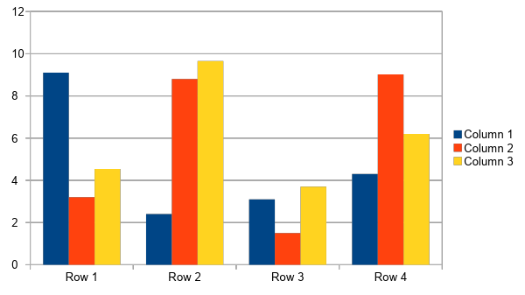
Figure: Strategic Business Units of ACI
Consumers Brand:
- Household Insecticides
- Antiseptic & Personal Care
- Home Care
- Female Personal care
- Commodity Foods
- ACI Consumer Electronics
- ACI Electrical Division
Agribusiness:
- Crop Care Public Health
- Livestock & Fisheries
- Fertilizer
- Crops
- Seeds
- Motors

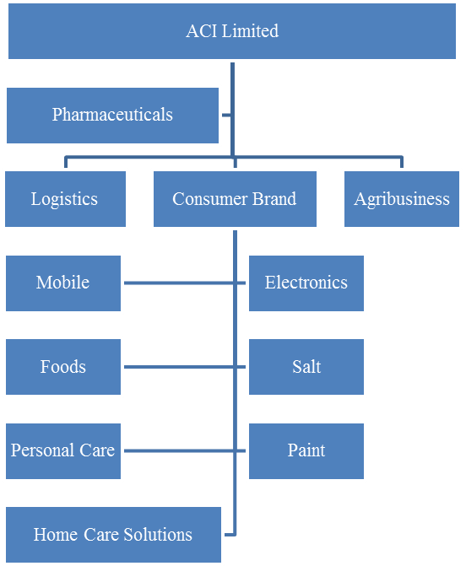
ACI Formulation’s Limited
ACI Formulation Ltd is a publicly listed company, separate from ACI Ltd. It manufactures for Agribusiness and Consumer Brands
Figure: SBU and Other Company of ACI LIMITED

Shawpno
ACI Limitedhas four strategic business units with twelve subsidiaries and also three joint venture that all mentioned above the pages. At the year 2017, the revenue of ACI Limited was Taka 18,306 million which was Taka 22,508 million for 18 months comparative period. The gross margin was 44.77% in the current year from 43.64% of the last year of the last 18 months comparative period. Also sale of high margin products. The current year operating profit was Taka 15,91million and profit after tax was Taka 1,244 million. And earning per share was Taka 28.3.30 June, 2017, ACI Limited contributed Tk. 3,302 million to the National Exchequer in the form of corporate tax .Equivalent to 18.04 percentage of company’s net sales revenue.

2.2.1 Subsidiaries and Joint venture:
Subsidiaries:
- ACI Formulations Limited (ACIFL)
- ACI Salt Limited
- ACI Pure Flour Limited (APEL)
- ACI Foods Limited
- Premiaflex plastic Limited
- Creative communication LTD
- ACI Motors Limited
- ACI Healthcare Limited
- ACI Logistics
- ACI Chemical Limited
Joint venture:
- ACI Godrej Agrovet private LTD
- Tetley ACI (Bangladesh) LTD
- Asian Consumer Care (Pvt) LTD

Figure: Personal Care Product of ACI LIMITED

ACI
Salt
ACI
Motors
ACI
Foods
ACI Leather Craft
ACI
Ltd
ACI
Health Care
Care
ACI
Chemicals

ACI
Logistics

ACI
Formulation

Creative Communication

ACI
Pure Flour
ACI Godrej Agro

Tetley ACI

Figure: Subsidiaries of ACI Limited

2.3 Company Mission and Vision
Company Missions
Their mission is to develop the quality of life of people through their products. ACI is committed to the pursuit of excellence through world class products and to provide highest level of consumer satisfaction. To enrich the quality of life of the people. As they are in a growing life stage so their target to increase their market share and create a distinctive position in the market.

Company Vision
- To take the leadership in each category of its business SBU’s.
- Establish an effective and everlasting relationship with the consumers
- To Provide consistent product quality and ensure the value of money
- To attain a position of leadership in each category of their business
They want to attain a high level of productivity through an effective utilization of resources and appropriate technology. Develop their employees and rewarding them for their innovative contribution.

Company Objectives
- ACI Limited has a several objective and these are given below:
- They want dominate the market with better quality and service
- To ensure superior return on investment
- Becoming the leader of every sector that they have
Values:
- Quality
- Customer Focus
- Fairness
- Transparency
- Continuous Improvement
- Innovation

2.4 Industry Perspective:
There are different forms and categories of soaps, interestingly, the bar soap is the most preferable among people while people are being provided with options for bathing. Nowadays number of brands designed different types of bar soaps for different uses of specific skin type or purposes. However, ACI limited has strategic goal and they know achieve it to be the market leader with a competitive advantage by competing with the competitors.
For endorsing bathing time pleasure and protection from germs ACI Consumer Brands launched Savlon Antiseptic Bar Soap under Health-care category in 2003 and today it has five different variants (e.g. Salvon Active, Savlon Mild, Savlon Fresh, Savlon Sports and Savlon Men) available in the market for the consumers. Savlon Antiseptic Bar Soaps are counted as the first of their kind to get presented in the personal care arena in Bangladesh as Savlon’s motto is “Everyday Protection against Germ”.

Later, to carry the legacy forward, ACI Consumer brands Launched Neem Original Soap under the Health-care category in June 2016. Nowadays, the trend of using natural soap among health-conscious people is quite high and thus many people are now switching to Natural/Herbal soaps from Traditional/Scratch Soaps. Therefore, to fulfill its consumer’s expectation ACI introduced Neem Original Soap in the personal care zone with the core value of “Regenerate your skin”.
Again, in January 2018, ACI Consumer brands launched another Beauty Soap product in the name ACI Sandal Soap with the tagline “Shonar Boron Konna” and set the expectations of their customers higher in the personal care zone with the core value of enhancing the natural beauty.
Moving forwards, ACI Limited is willing to figure out the opportunities lied ahead in the market in terms of serving its consumers. To face the extensive competitions, ACI Limited along with their R&D department is working on the further opportunities to satisfy its consumers‟ needs and desires.

Objectives and Methodology of the Study

3.1 Objectives of the Study
There are some specific objectives of the study and these are given below
Main objective is to “Describe the marketing mix and strategic Brand Management of ACI SANDAL SOAP”
- To identify problems, they have in their marketing mix and how to solve t these problems
- To get the total organizational view of ACI limited
- To Find out theefficiency and effectiveness of the existing marketing mix
- Analyze the importance or growth of personal care industry
- Find out what type of marketing problems ACI consumers brand’s personal care products face.

3.2 Methodology
Basically, it describes that how we collected the data or information to prepare this report and how we proceed on. Below the page I would like to discuss the methodology to collect the data for preparing the report
3.2.1 Primary data
Primary data means collected information by our own for the purpose of the report, project or any research. I collected primary data through my observation, discussion with professional, acquiring the knowledge through day by day activities and performing different activities in the organization. During my internship period, I did couple market visit for collecting information about their products position, customers’ requirements. Working with the employees, ZSM, ASM etc. of ACI consumer brand’s beauty department. Through activation I gathered information about personal care department. I was assigned for the trade marketing activities. Collect data over phone.
3.2.2 Secondary data
Secondary data or information is collected through their annual report, Website of ACI and other websites related to marketing articles and Newspapers.

Findings of the Study

4.1 Market analysis
A market analysis studies the attractiveness and the dynamics of a special market within a special industry. Through a market analysis, it is needed to identify the SWOT of a company. Through this analysis company can take the appropriate decision. There are several things I found through market analysis and these are given below:
1968 | Imperial Chemical Industries Pakistan Manufactures Limited (ICI Pakistan) was established in the then East Pakistan.
24 January, 1973 | Incorporation of ICI Bangladesh Manufacturers Limited.
24 January, 1973 | Commencement of Business.
5 May, 1992 | Imperial Chemical Industries Pakistan Manufactures Limited divested 70% of its shareholding to local management
5 May, 1992 | Name of the company changed to Advanced Chemical Industries Limited from ICI Bangladesh Manufactures Limited
9 March, 1994 | Listed with Dhaka Stock Exchange
22 October, 1995 | Listed with Chittagong Stock Exchange

4.2 Market Size
Market size is defined through the market volume and market potential. Volume depend on the consumer’s demand of products. Day by day the market size of beauty soap products is increasing. Consumers demand for beauty soap product is increasing. Because now a days women’s are very conscious about their skin. Though there are already several competitors are present in the market except that there is a huge potential to earn a profit for others in this industry. The market potential is equal importance. The relation between market volume and the market potential is the chances of market growth. Soap industry has a huge market not only in locally but also in globally. Day by day the size of market is increasing. But ACI Sandal soap market size is very small because it’s launched vert recently in the beauty soap market.

4.3 Market growth rate:
Market growth means forecasting the market growth rate is extrapolate historical data for future prediction. In future there is a huge chance to increase of market growth. Because day by day more people are become the consumers of this industry. It’s spreading around all over the country. The market growth rate is very low becauseit’s a new product, its market growth rate is now only 10%.

4.4 Profitability:
Already there are several competitors presented in the market and in spite of that there is a huge scope to earn profit and ACI soap department already create their own spaces in this industry. So they just need utilize their position. Because Sandelina is the main competitor of this soap. For competing them ACI need to do more promotional campaign, more advertising and using better distribution channel. Otherwise they won’t earn more profit by competing them. And also there are not so many barriers to entry in the market. So in future the number of competitors may raise.

4.5 Distribution channels:
Distribution channel is very much important for any new product in market .and also help for the market analysis. If product is not from or awell-known brand then distributor can dominate in the market but personal care products of ACI, Square, and Unilever are well known in the market. They have a good brand equity in the market. Through good distribution channel they can earn more market share.ACI beauty soap needs to prolong their distribution channel to coverage more areas.

4.6 SWOT
SWOT analysis is the strategic tool of a company which helps to know the company’s internal strengths and weaknesses and examine the opportunities of the business as well as the potential threats. Through SWOT analysis a company can study its current position and improve its future performances in comparison to its competitors. In the following some major strengths, weaknesses, opportunities and threats for ACI Limited is given which has been observed in the organization.
Strengths
- Maintain its growth above the market growth
- First company to obtain Quality Management Certification
- High quality products
- Wide range of products and services
- Strong management
Opportunities
- Growing demand
- High potentiality in both domestic and international market
- Power of supplier and buyers to bargain is
- Opportunity for new products and services
Weaknesses
- Reliance on imports
- Future low profit margin
- Higher cost in establishing new products
Threats
- Number of competitors on similar sectors are increasing
- Change in world economy may affect the export sector
(Super Admin, 2008) & (Institute of Business Administration, 2011)

4.7. Segmentation, Targeting and Positioning
Beauty Soap Industry Bar Soap continues to stick at the first place in all the markets of the world while Liquid Soap started to gain popularity in due time. According to a report, 72% of the consumers in US prefer to use and purchase Bar Soap. In 2013, the US Bar Soap market worth of $1,779 million and the UK Bar Soap market worth of £83.3 million alone. (Rosenburg, 2014) In Bangladesh, the soap market has been developed since it was introduced and distributed from 1960s. In past, soaps were imported by small distributions from different countries and as the days passed by, those distributions turned into large industry. At present, there are number of both National and Multinational companies who leads the soap market in the country and plays major role in the country’s economy. In a report published by Financial Express, it was stated that at present local manufacturer hold around 60% share of the domestic cosmetics and toiletries market compared to the late 90s when most of the products were imported and according to Bangladesh Cosmetics and Toiletries Manufacturers Association (BCTMA), the industry has employed 0.5 million people and reached BDT 150 billion turnover in 2014 where the local companies including national and multinational contributed BDT 90 billion. Md. Rezaul Karim, President of BCTMA said that before 2000, 60% of the products were imported and now the figure is decreasing dramatically because of the local producers; however, to maintain the following increasing demand, the industry needs to maintain 10% growth every year. (Wardad, 2015) Purchase behavior of the people of Bangladesh mostly depends on the product price and variety. In different arena of Bangladesh, different group of people use different types of soaps according to their culture, belief and awareness. Urban people are usually conscious regarding personal care products and look for and use different variety of soaps. Bangladesh’s Soap industry is still at the growing stage and has become more competitive as it is now developed with many exclusive extended product lines. To keep up with the consumers‟ living standards, expectation and to grow and grab the market share companies launched different types of soaps are being introduced based on the fragrance, color, textures and shapes.

4.8. Marketing Mix Evaluation
The marketing mix has been defined as a “set of marketing tools that the firm uses to pursue its marketing objectives in the target”. The marketing mix is also known the foundation model in marketing. There are four broad level of marketing decisions added to the marketing mix. And these are Product, Price, Promotion and place. The marketing mix or 4Ps is very important to manage the marketing decisions
4.8.1 Product Overview
Bangladeshi women are highly conscious about the health and beauty aspects of their skin. They want the very best and do not compromise on quality when it comes to the care and maintaining of skin’s state. In order to provide their skin with better care and in the process to improve their body & mind, ACI Consumer Brands stepped into the beauty soap category in 2018 with a sandalwood variant soap “ACI SANDAL SOAP”.
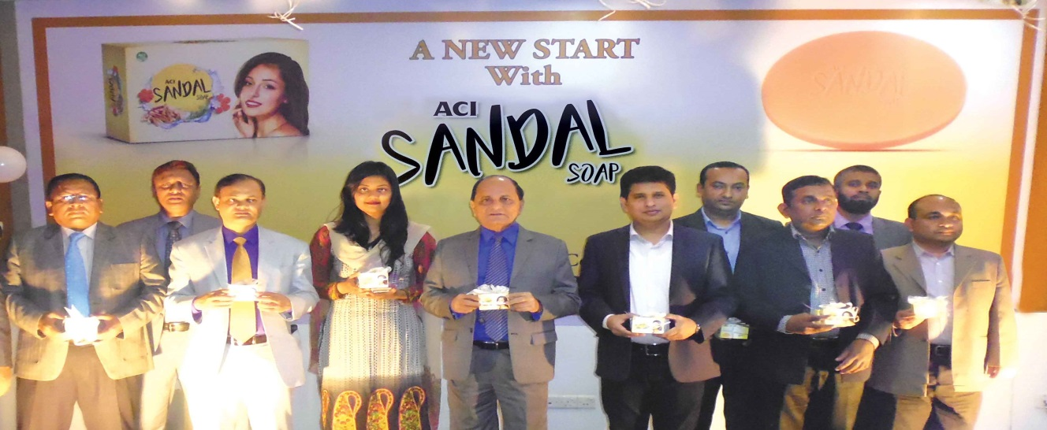

4.8.1.2 Total fatty matter (TFM)
TFM is one of the most important characteristics describing the quality of soap and it is always specified in commercial transactions. It is defined as the total amount of fatty matter, mostly fatty acids, that can be separated from a sample after splitting with mineral acid. TFM should be 70% to 75% is referred as Grade 1 soap.65% minimum as Grade 2 and less 60% as Grade 3. Sandal Soap is categorized by grade 1. Because its total fatty matter is above 70%.

Brand name | Grade
Lux | 2
Dove | 2
Meril | 1
Tibet | 1
Sandalina | 1

Sandalwood has been part of skincare regiment in the subcontinent for over 4000 years for its unique aroma, natural healing properties, & incomparable moisturizing abilities. Formulated with the highest quality of sandalwood oil and cocoa butter, ACI SANDAL SOAP is a Grade-1 soap which cleanses, moisturizes and soothes the skin. Its wonderful aroma is infused with lilac extract that captivates the mind. The soap is meticulously developed to offer intense moisturizing benefits and a magnificent long-lasting lather that leaves skin feeling clean, soft and radiantly beautiful.
ACI Sandal Soap is currently available in 2 SKUs: 125 gm and 75 gm
Product that satisfy or fulfill consumers need and wants. It can be tangible and or intangible. Tangible means like goods and intangible means service, idea or experiences. It’s very important to find out the consumers need. If we produced a product and if it’s not fulfill the consumers need then we won’t achieve our target. While producing a product there are many Marketing decision need to take like fix the product design, product assortment and many more things we need to consider. We need to maintain the branding of the product; what type of guarantee and warranties should we provide with our products all those things we need to consider here. ACI consumers brand has variety types of products in their bucket. But our main concern is to find out their new beauty soap product. Beauty soap product is under the SBU’s of Consumer Brand. The soapdepartment of ACI consumer Brand has several products and these are Savlon soap. Neem soap, they are all in different sizes and different prizes.

4.8.2 PRICE
Price strategy: Pricing strategy is an important factor to cover the more the market. Through proper pricing strategy they can capture the more market share. For different type of personal careproducts, they follow different pricing strategy. ACI personal care department follow competitive pricing and also penetration pricing for their new products. For ACI sandal soap they follow competitive pricing strategy to capture the market and for new product they follow penetration pricing strategy. Penetration pricing means setting lower price for a new products or service with initial offering.
Competitive pricing
Set your product price based on your competitor’s products price when there are so many competitors in the market that time you need to follow this. ACI sandal soap try to follow the competitive price. They follow competitive pricing strategy because they are new in this industry and there are several local competitors in the market.Sandelina sandal soap is their main competitor so they follow their competitive pricing strategy.
Penetration Pricing
Here set lower price for your products to earn more market share. New companies are doing price penetration to cover more area and market share. ACI sandal soap department now follow the price penetration strategy for pricing their product. Because whenever they launch any new product or want to earn more market share that time, they follow this strategy.
Price tactics: Price tactics means cutting the price for short-term period. Provide them various discount with products. Through this they want earn more consumers and market share and retain their loyal customers.
Price-setting: ACI setting their personal care products price based on several things. Adding production cost, distribution cost and promotional cost to set their product price. Sometimes they set price based on their competitor’s product price. For different types of products and sizes they charge different price from the customers. And based on product size and quantity they providedifferent price discount or allowances to the customers. Their product price is also varies based on consumers purchasing power and geographical based.
Discounts: ACI is also provided various offers to the consumers to attract and retain them. They provide discount to the various time. During the various period they provide different offers. ACI also provide holiday packs for their wholesalers based on their performance.
Payment terms: Since the soap is available in shops and supermarkets all around the nation, payment is at its most flexible state as customers can pay with Debit/Credit Cards and cash and also online.

Name | Weight | Price
Sandalina Sandal Soap | 150g | 48
Sandalina Sandal Soap | 125g | 44
Sandalina Sandal & Rose Soap | 100g | 36
Sandalina Sandal Soap | 75g | 26
ACI Sandal Soap | 125g | 40
Santoor Sandal and Tumeric Soap | 100g | 35
Dove Beauty Bar | 135g | 90
Lux Soap | 150g | 47
Lux Soap | 100g | 35
ACI Savlon Soap Men | 100g | 45
ACI Savlon Fresh Soap | 100g | 42
ACI Neem Original Neem Soap | 100g | 40
ACI Neem Original Honey and Tumeric Soap | 75g | 32

4.8.3 Place
Proving customers access and convenience. Place play a vital role in marketing mix. Here also we need to consider many things and these are distribution strategy like what type of distribution strategy we should follow to cover more customers, there are many types of distribution strategy like intensive distribution, selective distribution and exclusive distribution. We also need to decide the locations, channel number distribution, assortments, transport, warehousing and many more things we produce a product for consumers and if consumers can’t access the place that time, we can’t sell more products and can’t achieve our target.
Place is an important factor for marketing mix because if you don’t distribute your products to the right place then your target customers couldn’t able to reach your products. Place makes your products available to the customers. For placing your products, you need to identify your target customer and location and based on that deliver your products to those areas, Distributors, Wholesalers and Retailers. Through proper distributors we can reach our target customers and add more consumers to our portfolio. There are three types of distribution selective, intensive and exclusive distribution.Also, they provide different placement:
1. Retail Channel
2. Modern Trade Channel (Agora, Shwapno and others)
3. Institution/Corporate sales
4. Digital Channel.
ACI Consumer Brand’s personal care department follows intensive distribution. Intensive distribution means make available to your products everywhere. You can find ACI sandal soap in everywhere. Urban area to rural. Retailer shop, super shop, local shop, everywhere you will find their product. Because they used intensive distribution channel. So, they follow different tactics for different products. If your product is available in everywhere then you can easily capture more consumer and earn more profit. ACI after producing their products deliver it to the distributors then wholesalers to retailer to final consumer. They use this chain to cover more areas and consumers. They need to allocate their products into different location. ACI also follow their competitors that how they place their products and where they place their products. What types of distribution channel they are using? Because ACI is new firm in this industry. They can’t reach everywhere because most of the places are hold by the square. But day by day it’s increasing. ACI is continuously increasing its distribution channel to cover more areas. They use indirect distribution to sell their products to the ultimate consumers. During the activation period or campaign, they follow direct distribution channel. Where they sell their product to their final consumers
ACI Limited has twenty-six distribution centers across the country. Still they are increasing their distribution channel for serving better service to their consumers. The combination of multinational and advanced function that helps it to handle hundred product efficiency. They use ISO 9001-2008 manage of its distribution system.

Central Warehouse

Depot

Distributors

Wholesalers

Retailers

Consumers

Figure: Distribution Channel
Central Warehouse
Depot
4.8.4 Promotion
Consumers
Retailers
Wholesalers
Distributors
Promotion means the direct marketing communication to the target customer, which is used to refers to persuade target customers of the relative merits of the product, service and branding of that product. It also informsand aware your consumers about your products. Here we can follow different types of marketing strategy. Through advertising, direct marketing, Sales promotion and many other ways we can promote our products. For promoting the products, we need to consider some things like who is our targeted consumers, what is to be communicated, how to reach the target audience and how often we should communicate with the consumers, and also how we attract our target customers to our brand and aware of it.
They used various promotional strategies, such as – Online promotion, Digital marketing, Online Campaign, Social activation, Beauty contest, Women days activities and so on.
Retailers
Beauty product division is under the SBU, of ACI Consumer Brand. ACI personal care department following different promotional strategy for their different product. ACI consumer brand’s personal care department also follows different types of promotional strategy for their products and these are mentioned below the page:
4.8.4.1 Calendar Girls 2019
As the New Year approaches, with the theme “Let your Confidence Speak through Calendars”, ACI Sandal Soap is delighted to announce a nationwide contest “Calendar Girls 2019” for all young females. The brand aims to provide a platform for all the aspiring girls to help them boost their confidence and realize their true potential. Participants are initially asked to send their best portrait to ACI Sandal Soap’s fan pages on Facebook and Instagram, and after attending grooming sessions by the industry’s finest, 6 lucky girls will win a chance to be featured in the exclusive calendar of ACI Sandal Soap.
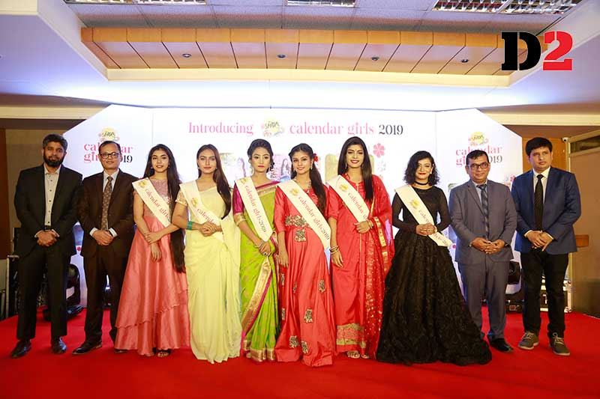
For promoting ACI sandal soap they use different types of broad segments. These are small size, medium size and large size. These are also available in different quantity (gram) in different sizes.
4.8.4.2 Their promotional strategies are
For any company it’s highly important to take a proper promotional strategy for their products. ACI consumer Brand’s beauty soap department also try to maintain those things in properly and these are

Push and Pull Strategy
Push and Pull both are different strategy and distinctive from each other. The strategy to promote the product that make your brand competitive. The promotional activities of different brand are quite different based on their target customers.
Push Strategy
ACI Consumers brand’s beauty soap is newly in the market. They informed people about their product through the effective promotional strategy. There are no barriers to inter in this industry. For this reason, the market is very competitive. For that reason, push marketing is used to push the product to the retailers. Through a chart we explain the push and pull marketing and their differences

Manufacturer
Wholesalers
Retailer
Consumers
Retailer

Consumers

Wholesalers

Manufacturer

Figure: Push Strategy Figure: Pull Strategy
Pull Strategy
They find out what type of soap consumers want from them, at which price, what type of benefits they want at how much quantity etc. This information they collect through retailers, wholesalers, or communicating directly to the consumers. So, based on this they can produce a product. That help they to capture more market share and help them to stay in the competitive market. In pull Strategy Company try to create a need. In this sector company spends a huge amount of money for advertising their products. ACI limited due to its limitation in the financial resources to telecast less commercials in the TV channels. ACI’s soap production department is growing day by day and they are increasing their promotional budget. Because without this they can’t increase their market share. So, pull strategy is very important for any organization to stay in the market. But now a days ACI consumer brand understanding this and use different types of policies to promote their products.

4.8.4.3 Promotional Mix
Advertising is highly popular in the 20th century. The process in printing and packaging industrial growth lead the popularity of adverting. Today we can’t imagine to reach the consumers without advertising. So, it’s an indispensable parts of promoting a products. Advertising is persuasive by nature. For adverting ACI spent some money for their target customers. Now they understand the importance of this and day by day they are increasing the amount. They also use newspaper and radio to promote their products. Though Television advertisement is quite expensive than printed media but to reach more customers it’s very important to spend money on this media sector. Because ACI want to create awareness to the mass people about their products. ACI Freedom Sanitary Napkin prepared on a printed that was published in “Daily Star” newspaper in the recent year. That was published at the International Women’s day for creating the brand awareness.

Figure: Promotional Mix
Advertising
Advertising is highly popular in the 20th century. The process in printing and packaging industrial growth lead the popularity of adverting. Today we can’t imagine to reach the consumers without advertising. So, it’s an indispensable part of promoting a products. Advertising is persuasive by nature. For adverting ACI spent some money for their target customers. Now they understand the importance of this and day by day they are increasing the amount. They also use newspaper and radio to promote their products. They use these media on a regular basis especially in summer. So, they try to promote their products through these. Though Television advertisement is quite expensive than printed media but to reach more customers it’s very important to spend money on this media sector. Because ACI want to create awareness to the mass people about their products.

Under this tool the activities that they do and these are
- Television Commercial (TVC)
- Above The Line (ATL)
- Below The Line (BTL)
- Outdoor advertising
- Using Billboard
- Doing campaign in different location to create awareness
- News newspaper, radio etc.

Personal Selling
In personal selling they meet to the consumer and try to sell their product to the consumers at that time. They have a face to face conversation with their consumers. Through campaign, activation etc. ACI’s personal care department also doing this on a regular basis. They create campaign for women’s day to awareness among the girls, their mothers. During the activation they directly communicate with people and try to sell their product to them.
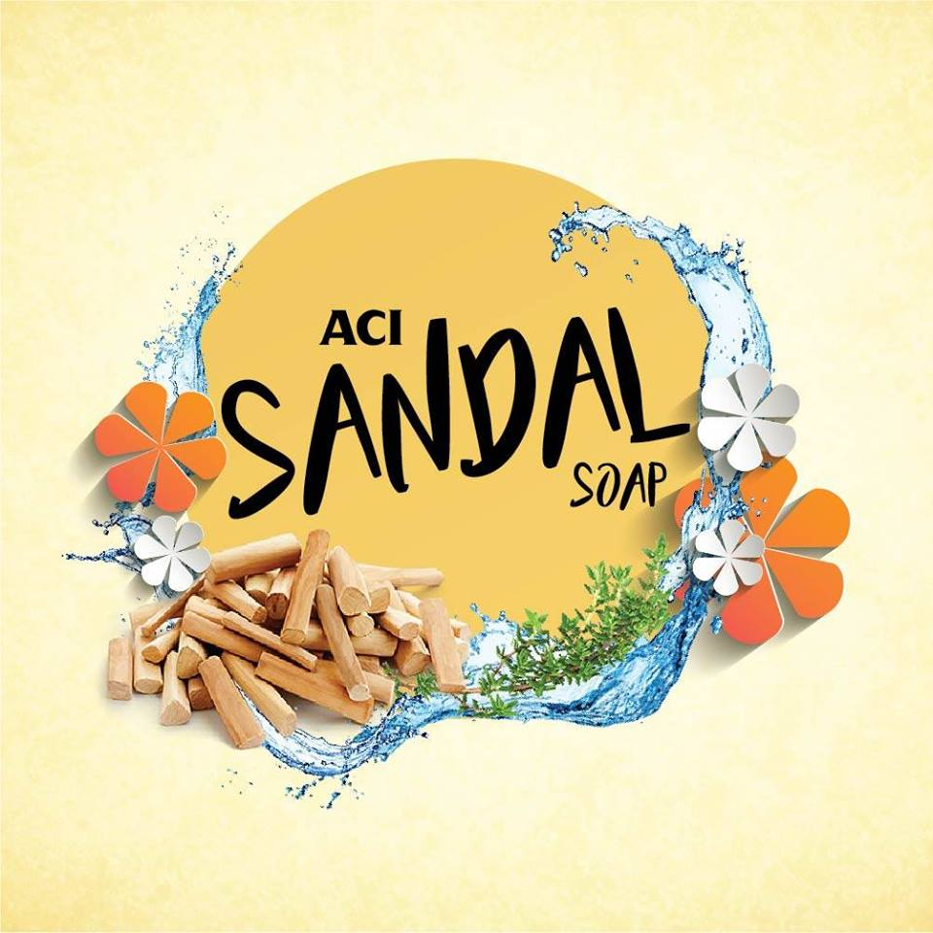
Product Activation Program: Savon twinkle baby diaper and freedom napkin are conducts activation in different hospitals in Dhaka city. Basically, for diaper they do activation in hospitals but for napkin they are doing activation in colleges, schools, universities and many more places.
For doing this they have a motive and these are
- To create brand awareness among the people
- Sell their products
- To inform the consumers about the importance of these
- Give information of the products
- Capture the target customer
- Create positive buzz about their product
- And importantly build relation with girls, mothers
Direct marketing
Through direct marketing we can communicate with consumers directly like give them mail, send massages to the mobile and communicate with them through telephone and many others ways. ACI sometimes doing direct marketing to promote their products. They are communicating to their retailers, distributors and wholesalers.
Sales Promotion
This is a short-term encourage to the customers, retailers and wholesalers. They give sales promotion offers an incentive to buy. Sales promotion is used to achieve different objectives. Sales promotion used to attract customers, retain old customers and to increase the market share. Price packs, coupon, rebates, point of purchase all are add under sales promotion. And under trade promotion Discount, Allowances, free goods also provided. ACI do all those things in different time period.
Consumers Promotion
Samples: ACI provide sample diaper, napkin during the time of activation in the hospital.
Point of Purchase: here they displayed products in way that can attract consumer’s attention
Gifts: they give various gift to the consumers to stay in the market and retain the consumers. ACI also provide gift to their consumers and retailers based on their purchase quantity or selling quantity for retailers.
Market Players in Soap industry:
As ACI limited (Savlon and Neem) discussed earlier, some other significant market players of soap industry are introduced below – Kohinoor Chemical Company Limited (KCCL): KCCL is popular for its beauty product brand „Tibet‟. The company considered as the pioneer of soap, cosmetics and toiletries manufacturing industry of Bangladesh. Their product line includes Tibet Beauty Soap, Sandalina Sandal Soap, Ice Cool Soap and Bactrol Family Health Soap.Square Toiletries Ltd.: It’s a Strategic Business Unit (SBU) of Square Group with the core value “Uniquely Touching Lives”. Meril Beauty Soap is the mail Banded product of this SBU which was later named as Meril Splash. Today, Meril‟s product line has expanded with different variants. Keya Cosmetics Ltd.: Alike Square Toiletries Ltd., Keya Cosmetics Ltd. is a SBU of Keya group. It started it journey with its most popular brand Keya Beauty Soap and since then it plays a major role in the soap industry and keeping up with the competition. Unilever Bangladesh: Unilever at present is the largest market shareholder in the soap industry. It has grabbed most of the market share and still maintaining to grow more popularity with its popular beauty soap brands which includes Dove, Lux and Lifebuoy. Reckitt Benckiser (RB) Bangladesh: Reckitt Benckiser, a world’s renowned multinational company who is currently market leader in world’s 37 countries‟ soap industry including Bangladesh’s soap market for their Antiseptic soap Dettol. (Reckitt Benckiser, 2016)

Lux | Meril | Tibet | Dove | Fa | Sandalina
75g. =24 BDT. | 100g.=30BDT. | 7g. =23 BDT. | 50g. =75 BDT. | 90g. =120BDT. | 75g. =25 BDT.
100g. =30 BDT. |  | 90g. =25 BDT. | 125g. =120 BDT. | 175g. =125BDT. | 125g. =40 BDT.
150g. =42BDT. |  | 100g. =30 BDT. | 135g. =140 BDT. |  | 150g. =45 BDT.
170g. = 120BDT.

Dove is the soap combination of moisturizer and softness so as to satisfy the particular need which was earlier not met thus touching the market which was untouched. Dove products are clinically proven to be one of the mildest moisturizer soap bars which suits all types of skin type and does not irritate the skin. Sensitive skin type can also use this soap bar. Lux is also a mild soap bar but less than dove. Sandal soaps are very good for all types of skin. It can purify and moisturize skin. ACI has recently launched Sandal soap which is very mild and with cocoa and sandal.

Job Description and Responsibilities

5.1 Nature of the Job
I started my internship program at ACI Consumer Brands Limited. The program made me realize how the real work life actually operates and learn how to work under pressure with responsibilities.

5.2 Job Responsibilities
My job responsibility was basically to work with the Consumer Brands team related to the Modern Trade marketing which includes from product development to its implementation and Later to improve it over time to time.
- New project – Beauty Soap
- Create and conducted the survey for the new soap project on the field via In-Person
- Interviews.
- Competitive analysis of bathing soaps of different brands of soap industry.
- Channel Inspection of cosmetic shops.
- Ingredients study which are commonly used in soap and their benefits.
Making necessary documents
Before visiting the market, I used to make necessary arrangements like making a format in a note pad to write down the information, collecting SR number of the respective area, Location name, and Market addresses.
Making relationship with sales representative:
As the area sub-divided under the sales representatives, they know about all the shop better. So, I have to maintain a good relationship with them so that I can access the information without any disturbance.

Visiting Market:
I have visited all the retail shop at the market. I asked the shoppers about personal care products like- sandal soap, Neem face wash and other beauty soaps.
Collecting the necessary data:
I have to collect all the necessary data regarding ACI Sandal soap. As all the shoppers are not equally amicable, I used different strategy to approach them.
Collected data into excel and reporting to the supervisor:
After my visiting of the market, I come to the office and I input all the data that I gathered. I created a format on my own and my supervisor approved it and wherever the fault is found, my supervisor showed me a way to solve it. Since it’s a very new product in market, so I gathered few data from market visits.
.

Recommendations and Conclusion

6.1 Recommendations
- While doing the survey, it is been observed that consumers are loyal to their current soap brands and they hardly think of switching. The Team for the new product development can emphasis on establishing and developing the new brand image in consumers’ mind. and aware tem about the product and its benefits.
- Consumers now look for products for the benefit of their skin and thus they are now moving towards though very slowly towards the handmade or natural soaps. ACI Limited while developing the new soap brand should focus on this factor.
- It is not possible for organizations like ACI to work by book as the development process moves simultaneously that may sometimes delay in different stages still the team can organize the process as it moves simultaneously that may sometimes delay the development process that the delay does not affect the other development sectors.
- The questionnaire could be developed in a way that would have fulfilled the objective of it entirely and more information could have been gathered. Along with that though the research was quantitative, more consumers can be reached if it were online.
- There are other brands in international market which move in the market either by selective importer or by market from which ACI‟s new brand has to stand against to establish its position in the market through consumers and for that the team needs to develop strategic plans in terms of product placements and promotion.
- ACI Limited is growing faster in the competitive market with the aim to provide its consumers with more benefits. From the observation I learnt how consumer satisfaction is important for them and thus with empathy they think and develop product and services for its consumers.
- Nonetheless, it is difficult to satisfy the never-ending expectation as the growing acceptance and engagement it is somewhat difficult to meet the satisfactions entirely due to insufficiency. However, in near future I believe ACI Limited will keep continuing its legacy and moving forward to its vision of making newer and better future for both national and international market.

6.2 Conclusion
ACI is the most conspicuous andtrustableorganization in Bangladesh. From 1968, they are satisfying customers' needs and building a sustainable relationship. It produces quality items. Presently, ACI consumer Brands are the most effective name to serve its definitive users. It was started with two noteworthy brands-ACI Aerosol and Salon in 1995. The division began to take new business through off shoring exchange and additionally neighborhood producing. Likewise, they import global items in Bangladesh. Usage of Beauty soaps in Dhaka city is increasing day by day. So that developing effective product analysis is needed. For this reason, ACI is conducting a survey finding its gaps. Also, this survey helps them to find the problems have in the market. Moreover, it is the only way to identify their market position. According to the consequence of the survey, ACI must take proper action as soon as possible. Furthermore, it will help them to create an effective strategy and fight back to the ground. By doing this kind of research work they will be improved

References

Research on Personal Care Industry A Comparative Analysis (1).pdf. (n.d.).
Bharucha, J. (2015). Dove vs Lux : A strong corporate brand or a strong product brand, 1(9), 166–169.
Fulfilment, P. (n.d.). Project Report on Consumer Behaviour towards Soap Market.
Ohmann, M. (2014). Internship report. Recruitment and Selection Process of SQUARE Toiletries Ltd. (STL)
Beauty, N., & Brand, S. (n.d.). ACI Limited.
http://www.assignmentpoint.com/business/organizational-behavior/internship-report-on-consumer-perception-of-keya-cosmetics-ltd.html
Female Consumer Beauty Products Perception about Unilever Bangladesh Ltd. (n.d.).
Advertising, C., & Stories, S. (1997). Canadian Advertising Success Stories.

