Project Report
On

The Impact of Brand Experience and Brand Trust on Brand Loyalty:

A Study on Carbonated Soft Drinks Industry in Bangladesh

Submitted by
Mahmuda Akhter Smrity
Program: BBA
ID: 111191150
School of Business & Economics (SoBE)

Submitted to
Muhammad Hasan Al-Mamun
Assistant Professor,
School of Business & Economics (SoBE)
United International University

Acknowledgement

I have much pleasure and kindness of the Almighty God, the supreme of the earth, for giving me the ability to work hard successfully. I would like to be thankful to my parents for encouraging and supporting me all the time. Words will never be enough to express how grateful I am but nevertheless I will try my best to express my gratefulness towards some people.

To this regard I would like to take the opportunity to express my gratitude to my faculty supervisor, Mr. Muhammad Hasan Al-Mamun, Assistant Professor, School of Business & Economics (SoBE), United International University, he suggested and guided me to prepare this report. A single individual can achieve no noble objectives. I am indebted to a number of persons for their kind advice, suggestions, directions, and cooperation that have enable me to have an experience in the dynamic environment learning and ultimately to prepare this report.

Letter of Transmittal

Date: September 11, 2024
Mr. Muhammad Hasan Al-Mamun, Assistant Professor
School of Business & Economics (SoBE)

Subject: Submission of the Project report

Respected Sir,
I am pleased to submit the attached project report titled " The Impact of Brand Experience and Brand Trust on Brand Loyalty: A Study on Carbonated Soft Drinks Industry in Bangladesh" This report has been prepared as part of my academic requirements at United International University.
I would like to express my gratitude to Mr. Muhammad Hasan Al-Mamun, Assistant Professor, for guidance and support throughout this project. I am also grateful to the respondents who participated in the survey, providing essential data for this study.
I hope this report meets your expectations and provides valuable insights into the CSD industry's brand-consumer relationships. I am available to discuss any question or further details you may require.
Thank you for your time and consideration.

Yours faithfully,

Mahmuda Akhter Smrity
ID: 111191150
Bachelor of Business Administration (BBA)
School of Business & Economics (SoBE)
United International University

Abstract

The report explores the relationships between brand trust, satisfaction, and loyalty within the carbonated soft drinks (CSDs) industry. Satisfaction, in the context of CSD, is described as the overall positive experience from consuming a favourite fizzy drink, influenced by taste, packaging, and brand interactions. Loyalty, in the same context, is conceptualized as the emotional bond that keeps consumers returning to the same brand, achieved through personalized marketing, loyalty programs, and consistent positive experiences.
The main objective of this research was to evaluate the impact of brand trust, and brand experience on brand satisfaction as well as the overall brand loyalty. It was found that brand satisfaction is significantly affected by brand experience and brand trust. It was also found that brand experience, brand trust, and brand satisfaction significantly affect the overall brand loyalty. Managerial implications of this research suggest that CSD marketers must develop strategies to foster a desirable brand experience and brand trust to ensure brand satisfaction and loyalty.
Globally, the CSD industry is shifting towards healthier options in response to health concerns and regulatory pressures, especially in developed markets. In contrast, emerging markets like Bangladesh present growth opportunities due to economic and demographic factors. Adapting to local preferences and regulatory environments is essential for global CSD companies.

Key Words: Brand Experience, Brand Trust, Brand Loyalty

Table of Contents
Acknowledgement 1
Letter of Transmittal 2
Abstract 3
Chapter 1 : Introduction 6
Topic in hand (Brand Experience, Brand trust, Brand satisfaction, Brand loyalty) 7
Industry prospective, Local perspective, Global perspective (Carbonated soft drinks) 8
Industry Perspective: Bangladesh Market 8
Local Perspective: Bangladesh Market 9
Global Perspective 10
Chapter 2: Literature review 11
Brand trust, Brand satisfaction, Brand loyalty, Brand experience 12
Chapter 3: Objective & Methodology 16
Objective of the study 17
Relations Between brand and loyalty 17
Methodology 18
Source of data: 18
Chapter 4: Findings of The Study 27
Path Coefficients 29
Construct Reliability 31
Construct Validity 32
Multi Co-linearity 34
Evaluation of overall model 35
Chapter 5: Future Research Direction and Conclusion 36
Future Research 37
Conclusion 38
Figures and Graphs Used 39
Appendix 40
References 49

Chapter 1:

Introduction

Topic in hand (Brand Experience, Brand trust, Brand satisfaction, Brand loyalty)

We're diving deep into the fascinating world of carbonated soft drinks (CSDs) to uncover the intricate dance between brand trust, satisfaction, and loyalty. Imagine walking down the soda aisle in your favorite store – which brands do you trust to deliver the flavors you love; with ingredients you can rely on? That's where brand trust comes into play, reflecting our beliefs in a brand's honesty, integrity, and dependability. In today's health-conscious world, knowing what goes into our drinks is more important than ever, making transparent communication and consistent quality assurance vital in building and keeping that trust alive.

Now, let's talk satisfaction – that feeling of contentment when you crack open a cold can of your favorite fizzy drink. It's not just about the taste; it's the whole experience, from choosing your preferred flavor to the satisfaction of every sip. Whether it's the refreshing burst of bubbles, the wide range of flavors, or the eye-catching packaging that draws you in, these factors all contribute to our overall satisfaction with a brand. And let's not forget the importance of a seamless experience, from grabbing your drink off the shelf to enjoying it to the last drop every step matters.

Exploring the world of carbonated soft drinks (CSDs) reveals the dynamic relationship between brand trust, satisfaction, and loyalty, which collectively shape the overall brand experience. This experience encompasses every interaction a consumer has with a brand, from initial awareness to post-purchase engagement, ultimately influencing their perception and emotional connection with the brand.

Lastly, there's loyalty that special bond that keeps us coming back to the same brand time and time again. It's like having a favorite go to drink that never fails to hit the spot. Building loyalty in the competitive world of CSDs is no easy feat. It's about creating emotional connections, understanding our habits, and making us feel like our chosen brand is the best choice out there. Whether it's through personalized marketing campaigns, loyalty programs, or unforgettable brand experiences, brands have to work hard to earn our loyalty.

Industry prospective, Local perspective, Global perspective (Carbonated soft drinks)

Industry Perspective: Bangladesh Market

In Bangladesh, the carbonated soft drinks (CSD) industry has experienced substantial growth over the past decade, primarily driven by factors such as increasing urbanization, rising disposable income, and changing consumer preferences. Multinational corporations like Coca-Cola and PepsiCo have established a dominant presence in the market, accounting for a significant share of sales and distribution. One of the key drivers of growth in the Bangladesh CSD market is the widespread availability of these beverages across various channels, including supermarkets, convenience stores, restaurants, and street vendors. Both urban and rural areas are well-served by an extensive distribution network, ensuring that consumers have easy access to their favorite brands.

Despite facing challenges such as fluctuating raw material costs, regulatory constraints, and intense competition, the CSD industry in Bangladesh continues to thrive. Companies have responded to these challenges by implementing efficient supply chain management practices, investing in marketing and advertising campaigns, and introducing innovative packaging and product variants to cater to diverse consumer preferences.

The COVID-19 pandemic temporarily impacted the industry, leading to disruptions in the supply chain and changes in consumer behavior. However, with the gradual easing of restrictions and the resumption of economic activities, the CSD market in Bangladesh has shown resilience and is expected to bounce back, driven by pent-up demand and promotional initiatives by key players.

Local Perspective: Bangladesh Market

In Bangladesh, carbonated soft drinks hold a special place in the hearts and habits of consumers, reflecting the country's vibrant culture and social dynamics. While multinational brands like Coca-Cola and PepsiCo enjoy widespread recognition and loyalty, local players have also carved out a niche for themselves in the market. Local brands such as Pran, RC Cola, and Mojo have gained popularity among consumers by offering a diverse range of flavors, packaging sizes, and affordable pricing. These brands often leverage their understanding of local tastes and preferences to introduce unique flavor combinations that resonate with Bangladeshi consumers.

Brand trust, satisfaction, and loyalty are significant factors influencing consumer behavior in the Bangladesh CSD market. Consumers tend to trust multinational brands for their consistent quality and global reputation, while local brands earn trust through their commitment to product quality, affordability, and community engagement initiatives. Satisfaction levels among consumers vary based on factors such as taste preferences, product quality, packaging, and brand image. While some consumers prefer the familiar taste of multinational brands, others are drawn to the affordability and cultural relevance of local offerings.

Brand loyalty in the Bangladesh CSD market is influenced by various factors, including taste preferences, habit formation, promotional activities, and peer influence. While multinational brands command a loyal customer base, local brands capitalize on their cultural resonance and affordability to foster long-term relationships with consumers.

Global Perspective

From a global perspective, the carbonated soft drinks industry is undergoing significant transformations driven by changing consumer preferences, health concerns, and regulatory pressures. Developed markets such as North America and Europe are experiencing a shift towards healthier beverage options, including low-sugar, natural, and functional drinks, in response to increasing health consciousness among consumers.
In contrast, emerging markets like Bangladesh represent a growing opportunity for CSD companies due to rising disposable incomes, urbanization, and a young demographic profile. Multinational corporations are expanding their presence in these markets through product innovation, strategic partnerships, and localization strategies to align with local tastes and preferences.

Brand trust, satisfaction, and loyalty are universal concepts in the global CSD industry, influencing consumer behavior and purchase decisions across different markets. However, cultural nuances, regulatory environments, and socio-economic factors shape the dynamics of brand perception and consumer loyalty in each region.

To thrive in the competitive global landscape, CSD companies must adapt their strategies to meet evolving consumer demands, navigate regulatory challenges, and build strong brand equity through transparency, sustainability, and consumer engagement initiatives. By understanding the unique dynamics of each market and leveraging consumer insights, brands can establish a competitive advantage and foster long-term loyalty in the global CSD industry.

Chapter 2:

Literature Review

Brand trust, Brand satisfaction, Brand loyalty, Brand experience

When it comes to carbonated soft drinks, trust goes beyond just the taste. Consumers want to know they're choosing a brand they can rely on, one that's transparent about its ingredients and production processes. As Kim et al. (2013) put it, trust means believing in a brand's reliability and its ability to deliver on its promises. In today's world, where information is readily available, consumers also look to peer reviews and recommendations to guide their trust in a brand (Chevalier & Mayzlin, 2006). So, it's not just about the fizzy drink in the bottle, it's about the story behind it and the values it represents. Brand trust is a fundamental aspect of consumer behavior, particularly in the context of soft drink brands. As consumers navigate a plethora of choices within the beverage market, their trust in a brand significantly influences purchase decisions and brand loyalty. This literature review delves into various factors that influence brand trust in soft drink brands, drawing insights from empirical research and theoretical frameworks. One critical determinant of brand trust in soft drink brands is brand reputation. Aaker (1996) emphasizes the pivotal role of brand reputation in building consumer trust. Soft drink brands with a positive reputation for quality, reliability, and ethical practices are more likely to engender trust among consumers. This is supported by Keller (2003), who underscores the importance of brand reputation in shaping consumer perceptions and loyalty.
Furthermore, the brand image projected by soft drink brands plays a significant role in cultivating trust among consumers. Erdem and Swait (1998) highlight the impact of brand image on trust perceptions, suggesting that brands associated with health, social responsibility, and environmental sustainability are more likely to be trusted by consumers. This implies that the alignment between brand image and consumer values enhances trust in soft drink brands. Consistency in brand messaging and consumer experience also contributes to building brand trust. Brown and Dacin (1997) argue that consistent brand communication and product quality foster trust among consumers. Similarly, Delgado-Ballester and Munuera-Aleman (2005) emphasize the role of positive consumer experiences in enhancing trust levels. Soft drink brands that deliver reliable product performance and satisfactory customer service are better positioned to cultivate trust and loyalty among consumers.

Imagine cracking open a cold can of your favorite carbonated soft drink on a hot summer day. It's not just about quenching your thirst, it's about the whole experience. From the moment you pick up that familiar package to the refreshing taste that leaves you wanting more, every aspect contributes to your satisfaction. Delgado-Baluster et al. (2003) highlight the emotional aspect of satisfaction, suggesting that it's not just about meeting expectations but also about creating positive memories and feelings associated with the brand. Whether it's the convenience of finding your favorite flavor or the personalized touch of a loyalty program, brands could create memorable experiences that keep consumers coming back for more.
Brand satisfaction is a pivotal aspect of consumer behavior, particularly in the competitive landscape of soft drink brands. Understanding the factors that influence brand satisfaction is essential for marketers to develop effective strategies aimed at fostering consumer loyalty and enhancing brand performance. This literature review examines various factors that contribute to brand satisfaction in soft drink brands, drawing upon empirical research and theoretical frameworks. One crucial determinant of brand satisfaction in soft drink brands is product quality. Numerous studies have highlighted the significant impact of product quality on consumer satisfaction (Oliver, 1980; Zeithaml, Berry, & Parasuraman, 1996). Soft drink brands that consistently deliver high-quality products are more likely to satisfy consumer needs and expectations, leading to increased brand satisfaction.
Moreover, brand image plays a vital role in shaping consumer perceptions of soft drink brands and influencing brand satisfaction. Consumers often associate soft drink brands with specific attributes, such as taste, packaging, and brand personality (Keller, 1993). Positive brand image, characterized by favorable associations and perceptions, contributes to heightened brand satisfaction among consumers. Additionally, consumer experience plays a significant role in shaping brand satisfaction in soft drink brands. Positive experiences, such as pleasant interactions with brand representatives or enjoyable consumption experiences, contribute to enhanced satisfaction levels (Homburg, Wieseke, & Bornemann, 2009). Conversely, negative experiences can lead to dissatisfaction and potentially tarnish the brand's reputation.
Brand loyalty is like having a best friend in the carbonated soft drinks aisle. It's that brand you turn to time and time again, not just out of habit, but out of genuine affection. Fournier (1998) talks about the emotional connection between consumers and brands, emphasizing the sense of belonging and identity that comes with being loyal to a particular brand. Loyalty isn't just about repeat purchases; it's about feeling a part of something bigger, whether it's a community of like-minded fans or the nostalgia of childhood memories associated with the brand. Brands that can tap into this emotional connection have the power to create lifelong relationships with their consumers. Brand satisfaction is a pivotal aspect of consumer behavior, particularly in the competitive landscape of soft drink brands. Understanding the factors that influence brand satisfaction is essential for marketers to develop effective strategies aimed at fostering consumer loyalty and enhancing brand performance. This literature review examines various factors that contribute to brand satisfaction in soft drink brands, drawing upon empirical research and theoretical frameworks.
One crucial determinant of brand satisfaction in soft drink brands is product quality. Numerous studies have highlighted the significant impact of product quality on consumer satisfaction (Oliver, 1980; Zeithaml, Berry, & Parasuraman, 1996). Soft drink brands that consistently deliver high-quality products are more likely to satisfy consumer needs and expectations, leading to increased brand satisfaction.
Moreover, brand image plays a vital role in shaping consumer perceptions of soft drink brands and influencing brand satisfaction. Consumers often associate soft drink brands with specific attributes, such as taste, packaging, and brand personality (Keller, 1993). Positive brand image, characterized by favorable associations and perceptions, contributes to heightened brand satisfaction among consumers. The role of brand loyalty cannot be overlooked when examining brand satisfaction in soft drink brands. Consumers who exhibit brand loyalty are more likely to be satisfied with their chosen brand (Jacoby & Chestnut, 1978). Soft drink brands that successfully cultivate loyalty through various strategies, such as loyalty programs or emotional branding, tend to enjoy higher levels of brand satisfaction among consumers.
In summary, trust, satisfaction, and loyalty are more than just buzzwords in the world of carbonated soft drinks. They represent the foundation of meaningful relationships between consumers and brands. By prioritizing transparency, delivering memorable experiences, and fostering emotional connections, brands can not only satisfy consumers' thirst but also win their hearts.
The concept of brand experience plays a pivotal role in shaping consumer perceptions and behaviours towards a particular brand. In the context of carbohydrate drinks, understanding brand experience involves delving into how consumers interact with and perceive these products across various touchpoints. Firstly, let's explore the dimensions of brand experience as outlined in the literature. According to Brakes, Schmitt, and Zarantonello, brand experience encompasses sensory, affective, intellectual, and behavioural dimensions. In the case of carbohydrate drinks, the sensory dimension refers to the taste, texture, and overall sensory appeal of the product. Consumers may associate certain flavours or packaging designs with their past experiences, influencing their purchasing decisions.
The affective dimension involves the emotional connection consumers have with the brand. This could stem from marketing campaigns that evoke positive emotions or personal experiences associated with consuming the product. For example, consumers may feel a sense of refreshment or vitality when drinking their favourite carbohydrate drink after a workout. The intellectual dimension pertains to how the brand engages consumers' thinking processes. This could include factors such as the brand's positioning, nutritional information, or messaging around health and performance benefits. Consumers may be drawn to carbohydrate drinks that align with their dietary preferences or fitness goals, leading to repeat purchases based on perceived intellectual value. Lastly, the behavioural dimension encompasses consumers' interactions with the brand, including their purchasing habits and brand loyalty. Brands that offer convenience, consistent quality, and positive experiences are more likely to cultivate loyal customers who regularly choose their products over competitors’. Considering the broader context provided in the article, it's evident that brand experience is crucial for both consumers and companies in the carbohydrate drink market. For consumers, brand experience influences their satisfaction, loyalty, and ultimately, their purchasing decisions. Meanwhile, for companies, creating memorable brand experiences can differentiate their products from competitors, enhance marketing effectiveness, and foster long-term relationships with consumers. Understanding and leveraging brand experience is essential for carbohydrate drink brands seeking to engage consumers, build trust, and drive brand loyalty. By focusing on sensory appeal, emotional connection, intellectual engagement, and positive behaviours, companies can create meaningful experiences that resonate with consumers and drive business success in this competitive market.

Chapter 3: Objectives & Methodology

Objectives of the Study

The objective of this study is to explore the intricate relationships between brand trust, brand satisfaction, and brand loyalty within the context of the carbonated soft drink industry. Through a comprehensive examination of consumer perceptions and behaviours, this research aims to uncover the underlying factors that influence individuals' preferences and purchasing decisions regarding soft drink brands. By understanding the dynamics of trust, satisfaction, and loyalty, this study seeks to provide valuable insights for marketers and brand managers to enhance their strategies for building stronger brand-consumer relationships and fostering brand loyalty in a highly competitive market environment. This research contributes to the existing body of knowledge in consumer behaviour and brand management, offering practical implications for industry practitioners and laying the groundwork for future research in this field.

Relations Between brand and loyalty

The long-term success of carbonated soft drink brands depends on how consumers feel about trust, satisfaction, and loyalty. Trust is like the foundation of a house – it's what makes us believe a brand will always give us a good drink. When a brand consistently meets our expectations, it makes us happy and satisfied, reinforcing our trust in that brand.

Loyalty is when we stick with a brand through thick and thin. It's like having a special connection with our favorite brand – maybe we love the taste, or we feel connected to its image or message. Loyalty means we keep buying from that brand and even tell our friends about it.

Understanding how trust, satisfaction, and loyalty work together is super important for companies that want to keep us coming back for more fizzy drinks. By figuring out what makes us loyal to a brand, companies can make their brands even better, so we keep choosing them over other options. This research aims to explore these concepts in depth, providing insights that can help companies build stronger relationships with consumers in the carbonated soft drink market.
By studying the connections between trust, satisfaction, and loyalty, this research aims to uncover valuable insights into consumer behavior in the carbonated soft drink industry. These insights can empower brands to tailor their marketing strategies effectively, ultimately enhancing consumer satisfaction and fostering long-term brand loyalty in a competitive market environment.

Methodology

Source of data:
1. Primary date: Mainly the primary data was taken by conducting a survey among the Student of UIU University. A Structured questionnaire was formed physically printed form and distributed to the employees of UIU University
Sample size: All the student of UIU university, the survey was conducted among 40 students
Data Analysis: The survey Data was presented by using Table, chart. The data was indexed to PLS.SEM
2. Secondary data: Secondary source of data means the data that are already stored and I have collected form those sources for the purpose of my report. The secondary sources of my data are mentioned below:
*Books, Published documents
*Reports, statistics
*Internet, Journal

An Academic Survey

(Evaluating Relationships among Brand Experience, Brand Trust, Brand Satisfaction, and Brand Loyalty)

Name (optional):

Phone Number (optional):

Gender: Male Female

Education: SSC or below HSC Bachelor Masters or equivalent professional degree or above

Profession: Student Service Holder Business. Others

Average Monthly Family Income: 30,000 or below 30,000—60,000 60,000—90,000
90,000 – 1,20,000 above 1,20,000

Please indicate your level of agreement with the following statements. Where
1 = highly disagreed,
2 = disagreed
3 = somewhat disagree
4 = neutral
5 = somewhat agree
6 = agreed
7 = highly agreed.

SN | Statements | 1 | 2 | 3 | 4 | 5 | 6 | 7
BT1 | I trust Coca-Cola brand
BT2 | I feel that I can trust Coca-Cola brand completely
BT3 | I feel I can rely on Coca-Cola brand
BT4 | I feel secure when I buy Coca-Cola brand because I know that it will never let me down
BS1 | I am satisfied with my decision to get Coca-Cola brand
BS2 | My choice to get Coca-Cola brand was a wise one
BS3 | I think that I did the right thing when I decided to get Coca-Cola brand
BL1 | I will not buy other brands if Coca-Cola brand is available at the store
BL2 | I consider myself to be loyal to Coca-Cola brand
BL3 | Coca-Cola brand would be my first choice
BE1 | Coca-Cola brand makes a strong impression on my visual sense or other senses
BE2 | Coca-Cola brand induces feelings and sentiments
BE3 | Coca-Cola brand results in pleasing experiences
BE4 | Coca-Cola brand positively stimulates me intellectually

An Academic Survey

(Evaluating Relationships among Brand Experience, Brand Trust, Brand Satisfaction, and Brand Loyalty)

Name (optional):

Phone Number (optional):

Gender: Male Female

Education: SSC or below HSC Bachelor Masters or equivalent professional degree or above

Profession: Student Service Holder Business Others

Average Monthly Family Income: 30,000 or below 30,000—60,000 60,000—90,000
90,000 – 1,20,000 above 1,20,000

Please indicate your level of agreement with the following statements. Where
1 = highly disagreed,
2 = disagreed
3 = somewhat disagree
4 = neutral
5 = somewhat agree
6 = agreed
7 = highly agreed.

SN | Statements | 1 | 2 | 3 | 4 | 5 | 6 | 7
BT1 | I trust PepsiCo brand
BT2 | I feel that I can trust PepsiCo brand completely
BT3 | I feel I can rely on PepsiCo brand
BT4 | I feel secure when I buy PepsiCo brand because I know that it will never let me down
BS1 | I am satisfied with my decision to get PepsiCo brand
BS2 | My choice to get PepsiCo brand was a wise one
BS3 | I think that I did the right thing when I decided to get PepsiCo brand
BL1 | I will not buy other brands if PepsiCo brand is available at the store
BL2 | I consider myself to be loyal to PepsiCo brand
BL3 | PepsiCo brand would be my first choice
BE1 | PepsiCo brand makes a strong impression on my visual sense or other senses
BE2 | PepsiCo brand induces feelings and sentiments
BE3 | PepsiCo brand results in pleasing experiences
BE4 | PepsiCo brand positively stimulates me intellectually

An Academic Survey

(Evaluating Relationships among Brand Experience, Brand Trust, Brand Satisfaction, and Brand Loyalty)

Name (optional):

Phone Number (optional):

Gender: Male Female

Education: SSC or below HSC Bachelor Masters or equivalent professional degree or above

Profession: Student Service Holder Business Others

Average Monthly Family Income: 30,000 or below 30,000—60,000 60,000—90,000
90,000 – 1,20,000 above 1,20,000

Please indicate your level of agreement with the following statements. Where
1 = highly disagreed,
2 = disagreed
3 = somewhat disagree
4 = neutral
5 = somewhat agree
6 = agreed
7 = highly agreed.

SN | Statements | 1 | 2 | 3 | 4 | 5 | 6 | 7
BT1 | I trust Seven Up brand
BT2 | I feel that I can trust Seven Up brand completely
BT3 | I feel I can rely on Seven Up brand
BT4 | I feel secure when I buy Seven Up brand because I know that it will never let me down
BS1 | I am satisfied with my decision to get Seven Up brand
BS2 | My choice to get Seven Up brand was a wise one
BS3 | I think that I did the right thing when I decided to get Seven Up brand
BL1 | I will not buy other brands if Seven Up brand is available at the store
BL2 | I consider myself to be loyal to Seven Up brand
BL3 | Seven Up brand would be my first choice
BE1 | Seven Up brand makes a strong impression on my visual sense or other senses
BE2 | Seven Up brand induces feelings and sentiments
BE3 | Seven Up brand results in pleasing experiences
BE4 | Seven Up brand positively stimulates me intellectually

An Academic Survey

(Evaluating Relationships among Brand Experience, Brand Trust, Brand Satisfaction, and Brand Loyalty)

Name (optional):

Phone Number (optional):

Gender: Male Female

Education: SSC or below HSC Bachelor Masters or equivalent professional degree or above

Profession: Student Service Holder Business Others

Average Monthly Family Income: 30,000 or below 30,000—60,000 60,000—90,000
90,000 – 1,20,000 above 1,20,000

Please indicate your level of agreement with the following statements. Where
1 = highly disagreed,
2 = disagreed
3 = somewhat disagree
4 = neutral
5 = somewhat agree
6 = agreed
7 = highly agreed.

SN | Statements | 1 | 2 | 3 | 4 | 5 | 6 | 7
BT1 | I trust Sprite brand
BT2 | I feel that I can trust Sprite brand completely
BT3 | I feel I can rely on Sprite brand
BT4 | I feel secure when I buy Sprite brand because I know that it will never let me down
BS1 | I am satisfied with my decision to get Sprite brand
BS2 | My choice to get Sprite brand was a wise one
BS3 | I think that I did the right thing when I decided to get Sprite brand
BL1 | I will not buy other brands if Sprite brand is available at the store
BL2 | I consider myself to be loyal to Sprite brand
BL3 | Sprite brand would be my first choice
BE1 | Sprite brand makes a strong impression on my visual sense or other senses
BE2 | Sprite brand induces feelings and sentiments
BE3 | Sprite brand results in pleasing experiences
BE4 | Sprite brand positively stimulates me intellectually

Chapter 4:

Findings of the Study

Gender
Brand | Male | Female
Coca cola
Pepsi
Sprite
Seven Up
Education
Brand | S.S.C or below | H.S.C | Bachelors | Master or equivalent degree or above
Coca cola
Pepsi
Sprite
Seven Up
Profession
Brand | Student | Service Holder | Business | Others
Coca cola
Pepsi
Sprite
Seven Up
Average Monthly Family Income
Brand | 30,000 or below | 30,000-60,000 | 60,000-90,000 | 90,000-1,20,000 | 1,20,000 or above
Coca cola
Pepsi
Sprite
Seven Up

Path Coefficients

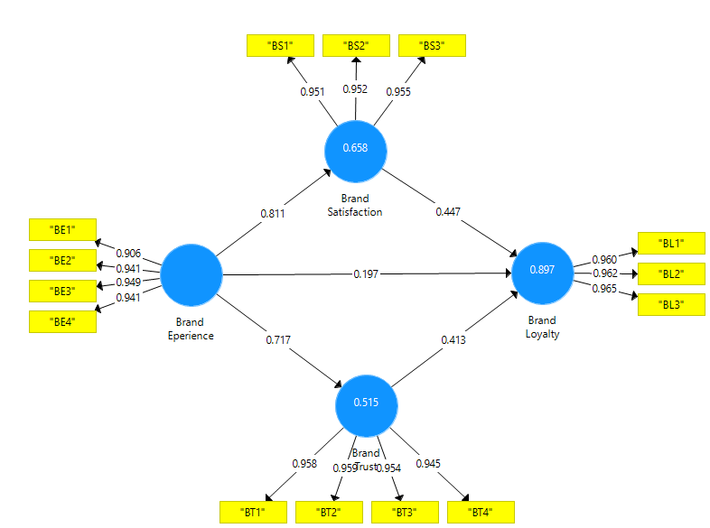

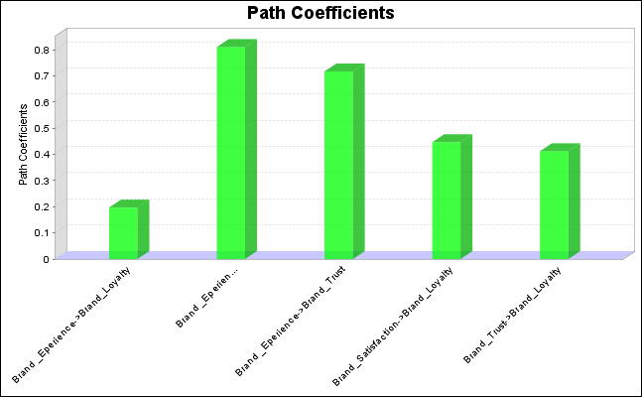
In this model, it shows the strength of all the direct relationships of the model, there are five direct relationships in the model. The first direct relationship is between the brand experience & brand satisfaction. Here brand experience is independent & brand satisfaction is dependent. The changes in Brand Satisfaction can be explained by changes in Brand Experience by 81.10%. The second relationship is between brand experience & brand trust. Here also brand experience is independent & brand trust is dependent. The changes in Brand Loyalty can be explained by changes in Brand Experience by 19.70%. In third relationship is between brand experience and brand loyalty. Here brand experience is independent and brand loyalty is dependent. The changes in Brand Loyalty can be explained by changes in Brand Experience by 71.70%. In fourth relationship is between brand satisfaction and brand loyalty. Here brand satisfaction is independent and brand loyalty is dependent. The changes in Brand Loyalty can be explained by changes in Brand Satisfaction by 44.70%. In fifth and last relationship is between brand trust and brand loyalty. here brand trust is independent and brand loyalty is dependent. The changes in Brand Loyalty can be explained by changes in Brand Trust by 41.30%.

Construct Reliability

Construct Reliability and Validity

 | Cronbach's Alpha | rho_A | Composite Reliability | Average Variance Extracted (AVE)
Brand _Experience | 0.951 | 0.952 | 0.965 | 0.873
brand Loyalty | 0.960 | 0.960 | 0.974 | 0.926
Brand Satisfaction | 0.949 | 0.949 | 0.967 | 0.907
Brand Trust | 0.967 | 0.967 | 0.976 | 0.910

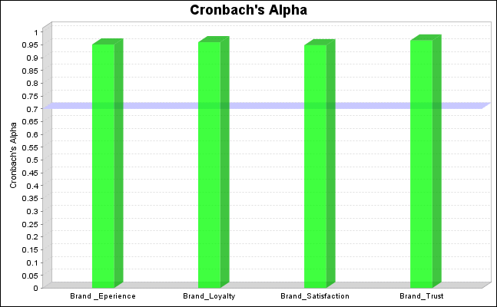

For the Cronbach's Alpha of the item, the outer loadings of each item must be equal or greater than 0.70. These table shows that all the items of Cronbach's Alpha loading values more significant than the threshold value of 0.70. This indicates that the data’s reliability parameters are entirely met, and the data is reliable for further analysis.

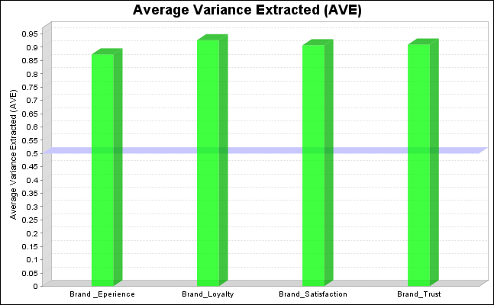

For Average Variance Extracted (AVE) these must be equal or greater than 0.50. These table shows that all the items of AVE loading values more significant than the threshold value of 0.50. This indicates that the data’s reliability parameters are entirely met, and the data is reliable for further analysis.

Construct Validity

Fornell- Larcker Criterion

 | Brand _Experience | Brand Loyalty | Brand Satisfaction | Brand Trust
Brand _Experience | 0.934
Brand Loyalty | 0.855 | 0.962
Brand Satisfaction | 0.811 | 0.863 | 0.953
Brand Trust | 0.717 | 0.831 | 0.622 | 0.954

For the Construct validity, Fornell Larcker criteria and HTMT values are used. The Fornell Larcker criteria shows that all the bold diagonal values are more significant than the values of the table, which are in horizontal and vertical diagonal values. While all the self-loading values of the individual items were also more significant than the cross-loading of the other items.

Heterotrait-Monotrait Ratio (HTMT)

 | Brand _Experience | Brand Loyalty | Brand Satisfaction | Brand Trust
Brand _Experience
Brand Loyalty | 0.894
Brand Satisfaction | 0.853 | 0.904
Brand Trust | 0.748 | 0.863 | 0.649

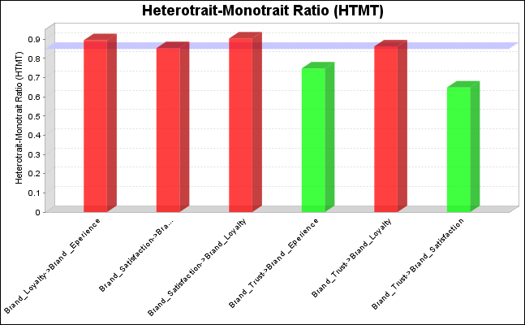

The HTMT values were must be required less than 0.90. but here in brand satisfaction and brand loyalty there the value was a slight greater than 0.90 which is 0.904.

Multi Co-linearity
Outer VIF Values
 |  | VIF
 | "BE1" | 3.360
 | "BE2" | 5.093
 | "BE3" | 5.652
 | "BE4" | 5.057
 | "BL1" | 5.881
 | "BL2" | 6.153
 | "BL3" | 6.509
 | "BS1" | 4.759
 | "BS2" | 4.902
 | "BS3" | 5.126
 | "BT1" | 6.901
 | "BT2" | 7.003
 | "BT3" | 6.381
 | "BT4" | 5.430

Inner VIF Values
 | Brand _Experience | brand Loyalty | Brand Satisfaction | Brand Trust
Brand _Experience |  | 3.730 | 1.000 | 1.000
Brand Loyalty
Brand Satisfaction |  | 2.951
Brand Trust |  | 2.080
Multicollinearity statistics tell the inter-correlation between the independent variables. The threshold value for the multicollinearity is that the VIF should be less than 10. Table shows that all the constructs have VIF values less than 10, that indicating no multicollinearity issue in the model.

Evaluation of overall model

Fit Summary
 | Saturated Model | Estimated Model
SRMR | 0.018 | 0.023
d_ULS | 0.035 | 0.053
d_G | 0.134 | 0.117
Chi-Square | 682.735 | 583.153
NFI | 0.960 | 0.966

Evolution of overall model is important to show the how accurate the model is by showing SRMR and NFI. For SRMR should by less than 0.05 and in the table, data met the required criteria. For NFI it required the value should be greater than 0.90 and the result of the table shows that all items are more than 0.90 which is 0.960 and 0.966. So that, NFI also matched the required condition. That indicates no issues in the model.

Chapter 5:

Future Research Direction and Conclusion

Future Research
There are several avenues for future research that could further enhance our understanding of the relationship between brand trust, satisfaction, and loyalty within the carbonated soft drink (CSD) industry, particularly in the context of the Bangladesh market.
Firstly, comparative analyses between local and multinational CSD brands across diverse emerging markets could provide valuable insights into variations in consumer perceptions and behaviors towards brand trust, satisfaction, and loyalty.
Secondly, investigating the effectiveness of marketing strategies, including promotional campaigns and loyalty programs, in bolstering brand loyalty within the Bangladesh CSD market could offer practical implications for marketers and brand managers.
Lastly, exploring consumer perceptions regarding sustainability initiatives and corporate social responsibility efforts within the CSD industry could shed light on evolving consumer preferences and expectations, guiding future sustainability-focused initiatives and strategies.

Conclusion
In conclusion, this thesis has illuminated the intricate relationship between brand Experience, Trust, Satisfaction, and Loyalty within the carbonated soft drink industry, with a specific focus on the Bangladesh market. Through a comprehensive literature review and involving 50 respondents from a university environment, several key findings have emerged. It has become evident that brand trust serves as the foundation of consumer-brand relationships, with consumers in Bangladesh valuing attributes such as transparency, reliability, and integrity in CSD brands. Furthermore, brand satisfaction extends beyond taste preferences to encompass the overall consumer experience, including emotional satisfaction derived from factors such as packaging aesthetics and personalized loyalty programs.
Additionally, the study highlighted the importance of brand loyalty in fostering enduring connections between consumers and CSD brands, with emotional connections and cultural resonance playing significant roles. These findings have valuable implications for marketers and brand managers operating in the Bangladesh CSD market, guiding tailored strategies to fortify brand-consumer relationships and drive sustained success in this competitive industry landscape.
Looking ahead, further research endeavors can build upon these findings to deepen our understanding of consumer behavior and decision-making processes within the Bangladesh CSD market, ultimately contributing to the development of more effective marketing strategies and initiatives aimed at enhancing Brand Experience, Trust, Satisfaction, and Loyalty.

Figures and Graphs Used

Appendix

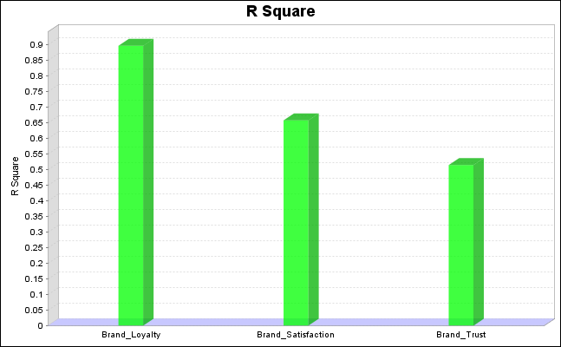

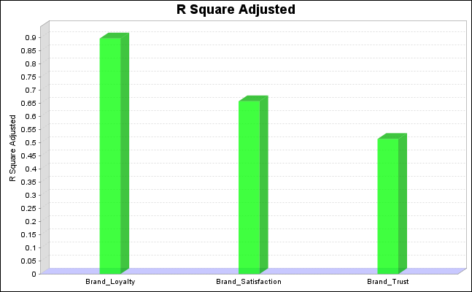

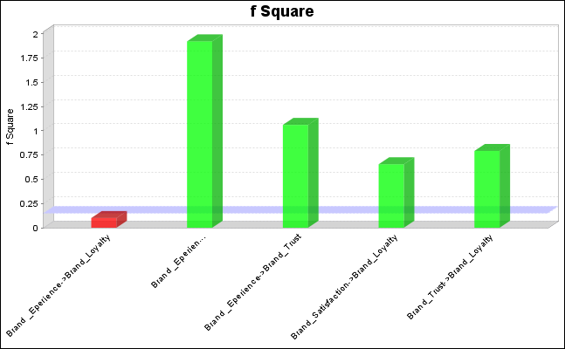

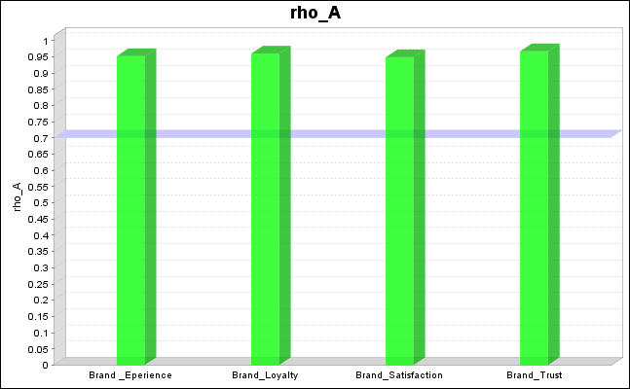

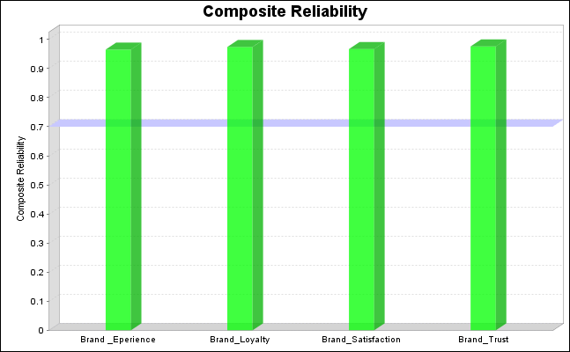

References

Aaker, D. A. (1996). Building strong brands. Simon and Schuster.

Brown, T. J., & Dacin, P. A. (1997). The company and the product: Corporate associations and consumer product responses. Journal of Marketing, 61(1), 68-84.

Delgado-Ballester, E., & Munuera-Aleman, J. L. (2005). Does brand trust matter to brand equity? Journal of Product & Brand Management, 14(3), 187-196.

Erdem, T., & Swait, J. (1998). Brand equity as a signaling phenomenon. Journal of Consumer Psychology, 7(2), 131-157.

Keller, K. L. (1993). Conceptualizing, measuring, and managing customer-based brand equity. Journal of Marketing, 57(1), 1-22.

Keller, K. L. (2003). Strategic brand management: Building, measuring, and managing brand equity. Pearson Education India.

Yoo, B., & Donthu, N. (2001). Developing and validating a multidimensional consumer-based brand equity scale. Journal of Business Research, 52(1), 1-14

Aaker, D. A. (1991). Managing brand equity: Capitalizing on the value of a brand name. Simon and Schuster.

Brodie, R. J., Hollebeek, L. D., Jurić, B., & Ilić, A. (2013). Customer engagement: Conceptual domain, fundamental propositions, and implications for research. Journal of Service Research, 14(3), 252-271.

Delgado-Ballester, E., & Munuera-Aleman, J. L. (2005). Does brand trust matter to brand equity? Journal of Product & Brand Management, 14(3), 187-196.

Keller, K. L. (1993). Conceptualizing, measuring, and managing customer-based brand equity. Journal of Marketing, 57(1), 1-22.

Keller, K. L. (2003). Strategic brand management: Building, measuring, and managing brand equity. Pearson Education India.

Kumar, V., & Pansari, A. (2016). Competitive advantage through engagement. Journal of Marketing Research, 53(4), 497-514.

Oliver, R. L. (1999). Whence consumer loyalty? Journal of Marketing, 63(Special Issue), 33-44.

Yoo, B., & Donthu, N. (2001). Developing and validating a multidimensional consumer-based brand equity scale. Journal of Business Research, 52(1), 1-14.
Homburg, C., Wieseke, J., & Bornemann, T. (2009). Implementing the marketing concept at the employee-customer interface: The role of customer need knowledge. Journal of Marketing, 73(4), 64-81.

Jacoby, J., & Chestnut, R. W. (1978). Brand loyalty: Measurement and management. John Wiley & Sons.

Keller, K. L. (1993). Conceptualizing, measuring, and managing customer-based brand equity. Journal of Marketing, 57(1), 1-22.

Oliver, R. L. (1980). A cognitive model of the antecedents and consequences of satisfaction decisions. Journal of Marketing Research, 17(4), 460-469.

Schiffman, L. G., & Kanuk, L. L. (2007). Consumer behavior (9th ed.). Prentice Hall.

Zeithaml, V. A., Berry, L. L., & Parasuraman, A. (1996). The behavioral consequences of service quality. Journal of Marketing, 60(2), 31-46..

Chevalier, J. A., & Mayzlin, D. (2006). The effect of word of mouth on sales: Online book reviews. Journal of Marketing Research, 43(3), 345-354.

Delgado-Ballester, E., Munuera-Aleman, J. L., & Yague-Guillen, M. J. (2003). Development and validation of a brand trust scale. International Journal of Market Research, 45(1), 35-54.

Fournier, S. (1998). Consumers and their brands: Developing relationship theory in consumer research. Journal of Consumer Research, 24(4), 343-373.

Kim, S., Choe, J. Y. J., & Petrick, J. F. (2013). The effects of perceived product attributes, customer satisfaction and trust on product involvement: A case study of theme park brands. International Journal of Hospitality & Tourism Administration, 14(4), 389-413.

