1/19/2022
Kazi Hashibur Rahman
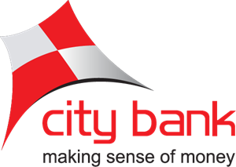

The City Bank | Prospects and Risks of City Agent Banking



Internship Report
On
Prospects and Risks of City Agent Banking



Submitted By Submitted To
Kazi Hashibur Rahman Mofijul Hoq Masum
ID: 111-181-061 Assistant Professor, SOBE
Section: B United International University
Department: BBA

Date of submission: 19th January, 2022

Letter of Acknowledgement
I got the opportunity to work with one of the top commercial bank in our country named The City Bank Limited. I got a great chance to learn the corporate culture with many top class corporate persons. And when I think about that I feel very happy as well as lucky to get the opportunity and became one of the parts of the organization for the 3 continuous months that I admire most. I am also grateful for those peoples who show their footprints and also share their secrets to become successful in the corporate world in my internship tenure.
Bearing in mind, I am using the opportunity to thanks and also my deepest gratitude to Mr. Muhibur Rahman, head of agent banking. Although, being busy with his responsibilities but always he gives us time and hears about our experience and give precious suggestions. He also helps me not only in my project by giving the detailed information on Agent banking but also giving so many career related suggestions that will helped me in the near future.
Here, I also show my deepest thanks to Mr. Morshed Abedin, Manager, Agent Monitoring and also my advisor. He helps me by assigning versatile work in every day that helps me to know about different managerial works and will help me to face twenty first corporate challenges. Mr Morshed Abedin also helps me by giving necessary information and makes sure that I can prepare a good internship report.
This opportunity is a significant step forward in my professional growth. I will make every effort to put my newly acquired skills and knowledge to the best possible way that I gain from The City Agent Baking, and I will also continue to enhance them in order to achieve my professional goals. I look forward to working with you all again in the future.

Sincerely,
Kazi Hashibur Rahman
United International University (UIU)
Dhaka
19th January, 2022
Mofijul Hoq Masum
Assistant Professor
School of Business and Economics (SOBE)
United International University

Subject: Submission of the internship report on “Prospects and Risks of City Agent Banking”

Dear Sir,
With due respect, I'm particularly pleased to present my internship report, which was covered a three-month internship at 'The City Bank' (Agent Banking Department).
As I am in learning curve, this report helps me to gain the practical experience about the Banking industry. As I am new in this format of report, it becomes a challenging as well as interesting experience. I am thanking you from depth of my heart for supporting me from the beginning to end, not only just by giving the idea of the report, but also correcting me in every part of the repot. Without your courageous inspiration this report won’t be done.
If anything in this report isn’t understood clearly, please feel free to contract to the following email and mobile number. Lastly, I would be grateful once again if you please give your precious advice on my effort.
Sincerely Yours’

Kazi Hashibur Rahman
ID: 111181061
Mobile: 01775800000
Email: krahman181061@bba.uiu.ac.bd

Declaration

Since I am a BBA undergraduate student, by seeing the opportunities of getting the practical knowledge, experiences and also the corporate ideas about the corporate life I choose the internship programs. Moreover, I done my internship program with one of the leading corporate bank named The City Bank Limited, which boosts my confidence level at the top. For completing my internship program I choose my topic “Prospects and risks of City Agent Banking”. I give my level best to prepare my internship report and always try to follow my honorable faculty’s guideline. If I make any kind of mistakes in my report, please try to see that issues in forgiveness. I am hoping that you will make the correct evaluations of my internship report.

Sincerely Yours’

Kazi Hashibur Rahman
19.01.2022
Table of Contents
Executive Summary 1
List of Acronyms 2
Part-1: Introduction 3
1.1: Introduction of the topic 4
1.2: Introduction of the organization 4
1.2.1: City Agent Banking 5
1.3: Objective of the Study 5
1.3.1: Broad Objectives 6
1.3.2: Specific Objectives 6
1.4: Rational of the Study 6
1.5: Scope of the Study 7
1.6: Limitation of the Study 7
Part-2: Methodology of the Study 9
2.1: Data Design 10
2.1.1: Nature of Data 10
2.1.2: Primary Data 10
2.1.3: Secondary Data 10
2.2: Sample Design 10
2.2.1: Sample Techniques 10
2.3: Analytical Tools 10
Part-3: Organizational Background and Industry Perspective 11
3.1: Industry Scenario 12
3.1.1: Background of Industry 12
3.1.2: The City Bank 13
3.2: Historical Background of the organization 13
3.2.1: Vision 13
3.2.2: Mission 14
3.2.3: Management 14
3.3: Operational Activities 15
3.3.1: Product or service line 17
3.3.2: Financial performance 17
3.4: SOWT Analysis 18
3.4.1: Strengths 18
3.4.2: Opportunities 19
3.4.3: Weaknesses 20
3.4.4: Threats 20
Part-4: Findings and Analysis of the Study 21
4.1: Prospects of City Agent Banking 22
4.1.1: Total Accounts and Number of Accounts 23
4.1.2: Deposits and Remittance 24
4.1.3: Loan disbursement and Utility bill payments 25
4.2: Risks of City Agent Baking 26
4.2.1: Agent Related Risks 26
4.2.2: High competition risks 27
Conclusion 28
Recommendations 29
Internship Experience 30
References 31

Executive Summary
Agent banking is booming in our country, every year it shows a new prospect for the conventional bank to expend its agent banking wings more and more. Now there are 27 banks that run their agent banking divisions and The City Bank is one of the industry leaders. Through this booming period of Agent banking I have make a research paper on Prospects and risks of City Agent Banking. In my research paper I am trying to highlight about the prospects of City agent banking and the different future risk factor of the agent and also is there any impact of Covid-19 on City Agents Banking lastly, suggest some of the solutions to get rid of the problem. In the research, I found City Agent Banking shows prospects in their every product or services. They acquire a huge base of customers, the number of deposits increased dramatically, and the collection of remittance is skyrocketed and other services also doing very good. Moreover, people now find more trust to invest or deposits on City agent banking. However there are some risk factors that The City Agent Banking might face suppose, since all the monetary is transacted by the agent, so there might be some risk factors involved because the agent can’t ensure the necessary security. Moreover, many people are not comfortable with the agent baking process that decreases the number of probable customers. The recent study about the agent banking suggests some of the points that the City Agent Banking implement in their baking activities that will resolve their risk factors and also helps them to secure their prospects in the industry. Like, City Bank is now more focused on educating their probable customer about the positive sight of agent banking. Moreover, City Agent banking is basically follows the centralized concepts, but if the bank decentralize their back office than they can give faster services.

Keywords: Agent Banking, Digital Financial Services, branchless banking

List of Acronyms

CBL= City Bank Limited
DFS= Digital Financial Services
AB= Agent Banking
AOF= Account Opening Form
FDR= Fixed Deposit Receipts
DPS= Deposit Pension Scheme
A/C= Accounts
AIN=Account Identification Number
AVP= Assistant Vice President
SO= Senior Officer
VAT= Value Added Tax
ABS= Agent Banking Solution
KYC= Know Your Customer
UDC= Union Digitalized Centre
SD= Service Delivery

Part-1: Introduction

1.1: Introduction of the topic
Each business graduate student desires to complete the internship program in order to get the practical experience by working in a corporate culture. It is a fantastic chance for every learner to gain some practical knowledge in addition to theoretical information throughout the academic careers. I always desire to gain knowledge to a specific industry like; banking sectors I completed my internship at the Agent Banking Department of The City Bank Limited that is one of Bangladesh's most well-known Commercial Bank in our country. However, my report's main emphasis is on: Prospects and risks of City Agent Banking. While the period of my internship, I see that City Agent Banking shows really good job by showing a high performance in their collection of total deposits, number of transactions, loan disbursements, utility bill payments, remittance and so on. They also show a good track record to gather new customers in math metical term which is 214.95% higher than the previous years. So it can be said that City Agent Banking has the higher prospects than others competitors in the industry. Although because of the high growth there are some risk factors too and since we are going with the pandemic situations so there will be some critical factors that The City Bank need to face or will face in the near future. To differentiate itself from the competition and gain greater confidence, The City Bank need to guarantee that, its services are distributed across Bangladesh through suitable tactics and distribution.

1.2: Introduction of the organization
The City Bank was established in 1983 by the hand of 12 visionary men and now it becomes one of the top private commercial bank. It has more than 132 branches and provides product and services like, retail banking, SME banking, corporate finance, women banking, digital banking, equity brokerage, asset management and so on. When we talk about The City Bank’s digital financial services than Agent Banking will come at first. So first we need to know what Agent Banking is. Delivering banking services to clients via engaging the agents under a legitimate agreement, instead of providing services through branches or conventional outlets, is referred to as agent banking. The owner of a business handles financial transactions on behalf of the bank. Retailers are becoming more essential distribution outlets for financial inclusion throughout the world. Bangladesh Bank also had opted to develop this complementary channel in order to provide a variety of financial services to the financially disadvantaged sector of society, particularly in geographically separated areas. Agent banking is regulated, designed, and implemented differently in different nations.
Agent banking is swiftly gaining traction as an effective technique for expanding formal financial services to backward and rural communities in many nations. A number of developing nations have embraced and deployed Agent Banking in recent years, with varied degrees of success. Brazil is widely regarded as a worldwide pioneer in the field of agent banking. In the later part countries like, Mexico, Peru, Colombia, Ecuador, Venezuela, Argentina, and Bolivia, as well as Pakistan, the Philippines, Kenya, South Africa, Uganda, and India, have all followed the concept of agent banking and give the banking services towards the huge number of people.

1.2.1: City Agent Banking
The City Bank Ltd. launched "City Agent Banking services" in response to Bangladesh Bank PSD Circular which was published on December 9, 2013. City agent banking introduced with the motivation of promoting financial inclusion by providing full-fledged banking services to geographically disperse and financially excluded regions. And in the year of 2017, City Bank launched its Agent Banking Services under the Digital Financial Services. Although there are so many major challenges and key areas such as application development and the formation of operational procedures, but the Agent banking stay steady and now they became one of the top giant in the industry. Now they have 7,685,990 accounts and 1,411 outlets and it increases in every day.

1.3: Objective of the Study
Every successful report has its own objectives because without any objectives the report can’t be fruitful. So before starting the study the researcher tries to complete the report by maintaining the broad and specific objectives. In the below the broad and specific objectives are shown in more detailed way.

1.3.1: Broad Objectives
The primary goal of this research is to learn more about the "Prospects and risks of City Agent Banking" that is the part of a BBA curriculum prerequisite.

1.3.2: Specific Objectives
The specific objectives are of the studies are given below:
- To analyze the prospects of City Agent Banking in the future
- To analyze the different risks factors of agent baking
- To obtain statistical data in the context of Agent Banking
- To analyze the data to find is there any impact of Covid-19 on City Agents Banking
- To make suggestions about how to solve the problems and also the recommendations to the challenges

1.4: Rational of the Study
The purpose of this research is to allow management to assess the prospects and the risks of The City Agent Banking. The researched uses the analytic talents to write the research paper on nutritional anthropology after acquiring unique data. Research methodologies and quantitative analytical practice will be very useful and relevant for the future of the bank and also the people who wants to further research.

1.4.1: To the Researcher
The researcher will get in-depth understanding of the field of Agent Banking. They also can use the numerical numbers to get more specific results from my research. The study's findings are also important in laying the groundwork for future or other research in the same or similar digital financial services.

1.4.2: To the policy Makers
The study might help the policy makers in the context of making guidelines on Digital financial services. It also helps the policy makers to know about the quantity of the customers and also the total deposits, loan disbursement, remittance and so on that a particular Agent Bank will have.

1.5: Scope of the Study
Agent banking department now become one of the important department for The City Bank. The main activities of the Agent banking are to manage agents and through agents they can give the services in the rural area. Here the bank can gives services like; collect deposits (FDR, DPS), loan disbursement, utility bill payments, collect remittance, and so on.
Here my primary responsibility is reviewing the AOF and I Almost reviewed 4200 AOF that helps me to found so many repetitive mistakes so I shared with my line manager about those mistakes. The line manager takes my findings on a serious note and gives training all of their agents based on my findings. On that time I also had the experience to visit almost 20 outlets and by seeing their book-keeping I gave so many suggestions (like, how to fill-up AOF and also how to write KYC and declarations) to solve those repetitive mistakes. That helps me to gain practical experience and also give the understanding about how agent banking really works. While I am doing my internship report I had the experience to mining the agent banking data’s. That helps me to know more about the numerical presents of The City Agent Banking. Above all it can be said that I was getting a huge scope and knowledge/ideas and experiences in The City Agent Banking that will give me extra advantages in the future.

1.6: Limitation of the Study
Because a research project of such a type cannot address every topic that are relevant to agent banking issues in all time, place, and scope. The research is on the prospects and risk of The City Agent Banking. The researcher picked The City Bank for research purpose because it will allow the researcher to investigate prospect and risk related to the banking industry especially for the Agent Banking. There are also some of the limitations that described in below:
Time constraints: since ethnographic research is difficult to engage in, there is also the possibility of obtaining other information while performing the study and teamwork in the organization may be constrained.
Since the Banking industry’s information has the confidential in nature so it is little harder to get the information. However, the researcher is trying the level best to collect the enough information to conduct my research.

Part-2: Methodology of the Study

2.1: Data Design

2.1.1: Nature of Data
This report is based on primary and mostly secondary data based.

2.1.2: Primary Data
The primary data are collected through by:
- An informal interview with the AVP and SO of the operational department was used to gather primary data.
- Through discussions with officer of The City Agent Banking, I was able to gather some information for the purpose of the report.

2.1.3: Secondary Data
For doing my report I basically based on the secondary data. I basically collect the secondary data, sources like;
- City Bank’s internal data
- City Bank’s annual reports and its website
- Monitoring the Banks day to day activities and also their clients

2.2: Sample Design

2.2.1: Sample Techniques
Every element has an equal probability of being chosen as a part sample in simple random sampling. It's employed when the researcher doesn't know anything about the people that the researcher trying to reach. As part of The City Agent Banking, I basically gather a random process document.

2.3: Analytical Tools
The information gathered is analyzed and compiled using Microsoft Word, Excel, and other computer-related tools. The necessary data have been created on the basis of acquired data, and various statistical approaches have been used in analysis based on categorized data. Details, elaborations, and analyses have also been included in this report.

Part-3: Organizational Background and Industry Perspective

3.1: Industry Scenario

3.1.1: Background of Industry
Bangladesh is indeed a developing nation with an optimistic banking sector, notably in terms of private banks services and customer care. In recent years, private banks have attempted to mimic the financial structures of more industrialized nations. However, government banks are little behind in case of giving customer services than the private banks. Following independence, Bangladesh's banking system began with six nationalized commercial banks, three state-owned specialty banks, and nine foreign banks. With the entry of private banks in the 1980s, the banking sector saw substantial development. In Bangladesh, there are essentially two kinds of banks they are; scheduled banks and non-scheduled banks. Bangladesh now has 61 scheduled banks in operations under the control of Bangladesh Bank. In Bangladesh Banking industry or financial institutions contributes very heavily in the total GDP.
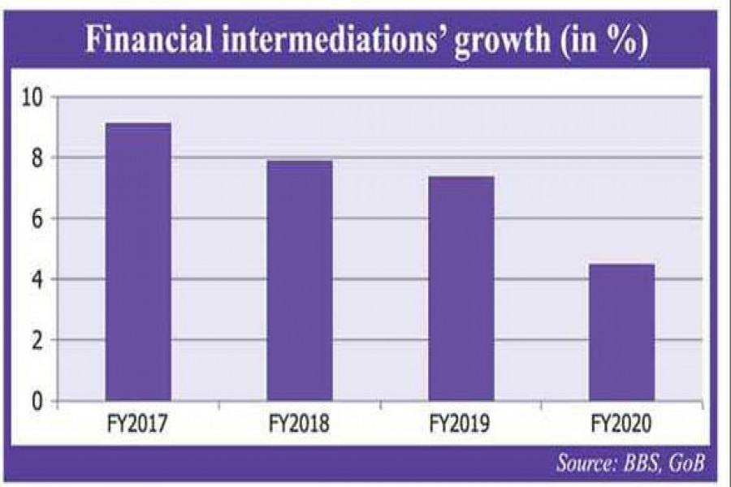
*Source: The Financial Express
However, because of pandemic situations the researcher sees that the growth is little decreasing but it also creates the important impact in the total percentage of growth. According the BBS (Bangladesh Bureau of Statistics), in 2020 the financial growth would going down and stays at 4.46% although in 2019 it stays at 7.38%. Although when the pandemic is over we can expect that the growth will be higher in the banking industry and contribute more and more in our economic growth.

3.1.2: The City Bank
In 1983, 12 young businesspeople put the wheels in motion. And with their hands the country's first private commercial bank was founded in 1983 thanks to the visionary entrepreneurship of 12 young businesspeople who weathered enormous uncertainty with bravery and energy.
City Bank has evolved from a conventional corporation to a highly praised multi-faceted institution that embraces worldwide best practices and chooses to be at the forefront of technology efforts since 1983. Unlike many others, the Bank's success criteria include not just bottom-line metrics, but also goals set toward becoming the country's most comprehensive bank. Present it has 132 branches, over 4,256 employees, over 17,00,000 customers and 413 ATM to give premium services to their customers.

3.2: Historical Background of the organization

3.2.1: Vision
In the vision of The City Bank basically denotes their bank as the financial supermarkets with the winning culture that ensure an enjoyable experiences for all their employees and as well as their customers.

3.2.2: Mission
The mission statement of The City Bank is described in below:
- Offer a diverse range of products and services that appeal to all client categories.
- Make yourself the "Employer of Choice" by providing an atmosphere where people can thrive and leaders can emerge.
- Challenge procedures and platforms on a regular basis to improve their efficacy and efficiency.
- Encourage innovation and automation in order to ensure and improve service quality.
- In whatever we do, we must ensure community respect, good governance, and compliance.

3.2.3: Management
The management teams of the Agent Banking Department of The City Bank are pictured in below:
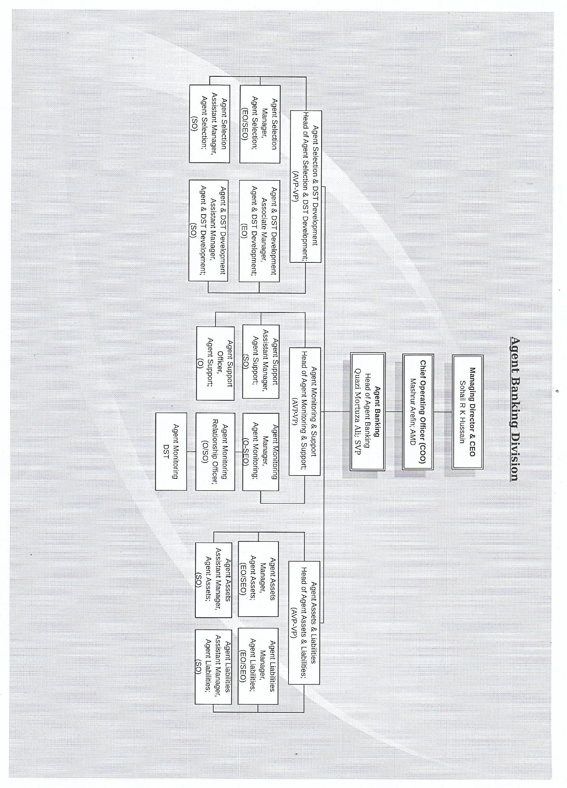
*Table: Management hierarchy of The City Agent Banking

3.3: Operational Activities
Agent banking is basically doing the conventional banking activities by the help with some predetermined agents. Agents are basically played the role of broker who is making the link between the customer and banks. So one question gyrate in everyone’s mind why banks are not open branches rather getting the help of the agents? First of all the bank has spent less cost to open agent outlets than a Branch. Secondly, bank doesn’t need to deploy their employees to run the outlets. So how The City Agent Banking run their operational activities:

In contrast to current mobile financial service models in our country, City Agent Banking offers a simple solution for full-fledged banking services via approved Agent Outlets. Consumers will visit Agent outlets where trained agents will give services to customers and transmit their requests to the Agent Banking division for approval/processing, according to the City Agent Banking model they done this through Smart Tab with the help of biometric features. After the request has been received, the Agent Banking Division will cooperate with CBL SD/Back office Department to complete the request.
In terms of operational flow City Agent Banking follows Bangladesh Bank rules. Basically the entire agent outlets will have CBL-approved outlet designs and will clearly state that they are serving on behalf of the bank. All the agent outlets will be open throughout normal banking hours, and all its transactions will be completed in real time.
Under the agency agreement, the Agent Banking Division will provide sufficient training and assistance to the engaged agents. Agent banking team will offer essential real-time service backup from Agent Banking Head Office to guarantee a smooth and uninterrupted operation. Agent Banking Division will deploy contractual employees at each Agent Outlet to guarantee operational compliance and service quality concerns, with extra checks by a regionally appointed Permanent Staff/Supervisor.

3.3.1: Product or service line
City Agent Banking is intended to offer full-service banking in order to suit the demands of its target client base. The following are the services supplied by Agent Outlets:
- Savings, Current, STD/SND, DPS, and Term Deposit accounts are all available
- Agricultural loans, SME loans
- Inquiry into the Balance of a Debit Card
- A brief statement
- Withdrawal
- Fund Transfer
- Payment of utility bills
- Inward Foreign Remittance, Insurance, Government Services, Social Payments, Senior Citizens' Allowances, Freedom Fighters, Student Stipend
- Payment of Utility Bills
- E-Commerce

3.3.2: Financial performance
Here in the below the researcher trying to display the financial performance at a glance. Here the researcher are basically try to show three different years agent banking performance and also show the changes in percentage from first two years (2019-2020) and then the three years changes from the year 2020to 2018.
 | Years |  |  | Changes
 | 2020 | 2019 | 2018 | Yearly Change (2020-2019) | Year to year change (2020-2018)
Total accounts | 7685990 | 3575659 | 243090 | 214.95% | 3161.79%
Outlets | 1411 | 642 | 154 | 219.78% | 916.23%
Deposits (Crore) | 10788.2 | 5251.3 | 329 | 205.44% | 3279.09%
Number of transactions | 7661508 | 4027689 | 243090 | 190.22% | 3151.72%
Loan disbursement (Crore) | 94.9 | 29.7 | 5.7 | 319.53% | 1664.91%
Utility bill payments (Crore) | 93.7 | 75.9 | 55.8 | 123.45% | 167.92%
Remittance (Crore) | 33279 | 637.1 | 230.1 | 5223.51% | 14462.84%
*Table: The year wise performance of The City Agent Banking

3.4: SOWT Analysis

*Source: Field Survey

3.4.1: Strengths
- Substitute to bank branches: Since an Agent can give all types of services that a branch can provide. That means an Agent Outlet can be the substitute of the Bank. For a bank it can be the great opportunities to reduce the cost and even target the rural people and give banking services to the huge number of people at a very low cost.

- Brand Awareness: Secondly, City bank introduced them as a very strong brand in the Banking industry. So it gives a strong base to build up the agent banking department with a high level of trust. It also helps them to gather a huge number of customers in a very short period of time.

- Flexibility: All the employees and agents are well trained that gives the bank a great chance to change or adopt in any situations. While the bank going through the pandemic situations the Agent banking department plays an important role to stay the bank into the track. And because of the flexibility The City Bank are stays at the top in so many difficult situations.

- Qualified and skilled employees: In the back office The City Bank has one of the most skilled employee team. Those employees always ensure the pace of the Agent banking. They are always there to solve all the customers and agents’ problem at a very short period of time. Since Agent Banking is provide real-time-services that means the back-office employees are always there to give the services to their valuable employees. And I think that is the secret for The City Agent Banking to gather that huge number of customer in that short period of time.

3.4.2: Opportunities
- Rural digitalization: Since our rural area are becoming more digitalized and because of the touch of digitalization many people in rural area wants to open the Bank account and get all the banking services in their own town. And by the help of agent’s bank are now giving their services all over the countries. It will ensure the rural digitalization with a minimal of cost for the bank.

- Automation in government utility sectors: Since the Agent Banking is all about the digital biometric features that means in will helps in the automation in government utility sectors. The government is assisting UDC (Union Digitalized Centre) by providing offices to the agent shops. Because of using digital services people are becoming more educated to use government digital services and make them more capable for the future.

- Innovations: Since, we are in the era of E-commerce and internet based banking has arrived. Many commercial transactions, such as B2B, B2C, and C2C, are conducted via online. That helps the banks to think new ways to provide banking services and fulfill the customers’ demand that gives a scope of innovations new technology to stay at the race.

3.4.3: Weaknesses
- Lack of awareness, trust and reliability: Since in the Agent Banking service there will be a middle man between the customers and bank. It will increase a question of trust and reliability. Since third party are involved in the process so customers are filling little trust issues in the process. There are little awareness issues too. And because all of this customers and even bank fell little trust issues to relay on the agents.

- Lack of service: To solve any kind of customer problem agents are needed to wait for the back office. Because they don’t have any power to solve critical customer problems. And because of this the customers are needed to wait some hours or sometimes some days to get their solutions. That will increase the lack of services in the mind of the customers.

3.4.4: Threats
- Extreme completions between the Agent Banking: According to Business Inspection websites there are 27 Banks whom are operates their agent banking department. That means it is a great competitions between the banks to stay at the race. And because of this there are great threats for City Agent Banking to stay at the race and compete with other banks. However, in the recent years City Agent Banking is trying to introduced new products to attract the consumers to reduce the threats.

- Hacking: Hacking is another tremendous threat for the Agent Banking. Since most of the works are done via digital transactions so it will increase the threats of hacking. And because of the recent Bangladesh Bank incidents will increase the threats of hacking. However, The City Bank always tries to take different steps to stay ahead from the hacker.

Part-4: Findings and Analysis of the Study

4.1: Prospects of City Agent Banking
Since The Agent Banking is playing a vital role to give banking service to the every part of the nation, so it has very good prospects not only for the bank owner but also the whole country’s economy. Now we see bank has more money to give loan, and they can give good interest rate for their deposit holders.
City Agent Banking Start its journey at the end of the year of 2017. When the researcher focuses on The City Agent Banking the researcher found that it has a very good future in the digital financial sectors. In the below, the table denotes that in the last 3 years City Agent banking increased its outlets dramatically from 154 outlets to 1,411 outlets which is more than 916% increased than the year of 2020. And because of the increase of number of outlets the researcher sees the high number of outlets open and the increase of total number of accounts open. In below the researcher try to show more detailed information about the prospects of The City Agent Banking.

 |  |  |  | Yearly Change (2020-2019) | Year to year change (2020-2018)
 | 2018 | 2019 | 2020 | Yearly Change (2020-2019) | Year to year change (2020-2018)
Total accounts | 243090 | 357565 | 768599 | 214.95% | 316.18%
Outlets | 154 | 642 | 1411 | 219.78% | 916.23%
Deposits (Crore) | 329 | 5251.3 | 10788.2 | 205.44% | 3279.09%
Number of transactions | 243090 | 4027689 | 7661508 | 190.22% | 3151.72%
Loan disbursement (Crore) | 5.7 | 29.7 | 94.9 | 319.53% | 1664.91%
Utility bill payments (Crore) | 55.8 | 75.9 | 93.7 | 123.45% | 167.92%
Remittance (Crore) | 230.1 | 637.1 | 3327.9 | 522.35% | 1446.28%

4.1.1: Total Accounts and Number of Accounts

The graph represents that the year wise transactions and total number of Agent Banking Accounts. And by seeing the year wise graph it can infer that the total number of account opening and number of transactions is booming. In the year of 2018 the number of accounts was 243,090 but in 2020 the number was increased and stays at 768,599 accounts that mean the number was increased by 316.18%. That Give a high prospects for the City Agent banking. Moreover, if the researcher enlightens on the total number of transactions, than it will represent a dramatic incensement in the last three years. In the year of 2019 the number of transactions was 402,7689 whereas in 2020 the transactions number was 7,661,508 that means in percentage the number was increased by more than 190%. So it can be said that in both cases (Number of transactions and Total accounts) the researcher founds that the higher margin and because of this it can said that the City Agent Banking has a good prospects for the future.

4.1.2: Deposits and Remittance

The graph is basically focused on the total number of deposits. The researcher found that in 2018 the number was 329 Crore and in 2019 the total number has increased and stays at 5,252.3 Crore, Moreover, by comparing with the percentage than the researcher found that it was increase by 1,596% which is a very high margin for any Agent Banking department. In 2020 the total number of deposits was 10,788.2 crore; and in the compare of the two years the researcher found that the percentage was increased and stays at the percentage of 205.44%. So in fine, it can be said that, when the researcher enlighten on the total number of deposits of City Agent Banking than the findings is basically the prospects of City Agent Banking is really high because all its customers and also the probable customers take the Agent Banking Department more positive way and invest their money by the help of the Agents.
On the other hand, when the researcher focused on the remittance of Agent Banking than he found in the year of 2018 the total collection of remittance was 230.1 Crore and it increased dramatically and in 2020 the number was 3327.9 Crore. In percentage the number was 1446% increase from the year 2020 to 2018 respectively. That will give a very high hope for the City Agent Banking in the future.

4.1.3: Loan disbursement and Utility bill payments

In the year of 2018 The City Agent Banking started their loan disbursement department. In 2018 they disbursed 5.7 crore loan. And in the year 2019 the amount was increased and stays at 29.7 crore which is more than 19% higher. And in 2020 the total loan amount was stayed at 94.9 crore which is 319% higher. That means people are now more interest to take loan from the City Bank Limited, and give the source the bank to invest their deposits money and earn interest. So it can be said that the people are more interest and show their trust to take loan and deposits their money in the Agent Banking Department. City Agent Banking introducing their loan facilities in the year of 2018 and in the year of 2020 they disburse almost 100 crore money in purpose of loan, although it is only 8% of total deposits.
Likewise, when the researcher focused on the utility bill payments than he found in the year of 2018 the amount was 55.8 crore and in the year of 2020 the amount was increased by 167% and stays at the amount of 93.7 crore. And when the people use the Agent Bank to payment their utilities bills that means the people trust the banks and invest their money.
In fine it can be said that, when the researcher focused on the year wise performance of the each year of The City Agent Banking than the researcher found that in every year the department were ensuring more strong positions and earn more trust to their customers. In reply City Agent Banking becomes more bigger and better for their customers. It gives high prospects for the bank and even in the pandemic situations the Agent Banking shows its strong positions on its performance. And even in more further focus on the total number of customers of City Bank than the researcher found that more than 30% of customers are coming from the Agent Banking Department and because of this we can said that the customer are seeing the high prospects into the City Agent Banking and because of this in the 3 years period customer finding strong bonds with the City Agent Banking. That ensures a great future for the agent banking department.

4.2: Risks of City Agent Baking
Here the researcher divides the risk factors into two different parts. First one is agent related risks and second one is high competition risk. In below, the researcher tries to give detailed information about those types of risks.

4.2.1: Agent Related Risks
When a bank open an agent outlet that means they will hand over a third party into the actions between the customers and the bank. So they need to truest the agents that he/she does all the works that a branch will do. So first risk will be whether the agent can give that level of services that a branch can provide. And most of the time the researcher sees that the agent are failed to give quality services to their customers and because of this many customers are turn down their hope towards the agent banking.
Secondly, since all the monetary is transacted by the agent, so there might be some risk factors involved because the agent can’t ensure the necessary security because they operate their service independently so when they carry money and manage from one place to another. Moreover, sometimes agent can also involve with the fraud. So bank always need to think how they can protect their money.
Thirdly, when agent faces any kind of customer problem they need to wait for the back office to solve those problems. It will take some times to solve and sometimes it might take some days. And because of this it became an inefficient process as well as time consuming for those customers.
Fourthly, agents need to gives their services by using the Smart Tab by the help of Biometric features. And because of this they might be easily target by the hacking group because they can’t make enough secure to their instruments to get rid of the hacker groups. As a result hacker group can easily manipulate their digital devices and hacked digital currencies.

4.2.2: High competition risks
Now there are 27 Banks are operates Agent banking services towards the customers. That means there will be a high competitions between the Banks and because of this many banks wrap up their agent banking activities. Many banks invest a huge sum of money to the agent banking sectors to develop digital financial services in the rural areas. But since many competitors are there sometimes many banks get not up to the mark response and shut down their Agent banking department. However the ranges of customers of agent banking become increased so there are many opportunities to provide better service to their customers and earn profits.
So in fine it can be said that although there is a high competition but there also so many opportunities of doing good in the Agent Banking sector under the Digital Financial services. And one day it might happen that agent banking dominate the world.

Conclusion
Because of the agent banking entire people of this nation is getting a probable chance to get the banking service at their door. It also contributes to the digitization of rural areas. Agent banking service is currently provided by 27 banks and there are also some other banks who are trying to open Agent banking sections. Agent banking involves combining two parties to undertake banking tasks on behalf of their respective institutions. First of all, the government wants to promote rural digitization by bolstering banking activity. People in remote regions would soon see the agent stores as their own bank in their own town and get the all kind of banking service in more digital way. And secondly, agent banking gives the touch of digitalization in the rural area. Thirdly, because of agent banking concept, bank can give their service all over the nations with a very little cost and very low manpower. As a result, the researcher would like to infer that, within the umbrella of digital financial services, City Agent Banking attempts to give banking services to those who are geographically underserved or who do not currently have access to banking services.

Recommendations
Now a days, City Agent banking providing one of the top services in the entire nations. In my internship period, I learn a great deal of knowledge of how to handle agents and give best services to its consumers. However, I found some flaws too. So, in this part the researcher will recommend some of the points thus the Agent banking will continue its bright prospects and reduces the risks.
- First of all, many urban people aren’t comfortable with the process of the agent banking. So it will the first responsibility for the bank to educate its probable customers by ensuring them that the agent banking is safe and they can get all the services like a bank can provides. Moreover, banks are taking the direct responsibility of the customers’ money.
- Secondly, City Agent Banking needs to more educate to its agents thus they can gain more knowledge about the banking activities. Like how to fill up the AOF more perfectly as well as their day to day activities.
- Thirdly, Banks and Agents need to collaborate more thus they can modify rural people's mindsets that might help to reduce the lack of trust and reliability.
- Fourthly, since the agents are running the stores in the same way like a branch manager does as a result, the relevant institutions should provide the required support and also can arrange seminars to help them to improve thus they can give the same types of service like branches.
- Fifthly, since the higher growth of City Agent Banking so the department can give more incentives to their agents thus they can encourage more and complete their task more perfectly.
- Sixthly, City Agent banking is basically follows the centralized concepts, where any agents around the country if faces any kind of problem every time they need to connect with the head office. That is very time consuming. So they should go de-centralized concept where the bank will open back office in every regions thus the agents can get faster services. This will helps the bank to reduce the waiting time for the customer to get any kind of services.

Internship Experience
I joined as a DFS (Digital Financial Services) intern on 10th October 2021 and my tenure period was over at 9th January 2022. In my tenure period I learn a great deal of experience about the core banking and Agent banking related activities. In my internship period I have some primary responsibilities. First of all, I need to review the AOF (Account Opening Form). In my internship period I reviewed almost 4200 AOF which is 20% of total pending forms. While I am reviewing the AOF i am listing down the common mistakes of the AOF. Secondly, I had the experienced to work with Finacle core banking software like, transaction making, account freeze or unfreeze, inquiry, and so on. My third primary responsibility was worked with Online Customer Acquisitions of Agent Banking Software (Provide customer CIF) where I successfully acquired almost 15% customers in my internship tenure. Along with the core primary works I also need to done many day to day activities. In below I am trying to describe my different month wise work responsibilities.
1st Month: In the first month I am completing responsibilities like; Reviewed AOF and Payroll, Provide customer CB, List down the common AOF mistakes, Manual data process and so on.
2nd Month: In the second month I am completing responsibilities like; Conduct De-dupe and SDN report, Keep records of Check and cards and also worked with tracker, helping in the file processing and so on.
3rd Month: In the 3rd month of my internship tenure I am mostly spend my time by visiting the outlets near Dhaka City with the line manager. The line manager and the researcher almost visited 20 outlets and give directions how to do the work more effectively.
Achievements:
While reviewing the AOF I found so many repetitive mistakes so I shared with my line manager about those mistakes. The line manager takes my findings on a serious note and gives training all of their agents based on my findings. On that time I also had the experience to visit almost 20 outlets and by seeing their book-keeping I gave so many suggestions (like, how to fill-up AOF and also how to write KYC and declarations) to solve those repetitive mistakes. Three weeks later I found the mistakes are more than 75% less.

References

- Islam, Mohammad & Rahman, Syed & Faisal, Fazle. (2019). Present Scenario of Agent Banking in Bangladesh.
- Afzal, M. H. B. (2017). Sustainable development of rural communities in Bangladesh by integrating mobile internet and agent banking technology. In Leadership, Innovation and Entrepreneurship as Driving Forces of the Global Economy (pp. 361-370). Springer, Cham.
- Uddin, M. M., & Sultana, A. (2019). Factors Shaping the Prospects of Agent Banking in Bangladesh. Journal of Business, 40(2).
- The following web site was accessed on October 17, 2021:
https://businessinspection.com.bd/rise-of-agent-banking-in-bangladesh/
- The following web site was accessed on January 11, 2019: https:/thefinancialexpress.com.bd/views/views/economic-growth-in-bangladesh-and-the-role-of-banking-sector-1547220114
- The following web site was accessed on August 23, 2020:
https://thefinancialexpress.com.bd/economy/financial-sector-clocks-lower-growth-in-fy20-1598153631

