Measuring Effectiveness of Human Resource Financing:
The Case Study of
“KAZI FARMS GROUP”



This report is submitted to the school of Business and Economics, United International University as a partial requirement for the degree fulfillment of
Bachelor of Business Administration

Measuring the effectiveness of Human Resource Financing:
The Case Study of
“KAZI FARMS GROUP”

Submitted to:
Name: Eliza Huq
Designation: Assistant Professor

Submitted by:
Name: Saif Ali
ID: 111 153 095
Major: Finance

School of Business and Economics

United international university
Date of submission
04/06/2020

Letter of transmittal
4th June, 2020
Eliza Huq
Assistant Professor,
School of Business & Economics,
United International University,
United City, Madani Avenue, Badda, Dhaka-1212

Subject: Submission of Internship report titled “Effectiveness of human resource financing of Kazi Farms Group”

Dear Madam,
With due respect, I would like to submit my Internship report on titled “Effectiveness of human resource financing of “Kazi Farms Group”. I have collected information from the organization & from secondary data sources. I believe that this report has enriched both my knowledge and experience.

Thank you,
Sincerely yours
SAIF ALI
-----------------------
School of Business & Economics
United International University

Declaration of the student

I am Saif Ali, hereby declare that the report submitted for an internship entitled “Effectiveness of human resource financing of Kazi Farms Group” It is prepared by me, under the guidance of, Eliza Huq, Asst. Professor, School of Business & Economics, United International University. At Kazi Farms after completing the internship time. I state that the report is written only for my academic requirement, not for any other reason and the internship report is submitted as part of the B.B.A completion requirement. I am very grateful to have the opportunity to prepare this report.

Acknowledgement

I would like to express my gratitude to my honorable faculty “Eliza Huq” Assistant professor of United International University. She gave me continuous guidance and many significant and constructive observations throughout the making this report. Her support, encouragement & availability to discuss ideas and problems have contributed much in completing our report. I would like to thank the people of who helped me by giving information’s and the creators of the websites from where I extracted information regarding my report. I am very happy for being able to submit the report on time.

Executive Summary

This report is about “Effectiveness of human resource financing of Kazi Farms Group”. This report is to find the financing techniques of the KFG for its Human resource division and how it is trying to progress. Kazi Farms is known as excellent weighed with other poultry properties of the country since it started adventure 25 years back. It proceeds with phenomenal resuscitate with the most recent things and organizations, thinking about buyers and customers' points of view. Its besides guarantee higher features for its potential clients and budgetary experts. The Finance & HR division walked through the appraisal and indicated their nature of mind by the open entrance scattering of yearly Financial Reports. This report is prepared to see Effectiveness of human resource financing by KFG. What and how KFG utilize their financing for HR office. The last part of this report is about disclosures and recommendations. Around there are stacks of positive and negative information about their present financing system. Kazi Farms Group should overcome their significant issues and at a time it could challenge any giant issue in the predictable days. It is worth to determine that, before realize a Financing structure, KFG need to plan or enroll new agent who are learned about their financing system.

Table of Contents
Letter of transmittal iii
Declaration of the student iv
Acknowledgement v
Executive Summary vi
List of Figures viii
List of Tables ix
List of Abbreviation x
CHAPTER I: INTRODUCTION 1
1.1 Background of the Report 1
1.2 Objectives of the Report 1
1.3 Motivation of the Report 1
1.4 Scope and limitations of the Report 2
1.5 Definition of Key terms 2
CHAPTER II: ECONOMY, INDUSTRY & COMPANY ANALYSIS 3
2.1 Economy Analysis 3
2.1.1 Types of economic analysis 3
2.1.2 Effects of current economic situation in KFG 4
2.2 Industry analysis 5
2.2.1 Specification of the industry 5
2.3 Company Analysis 7
2.3.1 Overview and history 7
2.3.2 Size, trend, and maturity of the industry 8
2.3.3 External economic factors 9
2.3.4 Barriers to entry 9
2.3.5 Supplier Power 9
2.3.6 Buyer Power 10
2.3.7 Threat of Substitutes 10
2.3.8 Industry rivalry 10
2.3.9 Customer mix 11
2.3.10 Product/service mix 11
2.3.11 Operations 12
CHAPTER III: EFFECTIVENESS OF HUMAN RESOURCE FINANCING 13
3.1 Methods for measurement of effectiveness of HR Financing 13
3.1.1 Kazi Farms Group accounting & financing policies 13
3.1.2 Measuring proportion of the yearly budget for the Human resource 14
3.1.3 Using of HR budget in different sectors 14
3.1.4 Return from investment in HR 23
3.1.5 Sample of Income statement 24
3.1.6 SWOT analysis 25
CHAPTER IV: INTERNSHIP EXPERIECNE 27
4.1 Position, duties, and responsibilities 27
4.2 Training 27
4.3 Contribution to departmental functions 27
4.4 Evaluation 27
4.5 Skills applied 28
4.6 New skills developed 28
4.7 Application of academic knowledge 28
CHAPTER V: RECOMMENDATION & CONCLUSION 29
5.1 Recommendations 29
5.2 Key understanding 29
5.3 Conclusion 30
Reference xii

List of Figures

1 | Customer Mix | 11
2 | Proportion of the yearly budget for the Human resource | 14
3 | Recruitment Process | 18
4 | Training proposals | 19-22

List of Tables

1 | Employee salary calculation | 15
2 | Income Statement | 24

List of Abbreviation

- KFG – Kazi Farms Group
- KFIL – Kazi Foods & Industry Limited
- RRF – Requester Requisition Form
- ROI – Return on Investment

CHAPTER I: INTRODUCTION

Background of the Report
In this era of business everyone has to be very careful while choosing strategy for business. Every organization has its own suitable policy and unique way of strategy to make their business successful and beneficial. In this predetermined world almost, every companies are using different type of advance system that makes their regular departmental work more effective and assure better output. This report is focused on Effectiveness of Human Resource Financing of Kazi Farms Group. To make this report I have basically focus on KGF (Kazi Farms Group). Here I would like to present the investment decisions of KGF for getting the best result from their human resource and to make their employee more efficient & as well as productive.

Objectives of the Report
The main objective of this report is to find out the effectiveness of the investments made by Kazi Farms Group in their Human Resource Department. As it is a production business it is very important to manage its human resource up to the mark.

Motivation of the Report
After making this report it will help KGF to make correct decisions about the human resource financing. This report is unique and it is based on theoretical aspect. This report will show the clear picture of KGF’s financial decisions for its human resource department.

Scope and limitations of the Report
This report will help to know how much return is Kazi Farms getting from its Human Resource. This will create scope for development & future decisions. The major limitation of this report was, as Kazi Farms Group is a privet company their financial data is very confidential. It was very difficult to arrange relevant information’s to make the analysis more reliable

Definition of Key terms

Effectiveness – It means making the work more accurate and getting the best return.
Financing – It’s an investment decision for a particular project/supplying the fund to run existing project/work to gain profit.
Human Resource – People who work for the organization also consider a resource.
Human Resource Financing – Investments made by the organization for their Human Resource Department

CHAPTER II: ECONOMY, INDUSTRY & COMPANY ANALYSIS

Economy Analysis
This analysis is the study of economic system & also be a study of a production process or an industry. The goal of an economic analysis is to provide a clear picture of the recent economic situation. Specifically, what the impact of the economic situation might be on the economy of Bangladesh is a developing market economy. In the period since 2004, Bangladesh to be an average of a GDP growth of 6.4%, that has been largely gained by its exports of ready-made garments, remittances and the domestic agricultural sector. It's the 39th largest in the world in nominal terms, and 30th largest by purchasing power parity; it is classified among the Next 11 developing market middle income economies and a frontier market. In the 1st quarter of 2019, Bangladesh's was the world's seventh fastest growing economy with a rate of 7.2% real GDP annual growth. Dhaka and Chittagong are the principal financial centers of the country, being home to the Dhaka Stock Exchange and the Chittagong Stock Exchange. The financial sector of Bangladesh is the second largest in the Indian subcontinent. Bangladesh is one of the world's fastest growing economy. The country has followed export-oriented industrialization, with its key export sectors include poultry industry, frozen foods, textiles, shipbuilding, fish and seafood, jute and leather goods. The government promotes the Digital Bangladesh outline as part of its efforts to develop the country's growing information technology sector.

Types of economic analysis
There are four types of economic analysis.
- Economic impact analysis
- Programmatic cost analysis
- Benefit-cost analysis
- Cost effectiveness analysis

Effects of current economic situation in KFG

KFG is working their business in several industries. Economic condition can be differed by industry to industry. The most favorable economy is in poultry industry for KFG. Secondly their frozen food industry, which is the NO.1 company in Bangladesh. As KFG is the most mature company in Bangladesh their cost effectiveness is very good, because they are doing the same job for many years.
But during making this report there is an impact of corona virus. So that the world’s economy goes down. As world economy goes down Bangladesh is also facing decreased GDP. Right now, the economic situation is not good for any industry, people don’t go outside of the house to work & they are not getting enough money to spend.
Now, KFG is running their business on online because their products are very important for pandemic situation, they are contributing to fill up peoples need of protein. Their quantity of selling has decreased right now. Before this pandemic situation their business was running very good & the whole economy was also stable and favorable for KFG.

Industry analysis

Specification of the industry
As we all know KFG started its journey by poultry industry. But now it is not limited only in poultry industry, KFG also concentrated on food industry, Media industry & enterprise resource planning solutions.
Poultry Industry - Population and growth of poultry in Bangladesh increasing day by day. During this pandemic situation the growth is slow but Poultry population in Bangladesh is estimated about 305.17 million where chicken population is about 256.31 million and duck population is about 950.86. Production of this kind of product is increasing day by day. The meat and egg production of last 10 years along with growth rate higher. The average growth rate of meat and egg for 10 years was 19.39 and 7.78%, correspondingly. The growth rate of meat production was highest in 2010-2011 (57.95%) and lowest in 2006-2007 (-7.97%). Growth rate of poultry was about 6.22% during 2004-2007 but growth rate declined (2.69%) during the financial year 2007-2008 due to incidence of bird flu. This situation improved during 2008-2009 (4.21%) and again declined since 2009-2010 about 2.88%.
Progress of poultry industry in Bangladesh: As people’s earnings are raising progress of the poultry industry is also raising. The necessity of meat and eggs of the country is although not being met but the involvement of poultry meat to the total meat products is 35.26% and egg production is 63.66% of the national need. Compared to that of poultry the contribution of beef, goat, sheep and buffalo to the total meat production is only 64.76%. 0%). The progress in the development of business in poultry sector has been outstanding in the last two periods. The progress is almost totally in the private sector. The business in poultry sector has been grown in two aspects-farming business and feed manufacturing. The growth of poultry farming has been increasing day by day. The later has been growing based on the demand by the poultry entrepreneurs. (Hamid, Rahman, Ahmed, & Hossain, 2016)

Food Industry- Food industry is growing very fast in our country. The Bangladeshi frozen food market is growing at a CAGR of 6.4% during the forecast period (2020-2025). The fast-paced city life, rising disposable incomes, increasing number of women in the workforce, and shortage of time, along with the preference for small families are major reasons for the growing acceptance for frozen food among Bangladeshi consumers. In addition, factors such as rising disposable income in the country, the introduction of longer shelf-life products, increasing instinct purchasing, and huge demand for frozen food products, due to the lack of time. (“Bangladesh Frozen Food Market | Growth | Trends | Forecasts (2020-2025),” n.d.)

Media Industry- The media industry of Bangladesh, having to serve to an audience of 160 million people, has experienced significance growth since it beginning a few decades ago. The industry primarily consists of print, television and radio broadcast, and very recently online mass media. It has also been subject to massive shifts in cultural trends and preferences which, at the lack of an interactive media body, were sometimes very hard to overcome. To some extent, it can be appealed that the media industry is potentially stable at current times, but the question still shows whether the industry has enough tools and mediums to operate efficiently in serving the Bangladeshi audience.

Company Analysis

Overview and history

Kazi Farms Limited was established in 1996 as a hatchery for imported eggs; the following year it started its own parent farms. In 2004 production started in our grand-parent (GP) farms. which was responsible for Bangladesh's first exports of hatching eggs and day-old chicks in 2004. In that year, our Managing Director, Kazi Zahedul Hasan, was named Businessperson of the Year by the Daily Star/DHL Business Awards.(:: “Kazi Farms Group ::,” n.d.)
Hence, Kazi farms have been able to retain the trust of their suppliers and consumers while retaining their reliability over time. By offering sustainability to reproducers to fulfill their own preconditions, in 2006 they set up the largest and most innovative encouraging process in the nation with advanced assistance from Cargill USA for cobb 500, known as the best broiler worldwide.(Saha Puja, n.d.)

Kazi Farms Limited
Kazi Farms Limited was established in 1996 as a hatchery for imported eggs; the following year it started its own parent farms. In 2004 production started in our grand-parent (GP) farms. which was responsible for Bangladesh's first exports of hatching eggs and day-old chicks in 2004. to produce high quality chicks and feed so that poultry farmers can be productive and prosperous. Purpose is to produce safe eggs and chicken which consumers can eat with confidence. (:: “Kazi Farms Group :: | Kazi Media,” n.d.)

Kazi Media
Launched in November 2015, Deepto TV has become the highest-rated Bangladeshi channel as measured by Total Rating Points (TRP). (:: “Kazi Farms Group :: | Kazi Media,” n.d.)

Kazi Foods Industries
- Kazi Food Industries Limited is a recent venture of the Kazi Farms Group. Located in Beron, Ashulia, KFIL produces and sells premium dairy ice cream with minimum 10% milk fat (as per international standard) under the brand name Bellissimo.
- Another line of ice creams and ice lollies is produced and sold under the brand name ZaNZee.
- A range of frozen food products are sold under the brand name Kazi Farms Kitchen. These are all guaranteed to not contain any antibiotic residues, as chickens are not fed any antibiotics within 7 days of slaughter, as per international practice. The meat is also guaranteed to be produced from chickens raised on feed not containing MBM (meat and bone meal) as per European standards. The meat products are also guaranteed to be MSG and nitrate-free, as we do not use any of these chemicals during food preparation. (:: “Kazi Farms Group :: | Kazi Food Industries,” n.d.)

Size, trend, and maturity of the industry
Kazi Farms Group is the largest & oldest poultry industry in Bangladesh. In every division of Bangladesh KFG have factories & also have regional offices to operate its business. It is one of the best poultry industries in Bangladesh. From 1996 Kazi Farms Group has started its journey and now it has become a one of the top national company, so in terms of maturity it is the oldest poultry industry in Bangladesh. Other industries are newly developed.

External economic factors
Like other business external factors always plays a role to success in the business. The favorable economic situations can bring easy success to the business.
- Political – New legislations & economic unstable situation effects the business operations of Kazi Farms Group.
- Economical – Inflation & changes in the bank rates takes effect on the operations of the Kazi Farms Group.
- Social – Day by day taste of individuals are changing & their spending power, pattern also changes. That’s why KFG have to arrange & develop their products according to the customer preference.
- Technological – Our world is now based on technological advancements. This makes humans life better and easy. So KFG also adopts all the helping technologies to develop their business operations.

Barriers to entry
When Kazi Farms started its journey, it was not difficult to capture the market and there were little barriers to entry into any segment of the market. But now days there are lots of barriers to entry.
- Resource ownership
- Patents & Copy rights
- Government Restrictions
- Startup cost

Supplier Power
It is the ability of the supplier who can increase price of the product, decrease quality & limit the number of the supplied product. As Kazi Farms Group is conducting its business from a decade. Its relationship with its suppliers is very good. And for that reason, suppliers always consider the benefits of KFG. They don’t create any trouble to them. Another hand the price of the product is fixed as the previous purchase record. So, supplier cannot increase the price as their wish. Only changes in the market price can be considered as an increase of the price.

Buyer Power
It is one of the forces in Porters Five forces. It includes the bargaining power of the customers. Which can add value to the product price. If the bargaining power is less than the goods can be sold at willing price.
If the consumer is price sensitive then the buyer power is high. Another hand if the buyer is not price sensitive then buyer power is low.

Threat of Substitutes
Under the KFG there are four industries. Their poultry industry doesn’t have any substitute threat. Because it the product which is mandatory for every human being.
There every product line is free of the threat of substitutes,

Industry rivalry
There are some potential competitors of KFG
- Paragon Agro Ltd.
- Aftab Bahumukhi Farms
- Nourish Poultry & Hatchery
- Reneta Agro Industries Ltd
- Index Agro Ltd
- ACI Godrej Agrovet Privet Ltd. (A MARKET SHARE ANALYSIS AND COMPETITOR ANALYSIS OF KAZI FARMS, 2006)

Customer mix
Customer mix is the all particular type of customer segments & each segment expressed as a percentage of total sales.
- Whole sale customers
- Retail Customers
- Direct consumers

Product/service mix
There are long range of products manufactured by Kazi Farms Group, all together it is the product mix of Kazi Farms Group.
- Kazi Farms Ltd – Broiler parent chicks and broiler chicks, Layer chicks and table eggs, Feed, Kazi Organic fertilizer.
- Kazi Food – Bellissimo Ice Cream, Za n Zee Ice Cream, Kazi Farms Kitchen
- Kazi Media – Dipto TV
- Sysnova – Sysnova Information System Limited is an IT company specializing in open source solutions.

Operations
It is a manufacturing company which is agriculture based. So, all type of manufacturing operation is done by Kazi Farms Group.
- Breeding Chickens
- Producing Consumer Goods (Frozen Foods & Ice Cream)
- Giving services to the business by using Sysnova.

CHAPTER III: EFFECTIVENESS OF HUMAN RESOURCE FINANCING

Human resource is one of the most important resource for an organization. Success & development is based on the human resource because they made every business decision. A big part of the business financing is invested into human resource. So, maintaining human resource is a crucial part for the organization.

3.1 Methods for measurement of effectiveness of HR Financing

- Kazi Farms Group accounting & financing policies.
- Measuring proportion of the yearly budget for the Human resource
- How this budget is used to make this investment effective?
- What is the return from investment in HR?

3.1.1 Kazi Farms Group accounting & financing policies
- Making financial reports
- Cash basis & accrual Basis
- Maintaining invoice & voucher
- Frequency of review
From the accounting department some information about their accounting policies, have listed. They do not create annual reports as it is a privet company, they don’t publish any financial reports & this information’s are very confidential. Most of the transections of the KFG is done by the cash & accrual basis. They purchase products by letter of credit to keep record of the financial data more accurate. Maintaining invoice and voucher is one of the most important part of the accounting, purchase & sales department. Yearly this information’s are audited and reviewed by the audit farms.

3.1.2 Measuring proportion of the yearly budget for the Human resource

Kazi Farms Group makes 700 cores business yearly form this income KFG use 250 cores for their Human Resource & rest of the money is for other expenses and net income.

3.1.3 Using of HR budget in different sectors

25% of their total income is used for the Human Resource. This proportion of the of the money is used for
- Employees’ salary & other benefits
- Recruitment & selection
- Training

- Employees’ salary & other benefits
General Calculation
Basic Calculation | Gross salary – Other Allowance (House Rent, Medical, Conveyance, Food) / 1.5 (Formula) = Basic Salary
House rent | Basic Salary x 50% = House Rent
Other Allowances | Total 1850 (Food:900 + Medical:600+Conveyance:350) will added with basic to find gross salary.
Gross salary | Basic salary + House Rent + Other allowances
Tax Holder/Manager (Practice of Envoy)
Basic Salary | 67% of the Gross Salary
House Rent | 30% of the Gross Salary
Medical | 03% of the Gross Salary

Salary Deduction
From Gross: Gross Salary ÷ 30 = Per day Gross Salary x Number of days deduction (Present / Absent)
From Basic: Gross Salary – 1850 ÷ 1.5 ÷ 30 x Number of days absent – Gross Salary
Note: As per labor law 2006 salary should be deducted from the basic salary not from gross salary.

Over Time
Basic Salary x 2 = Amount ÷ 208(8 hrs x 26 days) = OT Rate x Hours of OT

Average Basic Salary
Previous 12 months’ salary ÷ 12 months = ABS
Average Basic Salary ÷ 30 = Per day ABS x 60/30 (Number of days’ Notice)

Maternity Benefit
Total Salary ÷ Number of working days for previous 3 months x 112 days

Calculation of Annual leave
365 Days – 52 (Weeks) – 11 = 302÷18=16.77 or 17 days

Calculation of Earned day
17÷12 months = 1.4 x Period up to last working days = Earned Days (Up to last working days)

Annual Leave Due (Up to last working days)
Earned days up to last working days + Due Encashment before last working days= (Amount will be included in Annual leave due & total accumulated days.

Calculation of year, month & day
(Present Date – Previous Date)

Other Calculations
- Wages calculation in incomplete month: -
1-day wages = Total wages / total days of month (Labor rules-2015, section-114)

- Wages deduction calculation due to absent: -
1-day absent deduction =Basic salary/30 Labor rules-2015, section-115

- Overtime rate, working hour: -
Daily working hr- 8 & Monthly hr- 208(26*8) working hr rate = Basic salary/ 26*8 OT rate=Nor. working hr rate*2 Section-100 & rules-2015, section-102

- Earn leave calculation: -
EL days = Total days of working / 18(As per company type)
1-day avg = Gross salary / 30 EL amount = EL days*one day avg. Section-117, & rules-107,

- Service benefit: Payable day = Service length 5yr to below 10 yr- 14 days wages & month 10 years-30 days wages for every completed year. 1day average wages = Basic salary /30 (Section 27 (4)

- Maternity benefit: -
Total leave 16 weeks or 112 days One day average last 3-month total wages/last 3 month working days Section-45 & 48

- Death benefit: - A employee who has completed 2 yrs, he will get 30 days wages for norm death & 45 days wages for accidental death for every year or six (6) month above.

- Recruitment & selection
In this section company have to analyze the requirement of the employee. Then the company will publish a requisition form. After director approve the requisition, HR department will find out whether they have already suitable candidates or they have to publish an advertisement.
This recruitment process has some expenses
- Advertisement cost – starting from 3000 to 1 lac
- Interview cost – food, travel, arrangements.
- Equipment & other stationary cost.
Sometimes we cannot find the right candidate, then this whole expenditure will be a lost project.

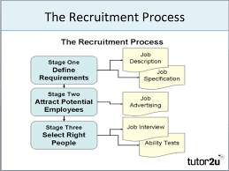

3. Training
After selection of the candidate we conduct orientation program for three days. Then company will provide some training, it can be on the job or off the job both. This training also needs some investment. Some training proposal is given bellow:
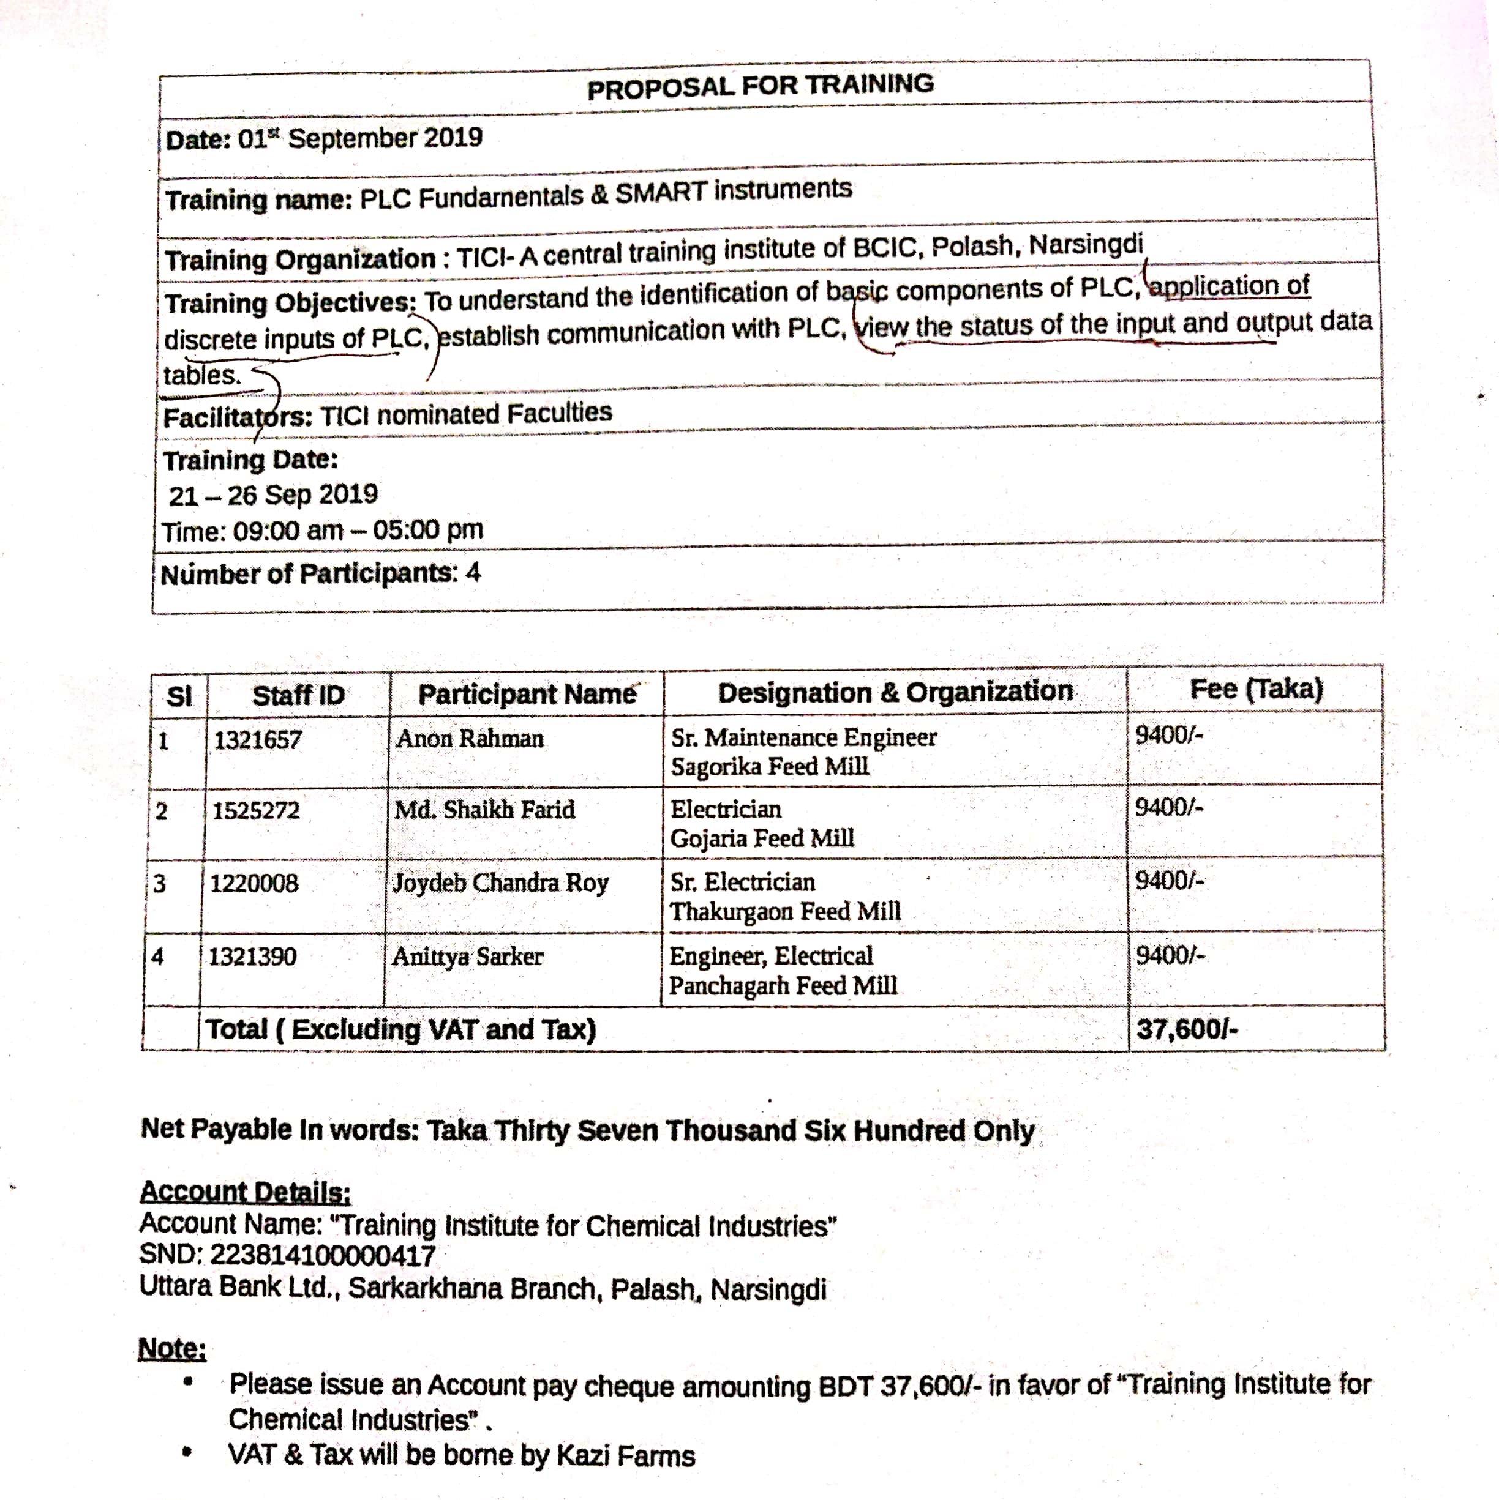
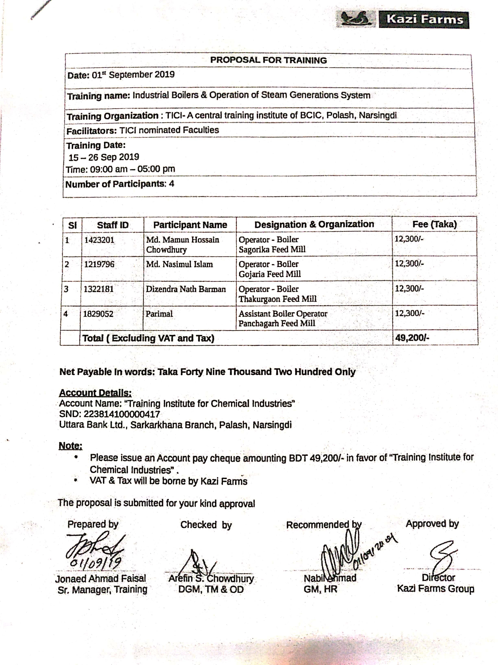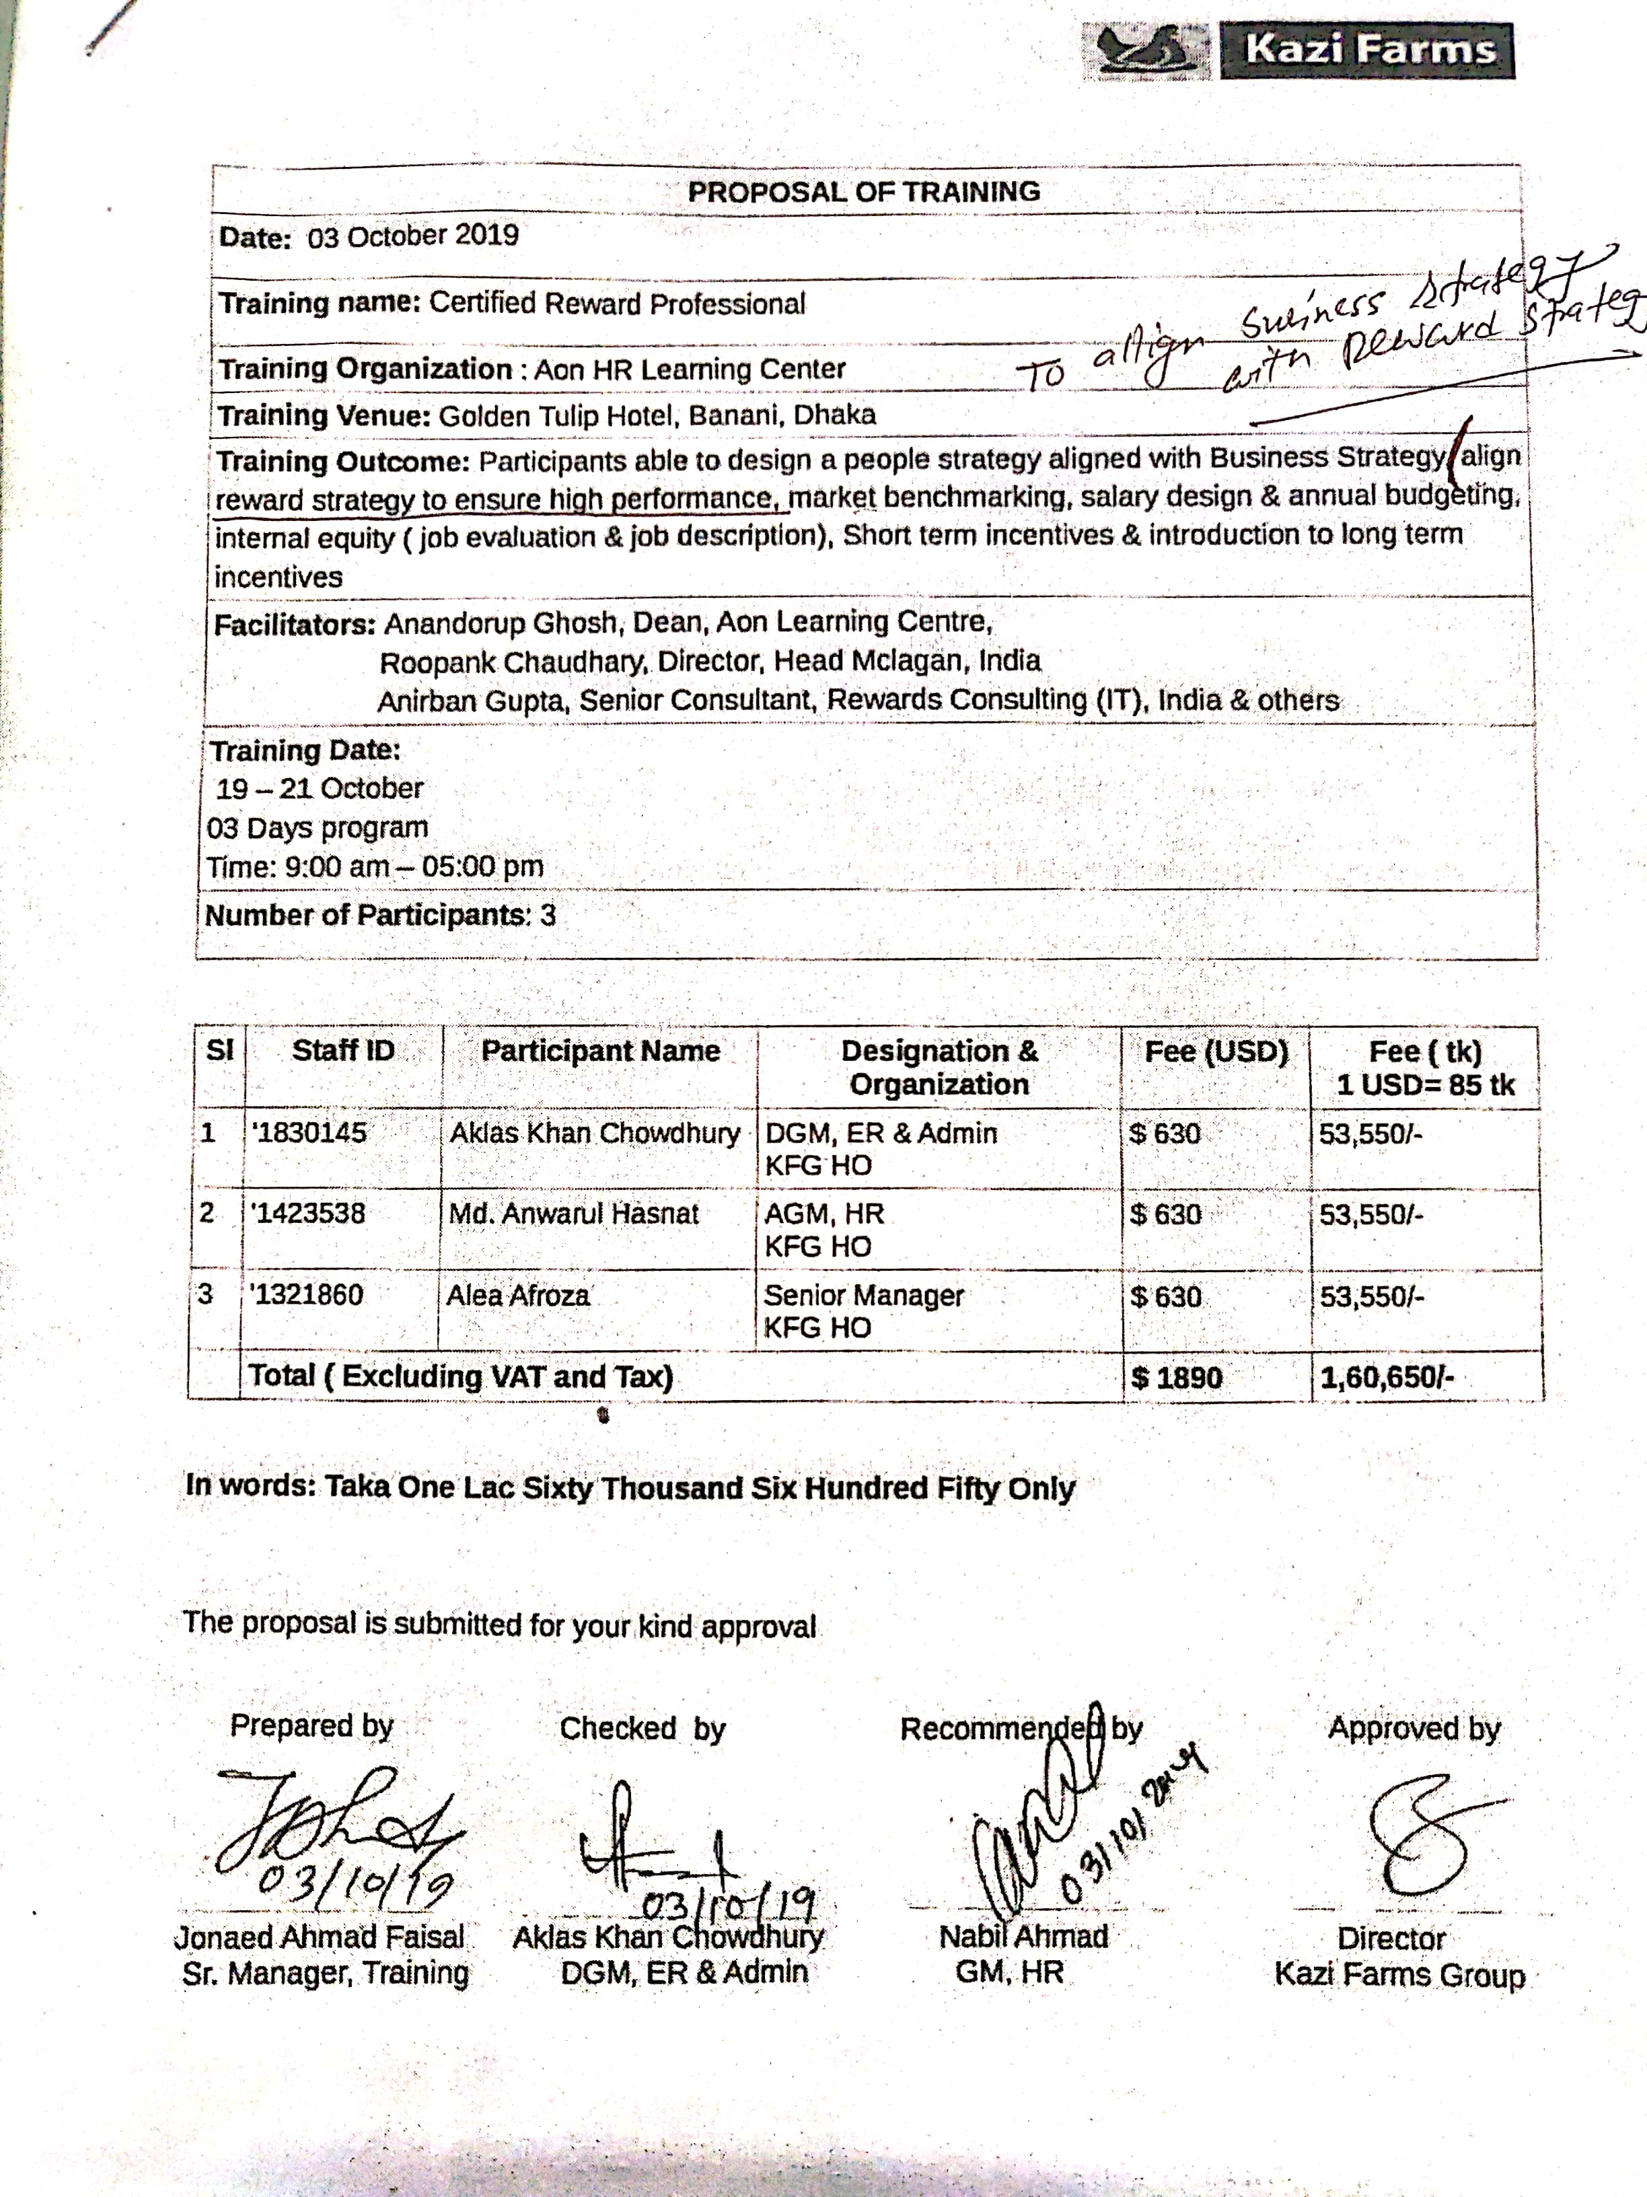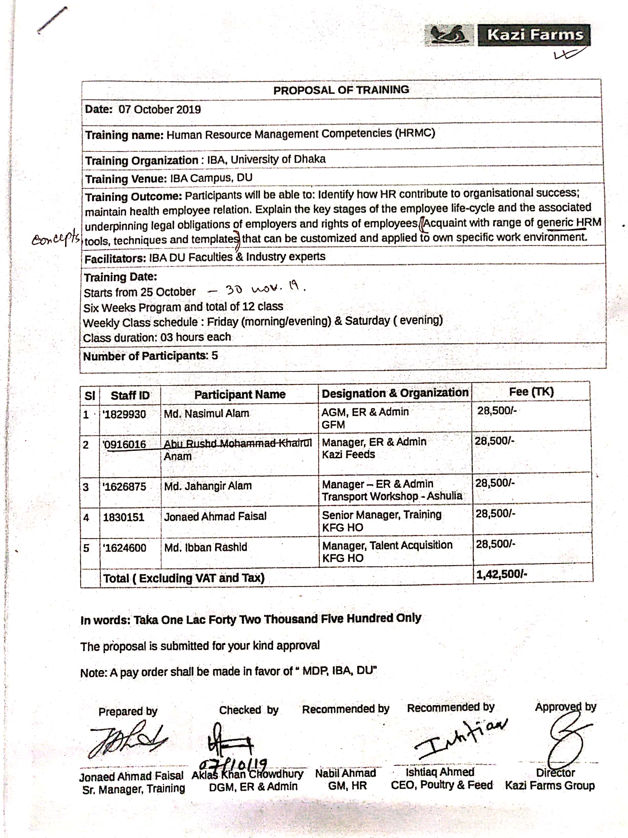

Return from investment in HR

As already mentioned, KFG is related with production. They produce daily food items, with the help of human hand. They also use machines, but to operate those machines they need humans. So that, behind the success of the KFG there is a contribution of its human resources. KGF earnings is totally dependent on the decisions taken by management employees and operations of non-management employees. I can conclude that, by investing in the human resource KFG is earning the profits & it has become a largest company in Bangladesh. So, this is the returns form the investment in human resource.

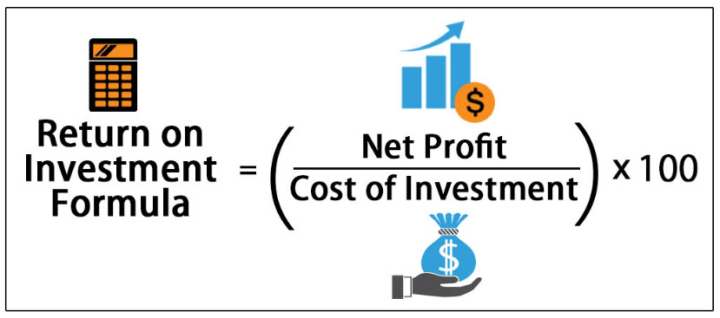

ROI= (16704000000÷2500000000) x 100
= 668.16%
A high ROI means the investment's gains compare favorably to its cost.

Sample of Income statement

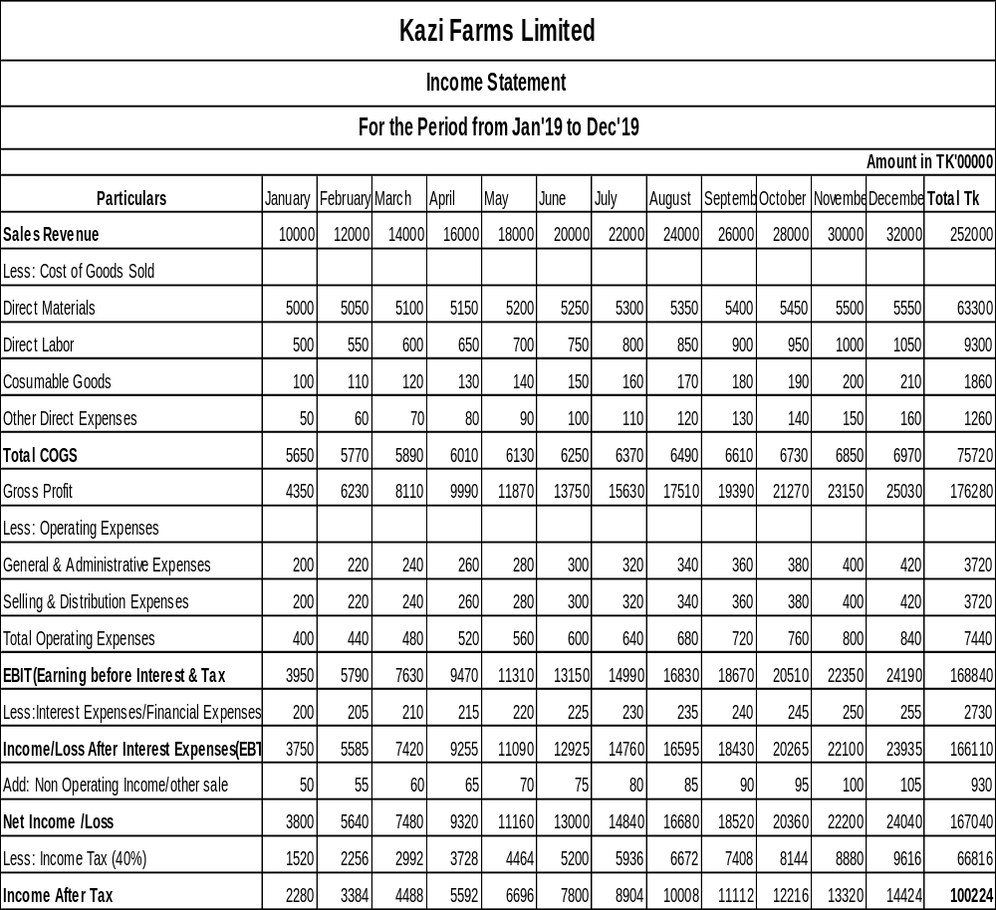

SWOT analysis

Strength –
- Kazi Farms Group is the leading Hatchery, Feed Mill & frozen food industry in Bangladesh. It exports goods to the other countries in the world.
- There is no competitor present in this frozen food industry. So, the whole market share of frozen food is under the Kazi Farms Group. Giving concentration in this sector can easily maximize their profit day by day. Another hand they made local frozen foods & which is available around the whole country by maintaining 15 depots.
Weakness –
- Maintaining the Bio security using the uneducated workers is the main weakness of the Kazi Farms Group.
- External environment like political issues are the weakness for the KFG.
- Already many media channels are available in our country, so that it is very hard Kazi Media to compete those already developed media industries.
- Sometimes controlling animal diseases becomes difficult. Example – Bird Flu.
Opportunity -
- KFG is the biggest hatchery & frozen food industry in Bangladesh. So that as the economy and living standards of the people is increasing, it is the opportunity for the KFG to expand their business and make huge profit.
- Kazi Media & Sysnova is the technological based industry. As we all know now days technology is the main part of every human’s life. So, developing the such kind of industry can bring success to the KFG.

Threat
- Many potential competitors are the main threat for the Kazi Farms Group. Now days all information’s are available in internet. Using those information’s competitors can easily monitor business operations of the KFG.
- Increasing price of the Raw Materials – To make good products KFG always uses best quality raw materials. But day by day these materials price is increasing. So that it has become very hard to make balance between purchase and selling price.

CHAPTER IV: INTERNSHIP EXPERIECNE

Position, duties, and responsibilities
In the Kazi Farms my position was an Intern. There was no specific job for me. My duty was to collect & record the expenditures of the HR department, arrange interviews, taking written exams, verifying documents of selected candidates. All these tasks are the part of recruitment & payroll. I also managed the files of newly joined employees.

Training
In Kazi Farms they gave me on the job training. Existing employees of the KFG gave me instructions before & while doing the job. They have showed me each and every task practically.

Contribution to departmental functions
My contribution to the department was to conduct recruitment process & evaluate the cost of each recruitment. This process includes several tasks from shortlisting CV’s to joining employee.

Evaluation
In this practical job experience the evaluation technique was doing the specific task at appropriate time & with accuracy. Supervisors gave me constant feedbacks about my results. Everyone was satisfied with my work. They evaluate me on the basis of my punctuality and my willingness to do the works.

Skills applied
During my B.B.A program I have learned many skills financial analysis, MS word, MS excel, mendeley. In Kazi farms they use Linux operating system. My previous learned skills helped me to come up with this operating system. Now I can use effectively Libre Office, Libre Cal & Linux operating system.

New skills developed
Mainly I have developed how to communicate and what will be the behavior in a corporate life. As a new in the job lt is very important for everyone. I have gained this skill during my internship. KFG uses Linux operating system. So, I have learned new skill from my internship.

Application of academic knowledge
Each end every task during my internship was the application of my academic knowledge. B.B.A program with Finance major taught me, how to invest and get the best return by analyzing previous or available data. Then how to present report to the supervisor. This academic knowledge was applied during each task of my internship.

CHAPTER V: RECOMMENDATION & CONCLUSION

Recommendations

- Reduce the lead time, when the HR department receives the RRF (Requisition Requirement Form) it is approved by the director and other managers. Then they place the advertisement or they try to fill up the requirement from their existing pool of employees. So, from approving the RRF to joining this is called lead time. If they can reduce the lead time. It will be more beneficiary for the KFG
- Reduce the advertisement cost, HR department have to be more advance to publish their job circular. So that they can get many levels of employees from this advertisement.
- Search candidate who can be perfectly fit for the job and need less training. So that the training cost can be reduced.
- Reduce the turnover rate because from the joining of the employee company invest money on then. If suddenly any employee leaves the job it will be a loss for that company.

Key understanding

In this report they key understanding is that, how “Kazi Farms Group” invest money for the human resource & what is the return they get from that investment. It was not possible to get the exact numbers because it is a privet company. So that, their financial information is very confidential. But in general, KFG is getting very good return from their Human Resources.

Conclusion

This report is a case study of Kazi Farms Group’s Effectiveness of human resource financing. In this modern era business is changing rapidly by the passing of time. The competition is getting much more challenging. So, to cope up with this competitive changing world every organization must have to apply its own unique theories & ideas This report is based on 3 months internship period on Kazi Farms Group (KFG). The main focus of this internship report is to complete BBA program as well as to get familiar with the corporate environment. This report basically contains 5 chapters. The 1st part is introduction part it contains the information such as background of the report, objectives of the report, scopes of the report, limitation. The 2nd chapter of this report contains economy analysis, industry analysis & company analysis which represent the descriptive view of Kazi farms group. The 3rd chapter is about the methods for measurement of effectiveness of HR financing. Then 4th chapter is about the internship experience. Lastly the 5th chapter is about recommendation & conclusion of the report. This report helped us to understand the importance of human resource financing. A big portion of the company’s investment goes for its Human resource department. So that to ensure the appropriateness of the investment we should know the previous pattern of investments and the returns from those investments. Now KGF can easily see their investment pattern for HR department & it will be very helpful for them.

Reference

:: Kazi Farms Group :: (n.d.). Retrieved March 22, 2020, from https://www.kazifarms.com/
:: Kazi Farms Group :: | Kazi Food Industries. (n.d.). Retrieved March 28, 2020, from https://www.kazifarms.com/Kazi Food Industries
:: Kazi Farms Group :: | Kazi Media. (n.d.). Retrieved March 28, 2020, from https://www.kazifarms.com/Kazi Media
A MARKET SHARE ANALYSIS AND COMPETITOR ANALYSIS OF KAZI FARMS. (2006). (April).
Bangladesh Frozen Food Market | Growth | Trends | Forecasts (2020-2025). (n.d.). Retrieved June 3, 2020, from https://www.mordorintelligence.com/industry-reports/bangladesh-frozen-food-market
Hamid, M. A., Rahman, M. A., Ahmed, S., & Hossain, K. M. (2016). Status of Poultry Industry in Bangladesh and the Role of Private Sector for its Development. Asian Journal of Poultry Science, 11(1), 1–13. https://doi.org/10.3923/ajpsaj.2017.1.13
Saha Puja. (n.d.). accounting policies-report final one.

