

Internship Report On
“General banking activities, Services and challenges during the pandemic situation of Southeast Bank Limited”



United International University
Internship Report
On
General banking activities, Services and challenges during the pandemic situation of Southeast Bank Limited.

Supervised by:
S M Asif Ur Rahman
Assistant Professor
School of Business & Economics
United International University

Submitted by:
Arshadur Rahman
Id: 111 151 576
BBA Program
School of Business & Economics
United International University

Date of Submission: 21/08/2021

CERTIFICATE OF APPROVAL

This is to certify that, Arshadur Rahman is a regular a student of United International University, ID # 151111 576 has effectively finished his 'Internship Program' and arranged a report named “General banking activities, Services and challenges during the pandemic situation of Southeast Bank Limited.” under my watch for halfway prerequisite to finishing the BBA program. He has finished his internship honestly under my watch and direction. He has attempted his level best to finish his doled-out work effectively.

-------------------------------------
S M Asif Ur Rahman
Assistant Professor
School of Business & Economics
United International University.



Letter of Transmittal

Date: 21/08/2021

S M Asif Ur Rahman
Assistant Professor
School of Business & Economics
United International University

Subject: Submission of internship report on “General banking activities, Services and challenges during the pandemic situation of Southeast Bank Limited.”

Dear Sir,
I'm particularly thankful to you for introducing herewith my "Internship Report", according to your guidelines. I have effectively finished my Internship report zeroing in on the "General financial exercises, Administrations, and difficulties during the pandemic situation of Southeast Bank limited.” as the partial completion of the Bachelor of Business Administration program necessity. The report offered me the chance to know the general ramifications of "General banking activities, Services, and challenges of Southeast Bank Limited”
Setting up this report was a decent encounter for me and subsequently, I'm thankful to you for showing such drive of functional situated instruction. I attempted with tirelessness, immediacy, and enthusiasm in arranging the material that added to the arrangement of this internship report.

In spite of various inadequacies, I have attempted to follow your rules and all the pertinent data that you have allocated me. I made an honest effort to give the most fitting and significant data accessible. Any weaknesses or defects might emerge; I will welcome any explanation and ideas with respect to this report.

-----------------------------------
Sincerely yours,
Arshadur Rahman
ID: 111 151 576

Table of Contents

CHAPTER ONE 1
1.1 Introduction: 1
1.2 Origin of the report: 1
CHAPTER TWO 2
Literature Review 2
2.1 Purpose statement: 3
2.3 Primary Objective: 3
2.4 Secondary Objective: 3
2.5 Scope and the limitations - 4
2.6 Methodology - 6
2.7 Type of Data Sources 6
2.8 Data Collection Process – 6
2.9 Data collection method – 7
2.10 Data Analysis methods: 7
CHAPTER THREE 8
3.1 Overview of the Company 8
3.2SOUTHEAST BANK AT A GLANCE 10
3.3 LAST 5 YEARS’ 11
FINANCIAL Condition and outcomes of Southeast Bank Limited – 11
CHAPTER FOUR 12
4.1 Impact of COVD – 19 in Bangladesh Banking Sectors 12
4.2 Type of accounts in South east Bank limited 14
CHAPTER FIVE 15
5.1 Southeast Bank Ltd. during COVID- 19 15
CHAPTER SIX 24
Recommendation 24
Conclusion 27
Appended Part 28
Reference 28

Executive Summary
A bank may be a money-related institution that brings together financial specialists and borrowers for giving/receiving flood and setback stores individually. The objective of a bank is to form an advantage while acting as a center man between the over-specified parties. Most of the bank directly concentrates of displaying achievability to win and make an opportunity to hold existing to keep enduring clients, inside the commerce sayings it is told that immovable clients increase the up and coming profitable pay. In this report, I am endeavoring to center around organizations, challenges, and the workplaces and energize more how SEBL has been publicizing to their clients roughly the level of client advantage given and its execution credibility for Southeast Bank Compelled to overcome all sorts of client complaints almost the advantage disillusionment and inadequacy.

To start with, a parcel of this report depends on the introduction which joins focuses like root, objective, establishment, method, hindrance of the consider. Basically, it characterizes the way and establishment of the think approximately to urge prepared the report. Inside the taking after parcel of the report highlights a brief establishment of Southeast Bank Limited, with their mission, vision, objective conjointly giving a brief rundown of all retail things and benefits publicized by the Southeast Bank Limited.

The other portion is essentially approximately the assignments done by me during the internship. Information from one on one interview of the Bank’s officers has been utilized to examine clients’ sees with respect to the quality and standard of the administrations; to distinguish the holes between the administrations that clients need and to recommend ways of progressing the services.

This report in addition comprising of all the discoveries of the report given with some proposals in organize to form strides client advantage quality as well as client fulfillment level based on the recognition and work experience in the midst of internship period.

CHAPTER ONE

Introduction:
The bank might be a money-related association that plays a basic obligation to make, screen, and controls any country's economy as a budgetary center individual. Effectively, in the financial exchange section, there wasn't that much rivalry to do keeping cash trade. Regardless, these days the show of keeping cash exchange has been changed separated. Additionally, because of globalization and this far-reaching, the opposition and difficulties of banks increase very all throughout the planet just as in Bangladesh. Consenting to kind of budgetary activities banks are divided into basically into four classes and those are nationalized banks, Nearby Private Commercial banks, specific cash related foundations, and distant banks. In plain view, in Bangladeshi dealing with a record structure, there are four state-possessed business banks, five specific banks, 38 private business banks, one show up progress bank, and nine distant business banks. Despite the way that the opposition in the budgetary fragment with the bank to bank is growing every day, still, family banks are loosening behind on various fronts contrasted and distant business saves money with a wide run of capitalization, strong arrange, progressed development, upgraded authoritative capacity, experience, and so on As Advanced business has concocted the idea with customer advantage with the best quality thus, this idea had the opportunity to be a convincing and basic key to encourage triumph in trade. These days banks are too fixating on not as they were a predominant thing and headway but rather likewise best customer advantage to shaping reliable customer.

1.2 Origin of the report:

This report on Southeast Bank Limited (Sat Masjid Branch) is ready to satisfy the fractional prerequisite of the temporary position program as a full credit subject of the BBA program of the college. The general work of this report depends on client assistance, challenges during the COVID-19 of SEBL (Sat Masjid branch), and the general perspective on the obligation as an understudy in a three-extended temporary position program or internship at this bank. My hierarchical director was Khushnuma Yasmin Zaman the Senior Officer and during the entire internship time frame, she administered me. Additionally, others from the various offices are likewise co-working me around then and without their assistance finishing this report will not have been conceivable.

CHAPTER TWO

Literature Review

1. The creating contest among nationalized, far off, and private business banks with regards to how the banks work it dealing with a record activity and how customer advantage can be made appealing. Business or private banks are endeavoring to evaluate their ordinary keeping cash advantage to a superior norm, to meet the difficult requirements. So they pay thought to way better execution and presence. Underneath the over conditions, it has wound up fundamental for Southeast Bank Obliged, one of the private business banks, to focus its thought towards its administrations.
2. Perceive things and advantage quality level, to know practically the rate and charges, to know around the customer plan. To consider the peril included in the midst of the boundless inside the overseeing account activities and to discover how the causes behind the risks are settled by the organization.

2.1 Purpose statement:
The main intention of this report is to provide the idea, over all banking activities and how the bank works during the pandemic situation and what kind of services they are providing through the whole time.
But on the other hand I segregated the purpose or the objective of the study in two categories. Those are –
- Primary Objectives
- Secondary Objectives

2.3 Primary Objective:
- To present an outline of SEBL.
- To break down the various kinds of banking exercises at the branch level.
- To present about the client care investigation of the bank.
- To give a few suggestions to further develop administration quality in the Sat Masjid branch dependent on my comprehension of the help and work methods overall in the pandemic season of COVID – 19.

Secondary Objective:
- To have a down-to-earth connection and dependability of the points we have accomplished from a literary foundation in our instructive life.
- To foster comprehension of client support cycles and principles in the financial area.
- To know the activity of business banks in Bangladesh.
- To realize how the branches are productively controlled
- To distinguish if all cycle is impeccably and viably rehearsed.
- To make an assessment on the report.

2.5 Scope and the limitations -
The extent of this report is to look at the overseeing of a record customer advantage related to general activities of the division. On the other hand, as I have conducted my internship at Southeast Bank Constrained in Sat Masjid Department, I have delighted in the enhanced environment and pleasant put. The officers were exceptionally co-operative but their gigantic workloads kept them as well active to deliver me sufficient time to induce information almost the commonsense exercises of the bank. It is right that every organization has a few hindrances. Besides, they are bound to bargain with money-related exercises in a really delicate as well as competitive environment. Any botch done by me may obstruct their execution and goodwill within the banking sector. For these reasons, I have been denied of having the right to commonsense information. Brief-time terms and the need for commonsense information are the most impediments of the ponder. A few other restrictions confronted amid the think about are specified below:

The Workload of the Administration:
Since the SEBL authorities remain exceptionally active with their agents, in a few circumstances I may not speak with them adequately.

Fears to Disclosure:
A few privacy of data was moreover an impediment that I have confronted in this consider. Since I was not a changeless worker, the administration was moreover panicked to disclose the secret information, different shapes, and records to me.

Lack of Experience:
Doing a report on a banking sector in a practical corporate life was my first time of mine. I am not knowledgeable enough to complete the study in a practical way. My limited experience was the main obstacle of this study.
Lack of Guidance:
Having an absence of staff in the unfamiliar trade division of the branch it was truly challenging to accept satisfactory data from them as they were occupied enough in their own work.

Limited Time:
Since I have got as it were three months to total this report, it was nearly incomprehensible to cover the all exercises of the bank appropriately inside this brief time. While a normal representative gets familiar with the exercises least after 6 months to 1 year of his trial period.

Limited Data Resources:
Since a few of the data related to the bank was not available, it was barely conceivable to get and summarize them legitimately. In spite of the fact that I had help, it was not adequate for me since he was moreover bound to concurring to the rules of the bank. A few suspicions have been taken due to the confinement of the data.

For security reasons, banks authorities degraded the request for giving data on a few aim issues. There was trouble in understanding a few capacities as a few of the areas of banking are still not secured by the courses. Another abridgment of this report is the bank’s approach of not uncovering a few records for private reasons.

2.6 Methodology -
Methods followed to conduct a report or study varies according to the category of the study & to activities related to the study. Type of Data, Data Collection Process & Scope which are arranged in this methodology adopted to conduct this report, are furnished below:

2.7 Type of Data Sources
The data and information for this report have been gathered from both primary and secondary sources.
Primary Sources Include:
- Personal engagement in desk to desk activities.
- Face-to-face conversation with the employee assigned to various sections.
- Discussion with senior personnel of the branch.
- Group discussion with another intern.
Secondary Sources Include:
- Annual report of SEBL.
- Official site of SEBL.
- Several distributions and manuals of SEBL.

2.8 Data Collection Process –
Significant information for this report has been gathered fundamentally by direct examinations of various records, papers, archives, articulations, functional cycles, and from the various work force. The discussion led with the representative alongside the senior staff was restricted to formal and casual conversation.

2.9 Data collection method –
As we all know that there are several types of data collection methods, but due to the pandemic situation and bank’s secrecy it was difficult to collect all kinds of information or data that I needed but still I choose to go for the easiest way such as the interviews with the officers and employees who work in the bank.

2.10 Data Analysis methods:
- This is a spellbinding report, for the most part, meaning to portray the interaction and all the improvement for to manage the client and give those legitimate services and all the overall financial exercises during the COVID – 19 circumstance of Southeast Bank Ltd.
- The information accumulated from both essential and auxiliary sources were orchestrated in organized to get a reasonable image of the Southeast Bank's overall financial exercises and its condition during the time.
- Study incorporates both subjective and quantitative examination of their financial actives and checking apparatuses.

CHAPTER THREE

3.1 Overview of the Company
Southeast Bank Limited might be a quickly developing second-era bank. The Bank has been achieving a relentless improvement rate in very surprising circles of banking tasks since its establishment inside the year 1995. The rationale of the bank is "A Save money with Vision" which shows its sincerity, shrewdness just as the nature of insight to oversee worldwide seriousness and movement. The improvement of Southeast Bank was at the intersection of the progression of overall monetary activities. It could be an arranged business bank inside the private division set up underneath the ambit of Bank Organization Act 1991 and joined as an Open Confined Organization underneath Organizations Act 1994 on Walk 12, 1995. The Bank started business banking tasks with the vision to stand apart as a pioneer banking foundation in Bangladesh and contribute by and large to the public economy on May 25, 1995.
It very well may be a second-age Bank and its Testament of graduation of exchange of the Bank was given by the Recorder of Business entities and Firms and was too dated Walk 12, 1995. The Financial Grant for the Bank was given by Bangladesh Bank on Walk 23, 1995. The Bank presented it, in the first place, the division at the most active business focus of the country at 1, Dilkusha Business Area, Dhaka, and was opened on May 25, 1995, by Mr. M. Saifur Rahman, past. Back Serve, Legislature of the Individuals' Republic of Bangladesh as the central guest.

The Bank is supervised by a gathering of powerful specialists. There wins a positive hierarchical environment inside the Bank that makes feelings of respectability, conviction, education, and transparency in its people that outcome in prodding them to post better comes about perpetually inside the Bank. The way of life of keeping up an agreeable workplace inside the Bank needs to urge engaged staff to benchmark themselves way better against organization wants. A promise to quality and significance in advantage is the benchmark of their character.

Southeast Bank today is an equivalent word of value banking items; it has a different cluster of painstakingly customized items and administrations to take into account the requirements of all client fragments. The Bank organized its functional systems to address the uncommon and regularly complex requirements of the clients.
CAPITAL BASE:
Authorized Capital: Tk. 6.00 Billion
Paid Up Capital: Tk. 5.50 Billion

VISION & MISSION:
VISION:
- To stand apart as a pioneer banking organization in Bangladesh.
- Contribute altogether to the public economy.
MISSION:
- High-quality monetary administrations with the assistance of the most recent innovation.
- Balanced development technique.
- High standard business morals.
- Innovative banking at a serious cost.
- Attract and hold quality HR.

CORE VALUES & STRENGTHS:
CORE VALUES:
- Harmony
- Integrity & Fairness
- Insight and Soul
- Business Morals
- Enthusiasm for Work
CORE STRENGTHS:
- Transparent and swift decision making
- Professional team of performers
- Satisfied clients
- Internal control
- Experienced risk administration

COMMITMENTS:
- Provide administrations with a serious level of demonstrable skill and utilization of present day innovation.
- Create drawn-out connections dependent on common trust.
- Response to clients' necessities with speed and exactness.
- Provide items and administrations at cutthroat evaluating.

3.2SOUTHEAST BANK AT A GLANCE

PARTICULARS | SOUTHEAST BANK LIMITED
Date of Consolidation | March 12, 1995
Theory of the Bank | “A Bank that has a vision”
Vision | To stand apart as a pioneer banking establishment in Bangladesh and to contribute altogether to the public economy.
Missions | - Excellent monetary administrations  - With the assistance of the most recent innovation.  - Fast and precise client support.  - Balanced development procedure  - High standard business morals.  - Innovative banking at a serious cost
Branches | 133 Branches
Authorized Capital | Tk. 6.00 Billion

3.3 LAST 5 YEARS’

FINANCIAL Condition and outcomes of Southeast Bank Limited –

BDT in Million
PARTICULARS | 2019 | 2018 | 2017 | 2016 | 2015
Authorized Capital | 15,000.00 | 15,000.00 | 15,000.00 | 15,000.00 | 15,000.00
Paid up Capital | 11,599.42 | 10,544.93 | 9,169.50 | 9,169.50 | 9,169.50
Reserve Fund/ Others | 24,493.91 | 28,315.19 | 24,595.63 | 24,886.78 | 19,340.03
Total Capital (Tier-I+Tier-II) | 36,093.33 | 38,860.11 | 33,765.13 | 34,056.28 | 28,509.53
Deposit | 329,250.27 | 298,334.79 | 269,828.08 | 229,973.43 | 210,431.09
Advance | 296,752.96 | 267,671.63 | 234,316.72 | 191,865.59 | 168,878.46
Investment | 77,310.04 | 65,609.55 | 62,911.04 | 61,731.63 | 58,829.27
Import Business | 248,901.33 | 242,294.80 | 215,379.77 | 171,531.73 | 151,812.58
Export Business | 205,907.10 | 190,402.80 | 167,562.98 | 146,606.09 | 126,423.89
Foreign Remittance | 138,272.00 | 116,803.00 | 95,405.43 | 64,665.84 | 60,708.50
Guarantee Business including ILC | 16,470.30 | 22,420.12 | 16,407.09 | 16,369.36 | 15,245.19
Total Income | 36,392.61 | 33,739.81 | 27,305.90 | 25,617.57 | 26,260.72
Total Expenditure | 27,409.63 | 23,956.82 | 18,243.60 | 17,114.35 | 18,226.45
Operating Profit | 8,982.98 | 9,783.00 | 9,062.30 | 8,503.22 | 8,034.27
Net Profit after Tax and Provision | 2,508.56 | 2,473.21 | 1,168.63 | 2,435.07 | 3,069.42
Fixed Assets | 9,333.66 | 9,337.30 | 9,321.80 | 8,947.16 | 7,885.23
Total Assets | 422,312.71 | 381,575.68 | 339,288.05 | 291,798.01 | 260,718.03

CHAPTER FOUR

4.1 Impact of COVD – 19 in Bangladesh Banking Sectors
The bank is a foundation where the world will go stop on the off chance that they stop, as different institutions, for example, emergency clinics and drug stores in the lockdown they will in any case be open during this time and in that circumstance where banks are not an exemption. Coronavirus simultaneously impacts the human body and acumen, society, world economy and to be sure breaks the idea of the overall town. Every one of the achievements of therapeutic science is missing the mark to end the far reaching. So to speak in four months of its erupt the entire world economy had the opportunity to be debilitate. The beast USA, UK, and countries of Europe are by and by stressed to face the diverse impacts of the contamination. Very much like the remainder of the world, Bangladesh is also experiencing the gnawing inclusion of the impact of Crown. In every day, the quantity of impacted people and passing is rising alarmingly. All around, organizations checking capital publicize has been staying shut for conclusive one month and it unsure when all that will restart. Like various different divisions, dealing with a record portion of Bangladesh is also really affected by the impacts of the Crown Infection. The financial division is the wheel of an economy. The prosperity of the keeping cash portion depends not so to speak on the methodology of the actual bank yet also on the advancement of any remaining divisions of the country. Due to the far and wide of Coronavirus and the lockdown of the country, the unmistakable danger of keeping cash divisions is being flooded which is especially upsetting for the economy. The significant possibility that banks will go up against is the credit risk, the Non – performing advance (NPL) of the bank might ascend to a cutting edge level because of this far reaching. As of now, the majority of the exchange has suspended their intruding nature activity because of lockdown.
Another danger that may addition is liquidity risk. The dealing with a record portion of the country has been bearing a crisis if there should be an occurrence of the liquidity in the last one and half years. Both credit hazard and liquidity hazard straightforwardly influence the likelihood, manageability development, lastly, the endurance of the bank's huge genuine pay of the bank might diminish because of an expansion of NPL coming about because of inability to standard recuperation from advances.
As we have determined the earlier turn of events and legitimacy of the bank that are not subject to the methodology of the actual bank however additionally on the overall advancement of the economy. As the majority of the pay making divisions of Bangladesh is in a weak position and underneath risk to lose of trade, banks have the possible results to go up against an essential situation ever. The public authority, financial backers, game plan makers, just as finance managers, had the chance to work simultaneously to defeat the possible possibility of the bank.
We can likewise see that the low interested rate circumstance, along the edge the imperative impact of the Coronavirus, is reducing the middle overseeing account efficiency in created markets. Budgetary instructors are in this manner moving towards commission-based compensation from any semblance of portions and tech organizations yet one of the fast effects of the prosperity emergency on the veritable overall economy is the extended credit chance of corporate and retail customers of the banks. In mastermind to continue to fund the real economy and reinforce its recovery, banks are called to perceive between just momentary miracles, foreordained to be reabsorbed in a short time frame, and longer suffering effects which would require exercises of organization and renaming.

Despite the way that Coronavirus might prompt a crisis inside the authentic economy, the impact on the dealing with a record structure and on the bank-customer relationship can in addition be portrayed as a 'positive irregularity' for the explanation of digitization of the division and the ability to offer a stunning customer contribution. Then again, Banks for sure the premier local and branch-driven ones, are obliged to stimulate the use of channels that have never been their key need. This stage would be especially unpredictable, which banks had the chance to address by outlining certifiable proximity with their customers. Yet, the reasonable agreement by overseeing account heads of their cleft inside the plan of organizations, having the chance to be more undeniable than any other time at some point as of late with Coronavirus, may make them for sure more skewed to animate the high level change way through affiliations and joint efforts inside the local area.

4.2 Type of accounts in South east Bank limited

Before we get to the issue of the bank situation during the pandemic let’s get to know the few bank accounts in SEBL to justify later that how they are working during that time so in each bank account is known as an orderly record of a department. Through a bank account the bank and its clients bargains with. Without an account a client cannot get any keeping money benefit. Clients store cash and pull back cash when they required through accounts. In SEBL taking after accounts are accessible:
- Conventional Banking: that include saving account, Current Account, Short Notice Deposit (SND), Fixed Deposit Receipt (FDR).

- Islamic Banking: Mudaraba Savings (MS) Account, Al-Wadiah Current (CD) Account, Mudaraba Special Notice Deposit (MSND) Account, Mudaraba Term Deposit Receipt (MTDR), Mudarba Pension Savings Scheme (MPSS), Mudaraba Monthly Savings Scheme (MMSS), Mudaraba Monthly Income Scheme (MMIS), Mudaraba Millionaire Deposit Scheme (MMDS), Mudara Double Benefit Scheme (MDBS).
Giving all sorts of commercial banking, buyer banking exchange benefit is the foremost action of each bank. All branches of the banks give same managing an account benefit but few banks give additional administrations to its clients.
- Retail Banking
- Islamic Banking
- SME Banking
- Corporate & Investment Banking
- SEBL Cards
- Digital Banking
- Priority Banking
- Treasury

CHAPTER FIVE

5.1 Southeast Bank Ltd. during COVID- 19
Bangladesh has been seriously affected by the COVID-19 widespread. The household scourge unfolded in the year of 2020 and formally recorded cases rose to a crest in July 2020. To slow the spread of the infection, a national shutdown was forced from May 2020 coming about in broad financial disturbances and along with the COVID-19 widespread is harming economies over the world, counting financial markets and institutions in all conceivable measurements. For banks in specific, the widespread produces multifaceted emergencies, for the most part through increments in default rates. Usually likely to be more awful in creating economies with destitute monetary showcase design.
The COVID- 19 pandemic impacted not only in southeast bank but also in overall banking sectors in three-dimension including firm esteem, capital ampleness, and intrigued income—under distinctive NPL shocking scenarios. Like other bigger banks are generally more defenseless like SEBL. The decrease in all three measurements will increment excessively on the off chance that NPL will be bigger. On the other hand, they usually deal with a wide stretch out of risks and the inescapable is getting to increase their reality through liquidity crunch, credit press, increases in non-performing assets and default rates, unavoidable losses from credits and theories, declining to promote fascinated rates, and enacting irresistible bank-run.
Even during and after the hazard of COVID-19 SEBL took the proper initiative to deal with this kind of situation and tried to maintain their reputation in the banking sector. Before the pandemic the way bank used to run they do run their institution now too but in a technical and different way to handle the situation and keep the customer satisfaction intact and to give them proper services in an alternative way. As we all know that before the corona outbreak customer has to come to the bank physically for taking any kinds of services for example if any customer has to take a check book he/she has to come to the bank and has to give the signature for authentication and as the officers can match his/her by recognizing the face of the client and after that the check book will be provided to them.
But during the pandemic situation the senior citizenship clients were not interested or didn’t want to visit the bank for safety concern so they would call the bank and ask for the services. In this case bank needed to the authorization of the client’s identity and after getting the proper authorization, bank would hand over any checks, check books or money. The client will be authorized through his attached signature sent by someone else. So in this kind of situation or scenario southeast bank provided the authorization services during the COVID- 19,
On the other hand bank emphasized on client’s safety security which is actually not about the health safety security is about the financial safety securities, bank focus on the matter in a subjective way for the customer benefits because in the pandemic situation, financial crisis was very noticeable among the middle class people and it brought the darkness among them to lead their lives in a normal or wealthy way and in this case bank did gave them all kind of facilities and services by lending them money for the crisis and also was not that much ridged about their policies and system during the time of crisis like bank overlooked the matter at moment. We can say that southeast bank was exceptionally adaptable towards the clients.

There is another kind of account that is called ESTEEM which is priority bank services of southeast bank limited. Clients who will get the banking services at their doorstep. In addition, ESTEEM privileges will cover many more complimentary benefits and personal support services such as a dedicated relationship manager will be assigned to take care of the customers banking needs on the other hand ESTEEM is more flexible with the services and customized financial services by saving their valuable time to keep their objective at its root. So the policies were very specific for this type of accounts which were hampered during the COVID-19 outbreak. The ESTEEM clients couldn’t pay the bill or interests at that moment which leads their account into inoperative or inactive which didn’t happen because bank didn’t let that happen and they overlooked the matter for the pandemic and kept their account activated. Which was a kind initiative for SEBL during the COVID- 19.

COVID-19 has changed client behavior and fast-tracked the assignment of inventive gadgets and progresses by the around the world keeping cash section. For event, the world has as of presently seen a fast increase in client severe dislike towards branch-based keeping cash due to broad lockdowns. At the appear, clients are more captivated by doing their overseeing an account while sitting at residential, utilizing progressed gadgets. They buy and by require their banks to move forward their computerized offerings, to excite the progression from brick-and-mortar branches to virtual overseeing an account organization.
In this case at the time of outbreak and lockdown SEBL focuses on the online and digital banking. This advancement is happening around the world, as banks have been closing down or adjusting branches significantly since the coronavirus widespread and even when it’s open customers were not able to come to the bank for the lockdown and transportation scarcity.
SEBL permit for the isolation of accounts into sub-accounts, which is well known among clients due to its effectiveness in overseeing diverse approaching and active installment streams. These sub-accounts empower the assignment of numerous reserve funds pots, which permits clients to coordinate their cash toward distinctive reserve funds objectives, from goods, car upkeep and eating out, to domestic proprietorship or lease along with they give cash administration instruments or mobile application that permit clients to effectively oversee their investing, sparing and charge installments and at the same time they offer minute microloans, to meet the sudden require for credit for emergencies and gigantic buys.
Their automatic bill payments feature allows customers to pay bills directly from different accounts. Also they give clear communication on expenses and item offerings, with no covered-up costs. They offer advanced stock exchanging for quick, online exchanges and exchanging options. They give great outside trade rates and quick universal cash exchanges.
They provide client benefit through helpful advanced channels like Facebook and Twitter. They grasp chat bots, which are encountering expanded request and selection in managing an account, enabling clients with consistent self-service. They permit clients to oversee all their funds in one put, and to associate to other bank accounts through open managing an account.

During COVID- 19 SEBL provided the client benefits through helpful advanced channels like Facebook and other social sites. They grasp chat bots, which are encountering expanded requests and selection in managing an account, enabling clients with consistent self-service. They permit clients to oversee all their funds in one put and to associate to other bank accounts through open managing an account.
Well it was not that easy to develop such digital banking even though it was there existing from the beginning but it was not that usable before but after the outbreak of the virus it was challenging to get used to with the digital platform for the customers to consume all the services from the bank. On the other hand, modern computerized bank would superior serve the unbanked by maintaining a strategic distance from the current legacy structures of banking, which are driven by human intercession in exercises like Know-Your-Customer forms, credit scoring, advance recuperation, etc. As a result, it would decrease working costs and destitute credit choices, permitting for lower loaning intrigued rates. Whereas the legacy banking framework is struggling to make strides clients encounter and draw in a modern era of the urban and semi-urban center course to the bank department, an advanced managing an account show would construct the whole benefit involvement from the ground up, keeping client involvement at the center.
SEBL would keep up a legitimate buyer security system, taking after the most excellent practices built up by the best-managed conventional banks. They are broad utilize of information and behavioral experiences from different pertinent sources would permit them to know their clients superior and guarantee those dangers are closely overseen over the organization and at each touchpoint.
The digital banking account, mobile financial services (MFS), (electronic fund transfer, EFT (electronic support exchange), and e-commerce got a boost within the year of 2020. Many accepted that such a trend might proceed within the months even after the pandemic to come as the coronavirus is still exceedingly dynamic in Bangladesh banking.
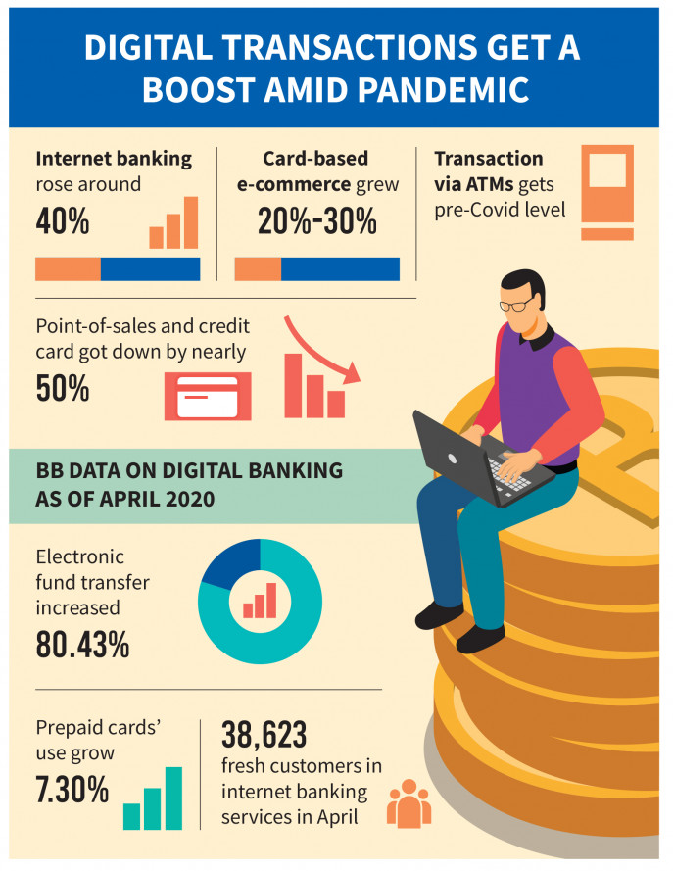


The clients of internet managing an account moreover rose 29.83% within the final one year, until February this year. Besides, debit card exchanges rose 22.24%; credit card exchanges 23.89%, and paid ahead of time card transactions rose 15.97% within the final year. Last year, in confront of the developing, to begin with, a wave of the widespread, most banks presented versatile managing a banking app, WhatsApp banking, and online account-opening platforms. Most of them expanded their speculation in internet banking, building up smart ATM machines such as cash store machines (CDM) and cash reusing machines (CRM), also extending their operator managing an account and portable monetary administrations.
On the other hand, southeast bank limited tried to push their system to manage the situation and cope up with the situation and customers demand and enhance the digital banking more for the better customer services experience.
It was a bit challenging for bank to make everything perfect and give the proper service while they were not that used to it. But furthermore there were also kind of clients who faced difficulties to utilize all these services as they are not aware of this type of banking process and know the usage of the digital banking or the use of the computer and all other digital services from the bank.


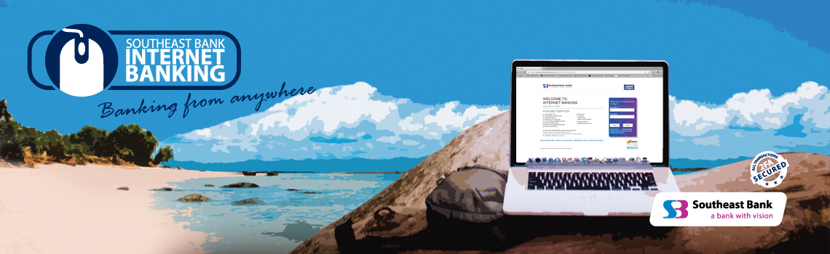
For not being aware of this type of banking system, SEBL started the new baking services which is called agent banking to prevent from not having all these services from the bank. In the pandemic of COVID- 19 there were so many people who didn’t get the proper bank service due to the lockdown and also due to being sick by the virus, so many people face the hazard during that situation. SEBL started their this banking services which is like the service from door to door to the clients. This service started to make aware about the digital banking through advertisement and those who are non-banking people will have the account for the betterment of the future.
Through this agent banking SEBL’s main focus is to educate the people about the usage of digital banking and spread it to the other for more service and customer satisfaction.
But we cannot say that There are no exact measurements almost to what degree banks' computerized administrations have extended. In any case, a few related administrations – such as credit and charge card exchanges – furthermore web and portable managing an account data give a few data. Southeast bank limited also did ensure that with a see to developing impression in cutting edge overseeing an account, Southeast Bank presents SEBL instant Banking. SEBL Second Banking is an Electronic Corner and condition of the craftsmanship progression which gives customers with true blue time cash certification and dispenses office close to different other regulating account associations all day, every day roundabout the clock.

This can be benefited by –
- Real Time Cash Deposit with Note Validation Facility
- Mini Statement
- Balance Inquiry
- Receipt with note serial numbers
- Utility bill payment, Fund Transfer
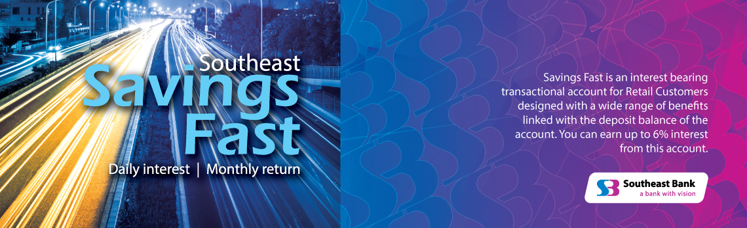

- Cash Withdrawal.

Along with all other enhancement in SEBL’s services they took the precautions for more about the health safety of the customers during the pandemic while the branches of the bank is open for providing the services.
Such as they
- Maintaining the social distance
- Reduce the limitation of entering the customer bank at a time.
- Keeping the chairs for customer at a level of distance
- Customers were not allowed to enter the bank without wearing the mask and officers were bound to wear the mask during the service and work.
- Bank provided the sanitizer before the entrance of bank
- The timing of the working hour was limited for the pandemic following the order of the government.
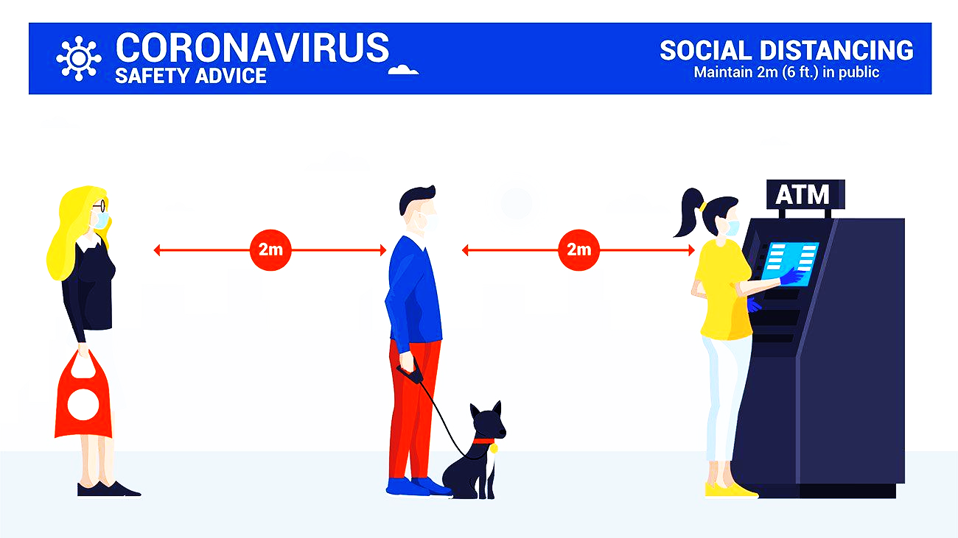

CHAPTER SIX

Recommendation

This report gives significant information regarding where changes were principal to push ahead of the nature of advantage. In the wake of doing the examination and meeting the clients, it has been seen that the clients are pretty much satisfied with the overall organization of customer advantage and the conduct of agents. They in addition have a couple of objections which make them unsatisfied in a couple of cases. From the investigation, I have observed that the customers slant toward predominant organizations. So Southeast Bank Limited should endeavor heart and soul to fix every one of the issues and administrations. From the over talk around client's wisdom practically the organizations of the bank; the accompanying proposition can be taken to make steps customer advantage nature of Southeast Bank Limited –
Continuous Market Research –
The organization of Southeast Bank Compelled can often manage advancing explore practices at regular intervals through coordinated reviews or through singular meetings, in orchestrate to keep a standard track of satisfaction levels. The standard examination may likewise be led to find clients' longings practically unique advantage viewpoints. In a nutshell, as customer wants and satisfaction are evolving consistently, standard ask about satisfactory between times likely could be led.
Establishment of more ATM Corner –
From the outline, clearly, customers are not extraordinarily peppy concerning the openness of ATM stalls of Southeast Bank Limited. So to speak various ATM stalls are accessible over the country. In this manner, a sufficient number of ATM stalls could be set up in a particular region to connect with the customers surely support and consequently satisfying their solicitations. As of late Southeast Bank limited made an affirmation with Dutch Bangla Bank limited to use their ATM Corner. It might offer help to them to satisfy the customers for the time being nevertheless the Bank can consider making a long haul hypothesis in this zone to deal with the extending amount of customers inside what's to come.

Development of the Customer Services –
Development of the client service is very important or essential, To compete with other banks, the client service ought to be progressed as online benefit, web benefit, 24 hours client benefit, etc. The organization ought to be compelling almost all client requests. Modern innovations should be taken for compelling administrations. The organization ought to take after up the employee’s enhancement and performance and give appealing compensation competitive to other banks.
Deal effectively with all the complains –
Bank may grant more prominent significance to oversee the complaints of different clients and to energize clients to provide criticism of almost all the administrations. By doing so, the administration will be able to gather and report complaints and to utilize that data to recognize disappointed customers.
Enhancement of the Online Banking –
Well this is the time and major scope for SEBL to enhance and utilize the online services during the pandemic of COVID-19. Numerous major issues lied inside the online benefit are avoiding getting more positive reactions from its clients. Hence, the SEBL IT division still has a few zones having a few scopes for assist enhancement. The Bank may take activities presently to overcome these issues. Unless these issues are unraveled, SEBL online managing an account benefit clients will not be fulfilled.
Enrollment of more Employees –
I have found one thing from my experience that the bank ought to increment their number of representatives. Sometimes representatives cannot give appropriate consideration to their clients since of expanding working weight. Bank can enroll more representatives and isolate their work legitimately so that they can allow proper consideration to the clients.



Pursue an appealing promoting campaign –
Southeast Bank Limited can focus on seeking after a forceful promoting campaign in arrange to construct up a solid picture and reputation among potential clients. In this setting, the profitable qualities can be utilized for situating the online banking picture of the bank. TV advertisements may be circulated to reach a more extensive cluster of clients. Hence a hostile showcasing methodology emphasizing client satisfaction and benefit quality can bring important commerce for the Bank.

Development of the training program –
I felt the need for the department to organize training program on diverse managing an account rules & direction set by Bangladesh Bank which will optimize the effectiveness of representatives.

Conclusion

The dealing with a record division as of now ascended as an imperative vehicle for exchange. It has no inquiry that as a developing country we should support our dealing with an account division. Nowadays, banks are doing almost exactly the same thing however unmistakably. Yet, every one of them expected to work for the government assistance of the country. South East Bank Limited isn't different from them. During my temporary job, I discovered that SEBL might be an extremely expected bank. This bank plays out a piece of indispensable dealing with a record and non-banking practices for both private and government. SEBL fixates on making the financial state of this country. Different banks are offering more to contributing where SEBL distributes the majority of their stores in an essential endeavor for the public monetary development particularly when the time was troublesome during the hour of Coronavirus; they managed the circumstance carefully and kept client care and fulfillment flawless. Then again, I've watched them intently and I discovered goliath potential in this bank. I collected brief data practically the current situation of the financial division in Bangladesh. As we probably are aware 3 months might be a concise term to get it a sum portion. Regardless, this contribution significantly impacted me getting the work grandstand also. I realized that this temporary position program will give me a chance to work on myself; therefore most raised effort has been given to understand the goal of the program.

Appended Part

Reference:
- www.southeastbank.com.bd
- Annual report of 2019
- Prospectus of southeast bank

Questionnaire:
- How the Banking sectors has been affected during the pandemic of COVID – 19 in Bangladesh?
- Is there any positive impact of this situation?
- Were there any changes in customer’s behavior during the pandemic?
- What changes you faced during the outbreak of coronavirus in bank and in the banking process?
- What kind of challenges bank faced during the time of pandemic?
- What is the negative impact of the situation?
- How did customer behaved before and after the lockdown during the crisis?
- What Bank focused on during the pandemic to run the institution?
- How bank provided their services during the lockdown?
- Was there any new facilities or enhancement that bank brought out for the customer services to dealt with the situation?

