MARKETING PRACTICES OF SHAHJALAL ISLAMI BANK: FOCUSING ON SHARIAH BASED SERVICES



Seafath-E-Saifa

(This report is submitted to the school of Business and Economics, United International University as a partial requirement for the degree fulfillment of Bachelor of Business Administration)

Internship Report On
Marketing Practices of Shahjalal Islami Bank: Focusing on Shariah Based Services
Submitted to:
Dr. Md. Shariful Alam
Professor
School of Business & Economics
Submitted by:
Seafath-E-Saifa
ID:111 162 014
School of Business & Economics

UNITED INTERNATIONAL UNIVERSITY
Date of Submission: 30th December, 2024.

Letter of Transmittal

30th December 2024
Md. Shariful Alam
Professor
School of Business & Economics
United International University

Subject: Submission of Internship Report on ‘Marketing Practices of Shahjalal Islami Bank: Focusing on Shahriah Based Services’.

Assalamu Alaikum Sir,
With due respect, I am submitting an Internship report entitled ‘Marketing Practices of Shahjalal Islami Bank: Focusing on Shahriah Based Services’ as an integral part of my degree requirement.
The purpose of making this report is to show the significance and contribution of marketing tools & techniques related to modern day banking trade and early development of Shariah based Islamic banking that has been and is practiced widely in Bangladesh. It has been a great and informative experience for me as I learned how the Islamic Banking System in our country operates. While formulating this report I went through a rigorous information survey and investigated or questioned many higher officers from the bank. As I may conclude from this report, that I have tried to gather adequate experience & other corresponding obligation as per your requirements and I hope to share this experience and knowledge with you through this report.
I expect this report will meet your proper anticipations about the Islamic Banking Sector that is emerging in our country. I will be more than happy to provide any clarifications if required on any of the relevant matters.
Sincerely,

Seafath-E-Saifa
(111 162 014)

Declaration of the student

I, do hereby, declare that that this internship report title ‘Marketing Practices of Shahjalal Islami Bank Limited: Focusing on the Shariah Based Services are solely my work and that I have collected and gathered all information prior to my internship experience. I have tried to analyze, accumulate and arrange data that are valid and almost accurate. And I do take responsibility that I have not copied directly from the Internet or other sources without giving enough credibility to the specific resource and that the people from whom I have taken proper information have been correctly acknowledged. Other than that, supplementary information that has been taken from the Internet is given proper reference.

Acknowledgment
At first, I would like to thank ‘Almighty ALLAH’ for providing me the opportunity to earn an internship programme with the renowned Shahjalal Islami Bank Bangladesh Limited. And then secondly I would like to thank my mother and my faculty members to happily help me out whenever there was an opportunity of learning and gaining insights of how the business world actually dominated in its ever changing dynamic notion.
I am thrilled and excited to convey special thanks to my supervisor Shariful Alam Sir for guiding me and encouraging me to prepare this report where I learned and reflected upon so many things during my internship period. Without, his direction and assistance, the preparation of this Internship report would have not been possible.
And last but not the least I would like to thank my office colleagues, the marketing, general banking and investment banking professionals who led and directed me how to regularly multi task in the various banking sectors starting from general banking to investment banking. Special mention goes to Md Ashraful Azim (FCA, CERM, Executive Vice President and Manager), Md Khairul Alam (Vice President and the Deputy Manager) and Sajeda Khatun (JAVP & GB In-charge) of Shahjalal Islami Bank, Eskaton Branch, for the facilities provided to me throughout the Internship period. Their precious direction and guidance were tremendously valuable for my study both in the sense of practical development and for theoretical purpose.
I look forward to this kind of prospect as a big milestone in my career development and will try to use these gained skills and knowledge in the best possible way in order to receive the greatest possible outcome in my career enhancement.

Executive Summary

Shahjalal Islami bank Limited started with a journey to encourage people to invest in businesses in Shariah inspired ways. It was established on April 2001 under the company Act. 1994 as a public enterprise. SJIBL’s Mission and Vision is clear to serve the general public and to build strong economic reform across the nation.
All this while, the Shariah inspired transaction and the Islamic methods of money lending and borrowing methods are explained in details to encourage general public to put their precious assets into action by investing in this bank. SJIBL is run solely on Islamic Business Policies and gives a clear picture of how this policies, regulations and rules are implemented in the organization.
In this report I have discussed about every major aspect of my work experience during my internship period. I have worked on general banking section of SJIBL.
The main purpose of this study is to evaluate, assess and describe the operations and activities of the assigned department, lending and deposit services, the SJIBL loan sanction procedure, investment mechanisms based on Shariah Principles, and lastly recommendations and suggestions. Detail study has been done, both primary and secondary data were collected. Evaluation, analysis and detail processing makes up this report. The description of each chapter as a descriptive study and is tried to make this report as accurate as possible. Complete facts are given in the bank's profile so that readers may correctly interpret the profile. Shariah based investment policies and procedures and investment mix has been attempted to be explained by this report.

Tables of Contents

Contents
Letter of Transmittal 3
Declaration of the student 4
Acknowledgment 5
Executive Summary 6
Tables of Contents 7
Contents 7
List of Abbreviations 11
CHAPTER 1: INTRODUCTION 12
1.1 Background of the Report 13
1.2 Objectives of the Report 13
1.3 Motivation of the Report 14
1.4 Scope and Limitations of the Report 14
1.5 Definition of Key Terms 14
CHAPTER 2: COMPANY AND INDUSTRY PREVIEW 17
2.1 COMPANY ANALYSIS: 17
2.1.1. Overview and History 17
2.1.2 Trend and Growth 18
KEY FINANCIAL HIGHLIGHTS 19
2.1.3 CUSTOMER MIX 20
2.1.4 PRODUCT / SERVICE MIX 22
2.1.5 OPERATIONS 29
2.1.6 SWOT ANALYSIS 31
CHAPTER: 3 OVERALL INDUSTRY ANALYSES 33
3.1.1 INDUSTRY ANALYSIS 33
3.1.2 SPECIFICATION OF THE INDUSTRY 35
3.1.3 SIZE, TREND AND MATURITY OF THE INDUSTRY 35
3.1.4 EXTERNAL ECONOMIC FACTORS 35
3.1.5 TECHNOLOGICAL FACTORS 36
3.1.6 BARRIERS TO ENTRY 36
3.1.7 SUPPIER POWER 36
3.1.8. BUYER POWER 37
3.1.9. THREATS OF SUBSITUTES 37
3.2. INDUSTRY RIVALRY 37
CHAPTER 4: INTERNSHIP EXPERIENCE 38
4.1. POSITION, DUTIES AND RESPONSIBILITY 38
4.2. TRAINING PERIOD 39
4.3. CONTRIBUTION TO DEPARTMENTAL FUNCTIONS 39
4.4 EVALUATION 39
4.5 SKILLS 40
4.6 NEW SKILLS DEVELOPED 40
4.7 APPLICATION OF ACADEMIC KNOWLEDGE 40
CHAPTER 5: CONCLUSION AND KEY FACTS 40
5.1 RECOMMENDATIONS FOR IMPROVING DEPARTMENTAL OPERATIONS 41
5.2 KEY UNDERSTANDING AND CONCLUSION 41
References 41
5.4 APPENDIX 42

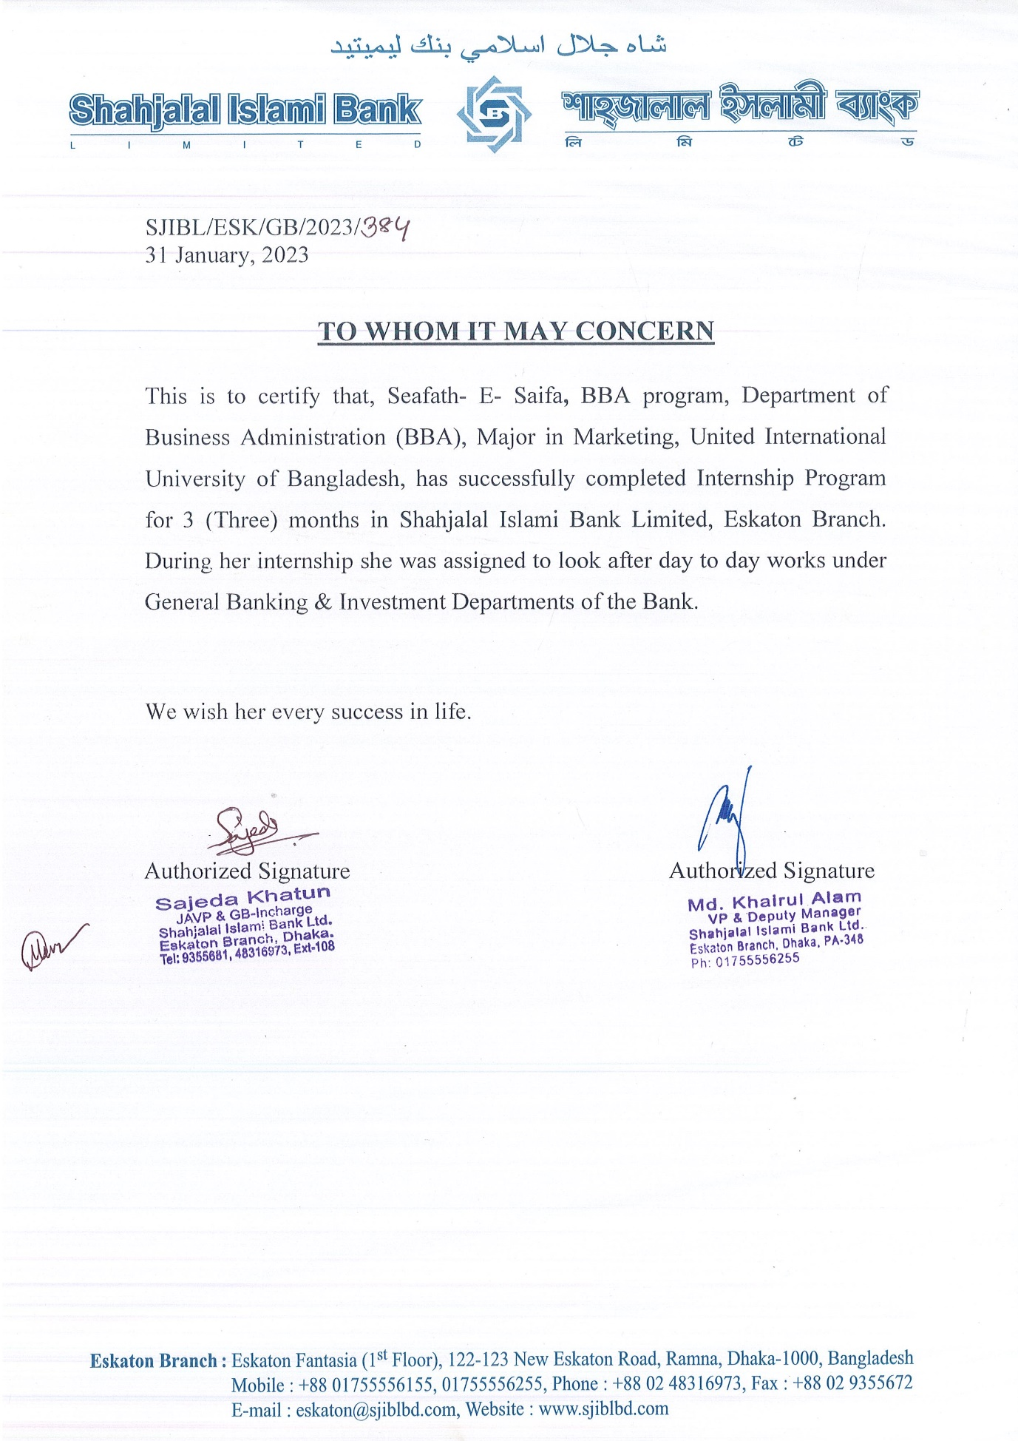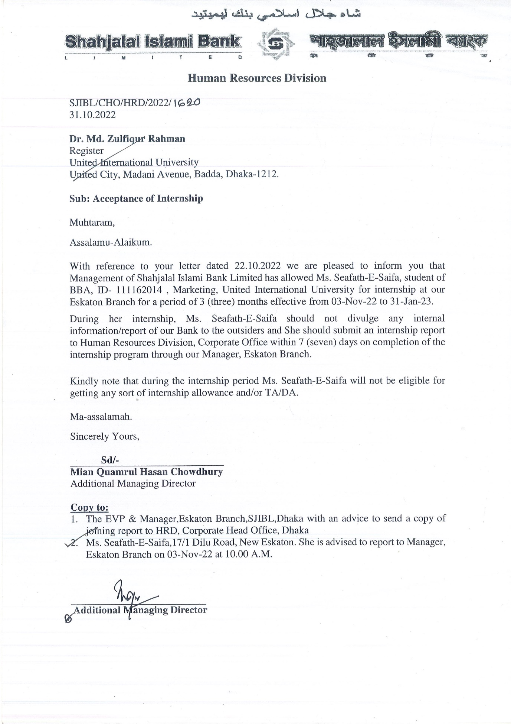

List of Abbreviations
- Shahjalal Islami Bank Limited (SJIBL)
- KYC = Know Your Customer
- TP = Transaction Profile
- GB = General Banking
- EFT = Electronic Fund Transfer
- RTGS = Real Time Gross Settlement
- NID = National Identity Card
- EC = Election Commission
- MOA = Memorandum of Association
- AOA = Articles of Association
- PO = Payment Order
- HP = Hire Purchase
- HPSM = Hire Purchase under Shirkatul Meelk
- MSD = Mudaraba Savings Deposit Accounts
- MSND = Mudaraba Special Notice Deposit Accounts

CHAPTER 1: INTRODUCTION
A country’s Economic Prospect is measured in terms of its financial independence, it’s financial sustainability and its production possibilities. As we all know, Bangladesh is slowly and steadily emerging from a developing nation to a more economically sound progressive country. It has been possible for a numerous reasons and one of them is the fact that our country’s banking sector is seemingly booming over the past several years. The Banking Industry in our country is flourishing due to the huge flow of Investments that are occurring on a daily basis and partly to the overflow of Remittances. The Banking Industry plays an important role in the country's economic development. Banks act as intermediaries between the lenders or depositors who are willingly putting their money in the banks in order to obtain certain financial gain. Thus banks form a bridge between the lenders and the borrowers (who are willingly accepting the borrowed money with respect on an agreement upon the fact that they are going to share their certain amount of profit they are about to make on their businesses. These are known as Investment Sections of the Banking Division. If the Entrepreneur or Business Model fails, the borrower has to take the responsibility of the borrowed money and the revolving interest.
The Islamic Banks in our country operates in quite a familiar method but they do not believe in charging Interest as Business Models or Entrepreneurs may fail to make a profit or they may accidentally incur a loss in their respective businesses. Rather, the Islamic Banks, particularly Shahjalal Islami Bank make their investments based on the Shariah Principles- known as the Bai Mechanism (Trading Mode) or Share Mechanism (Financing Mode) and the Ijara Mechanism (Leasing Mode) Investments. Under these three broad form of Investments they have many sub-categories of Investments Schemes like Bai-Murabaha, Bai-Muazzal, Mudaraba, Musharaka, HPSM, etc.
Bangladesh Bank is the governing body of all Public and Private Limited Banks. Thus all banks in Bangladesh follow the Bangladesh Bank's financial act and security compliance regulations. The Bangladesh Bank establishes rules and closely oversees commercial banks' compliance with them.

1.1 Background of the Report
This internship report has been composed after a particular period of being an intern in the Shahjalal Islami Bank, Eskaton branch, Dhaka. The period of internship was off three months where a Bachelor of Business Graduate must undertake this course work as a pre-requisite to complete his/her BBA Degree. I was thrilled to join as an intern over there where I learned the do’s and don’ts of the Corporate World. Primarily I gained knowledge about the Corporate Culture of Bangladesh where I was exposed to large and essential information and insights of the banking division. I finally managed to achieve all the informative data, facts and figures suggested by the banking professionals and thus it helped to create this report. I assure you that this report is my own work and contains details of my knowledge and experiences taken from this three month of internship at SJIBL.

1.2 Objectives of the Report
This report has been prepared in order to deliver a brief idea upon the Marketing Practices of Shahjalal Islami bank primarily focusing on the Shariah based services. The objectives of this report is to analyze the Shariah based practices of the Islami banks in particular SJIBL where the institution provide loans to borrowers without charging any ‘Riba’ or ‘Interest’. As mentioned earlier, the SJIBL have different lending schemes through which the financial institution manages to do so. The objective of this report is to make Islamic Banking familiar with the consumers/people of this country. Islamic banking introduces a relatively new concept of banking based on principles that follow the Quranic standards prohibiting usury and certain activities, such as lending money for interest. This is known as the Shariah Based Banking System and how SJIBL is trying to make it popular among its existing and potential customers. Furthermore, this report will assess the performance of SJIBL in comparison to its rival Islami banking institutions. Beside this report will justify how the Islamic banking of SJIBL is providing in socio-economic development of Bangladesh?

1.3 Motivation of the Report
As Islamic Banking is relatively a new concept in this world today, I thought articulating a report would be beneficial for our generation. Through this report, people would be enlightened on how the Islamic banking system works and how this Shariah based rules and regulations may allow the potential customers to take loans from these banks for investment purposes and how in other words avoid paying a large sum of interest which the conventional banks and other financial institutions charges. Small scale investors like new entrepreneurs can advantage of this banking system.

1.4 Scope and Limitations of the Report
The scope of this paper is confined to the marketing tools and techniques of Shariah based rules in SJIBL. The banks provide financing for a variety of loans, which are divided into fund-based loans such as the Bai Mechanism (Trading Mode) and the Sharing Mechanism (Financing Mode) and non-fund-based loans such as the IJARA Mechanism or Leasing Mode. It helps in our perception of the risk associated with favouring a borrower for a loan. This forces us to calculate the potential borrower's solvency and estimate the net value of their wealth, which helps SJIBL decide the maximum loan amount they might lend to the borrower.
As I prepared this report, I faced certain limitations of resources such as time constraint and useful data collection was hampered because of confidentiality purposes and internal data was unavailable to be used by a student. Other than that, my seniors and colleagues were busy in their day to day responsibilities so enough extraction of information was not possible by simply interviewing them.

1.5 Definition of Key Terms
- Credit Worthiness: An assessment of a persons or a business ability to pay for goods purchased or services received.
- Portfolio Construction: Assessing client’s investment objectives and associated risk tolerance to meet those objectives. In other words, selection of assets and their weights.
- Portfolio Analysis: Estimate or calculate portfolio’s performance on a regular basis in relation to market movements and primary objectives.
- Portfolio Revision: Passive, active and formula plans are the types of portfolio revision. In total, revision strategies include, Rebalancing and Portfolio Insurance.
- National Interest: The lending banker should be careful in giving loan so that it is not used against national interest.
- Diversification: Loan should be diversified into different form to various hands. Concentration to a limited hand is very risky and against socio-economic development.
- Security: Since it is peoples’ money for the purpose of return, no loan should be given without security both primary and collateral in case of need.
- Bai – Mechanism: It is a form of investment mechanism heavily dependent on the Shariah Principles.
- Bai – Murabaha: It is one of the categories of Bai Mechanism where the value of goods purchased are added with the obtained revenue from the business and is returned to SJIBL as gain from the business against the loan taken. Mainly, Bai-Murabaha means sale on agreed upon profit.
- Bai – Muajjal: In Bai - Muajjal mechanism, the borrower promises to pay the debt in easy instalments or in accumulation to SJIBL in the upcoming years so that the bank SJIBL finally agrees to buy the products or goods ‘on credit’ on behalf of the borrowers. The borrowers have to share a certain amount of profit along with the hired money which the bank has financed through its depositors.
- Bai – Salam: It means to buy the manufacturing goods beforehand for the existing clients or potential sister concerns of the mother company who is now an existing client of the bank SJIBL. It is done before the borrowed company requests for loan to SJIBL based on certain hints or clues.
- Bai – As – Sarf: It means purchase or sell of foreign currency, gold and silver.
- Bai – Istisna: The word Istisna has been derived from the word ‘‘SANA’A’’ that means making, manufacturing and constructing something. Istisna is an agreement in a sale at an agreed price whereby the purchaser places an order to manufacturer, assemble or construct anything to be delivered at a future date.
- Bai – Istijrar: It is also known as the Supply Contract. It is a form of repeat sale/purchase arrangement of normal sale in which a seller agrees to sell in various limited amounts/units of a product/good from time to time. The seller may deliver the product agreed upon once in a number of consignments and the payment is done in advance. The terms & conditions of repeat sale might be made in cash or on credit sale. A deed may take place between the buyer and the supplier where the supplier decides to supply a particular product on an ongoing basis at a reasonable price & on the basis of agreed mode of payment, i.e. monthly.
- Share Mechanism: Shared mechanism involves two types of funding in Islamic Rules and Regulations and as the term suggests the profit/loss is shared between the two parties. For example: SJIBL (the bank) and the borrower.
- Mudaraba: It is a kind of contract and is one of the Shariah based Islamic financial instruments that sanction funds to the borrower to be used into their profitable business ventures. One party provides labour/expertise and is known as the Mudarib and the other party provides capital known as the Rab El Mal.
- Musharaka: It refers to a joint partnership under the Shariah Principles where two or more parties combine together to invest their accumulated capital or provide expertise or labour and the profits or loss are shared according to a specific ratio.
- Leasing Mechanism or Ijara: As the name suggests Ijara is a type of leasing mechanism where one party acts as the Hiree (Lessor) and the other party acts as the Hirer (Lessee). It forms as a deal or a pact between the two parties where one party gives the other party privilege to use their property or asset for a specific time in return for a fixed payment.
- Hire Purchase (HP): It is a form of agreement where the borrower cannot become the owner of the asset until and unless full payment of the purchased asset is made to SJIBL (the Bank). In the meantime, SJIBL rents the asset for use to the borrower.
- Hire Purchase under Shirkatul Meelk (HPSM): It is a kind of hire purchase agreement that has been developed through practice and approved in Shariah. It is a combination of three contracts:

- Shirkat is partnership.
- Sale Contract is decided by buying/selling of goods.
- Ijara means rent.

CHAPTER 2: COMPANY AND INDUSTRY PREVIEW
Banking sector is one of the major financial institutions of a country and for a progressing country like Bangladesh well established banking system serves as a backbone in the socio-economic development of the country. In the year 1974, the People’s Republic of Bangladesh Governing Body signed a deed with the Islamic Development Bank and dedicated itself to rearrange the monetary and economic system of the country as per the Islamic Shariah rules and regulations. Bangladesh Government showed positive attitude towards the principles of the Shariah Laws and encouraged Islamic Banks to operate in the Bangladeshi financial markets. This is how the Shahjalal Islami Bank came into existence in the year 2001.

2.1 COMPANY ANALYSIS:
Shahjalal Islami Bank is a very promising financial institution. In this era, of industrialization and globalization where developed countries are moving into a free market economy, the challenges of successively running a bank is huge. And the stakeholders of SJIBL is trying very hard to run this bank as smoothly as possible. Below, the company SJIBL has been further explored.

2.1.1. Overview and History
Shahjalal Islami Bank Limited is a privately owned commercial bank that is run in compliance with the Shariah rules and regulations. In accordance with the Islamic principles of the Banking Corporation Bill that has been recognized in the Act. of 1991, Shahjalal Islami bank was founded on 10th May, 2001. The Shahjalal Islami Bank has been named after the Saint Hazrat Shahjalal (RA) who faithfully dedicated his life to help others and tried to assist people in attaining global peace in this worldly life and the hereafter. Moreover, to make sure of the well-being of all our rural and urban areas SJIBL founded another Sister Concern named Shahjalal Islami Bank Foundation that runs via funds from peoples’ C.S.R activities and through Zakat.
SJIBL’s operations and services have grown from time to time and they have managed to establish many more branches in major cities like Khulna, Chittagong, Dhaka, Barisal, Sylhet and in many more cities throughout Bangladesh. As the bank has established the Shariah based Islamic Banking System, it is very popular among the aggregated Muslim Community. The Managing Directors and the Board of Trusties of SJIBL is extremely knowledgeable and they possess great expertise in their own respective fields particularly in the banking division so the bank has been performing well in all these years. The management group is directed by one of the senior most experienced banker known as Muhammad Shahidul Islam.
SJIBL is becoming a strong rival to all other conventional banks as its projects yield a higher return on investment. SJIBL loans are rather investments that they provide to its customers. SJIBL is always looking for new opportunities for invest. SJIBL has shaped the country’s economic system in certain ways and has made a prominent place for itself in the country’s banking industry. It has a keen process of investment and plays a vital role in foreign trade.

2.1.2 Trend and Growth

From the early development of societies, banks have not only served solely as moneylenders, the earlier known banks which were mere Temples used to serve as Repositories for valuable items and grains and the temple priests would provide the above mentioned resources to the local peasants, farmers and people as loan. However, these temples used to record this kind of transactions which were later known as ‘BOOK KEEPING’.
Today’s banks indulge in a lot of transactional and book keeping activities and nevertheless Shahjalal Islami Bank is no exception. Shahjalal Islami Bank was established in 10th May 2021 and it started its operation immediately afterwards. SJIBL was named after the famous Islamic Scholar ‘Hazrat Shahjalal (R),’ who devoted his life in serving people and peace among them and educating commoners about Allah and the afterlife. SJIBL is an Islamic-compliant commercial bank in the private sector and is here to confirm the welfare of the greater community, the bank established the "Shahjalal Islami Bank Foundation" with funds from C.S.R. & Zakat.
At present it has 140 branches around the country;
- In Dhaka and its surrounding areas, SJIBL has 75 branches
- In the district Barisal, the bank has 5 branches
- In Chittagong division it has 32 branches
- In Khulna division the bank is serving the people with 9 branches
- In Rajshahi division, 12 branches are there
- In Sylhet division, it has 7 branches
The primary goals of the Shahjalal Islami Bank Foundation are:
  - to provide the underprivileged and suffering.
  - to assist financial aid for study to deserving yet underprivileged pupils.
  - to help flood, storm, or catastrophically affected victims cash aid & to assist in human rights.
  - To offer funding for the country's culture and sports.
  - To develop and take part in environmental and social initiatives.

KEY FINANCIAL HIGHLIGHTS

TOTAL ASSETS
2023-339,819m
2022-313,731m
2021-293,518m
TOTAL DEPOSITS
2023-Tk.34,064m
2022-Tk.33,778m
2021-Tk.28,308m
TOTAL DEPOSITS
2023-Tk.227,982m
2022-Tk.217,289m
2021-Tk.218,443m
TOTAL ASSETS
2023-Tk.339,819m
2022-Tk.313,731m
2021-Tk.293,518m

IMPORT BUSINESS
2023-Tk.254,756m
2022-Tk.248,934m
2021-Tk.148,496m
COST OF FUND
2023-5.27%
2022-2.28%
2021-7.39%
EXPORT BUSINESS
2023-Tk.265,942m
2022-Tk.191,899m
2021-Tk.133,580m

OPERATING PROFIT
2023-Tk.8,335m
2022-Tk.6,004m
2021—Tk.4,095m
ROE
2023-16.92%
2022-13.70%
2021 – 11.08%
EPS
2023-Tk.3.26
2022-Tk.2.39
2021-Tk.1.85

2.1.3 CUSTOMER MIX

The majority of the population of Bangladesh comprises of Muslim communities. Keeping this in mind and to meet the ever-growing demand of Shariah Based Laws and Principles while performing banking transactions for the firm believers of Islamic mindset followers, the Shahjalal Islami Bank emerged as a breakthrough national institution that discourages RIBA i.e. INTEREST and aids to perform banking transactions through smooth multiple Shariah Based Islamic ways of money lending and borrowing techniques that are specifically and solely based on Islamic principles. From above mentioned points, we can conclude that the ‘TARGET CUSTOMERS’ of Shahjalal Islami bank are practicing Muslims. Although there are people as their clients who are from different religions but are fascinated by the Islamic methods of borrowing and lending money. A popular Australian Jewish Society issued collections of documents (Magid 1986) that why are the Islamic Shariah based banking system becoming widespread around the world and in a recent research paper named ‘Customer Demographics Affecting Bank Selection Criteria’ mentioned why Shariah based banking system is popular due to three major factors. They are:
- To make an aggregated Islamic political and economic system around the world.
- To try and create a pure Islamic economical system in Islamic regions.
- To adopt to the Shariah laws as the foundation for business transaction.
However, the idea of Islamic banking system comes from the desire to conduct business financial activities in harmony and aligning with the Shariah principles which gave rise to the idea of opening Islamic window services for the conventional banks.
Moreover, the Islamic fundamental monetary techniques such as risk-profit sharing principles which gives an upper hand to the Islamic banks compared to the non-Islamic banks and thus allows an equitable circulation of resources to the general public. This is why non-muslims are also interested in utilizing the services of Islamic banks around the globe and this brews tension as well as severe competition from the conventional banking sectors.
Coming Back to SJIBL services that are not only restricted to the Muslims but are also popular among the people of other religion due to their commitment to cater to the client’s best satisfaction. To categorize customers’ requirements and to observe those needs and view to fulfil the required needs. This is why they are growing and opening branches almost in every district. One can also observe that the pool of customers of SJIBL comprises of diversified general public who belongs from every walk of life – from top class business men to general housewife, from remittance earners to local vehicle drivers, etc.

2.1.4 PRODUCT / SERVICE MIX

As we are all aware of the financial instruments (different products and services) offered by financial institutions such as banks to the general public to cater the different needs of the common people in order to make them economically sound in their daily lives. SJIBL as a bank is no different. Their policies, products and services encourages common people to take up challenges like investments, loans, purchasing of shariah based bonds and schemes like deposit accounts, savings accounts, cash management, line of credits, foreign currency loans, etc. Some of the popular products and services of SJIBL are listed below:
DEPOSIT ACCOUNTS OF SHAHJALAL ISLAMI BANK LIMITED
- Mudaraba Savings Deposit Accounts (MSD) – This is the most hyped savings account of SJIBL with a monthly profit-sharing ratio of around 2 % to assist people to save their precious money on a monthly basis.
- Mudaraba Money Spinning Accounts - This is also a deposit scheme of SJIBL where an individual can open an account to save their money with an opening balance of BDT 10,000/- (minimum). Account maintenance is free for a year. Afterwards, necessary charges apply to this account.
- Mudaraba Savings Account Pay-Roll Scheme – This account is encouraged to be opened by service holders or by people who are employed in different offices and industries based on their monthly salaries or wages with a ratio of profit-margin of 2% to be maintained in this account at all times.
- Mudaraba School Banking Account – It is for the little dwellers of our country who are enrolled in any school of Bangladesh. This account is opened by the children’s legal guardian who operates and manages this account on the kids’ behalf. Age criteria applies to this account. Usually from four to seventeen years old are encouraged to open this sort of account under the supervision of their parents with an opening amount of BDT 200 and that little one can also enjoy card privileges to a certain limit. 2.5% profit sharing ratio is relished by the account holders.
- Al- Wadiah Current Deposit Account – Al – Wadiah is the term given to the depositor’s reserve of money that is the ‘Amanat’ or ‘Bailment’ and is given power to the mentioned bank (SJIBL) to utilize the reserved money in any Shariah based investment and the Bailee (SJIBL) is generally responsible to give the deposit back to the Bailor (to the depositor) on demand. It is opened by companies and organizations to enjoy a higher transaction benefit compared to the usual deposit schemes.
- Mudaraba Special Notice Deposit (MSND) – Mudaraba Special Notice Deposit (MSND) owner enjoys the combined privileges of the accounts of Al- Wadiah and Mudaraba Savings Deposits Accounts. MSND owner gets the chance to withdraw large funds and is subjected to profit sharing opportunities in this account.
- Mudaraba Term Deposit – It is a profit/loss sharing financial service of SJIBL. This is opened by people who want to utilize their money in investments that relies upon the Shariah principles. It is opened for a fixed period of time. Usually varying from 90 days, 180 days, 360 days or above and these accounts are matured at a fixed date with an opening balance of ony BDT 2000/-.
- Mudaraba Cash Waqf Deposit Account - It is an agreement between the depositor and SJIBL where the account holder benefits by the Mudaraba Principle of Islami Shariah.

Deposit Product | Provisional Rate
Mudaraba Savings Deposits | 2%
Mudaraba School Banking Account | 2.5%
Mudaraba Savings Payroll Account | 2.0%
Mudaraba Foreign Remittance Savings Account | 4.5%
Mudaraba Money Spinning Account: Daily Product Basis
BDT. 1 Lac to less than BDT. 10 Lac | 2%
BDT. 10 Lac to less than BDT.1 Crore | 2.25%
BDT. 1 crore to less than BDT. 10 Crore | 2.50%
BDT. 10 Crore to less than BDT. 100 Crore | 2.75%
BDT. 100 Crore & Above | 3%
Mudaraba special Notice Deposit: On Average Balance
BDT. Less than 1 Crore | 2%
BDT. 1 Crore to less than 25 Crore | 2.5%
BDT. 25 Crore & Above | 3%
Mudaraba Term Deposit
90 Days
- For Individual, Provident Fund, Retirement & Other Benefits | 7.25%
- Corporate & Others | 5%
120 Days to 360 Days
- For Individual, Provident Fund, Retirement & Other Benefits | 8%
- Corporate & Others | 5%

DEPOSIT SCHEMES OF SHAHJALAL ISLAMI BANK
  - Mudaraba Monthly Deposit Scheme – As an account holder this scheme provides double benefit and triple benefit according to the time duration for how long the funds were in that particular account till maturity date. A 6% profit will be shared if the funds remained in the account for around 12 years and a profit of around 6.25% if the fund remains in the account for 18 years.

Mudaraba Monthly Deposit Scheme* | Provisional Rate
3 Years | 9%
5 Years | 9.25%
8 years | 9.50%
10 Years | 9.75%

  - Mudaraba Monthly Income Scheme - It provides us the benefits of multiplying the money by fixed percentage if already BDT.1 Lac is already deposited into this account.
Mudaraba Monthly Income Scheme*
1 Year | 8.70% (Tk.725.00/- per month per lac before tax)
2 Years | 8.70% (Tk.725.00/- per month per lac before tax)
3 Years | 8.70% (Tk.725.00/- per month per lac before tax)

  - Mudaraba Hajj Deposit Scheme - People who are interested to perform Hajj can undertake this scheme to deposit the money required for performing Hajj. The slight details are given in the table.

Year | Rate | Monthly Installment in BDT. | Expected Amount at Maturity
1 | 8.75% | 48,000 | 604,040
2 | 8.90 % | 24,000 | 632,565
3 | 9.05% | 16,150 | 670,135
4 | 9.21% | 12,250 | 713,120
5 | 9.35% | 10,000 | 767,140
6 | 9.45% | 8,200 | 796,610
7 | 9.55% | 7,100 | 850,825
8 | 9.60% | 6,250 | 904,740
9 | 9.70% | 5,500 | 950,465
10 | 9.85% | 5,000 | 1,023,805

OTHER BANKING SERVICES
  - ATM Services
  - Remittance Services
  - Locker Services
  - Online Banking
  - SMS Push-Pull
  - SJIBL Student File
  - Evening Banking Services
  - Internet Banking Services (SJIBL NET)
  - Utility Bill Payment Services
  - Priority Banking Services
  - E-Account Opening Service
RETAIL INVESTMENT PRODUCTS:
- Household Durable Scheme
- Housing Investment Program
- Car Investment Scheme
- Semi Pukka Housing Investment Scheme
- Investment Scheme for Executives
- Investment Scheme for Doctors
- Investment Scheme for Marriage
- Investment Scheme for Overseas Employment
- Investment Scheme for Education

SOME CORPORATE INVESTMENT PRODUCTS:
- Bai-Muajjal – In Islam Bai-Muajjal means purchase and sale after a fixed period. It basically gives us the idea of selling an asset where payment for that asset has been made at a future fixed date. In conventional banking system, it is a sale on credit.
- Bai-Salam – According to Islamic context, it is a contract where full payment has been made in advance for specific goods (often agricultural products) to be delivered at a future date.
- Murabaha – A Shariah based financing structure that provides the customers a sales contract, fixing the price of goods or items as mentioned by the customer, inclusive of a pre-agreed profit margin.
- Qard-E-Hassana – Qard-E-Hassana is a loan provided due to generosity purposes to bring economic development to the organization taking it. The organisation need only to refund the amount they borrowed, with no interest. On principle, Islam does not allow interest. If the Borrower faces difficulty the time period is extended again for easy repayments.
- Lease/Ijara - One side is the ‘Hiree’ (Lessor) and the other side is known as the ‘Hirer’ (Lessee) in a legal agreement to purchase a rented asset or property for the reason to take advantage of the asset's services undertaken by the Hirer in exchange for rent and the asset's value is paid to the ‘Hiree’ in easy instalment facility in order to gain the ownership of mentioned rented asset. In conclusion we can say that a Hirer buy transaction, both the groups involved signs a legal contract that is put into action at a time. As soon as the lease term ends, a Bai takes charge, which originates the sale or purchase of the property mentioned in the first contract
- Hire Purchase Under Shirkatul Melk (HPSM) – it is a form of hire purchase agreement SJIBL jointly buys with the organization an asset as per the contract, rent out the asset to the client against some rented amount and the organization then periodically makes payment to the bank in easy installments within a given time frame.

Some SME Investment Products:
- Biological or combination of Biological and Chemical ETP
- Solar Grid
- Machineries (Energy Auditor Certified)
- Zigzag Brick Field (other than coal-based)
- Green Featured Building
- Organic Farming
- Rooftop/ Vertical Agriculture

VISA CARDS
- Debit Card
- Classic Credit Card
- Gold Credit Card
- Platinum Credit Card
- International Prepaid Card
- Local Gift Card

2.1.5 OPERATIONS

Shahjalal Islami Bank Limited started its commercial operation in harmony with the principle of Islamic Shariah on the 10th May 2001 under the Bank Companies Act, 1991. During these years SJIBL has diversified its service coverage by opening new branches at different strategically important locations across the country offering various services and products both investments & deposits. Islamic Banking, in essence, is not only INTEREST-FREE banking business, it cares to deal wise business product thereby generating real income and thus boosting GDP of the economy. Board of Directors enjoys high credential in the business arena of the country, Management Team is strong and supportive equipped with excellent professional knowledge under leadership of a veteran Banker Mr. Mosleh Uddin Ahmed.
At present it has 140 branches around the country. ATM Services of SJIBL are also available in various points across the country.
- In total our Dhaka division has 75 branches of SJIBL. They are located at Ashkona, Ati Bazar, Baipail (Dhaka EPZ), Banani, Bandura, Bangshal, Bijoynagar, College Gate, Dhania, Dhanmondi, Dhaka Main Branch, Eskaton, Foreign Exchange Branch (Motijheel), etc.
- In Barisal, SJIBL has 05 branches. They are located mainly in Bangla Bazar, Amtali, etc.
- In Chittagong division, it has 32 branches They are located in multiple regions like Agrabad, brahmanbaria, Chawkbazar, etc.
- In Khulna division, SJIBL is operating with 9 branches. They are found in Kaliganj, Khulna, Jessore, Chuadanga, etc.
- In Rajshahi, there are 12 branches. They are at Bogura, Chapainawabganj, Dinajpur, etc.
- In Sylhet, it has 7 branches. They are In Moulvibazar, Habiganj ,Dargah Gate Branch.
Till now, SJIBL established foreign correspondent banking relationship with 18 different banks with a coverage of their global network of 385 branches/units of International repute at different important locations. SJIBL tried to establish accounting relationship with 10 other important banks and maintaining 22 NOSTRO Accounts in 8 (eight) major Currencies at various useful locations.
Number of Employees-
The bank has around 3000 employees that may shift over the years. Its corporate office located in Uday Sanz, Gulshan 1, Plot SE(A), 2/B Gulshan South Avenue, Dhaka, Bangladesh 1212.
The bank carries out different kinds of operations according to its different departments and some specific operations due to the cross-functional departments. Some of the names of those departments and their operations are listed below:
General Banking Division - This division is the core of the SJIBL and carries out operations and activities like accounts opening, petty cash management, remittance earning section (a combined part of general and foreign currency section), Bills and clearing sector and accounts management section, retail banking, etc. Usual cheques are cleared in this section along with duplication and issuing of new cheque books are done here.
Investment Division – It is the department where investments related loans are disbursed, LOC are sanctioned, SME loans are processed, etc.
Remittance and Foreign Currency Department – Reserve of Foreign Currency through inflow and outflow of remittance earnings are undertaken over here. Such as TT (Telegraphic Transfer), Pay Order (PO), Demand Draft (DD), etc.
Human Resource Department – It offers and executes operations like training, screening of potential candidates, etc.
IT Section – It operates and manages online banking transactions and off-shore banking activities.
There are other activities and operations as well that SJIBL carries out with regard to their different departments.

2.1.6 SWOT ANALYSIS

An organization frequently needs to do SWOT Analysis to measures its strengths, its weaknesses, opportunities in different areas and it needs to know the company’s potential threats that might not be evident right now. Shahjalal Islami Bank Limited is no different. It should monitor frequently its competitor’s products, measure its strengths, evaluate its weaknesses, etc.

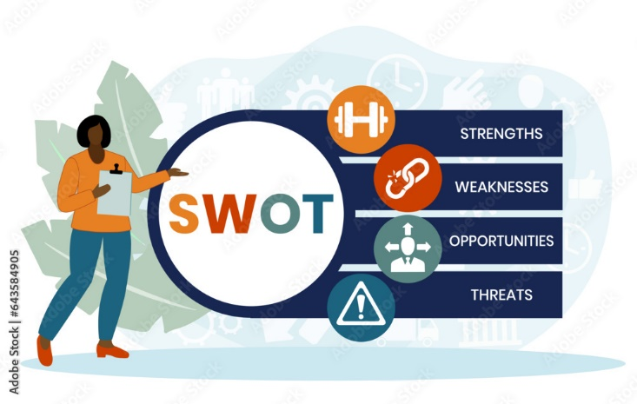

STRENGHTS OF SJIBL:
- Shahjalal Islami Bank Limited is monitored and operated by the Shariah Council as it follows Shariah Based Principles.
- The pool of employers, staffs and the management team are working 24/7 to provide what is best for the customers. They are highly intelligent, experienced and efficient professionals and bankers trying to make our banking experience smooth.
- Online Banking Services are provided.
- Top management team plans and tries to foresee what is about to happen in the future and the all the employees are expected to perform accordingly
- Business locations are quite feasible and strategic.
- Huge Shariah based products and services are offered by this bank.
- Computerized accounts maintenance.
- Adaptability factor of SJIBL is very impressive and SJIBL can get accustomed with the recent changes in the economic front.
- Financial weight and valuable assets position of SJIBL is strong and sound that can be deducted from the Year End Financial Statements and Cash flow statements.
- SJIBL uses Foreign Currency Reserve very cautiously when issuing letter of credit, fund transfer to the maximum security.
- The HR Department does an excellent job by bringing in different intellectual personalities from the industry to excel in their respected field.
WEAKNESSESS OF SJIBL:
- Promotional activity and advertising are restricted to a certain limit and does not often provide enough coverage in the geographical forefront.
- ATM Booths are not adequate and are frequently located across the region.
- Some clients complained that the service charges and other fees like Debit Card charges are high compared to other conventional banks.
- Upgradation of the current website and hassle free internet connection in all the branches should be established.
- Offshore banking should be established in other countries.
OPPORTUNITIES OF SJIBL:
- Recruitment should be made more often and not just a year.
- Micro-credit based investments should be offered to the fishing and agricultural oriented people.
- Many more branches should be opened in all the districts.
- Introduction of Merchant Banking Division based on Shariah principles.
- ATM Booths should be widely available.
- Credit and Debit Cards holders should get more privileges across the world.
- Offshore banking should be introduced in more countries.
- New opportunities of investments should be made.
THREATS OF SJIBL:
- Conventional Banks are introducing Shariah based transactions.
- Bangladesh Bank (BB) sometimes give some instructions that is needed to be aligned with Islamic Principles before implementing into this kind of banking division.
- New potential threats of competitors are growing nationally and internationally.
- Sometimes due to volatility and market pressure the profit sharing scheme is hampered.
- Political ups and downs create an unstable economic front for Islamic banks like SJIBL.

CHAPTER: 3 OVERALL INDUSTRY ANALYSES

3.1.1 INDUSTRY ANALYSIS

The banking industry of Bangladesh is moderately large and growing as there are 62 banking institution operating in the country and 44 domestic Private Commercial Banks (PCBs) entirely owned by individuals and private entities. Due to the political unrest and global upheaval, our banks are facing a hard time but they are trying their best to manage and overcome this crisis.
Our banking industry comprises of conventional banks and Islamic banks. There is some state owned banks, some private banks, some international banks operating in this small country of south-east Asia. Although not all bank has opened Shariah based transaction but some conventional banks did open some form of Islamic principle based borrowing and lending activities. And thus, there are some Islamic banks as well.
State Owned Commercial Banks (SOCBs)
- Agrani Bank PLC
- Basic Bank
- Janata Bank PLC
- Rupali Bank PLC
- Sonali Bank PLC
- Bangladesh Development Bank
Specialized Banks (SDBs)
- Bangladesh Krishi Bank
- Probashi Kallyan Bank
Private Commercial Banks (PCBs)

Conventional Islamic Shariah based PCBs
PCBs

Some Conventional PCBs | Some Islamic Shariah based PCBs | Some Foreign Commercial Banks (FCBs)
Bank Asia Bank | Exim Bank | Standard Chartered Bank
BRAC Bank | Al Arafah Islami Bank | Citibank
City Bank | Shahjalal Islami Bank | Bank Alfalah
Dutch-Bangla Bank | Islami Bank Bangladesh | Commercial Bank of Ceylon
Dhaka Bank | ICB Islamic Bank | HSBC
Eastern Bank | Social Islami Bank | Woori Bank
Mercantile Bank | First Security Islami Bank | Habib bank Limited

Competition is huge among these banks to serve existing clients and to acquire new clients.

3.1.2 SPECIFICATION OF THE INDUSTRY

SJIBL mainly serves the national citizens of our country who has a strong Islamic belief. So this narrows down to PCBs that operates in an Islamic way. Due to the growing demand of Islamic banking reputation, some conventional banks alongside some Micro Financial Institutions (MFIs) has implemented the Shariah policies into their conventional banking system. This increased competition among the conventional and Islamic banking entities.

3.1.3 SIZE, TREND AND MATURITY OF THE INDUSTRY

From the above mentioned summary, we can conclude that the size and trend of this industry is gradually growing. Although not rapidly, but taking its time to grow adjacently when compared to the conventional banking institutions and non-banking financial institutions that tries to implements Shariah policies for example IDLC.
This industry has not yet reached its peak and thus can be concluded that it is a new Industry as it is still growing gradually.

3.1.4 EXTERNAL ECONOMIC FACTORS
- Inflation is a challenge faced by many banks specifically SJIBL and it influences the profit and risk sharing ratio among its lenders and borrowers.
- Political Turbulence upsets the financial and fiscal year policies.
- Import-Export and RMG Industries further play a vital role in money lending and borrowing services of SJIBL.
- Fluctuation in the exchange rate currency specially dollar and reserve ration imposed by BB sometimes obstruct the smooth transaction process of sanctioning loans.

3.1.5 TECHNOLOGICAL FACTORS
- Technological factors affect SJIBL’s performance as internet sometimes slows down or shuts down in a few branches and then clearing Pay Order Cheques and issuing FT (Fund Transfer) contract process gets delayed.
- Online Banking issues arise when the apps or website does not function properly.
- Funds related like LOC and Off-shore banking system comes to a halt when the internet becomes inefficient.

3.1.6 BARRIERS TO ENTRY
As this is a relatively growing industry, there are no significant barriers for entering into this industry. Until and unless political influences occur restricting the entrance into this industry. But more studies and research should be made into the Islamic Perspectives to manage funds through borrowing and lending. Detail studies and emphasis of Islamic Scholars can enlighten us more about how to conduct business in a proper ‘HALAL’ method. New competitors can easily enter this industry if they have adequate knowledge and funds.

3.1.7 SUPPIER POWER
There are around ten to eight Islamic banks operating in this sector and some non-banking financial institutions and some conventional banks offering Shariah services and products. So, this gives more power to the suppliers’ end to propose for more ‘Munafa’ that is profit sharing. This will eventually become a burden to individuals who have taken loans from these banks. And the interest rates keep on increasing due to the economic condition and political agenda in our country. Dollar rates which is the exchange rate keeps on fluctuating as resource of reserve is limited. Although Bangladesh Bank tries to monitor these abrupt changes but BB still needs effective management policies to amend these changes.

3.1.8. BUYER POWER
The buyer power is somehow overshadowed by the supplier’s power to increase interest on every financial instrument offered by SJIBL or by any other Islamic banks as there are few Shariah based business entities.

3.1.9. THREATS OF SUBSITUTES
Substitutes can easily enter this banking industry and there is always a potential threat for the existing Islamic banks as commercial banks can introduce products and services based on the Islamic Teachings and Methods of our Beloved Prophet Muhammad (PBUH) on how to do proper business in a ‘HALAL’ way.
There are some products and services which are both available in Islamic Banks as well as Commercial Banks and in other non-banking financial institutions. So customers can choose from these products which is best suited for them.

3.2. INDUSTRY RIVALRY
Industry Rivalry is very common in banking firms as competition is getting tougher day by day and the banks need to have significant market shares to outperform its competitors. Price competition, marketing strategies and advertising campaign of the products needs to be done to capture the client’s attention. New products and services needs to be launched keeping in mind the customers’ requirements and to serve their best interests. Research and development of these new and existing products and services should be done and evaluated frequently.
SJIBL should study more about their competitors offering and price caps for investments.

CHAPTER 4: INTERNSHIP EXPERIENCE
I got to learn many things when I joined as an intern in Shahjalal Islami Bank Limited, Eskaton Branch from my 3 months’ internship period. At first, I learned and was given some responsibilities in the general banking section where I checked Pay Order (PO) through online portal of the banking system and then filled out forms related to clients’ detail information through the various KYC forms. Later I was moved to the Investment Section where I filled out various Mudaraba Investment forms for different business firms. Detailing of my duties is done in the next topic.

4.1. POSITION, DUTIES AND RESPONSIBILITY
Position – I joined Shahjalal Islami Bank Limited, Eskaton Branch as an Intern for a period of 3 months to know the difference between academic knowledge and practical world.]
Duties and Responsibilities – I mainly worked in the general banking division for around 1.5 or 2 months by filling out different forms like Know Your Customers (KYC) profile forms. Eliminating any kind of mistakes and matching the detailed information from the customers’ given National Smart Card ID as proof for verification. I also worked on the Election Commission (EC) Server to match and verify different customers profile and confidential data.
Then I assisted my supervisor in the bank by cross checking Pay Order Information and matching it with a number on the ‘Ultimus’ software.
Helped in opening and closing different accounts. Verified the signature and also put some seal on a few important documents.
Read some articles of association of different companies. Filled out and cross-checked some investment forms.
Listed out lost and expired Debit and Credit cards.
Introduced to the software applications of EFT (Electronic Fund Transfer) and RTGS (Real Time Gross Settlement)

4.2. TRAINING PERIOD
My training period was for 90 days in the bank and I learned how to communicate with my peers such as other Interns and with my seniors. Mainly I was introduced to the corporate culture of Shahjalal Islami Bank and I learned how cross-functional teams perform across different departments.
I learned about time management and office etiquettes. Other than that, I applied my Computer skills, team building skills, performing your best under pressure and in a rush.
My gained many insights about the tools and techniques about the financial instruments of Islamic Banking. I also learned about the Sukook Bonds which were not introduced by SJIBL at that time.

4.3. CONTRIBUTION TO DEPARTMENTAL FUNCTIONS
I hope I contributed to different departments of SJIBL through my knowledge and skills. I worked in the general banking division by filling out different forms, verifying clients’ profile and amended some mistakes which needs to be noticed.
I filled out Investment Proposal Forms of Bashundhara Group through the Bai Muajjal (Term) Investment Forms and I also filled out different Ijara forms for proposal of new business ventures of big companies such as Incepta Pharmaceuticals.
Unfortunately, I was not assigned to the duties of the Foreign Exchange Department as it bears excessive risks for an intern like me to verify or fill out any kinds of documents.

4.4 EVALUATION
From my understanding, I can say that being a banker is not easy although it seems very hyped job position but one has to be under constant pressure.
I did my performance quite well so the management team could not find any faults regarding my duties and responsibilities.
Nevertheless, I hope that the intern’s job duties should be much more detail oriented and the higher authorities should trust us more with their job duties and responsibilities. We as interns will not leak confidential information to outsiders.

SKILLS
I adapted to time management skills, office etiquettes, brushed up my communication skills, computational skills and above all if I have done any mistake regarding my work I should own it.

4.6 NEW SKILLS DEVELOPED
I was introduced to the SJIBL own servers where applications like RTGS and EFT and thus I saw how a banking system works online and offline. I learned about office etiquettes.

4.7 APPLICATION OF ACADEMIC KNOWLEDGE

Computer skills were applied and I saw many factors that I learned through my Business Administration courses were put into practical knowledge like making financial statements when some outside auditors were implementing them into action.

CHAPTER 5: CONCLUSION AND KEY FACTS
In conclusion, one can say it was a great learning experience as I witnessed how the practical world operates and how a blend is created through academic knowledge.
Sometimes one has to be certain about the outcomes and in a way has to foresee the future when taking business decision. One has to have that instinct that motivates them to do business. Not everything can be acquired through academic knowledge.
I learned great details about the shariah and Islamic rulings on doing business.

5.1 RECOMMENDATIONS FOR IMPROVING DEPARTMENTAL OPERATIONS
The Human Resource Division of SJIBL should focus on training before assigning duties to their employees and cross functional activities should be encouraged more to create more bonding between team members.
Online training should be provided to each and every employee regardless of designation and age.
Communication and access to the top management team should be improved. Well- informed employees can serve the general banking section more efficiently.
Rotation across departments of different employees should be made as this increases the bonding of the SJIBL family.
Lag time of online banking transaction should be reduced by purchasing new computers and scanners.
ATM booths and Credit-Debit Card facilities should be more available across the nation.
Upgradation of the Internet servers are required.
SJIBL should engage in more CSR activities.
SJIBL should develop plans for tourism companies.

5.2 KEY UNDERSTANDING AND CONCLUSION
All in all, I can say that SJIBL should improvise their strategies, products and services according to the majority of the Client’s preferences. Then only it can excel in its banking industry.

References
https://en.wikipedia.org/wiki/List_of_banks_in_Bangladesh
https://sjiblbd.com/
http://dspace.daffodilvarsity.edu.bd:8080/bitstream/handle/123456789/2466/P12888%20%2823%25%29.pdf?sequence=1&isAllowed=y
https://www.scribd.com/document/311765778/An-Internship-Report-Final-on-Shahjalal-Islami-Bank-Limited-Bangladesh
https://sjiblbd.com/ATM_Locator.php
http://182.160.117.219:8080/xmlui/bitstream/handle/123456789/103/Chapter%2007%20-%20Findings%20_%20Analysis.pdf?sequence=27&isAllowed=y
https://www.google.com/search?q=industry+analysis+of+banking+sector+of+bd&sca_esv=35ffd0becc4189bf&ei=VVpxZ4OhO_SXnesPzq-AqA4&ved=0ahUKEwjDn6mFls
file:///C:/Users/com/Downloads/238-Article%20Text-317-2-10-20190324.pdf
https://dspace.bracu.ac.bd/xmlui/bitstream/handle/10361/6131/12104212_BBA.pdf?sequence=1&isAllowed=y

5.4 APPENDIX
