

UNITED INTERNATIONAL UNIVERSITY (UIU)
Name: Hussein Muse Hassan.
ID: 115202011
TOPIC: Communication skills in HRM.

Dedication:
This research project is my original work, and it has been submitted for a master's degree from UIU University. I dedicate this thesis to my dear wife, Fadumo Mahamud Hassan, my sister Kadijo Muse and all my brothers who assisted me in completing it

Acknowledgement.
From the beginning to the end of this project, I owe my supervisor, Jennifer, an enormous debt of gratitude for her invaluable assistance. Her constructive feedback, careful direction, and patience enabled me to complete the project on time. I'd like to thank everyone at my college who helped me collect data. Thanks especially to Zakarie Abdulkadir and his sister, Zahra Abdulkadir, who assisted me as technicians. Finally, I'd like to express my heartfelt gratitude to the Almighty God for providing me with the strength and resources to carry out this research. I'd like to thank everyone mentioned above from the bottom of my heart.

Table contents:
1-Dedication: ---------------------------------------------------------------- i
2-Aknowledgement -------------------------------------------------------- ii
CHAPTER ONE: Introduction to communication.
1:1-Background: -------------------------------------------------------------------------- 3.
1:2- Study Goals and Objectives: ------------------------------------------------4----6.
1:3- Study Purpose: ------------------------------------------------------------------7—8.
1:4- Research Motivation for the Choice of the Study: ------------------ 8 ----10.
1:5- Problem Statement of the Research: ------------------------------- 10------ 11.
1:6- Communication skills fundamentals: -------------------------------- 11------- 14.
CHAPTER TWO: Concept of communication skills.
2:1- Introduction to communication: -------------------------------------------------- 15.
2:2- Definition of term communication: ----------------------------------------- 15--- 18.
2:3- Importance of communication skills to an organization: ------------- 18---- 19.
2:4- Process of Communication: --------------------------------------------- 19 ------ 20.
2:5- Literature review on communication skills: ---------------------------- 21 ------ 22.
2:6- Questionnaires: ---------------------------------------------------------------- 22------ 23.
CHPTER THREE: Characteristics of communication skills:
3:1- Introduction: ------------------------------------------------------------------------------- 24.
3:2-Types of communication in HRM: --------------------------------------------24 ----27.
3:3 –Functions of communication: ------------------------------------------------ 27---- 30.
3:4- Improvement of communication skills: -------------------------------------- 30---32.
3:5- Good communication creates a great career: ------------------------ 32 --- 33.
3:6- Tips of effective communication in workplace: -----------------------33 ----- 37.
CHAPTER FOUR: ANALYSIS OF DATA AND RESULTS:
4:1-Introduction: ---------------------------------------------------------------- 37 -------38.
4:2: Structure of research: —————-------------------------------------------- 38
4.3: Research area: ———————--------------------------------————— 38
4.4: Population to be targeted: ———---------------------—-—————— 39
4:5: Demographic information: —————--------------------——— 39--- 45
4:6: Data Analysis And Presentation: —————------------------- 46 --- 55
4:7: Important Findings —————————---------------------------—— 56
4:8: Conclusion And Recommendations: -------------------------------- 56 – 57.
4:8:2: Recommendations ---------------------------------------------------- 57—58.
4:8:3: References: ------------------------------------------------------------- 58—59.

CHAPTER ONE: Concept of communication.
1:-1- Background/Introduction. Communication is the act of expressing thoughts, information, opinions, facts, and feelings, among other things. It is a necessary fundamental system for human life in this world, and nobody can live alone for their entire lives. It is also a process of expressing ideas, information, views, facts, feelings, and so on. To put it another way, communication is the process of transferring information between two or more people in order to create mutual understanding. As a result, the major phases in communications are message creation, message encoding, and signal transmission to individuals via technology.
A manager may be extremely qualified, skilled, and talented, but if he or she lacks effective communication skills with his or her staff, the rest of their qualifications become meaningless. To get work done from his organizational subordinates, a manager must communicate effectively with them. Effective communication builds good relationships and organizes employee performance in organizational structures. Typically, messages in organizational contexts have a specific goal, such as motivating, informing, teaching, persuading, or inspiring. One of the primary distinctions between casual conversation and managerial communication is the existence of a specific goal; therefore, effective workplace communication is dependent on well-defined goals that support the organization's goals and mission.

1: 2- Study Goals and Objectives:
A primary communication objectives are to convey important information such as instructions, policies, decisions, and specific communication goals. As a result, the communication receiver will listen, read, and comprehend what is said, and will attempt to react or respond in the manner intended by the manager or sender of communication.
The manager, on the other hand, will credibly prefer to influence the employees in a way that focuses on maintaining positive relationships. Other motivating factors or objectives of managerial communication, such as personal advancement or self-expression, may be interchangeable.
Management information systems have taken on and are being used with unprecedented importance in modern management. Then we always want effective communication to get decisions to those who will carry them out. Communication teaches a group how to think together, see together, and act together in order to achieve specific goals.
In reality, there could be no organization or company without communication, because people would be linked by a chain of instruction but acting without a chain of understanding. Poor communication leads to poor collaboration. Similarly, effective communication within the organization is essential for cooperation.
Communication objectives assist you in comprehending the significance of communication. The following are some examples of communication goals:

1:2:1-Building awareness.
This is a significant point for both organizations and individuals these days, as most firms want to ensure that their information about their products and services reaches as many people as possible, so the better you communicate with your employees, the more awareness you can gain or convey your message
1:2:2: Providing information
One of the most important goals is to recognize when your clients are looking for something and how to satisfy their needs. As soon as you respond to their needs, this may lead to good communication between the manager and employees.

1: 2:3: Creating Interest.

Some clients, for example, are interested in specific items or are just familiar with a particular product or service. As a result, you must ensure that they may advance from being aware of the product to being enthusiastic about it. This is a factor that can be accomplished through effective communication.

1:2:4: Motivating Audiences.

Employees are empowered to pick a greater performance in an enthusiastic way when the correct emotional intelligence strategies are applied in communication. As a result, the manager may use a variety of methods to promote people's desire, such as workshops, lectures, meet-ups, talks, training, and so on, to motivate audiences.

1:2:5: Offering better Coordination

It is one of the most significant aims of communication when it comes to the productive and efficient administration of the organization.

The exact application of communication tactics that managers might employ to connect diverse functional areas of a company in a way that is result-driven. It's also crucial for accomplishing well-coordinated corporate goals.

1:2:6: Harmonious Relationship between Managers & Workers

The most potent tool for creating trust among employees is communication. As a result, when it comes to communication goals, its importance in maintaining a harmonious relationship between management and employees cannot be underestimated.

In order for performance to continue to develop, the communication strategy must ensure unbiased information throughout the organization.

1:2:7: Job Satisfaction among Employees.
Employee job satisfaction is a critical factor in achieving success when HR managers create an environment in which employees are given the opportunity to express their opinions, desires, and demands. As a result, communication strategies are critical for ensuring that employees have complete freedom of expression while remaining motivated and satisfied
1:3: Study Purpose
The most self-knowledge is gained through communication, studying communication skills involves improving self-knowledge and self-perception about the world. Studying communication skills such as verbal or nonverbal communication, written communication, and visual communication allows us to convey meaning as intended by the sender.
It directs the selection of the appropriate speech for the appropriate occasion. Knowledge of communication skills can assist you in selecting a relevant speech and tone for any public speech. For example, in a public presentation, such as in a political matter, you can either inform or persuade the audience to do something. It also helps to communicate efficiently. At each level of the communication process, this is accomplished by decreasing potential misconceptions and removing communication barriers. Communication skills is a subject that teaches effective verbal, nonverbal, and written communication skills that promote information sharing among society members for the benefit of everyone.
Learning communication skills can assist you in identifying communication barriers that must be overcome in order to communicate effectively.
Communication studies assist us in developing positive relationships with our peers. Because communication is how we meet others, it improves our perception of them. It broadens our understanding of relationships by allowing us to explore and learn about other cultures in order to effectively develop and manage relationships and collaborate.
Critical thinking, problem solving, conflict resolution, team building, and public speaking are all enhanced by studying communication skills. Because newly learned communication skills are still being practiced, this is the case.
Studies in communication can help you advance in your job. As a result of the subject, you will be capable of making powerful oral and written communication, collaborate effectively with others, manage your image, and study, analyze, and solve problems.
1:4 Research Motivation for the Choice of the Study.
People pay a high price for communication to be an effective factor that can promote employee confidence and engagement, so good communication can foster cooperation and unification of attitude toward the organization's limited objectives.
According to Smith (1994), organizations seek motivated employees in order to survive. This is because motivated employees help organizations survive, and motivated employees are more productive and creative. Managers, on the other hand, have a strong desire to understand the critical factors that boost employee motivation within the context of the roles they play
Managers must understand their employees' needs and priorities in order to influence their employees' performance and productivity. Employee motivation is heavily reliant on effective communication.
Employees must feel respected and valued in order to receive appreciation, which is an important part of the business.
The value of clear communication in promoting morale and self-esteem is highlighted in numerous motivational theories.
Effective communication is also a key component of the Kaizan approach to constant improvement. People who work in an organizational culture that encourages employees to discuss their thoughts and ideas are the most likely to bring about changes (Cummings, 2002).
Businesses that want to empower their employees by giving them more authority and extending their roles must communicate effectively. Employees should be aware of the organization's objectives and comprehend how their jobs contribute to achieving those objectives, as well as how successfully they carry out their duties. Employees who are highly motivated are more inclined to share their thoughts, opinions, and ideas with management and to listen to their advice and proposals (Kinicki& Kreitner, 2006).
Involving a motivated staff in decision-making is also essential. The next step is to recognize that every administrative role and activity involves some type of direct or indirect communication.
Ineffective communication can visibly harm a company's success and cause its stock price to drop. Employee motivation and job satisfaction also require efficient communication (Kinicki&Kreitner, 2006)
According to Elashmawi and Harris (1993), a thorough understanding of organizations is necessary at all stages of the career process, and communication is a critical component in understanding how organizations work and how members of organizations should behave in organizations if they want to advance their careers.
Employees who are demotivated are dissatisfied with their jobs. As a result, a business may suffer as a result of this circumstances.
1:5: Problem Statement of the Research.
Research is a vital investigative process that seeks new facts in order to expand or revise existing knowledge. It is classified into two broad categories: (1) basic research (investigation aimed at increasing scientific knowledge) and (2) applied research (inquiry aimed at using basic research to solve problems or develop new processes, products, or techniques).
Problem statement is a claim used in research to highlight the problem defined by a study. The investigation's findings are summarized in the problem statement.
Operating organizations around the world is extremely difficult today because all aspects of production must be coordinated in order to achieve maximum productivity in the shortest amount of time. Human resources have become the most difficult challenge in achieving good performance; thus, effective employee management necessitates the skillful handling of fruitful thoughts, feelings, and concepts in order to achieve maximum productivity. Organizational communication is essential for overcoming any challenges that the organization's departments may face.
In Somalia, public service managers have traditionally met on a regular basis to either negotiate ways to bring any progress or other reasons such as changes within an organization in closed door meetings with those at the top management levels and instructing those at the middle and lower levels in the organization in closed door meetings with those at the top management levels and directing those at the middle and lower levels in the organization in closed door meetings with those at the top management levels and directing those at the middle and lower levels in the organization in closed door meetings with those at the top.
In recent years, many people have begun to complain about poor communication in Somalia, owing to a lack of a powerful administration with the enforcement to manage all levels of life, so that good communication is a necessary element to seek reduction of sources of stress, which can lead to the fragmentation of rooted relationships between employees and managers or between wife and husband.
1:6- Communication skills fundamentals
The factors that should be addressed while developing a firm foundation for communication skills in any company are the key principles of communication skills. These fundamental principles provide clear guidance for the content as well as a beautiful example of how the information should be presented to the recipient. Clarity, completeness, conciseness, consideration, concreteness, civility, and accuracy are the seven "C's."
i: Clarity
It means that the writing must be exactly organized and conveyed in a credible manner in order to identify thoughts, ideas, and expressions, and the writer must ensure that From start to finish, the thoughts and concepts flow nicely. Even the most illiterate person on the globe must be able to understand the message; hence, the sender must have extremely clear parts of the idea as well as the aim for which it is to be delivered in his or her head.
The speaker could also speak in plain English, using accurate expressions, avoiding excessive use of infinitives, avoiding jargon, avoiding ambiguity, and using short sentences (Saleemi, 1997). The goal of is to communicate as much information as possible from the sender's head to the receiver's head.
ii: Completeness
Completeness of facts, according to Saleemi (1997), is critical. The receiver is irritated by incomplete communication since it leaves him bewildered. If the communicator's actions mislead the audience about the message's meaning, the audience may get confused, and communication between the communicator and the receiver becomes ineffective. A message should be well-organized and include all necessary details. The contents of the communication must be confirmed and double-checked to ensure that no important information is missing. A message that isn't full will fail to communicate information or persuade the recipient.
iii: Conciseness.
Conciseness relates to communicating ideas and thoughts in the fewest words possible, which is shortness; as a result, conciseness influences the reader's or receiver's attention; however, conciseness should not be at the expense of appropriateness, clarity, correctness, completeness, or courtesy (Saleemi, 1997). You should only present essential information, prevent redundancy, eliminate hackneyed and wordy terms, and carefully organize your message, according to Saleemi.
iv: Consideration
Consideration is a key aspect, which entails crafting a powerful message to be given to the receiver's mind at the right moment and in the right place. Because the receiver is always seeking to understand the essence of the sender's message, the communicator must focus on the recipient's mindset.
v : Correctness:
Communication must be perfect in terms of tone and style, spelling, grammar, structure, content, statistical data, and so on. The message should not contain any false statements. Efforts must be made to avoid inaccuracies in papers that have been written wrongly. The heart of accuracy is proper grammar, punctuation, and spelling. The term conciseness, on the other hand, refers to the following conditions if a message is flawless mechanically and grammatically:
1-Using suitable and correct terminology.
. 2-Check the figures, facts, and words for accuracy
3- Keep the writing mechanism in working order.
Vi: Courtesy
It means politeness and decency, and in effective communication skills, the communicator must omit any annoying expressions, use apologizing methods for an omission, and thank generously for a favor by knowing what can satisfy your audiences, so here are some suggestions for generating the courteous tone:
1- Be courteous, attentive, and appreciative
2- Be courteous, attentive, and appreciative;
3- Use nondiscriminatory language.
4- Avoid irritable statements.

CHAPTER TWO: Concept of communication skills.
2:1- Introduction to communication skills.
Our capacity to develop and sustain our social environment is strongly based on how well we communicate. Communication skill is defined as the professional ability to connect effectively with clients, employees, and other professionals. Social skills are essential for people's personal and social well-being
To perform properly, nearly every business relies largely on communication. Effective communication is essential for any business or organization's actions to be successful. It saves time and gives clients and workers the tools they need to succeed. Ineffective communication leads to longer production times and a worse bottom line.
The efficiency and usefulness of a company's or organization's meetings, where goals, targets, and actions to be performed are all contested through communication, are critical to the company's or organization's success. If the ideas are not adequately stated during the meeting, there may be misunderstandings, which can lead to panic, sabotage, delays, and a lack of motivation in carrying out the obligations (Cummings, 2002).
2:2- Definition of term communication skill.
Communication is present in all facets of our lives or is such an integral component of our daily routines that experts estimate that 70–80 percent of our working time is devoted to communication in some way. We regularly share our thoughts, opinions, wants, and sentiments with others around us, not only verbally but also through modern devices like computers and smart phones. Being a good communicator is important in business, especially in situations like e-mails, phone conversations, meetings, speeches, videoconferences, presentations, and one-on-one contacts, which are all different types of communication in different parts of a company.
Communication within the organization is impassable in each department by Regularly speaking about daily duties and the organization's relationships with both internal and external stakeholders. Messages must be given through the desired measurement using both recorded and unrecorded data, either planned or unplanned. It may be hierarchical, with the highest level coming before the lowest, or vice versa. It could be formal or informal, vertical or horizontal, formal or casual, and formal or casual. The most important factor is that the intended audience be reached, regardless of which tools, methods, or forms of communication are used in an organization (McFarlane, 1984).
On the contrary, When communication is sufficient and successful, there will be integrated and coordinated cooperation, and truth and confidence will develop from this common understanding, providing communication process significance in order to achieve the intended objectives.
There are numerous definitions for communication abilities, but I'd want to focus on two or three of them. The Latin word "communis" is the source of the term "communis," which means "common." We share facts or attitudes when we try to communicate, thus I try to choose three definitions. 1- People with good communication abilities can comprehend and be understood by others.
2- Communication abilities are the skills to offer and receive various types of information. Communication of fresh ideas, thoughts, or even a project update are some examples. Communication skills such as listening, speaking, watching, and empathizing will help you understand the differences between face-to-face conversations, phone calls, and digital communications such as email and social media.
3- The sharing of information via speech, writing, or other means is known as communication. There is a sender, a message, and a recipient in every communication. Communication is a complicated subject, but it can be influenced by a variety of things, such as our emotions, ambitions, cultural background, and the medium used to communicate in order to reach specific goals.
According to certain experts, such as Scolt and Mitchell (1976), effective communication is more than just speaking; it is one of the most important skills to cultivate in your life.
The transmitter is the person who sends the message, while the receiver is the person who receives the knowledge or information. Employers, employees, and other company shareholders communicate via exchanging ideas, opinions, actions, skills, arts, meanings, and experiences.
Communication, on the other hand, is a two-way interaction in which the transmitter and receiver switch roles on a regular basis. In light of this, Obilade (1987) claimed that communication is the glue that holds a society together; without effective communication, there would be no cooperation, organizing, coordinating, or social organization. Bello-Imam and colleagues (2007) described communication in this context as a system that allows employers and employees to reflect on the past, assess the present, and make plans for the future. Communication is an essential life skill that may be honed through time. Empathy and satisfaction in others can be easily fostered by persons who are strong communicators.
2:3- Importance of communication skills to an organization
One of the most crucial components of life is the ability to communicate. Employees and managers/supervisors those can communicate effectively using this approach. Communication skills are the talents that allow a person to transmit information to others and grasp the context of the data. They are employed when offering and receiving information in various ways.
Communication skills have become one of the most significant needs for organizational and institutional progress; nonetheless, strong communication skills are an important leadership function and a key quality of a good leader. Excellent leadership strategies and effective communication abilities are intricately intertwined. A lack of communication skills can make team members feel uneasy and bored in their job, but effective communication skills can lead a team to work together to reach the set objectives. Communication skills are necessary for reaching predetermined goals, providing a clear perspective of those goals, and ensuring enough preparation in a proper setting.
When interviewing for a job, the hiring manager may enquire about your communication skills; so, regardless of the organization in which you constantly work, the ability to successfully interact with top managers, colleagues, and employees is vital.
Communication skills are particularly crucial in business because they can help you and your staff work together more effectively, which can enhance morale and productivity.
You can use your communication skills to develop meaningful relationships with subordinates, change their attitudes, lift their spirits, and elicit their cooperation.
Many nations, faiths, and individuals benefit from effective communication because it encourages loyalty, trust, love, connection, sharing, care, and friendship.
Effective communication skills unite individuals in a common cause, promoting population, cultural, and economic expansion. As a result, communication skills are crucial in life. A tongue can make hundreds of allies and opponents at the same time. When we are furious, for example, we lose words and language.
We are unconcerned about a situation in which someone has harmed others. Fathers, moms, loyal friends, wives, and children are unimportant to us.
2:4: Process of Communication.

The sender, the message, and the receiver are the three essential components of communications. The following are some of the details of the communication process:

1. The sender, also known as the communicator, is the individual who initiates communication and sends the message to the receiver. He is the one who started the conversation.

2. Message: The sender's point of view, information, concept, fact, or attitude that he or she desires to communicate to others is called a message.

3. Encoding: The sender begins the encoding process by transforming the data into a message by utilizing predetermined words or nonverbal means such as symbols, gestures, and body motions. The success of the communication is influenced by the messenger's knowledge, skills, perception, foundation, competencies, and other attributes.

4. Media: The medium through which the encoded message is conveyed is referred to as this. The message could be delivered orally or in writing. The telephone, internet, mail, e-mail, and other forms of communication are all included. The sender chooses the best medium for the job.

5. Decoding: The receiver makes every effort to interpret and comprehend the sender's message. It can only be called important communication when the recipient comprehends the message in the same way as the sender.

6. Receiver: The final individual to whom the communication is directed is the recipient. He makes every effort to grasp it as completely as possible in order to achieve the communication aim. The receiver's ability to decode the message is influenced by subject matter knowledge, experience, trust, and the sender's relationship.

2:5- Literature review on communication skills

A literature review evaluates published information on a certain topic, area, or, in some cases, issue over a set period of time A literature review can be as simple as a list of sources, but it usually has an organizational structure and includes both a summary and a combination of sources. A summary is a reorganization or reforming of the source's significant information, whereas a synthesis is a restructuring or reforming of the material. It may be possible to create a fresh explanation for existing material by combining new and earlier interpretations. Alternatively, depending on the circumstances, it may seek out the sector's intellectual advancement, which might include a lot of discussion. The literature review may assess essential sources and advise the reader or researcher on the most pertinent topic, but it mostly focuses on establishing fresh arguments and building the framework for summarizing and synthesizing other people's disagreements and ideas in order to achieve certain goals.

Literature evaluations give you important knowledge on a certain subject. If you just have a short amount of time to conduct research, literature reviews might help you figure out what to do. Expert specialists have important reports that keep them up to date on what's happening in the field. The complexity and breadth of the literature study highlight the writer's credentials in his or her field for academics. Literature reviews also serve as a solid foundation for a research paper's study. The majority of research papers rely substantially on a good knowledge of the literature in the topic.

Because communication is at the heart of company and the most crucial of all entrepreneurial abilities, every organization's capacity to convey information has a favorable or bad impact on both clients and employees, and this is usually the case. However, communication is more necessary today than in past years, owing to the increasing complexity of business and market conditions as a result of current technology's high level of sophistication.
The success and implementation of a communication strategy can benefit an organization in a variety of ways, including keeping employees motivated and engaged and communicating clear, consistent messages to employees in a timely manner, all of which contribute to organizational productivity and performance (Charles, 1998).
2:6- Research Questionnaires.
The research questions are very important to researchers because they show them how to get more data and collect all relevant information in their observations. The study questions are as follows:
1-Does a company keeps employees in a good communication?
2- Does the employees are satisfied with the company communication?
3- Are Employees communicated respectively in workplace?
4- Does good communication supports employee talent development?
5- Effective communication helps to achieve organizational goals.
2:6:1: Significant Study.
This study will be beneficial to high-level managers and senior authority managers since it will assist them in gaining a better knowledge of how they may ensure that their communication skills research is directed toward employee performance and growth. Furthermore, the study may be valuable for Somalia's organizations and government to adjust their communication skills policies that affirm useful strategies, particularly when it comes to satisfying communication planning.
Experts and academic researchers, on the other hand, will benefit from their extensive research since they will provide an engaging understanding that will serve as a solid foundation for future research. Furthermore, the study will benefit Somalia's public and private organizations by facilitating practical communication about efficient corporate management in order to boost employee enthusiasm and confidence.
2:6:2: Scope Of the Study
This research will be place in Mogadishu, Somalia, between August and December 2021. The study focuses on effective communication skills in Somali companies in Mogadishu since effective and efficient communication skills are a critical component of any organization, company, or public or private institution's ability to achieve its objectives.
CHPTER THREE: Characteristics of communication skills:
3:1: Introduction.
We all know that communication is the process of passing thoughts, information, emotion, and ideas from one person to another through gestures, words, symbols, signs, and expressions.
Communication is crucial in determining whether or not a company will succeed. Motivation is a set of attitudes, ideas, and values that influence a person's or an employee's willingness to work toward a set of objectives. Human needs/wishes and their satisfaction are at the heart of motivation. This is demonstrated by the fact that employees have varying requirements and priorities; therefore, managers must be able to use varied motivational instruments to meet their needs and desires. Individuals' inner drives must be stimulated in order to increase appropriate behavior.
3:2- Forms of communication in HRM
People can express their knowledge, attitudes, ideas, thoughts, and abilities through communication, which is the process of delivering and receiving information. There are two types of communication: verbal and nonverbal.
1- Verbal communication 2- Non-verbal communication.
1- Oral communication is defined as the use of language to communicate information through speech or gestures. In video and phone conferences, meetings, and one-on-one talks, this is the most popular presenting technique. Since it is the most effective, verbal communication is the most crucial. Nonverbal and written communication could be useful to supplement verbal communication.
- Verbal communication factors that are effective.
1- Take a moment to consider what you're going to say before you say it
2- Speak with assurance
2- Be concise and straightforward
4- Recognize your nonverbal communication signals.
5- Pay attention to what others are saying.
6- Consider your audience's point of view.
7- Use a variety of vocal tones.
Verbal communication skills that are important.
A- Oral communication refers to communication that actually happens through spoken words, dialogues, and any messages or information that is sent or exchanged between people using speech or word of mouth. Public speaking, news reading, television, radio, telephone, and mobile chats are just a few examples.
B- Written communication refers to any written word or frequently written symbol that matches to the languages used in any medium. Any handwritten, newspaper, typed, or printed word documents, letters, books, or periodicals, whether typed or printed.
2- Non-verbal communication.

In nonverbal communication, body language such as eye contact, facial expressions, gestures, and others are utilized to convey information. Smiling, for example, conveys kindness, welcome, and openness when you meet someone. Nonverbal communication is used by everyone on a regular basis, whether they are aware of it or not.

In contrast to verbal communication, written text, voice, or sign language are used to communicate information. Physical motions are observed and evaluated in nonverbal communication.
Nonverbal communication is significant because it shows us important things about a situation, like what a person is feeling, how they receive information, and how to communicate with a person or group of people

Advantages of effective nonverbal communication:
There are a variety of nonverbal communication techniques that can aid in good business communication, including the following:
• It lends credibility to your message. Nonverbal cues can amplify the content of your message when you're having a chat, participating in a meeting, or engaging in conversation. For example, using hand gestures to underline the importance of an idea may prompt your audience to pay attention to and remember a key point.
It has the ability to send and receive messages. You can also communicate with others without saying anything. You can nod your head up and down to show your support if someone offers an idea with which you agree.
It demonstrates purpose. Your body language may also express your current mood, whether consciously or unconsciously. People may attempt to decipher nonverbal cues that you are dishonest, eager, or aggressive.
• It provides emotions. Nonverbal communication can also be used to express emotions such as dissatisfaction, relief, happiness, contentment, and others.
• It gives assistance. Nonverbal cues can also be used to express support. Actions, whether a simple grin or a pat on the back, often speak louder than words.
• It indicates a course of action that should be taken. Raising your hand to express an idea or extending your hand to greet a new acquaintance are examples of this.
• It reduces the level of stress. It may be beneficial to use a calm tone of voice, open body language, and directed gestures.
3:3 –Functions of communication skills
The activities for which any organization is designated or in which it is used are referred to as functions. Functions are the responsibilities or missions of an entity. In order to attain some aims, communication functions are coupled with planned missions. In fact, communication functions are functions of a communication system that include a set of basic functions and one or more complimentary functions. A system is defined as a collection of interconnected elements that operate in a procedural, unified, and coherent manner. Systemic entities or groups perform functions.
Functions are important factors in achieving some objectives. It is well established that goals determine the functions of an animated system. But who is in charge of configuring or arranging the goal?
Goals are governed and shaped by needs. Ratiocination is defined as: 1) A system has specific requirements. 2) To satisfy them, make decisions and assessments about some aims, and 3) to put the goals into action. The following is an example of a function equation: Needs lead to objectives, which lead to functions. Needs might be necessities, obligation, imperatives, or mandates, among other things.
Good performance, motivation, targets, and finality are examples of goals. Goals are substituted for needs. Needs are more satisfied as a result of achieving the objectives. However, communication has an indirect role in meeting all demands and achieving all objectives.
Effective communication skills are critical for the everyday operations of any worldwide firm. It gives the organizational process of notifying, persuading, and encouraging a boost. Workers must have good organization's verbal interchange competencies in order to attain exceptional performance.
As a result, communication in organizations serves four basic purposes, according to Oribabor (2004): control, incentive, emotional expression, and information.
A goal of passing information and data inside the organization is to enable employees to redouble their efforts in order to complete their tasks more efficiently. A worker's knowledge of the fundamental principles that govern organizational structures is referred to as information. When people are well-trained to improve productivity and performance, job insecurity is avoided. Communication has an impact on member behavior in a variety of ways.
Organizations should have formal authority hierarchies and directives that direct personnel to carry out critical instructions. According to Akindele (2007), In order to follow their job description or comply with business policy, an employee should first approach their immediate management about any job-related complaints before proceeding to the hierarchy.
Akindele (2007) goes on to say that informal communication influences behavior. Informal communication also regulates behavior. When coworkers make fun of or harass a member for producing too much (and making the workforce's leisure look bad), they are essentially interacting with and influencing the member's behavior.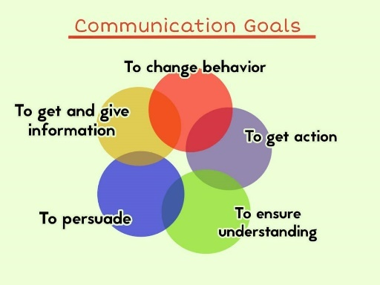
Communication, in addition to controlling, motivates employees by defining who does what, how to do it, and who does it. This helps them perform better. Moreover, Employees can express their emotions and meet their social requirements through communication (Bello-Imam et al 2007). Communication aids decision-making by allowing individuals and organizations to exchange information on which decisions are made This is accomplished through the exchange of data in order to identify and evaluate alternatives. The following communication functions have been expanded upon by CIPM (2007):
Increased productivity is a result of good communication. Employees will be more aware of their duties, roles, and expectations as a result of better communication.
a. Effective communication is based on a two-way system that allows subordinates to express themselves, ask questions, make suggestions, and feel involved
b. Organizations can avoid costly failures by using effective communication.
c. Employees are encouraged to express their wants and sentiments with one another, which fosters a cooperative atmosphere.
3:4- Improvement of communication skills in work place.

Whether you work on-site or via video chats, communication skills are a valuable asset for every professional. As a result, these skills influence how we interact with our coworkers, friends, and families. If we have a logical desire to improve our communication skills, we should take the following steps:

1. Record yourself conversing.

You should record a few communications and evaluate opportunities for improvement by determining where a good starting step to establishing a baseline for skill development is, whether you're working on a group project, giving a speech, or simply interacting with others.

2. Improve your listening abilities.

You must be able to listen and respond appropriately in order to have a successful conversation with someone. Active listening is a technique for improving your listening skills that involves using both verbal and non

verbal communication techniques. Improving your active listening skills will allow you to communicate with others more effectively.

3. Learn to control your emotions.

Good communicators improve their ability to control and respond to their emotions in acceptable ways. Learning to communicate with people necessitates gaining a better understanding of yourself as well as your emotional development.

4. Enhance your nonverbal communication skills.

Understanding what you and others are saying requires nonverbal communication in addition to words. Keep an eye out for a person's body language, facial expressions, and speech tone. Nonverbal communication includes making eye contact as well. When speaking and listening, for example, making eye contact can help in communication.

5. Make soft skill development a top priority.

Empathy, adaptability, cooperation, and open-mindedness are all soft talents that can help you improve your communication abilities. You will see a considerable improvement in your overall ability to interact with coworkers, family, and friends if you concentrate on improving these skills.

6. Be open to suggestions.

Pay attention to both verbal and nonverbal signs when speaking, and examine whether your audience is nodding in agreement or appearing puzzled.

7. Communicate clearly and regularly
It's vital to stay on topic and provide your audience all of the information they need to grasp when communicating vocally or in writing. This is especially true for technical issues; regular communication with your target audience is also required.
3:5: Good communication creates a great career

A good communicator is essential for daily activities; effective workplace communication improves relationship between the organization and with clients, as well as employee contract and team effectiveness.

Because good communication leads to satisfaction, high motivation of subordinates, and good team building, I'd like to list some advantages below.

1. It enhances teamwork.

Open and honest communication can help to build a strong team. Staff will be more willing to collaborate if they can consult with one another, consider other people's points of view, and discuss their progress. The workplace becomes more fun as a consequence of the strong unit they make, and they will be eager to do well so that they do not disappoint their coworkers..

2. It stimulates growth.

Excellent communication aids the growth of the company, which is beneficial to your career. It reduces uncertainty and speeds up the policy-making process, ensuring that projects are finished on schedule.

3. It promotes creativity.

Employees who are afraid to communicate their ideas and opinions for fear of being rejected are more prone to become stuck in their jobs. Employees who have open lines of communication with their supervisors are more likely to be creative and innovative at work, and they are more likely to submit new and original ideas.

4. It boosts productivity.
The ability to communicate effectively at work can help to increase overall productivity. Managers can have a better understanding of their employees' abilities and skills, and then give clear directions to those who are best suited for the job.
3:6-Tips of effective communication in workplace
In a workplace, we are constantly in contact with our coworkers, so the workplace Communication refers to task-related communication at work. Knowing when and how to communicate effectively at work can help you reduce miscommunication, promote team happiness, tighten cooperation, and boost trust. Teams that understand how to communicate effectively on the job are better prepared to deal with difficult situations. However, developing good communication skills takes time and effort to achieve the desired results. However, here are 10 strategies for achieving effective workplace communication.
1-Give your whole attention
You will always come across someone who is looking at his smartphone while talking or listening to you; this is known as being absent-minded, and it is a sign of poor communication. As a result, you should be attentive of how you communicate effectively, giving your full attention by maintaining eye contact during conversations, and meetings will benefit greatly from effective communication.
2- Instruct and Motivate.
In order to be an effective communicator, you must explain and identify your thoughts and ideas when passing on information. The dissemination of knowledge is only half the battle. Put a useful plan in front of what you want to inform the audience during the conversation, because this habit will help you attract and influence the behaviors of your audience.
3- Active Listening should be practiced.
Employees who "listen well" tend to be better workers, but listening is twice as important as talking and is an essential component of effective workplace communication skills. The more attentively you listen, the better you will understand the information. Do the following to improve your listening skills:
• Maintain eye contact with the speaker; please, no interruptions.
• Respond appropriately
• Be aware of your body language
4- Choose the most effective communication methods.
Understanding and being understood are required for effective communication. It is just as important to know the proper communication methods as it is to have effective communication skills.
5- Don't mince words.
Remember the value of communication at work, so communication must be clear and concise, whether you use verbal or nonverbal communication, and do not get into long speeches to understand your concept.
6- Personal qualities:
Interpersonal communication abilities will help you in both your professional and personal lives. You will require it every day of your life. It includes critical emotional intelligence skills for assessing your own and other people's emotions: High self-esteem and confidence, for example, may provide you with more positivity, which leads to communication effectiveness.
7- Participate in team-building activities.
Team-building activities can improve performance by allowing your employees to communicate more effectively and build positive relationships with one another.
Plan structured opportunities for your employees to collaborate, such as team lunches, ice breaker games in meetings, group meetings, fitness sessions, or any important outdoor activities. To gather your team in the room, you plan an appropriate schedule for these activities at the end of the month or on a weekly basis.

8- Show your gratitude.
Express your gratitude and respect to your employees, coworkers, and colleagues. Because it fosters confidence and useful communication within the team, showing appreciation is an effective way to influence employee morale. Show your gratitude to your team members by congratulating them on good ideas, thanking a team member for completing a task, and expressing gratitude for even minor activities.
9-Handle the conflict with diplomacy.
If you suspect that someone misunderstood something you said to them, notify them as soon as possible. This can help to avoid unnecessary resentment and loss of productivity. Handle the situation as soon as possible to prevent a minor misunderstanding from escalating into a major crisis. Respond with an open mind and avoid personal misconceptions when preventing a conflict. As a result, you ask questions and carefully listen to his/her responses in order to understand the general complaints about him. This will assist you in reaching an agreement that is acceptable to all parties.
10- Refrain from gossiping.
If your employees are gossiping about other members of the organization or department, simply listen carefully, smile, and return to work. Gossiping can leave a bad impression and lead to problems later on. Gossip is also a dangerous method of effective workplace communication because it harms coworker relationships. Avoiding gossip will earn you the respect of your coworkers, and you will be confided in with greater credibility.
CHAPTER FOUR: ANALYSIS OF DATA AND RESULTS:
4:1: Introduction
This chapter will present the study's findings, including descriptive analysis, frequency tables, and a pie chart, which were used to obtain positive feedback. There are three sections to this chapter: the first will present demographic data about respondents, the second will discuss data presentation and analysis, and the third will discuss the major findings of the data presentation.
The focus of this chapter is on data analysis, presentation, and interpretation. Data analysis and interpretation should be guided by research questions and objectives.
4:2: Structure of research.
The design of this study is descriptive, which means that the investigation problem is identified. In this structure, the researcher is always keen to provide an appropriate description of the problem rather than to analyze it. The purpose of this study is for the researcher to provide a more detailed description of the communication impact on human resources in Mogadishu, Somalia.
4.3: Research area
Mogadishu is Somalia's capital city, located in the country's south. It shares borders with Middle Shebelle in the east and north, Lower Shebelle in the west, and the Indian Ocean in the south: Dharkenley, Karaan, Shibis, Daynile, Abdiaziz,Wadajir, H/Wadaag, H/Jijab, H/Weyne, Waberi, Wardhigley ,Yaqshid, Huriwaa, Kahda, Bondere, Hodan, and Shangani are among the seventeen districts in Mogadishu.
Mogadishu is home to a number of well-known attractions, including Villa Somalia, Adan Adde International Airport, Mogadishu Seaport, and Liido Beach.
4.4: Population to be targeted
The population will be the total number of observational units or a subset of them. Employees of Dahabshiil who are willing to participate in the study will be the study's target population. The study targeted a total of 80 population.
4:5: Demographic information.
This section always displays the feedback information of the respondents who took part in this study in relation to the purpose of the original information, which was to find out the characteristics of the respondents; additionally, the respondents have promised that all of the data they provided will be used only for academic research purposes and that the respondents' identities will be kept confidential, 41 respondents filled out the questionnaire in total. The shape of the questionnaire is evaluated in terms of gender, age, marital status, level of education, and occupation in the demographic section.

4:5-1- Respondents' gender.
Table 4.5.1: Gender:
Data analysis | Frequency Percent | Percent
Valid Male  Female  Total | 31  10  41 | 75.6  24.4  100.0
Primary data source 2021.
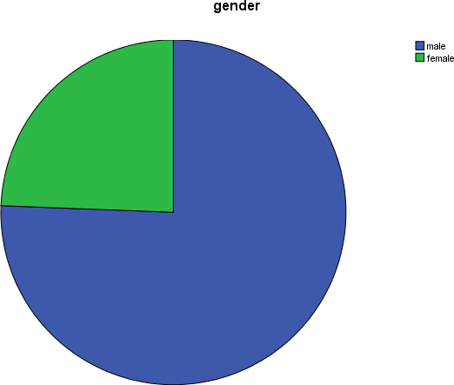
According to the findings in table 4.5.1 above, 75.6 percent of respondents were male, while 24.4 percent of respondents were female. As a result, the majority of respondents were male because Somali female employment is very low in comparison to male employment.

Figure 4.5.1: Respondents by gender.

Table 4.5.2. Respondents of various ages.
Data analysis |  | Frequency | Percent
 | 18-25 | 8 | 19.5
 | 26-33 | 16 | 39.0
 | 34-41 | 13 | 31.7
 | over42 | 4 | 9.8
 | Total | 41 | 100.0
Primary data source 2021
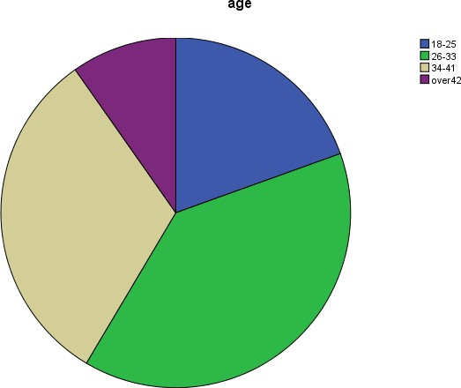
According to the findings in table 4.5.2 and the figure below, (19.5%) of respondents were between the ages of 18 and 25, (39% were between the ages of 26 and 33, 31.7% were between the ages of 34 and 41, and 9.8% were over the age of 42. As a result, the majority of respondents (39%) were between the ages of 26 and 33.

Figure4.5.2: Respondents by gender

Table 4.5.3: marital status
Data analysis |  | Frequency | Percent
 | Single | 12 | 29.3
 | Married | 24 | 58.5
 | Divorced | 4 | 9.8
 | Widowed | 1 | 2.4
 | Total | 41 | 100.0
primary data sources 2021
According to the table and figure 4.5.3, 29.3 percent of respondents were single, 58.5 percent of respondents were married, 9.8 percent were divorced, and 2.4 percent were widowed. As a result, the majority of respondents (58.5 percent) were married.
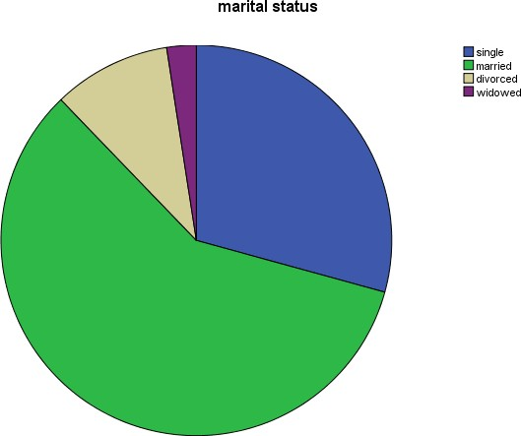

Figure 4.5.3 marital status of respondents.

Table 4.5.4. Level of education.
 |  | Frequency | Percent
Valid | Bachelor | 21 | 51.2
 | Master | 16 | 39.0
 | informal education | 4 | 9.8
 | Total | 41 | 100.0
Primary data source 2021
According to the table above and figure below, 51.2 percent of respondents had a bachelor's degree, 39 percent had a master's degree, and 9.8 percent had an informal education. As a result, 51.2 percent of respondents were bachelors.
.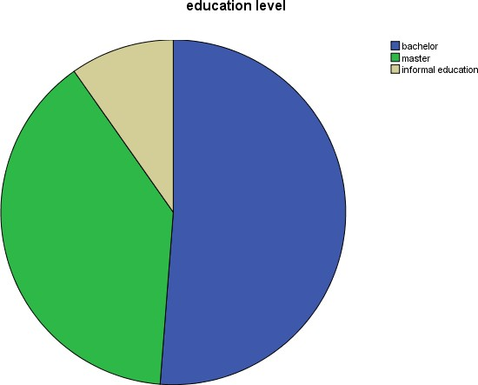
Figure 4.5.4: respondents of educational level.

Table 4.5.5. occupation
 |  | Frequency | Percent
Valid | Employed | 32 | 78.0
 | Unemployed | 9 | 22.0
 | Total | 41 | 100.0
Primary data sources 2021.
According to the findings in table 4.5.5 and the figure below, 78 percent of respondents were employed and 22 percent were unemployed. As a result, 78 percent of respondents were employed.
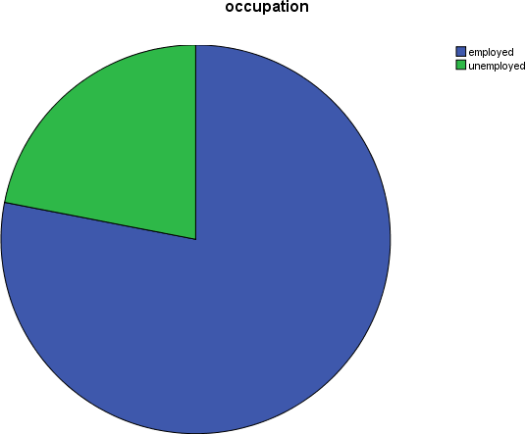

Figure 4.5.5 respondents of occupation.

4:6: Data Analysis And Presentation
Table 4.6.1 The company keeps employees in a good communication.
 |  | Frequency | Percent
Valid | strongly agree | 13 | 31.7
 | Agree | 28 | 68.3
 | Total | 41 | 100.0
Source of primary data 2021
The result of the table 4.6.1 shows that 31.7% of respondents were strongly agreed and 68.3% of respondents were agreed. So that the majority of respondents were agree

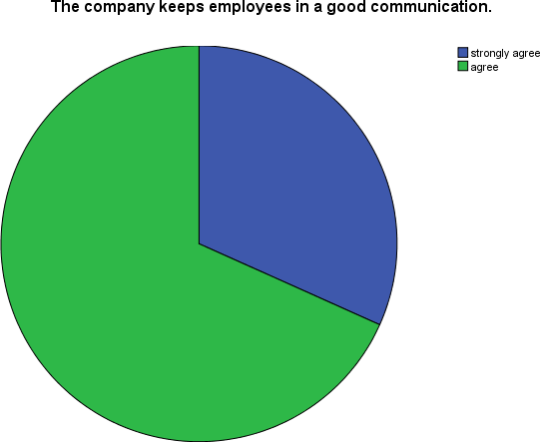
Figure 4.6.1 The Company keeps employees in a good communication

Table4:6:2: the employees are satisfied with company communication.
 |  | Frequency | Percent
Valid | strongly agree | 6 | 14.6
 | Agree | 28 | 68.3
 | Neutral | 2 | 4.9
 | Disagree | 5 | 12.2
 | Total | 41 | 100.0
Source of primary data 2021
Table 4.6.2 shows that 14.6 percent of respondents were very agreed, 68.3 percent were agreed, 4.9 percent were neutral, and 12.2 percent were disagreed. As a result, the vast majority of responders agreed.
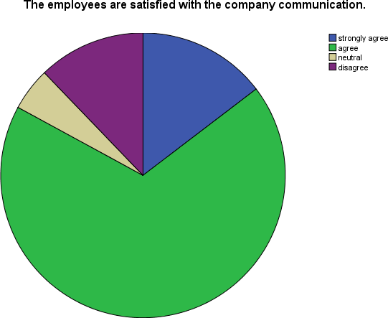

Figure 4.2.2 The employees are satisfied with the company communication.
Table 4.6.3 The company communicates whole employees equally.
 |  | Frequency | Percent
Valid | strongly agree | 10 | 24.4
 | Agree | 27 | 65.9
 | strongly disagree | 4 | 9.8
 | Total | 41 | 100.0
Source of primary data 2021
The result in the table 4.6.3 demonstrates that 24.4% of respondents were highly agreed, 65.9% of respondents were agreed and 9.8% of respondents were strongly disagreed. So that the majority of respondents were agreed.
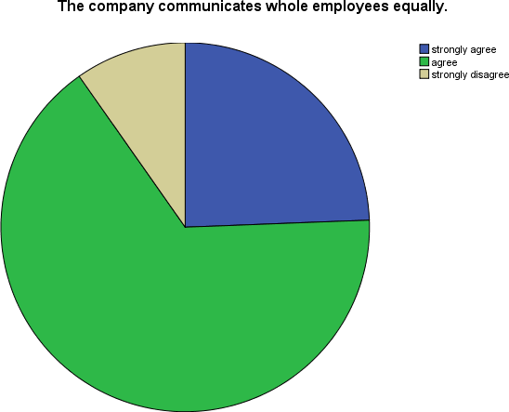
Figure 4.6.3 The company communicates whole employees equally
Table 4.6.4 Employees are communicated respectively in workplace.
 |  | Frequency | Percent
Valid | strongly agree | 13 | 31.7
 | Agree | 24 | 58.5
 | strongly disagree | 4 | 9.8
 | Total | 41 | 100.0
Source of primary data 2021
The result in the table 4.6:4 shows that 31.7% of respondents were strongly agreed, 58.5% of respondents were agreed and 9.8% of respondents were highly disagreed. So that the majority of respondents were agreed.
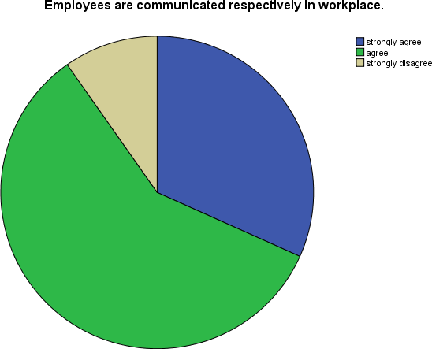
Figure 4.6.4 Employees are communicated respectively in workplace.
Table 4.6.5 Good communication supports employee talent development.
 |  | Frequency | Percent
Valid | strongly agree | 24 | 58.5
 | Agree | 17 | 41.5
 | Total | 41 | 100.0
Source of primary data 2021.
The result in the table 4.6.5 shows that 58.5% of respondents were strongly agreed and 41.5% of respondents were agreed. So that the majority of respondents were strongly agreed.
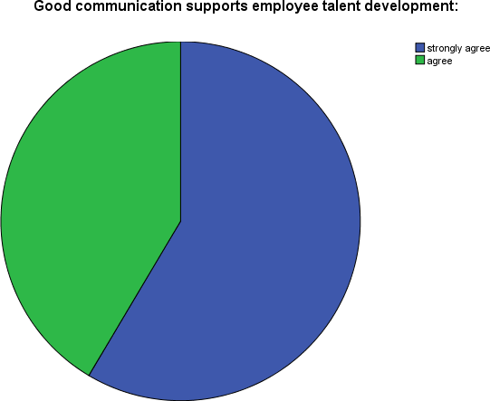
Figure 4.6.5 Good communication supports employee talent development.

Table4.6.6 Effective communication helps to achieve organizational goals.
 |  | Frequency | Percent
Valid | strongly agree | 32 | 78.0
 | Agree | 9 | 22.0
 | Total | 41 | 100.0
Source of primary data 2021.
The result in the table 4.6.6 shows that 78% of respondents were strongly agreed and 22% of respondents were agreed. So that the majority of respondents were strongly agreed.
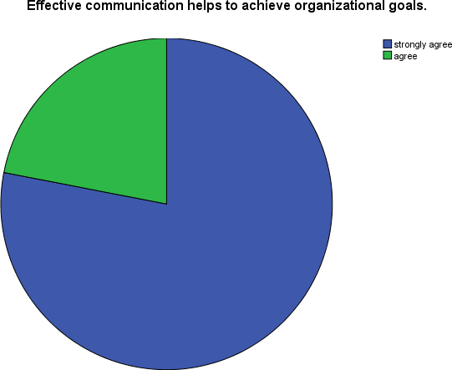

Figure 4.6.6 Effective communication helps to achieve organizational goals.

Table 4.6.7 Effective communication creates confidence between employees and managers.
 |  | Frequency | Percent
Valid | strongly agree | 29 | 70.7
 | Agree | 11 | 26.8
 | Neutral | 1 | 2.4
 | Total | 41 | 100.0
Source of primary data 2021
The result in the table 4.6.7 shows that 70.7% of respondents were strongly agreed, 26.8% of respondents were agreed and 2.4% of respondents were neutral. So that the majority of respondents were strongly agreed.
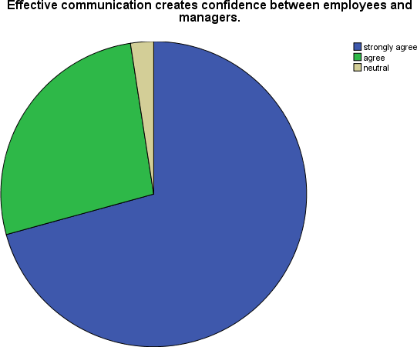
Figure 4.6.7 Effective communication creates confidence between employees and managers.

Table 4.6.8 Communication skills improves personnel relationships:
 |  | Frequency | Percent
Valid | strongly agree | 23 | 56.1
 | Agree | 18 | 43.9
 | Total | 41 | 100.0
Source of primary data 2021
According to the table 4.6.8 shows that 56.1% of respondents were strongly agreed and 43.9% of respondents were agreed. So that the majority of respondents were strongly agreed.
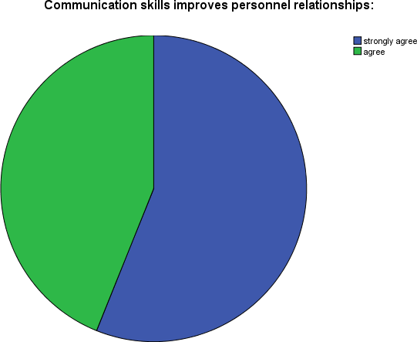
Figure 4.6.8 Communication skills improves personnel relationship.

Table 4.6.9 Face to face communication is the best.
 |  | Frequency | Percent
Valid | strongly agree | 22 | 53.7
 | Agree | 18 | 43.9
 | Neutral | 1 | 2.4
 | Total | 41 | 100.0
Source of primary data 2021.
According to the table 4.6.9 shows that 53.7% of respondents were strongly agreed, 43.9% of respondents were agreed and 2.4% of respondents were neutral. So that the majority of respondents were strongly agreed.
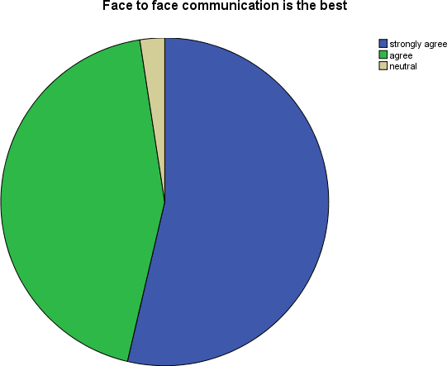

Figure 4.6.9 Face to face communication is the best.

Table 4.6.10: Without effective communication, without progress in the company.
 |  | Frequency | Percent
Valid | strongly agree | 26 | 63.4
 | Agree | 15 | 36.6
 | Total | 41 | 100.0
Source of primary data 2021
According to the table 4.6.10 shows that 63.4% of respondents were strongly agreed and 36.6% of respondents were agreed. So that the majority of respondents were strongly agreed.
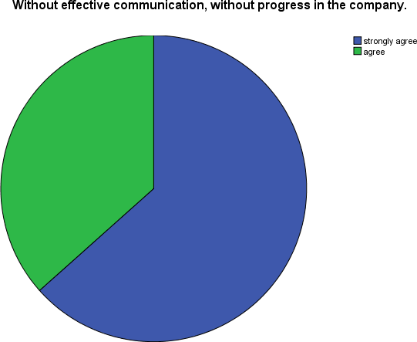

Figure 4.6.10 without effective communication, without progress in the company.

4:7: Important Findings.
This section was focused on discovers of the research result and findings attained from the distributed questionnaires. The main purpose of this study was to identify the study on communication skills in HRM in Mogadishu, Somalia. The Researcher measured the communication skills by considering mainly HRM, the findings of the study expose that majority of the respondents mostly assigned strongly agree, Agree and others assigned disagree and strongly disagree. So, most of the respondents believe that communication skills are too important in the HRM and has positive effect.
Based on the results, the researcher found that the questions of objective one which is to investigate the impact of effective communication on employee. that most of the respondents assigned strongly agree and agree which indicates that effective communication has positive effect on employee.
Based on the results, the researcher found that the questions of objective two which is to assess the Impact of effective communication on performance that most of the respondents assigned strongly agree and agree which indicates that effective communication has positive effect on performance. Finally, the study indicates that the study on communication skills has a positive effect on HRM.
4:8: CONCLUSIONS AND RECOMMMENDATIONS

4:8:1: Conclusions
This study was intended to examine the study on communication skills in HRM in Mogadishu, Somalia. The study has showed that communication skills have a positive effect on the HRM. The study's primary goal was to investigate the impact of effective communication on employee. The study found that majority of the respondents assigned agree and strongly agree, which indicates that effective communication has positive effect on employee.
The study's second goal was to see how effective communication influenced performance. The study found that majority of the respondents assigned agree and strongly agree, which indicates that effective communication has positive effect on performance. It leads organizational booming and the conclusion there is positive relationship between communication skills on HRM.
4:8:2: Recommendations:
    - Recite critical messages: In addition to using a variety of channels, you should reinforce organizational communication by repeating critical messages on a regular basis.
    - Pay attention to what you're saying – this is crucial in one-on-one communication ‘Because we don't take the time to actively listen, the majority of us are lousy listeners. Use reflective listening skills, good nonverbal behaviors and body language (e.g., face your verbal exchange partner with an open stance), and focusing on your partner by making a conscious effort to pay attention first rather than trying to get your message across first.
➢ Getting Your Message Across – Once you've paid attention and completely comprehended your conversation partner, you should be confident that you'll be able to get your message across in the intended manner. To try this, communicate openly and honestly, and be as straightforward as possible (i.e., no "beating around the bush"); speak inclusively and use terms that will be understood and understood; and be certain that your message has been received correctly.
Handle Communication Challenges — At the end of the day, we need to be better at managing conversational issues so that people will inevitably interact. Conflict resolution, problem solving, misconceptions, dealing with complex individuals, and managing cultural differences are all examples of such challenges.
4:8:3: References,
1- M. Bland, P. Jackson, Effective Employee Communications. London: Hainman, 1990.
2- Communication and human resource management and it’s compliance with culture, Article, January 2006, Kees Van der Veer Transcend Peace University (Germany).
3-Effective Communication in Human Resources Management, Ijie Ben Asuelimen, International Institute of Tropical Agriculture (IITA), Abuja Station, Nigeria.
4-Chukwuka, E. (2015). Communication as a Veritable Tool for Effective Human Resource Management in Organization. Review of Public Administration and Management.
3-Oribabor P.E. (2000). Effective Communication: A tool for Successful Management in Oribabor P.E. and Ogunbameru O.A. (ed) Introduction to Industrial Sociology.
6- Basics of Communication and Communication Skills, Robert Burton.
7- https://www.skillsyouneed.com.
8- Communication skills, Uttarakhand Open University
9- Nonverbal Communication Skills: June 22, 2021, By: Indeed Editorial Team.
10- Communication skills vol.1, student's book, Tabitha Winger.
11- communication skills for enhanced employability of engineers: review of literature,feb:2013, Deepshikha Mehra.
12-An assessment of students’ performance in communication skills, A Case Study of the University of Education Winneba, Abena Abokoma Asemanyi.
13-The role of communication skills in learning and using the second language: Perspectives from College ELS Students, by Muslat Alsubaie, B.Ed..
14-Campbell, B. (2008). Enhancing communication skills in ESL students within a community college setting. Teaching and Learning in Nursing,3(3), 100-104.
15-Treating communication anxiety: Implications of the communibiological paradigm. Communication Education, Kelly, L., & Keaten, J. A. (2000).
16-McCroskey, J. C. (1983). The communication apprehension perspective. Communication.
17- Leadership Tips: Effective Communication., Mary Juetten, oct19,2021.
18- Ten objectives of communication,oct:18,2021 ByHitesh Bhsin, article.

