ce

INTERNSHIP REPORT
ON
Impact of Employee Recruitment & Selection Process on HR Performance-A Survey on Kazi Farms Group


UNITED INTERNATIONAL UNIVERSITY

Submitted To:
Yeasmin Islam
Assistant Professor
United International University

Submitted By:
Shakib Alam
ID: 111 151 167

Date of Submission: 22thSeptember 2019

Letter of Transmittal

Date:22th septembar 2019
To
Yeasmin Islam
Assistant Professor
United International University

Subject: Submission of Internship Report on “Impact of Employee Recruitment & Selection Process on HR Performance- A Survey on Kazi Farms Group”.

Dear Mam
I would like to inform you that this report is made on the topic given by you. Though this Internship Report I have tried my level best to present the real picture of the “Impact of Employee Recruitment & Selection Process on HR Performance- A survey on Kazi Farms Group.” I have given enough efforts to prepare the report as per your instructions.
Though I have put my earnest effort to prepare the report, this report may have some loopholes. I hope you will consider those mistakes and this report.

Sincerely yours

………………………
Shakib Alam
Id- 111 151 167
Programme- BBA
Session: 2015-2019
Major: Human Resource Management

Acknowledgement

It is essential to have knowledge about the relationship among theory and practical knowledge. Only then a student can claim himself as a sincere student. Many people helped me a lot to prepare this report on time by giving necessary information. It is the time to thank all those people.
First and foremost, I would like to acknowledge my heartiest gratitude and indebtedness to Yeasmin Islam, Assistant Professor of United International University for her guidance, supervision and help in all stages of carrying out my work. Without his critical analysis and suggestion at every step of the report, this report could not have reached its present form.
Secondly, I would like to convey my thanks to Gopal Ghosh Assistant Manager of Kazi Farm GroupLtd. and other employees of KFG for providing me with valuable information that was very much needed for the completion of this report.
Finally, although I have given my utmost effort to prepare the report, this report may include some lacking. I apologies for any unintentional mistakes.

__________________________

Shakib Alam
Id- 111 151 167
Programme- BBA
Session: 2015-2019
Major: Human Resource Management

Executive Summary

HR activities are one of the most critical and major activities for an organization. The HR division of “Kazi Farms Group” is an ideal place for learning HR related practices. They consist an excellent team of management to conduct all the HR related activities. They are such a dedicated team, their dedication makes it possible to get suitable people for suitable position. They try hard and soul to maintain an adequate flow of each and every steps of recruitment process. This report is based on the “Recruitment & Selection” process of “Kazi Farms Group”. The main objective of this report is to know how the recruitment & selection process works. There are some other objectives like to know the HR policies, to get theoretical knowledge, how to remove loops etc. Two types of data are used in this report primary and secondary. The primary data’s are collected from observation, interview, employee survey etc. And the secondary data’s are gathered by their website, other articles, internet, medley reference etc. The whole report is detruncated in five chapters. The first chapter conveys; introduction, methodology, rationales’ of the report, scope of the report, objectives and limitations of the report. A full overview of Kazi Farms Group is given in chapter two including overview of the organization, their current products and services, corporate information and associates and sister concern. Literature review on Employee Recruitment & Selection Process in HR Performance is being presented in chapter three. In this chapter there is brief discussion about HR and HR related policies that have been followed by the organization. The fourth chapter of this report contains analysis and findings. SWOT analysis and brief discussion about the questionnaire are presented here. Total 15 employees interpretation about their organization have been collected as a questionnaire form to conduct the survey, after collecting the data from the survey the data’s are presented in a pie chart format, that express whether employees are agreed or not agreed in a particular issues about the HR field of the organization. Recommendation and conclusion have been presented in the last chapter of this report. No organization is 100% perfect. Every big or small organization need be very couscous about their present and future condition.

Table of Contents
Letter of Transmittal i
Acknowledgement ii
Executive Summary iii
Background of the Study: 1
1.2 Rational of the Study: 1
1.2.1 Reason for internship Study: 1
1.3 Scope of the study: 1
1.4 Objective of the Study: 1
The report contains two major objectives, they are- 1
• General Objective 1
• Specific Objective 1
1.4.1 General Objective: 1
1.4.2 Specific objective: 1
1.5 Methodology of the report: 2
1.5.1 Sources of information: 2
Limitations 2
2.1 Kazi Farms-Overview of the organization 4
2.2 Corporate Information of Kazi Farms Group: 5
2.3 Current Products and services of Kazi Farms Group and Kazi Food Industries Limited: 5
2.3.1 Broiler parent chicks and broiler chicks 5
2.3.2 Layer chicks and table eggs 6
2.3.3 Feed 6
2.3.4 Bellissimo: 7
2.3.5 Kazi Farms Kitchen: 7
2.4 Associates and Sister Concerns of Kazi Farms Group: 8
3.1 Literature review 10
3.1.1 Human Resource Management: 10
3.1.3 The Responsibilities of HR Management: 11
3.2 The Recruitment & Selection process of Kazi Farms Group: 11
3.2.1 The Scope of Recruitment and Selection 12
3.3 What is Recruitment? 12
3.3.1 Importance of Recruitment 12
3.3.2 The Purpose of recruitment: 13
3.3.3 Factors Affecting Recruitment 13
3.4 Recruitment Process& Planning: 15
3.4.1 Recruitment Process 15
3.4.2 Recruitment Planning 15
3.5 Recruitment Strategy 17
3.5.1 The steps involved in developing a recruitment strategy is given below- 18
3.5.2 Sources of Requirement: 18
3.6 Reviewing of Resumes and Cover Letters: 19
3.7 What is selection? 20
3.7.1 Initial Screening: 21
3.7.2 Written Employment Test: 21
3.7.3 Work Sample Test: 21
3.7.4 The Interview: 22
3.7.5 Salary Negotiation: 22
3.7.6 Job Offer: 22
3.7.7 Reference Check: 22
3.7.8 Pre-joining document: 22
3.7.9 Provision Period: 23
3.8 The summary of Recruitment & Selection Process of KFG: 23
4.1 Descriptive Analysis: 25
4.2 Questionnaire Analysis: 27
4.3 Brief Discussion about Survey Questionnaire: 34
Recommendations: 37
Conclusion: 37
References 38
Appendix: 39

Chapter: 01

Introduction

Background of the Study:

In this era of business everyone has to be very careful while choosing strategy for business. Every organisation has its own policy and strategy to make its business successful and beneficial. In this dynamic world almost every company are using different type of HRIS (Human Resource Information System). Here in this report the working situation, Impact of Employee Recruitment & Selection Process in HR Performanceof Kazi Farms Group is being presented. To make this report I have focused on the HR system that KFG (Kazi Farms Group) is at present following for recruitment and for getting the best output from their human resource and also for make their employee enforce able as well as productive.

1.2 Rational of the Study:

For the fulfilment of BBA internship program is required. The set-up of internship program is to prepare the students for the job world. Through this internship I get opportunity to apply my theoretical knowledge which I gained throughout the BBA programme into the real work life experience. An internship is an impression of the real job world.

1.3 Scope of the study:

I want to understand the topic of my report Impact of Employee Recruitment & Selection Process in HR Performanceof KFG” throughout the 3 months’ time period of my internship in KFG (Kazi Farms Group) where I have joined as internee.

1.4 Objective of the Study:

The report contains two major objectives, they are-
- General Objective
- Specific Objective

1.4.1 General Objective:
To identify the factor that createsimpact on employee Recruitment & Selection Process in HR Performance of KFG.

1.4.2 Specific objective:
- To understand the HR policy of KFG.
- To identify the various avenues for improving the HRM policies of Kazi Farms Group.
- To learn the system that is followed by KFG.
- To acquire in depth knowledge over the human resource department of the KaziFamrs Group.
- To find out the get-out of their existing policy.
- To suggestremoving those loop holes.

1.5 Methodology of the report:

This report is prepared in a systematic way. Initial from collecting data to interpret, analyse and giving recommendation I have used some method.
For collecting necessary data Survey researched strategy is used. Survey is done with some Quantitative questions. Respondents are asked to fill up those survey questions. Method called self-administrative questionnaire is followed where survey questions provided to the respondents and they have fill up those questions by them.
The time horizon used in this project is cross sectional time horizon. Using this way can reach 15 respondents within a very short period.

1.5.1 Sources of information:

1.5.1.1 Primary sources of data:
- Observations
- Interview with the supporter HR manager of KFG.
- Survey

1.5.1.2 Secondary Sources:
- KFG website
- Internet
- ERIC( Education Resources Information Centre)
- Medley for reference

Limitations
There are some limitations exists in this report -
- Sample size is small for conducting data analysis part.
- Respondents may not feel secure to providing answers that present themselves in an uncomfortable method.
- Due to confidentiality of some information, accurate response may not revealed.
- As some assumption is made on the basis of the collected data, so here can stay some error in this report.

Chapter 2
Company Profile

2.1 Kazi Farms-Overview of the organization

Kazi Farms is one of the leading poultry farms in our country its commencements 18 years ago. It was established in 1996 as a hatchery for imported eggs; the following year it started its own parent farms. In 2004 production started in their grand-parent (GP) farms. It continues to remain with the latest products as services, considering consumer and client’s perspective.
Kazi farm has thus been able to keep their customers and client trust while upholding their reliability across time. In 2006 they established the largest and most advanced feed mill in the country, in addition to producing breeder feed to meet their own requirements, with technical assistance from Cargill USA and Buhler Switzerland. Kazi Farm Group is the largest grand-parent franchisee of Cobb-Van tress USA for Cobb 500 which is acknowledged as world-wide to be the best broiler.
They have also a smaller number of grand-parents of the popular Ross broiler from Aviagen USA. Regarding layer they are the Bangladeshi distributer for Hy-line USA, the world leading layer breed. They were the first exporter of hatching eggs and day-old chicks from Bangladesh. Kazi Farms Group has established in different locations throughout Bangladesh over 70 broiler parent farms, broiler grand-parent (GP) farms, layer farms, hatcheries, feed mills and sales offices.
Kazi Farms is in a unique position to understand the interrelationships between nutrition, hygiene and farms care. They can do this with their strong science in bio-security capability and their locally rooted consumer inside. Kazi Farms commits to nations to take a lead in the farming sector though not only its strong financial position, but also through innovation of products and services. It also ensures creation higher value for its requested customers and shareholders.
The farm has focused to bring services at the doorsteps of its customer, and to bring millions into farming channels those who are outside the mainstream farming area Kazi Farms has continuously invested into its biggest asset, the “human recourse” to drive forward with its mission “to be the best performing farm in the country”.

2.2 Corporate Information of Kazi Farms Group:

Name of Company: Kazi Farms Group
Type: Private
Industry: Poultry
Founded: 1996
Founder: Kazi Zaedul Hasan, Kazi Shahidul Haque
Owner: Kazi Zaedul Hasan
Employees: 7000

Corporate Office: Ahmed Kazi Tower, House-35, Road-02, Dhanmondi, Dhaka-1205
Telephone: +880-2-9612290-93, 9612184
Fax number: +880-2-9612185
IP No: +09613606060
Email address: info@kazifarms.com

2.3 Current Products and services of Kazi Farms Group and Kazi Food Industries Limited:

2.3.1 Broiler parent chicks and broiler chicks
Kazi Farms Group is the Bangladesh franchisee of Cobb-Vantress USA for the Cobb 500 broiler, acknowledged to be the best broiler in the world. The Cobb 500 parent and broiler chicks of Kazi Farms Group are considered to be the best performing chicks in the domestic market, and are sold at a premium over other broiler breeds.
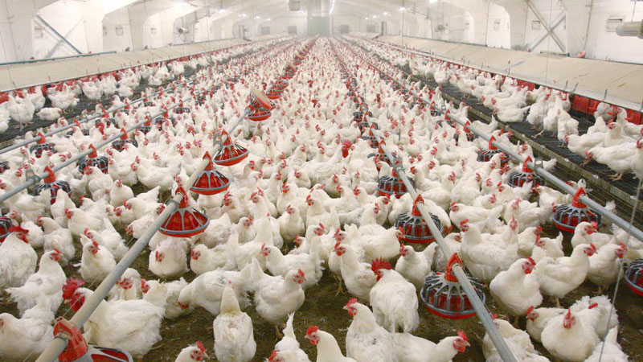

2.3.2 Layer chicks and table eggs
Hy-line International is the oldest poultry breeding company of the world, and is the leading breeders of layers Kazi Farms Group is also the distributor for Hy-line brown and white layers in Bangladesh also Kazi Farms' own commercial layer farms make it the largest producer of commercial table eggs in Bangladesh.


2.3.3 Feed
Kazi Farms Group expanded its operation into poultry feed manufacture in 2006. Within a very short period it has become recognized as a market leader in both quality and volume The Gajaria feed mill uses state-of-the-art sanitizing pellet mills from Buhler of Switzerland, manufacturer of the world's best feed equipment. By eliminating any possible bacterial contamination from the feed, the Buhler sanitizing pellet mills ensure that poultry farmers experience fewer disease outbreaks and see better results.
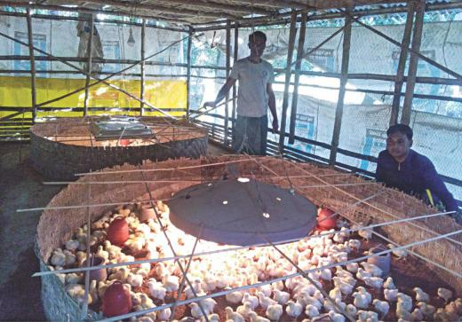

2.3.4 Bellissimo:
Kazi Food Industries Limited is a recent venture of the Kazi Farms Group. Located in Beron, Ashulia, KFIL produces and sells premium dairy ice cream with minimum 10% milk fat (as per international standard) under the brand name Bellissimo.


2.3.5 Kazi Farms Kitchen:
A range of frozen food products are sold under the brand name Kazi Farms Kitchen. These are all guaranteed to not contain any antibiotic residues, as chickens are not fed any antibiotics within 7 days of slaughter, as per international practice. The meat is also guaranteed to be produced from chickens raised on feed not containing MBM (meat and bone meal) as per European standards. The meat products are also guaranteed to be MSG and nitrate-free, as we do not use any of these chemicals during food preparation.
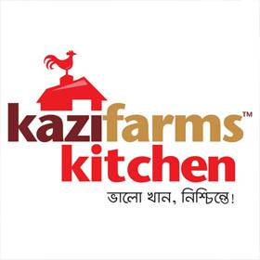

2.4 Associates and Sister Concerns of Kazi Farms Group:

• Kazi Farms Limited (largest poultry house in Bangladesh established in 1996)
• Kazi Food Industries Limited - located at Beron in Ashulia, Dhaka; some of its popular brands are Bellissimo, ZaNZee, and Kazi Farms Kitchen.
• Sysnova Information Systems Limited (IT Company at Dhanmondi, Dhaka)
• Kazi Media Limited (Deepto TV, a private TV channel)
• Central Women's University – the first private university in Dhaka, Bangladesh for women established in 1993.

• KaziZahuralHuq College (Gopinathpur, Gopalganj) (kazifarms, 2016

Chapter 3
HR Practice

3.1 Literature review

3.1.1 Human Resource Management:

Humans are the most critical asset for an Organization, if humans are not managed properly than all the work functions will get imbalanced. To manage these most important assets every organization has their own human resource movement department. The HR Department or management directly has an influence over the employees of the organization. The more attention the employees get from the management the more they get involved with the organization.

3.1.2 Human Resource Management Process: consists of eight activities necessary for staffing the organization and sustaining high employee performance. The process is described below:

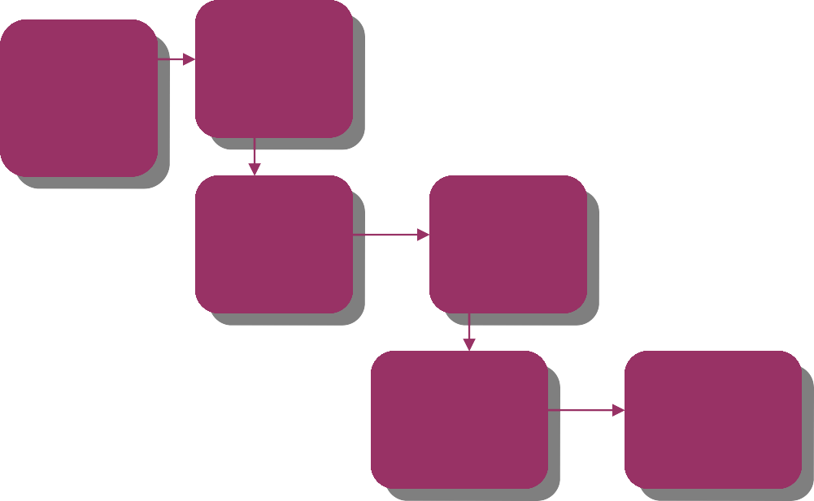
HRPlanning&
Selection
Requisition
Orientation
Training
Appraisal&
Evaluation
Benefits&
Compensation

3.1.3 The Responsibilities of HR Management:
# Support and suggest improvements to the entire recruitment process
# Ensure HR staff addresses employees’ requests and grievances in a timely manner
# Maintain HR procedures that comply with labor regulations
# Monitor HR metrics (e.g. turnover rates and cost-per-hire)
# Set objectives for the HR team and track progress
# Design and implement company policies that promote a healthy work environment
# Organize learning and development programs #Monitor HR metrics (e.g. turnover rates and cost-per-hire)
ThefollowingorganogramshowstheplaceofHumanResourcesDivisionanditsbasicfunctionsunderHead Office organ gram:

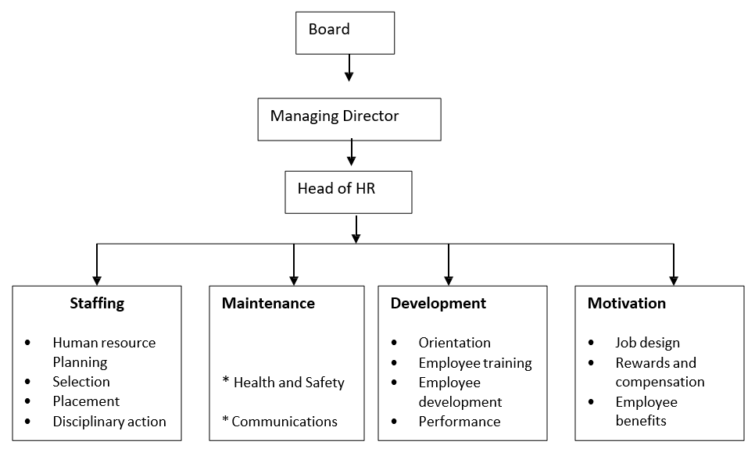

3.2 The Recruitment & Selection process of Kazi Farms Group:
Recruitment and selection process is an important function of HRM. It is designed to make the most of employee’s strength so that employers’ goals and objectives can be achieved. Briefly, it is the process of Attracting candidates, short listing and selecting the right resource for the repletion of devoid place.
According to Edwin B. Flippo, “Recruitment is the process of searching the candidates for employment and stimulating them to apply for jobs in the organization”.
According to Robins, “The ideal recruitment effort will attract a large no of qualified applicants who will take the job if it is offered. A good recruiting program should attract the qualified & not attract the unqualified. This dual objective will minimize the cost of processing unqualified candidates”.

3.2.1 The Scope of Recruitment and Selection

The scope of Recruitment and Selection process is very large and it includes mixture of operations. For any organisation resources are most important asset. Hiring right resources is the most important step of Recruitment. Every company has its own process of recruitment. According to this process organization completes their recruitment and selection segment.
This process includes some operations. That are-
- Recruitment and selection process deal with the situation if there is excess or scarcity in resources
- For different employee prepare different policy
- Analyse organisation’s policy of recruitment, agreement
- If there is area where improvement is needed, identify those areas
- Streamlining the hiring process with suitable recommendations
- Choosing the best suitable process of recruitment for effective hiring of resources
Hence, recruit the right employees is a very important task for every organization.

3.3 What is Recruitment?

Recruitment is one of the core functions of human resource management. It is process of identifying the demand of employee in the organisation, attracting potential employee, shortlisting and selecting for the required position.
Recruitment can be done internally, within the organization, or from external sources. The recruitment process is done within a specific time period.

3.3.1 Importance of Recruitment
Recruitment has many importance because if the recruitment process is efficient there will be-
- The productivity of the employee will increase
- Good working environment will create
- Employees will share good working relation
- Reduce dispute
- Increase overall growth of the organization.

3.3.2 The Purpose of recruitment:
The purpose and importance of recruitment in an organisation is given below-
- It identifies the future and current requirement of job.
- It increases the pool of job at the minimal cost.
- It helps to select the right candidates.
- It helps in reducing the probability of short term employments.
- It meets the organization’s social and legal obligations.
- Organisation can identify right job applicant for the required position
- Organisations effectiveness for both short time and long-time will increase
- Various recruitment technique can be evaluated effectively
- This process attracts potential employee to apply
- Identify the present and future demand of the organisation
- Connect the employers with the applicant
- The success ratio of selection process will increase

3.3.3 Factors Affecting Recruitment

Recruitment is a fundamental operation of HRM in every organisation. There are other factors that may affect the recruitment process. HR professionals should identify and understand those factors and take necessary action for the betterment of the organisation. Organisation should analysis the market changes time to time and identifies how the changes can affect the existing resources.
We have Internal Factors as well as External Factors that influence the recruitment process. This are-

a. Internal Factors
Organisation can control the internal factors that may influence their recruitment process. The internal factors are-
- Size of organization
- Recruiting policy
- Image of organization
- Image of job

Size of Organization
The size of the organisation affects the recruitment process. Whenever organisation decides to expand its operations, there more employees will be needed. As a result, hiring more resources will be needed. Those new employee will handle the future operations of the organisation.

Recruiting Policy
Every organisation has some policy regarding the recruitment whether they hire internally or externally. The policy may vary from organisation to organisation. It also affects the recruitment process.

Image of Organization
Organisation can attract skilled employees if they have good image in the market. Organisation can gain good image by maintain good relation with public, providing various public services. If they can enhance their image in the market, they can attain competent resources.

Image of Job
Image of job also plays an important role in recruitment function like image of the organisation. If jobs have good remuneration, promotion, recognition and good working environment with the opportunities of career development, it will create positive job image and can attain skilled candidates.

b. External Factors
Organisations can not the external factors. The recruitment process can be affected by the external factors. Those factors are-

- Demographic factors: The potential employee’s age, religion, gender, occupation, economic statuses are the demographic factors.

- Labor market – Demand and supply of labour are controlled by labour market. For example, if the there is a need of labour with specific skill but the supply is not sufficient to meet the demand then more effort will be needed for hiring. On the other hand, if supply is higher than the demand, hiring will be easier.

- Unemployment rate – If in any specific area unemployment rate is high, hiring new labour will be easier and simple. Because there will be more applicants search for job. On the other hand, if the rate of unemployment is low, hiring will be difficult as there is less number of resources.

- Labour laws − Labour laws are created by the central and state government. Social and political environment reflects through the labour laws. Labour laws include compensation, working environment, safety, health regulations for different position. Whenever the government changes, the laws will be also changed.

- Competitors – competitors are one of the important external factors. There are many organisations in the industries. They are competitors of each other. For hiring the best resources organisation have to consider their competitors. Organisation should offer better package than the competitor’s organisation.

3.4 Recruitment Process& Planning:

Recruitment is a process of sourcing, attracting the skilled candidates for the Right positions in an organization. It find out, hires the candidates who has the abilities, skills and attitudes that are required for gain the objectives of the organisation.
It is a process of identify vacancy in the organisation, analysis the requirement of job, evaluate the applicant, short listing, select the right person for right position.

3.4.1 Recruitment Process
For creating a powerful resource base recruitment process is the first step. It is a systematic process from sourcing the resources to arranging and conducting interviews and at last selecting the right candidates for the right position with required skills.

3.4.2 Recruitment Planning

The first step of recruitment process is recruitment planning. In this step, the bare positions are analysed and described. It includes job details, education, experiences which are needed for the post.
Recruitment planning is mandatory for the organisation. So that they can attracts and retains the employees. The candidates should be skilled, qualified to achieve the organisations objective.

3.4.2.1 Identifying Vacancy

The first step of recruitment plan is identifying the vacancy in the organisation. Different department send requisition to HR. Requisition form contains-
- Number of posts to be filled
- Number of positions
- Duties and responsibilities to be performed
- Qualification and experience required

When a vacancy is identified, it is the responsibility of HR team to find out whether the position is required or not, permanent or temporary, payment is full-time or part-time basis etc. before the recruitment this things should be evaluated. Organisation should have proper planning to select the right resource.

3.4.2.2 Job Analysis

Job analysis is a process of identify the duties of a particular job. Job analysis is done so that employee can know their responsibilities they have to perform. When employee will know their duties properly it can increase the productivity.

The following steps are important in analysing a job −
- Collect the job related information
- Based on the information make job description
- Determining the skills, knowledge and skills, which are required for the job
- After the job analysis job description and job specification are made

3.4.2.3 Job Description

Job description is an important document. It is descriptive in nature. It contains the final statement of the job analysis. For a successful recruitment process this description is very important
It includes the information related to the job. An employee can get clear idea about what he should do to meet the job descriptions requirements.

Job description is made for conducting the following-
- Classification and ranking of jobs
- Placing and orientation of new resources
- Promotions and transfers
- Describing the career path
- Future development of work standards

A job description provides information on the following elements −
- Job Title / Job Identification / Organization Position
- Location of the job
- Summary of job details
- Duties of the position
- Machines, Materials and Equipment
- The process followed for supervision
- Organisation working environment
- Health Hazards
- Job Specification

Job specification focus the employee’s physical, mental, emotional specification before HR team decided to hire the candidate. At first a list is prepared based on the jobs are available in the organisation. Then, the details of the jobs are identified and prepared a list on the information.

This information about each job in an organization is as follows −
- Physical specifications
- Mental specifications
- Physical features
- Emotional specifications
- Behavioural specifications

A job specification document provides information on the following elements −
- Education
- knowledge
- Training and development
- Skills requirements
- Work responsibilities
- Emotional characteristics
- Planning of career
- Job Evaluation

3.5 Recruitment Strategy
The second step of the recruitment process is recruitment strategy. It is made for recruiting the candidate. After job descriptions and job specifications, a strategy is to adopt for recruiting the qualified employee.
To prepare recruitment strategy, HR team considers-
- Make or hire employees
- Types of recruitment
- Geographical area
- Recruitment sources

It is a long process to make a recruitment strategy. But it is necessary for an organisation to attract and select the right labour.

3.5.1 The steps involved in developing a recruitment strategy is given below-

- Setting up a board team
- Analysing HR strategy
- Collection of available data
- Analysing the collected data
- Setting the recruitment strategy
- Searching the Right Candidates

3.5.2 Sources of Requirement:
Based on the job requirements searching process is done. Searching process is made for find out the right candidates. It is done after the recruitment strategy. There are two steps in this process-
- Source activation – when the line managers give requisition and permission about the current vacancy, search for right resources will start.
- Selling – in this steps organisation choose the media by which they want communicate and attract the candidates for the vacancy.
Searching process attracts the job applicant to apply for the position. There are two types of sources-
- Internal Sources
- Internal Sources

3.5.1.1 Internal sources of recruitment refer to hiring employees within the organization through:
- Promotions
- Transfers
- Former Employees
- Internal Advertisements (Job Posting)
- Employee Referrals
- Previous Applicants
- External Sources

3.5.1.2 External sources of recruitment refer to hiring employees outside the organization through:
- Direct Recruitment
- Employment Exchanges
- Employment Agencies
- Advertisements
- Professional Associations

3.5.1.3 Campus Recruitment
- Word of Mouth
- Screening / Shortlisting

Screening is an important step of recruitment process. It helps to identify the unskilled and unqualified candidates. In screening process organisation remove the candidates who are not right for the position. This process has three steps-

3.6 Reviewing of Resumes and Cover Letters:

- Step 1: Reviewing is the first step of screening candidates. Candidates resumes are being checked, their education, work experience and overall background are being reviewed.
While reviewing the resumes, to ensure better screening of right candidates an HR must follow-
- Reason for change of job
- Longevity with each organization
- Long gaps in employment
- Job-hopping
- Lack of career progression
- Conducting Telephonic or Video Interview

- Step 2: The second step of screening candidates is telephonic or video interview. After the resumes screening, the hiring manager or HR manager contact with the candidates through phone or video. There are two outcomes-
- Verify if candidates are active and available at that time.

- It provides a quick clear-sightedness about the candidate.

- Step 3: Identifying the top candidates: It is the third step of the screening process. In this process, the best resumes are selected. The candidates who have the skill, knowledge, ability to match with the job requirement are shortlisted. HR team choose the right candidate within the top candidates.

This process has the following three outcomes:
- 5 to 10 resume are shortlisted
- Hiring manager can get idea and recommendation
- HR team can hire right employee

- Step 4: Evaluation and Control: It is the last stage of the process. Here the recruitment process is evaluated continuously and control the unwanted situation. Recruitment process is costly.so it is necessary to evaluate continuously, so that organisation doesn’t have to conduct the process again and again.

The cost includes are-
- Recruiters salary
- Agency and advertisement cost
- Administrative cost
- Overtime cost
- Cost incurred in recruiting suitable candidates for the final selection process

3.7 What is selection?
Selection is the second stage of the recruitment and selection process. It may be defined as the process of choosing the best one from among the number of candidates. The selection process is a series of specific steps used to decide which recruits should be hired. The process begins when recruits apply for employment and ends with the hiring decision.

The Current Selection Process of KFG:


Initial Screening
WrittenEmploymentTest
Work Sample Test
Interview
Salary Negotiation
Job Offer
Reference Check
Pre-Joining Documentation
Provision Period

3.7.1 Initial Screening:
The process starts with initial screening- choosing from the CV’s that fulfill the specific requirements. After a vacancy is announced and CV’s are already collected from different sources.

3.7.2 Written Employment Test:
After the initial screening, next step is the written employment test. In KFG, written test is applicable for assessment of all entry level positions. The written test is taken mostly to check the candidate’s knowledge on the subject matter for which he is to be taken and also to check his written communication skill.

3.7.3 Work Sample Test:
Work sample tests require the applicant to perform tasks that are actually a part of the work required on the job. The tests are carefully conducted by the IT Division to include the major job functions.

3.7.4 The Interview:
For entry level positions, the next step of the process is the comprehensive interview that is usually conducted by a panel comprising of the Managing Director, Additional Managing Director, Deputy Managing Director and The Head of Human Resources Division. The interviews are always unstructured and each interviewer grades the candidate based on motivational level, communication skill, confidence, how he handles difficulties etc.

3.7.5 Salary Negotiation:
For the entry level positions, the salary is fixed. For other lateral entries, the Head of HRD negotiates the salary with the suitable candidate whenever necessary. The negotiation for suitable designation also takes place during this phase.

3.7.6 Job Offer:
The Head of HRD offers the job to the selected candidate after the final approval is obtained. The Managing Director is the sole signing authority of any appointment letter up to Additional Managing Director, Non-Management and all contractual employees if any other person is authorized for special reason. The Chairman of the Board of Directors is the sole authority to sign appointment letter for the post of Managing Director.

3.7.7 Reference Check:
Reference checks allow obtaining information and opinions regarding the person’s character, quality of the work and suitability for the position. It is an opportunity to validate the information received from the candidate via their resume and the interview. Speaking to the candidate’s manager or other people whom they have worked with should also check internal candidates. The opinion of a referee who has worked can for an extended period is likely to be more accurate than the assessment from one to two hours of interviewing.

3.7.8 Pre-joining document:
The following documents are obtained from the candidate prior to his joining. Officers of Human Resource Division are responsible for the following documents:
- Five Years Bond on part of the MPO.
- Medical Report from the Designated Hospital.
- Verification of all certificates.
- Copy of Last Education and Professional certificates.
- Filled up setup papers (Service Recodes, Declaration of Fidelity, Employee Profile)
- Six copy passport size photo.

3.7.9 Provision Period:
Finally that employee who doesn’t have any experience must have to go from a privation period. It’s for a short span of time like for 2/3 month. But those who are skilled and have experience doesn’t need it.

3.8 The summary of Recruitment & Selection Process of KFG:

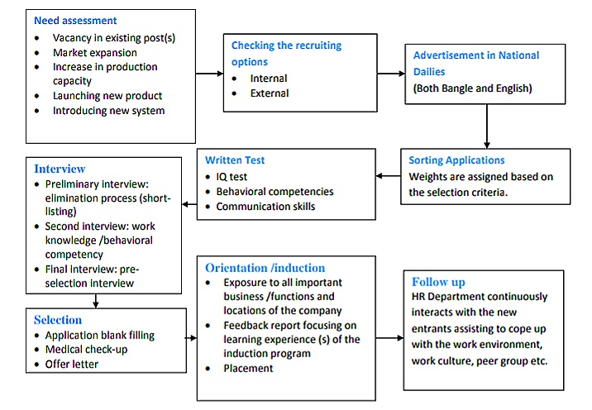

Chapter 4
Analysis and Findings

4.1 Descriptive Analysis:

Department Male:9 out of 15
Department Female: 6 out of 15
Age Average: 26-37

Particular | Strongly  Disagree  (1) |  | Disagree  (2) |  | Neutral  (3) |  | Agree  (4) |  | Strongly  Agree  (5)
Particular |  | % |  | % |  | % |  | % |  | %
1) “Kazi-Farm” clearly defines job description and specification in job advertisement to get right HR at right place. | 2 | 10% | 0 | 0% | 2 | 10% | 8 | 40% | 3 | 15%
2) “Kazi-Farm” propagate ideas like “Come Grow with us” & “Learning Environment” to increase their HR performance. | 1 | 5% | 1 | 5% | 1 | 5% | 8 | 40% | 4 | 20%
3) “Kazi Farm’s” HR Team act as a consultant to enhance the quality of applicant pre-screening process to get highly qualified employees. | 0 | 0% | 1 | 5% | 7 | 35% | 4 | 20% | 3 | 15%
4) Preferences of top managements personal references in Recruitment process creates barrier. | 0 | 0% | 3 | 15% | 2 | 10% | 7 | 35% | 3 | 15%
5) Direct recruitment & selection process is time consuming than outsourcing to acquire fruitful HR | 0 | 0% | 3 | 15% | 3 | 15% | 9 | 45% | 0 | 0%
6) The Resume screening and short listing method is useful to obtain effective employee. | 1 | 5% | 0 | 0% | 1 | 5% | 7 | 35% | 6 | 30%
7) Recruitment& selection process of this company is costly which creates impact on budget of HR department | 0 | 0% | 5 | 25% | 3 | 15% | 7 | 35% | 0 | 0%
8) Innovative techniques are adopted in selection process to acquire effective HR. | 0 | 0% | 2 | 10% | 5 | 25% | 6 | 30% | 2 | 10%
9) They did not comprise with any of the criteria in the recruitment and selection process to get potential employee. | 0 | 0% | 1 | 5% | 6 | 30% | 5 | 25% | 3 | 15%
10) HR Department should make changes the process of recruitment and selection if necessary to improve employee performance. | 0 | 0% | 0 | 0% | 1 | 5% | 9 | 45% | 5 | 25%
11) Their HR maintains an adequate pool of quality “protected Class” applicants so that they can use it when they need more potential employees. | 0 | 0% | 0 | 0% | 2 | 10% | 13 | 65% | 0 | 0%
12) “Kazi Farms” plays an affirmative action in the selection process to obtain productive employee. | 0 | 0% | 1 | 5% | 7 | 35% | 5 | 25% | 2 | 10%
13) Organization will accepts candidates from non-traditional sources if necessary to maintain good HR performance | 0 | 0% | 2 | 10% | 4 | 20% | 6 | 30% | 3 | 15%
14) Different recruitment process is applied for different grade of employees to select best people for the organization. | 0 | 0% | 1 | 5% | 3 | 15% | 7 | 35% | 4 | 20%

4.2 Questionnaire Analysis:

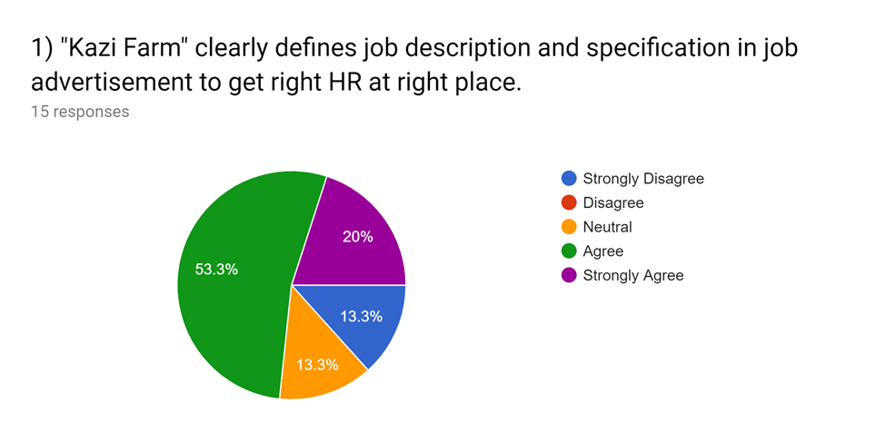

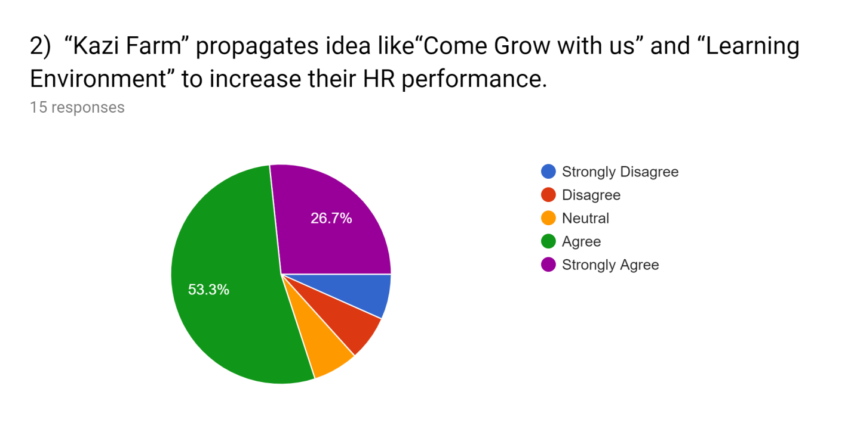
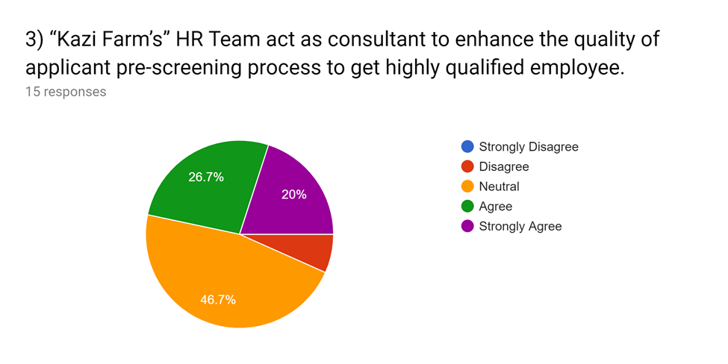

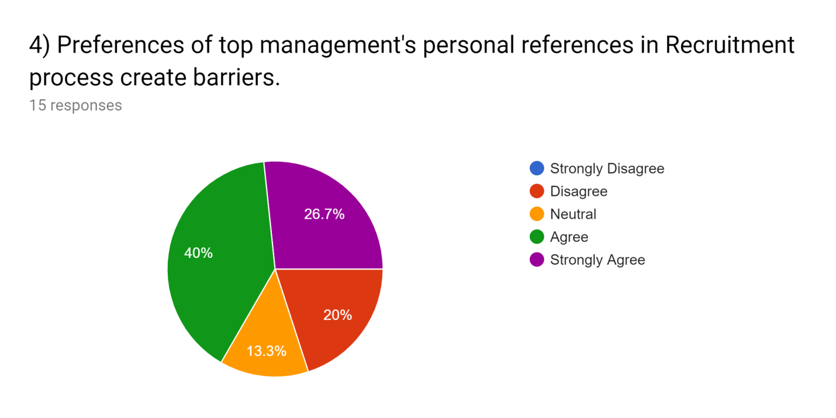
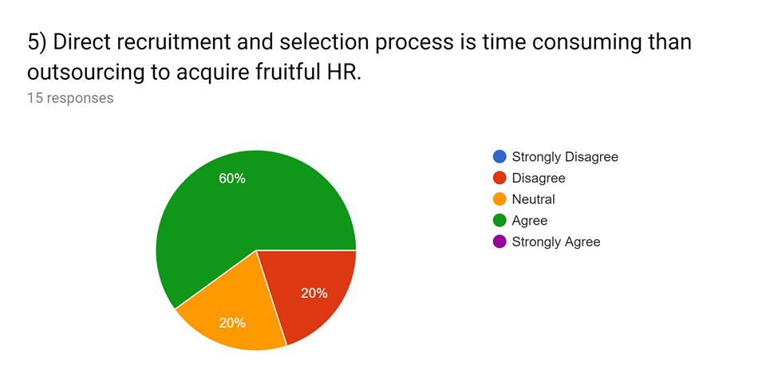

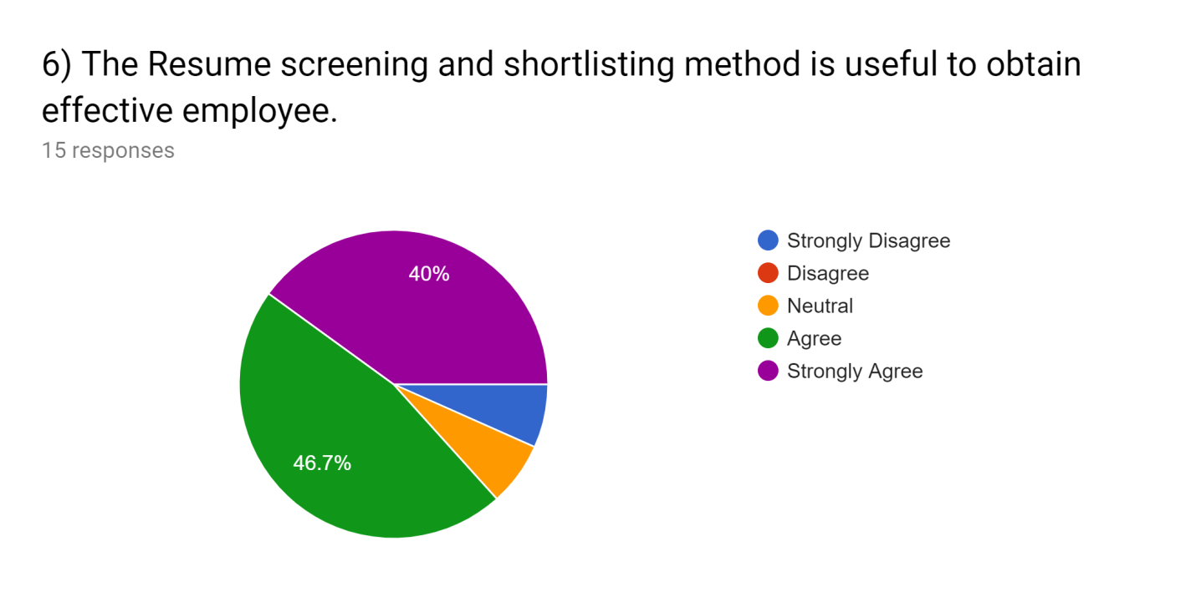
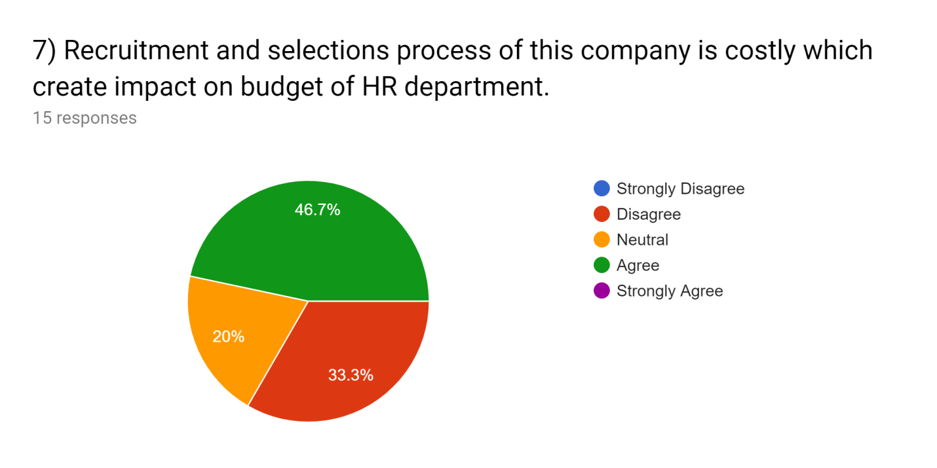

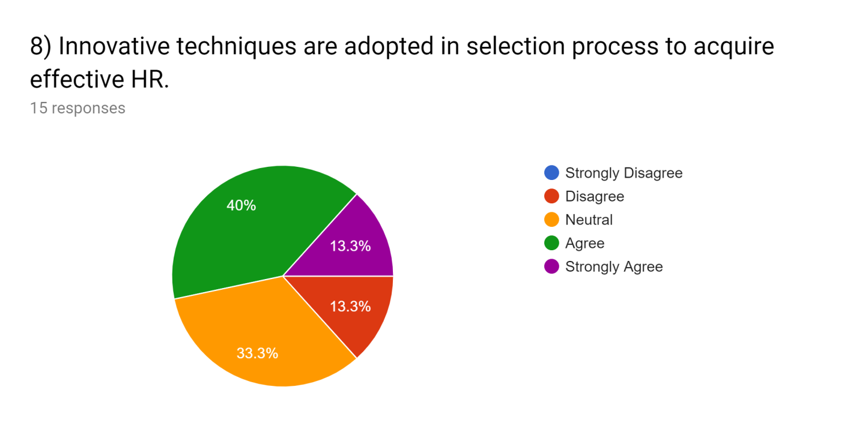
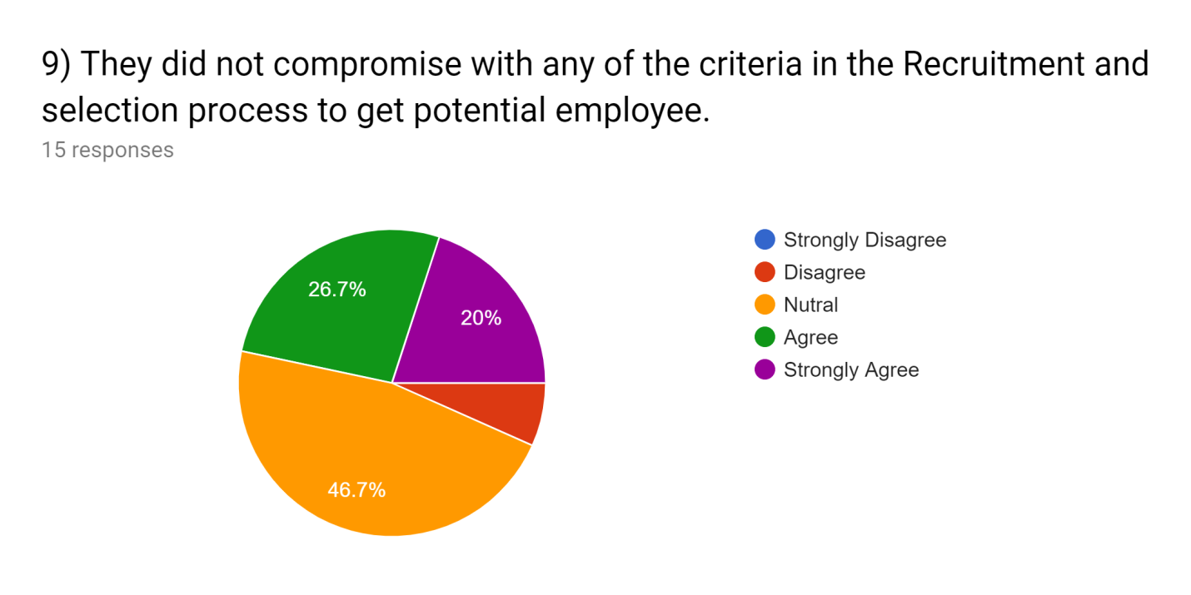

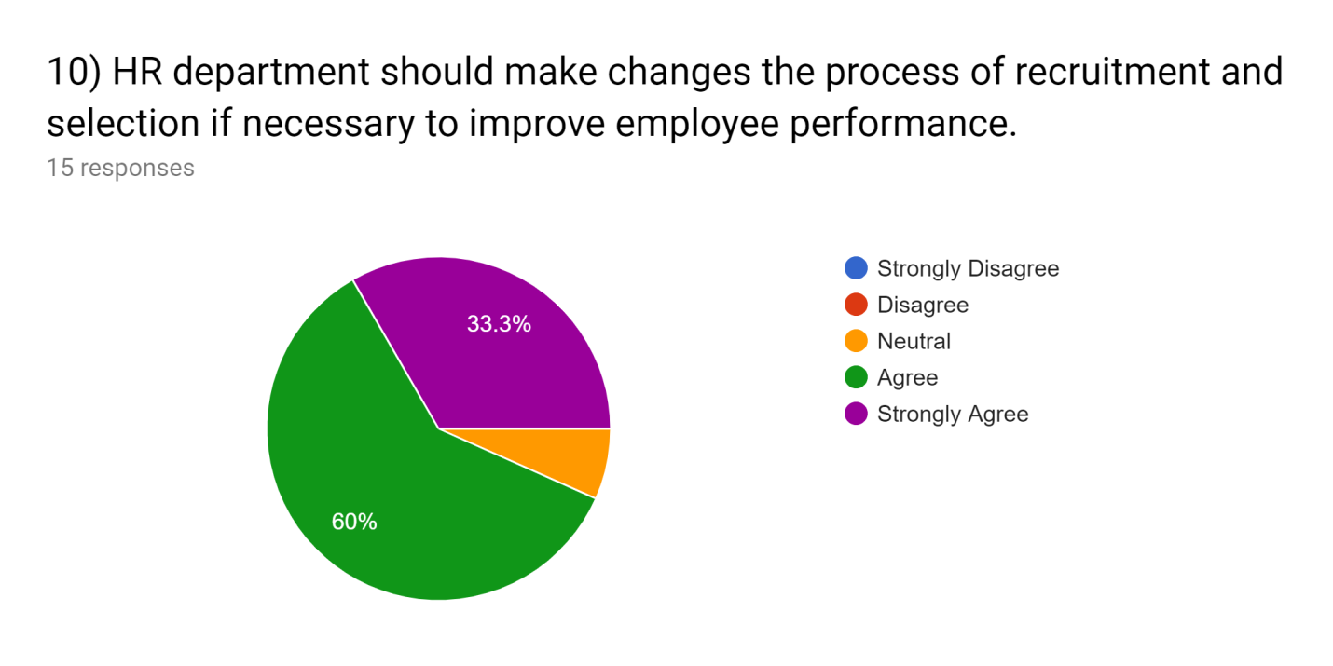
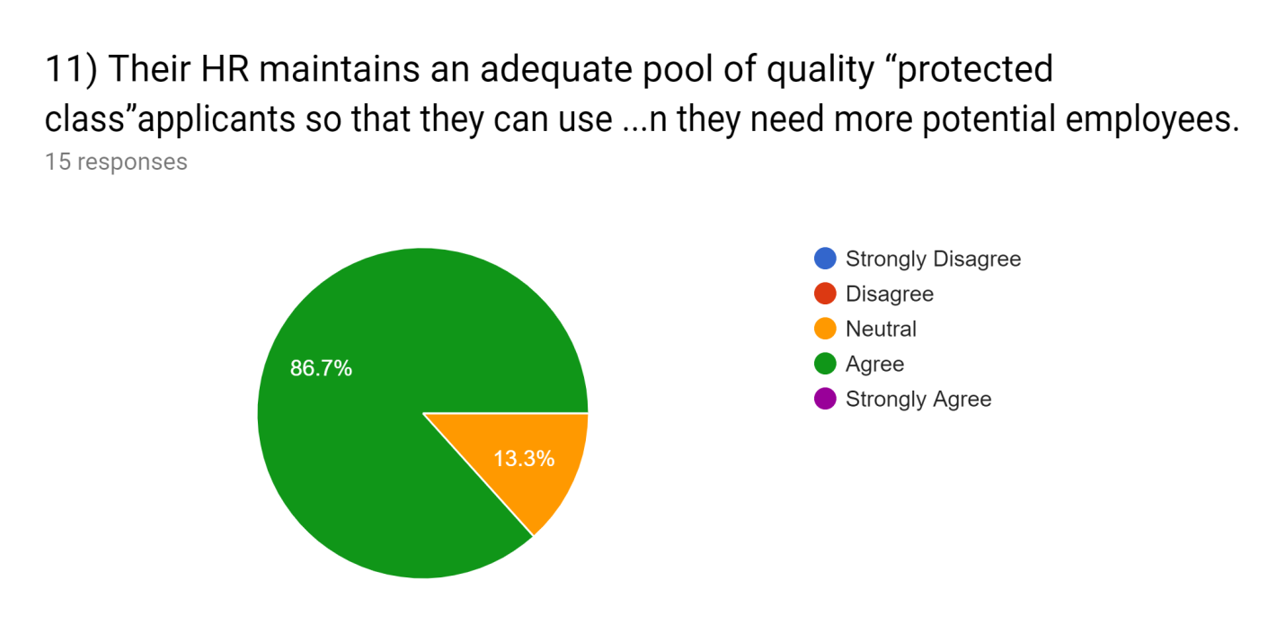

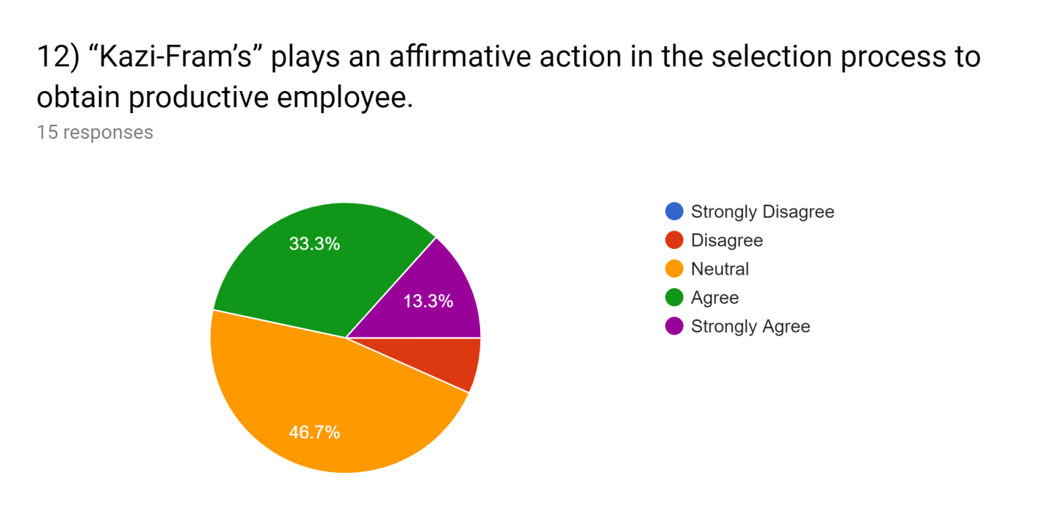
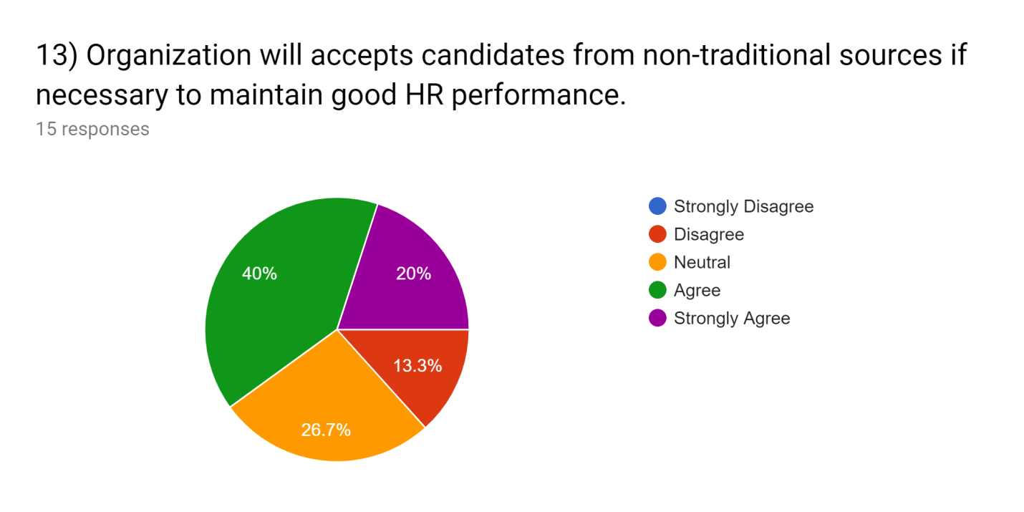

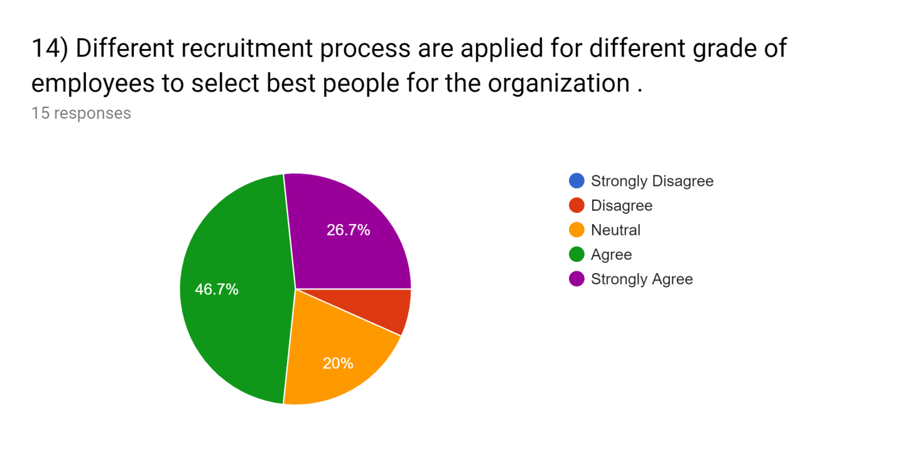

4.3 Brief Discussion about Survey Questionnaire:

- Now the first question they asked about their job description & job specification. 53.3% employees do agree & 20% strongly agree with the statement that when KFG distributes a job circular the job description & job specification are on it properly.

- Kazi Farm always patronage new employees. They are willing to provide a learning environment so that employees might not feel that they are like other machines perhaps they will explore & learn something new every day that’s why more than 50% employees do agree on this statement.

- Learning and development is a part of HR now-a-days, but if the term consultant comes that it’s not related with learning. Sometimes employees might feel that in pre-screening process the authority act as consultant but that just not always happen. So here most employees are in the neutral position.

- Biasness is very much unethical in every organization. If I talk about my survey than here 40% agreed & 26.7% strongly agreed that the top management put their personal reference in recruitment process. Which will definite creates barrier.

- Direct recruitment process must have to gone through a lot of procedures. Each and every step must have design & perform sophisticatedly, which is very time consuming. In other case if employees can be recruited from outsourcing that it needs very little time to find out high skilled employees.

- It is very obvious that in a re-known organization like Kazi Farm, lots of Cv’s are dropped every day in job purpose. The HR teams try from their heart & soul to find out the best of best among those applicants. That’s why the % of agree & strongly agree is very high in this point.

- Recruitment & selection process need some financial support like to create an interview session there have to be some light snacks, written examination needs paper, pen etc. There is also medical check-up system, provision period system. So by considering this type of factors 46.7% of the employees agree on this point. But sometimes the factors can be ignored or can be taken so simply that it might look requirement system doesn’t cost much that’s why 33.3% disagree with the statement.

- Recruitment and selection process is continuing from the very beginning of the industrialization. It is changing day by day, new technologies and innovation are introducing in it. Some organization brings so much unique or innovative methods. Kazi Farm is also trying to adopt unique process but not with too much updated version.

- No human being in this universe is 100% perfect. Every person has some lacking. So in the point of view of this statement the employees of KFG answer neutrally. Because sometimes they might compromise in some cases sometimes the might not.

- Based on this statement majority of the employees 60% agreed & 33.3% strongly agreed. Changes is a part of peoples life so if an organization want to achieve the highest position it must have to change its policies over time to adjust with the situation.

- Their HR maintains an adequate pool of quality in this statement 86.7% employees agreed. None of the employee disagreed on this point. As KFG is a big organization so they always try to maintain a protected class so they can maintain an adequate pool.

- Kazi Farm always looks for productive employees. But due to some reasons sometimes the recruitment process might not obtain the expected level. For that reason 46.7% employees here are confused about it that’s why more person neutral with this statement.

- This statement came with a difference or mix type of answer. If KFG gets opportunities than some think they will surely accept employees from non-traditional sources, some are in natural position.

- In an organization there is a hierarchy from top to bottom. To hire a top level employee the recruitment & selection process will be different than selecting a mid-level or low level employee. So for that reason different process are applied in their selection process for different groups. 46.7% employees do agree on this. 20% neutral & only 6% disagree on this issue.

Chapter 5
Recommendation & Conclusion

Recommendations:

- Recruit efficient manpower in HRD to reduce the work pressure.
- In the Job advertisement the HR department of KFG can mention their pay structure.
- The company can go for campus selection so that highly educated fresheners could get a chance
- Provide some motivational or recreational activities
- Online recruitment system should have to be more updated.
- HR recruitment and selection policy should be designed to attract more efficient workers for the organization for improvements.
- The organization should focus on their internal political issues; need to solve this problem because it might hamper their image.

Conclusion:

In modern time business is changing rapidly by the passing of time. The competition is getting wider and wider. So to match up with this competitive changing world every organization must have to apply its own unique theories, ideas & process. This report is based on 3 months internship period on kazi farms group. The main focus of this internship report is to complete BBA program as well as to get familiar with the "selecting & recruitment" process of kazi farms. This report basically contains 5 parts they are introduction it contains the information such as objective of the report, scopes of the report, rational, sources, limitation. The 2nd chapter of this report is company profile, which represent the descriptive view of Kazi farms group. The 3rd chapter is HR practices which represent the literature review, & the HR policies and practices based on mainly selecting & recruitment theme that have been used in kazi farms group. The 4th & most important chapter of this report is Findings & Analyze. The finding parts of this report have been conducted through a questionnaire survey on employees of kazi farms group. By collection of the answer of the questionnaire analysis part have been made which basically representation of what the employees think about a particular topic, than the answers were decorated through a pie chart. The final part is basically for recommendations and conclusion. Kazi farms group is a very renowned organization now days, despite being in a good position they have some problems or difficult issues. So to reduce problems or to maintain a good position in market the company should give more emphasize on their product and service quality. As well as they should recruit more educated, energetic, skilled employees than their competitors. As we all know humans are the main asset of an organization.

References

- :: Kazi Farms Group :: (n.d.). Retrieved April 22, 2019, from https://www.kazifarms.com/

- Internship report on recruitment and selection process. (n.d.). Retrieved September 8, 2019, from https://www.slideshare.net/PriyaDubey26/internship-report-on-recruitment-and-selection-process

- Recruitment and Selection Tutorial. (n.d.). Retrieved March 12, 2019, from https://www.tutorialspoint.com/recruitment_and_selection/index.htm

- :: Kazi Farms Group :: | Social Responsibility. (n.d.). Retrieved April 22, 2019, from https://www.kazifarms.com/Social Responsibility

- Recruitment and Selection Recruitment Process. (n.d.). Retrieved March 12, 2019, from https://www.tutorialspoint.com/recruitment_and_selection/recruitment_process.htm

- Recruitment and Selection Tutorial. (n.d.). Retrieved March 12, 2019, from https://www.tutorialspoint.com/recruitment_and_selection/index.htm

Appendix:

Organization-Kazi Farm
Department- Human Resource (HR)

 | Rating
Statements | Strongly Disagree  (1) | Disagree  (2) | Neutral  (3) | Agree  (4) | Strongly Agree  (5)
- “Kazi-Farm” clearly definesjob description and specification in job advertisement to get right HR at right place.
- “Kazi-Farm” propagate ideas like “Come Grow with us” & “Learning Environment” to increase their HR performance.
- ““Kazi Farm’s” HR Team act as a consultant to enhance the quality of applicant pre-screening process to get highly qualified employees.
- Preferences of top managements personal references in Recruitment process creates barrier..
- Direct recruitment & selection process is time consuming than outsourcing to acquire fruitful HR
- The Resume screening and short listing method is useful to obtain effective employee.
- Recruitment& selection process of this company is costly which creates impact on budget of HR department
- Innovative techniques are adopted in selection process to acquire effective HR.
- They did not comprise with any of the criteria in the recruitment and selection process to get potential employee.
- HR Department should make changes the process of recruitment and selection if necessary to improve employee performance.
- Their HR maintains an adequate pool of quality “protected Class” applicants so that they can use it when they need more potential employees.
- “Kazi Farms” plays an affirmative action in the selection process to obtain productive employee.
- Organization will accepts candidates from non-traditional sources if necessary to maintain good HR performance
- Different recruitment process are applied for different grade of employees to select best people for the organization.

