12/21/2021


Internship Report
CSR activities of Dhaka Bank Ltd. during Covid-19 pandemic

Date: 21st December 2021
Submitted by:

Name: Rajib Kumar Saha
Id: 111171152

Submitted to:

MD. SHARIFUL ALAM
Associate Professor
School of Business and Economics
United International University
Internship Report On

CSR activities of Dhaka Bank Ltd. during Covid-19 pandemic

Letter of Transmittal

21st December, 2021
MD. SHARIFUL ALAM
Associate Professor
School of Business and Economics
United International University

Subject: Submission of Internship Report

Dear Sir,
It is an immense pleasure for me to submit the Internship report on Dhaka Bank Ltd (Madhabdi Branch). Within this period, I have completed my Internship as well as report writing. I am very grateful to you as I have received full support as well as a guide during my internship. I had to gather the most relevant information as required for the report in order to prepare this report. I have tried to collect as reliable as possible. By making this report, I fully understand how an organization is going on through the simulation process. Working for three months in Dhaka Bank Ltd was inspiring and a great learning experience for me. I hope this knowledge will facilitate me a lot in my future career endeavors. I did my best to meet the report's objectives.
Therefore, I hope and pray that you would be kind enough to accept my Internship report and oblige, thereby. It would be a great honor if you asked me to explain any queries and enlighten me with your thoughts and views regarding the report.
Once again thank you so much for your support and patience.

Sincerely,
Rajib Kumar Saha
Id: 111171152

Acknowledgement

First and foremost, I want to thank Allah Almighty. Then everyone who was involved in the report's preparation, both directly and indirectly. I sincerely apologize to those whose names I have not mentioned, and I thank them for their contributions. I'd like to thank my academic supervisor, Md. Shariful Alam, Associated Professor, School of Business Economics, United International University, for grading me and allowing me to begin this report. I'd like to thank him in particular for sharing his time and wisdom with me.

I was assigned to work as an intern in the general banking division of Dhaka Bank, Madhabdi Bazar Branch, from September 1st to November 30th, 2021. I'd like to thank all of the Dhaka Bank Ltd. officials who were involved. I'd like to thank Md. Hannan Ahmed (VP & Branch Manager), Md. Atikur Rahman (SAVP & Operations Manager), and Saiful Islam (Senior Officer & GB In-Charge) in particular for their time and insights. I'd like to express my gratitude to them for providing me with the necessary information to begin this report and for granting me permission to conduct the necessary analysis.

Executive Summary

I have completed a 3-month internship at Dhaka Bank Ltd. as this is the part of BBA program. The purpose of this report is to analyze and reflect on my internship responsibilities, experiences, and learnings.In this banking sector, all the private banks are becoming more competitive. There are many ways for organizations to get closer to the customer. CSR (Corporate Social Responsibility) activities are one of them to get closer to the customer’s emotion.
I have analyzed the CSR activities of Dhaka Bank Ltd. during covid-19 pandemic situation. To prepare this report, the required information was collected from both primary sources and secondary sources. I did my internship at Dhaka Bank Limited, which began its operation on 5 July 1995. From 1995 to the present, Dhaka bank has been developing its business sector. Earlier, Dhaka Bank used to provide their services only in the corporate sector. Since then Dhaka bank has become known as "Corporate Banking". After that Dhaka bank extended its business operation area through retail banking.As an intern, I have worked for three months in Dhaka Bank, Madhabdi Branch. And this contains my three months internship experience in this Bank. I have explained the overview of Dhaka Bank as an organization, the working environment, my assigned task and my work experience, the lessons that I have learned from my co-workers and supervisors, the working experience in real-life groups, dealing with real customers, my interactions with my supervisors and many more. In addition, I have also discussed the difficulties that I faced during my three months of working and attending at an organization 5 days a week, and also mentioned the differences I realized between my expectation and the actual image of working for an organization.
Table of Contents
Chapter 1 6
1.1 Background of the study 1
1.2 Significance of the study 1
1.3 Scope of the Study 2
1.4 Objective of the study 2
1.5 Methodology 3
1.6 Limitation of the study 4
1.7 Acronyms and Elaborations 6
Chapter 2 7
2.1 Banking History 8
2.2 About Dhaka Bank Ltd. 9
2.3 Profile: 10
2.4 Philosophies of Dhaka Bank Ltd. 11
2.5 Objective 12
2.6 Branches 12
2.7 Management information system 12
2.8 Departments 13
2.9 Banking System 14
2.10 Growth of DBL 14
2.11 Products and Services of Dhaka Bank Limited 15
2.12 Hierarchy 18
2.13 SWOT Analysis 19
Chapter 3 21
3.1 Activities of General Banking Department 22
3.2 Activities of Foreign Exchange & Credit Department 23
Chapter 4 24
4.1 Corporate Social Responsibility 25
4.2 Donation for Social Improvement by CSR in matrix: (2019- Before Covid-19) 26
4.3 Donation for Social Improvement by CSR in matrix: (2020- During Covid-19) 30
4.4 Recent Activities & Achievement 34
Chapter 5 35
5.1 Job Responsibilities 36
5.2 Interactions with the supervisor and coworker 39
5.3 Lessons Learned from the Internship 40
5.4 Expectations versus Experience 42
Chapter 6 43
6.1 Recommendations 44
6.2 Conclusion 45
6.3 Reference 46







Introduction

Chapter 1

1.1 Background of the study

The internship program for BBA students at United International University (UIU's Faculty of Business Studies) is an essential component of the BBA program. Following the completion of the program period, the student must submit a report on the assigned topic to the Supervisor and the department. This internship program got three (3) credit hours out of a total of 123 credit hours. The course lasts three months. To finish the program, I was assigned to Dhaka Bank Limited. I worked with the organization's employees during this time period. After consulting with the program's supervisor, I choose the topic "The CSR activities of Dhaka Bank Limited in case of Covid-19 situation pandemic."

1.2 Significance of the study

For a business student, theoretical knowledge is insufficient. Even though there has to be a gap between theoretical knowledge and practical field. Our internship program was created primarily to bridge this gap. This study proposes to look into Dhaka Bank Limited's CSR activities in case of Covid-19 situation. The bank's goal is to become a highly professional and profitable bank that will contribute to the country's economic development. The bank intends to continue expanding its branch network in order to reach a diverse range of customers across the country and serve them by providing products and services that are supported by cutting- edge technology. The bank was able to cultivate trust in the minds of its customers by maintaining adequate liquidity to meet the needs of the borrowers. At the same time, the bank was able to maintain a higher spread while remaining profitable in terms of interest income. Also, loan rates are being reduced under Bangladesh Bank's policy guidelines, and the bank must adopt the necessary strategy to maintain its profitability from the loan portfolio. Dhaka Bank Ltd.'s mission is not only to provide credit, but also to help the country develop through industrialization by selecting appropriate projects and assisting in various ways in the successful implementation of those projects.

1.3 Scope of the Study

Dhaka Bank Limited's study would concentrate on the following areas.
- Dhaka Bank Limited's CSR activities.
- The strategy of CSR activities.
- Organizational structures and management responsibilities.
Each of the aforementioned areas would be scrutinized in order to assess the effectiveness of DBL's marketing and CSR activities.

1.4 Objective of the study

- Broad objective of the Report
The overarching goal of this project is to prepare an internship report on the topic "CSR activities of Dhaka Bank Limited in case of Covid-19 pandemic."
- Short objective of the Report
The following objectives have guided the project:
- To weigh the benefits of conventional ideas about the bank's CSR activities.
- To compare Dhaka Bank Limited's existing CSR policy with the best practices guidelines provided by Bangladesh's central bank.
- Identifying and recommending areas for improvement in DBL CSR area.
- To gain a general understanding of Dhaka Bank Limited's performance.
- To gain a better understanding of Dhaka Bank Limited's overall transaction.
- To gain a better understanding of DBL’s processes under each transaction.

1.5 Methodology

The report is based on Dhaka Bank Limited's CSR activities in case of Covid-19 pandemic. Various files, statements, and manuals aided me in preparing this report. This report's content is collected from the following data and information sources:

Primary Source: It contains new or entirely new data sources gathered for a specific purpose, like as-
- In-person interview and conversation.
- Expert advice
- Official documentation
- Related work experience.
- Review the different files and documents.
- Discussion in Groups
- Consultation with my superiors.

Secondary Source: It contains the data sources that are already available or have been published, such as -
- Books
- Articles
- The annual Report
- Leaflets
- Internet browsing

- Tools used for data collection: I used the following mechanisms to collect the data or information we considered necessary (both the primary & Secondary)-

Primary data: The following aspects or tools are used to generate all of the needed primary data:
- Observation while working at different desks
- Unofficial conversation with professionals
- Casual and unstructured interviews

Secondary data: The following aspects or tools are used to generate all of the needed secondary data -
- Dhaka Bank Limited's Annual Report (2019-2020)
- Dhaka Bank Limited manual principles.
- Dhaka Bank Limited has various kinds of documents.
- Dhaka Bank Limited leaflets
- Internet browsing

1.6 Limitation of the study

Despite the fact that I received complete cooperation from DBL Staff members, they were extremely busy. As a result, they were unable to devote as much time as they and I would have preferred. Furthermore, the total duration of the internship is insufficient to provide me with more than a cursory understanding of the operations of the various departments through which I was rotated. Throughout my studies, I have encountered the following issues, which may be referred to as the study's limitation/shortcoming. These are the following: --

- The major limitation of this study was a lack of necessary information.

- Even though the Bank staff are very overwhelmed with their activities, they did not cooperate with me to complete this report.
- The report's primary constraint was its short time span. Enough time is needed for an analytical purpose.

In addition,
- A lack of up-to-date information on the web.

Besides this, each necessary measures was taken to minimize the aforementioned issues and make the study as effective and productive as possible.

1.7 Acronyms and Elaborations

AGM | Annual General Meeting
B/L | Bill of Lading
BAS | Bangladesh Accounting Standards
BB | Bangladesh Bank
BOE | Bill of Exchange
BBL/C | Back to Back Letter of Credit
BC | Bill of Collection
BCD | Banking Control Division
BL | Bad Loss
BRPD | Bangladesh Regulation and Policy Department
FC | Foreign Currency
FDR | Fixed Deposit Receipt
BSA | Bangladesh Standards on Auditing
CC | Cash Credit
HS Code | Harmonized System of Coding
CIB | Credit Information Bureau
CL | Classification of Loan
CRR | Cash Reserve Requirement
DD | Demand Draft
DF | Doubtful
ECD | Exchange Control Department
FAD | Finance and Accounts Director
LC | Letter of Credit
FBP | Foreign Bill Purchase



Organization Overview

Chapter 2

2.1 Banking History

In general, the term "bank" refers to only financial resources that handle cash. Typically, when we hear the word "bank," we think of a financial institution that manages money. The entire state of affairs of a rustic company is consistently detected by inspecting the situation of the banking division. The banking division plays a key role in the economic operations and development of any country. Banks are classified into Central Banks, Commercial Banks, Savings Banks, Investment Banks, Industrial Banks, and Cooperative Banks, among others. But previously, we used the word "Bank" without qualification or limitation, and it referred to commercial banks. In a rural economy like ours, commercial banks are the first one to contribute. In our country, commercial banks dominate the economic sector and macroeconomic supervision, with the rest of the commercial banks' performance and investment divisions following closely behind. More people believe that non-public banks should be permitted to provide positive incentives to the development process for personal gain. In the 1980s, non-public sector banks were allowed to diversify for the first time. One of these is Dhaka Bank. The banking concept is no longer supported within the lodge of the branches. Non-cabin banking is now handled by bankers. As a result, having some knowledge of banks and banking systems is critical for everyone. There are currently fifty-six scheduled banks throughout the country. There are nine state-owned units (including five special banks), 38 private commercial banks, and nine commercial banks remaining. Despite the fact that the banking sector in Bangladesh is undergoing fundamental reform, it is still suffering from chronic deterioration. The most significant drawback of Bangladesh's banking sectors is the risk of loan default. In Bangladesh, numerous initiatives have been approved to prevent the loan default.

2.2 About Dhaka Bank Ltd.

Dhaka Bank Ltd. is a scheduled bank that was established under the Companies Act of 1994 and began operations on July 5, 1995, with the goal of playing an important role in the country's socioeconomic development. Dedicated to bringing commercial banking services to customers' doorsteps across the country. This company gained the trust of its customers almost immediately after it was founded. During this time, the bank has been successful in establishing itself as a forward-thinking and dynamic financial institution in the country. This is now widely acclaimed by the business community for modern and innovative ideas and financial solutions, from small entrepreneurs to large merchant and conglomerates, including top-tier corporate and foreign investors.

DBL is dedicated to forming a higher society by measuring the scale of the area and operating and donating in some alternative sectors such as education, health, disaster management, sports, and national priorities. The long 21-year journey can truly reflect our concern for people involved in crucial CSR in our financial consolidation. DBL, on the other hand, has incorporated property policies into its day-to-day operations. The inexperienced banking cell is tasked with boring development policies, products, and oversight of the bank's low-cost financial operations. The bank has a strong team of highly qualified and experienced professionals, as well as an economic Board of Directors that plays an important role in expressing and implementing policies.

2.3 Profile:

Name of the Bank | Dhaka Bank Limited
Status | Public Limited Company
Date of incorporation | April 06, 1995
Date of commencement | July 05, 1995
Registered office | Bir Uttam Khandakar Road, Gulsan, Dhaka 1212
Company registration number | C-28146 (1992)/95
Bangladesh Bank license no. | BCD (D) 200/57-421/95
Telephone | 9554514
Telex | 9556584, 9571013, 9565011
Swift Code | DHBLBDDH
E-mail | info@dhakabank.com.bd
Web Page | www.dhakabankltd.com
Chairman | Mr. Rashadur Rahman
Managing Director | Emranul Huq
No of Branches | 100
No of ATMs | 56
No of ADMs | 20
SME Service Centre | 3
Off Shore Banking Unit | 2
KIOSK | 1
logo | 

2.4 Philosophies of Dhaka Bank Ltd.



“To become a leading banking institution and play a significant role in the development of the country.”



“The Bank is committed to satisfy diverse needs of its customers through an array of best suited products at a competitive rate by using appropriate technology and providing timely service so that sustainable growth, reasonable return and contribution to the development of the country can be ensured with a motivated and professional work-force.” (Dhaka Bank, 2021)



“Trust, Integrity, Commitment, Business Ethics, Quality, Fairness, Teamwork, Respect, Courtesy Harmony, Unique Culture, Responsible Corporate Citizen.”

2.5 Objective

Their all employee, products, and working processes are all in a synchronization to meet the customer’s expectation. Their primary goal is to provide quality service that is a true reflection of their vision—Excellence in Banking.

2.6 Branches
The bank has 100 branches across the country, three SME service centers, six CMS units, two off-shore banking units, and communicators all over the world. The bank intends to open new branches in the coming year in order to expand its network.

2.7 Management information system
The Dhaka Bank Ltd advertising banks journey, which began in 1995, has put a strong emphasis on the use of cutting-edge technology. Since 2003, when two new banking software systems, particularly FLEXCUBE and DBCUBE, were established, it has been operating online. As a result, the bank is now able to provide services of international caliber. The bank has launched its company Portal (Intranet), which aims to create the first and comprehensive content management, paperless communication, and knowledge management by IT/BPR and integrates the first net applications across the enterprise. The platform is based on a split system for individuals. Dhaka Bank Ltd has made a financial investment in developing the software system and assigning individual IT divisions to fifty large integers.

2.8 Departments
It will be very difficult to manage the system effectively if the roles are not organized by considering their correlation and are not assigned to a very specific category. If departmentalization is not practical, the status will be defective, and the performance of the chosen category will not be measured. The work was fined by Dhaka Bank Ltd. These are their titles:

Human Resource

Operation

Central Accounts

Investment

Departments

Personal Banking

Global Trade

Audit & Risk Management

Information Technology

2.9 Banking System

- Retail Banking
- Corporate Banking
- Syndications Banking
- Digital Banking
- SME Banking
- Islamic Banking

2.10 Growth of DBL

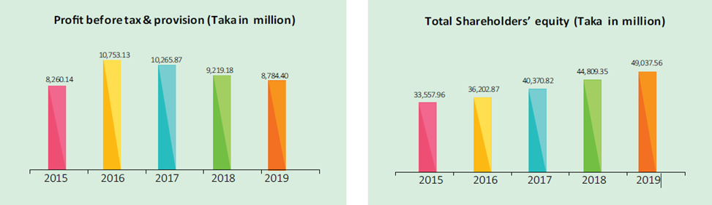

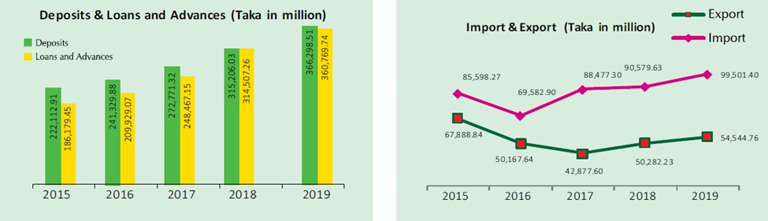

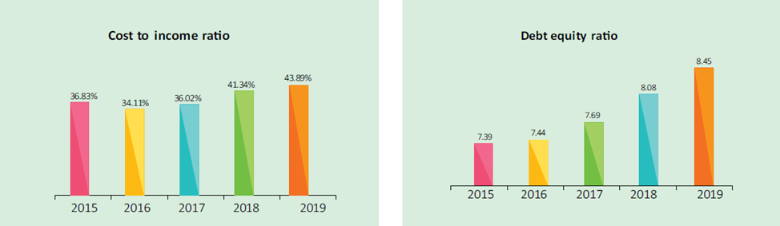

2.11 Products and Services of Dhaka Bank Limited

As it is a Bank the products are embedded with all the services as follows:

- Deposit Products: Dhaka bank has 22 types of Deposit seam for its customers. Of them some popular deposit products are mentioned below:
- Savings Bank (SB) Account
- Current Deposit (CD) Account
- Short Notice Deposit (SND) Account
- Student Savings Account
- Fixed Deposit Receipts (FDR)
- Double Growth Deposit Scheme
- Triple Growth Deposit Scheme
- Monthly Benefit Scheme (MBS)
- Lakhpati Deposit Scheme
- Millionaire Deposit Scheme
- Kotipati Deposit Scheme
- Monthly Savings Scheme

- Corporate Loan Products:
- Cash Credit (CC)
- Secured Overdraft Loan (SOD)
- Time Loan
- Lease Finance
- Performance Guarantee (PG)
- Letter of Credit (L/C)
- Bank Guarantee (BG)
Other than these Loans Dhaka Bank has other loan products also.

- Retail Loan Products:
- Auto Loan
- Any Purpose Loan
- Personal Loan
- Salary Loan
- Doctors Loan
- Education Loan
- Overseas Job Loan

- SME Financing:
For ensuring maximum financial inclusion of unbanked people Dhaka Bank also provide SME financing service to the Small and Medium Enterprises. Under this service they have different product bundle to the benefit of the customers.
- To ensure smooth services to the Cottage, Micro & SME clients Dhaka Bank opened 09 (nine) SME branches.
- To assist women entrepreneurs Dhaka Bank has undertook special strategies.
- Total SME loan disbursement was BDT 47,256.90 million.
- DBL has secured a position in the rated list of Top 10 (Ten) “SME business doing Banks”

- Agriculture Loan:
The Dhaka Bank Limited (JBL) has been providing agricultural and rural credit by its Agriculture Loan Project (ALP) since 2008.
- The loan is disbursed to mainly eight agriculture sub sectors.
- It has disbursed 26,325.12 Lakh taka under the Agriculture Loan Project (ALP).

- Cards:
Dhaka Bank has 9 types of Card facilities for its customers.
- VISA Electron Payroll Debit Card (Yearly Fee free)
- VISA Debit Card (Yearly Fee Tk. 500)
- VISA Local Classic Credit Card (Yearly Fee Tk. 690 including Vat)
- VISA Local Gold Credit Card (Yearly Fee Tk.1380 including Vat)
- VISA Dual Currency Gold Credit Card (Yearly Fee Tk. 3450 including Vat)
- RFCD Card (Yearly Fee USD 57.50)
- Exporter Retention Quota (ERQ) Credit Card (Yearly Fee USD 30.00)
- VISA Platinum Credit Card (Yearly Fee Tk. 4140 including Vat)
- VISA Co-Branded Platinum Credit Card (Only for Gulshan Club members)

- Locker Service:
Storing too much jewelries and valuables in the house at times becomes a security issue and an impediment in case of natural calamities. They are offering Locker service in 15 branches all over the country. The service hour is from Sunday to Thursday 10:00 AM to 4:00 PM.

- Online Banking Service:
Dhaka Bank Limited offers Real-time online banking throughout all of its branches. By online service any customer will be able to get the following facilities:
- Cash withdrawal from any branch.
- Cash deposit into any branch.
- Encashment of pay-order from any branch.
- Statement from any branch

2.12 Hierarchy

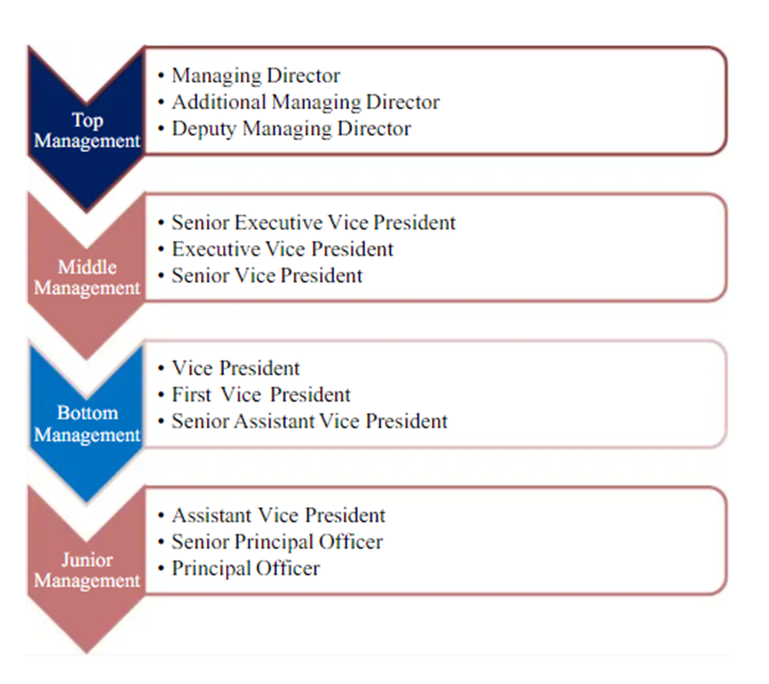

2.13 SWOT Analysis

SWOT stands for strengths, weaknesses, opportunities, and threats. These are critical issues that must be addressed before proceeding. Internal strengths and weaknesses are related to organizational performance, whereas external opportunities and threats arise from the current external environment. SWOT analysis must be performed so that the organization does not overestimate or underutilize its capabilities. It aids in capitalizing on potential opportunities and taking preventative measures against potential threats, reducing the likelihood of errors and increasing the likelihood of profit maximization. SWOT analysis helps organizations understand what needs to be done, what needs to be prepared for, what needs to be maintained, and most importantly, insight into their current position or status.

.
- Friendliness in the Workplace
- Skilled and energized workforce
- A distinctive corporate identity
- Efficient productivity
- Stable Financial Situation
Strengths

- Excessive L/C charges
- Inadequate Inspiration
- Small business owners are discouraged
- There is a lack of significant marketing activity
- There aren't enough innovative products on the market.
- Account maintenance is expensive.

Weaknesses

- Differentiated operational procedures
- Networking across the country
- Managers with Prior Experience

Opportunities

- Other banks provide comparable services.
- Future banks/branches
- The economic downturn
- Loans that are in default
Threats

Departmental Activities

Chapter 3

I was assigned in Dhaka Bank Ltd. Madhabdi Branch. This branch was formed in 8th November 2001 to serve the Madhabdi Pourosova’s people. Madhabdi is an industrial area of Narsingdi District and most of the people here are businessman. Therefore, the number customer in this area is huge. That’s why to serve this area Dhaka Bank has opened a branch in this area. Almost 21 employee work in this branch including Sub-branch. All the employee of this branch are very friendly and they are always ready to teach me. They made sure that I was feeling comfortable from the very first day. I never got any sort of unfair treatment from them.

3.1 Activities of General Banking Department

General Banking is the main banking function of a bank. General Banking is also called the heart of Banking. A lot of activities and services are provided in the general banking section. General Banking is the starting point of all banking operation where it provides day-to-day services to the customers. Some of the major functions of general banking department are given below:
- Accounting Opening
- Accounting Closing
- Cheque book requisition
- Debit/Credit Card requisition
- Cash Section
- Clearing online/offline Transactions
- Issue Pay order
- Remittance
- Encashment of DPS/FDR accounts
- Starting SMS Banking Service, Internet Banking Service and Mobile Banking Service

3.2 Activities of Foreign Exchange & Credit Department

Dhaka Bank Limited gives opportunity to its customer to maintain foreign currency account through its authorized dealer branches. This department also provide different credit facilities to its customers also. In this department export, imports and remittance related works are monitored and applied. This department make a connection between exporter and importer by giving them various kinds of services like Letter of Credit (LC), Bank Guarantee (BG) etc. In Madhabdi Branch the foreign exchange department works with 16 Exchange houses like Money gram, Western Union, Xpress money etc.


CSR Activities & Analysis

Chapter 4

4.1 Corporate Social Responsibility

Dhaka Bank is dedicated to fulfilling its corporate social responsibility. Every year, they set aside 2% of their tax profit for CSR initiatives. They've also undertaken a slew of initiatives aimed at improving social welfare and community development.
Dhaka Bank has contributed towards corporate social responsibility for…
- Sponsorship of the SHEID Trust,
- Sponsorship of the BADC School,
- Annual donation of Tk 1.2 million to the Center for Women and Children's Health Hospital beginning in 2006,
- Since 2006, Tk 1.2 million has been donated to BIRDEM Hospital.
- Contribution to the Scholastica Educational Trust
- Dhaka Bank ltd. sponsored Shaheed Smrity Hockey 2008
- Dhaka Bank Ltd. sponsored of the 2008 Golf Cup Tournament,
- Sponsored the 22nd Bangladesh International Junior Tennis Championship in 2008, as well as the Dhaka Bank sponsored Independence Day Hockey Tournament in 2008.
- Donated a check for $10,000 to the victims of the Sri Lankan tsunami.
- Prime Minister's Relief Fund and Chief Adviser's Relief Fund to alleviate the sufferings of the country's devastated flood victims,
- Donated Taka 3 million to sponsor a ten-bed ward at the proposed Ahsania Mission Cancer & General Hospital.
- Donated Taka 10 million to the Center for Women and Child Health Hospital for the establishment of pathological laboratories and imaging units
- Donated a passenger lift worth Taka 2.6 million to BIRDEM Hospital, as well as two hemodialysis machines worth Taka 1.8 million.

4.2 Donation for Social Improvement by CSR in matrix: (2019- Before Covid-19)

Dhaka Bank has spent overall BDT 111.32 Million taka to the betterment of the nation.

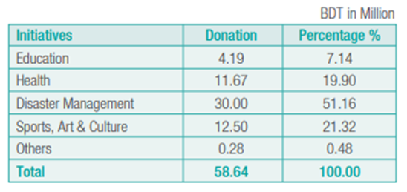

Education:
Dhaka Bank donated BDT 4.19 Million taka to the development of the educational infrastructure and merits scholarship.
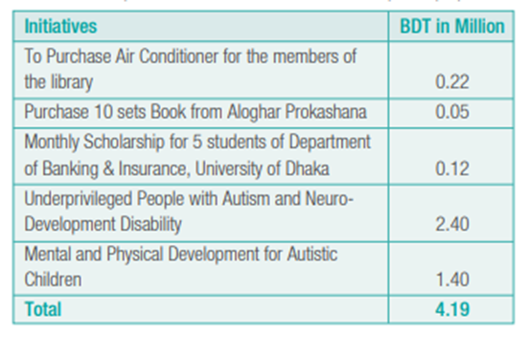

Health
Dhaka Bank donated sufficient fund with the support of BIRDEM Hospital to the better treatment of poor and needy patients.
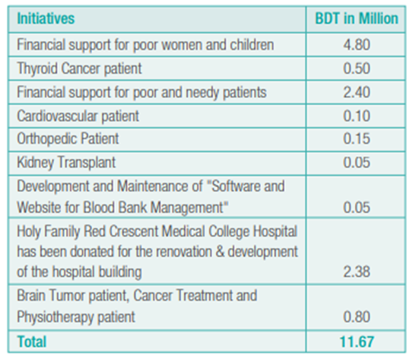

Disaster Management & Infrastructure Improvement
Dhaka Bank always promised to the welfare of the humanity. Dhaka Bank distributed warm cloths to the needy poor people in the winter season as well as donates sufficient financial support to the flood affected people across the country.
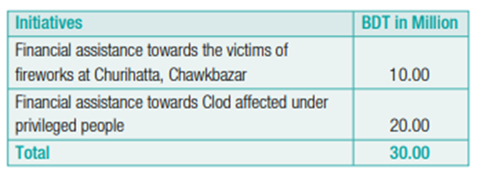

Sports, Arts and Culture
Dhaka Bank donated BDT 12.50 Million to the advancement of Women’s Football Team to Bangladesh Football Federation.
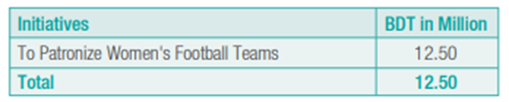

Other Social Projects
Dhaka Bank contributed BDT 0.28 Million to the different social welfare projects.
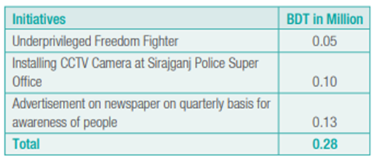

Other Contributions
- Dhaka Bank donated BDT 1 crore to the Prime Minister Relief & Welfare fund for assisting the people who were affected in the fire accident in Churihatta in Old Dhaka's Chawkbazar.
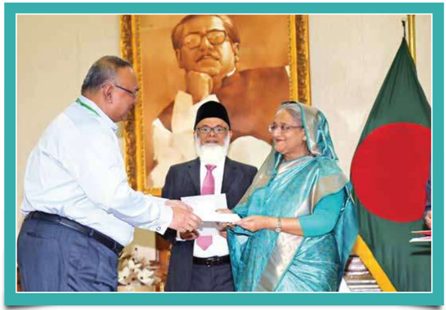

- Dhaka Bank handed over 24 lac taka cheques to the PFDA – Vocational Training Center Trust and 12 lac taka cheques to the SEID as well.
- Dhaka bank sponsored BDT 12.50 million to the Bangladesh Football Federation for an international tournament in Dhaka.
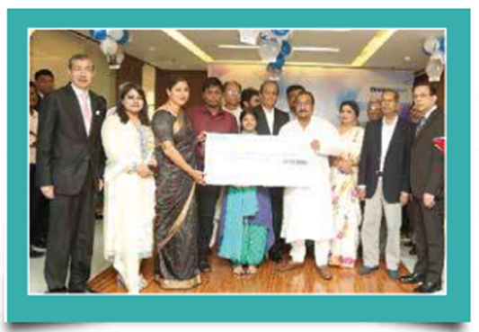
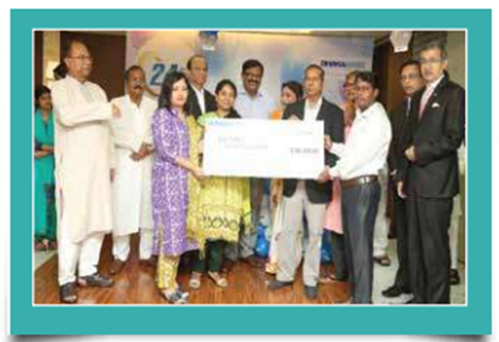
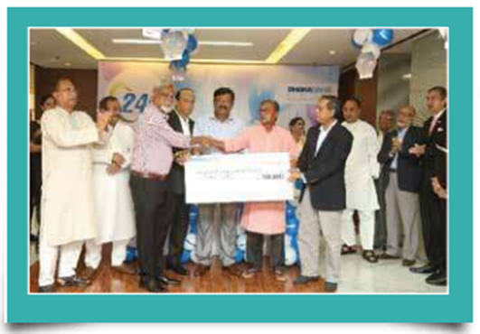

4.3 Donation for Social Improvement by CSR in matrix: (2020- During Covid-19)

Dhaka Bank has created a significant role by supporting against Covid-19 pandemic. Dhaka Bank distributed PPE and oxygen cylinder towards Bangladesh Police, Dhaka bank’s employee, and Prime Minister Relief & Welfare Fund. Dhaka bank has spent overall BDT 223.878 million to the welfare of the nations.

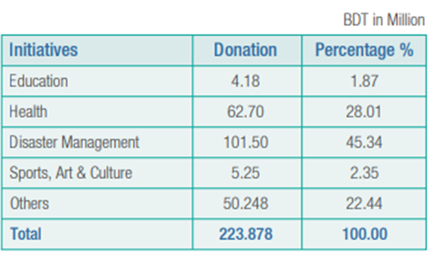

Education
Dhaka Bank donated BDT 4.18 Million taka to the development of the educational infrastructure and merits scholarship.

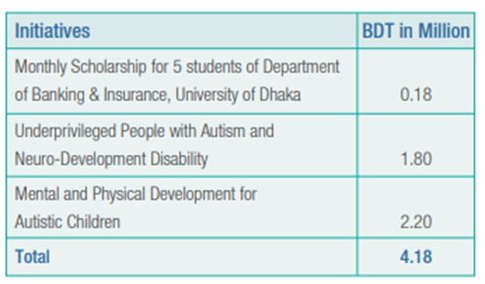

Disaster Management & Infrastructure Improvement
Dhaka Bank always promised to the welfare of the humanity. Dhaka Bank distributed warm cloths to the needy poor people in the winter season as well as donates sufficient financial support to the flood affected people across the country. During the Covid-19 pandemic Dhaka Bank also distributed PPEs towards employees, Bangladesh police, Prime Minister Relief & Welfare Fund.
During the Covid-19 pandemic, Dhaka Bank donated overall BDT 101.50 million to fight against Covid-19.
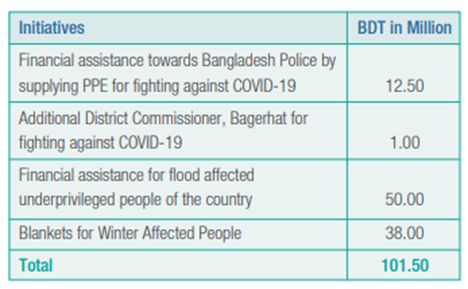

Health
Dhaka Bank donated sufficient fund with the support of BIRDEM Hospital to the better treatment of poor and needy patients.
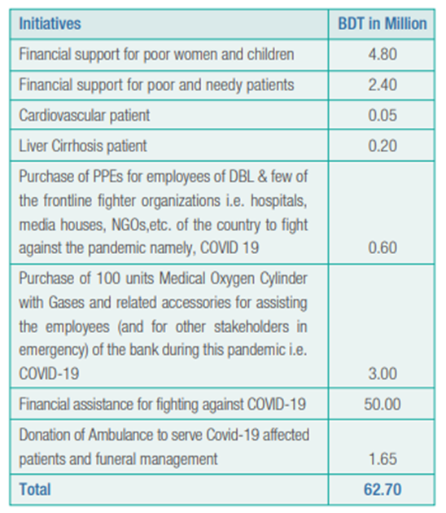

Sports, Arts and Culture

Dhaka Bank contributed BDT 5.25 million in 2020 to the advancement of Women's Football Team as well as to the acceleration of the practice of Art, Literature, and Culture in the Nilphamari district.

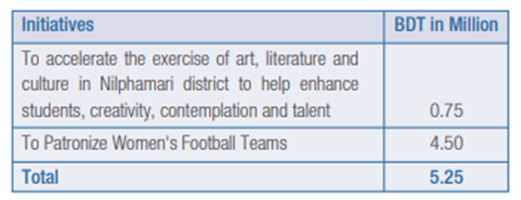

Other Social Projects

Dhaka Bank donated/sponsored/spent BDT 50.248 million in 2020 to commemorate the birth centenary of the nation's Father, Bangabondhu Sheikh Mujibur Rahman, as well as other social projects.

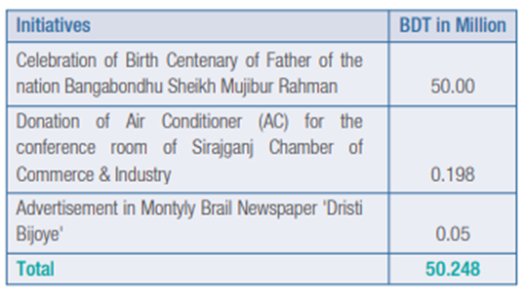

Other Contributions

- Dhaka bank donated 5 Crore taka to the Bangabondu Memorial Trust for celebrating the birth centenary of father of the nation.

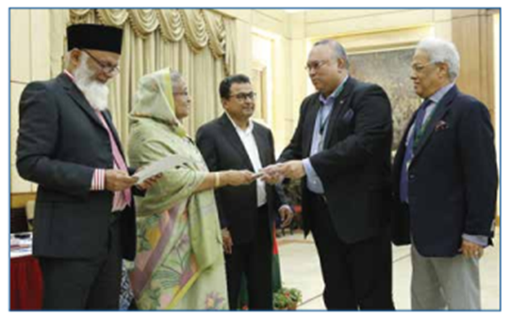

4.4 Recent Activities & Achievement

CSR activities:

- On August 5, Dhaka Bank Ltd. signed a Memorandum of Understanding (MoU) with BRAC to alleviate the crisis against Covid-19 pandemic.
- Under the terms of the agreement, Dhaka Bank gave Tk 2.03 crore cheque for the wellbeing of the nation.

Achievements:
Dhaka Bank recently received The Corporate Social Responsibility (CSR) Award 2006, in recognition of their active participation in various philanthropic activities.
Mr. Shahed Noman, Managing Director of Dhaka Bank Limited, received the award from Dr. Salehuddin Ahmed, Governor of Bangladesh Bank, on Saturday, April 26, 2008, at a function organized by the Bankers' Forum at the CIRDAP Auditorium.

Internship Experience

Chapter 5

5.1 Job Responsibilities

While doing my internship at Dhaka Bank Limited, Madhabdi Branch, I was involved with various responsibilities over the period. A short description of my responsibilities in this bank are given below:

Daily Operations

- Assist the customers with basic information, make sure whether the customers are getting proper service etc.

- Always interact with the customers to know what service they need, asked about their experiences also took suggestion to provide better service.

- Filled new account Opening Forms with proper information.

- Opened different types of accounts in Flora Banking System.

- Scanned and stored different account opening forms.

- Helped the customers by filling down their deposit slips, cheques etc.

- Accessed and printed files from the server for different official uses.

- Assisted the cheque bearing customers providing the information about whether they have enough balance or not.

- Authorized deposit instruments by the managers.

- Stored the new account opening forms and rearranged forms regularly.

- Delivered cheque books and Debit/Credit Card to the customers.

- Posted delivered cheque book to the flora banking system and authorized by the operation manager.

- Checked and correct with necessary information and documents for the incomplete forms.

- Write down Pay Order voucher to the P/O register daily.

- Posted requisitions for new cheque books, debit/credit card.

- Started SMS Banking Service for the customers.

- Familiarized with necessary documents and formats for the customers to fill up to open their loan accounts.

Assisting Supervisor and Coworkers

- Helped the Assistance Officers and customers to open their desire new accounts like Savings, Current, and Short Notice Deposit etc. by filling up their forms.
- Accessed, edited, stored, shared and printed necessary customer documents from the Dhaka Bank server and NID verification server for the Senior Executive Officer.
- Assisted the Assistance officer to serve the walk-in-clients.
- Helped the SEO by entering different service request in the online service portal.

Proofreading and Checking
- Always checked the Product type, Card Rate, Rate Deviation, Amount and Maturity of the deposit etc. before providing service and information to the customers.
- Checked the date, amount, signature, cheque numbers before posting delivered cheque book and also before authorized by the Operational Manager.
- Before scanning and storing Account opening forms, encashment forms and cheque books to the Dhaka Bank Server through Flora Banking System maintain proofread and checking.

Customer Service
- Assisted the customer by providing the basic information
- Assisted the customers to write cheques and deposit slips
- Assisted the customers by filling their Account Opening Forms
- Assisted the customers by writing down different request letter to the manager like Account Encashment, Information Changes, withdrawn of Interest etc.

- Assisted the customers by explaining the various elements and process of amortization schedule to the customers
- Explained the customers about the rate change effects, term change, amount changes etc.
- Provided the customers verified NID forms to open new account
- Provided the customers about the balance for encashment of cheque
- Delivered cheque books, debit/credit cards to the customers
- Assisted the customers by starting SMS Banking Service

Process Improvement
- Created a database enlisting different documents name that are stored in different files in the branch for easily locate the documents
- Created an Excel file for the delivered cheque book so that I can easily find out by typing the name or account number of a customer if his/her cheque book is ready for the delivery or not.
- Created a Document where I made different Application form sample for providing service quickly.

5.2 Interactions with the supervisor and coworker

Mr. Md. Atikur Rahman was the official supervisor for my internship program. He was the SAVP & Manager Operation of Dhaka Bank Ltd., Madhabdi Branch. He is a very nice and hardworking person. From time to time in the middle of his work he would ask what I am learning and also whether I need any help or anything.
I mainly worked under the officer of General Banking Department. The most senior of them is Mr. Md. Saiful Islam, he is a very nice person. He was the first person in the branch whom I was introduced first by the manager of this branch. Then he assigned me to the Assistance Officer Mr. Shefat Ahmed. Then Mr. Md. Saiful Islam gave me a short description of the working process of the bank so that I can understand the job of a different department.
Mr. Shefat Ahmed, was a very considerate person, he didn’t give me too much responsibilities in the first week and asked me to first get familiarized to the work place. He trusted me with my responsibilities and also, he always praised my good work to keep me motivated. We would talk whenever we had some free time and he was extremely friendly with me. I mainly had to work with him and help him serve the customers. I learned many tips and tricks to do well in the corporate life from him.
But soon he was transferred to another branch and then Md. Saiful Islam, Senior Officer of Dhaka Bank Limited, Madhabdi Branch was assigned as my supervisor by the manager of Madhabdi Branch. After transfer of Mr. Shefat Ahmed the full responsibility of Front Desk was assigned to me and by this chance, I got the chance to work with other CS officers and also with the FEO of this branch. They all were very friendly. They helped me a lot learning new things and also provide me necessary information and instruction to manage the front desk task effectively.
The Branch Manager, Mohammad Mohsin is also a very nice person. He also would come frequently to have a little chat and take notes on how my internship is going. Officers from the other departments were also very nice to me. Although I was an intern, they always treat me as their collogue and never made me feel like I was new at the office.

5.3 Lessons Learned from the Internship

Professional Communication

The frequent interactions with my supervisor, coworkers and managers at my internship helped me to learn and develop the manners and norms needed for professional communication. By working in this bank my professional communication skills developed by a great margin. For example:
- Learned without offending the coworkers, how to point out their mistakes.
- Learned how to deny requests of some customer service politely.
- Learned how to ask for the help of coworkers without disturbing them.
- Also learned how to keep professional and personal life separate.

Technical Skill

In my internship at Dhaka Bank Limited, Madhabdi Branch, I had done many technical skills required tasks. I have used Microsoft Office and Excel software which enriched my technical skill. Also, I had to maintain many databases, in doing so I got to learn lot of new functions of excel from my coworkers and supervisors. I also learned how to operate Banks software “Oracle”, “Flexcube” and I had come to know that how it works. I also learned operating the Scanners, Printers, and Photocopiers.

Work Management

As the Assistance Officer of Front Desk was transferred to another branch and no new officer was assigned to this desk so I was given different types of responsibilities, along with which I also had to fulfill the additional tasks given by coworkers and requested by customers. Of these tasks some has needed immediate action, some tasks were very boring and time consuming like write the P/O voucher to the P/O register. Hence, I had to manage these tasks to ensure that I could complete all the tasks without any mistakes and in time.

Working under Pressure
As I was working in the General Banking Department, I had to work under immense pressure because the employees working in this department had to ensure the customers are getting the best possible service on time, moreover the formal assistance officer was absent which created extra pressure to me. Mistakes or taking too much time or failing to provide necessary information can make the customer leave the branch displeased or dissatisfied. Moreover, I learned how to cope and work under pressure, without compromising the quality and quantity of work.

Time Management
Time is the most important elements in customer service. A major portion of customer satisfaction or dissatisfaction depends on the amount of time taken to fulfill their service. Generally, Customers do not care of the processes that need to be completed to give them what they want. They just want their work to be done as soon as possible, so work had to be done in short time. To ensure fast service time management was a must for me to learn.

5.4 Expectations versus Experience

Before joining the Internship program, I thought as an intern I will not be given much responsibilities and might be assigned to do just simple tasks like just managing the queue, data entry, typing, scanning or printing etc. I also had doubt about how they will treat me in the office. Also, as banking sector is deal with money and customer information so maybe they will not disclose any information with me. And I had very limited expectations about learning. I was mentally prepared myself to face the worst situation.
But as I started working in the office, the reality gone completely opposite of my expectations. Dhaka Bank Limited is very serious about their interns and they ensure that the intern should learn as much as possible not from only the supervisors, but also from everyone working in the bank from the customer service officers to the Branch Managers. I was given different types of responsibilities and tasks to do during my internship period, starting from filling up forms to handling customers. I had to do multitasking which was very challenging for me at times as I had to ensure everything was completed in time. To be proactive and to motivate me, my supervisor and other coworkers always showed trust and confidence.
The working culture of Dhaka Bank Limited is not very strict. Everyone officer here is very friendly, even they working in different departments have a very friendly gesture and helping approach. I was treated not as an intern but as an officer of this branch. They always approach me themselves to talk to me in different topics.
Working in Dhaka Bank Limited, Madhabdi Branch was much better than what I had expected before joining here.

Recommendation & Conclusion

Chapter 6

6.1 Recommendations

During my internship period at Dhaka Bank Ltd. I’ve observed and learned about banking sector. Here are some my recommendation based on my experience…
- Dhaka Bank charges high on cheque book requisition than other banks. Dhaka Bank should reduce some charges on cheque book requisition.
- Dhaka Bank should provide enough training their employees on maintaining customer relationship.
- Dhaka Bank is not active in campaigning that’s why their some special services are not popular like other services.
- Dhaka Bank does not active participate on marketing and branding activities that’s why many people still know that Dhaka Bank only offers commercial services, many people are unware about retail banking services. So Dhaka Bank should participate in marketing and branding activities.
- Dhaka bank should sponsor on youth and women training session to make skillful nation.
- Dhaka Bank should bring some changes in the rural area through CSR activities.
- Dhaka Bank should create some career opportunity for women.

6.2 Conclusion

It has been a wonderful and exciting experience working as an intern at Dhaka Bank Limited. I worked in the general banking department, which was a privilege for me to start my corporate life with banking sector. Doing internship in Dhaka Bank Limited was a great learning experience for me which allowed me to realize and understand how the corporate world runs and then compared it with academic knowledges. From top level management to bottom, I got every possible assistance and support from the people working here. I hope I will be able to utilize the experience and learning from this wonderful organization in my future life effectively. I covered the CSR activities of before and during the Covid-19 situation in this report. Due to the short time, I was not able to analyze in depth.
Corporate Social Responsibility (CSR) refers to a self-regulatory mechanism through which a bank ensures active compliance with the spirit of the law, ethical standards, and national or international norms. Dhaka Bank prioritizes long-term programs over short-term ones in order to have a long-term impact on the people and society of the country. Dhaka Bank's Corporate Social Responsibility (CSR) in Bangladesh is guided by the philosophies outlined by our Bank's Board of Directors. Dhaka Bank always concerned to the wellbeing of the nation.

6.3 Reference

Website, D. B. L. (2014, January 13). Dhaka Bank receives CSR award 2006 - Dhaka Bank: Excellence in banking. Dhaka Bank | Excellence in Banking. Retrieved December 10, 2021, from https://dhakabankltd.com/dhaka-bank-receives-csr-award-2006/.
Report, T. B. S. (2021, August 8). Dhaka Bank teams up with BRAC to mitigate Covid crises. The Business Standard. Retrieved December 10, 2021, from https://www.tbsnews.net/economy/banking/dhaka-bank-teams-brac-mitigate-covid-crises-285373.
Website, D. B. L. (2021, October 28). Financial Statements & Reports - Dhaka Bank: Excellence in banking. Dhaka Bank | Excellence in Banking. Retrieved December 10, 2021, from https://dhakabankltd.com/financial-statements-reports/.
Website, D. B. L. (2021, October 5). Press releases - Dhaka bank: Excellence in banking. Dhaka Bank | Excellence in Banking. Retrieved December 10, 2021, from https://dhakabankltd.com/press-releases.

THANK YOU

