Guided Research: ECO 4395
Spring, 2019

An Overview of Remittance
Flow in Bangladesh

Prepared by
Ishrat Jahan Khan
ID: 121 152 016

Abstract

Bangladesh is one of the highest remittance recipient countries in the Asian region. Every year approximately 400,000 workers move to developed countries in search for job opportunities. Consequently, their departure creates brain drain in their native countries. Although they often send foreign money to their families, which in result enables a cash inflow situation in the recipient country that contributes strongly to their economy. However, it is arguable whether the remittance is enough to eliminate the recent trade deficiency in Bangladesh. Thus, with this paper we will learn how remittances can have strong and positive impact on our trade balance.

Introduction

The economy of Bangladesh has been greatly depending on more than 10,000,000 migrant workers and temporary employees. These Bangladeshi citizens have established a livelihood in the foreign countries and transfer their income each year into the country which is known as remittances. This hefty amount of cash inflow contributes to our economy and economists view remittances as one of the main income sources for our country.
Undeniably foreign Investments and remittances have been the major income sources for our country. According to the World Bank reports, it is the second highest source of foreign currency earnings in Bangladesh, the first being revenue generated from exporting readymade garments. Nevertheless, remittance could be projected as the highest foreign currency generated factor for Bangladesh’s economy in terms of net earnings as RMG sector compensates a huge amount of the earnings in production related expenses. Bangladesh proudly entered the list of $10 billion inward remittances in fiscal year 2010.
Employment in overseas and remittances sent by the Bangladeshi migrants contribute to the economic development of this country in various ways. Firstly, it lowers the unemployment rate, alleviates poverty, and boosts foreign exchange reserves. The approach of how the government uses remittance impacts the development of the country. If this huge amount of revenue can be used strategically and invested in productive sectors, it can result in the overall progress of the economy.
Asia-Pacific is the biggest remittance beneficiary region on the planet; in any case, there is no proof about the effect of remittance inflows on the trade balance in this region. To fill out this observational lacking, one of the most successful studies was conducted by collecting data from 1980-2015 of seventeen nations in the Asia-Pacific region. The methods used in the study were the OLS, 2-SLS, and PGMM with ten regression models so as to obviously distinguish the impact of remittance inflows on the trade balance of these economies. Not at all like numerous past outcomes which more often showed the beneficial outcome on the recipient economies. The findings from this particular demonstrated that the remittances have a negative effect and statistically noteworthy impact on the trade balance. Additionally, it infers that the rise in income results in a trade imbalance in the region. The trade balance is the value of a country’s export minus the import. At long last, we likewise locate a constructive outcome of the exchange rate on the trade balance of in the Asia-Pacific region which affirms that the exchange rate policy plays a productive role in the nations in this locale. (Tung, Impact of Remittance Inflows on Trade Balance in Developing Countries, 2018)
With this paper we want to assess the significance of remittance on the trade balance, in doing so we will further explore the relationship between a well defined policy and trade balance deficiency. This paper consists elaborated analysis of studies done previously to observe the impacts of remittance on developing economies.

Review of Related Literature
Remittances not only contribute to improve employment rate but it greatly affects the economy as well. As per Bangladesh Bank Research Report (2012), 47 percent migrant workers have gone to abroad by loaning cash from others and 41 percent have gone by selling or leasing their lands to other people. A huge part of these migrant workers is semi-skilled or unskilled. They work in these foreign lands and earn money by participating in many low pay works. Consequently, they send a huge portion of their wages to Bangladesh. The migrants' families are maintaining their livelihoods with this cash.
This inflowing foreign money to the recipient country is known as remittance. The government of Bangladesh turns out to be more beneficial than relatives of these migrant laborers. The recipient country receives a large portion of foreign currency. The inward remittance isn't just expanding foreign currency reserve but in addition contributing to reduce high poverty rate and to upgrade the economic development of Bangladesh (World Bank, 2012). According to Government's estimation, Bangladesh would transform into a middle income nation within 2021 relying upon the remittance inflow (Minister, Ministry of Expatriates' Welfare and Overseas Employment, 2012).
Salim (1992) stated that remittance inflow is beneficial for the government since they use it to make import payments and productive investment domestically.
Although the impacts of remittance on economic growth are mixed, it could play a very powerful role in eliminating export competitiveness. Ratha and Mohapatra (2007) stated on their G8 outreach event note that remittances are one of the major source of national income for an under developed country. According to their note if the government follows a strategic policy, the exchange rate could be in our favor.
Jongwanich (2007) found in his study that remittance has direct correlation with economic growth and it contributes in alleviating the poverty rate in the developing country. This study included panel data from seventeen developing countries from Asia pacific.
K. Mamun and Nath (2010) conducted a study to identify the correlation of workers’ remittance on the economy of Bangladesh. It was revealed in this study that government uses a key strategy to improve the employment rate of our country and their strategy relies upon the migration of temporary workers to developed countries.
Wakayma (2011) completed a study on the relationship between foreign remittance and Gross Domestic Product in some developing countries from Europe and central Asia. It was concluded in the paper that there is no correlation between these two variables.
Cooray (2012) wrote in her paper that impact of the remittance could be perceived through the development of financial and educational sectors significantly.
Ali (1981) reported that foreign currency flowing inwards is favourable for balance of payments of Bangladesh. A huge portion of the foreign income is used for consumption, and other portions are used to investment in domestic trade and finance import of capital goods.
WB Dilshad (2013) studied the significant relationship between remittance and economic growth of Pakistan. During the time of this study, Pakistan was considered as a developing country as per the World Economic Outlook. He mentioned in his journal that inflowing foreign remittances could be a great way to solve various problems like brain drain and high rate of labor migration to the developed countries.
Jawaid and Raza (2014) did a research on the effects of workers’ remittances on economic growth in five South Asian countries. They investigated time series econometrics methods to confirm a positive relationship between these two variables in Bangladesh, India, Sri Lanka and Nepal, however Pakistan showed a negative relationship between remittances and economic growth in the long run.
In another study in the context of Nepal, Dahal (2014) inferred that increasing inflows of remittances had a negative relationship with International Trade during the period 1995-2011. He found that settlements had a positive relationship with business, and a negative relationship with manufacturing. At last, the paper demonstrated a blended impact of inward remittances on economic development in Nepal.
Salma (2016) implied that inflowing remittance is a major financial source for Bangladesh and many development projects are being financed with the help of these inflowing cash. However, there are other associated factors that affect the economy.
Hien (2017) while researching the economies of Southeast Asia contemplated the effect of remittance inflows on Malaysia's trade balance during 1990-2015. He stated that since remittances are foreign money that inflows in the recipient country, it could create a depreciation situation in the exchange rate of the economies. Nonetheless, the quantitative research affirmed the remittance inflows had constructively affected on the trade balance of the Malaysia economy. The outcome likewise found that the real exchange rate had positively affected the Balance of trade. Besides, the study result inferred that Malaysia was not confronted by an indication of Dutch infection in which, the exchange rate was influenced by the inflow of remittances.
Sinha and Tirtosuharto (2019) examined the impacts of FDI and remittance inflows and according to their observation these two variables have positive impact on the exchange rates and GDP in the developing countries in Asia. According to them, in the long run remittance inflow can help to improve the trade balance of the country.

Remittance inflow in South Asian Region
The evidences from experimental studies conducted previously propose that settlement inflows have a critical destructive impact on the exchange balance in the Asia-Pacific developing nations over earlier decades. The outcomes likewise inferred that the increasing pattern of the remittance inflows could make a rise in the trade deficit this area. Our proof affirms the increase in remittances perhaps lead to dependency syndrome which can take the recipient individuals to decrease their interest in the job market or business exercises. From that point onward, these activities will lessen the efficiency of the economy, and furthermore the complete yield of the economy and make increasingly advantageous conditions for the imported items bringing in to the countries. The decline in manufacturing could lead to a descending rate in the export value. These circumstances can likewise clarify the negative impact of settlement inflows on the exchange balance the Asia-Pacific area.
Moreover, remittances lead to a diminishing in the inspiration level of the remittances recipient individuals and they feel not motivated to partake in the labor market. The outcome has given a complex testing to beneficiary nations with regards to quick expanding of the remittances in this area. This finding is a significant data for the policymakers in the beneficiary nations in the Asia-Pacific region on the grounds that the settlement inflows are anticipated to arrive at another record soon (World Bank Report, 2016). Also, one of these research studies demonstrated that they had taken nine nations and its necessary data in the exploration test counting seventeen nations which had the trade deficiency in 2015 (Tung, 2018).
This above-mentioned result was supported by the past outcomes in the evidences from the nations in the Sub-Sahara Africa (SSA) area (Okodua, 2013) or in the Middle Eastern and North Africa (MENA) area (Farzanegan and Hassan, 2016). This outcome is additionally bolstered by the investigations done by explicit nation information in Nepal (Bhatta, 2013), in Serbia (Jovicic and Mitrovic, 2006), in Nigeria (Olubiyi, 2014) or Kenya (Kagochi and Kiambigi, 2012). However, this finding is conflicting with the outcome on account of Malaysia in the Asia region (Hien, 2017). In view of the assessed outcomes, we can clarify that the remittance inflows negatively affect exchange balance in light of the fact that these monetary assets stream in the Asia-Pacific nations which can raise the family units' utilization for the costly items originate from the outside nations. So the expanding of remittance inflows will make a beneficial outcome on imports and the exchange equalization can be harmed in this circumstance (Olubiyi, 2014). Our assessed outcome simply proposes that despite the fact that the remittances to the Asia-Pacific having unbalance effect on global exchange over the economies, this circumstance has made a few stresses over the huge of shortage esteem on account of the solid rising pattern of settlement inflows in this locale in the future.
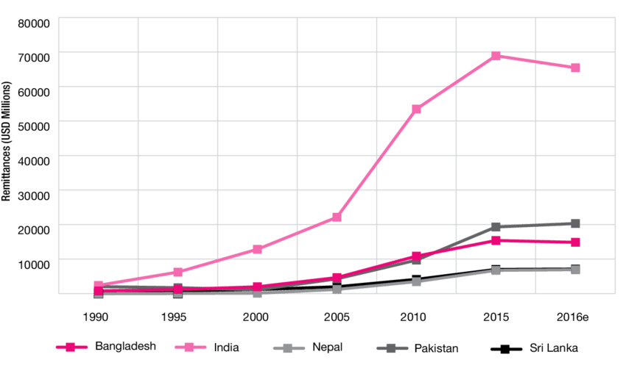
Figure 1: Remittance inflow in South Asian Region
In the figure, we can see the trends of remittance inflow in South Asian countries particularly India, Bangladesh, Nepal, Pakistan and Sri Lanka. These trends suggest that India is the highest remittance receiver in this region.
Additionally, when the economies begin to import an ever increasing number of imported items which lead to an expansion in the focused level in the business sectors, creates challenges for the domestic companies to sell their items in the business sectors (Jovicic and Mitrovic, 2006). Mallick (2012) likewise noticed that settlement inflows possibly do an ethical peril or reliance disorder circumstance which can provoke the beneficiaries to decrease their support in gainful exercises. So settlement inflows would bring about an expansion in private utilization without generation sway which prompts a shortfall in the exchange balance. We can stress when the residential organizations spent their assets on the rivalries with remote items in the local market which can diminish the fares estimation of the economies (Olubiyi, 2014). In light of these researched outcomes, we can thoroughly presume that the remittance inflows negatively affected the trade balance in the Asia-Pacific nations. Moreover, the outcome infers that remittances may be an issue for economic development because the effect is more from the demand side and this issue can prompt inflationary weight in the economy. Hence, the authors of the paper proposed an arrangement suggestion which was that the government officials ought to escalate their approaches and efforts on the improvement of the exports based activities by taking some important approaches. This will settle down the weight of emerging from the spending of foreign remittances.
The previous studies also infer that the increase in wage per capita will prompt a rise in both the imports and the trade deficit in the South Asian region. This increasing per capita income in the area would urge individuals to purchase more imports item and prompted a decline in the trade balance (Duasa, 2007). The negative impact of the GDP per capita on trade balance can be clarified by an explanation which is when the increase in income generated demand for the imported items as well as the local items but the manufacturing goods to produce these domestic items must be imported as well. It is implying that the import demand of resources will be raised and can make a bigger deficiency in the trade balance.
The policymakers in the Asia-Pacific region were given many suggestions throughout these studies. It was noted that they need some earnest solutions for tackle down this circumstance in light of the fact that the GDP per capita may expand at a faster rate in this area which can result in a bigger deficiency in the trade balance in the near future. This finding is supported by the past investigations, model, and the exploration of Duasa (2007). This paper stated that the rise in income negatively affected the trade balance in the short run on account of Malaysia which was a developing economy in the Asia-Pacific region at that time. The discovering suggests that local ventures must have more ways to connect with the clients, extend advertises just to build up the distribution systems. Also, the administrations need to help local firms by certain arrangements which will spotlight on growing exchange situations, monetary collaboration and give compelling help to the participation between domestic endeavors in the local economy.
These studies found a beneficial outcome of the exchange rate on the trade balance in the Asia-Pacific region with three relapses where the outcomes are likewise factually huge. As we realize that the remittances are the foreign money inflows so the policy makers need to make a few exchange rate strategies in the recipient nations since this approach will fulfill an objective for the economy to deal with foreign exchange market. In any case, one of the findings demonstrates that the exchange approaches in the recipient nations has had an important role to balance in the global exchange market. Specifically, our paper has given another proof about the impact of swapping scale on exchange offset with an enormous example of the nations in the Asia-Pacific region. The assessed outcomes are supported by a number of researches explored in some particular economies in the Asia-Pacific economies which are the situation in Thailand and Malaysia (Baharumshah, 2001), in Bangladesh (Aziz, 2008), in Vietnam (Trinh, 2014) or in Malaysia (Hien, 2017). Our outcome likewise recommends that the policy makers of beneficiary nations need to have a diligence to actualize their exchange rate strategy. Since our finding has shown the impact of this approach to improve the international trade this area.

Overview of Bangladesh’s economy

After a great sacrifice in 1971 Bangladesh was given an identity as an independent nation in the world. Sovereignty and a sense of nationalism inspired the entire nation to riot against West Pakistan. Since its inception, Bangladesh had deeply struggled in order to achieve economic stability. Its economy is still mostly dependent on agriculture based activities. The government soon enough realized without the economic intervention of other countries, Bangladesh can never achieve its financial stability as a new born nation. Many government front men were highly suspicious of every foreign company who expressed interest in investing in the country during that time. Even though their concern was justified however, no nation can survive such post war disastrous situation without any sort of foreign aid. Eventually the government accepted the foreign support and survived the sensitive time.
Over the years, Bangladesh government has adopted many policies that ensured healthy external relationship with the international community. Our country has established heavy reliance on United Nations and World Trade Organization (WTO) which in return benefitted both internal and external policies. Also, Bangladesh has been playing a constructive role in the neighborhood region for both peace and trade purposes. Bangladesh is welcoming to commercial opportunities from international companies operating in the energy, telecommunications, transport, textiles, education, mining sectors, infrastructure and agriculture. Foreign direct investment increased greatly in the last few years creating many job opportunities for the abundant labor force inside the country. Bangladesh’s economy is also affected positively by the inflows of foreign aid and remittances from migrant workers.
Our country has entertained 38 years of economic growth consecutively with an average 6.8 percent in 2016. The sustained economic growth and inward investment had contributed to achieve the economic stability Bangladesh had always aimed for. From 2003 exported goods enter Australian border without any quota and duty fee. Two-way trade has grown to accumulate over $2 billion dollars with exports to Bangladesh with value at $998 million dollars in 2016-2017.

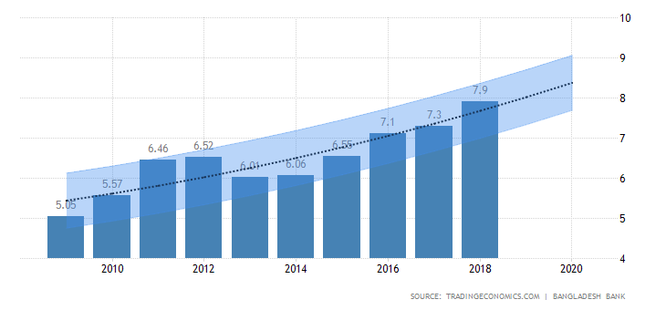
Figure: Recent GDP Growth Rate of Bangladesh

Bangladesh government aims to achieve the status of middle income country by 2021. In doing so, the government must triple foreign direct investment and increase the economic growth to 7.5 to 8 percent per annum. However, due to weak infrastructure, lack of appropriate skills, majority of population still under poverty line and the governance environment are viewed as obstacles in the route of achieving this vision. Another big constraint for this nation is to not being able to diversify the national income sources; the huge trade deficit is an indicator of this challenge.

Rise in Remittance Inflow
The government has taken up measures to export skilled manpower to the developed countries who seek migrant workers. Along with that, many professionals or aspirant students have left Bangladesh to explore versatile opportunities in abroad. This situation has created a brain drain in our country. However, according to Bangladesh Bank, expatriate those workers or migrants sent to Bangladesh have been estimated around $15.54 billion in 2018. This has been the highest in the history and recorded as 14.79 percent more than the previous year.
According to one of World Banks recent reports, Bangladesh has been ranked as the 9th most remittances recipient country in the world with $15.9 billion in 2018. This list includes countries like Pakistan who earned $20.9 billion, Egypt $26 billion, Philippines and Mexico earning $34 billion each, China is the second highest remittance recipient country with $67 billion, whereas India leading these countries with $79.5 billion.
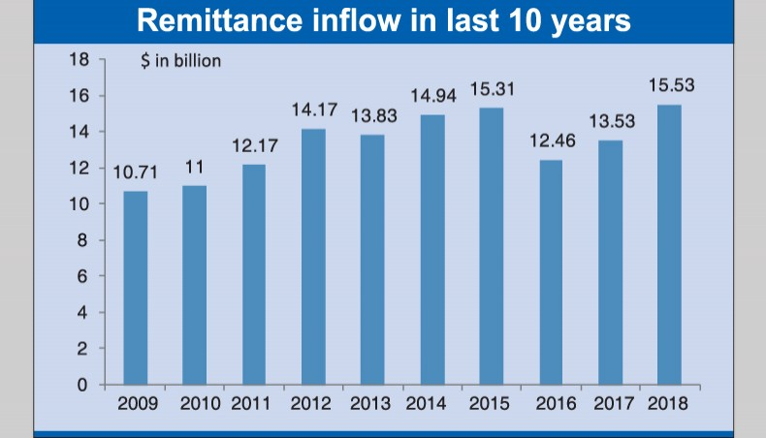
3 World Bank, 2018
This report indicated that Bangladesh has experienced tremendous upticks over the recent years especially in 2018. This increase was appreciated by the policy makers since in 2016 this economy faced a decline of inward remittances by almost 12.5 percent. The following year it experienced a flat trend but improvement has been showing ever since.
These reports published by World Bank suggest that in the developing countries remittances will increase by 10.8 percent that will earn $528 billion in 2018. This is almost 7.87 percent higher than 2017 and will be recorded as a new level of inward remittance in developing countries. These reports also estimated that remittances inflow in South Asian countries will increase by 13.5 percent which will earn $132 billion extra in 2018. Previously in 2017 this region encountered around 5.7 percent growth. Global remittances are also projected to grow by 10.3 percent which is almost $689 billion in the developed economies.
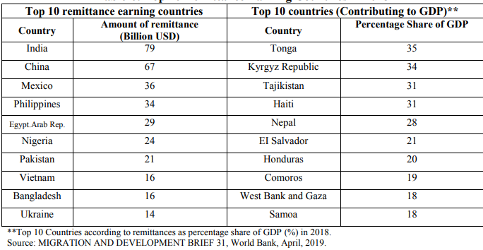
Remittances from non-resident Bangladeshis make up around 12 percent of the entire Bangladesh’s GDP. The foreign currency reserves of Bangladesh Bank had $30.99 billion this year. Remittances affects the economy directly in alleviating poverty for many households and World Bank is supporting these countries by providing scopes to do so. They are ensuring that these developing countries have facilitation scopes for remittance flows.
Nevertheless these improvements, the migrant deployment rate has weakened down in the first few months of 2018 which has been projected as 25 percent, which declined 0.55 million earnings. If we compare it with the last year’s declination in remittance earnings, it is still in better situation than 2017 when we lost about 0.73 million.

Rise in Export
According to a recent article, Bangladesh has experienced a significant turn in the international trading. The country’s trade deficit has decreased around 12 percent due to increase in the exports of local products. Also the decline in imports has contributed in narrowing down the deficit. The government had faced a record of all-time high trade deficit of $18.25 billion dollars in the fiscal year of 2017-2018. To improve the situation the government has taken down policies which in result helped the government tackle down this enormous obstacle. The economy is observing an upward trend in the export earnings and remittances, while having a moderate payment growth in the imports.
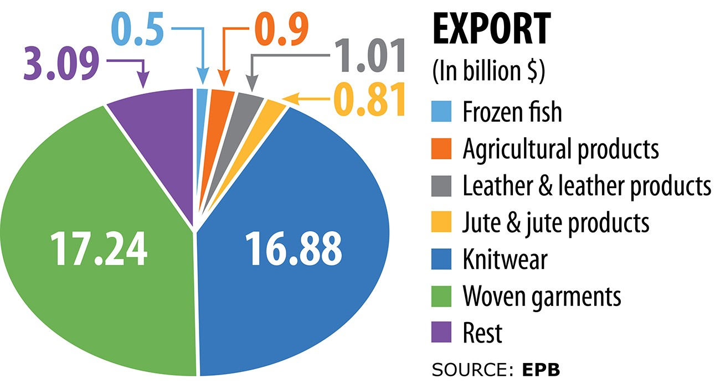
Bangladesh earns most of its revenue by exporting materials from RMG sector. 17.24 percent of total export income comes from sending woven garments to foreign countries and around 16.88 percent comes from knitwear. Therefore, Government has been taking measures to improve and sustain this sector. Other sources of foreign incomes come through Frozen fish, Agricultural products, leather and leather products, Jute and jute products.
Bangladesh’s current balance deficit is $6.65 billion which was around $7.60 billion in the previous fiscal year. This information was gathered from the central bank’s recent data. Import has been following a moderate trend which is being controlled by the government’s strategic policies. During the first five months of the fiscal year 2018-2019, export earnings were captured at $16.77 billion. The core policy makers are relieved since they believe the current trade deficit is not a matter of great concern, considering Bangladesh is still a developing country.

Government’s Policy
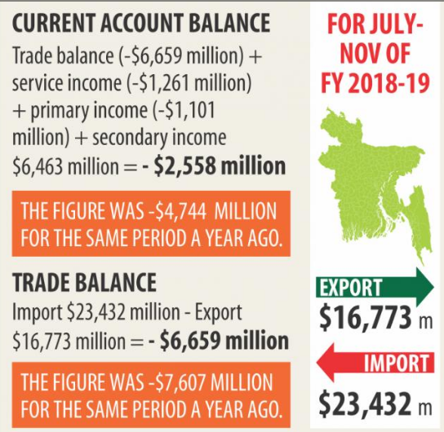
In order to ensure and protect the rights of all migrant workers and their family members, Government of Bangladesh raised this issue at the cabinet. As a result, a well defined and more detailed “Expatriates’ Welfare and Overseas Employment Policy 2016” was approved on 11 January 2016. This policy was established to ensure safety and security of the migrant workers and their families in both financial and physical context. The government has also taken a succession approach to set up a ‘National Migration Forum’ to monitor the implementation of this policy. Another objective of this policy is to simplify the migration for female workers who are looking for job opportunities in overseas.

Since, Bangladesh government has taken serious measures to tackle down this crisis; the current account balance has been improving. The strategies developed by the government high officials and policy makers resulted in the slight decline in the trade balance.
World Bank: Bangladesh ninth in remittances with $15.9bn. (2018). Dhaka Tribune.

Measures Taken by the Bangladesh Bank
To increase inward remittance through the banking medium, Bangladesh Bank has developed a few strategies in the last few years. They have introduced a digital process to deliver remittance to beneficiaries through bank to bank clearing systems. Bangladesh Electronic Funds Transfer Network (BEFTN) was established on 28 February of 2011. They have simultaneously simplified the distribution and withdrawing arrangements as well among the Bangladeshi bank channels and foreign exchange houses in abroad. According to a recent data, 1142 drawing systems are actively working and these systems are the vital role player in bringing the remittances from foreign countries to Bangladesh.
Bangladesh bank has provided permits to local banks to establish exchange houses, branch offices, or representative houses in foreign countries to easily operate all the transactions. Along with these local bank branches, around 26 Micro Finance Institutions, Bangladesh Post Office branches are also given permission to operate in these different countries to speed up the remittance inflow. This establishment has helped transactions to the most remote areas of Bangladesh easier and quicker. Even these transactions can be made using mobile devices; only 18 out of 24 banks are approved to do so. There are three active NRB commercial banks that have started their operations in Bangladesh to make facilitation of inward investments by Non Resident Bangladeshi easier.
NRBs are allowed to have Non-Resident Foreign Currency Deposit (NFCD) accounts. These accounts have to be in authorized banks at recipient country or home country to credit their retirement benefits, periodical pensions, superannuation benefits as per their individual employment agreement signed with their employers. The migrant workers are also given medical support. As per the Wage-Earner Development bond rules, 1981 transaction method allows Taka currency received against inward remittance for the purchase of Wage-Earner Development Bond (WEDB). Their families or beneficiaries can have privileges of having Taka fund credited through normal banking channel or authorized exchange house mediums. Many developing countries devalued their currencies against US Dollar to be competitive in the exchange market, Vietnam, India and China being few of them. Policy experts suggest the same for Bangladesh as well. According to one of them, US Dollar rate should be constant at 85 against Taka to increase remittance inflow and exports.

Policy Implications
Asia-Pacific is the biggest remittance beneficiary region on the planet, however, there is no proof about the effect of remittance inflows on the trade balance in this region. To fill out this observational lacking, one of the most successful studies was conducted by collecting data from 1980-2015 of seventeen nations in the Asia-Pacific region. The methods used in the study were the OLS, 2-SLS, and PGMM with ten regression models so as to obviously distinguish the impact of remittance inflows on the trade balance of these economies. Not at all like numerous previous results which more often showed the beneficial outcome on the recipient economies. The findings from this particular study demonstrated that the remittances have a negative effect and statistically significant impact on the trade balance. Additionally, it infers that the rise in income results in a trade imbalance in the region. And at last, we identified a constructive outcome of the exchange rate on the trade balance in the Asia-Pacific region which affirms that the exchange rate policy plays a productive role in the nations in this locale.
Moreover, we can talk about some strategy proposals that came following these research outcomes. These outcomes give some significant data about the inward remittances as well as the income and exchange rate in the trade balance. In view of the outcomes, the policymakers in these nations should attempt to develop a few strategies which will draw in remittances to invest in service and production sectors to ensure economic growth domestically. So as to diminish the deficiency in the trade balance, the administrations may attempt to raise the aggressiveness of local items by the supporting strategies for the local organizations. Furthermore, the government should attempt to extend the money related framework and banking framework to pull in an ever increasing number of household remittances to these frameworks. Plus, the policymakers need to have a positive strategy for inward remittances to invest in education, household maintenance or business purposes.
Our investigation affirms that the exchange rate approach has a powerful role as in improving the presence of the country in the Global Trade. So the policymakers in the nations need to have more diligence to do the exchange rate strategy in similar manners over the long run which can enable the economies to be increasingly stable in the future. Additionally, the government can see obviously that the income in the nations will be persistently increased; however, the rise in income may increase the trade deficit as people may buy foreign products at an ascending rate. Therefore, the government must develop strategies to motivate domestic producers to increase their production and attract foreign buyers to export these goods. This arrangement can decrease the deficiency of trade balance.

Policy Recommendations

Remittance inflow is the second highest income source for our country. This huge remittance inflow helps the government to pay off the import bills as well as reduce government’s dependency on foreign aids. Not only that, the more remittance is received by Bangladesh, the stronger Bangladeshi currency will be against the US dollar. Also, it will expand the financial activities in the domestic market.
The government of Bangladesh has to adopt some sustainable approaches to invest these inward remittances to encourage economic development of the country. However, it will not be ideal for policy makers to adopt plans that are given a sectoral focus such as remittances should be used efficiently only in sectors that are external trade oriented to minimize the trade deficit. Additionally, the government needs to ensure job security in the foreign lands for these expatriates.
Government should establish information booth centers in every district to provide intended interested groups to gather necessary information about migration and opportunities in abroad. The administration should set up a fixed amount of money to be submitted by the interested workers for migration, so that the recruiting agencies can not put extra financial pressure on these workers.
The administrative should build more training and learning centers to train these interested workers in order to develop their basic skills so that they can survive the competitions with other migrant workers in abroad. Also, the government should put emphasis on the workers safety, they often fall under the wrong recruiting agencies and face unnecessary problems during the departure face as well as while living in the abroad. There should be an emergency service for these migrant workers in abroad in case of any conflict in the foreign land. (Sheikh Abdur Rahim, 2012)

Conclusion

Throughout our exploration of different news articles and policy papers, we can surely develop a statement that remittances do have a positive significance on the trade balance of Bangladesh. However, it will be definitely wise to say that the Government of Bangladesh needs to adopt some policies to encourage more migrant workers to go overseas to seek job opportunities. Hence, every policy should be developed strategically by taking the insights of the current situations and probable scenarios of the near future. This will allow the economy to be stable and decrease the trade deficit of Bangladesh in a sustainable way using modern and innovative technologies.
We attempted to profoundly investigation the effect of remittance inflows on the trade balance throughout this paper. However, we can not identify the impact of remittance on import or export balance separately. We need further in depth researches to find out the answers.
References

- International Journal of Economics and Finance; Vol. 5, No. 3; 2013 ISSN 1916-971X E-ISSN 1916-9728 Published by CanMigrant Workers' Remittances and External Trade Balance in Sub-Sahara African Countries. (2012). Canadian Center of Science and Education

- Quarterly Report on Remittance Inflows. (January-March 2019). Bangladesh Bank

- Tung, L. T. (2018). Impact of remittance inflows on trade balance in developing countries

- World Bank: Bangladesh ninth in remittances with $15.9bn. (2018). Dhaka Tribune

- Harmachi, A. R. (2019). Bangladesh's remittance inflow rises 15% in 2018

- https://bdnews24.com/economy/2019/01/02/bangladeshs-remittance-inflow-rises-15-in-2018

- https://www.researchgate.net/publication/305095772_Foreign_Remittance_Income_in_Bangladesh_Opportunities_and_Challenges

