FACTORS AFFECTING UNDER FIVE MORTALITY
Evidence from Bangladesh

Sarah Shakib


UNITED INTERNATIONAL UNIVERSITY
JANUARY, 2018

FACTORS AFFECTING UNDER FIVE MORTALITY
Evidence from Bangladesh

A thesis by
Sarah Shakib

In partial fulfillment of the requirement for the Master of Science in Economics

Supervisor:
Mohammad Mokammel Karim Toufique
Assistant Professor and Coordinator
Department of Economics
United International University

January, 2018

Abstract
Bangladesh has been successful in reducing under-5 mortality, which is one of the indicators used to measure child mortality in MDG. From the year 2000 to 2010, the percentage of death of children aged under-5 reduced drastically from 85.7% to 47.8%. This paper focuses on determining the factors that helped reduce under-5 mortality to such an extent. Using statistical data of the variables, from the year 2000 to 2010, a regression model has been developed, that help explains the factors responsible most and least in reducing under-5 mortality.
Keywords: under-five mortality, mortality

Introduction

It has been calculated that, globally, every year approximately 9.7 million children die before reaching the age of five. Of the 9.7 million, most deaths are seen to occur in the sub Saharan region. Sub Saharan Africa making up 41% of the total annual child deaths, has regional child mortality rates that ranged from 69.1 to 219.2 per 1000 births in the year 2005. The primary reason for early child death is found to be contagious diseases. However, given proper healthcare and information about precaution and treatments, these diseases can be prevented. (Beaglehole et al 2003, Black et al 2003, Murray et el 2007)
Worldwide, from the year 1990 to 2012, child mortality rate has decreased significantly. Per 1000 live births, the number has fallen from 90 to 48 in the span of 22 years.
In 2012, sub Saharan Africa and Nigeria accounted for most of the child deaths occurrences. Among 6.6 million of the total early deaths, about 3 million occurred in sub Saharan regions while Nigeria itself accounted for 13% of the deaths.
This high rate of child mortality is mainly due to infectious diseases such as diarrhea, measles, cholera and malaria. Respiratory infections also cause these deaths. However, the deficiency of proper healthcare facilities as well as policies has caused the under-five child mortality rate (U5MR) to increase in the region even though these deaths are both preventable and curable (Kingsley et el, 2015)
‘Under- 5 mortality’ refers to the probability per 1000, that a new born baby will die before reaching age 5.
According to UNICEF, majority of these deaths result from one the following five causes or a blend of two:
- acute respiratory infections
- diarrhea
- measles
- malaria
- malnutrition

Acute Respiratory Infection (ARI):
Acute respiratory infection (ARI) is a foremost reason of child mortality in Bangladesh. Amongst the total number of children aged below five, nearly one fifth of the total deaths are due to ARI. Approximately 70-75% of all deaths are due to pneumonia. Indoor air pollution is a risk factor for ARI child death. There are some socio-economic factors such as- low income, parental low education etc which are responsible for ARI child death.
Some studies revealed that boys and infants are more likely to suffer than girls and toddlers respectively from ARI. Partial or no breast-feeding may also cause the ARI. Malnourished children are also at greater risk compared with healthy children. (Azad, 2008)
Diarrhea:

The other prime cause of early deaths among children under five years is Diarrheal disease which however is both preventable and curable. Children who are malnourished or have weak immune system are most at risk of this disease. It is caused by a variety of bacterial, viral and parasitic organisms. Causes for diarrhea in Bangladesh can be infection, malnutrition, shortage of clean water etc.
In Bangladesh, death rates due to diarrhea in the rural area are higher than that in the urban areas. There has been progress in the management of diarrhea. In 1993-1994 only 50% of children with diarrhea received oral rehydration therapy, while in 2007 that figure had increased to 77%.
Measles:
Measles, caused by a virus, is an infection of the respiratory system. It is a reason of child deaths in Bangladesh. However, deaths due to measles have decreased over years as immunization coverage has spread.
Malaria:
In Bangladesh, one of the prime reasons for health issues is said to be Malaria. Approximately 34% of the total population are prone to be infected with malaria. In most of these cases, it is reported from a specific 13 out of the total 64 districts in the country. Over 98% of the total cases in the country are reported from these areas, indicating the need of government intervention.
Malnutrition:
Malnutrition accounts to over 50 percent of child deaths in Bangladesh. 43.2%, 17.4%, and 41% of under-five children are, respectively, considered to be stunted, wasted, and underweight, which are all due to malnourishment. Rural children are found to be more malnourished than urban children. Thus, public and private intervention are much required, and they should emphasize on building up a better healthcare system. They should take proper measures to eliminate malnutrition and prevent infectious diseases. There should also be services that offer safe immunization from these diseases.
According to a report released by UNICEF, 2015 Bangladesh has brought down the child mortality rate by 73 percent in the last 25 years. In 2015, under-5 mortality rate for Bangladesh was 36.48 deaths per thousand live births. Under-5 mortality rate of Bangladesh reduced gradually from 231.65 deaths per thousand live births in 1966 to 36.48 deaths per thousand live births in 2015.
However, the report also indicates that 16,000 children aged under five are still dying every day.
Tragically, 45 percent of deaths under five years occur in the neonatal period, which is the first 28 days of life, highlighting prematurity, pneumonia, pre and post birth complications, diarrhea, sepsis, and malaria as the leading causes of mortality.

Objective
The objective of this paper is to determine and show the factors that has helped reduce under-5 mortality in Bangladesh. A linear regression model has therefore been developed.

Literature Review
This section reviews few literatures on reasons of child mortality across different regions and discusses the factors that contributes to the changing trend.
Akiyo (2009) emphasized that between the periods 1991-1995 and 1996-2000, under-five mortality remained unchanged and then declined in the period 2001-2005. Although children who are female had a lower risk of dying under the age of five, other factors increased under five mortality. According to the research, if there was a significant gap of 2 years or more between one birth and the next or if the child’s mother was more educated, the risk significantly decreased. Other determinants included that elevated under five mortality included multiple births, as well as region of habitat. It was seen that more children die early if they lived in the northern regions.
Haines et al. 2007; Rutherford et al.2009 and Bryce et al. 2005 have also examined key reasons that cause children to die before reaching the age of five years. According to their research, unavailability of proper healthcare and medical service is the dominant reason that causes these early deaths. Under five mortality rate can be decreased significantly, by 41% to 72%, by the provision of abundant health facilities. As more children die when delivered at home, the feasible access to adequate health facilities becomes more vital to solve the issue of child deaths.

As studies suggest, improving healthcare services is directly linked with decreased child mortality. It was observed that with the introduction of an intensive health care program that focused on children, there was a considerable slump in death rates. This program was held in Liberia and Zaire, where the results clearly show the importance of better healthcare. (Ewbank 1993). In Senegal the numbers fell from 350 to 81 per 1000 live births over a 25-year period. Furthermore, Mozambique saw a fall from 246 to 154 per 1000 live births from the year 1977 to 1991. In both these regions, the fall in child death has been due to higher quality and revised health services. (Cutts et al. 1996) and (Pison et al. 1993).

According to WHO, fact sheet of 2017, about 15 million babies are born prematurely each year. Thus each year approximately 1 million children die as they are born early. Among the premature babies who live, usually suffer from a degree of physical disability. Some may be deaf, others having visual or leaning inabilities. All in all, premature birth is the foremost reason leading to child deaths under the age of five. And according to evidence it is seen that preterm births are increasing globally. Out of 65 countries with evident data, except for three, there is an increase in premature births in the last 20 years. Possible explanations for this include women giving birth at an older age or when they have health issues during early pregnancy. Better measurements and Popularity of infertility treatments have also been a major key that has contributed to preterm births. Increase in the number of caesarean births is considered to be another factor as well. All suggestion directs to factors contributing to changing trend of mortality.
Liu et el (2016) advocates that main infectious causes in sub-Saharan Africa had reduced from 2000–15, but infectious causes such as pneumonia, diarrhea, malaria, and sepsis or meningitis remain central and should be of importance of child survival efforts going forward. Also in southern Asia, the complication of preterm birth to under-5 deaths have increased considerably in 2000–15, contributing to deaths of child under aged five.
Moreover, Mosley (1984) studies the cause of death and pointed out infections or malnutrition to be cause of mortality. He had developed a model that identifies of a set of possible factors that directly affect the rate of morbidity and mortality. There are five categories of these factors:
- Mother’s age, parity, interval between births
- Environmental pollution
- Nutrient deficiency: calories, protein
- Micronutrients (vitamins and minerals)
- Injury
Previous researches have revealed, a child’s physical well-being and hence how long he lives depends on many factors. The place they live in, place where they are given birth, breastfeeding, maternal age all play a role. It has also been suggested that whether children are receiving postnatal care and proper education are major keys to better child health.
Pneumonia alone stands out to be the foremost cause of deaths globally, especially in developing countries, where limited access and availability of health care or clinical services are inevitable, thus calling for low cost effective measures and massive participation of government.(Pandey et el,1991).
The place where children are given birth is said to be a factor that changes the probability of children’s deaths under the age of five years. Based on substantial data, it is seen that there’s greater probability of a child dying if delivered at home or similar place. However, if proper health facilities are available during the time of delivery, lower number of child deaths occur. The availability of healthcare professionals (also called skilled birth attendants) at health facilitates is the reason for such discrepancy.
Access to postnatal care is also responsible for reducing under-five deaths. It is seen that, if a healthcare professional visits the new born child for a regular checkup the probability of child death reduces. It must be noted that the visit must be within 2 days of delivery. This was evidently demonstrated in a Bangladeshi based research. (Baqui,-)
In developing countries, the mother’s age as well as her education are said to be vital factors that affect child mortality rates. According to studies, the probability of child death decreases when they are born to more educated mothers and conversely, increases if the mother is less educated. Better maternal education will help enhance a mother’s knowledge about child care and nurture. Furthermore, it will allow the mother to have access to more information, improving her skills and her ability to judge and make decisions regarding her child’s well-being. In addition to education, mother’s age also impacts child mortality as studies show very young mothers and very old mothers tend to report more child deaths when compared to middle aged mothers. (Mando 1999, Mturi 1995)

It is also proposed that the gender of the child as well as their birth order may have a role to play in child mortality. According to a study in Malawi, however, there is trivial effect caused by gender of the child, unlike higher birth order which tends to increase the risk of child death. (Mutisya 2010)

Another major determinant of child mortality is the household socioeconomic status of households. As Mturi (2010) investigated, evidence suggests that poverty is an underlying factor of child deaths. According to a Nigerian Demographic and Health survey conducted in 2008, more children die at a young age in poverty stricken houses, when compared to well-off households.

Child mortality rate has decreased by a heavy margin of 37% over a time span of 10 years, demonstrating that place of residence, condition of living or living in rural region, mothers’ education as well as poverty all lead to impacting early child deaths. (Kingsley et el. 2015)
Deribew et el (2007) concludes neonatal causes, pneumonia, malaria and diarrheal diseases were the key determinants of under-five children in Ethiopia. In this study, he quoted practice of mothers and availability of modern treatment are crucial to child survival.

Data and Methodology
A linear regression model has been developed to determine the influence of selected variables effecting under-five mortality in Bangladesh. Statistical data has been collected from database of World Bank, available in Google Public Data, for the year 2000 to 2010 (Appendix I). Previous and preceding years have been not been considered as the data shows a decreasing trend from the beginning of time, which on the contrary would produce similar results.

To explain the reduction in under-5 mortality in Bangladesh, eight variables have been considered.
- malnutrition prevalence (height for age)
- malnutrition prevalence (weight for age)
- immunization coverage
- births attended by skill health staff
- ARI treatment
- Diarrhea treatment
- fertility rate
- female education

- An average of malnutrition prevalence (height for age) and malnutrition prevalence (weight for age) is taken and a new variable ‘malnutrition prevalence’ is generated.
Prevalence of child malnutrition (height for age or weight for age) is the percentage of children under five years of age, whose height and weight in terms of age is more than two standard deviations below the median for the international reference population ages 0 to 59 months.
Malnutrition prevalence explains the percentage of children under 5 who are affected due to malnourishment. A decrease in percentage of Malnutrition prevalence thus explains a reduction in under-5 mortality.
- Immunization against diseases such as tetanus, measles or polio is the most important means of preventing early childhood deaths and illness. An average of a six vaccines has been taken for immunization coverage. The vaccines are:
BCG (Baccille Calmette Guérin vaccine)
DTP1 (First dose of diphtheria toxoid, tetanus toxoid and pertussis vaccine
DTP3 (Third dose of diphtheria toxoid, tetanus toxoid and pertussis vaccine)
MCV (Measles-containing vaccine)
PAB (Protection at birth against tetanus)
Pol3 (Third dose of polio vaccine)

An increase in the percentage of ‘immunization coverage’ indicates higher spread of vaccines, more protection and lower under-5 mortality.
- Births attended by unskilled health stuff are one of the reasons for under-five mortality in Bangladesh, especially in the rural areas. A skilled birth attendant is therefore needed to reduce the death rates. Skilled health personnel is an accredited health professional- such as midwife, doctor or nurse- who has been educated and trained to proficiency in the skills needed to manage normal pregnancies. People in the rural areas of Bangladesh are less likely to seek for skilled birth attendants (SBA) (doctor, nurse etc) for delivery. The reasons behind this reluctance for the SBA may be the proximity- the healthcare centre may be far away from home. In Bangladesh, over 80% of women give birth without any help from a skilled birth attendant. Most deliveries take place at home, often in conditions of very poor hygiene-placing the lives of both mother and the child at risk.
‘Births attended by skill health staff’ is an important factor in counting under-5 mortality. This variable is important as it ensures lower rate of new born mortality. An increase in ‘births attended by skill health staff’ is thus crucial in explaining a reduction in under-5 mortality.
- ‘ARI treatment’ refers to the percentage of children with ARI taken to a health care provider. An increase in ARI treatment therefore would mean a lower percentage of under-5 mortality.
- ‘Diarrhea treatment’ refers to the percentage of children aged under-5 who has received oral rehydration and continued feeding. An increase in diarrhea treatment therefore would mean a lower percentage of under-5 mortality.
- Over the past three decades Bangladesh has made considerable progress in reducing its fertility rate. ‘Fertility rate’ explains the average number of births per woman.
- Female literacy rate is a key indicator in determining under-5 mortality. An increase in ‘female education’ is therefore needed to increase awareness in reducing child mortality.

Statistical data of each variable from year 2000 to 2010 is given in appendix (1).
The variables are also given new names for convenience to be used in STATA. They are:
- under-5 mortality-u5m (dependent variable)
Independent variables
- malnutrition prevalence-malprev
- immunization coverage-immcov
- births attended by skill health staff-birthatt
- ARI treatment-aritret
- Diarrhea treatment-diartret
- fertility rate-fertilityrate
- female education -femaleeduc
Available literatures discussing factors effecting under five mortality used different and similar methods for analysis.
Akiyo et al (2009) used multivariate logistic regression analysis to evaluate the determinants of under-five mortality. Between the years 1996 to 2006, information provided by Three Uganda Demographic Health Survey (DHS) in 1995, 2000, 2001 and 2006 helped measure child mortality inclination and levels. Murray (2010) produced information that consisted of 16 174 measurements of child death, all under five years. The data, consisted information about 187 countries of about 39 years (1970-2009) and was generated Gaussian process regression. This information was based on several sources that includes birth histories, surveys as well as registration systems.
The impacts cause by geographic as well as demographic constituents and other determinants related to the mother, have been examined by different methods. Kingsey et el (2015) used multivariable regression analysis to determine the risk factors of under-five mortality. On the other hand, Ettarh (2012) used both Bivariate Pearson Correlation, and multivariate Cox proportional hazards regression to analyze the effects. Works by Caldwell and McDonald used tabular approach as methods to gauge percentage of child dying before their fifth birthday, emphasizing mother’s education to be a prime factor in reducing it. (Hobcraft et el, 1984)

Analysis
This section attempts to find the best possible variables responsible for reduction in under five mortality in Bangladesh.
R-squared value indicates how much of the model is explained by the variables.
Largest R^2 value thus shows which variable explains the model the most.
Hence, the dependent variable is regressed with each of the independent variables to find the R-squared values (in ascending order).The table also reveals the statistical significance of each variable. For a variable to be statistically significant p<0.05, given level of significance is 5%.(Appendix 2, table 1 to 7).
Variables | R² | p-value(p<0.5)
fertilityrate | 0.9981 | 0.00
Malprev | 0.8900 | 0.00
Diartret | 0.8665 | 0.00
immcov | 0.8082 | 0.00
Birthatt | 0.7748 | 0.00
Aritret | 0.4162 | 0.032
femaleeduc | 0.1496 | 0.240

The above table, (a summary of values taken from table 1 to 7, appendix 2) shows the variable ‘femaleeduc’, namely female education, is not statistically significant and is therefore dropped. This is contradicting to the various results found in the studies discussed in the previous section.
To find the best model, iterative method is adopted. It includes regressing the dependent variable on each independent variable, taking different powers.
The R² value and the AIC value of the original variable (example malprev) are compared with newly generated variables, such as malprev1, malprev2, etc (that is equivalent to malprev² and malprev³ respectively).
On comparison, variable with highest R² value and lowest AIC value is replaced in the model. On the process, variables that explain the model better are found.(Appendix 3, table 1 to 6).

The following is a summary of the above tables (1 to 6, appendix 3)
Variables | R² | AIC
Fertilityrate | 0.9981 | 20.79057
malprev5(malprev⁻¹) | 0.9085 | 63.4416
Diartret | 0.8665 | 67.59311
immcov3(immcov⁴) | 0.8202 | 70.87139
birthatt6(birthatt⁻²) | 0.8589 | 68.20757
aritret11(aritret¹²) | 0.6653 | 75.70579

Moreover, while comparing models, or to find the best model, the dependent variable should be regressed with each chosen variables individually. An increase in the value of adjusted R² indicates the model is good, thus if after regressing a variable decreases, the variable should be left out.(Appendix 4, table 1 to 6).
The following summarizes the tables (1 to 6, appendix 4)
variables | adjusted R²
fertilityrate | 0.9979
malprev5 | 0.9986
diartret | 0.9989
immcov3 | 0.9991
birthatt | 0.9993
aritret | 0.9994

No variable is dropped, as value of adjusted R² increases successively.
The regression model is therefore: u5m=α+β₁fertilityrate+β₂malprev5+β₃diartret+β₄immcov3+β₅birthatt6+β₆aritret11+u
where, u=error term, α=constant and β= coefficient of variables.

To see whether the model has any error, few tests are carried out, shown in Appendix 5.
All tests show the model is error free. Hence the final model is: u5m=α+β₁fertilityrate+β₂malprev5+β₃diartret+β₄immcov3+β₅birthatt6+β₆aritret11+u
Adjusted R² is 0.994, which shows the model is good and explains the variables responsible for decreasing under-5 mortality.
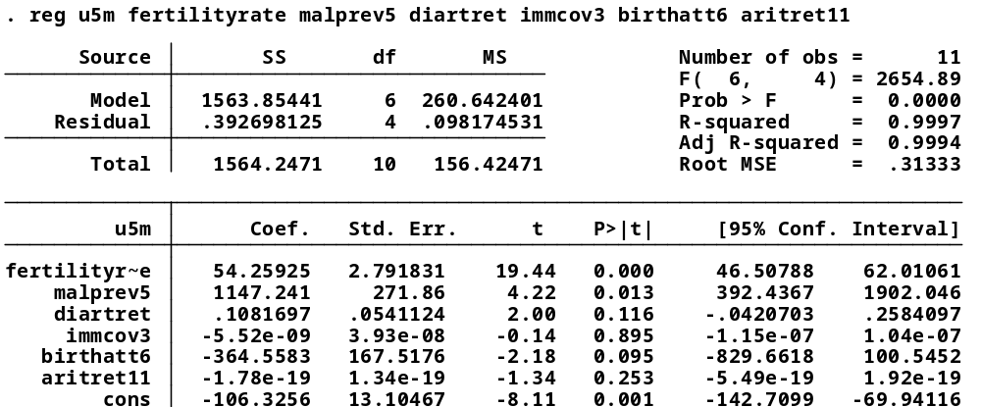

Findings

Using STATA, a number of tests have been carried out to find the best model for u5m.The linear regression model found is free of any specification errors. There is no multicolinearity, Heteroscedasticity or autocorrelation present in the model.
The final regression model is therefore:
u5m=α+β₁fertilityrate+β₂malprev5+β₃diartret+β₄immcov3+β₅birthatt6+β₆aritret11+u
where, u=error term, α=constant and β= coefficient of variables
or,
u5m = -106.33+54.25fertilityrate+1147.24malprev5+0.11diartret-5.52immcov3-364.55birthatt6-1.78aritret11+u
Interpretation of the regression model:
- u5m is expected to increase by 54.25 per thousand of under-5 population, if fertility rate per woman increases by 1.
- u5m is expected to increase by 1147.24 per thousand of under-5 population, if malnutrition prevalence increases by 1 percent of under-5 children population.
- u5m is expected to increase by 0.11 per thousand of under-5 population, if diarrhea treatment increases by 1 percent of under 5 population.
- u5m is expected to decrease by 5.52 per thousand of under-5 population, if immunization coverage increases by 1 percent.
- u5m is expected to decrease by 364.55 per thousand of under-5 population, if births attended by skilled health staffs increases by 1 percent of the total population.
- u5m is expected to decrease by 1.78 per thousand of under-5 population, if ARI treatment increases by 1 percent of under 5 population.
- α = -106.33 indicates u5m is expected to decrease 106.33 per thousand of under 5 population, when all the variables are equal to zero.

Conclusion
According to the regression model, fertility rate is the variable that affects under-5 mortality the most. A one unit increase in fertility rate would increase u5m by 54.25 per thousand of under 5 population but it is malprev5 that affects u5m severely, having a coefficient of 1147.24.Thus policies should be targeted to decrease malnourishment among children, thereby decreasing malnutrition prevalence. Conversely, birthatt have a coefficient of -364.55, indicating that availability of skilled birth attendant can reduce u5m by a large extent. Therefore it is important that health ministries and agencies allocate their budget in imparting training to health staffs. Lastly the variable that affects u5m the least is aritret11, which however helps decrease u5m by 1.78 per thousand of under 5 population, when it goes up by one percent of under 5 population. This is evident because ARI, according to UNICEF, is a major cause of child death and so increasing ARI treatment is most likely to decrease u5m.A surprising result found is associated with the variable diartret. Instead of exhibiting a negative relationship with u5m, a 1 percent increase in diarrhea treatment increases u5m by 0.11 per thousand of under 5 population. Such a contradiction can be a result of missing data of the particular variable.

Appendix 1
u5m | malprev1 | malprev2 | malprev
85.7 | 57.2 | 48.2 | 52.7
80.6 | 55.4 | 45.4 | 50.4
76.1 | 53.5 | 43.1 | 48.3
72.3 | 49.8 | 40.9 | 45.35
67.9 | 50.5 | 42.7 | 46.6
64.2 | 47.8 | 39.2 | 43.5
60.4 | 47 | 39.8 | 43.4
57.1 | 43.2 | 41.3 | 42.25
53.9 | 43.2 | 41.3 | 42.25
50.7 | 43.2 | 41.3 | 42.25
47.8 | 43.2 | 41.3 | 42.25

immcov | birthatt | aritret | diartret | fertility rate | femaleeduc
85.2 | 12.1 | 27.2 | 35 | 3.12 | 56
86.2 | 11.6 | 27.2 | 35 | 3.01 | 40.82
83.5 | 11.6 | 27.2 | 35 | 2.91 | 43.4
86.83 | 13.9 | 27.2 | 35 | 2.8 | 44.2
91.83 | 13.2 | 19.9 | 52.5 | 2.7 | 45.8
94.6 | 13.2 | 19.9 | 52.5 | 2.6 | 49
93.5 | 20.1 | 30.1 | 48.9 | 2.51 | 48.4
94.2 | 18 | 37.1 | 68 | 2.43 | 48
93.67 | 18 | 37.1 | 68 | 2.36 | 49.8
95.67 | 24.4 | 37.1 | 68 | 2.3 | 51.02
94.8 | 26.5 | 37.1 | 68 | 2.25 | 55.71

- Data in italic indicates missing data.
- Data of previous years have been used for years with missing data.
- Source: Google Public Data.

Appendix 2
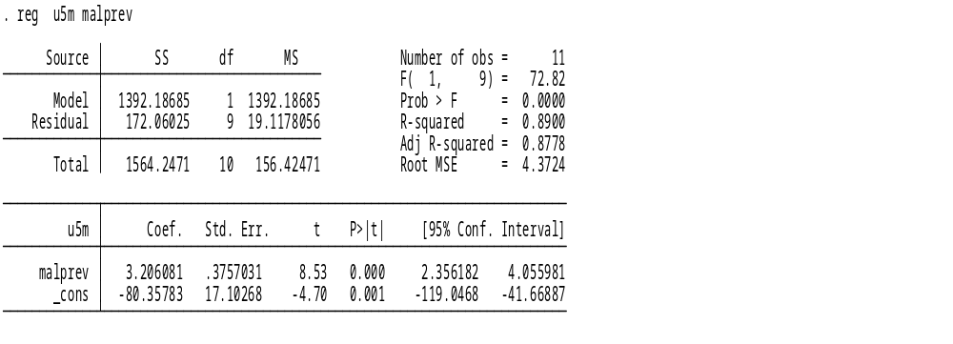
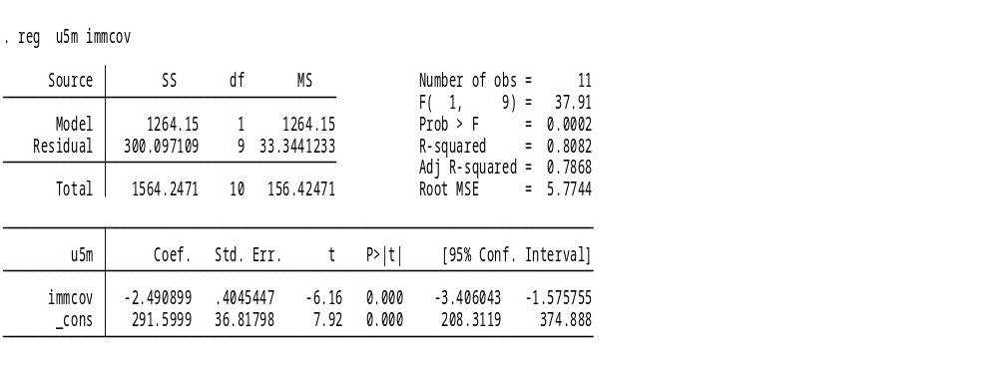
Table 1 to 7

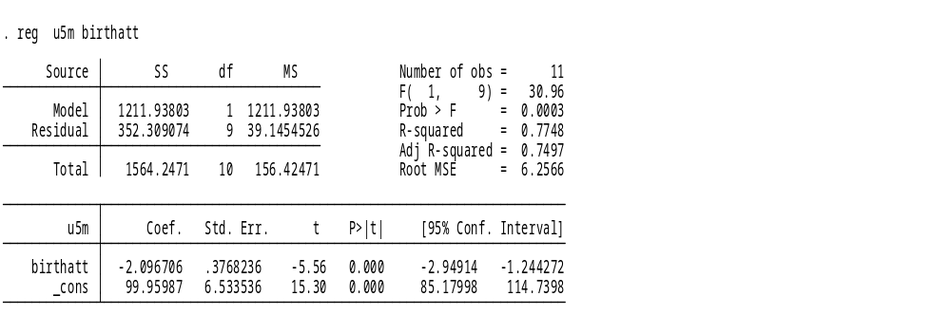

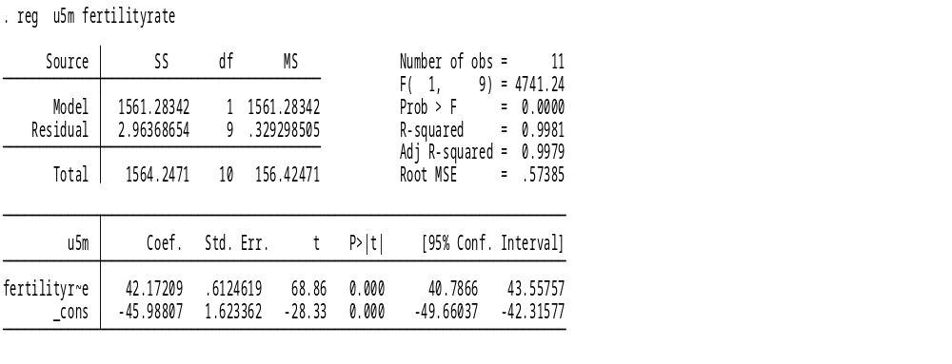
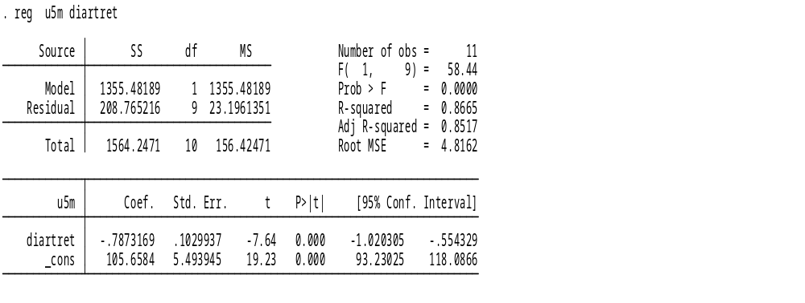

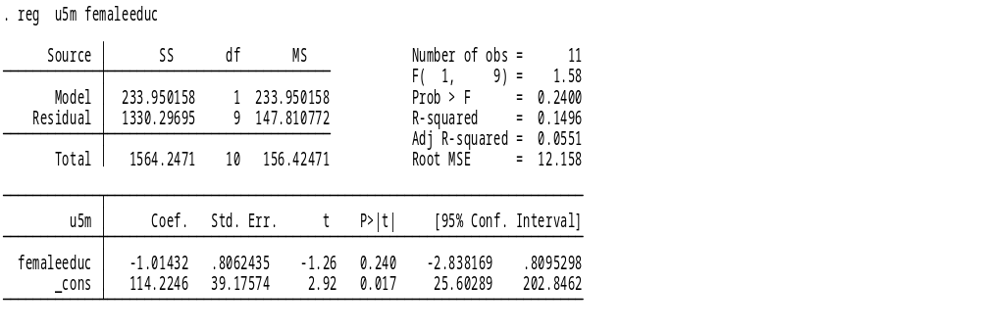
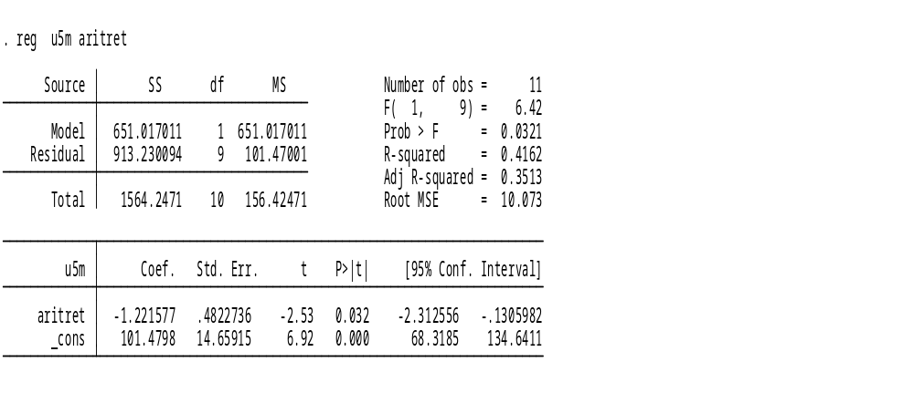

Appendix 3
Table 1 to 6
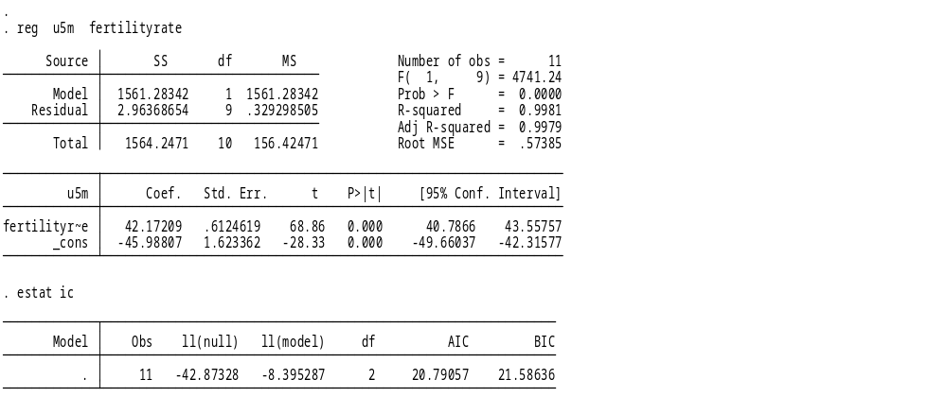

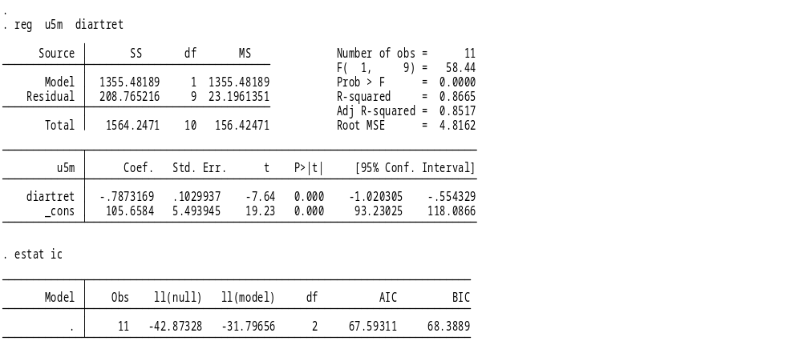

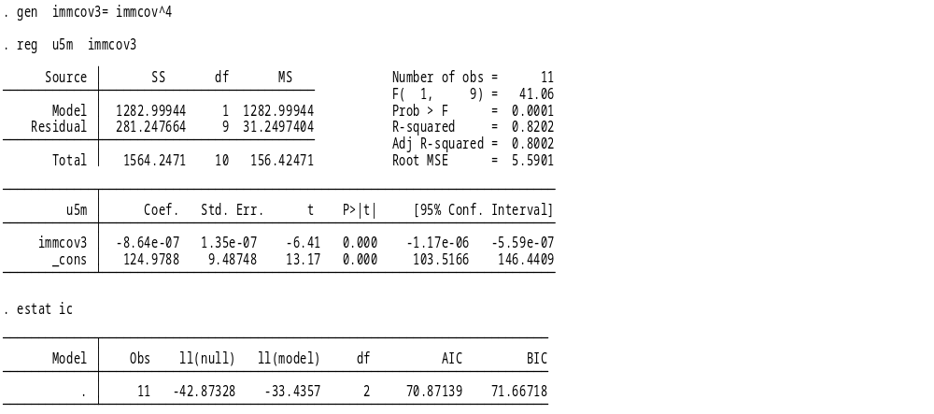

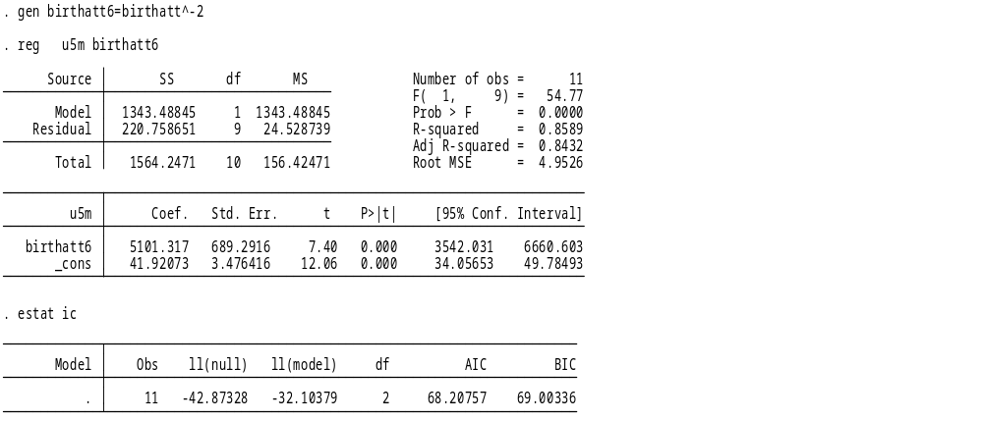

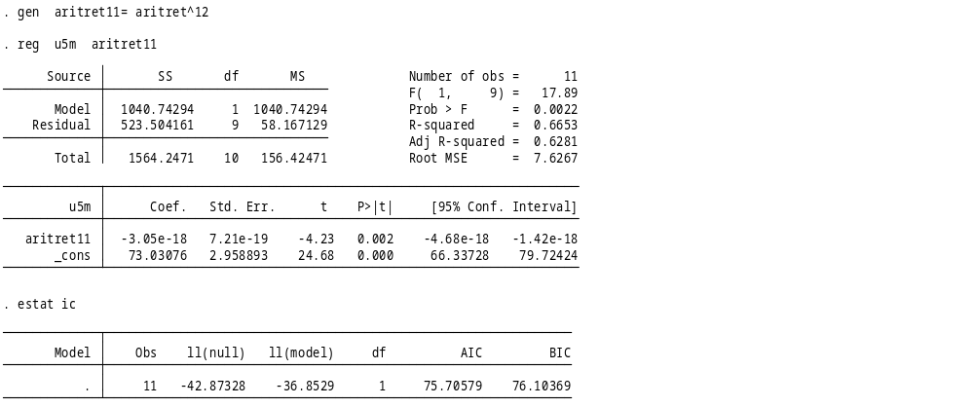

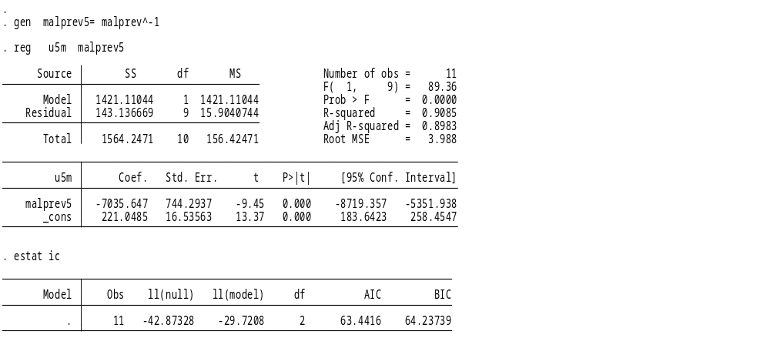

Appendix 4
Table 1 to 6
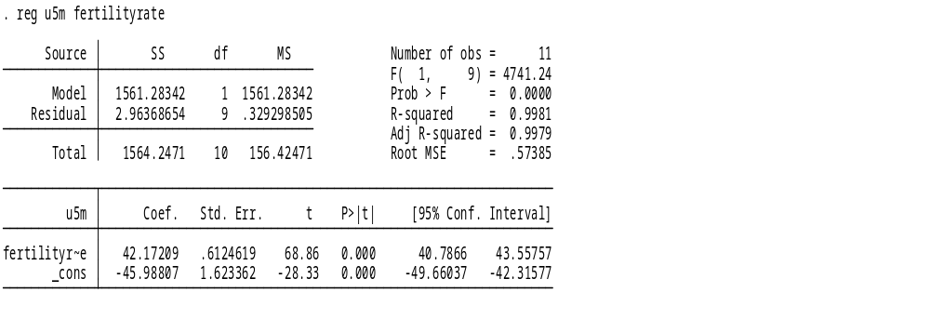

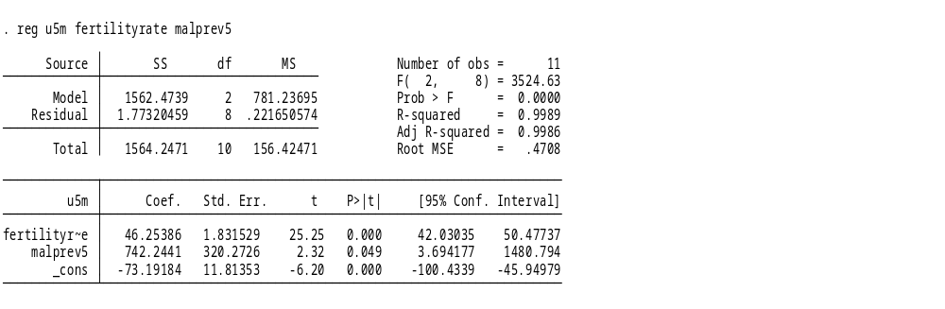

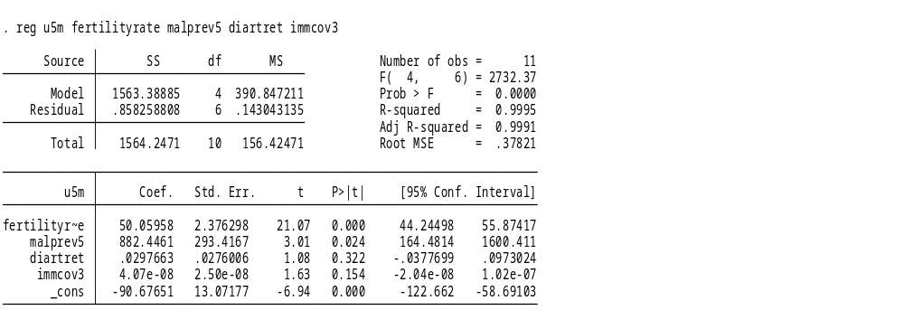
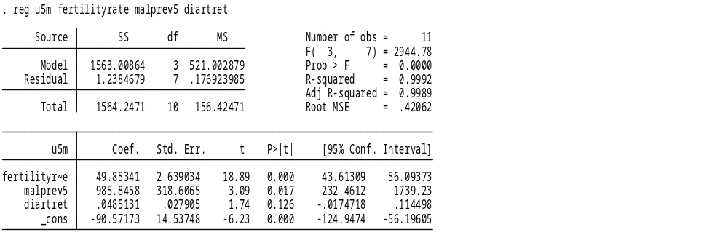

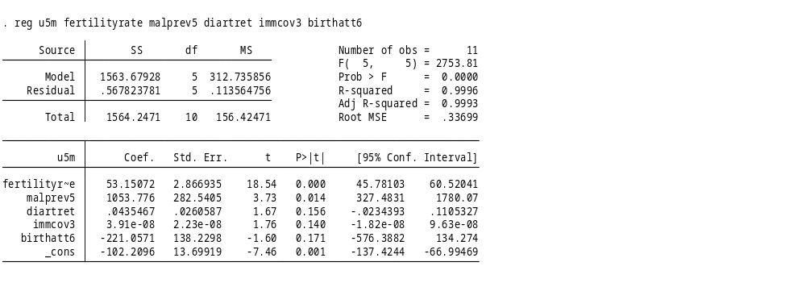

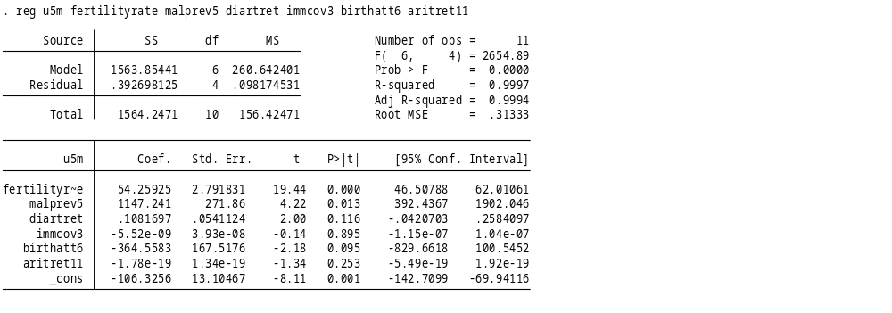

Appendix 5
- Model Specification and Diagnostic Test:
  - Boxcox
  - Ramsey test
According to Boxcox, theta=1.
This shows the regression model is linear.
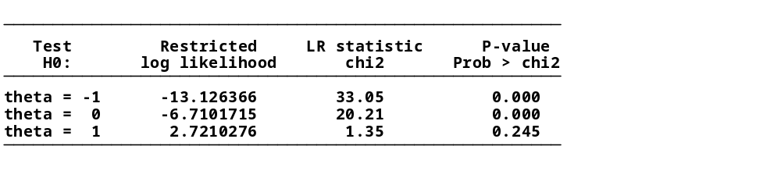
While as per Ramsey test, p-value>0.05(p=0.0945).Null hypothesis is accepted.
This indicates there are no specification errors.


- Test for multicolinearity (TOL)
No multicolinearity, as TOL (1/VIF) of each variable is less than 0.2
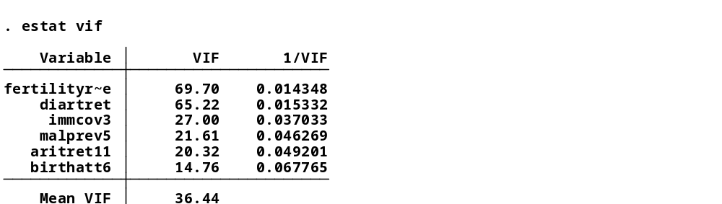

- Test for Heteroscedasticity(B-P test)
Test shows Heteroscedasticity is not present in the model.
As p>0.05(p=0.0641), null hypothesis (Ho is accepted).

- Test for Autocorrelation (Runtest)
The Ho of Runs test is: data are random.
Thus as p>0.05(p=0.53), Ho is s accepted. Therefore autocorrelation does not exist.
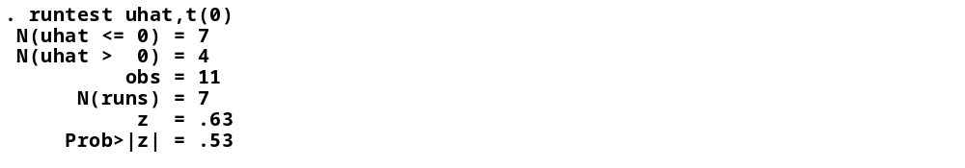

Therefore the final model is: u5m=α+β₁fertilityrate+β₂malprev5+β₃diartret+β₄immcov3+β₅birthatt6+β₆aritret11+u
Adjusted R² is 0.994, which shows the model is good and explains the variables responsible for decreasing under-5 mortality.

