“USA Retirement Savings Plan”
of
Data Path Ltd.

Sangida Sayed Oysi

This Report is Submitted to School of Business and Economics, United International University as a partial requirement for the degree for the Fulfillment of Bachelor of Business of Administrator.

“USA Retirement Savings Plan”
of
Data Path Ltd.

Submitted to:

Name: Dr. Md. Qamruzzaman

Designation: Associate Professor

Major: Finance

Submitted by:

Name: Sangida Sayed Oysi

ID: 111171051

Major: Finance

Trimester: Fall’21

School of Business and Economics
 United International University

Date of Submission: 13/04/2022




Letter of transmittal

13/04/2022

Dr. Md. Qamruzzaman

Associate Professor

School of Business and Economics

United International University

Subject: Submission of Internship Report on “USA Retirement Savings Plan” of

Data Path ltd.
Dear Sir,
It is my privilege to submit my report of internship on USA Retirement Savings Plan of Datapath limited that is needed for the completion of my Bachelor of Business Administration (BBA) degree. This given report consists of all my knowledge and understanding that I have received throughout my internship period in Data Path Limited. The entire internship period was both fascinating and exciting to me as an employee.
While writing this report, I have attempted my very best to follow your guidelines. I am extremely thankful to you, as it would not be possible for to complete this report without your help. I would like to request you to accept my report and help me complete my degree.

Sincerely,
Sangida Sayed Oysi
ID: 111 171 051

Declaration of the Student

I, Sangida Sayed Oysi, a student of United International University, state that the report of internship on “USA Retirement Savings Plan” of Data Path limited has been prepared by me and has not been submitted for any kind of degree, diploma, tittle or recognition.

Sangida Sayed Oysi
111 171 051
School of Business and Economic
United International University

Acknowledgement

First of all, I would like to thank the Almighty Allah, as I am nothing without Him and it would be impossible for me submit the report on time. Afterwards, I would like to thank Dr. Md. Qamruzzaman, who is my internship supervisor and the associate professor of the United International University. He has inspired me greatly while preparing this report and always believed in my. He supported me a lot by providing me guidelines, formats and many tips to prepare this report. He was very considerate about the COVID situation. Under his guidance it was a pleasure to prepare this report on “USA retirement provident plan(401k) in Data-Path Ltd. and in Bangladesh.”

Then, I would like to show gratitude to the manager of outsourcing department, Md. Shahdat Hossain Chowdhury, who never hesitated to guide me during the entire period.

After that, I would also like to thank the outsourcing department’s senior members and my colleagues who were more like friends and always helped me in my needs.

Finally, I would like to convey my gratitude towards all the members of the faculties of the United International University for helping me to be what I am today.

Abstract / Executive Summary

In the last trimester of completing my Bachelor of Business and Administration degree at the United International University, I have completed my internship over four months period in Data-Path limited. In this report I have tried to portray the information on the company and its operations. Amidst the other departments, I concentrated on its BPO department, which is very skilled. The BPO department is immediately tied to the July business services. The BPO, along with the other TPA in the United States, is providing July services.

First and foremost, I'd like to express my gratitude to During my four months as an intern, I learned a lot about the company and how important their work is. I received extensive work-related training and learned how to use a variety of applications. While working with these talented educators and kind coworkers, I also improved my Excel skills. I had the opportunity to operate in a live environment and contribute to the departmental function of BPO through project work that was tailored to the needs of the customer. As an Intern, I found the overall adventure to be incredibly appealing, intriguing, and difficult. During these four months, I had the opportunity to put myself to the test in every way. As a result, I can confidently state that working for Data-path is one of the best decisions I've ever made.

BPO's primary function is to provide services to its clients, such as plan administration.
Preparation of plan documents, plan setup/process, and plan review, as well as project management

Table of Content for Internship

Table of Content

Letter of transmit……………………..………………………………………………………………………………....……..…..04

Certification of similarity index…………………...……………………………………………………………………………….05

Declaration of the student…..............…………………………………………………………………………..………….….....06

Acknowledgement…………………………………………………………………………………………..…………….….….…07

Abstract / Executive Summary…………...………………………………………………………………….……………….…08

Table of Content for internship……………………………………………………….……………………….…………,….…..09

List of figures…………………………………………………………………………………………………….….……………..11

List of table……………….…………………………………………………………………………………………………….….11

List of abbreviation………….………………………………………………………………………………………………….…12

Chapter l: Introduction…………………………………………………………………………………………………..……..13

l.1 Background of the report………………………………………………………………………………………….…….13
..
l.2 Objective of the report………………………………………………………………………………………….………..14

l.3 Motivation of the report…………………………………………………………………………………………………..14

l.4 Scope and limitation of the report………………………………………………………………………………..……..14

l.5 Definition of the report……………….……………………………………………………….………………………….15

Chapter ll: Company Preview………………………………………………..………………………………………….…..17

2.1 Company Analysis…………………………………………………………………………….………………………..17

2.2 Overview and History…………………………………………………………………………………………………..17

2.3 Industry analysis………………………………………………………………………………………………………..24

Chapter lV: Internship Experience……………………………………………,………………………………….27

4.1 Position, Duties and Responsibility……,,…………………………………………………………………………….27

4.2 Training…………………………………………………………………………………………………………………..30

4.3 Contribution to Departmental Functions………………………………………………………………………..……..31

4.4.. Evaluation.……………………………………………………………………………………………………………….31

4.5 Skill Applied………………………………………………………………………………..………………………….....31

4.6 News Skill Development……………………………………………………………………………….……………….32
..
4.7 Application of Academic Knowledge……………………………………………………………………………….….32

Chapter v: Conclusions and Key facts……………………………………………………………………………33

5.1 Recommendation for improving Department Operations…………………………………………………………….33

5.2 Key Understanding………………………………………………………………………………………………………..33

5.3 Conclusion………………………………………………………………………………………………………………….34

Reference……………………………………………………………………………………………………………35

https://www.data-path.net/services-outsourcing/?temp=outsourcing ………………………………….35

Appendix A/……………………………………………………………………………………………………………………….

List of Figures

- Figure 2.l.5 : Operations

- Figure 2.l.5: SWOT Analysis

List of Table

Table : 4.1 Census File Calculation

List of Abbreviation

TPA; Third Party Administration
RK; Record Keeper
ACP; Avenage Contribution Percentage
ADP ; Avenage Deferral Percentage
ACP ; Avenage Contribution Percentage
ASPPA ; American Society of Pension Professionals and Actuaries
DOL; Department OF Labor
IRS; Internal revenue services
IRC; Infernal Revenue code
RPF; Retirement provident

Chapter l: Introduction

1.1 Background of the report

This internship program is one of the best ways by which the theoretical knowledge can be put in practice. The procedure of implementing America’s retirement programs is hard. Keeping a substantial retirement plan department is both expensive and difficult for the American companies to accomplish the retirement plan accurately and effectively. They, hence, hire a third party administrator dubbed “July Business Services”, that is Data-Path Limited’s parent firm for this. Due to the nature of the job, the outsourcing work process in July business services if comparatively hard to perform and also to train the new employees for outsourcing. As it is a very specialized job, both the trainer and the trainees are still gaining knowledge about the profession and having difficulty with retirement planning. It's difficult to recall every element of knowledge, thoughts, and American legislation pertaining to retirement plans. Data-path provided interns with the opportunity to study this job during the course of a four-month internship. I've learnt a lot about the outsourcing department and I'm constantly learning about it.
I.2 Objective of the report

The Purpose of the report is to Understand and analyze the “ out sourcing “ sector in Bangladesh and The United States, and also ibn detail of my four months of internship experience.

I.3 Motivation of the Report

The report's motivation is the United States' retirement plan structure. Employee contribution (deferral, Roth, and catchup) and Employer contribution (match, safe harbor match, safe harbor non-elective, and profit sharing) are examples of how they regard their employees and offer them with as much benefit as possible.

I.4 Scope and limitations of the Report

This report covers the issues and aspects that go into creating a retirement strategy. In my investigation, I've highlighted the outsourcing department in Data-path. Employees in the outsourcing department, with their knowledge in this subject and a previously created strategy, greatly assisted me in finishing this report on time.
Limitation of the report

I experienced certain limitations while preparing this report. They are, for example,

• Some critical and relevant information, such as the social security number (SSN) of employees involved in the plan, is not supplied here due to confidentiality.

• Employees' earnings and deferrals under the plan.
• The formula or proportion that the US corporation offers its employees.
• Due to a paucity of publications, there was no valuable information on the web.
• It's tough to provide 100 percent correct information because laws change every year.
• Due to time limits, there isn't enough time to gather information.

I.5 Definition of Key term

Allocated Compensation: After deducting overtime, bonuses, and pay before participations, the remaining compensation is referred to as allocated compensation.

Eligible employees: Employees those who have completed all of the rules and requirements necessary to engage in the plan, such as age, hours of service, years of employment, and participation date.

Fiscal Year and prior year: The fiscal year refers to the current year in which the plan is valued, whereas the prior year refers to the year in which the plan was valued before. After deducting overtime, bonuses, and pay before participations, the remaining compensation.
Highly compensation Employees: Those who earned more than $12,000 in the previous year. They are also considered HCE if they hold more than 5% of the company.

Key Employee: If an employee has more than, they can be considered a key employee.

- 5 % Ownership in the Company

- 1 % Ownership

- Officers Tittle

Entry Date: The day when employees will be able to participate in the plan.

TPA: Third-party administrator. The TPA for Data-path is July Business Service, for whom Data-path works.

Testing: To be tax-advantaged, the plan must meet specific criteria. Top-heavy test, coverage test, discrimination test, compensation test, ADP and ACP test are some of the most essential tests.

Chapter ll: Company Preview

2.1 Company Analysis

Data-Path Ltd. is Bangladesh's first officially recognized outsourcing company. July Business Services, a TPA based in the United States, is the mother company of Data-Path Ltd. John Humphrey and Jim Hudson are the actual owners of Data-Path Ltd. July Business Services is a renowned TPA company that offers retirement plan services and other administrative plan services to its clients.

July business services provides retirement services, administration, record keeping, and other services to its clientele. In 1994, it was established. It has roughly 94464 clients and is currently functioning throughout the United States. July business service has a current net worth asset of $5 billion.

Mission; To empower financial advisors and plan sponsors to select the retirement plan solution that best meets the goals of business owners and their employees by providing refreshingly responsive, unbiased, and dependable plan design, administration, recordkeeping, and consulting that encourages retirement saving.

Vision; The company's vision is to become the industry's leader in outsourcing. To progress from a typical BPO to a next-generation BPO.

2. 1.1 Overview and History

Data-path is a privately held corporation that provides business services to July. They are always available to help with retirement plan administration in the United States. One of the most well-known names in the 401k sector is Data-path, which is a subsidiary of July Business Services. John Humphrey and Jim Hudson are the proprietors of July Business Services. July's business service has over 4100 customers.

2.1.2 Trend and growth

Data-path is constantly expanding and providing end-to-end solutions for their Customers. In 2008, the company started with five people and has since expanded to over 200. Data-path has only one goal: to give its customers with the best service possible.

2.1.3 Customer Mix

July business service and other third-party administration are handled by Data-path limited.

2.1.4 Product / service Mix

July business and USA clients can benefit from a wide range of Data-path services.

Plan design:
By conforming to the US government's standards and rules as well as their goals, Data-path creates an appealing and effective plan for employers. The company specializes in retirement plan design.

Plan Document: With the support of their ERISA specialists, they are experts at preparing plan documents.

Plan Setup: The retirement plan is set up very efficiently by Data-path. Data-oath delivers services such as, as part of the plan setup.

- Setting up paperwork

- Loan Policy

- Submission of the Contribution

Plan Administration: Data-path has a team of highly skilled and qualified experts who are constantly offering services in the field of plan Administration.

Plan Operation Support: Data-path gives all of the information a client requires in order to estimate the plan in this field. This field entails.
- Eligibility Calculation
- Contribution Calculation
- Distribution Process

Compliance Testing: Data-path offers comprehensive support to their clients in every way. Testing is a crucial component of this. Many tests are available through Data-path, such as:
- ADP & ACP Test
- Coverage Testing
- Discrimination Test
- Top Heavy Test

Tax Compliance: In every way, Data-path provides comprehensive support to its clients. Testing is an important part of the process. Data-path provides access to a variety of tests, including:
- Form 5500
- From 5330
- Form 1099

Record Keeping: Data Path's partners and July business service's daily recordkeeping stage assessment provide automated recordkeeping services on a regular basis. Participants' quarterly statements, plan sponsor account access, and other services are available.

Payroll Service: By providing payroll services to its clients, Data-path reduces their work strain and increases their productivity.

2.1.5 Operation

Data-path Limited began with only five employees and has now grown to over 200, with the proprietor assembling a highly experienced workforce.

Building Team: Data-path is continuously working to strengthen and enhance the entire team, and July is assisting them in this endeavor.

Building Partnership: To provide more effective service to clients, Data-path has partnered with various well-known RK organizations, such as American funds and Mass Mutual.














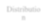




General
Manager

Plan Documens

Allocation
Tax
Return:
5500

Distributio
n IT

Record
Keeper

Team
Leader
Team
Leader
Team
Leader
Team
Leader
Team
Leader
Team
Leader

Sr. Executive
Sr. Executive
Sr. Executive
Sr. Executive
Sr. Executive
Sr. Executive

Executive
Executive
Executive
Executive
Executive
Executive

Figure: 2.1.5: operations

Accounting department: This department is in charge of accounting and financial services. Billing for work, stock statistics, and staff remuneration are all handled by this department.

Allocation Department: The goal of the allocation department is to disburse funds to members of each plan and update the process 5500.

Distribution Department: This Department is in charge of disbursing each participant's cash upon retirement or transfer to another company. The team needed a piece of software called Relius to finish the job.

5500 Department: Every year for July services, Data-path receives a ready-to-use "form 5500." The form is used to submit an annual report to the Labor Department on an employee benefit plan.

Human Resource Department: The human resource department is crucial to Data-path and is responsible for the security of the company. The HR department is in charge of recruitment and selection, and everything happened at Data-path Limited.

IT Department: The team is highly qualified and technologically advanced, which aids in the company's efficiency and security.

Outsourcing Department: Data-path Limited's most important and largest department, which is fully integrated with July's business services. July and other TPAs in the United States receive all outsourced help from this division.

Sales Department: The group is in responsible of selling Data-path limited and convincing new clients to sign up for a Data-path retirement plan.

Software Department: The team is always working to improve and upgrade the software that they created and that is used by other departments.
2.1.6 SOWT Analysis

The SWOT Analysis of Data Path Limited is given below.

Strength

Strong In Culture: The entire Data-path is built on a strong helping culture, in which everyone helps others with their research and learning. The business provides a welcoming prayer place for both men and women. The company also has a large dining area where employees may all eat lunch together.

Attractive pay Scale and Holiday: Every year, the company offers excellent salaries and bonuses to its employees. Every weekend, they also have two days off. Because Data-path is working in July, the company also provides additional vacation time from its end in the United States.
Appraisal system: The organization has a good employee appraisal system in place. If someone does an excellent job, they are rewarded for it with a performance bonus.

Weakness

Dependency on July Business services: Personnel of Data-path will not be able to access the data until July business employees upload information about plans, which will take some time.

Opportunity

Business Development: Data-path currently works primarily with July Business Services, but they may be able to work for other larger TPAs in the future.

Advancement of technology: Outsourcing is mostly based on technology, which is rapidly evolving and making Work more and productive.
Threats

Data Safety: Hackers are now much more easily able to attack servers via phishing emails, and the majority of outsourcing work is focused on domains. As a result, it is extremely vulnerable to Hackers.

Competition; Day by day, outsourcing employment is growing increasingly popular in Bangladesh, as more people join the industry. If a new company like Data-Path enters the market, Data-Path will face competition.

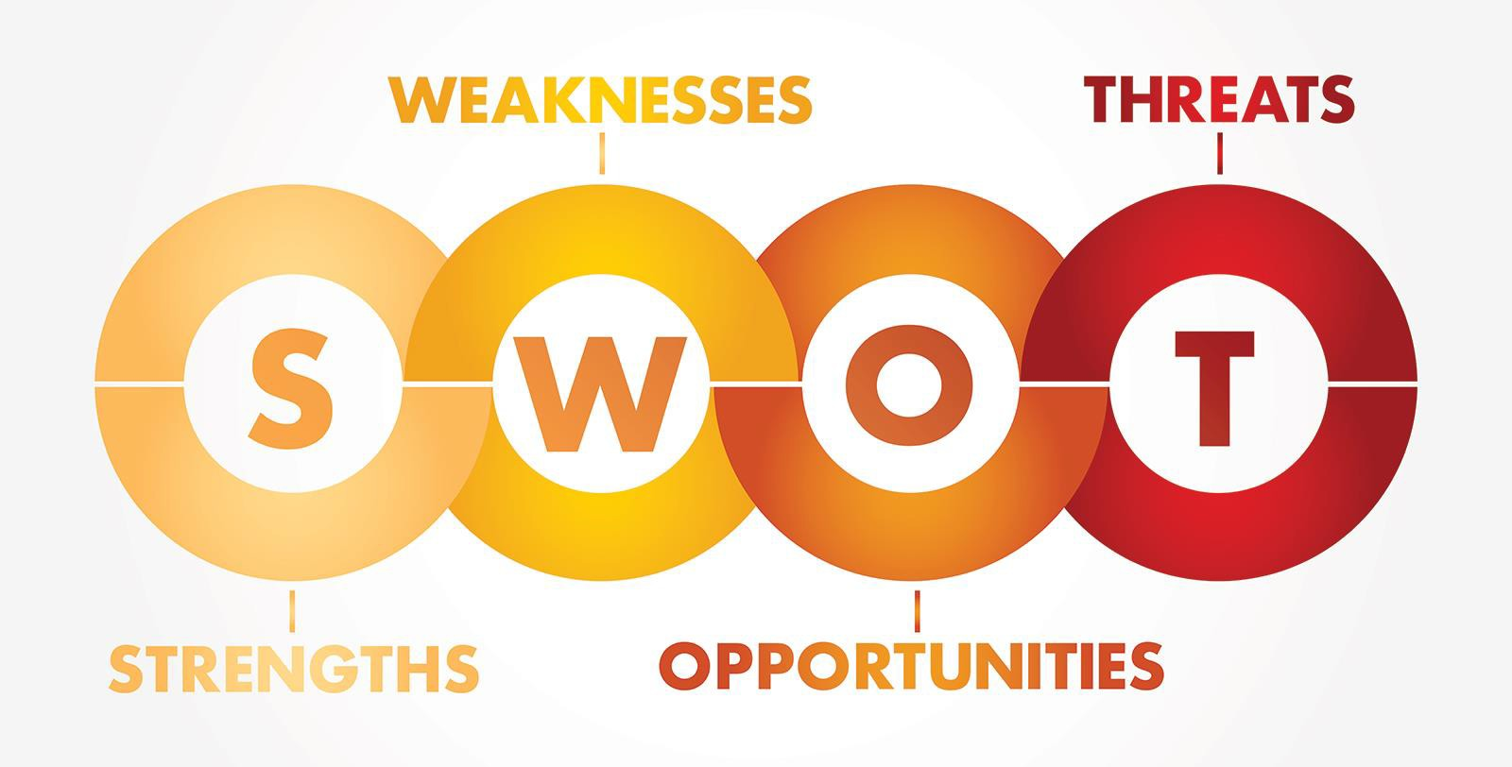

Figure: 2.1.5 SOWT Analysis
2.2 Industry Analysis

2.2.1 Specification of the Industry

Outsourcing is a business concept that involves the use of a TPA, or third-party administrator. A lot of work is being done. TPA offers project outsourcing, retirement plan outsourcing, software development, and other services to clients who require them.

2.2.2 Size, Trend and Maturity

Outsourcing Is a massive corporation that continues to expand at a steady rate. Within the last one or two decades, the level of outsourcing has risen. The outsourcing industry employs a large number of people and serves a variety of industries.

2.2.3 External Economic Factors

The vast industry may service its clients, establish businesses, and provide solutions to organizations. Clients gain from the service without having to pay for it. Although the price will be paid, outsourcing companies have the option of spreading the total cost among their customers.

2.2.4 Technological Factor

Outsourcing has a bright future, because to the rapid advancement of technology. Outsourcing is greatly aided by technological advancements. Clients might easily move to competitors at any time, thus outsourcing companies must keep up with the latest technologies.
2.2.5 Barriers to Entry

It is difficult to break into this business since it requires a large number of trained and experienced employees as well as a significant capital investment in IT support.

2.2.6 Supply Power

It is difficult to break into this business since it requires a large number of trained and experienced employees as well as a significant capital investment in IT support.

2.2.7 Buyer Power

The buyers should always provide useful and full information s to the TPA’s and also pay the costs on time in order to get the full support of the suppliers.

2.2.8 Threat of Substitute

Because Europe has progressed in this industry, and Bangladesh will soon follow suit as the government encourages the sector, the likelihood of a changeover is strong in the future.

2.2.9 Industry Rivalry

Existing competitors are vying for clients, and newcomers are attempting to break into the business and stay afloat. A good long-term connection is important to keep clients for a long time, which may be achieved through a large investment in the market place to get a good position and profits. To keep customers, a good, efficient service must be provided in the future as well, and the business must be enjoyed.

Chapter lll: Internship Experience

4.1 Position, Duties and Responsibility

Data-path limited has given me an internship position. I was offered an internship position in the department of Business Process Outsourcing (BPO). BPO is available at Data-Path for candidates with finance and accounting backgrounds. My internship time began on November 15th and finished on March 15th.

Duties and Responsibility

Except for following the task set by the trainers, my obligations and responsibilities as an intern were not very challenging. I was given tiny fundamental chores to complete with the training from the beginning. The tasks change on a regular basis. My trainer would occasionally urge me to write a report on previous work they had done, and then give me some Excel calculations for simple retirement plans. I was also given the opportunity to attend their team meetings and take notes on the most significant components of the strategy. Following that, I was given project tasks to do based on client needs, such as extracting data from a non-copy able pdf document. The text could be as little as 1000 words or as much as 4000-6000 words lengthy. Then, on occasion, my professor told me to use Excel formulae and macro functions to execute Deferral Calculation.

After that, I created a plan using Data Air software. The entire plan process was difficult because it included everything I learnt throughout training sessions. I must first read the plan document, which is around 60 pages long, to learn about the plan, and then I must go to software and begin inputting data based on the plan document and its specifications. Because the plan doc does not always contain all necessary information regarding the plan process, I must contact our client via email to seek it.

The software generated a lot of information about the calculations every time I had to do the plan process, but we couldn't rely on it entirely, so we had to do all of the calculations manually, including eligibility calculations, census checks, refund calculations if necessary, and importing and exporting account information into the software and matching it to the Asset reconciliation.

The client would next complete the entire plan and submit it to us for assessment. Reviewing the plan was easier than doing the entire plan because the calculations were already done, and we only needed to double-check that all of the information was provided.
CENSUS FILE

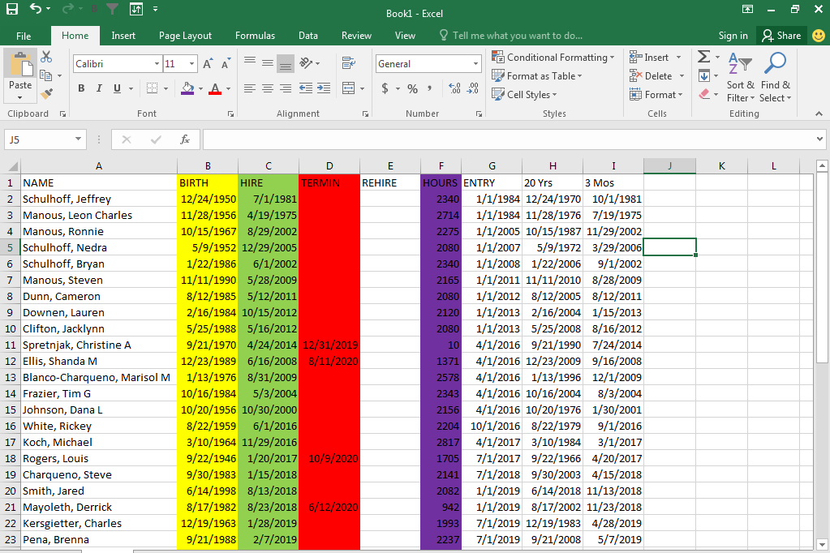

TABLE: 4.1 Census File Calculation

4.2 Training

We were all in the same batch of ten interns, and our training period lasted two weeks. They immediately introduced us to all of the trainers and departments. Then they slowly expose us to their work, the software they use, and lay out a two-week training schedule for us. We just received Microsoft Excel training for the first week, which lasted a couple days. After studying the basics and advanced Excel, we were taught "Retirement plan fundamentals," which covered the principles of a retirement plan (RPF). Due to the amount of content we needed to know in order to fulfill the plan, this training lasted four days. The RPF had a 790-page book that detailed everything.

After the RPF training, we were given instructions for calculations such as eligibility calculations and date of participation calculations. The calculations were tough for us at the time since we had never done them previously and they were based on a difficult-to-recall RPF study. Then we were taught about many sorts of testing, like ADP, ACP Top Heavy, coverage, and so on. We needed to comprehend and conduct this testing because, after going through the plan process, we wanted to double-check the testing section to see if all of the tests had passed or failed. Our plan procedure was completed if the exam was passed; but, if the test was not passed, we were advised to execute refund calculations in order to fix the situation.

Following that, we were trained on all of Data-tools, path's including RELIUS, DATAIR, FT. WILLIAM, and others. For the time being, we were simply provided a basic comprehension of the program. Following that, we were assigned to various BPO teams, with myself being assigned to the APCI team. We had 16 members in all, including myself, which was the most of any department. I, along with a few interns, received more training on our company's DATAIR program. All previous trainings were extensively evaluated because each customer has their unique set of practices. After covering all of the topics, our APCI training came to an end. The plan process and plan review, as well as a variety of project duties, kept us all busy.After that

4.3 Contribution to departmental functions

With my excel talents, I have made numerous contributions to our departmental operations, I've worked on a variety of initiatives, all of which involved establishing and discussing plans with my superiors. Despite the fact that this was live work, my planning and review approach was based on designs that had already been finished.. Our major work was only used for practice reasons due to the delicate nature of the task.

4.4 Evaluation

We were assessed at every stage of the program. Our seniors graded us on our work as well as our capacity to adapt and learn new skills and apply them to our jobs.

4.5 Skills Applied

Because the entire work process was on Excel, I had some Excel skills, which helped me acclimate fast. My MS Word skills were also put to good use when it came to creating charts and graphs. My best quality was adaptability, which has helped me tremendously and allowed me to learn quickly.

4.6 New Skill Development

I acquired a lot about Excel shortcuts, functions, and formulae, as well as how to use them successfully, after attending Data-training. Then, while working here, I gained time management skills as well as a few vital software programs such as DATAIR, RELIUS, and FT. WILLIAM, all of which are beneficial to me. While working here, I learnt how to use the macro feature in Excel as well as all of the business skills required.

4.7 Application of Academic Knowledge

Because Data-path Limited is an Outsourcing organization that watches and does USA retirement plans, my academic background was not used during my internship, but it was extremely helpful in preparing this report.
Chapter lV: Conclusion And Key Facts

5.1 Recommendation for Improving Operation

Make Training Process Easier: My academic background was not utilised during my internship because Data-path Limited is an Outsourcing firm that monitors and manages USA retirement programs, but it was tremendously useful in writing this report.

Developing the Software’s: UNIFY, DATAIR, RELIUS and FT.WILLIAM are among the software’s used by the complete Data-path. Some software concerns include slow loading, crashes, and expensive Relius account costs. By resolving these issues, Data-path will be able to expand there Departmental activities.

Internal Connection: Overall, the Data-path internet connection is good, although it can hinder productivity when used to function in the United States via VPN. The entire organization will be more efficient if the internet is quicker.

Office Space: Due to a lack of sitting arrangements, many top personnel are now working from home, potentially slowing down the operating process. As a result, the company should expand its space by moving or taking another level.

5.2 Key understanding

We may learn about Data-path Limited's system and departments through this report. How it operates, and the BPO department is the company's major department, which is rapidly expanding. Outsourcing is on the rise in Bangladesh, in the not-too-distant future, it will be highly competitive.

5.3 Conclusion

There are several outsourcing organizations in Bangladesh, but none compare to Data-path because it is entirely focused on the USA retirement plan. July Business Services is receiving nonstop services from Data-path, and the clients are pleased. The company began with only five employees in 2008 and has now grown to over 200 people, with more on the way. They want to be at the top of the outsourcing sector as a BPO. In every way, the industry is growing and becoming more competitive. The corporation wants to grow even bigger, so they're employing additional interns and attempting to turn them into assets. I attempted to highlight the whole BPO department in this report, as indicated above. Despite the fact that due to secrecy, not all useful information is shared. BPO is, without a doubt, the company's largest and most important department, and it's just becoming bigger. BPO's customers are happy because the company is dedicated to keeping its core values and offering outstanding service to its customers.

Reference

https://www.data-path.net/services- outsourcing/?temp=outsourcing

https://www.julyservices.com/

✓ Retirement Plan Fundamentals-1, Published from ASPPA, edition 2008

✓ Retirement Plan Fundamentals-2, Published from ASPPA, edition 2008

✓ IRS (Internal Revenue Service) Reporting Guidelines for Retirement Benefit Plan,
Published from IRS, edition 2008

Appendix-A:

