Factors Influencing Laptop Buying Behaviour among Consumers in Dhaka City

Tamjida Bilkis Eva

This project report is submitted to School of Businesses and Economics, United International University as a partial requirement for the fulfilment of Bachelor of Business Administration Degree requirement

Factors Influencing Laptop Buying Behaviour among Consumers in Dhaka City

Prepared by
Tamjida Bilkis Eva
ID: 111121043
BBA Program
United International University

Supervised by
Dr. Kawsar Ahmmed
Professor
School of Business and Economics
United International University

Date: 22nd July, 2020

Letter of Transmittal

To
Dr. Kawsar Ahmmed
Professor
School Of Business and Economics
United International University
Subject: Submission of project report on “Factors Influencing Laptop Buying Behaviour among Consumers in Dhaka City”.
Dear Sir,
You will be glad to know that I have prepared my project report following all the guidelines you have provided me. The title of the project report is “Factors Influencing Laptop Buying Behaviour among Consumers in Dhaka City”.

We know that laptops only account for a small portion of the market and were only used in special areas before. But now laptops have become a household product. Students, businesses, and professional users are inseparable from technology products. There are also plenty of well-known laptop brands that are selling laptops and offering a variety of features that make it difficult for customers to choose their preferred ones. Thus, based on an understanding of the need for a laptop, this report is prepared to analyse and discuss the factors that affect the purchasing behaviour of Bangladeshi customers (especially from students' perspective).

The completion of this project report would be so difficult for me without the guidelines and support you have provided me during these days. I want to assure you all the information used in the study are collected from relevant and valid sources. No information is directly copied or taken from any sources unnecessarily without proper citation or verification.

I, therefore, pray and hope that your honour would be kind enough to accept my project report and oblige thereby.

Sincerely yours,
Tamjida Bilkis Eva
ID: 111 121 043
BBA Program
United International University

Acknowledgement

I would like to start the study by thanking Almighty Allah and my parents for always supporting me and for all the blessings I have received from them so far.

First of all, I would like to thank and appreciate all the efforts of my course faculty as well as my project supervisor Dr. Kawsar Ahmmed, Professor, School of Business and Economics, United International University. During the preparation of my study, I received a lot of advice and guidelines to make my study a professional one. Without his kind efforts, the project study was very difficult to prepare.

I want to thank Waliullah Sumon, Manager, Computer Village, IDB Bhaban, Dhaka, Bangladesh for sharing several factors that have direct influence on customer buying behaviour. I also learned a good understanding of several brands' performance in the Bangladeshi market through his practical observation.

Finally, I want to thanks all my course faculties and friends for helping me during this preparation time by sharing verities of sources from where I have learned a lot and gathered different information on different laptop brands and their features through what they are trying to attract the Bangladeshi customers.

Executive Summary

Purchasing a new laptop is not an easy task and with so many brands and hardware available, it can be a sad experience to choose one that fits our needs. There are so many choices that it’s hard to decide. Technology is changing fast so our chosen laptop model may even expire before we take it out of the box! We can think about how much RAM we need, for example, which processor to choose or which graphics card to choose, which display to look for, which hard drive would be best for us. Moreover, due to globalization, many laptop brands in Bangladesh are supplying their products. Whenever we talk about technology in Bangladesh, the first technological shopping center comes to our mind is the IDB Bhaban where there are at least 300 computer accessories shops and most of them are selling laptops of different brands. These laptops differ in their specifications. Therefore, there are many areas to look at that make it difficult to know where to start the decision to buy a laptop.

The main purpose of the study is to explore the factors influencing the laptop consumer buying decision in Dhaka City. This research was prepared for the lack of well-known research on laptop consumer behavior in Dhaka City. The method used is a survey questionnaire, in which the target population is made up of university students and office workers. To collect the factors, 50 respondents were selected as samples through targeted sampling techniques and collected data from primary and secondary sources to use detection tools.

The findings of the report show that laptop price and after-sales service are factors that influence brand ownership, including laptop size, weight, hard drive and RAM capacity, operating system, and processor type. In addition, attributes of laptop specifications (such as reliability, portability, durability, and performance) have been found to have important significance in influencing brand ownership. In addition, other respondents believe that the brand has the greatest influence on the purchase decision. This can be seen from the fact that the most interesting brands are HP and Acer, well-known brands that produce high-quality products and influence consumer purchasing decisions. There are also several recommendations that are suggested both for Bangladeshi customers so that they can carefully choose while deciding to purchase any laptop and there are also recommendations for laptop sellers or brands so that they all can identify their shortcomings and improve their product offerings to attain customer’s needs.
Keywords: Factors, technology, Laptop computer, branding, consumer behaviour, Dhaka City

Contents
Letter of Transmittal 3
Acknowledgement 4
Executive Summary 5
CHAPTER ONE: INTRODUCTION OF THE STUDY 1
1.1 Background of the study 2
1.2 Scope of the study 2
1.3 Objectives of the Study 3
I. General objectives: 3
II. Core objectives: 3
1.4 Limitations of the Study 3
CHAPTER TWO: OVERVIEW OF LEADING LAPTOP BRANDS 5
2. Overview of Leading Laptop Brands 6
2.1 HP – Hewlett Packard 7
2.1 Dell 8
2.3 Lenovo 9
2.4 Asus 10
2.5 Acer 11
CHAPTER THREE: ANALYSIS AND FINDINGS 13
3. Analysis and Findings 14
3.1 Respondent’s overview 16
3.2 Considering laptops over desktop computer 16
3.3 Factors influencing purchasing behaviour 17
a. Most essential factors: 18
b. Size of Laptop: 18
c. Weight of Laptop: 18
d. Battery life: 18
e. Operating system: 19
f. Hard disk and RAM capacity: 19
g. Processor advancement: 19
CHAPTER FOUR: CONCLUDING PART 20
4.1 Recommendations 21
a. Recommendations for Consumers 21
b. Recommendations for Laptop Brands 22
4.2 Conclusion 23
Reference 24
Appendix – Survey Questionnaire 26

CHAPTER ONE: INTRODUCTION OF THE STUDY



1.1 Background of the study
The preparation and submission of project/internship reports is a prerequisite for obtaining a Bachelor of Business Administration (BBA) from United International University (UIU). Students must choose a project plan or internship plan at the start of the semester. In the internship program, students are assigned to an organization through the Career Counsel Department (UIUCC) to learn three months of practical work experience as an intern. When working in an organization, students must prepare internship reports according to their professional responsibilities. On the other hand, students who choose projects must observe a specific company or an entire industry. Based on three months of observations, they must submit a project report.

I chose a project thesis and got permission from my honorary course teacher to prepare a project report on the factors that influence the purchasing behaviour of Bangladesh customers when choosing a particular brand for a laptop. The title of the report I chose is "Factors that influencing laptop buying behaviour in the Dhaka city" as it is closely related to my area of ​​research.

1.2 Scope of the study
The scope of analysing the factors which influence the purchasing behaviour of consumers for a brand or a customer is an important issue. Customers always think of a variety of factors that lead to more benefits. These days, there is a lot of awareness and information readily available on consumer and competing products, so it is as important for marketers to understand the preferred behaviour process as for other sociologists. By identifying the reasons for moving towards a particular choice, marketers can better understand why and how to buy and therefore easily create and maintain appropriate marketing programs that will improve the capacity of their organization and the consumer to meet demand. However, identifying these causes has never been an easy task for researchers, because as a human mind, the only entity in nature is still more or less understood with a deeper power of understanding. For example, most consumers in Bangladesh come from middle-class families who cannot afford to spend much on essentials (such as laptops). Many factors influence their behaviour when making purchasing decisions. It helps to research and test positive and negative perceptions of products and brands. And the report also identifies the factors that affect the buying behaviour of consumers buying laptops.

1.3 Objectives of the Study
The objective of the report part is separated into two parts to facilitate understanding of the purposes of the report. These parts are described below:
- General objectives: The report has been prepared to meet several purpose. They are listed below:
- To apply my consumer behaviour knowledge into a practical perspective.
- To prepare a survey questionnaire through what consumer responses can be collected.
- To obtain BBA degree by submitting the study as project report.

- Core objectives: Consumer behaviour treats people as consumers and tries to present a theory that explains why and how people buy any particular product (and of course why they sometimes don’t). When analysing this process, it articulates clearly whether the idea of ​​choice as a final action is in favour of the product or not. This study seeks to explore the factors that influence consumer choice and decision-making while buying different laptops from a variety of laptop brands. However, the core objectives of the report are listed below:
- To analyse the consumer purchase behaviour.
- To analyse several well-known laptop brands.
- To identify factors that are influencing Bangladeshi consumers while buying laptops.
- To suggest recommendations for both laptop brands and consumer so that the study can help improve their decision making process.

1.4 Limitations of the Study
Choosing a laptop brand or buying a new laptop is undoubtedly one of the most daunting technology purchases one can make. There is an amazing number of different laptops on the market, and what they do is dazzling. Since a laptop brand is based on one or two products, it is also very difficult to announce the brand because there are many versatile laptops. Customer demand is changing the way technology is evolving. Therefore, it is difficult to analyse actual results in customer preferences.

Either way, the first step in answering this question is to understand what those needs are, and the truth is that for most of us, the answer is basic tasks such as browsing the Internet, sending the email, and watching news, TV shows or movies. In this case, there is good news and bad news: almost all new equipment on the market will be able to meet their needs, but this means that it is difficult to tell whether the money a customer pays is worth the investment. If customers only use it for the Internet, show on-demand services like Netflix and perform basic tasks in programs like Word, then using a laptop between BDT 20,000-30000 is fine. For high-quality SUVs to be used in commercial applications such as spreadsheets and presentations, it is recommended to use a device with better performance at BDT 30000. High-end games and performance laptops can be also found in Bangladesh that starts at BDT 50000. But in terms of user experience, this quality is important. BDT 20000-30000 can buy a laptop that can stream Netflix perfectly, but customers will not have that many high-definition screens, quality speakers or 360-degree hinges. At the same time, these are poorly designed 300-pound models, and customers found the writing uncomfortable after 20 minutes outside or were too heavy to carry a handbag to work.

Customers today don't care much about operating systems. Basically, there are three options here. Mac OS (Operating System), Windows, and Chrome OS (Operating System). These are all great operating systems, and they are handled slightly differently. All of this is intuitive and has been tested within a centimetre of the user's life cycle, so whatever the customer chooses, they will quickly accept it and it will soon appear natural, MacOS is easier to use, Windows may be more technical, and ChromeOS has slightly less support for software developers, but in fact, it doesn't have much impact on general users.

These are the limitations to consider when researching the laptop brand in this study. This research aims to find the best laptop brands for casual users: those who want a benchmark machine that meets the basic requirements well and is designed for frequent use without having to provide the necessary processing power to gamers or movie editors or software designers.

CHAPTER TWO: OVERVIEW OF LEADING LAPTOP BRANDS

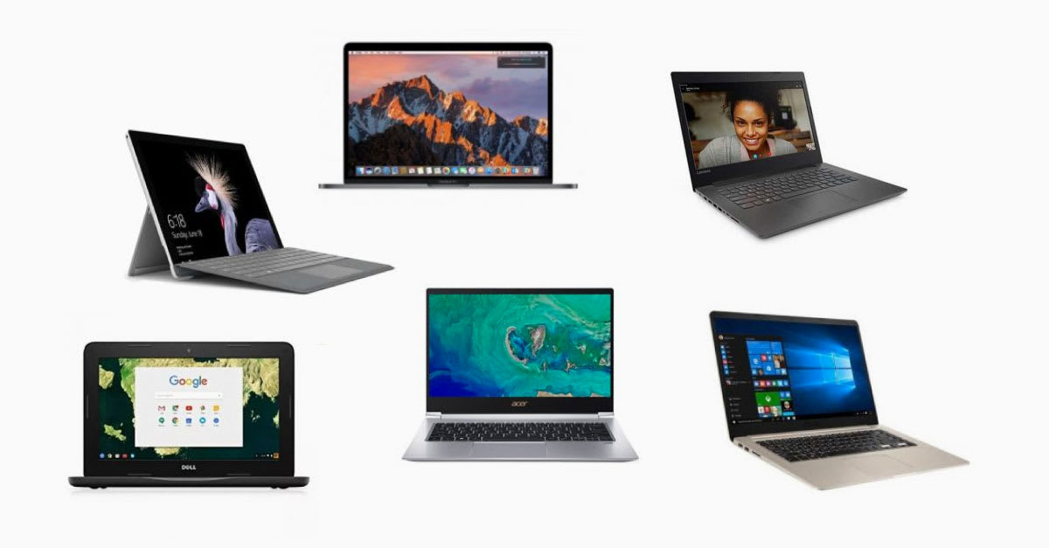

2. Overview of Leading Laptop Brands
As the technology and customer demand is advancing, laptop brands are also improving to sustain in the competitive market. On the other hand, many brands have recently started producing laptops and their accessories. Laptops have largely replaced desktop computers and desktop sales have dropped significantly due to laptop portability. In addition, laptop sales have been reduced to big progress in smartphones and tablets. However, for the office and heavy use, people still use laptops. An online research site called "The 6 Best Laptop Reviewers" conducted a survey on global laptop brands to study the overall performance of laptop brands and shown its findings of six laptop brands that are Apple, HP, Dell, Lenovo, Asus, and Acer. Apple macOS has been ranked number one in the past three years, but in 2019, HP notebooks are considered the most popular brand among consumers. By understanding the importance, the study was prepared for 50 students who answered the questionnaire in the appendix. This research is useful to both marketers and consumers, as these results will guide marketers to make products that meet the perceived needs of consumers. On the other hand, the results will help the consumer to make better decisions as well. According to Wikipedia, These six brand are most popular around the world, therefore, these companies country of origin, brand and product line of laptops, and the market share of 2019 is listed below in the table.

Name | Country | Brands and product lines | Market share (2019)
HP | United States | Envy, Spectre, Elitebook, Pavilion, Omen, Pavilion Gaming | 25.00%
Dell | United States | Alienware, Inspiron, Latitude, XPS, G Series, Precision | 20.50%
Lenovo | China | ThinkPad, ThinkBook, IdeaPad, Yoga, Lenovo Legion | 18.00%
Asus | Taiwan | ZenBook, Vivo, Republic of Gamers (ROG), TUF Gaming | 6.90%
Acer | Taiwan | Packard Bell, Predator, Aspire, Travel Mate, Nitro | 6.80%
Source: Wikipedia ‘Best Laptop Brands 2019’
In this chapter, the six world's leading laptop brands based on global laptop sales are being explored in the following.

2.1 HP – Hewlett Packard
Hewlett-Packard (commonly known as HP), was a multinational American information technology company headquartered in Palo Alto, in California. It has developed and supplied a wide range of hardware components, as well as software and services related to consumers, Small and Medium-sized Enterprises (SMEs) and large companies, including customers in the public, healthcare & education sectors. In 1999, HP split into two companies: one retaining the original name of the company, the other named Agilent Technologies. Hewlett-Packard's first line of products, test and measurement equipment, went to Agilent Technologies, while HP continued to focus on its later products, including computers and printers. In 2015, HP was split into two separate companies, HP Inc. and Hewlett Packard Enterprise.

The company was founded in a one-car garage (the historic HP garage at 367 Addison Avenue, an official California historic monument; its plaque reads "Silicon Valley Birthplace") in Palo Alto, in California, by Bill Hewlett and David Packard, and initially produced a range of electronic test and measurement equipment. The company won its first major contract in 1938, supplying its test and measurement tools for the production of animated film the great success Fantasia of Walt Disney Pictures This success led Bill Hewlett and Dave Packard to officially found their company Hewlett-Packard on January 1, 1939. The company became a multinational being much respected for its products. Its management style and culture is known as HP Way, which has been adopted by other companies around the world. HP was the world's leading PC maker from 2007 in 2013 when Lenovo took over as head of HP. HP specializes in the development and manufacturing of computer hardware, data storage and networking, software design and service delivery. The main product lines included personal computer peripherals, enterprise servers and industry standards, related storage devices, network products, software and a wide range of printers and other products. HP has marketed its products directly to families, small and medium-sized businesses and businesses, as well as through online distribution, consumer electronics and office supplies retailers, software partners and major suppliers of technologies. HP also had services and advice for its products and partner products.

Among the many projects HP worked on, their first financially successful product was a Precision Audio Oscillator, the HP200A model. Their innovation was the use of a small incandescent bulb (which also famous as Pilot Light) as a temperature-dependent resistance is a critical part of the circuit, the negative feedback circuit that stabilized the amplitude of the form of sine wave output. This allowed them to sell the 200A model for $ half of the price from its competitors who sold less stable oscillators for more than $200. The Model 200 generator series continued production until at least 1972 as the 200AB, still with a tube, but its design has improved over the years.

After several consecutive attempts, HP entered the computer market with the HP 2116A in 1966. It was designed to control the wide range of HP test and measurement products. In 1969, HP introduced a timeshare computer system and continued to launch new products, including the HP-35 laptop and several computers in the 1970s.

In the late 1980s, they had a full range of computer equipment ranging from large scientific machines to personal computers and peripherals. In 2002, HP acquired Compaq (and, therefore, the combined remains of DEC, Tandem and other companies).

2.1 Dell
Dell Inc. or Dell incorporation, Previously PC Limited (1984-1988) and Dell Computer Corporation (1988-2003) was a global personal computer manufacturing company. The company started its business as a Developer & designer of personal computers (PCs) and various types of computer accessories. Dell is one of the world's leading personal computer vendors. It’s headquarter is currently located in Round Rock, Texas.

This company, known as PC Limited, was founded in 1984 by an American student named 'Michael Dell' who was studying at the University of Texas at Austin. Initially, Dell started offering customized PC updates by trading in a shared room. The business was profitable, and Dell left college that same year to start producing PCs. In 1985, the company introduced the first computer turbo PC designed by Dell. Based on the principle of creating and selling custom PCs directly to customers, the company first sells its products through advertising and mail-order catalogues. Dell is able to deliver high-quality PCs at competitive prices, avoiding the costs associated with traditional retail markets. Dell focuses on sending technicians to implement customer service, PC maintenance, and secure return policies. This business model has been very successful and the business has grown rapidly and expanded into the global market. The company was renamed Dell Computer Corporation and publicly published in 1988.

Dell launched the first laptop, the 316LT, in 1989, generically which was actually a notebook computer. Over the next few years, Dell's mobile technology has improved. The first Dell Notebook laptop was launched in 1991 and the company was the first company to supply long-term lithium-ion batteries in 1994. Then, Dell started selling personal computers online in 1996 where they also used the Internet for customer service. Online sales helped Dell surpass Compaq Computer Corporation in 1999 as the largest PC provider in the United States.

In the early 2000s, Dell broadens its product line to include digital cameras, television, and various computer products. In 2003, the company named Dell Inc. to indicate the company was entering the larger consumer electronics market by changing its name. The company and an investment firm acquired the American company EMC in 2016, which specialized in data storage. The combined technology worth approximately 60 billion was the largest technology transaction of the day.

2.3 Lenovo
Lenovo is one of the largest private technology companies in the world, specializing in supercomputers, mobile phones, tablets, laptops and desktops. Although Lenovo was founded in China in 2004, the company began its journey since the 1980s.
Lenovo's real name is New Technology Developer Inc. And it quickly changed its name to Legend Holdings. Liu Chuanji and ten colleagues founded this company in China in 1984. Its first product was an additional device that provided Chinese functionality to a computer. The Chinese Academy of Sciences provided $ 25,000 in initial funds to private management companies as part of the first test conducted by the Chinese government. The firm was annexed to Hong Kong in 1988 as a "legendary Hong Kong" to raise funds and experience in a more open market.

Lenovo Group 1st began selling the first branded computer in 1988, named 'Legend Computer', to its main customer base in China. Sales have grown rapidly, and in 1996, the company became the market leader in the sale of office personal computers in China, the same year Lenovo launched its first laptop. In 1998, Lenovo manufactured millions of computers and became the largest PC provider in the Asia-Pacific region. The company expanded its product range in 2002 with the introduction of the first DeepComp supercomputer computer, which is the citizen market fastest computerized in China. Legend had introduced the Lenovo brand's logo in 2003 on its products on May 25 to expand its business to markets outside the Asia-Pacific region.

In 2004, Legend officially changed its name to Lenovo and emerged in the global market by partnering with the Olympic Games. However, this year's amazing announcement has made Lenovo the centre of global attention. The company acquired the personal computing division of IBM. Lenovo ThinkPad has been renamed the popular IBM ThinkPad laptop. Lenovo has become the third-largest Personal Computer Company in the world when the acquisition was completed in year 2005. The market expansion through the subsequent acquisition of the market extends Lenovo's product line to tablets and smartphones that helps Lenovo to expand the company's operations to Japan, Europe, and South America. Lenovo became the largest Personal Computer Company in the world and the third-largest smartphone company in 2013.

2.4 Asus
AsusTek Computer Inc., commonly known as Asus, is a multinational hardware and Electronics Company headquartered in Taipei, Taiwan, headquartered in Beitou District, Taipei, Taiwan. Its products include mobile phones, desktops, netbooks, motherboards, laptops, monitors, network equipment, WIFI routers, graphics cards, multimedia products, optical storage devices, projectors, wearables, servers, workstations, peripherals and tablets. Asus is also an original equipment manufacturer (OEM).

Asus was founded by T.H. Tung, Ted Hsu, Wayne Hsieh, and M.T. Liao in Taipei in 1989, who previously worked as a hardware engineer at Acer. At that time, Taiwan had not established a leading position in the computer hardware sector. Intel used to give first supply all-new processors to established companies such as IBM, while Taiwanese companies will have to wait about six months after IBM receives its engineering prototype. According to the company's history, Asus had created a prototype motherboard with Intel 486, but it must do so to access the real processor. When Asus asked Intel to test a processor, there was a problem with the Intel 486 motherboard. Asus solved the Intel problem and it turned out that the Asus motherboard could work without further modifications. Since then, Asus has placed Intel engineering champions ahead of its competitors.

Asus currently sells Chromebooks and Windows laptops under various sub-brands, including ZenBook, VivoBook, ASUSPRO Series, Republic of Gamers (ROG), TUF, ProArt Series and Laptop Series. Discontinued series previously offered by Asus include the EeeBook, A, B, E, K, X, V, P, Q, and F series.

2.5 Acer
Acer Inc., commonly known as Acer, is a Taiwan-based multinational hardware and electronics company specializing in the development of advanced electronic technologies, located in Xizhi, New Taipei City, Taiwan. Acer products include desktops, laptops (shells, 2-in-1 laptops, and Chromebooks), smartphones, servers, tablets, virtual reality devices, storage devices, displays, and other peripherals.

Acer was founded in Hsinchu, Taiwan in 1976 by Stan Shih, his wife Carolyn Yeh and five other people (like Multitech). The company initially had 11 employees and had a capital of $ 25,000. Initially, he was primarily a distributor of electronic components and a consultant who used microprocessor technology. He produced the Micro-Professor MPF-I training kit, then created two Apple II clones. Micro-Professionals II and III before entering the emerging PC markets compatible with IBM and becoming the leading PC manufacturers. The company changed its name to Macrocer in 1987.
In 1998, Hongcer was reorganized into five groups:
- Hongcer Information Products Group
- Hongcer Sertek Service Group,
- Hongcer International Service Group,
- Hongcer Semiconductor Group,
- Hongcer Peripheral Equipment Group.

To eliminate customer complaints about competition between Hongcer and its products and reduce the competitive nature of brand selling activities compared to contract manufacturing, the company ended its contractual activities in 2000 and renamed Wistron. The reorganization led to two main divisions: brand sales and contract manufacturing. In 2001, the company abandoned the production divisions of BenQ and Wistron to concentrate its resources on design and sales.

Acer also sells PCs and gaming accessories under its Predator brand. At the beginning of the 2000s, Acer implemented a new business model that went from being a manufacturer to a designer, a marketing operator, and a product distributor, while carrying out production processes through contract manufacturers. In 2015, Hongcer was the sixth-largest provider of personal computers in the world. Currently, in addition to the main activities of its IT products, Acer also has a new corporate entity that focuses on the integration of services and platforms in the cloud and the development of smartphones and portable items with IoT applications.

CHAPTER THREE: ANALYSIS AND FINDINGS

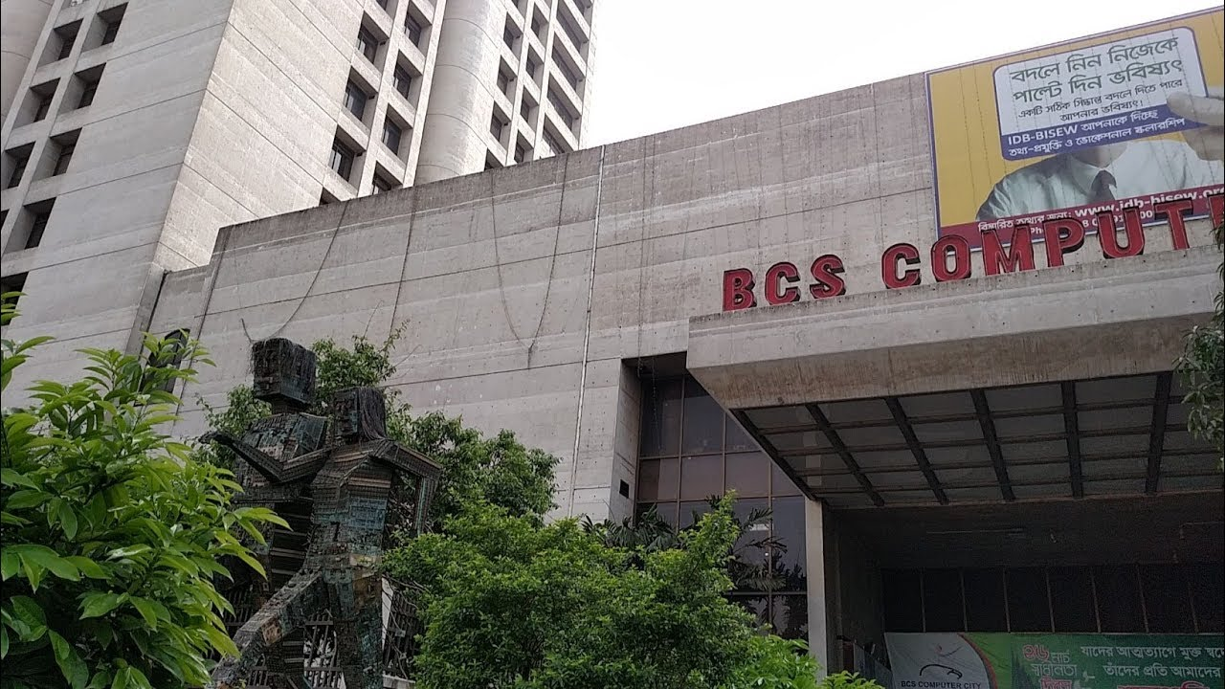
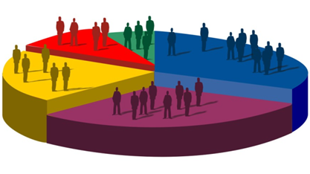

3. Analysis and Findings
Computer technology in the consumer market brought about the development of radio and television in the 20th century. It not only promotes the way consumers get information, but also the speed, quality, and density of their information. In addition to its role as a resource and productivity tool, computers are also a source of entertainment. Science and technology developed in this 21st century. In this modern world, we attach great importance to electrical and electronic equipment. Without it, we cannot make life easier in this busy world. From the introduction of computers to laptops today, we have been developing rapidly. In the laptop market, well-known brands have become more and more saturated, and each well-known brand provides consumers who are more and more informed about this hardly distinguishable products.

Customers today are more focused than ever. When deciding to buy a laptop, the customer first decides what purpose should be satisfied by buying a laptop. Most customers buy laptops for three reasons, such as personal use, including gaming, browsing, and entertainment; second, they buy for learning purposes, including reading, browsing, writing, and homework, and third, they Buy a laptop for professional purposes, including blogging, video blogging, design, freelance and more. Although this is not to say that you cannot use a purchased laptop for professional purposes, brands often use this method to categorize customers, and depending on these categories, laptop prices can vary. But for customers who need to buy branded laptops, they need to be more careful when buying laptops.

For many people, the brand of the laptop really matters, and for good reason. Some brands are immediate winners, while others are even less. Each popular laptop brand is usually highlighted in a different area to minimize competition, so if customers can't decide which brand to choose, they break down their requirements and compare among the competing brands. Some brands may not have the best warranty agreement but may offer better software packages. Certain brands may provide proprietary software that customers want to buy later, so even if the price of the entire product may be higher than other brands, consumers consider that.

The most important thing to consider when buying a laptop is the price. Even if customers know exactly what they need, if the cost of such a platform exceeds their budget, they will obviously choose a much cheaper model. Similarly, if a customer does not have the resources to pay a high price, the price must be taken into account.
Size is usually the second thing most users should consider when buying a laptop. Some people may like their large display to enjoy the view, while others may prioritize portability when choosing a smaller display. On the other hand, some prefer to buy smaller laptop for business purposes so that they can easily carry them to their office according to their necessity.

Some users prefer a laptop's appearance to performance, so they can choose a less attractive laptop to save more powerful video cards and additional RAM. The people who play games a lot, usually do this.

Most home users tend to buy laptops, primarily for browsing and lightening office and school workloads. In this case, they avoided a sales boom that increased performance. In many cases, store vendors will focus first on the amazing features of video cards, processors, and hard drives, making computers more expensive. Unless the customer wants to do heavy graphic tasks like gaming, video editing, 3D professional work, etc., the customer will not buy. If the customer knows that they just want to surf the Internet, chat with friends, or do housework, they can always save money earned in the future for other functions.

For customers, when they buy a laptop, the laptop's operating system is also very important because the operating system is pre-installed on the laptop and each brand, model and model is different. Customers are also very careful with laptop processors, and buying a laptop as a processor is an essential component of the computer that generally makes the performance of the computer nice or boring. For cheaper laptops running low-end processors, the task of surfing the Internet can be easily accomplished, but once users start loading multiple applications at the same time, performance may start to slow.

Consumers often choose brands based on the hard drive and RAM (Random Access Memory) capacity. Some customers buy a laptop with 500 GB (Gigabytes) of storage, others may choose a model with 1 TB (Terabyte) of storage. Also, some people who buy laptops also have an additional DVD ROM or USB port.

However, analysing the factors that influence the purchasing decisions of laptop consumers is an important task because there are many factors involved. There are very few or no divisions that indicate who the laptop buyer really is. Although there was no public study position at this stage of the thesis, the tradition of market research was mainly personal. Get easier access to more information to compare and contrast competing products, and ultimately create more fact-based laptops for every store and business. This unit provides an overview of the meaning and attitudes of consumer behaviour, as well as an understanding of why it is important to study the customer. The term customer behaviour is defined as the behaviour that customers believe will meet their needs when they want to buy, use, evaluate, and dispose of products and services.

The survey questionnaire (attached to the appendix) is based on knowledge of consumer behaviour and consumer-related articles, focusing on how people decide to spend their available resources (time, money, effort). This includes what they buy, why they buy it, when they buy it, where they buy it, how often they buy it, how often they use it, how they rate it after purchase, and the impact of this future assessment and how they get rid of it. In other words, consumer behaviour can be defined as the behaviour of people related to the acquisition and use and sale of products, services, ideas, or experiences. Customer behaviour also includes acquisitions and the use of information. Therefore, communicating with consumers and receiving feedback is an important element of consumer behaviour that is of great interest to merchants.

3.1 Respondent’s overview
Throughout the survey, a total of 50 respondents (25 men and 25 women) who recently bought a laptop were selected and they are all students living in Dhaka city. After analysing all the responses it is found that the respondents are much willing to buy HP and Acer laptops among the five listed laptops brands. The consumers get to know about the brands though online advertisements and word of mouth.

3.2 Considering laptops over desktop computer
Not only in Bangladesh, but laptops have also gained consumer preference over desktop computers worldwide due to their ease of use, portability, small size, and weight. Studies have shown that most Bangladeshi consumers (especially students) prefer laptops for convenience because they can take them to their university or workplace. Thus, dimension, weight, portability, and ease of use are found to be the most influential factors when students decide to purchase a laptop. A highly reputable laptop brand that can offer many other functions may lose its acceptance due to the lack of the above factors.

3.3 Factors influencing purchasing behaviour
After analysing the survey responses, it is identified that there are several factors that matter while Bangladeshi consumers take laptop purchase decision and these factors differ from various factors such as gender, status quo, income, price and so on. In Bangladesh, there are almost all types of customer exist based on their purchase capabilities. The rich section usually buy expensive, premium laptops. But these sections are not too large and most of the rich section import their laptops from foreign countries. The next laptop buyers, the large section of laptop buyers from Bangladesh, are from middle class families who buy laptops ranges in BDT 15000-50000. Therefore, all the laptop brands need to target these segment as the segment is huge. The final statement of the survey question was added to identify the basic factors that have direct influence on middle class families while making any laptop purchase decision. The findings are shown below in the chart.
Factors that influences to buy from a particular laptop brand | Strongly Disagree | Disagree | Neutral | Agree | Strongly Agree
- Laptop Size | 2 | 3 | 7 | 33 | 5
- Graphics Card | 2 | 2 | 29 | 12 | 5
- Colour of Laptop | 4 | 6 | 23 | 15 | 2
- Brand Image | 1 | 5 | 26 | 11 | 7
- Weight | 0 | 7 | 9 | 27 | 7
- Battery Life | 1 | 1 | 17 | 23 | 7
- Price of Laptop | 3 | 4 | 3 | 5 | 35
- Design of Laptop | 1 | 12 | 21 | 15 | 1
- Operating System | 0 | 7 | 15 | 17 | 11
- Hard Disk Capacity | 0 | 2 | 7 | 21 | 10
- Random Access Memory (RAM) | 0 | 5 | 9 | 20 | 16
- Processor Advancement | 3 | 2 | 13 | 22 | 10
- Store Location | 5 | 19 | 12 | 10 | 4
- Promotional Offers | 1 | 4 | 16 | 18 | 11
- Payment Option | 2 | 22 | 21 | 2 | 3
- After-Sale Services | 0 | 7 | 5 | 17 | 21
Chart: Consumer preferential factors that influence laptop purchasing behaviour in Bangladesh.
Interpretation: the survey was conducted among 50 laptop users who live in Dhaka and have owned or bought a laptop recently. In this section, the respondents were requested to provide their opinion through tick mark on all the boxes the shows their opinion perfectly regarding the factors mentioned in each box. After collecting all the responses it is found that:
- Most essential factors: Price and after-sales services, these two factors are so important that any purchase decision can be changed immediately if it is found that any laptop model is overpriced or if it is found that there is no after sales service are being given to the consumer.
While deciding to purchase a laptop, consumer consider the following factors:
- Size of Laptop: The size of a laptop is an important factor for Bangladeshi customers. We know that the larger the display, the wider and often allows for the better viewing experience, it can also be cut into the portability factor. The size of a laptop often determines the size of the keyboard and trackpad, which means customers will likely be tighter when choosing a laptop less than 13 inches.

- Weight of Laptop: Modern laptops are designed to be lightweight and portable. Normally the weight is relevant to its screen size. With modern designs, many laptops are becoming even lighter and more portable despite having larger screens. Therefore, the students or jobholders who require to carry their laptop in their universities or workplaces, consider the weight of the laptop as an important factor.

- Battery life: The battery life of a laptop is considered to be a necessary factor for buying a specific laptop rather than other laptops. After the laptop is fully charged and the power adapter is disconnected, the average battery life of the laptop can be between 1 and 6 hours. This time depends on the operations performed on the laptop, battery capacity, and battery life. As time goes by, the battery capacity of the notebook computer will decrease, which means that the battery usage time will not be as long as the first time you use the note book computer, and will continue to decrease as time passes. In addition, in Bangladesh, electricity is often lost, so the backup battery of laptops is an important factor for Bangladeshi consumers.

- Operating system: The operating system is another important factor that has a huge influence while deciding to purchase a laptop. Especially if a consumer is not familiar with Mac and PC. We know that most laptops have one of three operating systems: Windows, ChromeOS or MacOS (for MacBooks only). Based on these there operating system consumer often decide which laptop can fulfil their needs.

- Hard disk and RAM capacity: Hard Disk and RAM (random access memory) are the two most important hardware of any type of computer device. The hard disk of a computer or laptop is the primary storage device of the computer. This is a non-removable device that can retain all information when the computer is turned off. A fast hard drive can supply data to the computer as needed. Hard drives are measured in gigabytes (GB): the larger the number, the larger the storage space of the computer. Through RAM currently used operating systems, applications, and data are stored in the computer device so that the device processor can quickly access them. RAM is the main memory of the computer, and its reading and writing speed is much faster than other types of storage (such as hard disk drives (HDD), solid-state drives (SSD), or optical disk drives). Therefore, when buying new laptops, Bangladeshi consumers consider hard drives and RAMs as important factor.

- Processor advancement: When buying a laptop, the processor is an important factor, because several models of different laptop brands provide different types of processors, which will have a significant impact on the user-friendliness of the model. Consumers in Bangladesh have always wanted to have better processors within the budget price range.
Other important factors such as brand image, store location, promotional offers are also important factors that have a significant impact on Bangladeshi laptop customers.

CHAPTER FOUR: CONCLUDING PART

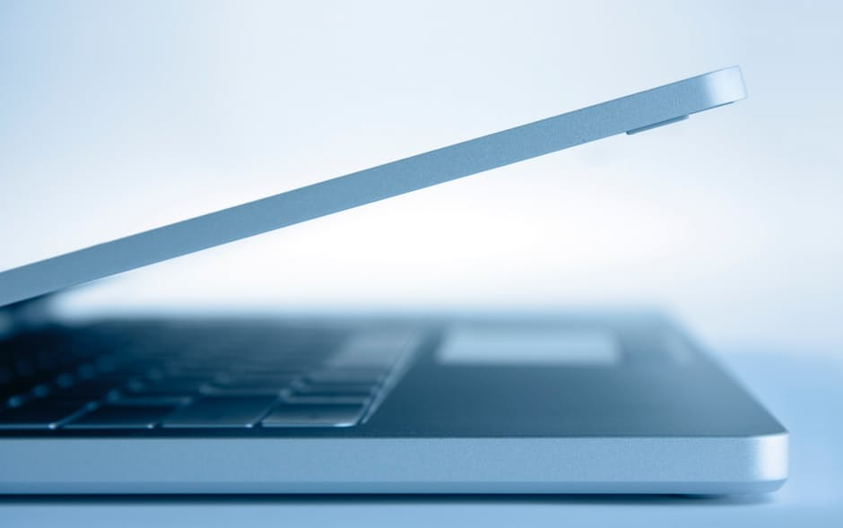

4.1 Recommendations

a. Recommendations for Consumers
- Size selection process: The best way to determine the size of laptops that customers need is to consider how they have used laptops in the past. A small Ultra-book, Net-book may be an effective option for frequent travellers, but for those looking for a standard laptop, they can choose one with a 13.3 or 14-inch screen. If Bangladeshi customers rarely leave home with their laptops, they should consider a 15.6-inch model for most as their laptop size.

- Weight Selection Process: It has been observed on the spot that Bangladeshi consumers are influenced by the weight of the laptop when they decide to buy it. We know that as the display gets wider and often gives the best viewing experience it can also be cut into the portability factor. So it is recommended that customers should buy 12.5 to 14-inch screens if they want to get any portable advantage in their laptop which provides the best balance between usability and portability. On the other hand, big screens are okay if they don’t travel much and small models are suitable for kids.

- Gather knowledge of specifications before purchase: While buying a laptop consumers should search laptops models that are available online within their budget segment so that they can learn at least how much specifications their budget can meet. The appearance of the tunnel when buying a laptop is bad news. Although it is interesting to add spot orders to each other, it is important to choose the specific specifications you like but don't overlook the other factors. For example, it is easy to pay more for dual RAM, but most people do not need more than 8 GB of memory unless you use serious software for commercial purposes. Similarly, don't indulge in battery life, resolution, processor speed. If your budget is limited and most people are in the budget, you need to learn how to balance different hardware. Make sure the laptop you want has the necessary features and hardware, and nothing else on the budget can be overdone.

- Operating system selection process: While selecting an operating system consumer needs to analyse the pros and cons of one of the three operating systems that are currently available. For Bangladeshi students, it is recommended to buy windows 10 installed laptops compared to Chrome OS or Mac OS X, although these more flexible operating system, Windows, works on multiple laptop models. Windows laptops are priced from less than BDT 15000 and offer a wide range of features, from touchscreens to fingerprint readers, to dual graphics chips. Windows 10 is the latest version of Microsoft's flagship operating system. It has many improvements on Windows 7 and 8, including the ability to switch between tablet and desktop modes, an improved Start menu with live tiles, and Powerful Cortana digital assistant.

- Hard disk and Ram storage: Consumers often confuse how much hard disk and RAM capacity they should buy. To solve this confusion, at first they need to identify the purpose of buying the laptop. If it is not for any professional purpose (that requires more space in HD and RAM, suggested to buy a model that has at least 1 TB Hard Disk and 8 GB RAM), They should go for 500 GB of Hard Disk Storage and 4 GB of Ram.

- Processor selection process: Core I series processors are better. Even if there is a generation of products, they are better than the latest generation of Pentium products, so if you must choose between two products at the same price, choose Core i. Similarly, Pentium is better than Atom in terms of performance. Although Pentium belongs to a generation with a two-year history, it can be selected.

- Brand Selection Process: Consumers are recommended not only to buy from popular brands as most of the popular brands are offering laptops in overpriced with low specifications. Before deciding to choose any particular brand it is also recommended to analyse the model of that brand and if possible gather practical experience from the users who have experience of such models.

b. Recommendations for Laptop Brands
Laptop brands should offer verities of models for Bangladeshi customers as there are verities of customers exists who have different social status, income level, and professional needs. But to attract the majority of the laptop users who pursue to buy a laptop for their studies or workplaces responsibilities, the brands should offer budget laptop segments that also offer a trustworthy after sales services, portability, durability, Windows 10 operating systems, minimum of 500GB hard disk, 4GB RAM, with Intel 5th generation processors. The price should varied between BDT 15000-30000. As the whole survey represents that consumer’s decisions are highly influenced by these factors.
The brands or seller of laptops should also aware that consumer can sacrifice the colour of the products, inappropriate payment options or distant store location if the mentioned factors are offered.

4.2 Conclusion
The study was prepared to identify and analyse the factors that influence the consumer purchase decision from several competing laptop brands in Bangladesh. Due to a verities of professional level, income level, the demand for laptops in Bangladesh varies. The study is prepared mostly for the students, fresher’s, or working class people who have come from a middle class family, as this is the largest segment in Bangladesh who buys laptops. To identify the factors 50 respondents were selected who recently have bought a laptop and their opinions were collected through a survey questionnaire. After the collection of their opinion, it is found that, the price of laptops and after-sales service are the components that influence brand ownership, including size, weight, hard drive and RAM capacity, operating system and processor type. In addition, it has been found that the specification features of laptops (such as reliability, portability, durability and performance) have an important meaning in influencing the purchase decisions. Also, other respondents believe that the brand has the most influence on the purchase decision. This shows that the most attractive brands are HP and Acer, well-known brands that produce high-quality products and influence consumer purchasing decisions. There are a number of suggested tips for both Bangladeshi customers, who can choose carefully when deciding to buy any laptop, and there are also recommendations for vendors or laptop brands so that everyone can identify their flaws and improve their offers.

Reference
(1) Aditya S. & Abhinav D., (2009), "The global laptop industry". Retrieved from: http://srl.gatech.edu/Members/ashah/laptop_industry_analysis _aditya_abhinav.pdf
(2) Kotler P. & Keller, K., (2006), Marketing Management. Pearson Prentice Hall, New Jersey
(3) Encyclopaedia Britannica, Available at: https://www.britannica.com/topic/Dell-Inc
(4) Farzana, W. (2012). Consumers’ Psychological Factors Association with Brand Equity of High-Involvement Product: Case of Laptop. World Journal of Social Sciences Vol 2. No 5.
(5) Dillon, T. and Reif, H. (2004). "Factors Affecting Consumer E-Commerce Purchases" IT, learning and performance journal. 22 (2), 1-12.
(6) Geisler, E. and Hoang, W. (1992). "Information technology purchases: behavioural patterns in service companies". International magazine of purchases and materials management. 28 (3), 38-42.
(7) Ganesh, J., Arnold, M. and Reynolds, K. E. (2000). "Understanding the Service Providers' Customer Base: An Examination of the Differences Between Switchers and Landlords", () Journal of Marketing, 64 (3). 65-88.
(8) Sheth, J.N., (1985), "History of Consumer Behaviour: a Marketing Perspective", in Historical Perspective in Consumer Research: National and International Perspectives, Jagdish N. Sheth and Chin Tiong Tan (eds), Singapore, Association for Consumer Research, 1985, pp 5-7.
(9) Johnson, M.D. and Lehmann, D.R., "Consumer Experience and Consideration Sets For Brands and Product Categories", in Advances in Consumer Research, Vol. 24, 1992,
(10) Merrie Brucks and Deborah J. MacInnis (eds), Provo, UT: Association for Consumer Research, Pages: 295-300
(11) Suri, R. and Monroe, K.B., 1995, "Effect of Consumers' Purchase Plans on the Evaluation of Bundle Offers", in Advances in Consumer Research Vol. 22,
(12) Frank R. Kardes and Mita Sujan (eds), Provo, UT, Association for Consumer Research, 1995 pp 588-593
(13) Srinivasan, N., 1990, "Pre-purchase External Search Information," in Valarie A. Zeithaml (ed), Review of Marketing 1990, Marketing Classics Press (AMA), 2011, pp 153-189
(14) Hong, Se-Joon, Lerch, F. Javier (2002). "A laboratory study on consumer preferences and purchasing behaviour in relation to software components." ACM SIGMIS, 33 (3), 23-37.
(15) Hair, J., Anderson, R., Tatham, R. and Black, W. (1998), Multivariate Data Analysis, 5th Edition. New York: Prentice-Hall.

Appendix – Survey Questionnaire

Questionnaire on Factors that influencing laptop buying behaviour in the Dhaka city
This questionnaire aims to acquire data and the responses obtained will only serve the stated purpose and confidentiality is guaranteed. Answering the questionnaire is not time-consuming and due to limited time to conduct the research, a timely response will be appreciated. Please answer the following questions as honestly and openly as you can.
- Your Gender:
- Male
- Female
- Your occupation:
- Student
- Jobholder
- Unemployed
- Have you purchased any laptop yet?
- Yes
- No
- Which brand you prefer most from the following brands:
- HP
- Dell
- Lenovo
- Asus
- Acer
- How did you get to know about the laptop brand?
- Offline Advertisements
- Online Advertisements
- Newspaper
- Brochures and leaflets
- Word of mouth
- Why do you want to buy a laptop, not a desktop computer?
- Portability
- The convenience of assembly
- Power usage
- Dimensions & Weight
- Information at your fingertips
- Most user-friendly
- Durability

- The factors that influences your purchasing behaviour or preference of any particular laptop are: (please tick on only one box beside each factors that abbreviates as S. D. = Strongly Disagree; D. = Disagree; N.= Neutral; A. = Agree; D. A. = Strongly Agree
Factors that influences to buy from a particular laptop brand | S. D. | D. | N. | A. | S. A.
- Laptop Size
- Graphics Card
- Colour of Laptop
- Brand Impact
- Weight
- Battery Life
- Price of Laptop
- Design of Laptop
- Operating System
- Hard Disk Capacity
- Random Access Memory (RAM)
- Processor Advancement
- Store Location
- Promotional Offers
- Payment Option
- After-Sale Services

